e-Newsletter, Issue 9, July 2017

Welcome to the latest issue of National Plan e-Newsletter.

It has been another busy quarter with the implementation of initiatives under the Third Action Plan of the National Plan to Reduce Violence against Women and their Children 2010-2022 (the National Plan) progressing through the collaborative efforts of the Australian Government, state and territory governments and our National Plan partners.

We celebrated International Women’s Day on 8 March by commencing the next round of advertising for the Stop it at the Start campaign. It will run until mid-April and includes online video, social media and out-of-home advertising (such as bus and train interiors).

In this issue, you’ll see updates from Australia’s National Research Organisation for Women’s Safety (ANROWS) on building the evidence base to help prevent violence and the Australian Institute of Family Studies (AIFS) on the effects of pornography on children.

We would like to thank everyone for their continued support of the National Plan and your ongoing efforts to make Australia a safer place for women and their children.

Table of contents
Welcome to the latest issue of National Plan e-Newsletter. 1
Message from the NSW Minister for Prevention of Domestic Violence and Sexual Assault, Family and Community Services and Social Housing, the Hon Pru Goward MP 3
Feature stories 4
The Building Safe Communities for Women and their Children program 4
The Line’s O-Week campaign 5
Family law updates 5
New sponsor requirements for partner and prospective marriage visa applications 6
Keeping Women Safe in their Homes 6
Updates from around the country 8
Australian Capital Territory 8
New South Wales 9
Victoria 10
South Australia 12
Queensland 13
Tasmania 15
Upcoming key dates for your diary 19
Have your say! 20
Do you need help? 20

This edition we have a message from the NSW Minister for Prevention of Domestic Violence and Sexual Assault, Family and Community Services and Social Housing, the Hon Pru Goward MP
I am proud and humbled to be Australia’s first Minister for the Prevention of Domestic Violence and Sexual Assault. With the collaboration of government agencies, as well as
non-government service providers and the broader community, NSW is leading the way on a number of domestic and family violence reforms.

The NSW Government’s commitment to tackling domestic and family violence is reflected in the 2017-18 Budget, which continues our investment of more than $350 million over four years for specialist domestic and family violence services. This is in addition to the hundreds of millions of dollars we invest each year into mainstream services like health, police, justice, housing and child protection.

In August last year I released the NSW Domestic and Family Violence Blueprint for Reform
2016-2021 (the Blueprint) which provides a policy framework for ensuring this increased investment delivers even further improvements to the domestic and family violence response in NSW. The Blueprint introduces a range of initiatives and reforms that will both support victims and prioritise measures to prevent violence from occurring in the first place.
I am pleased to report that work on the initiatives under the Blueprint is well underway.

On 19 June 2017, I announced seven successful applicants of the first round of the Domestic and Family Violence Innovation Fund. The $20 million Innovation Fund is an Australian first that provides financial investment for projects focusing on prevention, early intervention, and crisis response to reduce domestic and family violence in NSW. Projects range from more support in rural communities, more support for people with a disability and more support for education in the workforce. I am excited about what these projects offer the community and victim-survivors of domestic violence.

More than $4.8 million from this round of the Fund will be invested in these projects. Applications were open to service providers, non-government organisations, community groups, educational institutions, government agencies, and the private sector. The Fund forms part of the NSW Domestic and Family Violence Blueprint for Reform 2016-2021: Safer Lives for Women, Men and Children.

Another component of the Blueprint is the domestic and family violence service system redesign, which aims to work towards a domestic and family violence service system that is transparent and accountable, so that services are better aligned and can respond more flexibly to the needs of clients.

Over the coming years, the NSW Government will continue its work in reducing the effects of domestic and family violence on all communities in NSW. We look forward to continuing to work with all states and territories through the National Plan, as together we build on the progress made so far and aim for a future where women and children are safe from violence.

For more information on the successful projects under the Domestic and Family Violence Innovation Fund, visit: http://www.women.nsw.gov.au/violence_prevention/innovation-fund.

Feature stories

The Building Safe Communities for Women and their Children program
The Building Safe Communities for Women and their Children (BSCW) program is an initiative under the Second Action Plan of the National Plan. The BSCW program funds 40 projects in local communities to develop and implement practical solutions to reduce violence against women and their children.

ANROWS has partnered with the Department of Social Services to support the BSCW projects to design, implement and share their project findings through the use of action research. Action research is undertaken in the course of everyday work and requires ongoing reflection on project directions and outcomes. This provides the opportunity to adapt project activities when necessary. Action research is being used to capture, document and share lessons in order to build the evidence base for future policy, program and service delivery arrangements.

For more information about action research, visit the ANROWS Action Research Support webpage.

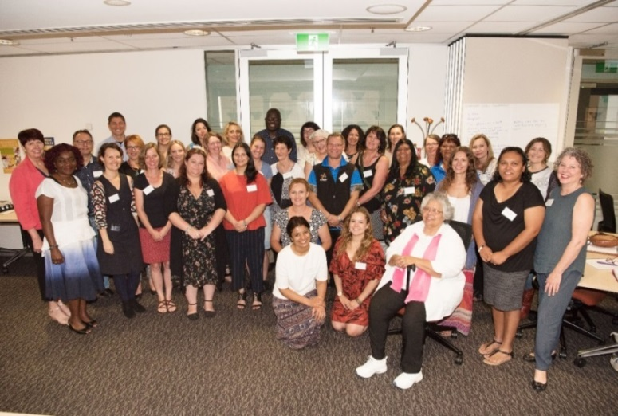
ANROWS with BSCW staff in Brisbane.

The Line’s O-Week campaign
Orientation week (O-Week) in universities can be a high-risk time for incidents of sexual assault and violence. To coincide with 2017 O-Week activities, The Line launched the ‘Don’t Blow It’ campaign, which asked young people to recognise and understand unwanted pressure for sex.

Our Watch has partnered with 13 Australian universities to drive home the message that it’s never okay to pressure someone into sex, and that consent must be mutual and continuous.

The campaign includes over 600 posters around universities and public transport hubs across the country, post card distribution, and social media content that encourages viewers to undertake a 'Pressure for sex’ quiz on The Line website.

Family law updates
On 9 May 2017, the Government announced a $26.8 million family law package, including funding for additional family consultants and domestic violence units, and establishing Parenting Management Hearings, a new forum for resolving less complex disputes between self-represented litigants.
The Government also announced that it will direct the Australian Law Reform Commission to undertake a comprehensive review into the family law system.

The media release is at: https://www.attorneygeneral.gov.au/Mediareleases/Pages/2017/SecondQuarter/Transforming-the-Family-Law-System.aspx

Family Advocacy and Support Services
The Australian Government is funding new ‘Family Advocacy and Support Services’ at family law courts across the country. These services aim to strengthen the legal and social support available to families experiencing family violence.

Legal aid commissions will increase the capacity of their existing duty lawyer services in family law court registries and work alongside specialist family violence services delivering trauma-informed social support services.

Services have commended in all jurisdictions and will provide continuity of support for families as they move through the legal system.

Legally-assisted and culturally appropriate family dispute resolution
As part of the Third Action Plan, enhanced models of legally-assisted and culturally appropriate family dispute resolution services will be piloted for separating or separated families from Indigenous and culturally and linguistically diverse backgrounds experiencing family violence.

The pilots will run for three years and be delivered by Family Relationship Centres, in partnership with other providers, and will be independently evaluated upon completion.

The pilots are expected to commence mid-2017.

Exposure draft of Family Law Amendments
On 9 December 2016, the Australian Government released and invited comments on an exposure draft of the Family Law Amendment (Family Violence and Other Measures) Bill. The Bill will make amendments to the Family Law Act and enable certain state and territory courts to exercise family law jurisdiction, protect victims of family violence, and criminalise breaches of personal protection injunctions.

The Australian Government is currently considering submissions on the exposure draft. Submissions closed on 20 January 2017.

For more information about the proposed amendments, visit the Attorney-General’s Department website

New sponsor requirements for partner and prospective marriage visa applications

On 18 November 2016, a new regulation came into effect requiring sponsors of partner and prospective marriage visa applicants to provide a police clearance to the Department of Immigration and Border Protection and to consent to share information about their criminal history with the visa applicant. If the sponsor does not provide this consent, the visa application could be refused. This regulation addresses Action Item 11 in the Second Action Plan of the National Plan.

The sponsorship requirements will strengthen the integrity of the program and improve protections for partner visa applicants by ensuring that they are aware of their sponsor’s criminal history before they decide to continue with the visa application process. It will also prevent people with serious and violent criminal records from being able to sponsor potentially vulnerable spouses.

For more information about the new regulations, visit the Department of Immigration and Border Protection website at www.border.gov.au/Trav/Brin/sponsor-requirements.

Keeping Women Safe in their Homes

The Keeping Women Safe in their Homes, an initiative under the Women’s Safety Package, is almost fully implemented. The measure supports women and their children who have experienced violence to stay in their home or a home of their choice.

The initiative supports states and territories to expand already existing programs. Funding under the initiative is being used by:
- New South Wales – to expand the reach of the Staying Home Leaving Violence program by offering additional tailored flexible packages.
- Victoria – to expand the reach of the Personal Safety initiative.
- Australian Capital Territory – to assist women in private rentals and those who own their own homes.
- Queensland – to trial new security technologies and options for Aboriginal and Torres Strait Islander women and partnering with landlords.
- Western Australia – to provide six additional workers to deliver Safe at Home services.
- South Australia – to provide more security upgrade items and technology options through the Staying Home Staying Safe program.
- Tasmania – to provide practical assistance with a range of security measures and technology options.

The initiative also provides support through The Salvation Army. Work undertaken through The Salvation Army includes searching for tracking and surveillance devices and basic upgrades to women’s homes, such as improved door locks. This measure is being progressively rolled out nationally.

Defence Family and Domestic Violence Strategy
The Defence Family and Domestic Violence Strategy was launched by the Minister for Defence, Senator the Hon Marise Payne, on 16 March 2017. The strategy supports initiatives that will promote awareness and enhance support services for all Defence personnel and their families affected by family and domestic violence. It sets out Defence’s objectives and key areas of focus and principles, including that family and domestic violence is never acceptable and that perpetrators will be held to account. The strategy will provide the foundation for the development of further policies, programs and practices across Defence. For more information about the Defence Family and Domestic Violence Strategy 2017-2022, visit the Department of Defence website.
White Ribbon Workplace Accreditation program

White Ribbon Australia has recently accredited 29 new workplaces as a part of the White Ribbon Workplace Accreditation program. The current cohort of White Ribbon Workplaces brings the total number of Australian employers to achieve accreditation to 106, with 78 other organisations currently working toward accreditation.

These organisations are a part of the sixth and largest group of White Ribbon Workplace graduates, and have been recognised by White Ribbon as a pioneer in contributing to national cultural change to prevent and respond to violence against women.

Over the past 18 months, these workplaces have demonstrated effective leadership, resource allocation, communication, HR policy development and training to create a safer and more respectful workplace, supporting employees to be respectful across all spheres. They have supplied documented evidence in practice against White Ribbon Australia’s Workplace Accreditation Framework.

The internationally recognised program has reached over 600,000 Australian adults via their workplaces.

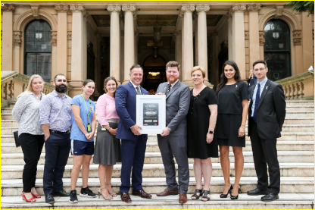
Council of City of Sydney.

United Nations Special Rapporteur for Violence Against Women tours Australia

From 13 to 27 February 2017, the United National Special Rapporteur (SR) on Violence against Women, Dr Dubravka Šimonović, visited Australia as part of her mandate to examine information on the situation of violence against women, and to offer an assessment of the country’s existing mechanisms and challenges with a focus on prevention, protection and prosecution.

As part of her visit, Dr Šimonović met with officials and ministers from governments and a broad range of civil society representatives, service providers and academics. Dr Šimonović identified that there are different ways that women are protected from violence, and the extent to which they align with the Convention on the Elimination of All Forms of Discrimination against Women. Throughout the visit to different jurisdictions, Dr Šimonović praised examples of good practice, such as the development of data collection on women’s killings, as well as relevant legislative and policy reforms, including the National Plan and initiatives related to prevention like OurWatch.

Dr Šimonović released a media release on the completion of her visit and will compile a report on the findings of her visit that will be presented to the Human Rights Council later this year.

Updates from around the country

Australian Capital Territory
New grants program for people leaving family violence

The ACT Government’s Safer Families grants program is an initiative to support women and children leaving violence. This is done through practical financial assistance to establish a private rental tenancy and avoid homelessness after fleeing violence.

A grant of up to $2,000 will be provided to eligible Housing ACT Rental Bonds Loan Scheme applicants affected by domestic and family violence. This grant is designed to assist with the costs of moving, buying furniture and white goods, setting up utilities and services and paying advance rent. Applicants will also receive fast-tracked access to an interest-free loan of up to 90 per cent of their rental bond under the existing scheme.

The ACT Government will pilot this program in partnership with the Domestic Violence Crisis Service and local businesses. The program will be evaluated after the first 12 months to ensure its effectiveness. Pending the success of the program, the government will explore opportunities to partner with additional service providers.

For more information on the Safer Families Grants Program, visit the ACT Budget 2016-17 website or the Community Services website.

New South Wales

Domestic and Family Violence Innovation Fund

The NSW Domestic and Family Violence Innovation Fund was launched in December 2016, the first of its kind in Australia.

It aims to support innovative approaches that:

- strengthen services for victims of domestic and family violence
- increase prevention and early intervention efforts
- are evidence based and build the evidence base
- address the needs of communities at higher risk.

On 19 June 2017, the NSW Minister for the Prevention of Domestic Violence and Sexual Assault, the Hon Pru Goward MP announced seven successful applicants of the first round of the Domestic and Family Violence Innovation Fund:

- Building Access for Women with Disability People with Disability Australia
- Kalypi Paaka Mirika Healing Program
- Respectful Relationships Peer Educators
- Safe Families
- Toolbox Talks
- Leaving Prison / Leaving Violence
- Linking Communities Education Van.

For more information visit the Women NSW website.
2017 NSW Women of the Year Awards – International Women’s Day

The 2017 NSW Women of the Year Awards were presented in Sydney on International Women’s Day on 8 March 2017.

“The Women of the Year Awards recognise the many inspirational women leading the way in their fields across NSW and the calibre of the finalists was very high,” noted NSW Premier, the Hon Gladys Berejiklian MP.

The winner of the 2017 Premier’s Woman of the Year Award was Associate Professor Catherine Birman. Catherine is one of the most experienced cochlear implant surgeons in the world and has given the gift of hearing to almost 1,000 people.

The other winners were:
- Community Hero Award – Debbie Higgison, who has built a network of festivals and community events across Mt Druitt, volunteers in a number of areas, and works with teenagers for whom formal education has failed.
- NSW Aboriginal Woman of the Year Award – Kristal Kinsela, an advocate and mentor for Indigenous women, who has also started her own consultancy in the area of supplier diversity.
- REX Airlines Regional Woman of the Year Award – Julia Harpham, for her work championing a ground-breaking resettlement plan for African refugees that transformed her rural community.
- NSW Business Woman of the Year Award – Gina Field, who established a successful security company, and as President of the Penrith Valley Chamber of Commerce, is a champion for women working in male dominated areas.
- Harvey Norman Young Woman of the Year Award – Dr Nicole Seebacher, who works and volunteers in cancer research, is a member of Level Medicine, a group advocating for gender equity in medicine; and volunteers as a mentor with Indigenous students.

For more information, visit the Women NSW website.
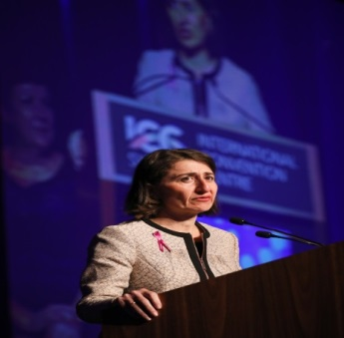
NSW Premier, the Hon Gladys Berejiklian MP – Women of the Year Awards.

Victoria

10 Year plan to end family violence

Ending Family Violence: Victoria’s Plan for Change was released on 24 November 2016. The 10-year plan to end family violence details how the Victorian Government will deliver the 227 recommendations made by Australia’s first Royal Commission into Family Violence and build a new system that protects families and punishes perpetrators.

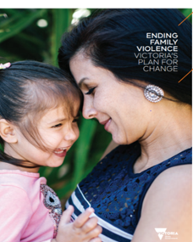

For more information, visit the Family Violence: A plan for change website.

Safe and Strong: A Victorian Gender Equality Strategy
On 5 December 2016, Safe and Strong: A Victorian Gender Equality Strategy was launched as part of the 2016 Victoria Against Violence – 16 Days of Activism campaign.

The strategy aims to progressively build the attitudinal and behavioural change required to reduce violence against women and deliver gender equality.

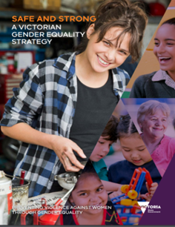

For more information, visit the Women Victoria website.

Respectful relationships education

The Victorian Government is investing $21.8 million over two years to roll out a
whole-of-school approach to respectful relationships across schools and early childhood services. All Victorian students will learn about respectful relationships to help end the cycle of family violence as part of a new mandatory school subject and approach.

For more information, visit the Victorian Department of Education and Training website.

International Women’s Day

The Victorian Government hosted a number of activities to mark International Women’s Day on 8 March 2017. On 6 March, 25 outstanding women were inducted onto the 2017 Victorian Honour Roll of Women at a ceremony in Melbourne.

The Victorian Government highlighted the contribution of Victorian women in sport by holding a bipartisan sporting event on the steps of Parliament House. The event was well-attended by elite female athletes and coaches across the sporting sector, including AFL, netball, cricket and soccer.

The Victorian Government also announced $550,000 in funding for a new program to promote gender equality in grass roots sporting clubs across the state.

To promote the outstanding work that women contribute year-long to Victoria’s economic and social prosperity, the Victorian Government also launched a calendar of women’s cultural events.

For more information visit the Women Victoria website.

South Australia

Social Development Committee Inquiry into Domestic and Family Violence

The Social Development Committee Inquiry into Domestic and Family Violence report was tabled in Parliament in April 2016. The Committee examined the effectiveness of national and state women’s safety policies, programs, and court processes.

The South Australian Government responses to the recommendations from the report include:
- increased funding for the Women’s Domestic Violence Court Assistance Service. The South Australian Government committed additional funding to this important service with the budget doubling in 2016-17;
- the provision of additional funding for the Multi Agency Protection Service (MAPS) as part of the last state Budget. This funding, allocated over four years, allows for a specialist non-government domestic violence service to co-locate two positions in MAPS. The funding was provided to Women’s Safety Services (SA).

The South Australian Government has also responded to other recommendations in the report including advocating for domestic violence leave in national employment standards and national school curriculum standards in gender equality and respectful relationships.

Women’s Domestic Violence Court Assistance Service

The Women’s Domestic Violence Court Assistance Service to address domestic violence in South Australia began operation in July 2015.

The free and confidential state wide service supports victims of violence to apply for an intervention order or to alter an existing intervention order. During 2015-16 the service supported 450 women, including over 200 court appearances. Additional funding has subsequently been committed to the service.

The service also provides assistance to women seeking to leave rental tenancy situations, under recent changes to the Residential Tenancies Act 1995. These changes will assist those affected to stay in the rented home and have the perpetrator removed; or leave the rented premises and be removed from the rental agreement with no financial penalty.

For more information, visit the Women’s Domestic Violence Court Assistance Service website.

Women’s Safety Services South Australia

In November 2016, the South Australian Government launched the new Women’s Safety Services South Australia (WSSSA).

The WSSSA is an amalgamation of three existing services providing greater flexibility and more streamlined service delivery. WSSSA will also house Family Violence Officers from South Australia Police, representatives from the Department for Correctional Services and provide a liaison service between specialist domestic violence services and existing partner agencies of the Multi Agency Protection Service.

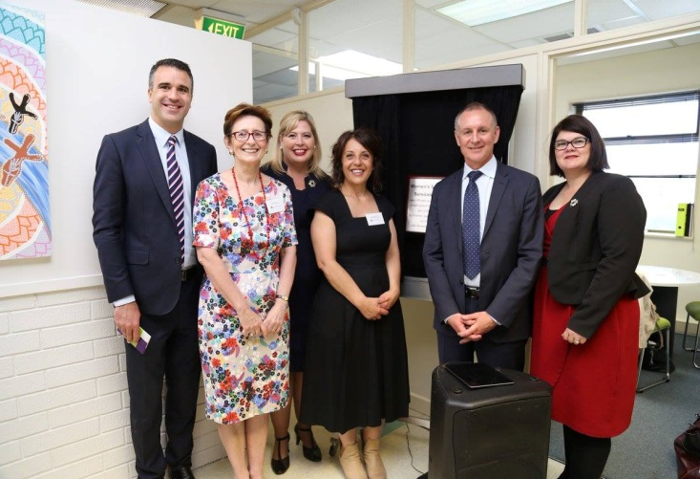

From L-R Minister for Correctional Services, the Hon Peter Malinauskas MLC, Marta Lohyn WSSSA Board, the Hon Katrine Hildyard MP, WSSSA Executive Director Maria Hagias, Premier Jay Weatherill, Minister for the Status of Women the Hon Zoe Bettison MP.

Queensland

Queensland Women’s Week 2017

From Bamaga to the Gold Coast, women and girls across Queensland celebrated this year’s Queensland Women’s Week in style, following the awarding of $150,000 in grants.

More than 60 organisations were awarded Queensland Government grants for activities and events during Queensland Women’s Week 2017, which ran from 6–12 March. This year’s theme was Queensland Women: Be involved. Lead the way. The theme aimed to encourage women and girls to participate, and pursue leadership roles in their community and workplace.

Women in STEM Awards 2017

It is important we encourage and inspire women and girls to access male-dominated industries such as science, technology, engineering and maths (STEM).

The Women in STEM Awards recognise women paving the way in STEM fields whose work has had a significant impact on Queensland.

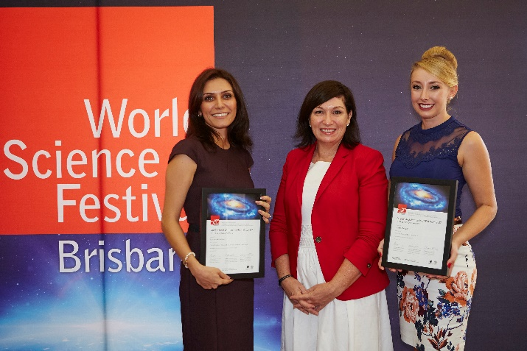
From L-R Dr Nasim Amiralian, The Hon Leeanne Enoch MP and Ms Jordan Debono

The 2017 awards were held on 26 March as part of the World Science Festival Brisbane event Under the Microscope: Pioneering women in science. Two scientists from the University of Queensland were recognised for paving the way for other women scientists:

- Dr Nasim Amiralian was awarded the Judge’s Choice Award for her research into spinifex nanofibers, which could result in the establishment of new manufacturing industries in Queensland.
- Ms Jordan Debono was awarded the People’s Choice Award for her research into the blood system, which could lead to the discovery of new drugs to combat heart disease, stroke and diabetes.

For more information, visit the Queensland Government website.
Gender Analysis Toolkit review

The Queensland Government developed its first Gender Analysis Toolkit in 2009. The toolkit was designed to support all government departments, businesses, community organisations and individuals to undertake gender analysis in the development of policy, programs and service delivery. It has been eight years since the release of this resource and in 2017 we will be updating it through an online survey. We welcome feedback on the Gender Analysis Toolkit.

Toward Gender Parity: Women on Boards Initiative

Through the Toward Gender Parity: Women on Boards Initiative, the Queensland Government has made great progress towards achieving the Queensland Government’s target of 50 per cent of all new appointees to Queensland Government boards to be women.

In the second quarter of 2016–17, 51 per cent of all new appointees were women. As at 3 January 2017, there is 42 per cent representation of women on Queensland Government boards, increasing from 32 per cent in July 2015. For more information on this initiative see website and Queensland Register of Nominees.

Keeping Women Safe in Their Homes Trial

On 1 September 2016, the Keeping Women Safe in their Home trial commenced to improve the safety of women and their children escaping domestic and family violence. Through the use of innovative technologies, this trial seeks to enable women to remain in their own homes, when it is safe to do so. In partnership with the Australian Government, the Queensland Government is supporting four trial sites in Caboolture, Cairns, Ipswich and Rockhampton.

The trial sites are testing technologies such as:
- personal duress alarms with 24/7 monitoring through an external security service
- home security cameras (CCTV) linked to devices to record data
- victim-focused smartphone technology applications.

Information technology consultants and specialist security monitoring companies are being engaged at the trial sites to raise awareness of technological abuse with trial participants and conduct electronic sweeps, scanning and debugging of victims’ homes and belongings for surveillance technology. On completion of the trial in June 2019, an external evaluation conducted by the Department of Social Services will be shared nationally.

Tasmania

Launch of the ASPIRE Project

On 8 December 2016, the Tasmanian Government and ANROWS co-hosted the launch of the ASPIRE Project Research Report in Hobart.

The ASPIRE Project aims to increase understanding of the nature and dynamics of violence against immigrant and refugee women with research being conducted in sites across Victoria and Tasmania including Hobart, Glenorchy and Launceston.

The launch event featured a photographic exhibition which encouraged participants to reflect on and focus their ideas about family violence in Australia.

For more information about the ASPIRE Project visit the ANROWS website.
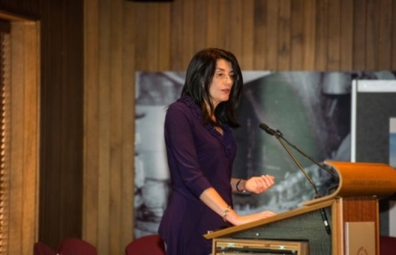
Tasmanian Minister for Women, the Hon Jacquie Petrusma MP, launching the ASPIRE Project Research Report.

Visit by the United Nations Special Rapporteur for Violence Against Women - Hobart

On 15 February 2017, Dr Dubravka Šimonović, the United Nations Special Rapporteur on Violence against Women, visited Hobart as part of her tour of Australia. She spent the morning with government and non-government service providers discussing Tasmania’s response to domestic and family violence.

Dr Dubravka Šimonović lectures human rights and women’s rights at the MFA Diplomatic Academy, the Centre for Human Rights and Women’s studies. She is author or editor of books and articles in the areas of women’s rights, human rights, and medically assisted procreation.

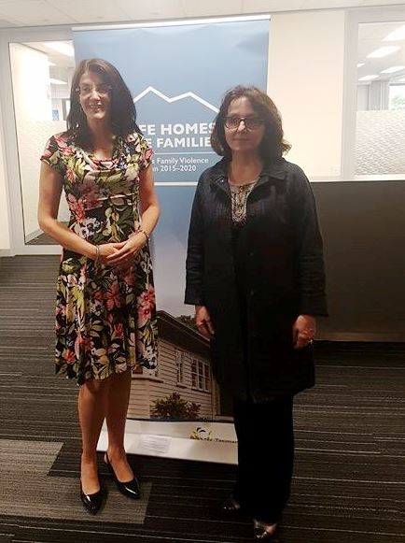
From L-R Tasmanian Minister for Women, the Hon Jacquie Petrusma MP and Dr Dubravka Šimonović, the United Nations Special Rapporteur on Violence Against Women.

Gender pay gap forum

On 27 February 2017, the Tasmanian Government and the University of Tasmania hosted a forum, Agents of Change: Reducing the gender pay gap, aimed at highlighting the gender pay gap for young women studying at university and discussing steps to address the problem.

Angela Ross, ABC news presenter, performed the master of ceremonies role at the forum and the panel members included: the Hon Jacquie Petrusma MP, the Minister for Women; Rebecca White MP, Leader of the Opposition and Shadow Minister for Health; Cassy O’Connor MP, Leader of the Tasmanian Greens; Heidi La Paglia, Tasmanian Women’s Council member; and Dr Vicki Gardiner, General Manager Engineers Australia (Tasmanian Division).

Panel members shared their experiences of gender discrimination and how the gender pay gap has impacted their careers and how they see themselves as being agents of change.

For more information visit the Tasmanian Government website.

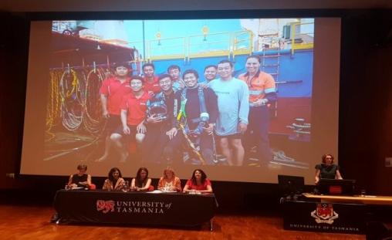
Panel members: Agents of Change: Reducing the gender pay gap forum.

Launch of Safe Homes, Safe Families: Responding and Reporting

In March 2017, the Safe Homes, Safe Families: Responding and Reporting (Responding and Reporting) was tabled in the Tasmanian Parliament. The report outlined key achievements of the first 18 months and future milestones from 1 January 2017 to 30 June 2018 of the Safe Homes, Safe Families, Tasmania’s Family Violence Action Plan 2015-2020.

Responding and Reporting announced three new actions:
- Provide practical supports to enable victims of family violence to stay safely in their own homes.
- Develop a practice guide to support service providers working with clients impacted by family violence.
- Work with the Tasmanian Aboriginal community to support Aboriginal families experiencing family violence.
For more information about Responding and Reporting, visit the Tasmanian Government website.

International Women’s Day

To mark International Women’s Day 2017, the Tasmanian Government supported a number of events across the state.

The International Women's Day luncheon was held in Launceston on 10 March 2017. Specialist breast cancer surgeon Dr Chantel Thornton was guest speaker at the event which was hosted by the Clifford Craig Foundation, with support from the Department of Premier and Cabinet.

The International Women’s Day breakfast was held in Hobart on 15 March 2017. Dr Susan Alberti AC was keynote speaker at the event with the Hon Jacquie Petrusma MP, Minister for Women, also speaking and launching a new Tasmanian Government women’s website and Facebook page.

The breakfast was jointly hosted by the Royal Hobart Hospital Research Foundation and the Department of Premier and Cabinet.

Upcoming key dates for your diary

4 August 2017 National Aboriginal and Torres Strait Islander Children’s Day

22-24
November 2017 2017 Family and Relationship Services Australia Conference

25 November 2017 White Ribbon Day

25 November to
10 December 2017 16 Days of Activism Against Gender Violence

Have your say!
We would love to hear from you! If you have content you’d like included in future editions of this e-Newsletter, or have other questions, comments or ideas, please email us at NPSecretariat@dss.gov.au.

Do you need help?
If you or someone you know is experiencing domestic and family violence or sexual assault, get help by calling:
- 000 if you, a child, or another person is in immediate danger
- 1800RESPECT – 1800 737 732
- Relationships Australia – 1300 364 277
- Mensline – 1300 789 978
- You can ask for a free interpreter if needed.

National Relay Service
- TTY users - phone 133 677 then ask for the phone number you wish to contact
- Speak and Listen (speech-to-speech relay) users - phone 1300 555 727 then ask for the phone number you wish to contact
- Internet relay users - visit the National Relay Service website and ask for the phone number you wish to contact.

