DSS1588.05.15
Flexible Support Funding Limits | 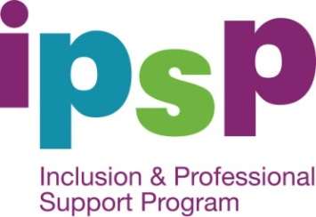
  - Inclusion and Professional Support Program
Service Type | Funding Limit as at 1 July 2015 (indexed annually)
All eligible service types (excluding VC, FDC and IHC) | Services are eligible for a $17.41 hourly contribution with a daily cap of five hours for a maximum of 100 hours each year, i.e. 12 months from date of approval, in respect of each eligible child enrolled.
Vacation Care | Services are eligible for a $17.41 hourly contribution with a daily cap of eight hours for a maximum of 80 hours each year, i.e. 12 months from date of approval, in respect of each eligible child enrolled.
Family Day Care and In Home Care | Services are eligible for a $17.41 hourly contribution with a weekly cap of five hours for a maximum of five weeks (or 25 hours) each year, i.e. 12 months from the date of approval, in respect of each eligible child enrolled.  Flexible Support Funding (FSF) can be used to employ an additional carer to increase the staff to child ratio above licensing requirements on out of home excursions such as playgroups or vacation care excursions.  FSF can also be used to provide a financial contribution for educators who are unable to attend specialist training during business hours. Training must relate specifically to the additional needs of a child in care. Educators are eligible for a $17.41 hourly contribution for a maximum of 15 hours each year or 12 month period.
All service types | Services are eligible to apply for FSF to allow release time for permanent educators to attend specialist training and/or prepare Inclusion Improvement Plans (IIPs) in respect of a child with ongoing high support needs. Services are eligible for a $17.41 hourly contribution with a combined 15 hour limit per service each year or 12 month period, for these activities. Note: Services are advised to apply for funding for these activities as required, not as a lump sum.

