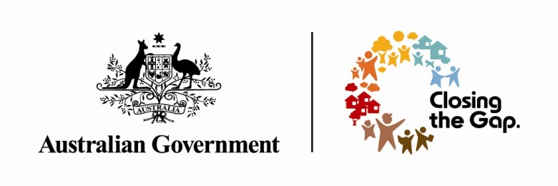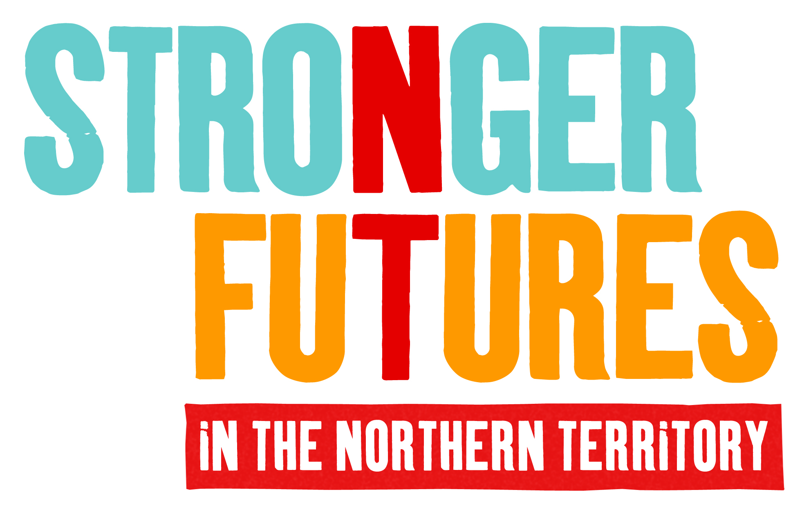

Stronger Futures in the Northern Territory: Implementation approach for the Intensive Family Support Service
The Australian Government is publishing this Implementation Plan (IP) because it is committed to working with Aboriginal people in the Northern Territory, their representatives and leaders to effectively implement Stronger Futures in the Northern Territory measures.
The Intensive Family Support Service (IFSS) Implementation Plan contributes to the objectives and outcomes of the National Partnership Agreement for Stronger Futures in the Northern Territory. This IP sets out the strategy for how the Commonwealth will deliver projects and services for which it is responsible. It should be read in conjunction with the Stronger Communities for Children (SCfC) Implementation Plan, and both the IFSS Program Guidelines and IFSS Pre Employment Training (IFSS PET) Program Guidelines.
The Australian Government has made a 10 year commitment to work with Aboriginal people in the Northern Territory to build strong, independent lives, where communities, families and children are safe and healthy. Stronger Futures in the Northern Territory is a $3.4 billion investment and responds directly to what Aboriginal people told the Government what is important to them.
The Australian Government will work with Aboriginal people in both large and small communities to support local jobs, tackle alcohol abuse and encourage children to go to school, as well as provide important services, including health, education and police. The Australian Government will talk to Aboriginal people in each community about how best to deliver services under Stronger Futures, providing Aboriginal people with more responsibility for services within their own community.
The Australian Government will support Aboriginal organisations to deliver services under Stronger Futures in the Northern Territory and all services will be expected to employ Aboriginal people wherever possible.

Stronger Futures in the Northern Territory: Intensive Family Support Service

IFSS is a free support service that provides intensive support to families in their homes and communities, to help them improve the health, safety and wellbeing of their children. IFSS is available to families with children aged 0-12 years of age where neglect has been substantiated by State or Territory child protection authorities. The referral pathway to IFSS is through the child protection agency. In the Northern Territory, families must be referred to Child Protection Income Management (CPIM) by the NT Government’s child protection authority in order to be eligible for the service.
In order to support the implementation of new IFSS services funded under Stronger Futures in SCfC communities, the IFSS: Pre-Employment Training (IFSS PET) initiative has been established to develop a skilled and sustainable local Indigenous child and family sector workforce. A Registered Training Organisation (RTO) will deliver the IFSS PET initiative from June 2013 to June 2014 in each IFSS site. The IFSS PET is part of a broader IFSS Workforce Development Strategy, which includes a Certificate IV in Child, Youth and Family Intervention (Family Support), and training and coaching on the IFSS Practice Model.

Why is IFSS included in the Stronger Futures in the Northern Territory package of elements?
IFSS forms part of the Commonwealth’s $34 million package in response to the 'Growing them strong, together' report (the Bath Report) by the Northern Territory's Board of Inquiry into the Child Protection System in 2010. IFSS was established to support the NT Government’s increased use of CPIM, and to ensure that people on CPIM were able to access complimentary family support.
IFSS now forms part of Stronger Futures, as one of the suite of services delivered as part of the Child, Youth, Family and Community Wellbeing Package to meet the different needs of families and communities. IFSS is designed to support the most vulnerable and disadvantaged families where children are neglected or at risk of neglect. IFSS is an initiative to support these families to improve their situation, keep their children safe and healthy, and keep children with their families and in community.

A key deliverable for all measures under the Stronger Futures package is also providing support for service providers to engage Indigenous staff, particularly at the local level, and invest in their career development wherever possible. The IFSS PET initiative, and Workforce Development Strategy, will help develop a skilled and sustainable local Indigenous child and family sector workforce.

What is the objective of IFSS?
The key objectives of IFSS are to reduce child neglect, keep families together and reduce the use of out of home care by enhancing parenting skills. IFSS aims to:
- increase the capacity of families on Child Protection Income Management to support their children to be safe, nurtured and thriving;
- support the development and implementation of an evidence-based intensive family support service; and
- strengthen the local Indigenous workforce through the provision of employment and training opportunities for staff involved in the delivery of IFSS.

The key objective of IFSS PET initiative is to develop a skilled and sustainable local Aboriginal workforce that increases the capacity of families and communities to support children to be safe, nurtured and thrive, when delivering the IFSS.

IFSS PET is linked to the overall key objective of the IFSS Workforce Development Strategy, which aims to support the professional development of staff and support agencies to embed and fully implement the IFSS evidence based model within their services.

What are the expected outcomes and outputs of IFSS?
The IFSS practice model seeks the following five outcomes:
- Children are adequately supervised;
- Children have all their basic physical needs met;
- Children have all their health needs met;
- Children have their emotional and developmental needs met; and
- Children have their educational needs met.
Specific outcomes sought from the IFSS PET initiative will be co-produced with local participating communities to ensure they are relevant and align with local needs.
- IFSS will commit to the following outputs:
IFSS providers are required to work with the whole family in a way that is flexible, practical, tailored, intensive and culturally appropriate and may include:
  - Practical and structured in home assistance (including home visiting);
  - Individual and group parenting and life skills education and development;
  - Development of peer support and mentoring;
  - Some case management of referrals and advocacy;
  - Support to access other specialist services the family needs;
  - Links to community networks (including the SCfC Facilitating Partner); and
  - Working collaboratively with the IFSS Implementation Partner to effectively implement the IFSS Practice Model.

- Professional development of the local workforce that includes:
  - an RTO identifying local child and family sector workforce needs and co-developing IFSS PET outcomes to meet these needs;
  - developing and implementing IFSS PET Program which includes nationally recognised courses; and
  - linking local Aboriginal people in the program to employment opportunities.

How will IFSS be implemented?
IFSS is currently available in 20 locations across the NT and APY Lands and is delivered by five non-government providers. Subject to community consultation outcomes, new services will be established in six communities during 2013-14: Ngukurr, Galiwinku, Ntaria, Santa Teresa, Maningrida and Gunbalanya. FaHCSIA will contract non-government organisations in these communities during 2013-14 to be responsible for the delivery of IFSS following successful community consultations.
IFSS will roll out to up to an additional three communities in 2014-15 and up to another five during 2017-18.
The Parenting Research Centre (PRC) has been engaged as the IFSS Implementation Partner until 30 June 2014. The PRC is responsible for developing and supporting the implementation of a culturally appropriate IFSS Practice Model that is outcomes based, in partnership with IFSS providers, FaHCSIA and the child protection authority/ies.
BCA National and the PRC are funded to deliver different components of the Workforce Development Strategy.
FaHCSIA will contract an RTO to deliver the IFSS PET initiative in up to six new communities until 30 June 2014.

Stronger Futures Commitment to Aboriginal Service Providers and Aboriginal Employment:
Under Stronger Futures, the Australian Government is strongly committed to developing the capacity of Indigenous service delivery organisations and increasing employment opportunities for Aboriginal people. Aboriginal employment targets are being set for all Stronger Futures measures to encourage service providers to invest in employing Aboriginal staff and developing their skills.
The IFSS PET and Workforce Strategy initiatives are a central component to the effective delivery of IFSS. IFSS has set the following Aboriginal Employment Targets:
- 50% Aboriginal employment by 2014-15;
- 60% Aboriginal employment by 2017-18; and
- 75% Aboriginal employment by 2020-21.
Of the current 44 IFSS staff, 21 (48% of total workforce) identify as Indigenous
Stronger Futures Commitment to Engagement with Aboriginal people:
The Australian Government is also strongly committed to changing the way it engages with Aboriginal people. All Stronger Futures measures are required to ensure services are responsive, effectively meet community needs and that agreed mechanisms are in place to provide for their ongoing feedback.
IFSS will continue to build on the SCfC consultation process with each of the six new 2013-14 communities to provide detailed information about IFSS and identify possible IFSS providers.
It is expected that IFSS providers will develop and maintain relationships with the SCfC Facilitating Partner and the Local Community Board. IFSS providers will participate in local service delivery forums once established and may be required to attend meetings with the SCfC Facilitating Partner or the Local Community Board (if invited). IFSS providers may be required to contribute to the development and implementation of the SCfC Facilitating Partner’s Service Delivery Plans if requested.
IFSS providers will be expected to develop culturally appropriate ways of engaging with local communities and clients and achieving IFSS outcomes while delivering services in accordance with the evidence-informed practices. It is expected that IFSS providers will work with FaHCSIA Indigenous Coordination Centres, Regional Operation Centres and Government Engagement Coordinators to ensure joined up community engagement approaches.
The IFSS Implementation Partner is responsible for developing and supporting the implementation of a culturally appropriate IFSS Practice Model that is outcomes based, in partnership with IFSS providers, FaHCSIA and the child protection authority/ies. The IFSS Implementation Partner is committed to ongoing service improvement and will work with IFSS providers and FaHCSIA to review the Practice Model based on evidence and culturally appropriate practice.
Links to other programs
IFSS is one program of many under the Child, Youth, Family and Community Wellbeing Package (CYFCWP) of Stronger Futures in the Northern Territory. Under the CYFCWP the Commonwealth is supporting a range of measures that complement each other in providing early intervention supports for the whole community. Stronger Communities for Children will cooperate in remote communities with programs such as:
- Stronger Communities for Children;
- Youth in Communities;
- Mobile Child Protection Teams;
- Women’s Safe Houses; and
- Remote Aboriginal Family and Community Workers.
And with other Stronger Futures Measures such as:
- Remote Jobs and Community Program; and
- Regional Education Skills and Jobs

Funding and governance arrangements
IFSS was originally funded as part of the Commonwealth’s response to the 'Growing them strong, together' report (the Bath Report) and has been funded until 30 June 2022 as part of the SFNT CYFCWP. Funding for IFSS under SFNT commences in 2014- 15 and this funding ensures the continuation of funding for the existing IFSS locations, as well as expansion in up to 15 additional communities in the NT as part of SCfC.
The SFNT funding available for this project is:
Year | 2012-13 | 2013-14 | 2014-15 | 2015-16** | 2016-17
Australian Government Funding* |  |  | $11.405m | $11.952m | $11.865m
Year | 2017-18 | 2018-19 | 2019-20 | 2020-21** | 2021-22
Australian Government Funding* | $12.103m | $12.345m | $12.592m | $13.196m | $13.100m

Please note that 2012-13 and 2013-14 funding:
- also includes funding that is allocated to IFSS in the APY Lands in South Australia; and
- is not sourced from SFNT.

* Funding each year includes $9.5m base + SACS, indexation and efficiency dividend.
** 2015-16 and 2020-21 both include an additional $300k for program evaluations.

Evaluation, monitoring and review
This Implementation Plan will be reviewed in 2016-17 and 2019-20 in line with evaluation of the NPA with regard to progress made in respect of achieving the stated objectives.

IFSS will be undertaking independent evaluations of existing services in 2013-14, 2015-16 and 2020-21. Broadly these evaluations will focus on the structure of the IFSS program and its effective implementation as a whole, and are timed to occur parallel to SCfC evaluations. The PRC is also undertaking an evaluation currently that will assess the effectiveness of the implementation of the IFSS Practice Model and the outcomes for children receiving IFSS.

Lead agency
The Department of Families, Housing, Community Services and Indigenous Affairs is the lead agency on the implementation of this measure.

Contact details and questions
Intensive Family Support Services - Family Support Program Branch
Department of Families, Housing, Community Services and Indigenous Affairs
AE3 Tuggeranong Office Park PO Box 7576
CANBERRA BUSINESS CENTRE ACT 2600
Website: www.fahcsia.gov.au
Email: ifss@fahcsia.gov.au
Phone: 1300 653 227

