**Interim   
Economic Inclusion   
Advisory Committee**

2023–24 Report to the Australian Government

The Interim Economic Inclusion Advisory Committee acknowledges the traditional owners of country throughout Australia, and their continuing connection to land, water and community. We pay our respects to them and their cultures, and to Elders both past and present.

© Commonwealth of Australia 2023



With the exception of the Commonwealth Coat of Arms and content supplied by third parties, this copyright work is licensed under a Creative Commons Attribution 4.0 International licence. In essence, you are free to copy, communicate and adapt the work, as long as you attribute the work to the Interim Economic Inclusion Advisory Committee (but not in any way that suggests the Committee endorses you or your use) and abide by the other licence terms. The licence can be viewed at: https://creativecommons.org/licenses/by/4.0.

The terms under which the Coat of Arms can be used are detailed at: www.pmc.gov.au/government/commonwealth-coat-arms.

Wherever a third party holds copyright in this material the copyright remains with that party. Their permission may be required to use the material, please contact them directly.

An appropriate reference for this publication is: *Interim Economic Inclusion Advisory Committee 2023–24 Report to Government*

Publication enquiries: Communication Branch communications@dss.gov.au

Introduction 4

Recommendations 8

1 Adequacy of working age payments 15

1.1 Introduction 15

1.2 Recommendations 15

1.3 Key Findings 16

1.4 Conclusions 46

2 Full employment objective 48

2.1 Introduction 48

2.2 Recommendations 48

2.3 Key findings 49

3 Addressing disadvantage in places where it is concentrated 57

3.1 Introduction 57

3.2 Recommendations 58

3.3 Key findings 62

4 Removing barriers to economic inclusion – families with children 68

4.1 Introduction 68

4.2 Recommendations 68

4.3 Key findings 69

4.4 Conclusion 84

5. Advice on legislated measures on economic inclusion and poverty reduction 85

5.1 Introduction 85

5.2 Recommendations 85

5.3 Key findings 85

Terms of Reference 90

Purpose 90

Membership 90

Scope 90

Timing 91

Administration 91

List of members 91

Bibliography 92

# Introduction

In December 2022, the Treasurer, the Hon Dr Jim Chalmers MP, and the Minister for Social Services, the Hon Amanda Rishworth MP, established an interim Economic Inclusion Advisory Committee (the Committee).

The Committee provides non-binding advice on boosting economic inclusion and tackling disadvantage, including policy settings, systems and structures, and the adequacy, effectiveness and sustainability of income support payments. Its advice is to be delivered ahead of every Federal Budget.

The Committee is comprised of social security and economics experts and leaders from the community sector, advocacy organisations, unions, business, and philanthropy.

The Committee has been guided by its Terms of Reference to deliver priority recommendations on five themes for the 2023-24 Budget. These seek to:

1. Improve the adequacy of income support and rent assistance;
2. Support more Australians to participate in the economy through commitment to a broader full employment objective;
3. Address disadvantage in the places it is concentrated;
4. Remove barriers to economic inclusion for families with children; and
5. Propose legislated measures on economic inclusion and poverty reduction.

The Committee considered a range of topics to finalise this initial advice. Given the short timeframe, the Committee decided to concentrate on the needs of the largest number of Australians experiencing poverty and disadvantage today, namely people on Jobseeker, Youth Allowance and related working age payments. The Committee is grateful to people who participated in workshops on what it is like to live on income support, who greatly helped to guide its advice.

**Adequacy of income support**

The Committee focused first on the adequacy of income support for more than one million people in Australia who receive working age payments like JobSeeker or Youth Allowance. All indicators available to the Committee show current rates of these payments are seriously inadequate, whether measured relative to the National Minimum Wage, in comparison with pensions, or against a range of income poverty measures. People on these payments face the highest levels of financial stress in Australia. Committee members heard from people who live on income support having to choose between paying for their medicine or electricity bills.

The Committee recommends the Government, as a first priority, commit to a substantial increase in the base rates of the JobSeeker Payment and related working age payments. Income support should better value unpaid caring work and support those who cannot be in full-time paid employment, including due to illness, disability or partial capacity to participate.

The Committee also found the current rate of Commonwealth Rent Assistance (CRA) to be inadequate. At a time of rapidly rising rents, the 1.3 million Australian households receiving CRA are at greater risk of financial stress and poverty. The Committee recommends the Government commit to increase CRA and reform its indexation to better reflect rent paid.

The Committee believes an increase in income support must be accompanied by, but not be contingent upon, a major reform of the employment services system so that it works much more effectively with disadvantaged jobseekers and employers. The Committee welcomes the Government’s efforts to improve Australia’s employment and training system through the Select Committee Inquiry into Workforce Australia Employment Services, the establishment of Jobs and Skills Australia, the work of the Women’s Economic Equality Taskforce, and the Employment White Paper.

**Full employment**

The Committee recognises a strong labour market is key to boosting participation and growing economic inclusion. Employment advances the wellbeing of individuals and their families, grows community capability, and enables employers and the economy to be more productive. The Committee heard from people seeking paid work about barriers they face to work due to physical and mental health issues, ageism, a lack of regional job opportunities, and unrecognised caring responsibilities.

The Committee recommends the Government commit to a full employment objective as a critical means of maximising economic inclusion. The Committee believes this objective should receive increased weight in the design of macroeconomic policy. The Committee further believes this objective should take into account unemployment and underemployment as barriers to inclusion, and include a focus on those who face high barriers to employment. The Committee notes one outcome of the Jobs and Skills Summit was to initiate a detailed consultation and research process on the concept of a living wage.

**Rewiring investment into places of recognised disadvantage**

Although disadvantage can be experienced anywhere in Australia, it is also highly concentrated. A tailored effort is needed in places of entrenched disadvantage and where communities face rapid economic, social or environmental dislocation. The Committee recommends greater focus on place based approaches to rewire investment in areas where the biggest lift in economic inclusion can be achieved.

To do this well, Commonwealth, state, territory and local governments should work together to empower shared decision making at the local level and combine investment across many agencies into integrated, people-focused, and capabilities-based models of care and support. Decision making will be further strengthened by investment in key enabling infrastructure for data sharing. The Committee recommends place based innovation zones and support hub models be created as part of the Employment White Paper and Early Years Strategy.

These place based themes resonate strongly with priority actions under the Closing the Gap agenda negotiated by First Nations leaders through the Partnership Working Group. The Committee recommends the Government continue to build support for Aboriginal Community Controlled Organisations and reinvigorate the network of Aboriginal Child and Family Centres.

The Australian community must also adapt to decarbonisation. To this end, the Committee recommends the Government establish an independent National Energy Transition Authority to manage an equitable and inclusive energy transition and support the most impacted communities.

**Reforming services and systems that compound disadvantage**

The Committee heard how our social security system and broader policy settings can, at their best, support people to participate in employment, society and family life. The Committee also heard how, at their worst, these settings undermine people’s ability to participate by creating additional barriers, poorly investing in human capital, and adding to income uncertainty. The Committee began to examine services and settings which compound disadvantage and trap people in poverty.

The Committee identified the ParentsNext scheme and the Activity Test for the Child Care Subsidy as examples where the social security system reduces rather than enhances economic inclusion, especially for women, and causes additional hardship and disadvantage for children. The Committee recommends they are abolished. The Committee also recommends removing the Maintenance Income Test from calculating Family Tax Benefit Part A for child support customers.

**Setting economic inclusion up for the long term**

The Committee considered what Australia can learn from other countries to boost economic inclusion and address disadvantage over the long term. To do so, the Committee recommends Australia legislate measures on economic inclusion and poverty reduction and establish a multidimensional poverty index. This should be done after the release of the Measuring What Matters statement and be supported by a data, evidence and consultation strategy.

The Committee was unable to consider all topics relevant to its Terms of Reference in the three months between its establishment and finalising its initial advice. Many of these topics require deeper exploration. The Committee knows it will be essential to consult widely with the community on what economic inclusion means to them and what the Committee’s next priorities should be.

The Committee presents its initial advice to lift support for the most vulnerable in Australia and grow capability to enable economic and social participation by all.

# Recommendations

***Adequacy of working age payments***

*Recommendation 1*

The Government commit to a substantial increase in the base rates of JobSeeker Payment and related working age payments as a first priority.

*Recommendation 2*

The Government commit to increase Commonwealth Rent Assistance and reform its indexation to better reflect rent paid.

*Recommendation 3*

The Government commit to a timeframe for the full increases to be implemented, if increases are to be staged.

*Recommendation 4*

The Government consider any increase in income support be accompanied by, but not contingent upon, major reform of employment services to support people who have been on payments for an extended period, including exploring demand-led and place based approaches.

***Full employment objective***

*Recommendation 5*

The Government commit to a full employment objective as a critical means of maximising economic inclusion.

*Recommendation 6*

The Government commit to a full employment objective receiving increased weight in the design of macroeconomic policy – both monetary and fiscal.

*Recommendation 7*

The Government commit to a full employment objective including a target for labour utilisation that encompasses both unemployment and underemployment; ideally expressed as a (hours-based) rate of labour underutilisation.

*Recommendation 8*

The Government commit to an appropriate full employment target for labour utilisation, based on recent labour market outcomes, at a rate of unemployment close to 3.5 per cent. Moreover, there still being uncertainty about what the rate of unemployment can be reduced to without causing excessive wage inflation, the possibility that the target rate should be lower needs to motivate macroeconomic policy. [Expressed in terms of labour underutilisation incorporating both unemployment and underemployment, this corresponds to a target for the Australian Bureau of Statistics (ABS) (hours-based) rate of labour underutilisation of 5 per cent to 5.5 per cent.]

*Recommendation 9*

The Government commit to a full employment objective incorporating the objective of achieving high rates of labour utilisation for specific groups who face high barriers to employment and economic inclusion. For example, First Nations people, people with disability, young disengaged people, refugees and recent immigrants from Culturally and Linguistically Diverse (CALD) backgrounds, people living in regions with low levels of employment opportunity, and homeless people or people with insecure housing.

*Recommendation 10*

The Government explore broadening the full employment objective to encompass issues of job quality, for example, for inclusion in the set of Wellbeing Indicators for the 2023-24 Budget and through the Employment White Paper process. That similarly, the House Select Committee inquiry into Workforce Australia Employment Services takes a broad perspective on the objectives of the employment services system.

***Addressing disadvantage in places where it is concentrated***

*Recommendation 11*

The Government provide long-term certainty around funding provision for place based strategies, with a priority on ensuring operational continuity for successful existing initiatives.

*Recommendation 12*

The Government agree to a whole-of-government policy and investment framework for place based initiatives, informed by an audit of current place based initiatives and their funding, administrative and support arrangements across different levels of government and philanthropy. This work should also embrace the priorities set out by the Closing the Gap Implementation Plan.

*Recommendation 13*

The Commonwealth and state and territory governments should proceed with the creation of key enabling infrastructure such as a Community Data Asset to inform decision-making and measure progress. This Community Data Asset might best be developed leveraging the National Disability Data Asset which should be fully funded and progressed without delay. The voices and agency of people in communities should be reflected in the design and implementation of data strategies. The data initiatives underway via the Closing the Gap Implementation Plan should be supported and linked where appropriate.

*Recommendation 14*

The Government progress two key administrative instruments to support place based strategies:

* 1. Mechanisms to coordinate and control services investment into target communities from across multiple agencies and multiple levels of government.
  2. Mechanisms to support shared local decision making at scale. These should be designed in concert with similar work underway via the Closing the Gap agenda.

*Recommendation 15*

The Government create “Innovation zones” in partnership with a select number of communities to allow trial and learning of new social and economic development strategies, including as part of the Employment White Paper and Early Years Strategy. This opportunity should also be open to First Nations communities if it is of value to them.

*Recommendation 16*

The Government commit to systematic developmental and summative evaluation of all existing and new place based strategies. This should include evaluation that is properly funded and conducted independently, including randomised control trials and effective use of administrative data. The funding and continuation of individual programs should depend upon the outcomes of evaluation. Funding should be   
re-allocated from things that do not work to things that do, so that approaches that are found to deliver the best outcomes can be scaled up.

*Recommendation 17*

The Government should set out a Local Jobs Deals framework to guide future decision making and resourcing by governments, industry, the community sector and philanthropy. This framework should build on work underway through the Net Zero Economy Taskforce, Employment White Paper, Local Jobs Program, the House Select Committee inquiry into Workforce Australia Employment Services, and employment initiatives priorities under the Closing the Gap Implementation Plan.

*Recommendation 18*

The Government commit to an innovation, evaluation and strategic learning framework to be designed as an intrinsic part of any Local Jobs Deals framework to support agile development of localised schemes and the wider framework to support them. The evaluation strategy should be fully funded and should be developed simultaneously with program design.

*Recommendation 19*

The Government establish a national framework to manage an equitable and inclusive energy transition for people experiencing poverty and disadvantage, including coordination, monitoring and recommending reforms to reduce energy inequity and stress, promote access to household electrification, efficiency and renewables, and other measures to ensure people experiencing disadvantage benefit from the transition.

*Recommendation 20*

The Government establish an independent and properly resourced National Energy Transition Authority to manage an orderly and fair transition process for workers in emissions intensive industries and impacted communities to support economic and social inclusion - that has governance of governments, industry, community and unions.

*Recommendation 21*

The Government use the Early Years Strategy to explore how it can partner with States and Territories, philanthropy and other stakeholders to expand holistic child and family models across community, school, primary health, early learning and other relevant settings, including by creating common infrastructure, workforce and standards to support these at network scale.

*Recommendation 22*

The Government commit to an audit of existing integrated models is undertaken, and secure resourcing provided for those which are (or have the potential to be) high performing.

*Recommendation 23*

Pending the outcome of recommendations 21 and 22, the Government commit to establish a forward program of projects creating a pipeline of shovel-ready capital and services projects that can be accelerated in the event that economic stimulus is required in a future downturn.

*Recommendation 24*

The Government work with the Secretariat of National Aboriginal and Islander Child Care (SNAICC) and other First Nations stakeholders to re-invigorate, re-fund and expand the Aboriginal Child and Family Centre model, learning the lessons of past successes and challenges. This should include a robust evaluation strategy and funding which is linked to outcomes.

*Recommendation 25*

The Government continue to build support for Aboriginal Community Controlled Organisations (ACCOs) so these multidisciplinary service models are led by Aboriginal and Torres Strait Islander organisations, and create a dedicated fund to support ACCO-led innovation, monitoring and evaluation.

*Recommendation 26*

The Government progress all actions from the Closing The Gap Implementation Plan relating to early childhood.

*Recommendation 27*

The Government commit that Measuring What Matters reporting includes legislated measures on economic inclusion and poverty, and an expansion of the Intergenerational Report to include forecasting, benchmarking, tracking and modelling of savings from the alleviation of disadvantage, with a specific focus on outcomes in places of persistent disadvantage.

*Recommendation 28*

The Government commit to use actuarial and whole-of-society modelling such as the Priority Investment Approach to underpin long-range investment in alleviation strategies, with returns tracked and savings through cost avoidance reported. This may best be first applied to communities where place based strategies are active and to delivery of the kinds of holistic integrated models set out above. New models and tools capable of capturing social and non-monetary benefits that are difficult to quantify will also be needed.

*Recommendation 29*

The Government commit to a whole-of-government strategic learning framework to coordinate evidence, evaluation, learning, innovation and adaptive decision-making. This includes leading cross-jurisdictional efforts to ensure data held by all levels of government is made readily available to inform and evaluate place based approaches.

*Recommendation 30*

The Government review public service capability to deliver a place based agenda and an appropriate skilling and workforce development program be introduced. This review should consider what arrangements, tools, capacity and resources are required for effective policy-to-practice implementation, including in cross‑departmental governance and coordination.

***Removing barriers to economic inclusion – families with children***

*Recommendation 31*

The Government abolish the Activity Test on the Child Care Subsidy and commit to guaranteeing all Australian children access to three days of early childhood education and care. All children benefit from access to early childhood education and care, and government policies that ensure affordable access can lift female participation.

*Recommendation 32*

The Government abolish the ParentsNext program. Its resources should be redirected to a co-designed set of voluntary support programs for vulnerable families, particularly low income parents with young children who want to enter or re-enter the workforce or access more financially secure employment. These voluntary support programs should be designed with a fully-funded evaluation strategy, to inform ongoing service improvements.

*Recommendation 33*

The Government remove the Maintenance Income Test (MIT) from the calculation of Family Tax Benefit Part A (FTBA) for child support customers. Affected families should be provided with a similar amount of family benefits as would have resulted under the MIT. The removal of the MIT would result in more certain FTBA payments for financially vulnerable families, remove the prospect of retrospectively applied FTBA debts, and concurrently close a loophole that allows child support and FTBA to be used as vehicles for enacting financial abuse.

***Advice on legislated measures on economic inclusion and poverty reduction***

*Recommendation 34*

The Government specify and include measures on economic inclusion and poverty reduction in the legislation to establish an Economic Inclusion Advisory Committee. The legislation should follow the release of the Measuring What Matters statement and specify the process to agree targets and track progress against economic inclusion and poverty measures over time.

*Recommendation 35*

The Government develop a data, evidence and consultation strategy to support the legislated measures and agreed targets.

*Recommendation 36*

The Government establish a multidimensional poverty index to supplement legislated measures, to provide a more comprehensive picture of the nature and extent of poverty, and to enable monitoring of trends and targeting of effort by population and dimensions such as health, education and living standards.

*Recommendation 37*

The Government include Economic Inclusion and Poverty Reduction in the Treasury Portfolio, with the Treasurer to be the responsible Minister for setting targets and driving whole of government implementation.

# Adequacy of working age payments

## Introduction

* The concept of ‘adequacy’ is one of the core values of the Australian social security system. The McClure Review defined ‘adequacy’ as providing ‘income support recipients with sufficient support to ensure a basic standard of living in line with community standards.’
* All indicators available to the Committee show that current rates of social security payments for JobSeeker Payment and related non-pension payments for working age Australians are seriously inadequate, whether measured relative to National Minimum Wages, in comparison with pensions, or measured against a range of income poverty measures. People receiving these payments face the highest levels of financial stress in the Australian community.
* The application of measures and benchmarks used in the Harmer Pension Review shows that the highest priority to addressing inadequacy of income support payments must be to lift the base rates of JobSeeker Payment and related working age payments.
* The current rate of Commonwealth Rent Assistance (CRA) is inadequate. In addition to substantially increasing base rates of JobSeeker Payment and related payments, there should be increases in the rate of CRA to reflect the long-term reduction in its inadequacy.
* While there may be concerns about the effect of increased payments on incentives for work, it is our view that current unemployment payments have fallen to such an inadequate level that they create a barrier to paid work.

## Recommendations

*Recommendation 1*

The Government commit to a substantial increase in the base rates of JobSeeker Payment and related working age payments as a first priority.

*Recommendation 2*

The Government commit to increase Commonwealth Rent Assistance and reform its indexation to better reflect rent paid.

*Recommendation 3*

The Government commit to a timeframe for the full increases to be implemented, if increases are to be staged.

*Recommendation 4*

The Government consider any increase in income support be accompanied by, but not contingent upon, major reform of employment services to support people who have been on payments for an extended period, including exploring demand-led and place based approaches.

## Key Findings

The current base rates of JobSeeker Payment and related working age payments are inadequate against existing benchmarks.

Indexing JobSeeker Payment and related income supports only in line with the consumer price index has resulted in their relative base rates falling significantly below existing benchmarks such as the Age Pension. Increasing their rate to 90 per cent of the Age Pension would improve adequacy and return them to payment relativities of 1999.

Further work on ongoing structure, rates and conditions of social security payments, including supplementary payments and payments for remote areas, disability, ill‑health, and caring responsibilities should be undertaken by the Committee. The Committee will explore more appropriate economic inclusion frameworks and a process through which adequacy and financial stress can be benchmarked and monitored prior to finalising its annual recommendations.

### There is a range of credible approaches to measuring adequacy of working age payments

Over recent decades, there have been a number of Government reports and Parliamentary Inquiries that have discussed the adequacy of social security payments, including an internal analysis by the then Department of Social Security (1995), a Senate Community Affairs Committee Inquiry into Poverty and Financial Hardship (2004), the Henry Review of the Australian Tax System (2010), a Senate Education, Employment and Workplace Relations Committees Inquiry (2012)[1], and the McClure Review (2015).[2]

The McClure Review emphasised the concept of ‘adequacy’ as one of the core values of the Australian social security system. It described ‘adequacy’ as providing ‘income support recipients with sufficient support to ensure a basic standard of living in line with community standards’.[3]

The McClure Review set out some principles for assessing adequacy, as well as ways to measure adequacy on an ongoing basis. It stated that:

“People need a payment that enables them to have a basic, acceptable standard of living, and that allows them to meet their obligations to look for work, or to study, and/or to support children”.[4]

International human rights standards to which Australia is a signatory also use the term ‘adequacy’ as a key measure by which a State Party will be assessed as to whether it is meeting its human rights obligations regarding the right to social security and the right to an ‘adequate standard of living’.

For example, in UN General Comment No 19 regarding Article 9 of the UN International Covenant on Economic, Social and Cultural Rights on the Right to Social Security, the UN Committee on Economic, Social and Cultural Rights expands on the meaning of ‘adequacy’ as follows:

“Benefits, whether in cash or in kind, must be adequate in amount and duration in order that everyone may realise his or her rights to family protection and assistance, an adequate standard of living and adequate access to health care, as contained in articles 10, 11 and 12 of the Covenant. States parties must also pay full respect to the principle of human dignity contained in the preamble of the Covenant, and the principle of non-discrimination, so as to avoid any adverse effect on the levels of benefits and the form in which they are provided. Methods applied should ensure the adequacy of benefits. The adequacy criteria should be monitored regularly to ensure that beneficiaries are able to afford the goods and services they require to realise their Covenant rights. When a person makes contributions to a social security scheme that provides benefits to cover lack of income, there should be a reasonable relationship between earnings, paid contributions, and the amount of relevant benefit”.[5]

The Government has also adopted the Sustainable Development Goals (SDGs). The SDGs include a commitment to reduce poverty and develop a national definition of poverty, a key component of measuring adequacy.

The Government has now also adopted ‘wellbeing’ as a key standard by which fiscal policy is to be developed. The Government is currently calling for public submissions to inform the development of a new stand-alone “Measuring What Matters” Statement tailored to Australia, which will be released in 2023.

Defining adequacy involves many of the same questions and issues as defining poverty.[6] These include setting the basic adequacy benchmark (poverty line) for a specified type of individual, family or household (the income unit), generalising from the baseline income unit to other types of households or families by setting relativities in payments or poverty lines (equivalence scales), and updating the standards over time (indexation).

Answering these questions involves many technical judgements, but also value judgements about what is an acceptable standard of living in line with contemporary community values in Australia. Adequacy of payments can be defined through a range of approaches. Australia has never had an official poverty line, although nearly 100 countries across the world do (Ravallion, 2010).

Since the legislation introducing Age Pensions in 1908, levels of social security payments in Australia have been set by Parliament through a complex historical process, usually involving long periods of inaction or “set and forget”, interspersed with bursts of activity that have been necessary as a result of the previous inaction.

The McMahon Government established the Commission of Inquiry into Poverty in Australia (chaired by Professor R F Henderson) in August 1972 (Kewley 1980, Stanton 1973). This inquiry followed public concern over the levels of poverty in Australia, partly as a consequence of research undertaken by Henderson and colleagues in Melbourne in 1966 (Harper 1967, Henderson et al 1970). While in many respects, this was the most comprehensive inquiry ever undertaken into poverty in Australia[7], the poverty line and therefore the standard of benefit adequacy has many limitations.[8] The original formulation of the Henderson poverty line for 1966 as $33 for a “standard” family of a man, his wife and two children, comprised of the then basic wage plus child endowment ($32.20, rounded up to $33). The man was employed, and the spouse was ‘at home’. This basic assumption was essentially arbitrary and reflected the community standards of the 1960s.

As poverty varies by size and composition of the family, the poverty line needed to be adjusted by an ‘equivalence scale’. As there was ‘… a complete lack of material in Australia on which to base adjustments of this kind’[9]

(Henderson et al., 1970, p. 26) they decided to make use of data prepared in 1954 by the Budget Standard Service of New York. This essentially reflected judgements about community living standards in the United States in the 1950s.

For the Poverty Inquiry, the poverty lines were uprated in line with changes in average weekly earnings since 1966. The Melbourne Institute which publishes updated poverty lines on a quarterly basis, subsequently changed the indexation method from average earnings (a measure of wages before tax) to Household Disposable Income per capita (HDIPC), a measure of broader community incomes after tax (Melbourne Institute, 2022). The Institute also publish poverty lines updated by the Consumer Price Index since the September quarter of 1973.[10]

In summary, the Henderson Inquiry did not fundamentally inquire into the adequacy of social security payments in Australia. The Department of Social Security did conduct a range of research on payment adequacy in the 1990s (DSS, 1995) and considerable academic research has been undertaken on alternative approaches to setting adequacy standards.[11],[12],[13]

In the Australian context, the most comprehensive review of payment adequacy is contained in the Report of the Harmer Pension Review in 2009.[14] The Harmer Review addressed the question ‘at what level should the full rate of pension be set?’ – a question which also is central to the work of the Committee when looking at the adequacy of working age payments.

It is worth emphasising that the Harmer Review looked at a range of different measures of adequacy and outcomes, to consider both the adequacy of payments and the relativities between households, in particular those living alone and those who are members of couples. The Review also recommended changes in the indexation of payments for pensioners.

The Harmer Review argued no single measure or benchmark could be used to determine whether or not the payment was adequate. It also considered the need for supplementary assistance for those with higher housing costs in the private rental market.

In terms of specific measures or benchmarks, the Harmer Review analysed:

* The purchasing power of payments (trends in their real value since the 1980s).
* Value relative to earnings (both Male Total Average Weekly Earnings (MTAWE) and the National Minimum Wage, also since the 1980s).
* Budget standards – that specify the detailed costs of purchases needed to sustain an adequate living standard.
* Income poverty measures (1/2 median, the Henderson Poverty Line).
* International comparisons with levels in other Organisation for Economic Co-operation and Development (OECD) countries.
* Wellbeing outcomes (These included the way in which pensioners themselves perceived their own level of wellbeing. The second was a measure that identified the extent to which particularly poor outcomes occurred among different populations).

The Harmer Review provides a robust starting point for further work on the adequacy of social security payments. Given the time constraints the Committee is under, our recommendations should be considered as preliminary, and further analysis should be undertaken as a matter of priority. The discussion that follows primarily focuses on the single adult rate of JobSeeker Payment. Future analysis will be required to consider the relativities between payments for different household types, including lone parents and couples with and without children, as well as any variations by age or other factors that have an impact on needs, for example, caring responsibilities, housing costs, health and location, including people living in very remote areas.[15] This future analysis should investigate the latest evidence on payment adequacy and consider further alternative measures and benchmarks. Despite the limitations on the Committee’s analysis as the result of the very short time frame for this initial report, our main conclusion is that on the best available evidence, a substantial increase is required to address the inadequacy of working age payments.

#### 

#### The highest priority to address inadequacy against existing benchmarks is increasing JobSeeker Payment and related working age payments

The application of measures and benchmarks used in the Harmer Review shows that the highest priority to addressing inadequacy of income support payments must be to lift the base rates of JobSeeker Payment, Youth Allowance (Other) and related working age payments.

Below is an analysis of the adequacy of working age payments, particularly the JobSeeker Payment, by reference to the following measures and benchmarks:

* The purchasing power of payments (trends in their real value since 2000);
* Value relative to earnings and other payments (both MTAWE and the National Minimum Wage since 2000, as well as pensions over the same period);
* Budget standards that specify the detailed costs of purchases needed to sustain an adequate living standard;
* Household incomes and income poverty measures (1/2 median, the Henderson Poverty Line);
* International comparisons with levels in other OECD countries.
* Against each of these measures and benchmarks, it is clear that the adequacy of JobSeeker Payment and other allowances has declined significantly, and the rate needs to be substantially increased.

We note that it is desirable to update evidence on some of these approaches, for example, Budget Standards and wellbeing outcomes, as well as to explore further approaches such as the consensual method (Saunders, 1991) of setting adequacy standards. The Committee has also had only very limited time to undertake community consultations, which will be an essential part of future reports to ensure that recommendations reflect acceptable community standards as advocated by the McClure Review.

### Trends in adequacy

#### The real value of payments

Figure 1 shows trends in the real value of the single adult and the partnered rate of JobSeeker Payment since 2000.[16] Because these payments are indexed to the Consumer Price Index, their real value has changed little over this period. In 2000, the single adult rate of payment was $278 per week in 2020-21 dollars, while in March 2020 it was $286 per week, a real increase of less than 3 per cent over a twenty-year period. The substantial temporary increase in assistance during the COVID‑19 pandemic is evident. The subsequent real increase in 2021 lifted the payment to $316 per week at the end of 2021. This is an increase of 13.7 per cent over a 21‑year period, which as discussed below is much lower than increases in community living standards over the same period.

**Figure 1: Real Value of JobSeeker Payment, 2000 to 2021**

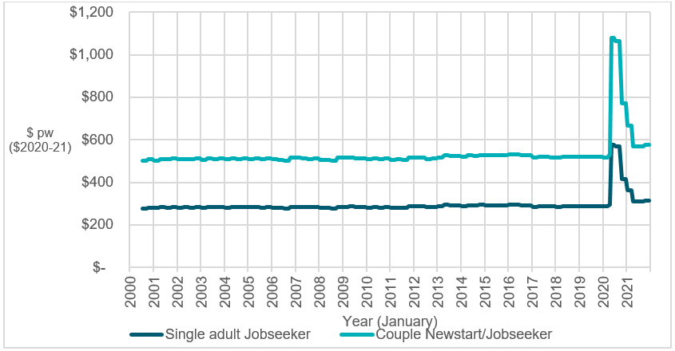

Source: B. Bradbury, and P. Hill, “Australian income support since 2000: Those left behind,” *ACOSS/UNSW Sydney Poverty and Inequality Partnership*, *Build Back Fairer Series* Report No. 2. Sydney, 2021.

#### Relativities to the National Minimum Wage

Figure 2 shows trends in the relativity between unemployment payments with and without Commonwealth Rent Assistance compared to the net National Minimum Wage over the same period. Because the National Minimum Wage has had real increases at different periods, the unemployment payment has fallen from 47 per cent of the National Minimum Wage in 2002 to 37 per cent in March 2020. Following the latest increase, it was 41 per cent of the National Minimum Wage in December 2021.

**Figure 2: JobSeeker Payment relative to National Minimum Wages, 2000 to 2021**

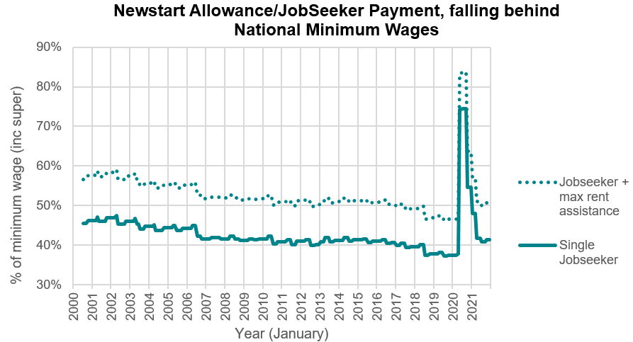

Source: Peter Whiteford and Bruce Bradbury, “Albanese has dropped Labor's pledge to boost jobseeker; with unemployment low is that actually fair enough?” *The Conversation*, April 21, 2022,

#### J**obSeeker Payment and pension levels**

Figure 3 shows the relativity between JobSeeker Payment and pension levels. Due to the benchmarking of pensions to MTAWE since 1997, the gap between unemployment payments has increased over time. In 2000, there was a gap of about $35 per week (in 2020-21 dollars) between the two payments. This had more than doubled to $75 per week by early 2009, and the increases as a result of the Harmer Review increased this further to $130 per week. Apart from the temporary increase with the Coronavirus Supplement in 2020, the difference in benchmarking has meant that the gap was $160 per week at the end of 2021.

**Figure 3: JobSeeker Payment relative to Age Pension, 2000 to 2021**

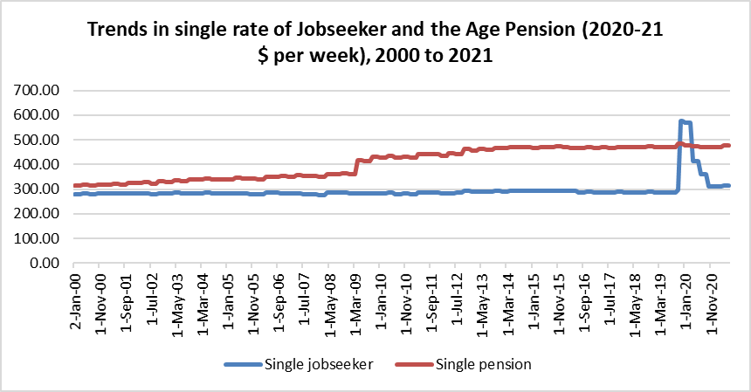

Source: Peter Whiteford and Bruce Bradbury, “Albanese has dropped Labor's pledge to boost jobseeker; with unemployment low is that actually fair enough?”

#### Relativities to median and lower household incomes

Figure 4 shows rates of the single unemployment payments as a ratio to median equivalised household disposable income. Since 2000, real median household disposable income has grown by 47 per cent, with most of this increase being in the period before the Global Financial Crisis in 2008-09. As a result, payment rates have fallen substantially, with the single rate falling from 42 per cent to 33 per cent of median household income over this period. If half-median income is used as a measure of relative poverty, then these trends would be expected to lead to increased poverty among people who are unemployed and a large increase in the poverty gap.

**Figure 4: JobSeeker Payment relative to half median equivalised disposable income, 2000 to 2021**

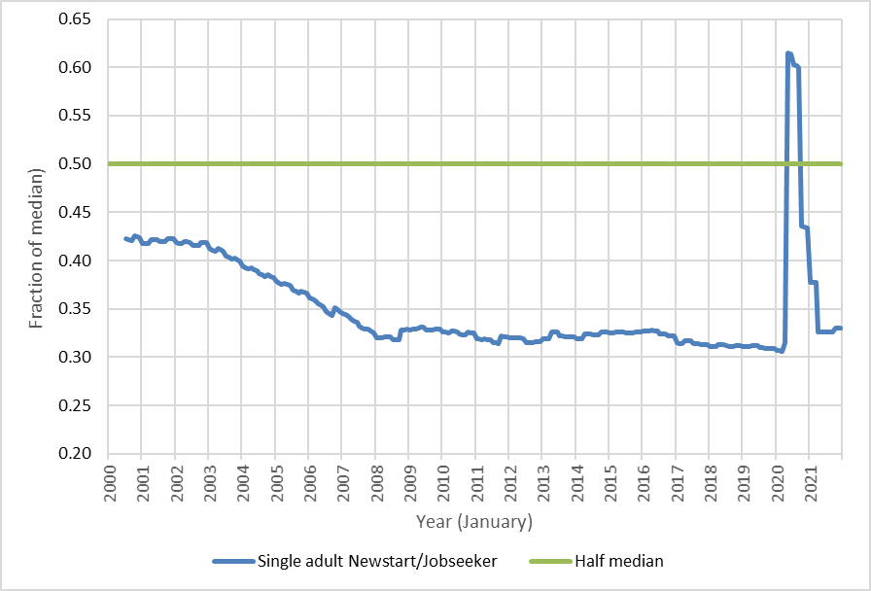

Source: Bradbury, B and Hill, P (2021) *Australian income support since 2000: Those left behind*, ACOSS/UNSW Sydney Poverty and Inequality Partnership, Build Back Fairer Series, Report No. 2, Sydney.

Figure 5 shows how the rate of JobSeeker Payment has fallen, even against the lowest incomes in the Australian community. Since 2000, the average incomes of the poorest 20 per cent of the Australian population have increased in real terms by 47 per cent, while a household at the 10th percentile (exactly 10 per cent of people live in poorer households) has seen an increase of nearly 50 per cent. Over the same period, the real rate of JobSeeker Payment rose by 3 per cent, and even the latest increase only increases this to 9 per cent. In 2000, the single rate of Newstart was close to the average for the poorest 20 per cent of Australians, $25 per week lower, but now even with the 2021 increase, it is $140 per week lower than the corresponding figure for the poorest 20 per cent. People receiving unemployment payments have incomes that are falling, even compared to the poorest of their fellow Australians.[17]

**Figure 5: Trends in the real value of JobSeeker Payment and Low Incomes in the Australian Population, 2000 to 2022**

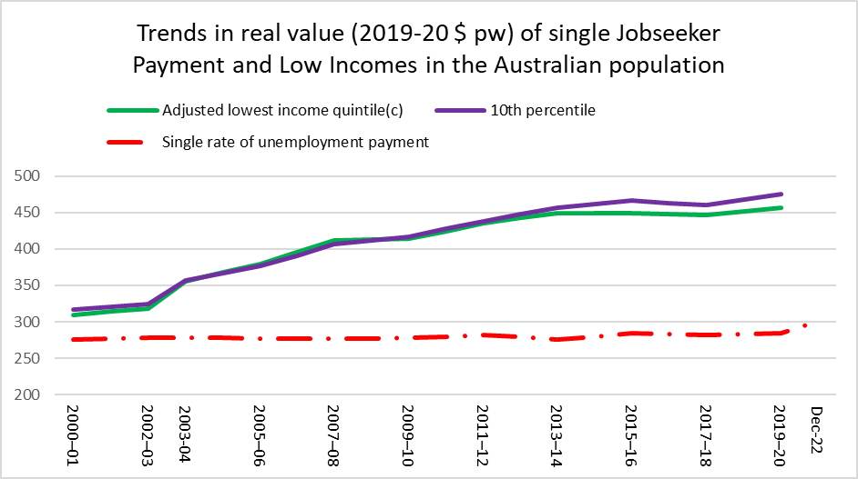

Source: Calculated from ABS (various years), Household Income and Wealth.

#### International comparisons

A common approach to comparing the level of benefits across countries is to calculate what people are entitled to under the rules of different social security systems, using what is called the ‘model family approach’.

This approach involves identifying specific household types – singles by their age, lone parents by the number and age of children, couples with and without children – and calculating what their benefit entitlements are based on the rules of the system in their country or specific location (different states in the United States or municipalities in some European countries).

The most comprehensive source is the OECD Benefits and Wages database[18], which “includes detailed descriptions of tax and benefit rules in OECD and European Union countries as they apply to working age families …and enables international comparisons of how tax liabilities and benefit entitlements affect the disposable incomes of families in different labour-market circumstances”.

The database contains estimates of disposable incomes of different household types for each year since 2001, expressed as ‘net replacement rates’ for people who are unemployed (what per cent of an individual’s previous net earnings they receive if they become unemployed), and also the level of minimum income payments as a percentage of median household income (adjusted for household size) in each country for which these data are available. There is also an online calculator[19] that allows users to estimate disposable incomes and their components using varying assumptions about the type of household, previous earnings level, length of unemployment and contribution history, amongst other policy variables.

Figure 6 shows one of the simplest measures of comparative benefit generosity, which is the net replacement rate for an unemployed single person aged 44 in 2021 in the second month of unemployment. This age (44 years) has been chosen as it is the median age for recipients of unemployment payments in Australia (including Youth Allowance (Other) as well as JobSeeker Payment).

**Figure 6: Net replacement rates for single, short-term unemployed, 2021**

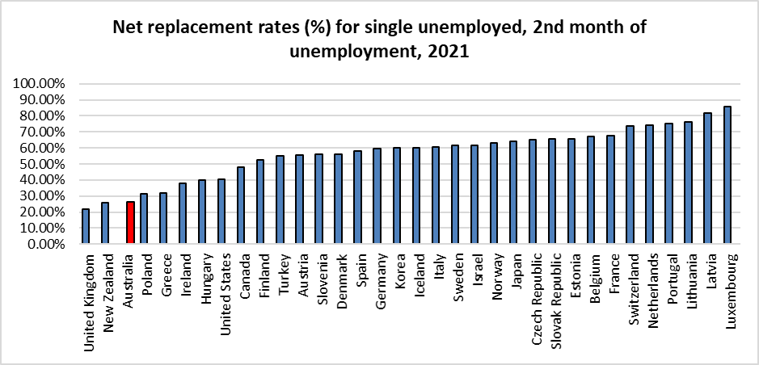

Source: OECD Benefits and Wages database, https://www.oecd.org/social/benefits-and-wages/.

Figure 6 shows that Australia had the third lowest benefit replacement rate in the OECD, with a single person who had previously worked at the average wage receiving just 26 per cent of their previous disposable income, compared to an OECD average of 59 per cent.

Figure 7 shows the effects of adding assistance with housing costs into these comparisons. This calculation is based on people paying 20 per cent of the average wage for their rent, which in the case of Australia would be around $360 per week. On this measure, *Australia drops to having the lowest level in the OECD*, primarily because assistance with housing costs is more generous in the United Kingdom and New Zealand.

**Figure 7: Net replacement rates for single, short-term unemployed, 2021 (including Rent Assistance)**

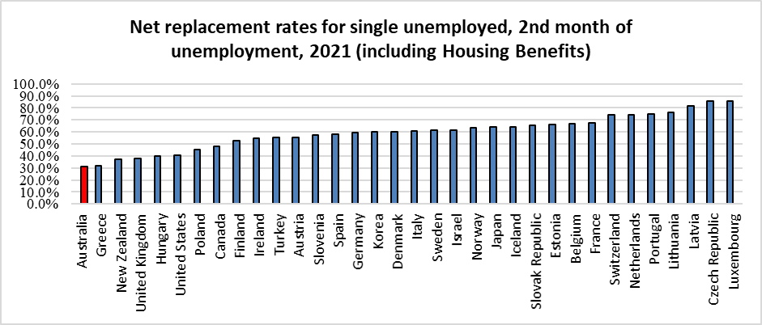

Source: Calculated from OECD Benefits and Wages database, https://www.oecd.org/social/benefits-and-wages/.

If unemployed people are disproportionately drawn from the lower wage sector of the labour market, it can be argued that rather than comparing benefit levels to average earnings, the more relevant base for comparison is likely to be take home pay for a National Minimum Wage worker.

**Figure 8: Net replacement rates for single National Minimum Wage workers, short-term unemployed, 2021 (including Rent Assistance)**

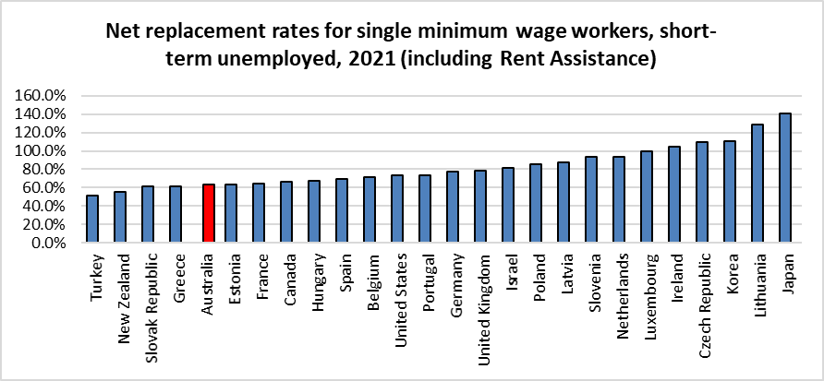

Source: Calculated from OECD Benefits and Wages database, https://www.oecd.org/social/benefits-and-wages/.

Figure 8 shows OECD calculations for benefits compared to the previous disposable incomes of minimum wage workers. Not all OECD countries have minimum wages, although in some countries without minimum wages such as Austria, Denmark, Finland, Norway and Sweden, collective agreements mean that the extent of low pay is even lower than in countries with generous statutory minimum wages.

This comparison increases replacement rates in most countries – in Australia the replacement rate roughly doubles from 31 per cent to 63 per cent, but Australia still is placed towards the bottom of OECD rankings. Even for low-paid Australian workers their incomes drop more when they became unemployed than in most other high-income countries.

In considering these figures, it is important to note that the Australian social security system differs from those in most other OECD countries, as benefits are flat rate and financed from general government revenue, rather than from contributions from workers and employers.

The level of contributory benefits not only depends on how much unemployed people earned in their previous job, but how long they had been contributing to the unemployment insurance system. The calculations shown above all assume that the person is aged 44 years old, but has also made 26 years of contributions to the relevant social security fund, i.e., they have been in continuous employment since the age of 18.

What happens if we compare levels of benefits for those who have never contributed to a social insurance system? Figure 9 shows the level of benefits for a single person as a per cent of median household disposable income in 2021.

On this measure, Australia fares comparatively better, being above the OECD average, but less generous than seven other OECD countries. It is also notable in all countries, these minimum safety nets are less than 50 per cent of median household income.

**Figure 9: Minimum income benefits for single person, OECD countries, 2021**

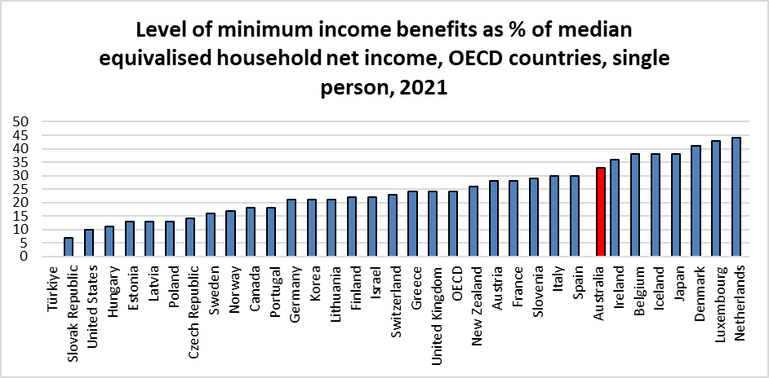

Source: OECD, “Adequacy of Guaranteed Minimum Income benefits,” OECD, https://stats.oecd.org/Index.aspx?DataSetCode=IA.

In considering these international comparisons, it should be noted that the fact that Australia does not have a contributory social insurance scheme for people who are unemployed does not change the financial reality that when an average earner becomes unemployed their income drops by more than any other high-income country. In addition, while the Australian system does not rely on contributions, most unemployed people have paid tax throughout their working life, with half of all people receiving JobSeeker Payment and Youth Allowance (Other) being aged 45 or over.

#### Household Analysis – Poverty Rates, Poverty Depth and Financial Stress

The above measures provide analysis of a single JobSeeker Payment on the maximum rate. A household analysis broadens this analysis using nationally representative surveys such as the ABS Survey of Income and Housing to consider actual levels of disposable income. Household analyses include other incomes that households may also receive such as wages, interest, superannuation, and other social security payments and deducts any personal income tax.

The household analysis has the strength of including all members of a household and implicitly assumes a degree of resource and cost sharing amongst household members. This can also be a drawback as it may not always be the case that all members of a household do share resources and costs.

The household analysis also provides useful metrics around economic wellbeing of the household with measures of financial stress. Financial stress is a direct way of comparing the relative financial wellbeing of different household types including by the main source of income of the household. Financial wellbeing and financial stress can provide a broader measure of financial and economic wellbeing than income alone. For example, financial wellbeing can pick up the impacts of differing endowments of wealth and costs of living at different life stages and for different family types. For example, a single pensioner household with some superannuation wealth, low housing costs may have a lower cost of living and/financial stress than a young single unemployed person with job search requirements, renting privately and limited financial and other forms of wealth.

ANU research[20] has considered a range of household-based measures of financial wellbeing including poverty rates, depth of poverty and financial stress (count of stress measures, ‘any’ financial stress and ‘severe’ financial stress). These measures were considered for a range of household types. Of particular relevance to this committee are the results for the main source of income household type. Main source of income was defined for various welfare sources (JobSeeker Payment households, Age Pension and working age pensions such as Disability Support Pension, Parenting Payment Single and Carer Payments).

The analysis found considerable differences between different household types. The greatest poverty gaps and rates were found for households whose main source of income was the JobSeeker Payment. The ANU research showed that the average (per adult) after-housing poverty gap was $140 per week in 2020 for the JobSeeker Payment households compared to just $16 per week for Age Pensioners and $8 for wage and salary households. The full $550 per fortnight COVID-19 supplement paid briefly in 2020 lowered the JobSeeker Payment poverty rates and poverty depth levels to levels similar to the rest of the population.

Similar results were found for financial stress for different households by source of income. The ANU research showed that the count of financial stress was around 6 to 7 times higher for JobSeeker Payment households than both wage and salary and age pension households. Other working age welfare payment recipients also had very high rates of financial stress, but around 30 per cent lower than JobSeeker Payment households.

The ANU analysis (optimal policy modelling) also modelled options for increasing welfare payments in such a way that the household after-housing poverty gap and separately household financial stress could be reduced. For both objectives the largest reductions in poverty and financial stress for a given dollar increase in spending was achieved by increasing the JobSeeker Payment.

Research into energy stress using Household, Income and Labour Dynamics in Australia (HILDA) data by the Brotherhood of St Laurence[21] found the highest proportion of households in energy stress were those relying on JobSeeker Payment. Between 2006 and 2020, 18 to 23 per cent of Australian households experienced at least one form of energy stress. Of households relying on Newstart/JobSeeker Payments, 58 per cent experienced energy stress in 2019. The proportion of Newstart/JobSeeker Payment households experiencing energy stress fell by 15 points in 2020 (to 43 per cent) when the temporary Coronavirus Supplement was introduced.

### What do these adequacy benchmarks show?

What are the implications for benefit adequacy of these comparisons between payment levels and these different benchmarks?

Figure 10 shows the relativity between the single rate of unemployment payments and the most recent figures for these adequacy benchmarks. For example, the most recent figures for median income are for 2019 using the ABS survey and 2020 for HILDA – and the level of estimated median income varies between the two surveys. The most recent estimate of Budget Standards for unemployed households was based on calculation for 2016.

Figure 10 shows that the single rate of JobSeeker Payment ranged between 53 per cent of the Henderson Poverty Line for a working household[22] and 66 per cent of the Age Pension. The other adequacy measures fall in-between these two levels (treating MTAWE and the net National Minimum Wage as indicators of community living standards rather than measures of benefit adequacy).

**Figure 10: Relationship between payments and different standards**

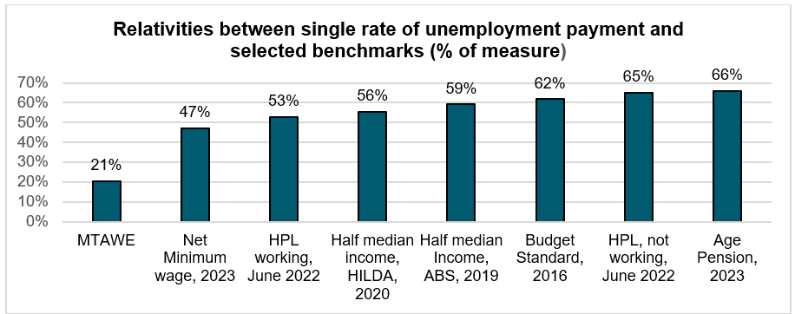

Figure 11 shows calculation of the implied increase in JobSeeker Payment for a single person, based on these different measures of adequacy.[23] This assumes that the ratio between benefit levels and the adequacy benchmark remain unchanged. This is unlikely to be the case for Budget Standards given the more recent experience of inflation. As a result, this comparison should be treated with caution.

**Figure 11: Implied increase in payments to reach different adequacy benchmarks**

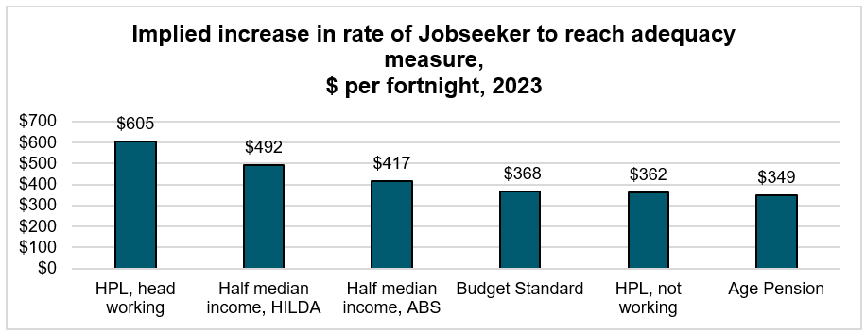

The implied increase in current rates of payment ranges between $349 per fortnight for Age Pension and $605 per fortnight for the in-work Henderson line.

Figure 12 shows the estimated cut-out points of benefits – where benefits are reduced to zero - assuming these different benefit increases and the maintenance of the current income-tests on payments, where JobSeeker Payment is reduced by 50 cents in the dollar for earnings over $150 per fortnight and 60 cents in the dollar on earnings over $256 per fortnight. These figures also take account of the increased income tax and Medicare Levy paid at these higher cut-out points.

**Figure 12: Interaction of benefit increases with National Minimum Wages**

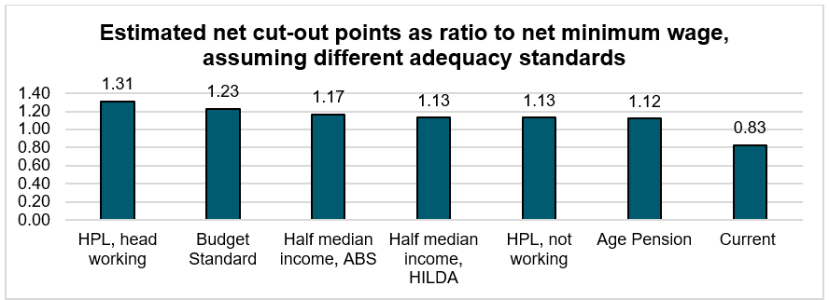

In all cases, the cut-out points are higher than the net National Minimum Wage at its current level. The current system produces a cut-out point that is equivalent to around 4 days full-time work at the National Minimum Wage, while increasing JobSeeker Payment to higher levels would mean that someone working full-time at slightly above the National Minimum Wage would be receiving some income support. Further work would need to be done to design the system so that there were not perverse outcomes whereby someone earning a full-time National Minimum Wage would be worse off than someone in a comparable job but also receiving a part rate of JobSeeker Payment. This is discussed below.

Adequacy must also be seen within the context of duration on payment. The majority of people receiving JobSeeker Payment have received income support for

12 months or more. This is due to changes in eligibility criteria for other income support payments and a growing number of people with partial capacity to work, and older people who face substantial barriers to paid work.

In conclusion, by any measure or benchmark, an assessment of the adequacy and effectiveness of income support payments shows that allowance-based payments (JobSeeker Payment, Youth Allowance (Other), etc.) are the most inadequate to meet basic costs. It is the Committee’s view, therefore, that addressing their inadequacy must be the first priority of Government for reform in the

2023-24 Budget.

### Which adequacy benchmark is appropriate in the short term?

The review of the benchmarks of adequacy above strongly suggests a substantial increase in the single level of JobSeeker Payment is required.

The Committee’s clear finding is that the current base rates of JobSeeker Payment and related working age payments are inadequate against existing benchmarks.

Indexing JobSeeker Payment and related income support payments only, in line with the consumer price index, has resulted in their relative base rates falling significantly below existing benchmarks such as the age pension. Increasing their rate to

90 per cent of the age pension would improve adequacy and return them to payment relativities of 1999.

The current level of pensions was set as the result of the Harmer Review, which as discussed, has been the most comprehensive analysis of adequacy of payments in the Australian social security system for several decades. To be consistent with the best available evidence on adequacy, the pension level is the most appropriate benchmark.

As flagged above, further analysis should be undertaken as a matter of priority. This analysis should investigate the latest evidence on payment adequacy and consider further alternative measures and benchmarks.

There are other considerations. As discussed earlier, the Henderson Poverty Line is based on an arbitrarily set measure from the 1960s and relativities for other household types derived from New York measures of the cost of living from the 1950s. It also appears to be the case that the Head Working Line was originally set as establishing a standard of adequacy for households who were in full-time work, rather than as a measure of adequacy for households reliant on income support payments. The method of uprating the Henderson lines has been inconsistent over time, and the current method is problematic.[24]

The 50 per cent of median income poverty lines are also essentially arbitrary, although they have the advantage of being derived from contemporary Australian living standards for the community as a whole.

Budget standards offer the prospect of being more relevant to Australian living standards. However, as discussed earlier to be confident about the results of this methodology it would be desirable to recalculate the standards, which were last updated in 2016, and therefore do not take account of the subsequent complexities of changes in the cost of living.

JobSeekers who provided insight to the Committee noted the inadequacy of the payment:

I'm just always looking around the house thinking, you know, what can I sell? You know, to bring in some money. It's just, it's just terrible.

Now what happens is the quantum of the payments are so low that people are choosing between their medicine or their electricity bills. So medical conditions are getting worse. There's no room in budgets for preventative treatments.

I needed to manage my budget strictly. This included going for cheaper items in the supermarket, having smaller meals (i.e. an orange for lunch, soup at dinner time), only filling up petrol when I really needed to, using public transport or walking where I could to save on the cost of fuel, managing health appointments around how much money I had left in the bank that week. It was difficult to plan long-term as I was mostly living day-to-day or week-to-week.

You can buy a tray of sausages and, you know, bag them up in the freezer for the fortnight. But yeah, you rarely get to have any meat. Fruit and vegetables are absolutely shocking. You can't afford to do eat healthily, that’s for sure. So, they're killing us, basically. They're not helping us. They're making us a hell of a lot worse. And like, I'm meant to have at least 3 medications a day, but only have one because I can't afford the others, and they [doctor’s] say, you know, they'll help me sleep, and they'll help me with my pain, but I'll just take the one for restless legs syndrome that can't live without. And yeah, I just, I'm just used to living with pain.

In addition, increasing JobSeeker Payment to levels above those of Age and Disability Pensions and Carer Payment obviously creates anomalies unless those payments are also increased. Such a reconsideration of the level of these payments should take place in the future work of this Committee, but has not been possible given the limited time and research capacity available to the Committee.

Comments from people consulted as part of the Committee’s work noted issues with accessing Disability Support Pensions (DSP), including:

So, I applied for the Disability Support Pension, and of course I got the knockback straight away, and the three reasons they tend to give are a) not stabilized [and] not all treatment options have been exhausted. I thought this was rubbish, so I uploaded essentially like 400 pages of CTs ultra sounds. MRI and said, ‘you can't say that the condition is not being diagnosed. You can't say that it's not being stabilized’.

Had income support been sufficient (at least at the same amount of DSP) perhaps I would have managed to keep my home and I would not be in the situation that I am in today where rents have skyrocketed in price now exceeding what my mortgage was. That point between illness first striking and getting a diagnosis on your condition to even being in the situation to apply for DSP or TPD [Total Permanent Disability] from super[annuation] is an imperative time to being able to access a livable amount of income support.

If at any point I had been placed on the DSP, and allowed access to the assistance I need, a stable place to live, and a base-line adequate income, I might have had a chance at life, to contribute to and participate in society.

### Commonwealth Rent Assistance

While, as a first priority addressing inadequacy in the base rate of JobSeeker Payment and associated payments is necessary to address the adequacy of working age payments, inadequacy of Commonwealth Rent Assistance (CRA) risks leaving households that rent in housing and financial stress.

Around 1.3 million Australian households receive CRA, a payment that reflects the fact that renters are at a greater risk of financial stress and poverty, and therefore need additional assistance. The retirement income review found that 60 per cent of single retirees that rent live in poverty, compared to less than 10 per cent that own their own home[25] – reflecting the impact of renting on payment adequacy.

While CRA provides some assistance, the vast majority of recipients pay rents above the maximum amount of CRA. This means that CRA is not adequately addressing the additional costs faced by renters on government payments.

**Figure 13: Proportion of CRA Recipients Receiving Maximum Payment**

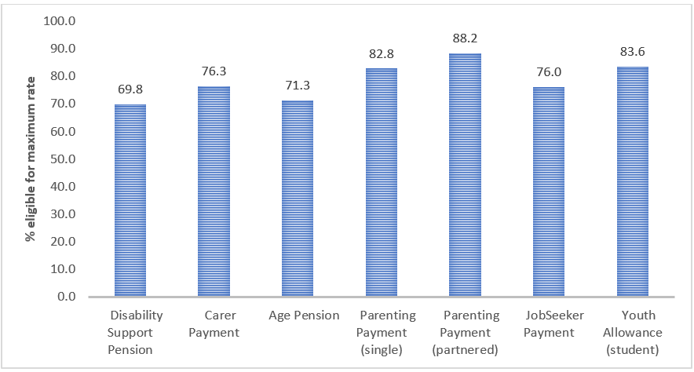

Source: DSS (2022), DSS Demographic Data September 2022.

The percentage of households receiving CRA that are in housing stress fell significantly during the pandemic because of the temporary $275 per week Coronavirus Supplement, highlighting the role that income support payments play in addressing housing stress. Following the removal of pandemic supplement, levels of housing stress bounced back, and are above pre-pandemic levels.

The Committee’s consultations elicited such feedback as:

Rental allowances need to be looked at, and that needs to be looked at urgently because it has no relationship whatsoever with the rent that is really paid.

The payment I receive. My rent is $450 a week and my Family Tax Benefit is $430, so I am, like getting my daughter to bring vegetables home from work, and we grow vegetables, and it's just like, put 20 bucks in the car here, buy couple of rolls toilet paper.

The rent and everything else, like, you literally just can't survive on that alone. So, it's about prioritizing. What's the most important, and of course, the roof over your head is number one, especially for your kids as well.

Rates of housing stress are set to increase as observed rental rises in new bonds data flow through to existing leases in annual rent adjustments.

**Figure 14: Percentage of CRA Recipients in Housing Stress\***

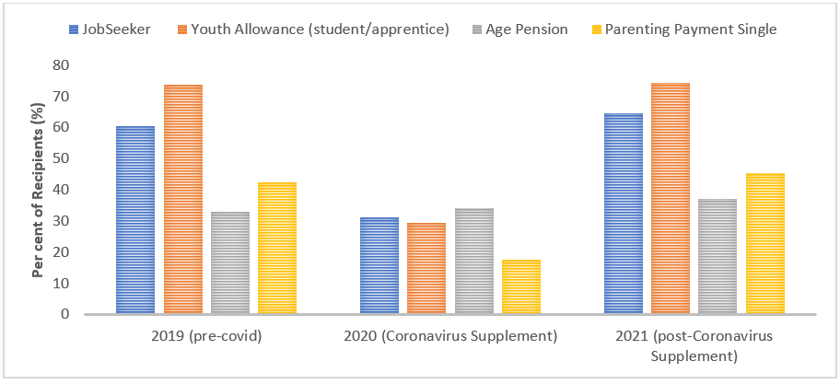

Source: Productivity Commission (2023) Report on Government Services, Housing – attachment

*Housing stress is defined as spending more than 30 per cent of income on housing costs.

Since 2000 the impact of rents growing faster than the rate of CRA has led to the maximum rate of CRA for singles falling as a share of average low income renter housing costs from nearly 50 per cent to just above 30 per cent.[26] While there has been some recent improvement, this is likely to reverse in 2023 with rents projected to increase substantially.[27]

**Figure 15: CRA Maximum Share of Rent (2022 Projection Only)**

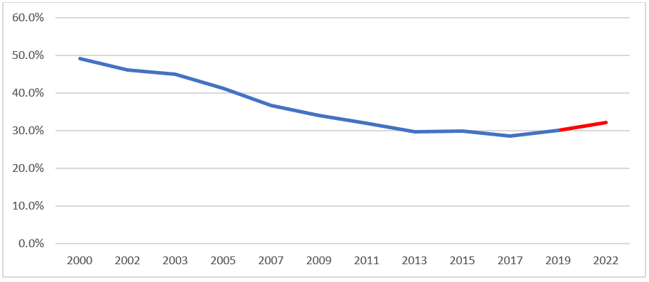

Source: Survey of Income and Housing, Rent Assistance Maximum historical amounts

#### Housing Costs for Low Income Renter Households

The chart below shows that housing costs for low income renter households has increased dramatically over recent decades.[28] In 1984, the average ratio of housing costs to disposable income was around 26 per cent. By 2019, this ratio increased to around 33 per cent. The result is driven by both strong increases in rent costs for low income households but also a structural shift in the housing market away from social housing towards the private rental market. That CRA has not kept up with low income rent growth is expected to have contributed to the upward shift in housing costs relative to income.

**Figure 16: Housing Costs for Low Income Renters**

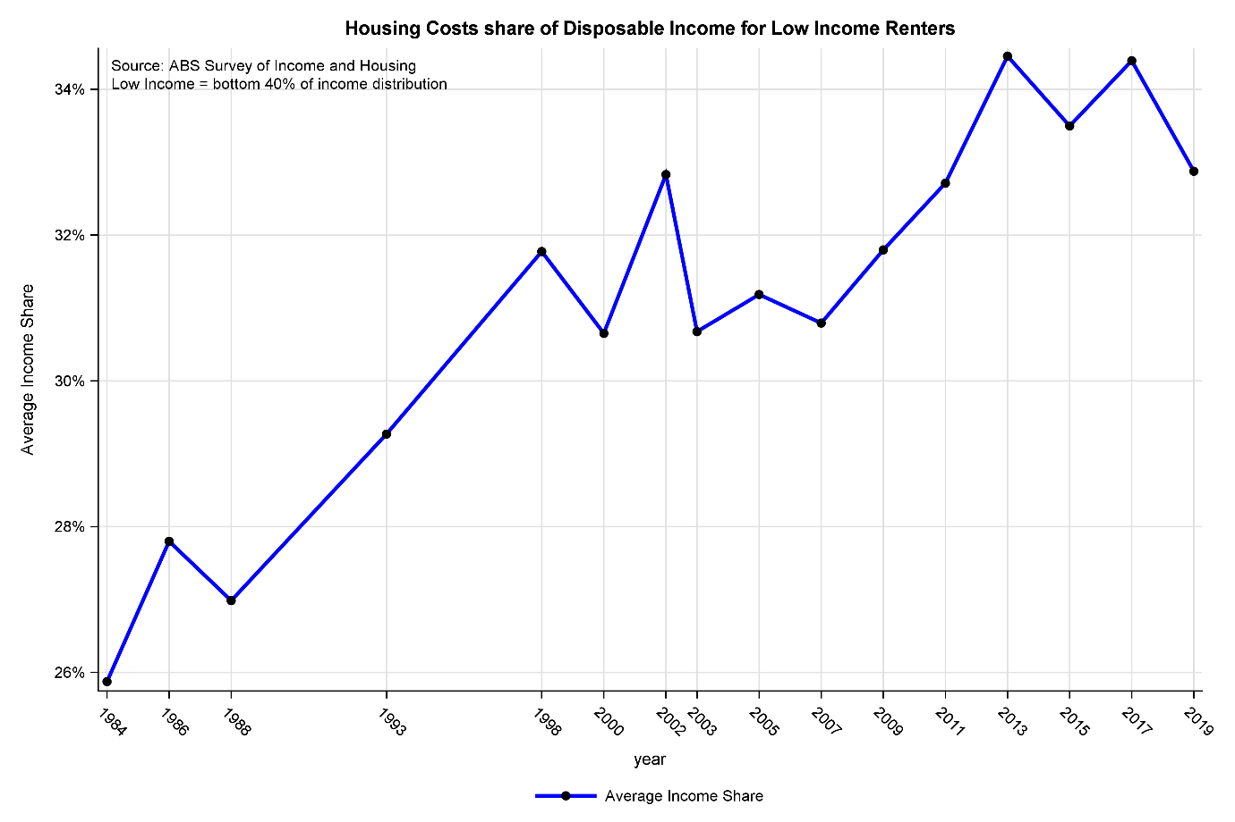

#### Regional Markets Facing Broader Challenges

In regional markets, the average level of CRA is more likely to be below the maximum payment due to lower median rents, however supply can be a significant issue in some markets. The long-term reduction in the share of social and affordable housing and a private sector rental market that does not provide sufficient low income housing means that an increasing share of low income households are in housing stress (AHURI 2022).

There is also a chronic underinvestment in Aboriginal and Torres Strait Islander housing, particularly in remote areas, and a need to strengthen the Aboriginal Controlled Housing Sector. CRA coverage in remote areas is much lower than other areas. For example, 14.6 per cent of income support recipients receive CRA coverage in the Northern Territory, compared with an average of 23 per cent nationally.[29] As a result, an increase in CRA would not reach as many people in need in remote Australia compared with elsewhere. All these issues should be the focus of the National Housing Strategy announced by the Government.

#### Policy Options

The adequacy of CRA has been the subject of several reviews and reports, with various recommendations for reform.

The 2009 Henry Taxation Review recommended linking the maximum rate of CRA to the 25th percentile of paid rents in capital cities[30], which, based on 2021 Census figures, indexed for rental price growth to December 2022 would represent over a 78 per cent increase in the maximum threshold and a 130 per cent increase in the maximum CRA payment.[31]

The Grattan Institute has proposed increases in the order of 40 per cent[32], that would provide singles with a $71 per fortnight increase and provide some relief from higher rental costs. However, in the absence of a substantial increase in the rate of JobSeeker Payment*,* such an increase will leave many in this cohort experiencing significant levels of housing stress because of the inadequacy of their base rates of payment.

**Figure 17: Impact of Increasing CRA on Maximum Affordable Rents**

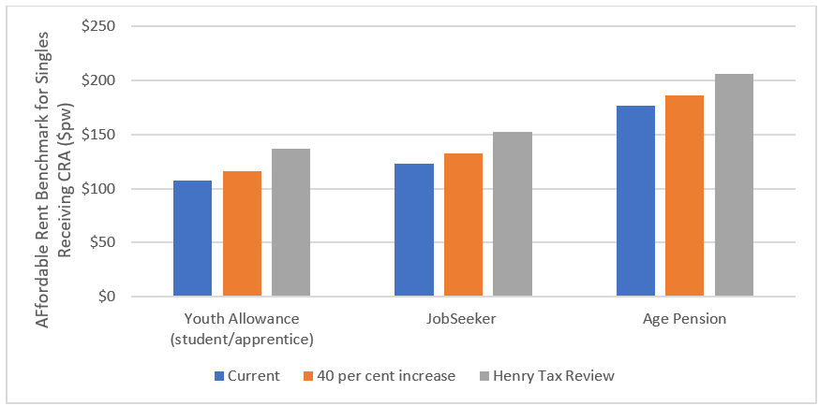

#### Discussion

More generous CRA payments need to be carefully considered alongside workforce incentives and any potential impacts on the rental market. While increased CRA payments will improve housing affordability for low income renters, they may also distort the market in such a way that is not tenure-neutral, and contribute to an increase in rents for low income earners that are not eligible for the payment.[33]

Current CRA rates have fallen well below rent and income levels of the broader community and so should be increased. The Committee understands the need to balance adequacy with workforce participation and potential housing market distortions, and so recommends modest increases in CRA is appropriate alongside other recommendations of the Committee such as the increase JobSeeker Payment.

The Committee recognises that the setting of CRA is complicated with recipients having a great diversity of financial, housing and family situations. Further work is required to better understand the current and evolving needs of recipients.

**Finding:** The current maximum rate of CRA is inadequate.

**Recommendation:** In addition to substantially increasing base rates of JobSeeker Payment and related payments, increase the rate of CRA to reflect the long-term reduction in adequacy.

### Will increasing unemployment payments create disincentives to paid work?

The obvious question arising from our recommendation is how it would affect incentives to work.

Research on work and labour supply issues related to welfare reform has long been the subject of attention by economists.[34] In the United States and elsewhere, there has been extensive research for decades using the basic static model of labour supply.[35] Moffitt[36] (2014) points out that the most relevant considerations are the level of payments, the duration of assistance and the extent to which recipients are required to actively look for work. The level of payments has a potential “income effect” – when payments are high relative to earnings individuals may reduce their hours of work. In addition, when payment withdrawal rates are high, there may be a “substitution effect” penalising additional hours of work.

Moffitt[37] (2014) points out, however, that there are potentially both positive and negative effects of more generous benefits for the unemployed, “All developed economies have unemployment benefit programs to protect workers against major income losses during spells of unemployment. By enabling unemployed workers to meet basic consumption needs, the programs protect workers from having to sell their assets or accept jobs below their qualifications. The programs also help stabilize the economy during recessions. [They also potentially reduce income poverty, particularly among the unemployed.] If benefits are too generous, however, the programs can lengthen unemployment and raise the unemployment rate. The policy challenge is to protect workers while minimizing undesirable side effects.”

Individuals who provided feedback to the Committee made similar comments about higher benefits assisting, rather than impeding, their employment prospects, and their desire to exit the unemployment system:

When you’re stuck on JobSeeker, you just feel like … you feel suicidal. A couple of times I’ve felt suicidal, because I think there is no way out.

No one is choosing this [to be on income support].

I’ve got these medical problems. I can’t make things better. Most days I can’t hardly get out of bed of a morning, and I think, you know, I’d like to have a full-time job, but I’d have to have so much time off work [because of medical conditions] and who is going to want to employ you like that?

Because I can't get out [due to health issues], I can't get a job. Because I can't get a job, I can't get out [due to lack of funds to address health issues].

To the extent that behaviour change in the early part of the pandemic can be generalised, the evidence from 2020 that higher rates of income support did not lead to a reduction in take-up of paid work. Borland’s analysis of people receiving JobSeeker Payment in the later part of 2020 found that with the $125 per week rate of Coronavirus Supplement, people took up paid work at similar rates to what they did pre-pandemic on lower rates of payment. Borland[38] (2020, 2) also pointed out that “Comparison with weekly earnings of the current workforce provides an even stronger message about the minimal disincentive effect from an increase in JobSeeker Payment. An increase in the JobSeeker Payment of $125 per week would place a recipient at just the 1st percentile of the distribution.” That is,

99 per cent of full‐time employees are earning more than the increased JobSeeker Payment.

The potential disincentive effects of higher payments need to be seen primarily in the context of the evidence presented here that Australian benefit levels for the short-term unemployed are among the lowest in the OECD[39], and that on all the measures of adequacy surveyed existing benefits fall far below these benchmarks, and that they have been falling relative to these benchmarks for decades.

In summary, it is our view that unemployment payments have fallen to such an inadequate level that they create a barrier to paid work. It is also our view that our income support system should prevent poverty and financial distress to ensure people looking for paid work are not placed at a greater disadvantage by virtue of not having enough money to meet the essentials of life.

As noted earlier, increasing JobSeeker Payment opens up the possibility that someone working full-time at slightly above the National Minimum Wage would receive some income support. In itself, this is not a substantial disincentive to work, as to achieve this result would mean that the individual was working full-time. This could be seen as inequitable, however, as two people working in comparable jobs would have different disposable incomes depending on whether one had passed through the benefit system and then found a job, compared to someone who had never been unemployed.

There is a range of options to address this issue.

When the pension increases recommended by the Harmer Review were made, the Government also increased the pension income test back from 40 per cent to

50 per cent (which was the rate between 1969 and 2001) so that the cut-out point stayed the same and no new people over 65 became eligible for payments. Increasing the withdrawal rate of JobSeeker Payment, however, would clearly reduce incentives to seek part-time work as a means of progression outside the benefit system.

An alternative approach would be to increase the Low Income Tax Offset for low-paid workers but deduct excess JobSeeker Payments from the increase in the Offset in roughly the same way that the Remote Area Allowance in the social security system reduces the Zone Tax Offset in the tax system. This could maintain equity between individuals although it would reduce overall tax revenue, probably to a minor extent, but also add to the complexity of the tax system.

As Chapter 2 outlines, full employment is an important part of increasing economic inclusion. Inequities and barriers to participation in the labour market lower workforce participation and fail to make use of people’s skills and talents, which contributes to labour shortages.

An increase in income support must be accompanied by (but not contingent upon) a major reform of employment services. We recommend that there be a shared commitment to reduce long-term unemployment through investment in programs that make a difference, including demand-led approaches in which people are trained based on the needs of a business and the demand it has for labour, as well as supporting people who are long-term unemployed and want to get paid work. This should include accredited training linked to current and emerging workforce needs (such as aged care workers), career guidance, and/or assistance with health and social barriers to employment. This would ensure the program is sustainable and delivers long-term employment opportunities as it is based on real jobs, as well as centered on what people need to help them secure paid work.

There must be improved support for people who have been on payments for an extended period. For example, people on JobSeeker for at least 12 months could access a Foundational Skills Guarantee to ensure they have fully funded access to the basic skills that enable them to succeed in the workforce.

There also needs to be reform of employment services to provide wrap around support and continuity of programs for people experiencing disadvantage. For example, this could be through more highly specialised case management that recognises employment may only be possible once the underlying causes of disadvantage (for example, poor literacy and numeracy, poor health, mental illness, and other complex issues) are tackled properly. It must also be recognised that over a quarter of the Australian population are digitally excluded. There are significant benefits from digital service delivery, but we must ensure this does not exclude or disadvantage people with limited digital access or capabilities. This should be alongside an increase in JobSeeker Payment and related payments to address their inadequacy. The inadequacy of income support is trapping people in cycles of disadvantage instead of building their capacity and capability to engage in employment and the community.

### Lifting base rates of JobSeeker and related income support payments should take priority

The rate of CRA needs increasing, and the Government should benchmark the payment to rents paid rather than index it to Consumer Price Index on its own. However, this is a second priority to lifting base rates of JobSeeker Payment and related payments, for two reasons:

Fewer than 40 per cent of people receiving JobSeeker Payment receive CRA, and fewer than 50 per cent of people receiving Parenting Payment Single receive CRA. An increase to CRA would undoubtedly help these households, but it would leave a large number of other people receiving income support on grossly inadequate payment rates. Lifting CRA without dealing with inadequate base rates of payment will likely see people on JobSeeker Payment renting privately remain in housing stress. Unless CRA were to be increased substantially (e.g. tripled or more), evidence suggests that the average person renting privately receiving JobSeeker Payment would be paying in excess of 30 per cent of their income on rent (Productivity Commission, Vulnerable Private Renters: Evidence and Options, 2019). In other words, lifting CRA on its own would not deal with the core inadequacy problems in our income support system.

## Conclusions

As discussed earlier, the Harmer Review argued that no single measure or benchmark could be used to determine whether or not payments are adequate. While further research and analysis is necessary to improve and update these measures of adequacy, it is fair to say, however, that all of the evidence presented points to the same broad conclusion that current JobSeeker Payment and related payments are seriously inadequate.

Payments for people who are on JobSeeker Payment have fallen relative to most measures of earnings and household incomes, relative to pension payments, and their financial stress rates are at unacceptably high levels. For the short-term unemployed, payment levels are among the lowest of all wealthy countries. All these benchmarks strongly support the conclusion that payments need to be increased significantly.

Evidence from recent Senate inquiries, qualitative reports analysing ability to cover living costs and poverty data all show JobSeeker Payment and related working age payments being inadequate. Even when supplementary payments like CRA are factored in, these payment rates fall well below an income required to cover minimum costs.

The Committee has not had the time to date to assess whether the overall structure of social security payments for people of working age remains appropriate for the wide range of circumstances that the social security system needs to cover. Historically, a strong assumption underlying the setting of payment levels has been that allowance payments such as JobSeeker Payment are expected to be a

shorter-term payment and should be set at a lower rate than pensions that are typically expected to be required for much longer periods. The JobSeeker Payment is also paid to recipients with greater opportunities for employment to combine with the JobSeeker Payment (around 24 per cent of JobSeeker recipients have earnings compared to 7 per cent of those on Disability Support Pension and 9 per cent of people on Carer Payment).

The Committee acknowledges there are growing concerns around the changing structure, coverage and composition of the population receiving JobSeeker Payment, with a trend to longer payment durations among those with partial capacity for employment and those in older age groups, particularly women. The suitability of the JobSeeker Payment and current social security structures are of major concern and require more in-depth analysis and research in the future.

There is a range of serious issues identified regarding the adequacy of social protections for people living in Australia on a range of temporary visas classes and newly arrived residents. This issue was starkly illustrated by the plight of people on temporary visas during the COVID-19 pandemic period and by the fact that the then Government had to relax the four-year waiting period. The Committee considers it essential that the scope of its further work includes the adequacy of social protections for people on temporary visas and newly arrived residents.

The social security system is complex. The Committee considers it essential that further analysis is undertaken of the overall system of support for working age households. **However, the immediate priority is a substantial increase to the base rates of JobSeeker Payment and related payments.**

# Full employment objective

## Introduction

Groups for whom we are concerned about economic inclusion are more likely to be out of work or working less than they want, compared to other groups. It follows that having a larger proportion of the available workforce in employment – that is, reducing the extent of labour underutilisation – most benefits those groups. An essential element for maximising economic inclusion is therefore that government macroeconomic policy – both monetary and fiscal – is oriented towards a full employment objective, aimed at keeping labour underutilisation as low as possible.

## Recommendations

*Recommendation 5*

The Government commit to a full employment objective as a critical means of maximising economic inclusion.

*Recommendation 6*

The Government commit to a full employment objective receiving increased weight in the design of macroeconomic policy – both monetary and fiscal.

*Recommendation 7*

The Government commit to a full employment objective including a target for labour utilisation that encompasses both unemployment and underemployment; ideally expressed as a (hours-based) rate of labour underutilisation.

*Recommendation 8*

The Government commit to an appropriate full employment target for labour utilisation, based on recent labour market outcomes, at a rate of unemployment close to 3.5 per cent. Moreover, there still being uncertainty about what the rate of unemployment can be reduced to without causing excessive wage inflation, the possibility that the target rate should be lower needs to motivate macroeconomic policy. [Expressed in terms of labour underutilisation incorporating both unemployment and underemployment, this corresponds to a target for the ABS (hours-based) rate of labour underutilisation of 5 per cent to 5.5 per cent.]

*Recommendation 9*

The Government commit to a full employment objective incorporating the objective of achieving high rates of labour utilisation for specific groups who face high barriers to employment and economic inclusion. For example, First Nations people, people with disability, young disengaged people, refugees and recent immigrants from Culturally and Linguistically Diverse (CALD) backgrounds, people living in regions with low levels of employment opportunity, and homeless people or people with insecure housing.

*Recommendation 10*

The Government explore broadening the full employment objective to encompass issues of job quality, for example, for inclusion in the set of Wellbeing Indicators for the 2023-24 Budget and through the Employment White Paper process. That similarly, the House Select Committee on Workforce Australia Employment Services takes a broad perspective on the objectives of the employment services system.

## Key findings

### Why a full employment target for labour utilisation is important for economic inclusion

There is a long history of research demonstrating that groups who face barriers to finding work benefit disproportionately from stronger overall labour market conditions[40]In other words, the extent of economic inclusion depends importantly on overall labour market conditions. An appropriate target for labour utilisation, when actively pursued by macroeconomic policy, will ensure a strong labour market, and therefore promote economic inclusion.

In Australia, the impact of the state of the overall labour market on economic inclusion has been evident most recently in the effects of moving from a rate of unemployment above 5 per cent prior to the COVID-19 pandemic, to the rate in the mid 3’s since mid-2022. For example, the stronger labour market has brought:

* 1. A larger increase in the proportion of persons without a post-school qualification in work, from 55.6 per cent to 57.6 per cent between May 2019 and 2022, compared to those with a Bachelor degree or above (increase of 1 percentage point) and for those with a below-Bachelor level post-school qualification (increase of 1.3 percentage points).[41]
  2. Much stronger growth in the proportion of young people employed than for older ages from March 2020 to December 2022 (6.1 percentage points for 15‑24 years compared to 2.2 percentage points for those 25-64 years and 0.8 percentage points for those aged 65 years and over);[42] and
  3. The proportion of long-term unemployed as a share of total unemployment has decreased, from 24.8 per cent to 21.6 per cent between November 2019 and 2022.[43]
  4. A female participation rate of 62.3 per cent in December 2022, compared to the pre-pandemic high of 61.4 per cent in January 2020.[44]
  5. In the 25 per cent of regions (ABS SA4 level) with the lowest proportions of population in employment in 2019 the proportion had increased by 2.2 percentage points in 2022, compared to 0.8 percentage point in the 25 per cent of regions with the highest proportions of population in employment in 2019.[45]

Saying a full employment target matters for economic inclusion recognises the important financial and intrinsic benefits of participation in the paid workforce.[46] At the same time, it is essential to appreciate the value of unpaid work (such as care work or volunteer activity) for the individuals doing that work and for society; and that therefore strategies for inclusion need to be designed to regard the many different forms of contribution to society as equally important. It is also important that a full employment objective not be taken to imply full-time employment for the whole workforce. Full employment is about individuals being able to work their preferred number of hours, so that what constitutes full employment will vary between individuals depending on their circumstances and stage in the life cycle.

### What should be the full employment target for labour underutilisation?

There are two main considerations in setting a full employment target for labour underutilisation:

1. How should underutilisation be measured?
2. What should be the target rate of labour underutilisation?

A full employment objective has usually been expressed in terms of a target rate of unemployment. Familiarity with the rate of unemployment is a reason for continuing with that approach. But there are also major problems with expressing the objective in terms of unemployment. Growth of underemployment has meant that unemployment accounts for an ever-diminishing share of the underutilisation of available labour supply. Between 1978 and 2022, for example, the share of hours of underutilised labour accounted for by unemployment decreased from 84.3 per cent to 56.8 per cent.[47]

In the short-term, a more useful measure of labour underutilisation to guide policy is the ABS (hours-based) rate of labour underutilisation. This measure, which incorporates both unemployment and underemployment, is the ratio of hours of work desired by unemployed plus extra hours of work sought by underemployed divided by total available hours of labour supply.

A longer-term objective, at least for the purpose of informing policy making, could be to develop a measure that also encompasses underutilisation among those persons currently out of the labour force, such as individuals discouraged from actively seeking work by feeling they would not be likely to obtain a job.[48]

The target rate of labour underutilisation needs to appropriately balance benefits and costs. A lower target rate brings two main benefits: first, an increase in national output as greater use is made of available labour; and second, an increase in economic inclusion due to the stronger labour market.[49] The main cost of a lower target is when the balance between labour demand and labour supply narrows to a degree that wage inflation accelerates excessively, thereby slowing employment growth, and also potentially feeding into higher general price inflation.

During much of the 2010s, full employment was regarded as being equivalent to a rate of unemployment of around 5 to 5 1/2 per cent. Recent experience, however, demonstrates that it is possible to have a much lower rate of unemployment – with the benefits that accrue from that – without any costs from a major increase in wage inflation. Despite the rate of unemployment having fallen to around 3.5 per cent since mid-2022, there is little evidence of accelerating or excessive wage inflation. Annual growth in the Wage Price Index to the September quarter 2022 was 3.1 per cent; and annual growth in median hourly earnings in the year to August 2022 was 3.3 per cent.[50]

Getting to a rate of unemployment of around 3.5 per cent without wage inflation accelerating suggests that the full employment target should be no higher than an hours-based rate of labour underutilisation that corresponds to that rate of unemployment; that is 5 per cent to 5.5 per cent.

An even lower rate of labour underutilisation being possible without causing a major increase in wage inflation should also be considered possible, and motivate macroeconomic policy. As Ross Garnaut has written: “There is no need to guess the NAIRU. We can find out what it is by increasing demand for labour until wages in the labour market are rising at a rate that threatens to take inflation above the Reserve Bank range for an extended period”.[51]

The scope to aim at a lower target rate of labour underutilisation, without causing excessive wage inflation, can be attributed to wage growth becoming less responsive to labour market conditions. Factors such as reduced worker bargaining power due to institutional changes or a change in the degree of labour market competition are possible explanations for that development. Where the full employment target is being expressed as a rate of unemployment, it is also necessary to take into account that, with the rise in the share of underemployment in labour underutilisation, the rate of unemployment is increasingly under-representing the extent of labour underutilisation. Hence, to achieve any given rate of labour underutilisation via a target for the rate of unemployment, that target must be progressively lowered.

### Putting appropriate weight on the full employment target

A full employment target for labour underutilisation will only assist economic inclusion if it is actively pursued with macroeconomic (and other) policies. For much of the 2010s (and arguably going back even earlier, to changes in the conduct of macroeconomic policy in the early and mid-1990s), in the design of macroeconomic policy, the weight placed on achieving employment growth, compared to the objective of maintaining low inflation, has diminished.[52] A rebalancing of full employment and inflation objectives, to recognise the substantial output and equity benefits from achieving full employment, is now desirable.

### Targets for specific groups

A full employment target, the aim to achieve a specified overall rate of unemployment or labour underutilisation, is intended to have macroeconomic policy directed to achieving the strongest possible aggregate labour market conditions, thereby promoting economic inclusion.

Underneath the overall target, however, labour market outcomes for specific groups, for whom we are concerned about economic inclusion, can differ. Ensuring that all groups benefit from improvements in economic inclusion therefore seems an important extra dimension of a full employment objective. Specifically, the objective should encompass achieving high rates of labour utilisation for groups who face high barriers to employment and economic inclusion; for example, First Nations people, people with a disability, young people disengaged from study and work, refugees and recent immigrants from CALD backgrounds, people living in regions with low levels of employment opportunity, and homeless people or people with insecure housing.

### A full employment objective is only one part of the set of policies needed for economic inclusion

Ultimately, it is the number of jobs available that determines employment outcomes for the groups for whom we are concerned about economic inclusion. That’s why a full employment objective is essential for achieving economic inclusion.

But a full employment objective is not enough by itself. While a strong labour market improves employment outcomes for the groups for whom we want to improve economic inclusion, that will not be sufficient to achieve equity. Other policies are therefore needed to address other dimensions of labour market-related barriers to economic inclusion.

First, a precondition for getting a job is being able and available to work. Hence, it is also necessary to ensure that the groups about whom we are concerned are able to participate in the workforce. Policies that improve the capabilities of job seekers, assist with personal or family barriers and increase access to work (such as education and training, childcare policy, housing policy etc.) are critical in this regard.

Individuals who provided input to the Committee described a range of barriers to employment and economic inclusion, particularly with respect to physical and mental health issues, ageism, a lack of regional job opportunities, and unrecognised caring responsibilities:

If you've got an illness or you've got mental health issues or whatever it is, you know they need to work around these things, and, and not because, like someone just said earlier, it's not sustainable. They've [employment providers] done it to me. Pushed me into jobs, and then it doesn't work, and in the end you can't do the job anymore. And then you back there [unemployed] again.

I have the difficulties keeping my car running. I can't pay for fuel. So, I have to cycle 25 min to work, and then 25 min from work every day. I mean, sure, I'm getting fit. Yeah, but like, it's a pain in the neck, you know, because I'd like to be able to drive to work. I'd like to be able to look for work using the skills that I have, and sadly, because I live in [a regional area], which is quite far out from the city. That's just not an option. I have to stay in my current job and just put up with it [inadequate work hours]. And that's because of the low income that Centrelink is.

When you're a mom they’re like, ‘Right. There's a job in, you know, like, a minimum of 45 min away, and you need to go and get that’, and it's like, ‘Who’ll look after the kids?’. ‘Oh, it doesn't matter’, you know, like. So, they expect you to drive an hour to 45 min to the other side of the city morning, and night. It's like, ‘Well, who's actually gonna look after my child?’

Ageism is very, very real and discrimination is very, very real. I've had people tell me when I advocate for something they say, ‘Oh, you've got too much time’ and, and ‘get a job’. I wish I had a job. I think I'm capable of working, or intellectually capable, anyway. Perhaps not physically so - there are physical barriers out there. So, there are very real barriers to, to people in the workplace. There are perceptions which are wrong, that we're slower, perceptions that we're wrong, that we're going to need more time off. And even though there's a lot of people who want to work now, and they're crying out for jobs, employers are still reluctant to take them on.

In addition, the Committee heard examples of policies making it more difficult for people to participate in the workforce, rather than providing support:

What I had found in accessing it [Centrelink benefits], that you'd make your anxiety worse. And to navigate the system, English is my first language, and I find, I suppose, with my own barriers, mental health, physical, it all ends up, my mental health does end up, with trying to navigate a system … and you get stuck in a system of compliance.

I’ve been unable to, so been unable to study, having severe difficulties submitting assignments, difficulty finding work because it’s [my income has] never, never been high enough. I find that the rate of pay that I received really increases my anxiety about worry about running out of money and reduces me actually helping myself out of the situation.

Second, being in employment does not guarantee earning an income that is sufficient for economic inclusion. The groups for whom we are concerned about inclusion are concentrated in lower paid jobs, on the National Minimum Wage and lower rungs of the award system. Analysis by researchers at the Fair Work Commission, for example, finds that workers who are female, younger, have low education attainment, are of Aboriginal or Torres Strait Islander origin, have a long term health condition, disability or impairment, or work in part-time or casual jobs, are relatively more likely than other workers to be in low-pay jobs.[53] Hence, a further important element of policy for economic inclusion is that the wage setting system and tax/transfer system work to ensure an adequate income from work for all.

Third, it is important to acknowledge that, even with a full employment objective, the ever-changing pattern of demand in the labour market means there will always be some people who are out of work or working less hours than they would like. For that reason, other important policy dimensions for economic inclusion are ensuring adequacy of income support for those who working less than they want, and having an employment services system that is effective at assisting job seekers to move into employment.

### Full employment is about more than labour utilisation

A full employment objective can be interpreted more broadly than a target for labour utilisation: incorporating, for example, whether workers have jobs where they can fully utilise their capabilities and the types of jobs they have.

Groups for whom we are concerned about economic inclusion may face constraints on utilising their capabilities in employment in a variety of ways. One type of constraint is on the capacity to acquire the education and training needed for doing jobs which they have the natural attributes to do successfully, such as financial constraints or a lack of information about education opportunities. Another type of constraint is on the scope to be in the workforce, such as where lack of access to suitable housing, transport, childcare services or supportive work arrangements, such as appropriate rostering restrict labour force participation; or where health, disability or family challenges make employment harder. A further type of constraint is where the structure of the labour market restricts options for employment, such as where norms and workplace practices create occupational segregation, effectively forcing groups into a particular subset of jobs.

A broader full employment objective that incorporates aspects of job quality may also be relevant to economic inclusion. Groups for whom we are concerned about economic inclusion will often have low bargaining power. This can be due to factors such as limited employment options and limited knowledge of their rights. This raises the risk of those groups being more likely to be in low-quality jobs. A major concern in this regard is a lack of secure employment. A workers’ lack of workplace rights to ongoing work or hours, or to key entitlements such as sick or annual leave, increases the likelihood of them facing economic and social insecurity, and poorer mental and physical health.

# Addressing disadvantage in places where it is concentrated

## Introduction

This Chapter makes recommendations for communities facing high barriers to social and economic participation, where people face constrained opportunities to lead lives they value. A tailored effort is needed in places of entrenched and persistent disadvantage and where communities face rapid economic, social or environmental dislocation.[54] Preventing and alleviating disadvantage in these communities must be a priority for Australia. This should be reflected in policy, planning, modelling and reporting instruments that drive decision making for the whole economy.

We aspire for economic inclusion for all. But this aspiration does not imply the same plan for every community and local economy. It means the right plan, developed to local conditions in partnership with local people, and with a realistic, long-term horizon to strengthen economic and social capital and connection. Implementing these plans requires shared decision making at the local level, and the ability to direct and combine investment flows from across many agencies into integrated, person and family-centric and capabilities-based models of care and support. Population-level data should inform local strategies, with dedicated resourcing for implementation and evaluation.

Sustaining a commitment to place based initiatives will not happen without a greater authorising environment across government. It requires the Government to take on an expanded role in stewarding change, partnering with communities to co-design a more integrated and collaborative service system capable of adapting to individual and community needs. Networked governance structures, with representation from both policymakers and community, help to combine local insights with the ‘top-down’ authority required to transform systems. Courage will be needed to redesign early years, employment, justice and other service systems around the needs of people and places, to create holistic integrated service offerings and hub environments that local communities yearn for.

These place based reform themes resonate strongly with many priority actions under the Closing the Gap agenda negotiated by First Nations leaders through the Partnership Working Group. There may be many actions recommended here that can support or, conversely, leverage off actions identified in the recent Closing the Gap Implementation Plan. It is the Committee’s view that in respect of First Nations policy, priorities and actions, the Closing the Gap agenda and partnership processes are the pre-eminent source of advice to Government. Where the Committee’s work may align or intersect with that advice the Closing the Gap recommendations and agreed actions should take precedence.

In conclusion, the costs of poverty and social and economic exclusion are borne by us all. Most tangibly in the $50 billion annual spend on social support services and the significant cost of the welfare payments system – but also in the avoidable costs of crime, poor mental health, lost productivity and other secondary effects that accompany the underutilisation of human potential. To reduce these costs and realise the potential of all Australians we must build our national capacity to respond deftly to the different needs of local communities facing adversity.

We can do this by:

1. Developing a national framework, investment and evaluation scheme to underpin **place based strategies**, supported by a networked governance structure that brings together community and multiple levels of government;
2. Ensuring the Full Employment White Paper sets out a **Local Jobs Deals** **framework** for communities facing persistent disadvantage;
3. Sustaining and scaling holistic and **integrated child and family models across school, community centre, early childhood and other settings** as part of the Early Years Strategy, supported by a robust evaluation and practice framework;
4. Reinvigorating the network of **Aboriginal Child and Family Centres**, supported by a robust evaluation and practice framework; and
5. Expanding **Treasury’s mandate** to measure, model and coordinate policy to alleviate and prevent poverty and disadvantage, in partnership with social policy agencies and across all levels of government.

## Recommendations

*Recommendation 11*

The Government provide long-term certainty around funding provision for place based strategies, with a priority on ensuring operational continuity for successful existing initiatives.

*Recommendation 12*

The Government agree to a whole-of-government policy and investment framework for place based initiatives, informed by an audit of current place based initiatives and their funding, administrative and support arrangements across different levels of government and philanthropy. This work should also embrace the priorities set out by the Closing the Gap Implementation Plan.

*Recommendation 13*

The Commonwealth and state and territory governments should proceed with the creation of key enabling infrastructure such as a Community Data Asset to inform decision making and measure progress. This Community Data Asset might best be developed leveraging the National Disability Data Asset which should be fully funded and progressed without delay. The voices and agency of people in communities should be reflected in the design and implementation of data strategies. The data initiatives underway via the Closing the Gap Implementation Plan should be supported and linked where appropriate.

*Recommendation 14*

The Government progress two key administrative instruments to support

place based strategies:

1. Mechanisms to coordinate and control services investment into target communities from across multiple agencies and multiple levels of government.
2. Mechanisms to support shared local decision making at scale. These should be designed in concert with similar work underway via the Closing the Gap agenda.

*Recommendation 15*

The Government create “Innovation zones” in partnership with a select number of communities to allow trial and learning of new social and economic development strategies, including as part of the Employment White Paper and Early Years Strategy. This opportunity should also be open to First Nations communities if it is of value to them.

*Recommendation 16*

The Government commit to systematic developmental and summative evaluation of all existing and new place based strategies. This should include evaluation that is properly funded and conducted independently, including randomised control trials and effective use of administrative data. The funding and continuation of individual programs should depend upon the outcomes of evaluation. Funding should be   
re-allocated from things that do not work to things that do so that approaches that are found to deliver the best outcomes can be scaled up.

*Recommendation 17*

The Government should set out a Local Jobs Deals framework to guide future decision making and resourcing by governments, industry, the community sector and philanthropy. This framework should build on work underway through the Net Zero Economy Taskforce, Employment White Paper, Local Jobs Program, the House Select Committee inquiry into Workforce Australia Employment Services, and employment initiatives priorities under the Closing the Gap Implementation Plan.

*Recommendation 18*

The Government commit to an innovation, evaluation and strategic learning framework to be designed as an intrinsic part of any Local Jobs Deals framework to support agile development of localised schemes and the wider framework to support them. The evaluation strategy should be fully funded and should be developed simultaneously with program design.

*Recommendation 19*

The Government establish a national framework to manage an equitable and inclusive energy transition for people experiencing poverty and disadvantage, including coordination, monitoring and recommending reforms to reduce energy inequity and stress, promote access to household electrification, efficiency and renewables, and other measures to ensure people experiencing disadvantage benefit from the transition.

*Recommendation 20*

The Government establish an independent and properly resourced National Energy Transition Authority to manage an orderly and fair transition process for workers in emissions intensive industries and impacted communities to support economic and social inclusion - that has governance of governments, industry, community and unions.

*Recommendation 21*

The Government use the Early Years Strategy to explore how it can partner with States and Territories, philanthropy and other stakeholders to expand holistic child and family models across community, school, primary health, early learning and other relevant settings, including by creating common infrastructure, workforce and standards to support these at network scale.

*Recommendation 22*

The Government commit to an audit of existing integrated models is undertaken, and secure resourcing provided for those which are (or have the potential to be) high performing.

*Recommendation 23*

Pending the outcome of recommendations 21 and 22, the Government commit to establish a forward program of projects creating a pipeline of shovel-ready capital and services projects that can be accelerated in the event that economic stimulus is required in a future downturn.

*Recommendation 24*

The Government work with the Secretariat of National Aboriginal and Islander Child Care (SNAICC) and other First Nations stakeholders to re-invigorate, re‑fund and expand the Aboriginal Child and Family Centre model, learning the lessons of past successes and challenges. This should include a robust evaluation strategy and funding which is linked to outcomes.

*Recommendation 25*

The Government continue to build support for Aboriginal Community Controlled Organisations (ACCOs) so these multidisciplinary service models are led by Aboriginal and Torres Strait Islander organisations, and create a dedicated fund to support ACCO-led innovation, monitoring and evaluation.

*Recommendation 26*

The Government progress all actions from the Closing The Gap Implementation Plan relating to early childhood.

*Recommendation 27*

The Government commit that Measuring What Matters reporting includes legislated measures on economic inclusion and poverty, and an expansion of the Intergenerational Report to include forecasting, benchmarking, tracking and modelling of savings from the alleviation of disadvantage, with a specific focus on outcomes in places of persistent disadvantage.

*Recommendation 28*

The Government commit to use actuarial and whole-of-society modelling such as the Priority Investment Approach to underpin long-range investment in alleviation strategies, with returns tracked and savings through cost avoidance reported. This may best be first applied to communities where place based strategies are active and to delivery of the kinds of holistic integrated models set out above. New models and tools capable of capturing social and non-monetary benefits that are difficult to quantify will also be needed.

*Recommendation 29*

The Government commit to a whole-of-government strategic learning framework to coordinate evidence, evaluation, learning, innovation and adaptive decision-making. This includes leading cross-jurisdictional efforts to ensure data held by all levels of government is made readily available to inform and evaluate place based approaches.

*Recommendation 30*

The Government review public service capability to deliver a place based agenda and an appropriate skilling and workforce development program be introduced. This review should consider what arrangements, tools, capacity and resources are required for effective policy-to-practice implementation, including in cross-departmental governance and coordination.

## Key findings

### Place based strategies

The Government already invests in a suite of place based strategies to support progress in some of Australia’s most challenged communities. These strategies originate from several different agencies, including the Department of Social Services-funded Empowered Communities model and the Stronger Places, Stronger People initiative, and the Department of Infrastructure, Transport, Regional Development, Communications and the Arts-funded City and Regional Deals. Whilst progress is not uniform, the more mature community initiatives – particularly those that have successfully harnessed community leadership – appear promising in their ability to set and achieve whole-of-population improvements in community outcomes and to direct the substantial levels of social services investment flowing into their communities more effectively.

Place based strategies can and should occupy a more central place in Australia’s efforts to address disadvantage and grow economic and social inclusion. They will be necessary to supporting effective delivery of other Government priority strategies, such as the Early Years Strategy and Employment White Paper. Many aspects of the recent Closing the Gap Implementation Plan reflect place based policy design and call for the enabling capabilities to support it.

When effectively designed, governed, delivered and supported, place based initiatives bring long-term, strategic and disciplined execution to local social and economic development plans. There is still much to understand about how best to support and deliver place based strategies across Australia’s diverse community contexts, so a robust innovation, evaluation and strategic learning and capability-building framework must guide the work. To do this well, state and territory governments will need to invest in partnership with the Government and commit to greater levels of data sharing and data transparency.

### Local Jobs Deals

Some Australian communities are facing large and rapid changes to their local economies – for instance through the relocation of industry or changes arising from decarbonisation of the economy. Others have traditionally faced deep and persistent disadvantage regardless of the performance of the wider economy. Remote communities often have particular challenges determined by their context and history. Such communities warrant localised transition and employment plans that cater for local circumstances and provide viable pathways for local people.

Whilst some workers and their families are able to relocate for employment or to escape the poor outcomes common in disadvantaged communities, many do not. Depressed local economies and residualised populations of highly vulnerable families ensue. Economy-wide measures are insufficient in addressing the needs of these communities and the job seekers and industries they are home to. At a time of historically low unemployment and associated labour shortages, there is extra incentive to unlock the human capital and productive potential of workers in these communities.

Several elements that could be combined for effective localised responses present themselves:

* local learning and employment pathways schemes attached to jobs pledges from industry and to Government and industry social procurement employment targets,
* better coordination of the local training, employment and support ecosystem, including through joined-up governance across levels of government, sectors and communities,
* co-designed training-to-employment pathways with industry, employers, training providers and support agencies,
* combined employment-plus-family support service models that use a capabilities approach to build foundations for economic security,
* a mix of supply, demand and bridging employment interventions tailored to local circumstances,
* better understanding of nationally significant precincts where industry policy can drive innovation and investment,
* wage subsidies targeted to workers in Local Jobs Deals locations,
* “Drive In Drive Out replacement” schemes to put local people into jobs previously done by non-local workers,
* social enterprises to create supported employment stepping stones and create locally-employing and locally-reinvesting businesses,
* well supported labour mobility schemes,
* focused strategies to address structural barriers to participation, including access to early learning, affordable housing and transport,
* digital inclusion strategies and resourcing.

As with place based responses, creating frameworks for the successful execution of local jobs deals is an emerging area of practice requiring sustained evaluation and strategic learning. Some innovation and experimentation is currently occurring, including through initiatives in youth employment and through area-based initiatives such as the Western Melbourne Jobs and Skills Collaboration. Work underway through other Government initiatives such as the Net Zero Economy Taskforce[55] is encouraging. Remote area employment and other initiatives identified under the Closing the Gap Implementation Plan should be supported. The priority should be to evaluate what is being done, build on what works and avoid duplication.

### Holistic child and family models

There is evidence from Australia and internationally that integrated delivery of a holistic set of supports for vulnerable children and their families within a welcoming, universal hub environment gets results. Successful models exist across school environments, in neighbourhood and community centres, in early childhood education and care, primary health and other settings.

In Australia, there are a variety of attempts underway to expand delivery of these models. For example, the Our Place model developed initially at Doveton College in Melbourne and now applied in 10 schools across Victoria seeks to bring a pipeline of supports for the whole family into an integrated offering delivered from the school campus, leveraging the school’s natural role as a centre for community life. Maternity care, child health, early learning, social and emotional wellbeing services, family support and a rich range of adult learning and pre-vocational programs are delivered from dedicated community facilities built into the school campus. School-based models in Queensland, Adelaide, western Sydney and Perth seek to apply similar “birth to graduation” and whole-of-family design principles.

Child and family centres located in high streets, civic precincts and other community locations have comparable goals and sometimes incorporate long day care, kindergarten or other early learning elements or less structured playgroup offerings. The network of Tasmanian Child and Family Centres and the Early Years Places in Queensland are examples which aim for this kind of integration. Child and Family Centres operating from a community context provide an alternative to school-based models and are important in reaching parents who are averse to school environments. Neighbourhood houses also play a critical role in some of the most disadvantaged communities and among the most disadvantaged populations. In Tasmania, for example, they are used as soft and trusted entry points for many child and family centres, and can play a vital role in addressing intergenerational disadvantage. In yet other examples, early childhood education and care services are used as a base to assemble health and therapeutic supports, including mental health and allied health services, in clusters around children and families.

Across these many different settings, integrated and holistic service models are seen as promising methodologies and the opportunity to scale and move them towards a more central place in local service systems warrants consideration. However, a more sophisticated policy and investment framework is required, supported by evaluation of these programs to determine their ability to achieve their intended outcomes.

There is already a body of process evaluation literature and work on practice models, physical design principles and good practice standards underway. These can be built on to inform a more organised, wider scale and strongly evidenced delivery program where they are found to be effective. This may require a capital spend to create appropriate spaces, coordination and community development staff to drive relationships with families and between service providers, as well as coordinated participation by a range of service providers across service systems. Synchronisation of these elements remains more challenging than it should be and these models remain very much the exception rather than the rule in local service systems. Many, including some which appear to be successful, are precariously funded or have ceased or scaled-back operations.

The States and Territories have varying levels of engagement with these models and there are many elements which are clearly the responsibilities of those jurisdictions. Even so, we believe there is a valuable role for the Government to play in co-investing and facilitating wider take-up of these models and supporting the development of common infrastructure and systems required to scale delivery. This is particularly true with respect to First Nations models.

### Aboriginal and Torres Strait Islander Child and Family Centre model

The National Aboriginal and Torres Strait Islander Early Childhood Strategy[56] reinforces the importance of integrated service offerings like the Aboriginal Child and Family Centre model[57] and the vital role played within them by ACCOs. These are seen as necessary conditions for trusted and culturally-safe support for Aboriginal and Torres Strait Islander families and the provision of integrated child development and family supports beyond mainstream early years services.

There are many examples[58] of these centres across Australia, such as the Yenu Allowah Aboriginal Child and Family Centre in Mount Druitt, New South Wales. Despite promising results and independent evaluations, funding for these centres has fluctuated and remains uncertain.

### A new mandate for Treasury and the APS in partnership with social policy agencies

The Government’s commitment to “Measuring What Matters” and a wellbeing framework signals an intent to create a broadened economic mandate that incorporates social objectives, including reducing poverty, inequality and disadvantage. This adjustment of perspective ushers in a role for Treasury and core economic agencies to drive a long-term intergenerational poverty alleviation agenda, modelling the costs and returns, coordinating whole-of-government investment, measuring progress and enabling the local decision-making reforms that allow customised local strategies to fit local conditions. Chapter 5 of this report proposes legislated measures and formalising the role of the Treasury portfolio in leading economic inclusion and poverty reduction.

Significant capability building will be required across the public service to adopt this new perspective and embrace new ways of working. While promising, ill-designed local social and economic development policies and initiatives can be set up to fail. Key elements that determine success are the ability to adapt to local conditions, to change course when things are not working, to listen carefully to affected individuals and communities, to analyse and interpret data, and the dedication and commitment of the staff involved in program implementation. The Australian Public Service and state and territory governments will need to embrace these practices and be supported to grow these skills. As a central agency, the Australian Treasury alongside its state counterparts, has the potential to coordinate a whole-of-government approach to learning, evaluation and innovation that a broadly based poverty alleviation effort will demand.

Addressing local disadvantage requires understanding the specific needs of local communities and the impact of policies and programs. The availability and sharing of data held by all levels of government is critical to addressing local needs and measuring the impact of local initiatives. While there has been recent progress, there is a need for greater cross-jurisdictional coordination and effort to ensure we are fully utilising the potential of data held by governments to address areas of local disadvantage.

# Removing barriers to economic inclusion – families with children

## 4.1 Introduction

Beyond a Government commitment to supporting full employment and providing an adequate level of income support, reform priorities that can address disadvantage and remove barriers to employment have been identified by the Committee.

In this first report, the focus is on three policy initiatives that, rather than providing income certainty and employment incentives, produce financial risks for low income and vulnerable families. Two policies that potentially acting to increase, not reduce, barriers to work for parents of young children are examined - the Activity Test for the Child Care Subsidy (the Activity Test) and ParentsNext. One payment that is illustrative of a benefit system that can cause, rather than reduce, income uncertainty for separated parents is also examined – the inclusion of child support income in FTBA payment calculations.

## Recommendations

*Recommendation 31*

The Government abolish the Activity Test on the Child Care Subsidy and commit to guaranteeing all Australian children access to three days of early childhood education and care. All children benefit from access to early childhood education and care, and government policies that ensure affordable access can lift female participation.

*Recommendation 32*

The Government abolish the ParentsNext program. Its resources should be redirected to a co-designed set of voluntary support programs for vulnerable families, particularly low income parents with young children who want to enter or

re-enter the workforce, or access more financially secure employment. These voluntary support programs should be designed with a fully-funded evaluation strategy, to inform ongoing service improvements.

*Recommendation 33*

The Government remove the Maintenance Income Test (MIT) from the calculation of Family Tax Benefit Part A (FTBA) for child support customers. Affected families should be provided with a similar amount of family benefits as would have resulted under the MIT. The removal of the MIT would result in more certain FTBA payments for financially vulnerable families, remove the prospect of retrospectively applied FTBA debts, and concurrently close a loophole that allows child support and FTBA to be used as vehicles for enacting financial abuse.

## Key findings

### Child Care Subsidy Activity Test

The Activity Test is a poor piece of public policy that should be reformed to guarantee all children access to a minimum three days of early childhood education and care.

Under its current design, the Activity Test is adding unnecessary complexity to the social security system, increasing job search costs for unemployed parents and creating uncertainty for parents engaged in casual work.

#### Background

The Activity Test is one of the three key factors used to determine whether and how much subsidised childcare a family receives in Australia, along with an hourly rate cap and family income test.

Under the Activity Test, access to child care subsidies is linked to approved levels of work related activity.[59] Without access to a subsidy, families face out of pocket costs of up to $150 per day for childcare, which makes it unaffordable for many low to middle income families that do not satisfy the Activity Test. This would be expected to lower rates of attendance of children in these families in early childhood education and care.

Currently under the Activity Test, the lowest income families can receive 24 hours of subsidy per fortnight regardless of activity levels[60], with other families that satisfy the Activity Test receiving between 36 – 100 hours per fortnight.

*Table 1: Hours of activity and subsidy hours*

| **Activity hours per fortnight** | **Subsidised hours of childcare per fortnight** |
| --- | --- |
| Up to 8 hours, income test | 24 hours |
| 8 hours to 16 hours | 36 hours |
| 16+ hours to 48 hours | 72 hours |
| 48+ hours | 100 hours |

Changes in 2018 halved the level of subsidy available to the lowest income families from 48 hours to 24 hours a fortnight. It also removed the 50 per cent rebate for out‑of-pocket child care costs, which had no minimum hours of activity a week. Due to child care session times, this effectively limits low income families to one day per week of early childhood education and care, well below the three days per week recommended by early childhood development experts.[61]

#### Issues

Introduced in its current form in 2018, the Activity Test:

* is poorly designed and punitive;
* contributes to children from the poorest households missing out on subsidised early childhood education and care;
* leaves low income families most likely to be paying extra for unsubsidised care;
* acts as a barrier to some parents participating in the labour force and working more hours;
* has significant administrative complexity for little benefit; and
* produces a risk of overpayment for casual employees.

For children growing up in households where one or both parents are not working, the Activity Test limits subsidised access to early childhood education and care.[62] Given children in low income households have been found to benefit the most from early childhood education and care, this restriction is undermining childhood development of these children.[63] While some children in particularly vulnerable circumstances can access the recommended three days of subsidised care a week, the current Activity Test operates to limit this access to many children based on the work related activity of their parents.

The Activity Test has been justified on the basis that it acts to incentivise parents to work. However, the Productivity Commission, in recommending the current Activity Test settings, cites no empirical evidence to support this claim and acknowledges that it could reduce incentives for some women.[64] This is because the Activity Test increases the costs of searching for work, and creates the risk of overpayment for parents engaged in casual work with unpredictable hours.

The OECD warns the few countries that impose such work requirement, that care is needed to ensure that such policies do not undermine participation.[65] More broadly, the empirical evidence indicates that lowering the cost and increasing access to childcare increases workforce participation of women.[66]

#### Barrier to Labour Force Participation

The Activity Test exists on the basis that it encourages parents to engage in work in order to access subsidised early childhood education and care for their children.[67] However, this view discounts the well-established impact of search costs on labour market participation.[68] It also is inconsistent with empirical findings from overseas that have found improving access to child care, including through universal subsidies, increases labour force participation of women outside the labour market.[69]

In order to search for work and be confident that a job can be accepted, women with young children need access to affordable child care during their job search and once they enter the labour market. The extent to which the Activity Test is increasing the cost and uncertainty of that access, it is acting as an additional barrier to participation, particularly for women in low income households that face budget constraints.

***Barrier to Increasing Hours of Work***

There is evidence to suggest that the operation of the Activity Test discourages parents working more hours, especially those in casual jobs, with variable hours, and insecure work. An evaluation of the 2018 Childcare Subsidy reform by the Australian Institute of Family Studies (AIFS) describes the problems for people who have irregular or unstable employment and/or earnings as one of the ‘particular blockages to system simplicity’.[70]

When it proposed the current Activity Test settings in 2015, the Productivity Commission acknowledged that “setting an activity test that is simple to implement and enhances rather than detracts from work incentives is challenging”.[71]

The AIFS evaluation also found that ‘services and stakeholders expressed some concern about parent understanding of the activity test, particularly where the parent/carer is engaged in casual or intermittent work, or undertaking non-paid work activity, that would be eligible towards meeting the activity test’.[72]

Stakeholder feedback to the evaluation made similar points:

… for many families and particularly for women at the bottom end of the labour market … circumstances would be constantly changing … women who are on casual rosters and on short term contracts and highly variable work arrangements, and for them to navigate the complexity of the activity test … It was much more likely that women would think, ‘Oh no, I’m not going to be able to access that subsidy because I don’t have stable work. And I can’t be sure that I’m always going to meet the activity test and I don’t want to take the risk that one fortnight I’m going to lose it.’ And so that they would rule themselves out [Child care stakeholder, November 2018]

This self-selection is consistent with well-known behavioural economics, where cognitive biases – like the fear of losses – play an important role in shaping human behaviour. People will choose not to participate out of fear that something will go wrong. Overpayment risks are producing perverse outcomes that reduce low income parents’ income certainty and employment participation. The Committee heard similar concerns from people who received Centrelink payments:

I've tried to figure it out myself. I tried to figure out childcare. I try to figure out Family Tax [Benefits]. I try to figure out Parenting Payment. I don't know what, what it's based on. I don't know how much I'm gonna get. I don't. I have no idea.

#### Low income families are being disproportionately affected

Analysis of the latest Household, Income and Labour Dynamics in Australia (HILDA) data shows that use of early childhood education and care is lower amongst families with lower levels of education. This is of policy concern because children from lower SES families have been shown to benefit the most from access to early childhood education and care.[73]

**Figure 18: Used childcare in last 12 months**

Analysis of the latest Household, Income and Labour Dynamics in Australia (HILDA) data shows that use of early childhood education and care is lower amongst families with lower levels of education.


*Source; Household Income Labour Dynamic Australia 2021 survey data*

Many factors could explain this lower attendance amongst families with lower levels of education including availability of child care in local communities, views about the value of early childhood education and care, and transport costs. However, given the lower levels of participation in the labour market of individuals with lower levels of education[74] it is reasonable to conclude that the Activity Test – which limits and complicates access to subsidised child care for those not participating in labour market activities – is one driver of lower levels of attendance.

There is also evidence from the AIFS Evaluation of the 2018 Child Care Reforms that the changes to the Activity Test disproportionately impacted children in more disadvantaged circumstances.[75]

The AIFS Evaluation concluded that ‘The reduction in the minimum hours of subsidised care from 24 hours a week to 24 hours per fortnight has disproportionately impacted children in more disadvantaged circumstances’.[76]

While only 1.9 per cent of all families received the minimum 24 hours of subsidised care per fortnight under the Activity Test according to the evaluation, 4.4 per cent of single parent families, 5.8 per cent of Aboriginal and Torres Strait Islander families and 8.4 per cent of non-English speaking families received the minimum entitlement. This is below the level of early childhood education and care recommended by experts.[77]

Figure 19: % PER CENT OF FAMILIES USING CHILDCARE WITH 12 HOURS OR LESS PER WEEK OF APPROVED CARE DUE TO ACTIVITY TEST

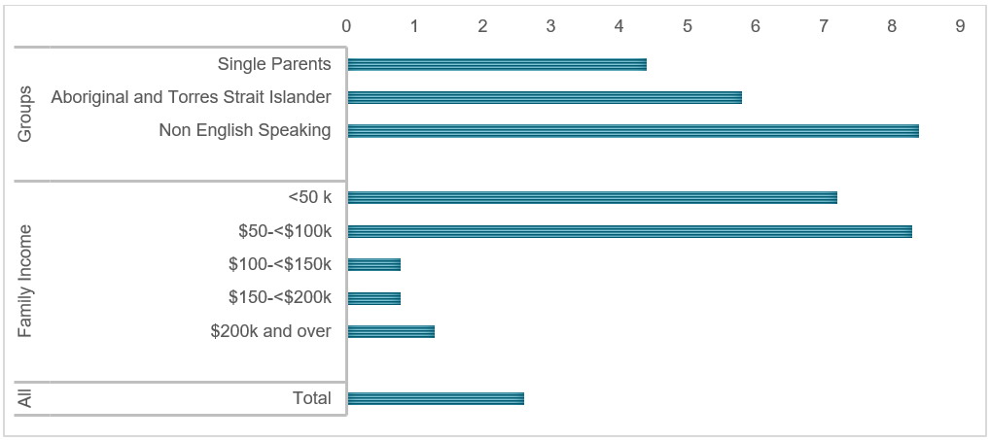*Source:* J. Rob Bray et al., *Child Care Package Evaluation* (Melbourne: Australian Institute of Family Studies, 2021).

### 4.3.2 ParentsNext

ParentsNext has its origins in policies to support parents return to paid work, but over time it has morphed into a compliance-focused program that unfairly targets parents and causes significant hardship.

ParentsNext has been shown to provide more barriers than pathways to parents’ employment. Breaches and payment suspensions place mothers in an extremely vulnerable financial position which is counterproductive to them achieving employment and economic inclusion. Discontinuing ParentsNext will provide budgetary savings that can be diverted to support other programs that support economic inclusion and employment.

#### Background

Since the late 1980’s the Government recognised the need for targeted employment pathways for parents. The Jobs, Education and Training (JET) program operated for almost 10 years as a voluntary program providing targeted education support, employment services and subsidised childcare to single parents.

Incremental reforms to the JET program - that initiated its transition into the current ParentsNext program – began in the late 1990’s when it became compulsory. Over time, the number of people covered by the program, the obligations and the enforcement activities have expanded. Parents that fail to meet obligations can face losing benefits, placing families at risk of significant hardship.

Evaluations have shown that since becoming compulsory, the program has become less effective, and a Parliamentary Inquiry has recommended its compulsory requirements be removed.[78],[79]

#### Issues

ParentsNext aims to target early intervention services to parents that are at risk of long-term welfare dependency; assist parents in identifying and achieving their education and employment goals and connect parents to local services that can address any barriers to employment.

The ParentsNext program targets recipients of the Parenting Payment with young children, deemed most at risk of long-term disadvantage.

Two main critiques have been made about the scheme:

* it fails to address the broader barriers and structural factors that contribute to economic insecurity and disadvantage
* its punitive compliance measures act to undermine its policy intent and cause widespread hardship.

#### Broader Barriers

There are a number of barriers that parents of young children face, particularly women in returning to work that are not addressed by the ParentsNext program:

* high effective marginal tax rates for second earners due to the interaction of the tax and social security system
* housing costs resulting in parents living in areas that have few easily accessible jobs
* insecure and unpredictable employment that for young parents increases economic insecurity and makes organising childcare more onerous
* the impact of family violence on participation and productivity.

The Government has an opportunity to design a more targeted program that meets individual needs and reflects structural barriers to employment.

#### Counterproductive Compliance

The forced nature of the program assumes that participants lack the capacity and motivation to participate, and must be coerced to engage in the program. This approach fails to reflect that fact that people tend to be more engaged when they have agency.

The coercive nature of the program may explain why its effectiveness has declined since it became compulsory. There is little evidence from the international literature that harsh welfare compliance is effective in moving people from income support into secure employment.[80] Moreover, punitive approaches may instead undermine the capacity of people to engage in work.

ParentsNext compliance is particularly harsh, as it denies parents and their young children access to a basic standard of living. The 2019 Parliamentary Inquiry heard of cases where parents had their support payments cut-off over the Christmas period, placing them and their children at risk and needing emergency relief.[81] The withholding of income support payments from low income parents and their children is counterproductive to improving economic inclusion.

### 4.3.3 Child support and Family Payment interactions

#### Background

Child support is a complicated area of social policy, but one that has a significant impact on the 1.02 million children affected by the scheme, many of whom live in single-mother-headed households.

The Australian system, introduced in 1988-89 to reduce child poverty in single parent households, was based on the model operating in the US state of Wisconsin; a model that has also informed the systems in operation in New Zealand and the United Kingdom. However, since inception, the four schemes have deviated – and the Australian system no longer sees consistent poverty reduction effects.[82]

Despite being described by a former Chief Justice of the Family Court as a ‘one of the most progressive child support systems in the world’,[83] the complexity of the administrative system and its interaction with family payments has produced a number of perversities and blind spots that make children and parents living in receiving families less financially secure.

#### Issues

Women are the overwhelming majority of child support recipients, as they undertake the majority of unpaid care of children before and after parental separation. A single parent household, with a parent aged 15-44, is the family household type most likely to be living in Australia’s lowest equivalised disposable household income quintile.[84] An analysis of the Household Income and Labour Dynamics in Australia dataset showed that receiving child support reduced female-headed single parent households’ poverty rate by 21 per cent.[85]

*Table 2: Breakdown of child support customers by sex*

|  | **Child support payers (%)** | **Child support payees (%)** |
| --- | --- | --- |
| Female | 72,629 (12.3) | 516,144 (88.0) |
| Male | 515,594 (87.7) | 70,470 (12.0) |

*Source: September 2022 Child Support Program Information dataset, available data.gov.au*

However, women report that child support payments are unreliable, or are even used as a weapon. Research has reported malicious ex-partners withholding payments before Christmas, children’s birthdays, when significant bills are due or the beginning of the school year, or varying their income and payment details to elicit Family Tax Benefit debts raised by the Government against the resident parent.[86]

An anonymous witness to the Joint Select Committee on Australia’s Family Law System said

He's supposed to pay $400 a fortnight … Intermittently he might pay—for the last financial year he's paid a total of $3,900 for four children. When we were married we used to live off $2,800 a week … Everyone I've had in Child Support has been lovely … but at the end of the day nothing is done to get me that money. They just say: 'You'll get it eventually. When he retires you'll get it out of his super.' It's not going to be much use to me when I'm 70!

For the 1.02 million children who are supported by the child support system, $3.774 billion in child support is expected to be transferred annually, of which 45 per cent is transferred via Services Australia (Agency Collect) and 55 per cent is transferred privately (Private Collect).[87]

There is currently $1.686 billion in unpaid liabilities, of which only 38.4 per cent are subject to a payment plan.[88] However, these compliance figures only apply to the 50 per cent of the child support caseload who transfer payments using Agency Collect. For the other 50 per cent of cases, Privately Collected payments are assumed to be 100 per cent compliant – even when liabilities are recalculated retrospectively.

While the total value of Agency Collect debt has remained steady in recent years, despite a declining caseload, the value of cases that have ended with a debt (where children have ‘aged out’ of the system, for example) has significantly increased over previous decades. From the Child Support Scheme’s inception in 1988 to 30 June 2010, $54.1 million was owed at the time a case was closed. Between 1 July 2010 and 30 June 2021 this figure increased to $645.3 million. As such, the late, absent or partial payment of child support to some of Australia’s most vulnerable children is a significant economic and social issue.

For recipient families, the partial or non-payment of child support has implications beyond the direct loss of expected child support income. It also affects single parents’ FTBA calculations. When child support is not paid, children in recipient households receive less income than is expected, but do not receive commensurate increases in FTBA payments.

In addition to unreliable child support payments, the calculation of payment liabilities is also problematic. The number of child support customers who were required to, but did not lodge, a tax return – which is used to calculate child support liabilities and in turn FTBA entitlements – has increased. In 2015-16, 7.9 per cent of the caseload did not meet their annual income reporting requirements, which excludes parents whose incomes are below the income-reporting threshold. By the 2019-20 tax year, the proportion of parents who had not met the annual income-reporting requirement had increased to 12.3 per cent.

When tax returns are not lodged, a provisional income is used. This can result in an inaccurate child support liability. The Department of Social Services’ figures show that the three most commonly used provisional income calculation methods produced lower median incomes than the median incomes calculated after tax returns were lodged.[89]

Child support recipients are required to lodge a tax return in order to determine their eligibility for family and income support payments, and thus have less incentive to avoid declaring their annual income. Paying parents, by contrast, are less likely to be in receipt of income support or FTBA payments. They have a financial incentive to reduce their child support outlays by not lodging a tax return and having their annual income imputed into the child support formula at a lower rate.

The value of child support and FTBA payments make them an important part of single parents’ income package, particularly for those in receipt of

JobSeeker Payment. Yet the way that child support and FTBA are calculated make them unreliable when child support is not paid in full and on time. As a result, child support can be used by malicious ex-partners to inflict financial harms on recipient parents.

For child support recipient parents, the interaction between child support and family payments can:

* impose financial hardships due to a lack of income and inappropriately reduced FTBA
* make it impossible to predict fortnightly income, including whether it will be above or below the poverty line
* allow debts to be levied against FTBA recipients through no fault or action of their own, providing a means for malicious ex-partners to inflict financial abuse.

#### Unfairly reduced Family Tax Benefit payments

Child support payments received from a child’s parent living elsewhere is counted as income in the calculation of FTBA, known as the MIT. Every dollar of child support received over a threshold reduces FTBA by 50 cents. In the most recently reconciled years (2019-20), department data reveals that the MIT resulted in $799 million in reduced Family Tax Benefit outlays.

Australia is the only ‘Wisconsin-model’ child support system that uses child support as income in the calculation of family payments. New Zealand, the United States and the United Kingdom do not use child support as income in the calculation of other benefits.[90]

The Australian child support-family payment interaction makes budgeting on a low income impossible for recipients, as FTBA cannot be predicted from fortnight-to-fortnight. For Agency Collect recipients, FTBA is dependent on child support receipts. For Private Collect recipients, FTBA is paid assuming that all child support is received, but variations to the payers’ annual income estimates can retrospectively produce FTBA debts to payee parents. Parents who provided information to the Committee reported similar concerns with the interaction of child support and family tax benefits:

My ex continues financial abuse through child support nonpayment, which I'm penalised for, go figure. Never received a cent for years. They got a small amount last tax [year] and since they’ve reduced my [Family Tax Benefit] payments by several hundred a fortnight despite getting nothing else.

Unlink social security payments and child support payments.

My payment was cut because of a child support debt I am OWED but NOT receiving.

Because of the savings that child support makes to FTBA outlays through the MIT, separated parents with care of children are required to seek child support from the parent living elsewhere, known as the Maintenance Action Test (MAT), or they can only receive the base rate of FTBA.

|  |  |  |
| --- | --- | --- |
| **MAT status** | **N** | **%** |
| Passed MAT | 864,233 | (71.3%) |
| Failed MAT | 170,347 | (14.1%) |
| Exempted from MAT | 167,506 | (13.8%) |
| MAT decision pending | 10,167 | (0.8%) |
| Unknown MAT status | 70 | (0.0%) |
| Total | 1,212,323 | 100% |

*Table 3: MAT status of parents in receipt of Family Tax Benefit Part A*

Most FTBA recipients seek child support and are eligible for above-base-rate FTBA payments, having passed the MAT. However, 14 per cent of parents fail to seek child support. Of these parents who fail the MAT, 93.4 per cent are single parents, and 61 percent receive income support payment.

The MAT disproportionately impacts Indigenous children with 13.5 per cent of those failing the test having an indicator of indigeneity. Young children are also disproportionately affected, with 50.5 per cent of children whose resident parent failed the MAT being aged six years or under.

Failing the MAT compounds existing disadvantages, reducing the income of children living in already vulnerable families.

#### Child support income and Family Tax Benefit overpayments

The *Family Assistance and Child Support Legislation Amendment (Protecting Children) Bill 2017* included a provision that applies the same debt collection provisions to FTBA recipients as apply to non-compliant child support payers. The consequences of the 2017 amendment is that FTBA debts can be retrospectively applied to payee parents who collect child support privately.

Almost 50 per cent of payee parents receive payments via Private Collect.[91]

*Table 4: Proportion of child support cases, by payment type*

| **Active cases by payment method** | **Number of cases (%)** |
| --- | --- |
| Agency Collect | 332,776 (50.27) |
| Private Collect | 329,223 (49.73) |

For parents who receive child support via Agency Collect, FTBA is automatically calculated based on how much child support is actually paid. However, for parents who receive child support directly from their ex-partner, known as Private Collect, the full amount of child support is assumed to be received.

Family Tax Benefit recipients have no control over how their ex-partner’s child support payments will affect their FTBA payment entitlements, or whether a retrospective debt will be raised. Debts and FTBA variability create financial hardship and uncertainty, making it impossible for families on very low incomes to budget or make ends meet.

The recovery of Family Tax Benefit overpayments that result from backdated child support assessments is a draconian policy that inflicts financial harm on vulnerable payee families as a result of behaviour of child support payer behaviour. This issue is especially pertinent to separated parents who are victim survivors of family violence.

#### Child support and family violence

Family violence affects all aspects of child support calculation, collection and compliance. The third interim report of the Joint Select Committee on Australia’s Family Law System noted:

The committee notes that numerous submitters expressed concerns regarding child support being weaponised to perpetuate financial abuse after separation. The committee is very concerned about these reports, and the evidence suggesting that some individuals are making intermittent payments, or withholding them entirely—resulting in significant challenges for the payee parent who is relying on these payments to support their child/ren.

The Government has agreed to the Committee’s recommendation to equip Services Australia staff with the skills and knowledge required to support customers and staff affected by family and domestic violence, noting this a priority area.[92]

On seeking child support, there has been no examination of why parents have failed the MAT. However, recent qualitative research reported that almost all of the single mothers who had experienced violence did not know that they could seek an exemption on this basis.[93]

FTBA recipients can be exempt from the MAT for a number of reasons, the most common of which is a fear of violence. However, seeking an exemption – and identifying their ex-partner as violent to authorities – may exacerbate a women’s risk of violence.

*Table 5: Reasons for exemption from the MAT*

|  |  |  |
| --- | --- | --- |
| Grounds for a MAT exemption | Number | Percentage%* |
| Fear of violence | 92,910 | 55.0 |
| Unknown parentage | 35,916 | 21.4 |
| Imposition | 11,814 | 7.1 |
| Payer overseas – non reciprocal country | 11.886 | 7.1 |
| Other | 14,980 | 8.9 |
| Total | 167,506 | 100 |

*Source: June 2022 Department of Social Services data; *may not sum to 100 per cent due to rounding*

However, a submission cited in the First Interim Report of the Joint Select Committee on Australia’s Family Law System reported that the exemption was failing family violence victim survivors.

Currently, the system provides a perverse incentive that financially reward abusive payers (typically men), as they may be exempt from paying any form of child support.[94]

Similarly, while women who receive an exemption from seeking child support remain eligible to receive above-base-rate FTBA payments, they do not receive child support income, which may be the difference between living above or below the poverty line.[95]

Even for women with a child support order in place, perversities within the system enable its use as a vehicle for perpetrating financial abuse. In their response to the Final and three Interim Reports of the Joint Select Committee, the Government has recognised the need to examine the interaction between child support and FTBA in the context of family violence.[96]

The National Plan to End Violence against Women and Children 2022-2032 (the National Plan) recognises that women are at heightened risk of violence in the period leading up to, and directly following separation. The Government will review the interaction between the Child Support Scheme and family assistance payments to further ensure legislation and service delivery support vulnerable parents after separation.

Three features of the Child Support Scheme make financial abuse possible:

1. The reliance on payer income and child support payment data to calculate payee FTBA
2. The use of Private Collect as the method of payment transfers, which assumes 100 per cent compliance, even when liabilities change retrospectively
3. The retrospectivity of FTBA debts applied to Private Collect recipients.

Each of these issues are associated with the MIT. If child support were not included as income in the calculation of Family Tax Benefits, recipient parents would have greater income certainty. While issues over child support compliance would remain, family payments could not be used as a vehicle for inflicting financial harm and the Government would not be complicit in recouping FTBA debts accrued on this basis.

## 4.4 Conclusion

The way in which our social security system and broader policy settings operate can, at their best, support people to participate in employment, society and family life. At their worst, the operation of the social security system can undermine people’s ability to participate by creating additional barriers, income uncertainty, and not adequately investing in people’s human capital.

In the future, the Committee will continue to look at these issues and provide advice to Government on reform priorities. In this first report, we have highlighted three policies that impede parents’ economic inclusion and capacity to engage in paid work. The recommendations the Committee has made will provide long-term benefits for children, their parents, and the economy through greater access to early childhood education and care, and by reducing parents’ risk of benefit overpayment or suspension.

# Advice on legislated measures on economic inclusion and poverty reduction

## Introduction

This Chapter recommends legislated measures and targets on economic inclusion and poverty reduction. It draws on the Canadian and New Zealand experiences, including discussions with senior officials leading the Child Wellbeing and Poverty Reduction Unit in the Department of Prime Minister and Cabinet in New Zealand.

## Recommendations

*Recommendation 34*

The Government specify and include measures on economic inclusion and poverty reduction in the legislation to establish an Economic Inclusion Advisory Committee. The legislation should follow the release of the Measuring What Matters statement and specify the process to agree targets and track progress against economic inclusion and poverty measures over time.

*Recommendation 35*

The Government develop a data, evidence and consultation strategy to support the legislated measures and agreed targets.

*Recommendation 36*

The Government establish a multidimensional poverty index to supplement legislated measures, to provide a more comprehensive picture of the nature and extent of poverty, and to enable monitoring of trends and targeting of effort by population and dimensions such as health, education and living standards.

*Recommendation 37*

The Government include Economic Inclusion and Poverty Reduction in the Treasury Portfolio, with the Treasurer to be the responsible Minister for setting targets and driving whole of government implementation.

## Key findings

### Canadian approach

Canada’s first Poverty Reduction Strategy was released in 2018 following over two years of consultations. It was based on the vision that all Canadians should be able to live in dignity.[97] The strategy established a legislated National Advisory Council on Poverty and introduced an official poverty line, with indicators to monitor dimensions of poverty and inclusion. The strategy included a legislated consumption based poverty reduction target of 20 per cent by 2020 and 50 per cent by 2030 (compared to 2015 levels).

The Canadian National Advisory Council has since released three reports examining progress against the strategy. The first two reports, in 2020 and 2021, focused on a deeper understanding of Canada’s social safety net and how the systems comprising the safety net created, sustained and perpetuated poverty. The 2022 report began to identify tangible ways to change those systems and move toward a Canada free of poverty. The interim 2020 target was achieved and Canada is ahead of the 2030 target, although the Council has warned current progress is inequitable and may be short-lived because support measures implemented during the COVID-19 pandemic were temporary.[98]

### New Zealand approach

The New Zealand *Child Poverty Reduction Act* (2018) (“the Act”) was enacted with the purpose[99] of helping to achieve a significant and sustained reduction in child poverty. The Act specifies four primary and six supplementary measures for child poverty and requires the relevant Minister to set long-term and intermediate targets for each primary measure. The four primary measures are:

1. Low income: less than 50 per cent of median equivalised disposable household income (DHI) for the financial year (without deducting housing costs);
2. Low income: less than 50 per cent of median equivalised DHI for the base financial year (after deducting housing costs);
3. Material hardship; and
4. Persistent poverty.[100] Under the Act, the Minister must set (and may change) long-term targets for reducing child poverty over a decade-long period, and intermediate targets over a three-year period to support the long-term targets. Targets must be set for each primary measure, are gazetted[101], reviewed annually, and must be presented to the House of Representatives by the Minister after being gazetted or changed.

The Act also requires the Government Statistician to prepare a report measuring child poverty each financial year. In February 2022, Stats NZ reported[102] all the measures were trending downwards, and that two of the three intermediate targets had been met (although noted the difficulty posed by COVID-19 in assessing the trend).

Below is a graph produced by StatsNZ summarising the findings:

**Figure 20: New Zealand children in poverty by measure**

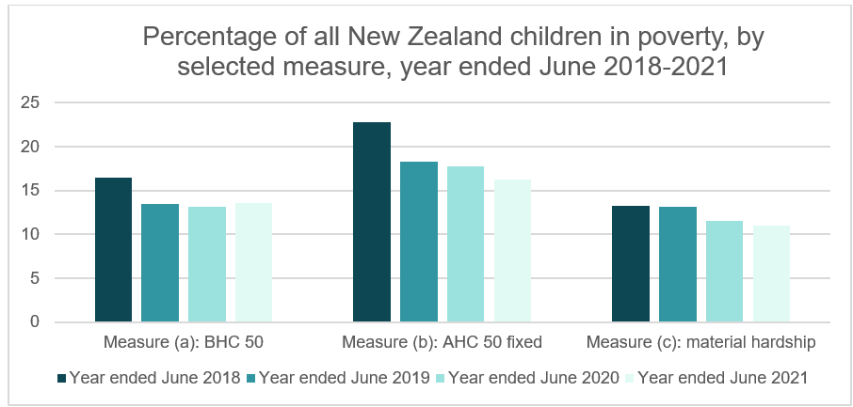

### Relevance to Australia

The Committee’s focus on boosting economic inclusion and tackling disadvantage is broader than child poverty. It is closer to the remit of Canada’s National Advisory Council given the agreement to legislate a permanent Committee. However, there is alignment between the New Zealand approach and the Government’s commitment to “Measuring What Matters” announced[103] in the October 2022-23 Budget. The primary child poverty measures legislated in New Zealand are connected to the “Living Standards Framework[104]” and wellbeing approach of the New Zealand Treasury. It is natural to expect the “Measuring What Matters” statement to be released by the Commonwealth in 2023 will include a greater focus on reducing poverty and entrenched disadvantage. The New Zealand precedent was among several cited in the initial statement[105] in October 2022.

Common to both the Canadian and New Zealand approaches are legislated measures and targets. Discussions with senior officials suggest the benefits of legislated measures have been:

* Regular and transparent spotlight on the issues and whether or not progress has been made;
* Greater coordination within government on strategies to reduce poverty and grow wellbeing, including approaches to data, evidence and community consultation; and
* Deepening understanding and awareness of the issues in the community.

Senior officials in New Zealand benefited from having the Prime Minister as the lead Minister for Child Poverty Reduction. When she resigned in January 2023, Prime Minister Ardern cited[106] the work done to turn around child poverty statistics[107] as among her greatest achievements. While it is too soon to know if reducing child poverty will be a priority for her successor, the legislated measures will ensure a consistent focus regardless of who is in government, unless the Act is repealed.

While income-based poverty measures are essential, they do not provide a complete picture of the extent and nature of poverty and disadvantage. Income based measures are ideally supplemented by material deprivation measures (as in New Zealand), as well as other indicators of disadvantage and social exclusion such as wealth inequality, and indicators based on the Capabilities Approach, such as opportunity deprivation and relational deprivation.[108]

Legislated targets could be supplemented by non-legislated multidimensional indicators of economic equity. These could be incorporated into the wellbeing framework Treasury is developing. Consideration could be given to a multidimensional poverty index[109] to assess the depth of poverty across deprivations, which could then be disaggregated by population group and dimension to investigate trends and patterns, and identify cohorts and domains where targeted effort is required.[110]

# Terms of Reference

## Purpose

The Government has committed to establishing an Economic Inclusion Advisory Committee before the end of 2022 to provide non-binding written advice on economic inclusion, including policy settings, systems and structures, and the adequacy, effectiveness and sustainability of income support payments ahead of every Budget.

## Membership

The Committee will have up to 14 members, including a Chair, and will include social security academic experts, representatives from key relevant advocacy organisations, unions, business peak bodies, the philanthropic sector and economists.

The Prime Minister will appoint an interim Committee ahead of the introduction of legislation in 2023 for the establishment of a permanent Committee. Under legislation, members will be appointed by written instrument and hold office on a part-time basis for the period specified in the instrument, which must not exceed 3 years. Members are eligible for reappointment.

Members are able to nominate a person for the Minister for Social Services’ agreement to attend the meeting in the member’s place, if the member is unable to be present at the meeting.

## Scope

The Committee will consider and provide advice and proposals on:

1. Economic inclusion including approaches to boost participation through policy settings, systems and structures, in the social security system and other government programs and policies.
2. The adequacy, effectiveness and sustainability of income support payments including options to boost economic inclusion and tackle disadvantage.
3. Options to reduce barriers and disincentives to work, including in relation to social security and employment services.
4. Options for tailored responses to address barriers to economic inclusion for long-term unemployed and disadvantaged groups, including place based approaches at the local level.
5. The impact of economic inclusion policies on gender equality including consideration of work being undertaken by the Women’s Economic Equality Taskforce.
6. The trends of inequality markers in Australia, and any other relevant advice.

The Committee’s report to Government should include supporting discussion and analysis. In providing advice on these matters, the Committee will have regard to the Government’s fiscal strategy, existing policies, and the long-term sustainability of the social security system.

## Timing

The Committee will meet at least every quarter, with the first meeting of the interim Committee in December 2022. The Committee will present its first report to Government prior to the 2023-24 Federal Budget and report on a yearly basis.

High level recommendations are to be released publicly (with the timing to be agreed between the Chair and Ministers), but must be no later than 14 days prior to each Budget being handed down. To inform Government deliberations for Budget, the Committee’s advice would be required in February – March 2023.

## Administration

Secretariat support for the Committee will be provided by the Department of Social Services (DSS). DSS and other government departments, including the Treasury and the Department of Finance, will provide advice and information to the Committee.

Meeting agendas and papers will be shared at least 3 days before each meeting, and action items recorded and addressed at the next meeting.

## List of members

| **Members of the Committee** | |
| --- | --- |
| Hon Jenny Macklin | Chair |
| Professor Jeff Borland | Melbourne University |
| Ms Emily Carter | Marninwarntikura Women’s Resource Centre |
| Professor Kay Cook | Swinburne University of Technology |
| Mr Matthew Cox | The Bryan Foundation |
| Dr Cassandra Goldie | Australian Council of Social Service |
| Dr Angela Jackson | Impact Economics and Policy |
| Mr Travers McLeod | Brotherhood of St Laurence |
| Ms Sally McManus | Australian Council of Trade Unions |
| Associate Professor Ben Phillips | Australian National University |
| Ms Leah van Poppel | Independent Advisory Council to the NDIS |
| Ms Jennifer Westacott AO | Business Council of Australia |
| Professor Peter Whiteford | Australian National University |
| **Ex-officio members** | |
| Dr Steven Kennedy PSM | Secretary to the Treasury |
| Mr Ray Griggs AO CSC | Secretary Department of Social Services |

# Bibliography

Aaronson, Stephanie, et al. “Okun revisited: Who benefits most from a strong economy?” *Brookings Papers on Economic Activity* Spring (2019): 333-404.  
https://www.brookings.edu/wp-content/uploads/2019/03/aaronson_web.pdf.

Alkire, Sabina et al. “Global Multidimensional Poverty Index 2022: Unpacking deprivation bundles to reduce multidimensional poverty.” *Oxford Poverty & Human Development Initiative* (2022).   
https://hdr.undp.org/system/files/documents/hdp-document/2022mpireportenpdf.pdf.

Australian Bureau of Statistics. “Education and Work, Australia.”

—. “Employee Earnings and Hours, Australia.”

—. ”Household Income and Wealth, Australia.”

—. “Labour Force, Australia.”

—. “Labour Force, Australia, Detailed.”

—. “Participation, Job Search and Mobility, Australia.”

—. “Wage Price Index, Australia.”

Australian Council of Social Services. *Submission to the Review of the Reserve Bank; 7 November 2022*, 14-18.   
https://www.acoss.org.au/wp-content/uploads/2022/11/ACOSS-RBA-Review-2022.pdf.

Australian Government. “Australian Government response to the inquiry of the Joint Select Committee on Australia’s Family Law System.” Commonwealth of Australia, 2023.   
https://www.ag.gov.au/system/files/2023-01/government-response-to-the-JSC-reports.pdf.

Ballantyne, Alex and Coates, Brendan. “No one left behind: Why Australia should lock in full employment.” Grattan Institute, 2022.  
https://grattan.edu.au/wp-content/uploads/2022/05/No-one-left-behind-Why-Australia-should-lock-in-full-employment.pdf.

Banks, Marcus. *One side of the workfare desk A history of the Jobs, Education and Training Program in the political economy of Australian ‘welfare reform’ (1989-2006)*. Melbourne: RMIT University, 2011.

Beehive.govt.nz. “Prime Minister Jacinda Ardern announces resignation.” New Zealand Government, 2023.   
https://www.beehive.govt.nz/release/prime-minister-jacinda-ardern-announces-resignation.

Bessell, Sharon, “Rethinking Child Poverty.” *Journal of Human Development and Capabilities* 23, no. 4. (2022): 539-561.

Borland, Jeff. “Would a rise in JobSeeker affect incentives for paid work?” *The Conversation*, November 19,2020. https://cdn.theconversation.com/static_files/files/1343/Borland_Labour_market_snapshot__71.pdf?1606359052.

Botha, Ferdi. “Financial well-being,” in *The Household, Income and Labour Dynamics in Australia Survey: Selected Findings from Waves 1 to 20*. Melbourne Institute: Applied Economic & Social Research, University of Melbourne, 2022.

Bradbury, B and Hill, P. “Australian income support since 2000: Those left behind.” *ACOSS/UNSW Sydney Poverty and Inequality Partnership*, *Build Back Fairer Series* Report No. 2. Sydney, 2021.

Bray, J. Rob; Baxter, Jennifer; Budinski, Mikayla; Caroll, Megan; Gray, Matthew; Hand, Kelly; Jones, Anna; Katz, IIan; Phillips, Ben; Warren, Diana and Webster, Richard. *Child Care Package Evaluation: Final Report*. Melbourne: Australian Institute of Family Studies, 2021.

Bryant, David; Porter, Emily; Rama, Ismo and Sullivan, Damian,. “Power Pain: An investigation of energy stress in Australia.” Brotherhood of St. Laurence, 2022.

Canadian Government. *Opportunity for All: Canada’s First Poverty Reduction Strategy*. Gatineau, Quebec: Employment and Social Development Canada, 2018. https://publications.gc.ca/site/eng/9.857663/publication.html#:~:text=%22Opportunity%20for%20All%20%E2%80%93%20Canada%27s%20First,against%20poverty%20on%20multiple%20fronts.

—. *Transforming our Systems: The 2022 report of the National Advisory Council on Poverty*. Employment and Social Development Canada, 2022.

Carroll, Nick. “Unemployment and psychological well-being.” *Economic Record 83*, no. 262. (2007): 287-302.

Centre for Policy Development. *Starting Better – A Guarantee for Young Children and Families*. Centre for Policy Development, 2021.  
https://cpd.org.au/wp-content/uploads/2021/11/CPD-Starting-Better-Report.pdf.

Community Affairs References Committee. *ParentsNext, including its trial and subsequent broader rollout, Final Report*. Senate Standing Committees on Community Affairs. Commonwealth of Australia, 2019.

Cook, Kay; Edwards, Terese; Goodall, Zoe and McLaren, Juanita. “Debts and disappointments: Mothers’ experiences of the child support system.” Melbourne: National Council of Single Mothers and their Children & Swinburne University of Technology, 2019.   
doi:10.25916/5dd4ab2528b12.

Cook, Kay. “State tactics of welfare benefit minimisation: the power of governing documents.” *Critical Social Policy* 42, no. 2. (2021).   
doi:10.1177/02610183211003474.

Dare, Lain; McCabe, Marita; Miranti, Riyana; Tanton, Robert; Vidyattama, Yogi and Yule, Andrew. *Dropping Off the Edge 2021: Persistent and multilayered disadvantage in Australia*. Melbourne: Jesuit Social Services, 2021.

Department of Social Services. “Child Support Program Information.” *September 2022*. data.gov.au, 2022.   
https://data.gov.au/dataset/ds-dga-6379b974-e547-4303-a361-6edebbb52550/details?q=child%20support.

—. “Child support scheme and tax lodgement figures.” *December 2021*. data.gov.au, 2022.

Department of Social Services. “McClure review: A New System for Better Employment and Social Outcomes.” Commonwealth of Australia, 2015.

Department of Treasury. “Australia’s Future Tax System – Report to the Treasurer.” Commonwealth of Australia, 2010.

—. “Retirement Income Review.” Final Report. Commonwealth of Australia, 2020. https://treasury.gov.au/publication/p2020-100554.

Duncan, Greg; Kalil, Ariel; Mogstad, Magne and Rege, Mari . *Investing in early childhood development in preschool and at home*. Chicago: Becker Friedman Institute, 2022. https://www.nber.org/system/files/working_papers/w29985/w29985.pdf.

Garnaut, Ross. *Reset: Restoring Australian after the Pandemic Recession*. Latrobe University Press, 2021.

Harmer, Jeff. *Pension Review Report*. Commonwealth of Australia, 2009. https://www.dss.gov.au/sites/default/files/documents/05_2012/pensionreviewreport.pdf.

Henderson, Ronald F; Harcourt, Alison and Harper, Raymond. *People in Poverty: A Melbourne Survey*. Cheshire, Melbourne, 1970.

Hines, James; Hoynes, Hilary Williamson and Kruger, Alan. “Another look at whether a rising tide lifts all boats.” National Bureau of Economic Research. Working Paper no. 8412, 2001.

Joint Select Committee on Australia’s Family Law System. *Australia’s Child Support Scheme; Third interim Report*. Commonwealth of Australia, 2021.

—. *Improvements in family law proceedings*. Interim Report. Commonwealth of Australia, 2020.

Killingsworth, Mark R. *Labor Supply*. Cambridge University Press, 1983.

Moffitt, Robert. “Unemployment benefits and unemployment,” *IZA World of Labor* 13 (2014): doi: 10.15185/izawol.13.

—. “Welfare Programs and Labor Supply.” National Bureau of Economic Research, w9168 2002. https://ssrn.com/abstract=331022.

Moloney, Joey and Coates, Brendan. “Renters spend 10 times as much on housing as petrol. Where’s their relief?” *The Conversation*, April 12, 2022. https://theconversation.com/renters-spend-10-times-as-much-on-housing-as-petrol-wheres-their-relief-180702.

Okun, Arthur Melvin. “Upward mobility in a high-pressure economy.” *Brookings Papers on Economic Activity* 1 (1973): 207-252.   
https://www.brookings.edu/wp-content/uploads/1973/01/1973a_bpea_okun_fellner_greenspan.pdf.

OECD. *Is Childcare Affordable? Policy Brief on Employment, Labour, and Social Affairs.* OECD, 2020.   
https://www.oecd.org/els/family/OECD-Is-Childcare-Affordable.pdf.

—. “Tax-benefit web calculator,” *OECD*.   
https://www.oecd.org/els/soc/benefits-and-wages/tax-benefit-web-calculator/#d.en.500997.

—. “The OECD tax-benefit data portal,” *OECD*. https://www.oecd.org/els/soc/benefits-and-wages/data/.

Ong, Rachel; Pawson, Hal; Singh, Ranjodgh and Martin, Chris. “Demand side assistance in Australia’s rental housing market: exploring reform options.” AHURI Final Report 342. Melbourne: Australian Housing and Urban Research Institute Limited, 2020.   
doi:10.18408/ahuri8120801.

Parliamentary Joint Inquiry on Human Rights. *ParentsNext: examination of Social Security (Parenting payment participation requirements–class of persons) Instrument 2021*. Inquiry Report. Commonwealth of Australia, 2021. https://www.aph.gov.au/Parliamentary_Business/Committees/Joint/Human_Rights/ParentsNext/Report.

Phillips, Ben and Narayanan, Vivikth. “Financial Stress and Social Security Settings in Australia.” Australian National University, 2021.  
https://www.socialventures.com.au/assets/Making-a-difference-to-financial-stress-and-poverty_full-report-SVA-BSL.pdf.

Productivity Commission. *Childcare and Early Childhood Learning*. Commonwealth of Australia, February 20, 2015.  
https://www.pc.gov.au/inquiries/completed/childcare/report.

—. “Report on Government Services, Housing.” Commonwealth of Australia, 2023.

Regan, Sue and Stanton, David. “Social Policy Inquiries in Australia: the Henderson Poverty Inquiry in Context.” Australian National University, 2018. https://researchprofiles.anu.edu.au/en/publications/social-policy-inquiries-in-australia-the-henderson-poverty-inquir.

Reserve Bank of Australia. “Statement on Monetary Policy.” Reserve Bank of Australia, 2023. February 9, 2023.   
https://www.rba.gov.au/publications/smp/2023/feb/pdf/statement-on-monetary-policy-2023-02.pdf.

Saunders, Peter; Naidoo, Yuvisthi and Wong, Melissa. “Comparing the Monetary and Living Standards Approaches to Poverty Using the Australian Experience,” *Social Indicators Research* 162. (2022): 1365 – 1385.   
http://dx.doi.org/10.1007/s11205-022-02888-8.

Saunders, Peter and Naidoo, Yuvisthi. “Mapping the Australian Poverty Profile: A Multidimensional Deprivation Approach.” *The Australian Economic Review* 51. (2018): 336-350.   
http://dx.doi.org/10.1111/1467-8462.12266.

—. “The overlap between income poverty and material deprivation: Sensitivity evidence for Australia.” *Journal of Poverty and Social Justice* 28. (2020): 187 – 206. http://dx.doi.org/10.1332/175982720X15791323755614.

Saunders, Peter. and Whiteford, Peter. “Measuring Poverty: A Review of the Issues.” *Economic Planning Advisory Council Discussion.* Paper 89/11, 1989.

Senate Education & Employment Legislation Committee. “Department of Education and Training 4 March 2016.” *Inquiry into the Family Assistance Legislation Amendment (Jobs for Families Child Care Package) Bill 2015*. https://www.aph.gov.au/Parliamentary_Business/Committees/Senate/Education_and_Employment/jobs_for_families/Additional_Documents.

Senate Education, Employment and Workplace Relations Committee. *The adequacy of the allowance payment system for jobseekers and others, the appropriateness of the allowance payment system as a support into work and the impact of the changing nature of the labour market* (2012). https://www.aph.gov.au/Parliamentary_Business/Committees/Senate/Education_Employment_and_Workplace_Relations/Completed%20inquiries/2010-13/newstartallowance/index.

Skinner, Christine; Meyer, Daniel R.; Cook, Kay and Fletcher, Michael. “Child Maintenance and Social Security Interactions: the Poverty Reduction Effects in Model Lone Parent Families across Four Countries.” *Journal of Social Policy* 46, no. 3. (2017): 495-516.

Skinner, Christine;, Cook, Kay and Sinclair, Sarah et al. “The potential of child support to reduce lone mother poverty: comparing population survey data in Australia and the UK.” *Journal of Poverty and Social Justice* 25, no. 1. (2017): 79-94.

Stanton, David. “The Henderson Poverty Line: A Critique.” *Social Security Journal* (1973).

The Royal Swedish Academy of Sciences. *Markets with Search Frictions*. Economic Sciences Prize Committee of the Royal Swedish Academy of Sciences. Stockholm: Kungl. Vetenskaps-Akademien 2010.   
https://www.nobelprize.org/uploads/2018/06/advanced-economicsciences2010.pdf.

Tseng, Yi-Ping; Jordan, Brigid; Borland, Jeff; Coombs, Nichola; Cotter, Kate; Guillou, Mael; Hill, Alice; Kennedy, Anne and Sheehan, Jane. “24 months in the Early Years Education Program: Assessment of the impact on children and their primary caregivers.” *Changing the Trajectories of Australia's Most Vulnerable Children* 4. May 2019.

United Nations Committee on Economic, Social and Cultural Rights. “General Comment No 19: The right to social security.” United Nations, 2007. https://www.ohchr.org/en/resources/educators/human-rights-education-training/g-general-comment-no-19-right-social-security-article-19-2007.

Whiteford, Peter and Bradbury, Bruce. “Albanese has dropped Labor's pledge to boost jobseeker; with unemployment low is that actually fair enough?” *The Conversation*, April 21, 2022.   
https://theconversation.com/albanese-has-dropped-labors-pledge-to-boost-jobseeker-with-unemployment-low-is-that-actually-fair-enough-181256.

Yuen, Kelvin; Ellis, Grant and Nelms, Lucy. “Characteristics of workers earning the national minimum wage and of the low paid.” *Annual Wage Review 2017-18: Research Report 3/2018*. Fair Work Commission, 2018.  
https://www.fwc.gov.au/documents/sites/wagereview2018/research/rr32018.pdf.

1. Senate Education, Employment and Workplace Relations Committee, *The adequacy of the allowance payment system for jobseekers and others, the appropriateness of the allowance payment system as a support into work and the impact of the changing nature of the labour market* (2012). https://www.aph.gov.au/Parliamentary_Business/Committees/Senate/Education_Employment_and_Workplace_Relations/Completed%20inquiries/2010-13/newstartallowance/index
2. Department of Social Services, “McClure review: A New System for Better Employment and Social Outcomes,” (Commonwealth of Australia, 2015).
3. Department of Social Services, “McClure review” (Commonwealth of Australia, 2015): 9.
4. Department of Social Services, “McClure review” (Commonwealth of Australia, 2015): 84.
5. United Nations Committee on Economic, Social and Cultural Rights, “General Comment No 19: The right to social security,” (United Nations, 2007). https://www.ohchr.org/en/resources/educators/human-rights-education-training/g-general-comment-no-19-right-social-security-article-19-2007.
6. P. Saunders and P. Whiteford, “Measuring Poverty: A Review of the Issues,” *Economic Planning Advisory Council Discussion* Paper 89/11 (1989).
7. Sue Regan and David Stanton, “Social Policy Inquiries in Australia: the Henderson Poverty Inquiry in Context,” (Australian National University, 2018). https://researchprofiles.anu.edu.au/en/publications/social-policy-inquiries-in-australia-the-henderson-poverty-inquir.
8. David Stanton, “The Henderson Poverty Line: A Critique”, *Social Security Journal* (1973).
9. Ronald F. Henderson et al. *People in Poverty: A Melbourne Survey*, Cheshire, Melbourne (1970): 26.
10. n.b. The Melbourne Institute refer to these as “absolute” poverty lines. In the view of this Committee, they should be considered as “fixed” lines, since there is no justification for arbitrarily setting 1973-74 as the starting point for assessing adequacy and ignoring all of the changes in Australian living costs and patterns since then.
11. Peter Saunders et al., “Comparing the Monetary and Living Standards Approaches to Poverty Using the Australian Experience,” *Social Indicators Research* 162 (2022): 1365-1385, <http://dx.doi.org/10.1007/s11205-022-02888-8>.
12. Peter Saunders and Yuvisthi Naidoo, “Mapping the Australian Poverty Profile: A Multidimensional Deprivation Approach,” *The Australian Economic Review* 51 (2018): 336-350, <http://dx.doi.org/10.1111/1467-8462.12266>.
13. Peter Saunders and Yuvisthi Naidoo, “The overlap between income poverty and material deprivation: Sensitivity evidence for Australia,” *Journal of Poverty and Social Justice* 28 (2020): 187 - 206, http://dx.doi.org/10.1332/175982720X15791323755614.
14. J. Harmer, *Pension Review Report* (2009), https://www.dss.gov.au/sites/default/files/documents/05_2012/pensionreviewreport.pdf.
15. n.b. In 2018, the Government of Canada released Opportunity for All, Canada’s First Poverty Reduction Strategy, which contained long-term commitments to guide current and future government actions and investments to reduce poverty. Since the release of Opportunity for All, Statistics Canada has investigated Market Basket Measure thresholds for Canada’s remote territories, (Yukon, the Northwest Territories and Nunavut).  These poverty thresholds are also adequacy benchmarks, which are likely to be of relevance to related work in Australia. Statistics Canada has also consulted extensively with First Nations people in the development of these measures. (Source: https://www.canada.ca/en/employment-social-development/programs/poverty-reduction/reports/strategy.html).
16. n.b. Note that analysis concerns single rates of payment unless otherwise stated.
17. n.b. These calculations compare the single adult rate of Newstart/Jobseeker with average equivalised household disposable income per adult in the income surveys. Comparisons with the “adjusted lowest income quintile” exclude the first and second percentiles, whose incomes are regarded as unreliable. The lowest decile is the income level below which 10 per cent of people in households (adjusted for household size) live.
18. OECD, ‘The OECD tax-benefit data portal’, *OECD*, https://www.oecd.org/els/soc/benefits-and-wages/data/
19. OECD, “Tax-benefit web calculator,” *OECD*,

    https://www.oecd.org/els/soc/benefits-and-wages/tax-benefit-web-calculator/#d.en.500997.
20. Ben Phillips and Vivikth Narayanan, “Financial Stress and Social Security Settings in Australia,” (Australian National University, 2021), https://www.socialventures.com.au/assets/Making-a-difference-to-financial-stress-and-poverty_full-report-SVA-BSL.pdf.
21. David Bryant et al. “Power Pain: An investigation of energy stress in Australia”, *Brotherhood of St. Laurence* (2022).
22. n.b. While it may be argued that people looking for work face additional costs in job search, the First Main Report on Poverty in 1975 argued that households on all social security payments should be treated as if they were not working, given that the poverty line was originally set for a household in full-time work.
23. n.b. The $50 per fortnight increase in Jobseeker Payments in 2021 is taken into account in these calculations.
24. n.b. Household Disposable Income per capita being derived from the National Accounts includes items not measured in income surveys, producing rising estimates of income poverty.
25. Department of Treasury, “Retirement Income Review,” Final Report (Commonwealth of Australia, 2020): https://treasury.gov.au/publication/p2020-100554.
26. n.b. Low income relates to those renters in the bottom 40 per cent of the income distribution using equivalised disposable income.
27. Reserve Bank of Australia, “Statement on Monetary Policy,” (Reserve Bank of Australia, 2023), February 9, 2023: https://www.rba.gov.au/publications/smp/2023/feb/pdf/statement-on-monetary-policy-2023-02.pdf.
28. n.b. Low income households are defined as any renter household with a disposable income in the bottom 40 per cent of the equivalised income distribution for all households in a given year. Adjustments were made account for changes in income definitions in the 2007 income survey and for all subsequent years.
29. Productivity Commission, “’Report on Government Services, Housing,” (Commonwealth of Australia, 2023).
30. Department of Treasury, “Australia’s Future Tax System – Report to the Treasurer,” (Commonwealth of Australia, 2010): 610.
31. n.b. Author’s calculations using 2021 Census Tablebuilder and ABS (2023), Consumer Price Index – December Quarter, Chart 6.
32. Joey Moloney and Brendan Coates, “Renters spend 10 times as much on housing as petrol. Where’s their relief?,” *The Conversation*, April 12, 2022, https://theconversation.com/renters-spend-10-times-as-much-on-housing-as-petrol-wheres-their-relief-180702.
33. Rachel Ong et al., ”Demand side assistance in Australia’s rental housing market: exploring reform options,” *AHURI Final Report* 342 (Melbourne: Australian Housing and Urban Research Institute Limited, 2020), doi:10.18408/ahuri8120801.
34. Robert Moffitt, “Welfare Programs and Labor Supply,” *National Bureau of Economic Research*, w9168 (2002), https://ssrn.com/abstract=331022.
35. Mark R. Killingsworth, *Labor Supply*, *Cambridge University Press* (1983).
36. Robert Moffit, “Unemployment benefits and unemployment,” *IZA World of Labor* 13 (2014): doi: 10.15185/izawol.13.
37. Robert Moffit, “Unemployment benefits and unemployment.” (IZA World of Labor, 2014).
38. Jeff Borland, “Would a rise in JobSeeker affect incentives for paid work?” *The Conversation*,November 19, 2020, https://cdn.theconversation.com/static_files/files/1343/Borland_Labour_market_snapshot__71.pdf?1606359052.
39. n.b. The most recent International Monetary Fund Article IV Staff Report on Australia: 2022 has argued that Australia should introduce an unemployment insurance programme, given the very low level of Jobseeker Payments (Source: https://www.imf.org/en/Publications/CR/Issues/2023/01/26/Australia-2022-Article-IV-Consultation-Press-Release-and-Staff-Report-528629).
40. Arthur Melvin Okun, “Upward mobility in a high-pressure economy,” *Brookings Papers on Economic Activity* 1 (1973): 207-252, https://www.brookings.edu/wp-content/uploads/1973/01/1973a_bpea_okun_fellner_greenspan.pdf

    James Hines, Hilary Hoynes and Alan Krueger, “Another look at whether a rising tide lifts all boats,” *National Bureau of Economic Research*, Working Paper no. 8412 (2001).  
    Alex Ballantyne and Brendan Coates, “No one left behind: Why Australia should lock in full employment,” *Grattan Institute*, last modified May 11, 2022, https://grattan.edu.au/wp-content/uploads/2022/05/No-one-left-behind-Why-Australia-should-lock-in-full-employment.pdf.
41. Australian Bureau of Statistics, “Education and Work, Australia,” *Highest educational attainment: Level–By state or territory of usual residence and sex*, Persons aged 15-74 years, last modified November 13, 2019, https://www.abs.gov.au/statistics/people/education/education-and-work-australia/may-2019.  
    Australian Bureau of Statistics, “Education and Work, Australia,” *Highest educational attainment (non-school priority level) by labour force status, by sex,* last modified 10 November 2022, https://www.abs.gov.au/statistics/people/education/education-and-work-australia/may-2022
42. Australian Bureau of Statistics, “Labour Force, Australia,” *Labour Force Status*, last modified January 19, 2023, https://www.abs.gov.au/statistics/labour/employment-and-unemployment/labour-force-australia/dec-2022.
43. Australian Bureau of Statistics, “Labour Force, Australia, Detailed,” *Unemployed persons by duration of job search and sex*, last modified December 22, 2022, https://www.abs.gov.au/statistics/labour/employment-and-unemployment/labour-force-australia-detailed/nov-2022.
44. ABS, “Labour Force,” *Labour Force Status*, January 19, 2023.
45. ABS, “Labour Force, Detailed,” *Labour force status by labour market region (ASGS) and sex, annual averages*, December 22, 2022.
46. Nick Carroll, “Unemployment and psychological well-being,” *Economic Record* 83, no. 262 (2007): 287-302

    Ferdi Botha, “Financial well-being,” in *The Household, Income and Labour Dynamics in Australia Survey: Selected Findings from Waves 1 to 20* (Melbourne Institute: Applied Economic & Social Research, University of Melbourne, 2022).
47. ABS, “Labour Force, Detailed,” *Labour force status by labour market region (ASGS) and sex, annual averages*, December 22, 2022

    n.b. Assuming that unemployed persons seek to work 29.9 hours per week and underemployed persons seek to work 13.3 hours extra per week.
48. Australian Bureau of Statistics, “Participation, Job Search and Mobility, Australia,” last modified May 24, 2022, https://www.abs.gov.au/statistics/labour/employment-and-unemployment/participation-job-search-and-mobility-australia/latest-release.

    n.b. An estimated 1.4 million people were not attached to a job but wanted to work
49. n.b. It also has a positive impact on Commonwealth fiscal balance through increases in income taxes paid and decreases in social security payments.
50. Australian Bureau of Statistics, “Wage Price Index, Australia,” *Total hourly rates of pay excluding bonuses*, last modified February 22, 2023, https://www.abs.gov.au/statistics/economy/price-indexes-and-inflation/wage-price-index-australia/latest-release.

    Australian Bureau of Statistics, “Employee Earnings and Hours, Australia,” *Number of employees, average weekly total cash earnings*, last modified January 19, 2022, https://www.abs.gov.au/statistics/labour/earnings-and-working-conditions/employee-earnings-and-hours-australia/latest-release.
51. Ross Garnaut, *Reset: Restoring Australian after the Pandemic Recession*, (Latrobe University Press, 2021): 74.
52. Australian Council of Social Services, *Submission to the Review of the Reserve Bank; 7 November 2022*, 14-18, https://www.acoss.org.au/wp-content/uploads/2022/11/ACOSS-RBA-Review-2022.pdf.
53. Kelvin Yuen, Grant Ellis and Lucy Nelms, “Characteristics of workers earning the National Minimum Wage and of the low paid,” *Annual Wage Review 2017-18: Research Report 3/2018*, (Fair Work Commission, 2018), 19-20, https://www.fwc.gov.au/documents/sites/wagereview2018/research/rr32018.pdf.
54. Lain Dare, Marita McCabe, Riyana Miranti, Robert Tanton, Yogi Vidyattama, and Andrew Yule, *Dropping Off the Edge 2021: Persistent and multilayered disadvantage in Australia*, (Melbourne: Jesuit Social Services, 2021).
55. Department of the Prime Minister and Cabinet, ‘Net Zero Economy Taskforce’, *Commonwealth of Australia*, https://www.pmc.gov.au/domestic-policy/climate-change-energy-environment-and-adaptation/net-zero-economy-taskforce.
56. National Indigenous Australians Agency, ‘National Aboriginal and Torres Strait Islander Early Childhood Strategy’, *Commonwealth of Australia*, (2021), https://www.niaa.gov.au/sites/default/files/publications/niaa-early-years-strategy-5.pdf.
57. SNAICC, ‘Profiles of Aboriginal and Torres Strait Islander Child and Family Centres’, *SNAICC – National Voice for our Children*,

    https://www.snaicc.org.au/policy-and-research/early-childhood/profiles-of-aboriginal-and-torres-strait-islander-child-and-family-centres/.
58. NSW Department of Family and Community Services, ‘Evaluation of NW Aboriginal Child and Family Centres’, *NSW Government*, (2014), https://www.circaresearch.com.au/wp-content/uploads/CIRCA-Final-Evaluation-Full-report-Final-for-publication-14-Oct-2015.pdf.
59. Recognised work activity includes being self-employed, on paid or unpaid leave, unpaid work in a family businesses, unpaid internship, setting up a business, education or study, looking for work, volunteering. However, unpaid leave is only recognised for 6 months, setting up a business for 6 out of every 12 months, and if looking for work or volunteering the Activity Test only recognises 8 hours of activity and provides up to 36 hours a fortnight in care, or 1.5 days a week.
60. n.b. Recent changes mean Aboriginal and Torres Strait Islander children will receive up to 36 hours of subsidy per fortnight from 1 July 2023.
61. Centre for Policy Development, *Starting Better – A Guarantee for Young Children and Families*, (Centre for Policy Development, 2021).
62. Centre for Policy Development, *Starting Better – A Guarantee for Young Children and Families*, (Centre for Policy Development, 2021),

    https://cpd.org.au/wp-content/uploads/2021/11/CPD-Starting-Better-Report.pdf.
63. Yi-Ping Tseng et al. “[24 months in the Early Years Education Program: Assessment of the impact on children and their primary caregivers](https://fbe.unimelb.edu.au/__data/assets/pdf_file/0003/3085770/EYERP-Report-4-web.pdf),” *Changing the Trajectories of Australia's Most Vulnerable Children* 4 (May 2019).
64. Productivity Commission, *Childcare and Early Childhood Learning*, (Productivity Commission, 2015), last modified February 20, 2015, https://www.pc.gov.au/inquiries/completed/childcare/report.
65. OECD, *Is Childcare Affordable? Policy Brief on Employment, Labour, and Social Affairs* (OECD, 2020), https://www.oecd.org/els/family/OECD-Is-Childcare-Affordable.pdf.
66. OECD, *Is Childcare Affordable?* (OECD, 2020).
67. Productivity Commission, *Childcare and Early Childhood Learning*, (Productivity Commission, 2015), last modified February 20, 2015, https://www.pc.gov.au/inquiries/completed/childcare/report.
68. The Royal Swedish Academy of Sciences, *Markets with Search Frictions*, Economic Sciences Prize Committee of the Royal Swedish Academy of Sciences (Stockholm: Kungl. Vetenskaps-Akademien 2010), https://www.nobelprize.org/uploads/2018/06/advanced-economicsciences2010.pdf.
69. Hermes, Henning & Krauß, Marina & Lergetporer, Philipp & Peter, Frauke & Wiederhold, Simon, 2022. "[Early child care and labor supply of lower-SES mothers: A randomized controlled trial](https://ideas.repec.org/p/zbw/dicedp/394.html)," [DICE Discussion Papers](https://ideas.repec.org/s/zbw/dicedp.html) 394, Heinrich Heine University Düsseldorf, Düsseldorf Institute for Competition Economics (DICE); Bousselin A. Access to universal childcare and its effect on maternal employment. Rev Econ Househ. 2022;20(2):497-532. doi: 10.1007/s11150-021-09572-9. Epub 2021 Jul 1. PMID: 34226822; PMCID: PMC8245926.; Lefebvre, P., Merrigan, P., and Verstraete, M. (2009). Dynamic labour supply effects of childcare subsidies: Evidence from a Canadian natural experiment on low-fee universal child care. Labour Economics *16*, 490 – 502.
70. J. Rob Bray et al. *Child Care Package Evaluation: Final Report* (Melbourne: Australian Institute of Family Studies, 2021).
71. Productivity Commission. Childcare and Early Childhood Learning. Commonwealth of Australia, February 20, 2015. https://www.pc.gov.au/inquiries/completed/childcare/report.
72. J. Rob Bray et al., *Child Care Package Evaluation* (Australian Institute of Family Studies, 2021).
73. Greg Duncan et al., *Investing in early childhood development*, (Chicago: Becker Friedman Institute, 2022).
74. Leigh, A. (2008). Returns to education in Australia. *Economic Papers: A journal of applied economics and policy*, *27*(3), 233-249.
75. J. Rob Bray et al., *Child Care Package Evaluation* (Melbourne: Australian Institute of Family Studies, 2021).
76. J. Rob Bray et al., *Child Care Package Evaluation* (Melbourne: Australian Institute of Family Studies, 2021).
77. Centre for Policy Development, *Starting Better – A Guarantee for Young Children and Families*, (Centre for Policy Development, 2021),

    https://cpd.org.au/wp-content/uploads/2021/11/CPD-Starting-Better-Report.pdf.
78. Marcus Banks, *One side of the workfare desk A history of the Jobs, Education and Training Program in the political economy of Australian ‘welfare reform’ (1989-2006)* (Melbourne: RMIT University, 2011).
79. Parliamentary Joint Inquiry on Human Rights, *ParentsNext: examination of Social Security (Parenting payment participation requirements–class of persons) Instrument 2021*, Inquiry Report (Commonwealth of Australia, 2021), https://www.aph.gov.au/Parliamentary_Business/Committees/Joint/Human_Rights/ParentsNext/Report.
80. Community Affairs References Committee, *ParentsNext, including its trial and subsequent broader rollout, Final Report*, Senate Standing Committees on Community Affairs (Commonwealth of Australia, 2019).
81. Community Affairs References Committee, *ParentsNext* (Commonwealth of Australia, 2019).
82. Christine Skinner et al., “Child Maintenance and Social Security Interactions: the Poverty Reduction Effects in Model Lone Parent Families across Four Countries,” *Journal of Social Policy* 46, no. 3 (2017): 495-516.
83. Joint Select Committee on Australia’s Family Law System, *Australia’s Child Support Scheme; Third interim Report*, Joint Committees (Commonwealth of Australia, 2021): 8.
84. Australian Bureau of Statistics,”Household Income and Wealth, Australia,” *Summary of Results 2019-20*, last modified April 4, 2023, https://www.abs.gov.au/statistics/economy/finance/household-income-and-wealth-australia/latest-release.
85. Christine Skinner et al., “The potential of child support to reduce lone mother poverty: comparing population survey data in Australia and the UK,” *Journal of Poverty and Social Justice* 25, no. 1 (2017): 79-94.
86. Kay Cook et al., “Debts and disappointments: Mothers’ experiences of the child support system,” (Melbourne: National Council of Single Mothers and their Children & Swinburne University of Technology 2019), doi:10.25916/5dd4ab2528b12.
87. Joint Select Committee on Australia’s Family Law System, *Australia’s Child Support Scheme* (Commonwealth of Australia, 2021): 8.
88. Department of Social Services, “Child Support Program Information,” *September 2022* (data.gov.au, 2022), https://data.gov.au/dataset/ds-dga-6379b974-e547-4303-a361-6edebbb52550/details?q=child%20support.
89. Department of Social Services, *“*Child support scheme and tax lodgement figures,” *December 2021*.
90. Skinner et al., “Child Maintenance and Social Security Interactions,” *Journal of Social Policy* 46, no. 3 (2017): 495-516.
91. Department of Social Services, “Child Support Program Information,” *September 2022* (data.gov.au, 2022).
92. Australian Government, “Australian Government response to the inquiry of the Joint Select Committee on Australia’s Family Law System,” (Commonwealth of Australia, 2023): 15, https://www.ag.gov.au/system/files/2023-01/government-response-to-the-JSC-reports.pdf.
93. Kay Cook, “State tactics of welfare benefit minimisation: the power of governing documents,” *Critical Social Policy* 42, no. 2 (2021), doi:10.1177/02610183211003474.
94. Joint Select Committee on Australia’s Family Law System, *Improvements in family law proceedings*, Interim Report (Commonwealth of Australia, 2020): 253.
95. Skinner et al., “Child Maintenance and Social Security Interactions,” *Journal of Social Policy* 46, no. 3 (2017).
96. Australian Government, “Australian Government response to the inquiry of the Joint Select Committee on Australia’s Family Law System,” (Commonwealth of Australia, 2023): 12.
97. Canadian Government, *Opportunity for All: Canada’s First Poverty Reduction Strategy* (Gatineau, Quebec: Employment and Social Development Canada 2018): 2. https://publications.gc.ca/site/eng/9.857663/publication.html#:~:text=%22Opportunity%20for%20All%20%E2%80%93%20Canada%27s%20First,against%20poverty%20on%20multiple%20fronts.
98. Canadian Government, *Transforming our Systems: The 2022 report of the National Advisory Council on Poverty*, (Employment and Social Development Canada, 2022): 3, 11.

    n.b. See also *Building Understanding: The First Report of the National Advisory Council on Poverty* (Employment and Social Development Canada, 2020) and *Understanding Systems: The 2021 Report of the National Advisory Council* (Employment and Social Development Canada, 2021).
99. New Zealand Government, *Child Poverty Reduction Act 2018.*
100. n.b. Although the Act was passed without a definition of persistent poverty, it requires a definition to be finalised by 1 July 2025 and subsequently measured.
101. New Zealand Gazette, ‘Notification of Setting of Targets Under the Child Poverty Reduction Act 2018’, *New Zealand Government* (2019),

     https://gazette.govt.nz/assets/pdf-cache/2019/2019-ps2326.pdf?2020-12-17_22%3A46%3A29=.
102. Stats NZ, ‘Child poverty statistics show all measures trending downwards over the last three years’, *Stats NZ*, (2022).

     https://www.stats.govt.nz/news/child-poverty-statistics-show-all-measures-trending-downwards-over-the-last-three-years#:~:text=Poverty%20rates%20for%20all%20New,income%20before%20deducting%20housing%20costs.
103. The Treasury, ‘Statement 4 Measuring What Matters’, *Commonwealth of Australia* (2022), https://budget.gov.au/2022-23-october/content/bp1/download/bp1_bs-4.pdf.
104. New Zealand The Treasury, ‘The Living Standards Framework’, *New Zealand Government*, (2021) https://www.treasury.govt.nz/publications/tp/living-standards-framework-2021.
105. The Treasury, ‘Statement 4 Measuring What Matters’, (Commonwealth of Australia, 2022).
106. Beehive.govt.nz, “Prime Minister Jacinda Ardern announces resignation,” New Zealand Government (2023), https://www.beehive.govt.nz/release/prime-minister-jacinda-ardern-announces-resignation.
107. Beehive.govt.nz, “Prime Minister Jacinda Ardern announces resignation,” (2023).
108. Sharon Bessell, “Rethinking Child Poverty,” *Journal of Human Development and Capabilities* 23, no. 4 (2022): 539-561.
109. Sabina Alkire et al., “Global Multidimensional Poverty Index 2022: Unpacking deprivation bundles to reduce multidimensional poverty,” *Oxford Poverty & Human Development Initiative* (2022), https://hdr.undp.org/system/files/documents/hdp-document/2022mpireportenpdf.pdf.
110. n.b. See for example Oxford Poverty and Human Development Initiative (OPHI) https://ophi.org.uk/, and United Nations Development Programme (UNDP), https://www.undp.org/, Sabina Alkire et al., “Global Multidimensional Poverty Index 2022: Unpacking deprivation bundles to reduce multidimensional poverty,” *United Nations Development Programme (UNDP)* (United Nations, 2022), Sabina Alkire et al., *Multidimensional poverty measurement and analysis* (Oxford University Press, 2015).