

Children and Family Intensive Support

Newsletter 1

JUne 2022



Welcome

Welcome to the inaugural Children and Family Intensive Support (CaFIS) newsletter. The purpose of the CaFIS newsletter is to update providers on recent developments, feature good news stories and highlight achievements by providers.

Newsletters will be published a few times a year when there is news to share. If you would like to share some information in the newsletter or a good news story, please send content to your Funding Arrangement Manager.

The Department of Social Services (the department) [website](https://www.dss.gov.au/families-and-children-programs-services-parenting-families-and-children-activity/children-and-parenting) contains a number of useful resources for CaFIS providers including:

* Activity Work Plan template
* Critical Incident Report form
* CaFIS Operational Guidelines.

The CaFIS Operational Guidelines outline the key elements of service delivery and seek to clarify policy and process questions that may arise during the delivery of the CaFIS activity.

Spotlight

Central Australian Aboriginal Congress recently released its publication [“IT’S ABOUT TIME” Transformative practice in an Aboriginal intensive family support service](https://www.caac.org.au/news-events/news/2021/11/new-publication-its-about-time-transformative-practice-in-an-aboriginal-intensive-family-support-service).

In 2020, staff of the Congress service initiated a project to identify the key features of their model that they believe contributes to their successful operation. An external project officer worked with the team to develop a publication that details their service model.



Capacity building tools

As part of the roll-out of the CaFIS program and on boarding of CaFIS providers, the department engaged Pricewaterhouse Coopers Indigenous Consulting to develop capacity-building tools to assist CaFIS providers to implement the new program and embed good practice considerations into the way the services are delivered.

An overarching framework was developed comprised of 23 tools, which sit under six modules. You can view the tools [here](https://www.dss.gov.au/families-and-children-programs-services-parenting-families-and-children-activity/cafis-capacity-building-tools). We encourage providers to make time to view the tools. You can choose which tools are most useful to you. If you have feedback on the tools please contact your Funding Arrangement Manager.

Data EXchange (DEX)

DEX Webinar

In February, the department held a DEX webinar for providers to learn more about The DEX portal and reporting. If you were unable to make the session or would like see the session again you can find the recording [**here**](https://www.youtube.com/watch?v=yC0NEPF7jiY)

Stay up to date!

To never miss a DEX announcement or update you can subscribe to their updates [here](https://dss.us10.list-manage.com/subscribe?u=1edf54bd67322805195f230c8&id=c23c942093). To see DEX most recent notifications and updates [click here](https://dex.dss.gov.au/updates).

Good news!

The department always looks forward to receiving best practice stories, good news stories or ideas for future editions of the CaFIS Newsletter. If you have any, please forward these to your FAM via [NTperformanceDSS@communitygrants.gov.au](mailto:NTperformanceDSS@communitygrants.gov.au)

DSS Grants Service Directory

The DSS grants service directory is a way for communities and clients to find the nearest organisation, to support their needs. You can search the directory by program name, state/territory, region or postcode, or a combination of these. CaFIS has recently been added to the grants service directory. [Click here](https://serviceproviders.dss.gov.au/) to view the DSS grants service directory.

Child safety requirements

CaFIS providers have a number of child safety requirements under their grant agreement. There is more information about the child safety requirements and how to implement them in the CaFIS tools:

* [1A – National Principles for child safe organisations guidance and template](https://www.dss.gov.au/families-and-children-programs-services-parenting-families-and-children-activity/cafis-1a-national-principles-for-child-safe-orgs-guidance-and-template)
* [5A – Child Safety Obligations](https://www.dss.gov.au/families-and-children-programs-services-parenting-families-and-children-activity/cafis-5a-child-safety-obligations)

The Australian Human Rights Commission has also developed a suite of free e-learning modules to help organisations increase their knowledge and understanding of the National Principles. [Click here](https://childsafe.humanrights.gov.au/learning-hub/e-learning-modules) to find out more.

Pathway to Outcomes

The department has developed a program logic or “Pathway to Outcomes”. The CaFIS [Pathway to Outcomes](https://www.dss.gov.au/families-and-children-programs-services-parenting-families-and-children-activity/children-and-family-intensive-support-cafis-pathway-to-outcomes) outlines inputs, activities, outputs, short-term outcomes, medium-term outcomes and long-term outcomes.

You can use the program logic to assist you in developing your Activity Work Plan. You may also want to develop a program logic for your organisations CaFIS program.

CaFIS tool [6A – Developing a program logic](https://www.dss.gov.au/families-and-children-programs-services-parenting-families-and-children-activity/cafis-6a-developing-a-program-logic) includes information and templates to assist you to develop a program logic.

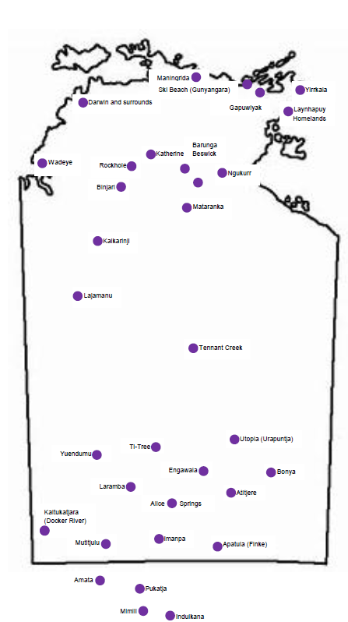

Providers and Locations

**Laynhapuy Homelands Aboriginal Corporation**

Gapuwiyak, Yirrkala, Laynhapuy Homelands Gunyangara (Ski Beach)

**Mala'la Health Service Aboriginal Corporation**

Maningrida

**Save the Children Australia**

Wadeye

**Larrakia Nation Aboriginal Corporation**

Palmerston, Gurdorrka, Kulaluk

Darwin – includes Knuckey Lagoon, Bagot,

Minmarama Park

**Yugul Mangi Development Aboriginal**

**Corporation**

Ngukurr

**Katherine West Health Board Aboriginal**

**Corporation**

Lajamanu, Kalkarinji

**Kalano Community Association Inc**

Katherine, Mataranka, Beswick, Barunga, Binjari, Rockhole

**Anyinginyi Health Aboriginal Corporation**

Tennant Creek

Children and Family Intensive Support (CaFIS)

*As at June 2022*

**Central Australian Aboriginal Congress**

**Aboriginal Corporation**

Alice Springs

**Waltja Tjutangku Palyapayi**

Ti Tree, Laramba, Engawala, Bonya, Atitjere, Utopia (Urapuntja)

**Ngaanyatjarra Pitjantjatjara Yankunytjatjara Women's Council Aboriginal Corporation**

Apatula (Finke), Imanpa, Mutitjulu, Kaltukatjara (Docker River), Amata, Mimili, Pukatja, Indulkana

**Warlpiri Youth Development Aboriginal Corporation**

Yuendumu