NDIS National Workforce Plan:
2021–2025
  - Building a responsive and capable workforce that supports NDIS participants to meet their needs and achieve their goals

  - June 2021

A message from the Minister

Senator the Hon Linda Reynolds CSC

Minister for the National Disability Insurance Scheme (NDIS)
The NDIS National Workforce Plan: 2021–2025 outlines the Australian Government’s commitment to work with NDIS participants, industry and other stakeholders to grow a responsive and capable care and support workforce, and to strengthen the sector to meet the needs and aspirations of Australians with disability, now and in the years ahead.
The initiatives in this Plan will also strengthen the broader care and support sector, ensuring more sustainable and high-quality services for older Australians and veterans.
The care and support sector is one of Australia’s largest and fastest growing sectors, with around 3,750 unfilled vacancies now and an additional 83,000 NDIS workers expected to be required by 2024.
This growth is being driven by continued rapid expansion of the number of NDIS participants and an increasing number of older Australians and veterans within our community accessing care and support.
Many outstanding people already work in the sector and, under this Plan, Commonwealth and state and territory governments will work in partnership with NDIS participants, industry, and education and employment providers to retain and grow the skilled workforce that will be required.
This Plan complements other Australian Government reforms to build a simpler, fairer, faster and more flexible NDIS.
Participants will have access to higher quality supports, improved service continuity, and a workforce that reflects the diversity of NDIS participants.
Workers will benefit from improved training and access to professional development opportunities.
Providers will benefit from better regulation across the sector and more market demand information to drive innovation and enable a flexible workforce to meet the needs of participants.
We will draw on the experience of peak bodies, participants, carers and families as initiatives are implemented and are committed to keeping key stakeholders informed on progress. The Australian Government will also work closely with states and territories to ensure complementary actions they are taking remain closely aligned.
It will be critical for every provider across the sector to also focus on their own strategies and plans to improve workforce attraction, retention and development, as well as enhancing leadership capability and fostering innovation, efficiency and best practice.
Together, through this Plan and our collective action, we will help to build a capable and responsive workforce that delivers high quality care and support that makes a positive difference to the lives of our fellow Australians.

Our vision is to build a responsive and capable workforce that supports NDIS participants to meet their needs and achieve their goals.

Governments, industry, peak bodies and workers will need to work together to:

Support and retain existing workers

Enhance care and support sector jobs to retain suitable existing workers. An NDIS provider said - If we don’t have a stable workforce, then we can’t develop their skills and the quality of services.

Grow the workforce
Attract new suitable workers to meet growth in demand for support workers, allied health professionals, nurses and others.
An NDIS participant said - The workforce is not big enough to cover demand. We really need to get more people, and provide opportunities for a career within the disability workforce.

Maintain quality of participant supports delivered by workers
Improve and maintain the quality of supports to meet the standards expected of participants
and their families. An NDIS participant said - This is a workforce that is unique. To go into people’s homes, in an uncontrolled environment, and to be professional in an unprofessional space, that brings a lot of skill sets.

Support sector efficiency and innovation
Improve regulatory alignment and enhance market information to enable more flexible use of the workforce and drive provider innovation. A provider peak said - This would massively increase the capacity of providers to meet the needs of participants around Australia, particularly rural and remote regions.

Priority actions

Sixteen initiatives will be implemented by the Australian Government to support building a responsive and capable workforce

Priority 1: Improve community understanding of the benefits of working in the care and support sector and strengthen entry pathways for suitable workers to enter the sector
Promote opportunities in the care and support sector.
Develop a simple and accessible online tool for job seekers to self-assess their suitability for new roles based on values, attributes, skills and experience.
Improve effectiveness of jobs boards to match job seekers to vacancies in the sector.
Leverage employment programs to ensure suitable job seekers can find work in the sector.
Better connect NDIS and care and support providers to employment and training providers and workers.

Priority 2: Train and support the NDIS workforce
Develop micro-credentials and update nationally recognised training
Support the sector to develop a Care and Support Worker Professional Network.
Work with the sector to establish a skills passport.
Support the sector to grow the number of traineeships and student placements, working closely with education institutions and professional bodies

Priority 3: Reduce red tape, facilitate new service models and innovation, and provide more market information about business opportunities in the care and support sector
Improve alignment of provider regulation and worker screening across the care and support sector
Continue to improve NDIS pricing approaches to ensure effective operation of the market, including in thin markets.
Provide market demand information across the care and support sector to help identify new business opportunities.
Support participants to find more of the services and supports they need online.
Explore options to support allied health professionals to work alongside allied health assistants and support workers to increase capacity to respond to participants’ needs
Enable allied health professionals in rural and remote areas to access professional support via telehealth.
Help build the Aboriginal and Torres Strait Islander community controlled sector to enhance culturally safe NDIS services

01 Context for this plan

Australia needs to build a responsive and capable disability workforce, comprising primarily of disability support workers, nurses and allied health professionals

Today 450,000 NDIS participants receive support from over 11,600 active NDIS providers employing around 270,000 workers across 20 occupations. There were 270,000 estimated workers in 2020. Workforce forecasts are from Department of Social Services and AlphaBeta analysis of National Disability Insurance Agency (NDIA) data. By 2024, around 500,000 participants will require support from almost 353,000 workers.

The NDIS National Workforce Plan (the Plan) builds on existing efforts to deliver significant improvements to the NDIS. The Growing the NDIS Market and Workforce Strategy 2019 (DSS) set out the long-term vision for a capable and responsive NDIS workforce.

The NDIS Workforce Capability Framework, developed in response to this strategy, continues to translate the NDIS Principles, Code of Conduct and Practice Standards into a set of observable skills and behaviours for workers in the sector. More broadly, the Human Services Skills Organisation Pilot is developing new ways for the training system to be more responsive to skills needs within the care and support sector.

The actions in the Plan align with Commonwealth priorities, including the Economic Recovery Plan for Australia, the JobMaker Plan and JobTrainer Fund, as well as Vocational Education and Training (VET) reforms, while also reflecting the skills needs reported by providers.

The $64.3 million investment in the NDIS Jobs and Market Fund (JMF) follows the success of the $112 million Sector Development Fund, with targeted projects to grow the provider market and workforce in size and capability. Of this, $5.9 million has been invested to support Aboriginal and Torres Strait Islander people with disability to access culturally appropriate and localised NDIS supports as part of the NDIS Ready project. Also funded through the JMF is the Frontline Leadership Role Clarity Project, which helps identify the capabilities, qualities and values required for frontline leadership in the sector.

The $41.5 million investment in the Boosting the Local Care Workforce program has funded projects to assist individual providers to transition to the NDIS, and build sector wide business and workforce capability. The appointment of a Chief Allied Health Officer in July 2020 will continue to support workforce planning and allied health leadership into the future.

Diagram of the estimated share of the NDIS workforce by occupation.

2020 estimates include disability support workers working under the National Disability Agreement (NDA) (based on in-kind services delivered in 2020) as well as disability support workers in the NDIS (Department of Social Services estimates). Occupations which make up ‘Other’ include: Chauffeurs, Interpreters, Driving Instructors, Garden Labourers, Domestic Cleaners and Home Improvement Installers.

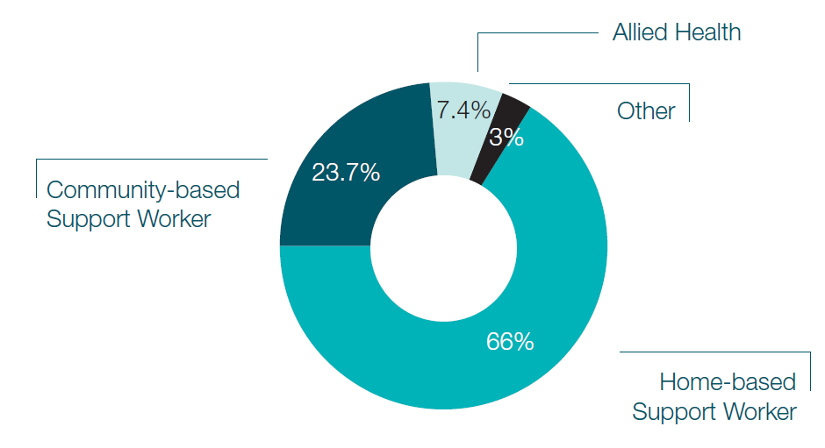
Enhancing the disability workforce will also boost the aged care and veterans’ care workforce
Disability support, aged care and veterans’ care programs are highly connected. Around 30 per cent of aged care providers also operate in the NDIS or veterans’ care programs. 36 per cent of veterans’ care providers operate across all three programs. Department of Social Services analysis comparing registered aged care providers, veterans’ care providers and NDIS providers with a claim for support provided to a participant in the 2019-2020 financial year (as at June 2020).

Like the disability sector, the aged care sector will also need to grow in the years ahead. By 2024, the sector is expected to grow by almost 20 per cent, equivalent to 57,000 people, to meet the needs of an ageing population. Based on an interpretation of Productivity Commission’s growth estimates of workforce headcount, as at 2020.

Although there are some important differences in the workforce requirements across the NDIS, aged care and veterans’ care programs, there are also many common elements and opportunities to increase regulatory alignment for providers and workers across the sector. Some of the key job roles are also common to all three programs. Strengthening the care and support sector as a whole will increase productivity and consistency across the entire sector to meet demand, and grow the pool of available workers in order for disability support, aged care and veterans’ care programs to meet demand.

Diagram of estimated share of providers operating across care and support programs at June 2020. Department of Social Services analysis of NDIS, aged care and veterans’ care registered providers (June 2020).

Estimated share of providers, June 2020 (%)

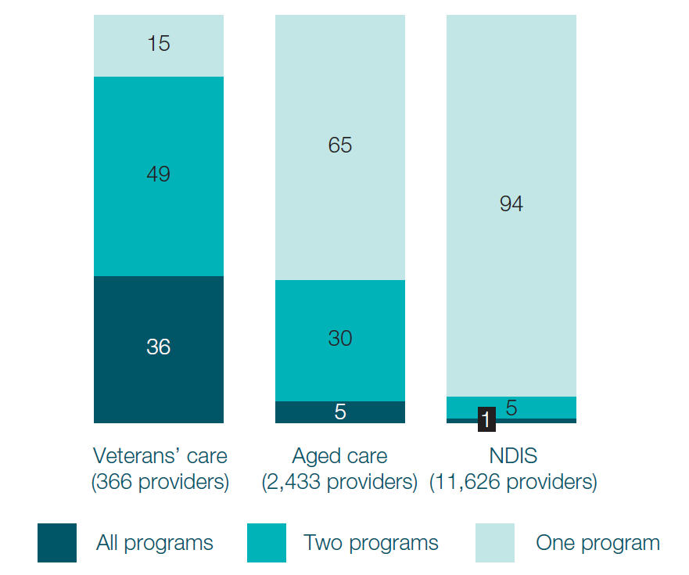

The NDIS workforce will need to grow rapidly to meet the needs of around 500,000 participants

Retain existing workers
High workforce retention is crucial for service continuity and reducing the high cost of recruiting, onboarding and training replacement workers. Historically, NDIS workforce turnover has been high relative to other sectors.
If turnover remains at this historical level, it is expected that the NDIS will lose around 213,000 workers to churn by 2024. NDIS sector turnover upper bound (25 per cent) is based on analysis of Australian Taxation Office Linked Longitudinal Employer-Employee Data (L-LEED) from 2015–2016 to 2017–2018. NDIS sector turnover lower bound (17 per cent) is based on the National Disability Services (NDS) Workforce Census, December 2019. The lower bound was used to calculate the number of workers the NDIS may lose to churn by 2024.

This is in addition to the 83,000 new workers needed to meet growth in demand. However, it is anticipated that turnover is unlikely to remain as high in forward years as initiatives under this Plan are implemented, supporting sector maturity and given the changed economic and labour market conditions.

Diagram of workforce turnover in the NDIS and other sectors 2015–2016 to 2017–2018 by percentage.

Turnover rates in other sectors are based on Australian Bureau of Statistics 6226.0 Participation, Job Search and Mobility, Australia 2017 and 2018. Sector defined by Australian and New Zealand Standard Industrial Classification subdivisions (Administrative services is Administrative and Support Services and Hospitality is Accommodation and Food Services).

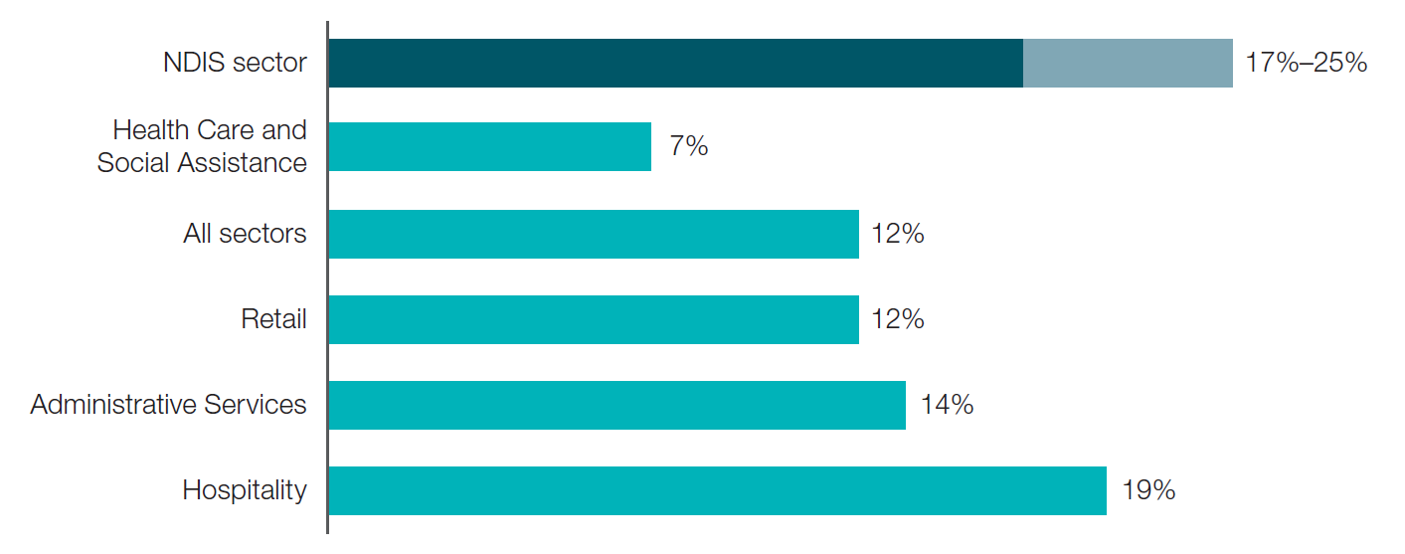

Attract new workers
The NDIS needs to attract around 83,000 net additional workers by 2024, equivalent to a 31 per cent increase in the size of the workforce. This growth will be across all states and territories and NDIS occupations, particularly support workers, nurses and allied health professionals. As the NDIS grows, attracting suitable workers will be essential. This means attracting workers with the right skills, values, attributes and diversity of experience to match the diverse range of participants. This will include a focus on attracting culturally and linguistically diverse workers, and Aboriginal and Torres Strait Islander workers to the sector, in order to meet participant needs. As a human services sector, the values and behaviours of workers are often more important to participants than the formal skills that they bring.

Estimated required growth of the NDIS workforce to 2024. Department of Social Services and AlphaBeta analysis of NDIA monthly data; Disability Reform Council (2015) NDIS Integrated Market, Sector and Workforce strategy; NDIA Quarterly Reports; Stakeholder interviews.
Occupations which make up ‘Other’ include: Chauffeurs, Interpreters, Driving Instructors, Garden Labourers, Domestic Cleaners and Home Improvement Installers. 2020 estimates include disability support workers working under the National Disability Agreement (NDA) (based on in-kind services delivered in 2020) who will transition into the NDIS as well as disability support workers in the NDIS (Department of Social Services estimates).

'000, headcount

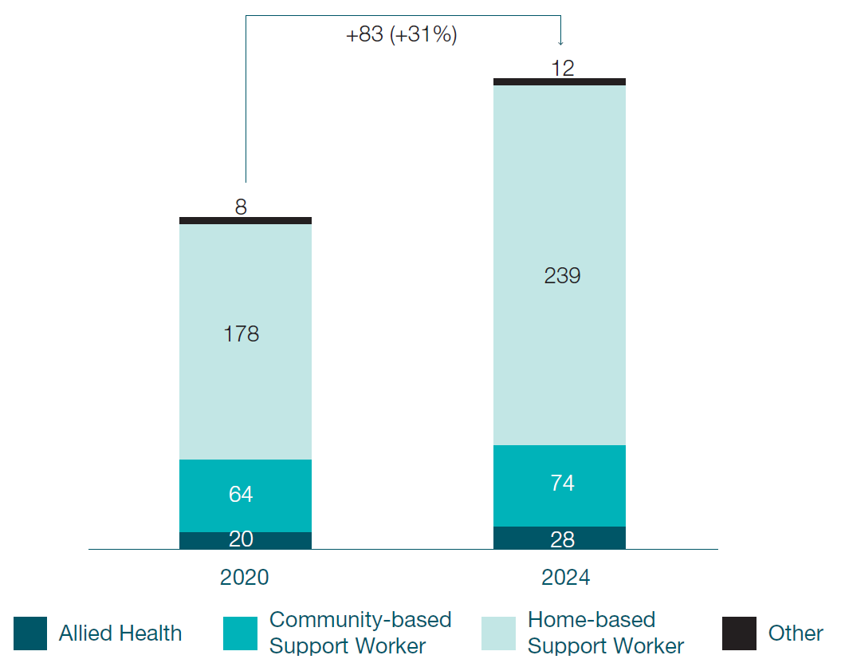

Improving workforce quality and sector efficiency will be essential to build a responsive and capable disability workforce

Maintain quality of support delivered by workers
The expectations around the quality and safety of disability support have rightly increased with the establishment of the NDIS.
The Workforce Capability Framework (the Framework), developed by the NDIS Quality and Safeguards Commission, articulates the Australian Government’s expectations around workforce quality. Moving forward, it will be crucial for governments and industry to provide support to embed the attitudes, behaviours, skills and knowledge described in the Framework in the workforce. The Australian Government will support implementation of the Framework through a range of activities, including developing resources, supporting research activities, and developing assessment criteria for the implementation of the Framework. The education sector, working with governments and providers, will also need to support the development of micro-credentials so that workers can learn and further develop on the job while also providing potential pathways to recognised qualifications.

The care and support sector will create thousands of new jobs across Australia at a critical time
The NDIS has already created a significant number of new jobs and is expected to continue to do so across each state and territory. Many of these jobs will be created in regional and remote areas.
Unemployment in Australia increased as a result of the COVID-19 pandemic, with slowing of jobs growth in other sectors.
The forecast growth in the NDIS and aged care workforce of 31 per cent and 20 per cent respectively will make a much needed contribution to jobs creation across the economy, and provides an opportunity to attract suitable workers from sectors that have lower growth prospects. Workforce forecasts based on Department of Social Services and AlphaBeta analysis of NDIA data and Department of Employment, Skills, Small and Family Business (2019 ) Occupation Projections.
This jobs growth will also support the Participant Employment Strategy 2019-2022, targeting a 30 per cent employment rate for working-age NDIS participants by June 2023.
As career pathways to the sector are improved and the focus shifts to attracting workers with the right values and as well as skills to the sector, NDIS participants and their families will be well placed to join the NDIS workforce.
Estimated required growth of the NDIS workforce to 2024. Workforce forecasts based on Department of Social Services and AlphaBeta analysis of NDIA data. Note that the forecast figures are displayed as confidence intervals, and should not be summed to compare with the total national forecast.

'000, headcount

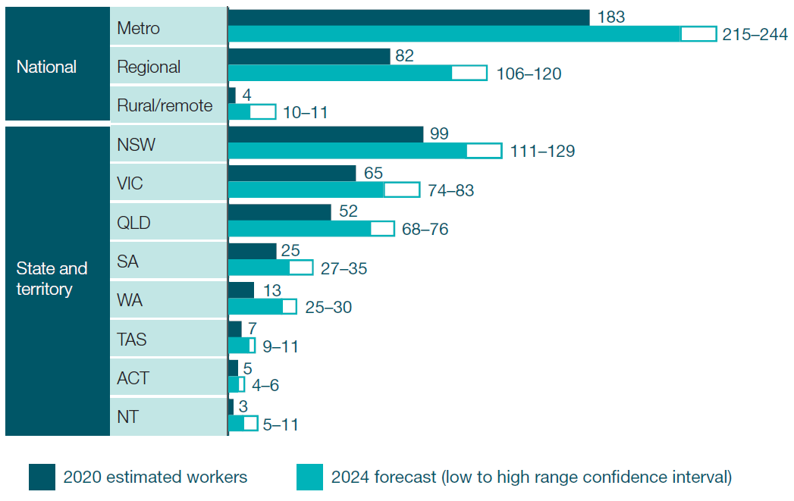

Support sector efficiency and innovation
There is an opportunity for providers in the sector to adopt innovative service models that support appropriately skilled workers to work more seamlessly across programs, with potential to deliver services to multiple client types (for example people living with a disability, veterans and older Australians accessing home care packages). This will also help to reduce the number of thin markets with service gaps, and will be supported by government actions to improve alignment of provider and worker regulation across the sector.

02 Current state of the care and support workforce

The care and support sector faces three types of challenges in developing its workforce to better meet the diverse needs of NDIS participants

Poor perception of the sector and unsupported entry pathways hinder attraction. 43 per cent of unfilled support worker vacancies were because of a lack of suitable or qualified candidates. Source - National Disability Services (2018), Australian Disability Workforce Report 3rd edition - July 2018.

Variable and disconnected work conditions with limited training opportunities impact retention and quality. 64 percent of support workers report feeling isolated in their job at least some of the time.

Red tape and difficulties in adapting service models of providers reduce the time that workers spend supporting participants. Excessive administrative tasks is the most significant challenge impacting workforce productivity. Note: These challenges were identified through extensive consultations with stakeholders, survey data and external reports.

The perception of the sector and its entry pathways should be enhanced
There is an opportunity to increase awareness of career prospects in the sector and improve how it is perceived
- Disability work is widely misunderstood. 42 per cent of Australians are unaware of what disability support work involves.
- Disability support work is perceived to have lower job prestige, pay and fewer opportunities for career progression compared to other sectors. 51 per cent of Australians would prefer retail work over disability work, and 32 per cent would prefer to work in aged care.
- There are particular challenges attracting and retaining culturally and linguistically diverse workers and Aboriginal and Torres Strait Islander workers. In many communities, there is a lack of culturally appropriate communications materials about the NDIS, and there remains a lack of community understanding about the NDIS and the broader disability sector.
Low and variable hours affect take-home pay
- Many workers (34 per cent) in the disability sector are employed casually. While for some workers casual work is attractive and the flexibility is important to them, other workers would like the opportunity to work regular full time hours. While casualisation in the NDIS has fallen slightly from its peak of 42 per cent in late 2018, it is still higher than in aged care (14 per cent).

Difficulty identifying and matching suitable workers is also an issue
- The main reasons for unfilled NDIS vacancies are a lack of suitable or qualified candidates (43 per cent) and candidates being unable or unwilling to meet specific job requirements (29 per cent).
Limited opportunities for entry-level workers to enter the NDIS restricts the future workforce pipeline.
- Clinical placements and work experience in disability for allied health professionals directly influences recruitment into disability positions, but NDIS placements are increasingly limited. Education providers, disability providers and state and territory governments need to work together to re-establish pathways between education and industry that may have been disrupted through the introduction of the NDIS.
- Implementing traineeships for support workers is more complex as supervisory arrangements in a participant’s home look different to a more traditional service setting.

Disability support work is perceived as having low job prestige, low pay, and limited opportunities for career progression.

Diagram of share of respondents that responded 'very good' or 'fairly good' to each statement in percentage

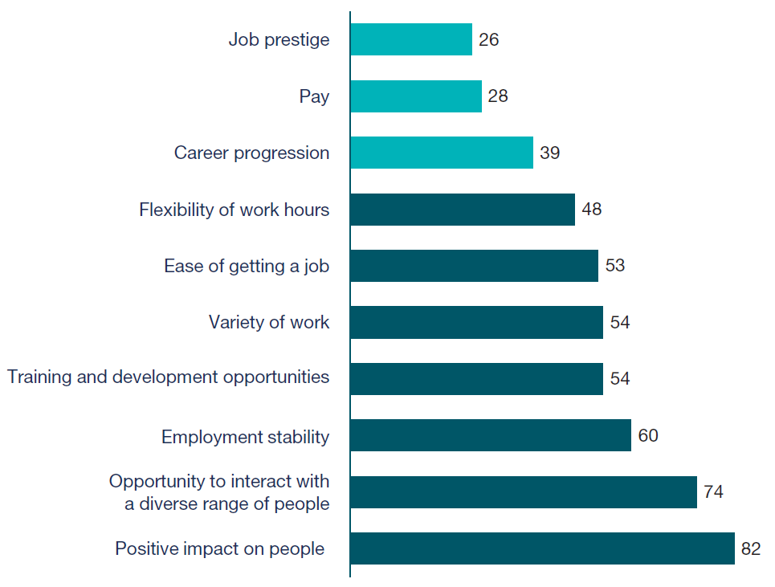

Workers want to feel connected to their peers and increase their professional skills
Disconnection with peers and organisation and low engagement
- With the rise of individualised support, more workers are delivering support alone. Work such as in-home support can be isolating for workers who do not interact with their colleagues on a day to day basis.

Lack of time and resources to train and supervise workers
- NDIS providers have a responsibility to ensure workers are adequately trained in the skills they need. However, many providers report that they struggle to provide necessary training and supervision to staff due to lack of time and resources.
- It is common for workers to sacrifice time earning wages in order to do training. A 2020 study found that 20 per cent of providers said that staff were not paid for all the time spent to attend training and development activities.
Less relevant and inconsistent training for workers
- Training needs to evolve quickly to match the changing needs of participants. Only 31 per cent of workers strongly agreed that their skills were well matched to the work they are asked to do. Workers are increasingly disinterested in traditional qualifications, in part due to the preference among participants for workers who have been trained in supports which respond to their unique requirements.
- Consultations with industry indicate that different entry requirements across the sector and on-the-job training across providers has contributed to inconsistent training for NDIS workers. There are currently no minimum qualifications to work in the NDIS and job ad data showed only 50 per cent of providers required a certificate qualification.
- Workers have increasingly turned to more relevant training developed by providers to upskill, but this training has limited recognition across the broader sector.

NDIS workers prefer specific, rather than general training courses
Training preferences reported by NDIS workers
Share of survey respondents, 2019 (%, n=615 NDIS workers)

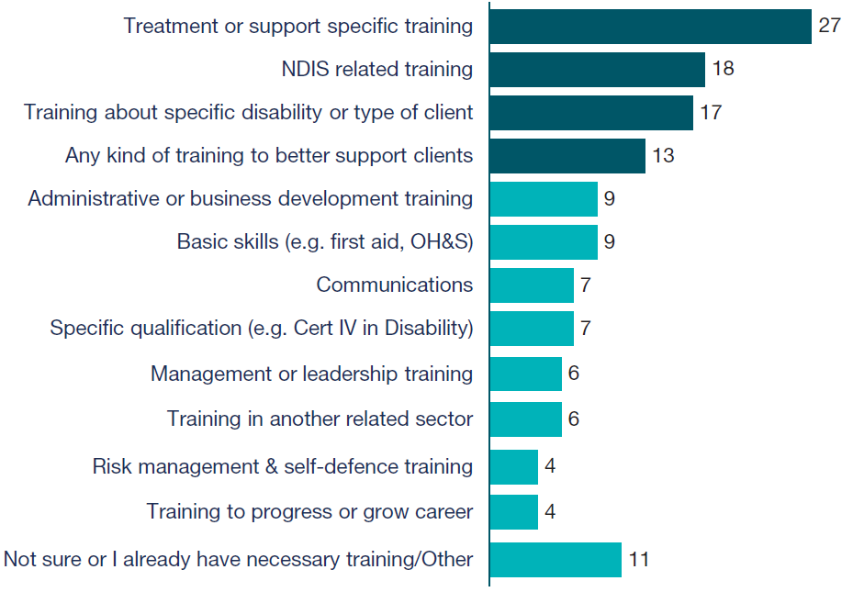

Red tape should be reduced to encourage innovation and adaption
Administrative burden can deter market entry
- 58 per cent of providers agree or strongly agree that there are too many unnecessary rules and regulations in the NDIS. Providers report that costs of processes like audits, which can cost upwards of $15,000, impact viability in the NDIS, particularly for small providers.
- Only 30 per cent of aged care providers operate in the NDIS despite opportunities to improve workforce productivity and manage peak demand periods.
- During consultations, allied health providers cited administrative hurdles as one of their top challenges to attracting workers to the sector.
There is a need for more market information to support growth and innovation
- Many providers report that they find it difficult to identify opportunities for growth and areas of unmet demand, limiting growth potential and attractiveness of entering the sector. While the NDIS Demand Map has provided valuable information on local market potential, there is a need for more information on broader care and support sector market opportunities.
- Many providers report that under existing price caps they struggle to invest in new business processes and technologies. Many small providers, including sole traders that account for over 40 per cent of active NDIS providers, find it difficult to take their business online, making it hard for participants to find their supports.

- Providers and business leaders need to be supported and encouraged to invest in themselves at the same time as transitioning to more innovative technologies. Investment in leadership capabilities, including at the board, senior management and supervisory levels, can help to strengthen provider capability while generating the change needed for greater innovation.
Duplication of worker screening creates additional barriers to entry for workers
- Differences in worker screening checks across the care and support sector create barriers for workers to move across programs. For example, aged care workers who have their aged care screening check and want to work in the NDIS must undertake an NDIS screening check. This creates barriers for workers to move across the care and support sector.

Varying demand that leads to rostering and administrative challenges impacts productivity
Most significant challenges impacting the productivity of the NDIS workforce
Share of providers with challenge listed in their top three (%)

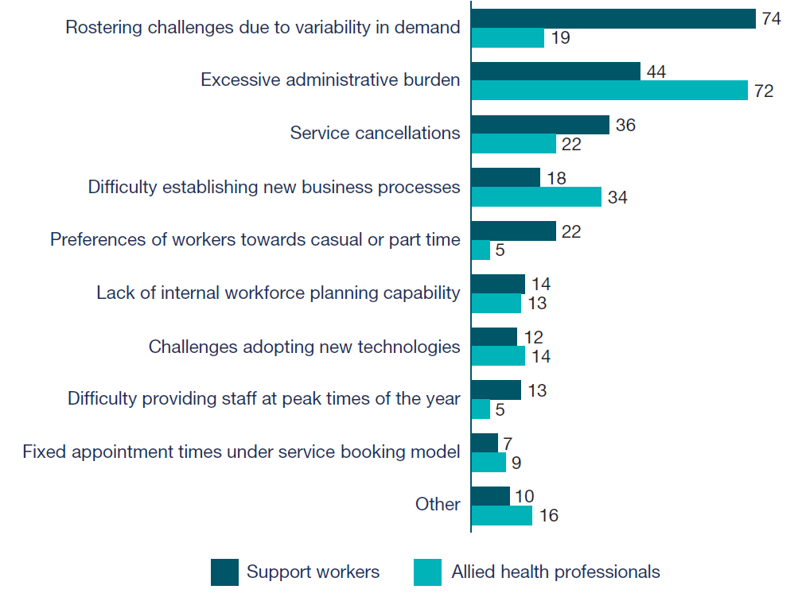

Many of these workforce challenges are particularly acute in regional and remote communities and in supporting participants with complex needs
Thin markets face more acute and varied challenges in growing a quality workforce. These challenges include a lower supply of providers and workers already operating in these markets, difficult working conditions and barriers to accessing training and support. Thin markets for the NDIS occur by service type (including supports for participants with complex needs) or by geography, mostly in regional and remote communities.
For example, attracting workers is particularly challenging in regional communities, with longer vacancy times and smaller applicant pools. It takes regional employers 22 per cent longer to fill vacancies in disability and aged care roles, with each vacancy attracting 55 per cent fewer suitable applicants. Remote and regional workers often have limited access to supervision, support and training in their communities, which can lead to talent drain to metropolitan areas.
NDIS providers also report having difficulty recruiting and retaining an adequately skilled and experienced workforce to support participants with high and complex needs. This includes a lack of workers with the ability to assist participants with psychosocial disability. In 2019, the then Disability Reform Council agreed to use a more flexible approach to address thin market challenges in the NDIS. This was based on extensive engagement with participants, providers and peak bodies through surveys and workshops held across Australia.
Since then, projects to address thin markets have been implemented in all jurisdictions to address specific needs, such as disability support types. This includes deepening the behavioural support market in Victoria and the Australian Capital Territory, and professional groups including allied health.
Workforce diversity is increasingly important to support choice and control. Aboriginal and Torres Strait Islander people and people from culturally and linguistically diverse backgrounds experience additional barriers to accessing supports where the current workforce is unable to meet their language and cultural needs.

Disability worker experiences in regional vs metropolitan areas, Share of workers (%)

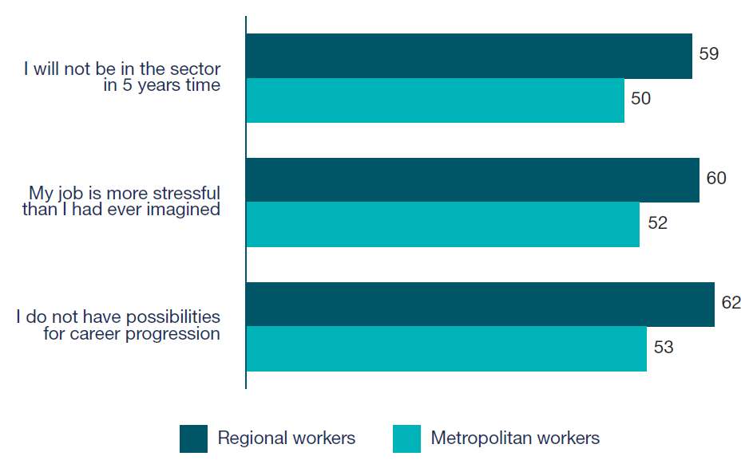

03 Priority actions – detailed view

Government will take action across three key priorities to overcome long-standing workforce challenges and improve outcomes for NDIS participants

- Improve community understanding of the benefits of working in the care and support sector and strengthen entry pathways for suitable workers to enter the sector

- Train and support the NDIS workforce to support retention and meet the needs of NDIS participants

- Support efficiency and innovation through reduced red tape, new service models and innovation, and improved market information.

Priority 1

Five initiatives form an integrated user journey to attract new workers with suitable values, attributes and skills to the care and support sector workforce

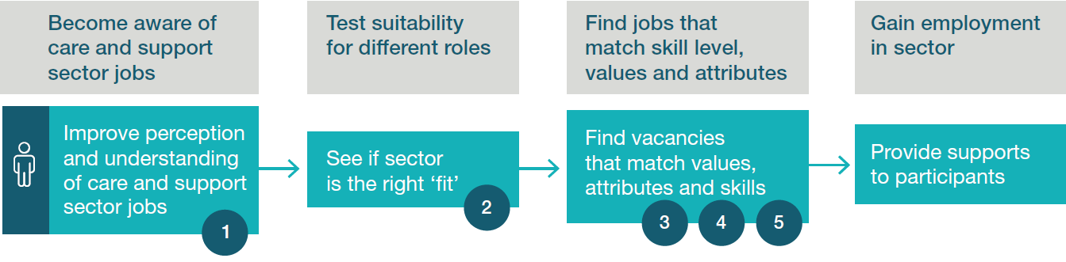

- To help raise awareness in the care and support sector, and change public perception of the work, communication activities will promote opportunities in the care and support sector, highlight success stories, promote support work as a career and highlight the benefits of working in the sector.

- As more people become aware of care and support sector roles, they will need to see if the sector is the right ‘fit’ for them. An online tool for potential workers to self-assess suitability and skills required to work in the sector, based on values and attributes, skills and experience, will be an important first step in a more integrated job seeker journey.

- More targeted jobs boards will then better match suitable job seekers to vacancies based on their values, attributes, skills and experience.

- Employment programs will be leveraged to ensure suitable unemployed job seekers can find work in the sector. This will include enhancing the links between care and support service employers and employment service providers, possible improvements in the New Employment Services Model to outcome payments and performance ratings frameworks, and improving information to job seekers.

- The Australian Government will use the Boosting the Local Care Workforce program to support stronger connections between employment service providers, universities, VET and NDIS providers.

As workers gain employment in the sector, they will have access to a learning system and culture, developed in Priority 2,that promotes and supports ongoing career development.
1. Promote opportunities in the care and support sector - Working in the care and support sector is often poorly perceived by the public as a low paid job with limited career potential and low prestige. Recent Royal Commissions have shone a light on the challenges in the sector which have contributed to changing perceptions of care work. The workforce also does not reflect the diversity of the participants Communication activities will lift public perception of the sector, highlight the benefits of working in the sector, promote and showcase the opportunities across diverse care and support sector roles. Communications will emphasise the values and attributes required for care and support sector roles to support

2. Develop a simple and accessible online tool for job seekers to self-assess their suitability for new roles based on values, attributes, skills and experience. Employing workers with the right values and attributes is critical to ensuring quality of care. Misaligned values and attributes of support workers was raised as a key NDIS workforce challenge by participants and providers. At a time of high unemployment, this tool provides an opportunity to attract more workers while ensuring they have the right skills and attributes.supports. The tool would support individuals in developing career goals, identifying job

3. Improve effectiveness of jobs boards to match job seekers to vacancies in the sector opportunities, and required support for training needs (including links to micro- Online job platforms are the most common tool people use to look for new jobs and to hire workers. As job seekers recognise their suitability for the sector, they may struggle to identify vacancies to match their skills, values and interests.credentials). Jobs boards will be improved to make it easier for suitable job seekers to find care and support sector jobs that match with their capacity and skills.

4. Leverage employment programs to ensure suitable job seekers can find work in the sector. There is scope to better leverage existing initiatives (including through the introduction of the New Employment Services Model) to enhance efforts to identify job seekers suitable for care and support work, raise awareness of opportunities in the sector, and ensure strong links between employment service providers and care and support workforce employers. Employment services providers are incentivised to place job seekers into work with sufficient hours to reduce reliance on income support which could de-emphasise the placement of job seekers in industries with jobs that are unpredictable or that have relatively few hours. Despite this, a higher proportion of job seekers who take up care and support sector roles are still in employment after six months and working sufficient hours to no longer receive income support, when compared with the average. This could include enhancing efforts to identify job seekers suitable for care work (through providers and digital services), raising awareness of care workforce opportunities, and ensuring strong links between care and support service employers and Employment Services Providersfor all other sectors.

5. Better connect NDIS and care and support providers to employment and training providers and workers. Job seekers (school leavers, VET students, unemployed people, allied health students) are not always aware of NDIS or broader care and support sector opportunities and not all Employment Services Providers are actively targeting opportunities in the NDIS and care and support sector. NDIS providers report great difficulty in attracting allied health professionals from university, with reports that universities do not recognise the growth potential in the NDIS and care and support sector more broadly. Boosting the Local Care Workforce coordinators will provide market information on demand for workers to educators (schools, VET providers and universities) and employment service providers and support them to connect with care and support sector providers. This will support job seekers (including school leavers, those with disability, family carers with lived experience of disability) and students to find NDIS and care and support sector employment opportunities. Connections will be leveraged with other government programs to help promote care and support sector employment opportunities. Boosting the Local Care Workforce coordinators can support providers to improve the sophistication of their workforce and attraction strategies by fostering connections between business leaders to showcase innovation and success stories.

Priority 2

Four initiatives will provide a stronger learning system and culture throughout the career of an NDIS worker

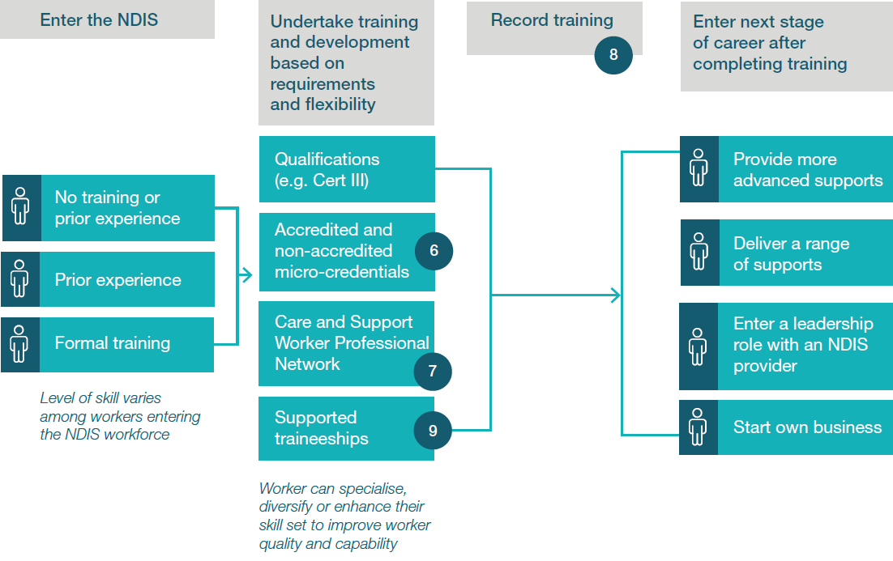

- Accredited micro-credentials will enable workers to upskill. Over time, these micro-credentials and other learning activities based on skill sets may build towards a recognised qualification. Non-accredited training remains an important tool for educating staff on NDIS standards and an organisation’s service expectations.

- A Care and Support Worker Professional Network will promote excellence via a professional network which provides peer mentoring, professional development, and opportunities to collaborate across, and deepen practices within, disciplines.

- As NDIS workers undertake different training and development based on their needs, training will be recorded on a skills passport. The skills passport will strengthen the recognition of training in the sector and support career development.

- Students will be able to discover entry-level pathways into the care and support sector through supported traineeships. These supports will enable providers to offer more entry-level opportunities to inexperienced workers.

6. Develop micro-credentials and update nationally recognised training to improve the quality of supports and enhance career pathways. More than half of workers said that the main barrier to training was lack of time. Moreover, training has not evolved quickly enough to match the changing needs of participants. Only 53 per cent of workers find that their qualification prepared them very well for their role. Some participants need workers to be trained in specific things e.g. cultural competency or complex needs. Job seekers wanting to work in the care and support sector may be discouraged from seeking opportunities if there is a hard qualification barrier to entry. Accredited micro-credentials provide a viable initial learning pathway, which can later lead to formal qualifications. Leverage the industry-led Human Services Skills Organisation (HSSO) and relevant Industry Reference Committees (IRCs) to develop micro-credentials and update nationally recognised training to support the skills needs and career pathways of the broader care and support sector. The values and behaviours outlined in the NDIS Workforce Capability Framework will be embedded into training, and used to shape skills pathways in the sector. The Department of Education, Skills and Employment will work with HSSO and IRCs to provide support, build engagement and explore innovative models to advance this initiative. Options to support the development of micro-credentials to enhance culturally safe practices for Aboriginal and Torres Strait Islander and culturally and linguistically diverse care recipients will also be explored. Micro-credentials will be linked to job roles and career pathways in the sector.

7. Support the sector to develop a Care and Support Worker Professional Network. Industry leaders say lack of peer connection and support in a challenging job is a major retention challenge. Workers report feeling isolated in their jobs with limited opportunities to meet and network with colleagues. Almost two thirds of workers felt isolated in their jobs at least some of the time. The Network will help workers engage with their peers and mentors to foster a culture of peer learning and continuing professional development. The types of supports offered through the Network will be developed in consultation with the sector and with workers. The Network will adapt information and ensure accessibility in order to meet the needs of regional and remote workers who may experience a greater lack of peer connection.

8. Work with the sector to establish a skills passport. Evidence indicates that disability support workers feel organisations do not properly recognise their skills and skills are not transferable across providers. One reason for this is the rise of informal, provider-based training that is frequently updated to reflect the evolving sector. Informed by the outcomes of a trial with NDIS providers currently underway in Western Australia, as well as similar approaches in other industries, a skills passport for the care and support sector will be developed to provide industry with a record of training undertaken by workers. The skills passport will focus on recording and verifying training (non-accredited), professional development, screening checks, and references for individual workers. An industry-led group will be established to identify relevant and valued non-accredited courses to be verified and recorded in the skills passport. Opportunities to connect the Unique Student Identifier transcript, which is a record of nationally recognised training, with the skills passport, will be explored in the design phase, subject to worker privacy.

9. Support the sector to grow the number of traineeships and student placements, working closely with education institutions and professional bodies. Traineeships and student placements are a valuable source of training and work experience for potential NDIS workers and providers. Demand for traineeships is low due to a lack of awareness. Providers have reflected that supply for traineeships and student placements is low as they lack resources to provide supervision, cover costs of administration relating to placements, and guarantee work hours. Governments will explore how training organisations, tertiary institutions and professional bodies can be supported to increase the number of traineeships and student placements offered in the sector. Tips and guidelines about offering effective traineeships in the NDIS workforce will be developed by industry and governments. Traineeships will be promoted to various cohorts (e.g. students, workers transitioning from other industries).Governments will work with tertiary institutions and professional bodies to explore how student placements can be delivered efficiently in a disaggregated market.

Priority 3

Seven initiatives have been identified to remove red tape, encourage new service models and improve market information to enable efficient operation

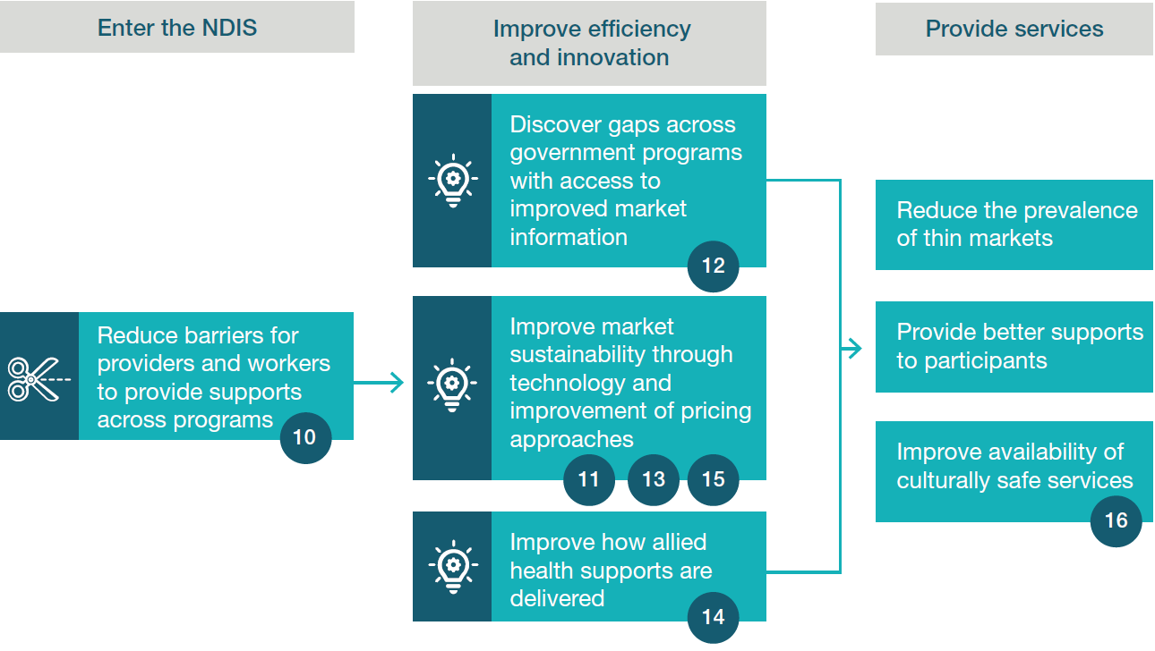

- Aligning provider regulation and worker screening requirements across the care and support sector will increase the number of workers and providers able to operate in the market, providing greater choice and control for participants without compromising on quality and safeguarding.

- The sustainability and effective operation of the market will also be supported by continued improvements to NDIS pricing approaches.

- Providers will be able to expand services across government programs and in thin markets through access to market demand information across the care and support sector.

- Participants will be able to more easily identify services and supports online.

- Improved connections between allied health professionals, assistants and support workers will improve participant supports and health outcomes.

- Access to professional support via telehealth will allow allied health professionals in rural and remote areas to deliver a greater range of supports in regional and remote communities.

- Building the Aboriginal and Torres Strait Islander community-controlled sector will enhance culturally safe NDIS services.

10. Improve alignment of provider regulation and worker screening across the care and support sector. Different worker screening checks within the care and support sector create duplication in screening for workers looking to work in adjacent programs. Higher registration and compliance costs for providers operating in the NDIS is a key challenge in attracting providers to the sector. A review will explore options to achieve greater regulatory alignment across the care sector, including for disability, aged care and veterans’ affairs. The review will explore the merits of streamlining provider audits and worker screening checks, while still maintaining quality.

11. Continue to improve NDIS pricing approaches to ensure effective operation of the market, including in thin markets. Pricing approaches influence the quality of supports, participant outcomes, innovation and broader sustainability. The Australian Government will continue to consider pricing approaches that improve the effective operation of the market for NDIS services, including in thin markets. This will include a pricing project to consider approaches to improve pricing practices and governance, building market confidence and consumer choice and supporting workforce development.

12. Provide market demand information across the care and support sector to help identify new business opportunities. Several government agencies collect care and support sector market data but information is not shared with providers in a consolidated way, making it difficult to effectively operate and expand across programs. Potential and existing providers will be able to access and use market demand information across the care and support sector to identify opportunities and make informed business decisions about market entry and growth, particularly in thin markets.

13. Support participants to find more of the services and supports they need online It can be challenging for participants and their families and carers to find providers near them that offer the supports they need in the online environment. The Government will explore options to better assist participants and their families and carers to identify supports online, working closely with participants and providers.

14. Explore options to support allied health professionals to work alongside allied health assistants and support workers to increase capacity to respond to participants needs. The efficient delegation of appropriate tasks to allied health assistants or support workers can increase the capacity of allied health professionals by up to 17 per cent and enable allied health professionals to deliver more services to participants. Options will be explored through co- design to ensure appropriate models are developed and implemented. Future stages should explore additional training and regulatory requirements for AHAs and support workers.

15. Enable allied health professionals in rural and remote areas to access professional support via telehealth. Allied health professionals can be isolated and require support to review practice decisions, and supervision to provide high quality services to rural and remote participants. Options to enable allied health professionals to access professional support and supervision remotely will be explored, including for multidisciplinary team interventions.

16. Help build the Aboriginal and Torres Strait Islander community-controlled sector to enhance culturally safe NDIS services. Aboriginal and Torres Strait Islander people can face additional challenges when trying to join the care and support sector workforce. Research has shown that Aboriginal and Torres Strait Islander people often prefer to use Aboriginal community-controlled services where available. Support for these organisations will be critical to ensuring the availability of culturally safe services, and, in turn, will enable the growth of the Aboriginal and Torres Strait Islander care and support workforce. Government will support Aboriginal Community Controlled Health Organisations to become registered to deliver NDIS services through the NDIS Ready project. Governments will continue to explore options to attract Aboriginal and Torres Strait Islander workers, including leveraging connections with other government programs.

04 Role for providers in the care and support sector

Role for providers in the care and support sector
Providers and associated peak bodies will play a crucial role in the successful implementation of the initiatives and vision of the NDIS National Workforce Plan. It will be particularly important for providers to continue to focus energy and investment in the following areas.

Cultural and service model transformation
- Providers should lead organisations through the cultural change (toward professionalism, innovation and digital literacy) needed to embrace opportunities to support participants under the NDIS.
- As governments align regulation and develop tools and platforms to reduce administrative burden in the sector, providers will be expected to reinvest reduced costs of regulatory compliance in initiatives that support innovation, underpinning their long term sustainability and efficiency.
- Providers have a responsibility to consider their employee value proposition to ensure conditions of employment remain competitive relative to other industries to support the attraction and retention of suitable workers.
- Providers can contribute to the overall perception of the sector by striving for best practice.
- Providers have the opportunity to lead the shift towards values-based hiring practices and leadership.

Active workforce planning and investment in skills development and leadership capability
- Providers should undertake active, long term workforce planning that ensures they are well positioned for current and future workforce requirements, including in leadership and supervisory roles.
- Providers have a responsibility to invest in training and support resources for their workers, and to take a long-term view of skills needs in their organisations and the sector.
- Providers should identify career pathways and develop mechanisms to recognise outstanding achievements.
- Providers should also focus on strategies to enhance leadership capabilities at the board, senior management and supervisory levels to support long term success.

05 Benefits and implementation

These 16 initiatives will generate benefits for participants, workers, providers, and the broader Australian economy

Benefits that will flow from implementation of this Plan

Participants
- Improved participant outcomes
- Increased capacity to meet demand, including in thin markets
- Greater choice and control, and diversity of services
- Continuity of services

Workers
- Decrease in workforce churn
- Increase in average work hours due to reduced red tape
- Substantial growth in workforce size across the NDIS and broader care and support sector
- Higher adoption and completion of training

Providers
- Increase in adoption of innovative service models
- Greater visibility of opportunities in the market
- Reduced red tape

Economy
- Job creation
- Increase in number of business opportunities

Consultation, engagement and monitoring throughout implementation
The Australian Government will work with state and territory governments, industry, providers, participant groups and workers to design and deliver the initiatives in this Plan.
This will include:
- Convening stakeholder briefing sessions shortly after publication of the Plan, followed by regular updates.
- Engagement sessions and working groups to support the co-design of the initiatives in this Plan where appropriate, drawing on the experience of peak bodies, providers and participant groups.
- Ongoing collaboration with states and territories on linkages between this Plan and related state and territory initiatives.
To ensure there is momentum and accountability to achieve results, we will monitor and evaluate the success of the Plan through to 2025 using success indicators for each initiative and established stakeholder feedback mechanisms. Implementation will be reviewed and adjusted over time to take account of feedback from stakeholders and findings of the Royal Commission into Violence, Abuse, Neglect and Exploitation of People with Disability.

