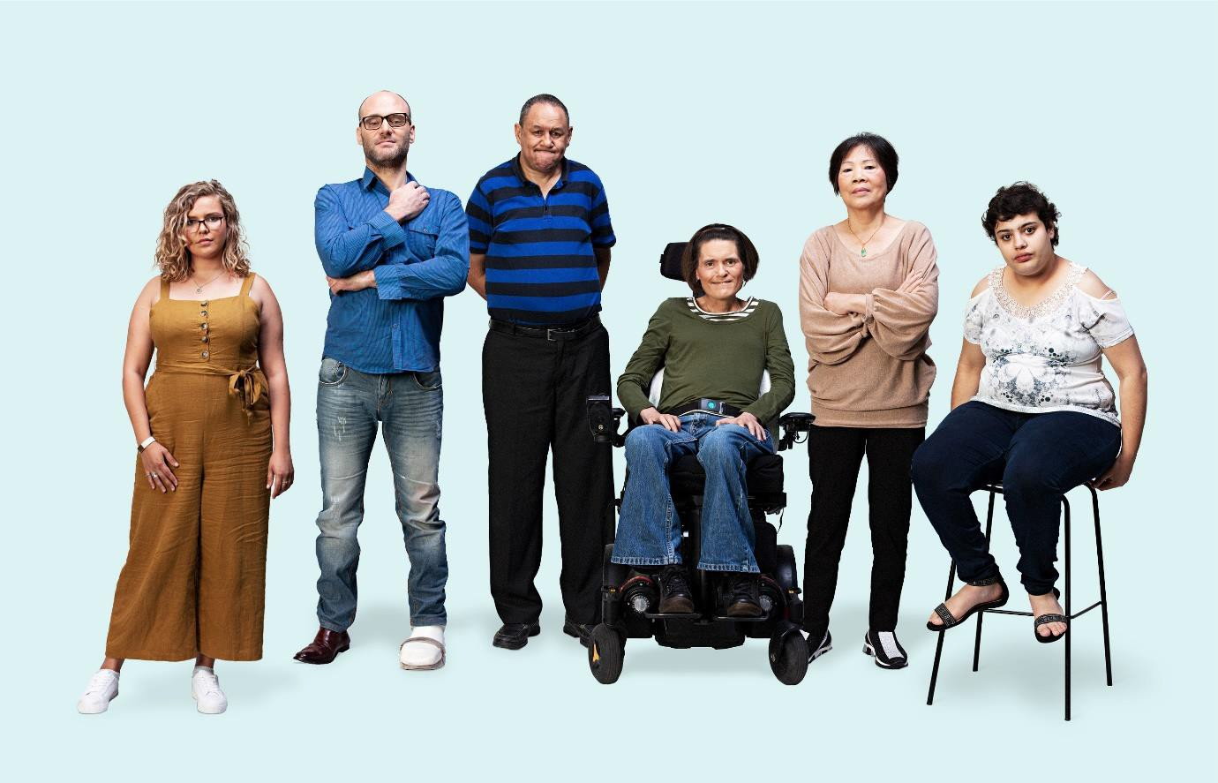
Counselling and advocacy support
For people affected by violence, abuse, neglect and exploitation or engaging with the Disability Royal Commission

Communication toolkit
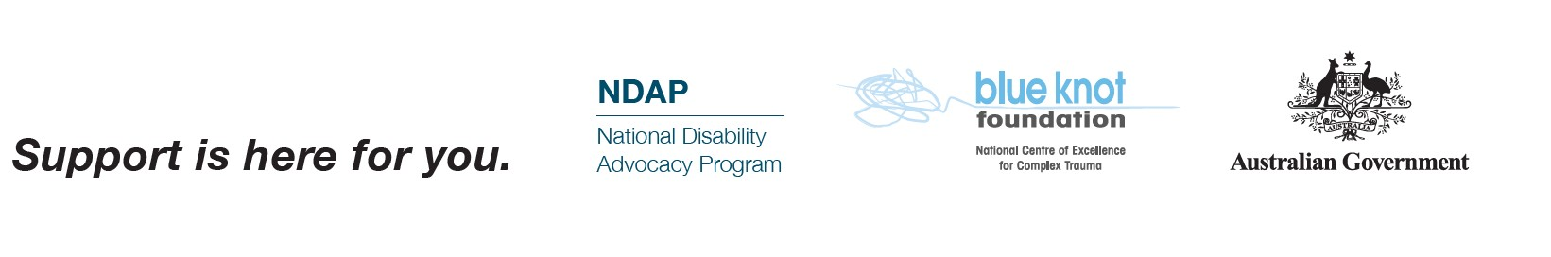
Last updated 8 June 2021
1

What’s in this kit?
Introduction 3
Disability Royal Commission 4
Counselling support 5
Advocacy support 6
Support for Aboriginal and Torres Strait Islander peoples with disability 7
Legal and financial support 8
Social media and website images 9
Accessible resources 10
Social media content 13
For people with disability 13
People with disability from culturally and linguistically diverse backgrounds 14
Aboriginal and Torres Strait Islander people with disability 15
Family, friends, carers and support workers 16
Newsletter or website content 18
Frequently asked questions 20

Introduction

The Australian Government is funding counselling and advocacy support services for:

- people with disability who have experienced violence, abuse, neglect and exploitation
- anyone who is engaging with or affected by the Royal Commission into Violence, Abuse, Neglect and Exploitation of People with Disability (‘the Disability Royal Commission’).

These services are free, independent and confidential.

Anyone who wishes to access these supports does not need to make a submission or have any prior involvement with the Disability Royal Commission.

Advocacy and support services are available to a wide range of people including, but not limited to, women with disability, children with disability, Aboriginal and Torres Strait Islander peoples, people from culturally and linguistically diverse backgrounds, and members of the LGBTIQ+ community.

As a key touchpoint for people with disability and their family members, friends and carers, we encourage you to spread the word about these support services to ensure people get the support they need.

The Department of Social Services (DSS) has developed this communication toolkit to provide you with a suite of materials to help get the message out.

We are continuing to explore new ways to raise awareness of these support services, and we will provide you with updates as they become available.

Disability Royal Commission

On 5 April 2019, the Prime Minister, the Hon Scott Morrison MP and former Minister for Families and Social Services, the Hon Paul Fletcher MP, announced the establishment of the Royal Commission into Violence, Abuse, Neglect and Exploitation of People with Disability (Disability Royal Commission).

In Australia, royal commissions are the highest form of inquiry on matters of public importance.

The Disability Royal Commission wants to hear from the Australian community about experiences of violence, abuse, neglect and exploitation of people with disability.

People can tell the Disability Royal Commission about their experiences of violence, abuse, neglect and exploitation by phone, in writing, or by making an audio or video recording.

The Disability Royal Commission will run until September 2023.

For information about the work of the Disability Royal Commission call 1800 517 199 or visit disability.royalcommission.gov.au.

Counselling support

The National Counselling and Referral Service, delivered by Blue Knot Foundation, provides free, independent and confidential counselling to support people with disability, family members, carers, advocates and workers who have experienced or witnessed violence, abuse, neglect, or exploitation.

Blue Knot Foundation are specialists in phone counselling and complex trauma. They will provide short to medium-term, trauma-informed counselling over the telephone, or online (through webchat) or video conference.

There are also a number of additional organisations across Australia funded to deliver more in-depth counselling services including in-person, medium-term, trauma-informed counselling to help those who may have complex needs.

The National Counselling and Referral Service may refer people to these organisations where needed or people can contact these organisations directly.

All counselling providers are listed on pages 22–24 of this toolkit or you can visit the DSS website to find support services in your area.

Contact the National Counselling and Referral Service on 1800 421 468 (9am to 6pm weekdays, and 9am to 5pm weekends and national public holidays).

People who are deaf or have a hearing or speech impairment can contact the service through the National Relay Service (NRS) on 133 677.

People who require support in another language can use the Translating and Interpreting Service (TIS National) free of charge by:

- calling the National Counselling and Referral Service on 1800 421 468 and asking for an interpreter; or
- calling TIS National on 131 450 and asking to be connected to the National Counselling and Referral Service on 1800 421 468.
Visit dss.gov.au/disability-royal-commission-support for more information.

Any person currently experiencing any form of violence or abuse, or who is concerned for their or someone else’s safety, should call 000 immediately.

Advocacy support

After the Disability Royal Commission was established, 50 National Disability Advocacy Program (NDAP) providers across Australia received additional funding to provide independent advocacy support for people with disability, or family members or carers acting on their behalf, who may have difficulty in communicating or understanding the process.

An advocate can help a person with disability to:

- understand how to tell their story to the Disability Royal Commission
- work out problems or avoid discriminatory issues
- find communication supports such as interpreters
- access supports such as legal or financial services related to the Disability Royal Commission.

The Australian Government recognises the need to fund disability representative organisations for systemic advocacy, which seeks to remove barriers and address discrimination to ensure the rights of people with disability. For that reason, we are also funding seven disability representative organisations to:

- Develop submissions and prepare case studies for the Disability Royal Commission.
- Support members, both organisational and individual, to understand and engage with the Disability Royal Commission, including workshops and forums to reach vulnerable individuals and groups.
- Engage with hard to reach individuals and groups such as Aboriginal and Torres Strait Islander people with disability and people with disability from culturally and linguistically diverse backgrounds.

Advocacy providers are listed on pages 22–24 of this toolkit or you can visit the DSS website to find support services in your area.

People can contact the National Counselling and Referral Service on 1800 421 468 and ask to be referred to an advocate near them. For more information, visit dss.gov.au/disability- royal-commission-support.

Support for Aboriginal and Torres Strait Islander peoples with disability

Counselling and advocacy providers are funded to provide a range of independent, culturally appropriate counselling services to help those who may have complex needs and require more in-depth support, including Aboriginal and Torres Strait Islander peoples with disability and their families.

In some areas of Western Australia, South Australia, the Northern Territory and Queensland, counselling support is delivered by Aboriginal and Torres Strait Islander organisations.

Up to eight Indigenous Community Advocates will soon be employed to increase access to culturally appropriate support and information in identified communities.

The Australian Government has funded the First Peoples Disability Network (FPDN) to help build the capability of support providers to strengthen their understanding, skills and capacity to deliver culturally appropriate supports.

FPDN are developing a range of Aboriginal and Torres Strait Islander resources about the support services available, and working separately with the Disability Royal Commission itself on producing culturally appropriate information and videos about the process for sharing your story. More information is available at https://fpdn.org.au.

FPDN, along with the Department of Social Services and other partners, are also working to build pathways and connections with disability stakeholders and providers across Australia to find innovative ways to ensure Aboriginal and Torres Strait Islander people with disability, their families and communities find and access the support they need.

Contact the National Counselling and Referral Service for counselling support, or ask them to connect you to a counsellor or advocate near you. Contact details are on page 5.

Counsellors and advocates can arrange translations and interpreting for people who need help in another language.

Counselling and advocacy providers are listed on pages 22–24 of this toolkit or you can visit the DSS website to find support services in your area.

Visit dss.gov.au/disability-royal-commission-support for more information.

Legal and financial support

The Australian Government is funding free legal support and financial assistance for people who are engaging with the Disability Royal Commission.

Your Story Disability Legal Support is a free, national legal service. It provides information and legal advice to people about safely sharing their story with the Disability Royal Commission.

Your Story is available to people with disability, their families and carers, supporters and advocates.

Your Story does not provide legal advice to organisations e.g. disability service providers, non-government organisations and residential facilities.

Your Story for Aboriginal and Torres Strait Islander people with disability is delivered by Legal Aid Commissions and Aboriginal and Torres Strait Islander Legal Services in each state and territory (except Queensland where it is delivered by the Queensland Indigenous Family Violence Legal Service).

To contact Your Story Disability Legal Support:

- Call 1800 77 1800 (9am to 5pm AEST Monday to Friday)
- Visit www.yourstorydisabilitylegal.org.au

Financial assistance is also available for individuals and entities to help meet the costs of legal representation and disbursements associated with engaging with the Disability Royal Commission.

To contact the Attorney-General’s Department Financial Assistance Section:

- Call 1800 117 995 (9am to 5pm AEST Monday to Friday).
- People who are deaf or have a hearing or speech impairment can call the National Relay Service and give 02 6141 4770 as the number to call.
- Visit the Attorney-General’s Department website for more information.

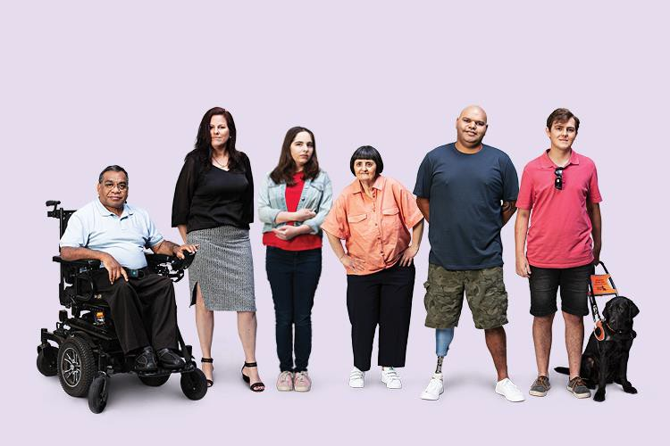
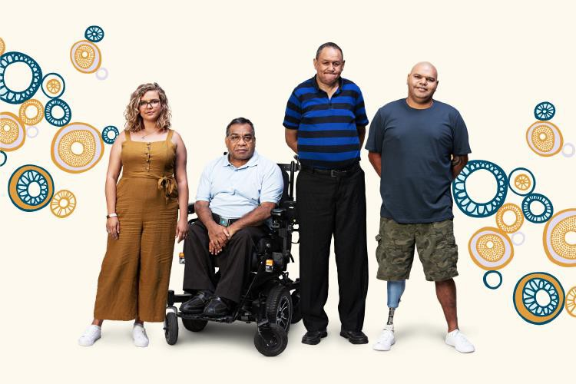
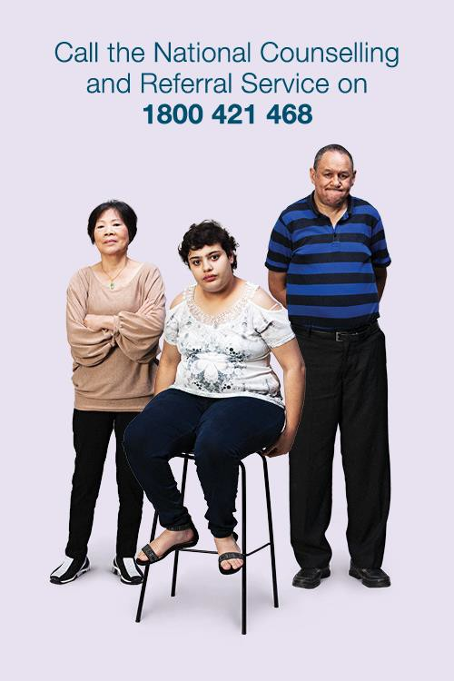
Social media and website images

We encourage any provider or organisation to download images from dss.gov.au/disability- royal-commission-support to help spread the word about support services.

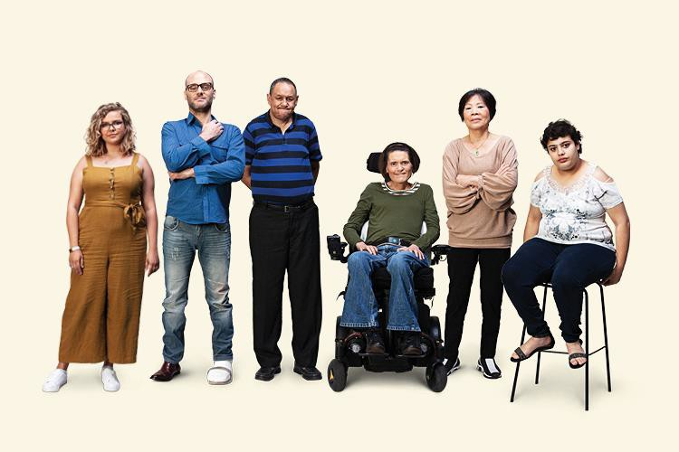
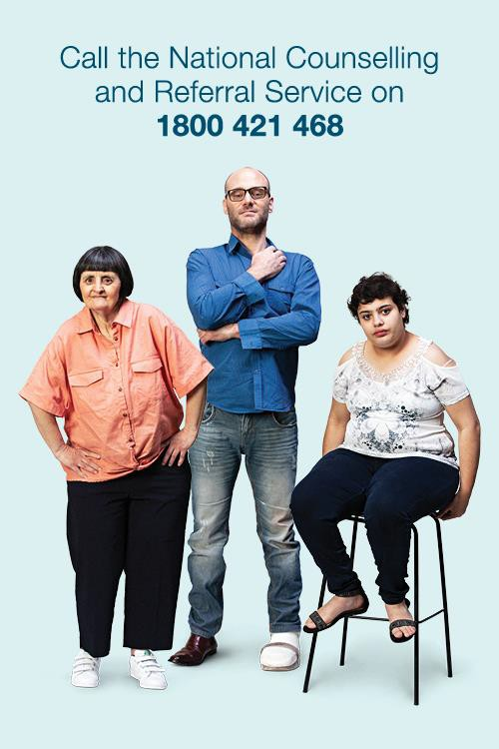
All people with disability portrayed in these images have provided their fully informed consent for this purpose.

Accessible resources

We encourage any provider or organisation to download the following resources from dss.gov.au/disability-royal-commission-support to help spread the word about support services.

These products were produced by Indigenous-owned creative company Carbon Creative and tested with people with disability through an independent research company.

They are WCAG 2.0 Level AA accessible and available in a range of formats.

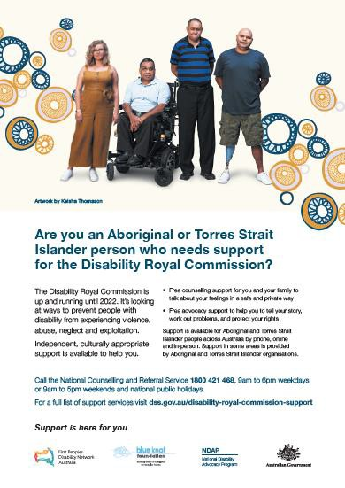
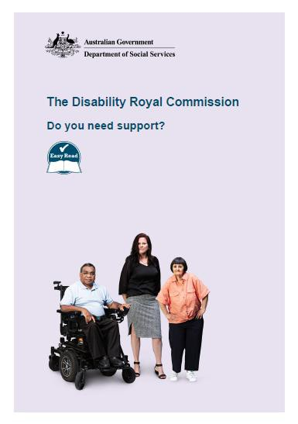
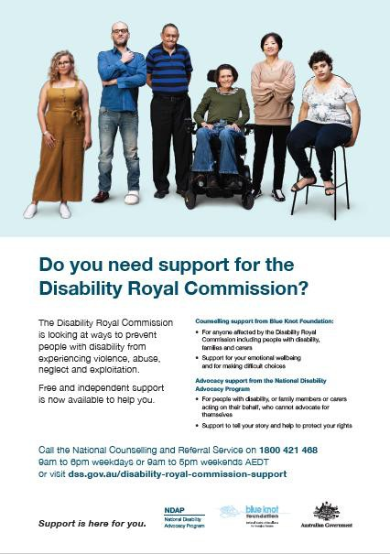
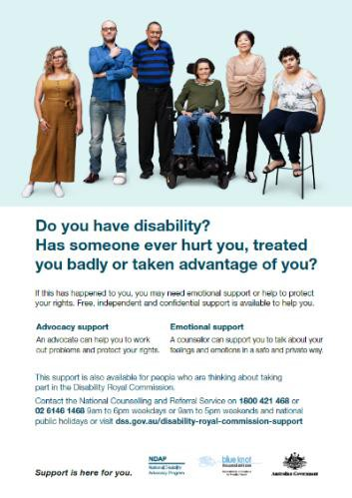
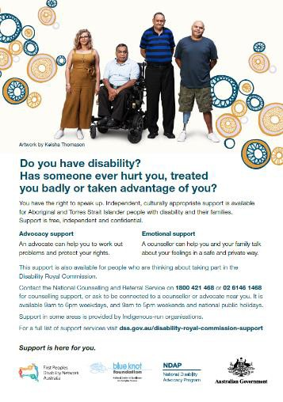
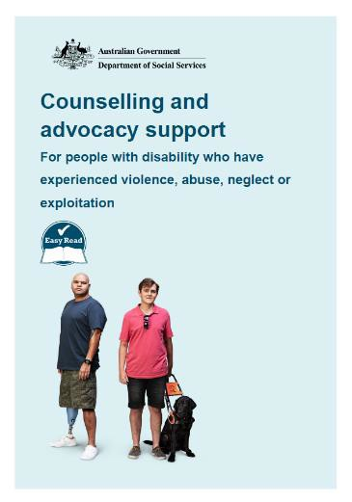
A3/A4 posters A4 Poster – Indigenous Easy Read fact sheets

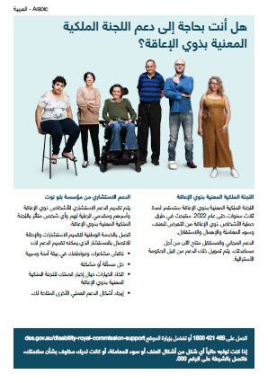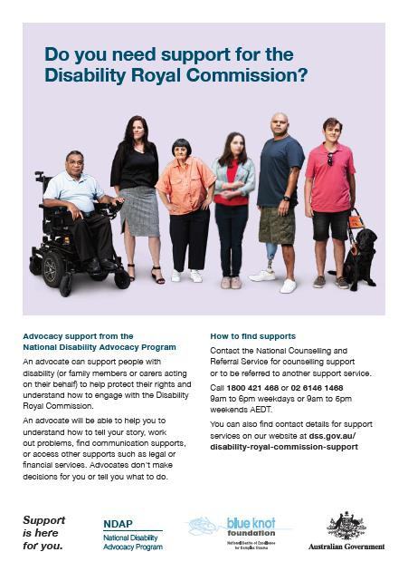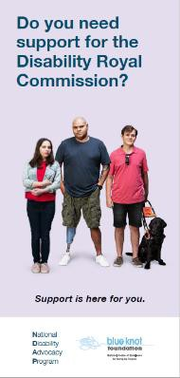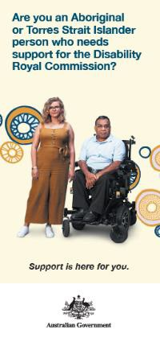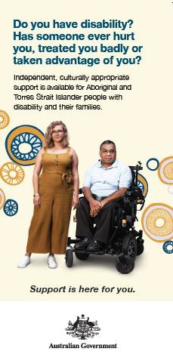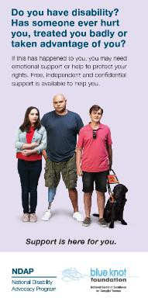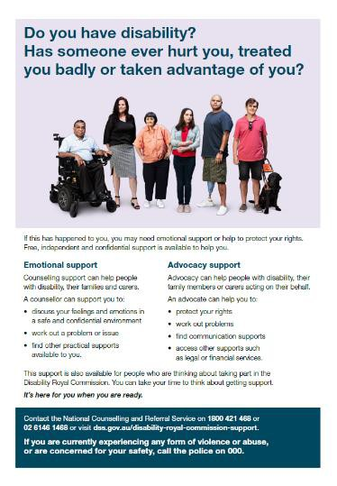

A4 factsheets – Indigenous
Translated fact sheets
DL Brochures
A4 factsheets
DL Brochures -
Indigenous

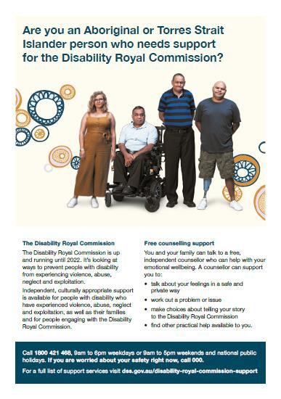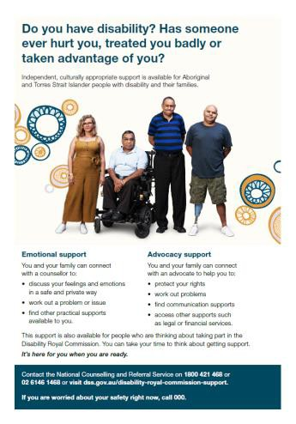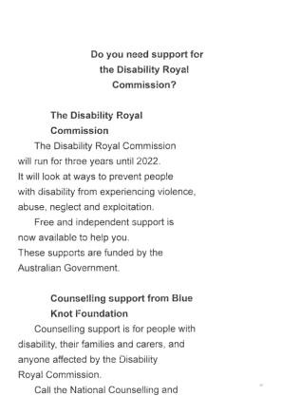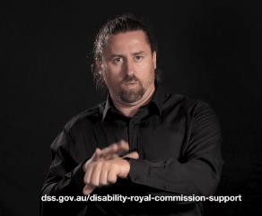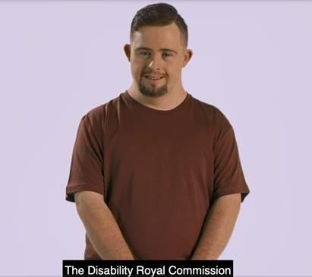
A4 factsheets –
Indigenous
Auslan videos
Counselling and
Advocacy videos
Braille with Large Print
Overlay

For more details about products please email DRCsupports@dss.gov.au

Social media content

You are welcome to use or adapt the content below for your own social media platforms to help spread the word about supports available for people with disability experiencing violence, abuse or neglect or exploitation or engaging with the Disability Royal Commission.

For people with disability

Facebook

Free and independent emotional support is available for people with disability who have experienced violence, abuse, neglect or exploitation, and their families and carers.
This support is also available for people who are engaging with or considering taking part in the Disability Royal Commission. A counsellor will provide trauma-informed support in a safe space, and work out a problem or issue.

Call the National Counselling and Referral Service on 1800 421 468 or 02 6146 1468. It’s open 9am to 6pm weekdays, and 9am to 5pm weekends and public holidays. Visit www.dss.gov.au/disability-royal-commission-support for information, including Auslan and Easy Read resources. #DisabilityRCsupport #DisabilityRC

Do you have a disability? Has someone hurt you physically, treated you badly or taken advantage of you? Support is available – you are not alone.

Contact the National Counselling and Referral Service on 1800 421 468 or 02 6146 1468. It’s open 9am to 6pm weekdays, and 9am to 5pm weekends and public holidays. For more information, including Auslan and Easy Read resources, visit www.dss.gov.au/disability- royal-commission-support DisabilityRCsupport #DisabilityRC

If you are thinking about taking part in the Disability Royal Commission, you might need advocacy support. An advocate can help you tell your story and access other supports. It’s free, independent and confidential.

Call the National Counselling and Referral Service on 1800 421 468 to be referred to an advocate or visit www.dss.gov.au/disability-royal-commission-support #DisabilityRCsupport #DisabilityRC

Twitter

Free, independent, confidential emotional support is available for people with disability affected by violence, abuse, neglect or exploitation. Call the National Counselling and Referral Service on 1800 421 468 for support. Find out more at www.dss.gov.au/disability- royal-commission-support #DisabilityRCsupport

Do you have disability? Has someone hurt you, treated you badly, or taken advantage of you? Support is available – you are not alone. Call the National Counselling and Referral Service on 1800 421 468. It’s free, independent and confidential. #DisabilityRCsupport

An advocate can help you tell your story to the @DRC_AU. Find a free and independent advocate calling 1800 421 468 and asking for a referral, or visit www.dss.gov.au/disability- royal-commission-support . #DisabilityRCsupport #DisabilityRC

People with disability from culturally and linguistically diverse backgrounds

Facebook

Do you have a disability? Has someone hurt you physically, treated you badly or taken advantage of you? You might need support from a counsellor. If you would like to speak to a counsellor in a language other than English, you can use the Translating and Interpreting Service (TIS National) free of charge.

Contact the National Counselling and Referral Service on 1800 421 468 and ask for an interpreter. A counsellor can support you, with the help of an interpreter, to talk about your feelings and emotions in a safe space, and work out a problem or issue. For more information, including translated resources, visit www.dss.gov.au/disability-royal- commission-support #DisabilityRCsupport #DisabilityRC

If you are thinking about taking part in the Disability Royal Commission, you might need support. A counsellor can support you to talk about your feelings and emotions in a safe space. Support is free, independent and confidential.

To speak to a counsellor in a language other than English, you can contact the National Counselling and Referral Service on 1800 421 468 and ask for an interpreter. It’s available from 9am to 6pm weekdays, and 9am to 5pm weekends and national public holidays. For more information, including translated resources, visit www.dss.gov.au/disability-royal- commission-support #DisabilityRCsupport #DisabilityRC

If you are thinking about taking part in the Disability Royal Commission, you might need support. An advocate can help you tell your story and access other supports. If you would like to speak to an advocate in a language other than English you can use the Translating and Interpreting Service (TIS National) free of charge.

Call the National Counselling and Referral Service on 1800 421 468 to be referred to an advocate or visit www.dss.gov.au/disability-royal-commission-support. #DisabilityRCsupport #DisabilityRC

Aboriginal and Torres Strait Islander people with disability

Facebook

Are you an Aboriginal or Torres Strait Islander person with disability? Has someone hurt you physically, treated you badly or taken advantage of you? Free, culturally appropriate counselling support is available for you and your family to talk about your feelings in a safe and private way. You can get support by phone, online or in person across Australia.
Support in some areas is provided by Aboriginal and Torres Strait Islander organisations.

Contact the National Counselling and Referral Service on 1800 421 468 for counselling support, or ask them to connect you to a counsellor near you. If you are worried about your safety right now, call 000. Counsellors can arrange translations and interpreting for people who need help in another language. For a full list of support services visit www.dss.gov.au/disability-royal-commission-support #DisabilityRCsupport #DisabilityRC

If you are thinking about taking part in the Disability Royal Commission, you might need support from a counsellor or advocate. Free counselling support is available for you and your family to talk about your feelings in a safe and private way. Free advocacy support to help you to tell your story, work out problems, and protect your rights. You can get support by phone, online or in person across Australia. Support in some areas is provided by Aboriginal and Torres Strait Islander organisations.

Contact the National Counselling and Referral Service on 1800 421 468 for counselling support, or ask them to connect you to a counsellor near you. If you are worried about your safety right now, call 000. Counsellors can arrange translations and interpreting for people who need help in another language. For a full list of support services visit www.dss.gov.au/disability-royal-commission-support #DisabilityRCsupport #DisabilityRC

Twitter

Are you an Aboriginal or Torres Strait Islander person with disability? Has someone hurt you physically, treated you badly or taken advantage of you? Culturally appropriate counselling services are now available. Call the National Counselling and Referral Service on 1800 421 468 for counselling support or ask to be referred to a counselling service near you. It’s free, independent and private. #DisabilityRCsupport

Thinking about taking part in the @DRC_AU? You might need support from a counsellor or an advocate. Support in some areas is provided by Aboriginal and Torres Strait Islander organisations. Call 1800 421 468 and ask to be referred to a support service near you. It’s free, independent and private. #DisabilityRCsupport

Family, friends, carers and support workers

Facebook

Are you supporting a friend or family member with disability who has been affected by violence, abuse, neglect or exploitation? You might need support from a counsellor.
The National Counselling and Referral Service offers emotional support for people with disability, their families and carers.

Call 1800 421 468 for free, independent and confidential support. For more information visit dss.gov.au/disability-royal-commission-support #DisabilityRCsupport #DisabilityRC

Do you care for someone with disability? Are you, or is someone you know, thinking about taking part in the Disability Royal Commission? You might need support from a counsellor. The National Counselling and Referral Service offers emotional support for people with disability, their families and carers.

Call 1800 421 468 for free, independent and confidential support. For more information visit dss.gov.au/disability-royal-commission-support #DisabilityRCsupport #DisabilityRC

If you are affected by news stories about people with disability experiencing violence or abuse, emotional support is available. Free and independent counselling support is available from the National Counselling and Referral Service on 1800 421 468 (9am to 6pm weekdays, and 9am to 5pm weekends and national public holidays). You can also visit dss.gov.au/disability-royal-commission-support #DisabilityRCsupport #DisabilityRC

Do you work with someone with disability who has been affected by violence, abuse, neglect or exploitation? You might need support from a counsellor. The National Counselling and Referral Service offers emotional support for people with disability, their families and carers and support workers too. You are not alone. Call 1800 421 468 for free, independent and confidential support. For more information visit dss.gov.au/disability-royal-commission- support #DisabilityRCsupport #DisabilityRC

Twitter

Are you supporting a friend or family member with disability who has been affected by violence, abuse, neglect or exploitation? The National Counselling and Referral Service offers emotional support for people with disability, their families and carers. Call 1800 421
468. It’s free, independent and confidential. #DisabilityRCsupport

Are you, or is someone you know, thinking about taking part in the Disability Royal Commission? You might need support from a counsellor. The National Counselling and Referral Service offers emotional support for people with disability, their families and carers. Call 1800 421 468 or visit dss.gov.au/disability-royal-commission-support #DisabilityRCsupport #DisabilityRC

Newsletter or website content

Use the text below on your own websites or in your newsletters to help spread the word about supports available for people with disability experiencing violence, abuse or neglect or exploitation or engaging with the Disability Royal Commission.

Do you need support for the Disability Royal Commission?

The Australian Government is funding counselling and advocacy support services for people with disability who have experienced violence, abuse, neglect and exploitation, and anyone who is engaging with or affected by the Disability Royal Commission. These services are free, independent and confidential.

Anyone who wishes to access these supports does not need to make a submission or have any prior involvement with the Disability Royal Commission.

Counselling support

Do you have a disability? Has someone hurt you physically, treated you badly or taken advantage of you?

A counsellor will support you to talk about your feelings and emotions in a safe space, and work out a problem or issue. A counsellor can help you talk about your feelings if something bad has happened to you or if someone has hurt you. They can also help you if you are thinking about telling your story to the Disability Royal Commission.

Whatever you decide to share with the counsellor is private – it is not shared with anyone else. You do not have to give your name if you don’t want to.

Contact the National Counselling and Referral Service on 1800 421 468 or 02 6146 1468.
It’s open 9am to 6pm weekdays, and 9am to 5pm weekends and national public holidays.

Advocacy support

You or a family member or carers acting on your behalf may need an advocate to help you communicate or understand how to engage with the Disability Royal Commission.

An advocate can help you to tell your story and find the right supports to help you with communication or legal issues.

You can call the National Counselling and Referral Service on 1800 421 468 to be referred to an advocate or visit www.dss.gov.au/disability-royal-commission-support

Accessible supports

To get counselling support or to find an advocate, call the National Counselling and Referral Service on 1800 421 468.

If you are deaf or have a hearing or speech impairment you can contact the service through the National Relay Service (NRS) on 133 677.

If you find it challenging to use the telephone, you can request a video conference. To arrange this, send an email to ncrscounsellors@blueknot.org.au

Information about the support services are available in a range of accessible formats including Easy Read and Auslan at www.dss.gov.au/disability-royal-commission-support You can request information about the support services in large print with Braille overlay by emailing DRCsupports@dss.gov.au with your name and address.

Support in other languages

If you need support in a language other than English, the Translating and Interpreting Service (TIS National) can help you. It is free.

Call the National Counselling and Referral Service on 1800 421 468 and ask for an interpreter. The counsellor will make the arrangements. Or, call TIS on 131 450 and ask to be connected to the National Counselling and Referral Service on 1800 421 468.

The Disability Royal Commission

The Royal Commission into Violence, Abuse, Neglect and Exploitation of People with Disability (Disability Royal Commission) will run until 2023. For information about the work of the Disability Royal Commission, including attending public hearings or making a submission call 1800 517 199 or visit disability.royalcommission.gov.au.

Frequently asked questions

How are you ensuring services for Aboriginal and Torres Strait Islander people are culturally appropriate?

We acknowledge that Aboriginal and Torres Strait Islander communities are very diverse and require an innovative, and flexible approach to service delivery.

To support an innovative approach, the Department of Social Services is working with partners to build pathways and connections with disability stakeholders and providers across Australia to ensure Aboriginal and Torres Strait Islander people with disability, their families and communities find and access the support they need. This approach includes:

- Funding a range of organisations, including Indigenous-run organisations, to cater to a diverse range of people across Australia including Aboriginal and Torres Strait Islander people with disability and their families
- Employing up to eight Indigenous Community Advocates in identified communities to increase access to culturally appropriate support and information.
- Working with Indigenous organisations to provide culturally appropriate materials, translated or interpreter services where needed.
- Supporting providers to develop their own communication and tailored approaches to service provision to cater for local community considerations.

The First Peoples Disability Network (FPDN) has been funded to help build the capability of support providers to strengthen their understanding, skills and capacity to deliver culturally appropriate supports. FPDN are developing a range of Indigenous resources about the support services available, and working separately with the Disability Royal Commission itself on producing culturally appropriate information and videos about the process for sharing your story. More information is available at https://fpdn.org.au.

Who is paying for the support services?

The Australian Government is funding the National Counselling and Referral Service, the extension to the National Disability Advocacy Program and a range of in-person counselling services. This funding is being administered by the Department of Social Services.

The Australian Government is also funding legal assistance services for people participating in the Disability Royal Commission. This funding is being administered by the Attorney- General’s Department.

Why were Blue Knot Foundation chosen to deliver counselling services?

Blue Knot Foundation are specialists in phone counselling and complex trauma, and currently provide counselling and referral services for people engaging with the National Redress Scheme.

Who is eligible to access the counselling and advocacy support services?

Counselling support is available for any person with disability who has experienced violence, abuse, neglect or exploitation and/or who is engaging with or affected by the Disability Royal Commission.

You do not need to make a submission or have any prior involvement with the Disability Royal Commission to access this support.

Independent advocacy support from the National Disability Advocacy Program is specifically for people with disability, or family members or carers acting on their behalf, who are thinking about engaging with the Disability Royal Commission and may have difficulty in communicating or understanding the process.

Have the resources available on your website been tested and developed in consultation with people with disability?

The creative resources in this communication toolkit to promote counselling and advocacy support services were developed by Indigenous-owned company Carbon Creative. They were designed in close consultation with a diverse range of people with disability through an independent research company Whereto. Participants in this research included people representing a range of disability, Aboriginal and Torres Strait Islander people with disability and people with disability from culturally and linguistically diverse backgrounds. The Department of Social Services also consulted widely with disability representative organisations on designing these products.

All final products are in fully accessible PDF and Word formats and compliant with WCAG
2.0 accessible web standards. Information about support services is available in various accessible formats including Easy Read, Auslan and other languages.

Why is the Department of Social Services promoting the support services and not the Disability Royal Commission?

The organisations funded to deliver counselling and advocacy support services are funded through the Department of Social Services (the Department), which is independent from the Disability Royal Commission.

The Department is working with a range of stakeholders and organisations including the Disability Royal Commission to help raise awareness of available support services.
The Attorney General’s Department can provide further information on legal and financial support services available to people engaging with the Disability Royal Commission.

Does the National Counselling and Referral Service provide face-to-face counselling?

The National Counselling and Referral Service is primarily a telephone and online service. The Australian Government has also funded additional organisations across Australia to deliver counselling services to help those who may have complex needs and require more in-depth support.

These organisations provide in-person, medium-term, trauma-informed counselling, as well as other methods of counselling such as by telephone or online support. Some of these organisations are Indigenous-run. The National Counselling and Referral Service will refer people to these counselling services on a case-by-case basis as required.

Are in-person counselling support services available now?

In-person support is available now, however it does depend on coronavirus (COVID-19) restrictions and the limitation of face-to-face meeting in different states and territories.
You can contact the National Counselling and Referral Service on 1800 421 468 to find a provider in your state or territory and find out what options are available to you right now.

Can people use counselling if they haven’t decided to make a submission to the Disability Royal Commission?

Yes. The National Counselling and Referral Service is a free, confidential and independent service for people with disability who have experienced violence, abuse, neglect and exploitation.

It’s also available for people who are engaging with, or are thinking about taking part in, the Disability Royal Commission; and people who feel affected by stories or media reports about the Disability Royal Commission.

You do not need to make a submission or have any prior involvement with the Disability Royal Commission to access this support.

If a person tells their story to the National Counselling and Referral Service, does that count as a submission to the Royal Commission?

No. The National Counselling and Referral Service is run by Blue Knot Foundation and is independent from the Disability Royal Commission.

If a person speaks to a counsellor and they decide to make a submission, the National Counselling and Referral Service can refer them to an independent advocate for advocacy support or directly to the Disability Royal Commission.

What organisations are delivering counselling and advocacy support services? National
Blue Knot Foundation provides national counselling support through the National Counselling and Referral Service. Blue Knot can also refer people to the counselling and advocacy providers listed below.

Systemic advocacy

- Children and Young People with Disability Australia (CYDA)
- National Ethnic Disability Alliance (NEDA)
- People with Disability Australia (PWDA)
- Women with Disability Australia (WWDA)
- First Peoples Disability Network (FPDN) †
- Australian Federation of Disability Organisations (AFDO)
- Inclusion Australia
- Disability Advocacy Network Australia (DANA)

State and Territory providers

State/Territory | Advocacy (Individual) | Counselling
ACT | - ACT Disability Aged and Carer Advocacy Service*  - Advocacy for Inclusion | - Relationships Australia Canberra and Region
NSW | - SCIA Advocacy Northern Rivers  - Disability Advocacy NSW  - Illawarra Advocacy  - Intellectual Disability Rights Service  - Multicultural Disability Advocacy Association of New South Wales | - Relationships Australia New South Wales  - Relationships Australia Canberra and Region (Coverage includes ACT,

State/Territory | Advocacy (Individual) | Counselling
 | - Newell Advocacy*  - Self Advocacy (Sydney)  - Regional Disability Advocacy Service  - Side By Side Advocacy  - Sydney Region Aboriginal Corporation†  - Family Advocacy  - People with Disability Australia | Capital Region, Riverina, Murray)  - Interrelate Limited
Northern Territory | - Darwin Community Legal Service  - Disability Advocacy Service  - Ngaanyatjarra Pitjantjatjara Yankunytjatjara Women's Council*† | - Relationships Australia Northern Territory  - Danila Dilba Health Service Aboriginal Corporation†
Queensland | - Aged and Disability Advocacy Australia  - Independent Advocacy in North Queensland  - Mackay Advocacy  - People with Disability Australia  - Queensland Advocacy  - Rights In Action  - Speaking Up For You  - TASC National | - Micah Projects, including sub-contracting arrangements with:  - Link-Up QLD†  - Cape York/Gulf Remote Area Aboriginal and Torres Strait Islander Child Care Advisory Association Inc. †  - WWILD – Sexual Violence Prevention Association
South Australia | - Advocacy for Disability Access and Inclusion  - Disability Advocacy and Complaints Service of South Australia  - Disability Rights Advocacy Service  - Independent Advocacy SA | - Relationships Australia South Australia  - Nunkuwarrin Yunti†
Tasmania | - Advocacy Tasmania  - Speak Out Association of Tasmania | - Relationships Australia Tasmania
Victoria | - Action for More Independence and Dignity in Accommodation  - Action on Disability within Ethnic Communities  - Association of Employees with  Disability | - Relationships Australia Victoria  - Drummond Street Services

State/Territory | Advocacy (Individual) | Counselling
- Colac Otway Region Advocacy Service
- Disability Justice Australia
- Gippsland Disability Advocacy
- Grampians disAbility Advocacy Association*
- Leadership Plus
- Melbourne East Disability Advocacy
- North East Citizen Advocacy
- Rights Information and Advocacy Centre
- Southern Disability Advocacy
- Southwest Advocacy Association
- Victorian Mental Illness Awareness Council
- Villamanta Disability Rights Legal Service
- Regional Disability Advocacy
Service
Western Australia | - Advocacy WA  - Ethnic Disability Advocacy Centre  - Midland Information, Debt & Legal Advocacy Service  - People With Disabilities (W.A.)  - Sussex Street Community Law Service | - Relationships Australia Western Australia  - Yorgum Healing Services†  - Kimberly Stolen Generation Aboriginal Corporation†

*Organisations funded to employ Indigenous Community Advocates.
†Aboriginal and Torres Strait Islander organisations

