For further assistance, please contact [nrasithelpdesk@dss.gov.au](mailto:nrasithelpdesk@dss.gov.au)

## National Rental Affordability Scheme (NRAS) Portal

## Quick Reference Guide

Add and Edit Investor Information

This Quick Reference Guide (QRG) will take you through the steps to add or edit investor information in the NRAS Portal.

Access Required:

* Participant Read Write User; or Participant Claims User.

Warning Do not use the navigation buttons on your web browser while working in the portal. Using the back, forward or refresh buttons on your browser will cause you to lose the information you have entered.

Use the **Back** and **Continue** buttons to move through the different sections.

1. Log in to the [NRAS Portal](https://nras.dss.gov.au/nrasportal/).
2. At the Disclaimer, click **I Agree**.
3. There are two ways to navigate to the Search Dwellings screen from the main page: through the Dwellings tile (see step 4) or the dropdown menu (see step 5).
4. Click the **Dwellings** tile. A list of Dwellings will be returned, then select the **Search Dwelling** button.

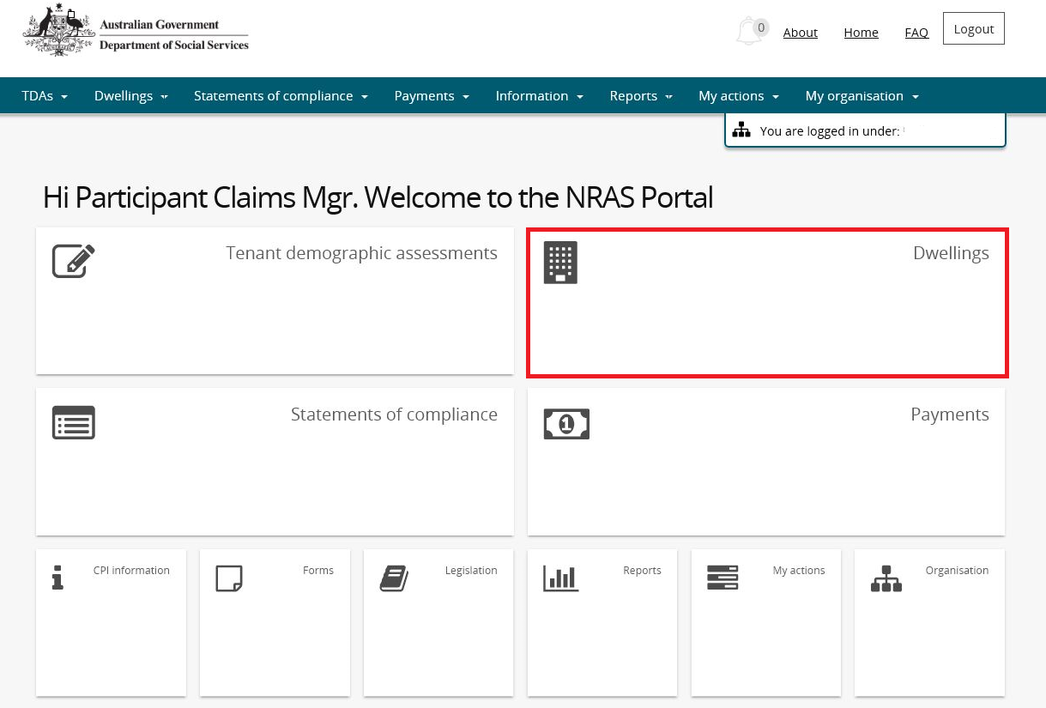

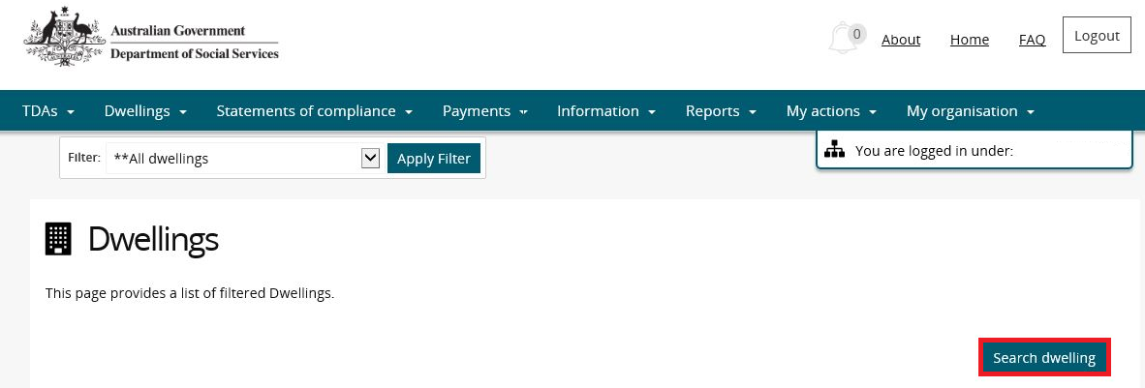

**OR**

1. At the **Welcome** screen, select **Dwellings>Search dwelling**.

Dwellings

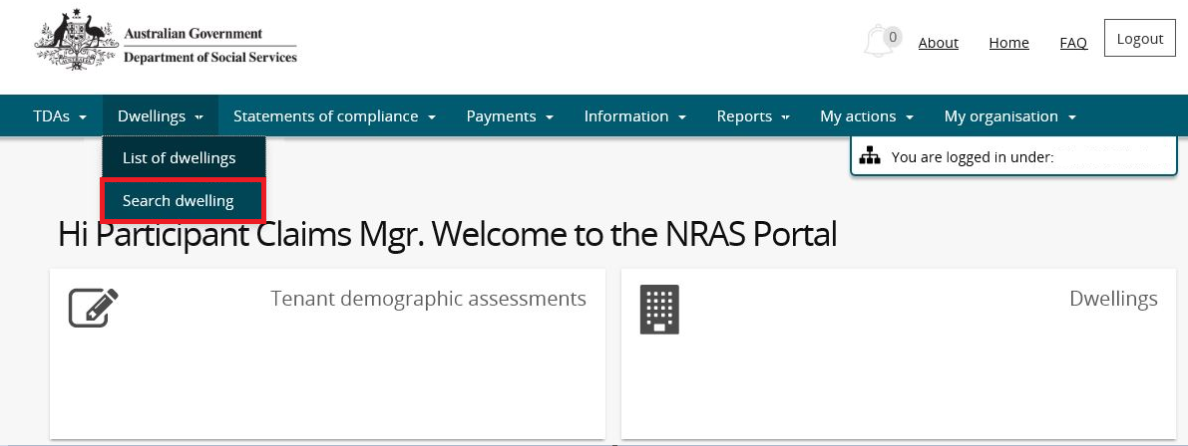

1. Enter required search criteria, then select the **Run Search** button.

Note icon.Click **Advanced** to display additional search fields.

Note icon. Search for a dwelling using any of the available search fields. All fields on the **Search dwellings** page are not case sensitive for searching. If you wish to view all dwellings you have access to, leave the Dwelling search fields blank.

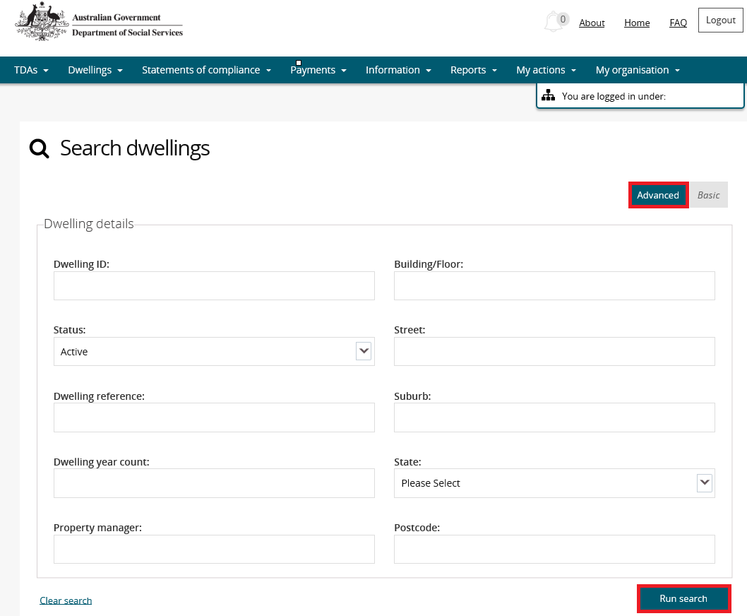

1. Results matching your entered search criteria will be returned.
2. Select the **View dwelling** button.

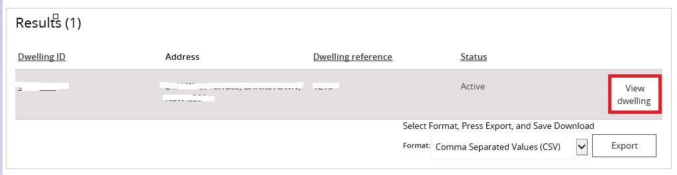

1. On the **View dwelling** page, select the **Investors Information** tab on the left hand side of the screen.

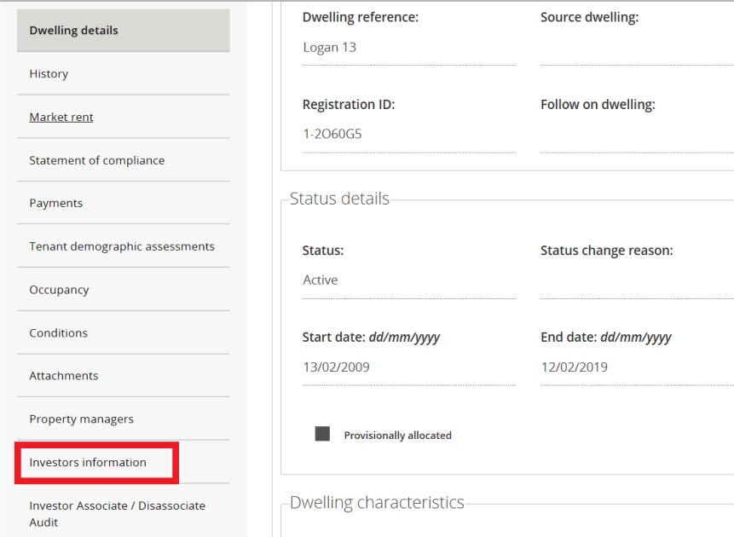

1. On the Investors information screen, you can add a new investor by clicking on **Associate** **Investor**. Then search for the investor you wish to associate with the record. If the investor does not yet exist, you will need to select add new investor. If the investor does come up in the search, click associate next to the relevant record.

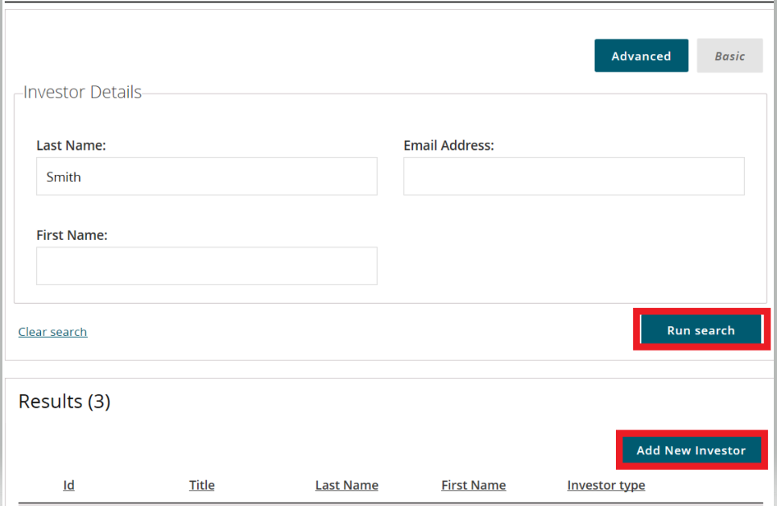

1. You can remove or **Disassociate** an investor from a dwelling, by select **Actions**, and then **Disassociate**.

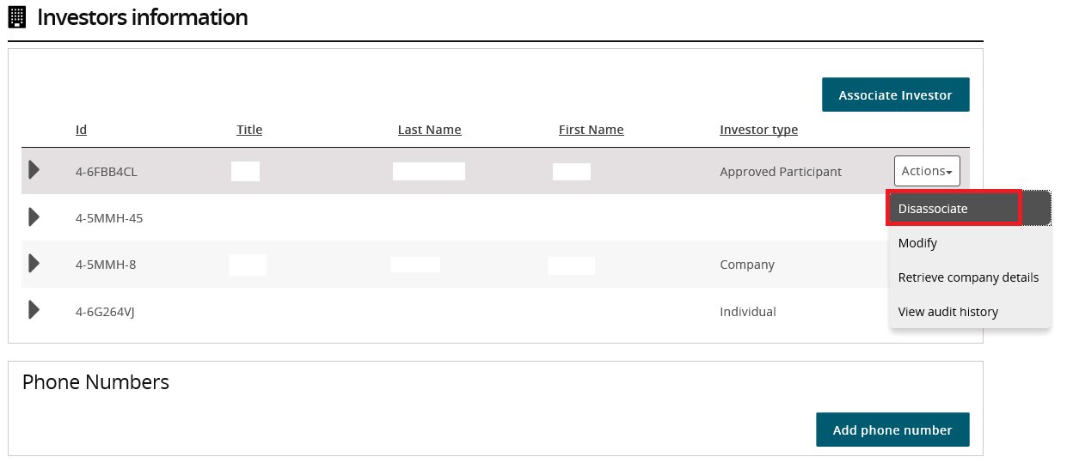

1. If an investor already exists on the record, and you just wish to modify or add further details, click on therelevant investor, then select **Actions**, and then **modify**

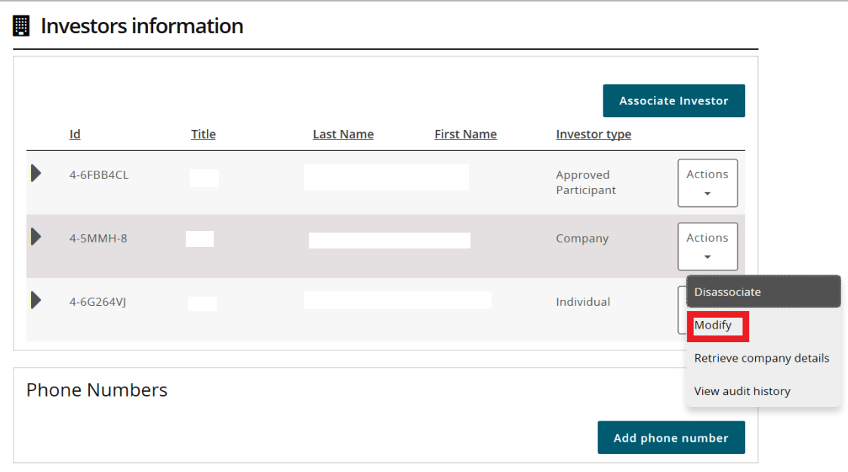

1. You will then be taken to a page where you can make any changes required. Make the necessary changes and click **Submit and return**

Note icon.The screen appears differently depending on the investor type. The red fields are mandatory for all investors. For investor types of approved participant, company and SMSF, the data held within the blue fields are filled in using data from the Australian Business Register based on the ABN.

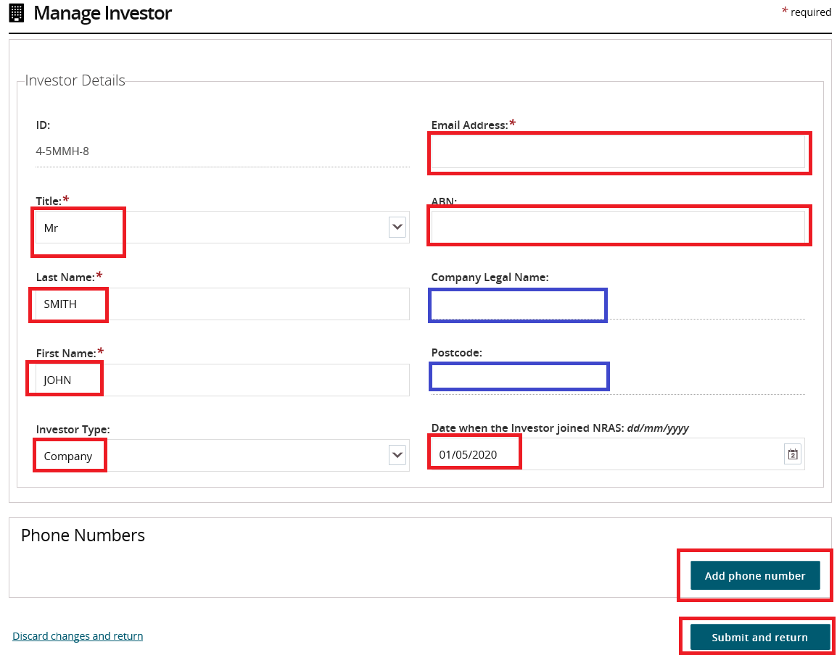

Where the investor type is Approved Participant, Company or SMSF, you can click on the **Retrieve Company Details** to update the investor record based on the ABN with data held with the Australian Business Register.

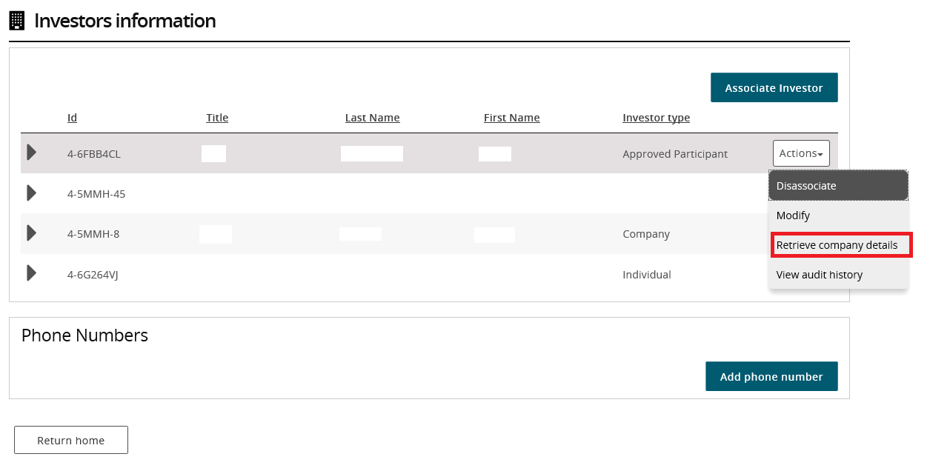

1. You can click on **View audit history** to see who has made changes to the investor records.

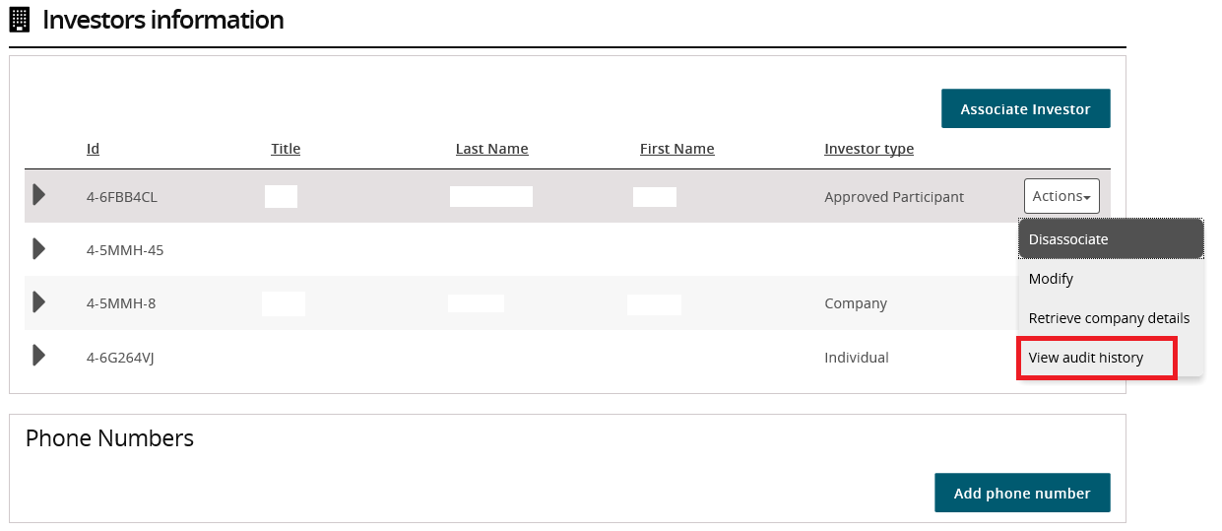

1. You can add phone numbers by clicking on **Add phone number**. Once entered, click **Submit and return**

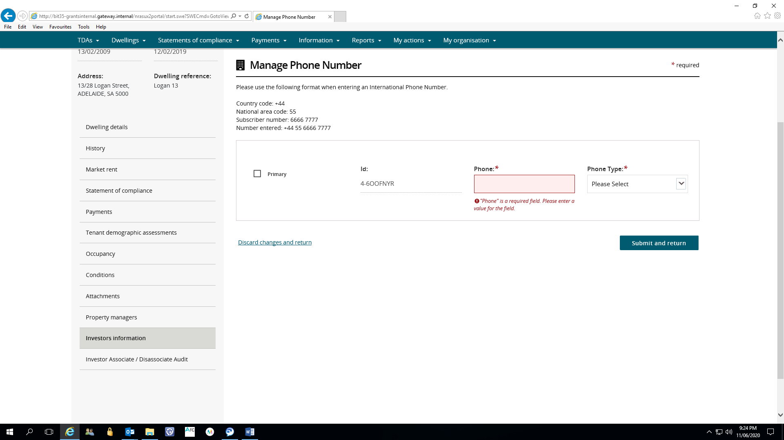

1. You can then click **Save and Return** after any changes are made.

Logging out of the NRAS Portal

To log out of the NRAS Portal click **Logout**.

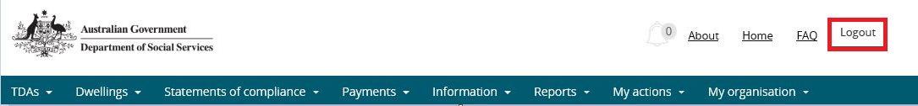

Note icon. For technical support enquiries, please contact [nrasithelpdesk@dss.gov.au](mailto:nrasithelpdesk@dss.gov.au) or 1300 911 235.

.