For further assistance, please contact [nrasithelpdesk@dss.gov.au](mailto:nrasithelpdesk@dss.gov.au)

## National Rental Affordability Scheme (NRAS) Portal

## Quick Reference Guide

Submitting a TDA (All pathways)

This Quick Reference Guide (QRG) will take you through the steps to submit a Tenant Demographic Assessment (TDA) for an NRAS Dwelling.

Access Required:

* Participant Read Write User or Participant Claims User.

Warning Do not use the navigation buttons on your web browser while working in the portal. Using the back, forward or refresh buttons on your browser will cause you to lose the information you have entered.

Use the **Back** and **Continue** buttons to move through the different sections.

Additional Information Note Any field with a star/asterisk is a mandatory field and must be completed to move through the TDA.

1. Log in to the [NRAS Portal](https://nras.dss.gov.au/nrasportal/).
2. At the Disclaimer, click **I Agree**.
3. There are two ways to navigate to the *Submit a TDA* screen from the main page: through the Tenant demographic assessments tile (see steps 4 to 5) or through the drop down menu (see step 6).
4. Clickthe **Tenant demographic assessments tile**. A list of all TDAs will be displayed.

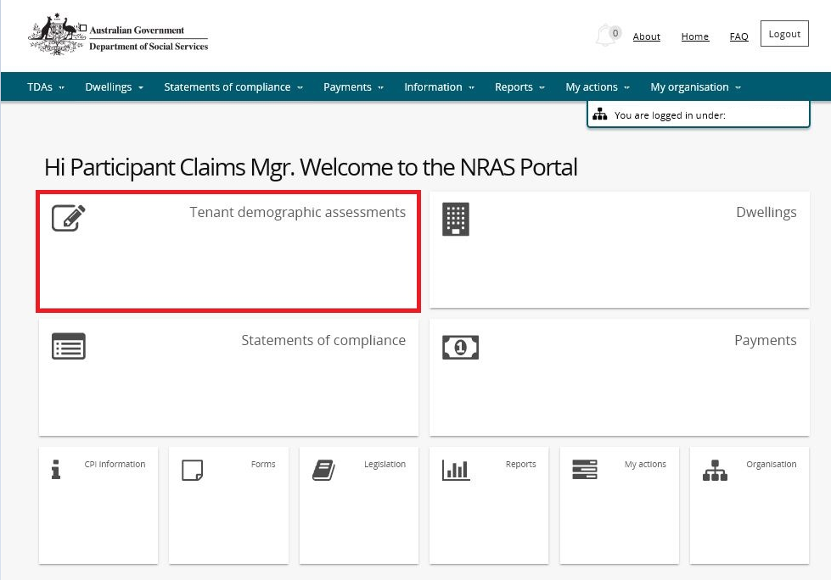

1. Select the **Submit new TDA** button.

How to select "Submit new TDA"


**OR**

1. At the **Welcome screen**, select **TDAs > Submit new TDA**

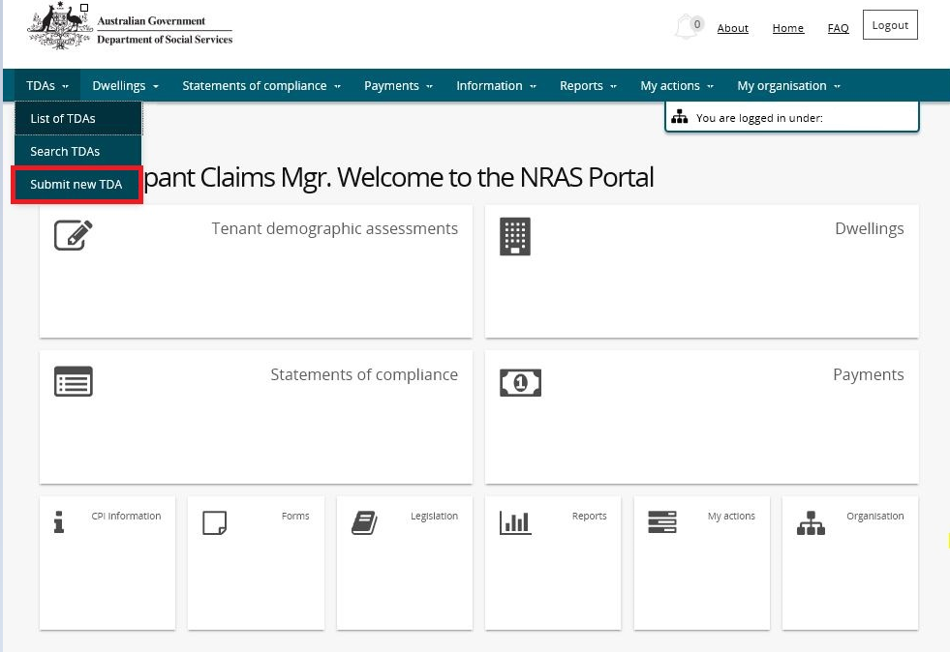

1. Select **the TDA pathway** that is relevant.
2. Select the **Start** button.

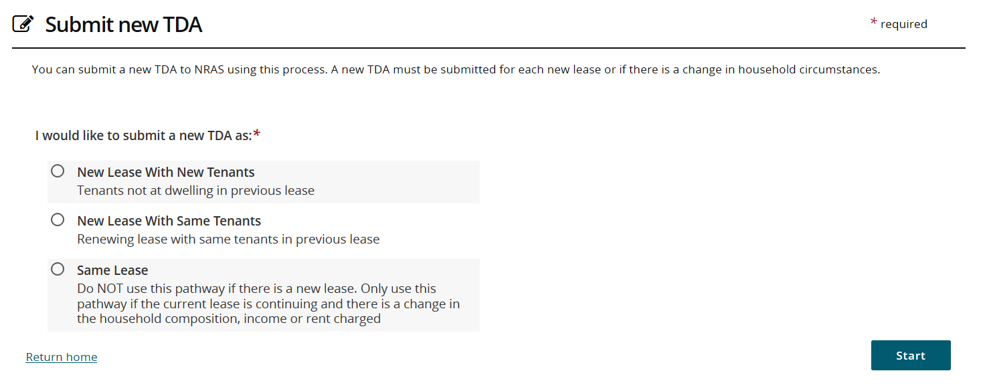

1. To search for a dwelling, enter the **Dwelling details**.

Note icon. The Dwelling ID search field on the ‘Select a Dwelling’ page is not case sensitive. If you do not have the dwelling details or you wish to view all dwellings you have access to, leave the Dwelling details blank.

Note icon. Click **Advanced** to display additional search fields.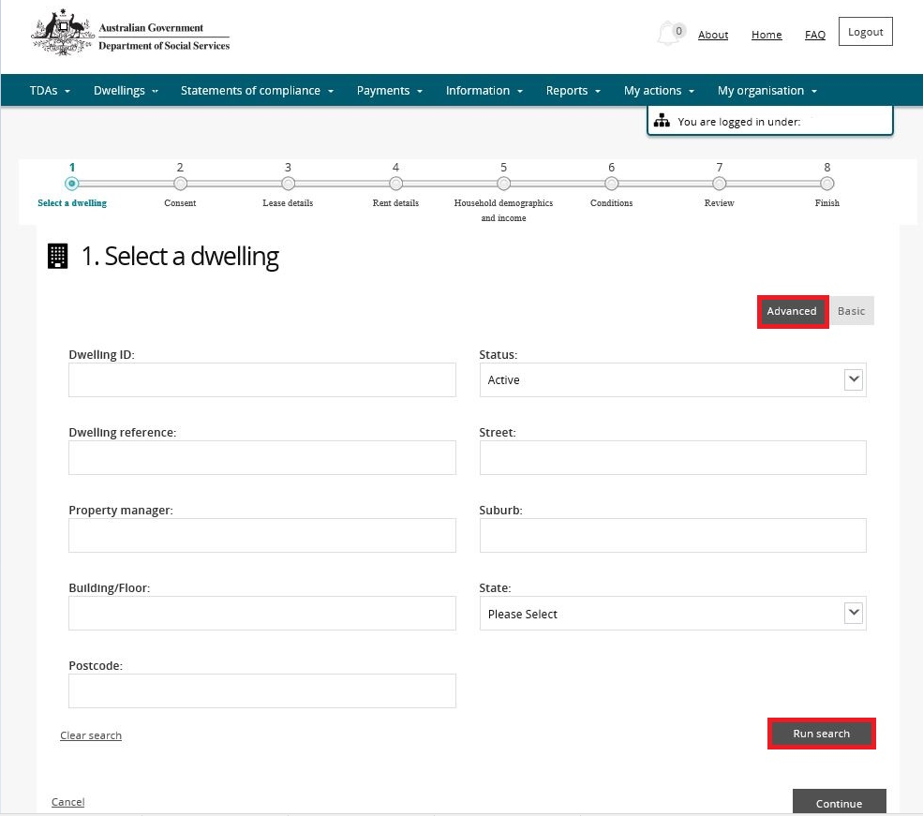

1. Click **Run search**.
2. Dwellings matching the entered search criteria will be returned.
3. Scroll down and select the dwelling.

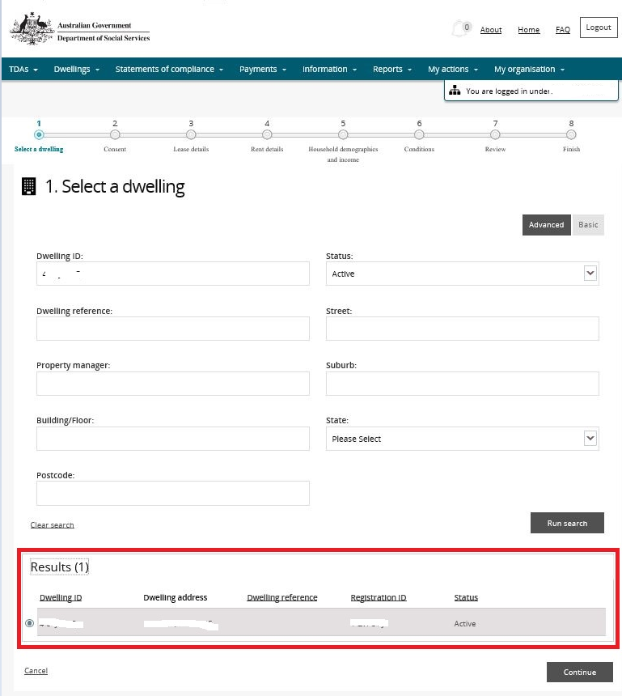

1. Click **Continue**.
2. Select **Yes** or **No** on the Consent screen.

Additional Information Note Tenant consent must be obtained to create a TDA. If you choose ‘No’, you will need to begin the process again after you have received tenant consent.

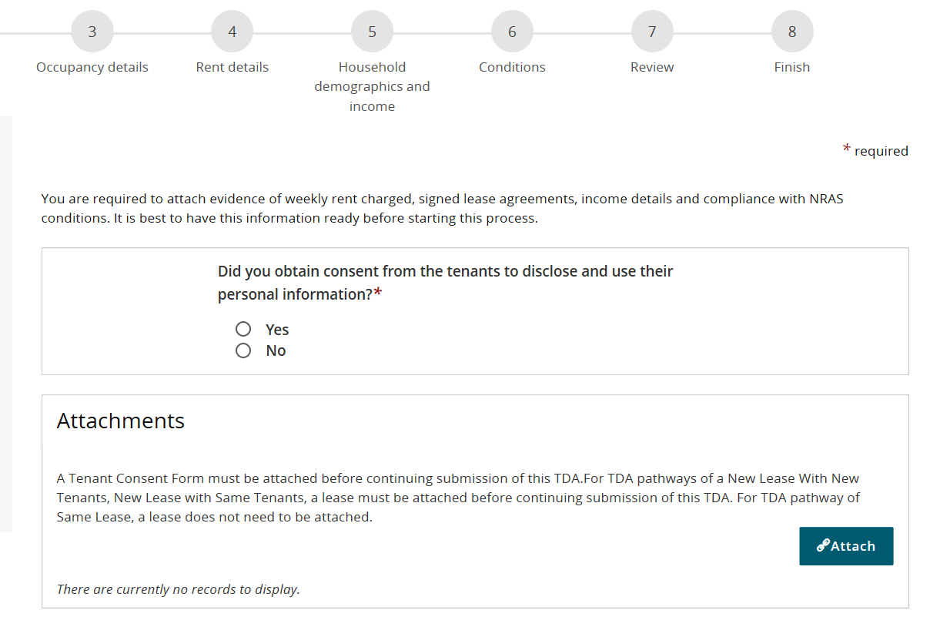

1. Attach any evidence documents. **NOTE * A Tenant Consent Form and lease must be attached before continuing submission for TDA pathways of a New Lease With New Tenants or New Lease with Same Tenants. For TDA pathway of Same Lease, a lease does not need to be attached.**
2. The **Occupancy Details** screen displays.

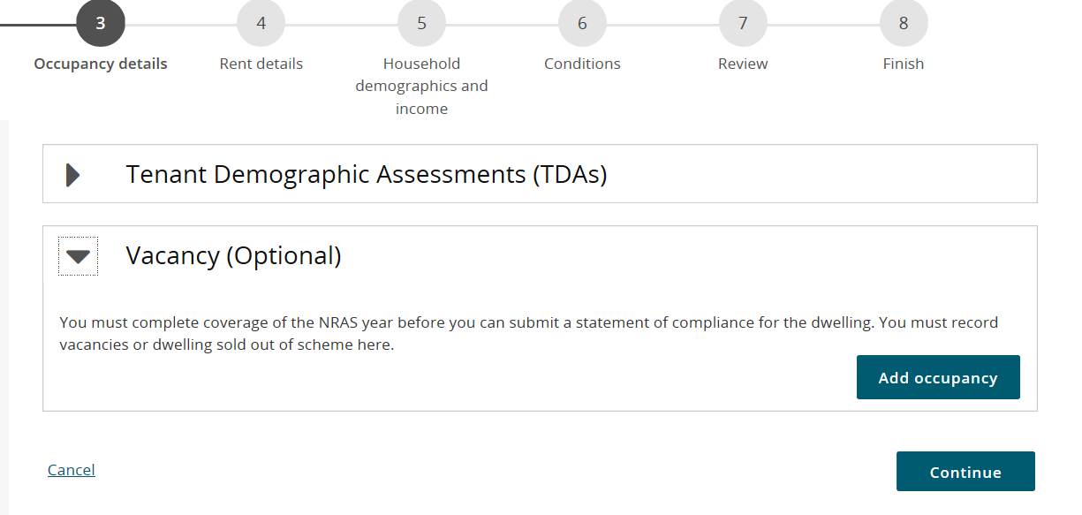

Additional Information NoteThe Occupancy details screen will display existing TDA’s for the dwelling.

1. If required, enter a vacancy period by expanding the **Vacancy (Optional)** section and selecting the **Add** **Occupancy** button. Enter **Start date, End date and Reason** and then select the **Save and return** button.

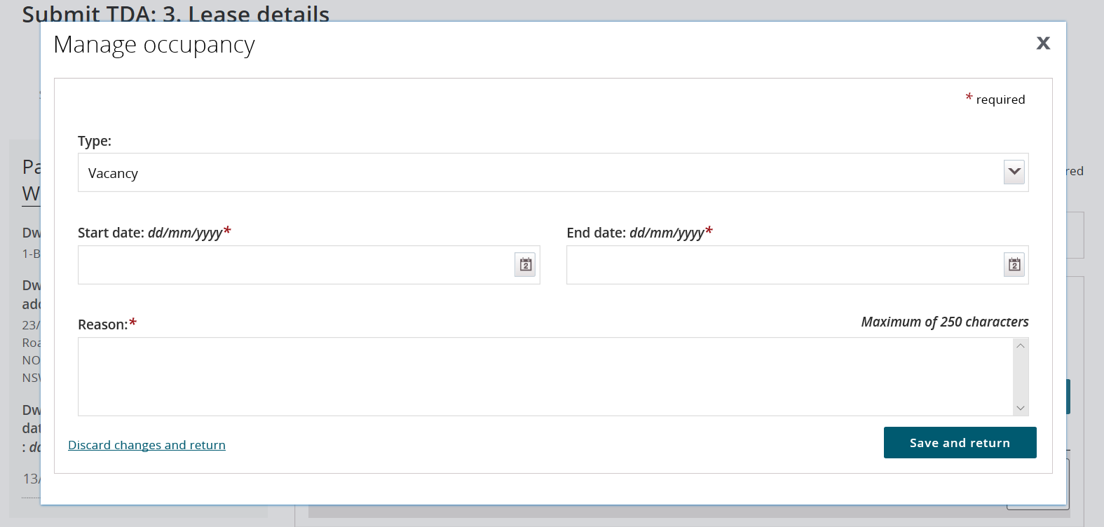

1. Select **continue**.
2. On the Rent details screen, please enter the relevant details

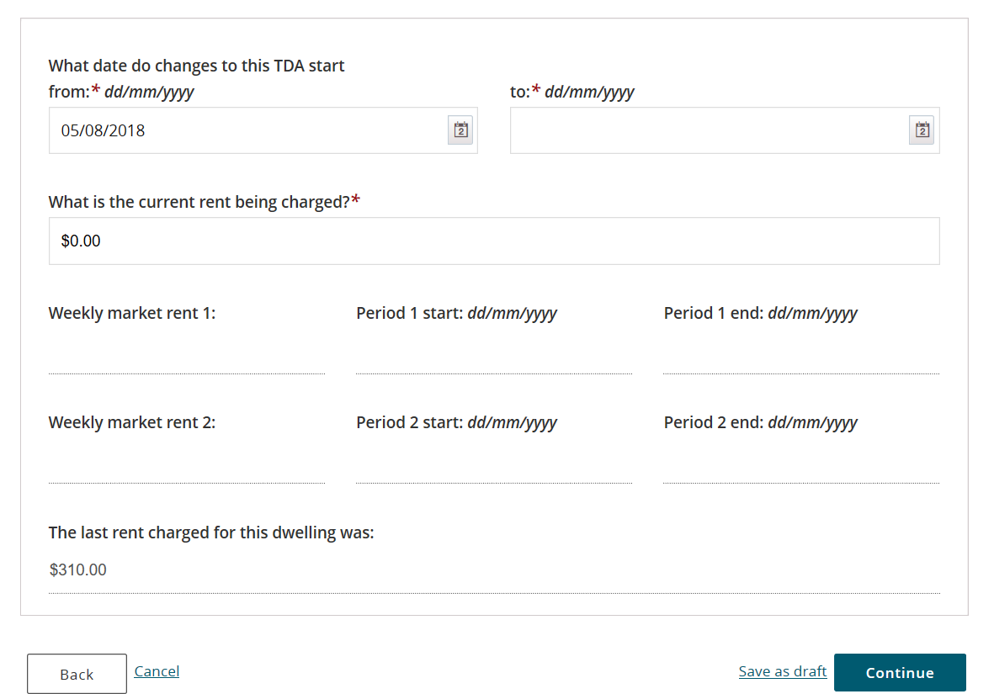

Additional Information Note The **Period** **from** date will default to the dwelling start date (if there are no previous TDA’s) or the day after the end date of the last TDA.

1. Enter the **To** field details and the **rent charged** field details.
2. Select the **Continue** button.

Additional Information Note The **What date do changes to the TDA start from** field will default to the day after the last TDA ended (This can be changed if you are entering a TDA for a previous date).

Additional Information Note You are now able to create multiple TDAs by entering a TDA end date that is after the NRAS year end date. This will create multiple ‘split’ TDAs based on the TDA Start and End dates entered. These additional TDAs will be created with the ‘Same Lease’ pathway. The ‘Source TDA’ field on the Lease and TDA details page contains the TDA ID of the originally created TDA.

Additional Information Note Where split TDAs are being created, Weekly market rent 1 and 2 information will be relevant to the current NRAS year only.

Additional Information Note The **Rent details** screen is the first opportunity to save the TDA as a draft. Clicking **Save as draft** will exit you from the TDA process. You can return to the draft and complete it at a later date. All screens from this point onward will provide the **Save as draft** functionality. There is a Quick Reference Guide that has more information on saving, finding and resuming submission of Draft TDAs.

1. Click **Continue**.
2. The **Household demographic and income** screen displays. The data will be pre populated for Same lease and some data will be populated for New lease Same Tenant.
3. This screen is divided into four sections.

Section 1 – How many tenants in your household are in the following age groups?

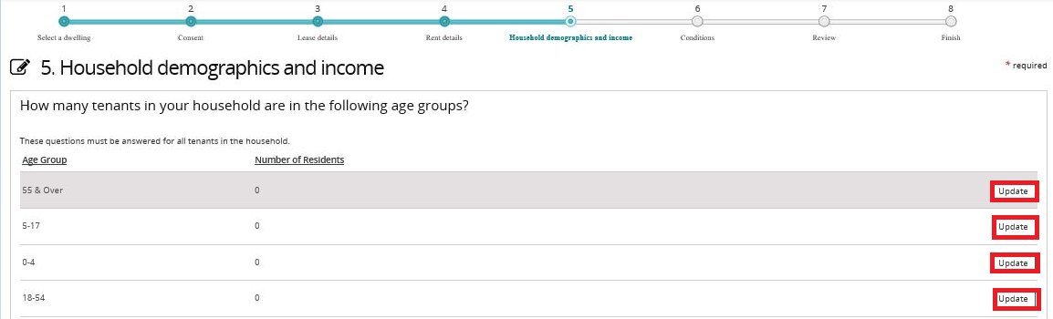

1. Click **Update** to select the age range and number of tenants in the listed age groups.

Additional Information Note Add each age range represented in the household and indicate the number of householders in this age range as separate entries.

Section 2 – Household demographics

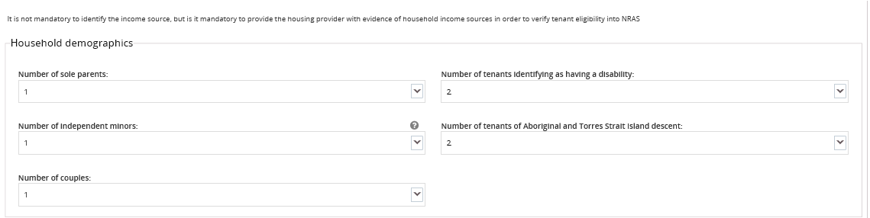

Additional Information Note Information in the Household section of the TDA is voluntary for tenants to provide, with the exception of the sole parent and Independent minor response. If there are no sole parents and/or independent minors in the household, or if the tenant has not provided this information, select zero.

1. Select an entry in the **Number of sole parents** and **Number of independent minors** fields.

Additional Information Note**Independent minors** are those aged under 18 years living independently and who are not financially dependent on an eligible tenant over the age of 18 years old.

1. Where applicable, select an entry in the **Number of couples**, **Number of tenants identifying as having a disability** and **Number of tenants of Aboriginal and Torres Strait Island descent**.

Section 3 – Income

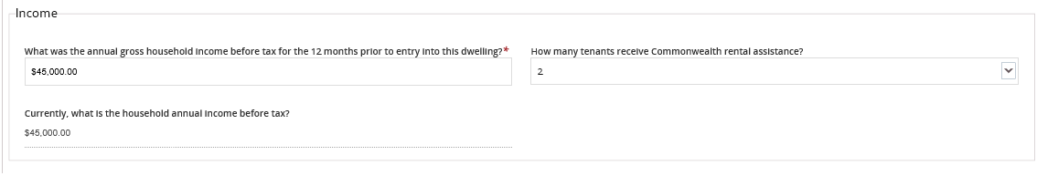

1. Enter the annual gross income for the twelve months prior to entering the dwelling in the **What was the annual gross household income before tax for the 12 months prior to entry into this dwelling?** field.
2. Where applicable, select an entry in the **How many tenants receive Commonwealth rental assistance?** field.

Section 4

Additional Information NoteAll fields in this section are not mandatory.

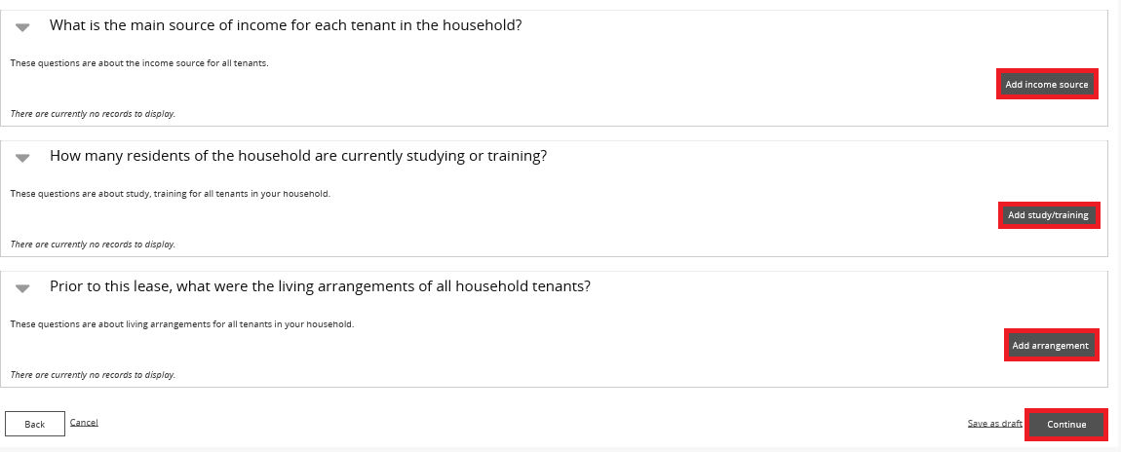

1. Where relevant, select the **Add income source** button and add an income source.
2. Where relevant, select the **Add study/training** button and add study and training information.
3. Where relevant, select the **Add arrangement** button and enter prior living arrangements.
4. Click **Continue**. The **Conditions** screen displays.
5. If condition/s do not exist, or condition/s exist and have been met, select the **Continue** button.
6. Where condition/s exist and the condition/s have not been met, select the **Update** button.

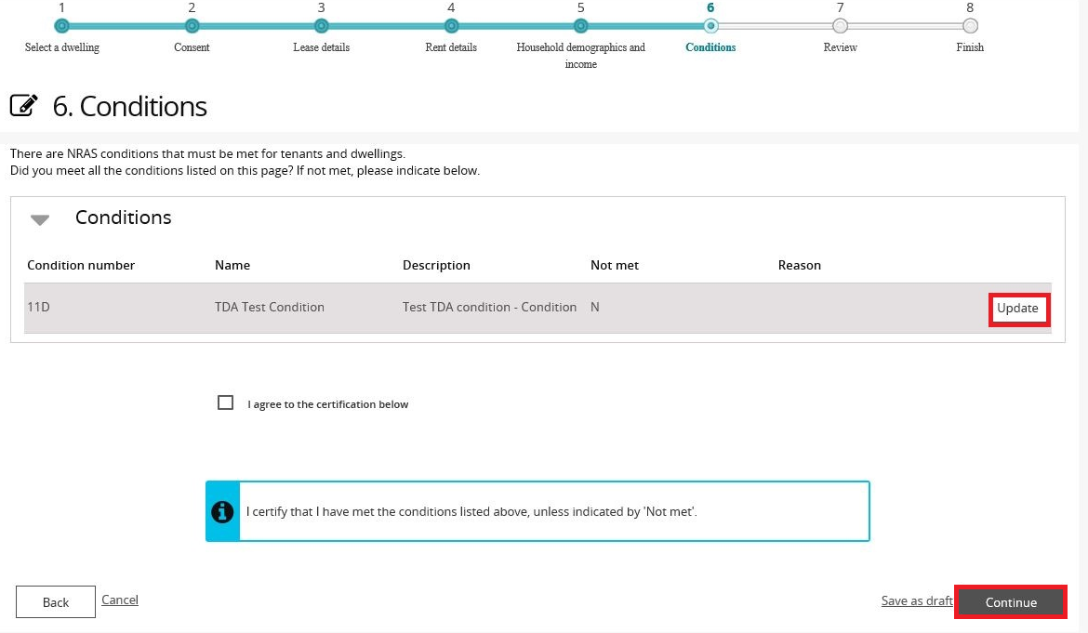

1. Where condition/s have not been met, select the **Not** **met** checkbox, enter the reason the condition was not met and then select the **Save** **and** **return** button.

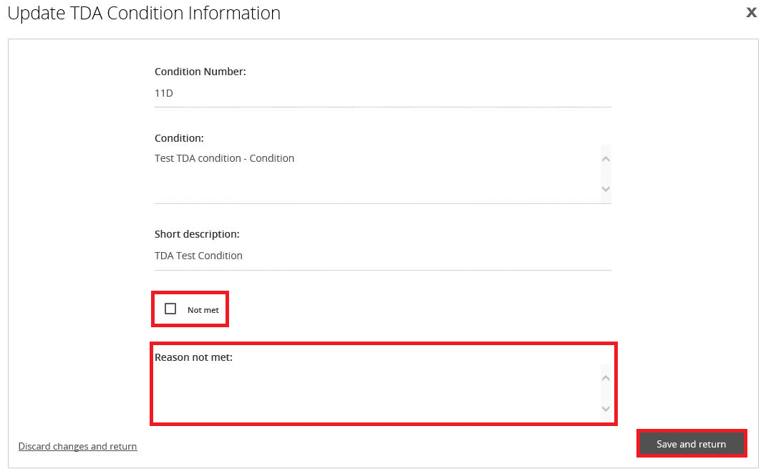

1. Read and agree to the certification.
2. Select **I agree to the certification below** checkbox and then select the **Continue** button.

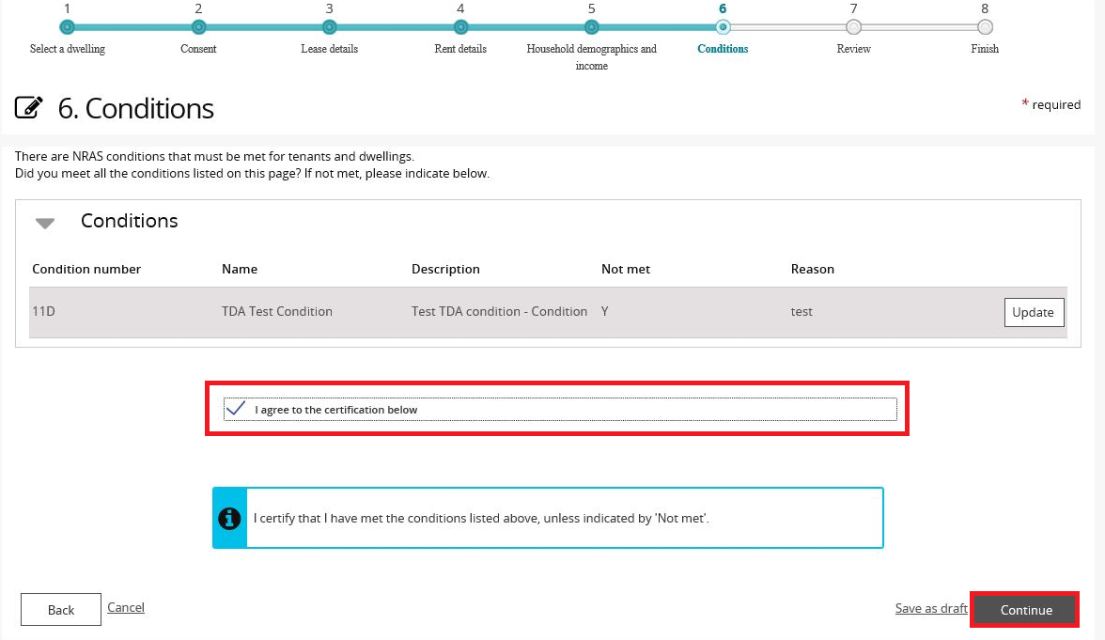

1. The **Review** page is returned.

Shows categories to expand for review

Age groups
Household demographics and income
Source of income
Study or training
Prior living arrangements 
Conditions
Attachments
How to select "Add attachment"


1. Review all information provided on the **Review** page.

Additional Information NoteClick on the arrows to view the expanded view for Age groups, Household demographics and income, Source of income, Study or training, Prior living arrangements, Conditions, and Attachments.

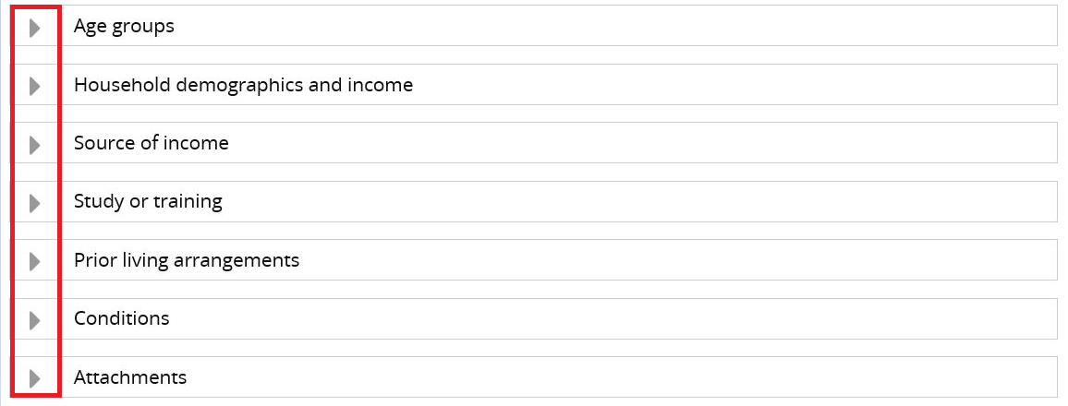

1. If any additional attachments need to be made to the TDA, attach them via the **Attachments** section on the Review screen.

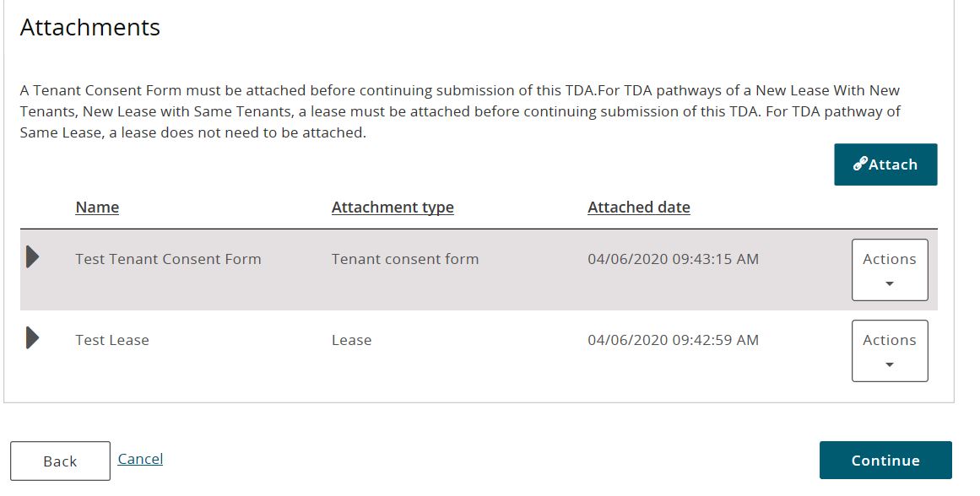

1. Read and agree to the certification on the Review screen.
2. **Tick the checkbox** to certify that the information provided in the TDA is true and accurate.

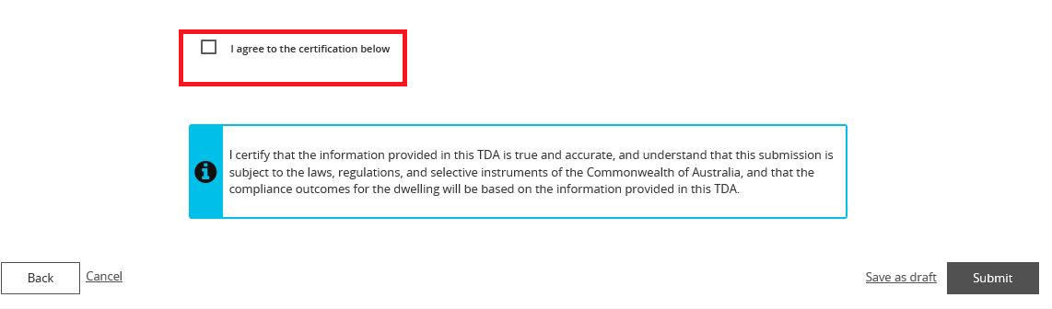

Additional Information Note If any part of the TDA needs to be amended, click **Back** to move through to the relevant TDA screens.

1. Click **Submit**.A message appears to indicate that the process has been completed successfully.
2. Click **Finish**. The Tenant Demographic Assessments (TDAs) screen is displayed.

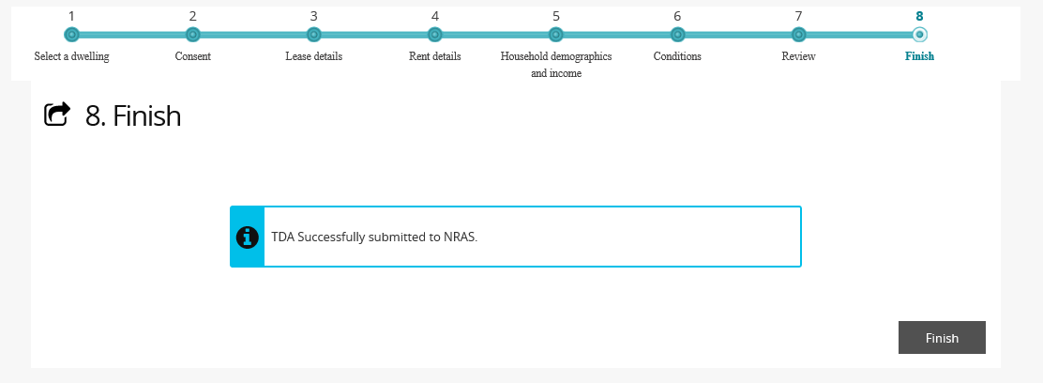

Note icon. You are now able to update TDAs after they have been submitted. See QRG #9 – Updating submitted TDAs.

Logging out of the NRAS Portal

1. To log out of the NRAS Portal click **Logout**.

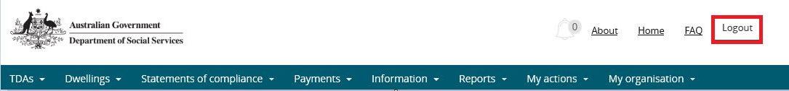

Note icon. For technical support enquiries, please contact [nrasithelpdesk@dss.gov.au](mailto:nrasithelpdesk@dss.gov.au) or 1300 911 235.