For further assistance please contact [nrasithelpdesk@dss.gov.au](mailto:nrasithelpdesk@dss.gov.au)

National Rental Affordability Scheme (NRAS) Portal

Quick Reference Guide

## Submit a Statement of compliance

This Quick Reference Guide (QRG) will take you through the process required to submit a claim in the NRAS Portal.

Access Required:

* NRAS Claims Manager Access.

Warning Do not use the navigation buttons on your web browser while working in the portal. Using the back, forward or refresh buttons on your browser will cause you to lose the information you have entered.

Use the **Back** and **Continue** buttons to move through the different sections.

1. Log in to the [NRAS Portal](https://nras.dss.gov.au/nrasportal/).
2. At the Disclaimer, click **I agree**.
3. There are two ways to navigate to the **Submit Statement of compliance** screen from the main page: through the Statements of compliance tile (see step 4) or through the dropdown menu (see step 5).
4. Click the **Statements of compliance** tile. A list of Statements of compliance will be returned, then select the **Submit new SOC** button.

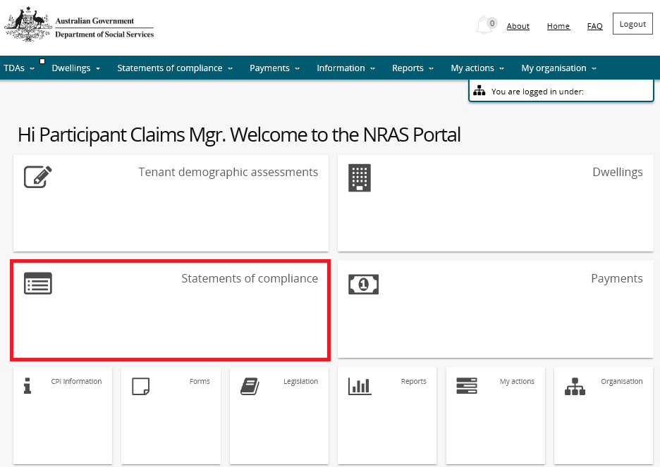

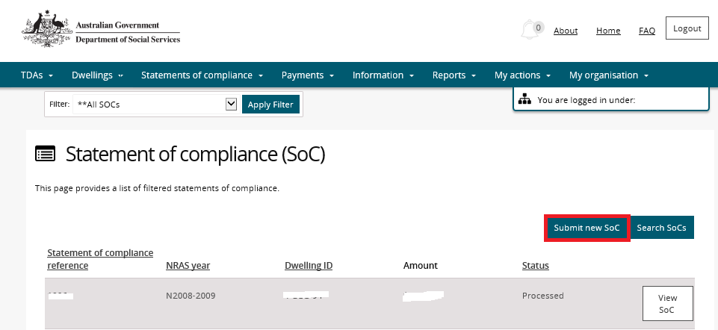

**OR**

1. At the **Welcome screen**, select **Statements of compliance>Submit new statements of compliance**.

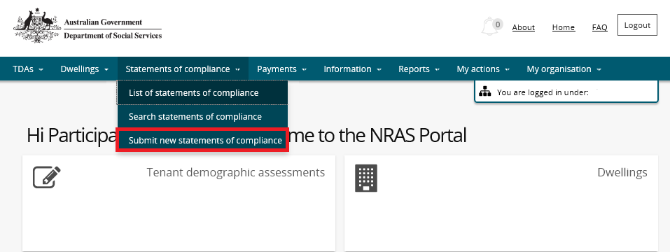

1. The **Submit a new Statement of compliance** screen is displayed.
2. Read the information on the screen and if you are ready to proceed select the **Start** button.

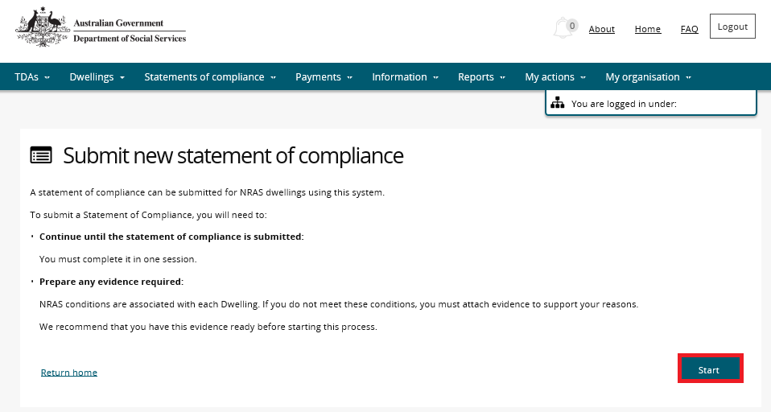

1. The Select Dwelling screen is displayed.

Additional Information Note The NRAS year field is a mandatory field and will default to the current claiming NRAS year.

Note icon.Click **Advanced** to display additional search fields.

Additional Information Note The dwelling ID search field is not case sensitive, all other fields are.

If required, select a different **NRAS Year** and enter any other search criteria required.

1. Click **Run search**.

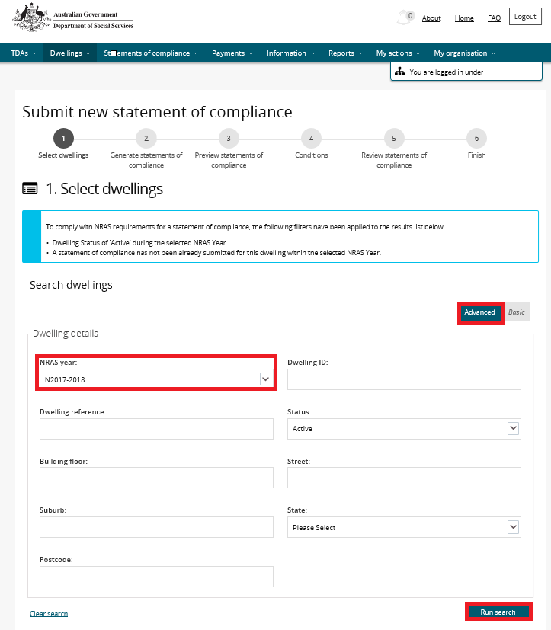

Results matching the entered search criteria will be returned.

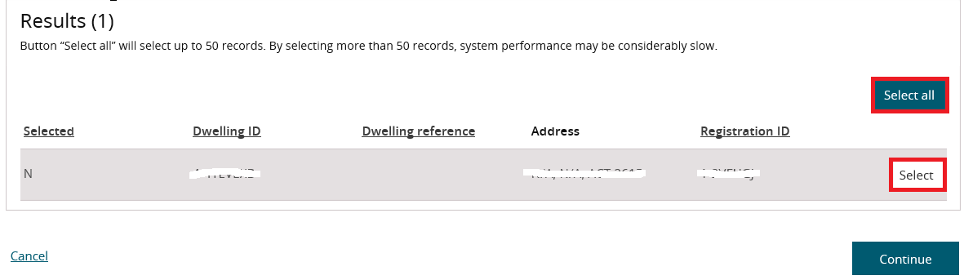

1. Select dwelling(s)you wish to submit a claim for by clicking the **Select** button associated to the Dwelling.

Additional Information Note Selecting the **Select all** button will automatically select up to 20 records.

Additional Information Note The **Select** button will appear as **Deselect** once selected. To deselect the Dwelling, click on the **Deselect** button.

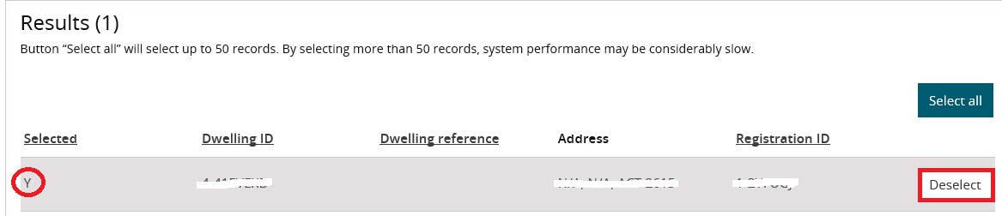

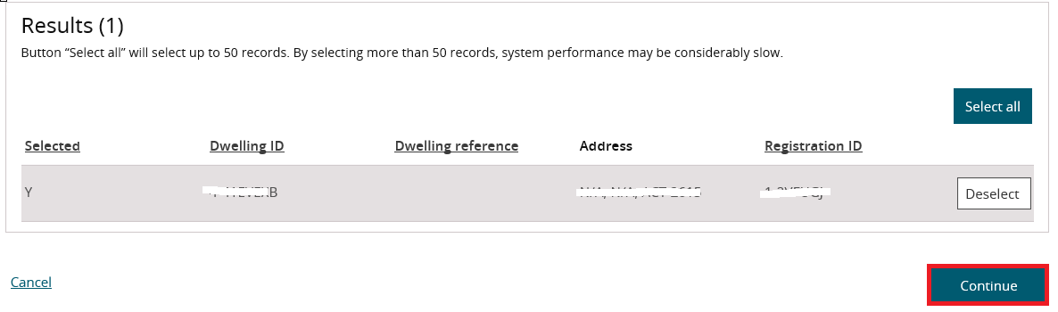

1. Click **Continue**. The **Generate statements of compliance** screen displays.
2. Click the **Generate a statements of compliance** button.

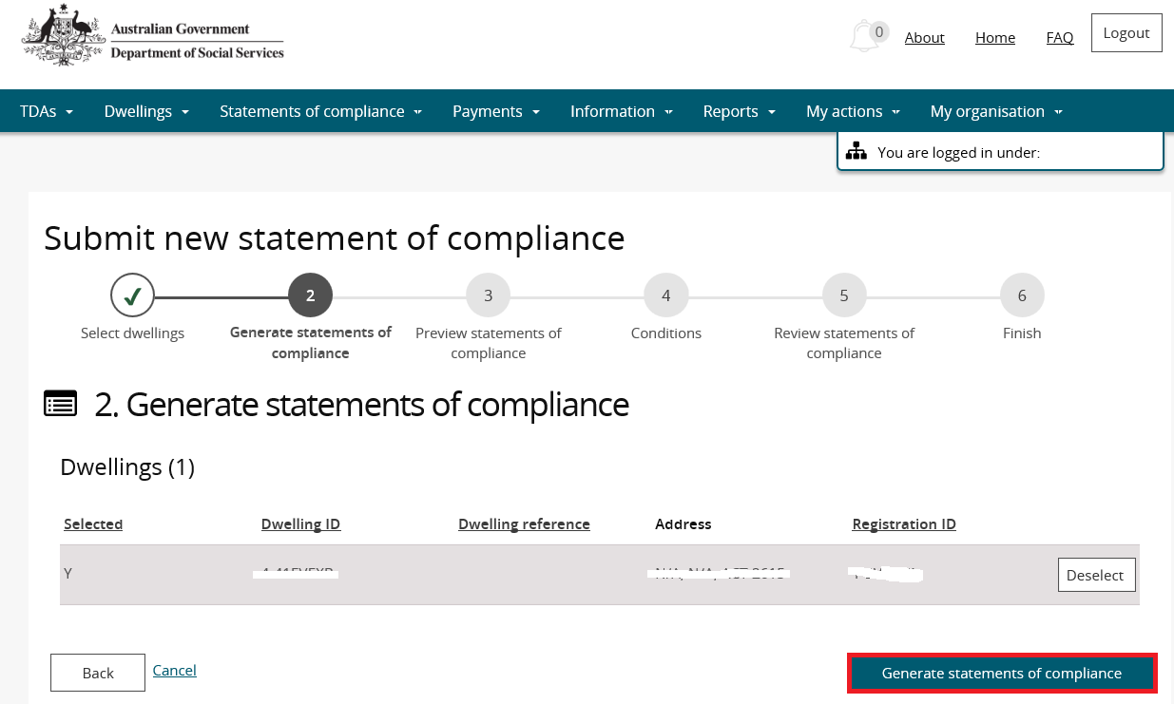

The **Preview Claims** screen displays.

1. If you would like to add a Statement of Compliance reference to your claim/s, select **Actions>Update statement of compliance** and add the Statement of compliance reference for each claim.

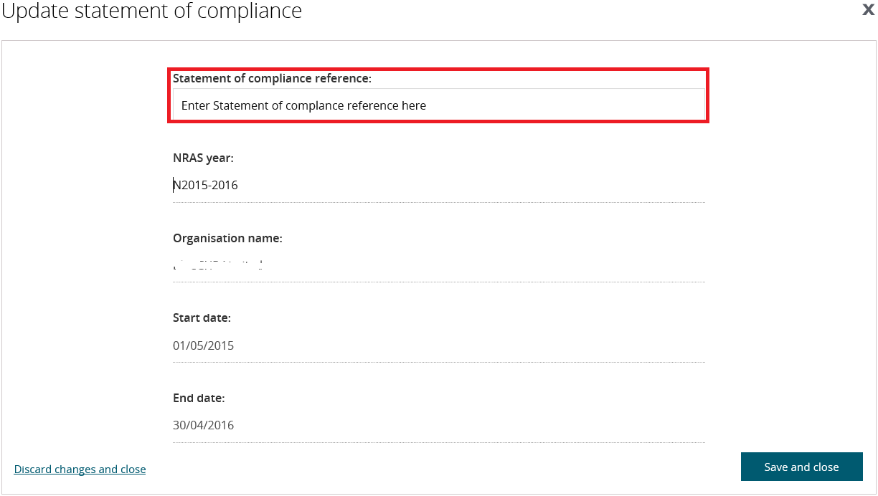

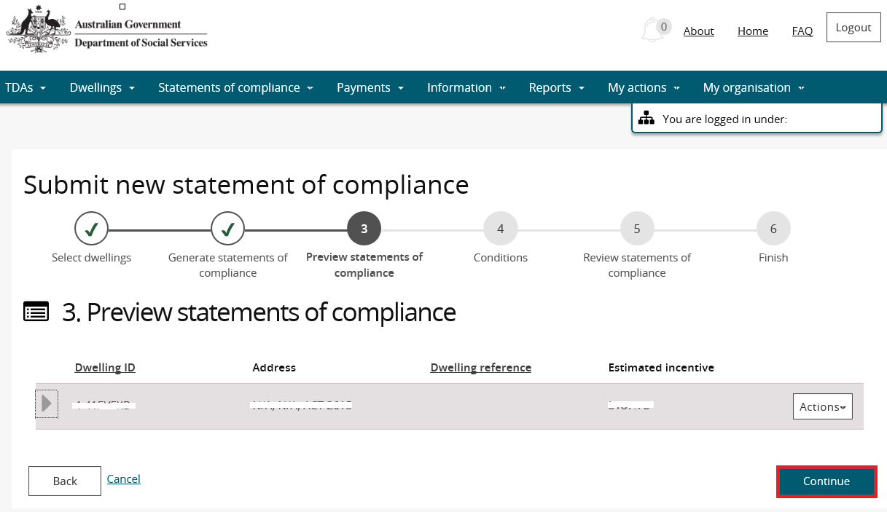

Additional Information Note If there is any issue with your claim, you will receive an error message on this screen and you will need to follow the instructions on this message.

1. Click **Continue**.

The **Conditions** screen displays.

Warning If you need to add reasons why any of the dwelling conditions or regulatory requirements have not been met, select **Actions>Update conditions**, select the ‘Not met’ checkbox and then enter your reasons in the ‘Reason field’.

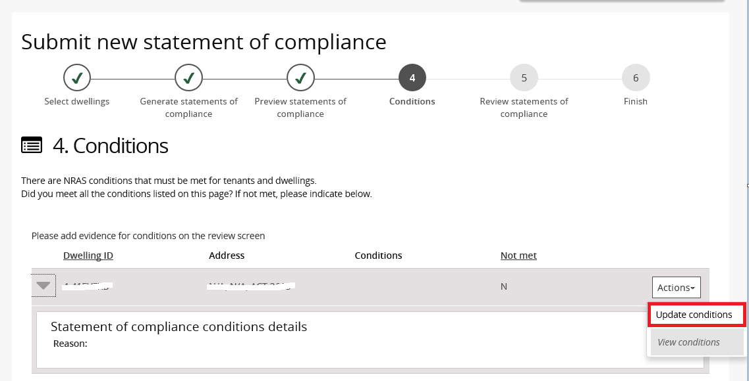

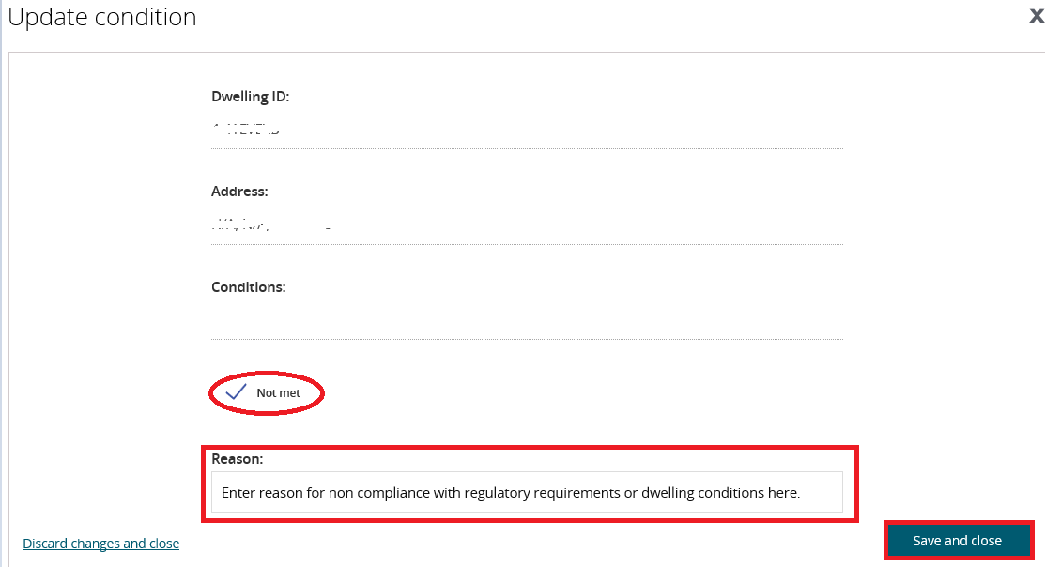

1. Select **Save and close**. The entered reasons will be displayed in the expanded section of the Conditions screen.
2. Check the **I certify…** checkbox and then select **Continue**.

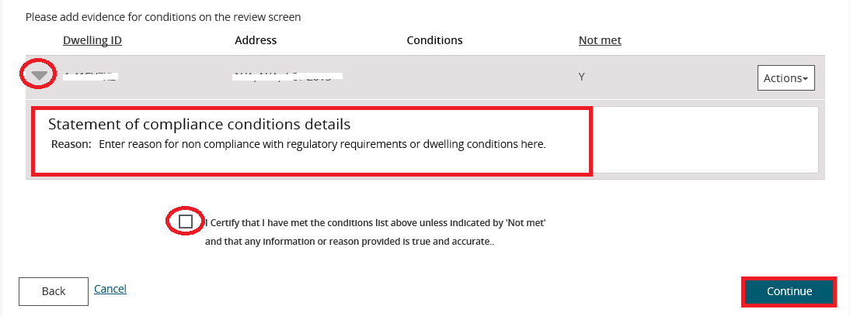

1. The **Review** screen displays. Reviewthe List of Dwellings for which you are claiming an incentive.
2. Read the ‘Statement of Compliance’ and agree to the conditions of allocations ticking the ‘**I agree**’ check box.
3. Click the **Submit Statements of compliance** button.

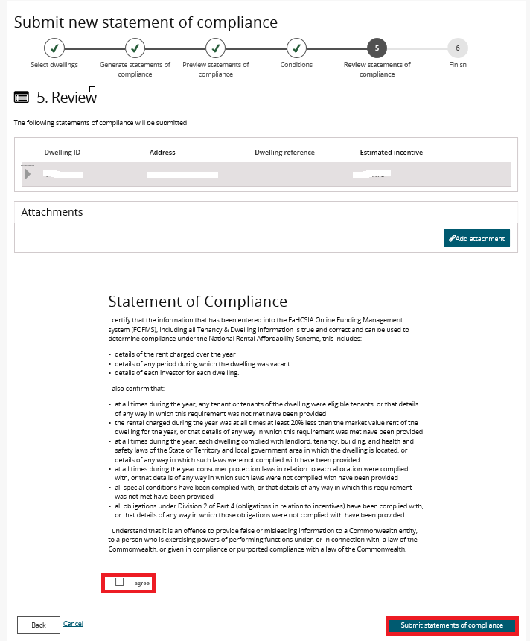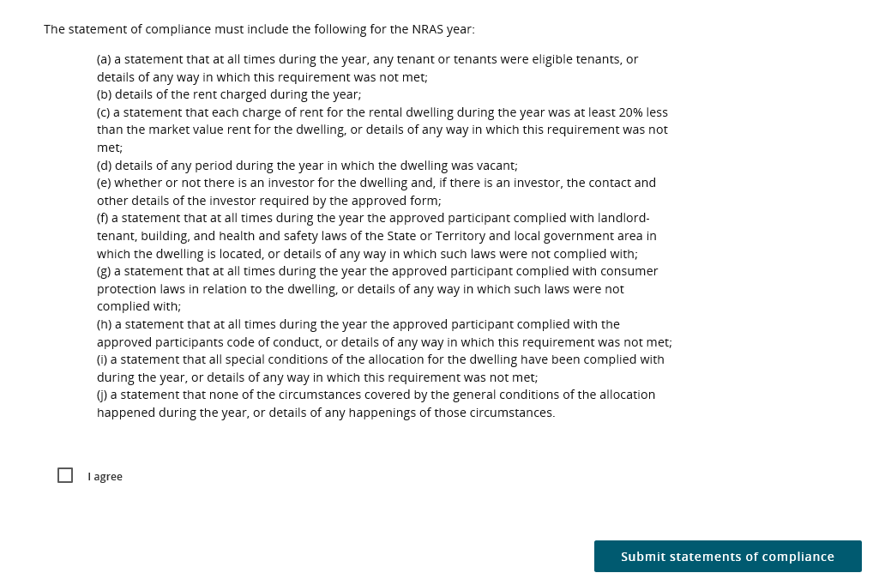

1. The **Finish** screen displays listing all information for all claims submitted.

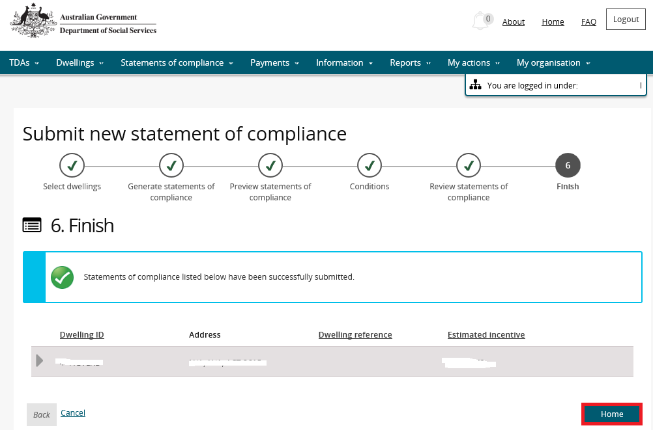

1. Click **Home** to return to the beginning of the **Submit a Statement of compliance** workflow.

Logging out of the NRAS Portal

1. To log out of the NRAS Portal click **Logout**.

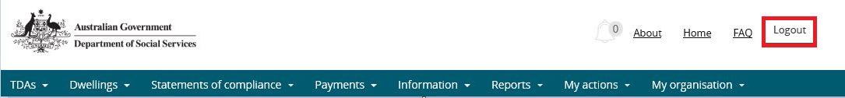

Note icon. For technical support enquiries, please contact [nrasithelpdesk@dss.gov.au](mailto:nrasithelpdesk@dss.gov.au) or 1300 911 235.