For further assistance, please contact [nrasithelpdesk@dss.gov.au](mailto:nrasithelpdesk@dss.gov.au)

## National Rental Affordability Scheme (NRAS) Portal

## Quick Reference Guide

View and complete Actions

This Quick Reference Guide (QRG) will take you through the steps to view and complete Actions in the NRAS Portal.

Access Required:

* Participant Read Write User; or Participant Claims User.

Warning Do not use the navigation buttons on your web browser while working in the portal. Using the back, forward or refresh buttons on your browser will cause you to lose the information you have entered.

Use the **Back** and **Continue** buttons to move through the different sections.

1. Log in to the [NRAS Portal](https://nras.dss.gov.au/nrasportal/).
2. At the Disclaimer, click **I Agree**.
3. There are two ways to navigate to the Actions screen from the main page: through the My actions tile (see step 4) or through the dropdown menu (see step 5).
4. Click the **My actions** tile.

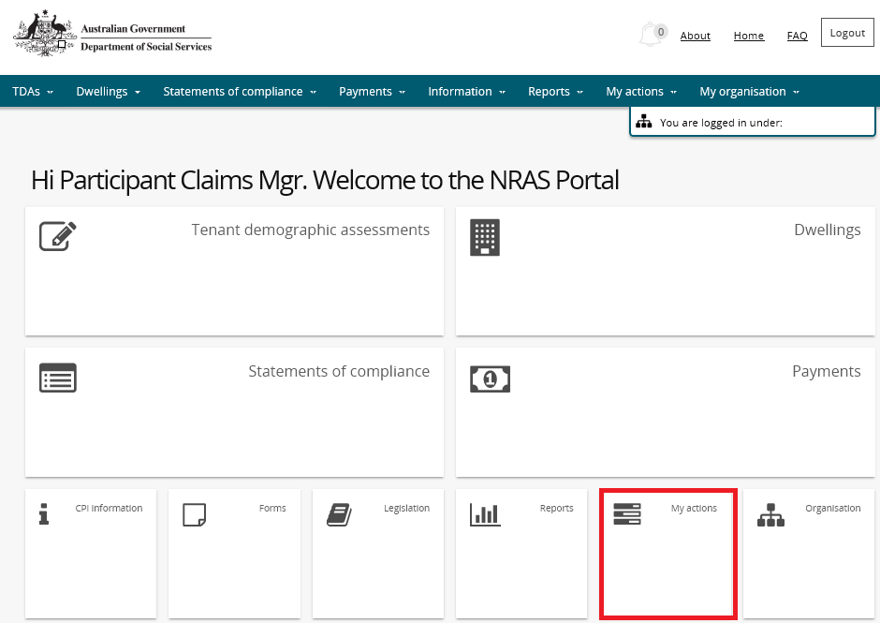

**OR**

1. At the **Welcome** screen, select **My actions>Search Actions**

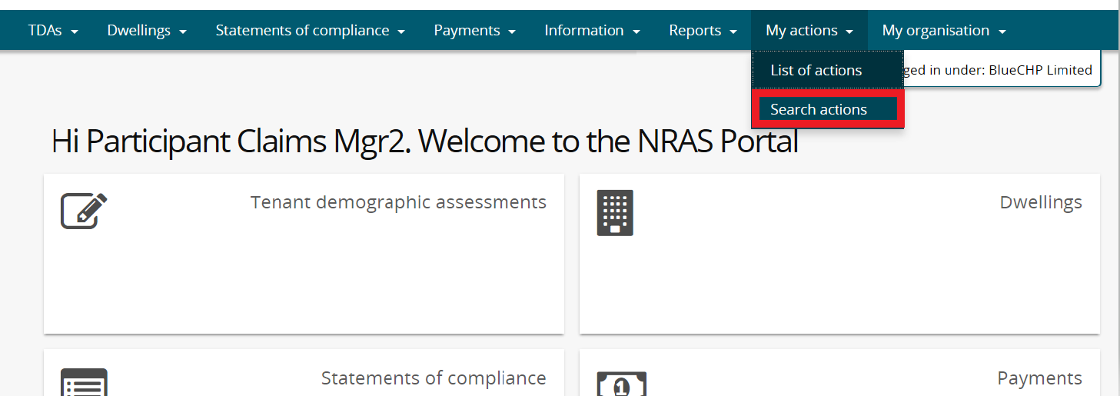

1. Complete fields you wish to search by and click **run search**.

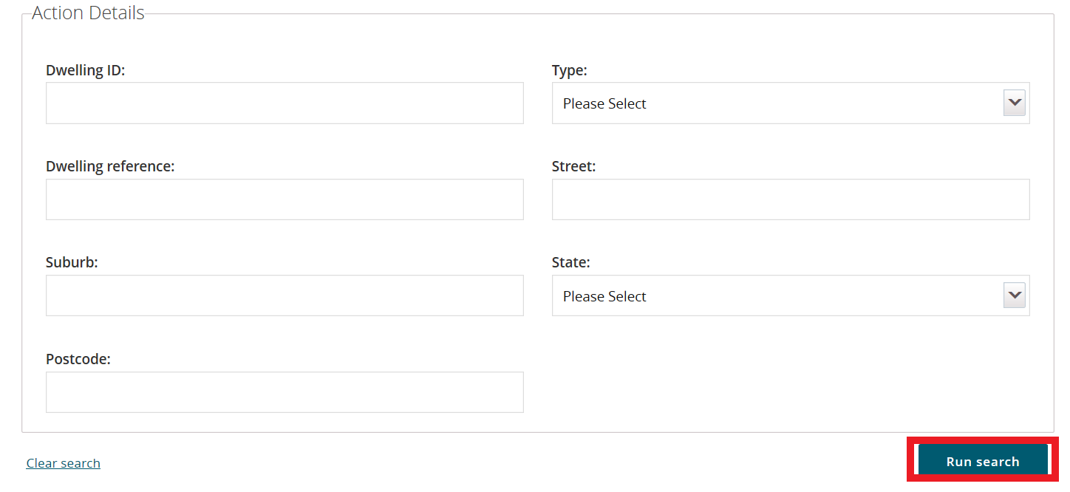

1. A list of Actions will be returned for the Organisation.

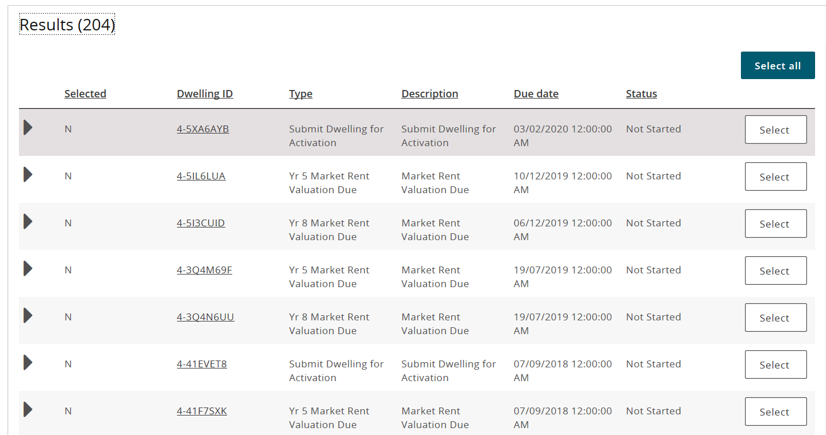

1. You can complete and close these action individually, or you can select multiple records to close at one time by clicking select all or clicking select on the actions you wish to complete. Then click ‘update selected’.

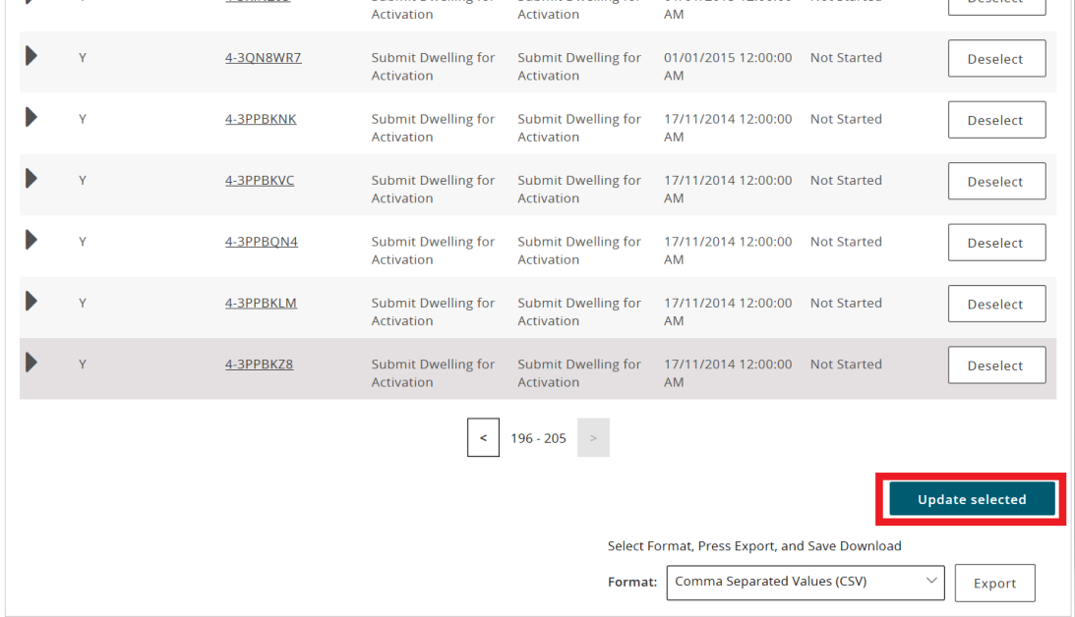

1. It will then advise you that the status of the selected records have been updated to ‘done’.

Note icon.If the action you are updating to Done is Dwelling is Ceasing, the Dwelling is Ceasing field on the dwelling will be updated to Informed Tenants.

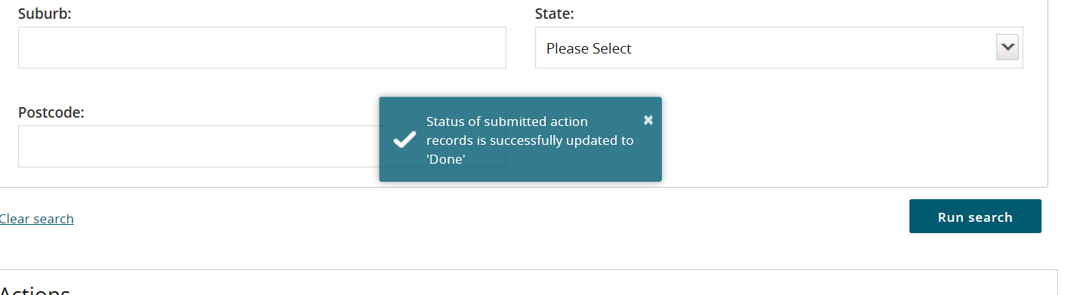

Note icon. Market Rent Valuation and Submit for Activation Actions are created by the system at a specified period of time prior to the due date. Adding the Market Rent Valuation or submitting the Dwelling for activation will not remove the Action. You will need to manually complete the Action before it is removed from the My actions page.

1. To complete the records individually, select the **Update** button for the Action you wish to work on. The **Update action** window will be displayed with the Action status set to **Not Started.**

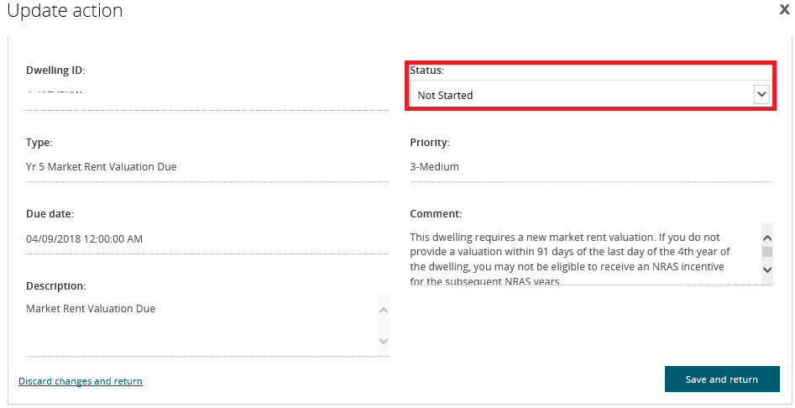

1. Update the Status to **In Progress** and select **Save and return**.

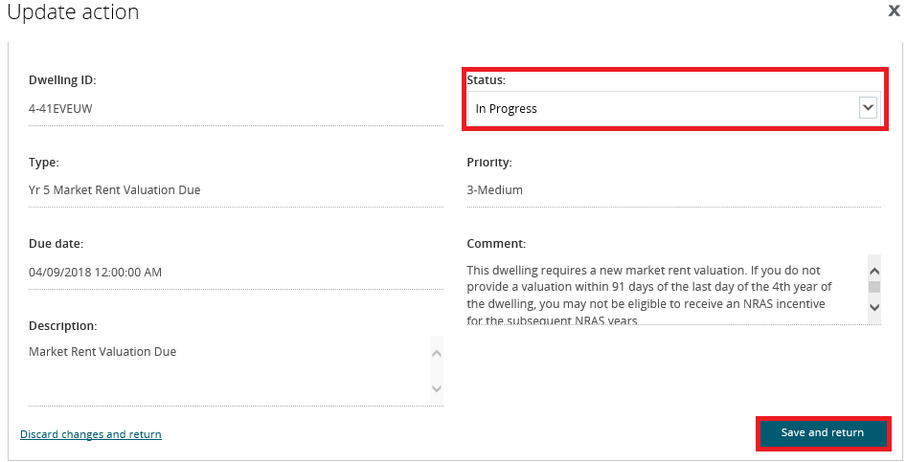

The Action will now appear on the My actions screen with the status of ‘In progress’.

1. Select the **Dwelling ID** link for the Action.

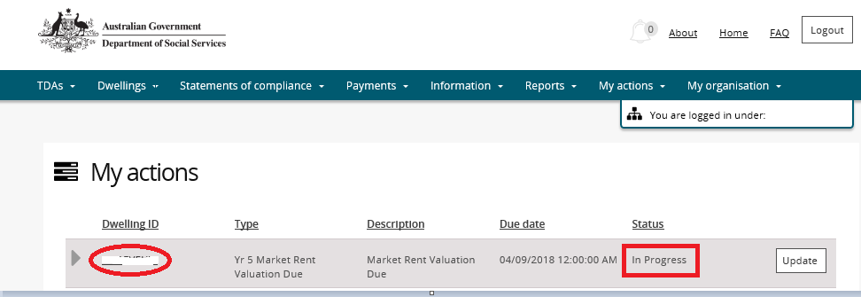

The Dwelling details page will be displayed for the Dwelling.

Note icon. Please refer to the QRG #14 - How to lodge a market rent valuation for further instructions on adding a Market Rent Valuation.

1. Once you have completed adding the Market Rent Valuation or Submission for Activation, return to the Actions page and select the Update button for the relevant Action.

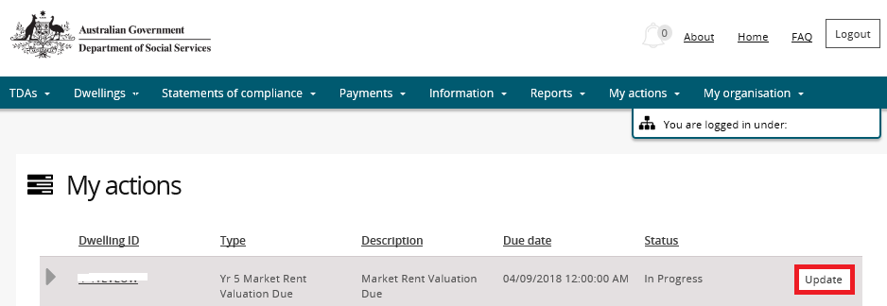

1. Update the Status of the TDA to **Done** and then select the **Save and return** button.

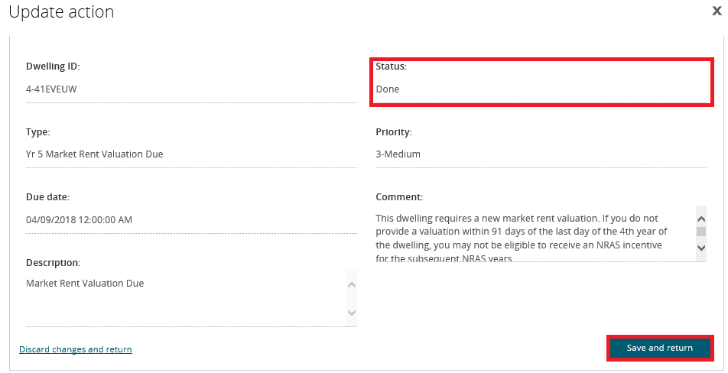

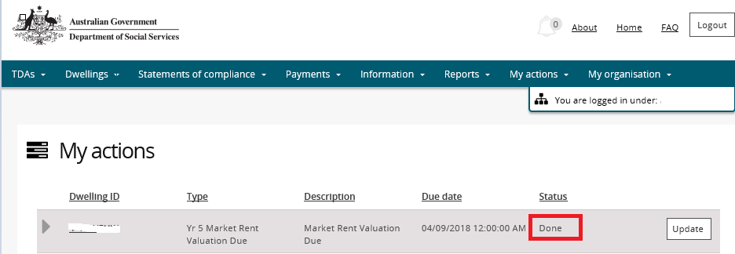

The Action will now appear on the **My actions** screen with the status of **Done**.

Note icon.The Action will not be visible on the My Actions screen the next time you log on to the NRAS Portal.

Logging out of the NRAS Portal

1. To log out of the NRAS Portal click **Logout**.

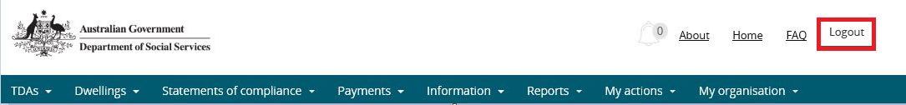

Note icon. For technical support enquiries, please contact [nrasithelpdesk@dss.gov.au](mailto:nrasithelpdesk@dss.gov.au) or 1300 911 235.

.