For further assistance, please contact [nrasithelpdesk@dss.gov.au](mailto:nrasithelpdesk@dss.gov.au)

## National Rental Affordability Scheme (NRAS) Portal

## Quick Reference Guide

Withdrawing a TDA

This Quick Reference Guide (QRG) will take you through the steps to withdraw a Tenant Demographic Assessment (TDA) and the lease period for an NRAS Dwelling.

WarningIf you withdraw a TDA you will lose all of the information associated with that TDA. This means that you will have to recreate the TDA and re-enter all associated information.

Access Required:

* Participant Read Write User; or Participant Claims User.

Warning Do not use the navigation buttons on your web browser while working in the portal. Using the back, forward or refresh buttons on your browser will cause you to lose the information you have entered.

Use the **Back** and **Continue** buttons to move through the different sections.

# Withdrawing the TDA

1. Log in to the [NRAS Portal](https://nras.dss.gov.au/nrasportal/).
2. At the Disclaimer, click **I Agree**.
3. There are two ways to navigate to the Search TDAs screen from the main page: through the Tenant demographic assessments tile (see steps 4 to 5) or through the dropdown menu (see step 6).
4. Clickthe **Tenant demographic assessments** tile. A list of all TDAs will be displayed.

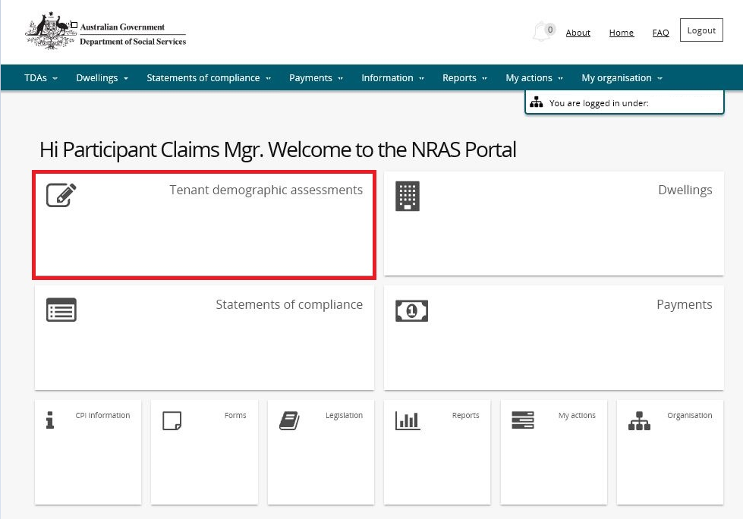

1. On the **Tenant Demographic (TDAs)** screen, select **Search TDAs**.

**OR**

1. At the **Welcome** screen select **TDAs>Search TDAs**.

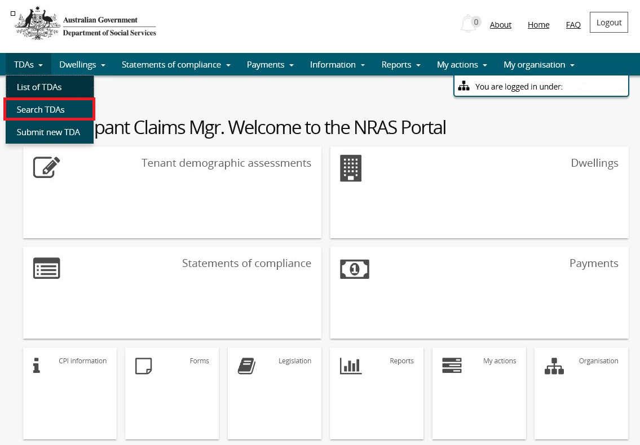

1. The **Search TDAs** screen will be returned.

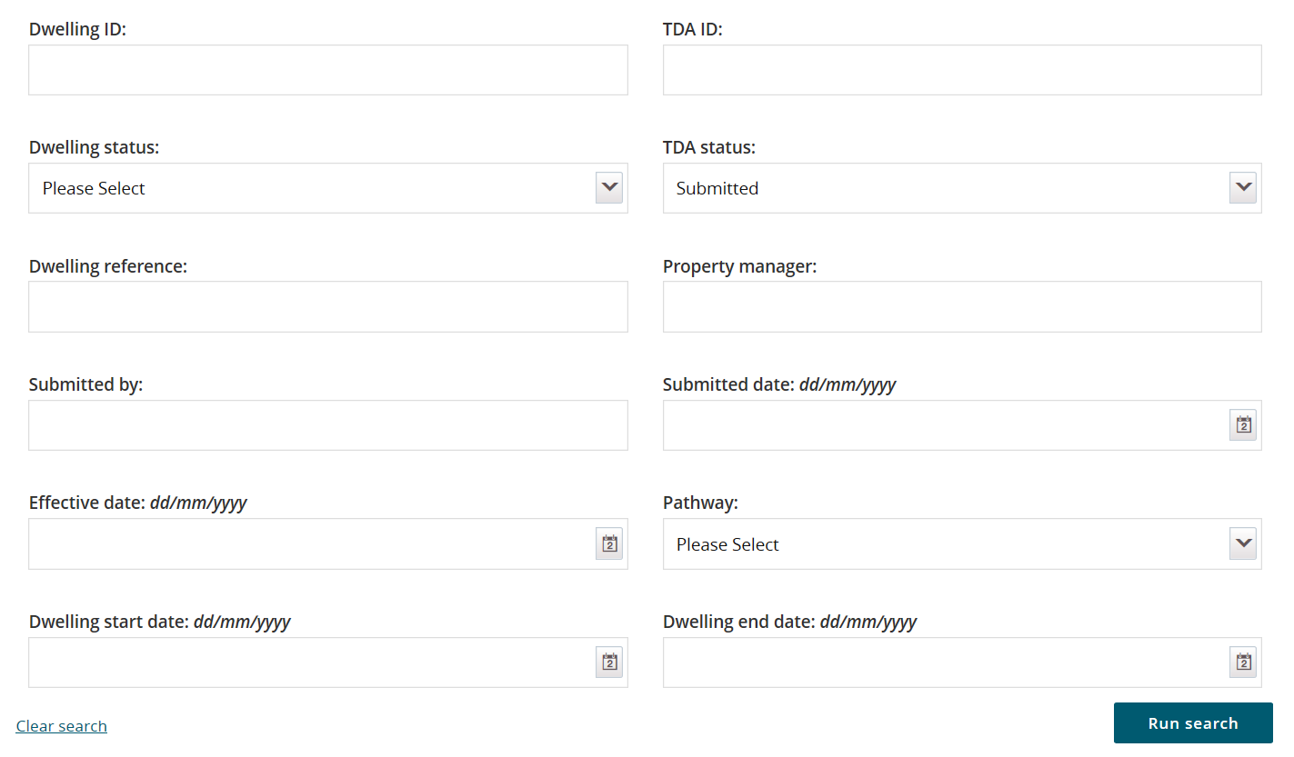

Note icon. The Dwelling ID and TDA ID search fields on the ‘Search TDAs’ page are not case sensitive. If you do not have the Dwelling or TDA details or you wish to view all TDAs you have access to, leave the all search criteria blank.

Note icon. Click **Advanced** to display additional search fields.

1. Enter search criteria and then select the **Run search** button.
2. TDAs matching the entered search criterial will be displayed.
3. Select the relevant TDA by selecting the **Action>View TDA button**.

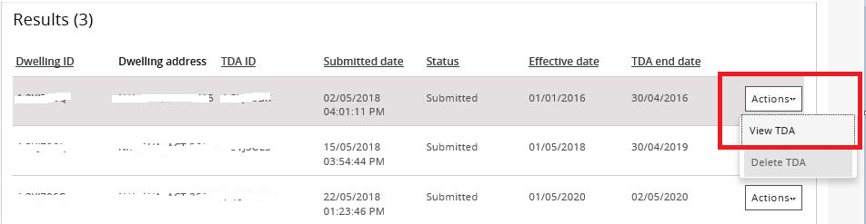

1. The **Lease and TDA details** page will be displayed for the selected TDA.
2. Select the **Withdraw TDA** button.

Note icon.When you withdraw a TDA you will lose all of the information associated with that TDA. This means that you will have to recreate the TDA and re-enter all associated information.

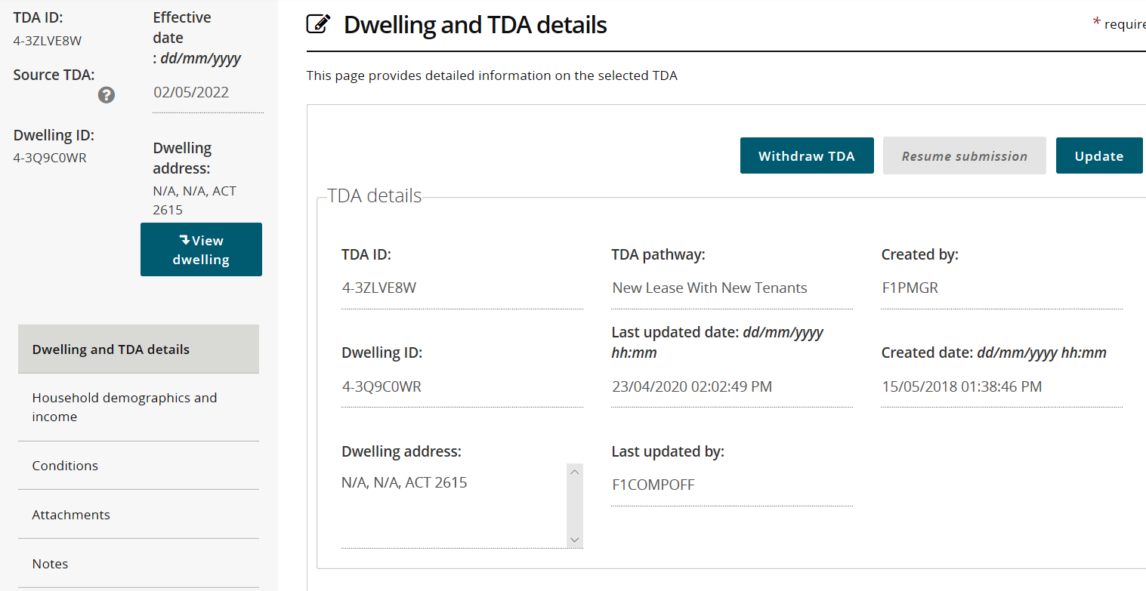

1. The **Withdrawn TDA** popup screen is displayed.
2. Enter a reason in the **Please provide a reason for withdrawing this TDA** field and then select the **Save and** **return** button.

Note icon. Entry of a reason when withdrawing a TDA is mandatory.

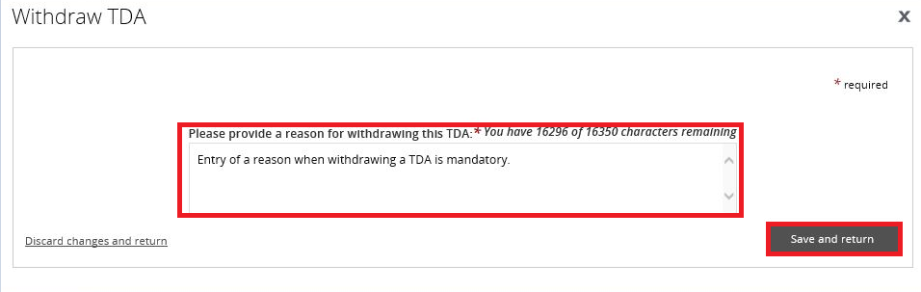

1. The TDA is withdrawn.

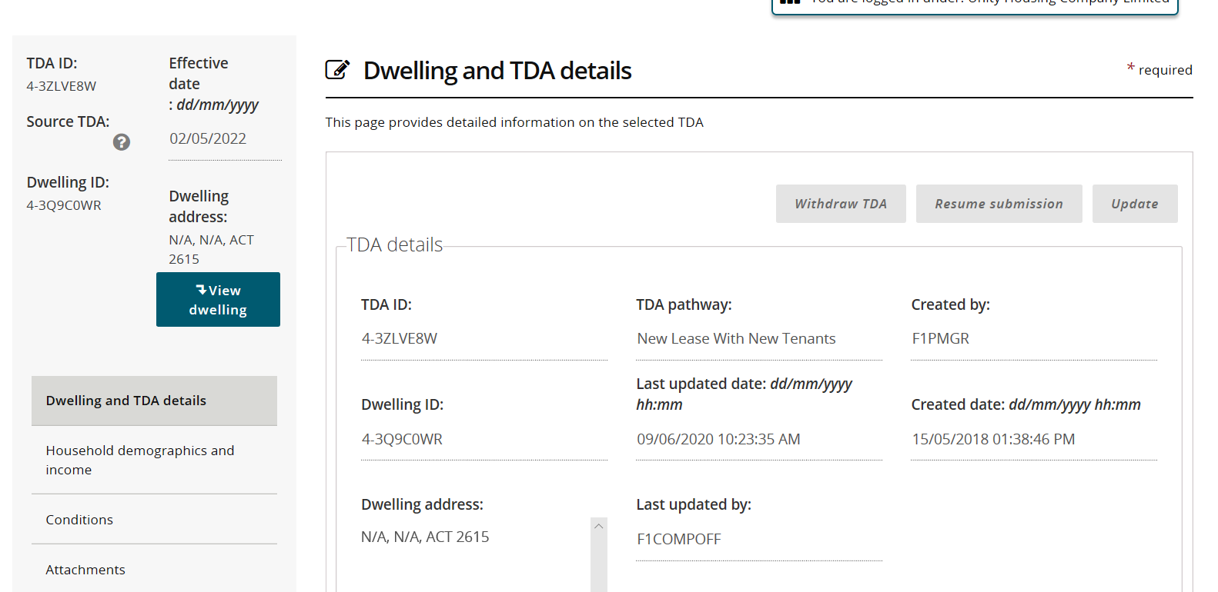

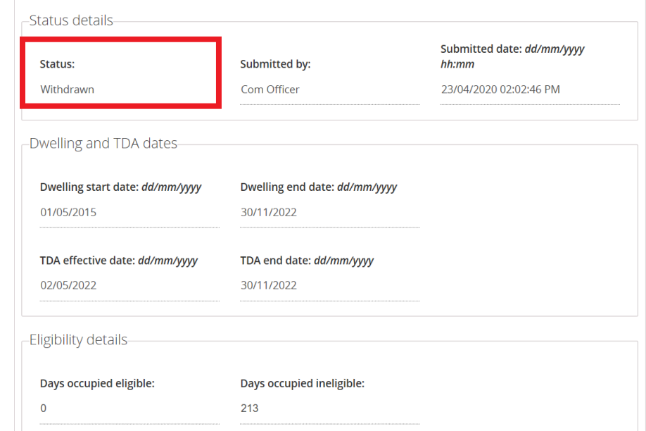

Logging out of the NRAS Portal

1. To log out of the NRAS Portal click **Logout.**

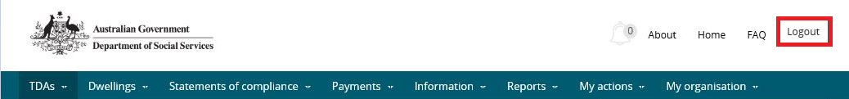

Note icon. For technical support enquiries, please contact [nrasithelpdesk@dss.gov.au](mailto:nrasithelpdesk@dss.gov.au) or 1300 911 235.