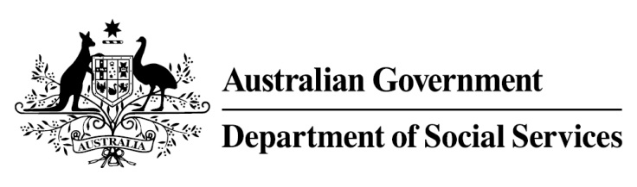

Try, Test and Learn Fund

  - Y4Y Youth Force
Using insights from the Priority Investment Approach, the $96.1 million Try, Test and Learn Fund is trialling new and innovative approaches to assist groups of people at risk of long-term welfare dependence.
The Try, Test and Learn Fund will help achieve the objectives of welfare reform—that is, to develop a modern welfare system that increases the capacity of individuals, reduces the risk of welfare dependency and maintains a strong welfare safety net.

What does the evidence tell us?

Fast facts
Priority group: Unemployed former students
Participant numbers: 80
Locations: Melbourne and Hobart
Trial period: 24 months
Total funding: $1.38 million
Co-designer: Whitelion Youth Agency
Service provider: Whitelion Youth Agency (subcontracting Nous Group)
Potential future saving: The purpose of these initiatives is to test whether an intervention works to reduce long-term reliance on welfare. It is not possible to predict success rates in advance—this is the purpose of testing new approaches. If 20 per cent of participants (17) move off welfare, the savings to the welfare system are likely to outweigh the costs
- 22 per cent of all current 17-19 year olds receiving student payments are expected to be on income support in 10 years.
- From 2003 to 2012, there were 7,160 vocational or university students who started receiving a student payment aged 17 to 19; then experienced more than 12 months on unemployment payments; and were receiving unemployment payments in 2015-16. On average, all of these former young students who transitioned directly to unemployment payments are expected to receive income support in 33 years of their future lifetimes.
- If nothing changes for these former young students, 39 per cent will be receiving income support payments in 10 years, and 30 per cent will be receiving income support payments in 20 years.

What is Y4Y Youth Force?
This project aims to assist unemployed former students, many of whom have never had a job, to gain some work experience and work skills. This will give participants a better chance of finding work, and could also stimulate their interest in further education.
Participants are provided with small group training, and are assisted by mentors, youth and employment-focused support workers who help them to address any vocational or non-vocational barriers they may have to participating in the workforce. Training could include barista courses, IT skills, customer service, administration work or maintenance.
To help build their work experience, participants are offered one-off tasks donated by community partners (for example, drafting a social media post for an organisation) and provided support to participate in short-term work via the online gig economy, if interested, as a way of building their skills, confidence and work experience. Participants are provided with transport to task locations and have access to a central hub to connect with each other, develop support networks and borrow shared resources (such as tools) for tasks.

What are we trying to achieve?
Development of participant’s work experiences and skillset, the result of which is longer-term employment opportunities. It may also stimulate interest in further education.

How is this initiative new and innovative?
This initiative will provide evidence on the effectiveness of supporting unemployed former students to build work experiences and skills through the task-based economy, as a way to support their longer-term engagement in work and education.

How will this initiative be evaluated?
This initiative will be tracked using a range of evaluation methods, such as surveys, participant interviews and actuarial analysis.

