**Place-based Evaluation Framework**

***A guide for evaluation of place-based approaches in Australia***

**Prepared for the Queensland Government Department of Communities, Disability Services and Seniors (DCDSS), the Australian Government Department of Social Services (DSS), and Logan Together**

27 August 2018

By Jess Dart

Creative Commons logo This work is licensed under the Creative Commons Attribution 4.0 International License. To view a copy of this license, visit http: [//creativecommons.org/licenses/by/4.0/](https://creativecommons.org/licenses/by/4.0/)





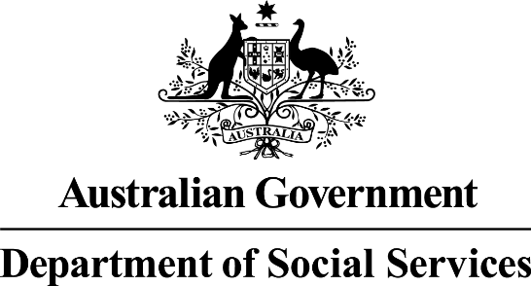

To attribute this work, cite the Commonwealth Government (Department of Social Services) and the Queensland Government (Department of Communities, Disability Services and Seniors).

This document has the following companion resources: a Toolkit and Literature Scan.

Prepared by

Clear Horizon logo

Dart, J. 2018. *Place-based Evaluation Framework: A national guide for evaluation of place-based approaches*, report, Commissioned by the Queensland Government Department of Communities, Disability Services and Seniors (DCDSS) and the Australian Government Department of Social Services (DSS).

In partnership with

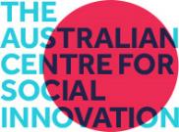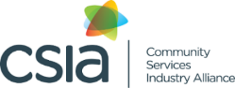

Acknowledgements

This framework was written by Clear Horizon (led by Dr Jess Dart) in partnership with the Australian Centre for Social Innovation (TACSI), Collaboration for Impact (CFI) and the Community Services Industry Association (CSIA). It has been developed in close consultation with the Queensland Government, and commissioned by the Department of Communities, Disability Services and Seniors (DCDSS) and the Australian Government Department of Social Services (DSS) to be applied in Logan Together as a proof-of-concept.

We are extremely grateful to all the people (over 100) who contributed their ideas and feedback for the design of this framework. The co-design and research involved stakeholder contributions from the Queensland and Australian Governments, the evaluation community, and representatives and practitioners from non-government and community organisations working across place-based delivery approaches in Australia and internationally.

Logan Together, we would like to thank you for the contributions and goodwill in testing this framework. The user testing was led by Dr Ingrid Burkett (TACSI). Particular thanks is extended to Matthew Cox and Sherena Oxley from the facilitating partner (backbone team) and participants from across the collective who engaged with the framework at the local level.

We would like to acknowledge the contributions and thought leadership from our inner core of expert advisers including Dr Ingrid Burkett and Rhianna Dean (TACSI or The Australian Centre for Social Innovation), Mark Cabaj, Kerry Graham (Collaboration for Impact), Dr Ellise Barkley, Caitlin Barry, Liz Bloom and Eunice Sotelo (Clear Horizon), Belinda Drew and Matthew Gillett (CSIA or Community Services Industry Alliance), Samantha Togni (S2 Consulting), Margaret Smith (Uti Kulintjaku Project Team, Ngaanyatjarra Pitjantjatjara Yankunytjatjara Women’s Council), Margaret Heffernan (Menzies School of Health Research), Eva Nagomara, Ruth Nagomara, and Carol Vale (cultural consultants), Jen Riley, Anna Powell, Zazie Tolmer, and Mila Waise.

The framework has also benefited from expertise and advice of the Place-Based Evaluation Joint Working Group and from the collaborative efforts and input across the Queensland and Australian government departments working on place-based initiatives and policy. Particular thanks is extended to the DCDSS Place & Industry team for their great flexibility and engagement.

Contents

Executive Summary 1

1. Introduction 3

1.1. About this framework 3

1.2. The case for evaluation 3

1.3. Purpose 3

1.4. Scope 3

1.5. Who it is for 4

1.6. How to use this framework 5

2. Key definitions 7

2.1. Definition of place-based delivery approaches 7

2.2. Definition for evaluation 8

2.3. Shared measurement versus evaluation 9

3. Evaluating with and by community 11

3.1. The role of community in evaluating PBAs 11

3.2. Appropriate evaluation for different contexts 12

3.3. Ethical conduct 16

3.4. Summary 17

4. The framework in a nutshell 18

4.1. The components of the framework 18

4.2. The evaluation principles 18

4.3. The planning steps – frame and scope 19

4.4. The concept cube 21

4.5. The generic theory of change 22

4.6. Key evaluation questions 25

5. Minimum standards for evaluating PBAs 27

6. Planning your own adventure: designing the right evaluation approach for your PBA 28

6.1. Phase and pace of change 28

6.2. Different MEL plans for different parts of the PBA 30

6.3. Different levels of resourcing and capability for evaluation 30

7. Step 1: Frame and scope 33

7.1. The importance of getting clear 33

7.2. Clarify the ‘thing’ you are evaluating 33

7.3. Clarify the audiences 34

7.4. Clarify the purpose and focus of the MEL 34

7.5. Clarify your resourcing and degree of investment in evaluation, and choose your ‘level’ 34

7.6. Plan your stakeholder engagement approach for MEL 35

8. Step 2: Clarify your theory of change and principles 37

8.1. Ideas for how to apply the generic theory of change to your context 37

8.2. More detail about each element 40

8.3. How to use the theory of change once you have one agreed 42

9. Step 3: Plan the evaluation 44

9.1. Key evaluation questions (KEQs) 44

9.2. Different questions may be relevant for different perspectives and phases 45

9.3. Develop your sub-questions and key indicators 49

9.4. Indicators and questions 54

9.5. Identifying the evidence you need 55

9.6. Scoping and planning tools (the planning tool) 56

10. Step 4: Plan for strategic learning and adaption 57

10.1. Consider resourcing for developmental evaluation (DE) 57

10.2. Strategic learning and reflective practice tools 59

10.3. Reporting 59

11. Theoretical underpinnings of this framework 61

Background to evaluating PBAs 61

Why it’s tricky to evaluate place 61

Appropriate theoretical approaches for evaluating PBA 62

References 67

Annex 1: Glossary 69

Annex 2: The co-design process 73

Annex 3: Practical guide to cultural capability 75

List of figures

Figure 1: Shared measurement and evaluation 2

Figure 2: The planning steps (simple) 2

Figure 3: The planning steps (detailed) 2

Figure 4: The concept cube 2

Figure 5: Levels of theory of change 2

Figure 6: Full generic theory of change 2

Figure 7: The logic of evaluation 2

Figure 8: Phases of place-based delivery approaches and changes 2

Figure 9: Theory of change visualised as a tree 2

Figure 10: Likely results by actor group 2

Figure 11: Adaptive cycle 2

Figure 12: Difference between attribution and contribution 2

List of tables

Table 1: Guiding key evaluation questions 2

Table 2: Different levels of resourcing 2

Table 3: Levels of engagement in evaluation 2

Table 4: Key and sub-evaluation questions 2

Acronyms

|  |  |
| --- | --- |
| DCDSS  DSS  CFI  PBA  MEL | The Queensland Department of Communities, Disability Services & Seniors  The Australian Government Department of Social Services  Collaboration for Impact  Place-Based (Delivery) Approach  Monitoring, evaluation and learning |

# Executive Summary

The Place-based Evaluation Framework has been designed as a flexible user guide for evaluating place-based delivery approaches in Australia. It is designed for communities and facilitating partners implementing place-based delivery approaches (PBAs), funders, partnering organisations, service providers and evaluators. There is no ‘one size fits all’ solution for evaluating PBAs - evaluation needs to be context specific and based on the community and collective needs of partners and stakeholders.

*PBAs are collaborative, long-term approaches to build thriving communities delivered in a defined geographic location. This approach is ideally characterised by partnering and shared design, shared stewardship, and shared accountability for outcomes and impacts.*

*PBAs are often used to respond to complex, interrelated or challenging issues – such as to address social issues impacting those experiencing, or at risk of, disadvantage, or for natural disasters.*

The framework is relevant for the planning, establishment, and initial, middle, and later years of PBAs and outlines practical steps and considerations for designing appropriate and proportional evaluation solutions. It provides guidance and tools to help users to:

* navigate the planning, design and implementation of place-based evaluation across the distinct PBA phases of implementation and progress, and
* evaluate the processes, changes, impact and principles of place-based delivery PBAs.

### Key components of the Place-based Evaluation Framework

In the framework you will find instruction for multi-site PBAs, evaluation scoping, collective impact, cultural capability, theory of change, key evaluation questions, principles, indicators, measurement, ethical conduct, resourcing, reporting, and a theoretical overview of complexity aware evaluation approaches.

**Core Principles**

Principles for evaluating place-based delivery approaches

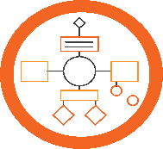

**Planning Steps**

A planning tool for developing a monitoring, evaluation & learning (MEL) plan

**Generic Theory of Change**

A process for mapping outcomes in the short, medium and long-term

**Key Evaluation Questions**

Addresses questions such as

Are we following our principles?

What is the quality of our process?

What are we learning?

What has changed as a result of our work?

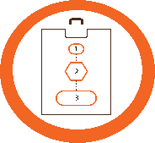

**Concept Cube**

A conceptual framework for understanding PBA evaluation and the dimensions involved

**Toolkit**

An extensive toolkit with resources, methods and templates for data collection & analysis



**The framework has 11 sections:**

Section 1 – Introduction

Section 2 – Key definitions

Section 3 – Community and stakeholder engagement

Section 4 – The framework in a nutshell (concepts, planning steps, principles)

Section 5 – Minimum requirements for PBA evaluation

Section 6 – User guide for determining user context, role and stage of PBA

Sections 7-10 – Practical steps to plan an evaluation framework

Section 11 – Theoretical overview of PBA evaluation app roaches

Glossary – Definitions for key terms*The framework was commissioned by the Queensland Government Department of Communities, Disability Services and Seniors (DCDSS), and the Australian Government Department of Social Services (DSS), with Logan Together as proof-of-concept. It was developed through a co-design process with input from over 100 practitioners and evaluators, and led by Clear Horizon in partnership with The Australian Centre for Social Innovation (TACSI), Collaboration for Impact (CFI), and Community Services Industry Alliance (CSIA).*

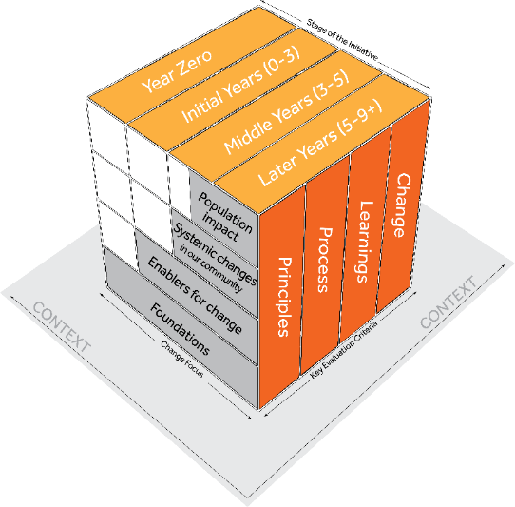

**Section 4** includes the ‘conceptual cube’ which shows the multi- dimension considerations for evaluating place-based delivery approaches. It highlights the interplay between the levels of change over time (across starting conditions; enablers for change; systemic changes in community, and population impact); and the different phases of the PBA. Linked to this is the evaluation criteria that may be important for your evaluation (principles, process, learning and change).

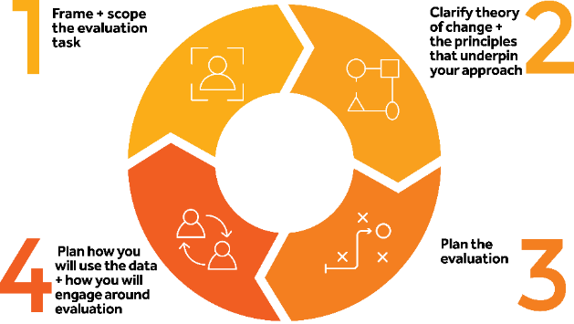

**Sections 7 – 10** of the framework provide the practical steps to get started. The planning tool provides guidance on how to develop a Monitoring, Evaluation and Learning (MEL) plan across 4 steps – frame and scope; clarify the theory of change; plan the evaluation; and plan for strategic learning and reporting.

# Introduction

## About this framework

This framework aims to provide flexible guidance for how to evaluate place-based delivery approaches in Australia. Although ***place-based delivery approaches*** (PBAs) are not new, there is limited understanding of their impact due to their complexity, the number of stakeholders involved, the range of changes initiated, and their long-term nature. This framework was commissioned to address this gap and as a joint initiative between the Queensland Government Department of Communities, Disability Services and Seniors (DCDSS), the Australian Government Department of Social Services (DSS), and Logan Together.

Clear Horizon Consulting developed the framework through a co-design process with input from over 100 practitioners and evaluators. The framework was tested with Logan Together (as proof of concept), and we hope that it will continue to be tested and evolve over time. The co-design facilitation and writing of the framework was led by Dr Jess Dart from Clear Horizon, with user testing with Logan Together led by Dr Ingrid Burkett from The Australian Centre for Social Innovation (TACSI).

## The case for evaluation

There is overwhelming agreement in the literature of the importance of evaluating PBAs. Evaluations can help communities, policy makers, program designers and funders determine which interventions work best and under what conditions, and to identify the innovations that should be scaled up or replicated in other communities. DSS (2017) highlights the importance of testing whether PBA theories are working, and for building the evidence base for what works in the context of complexity. Evaluation can be creatively used by communities to build the momentum and develop capability in how to create lasting and sustainable change in people’s lives.

## Purpose

The aims of the framework are to:

* provide consistent, flexible guidance for how to evaluate PBAs in response to complex, interrelated issues within geographic areas
* clarify the different types of outcomes across PBA phases that may be achieved to help establish expectations and report on progress to government and other partners
* provide guidance and build capacity about the types of methods and approaches that may help place-based collaborations enhance their evaluation practice.

## Scope

This framework provides guidance on how to evaluate the initial stages, middle and later phases of place-based delivery approaches. It includes monitoring, evaluation and learning (MEL) being managed from within and across a place-based delivery approach, as well as discrete evaluation studies that might be conducted by an external evaluator. While it has been primarily written for government-funded PBAs, it is hoped that it will also be relevant for other non-government PBAs.

This framework has been created specifically for place-based delivery approaches, and is not intended for use in all or any initiatives/interventions associated with ‘place’ (see Section 2.1 for PBA definition). It is also beyond the scope of this evaluation framework to provide comprehensive guidance on how to design and implement PBAs[1]. Our focus is monitoring, evaluation and learning for PBAs.

## Who it is for

This framework has initially been developed to provide guidance for people involved in designing, managing and conducting evaluation of PBAs that are supported by and receive some funding from the Australian Government and/or the Queensland Government. This encompasses PBAs that happen in a broad range of contexts and with culturally diverse populations.

We hope that it will also be useful for other states and territories, non-government agencies, philanthropy, and community users involved in evaluating PBAs and other similar initiatives.

### Communities implementing PBAs

People living in the communities where PBAs are being implemented can use this guide to do their own evaluation and learning processes, as well as to understand the sort of requirements that governments might have when providing funding.

### PBA leaders, facilitating partners and intermediary organisations

People facilitating the implementation of PBAs can use this guide to assist the co-design of tailored MEL that acknowledges multiple funders and users while meeting minimum requirements and allowing for local flexibility. ***PBA leaders***, ***facilitating partners***[2] and ***intermediary organisations[3]*** can also use this guide to evaluate and learn about their own efforts in PBAs.

### Funders

Government, philanthropic and other funders can use this guide to:

* help write a tender for an external evaluation of a PBA
* help co-design a MEL plan for a PBA they are involved with
* think about what levels of resourcing may be needed for an evaluation
* inform expectations and communications about the types of changes that might realistically be expected for progress at different phases of PBAs
* understand the results being achieved via PBAs and support accountability for public investment
* evaluate their role in PBA (beyond funding), e.g. a catalyst, enabler and influencer.

### External evaluators

This framework aims to provide guidance around how to evaluate or help build a MEL plan for PBAs. It may also provide some insights for working on a specific evaluation study that the evaluator has been commissioned to lead.

## How to use this framework

The framework has been designed as a flexible user guide, as there is no ‘one size fits all’ solution for evaluating PBAs. Each PBA evaluation will be context specific.

In using this framework, we encourage you to pick and choose the most relevant sections for your PBA needs depending on your context and the role you play. This framework has been built like a ‘choose-your-own-adventure book’. You choose the most relevant pathway.

Below is an overview of the sections and what you can expect to find in:

* **Section 2** – provides key definitions for PBAs and evaluation
* **Section 3** – covers engaging community and stakeholders in evaluation
* **Section 4** – describes the framework in a nutshell (concepts, planning steps, principles)
* **Section 5** – outlines the minimum requirements for evaluation
* **Section 6 –** offers guidance for ‘choosing your own adventure’ depending on user context, role and stage of PBA
* **Sections 7-10** – contain the practical steps to planning an evaluation framework
* **Section 11** – explores the case for evaluation, the challenges of evaluating PBAs, and what types of theoretical approaches to evaluation approaches are most suitable
* **Glossary** – contains key concepts and definitions. Glossary words appearing in the first instance are signposted in the text as bold and italicised, e.g. ***formative evaluation.***

Within the sections, the framework contains evaluation guidance relevant across the distinct PBA phases of implementation and progress, with instruction and tools for the planning, establishment, and initial, middle, and later years of PBAs.



Accompanying the framework is a toolkit with resources, templates and information about the tools and methods suggested for evaluating PBAs. Links to the tools are marked with a magnifying glass icon.

So, where to from here?  
  
If you would like some context to this framework, read sections 2 and 3. If you want to understand the theory behind it all, Section 11 is for you. If you are ready to jump straight into understanding what the framework offers about the concept and minimum requirements for evaluating PBAs, read sections 4 and 5. If you want to plan your evaluation framework right away, read sections 6 to 9.

#### Remember

***Words in bold and italics*** refer to glossary terms (see Annex 1).

Toolkit symbol

Icon refers to tools in the accompanying toolkit.

# Key definitions

## Definition of place-based delivery approaches

There is no commonly agreed definition for PBAs. For this document, we use the following definition and characteristics statement to define PBA:

A collaborative, long-term approach to build thriving communities delivered in a defined geographic location. This approach is ideally characterised by partnering and shared design, shared stewardship, and shared accountability for outcomes and impacts.[4]

Common characteristics of PBAs include:[5]

* responding to complex, interrelated or challenging issues, including social issues impacting those experiencing, or at risk of, disadvantage, or for natural disasters
* a strength-based delivery approach that focuses on prevention not just intervention
* identifying and working on community priorities, valuing local knowledge, and building on and from social and cultural relationships
* a commitment to strategic learning, and using data and evidence to collectively adapt in real time
* ongoing building of capacity and capability amongst all stakeholders involved in the work
* focus on collective and collaborative action, active engagement, and partnership with communities so that all stakeholders see themselves as active participants
* an underpinning value of creating greater equity.

### Roles within a PBA

PBAs are collaborative and involve a lot of different stakeholders playing different roles. In this framework, we refer to three specific roles:

* The ***facilitating partner*** is the person or group who has the role of convening, facilitating and catalysing the PBA -- this is often a funded function.
* The ***PBA leaders*** are a group of leaders (or quorum) from different organisations and from the community who play a leadership and governance role in the PBA -- this is often an in-kind contribution.
* The ***broader collaboration*** are all the organisations, including community groups, academics, service providers and government, policy makers, individuals, and families who are involved in implementing the PBA across the place -- this can be in-kind or can be funded in many diverse ways.
* **Funders** are the people or agencies providing funding (often funding the facilitating partner) – these are usually government and philanthropic organisations.

### Multiple-site PBAs

As well as PBAs that focus on a defined geographic area, some PBAs contain multiple sites or ‘places’. In these cases, there is usually a local facilitating partner for each ‘place’ and an intermediary organisation that provides centralised support to multiple facilitating partners. This framework provides some guidance for intermediaries and multi-site PBAs.

### Collective impact

While this framework is not specifically for ***collective impact***, it is important to note that collective impact is being used in Australia in a growing number of communities and is one type of PBA. While this evaluation framework refers to some collective impact terminology such as ‘shared measurement’, it aims to cater for a range of PBAs, including those not using collective impact methodology. A definition for collective impact can be found in the Glossary in Annex 1.

## Definition for evaluation

We define evaluation as:

…the systematic collection of information about the activities, characteristics and outcomes of PBAs to make judgments about the PBA, improve the effectiveness and/or inform decisions about future activities.[6]

When we refer to evaluation we are including ***formative evaluation*** (for improving implementation), ***summative evaluation*** (for accountability), ***impact evaluation*** (for tracking change and causality), and ***developmental evaluation*** (for informing the development of the PBA; see Section 10.1 for a detailed description).

### Evaluation framework

When we refer to the ‘evaluation framework’, we mean the overarching evaluation framework offered in this document, see specifically Section 4 ‘Framework in a Nutshell’ and Section 5 ‘Minimum Standards for PBAs’. The place-based evaluation framework covers the different phases of a PBA, different users and contexts.

### Monitoring, evaluation and learning (MEL)

In this framework, we refer to ‘MEL’ plans. MEL plans combine ***monitoring***, ***evaluation*** and ***learning*** into one integrated plan.

* **Monitoring** involves communities and PBA stakeholders continually collecting routine data.
* **Evaluation** involves communities and PBA stakeholders posing and answering key evaluation questions with evidence.
* **Learning** refers to using monitoring, shared measurement and evaluation data to answer key evaluation questions to inform strategic learning and adaption.

Some people refer to it as ‘monitoring and evaluation’ (M&E); we call it MEL here to emphasise the critical role of learning.

### Evaluation study

We refer to ‘discrete evaluation studies’ as an evaluation that may be conducted at a specific phase or time. They are often (but not always) conducted by external evaluators and result in a more formal report. Good practice is to narrow an evaluation study down to a specific set of evaluation questions. The evaluation framework provides some guidance on conducting evaluation studies.

## Shared measurement versus evaluation

Shared measurement refers to the “use of a common set of measures to monitor performance, track progress towards outcomes, and learn what is and is not working in the group’s collective approach” (Kania, 2012). While it is not essential for all PBA evaluation, it is an important consideration and inclusion for many PBAs, particularly those delivery approaches following the collective impact model. For collective impact PBAs, some see shared measurement as an essential component. However, there is still much debate about the approach in the field.

In summary, shared measures aim to (CFI, 2018)[7]:

* enable the group/collective to determine what success looks like in their place
* improve data quality
* track progress toward a shared goal/vision
* enable coordination and collaboration
* learn and course correct
* catalyse action.

Shared measurement involves collecting data and measuring results consistently with a short list of quantitative indicators at the community level and across all participating organisations. This not only ensures that all efforts remain aligned; it also enables the participants to hold each other accountable and learn from each other’s successes and failures (CFI, 2018).

If considering shared measurement, here are some things to keep in mind. Cabaj (2014) cautions overemphasis on shared measurement as the only or central element of a learning and evaluation strategy, and points out it can be an expensive and time-consuming endeavour. Some practitioners from the field have also indicated that some PBAs have become ‘stuck’ in the development of their shared measurement framework. There is also a tendency to spend evaluation budget on shared measurement rather than on evaluation more broadly.

In light of the pros and cons emerging from the field, we recommend that shared measurement be seen as an important part of evaluation, but that it is not sufficient as a sole approach, and effort and time should also be invested in evaluation. As outlined in the next section, while shared measurement and evaluation have their differences, they can be complementary.

### The difference between shared measurement and evaluation

As shown in Figure 1, shared measurement and evaluation overlap. Shared measurement provides data against key indicators about baseline and trends at the population level that are used as part of the evidence for evaluation. Yet shared measurement can also play a critical role in setting the overall agenda and priorities that the collective and the community wish to focus on, and this aspect falls outside of evaluation.

Venn diagram showing evaluation and shared measurement overlapping.
Evaluation includes: evaluation process, quality and developmental components, such as testing innovation, and exploring contribution.
Shared measurement includes: setting agenda, gaining insights from population level data to plan action.
Where these overlap includes: tracking population level trends and pre-conditions or determinants.

Figure 1: Shared measurement and evaluation

Equally, evaluation has a broader focus than shared measurement. Evaluation looks beyond population-level results and indicators and asks a broader set of questions. For example, it may consider what strategies are working, whether capacity is being built, and whether we are working in ways that match our values. Evaluation is concerned with causation, and whether the outcomes emerging are a result of our work, or whether they would have happened anyway. Evaluation uses both ***quantitative*** and ***qualitative*** methods to address key evaluation questions.

In terms of the ‘shared’ nature of evaluation, this framework encourages users to develop population (community) level indicators in a participatory manner involving community, key service providers, and other collaborators. Yet we suggest that not all aspects of evaluation need to be shared by all parties. In this evaluation framework, we note where shared measurement fits with evaluation and provide links to guidance in the toolkit but the focus is more on evaluation rather than shared measurement.



**See Toolkit: Section 4**

# Evaluating with and by community

*“Evaluation is an opportunity for everyone to come together and see what is being learned.”* (Participant from Logan Together monitoring, evaluation and learning co-design)

Place-based delivery approaches are participatory in nature, and often develop from existing community strengths, movements, and relationships as a means to increase opportunities for collaborative action. In keeping with this participatory and strengths-focused ethos (see Section 2.1 for PBA definition and characteristics), PBAs involve partnering with communities in shared design, stewardship, and accountability for outcomes and ***impacts***. This may involve community members in evaluating PBAs, from the design of the MEL plan right through to the prioritising of recommendations. This may involve utilising and valuing local and cultural knowledge in the evaluation process; and/or engaging with community leaders, citizens, and local groups about the findings and the recommended actions.

We learn more and adapt better and faster when local community members are meaningfully engaged in evaluative thinking and work.

## The role of community in evaluating PBAs

There are many good reasons for community members to be involved in evaluation, and there is a case that evaluation of PBAs is best done in a participatory manner. When done properly, evaluation can improve efforts to achieve goals and improve life for people who live in your community.

Patton writes that participatory evaluation:

*…is most appropriate where the goals of the project include helping participants become more self-sufficient and personally effective. In such instances...evaluation is also intervention orientated in that the evaluation is designed and implemented to support and enhance the program’s desired outcomes (Patton 2008, p. 179).*

In particular, participatory evaluation helps communities:

* provide ongoing feedback that can improve community work by encouraging continuous adjustments of programs, policies and other interventions
* showcase evidence of success which can help encourage more people to become involved and build momentum
* invite people who haven't had an opportunity to express their views to do so, and this can help better understand diverse perspectives
* hold people initiating changes accountable to the community and to those providing funding. It can also help hold funders and facilitating partner/intermediary agencies accountable to the communities that they serve and/or are involved in
* build local skills and capabilities that have broader application.

In culturally diverse contexts, especially in Aboriginal and/or Torres Strait Islander communities, evaluation needs to be relationships-based – and there needs to be trusting relationships between Aboriginal and Torres Strait Islander people/evaluators and non-Aboriginal evaluators – these take time to develop and should not be overlooked. Not only are relationships-based evaluations culturally respectful, they also enable better quality and more meaningful data collection.

## Appropriate evaluation for different contexts

Each PBA will have its own unique desired outcomes and context that require careful consideration for evaluation design and implementation. The different contexts and communities involved, along with the type of PBA delivery model used, will all have important implications for how evaluation is approached, and how community and stakeholders are included. Strategies for appropriate engagement and participation need to reflect your context. This means users need to consider ***appropriateness*** to context across all stages of MEL design and implementation.

This section explores considerations for the following groups of people and contexts, and the implications for evaluation:

* Aboriginal and/or Torres Strait Islander peoples (Section 3.2.1)
* People experiencing vulnerability – this may include, for example, ***culturally and linguistically diverse (CALD)*** communities (Section 3.2.2)
* People who live in regional, rural or remote contexts (Section 3.2.3).

### 3.2.1 Aboriginal and/or Torres Strait Islander peoples

To ensure evaluations are high quality, ethical, inclusive and focused on improving outcomes for Aboriginal peoples and Torres Strait Islander peoples, the Australian Government Department of the Prime Minister and Cabinet’s ‘*Indigenous Advancement Strategy Evaluation Framework*’ has three core values:

* build on strengths to make a positive contribution to the lives of current and future generations of Indigenous Australians
* design and deliver evaluations in collaboration with Indigenous Australians, ensuring diverse voices are heard and respected
* demonstrate cultural respect towards Indigenous Australians.

It is important to recognise that all Indigenous communities are not the same; they all have different languages, cultures, protocols and histories (including locally specific socio-political histories and intergenerational impacts from colonisation).

Evaluations in such contexts should be carefully planned, and wherever possible, and for evaluations relating to Aboriginal and/or Torres Strait Islander peoples it is best to engage Aboriginal and/or Torres Strait Islander evaluators and researchers. Ideally, engagement and participation in evaluation will build on the relationships and processes established with traditional owners, Elders and community members initiated prior to the implementation of a PBA.

Cultural respect will be important for establishing the trust-based relationships and participation, and meaningful community consultation takes time and commitment. In undertaking evaluation with Aboriginal and/or Torres Strait Islander communities, it is important that practitioners and evaluators are ethical and culturally capable[8], which means they have the ability to respectfully and effectively communicate with different cultural groups in ways appropriate for the norms and protocols of that group. In Annex 3, a practical guide for cultural capability is provided with some important considerations for engagement and evaluation in this context.

When evaluating the outcomes or impact of a PBA with/for Aboriginal and/or Torres Strait Islander peoples, families or communities, it is essential to support Aboriginal and/or Torres Strait Islander leadership, participation and ownership at all phases of the monitoring, evaluation and learning.

One important practical consideration is that sufficient time and resources are provided to enable and support the involvement of Aboriginal and/or Torres Strait Islander communities in MEL design and implementation. Support may include arranging transport, remuneration for people’s time and providing other social support to ensure they have equitable access to participate. Participatory evaluation approaches can also be used to build capacity and capability, such as creating opportunities for interested community members to develop skills across the research, data collection, assessment, and communications steps of evaluation.

When designing and implementing a MEL plan, make sure the questions and methods being used are culturally acceptable, suitable and inclusive. Working together effectively may mean translating information into local languages and/or having an interpreter attend community meetings (for groups where English is the second or third language spoken). Using ethical frameworks that recognise the responsibilities of all parties in the MEL plan is also essential, including agreeing on who owns the data or has access to data collected.

Evaluation findings will need to be disseminated back to the community and communicated in culturally appropriate ways so that they are meaningful and relevant. This will need to be guided by the community, and may involve using creative methods such as visual representation of information and storytelling. Providing information on what worked and what didn’t can be extremely helpful for future program design and implementation.

There are several national and state sources regarding communication, engagement and negotiation with Aboriginal and/or Torres Strait Islander peoples and communities, including:

* Australian Government Department of the Prime Minister and Cabinet (PM&C). (2018). Indigenous Advancement Strategy Evaluation Framework. Sourced from <https://pmc.gov.au/sites/default/files/publications/ias-evaluation-framework.pdf>
* Queensland Government Department of Aboriginal and Torres Strait Islander Partnerships resources, including:
  + 1. Protocols for consultation for Queensland Aboriginal and Torres Strait Islander peoples: <https://www.datsip.qld.gov.au/people-communities/protocols-consultation>
    2. Communicating with Aboriginal and Torres Strait Islander audiences: <https://www.pmc.gov.au/resource-centre/indigenous-affairs/communicating-aboriginal-and-torres-strait-islander-audiences#_Communicating_in_print>
* Sithole, B. (2012). The ARPNet Dillybag: A practical field guide to participatory and other research tools for use by Aboriginal Research Practitioners in Australia. ARPNet at RIEL, Charles Darwin University. Sourced from <https://www.researchgate.net/publication/302957598_The_ARPNet_Dilly_bag_A_practical_field_guide_to_participatory_and_other_research_tools_for_use_by_Aboriginal_research_practitioners_in_Australia>
* Fogarty, W., Lovell, M., Langenberg, J. & Heron, M.J. (2018). Deficit discourse and strengths-based approaches: changing the narrative of Aboriginal and Torres Strait Islander health and wellbeing. The Lowitja Institute, Melbourne. Sourced from <https://www.lowitja.org.au/lowitja-publishing/l055>
* Laycock, A. with Walker, D., Harrison, N. & Brands, J. (2011). Researching Indigenous Health: A Practical Guide for Researchers. The Lowitja Institute, Melbourne. Sourced from <https://www.lowitja.org.au/researchers-guide>
* Keeping Research on Track: A guide for Aboriginal and Torres Strait Islander peoples about health research ethics, produced by National Health and Medical Research Council. This document is targeted at building the capacity of Indigenous communities where research is being undertaken. It also serves as a great guide for researchers and evaluators in ensuring they stay on track with the research. <https://www.nhmrc.gov.au/guidelines-publications/e65>
* Values and Ethics: Guidelines for ethical conduct in Aboriginal and Torres Strait Islander health research. This document provides guidance to researchers and Human Research Ethics Committees (HRECs) on the complex considerations necessary in the conception, design and conduct of appropriate research in Aboriginal and Torres Strait Islander communities. Sourced from <https://www.nhmrc.gov.au/_files_nhmrc/publications/attachments/e52.pdf>

### Considerations for evaluations involving people experiencing vulnerability

The definition of ‘vulnerable’ varies across the literature, being used interchangeably with terms such as ‘disadvantaged’, ‘sensitive’, the ‘hard-to-reach’, and ‘hidden’ populations (Liamputtong, 2007). People experiencing vulnerability may come from a wide range of contexts and may include intergenerational unemployment, culturally and linguistically diverse (CALD) families, Aboriginal and/or Torres Strait Islander communities, refugee/asylum seekers, or people with disability.

In Australia, CALD groups comprise a significant proportion of the population (particularly in urban areas) and thus are an important group to consider to ensure evaluation is inclusive. While definitions vary, CALD families/groups generally refer to those originating from countries in which English is not the main language.

People experiencing vulnerability can and should be involved in evaluation of community change agendas and services that affect them. The involvement of vulnerable groups in research and evaluation can be part of an empowerment process, and can lead to improvements in services and programs. By providing avenues for people experiencing vulnerability to have their voice heard and included via monitoring, evaluation and learning, we can also improve the equity of PBA planning, power relations, decision making and action.

For this context, it is important to be aware that many of the traditional and conventional methods for communication are not appropriate or often do not reach intended groups. In undertaking research and evaluation with people experiencing vulnerability, it is important that users understand that every person and group is different, and that the approach and methods must be tailored to individual needs.

Developing respectful relationships and trust, which are culturally and contextually appropriate, will be a vital foundation. Communication works best when relationships are formed. Understanding the impact of communication at different times throughout the life of the PBA will also be vital. Things that can help include:[9]

* Engage local researchers and/or build capacity of key stakeholders to collect and analyse information
* Be flexible and prepare for longer timeframes for the fieldwork/research
* Do not dictate (adopt an open mindset and respect others as experts in their own lives)
* Use clear and accessible language and communication, and get feedback
* Consider making information available in different languages and accessible formats
* Use a range of verbal and written tools and communication formats in ways and at times that make people comfortable
* Choose appropriate methods, for example, written survey methods (electronic or paper) are rarely appropriate for people experiencing vulnerability
* Take advantage of existing relationships through partnering
* Recognise the strategies that people use to survive and thrive, instead of emphasising disadvantages
* Engage in dialogue rather than just sending through information and requesting a reply.

Key references and guides for researching or evaluating with people experiencing vulnerability are:

* Liamputtong, P. (2007). Researching the Vulnerable – A Guide to Sensitive Research Methods.London**:** Sage.
* Froonjian, J. and Garnett, J.L. (2013). Reaching the Hard to Reach: Drawing Lessons From Research and Practice. International Journal of Public Administration, 36: 831-839.
* Crowther, J.L., and Lloyd-Williams, M. (2012). Researching sensitive and emotive topics: The participant’s voice. Research Ethics, 8(4), 200-211.
* Owen, S. (2001). The practical, methodological and ethical dilemmas of conducting focus groups with vulnerable clients. Methodological Issues In Nursing Research, 36(5), 652-658.

### Considerations for evaluations in remote contexts

Geographic location plays an important role in shaping the demographics and context of PBA initiatives, and this has implications for MEL. While there are many similarities between Australia’s communities in urban and remote areas, there are also significant differences. For example, the geographic remoteness of living in some regional areas can mean long distances, or limited access, to services for families and individuals.

According to the [Australian Institute of Health and Welfare](https://www.aihw.gov.au/getmedia/6d6c9331-5abf-49ca-827b-e1df177ab0d3/ah16-5-11-rural-remote-health.pdf.aspx), in 2013, 29% of the Australian population lived in rural and remote areas: 18% in Inner regional areas, 8.9% in Outer regional areas, 1.4% in Remote areas and 0.9% in Very remote areas, As well as being more geographically remote, there are other differences between communities in the ‘bush’ compared to those in the city. For example, remote areas are likely to have proportionally higher Aboriginal and/or Torres Strait Islander populations, a higher ratio of multi-family households, and higher old age dependency ratios (reflecting trends for many Australians to leave major cities on retirement) (Baxter et al., 2011).

There can also be quality of life and health differences too. The Australian Institute of Health and Welfare’s Rural and Remote Health Report (2017) states that Australians living in rural and remote areas tend to have shorter lives, higher levels of disease and injury, and poorer access to and use of health services compared to people living in metropolitan areas.

When working in remote areas, you will need to reflect on which MEL approaches best fit the context. For example, distance may make certain types of evaluation tricky, especially where you will bring people together, and it will be expensive to reach community members for face-to-face exchanges. Additionally, it is not always possible to rely on good internet speeds, so internet-based data collection can be problematic.

In noting the differences (and in some instances challenges) that remote or rural communities face, evaluations in these contexts should therefore consider:

* the higher percentages of Aboriginal and/or Torres Strait Islander people living in remote and very remote areas, and the requirement for cultural capability and the need to ensure evaluators and researchers are well informed about how to engage culturally appropriately when undertaking research and evaluation (see Section 3.2.1 above)
* the large distances between towns and communities, and any implications for workshops, meetings and interviews, particularly if the PBA is spread over a large geographic area
* the potential lack of reliable, fast internet if considering the use of online data collection methods and emailing documents
* implications of seasonal access
* the implications and sensitivities of higher suicide levels in rural communities
* challenges in accessing local, external evaluators in remote areas.

## Ethical conduct

If you are going to collect data from people, then you need to have a clear process in place to ensure ethical conduct, confidentiality and privacy. Ethical considerations are relevant across many MEL activities. Generally speaking, you need to pay particular attention to ethical conduct when you are collecting data from community members or stakeholders as part of interviews or survey work, and when you embark on sharing and using the data collected. An important consideration to agree on is who owns the data; this includes being clear on use of cultural knowledge, public release of information, and intellectual property rights.

We recommend that all PBAs have an ethics policy that ensures all research and evaluation studies require a documented process for enabling potential participants to make an informed decision about their involvement in the study. While the formality and detail of this process may differ, in most cases, it will involve the development of clear, concise and accessible information sheets for participants. A framework for ethical conduct and an example of a participant consent sheet are provided in the toolkit. There are also some useful resources available in the public domain, such the Australasian Evaluation Society’s ‘Code of Ethics’ guide.[10]



**See Toolkit: Section 13**

## Summary

PBAs involve partnering with diverse communities and stakeholders in shared design, shared stewardship, and shared accountability for outcomes and impacts, and for the conduct of evaluation. Because of this, it is critical to think carefully about the different contexts and apply appropriate evaluation methods and ethical process that encourage rather than inhibit participation of all groups.

# The framework in a nutshell

## The components of the framework

The framework is made up of six components that include:



**See Toolkit**

* core evaluation ***principles*** to frame the general approach to evaluation
* a set of planning steps
* a concept cube
* a generic ***theory of change***
* a set of key evaluation questions
* a toolkit of planning, data collection and analytical tools.

Here we will briefly outline each of the components, and in the following sections, we will provide practical guidance for applying them to your context. Section 11 explores some of the underpinning theory of the framework and outlines the rationale for why these components were chosen.

## The evaluation principles

Evaluation of PBAs needs to:

* recognise the phased and emergent nature of PBAs
* be flexible enough to be applied in different contexts
* take a proportional approach based on available resourcing and need
* be culturally inclusive, appropriate and ethical
* be user friendly, clear and practical
* build local capacity and enable strategic learning
* have enough consistency to help build an evidence base
* use a mixture of credible qualitative and quantitative methods
* be accessible to people of all ages and abilities
* help communities and other stakeholders to understand what is changing and why, and also what is *not* changing and why.

By culturally inclusive/appropriate, we mean that a cultural lens should be applied to all evaluations of PBAs (this means considering, respecting and being inclusive of the worldviews, perspectives and needs of culturally diverse groups relevant to the evaluation context). Where possible, this should include representation from relevant cultural groups and ensuring that those involved in data collection and planning have cultural capability for working with the respective cultural groups. See Section 3 and Annex 3.

## The planning steps – frame and scope

Below we step out how you might develop a MEL plan or a discrete evaluation study. We provide a planning tool in the toolkit to guide your process. The planning tool is also available on [Clear Horizon’s ‘Tools for evaluating complexity’ series](http://www.clearhorizon.com.au/tools-for-evaluating-complexity.aspx). It is a great idea to involve your stakeholders in thinking through this framing phase. You may need to do some preliminary stakeholder mapping and scoping research (interactive conversations with stakeholders, interviews and document scans) to make sure the most relevant mix of people are involved. The steps are divided into 4 phases – frame and scope; clarify the theory of change; plan the evaluation; plan for strategic learning and reporting (see Figure 2 and 3 below). You will need to apply them in an iterative manner.

**Tip**: Given the long timeframes associated with PBAs, we suggest you develop phase-specific evaluation plans. E.g. one MEL plan for early years of the PBA; a second plan for middle years; and a plan for later years. These can be developed iteratively. Across the plan, you may wish to include some in-depth case studies into areas of particular interest or aligned with information timing needs for partners. At each phase, look for intended as well as unexpected outcomes.



**See Toolkit: Getting started**

the key steps are: frame and scope, clarify the theory of change, plan the evaluation, and plan for strategic learning and reporting.
These steps are displayed as a cycle.

Figure 2: The planning steps (simple)

the key steps are: frame and scope, clarify the theory of change, plan the evaluation, and plan for strategic learning and reporting.
These steps are displayed as a cycle.

Figure 3: The planning steps (detailed)

## The concept cube

**Example**: Logan Together is in the middle years. It has a medium level of resources and operates in an urban context. It’s funded by various levels of government and philanthropy. It is aiming to help 5,000 more kids in Logan thrive by the age of 8. It will focus its next MEL plan on levels 2-3 of change (enablers for change and systemic change at place), and all four of the criteria (principles, process, learning and change).

Behind these generic steps sits a conceptual framework that we refer to as the ‘concept cube’ (see Figure 4).

The idea of the cube is to give an overall sense of the different aspects that need to be considered when designing a MEL plan for place-based delivery approaches. A good MEL plan is responsive to context and considers each of these dimensions.

The grey side of the cube (labelled ‘change focus’) shows four basic levels of change (foundations; enablers for change; systemic changes in our community[11] and population impact). This relates to how we expect change to happen over time – and related to the ‘generic theory of change’ which we discuss in the next section.

The yellow side of the cube (labelled ‘stage of the initiative) shows the phases of a PBA in terms of the number of years that the PBA has been implemented (year zero, the initial years, middle years and later years[12]). Note, these timeframes are not meant to be prescriptive, and instead, are estimates to provide a guide to how long each phase of a PBA may take.

The orange side of the cube (labelled ‘key evaluation criteria’) shows the different types of criteria that may be important to cover in your evaluation, and these include focusing on the principles, process, learning and change.

**Principles** refer to our intended approaches to achieving these changes. **Process** refers to the quality and reach of our engagement and activities. **Learning** refers to our ability to learn from data and evaluation, and adapt our work to improve our chances of achieving outcomes and using appropriate ways of working. **Change** (or outcomes) refer to the changes that we expect to happen because of our work. The generic theory of change (Figure 6) can help you think through the changes you might expect to see at different levels.

You will notice that our cube sits in a base of context. It is very important to consider and adapt your approach to suit the context. By context we refer to the socio-historical context of what has gone before, the physical context, the community context in terms of demographics, assets, services, and the willingness and capability of the community and stakeholders to embrace change.

This concept cube combines ***outcomes measurement*** (measuring against a theory of change) with a modified version of the balanced ***scorecard***. A balanced scorecard encourages us to think beyond outcomes measurement, but also consider other criteria such as the quality of process and our own learning. You can read more about the underpinnings in Section 11.

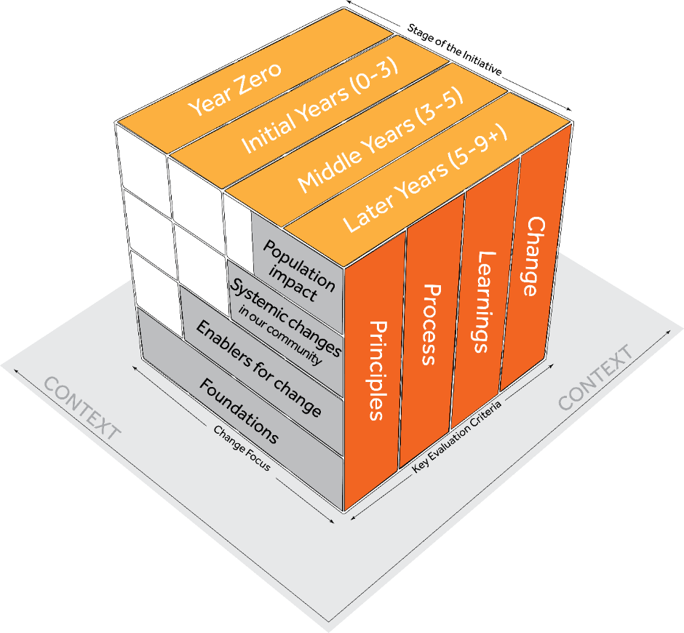

Figure 4: The concept cube

## The generic theory of change

Figure 5 shows five levels of change that we think happen in PBAs. This simplified model shows the main ‘levels of change’ only. First, it recognises that each PBA has unique foundations, and that many PBAs arise from existing community movements or collaborative effort. Next, the theory of change says that if all parties (funders, community, service providers and government) collaborate toward the shared vision, and are guided by a sufficiently equipped facilitating partner, then enabling conditions for systemic changes can be created and realised. Over time, community and systems-level changes occur, and this will ultimately lead to sustainable and positive changes for people living in the area of the PBA. This is bound by context-specific principles that guide the way work is done.

Figure 6 shows this in more detail; it also provides some examples of the sort of change we’d expect to see at different levels. For example, across levels 1 and 2, we hope to see changes in capacity and shifts in decision making and collaboration. Across Level 3 we hope to see systemic changes such as new or expanded programs/services, or collective leveraging of resources. At Level 4 we hope to see instances of positive change for specific cohorts and micro-communities before achieving longer-term population change for all the people living in our community (Level 5). We have also added an optional pathway up the right-hand side that shows how a PBA might influence broader policy systems (see Figure 6 for the full generic theory of change).

We explore how to use this generic theory of change in Section 8.2.

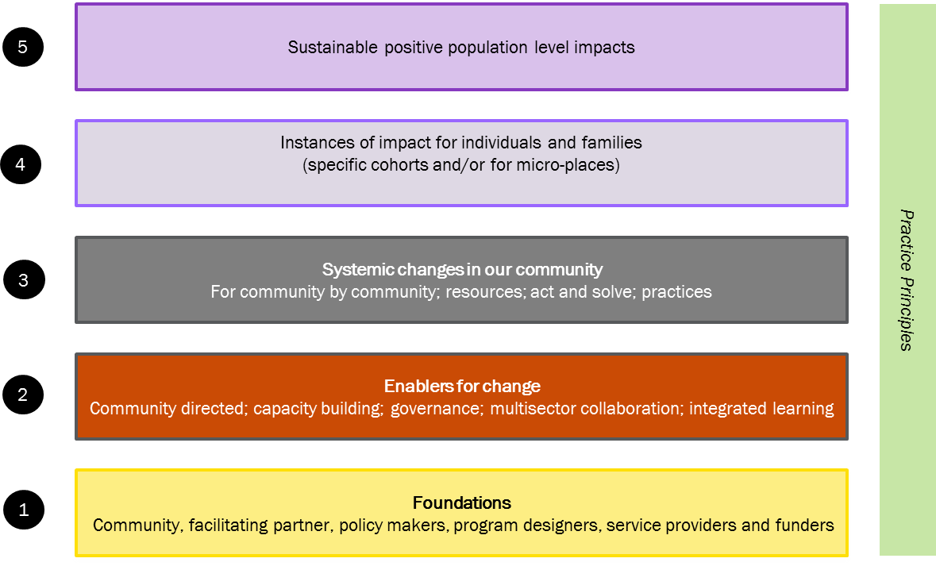

Figure 5: Levels of theory of change

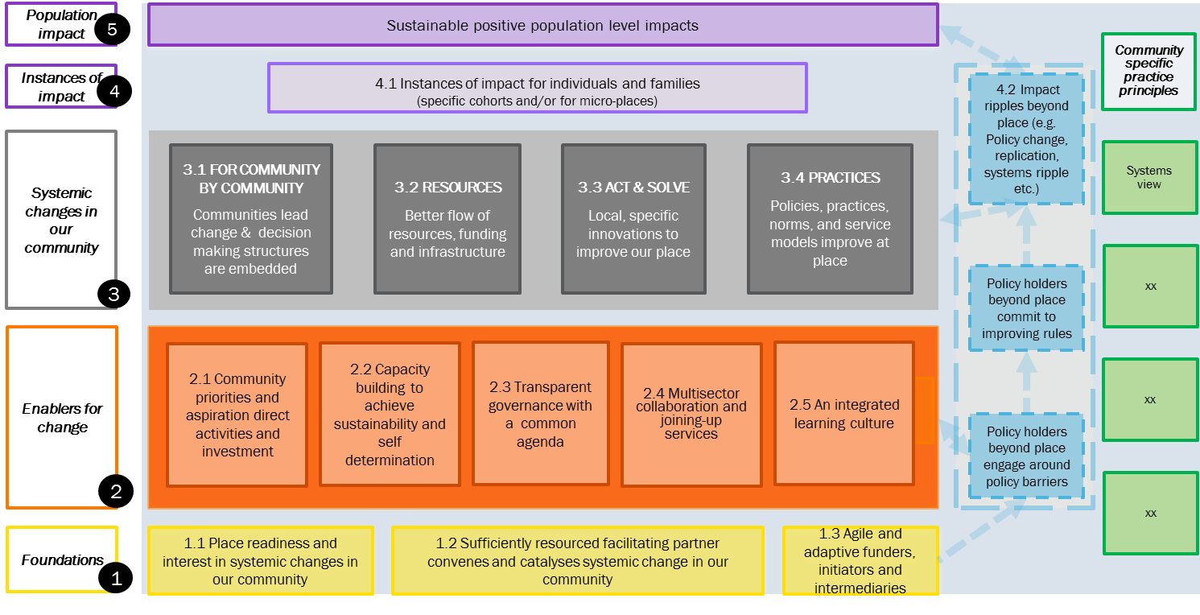

Figure 6: Full generic theory of change

## Key evaluation questions

Key evaluation questions are carefully crafted and focused questions that crystallise the purpose of the MEL plan. These are often formulated and/or refined once the audience and purpose are clear. They are best written around evaluation criteria.

Key evaluation questions are not the same as the questions that form the basis of a survey. They are high-level questions that frame what we really want to know, and to answer them we will need to collect data from a range of sources and then make an evidence-based judgment. We break each key evaluation question down into sub-questions that direct what we need to collect data on. Key evaluation questions can also be used as a report structure, and they are worth getting right.

Figure 7 lays out the logic of evaluation. It is worth noting that key evaluation questions are best pitched at the ‘so what’ level and they ‘beg’ an answer. Questions about what happened are generally more descriptive and form the sub-questions and guide data collection.

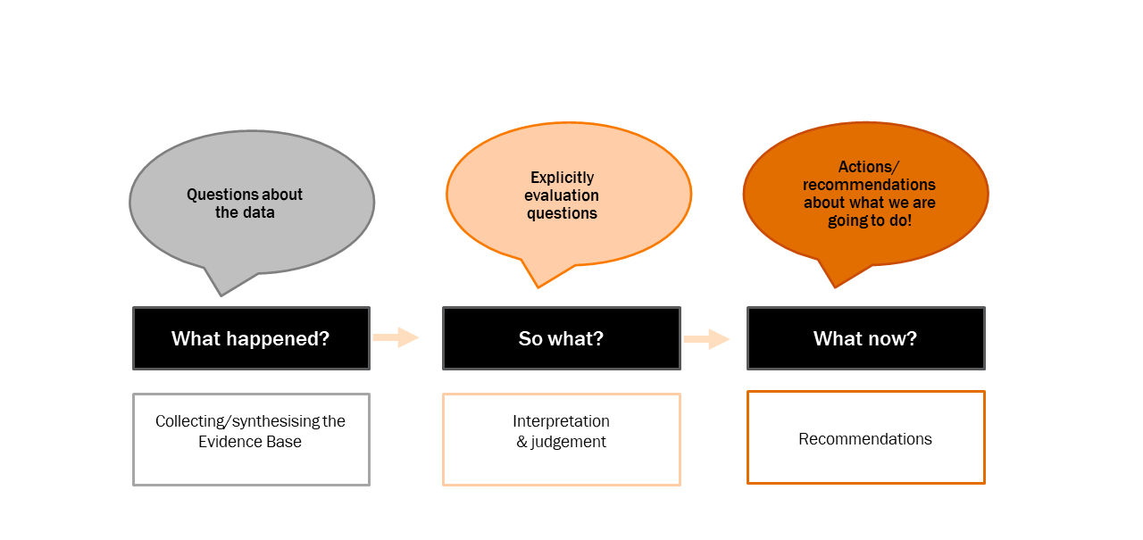

Figure 7: The logic of evaluation

### 16 guiding key evaluation questions

This framework offers a set of 16 guiding key evaluation questions. You are not likely to need all of these questions in a given phase of your PBA unless you have an extremely comprehensive MEL plan. Using guidance from Section 6, we hope you can select the questions that are most relevant. We suggest that you then tailor them and ensure that a cultural lens is considered as part of the process (reflective of relevant cultural groups and diversity of communities involved), and add sub-questions to meet your need. We provide more detail in Section 9.

The key evaluation questions are drawn from the four criteria in our concept cube (principles, process, learning and change) with the questions around change being drawn from the generic theory of change. We’ll explain how you might select questions and adapt them to your context in Section 9.

Table 1: Guiding key evaluation questions

| **Guiding key evaluation questions** | The sides of the cube or levels of ToC to which questions relate |
| --- | --- |
| 1. What is the stage of place readiness and what are the implications for the design? | ToC – Level 1.1 |
| 1. To what extent are the facilitating partner/PBA leaders/funders learning and managing the process well? | ToC – Level 1.2 |
| 1. To what extent are the funders being flexible and adaptive and helping to create an enabling environment? | ToC – Level 1.3 |
| 1. To what extent has the facilitating partner/PBA leaders been effective in helping to establish the enabling conditions for systemic change within the community and beyond? | ToC – link from Level 1 to 2 |
| 1. To what extent have community aspirations and priorities driven activities and investments sufficiently? | ToC – Level 2.1 enabler for change |
| 1. Has **capacity building** been sufficient to foster sustainability and self-determination? | ToC – Level 2.2 enabler for change |
| 1. To what degree is the **governance** transparent and sufficiently representative of those with a stake in the system? | ToC – Level 2.3 enabler for change |
| 1. How well has data been used for **strategic learning** – to understand and adapt to the problems, opportunities and progress? | ToC – Level 2.4 enabler for change |
| 1. To what extent is **multisector collaboration** occurring and helping join up services? | ToC – Level 2.5 enabler for change |
| 1. To what extent have context-specific practice **principles** been followed? | Practice Principles |
| 1. What expected and unexpected results are emerging from **projects**? | Change Level 3.3 of ToC |
| 1. What is **changing in the system** because of the collaborative work? | Change Level 3 of ToC |
| 1. What are the instances of impacts for the individuals, families (micro-communities and specific cohorts)? | Change Level 4 of ToC |
| 1. What are the population-level impacts for individuals, families and communities across the place? | Change Level 5 of ToC |
| 1. How has this work influenced things beyond place? | Change – optional pathway from ToC |
| 1. What have we learnt across PBAs about conditions and approaches needed to create systemic change? | Learning - (side of the concept cube) |

# Minimum standards for evaluating PBAs

It is hard to set standards for PBAs given that contexts vary so much, as well as considerations of phase and resourcing. Some evaluators argue that for complex initiatives, which is often the case with PBAs, ‘gold standard’ evaluation is achieved when the methodology is appropriately matched to the unique context of place.

With this caveat in mind, we offer some general minimum standards for evaluating PBAs:

1. Clarify your theory of change, including the population outcomes you wish to improve, and how you believe systemic changes will enable this to happen.
2. Clarify your core approaches and principles for how you will influence the systemic change (your theory of action).
3. Include broader collaboration in co-creating this theory of change and theory of action using culturally appropriate and accessible techniques.
4. Develop a written MEL plan for each phase of your PBA that lays out how you plan on evaluating your efforts (note you don’t need to do all the plans at the start, just the phase you are entering).
5. Co-design your MEL plan with the broader collaboration using culturally appropriate and accessible techniques.
6. Collect baseline data and track trends data for your selected population-level outcomes against a small set of locally meaningful quantitative indicators.
7. Include 2-5 key high-level evaluation questions per MEL plan.
8. Collect data against all selected key evaluation questions and key indicators.
9. Pay attention to ***contribution***, at minimum investigate possible other causes for results in the middle to late phases.
10. Use mixed methods – both qualitative and quantitative.
11. Continually use the evidence to inform strategic learning.
12. Allocate an appropriate level of resourcing for the MEL and evaluation work (10-20%[13]).

# Planning your own adventure: designing the right evaluation approach for your PBA

Here we provide guidance to help you tailor your MEL plan to meet your context and need. To do this we suggest you consider:

* the phase of development of your PBA
* the context of the location
* resourcing you have available
* which aspects of the place you wish to cover in your MEL.

Whatever level you are working at, cover off on the minimum standards and consider culturally appropriate and accessible techniques.

## Phase and pace of change

PBAs are generally long-term ventures. Depending on the particular population-level outcomes you are trying to improve, it can take many years – far more than the typical funding cycle. For this reason, it is very important to factor the phase of development of the PBA into your MEL plans and evaluations. It becomes particularly important for setting expectations around what sort of outcomes you are expecting to achieve at different phases of the PBA, and which types of evaluation questions and methods you will adopt. A comprehensive MEL can be used to influence potential supporters to become involved in your PBA.

### Pace of change

Figure 8 lays out a depiction of how change in PBA can happen across years. It is important to note that context and level of complexity will affect pace of change. The diagram is very much a generalisation, but we hope it will help conversations around expectations over different years.

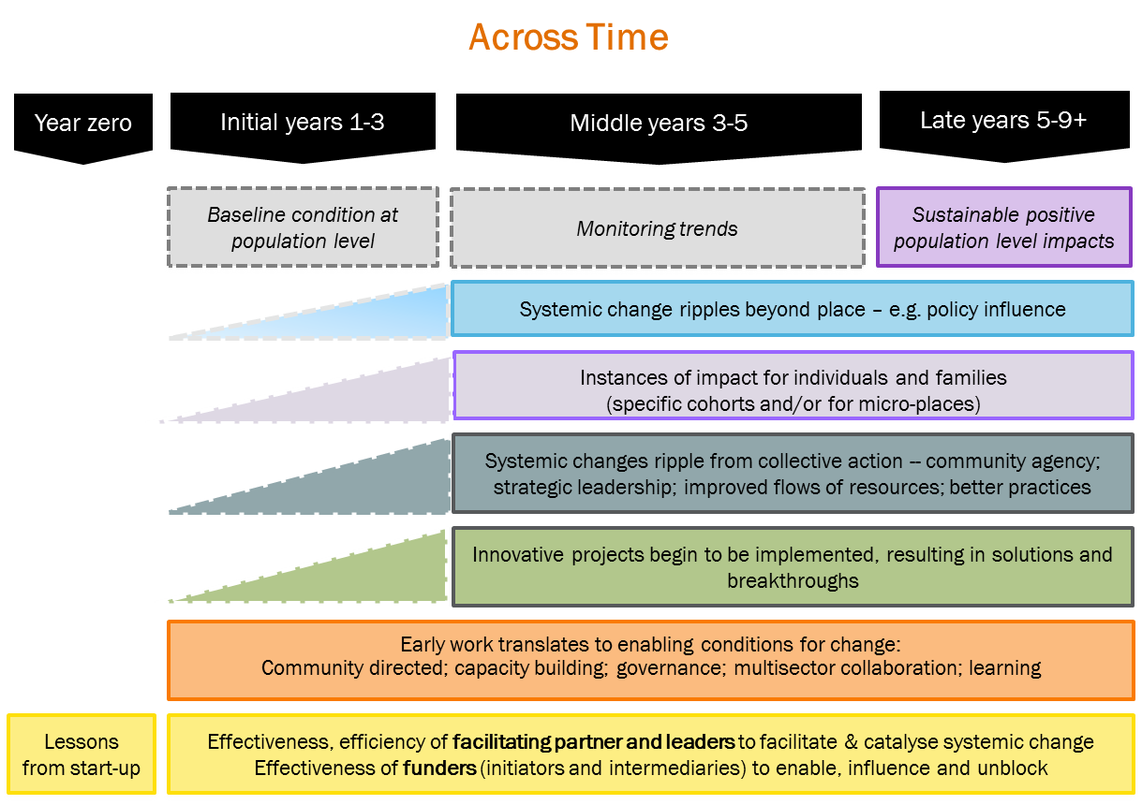

Figure 8: Phases of place-based delivery approaches and changes

### Different timeframes for different starting points

Year zero can take more than one year depending on the foundations of the initiative, which should be factored into understanding expectations for when outcomes will be achieved. From our theory of change, we note that foundations include ‘place readiness’ – by this we mean the readiness of communities, service providers and leaders to embark on change together. The toolkit provides tools for assessing place readiness such as the Harwood five stages of community life. This is important because places at different starting points will require different approaches and timeframes to achieve their goals. The five stages of community life help explain why some communities move faster and others slower when it comes to change. The same strategies may work well in one community, but fail in another. This is why it is important to assess place readiness when designing a PBA to ensure that a PBA is the right choice, and if so, what sort of PBA may fit the local context, and may explain why things take longer than expected (or fail) when evaluating a PBA.



**See Toolkit: Section 3**

### Different timeframes for different areas of focus

As well as the unique context, PBAs focus on very different types of issues including: homelessness; teenage pregnancy; early learning; childhood obesity; poverty reduction; and juvenile justice. Some PBAs address several different issues at once, and others focus tightly on one issue at a time.

Some of these issues are more challenging and long term than others (some are generational issues). In setting realistic timeframes for when changes are expected to be seen and measured, studies in the United States of a range of PBAs note that issues such as teenage pregnancy, homelessness and school completion rates have been addressed within nine years, whereas other issues appear to require a longer-term approach, especially when the roots lie in intergenerational trauma.

## Different MEL plans for different parts of the PBA

MEL plans can be developed for different parts of the PBA. You can develop a MEL plan for:

* the work of the facilitating partner
* a particular pilot or project
* an in-depth evaluation study on a particular topic or set of evaluation questions
* specific work with one micro-community
* all the work of the broader collaboration
* different phases (e.g. one for initial years, another for middle years, and another for later years).

MEL plans are created for groups of people to monitor, evaluate, and learn and report about their efforts, and should be created as a unique plan where the group would benefit from engaging and owning the MEL. It is really important to get clear what you are building your MEL plan for.

## Different levels of resourcing and capability for evaluation

The level of resourcing for the PBA (both in terms of the investment and resourcing of the facilitating partner/facilitator and the pooled resourcing of the broader collaboration) will affect the level of resourcing for evaluation. The things that may affect required resourcing include:

* location of the PBA – whether the PBA is in an urban, rural, or remote location
* the size of the PBA – and whether it is a single site or multiple sites
* priorities for the evaluation – if there are expectations to answer certain Key Evaluation Questions this may influence the type of monitoring and evaluation planned and how much it costs.
* capabilities – whether staff in the facilitating partner/other supporting partners have the skills and experience to undertake parts of the evaluation or whether expertise will need to be brought-in.

Table 2 below provides some general guidance regarding the sort of monitoring and evaluation resources and activities that might be expected at three levels of funding. Please note this is a rough schema to provide a broad sense of resourcing. It is based around a rule of thumb of 10-20% resourcing for evaluation. In this 10-20% we including all aspects of monitoring, evaluation and learning. It includes time to develop the theory of change, developing routine monitoring tools, developmental evaluation, development of the shared measurement framework at the population level as well as funding for any externally commissioned evaluation and research studies.

If offers three levels of resourcing: light, medium and extensive.

Table 2: Different levels of resourcing

| Level of resourcing | Description of PBA | Evaluation purpose | Example of evaluation depth |
| --- | --- | --- | --- |
| ‘Light’  Basic evaluation | **Lightly resourced or small PBA**, or sub-project:  May be a small PBA with only modest resourcing (1 FTE or less in facilitating partner)  Or one activity under the PBA  Or year zero – wanting a light touch evaluation/evaluation readiness assessment  Light level of resourcing for evaluation  A part-time person playing the monitoring and evaluation role may do this internally. | Mainly want MEL for learning and development  May include simple reports to stakeholders and accountability for accountability purposes  (Or may be a more in-depth evaluation of a specific pilot or project)  (Or may be mostly process-focused evaluation in the initial stages of a larger PBA) | For a small-scale PBA:   * Can be based mostly on 2 criteria: learning and change * Use mixed methods – use a simple survey and participatory analysis to assess enablers for change; a broader-brush outcome tracking tool like Most Significant Change technique (MSC) with developmental evaluation to test and evaluate social innovation, and one or two population-level indicators tracked over time * May not require formal report. |
| ‘Medium’  Comprehensive evaluation | Medium-sized PBA   * Moderate dedicated resourcing for the facilitating partner role in the broader collaboration * For early-middle or late-year phases * May not have strong evaluation expertise in facilitating partner   Medium resourcing for evaluation   * 10%-20% for MEL plus in-kind contributions from broader collaboration | For accountability to funders and community  For strategic learning and adaption  May not need highly defensible evaluation  Developmental evaluation to support adaptive management and testing of social innovations | For medium-resourced PBA   * Fully elaborated theory of change and principles * MEL plan for each phase * Baseline data and trend data for 1-3 key population-level indicators * Quantitative inquiry as well as qualitative analysis of data to strengthen the level of rigour * Some light contribution analysis for later years to show how the PBA contributed to the changes * Include unexpected outcomes * Include strategic learning throughout the work of the developmental evaluator to ensure that innovation and adaption are supported and maximised * Include nested MEL plans for each substantial project * KEQs 1-14 may all be relevant, but you would need to prioritise different questions at different times. |

| Level of resourcing | Description of PBA | Evaluation purpose | Example of evaluation depth |
| --- | --- | --- | --- |
| ‘Extensive’  In-depth evaluation | **Well-resourced** PBA in mid-to-later phase  For example:   * A facilitating partner with several staff * Significant expenditure on the facilitating partner per year plus extensive in-kind contribution of the broader collaboration * At least 5 years in terms of maturity of PBA   Well-resourced for MEL   * 10%-20% plus, in-kind contributions from the broader collaboration * Internal evaluation and measurement expertise * External evaluator required (the external evaluator should be suitably qualified – for example they may have a post-graduate degree in evaluation or a research-based post graduate as well as experience) | For accountability to funders and community  Highly robust defensible evaluation design needed that includes attention to contribution  Developmental evaluation to support adaptive management and testing of social innovations  To inform policy/program reform | For a well-resourced PBA:   * Fully elaborated theory of change and principles * Full MEL plan for each phase (2-3 years each) * External evaluation study commissioned at end of mid/final phases plan * Baseline data and trend data for key population-level indicators * Quantitative and qualitative data * Rigorous contribution analysis for mid and final years to show how the PBA contributed to the changes * Focus on systemic changes as well as population-level trends to help make a case for contribution, as well as for learning in the middle years * Include unexpected outcomes * Include strategic learning throughout through work of the developmental evaluator to ensure that innovation and adaption are supported and maximised * Include nested MEL plans for each substantial project – may include more advanced evaluation methodology for pilots if there is a need to prove their impact to make a case for scale * KEQs 1-14 may all be relevant, but you would need to prioritise different questions at different times. |

# Step 1: Frame and scope

## The importance of getting clear

Before diving into our evaluation journey, we need to get clear about what we really want from evaluation.

When designing a MEL plan, there is a natural tendency to jump in and firstly choose methods for data collection (or indicators). In this guide, however, we suggest that you first focus on clarifying the purpose of the evaluation, the general approach you are going to take and developing key evaluation questions. Therefore, a good place to start is *not* choosing the methods first. Instead, we suggest that you spend time learning about your PBA and considering the purpose for which it is to be evaluated.



**See Toolkit: Getting started**

Good evaluation ventures start by first co-developing a written plan. This is best seen as a ‘living document’ that may need to be revised and amended as the PBA changes. In fact, given the substantial twists and turns a PBA can take, it is sensible to develop a MEL plan for two to three years, perhaps with an overall umbrella framework too. We have included a planning tool in the toolkit to get you started with the key elements of planning. The planning tool is also available on [Clear Horizon’s ‘Tools for evaluating complexity’ series](http://www.clearhorizon.com.au/tools-for-evaluating-complexity.aspx). You may also need mini-MEL plans for any substantial projects or pilots.

Planning an evaluation of a complex initiative involves lots of scoping. We need to get clear on why you want the evaluation and whose needs it must serve. We also need to be clear about what level of resourcing in terms of time and costs we are willing to invest. In this section, we provide guidance against the planning of these first scoping steps. They are:

* Clarify the ‘thing’ (and which bits of it) you plan to evaluate including the context/phase/perspectives (known as the ‘evaluand’)
* Clarify the purpose and audience for the evaluation framework you wish to build
* Clarify your resourcing and degree of investment in evaluation, and choose your ‘level’
* Plan your stakeholder engagement around MEL.

## Clarify the ‘thing’ you are evaluating

An early step in planning your evaluation is to get clear what you are evaluating (see [Planning Tool: Section 1](http://www.clearhorizon.com.au/tools-for-evaluating-complexity.aspx)). For example, is it the work of the facilitating partner, a specific ***activity***, or is it the efforts of the whole collective? Also, how far back are you going to look? Is it what you have done over the last few months, or over several years since the PBA commenced? Sometimes even working out when ‘it’ commenced can be tricky! The key questions are:

* What will the evaluation cover – what is in/out?
* What are the timelines?

## Clarify the audiences

The evaluation ‘audience’ consists of the people who require evaluative information about your PBA and who are going to use the information to make decisions. This usually includes people doing the work, and the funders. In PBAs it often includes stakeholders involved in the wider collaboration as well as the ‘place’ community members. Sometimes it helps to distinguish between primary audience and secondary audience. The ***primary audience*** are the people who will analyse, reflect and inform their decision making because of their involvement with the evaluation. ***Secondary audiences*** may read the reports, but we won’t necessarily tailor the MEL plan specifically to their needs (see [Planning Tool: Section 1](http://www.clearhorizon.com.au/tools-for-evaluating-complexity.aspx)).

## Clarify the purpose and focus of the MEL

Once you have the audience clear, the next step is to get clear on their requirements. The literature tells us that there are several typical purposes for doing MEL. They are:

* **accountability** – being accountable for the funds invested, and reporting on what you have done and achieved; this may also include accountability to community
* **improving and developing** – to improve and develop things as they are being implemented, sometimes referred to as ‘strategic learning’
* **knowledge** –establishing a knowledge base for future investment or other parties to access, sometimes called ‘field building’ or ‘broader learning’
* **providing evidence to help build the movement –** this can be done by providing results of early changes to galvanise momentum, or use data to help focus action.

While it is good to know these categories, ultimately the purpose of any evaluation is context specific and may be different for each audience.

A good technique is to ask key people to write down how they plan to use the findings from the evaluation – in conversational plain language. If they struggle with this, you can try getting them to prioritise the KEQs they are interested in and work back from that (see [Planning Tool: Section 3](http://www.clearhorizon.com.au/tools-for-evaluating-complexity.aspx)).

## Clarify your resourcing and degree of investment in evaluation, and choose your ‘level’

The next step involves getting clear on what resources you have (or what you need to seek) to conduct the evaluation. It is important to take a proportional approach, and not build a massive plan that you can’t resource.

So first, get clear on what resources are available (or need to be sought) to design and implement the plan. This is in terms of both time and financial resources, and the skills and capabilities available to help with the evaluation.

To work this out, see Table 2 (Section 6.2) or in the [Planning Tool: Section 1.5](http://www.clearhorizon.com.au/tools-for-evaluating-complexity.aspx). Please note this table aims to provide a sense of resourcing only, but every situation will be different.

## Plan your stakeholder engagement approach for MEL

Active participation of stakeholders in any evaluative process is critical to effective reflection, learning and improvement. This is especially true for PBAs. Their involvement in developing the MEL plan, in data collection, analysis, and the development of insights and strategic learning engenders strong ownership of the evaluation outcomes and a high likelihood that the evaluation will lead to effective change.

When thinking about the future implementation of the MEL plan, it really helps to develop an engagement/influence plan to answer the following questions:

* Which people need to be engaged in developing the MEL plan?
* How will we involve people at different stages of the rollout?
* How will we ensure engagement is culturally appropriate?
* Who should be involved in reflective exercises?
* Who should make the judgments?
* Who needs what information and in what form?

When thinking about the answers to these questions, it is important to consider the existing support structures/governance around the PBA, i.e. working groups and steering committees. Be aware of which stakeholders will be the ultimate ‘sign-off’ or endorse the MEL as you will need to manage that relationship closely.

We suggest that you include a plan of how/who and when you engage with different stakeholders through the MEL process. There are some great resources through International Association for Public Participation (IAP2) to help with this. Table 3 below shows a modified version of the IAP2 for helping to consider types of engagement and/or participation when developing the MEL plan.

Depending on the needs and context of the PBA and stakeholders, the level of engagement required will vary. Engagement can be imagined as a spectrum from light engagement, where you keep people informed, to participatory engagement where people are involved and collaborating (see Table 3). Sometimes the very way you approach co-designing the MEL plan can be capacity building. This will require taking a little more time and explaining the steps involved, as well as applying them, and ensuring quality and consistency during implementation is maintained.

### Consider evaluation capacity building (ECB)

In order for people to engage meaningfully in MEL, they need a basic level of understanding about, and skills in, evaluation (capability) and the capacity to be involved to the level required. To this end you may need to invest time and resources toward capability and capacity building.

The first definitions of evaluation capacity building (ECB) were narrow, and were based around people having the skills to conduct evaluations. More recently we have begun to understand that supply is not the only issue that needs to be addressed. In addition, we need to ensure there is a demand from organisational leaders and those responsible for delivering the supportive/managerial frameworks (such as strategy, integrated planning, information systems, processes, and performance management) that reinforce the use of evidence-based decision making. There is a huge volume of work and research on ‘ECB’ and we only hint at it here.

For your MEL plan you need to consider questions such as:

* What are the evaluation capability and capacity levels of key people/groups involved? What will be needed?
* What do our partners and staff already do, and have in place (in terms of evaluation capabilities systems), and what are the gaps?
* How will we build people’s skills to do this work?
* How do people learn around here – what strategies work well?

Table 3: Levels of engagement in evaluation

| **Inform** | **Consult** | **Involve** | **Collaborate** |
| --- | --- | --- | --- |
| To provide balanced and objective information to assist stakeholders in understanding problems, alternatives and solutions associated with the intervention | To gain feedback by way of consultations during the development of the process to ensure that different stakeholder views are taken account of in the MEL plan | To involve targeted stakeholders in the design/conduct/ development of the MEL so their stakeholder views and concerns are consistently understood and considered | To partner with targeted stakeholders and community members in various aspects of the MEL planning and data collection process |
| **Promise**: We will keep you informed about the MEL planning, findings and recommendations. | **Promise**: We will keep you informed, listen and acknowledge your views, and provide feedback on as we implement. | **Promise:** We will work with you to ensure your views are considered and respond to your recommendations & comments.  Where required we will build your capacity so that you can be meaningfully involved. | **Promise:** We will look to you for direct advice in developing and implementing the MEL. |
| **How:**  Inform: Social media tools such as blogs, Twitter, fact sheets, web page etc.  Also face-to-face meetings at critical times to explain information. | **How**:  Consult with these stakeholders throughout the process of building the MEL using both formal meetings (steering committee) and informal means (ad hoc meetings and exchanges). | **How**:  Involve these stakeholders in the co-process by: being on a working group; being part of a co-design workshop; providing feedback; and being involved in testing tools etc. | **How**:  Collaborate with them fully as part of the core team responsible for design of the MEL plan, collection of data, analysis of data, reflection on results, and adaption of the work as well as any reporting. |

# Step 2: Clarify your theory of change and principles

Getting clear on your theory of change can help you decide what to measure as well as getting clearer strategy. In this section, we offer you a ‘generic’ theory of change for systemic changes. By generic we mean that it is not specific to any context, but has some structure that we hope will help you develop your own theory of change for your setting.

It is worth noting that it is not the first step in planning for evaluation. If you are using it as part of agenda setting, then it is usually done after conducting community conversations and research about the key issues that people want to address.

As well as being a step in evaluation planning, getting an agreed and clear theory of change can also be very important for the design of the PBA itself. It can help bring a shared understanding and be a central part of the glue of the collaboration. For this reason it’s worth engaging the broader collaboration in building it wherever possible.

It is worth noting that theory of change is often developed in an iterative manner. Sometimes, groups like to develop a fairly complete theory of change early on, and it may refine it, and add to it over time as more is learned. Other times, it evolves gradually through an emergent process, and groups start just with the high-level outcomes, testing and trying things before getting clear on their approaches and systemic change outcomes. Mark Cabaj refers to this as an umbrella strategy, which has a high level theory of change and some principles.

We hope you can select elements of the generic theory of change and adapt them to make a tailored version that works for your context. You may already have one that works for you, or you may wish to modify it based on this framework. To create some consistency in how you describe PBAs, try to use the five levels and the five core ***effectiveness*** principles in your theory of change. However, we caution that it’s always worth trading a little ‘logic’ for ownership. If your group members feel that they wish to draw it differently or start from scratch, then this may be the best course. Once you develop your own theory of change, it is also great practice to add arrows to show how you think one step leads to the next (e.g. the causal links).

## Ideas for how to apply the generic theory of change to your context

#### Workshop it

It is great to hold a theory of change workshop where you invite people to co-create the theory of change together. We like to build them with pieces of paper stuck to the wall or floor. It is a great way to get your community or group involved. We particularly like using ‘magic walls’.[14]

Some people like to do it as a two-step process. First, get clear on the high-level theory of change at one workshop, then dive into the lower-level theory of change (or ***theory of action***) in the next workshop.

### The high-level theory of change

By ‘***high level theory of change***’ we mean the population-level results you aspire to achieve and the preconditions for change which may include things like changes in behaviour, attitudes, norms and capabilities. Unlike a full theory of change, it does not go into details of what we will do to catalyse change.

To arrive at your population-level outcomes, you will need to engage extensively with the broader community to ensure that these outcomes reflect their priorities. There is a lot of work that usually goes into selecting this goal, including community conversations, research and workshopping with the broader collaboration.

To develop your high-level theory of change, you and your community are likely to refer to scholarly literature about your given outcome area to help you identify key preconditions/determinants for change that you may wish to target through your collaborative effort. Depending on your chosen outcome, there are some great evidence-based resources for this (such as the [ARACY Nest framework](https://www.aracy.org.au/the-nest-in-action/in-aracy)).

Once this is clear, groups are encouraged to select a few key indicators at the population level, as well as a few preconditions, and set stretch targets to mobilise people and raise aspirations. So for population-level results, you ideally select one to three great/inspiring indicators, accompanied by a time-bound and quantitative target. We will go into some more detail about this in Section 9.4.

### Developing the full theory of change for your context

One way of adapting the theory of change to suit your context is to use the five levels of change to structure your theory of change, but make the boxes specific to your context: For example:

* Include the population change you are aiming for (Level 5) as well as any key preconditions/determinants that you are focusing on.
* Note any specific cohorts, communities, or ***micro-places*** where you expect to see change earlier on (Level 4).
* Select/adapt the systemic change outcomes to suit your aspirations and make sure they are sufficient to achieve the population-level changes you are after (Level 3).
* Choose which of the enablers for change are most important to you (Level 2).
* Add your own tailored principles, usually shown up the side.
* Keep or remove the policy pathway depending on your aspirations.

In some contexts people may wish to create their own styles of visualisation, such as in circles moving outwards or process diagrams that show the flow between action and change at different levels. It’s important to let stakeholders express their own visualisations.

For example, when this framework was tested with Logan Together, one group visualised the theory of change as a tree (see Figure 9), whilst another created it using three-dimensional cubes. In some cultural contexts ‘circles’ seem to resonate, with the people being placed at the centre. The creative version can be accompanied by the theory of change in table form (see Figure 6 in Section 4.5) as different people relate to visual information in different ways.

In the tree representation below, the roots are level 1 of the theory of change (foundations) and changes move upward to level 5 population outcomes as the fruit and foliage. Policy and ‘beyond place’ changes are part of the system (to the right-hand side) affecting the tree.

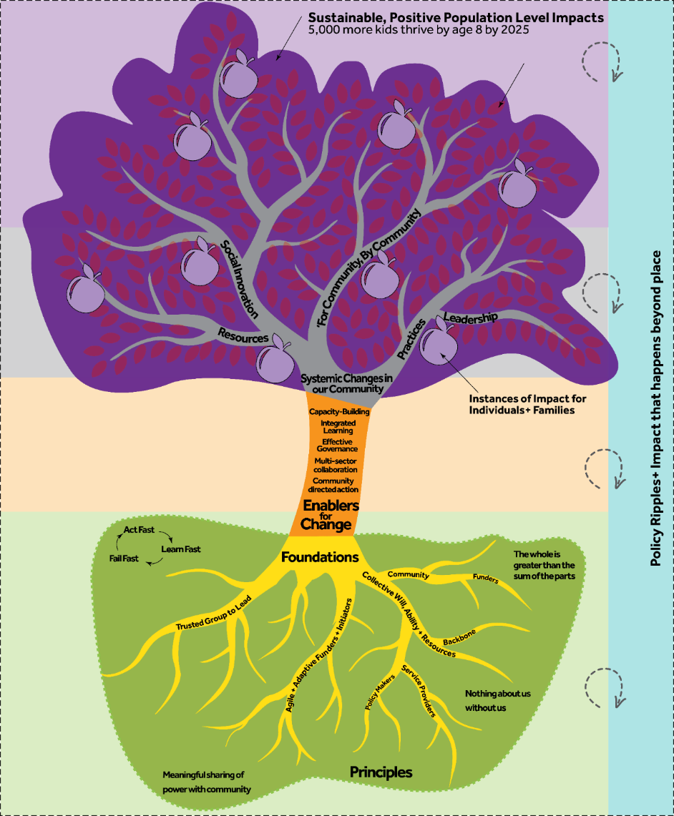

Figure 9: Theory of change visualised as a tree

## More detail about each element

### Level 5: What do we mean by sustainable population-level impacts?

Sustainable positive population level impacts

Population-level outcomes show how people’s lives or places will be changed, and should inspire people to become involved and communicate the main purpose of the PBA. They should be very meaningful to the broader collaboration.

When we refer to population outcomes, we mean whole-of-community or totality of all sub-units within the reference geography of place, rather than sub-cohorts or results for specific users. It asks whether impacts achieved sufficient ‘scale’ at the highest reference level.

### Level 4: What do we mean by instances of impact?

4.1 Instances of impact for individuals and families

(specific cohorts and/or for micro-places)

Instances of impact for individuals and families can also occur at the sub-population level and occur earlier in the life of a PBA than population-level change, and is an important lead indicator that change is happening across the relevant system/s. This type of change can happen at a few different levels within the theory of change. It can include:

* changes for just a few individuals or families who are working closely as part of a pilot or trial of a new way of working
* changes for a micro-place, that is, a subset of the broader population of people who live in the place that is covered by the PBA
* changes for a specific cohort (such as changes for Year 10 boys who are at risk of dropping out of school, for example).

Tracking and understanding these early instances of impact is very important for PBAs; it helps us understand whether our early ideas are beginning to work, for whom, in what situations and why, and can inform our future work, and give funders and the broader collaborative hope and momentum.

### Level 3: What do we mean by changes in our community?

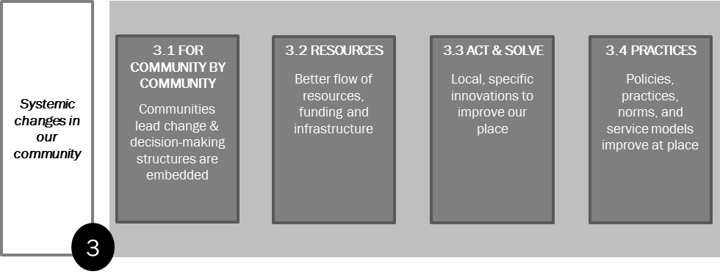

By ‘systemic changes in our community’ we refer to what needs to change in the way things are done in terms of community leading change, flows of money and power, local solutions, and improved policies and practices in services. These are examples of the sort of conditions that may be required to achieve your instance of impact, and eventually population-level change. You’ll need to work hard to decide which are the essential conditions needing change, and it is worth making them more specific to your context. The boxes above are really just ‘buckets’ to help you think about the sort of changes that might be needed.

They are important markers that you are on your way to achieve population change, and are particularly important to measure in the middle to late years of a PBA.

### Level 2: What do we mean by enablers for change?

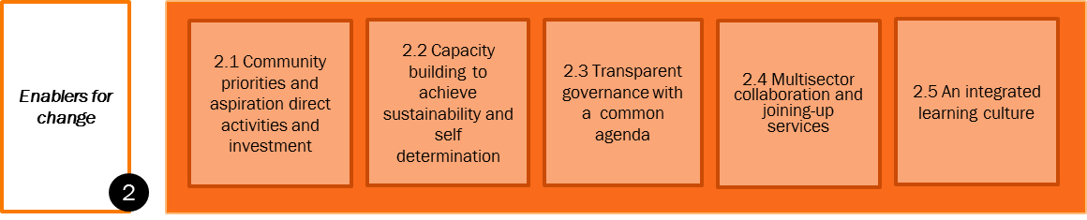

The enablers for change are the things we think need to be in place in order for a collaboration to be well set up for creating systemic changes. They can be evaluated and tracked, and are important markers for success in the initial years of a PBA.

### Level 1: What do we mean by foundations?

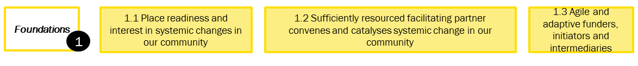

The foundations refer to the readiness of people to begin the change journey at the start of the PBA. Because there are different foundations, some PBAs may take much longer to get up and running than others. When designing and initiating a PBA, it is important to check in on all these aspects to give insights into what sort of design and timeframe will work.

### What do we mean by practice principles?

You will note that the theory of change has blank boxes up the side to enter practice principles. We think that it’s valuable to include a few principles that reflect the unique values and favoured approaches of the people who are part of the broader collaboration. Examples that other communities have included are:

* Nothing about us without us
* Taking a strength-based approach
* We all work together to help children here thrive.

These principles can emerge from community conversations and research into what works in the local context. It is definitely best to develop them together with your community. They should be meaningful for the people who live there.



**See Toolkit: Section 5**

Once agreed, principles provide advice and offer direction on what to do, how to think, what to value and how to be effective. In other words, they are principles for ‘the way we work’. A principle should provide sufficient guidance so that it is easy to distinguish from the contrary, e.g. harm minimisation rather than zero tolerance. For more about principles, see Section 11; the toolkit also provides more links and references.

## How to use the theory of change once you have one agreed

The theory of change can be used in a number of ways including:

* as a canvas to capture your ‘living design’
* to set realistic expectations about when change/outcomes are likely to be apparent
* to help you tailor your sub-evaluation questions to your context.

### As a canvas to capture your ‘living design’

Theory of change is likely to change throughout the implementation as you learn about what works and what doesn’t. In this way it can serve as a point-in-time understanding of change that can be adapted and refined as you learn what is working and what is important. For these reasons, we call it a ‘living design document’.

It can keep you focused on the population changes you are aiming for, and remind you of how the system fits together. It can also help create a shared understanding of what and how you are working.

### To tailor your sub-evaluation questions to your context

Having a fairly detailed theory of change is extremely useful for developing your MEL plan. We can use the theory of change like a canvas to decide what things we want to measure. In a workshop setting, we often get participants to stick dots on the most important items to measure. That is how we start to develop our key evaluation questions and sub-questions.

Once you have agreement on measurement points, you can turn these into questions that inform data collection.

# Step 3: Plan the evaluation

**Plan the evaluation**

1. Select/finalise/refine your key evaluation questions.
2. Develop your sub-questions.
3. Select suitable tools.

## Key evaluation questions (KEQs)

Once you have considered the purpose and who the evaluation is for (the audience), and clarified your theory of change, the next step is to consider the evaluation questions that will be used to evaluate your program.

### What are key evaluation questions?

Modern evaluation approaches tend to organise whole evaluation frameworks (and MEL plans) around a set of high-level key evaluation questions that link to specific criteria. It is very important to select only those that would be useful for your evaluation. Ideally an evaluation study is based on around 3-5 key evaluation questions, and a MEL plan around 5[15].

Later we break them down into sub-questions to guide inquiry. The key evaluation questions are the conceptual heart of your MEL plan and can be used not only to collect data, but also as a ***reporting*** framework (Section 4.3 provides a further introduction to key evaluation questions).

### Select your key evaluation questions

As part of the planning process, you need to select which KEQs your MEL plan will address. As already discussed, not all of them will be relevant to you. This will depend on the phase of your PBA, who you are, and the level of resourcing that you have available.

Use the separate [planning tool](http://www.clearhorizon.com.au/tools-for-evaluating-complexity.aspx) to select your KEQs.

## Different questions may be relevant for different perspectives and phases

We are writing this guide to cater for several different groups of people:

* the facilitating partner organisation, and their evaluators
* the PBA leaders and the broader collaboration, and their evaluators
* the funders and their evaluators
* intermediary organisations who provide support to multiple places.

We anticipate that different groups will be interested in different evaluation questions, and we try to offer some guidance with regard to this here. Figure 10 illustrates how the anticipated results can be spread across different actor groups.

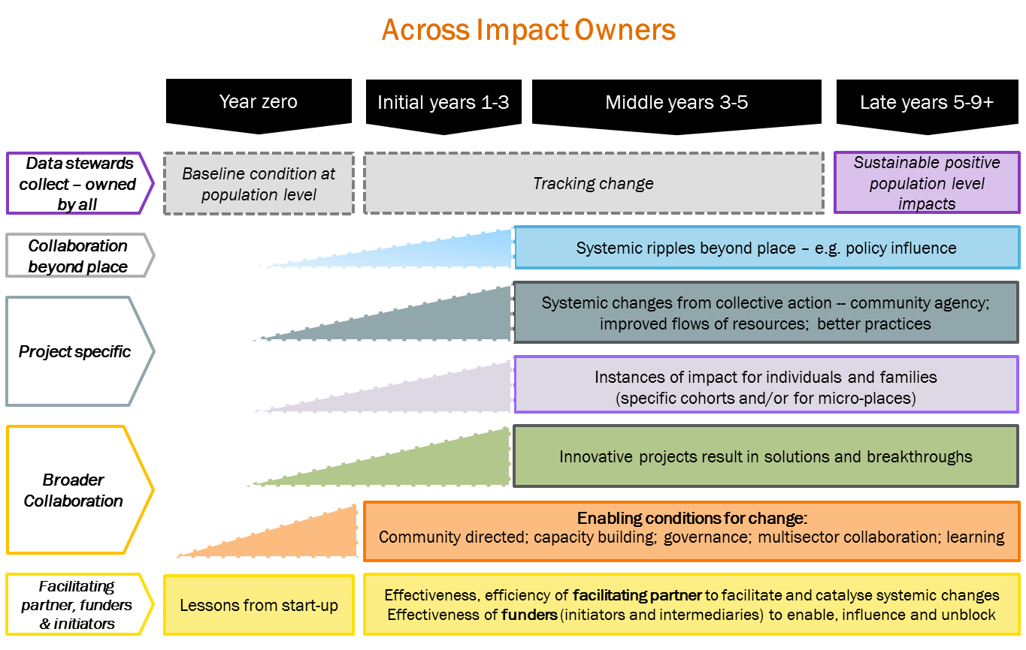

Figure 10: Likely results by actor group

### Guidance for a facilitating partner organisation

#### MEL for the performance of the facilitating partner

If you are a facilitating partner organisation, depending on your phase of implementation and level of resourcing, you may wish to select specific evaluation questions or sub-questions to help you learn, adapt and maximise your effectiveness as well as being accountable. Questions 1, 2 and 4 are strongly focused on the role of the facilitating partner and offer a different sort of accountability than the usual questions around whether pre-determined deliverables have been achieved (which is very tricky when deliverables keep shifting as is good practice in working to enable systemic changes).

| **Domain** | **Key evaluation questions** |
| --- | --- |
| Level 1 of ToC | KEQ 1: What is the stage of place readiness and what are the implications for the design?  KEQ 2: To what extent is the facilitating partner learning and managing the process well? |
| Link from Level 1 to 2 of ToC | KEQ 4: To what extent has the facilitating partner been effective in helping to establish the enabling conditions for systemic change within the community and beyond? |

#### MEL for the broader collaboration

The facilitating partner is often assigned stewardship over guiding and supporting the evaluation on behalf of the PBA leadership and broader collaboration. They may help measure and track population results, and changes in the community level. For this reason they may be involved in collecting evidence against all of the evaluation questions in collaboration with the broader movement. In this case it is very important to adopt a participatory MEL approach, and to ensure that learning and claiming impact is shared with the PBA leadership and broader collaboration. It can help with clarity to have one MEL plan for the performance of the facilitating partner, and a second MEL plan for work of the broader collaboration.

### Guidance for the PBA leadership and broader collaboration

If you are part of the PBA leadership or broader collaboration, then you may be most interested in tracking whether your own principles are being upheld, and whether change in your community is happening. If so the following questions may be most relevant:

#### Initial years:

| **Domain** | **Key evaluation questions** | **Timing** |
| --- | --- | --- |
| Link from Level 1 to 2 of ToC | KEQ 4: To what extent has the facilitating partner been effective in helping to establish the enabling conditions for systemic change within the community and beyond? | Initial years  (as well as middle to late years) |
| Level 2 of ToC | KEQ 5: To what extent have community aspirations and priorities driven activities and investments sufficiently?  KEQ 6: Has capacity building been sufficient to foster sustainability and self-determination?  KEQ 7: To what degree is the governance transparent and sufficiently representative of those with a stake in the system?  KEQ 8: How well has data been used for strategic learning – to understand and adapt to the problems, opportunities and progress?  KEQ 9: To what extent is multisector collaboration occurring and helping join up services? |
| Practice principles | KEQ 10: To what extent have context-specific principles been followed? |

#### For middle to late years, all the above questions as well as the questions below:

| **Domain** | **Key evaluation questions** | **Timing** |
| --- | --- | --- |
| Level 3 of ToC | KEQ 11: What expected and unexpected results are emerging from projects?  KEQ 12: What is changing in the system because of the collaborative work? | Middle to late years |
| Level 4 of ToC | KEQ 5: To what extent have community aspirations and priorities driven activities and investments sufficiently?  KEQ 6: Has capacity building been sufficient to foster sustainability and self-determination?  KEQ 7: To what degree is the governance transparent and sufficiently representative of those with a stake in the system?  KEQ 8: How well has data been used for strategic learning – to understand and adapt to the problems, opportunities and progress?  KEQ 9: To what extent is multisector collaboration occurring and helping join up services? |
| Practice principles | KEQ 10: To what extent have context-specific principles been followed? |
| Level 4 of ToC | KEQ 13: What are the instances of impacts for the individuals, families (micro-communities and specific cohorts)? |
| Level 5 of ToC | KEQ 14: What are the population impacts for the individuals, families and communities who live there? |

### Guidance for project teams

PBAs may include numerous social innovation projects. It is often useful to develop a specific MEL plan for each project (at least for the bigger ones). The general steps for planning provided in this framework can be used to develop a mini-MEL plan for each project. This is guided by the overarching KEQ 11:

| **Domain** | **Key evaluation questions** |
| --- | --- |
| Level 3 of ToC | KEQ 11: What expected and unexpected results are emerging from projects? |
| Level 4 of ToC | KEQ 13: What are the instances of impacts for the individuals, families (micro-communities and specific cohorts)? |

### Guidance for funders wanting to scope a discrete evaluation study

As a funder, you may be interested in any of the questions, but in particular, the following additional ones:

| **Domain** | **Key evaluation questions** |
| --- | --- |
| Level 1 of ToC | KEQ 1: What is the stage of place readiness and what are the implications for the design?  KEQ 2: To what extent are funders learning and managing the process well?  KEQ 3: To what extent are the funders being flexible and adaptive, and helping to create an enabling environment? |
| Optional pathway from ToC | KEQ 15: How has this work influenced things beyond place? |
| Learning | KEQ 16: What have we learnt across PBAs about conditions and approaches needed to create systemic changes? |

### Guidance for an ‘intermediary’ who provides support to multiple sites

If you are an intermediary organisation who provides evaluation support (and other types of support) to a number of different sites, each with its own facilitating partner, you may need to access a range of different key evaluation questions similar to the funder.

### Guidance for an external evaluator

What is relevant for you depends on what you are being asked to do. If you are charged with building a comprehensive MEL plan for a facilitating partner, you may wish to focus on the same aspects as the facilitating partner (see above). If you are contracted to conduct an external evaluation, it will be very much dependent on phase and scope; we suggest you try and pin the scope down to 2-3 key evaluation questions per evaluation study. If you are asked to look across different PBAs, you may find KEQ 16 useful.

### Guidance for developmental evaluation

If you are contracted or employed to work as a developmental evaluator, we suggest that you focus strongly on the learning sub-questions that are laced across different key evaluation questions. These questions are the sort of thing a developmental evaluator might explore and record. The role of the developmental evaluation goes beyond these questions in the way that they continually support development and adaption. The developmental evaluator will also play a strong role in helping design and evaluate social innovation projects. For more information on Developmental Evaluation, see sections 10.1 and 11.

| * What have we learned about designing PBAs to match place? | * Year zero |
| --- | --- |
| * What did the facilitating partner/PBA leadership learn about establishing and supporting the collective at different phases? | * Initial years |
| * What did the funders learn about establishing and supporting the collective at different phases? | * Initial years |
| * What are we learning about systemic change? | * Middle years |
| * What did we learn from each project (prototype/pilot)? | * Middle years |
| * What did we learn about how to scale/replicate? | * Late years |

## Develop your sub-questions and key indicators

**Tip**: A great way to test your question framework is to make up the answers and put them together in a narrative to see if they tell a sufficiently comprehensive story of what you did and what was achieved. We call this a performance story.

### How to develop sub-evaluation questions

There are different ways to break down key questions into sub-questions in an evaluation. In this framework, we use the sub-questions to detail all the *things we need to know to answer the key question*. The sub-questions need to provide sufficient information to answer the evaluation question. The sub-questions should guide data collection.

This is a critical point in ensuring that a cultural lens is considered in developing the sub-questions so they are inclusive of the perspectives and priorities for culturally diverse groups within the evaluation context.

Table 4 provides a set of sub-questions for each of the key evaluation questions. As with the key questions, we advise that you only pick those relevant, and may need to add your own in there too.

Table 4: Key and sub-evaluation questions

| **Domain** | **Key and sub-questions** | **When to apply** |
| --- | --- | --- |
| ToC Level 1 foundations | **KEQ 1: What is the stage of place readiness and what are the implications for the design?** | **(Year zero but can be done retrospectively, and for new micro-places or new phases)** |
| Were the key parties (community, service providers, leaders and government) ready to embark on a systemic change journey? And was this assessed? | For funders, facilitating partners, intermediaries, PBA leaders |
| Was the funder and system ready? And was this assessed? |
| Does the place need a systemic change approach? Is it value for money for this context? |
| Was there sufficient political will to try something different? |
| Was there sufficient adaptive leadership to start (funders/facilitating partner/PBA leaders)? |
| Was there a sufficiently resourced and skilled facilitating partner? |
| Was the broader collaboration sufficiently resourced to engage in the collaborative work? |
| How well is the community aspiration reflected in design of the form and function of the PBA? |
| Learning | What have we learned about designing PBAs to match place? |

|  | **KEQ 2: To what extent are the facilitating partner/funders learning and managing the process well?** | **Every year** |
| --- | --- | --- |
| Process | How well did the PBA leadership/facilitating partner/funder manage resources and processes? (efficiency/quality/effectiveness) | For the PBA leaders/facilitating partner/funders as needed, but could be each year |
| Learning | What did the facilitating partner/funder learn about establishing and supporting the collective at different phases? |

|  | **KEQ 3: To what extent are the funders being flexible and adaptive and helping to create an enabling environment?** | **Every year** |
| --- | --- | --- |
| Process | How effective was the funder in terms of embracing new ways of working and displaying adaptive leadership? | Specifically for funders |
|  | How effective was the funder in engaging and convening policy makers and whole-of-government partners and other funders to create enabling conditions at place and beyond. |
| ToC link from Level 1 - 2 | What were the ripples that occurred as a result of the funder convening, catalysing and promoting systemic changes as a way of working? |
| Learning | What was learned by the funder around how to support PBAs and systemic change endeavours? |

|  | **KEQ 4: To what extent has the facilitating partner been effective in helping to establish the enabling conditions for systemic changes within the community and beyond?** | **Every year** |
| --- | --- | --- |
| ToC link from Level 1 to 2 | How effective was the facilitating partner in ensuring community aspirations and priorities (from a sufficiently representative range of community members) are deeply understood and drive action? | For the facilitating partner, their funders and PBA leaders to whom they are accountable |
| How effective was the facilitating partner in ensuring that capacity is being built in the collaboration for self-determination and sustainability? |
| How effective was the facilitating partner in supporting governance structures that are sufficiently represented by those with a stake in the system? |
| How effective was the facilitating partner in ensuring data is used by the broader collaboration for strategic learning and adaption? |
| How effective was the facilitating partner in engaging and convening systems influencers beyond place? |
| What was the contribution of the facilitating partner to catalysing systemic changes? What would have happened without their input? |

| **ToC Level 2.1 enablers** | **KEQ 5: To what extent have community aspirations and priorities driven activities and investments sufficiently?** | **Every year** |
| --- | --- | --- |
| To what extent and how were community members involved in setting the priorities and shared aspiration? | For the PBA leadership and broader collaboration (See toolkit that explores this more deeply) see toolkit section 5 |
| How representative and meaningful was the engagement? |
| To what extent do community members feel that the agreed priorities and investment reflects their aspirations? |

| **ToC Level 2.2 enablers** | **KEQ 6: Has capacity building been sufficient in fostering sustainability and self-determination?** | **Every year** |
| --- | --- | --- |
| Who has been reached by the capacity building efforts and are they the right people, and is there sufficient reach? | For the PBA leadership and broader collaboration (See toolkit that explores this more deeply.see toolkit section 5 |
| What is the quality of the capacity building that has been done? |
| To what extent is capacity growing for collaborative governance, action and learning? |

| **ToC Level 2.3 enablers** | **KEQ 7: To what degree is the governance transparent and sufficiently representative of those with a stake in the system?** | **Every year** |
| --- | --- | --- |
| How well are people with a stake represented in the governance structures? | For the PBA leadership and broader collaboration (See toolkit that explores this more deeply) see toolkit section 5 |
| How clear are roles and responsibilities across the governance structures? |
| How well are the governance structures working, and do members feel they are learning and making progress? |

| **ToC Level 2.4 enablers** | **KEQ 8: To what extent is multisector collaboration occurring and helping join up services?** | **Every year** |
| --- | --- | --- |
| To what extent are multisector collaborations seen as important to achieving systemic changes? | For the PBA leadership and broader collaboration (See toolkit that explores this more deeply) see toolkit section 5 |
| To what extent did collaborators (including funders, NGOs, intermediaries) advocate for, support and sustain the facilitating partner? |
| To what extent are people from different sectors engaging in the collaboration and with each other? |
| To what extent are multisector collaborations leading to more joined-up services and better experiences for citizens? |

| **ToC Level 2.5 enablers** | **KEQ 9: How well has data been used for strategic learning – to understand and adapt to the problems, opportunities and progress? (across years)** | **Every year** |
| --- | --- | --- |
| What have we learned about the problems and underlying causes in our community? | For the PBA leadership and broader collaboration  (See toolkit that explores this more deeply) see toolkit section 5 |
| How well shared is this understanding? |
| How well set up are we to track changes at the population level going forward? |
| How well have we applied strategic learning to adapt our strategies for maximum effect? |
| How well are we learning about how to try, test and learn about what works? |

| **Principles** | **KEQ 10: To what extent have context-specific practice principles been adhered to?** | **Every year** |
| --- | --- | --- |
| To what extent did each local principle hold meaning for stakeholders? | For the broader collaboration |
| To what extent did the principle show up in the work that the collaboration is doing? |
| To what extent did the principle lead to better results for community? |

| **Change Level 3.3 of ToC** | **KEQ 11: What results are emerging from projects? (middle and late years)** | **From mid to late years** |
| --- | --- | --- |
| What are the changes in how people experiencing vulnerability live and thrive in the place (both services and living in the community)? | Select the questions that fit your theory of change.  Note this is led and owned by project makers.  Facilitating partner and funders are interested in this. May facilitate/co-design mini-MEL plan for this. |
| What instances of impact (for individuals, families and communities) came out of projects and PBAs? |
| Were there any unexpected outcomes? |
| **Learning** | What did we learn from each project (prototype/pilot)? |

| **Change Level 3 of ToC** | **KEQ 12: What is changing in the system as a result of the collaborative work? (mid to late)** | **From mid to late years** |
| --- | --- | --- |
| What changes are we seeing happening to the system in terms of **community leading change** and community decision-making structures being embedded? | Select the questions that fit your theory of change  Note this impact is owned by the broader collective  Facilitating partner, and funders are interested in this. Facilitating partner facilitate measurement of this. |
| What changes are we seeing in terms of **leadership?** |
| What changes are we seeing in terms of **flows of resources?** |
| What changes are we seeing in terms of **embedded practices, norms and policies**? |
| To what extent did the PBA contribute to the observed changes? |
| What were the unexpected outcomes? |
| **Learning** | What are we learning about systemic change? |

| **Change Level 4 of ToC** | **KEQ 13: What are the instances of impacts for the individuals, families ( including micro-places and specific cohorts)** | **From mid to late years (some may happen earlier)** |
| --- | --- | --- |
| What was the situation at the start with regard to these families/individuals? | This could be project makers, or the broader collaboration.  Note, funders will be particularly interested in these early results. |
| What expected/unexpected changes occurred for these individuals/families as a result of the work/project? |
| How did the collaboration/project contribute to this and what is the strength of evidence? |
| **Learning** | What are we learning about instances of change, and how might we work to scale this change to influence population change? |

| **Change Level 5 of ToC** | **KEQ 14: What are the population impacts for the individuals, families and communities who live there? (trends looked at all the way through, but impacts expected in final years)** | **Baseline in early years, early results may happen in middle years onwards** |
| --- | --- | --- |
| What was the situation at year zero with regard to key population-level indicators? | Tailor the questions to match your context  Note this impact is owned by the broader collective  Facilitating partner and funders are interested in this. May facilitate measurement of this. |
| What are changes in these key indicators for the targeted cohorts? |
| What were the key changes in key population-level indicators? |
| To what extent did this PBA reach the 15% most disadvantaged people, families and communities in the place? |
| How did the collaboration contribute to this and what is the strength of evidence? |

| **Change – optional pathway from ToC** | **KEQ 15: How has this work influenced things beyond place? (mid to late)** | **From mid to late years** |
| --- | --- | --- |
| What was scaled out to other locations and how did this occur? | For the facilitating partner and funders in particular |
| To what extent did we influence social reform and policy beyond place? |
| To what extent were funders influenced by this experience? |
| What were the unexpected outcomes and ripples beyond place? |
| **Learning** | What did we learn about how to scale? |

| **(learning) Field building** | **KEQ 16: What have we learnt across place-based delivery approaches about conditions to create systemic changes?** | **Final years and across multiple PBAs** |
| --- | --- | --- |
| What have we learnt across different PBAs about the core conditions and requirements for systemic changes? | For funders who are funding multiple PBAs. |
| What have we learned about the length of time and resourcing required to achieve systemic changes? |
| What have we learned about the role of different funders and policy makers in achieving systemic changes? |

## Indicators and questions

**Hint:** People can get overwhelmed and stuck if you have too many indicators. A tip is to just have a few key indicators for your high level theory of change (at the population level, and perhaps the one level below), and leave the rest as questions.

#### Questions or indicators?

Once you have your question framework in place, the next thing is to work out how to answer the questions with different types of evidence. In some cases you may wish to identify quantitative indicators that can be tracked over time. While quantitative indicators are certainly an important part of a MEL plan, not all questions need an indicator; sometimes we can answer them with a simple method, tool or reflective exercise; therefore, we don’t always need to break the question into indicators.

One place where it is worth developing indicators is for the population changes that you are seeking to address. There is a lot of guidance available on developing a shared measurement framework (see toolkit for links).



**See Toolkit: Section 4**

### Population-level outcomes and data

Work in the establishment and initial years sees PBA narrowing down to focus on specific population-level results they wish to address. High-level theory of change work and looking at scholarly literature about your given outcome area can help groups identify key preconditions/determinants for change that can be addressed through collaborative effort. Depending on your chosen outcome, there are some great evidence-based resources for this (such as the [ARACY Nest framework](https://www.aracy.org.au/the-nest-in-action/in-aracy)).

Once this is clear, groups are encouraged to set stretch targets to mobilise people and raise aspirations. So for population-level results, you ideally 1-3 great inspiring indicators, accompanied by a time-bound and quantitative target.

#### What is an indicator?

An indicator is a simple statistic recorded over time to inform people of changing trends. They can be pitched at different levels such as output indicators (e.g. number of people attending training programs per year), more about how services are being used (e.g. school enrolments over time), or higher-level outcomes that are more about quality of life (number of people in full-time employment).

With respect to theory of change, quantitative indicators could be set at every level of the theory of change, from inputs and activities to some measures of change at higher levels. However, given that can lead to a huge number of indicators, we advise saving the indicators for the high-level theory of change (key population indicators you wish to track as well as a few of the most important preconditions). This way you can have just a handful of key, meaningful indicators.

#### Good indicators

Once you have thought about what the meaningful measures or indicators are, it is worth checking that they are sensible and practical. You can apply the below AIMS filter, a simple test developed by the New Economics Foundation (NEF) to assess the effectiveness of measures:

* **Action-focused**. If there is no action that can be taken as a result of collecting data on a particular indicator, that indicator is probably not worth using.
* **Important**. Indicators must be meaningful and important to stakeholders as well as evaluators.
* **Measurable**. It must be possible to allocate data to the indicator.
* **Simple**. Simple indicators help to ensure that data collection is relatively easy and that the data collected can be widely understood.

Much care needs to be taken when setting targets and indicators. Inappropriate choices can lead to distorted/ misleading data. You also do not want, or need, to measure everything. Your choice of indicators and measures should be based on a good understanding of how you believe the changes will occur and what meaningful data is available.

### Developing your baseline

Developing a ***baseline*** for your population of interest is important for focusing your work, and for enabling you to know if change has happened.



**See Toolkit: Section 4**

Setting the baseline relates strongly to Level 5 – population-level impacts for individuals, families and communities. In the toolkit, we provide resources to help **select** meaningful population-level indicators and measure the foundations (baseline). This is strongly linked to developing a ‘shared measurement system’ and is an important part of PBAs.

## Identifying the evidence you need

A good exercise is to identify what evidence you already have and then to look at where the gaps are. Evidence in its broadest sense includes everything that is used to determine or demonstrate the truth of an assertion. It can include:

* scientific evidence – from highly rigorous studies
* something that is observed and recorded by you or by a partner
* public datasets – from census or other official large-scale datasets
* from scholarly literature or evaluation reports
* a collection of views about people’s own experience
* expert opinion.

### Choosing appropriate data collection tools

Ways to collect data against your sub-evaluation questions are extensive. It is important to include methods that match the level, capability and skillset of the people collecting the data and the cultural context. We provide a toolkit to help you choose suitable methods.



**See Toolkit document**

We have excluded experimental approaches to evaluation such as randomised control trials (RCTs) from evaluating a whole PBA, as they might be counterproductive to the aim of community mobilisation and collaboration (but we have suggested they might be relevant for rigorous evaluation of pilots).

The architecture of the toolkit is:

* Level 1:Assessing **place readiness** indicators
* Level 1b: Developing the **baseline** and tracking change
* Level 2: Tracking **enablers**
* Level 3a:Capturing and understanding **systemic changes** in our community
* Level 3c: Tracking **social innovation** projects
* Level 3b: Capturing ripples **beyond place**
* Level 4: Instances of impact for **families, communities and population**
* Level 5: Population impact for **families, communities and population**
* Tools for **reflective practice** and strategic learning
* Tools for **reporting**
* **Ethics** processes.

## Scoping and planning tools (the planning tool)

The [planning tool](http://www.clearhorizon.com.au/tools-for-evaluating-complexity.aspx) is provided in addition to the toolkit, which steps groups through the MEL planning process. It closely follows this framework.

#### Data collection tools for measuring enablers and principles

Enablers for change and practice principles by their very nature are general and non-prescriptive. In order to evaluate whether they are showing up in the work and leading to expected results, we provide an example assessment rubric for each of the given principles. A ***rubric*** is a simple scale that defines what good, excellent etc. looks like. It is commonly used in education to grade student performance (A, B, C etc.). Rubrics can be used in evaluation as an alternative way to establish performance standards and are gaining in popularity. Rubrics present another point to engage with your collaboration to gain agreement about what looks like. In this framework, we suggest a rubric is developed for each of the enablers for change as well as for the local principles; examples are provided in the toolkit.



**See Toolkit: Section 5.2**

# Step 4: Plan for strategic learning and adaption

The MEL plan should include attention to how you plan to approach strategic learning and adaptation. It is also worth planning who you will engage in co-designing the evaluation framework and what capacity might need to be built.

## Consider resourcing for developmental evaluation (DE)

Developmental evaluation has emerged fairly recently as a way to support adaptive learning in complex and emergent initiatives. Combining the rigour of evaluation with the flexibility and imagination required for development, this new form of evaluation brings critical thinking to bear on the creative process in initiatives involving high levels of uncertainty, innovation, emergence, and social complexity (Gamble, 2008).

Developmental evaluation (DE) originators liken their approach to the role of research and development in the private sector product development process because it facilitates real-time, or close to real-time, feedback to teams, thus facilitating a continuous development loop. DE differs from ‘regular’ evaluation in that its primary purpose is to support learning and development, rather than being about accountability and improvement.

DE does not prescribe any particular methodology or tools. It is more about the purpose you put evaluation to. In the case of DE, you are applying evaluative thinking to help inform the very development of the work. There are some great resources on DE including some case studies of exemplary practice. See reference list (refer to Patton’s books and exemplars).

Developmental evaluation is well suited to PBA. Developmental evaluators are best embedded in the facilitating partner, or at least, be routinely involved. This is because developmental evaluation is ongoing and needs to happen quickly to be able to feed learning into adaption in real time. While developmental evaluation can be useful at all phases of PBAs, it is particularly helpful when you start to design and test social innovations. While it is entirely feasible for community groups to lead their own design and testing, it can be enormously helpful to have a developmental evaluator who can help support the group to design, test and iterate a prototype service or develop an early pilot.

### Questions that guide developmental evaluation

In our guiding key evaluation questions, we included a number of learning questions that are specifically directed toward developmental evaluation. They will be relevant at different stages and for different actors. They are:

* What have we learned about designing PBAs to match place?
* What did the facilitating partner learn about establishing and supporting the collective at different phases?
* What did the funders learn about establishing and supporting the collective at different phases?
* What are we learning about systemic change?
* What did we learn from each project (prototype/pilot)?
* What did we learn from instances of impact for individuals, families and micro-places, and how can this be scaled? What did we learn about how to scale?

### Adaptive cycle

The [model of the adaptive cycle](https://www.resalliance.org/adaptive-cycle) (Figure 11) comes from thinking about natural ecosystems. It is meant to be a tool for thought. It focuses attention upon processes of destruction and reorganisation, which are often neglected in favour of growth and conservation. Including these processes provides a more complete view of system dynamics. When adapted for social innovation, the following phases have been identified:

1. Exploration
2. Development
3. Growth
4. Maturity
5. Collapse or release (omega)
6. Reorganisation (alpha).

This thinking tool can be applied in a number of ways. It can help us understand that systemic change can be transitory, and sometimes we need to move on from supporting an idea or initiative. It can also help us to consider where we are in the process of scaling and embedding new ideas or services.

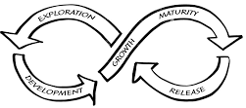

Figure 11: Adaptive cycle

### Involve the data collectors/users in building the plan and tools

It really helps if people from the broader collaboration and community are involved in building the MEL plan and can see why information is being collected. This involvement needs to continue throughout the life of the place-based delivery approach, including people coming together to analyse, reflect and make sense of the findings.

### Reflection workshops

Collaborations should allow time for reflection on progress and opportunities to incorporate lessons into practice. It is amazing what can be achieved if this is done well. Do not wait until the program has finished to start using the data! One of the key tools we promote is the ‘reflection workshop’ where the theory of change goes back up on the wall and all existing data is stuck onto it. Then a series of reflective questions are used to facilitate the group to consider what has and what has not been achieved. From here, both the MEL plan and the strategies can be revised. See [Clear Horizon’s ‘Tools for evaluating complexity’ series: Reflection workshop](http://www.clearhorizon.com.au/tools-for-evaluating-complexity.aspx).

### Get buy-in from senior management and the broader collaboration

It is critical that leaders at all levels (cultural leaders, funders, collaborators and the facilitating partner) are supportive of MEL efforts, and incentivise and encourage measurement and evaluation to inform strategic learning. They need to be comfortable with the idea of failing forward, not just presenting positive results. If they do not value MEL, it is pretty hard to get the resources and focus that are needed, and even more difficult to get agreement on recommendations and changes that are backed by the findings. While every person and organisation is different, a few good strategies include:

* finding out what type of evidence leaders and communities find credible and make sure this is included
* making sure the key questions that they care about are included in the MEL plan
* involving key leaders in strategic learning workshops where data is presented and explored
* finding out what type of visual reports they prefer and cater to this.

## Strategic learning and reflective practice tools



**See Toolkit: Section 11**

The toolkit provides some great tools to facilitate reflective practice.

## Reporting

An effective report is one that gets widely used. Too many hours are wasted writing evaluation reports that lie on shelves collecting dust. The first question you may want to ask is whether a report is even needed? Sometimes, for some forms of developmental or formative evaluation, simply presenting the key findings can be sufficient. But other times it is not!

So before starting to write up any evaluation reports, it is useful to check what kind of report is required. In some cases, a formal report may not be necessary – it all depends on the purpose of the evaluation and the requirements of the audience.

Sometimes you may have to prepare different versions of the evaluation report for different audiences. Some may only want a one-page summary while others may require more detail. However, if you do use summaries, remember that evaluation is not just about the communication of successful results. Somewhere in an evaluation process, there must be solid evidence to support the summary, including negative results and an explanation for these results.

### So what makes a good report?

A good report is fit for purpose and meets the audience’s needs. However, there are a few things that are generally consistent with all good reports:

* The data is woven together to answer the big key evaluation questions that have been asked.
* All findings are substantiated with evidence.
* They are written clearly, so that an intelligent outsider could understand the content.
* The structure is clear, with plenty of signposting for the reader.

### Data weaving

Most evaluation studies and even monitoring reports will require you to synthesise the findings of different methods to answer important questions. ‘Weaving’ is the process of taking individual strands and twisting/knotting/crossing them to make a solid piece of fabric. In the same way, when we talk about ‘data weaving’, we refer to the process of taking individual strands of data and bringing them together to make a solid ‘story’ about what has happened. In evaluation we can weave different data items (such as interview transcripts) to make a meta-narrative, or we can weave totally different methods (questionnaires, interviews and data from monitoring) together to answer key evaluation questions.

Good monitoring and evaluation reports should make use of data weaving to answer important questions. The idea is to provide a solid, evidence-based case for your findings. It should be possible to trace back the evidence to different sources. Ideally the sources of evidence should be referenced.

Involving communities in this process is also suggested where possible. For example, in contexts where evaluation is being undertaken with and/or for Aboriginal communities, Aboriginal peoples should be involved in data interpretation and sense-making to reduce cultural ***assumptions*** being made.

### The dummy report: the art of Japanese management

One great strategy to get reporting right is to develop a ‘dummy report’ a year or so before the report is due, or even at the time the monitoring and evaluation framework is developed. A ‘dummy report’ is a report that is written with made-up data, with findings that are more or less what we anticipate will happen at the end of the program. Careful consideration is given to the format and presentation. Then we share this ‘dummy report’ with our evaluation audience to find out if it meets needs and to negotiate the final product. This may also influence the way we collect data before it is too late. This step can be really valuable in avoiding wasting time creating a report that misses the mark.



**See Toolkit: Section 12**

The toolkit provides some examples of different styles of reports.

# Theoretical underpinnings of this framework

## Background to evaluating PBAs

This section provides some of the underpinning theory for the Place-based Evaluation Framework. It is a little more technical than other sections, and written for people interested in theory. We have tried to keep it brief, but if you want to know more, there are some fantastic resources available by following the references and links. In this section, we explore the challenges of evaluating PBAs and offer some appropriate evaluation approaches.

## Why it’s tricky to evaluate place

Across the literature, there is agreement that PBAs have common traits that complicate efforts to assess their impact (DSS, 2017). Evaluating PBAs is very different to evaluating linear, less complex initiatives. When evaluating PBAs there are many parts of the system to monitor, and the population-level changes that initiatives typically seek to affect take many years, sometimes decades.

#### Many moving pieces

With so many diverse players, so many different levels of work and so many moving parts, it is very difficult to design a one-size-fits-all evaluation model for PBAs. With so many elements, scales and timeframes, PBAs may require a number of discrete evaluation projects, each worthy of its own customised design.

#### Dynamic nature

It is challenging to evaluate the evolving nature of the initiative’s proposed activities and outcomes (which are often diverse and numerous). PBAs involve lots of learning and often see dramatic changes in direction and identify new things that need to be focused on at different points. Using a traditional approach whereby you set a series of goals, measure the baseline at the start and then measure the achievement of these goals over time (such as in results-based accountability) can be useful but problematic if the focus of the work changes continually.

#### Hard to attribute

A major challenge of evaluating PBAs is ***attribution***. It is hard to prove that the changes in outcomes were really caused by the PBA and not by other things happening in the community concurrently. Much of the literature highlights that traditional methods of determining causation/attribution such as randomised control trials (RCTs) are rarely possible for most PBA (Wilks et al., 2015; Horizons, 2011; United Way Toronto, 2012; Cabaj, 2014). This is because undertaking rigorous ‘scientific’ evaluation requires comparing one group with another – something that is difficult to achieve across demographically different communities. In delivering RCTs, the ‘test’ group is given a strict and clear process of program delivery, whereas PBAs need the opportunity to change and ‘grow’ in the communities where they are implemented and be tailored to local issues and conditions. Another issue compounding attribution is where multiple interventions are occurring simultaneously (United Way Toronto, 2012; DSS, 2017).

#### Rigour versus ownership

A further challenge is balancing the need for rigour with the importance of involving diverse stakeholders in the evaluation process and fostering community ownership (Horizons, 2011; TRCHM, 2014; DSS 2017). Evaluation can be very technical at times, and it can be challenging to bring non-evaluators along. Yet the *process* of developing the evaluation design may be crucial to the success of the evaluation. Stakeholder engagement and working with collaborative and collective processes for decision making and ownership can present challenges and opportunities when evaluating PBAs. Developing a MEL plan for evaluating a PBA will involve working with many different stakeholder agendas and worldviews. For this reason, participatory approaches to evaluation can be particularly relevant.

#### Whose reality and knowledge counts

Evaluation seeks to use evidence to determine whether things have been successful. Yet different types of knowledge, such as local knowledge versus expert knowledge, may be at odds with one another. There are also issues of who gets to decide ‘what is success?’ and of power, that is, who gets to decide what to do and how to adjust strategies. Issues of the primacy of local knowledge as well as expert knowledge, and the desire to build community agency mean that participatory and pluralistic approaches are critical.

#### Resource challenges

Resource challenges such as time, money and expertise are also common issues in evaluating PBAs. There is no point designing a huge, comprehensive evaluation framework if there are no resources or will to implement. For this reason, it is important to take a proportional approach to evaluation.

## Appropriate theoretical approaches for evaluating PBA

Evaluation today is characterised by great diversity with more than 50 different models for the conduct of evaluation. Predictably, there are considerable differences between these models in how they define what good evaluation is.

Some focus on the importance of establishing clear proof that the intervention caused the effect (experimental approaches). Others focus on casting clear judgment as to whether the intervention is serving its citizens (judgmental approaches). Some focus on whether there is a more shared agreement around what future actions to take across diverse lived experiences (pluralist). Then there are those that focus on differences in how interventions work across contexts (realists), or how to answer strategic questions of most importance (utilisation focused).

Given this diversity in approach, it is important that we aim for evaluation approaches that are best suited to the challenges, context and properties of PBAs. It should be noted that these approaches may only be relevant to certain phases, or elements of the PBA approach.

Evaluation approaches that are suited to evaluating PBA include:

* Utilisation-focused evaluation approaches
* Principle-focused evaluation
* Participatory or pluralistic approaches to evaluation
* Realist approaches to evaluation
* Contribution analysis rather than attribution.

### Utilisation-focused evaluation approaches

Utilisation-Focused Evaluation (UFE), developed by Michael Quinn Patton (2000), is an approach based on the principle that an evaluation should be judged on its usefulness to its intended users. Under UFE, MEL should be planned and conducted in ways that enhance the likely utilisation of both the findings and of the process itself to inform decisions and improve performance. UFE has two essential elements. Firstly, the primary intended users of the evaluation must be clearly identified and personally engaged at the beginning of the evaluation process to ensure that their primary intended uses can be identified. Secondly, evaluators must ensure that these intended uses guide all other decisions that are made about the evaluation process. According to Patton (1997), UFE is an “approach to making evaluations useful, practical, accurate, systematic and ethical” (p. 1). This involves matching the evaluation approach and the design to the information and decision needs of primary intended users, considering “other stakeholders, political factors, organisational constraints, project/program history, available resources and cultural factors of a specific evaluation context”. He suggests that this allows for ‘situationally responsive’ evaluations. This involves setting key evaluation questions that relate to audience needs for information at a point in time.

Utilisation-focused approaches are particularly relevant for PBAs and are incorporated into this framework. We include a focus on scoping, framing and getting really clear on who are the primary intended users, and frame the whole thing around key evaluation questions. We also note that phase- or project-specific ‘min-MEL’ plans may be required.

### Principles-focused evaluation

Principles-focused evaluation (Patton, 2018) offers a different perspective to the design and conduct of evaluations, which may be particularly relevant to systems change endeavours.

Under principles-focused evaluation, a principle is prescriptive. Patton refers to them as ‘effectiveness principles’. They provide advice and guidance on what to do, how to think, what to value, and how to be effective. They offer direction. A principle should provide sufficient guidance so that it is easy to distinguish from the contrary – e.g.:

Harm minimisation rather than zero tolerance.

A drop-in centre for homeless youth used this approach. They developed a set of principles that articulated their holistic and unique way of working (trauma-informed, journey-oriented, strengths-based etc.), then used these principles to evaluate their work, describe their work, and even to get the right employees. There is a careful way of arriving at and wording principles, of course, just like we carefully develop outcomes/theory of change.

PBAs show features of emergent complex systems. This means the work is likely to evolve and change in response to what is being learned about how to bring about systemic changes. A great feature of principles-focused evaluation is that they can stay relatively stable, even with changes in direction and gaining new insights. For this reason, they provide good solid ground for evaluating PBAs. Another feature of principles that make them suitable for community contexts is that they can very much be drawn from the values already present in the community.

Given the suitability of principles-based approaches, we have included principles in our concept cube, and they are both seen as embedded within the theory of change and offered as cross-cutting principles that are set by the community themselves.

### Participatory, or pluralistic approaches to evaluation

Participatory evaluation is a family of approaches that involves the stakeholders in the evaluation process. This involvement can occur at any stage of the evaluation process, from designing an evaluation, deciding what success looks like, collecting and analysing data, making recommendations, and reporting. A participatory approach can be taken with any evaluation design, and with quantitative and/or qualitative data. It is important to consider the purpose of involving stakeholders, and which stakeholders should be involved, in order to maximise the effectiveness of the approach and make good use of people’s time.

This evaluation framework draws heavily on participatory methods of evaluation to empower and engage the community and organisations. It can be seen in the encouragement to involve community in all aspects of the evaluation, as well as inclusion of tools that have been tested and found valuable in community contexts, such as the Most Significant Change technique (MSC).

### Theory-based approaches and realist evaluation

This family of approaches involves developing and testing a ‘theory’ or explanation for how a project or program is intended to work. Knowing only whether a statistically significant change has occurred through the use of a randomised controlled trial approach does not tell us enough to inform program improvement or policy revision. Theory-based evaluation can help understand how and why a program works or fails (Weiss, 1997).

A subset of theory-based approaches is realist evaluation. Rather than merely asking if the program works, realist evaluation aims to produce ever more detailed answers to ‘why a program works, for whom it works, and in what circumstances it works’. The realist approach is based on the premise that social programs only ever work for certain people in certain circumstances, and the central task is to understand and explain these patterns of success and failure. By focusing on the different people participating in the program and their context, realist evaluation acknowledges that it is not projects/programs that ‘work’, but rather the way people respond to the resources, ideas and practices that the program introduces that creates program outcomes.

We apply a theory-based approach in this framework at a macro level by offering a generic theory of change to help think through what outcomes may need to be measured.

Realist evaluation is recommended for evaluation that is well resourced when evaluating pilots that may emerge from place-based delivery approaches.

### Contribution analysis rather than attribution

Cabaj (2014) recommends seeking out contribution, not attribution to community changes. Traditional methods of determining causation/attribution are rarely possible for most PBAs. Cabaj (2014), therefore, recommends acknowledging that multiple factors are likely to have caused an observed change and seek to understand the contribution the collective impact activities had in achieving the change. See Figure 12 for a visual depiction of the difference between attribution and contribution.

attribution: a single output leads to a single outcome.
Contribution: multible outputs lead to an outcome.

Figure 12: Difference between attribution and contribution

There is an emerging family of evaluation approaches that attempts to understand the likely contribution rather than to prove attribution. This family of approaches seems particularly well suited to PBAs, and this framework attempts to incorporate them. These include:

* **Contribution analysis** is a theory-based evaluation approach, which aims to make credible causal claims about programs and their results (Mayne, 2012). Contribution analysis is particularly useful where: the program is not experimental; there is little or no scope for varying how the program is implemented; and the program has been funded on the basis of a theory of change (Mayne, 2008). Another advantage of contribution analysis is that many of the steps can be undertaken in a participatory mode (Mayne, 2008).
* **Process tracing:** In their recent evaluation study, ORS Impact and the Spark Policy Institute used process tracing as the primary approach to understand the degree to which CI contributed meaningfully to observed positive changes in people’s lives (or, in some cases, species or ecosystems) (Lynn et al., 2018). Process tracing is a rigorous and structured way to identify and explore competing explanations for why change happens, and to determine the necessity and sufficiency of different kinds of evidence to support different explanations found through the data collection (Lynn et al., 2018).



**See Toolkit: Section 10.3**

We suggest that process tracing is a particularly suitable framework for establishing reasonable case for whether the work contributed to outcome. We offer this as part of the toolkit for understanding contribution of work from projects, to systemic changes and population-level changes.

### Developmental evaluation

**Developmental evaluation**. DE is an evaluation approach that can assist social innovators develop social change initiatives in complex or uncertain environments. The approach is described in a book by Michael Quinn Patton, who is careful to describe this approach as one choice that is responsive to context. This approach is not intended as the solution to every situation. Development evaluation is particularly suited to innovation, radical program re-design, replication, complex issues and crises. In these situations, DE can help by: framing concepts, testing quick iterations, tracking developments, and surfacing issues (Better Evaluation, 2018). We draw heavily on developmental evaluation in this evaluation framework.

As mentioned in Section 10, developmental evaluation is particularly suitable for PBAs. In this framework, we offer a series of questions to situation learning relevant throughout the MEL planning, as well as recommending the services of a developmental evaluator.

### Results-based accountability and the balanced score card

Results-based accountability is an increasingly popular framework for measurement that is applied in the social sector. It helps communities focus on results, and provides a framework for setting and tracking targets. Results-based accountability is suitable for tracking population-level results, and perhaps also some key indicators of systemic change.

However, results-based accountability is focused squarely on whether changes have been achieved. In this framework, we direct users to also incorporate elements of principle-focused evaluation, learning and accountability for good process.

To balance the focus on results with other important lenses, we offer a framework (the cube) that marries results-based accountability with a modified version of the balanced scorecard. The balanced scorecard looks at results, customer feedback, learning and innovation, and process quality.

# References

The Australian Institute of Health and Welfare (AIHW). (2017). Rural and Remote Health Report. Sourced from: <https://www.aihw.gov.au/reports/rural-health/rural-remote-health/contents/rural-health>

Baxter, J., Hayes, A. and Gray, M. (2011). Families in regional, rural and remote Australia – research summaries. Sourced from: <https://aifs.gov.au/publications/families-regional-rural-and-remote-australia>

Better Evaluation. (2018). Sourced from: <http://www.betterevaluation.org/en>

Cabaj, M. (2014). Evaluating Collective Impact: Five Simple Rules, *The Philanthropist*: Vol 26: Issue 1, p109-124.

Collaboration for Impact (CFI). (2018). Collaborative Approaches - The Collective Impact Approach. Sourced from: <http://www.collaborationforimpact.com/collective-impact/>

Commonwealth of Australia. (2015). *Resource Management Guide (RMG) No. 131: Developing good performance information*. Sourced from: <https://www.finance.gov.au/sites/default/files/RMG%20131%20Developing%20good%20performance%20information.pdf>

Crowther, J.L., and Lloyd-Williams, M. (2012). Researching sensitive and emotive topics: The participant’s voice. Research Ethics, 8(4), 200-211.

Department of the Prime Minister and Cabinet (PM&C). (2018). *Indigenous Advancement Strategy Evaluation Framework*. Sourced from: <https://pmc.gov.au/sites/default/files/publications/ias-evaluation-framework.pdf>

Department of Social Services (DSS). (2017). *Place-based approaches to disadvantage – Departmental Policy Approach March 2017.* (Powerpoint presentation sent from DCCSD).

Froonjian, J. and Garnett, J.L. (2013). Reaching the Hard to Reach: Drawing Lessons From Research and Practice. International Journal of Public Administration, 36: 831-839.

Gamble, J.A.A. (2008). A Developmental Evaluation Primer. The J.W. McDonnell Family Foundation. Sourced from: <http://vibrantcanada.ca/files/developmental_evaluation_primer_1.pdf>

Horizons. (2011). *The evaluation of Place-based approaches. Questions for further research.* Sourced from: <http://www.horizons.gc.ca/en/content/evaluation-place-based-approaches>

Kania, J. (Producer). (2012). *Making collective impact work*. [Audio podcast]. Retrieved from <http://vibrantcanada.ca/content/making-collective-impact-work>

Liamputtong, P. (2007). ***Researching the Vulnerable – A Guide to Sensitive Research Methods.*** London: Sage.

Lynn, J., Gase, L, Roos, J., Oppenheimer, S., Dane, A., Stachowiak, S., Akey, R., Beyers, J., Chew, A., Habtemariam, E., Gutierrez, J., and Orians, C. (2018). When Collective Impact has an impact. A cross-site study of 25 Collective Impact Initiatives. Seattle, WA.

Mayne, J. (2008) Contribution Analysis: An approach to exploring cause and effect, ILAC methodological brief. Sourced from: <http://www.cgiar-ilac.org/files/ILAC_Brief16_Contribution_Analysis_0.pdf>

Mayne, J. (2012). ILAC Brief 26 – Making causal claims. Retrieved from: <http://www.cgiar-ilac.org/files/ilac_brief26_making_causal_claims_0.pdf>

National Health and Medical Research Council. (2003). Values and Ethics: Guidelines for Ethical Conduct in Aboriginal and Torres Strait Islander Health Research. Sourced from: <https://www.nhmrc.gov.au/_files_nhmrc/publications/attachments/e52.pdf>

National Health and Medical Research Council. (2006). Keeping Research on track: A Guide for Aboriginal and Torres Strait Islander peoples about health research ethics, Sourced from: <https://www.nhmrc.gov.au/guidelines-publications/e65>

Owen, S. (2001). The practical, methodological and ethical dilemmas of conducting focus groups with vulnerable clients. Methodological Issues In Nursing Research, 36(5), 652-658.

Patton, M.Q. (2018). Principles-focused Evaluation. The Guide. Guilford Press.

Patton, M. Q. (2010). Developmental Evaluation. Applying Complexity Concepts to Enhance Innovation and Use. Guilford Press, New York.

Patton, M.Q. (2008). Utilization-focused evaluation 4th Edition. Sage Publications.

Patton, M.Q. (1997). Utilization-focused evaluation: The new century text. 3rd Edition. Sage Publications.

Patton, M.Q. McKegg, K., and Wehipeihana, N. (2015). Developmental Evaluation Exemplars. Principles in practice. Guilford Press.

Sithole, B. (2012). The ARPNet Dillybag – A practical field guide to participatory and other research tools for use by Aboriginal Research Practitioners in Australia. ARPNet at RIEL, Charles Darwin University. Available from: <https://www.researchgate.net/publication/302957598_The_ARPNet_Dilly_bag_A_practical_field_guide_to_participatory_and_other_research_tools_for_use_by_Aboriginal_research_practitioners_in_Australia>

The Royal Children’s Hospital Melbourne (TRCHM) and the Murdoch Children’s Research Institute. (2014). The evidence: what we know about place-based approaches to support children’s wellbeing. Collaborate for children: scoping project. Sourced from: <https://www.rch.org.au/uploadedFiles/Main/Content/ccch/CCCH_Collaborate_for_Children_Report_The_Evidence_Nov2014.pdf>

United Way Toronto. (2012). Evidence review of place-based approaches – summary report. Sourced from: <http://www.publicinterest.ca/images/Place-Based_Approaches_Evidence_Review_Summary_FINAL_2012-11-26.pdf>

Weiss, C.H. (1997). Theory-based Evaluation: Past, Present, and Future. New Directions for Evaluation, 76, 41-55.

Wilks, S., Lahausee, J. and Edwards, B. (2015). Commonwealth Place-based Service Delivery Initiatives – Key learnings project. Sourced from: <https://aifs.gov.au/publications/commonwealth-place-based-service-delivery-initiatives/4-commonwealth-place-based>

# Annex 1: Glossary

| Term | Definition |
| --- | --- |
| Activity | A distinct effort of an entity undertaken to achieve a specific result. A purpose (that is, the objectives, functions or role of an entity, against which entities undertake activities) may be achieved through a single activity or multiple activities. Alternatively, an activity may make a contribution to multiple purposes (Commonwealth of Australia, 2015: 49, 52). Activities are conducted to bring a change in a situation or behaviour that is expected to contribute to outcomes. For example, incentives scheme advertised, workshops run, awareness raising. |
| Appropriateness | A measure of whether an intervention is suitable in terms of achieving its desired effect and working in its given context. Suitability may apply, for example, to whether the intervention is of an appropriate type or style to meet the needs of major stakeholder groups. |
| Assumptions | Hypotheses about factors or risks which could affect the progress or success of an intervention. |
| Attribution | When assessing *attribution*, we are attempting to determine if the program *caused* the observed outcomes. Attribution implies causation and involves drawing conclusions about the relationship between observed changes, whether anticipated or not for specific interventions.  Some questions posed for addressing attribution might be:   * Are the results attributable to the program? * Are the outcomes of interest changing as a result of the program? * Did the program cause the outcome of interest? |
| Backbone organisation | A defining feature of the Collective Impact approach is the role of a backbone organisation – a separate organisation dedicated to coordinating and supporting the various dimensions and collaborators involved. In this framework we use the alternative term ‘facilitating partner’.  Supporting backbone infrastructure is essential to ensuring the collaborative effort maintains momentum and facilitates impact across PBAs. For further information see: <http://www.collaborationforimpact.com/collective-impact/the-backbone-organisation/> |
| Baseline study | Information collected before or at the start of an activity that provides a basis for monitoring the difference made by that activity (Commonwealth of Australia, 2015: 47). Analysis of the situation prior to an intervention/initiative/program, and then after, can be used to measure and assess progress. |
| Broader goals | Are long-term goals that the program outcomes are expected to contribute towards (it is acknowledged that many other factors and programs are also contributing to these broader goals) (at the same level as a program’s Vision). Broader goals often refer to social, economic or environmental consequences, for example, ‘improved water quality’. |
| Broader collaboration | The broader collaboration are all the organisations, including community groups, academics, service providers and government, policy makers, individuals, and families who are involved in implementing the PBA across the place -- this can be in-kind or can be funded in many diverse ways. |
| CALD | Culturally and linguistically diverse (CALD) is a broad and inclusive descriptor for communities with diverse language, ethnic background, nationality, dress, traditions, food, societal structures, art and religious characteristics. This term is used broadly and often synonymously with the term 'ethnic communities'. |
| Collective impact | At the more complex end of the spectrum of PBAs is the collaborative organisational approach of collective impact (CI). Collective Impact is only one of many place-based delivery approaches. More than just a new way of collaborating, CI is a progressive, staged approach to problem solving that requires multiple organisations from different sectors to align with a shared agenda and mutually reinforcing activities. Collaboration for Impact (CFI, 2018) define CI as:  A framework to tackle deeply entrenched and complex social problems. It is an innovative and structured approach to making collaboration work across government, business, philanthropy, non-profit organisations and community members to achieve significant and lasting social change.  One distinguishing feature of Collective Impact from other collaborations or partnerships is the backbone organisation with dedicated staff whose role is to help participating organisations shift from acting alone to working together (CFI, 2018).  Collective impact is not business as usual and it is widely agreed that securing long-term, sustainable change takes many years. There is no agreed-upon or consistent timeframe that defines CI progress, and many scholars and practitioners relate to progress phases for systemic change that can involve iterative cycles of exploration, emergence, adaption, maturity and sustaining. |
| Contribution | Assessing *contribution* involves determining if the program contributed to or helped to cause the observed outcomes. Questions related to contribution are:   * Did the program contribute to the outcomes of interest? * Is there evidence that the program helped to achieve or was part of what caused the outcomes of interest? |
| Effectiveness | The extent to which an initiative or project meets its intended outputs and/or objectives, and/or the extent to which a difference is made. At the level of the purpose described in an entity’s corporate framework, for example, is the extent to which the purpose is fulfilled and provides the benefits intended. At the level of an activity, it is the extent to which it makes the intended contribution towards a specific purpose (Commonwealth of Australia, 2015, p. 48). |
| Efficiency | The extent to which activities, outputs and/or the desired outcomes are achieved with the lowest possible use of resources. For ‘economic efficiency’ for example, an activity is most efficient when the unit cost (e.g. in terms of dollars spent or human resources committed) of delivering an output (e.g. a service) at a given quality is at a minimum (Commonwealth of Australia, 2015, p. 48). |
| Facilitating partner | In this framework, this term refers to the person, group or team who has the role of convening, facilitating and catalysing the PBA -- this is often a funded function. They may provide supportive and/or driving functions for the initiative, such as coordinating the shared vision, strategy, aligned activities, learning and measurement systems, or mobilisation of funding. The way facilitating partners are structured, named, resourced and operated will differ between PBAs. For example in collective impact PBA delivery models they are referred to it as ‘backbone’ teams and/or structures. |
| Formative evaluation | Refers to evaluation conducted to inform decisions about improvement.  It can provide information on how the program might be developed (for new programs) or improved (for both new and existing programs). It is often done during program implementation to inform ongoing improvement, usually for an internal audience. Formative evaluations use process evaluation, but can also include outcome evaluation, particularly to assess interim outcomes. |
| High level theory of change | In this framework we also refer to a high level theory of change. That means just the population results and preconditions, without the theory of action. |
| Immediate outcomes and outputs | Any immediate changes or tangible products that are a direct result of the activities. |
| Impact | The ultimate difference or net benefit made by an intervention (usually longer term). It refers to measures of change that result from the outputs being completed and outcomes being achieved. Compared to the combined outcome of activities contributing to a purpose, impacts are measured over the longer term and in a broader societal context (Commonwealth of Australia, 2015: 49). |
| Intermediary organisation | An intermediary organisation is an organisation whose mission is to support and enable the conditions for systemic change. This often involves them providing capacity building support to local backbones and helping convene and catalyse broader coalitions for change. They support multiple PBAs. Some provide funding, and some do not. May also be referred to as ‘boundary organisations’. |
| Micro-place | Refers to the locales or suburbs within a broader geographic area or ‘place’. Sometimes in the PBA field the term ‘micro-communities’ is similarly used, and describes distinct communities within a wider geographic place-based ‘community’. |
| Monitoring | Monitoring is the ongoing process of collecting routine data, usually internally, to track progress with previously identified activities and outputs. |
| Outcomes measurement | A systematic approach to exploring the extent to which a place-based delivery approach has achieved its intended results, and may include assessing outcomes against targets and/or agreed progress measures. Involves measuring against a theory of change using indicators and evaluative questions (organised as an ‘outcomes framework’) for the purpose of measuring and evaluating changes, achieved outcomes, or the extent to which the program/initiative has made a difference. (For a guide see: <http://strengtheningnonprofits.org/resources/guidebooks/measuringoutcomes.pdf>). |
| Place | “Place” refers to the geographical area that is covered by the place-based delivery approach. |
| Place-based delivery approach (PBA) | A collaborative, long-term approach responding to complex problems delivered in a defined geographic location. This approach is ideally characterised by partnering and shared design, shared stewardship, and shared accountability for outcomes and impacts. |
| PBA leaders | “PBA leaders” are a group of leaders (or quorum) from different organisations and from the community who play a leadership and governance role in the PBA -- this is often an in-kind contribution. |
| Primary audience | The stakeholders who will receive the evaluation results directly, and who will use the information for decision making, such as program continuation or improvement. |
| Principles | **Evaluation principles**  Evaluation principles outline the approach to evaluation that we put forward as being relevant and viable for PBAs.  **PBA principles**  PBA principles accompany and expand the definition for a PBA.  **Theory of change principles**  In addition to developing a theory of change reflecting the cause and effect relationships in a program, sometimes it is also useful to develop a set of ‘principles’ to accompany the theory of change. These principles are cross-cutting in that they affect the way we should engage across the whole ***theory of change*** model. They are more akin to a ‘mindset’ or philosophy than a stand-alone action. They are about how we should behave while doing the influence activities. |
| Program logic | A visual depiction of the program theory and logic behind how activities lead to outcomes. It is usually represented as a diagram that shows a series of causal relationships between inputs, activities, outputs, outcomes and impacts. |
| Qualitative | Information or observations that emphasises narrative rather than numbers. Qualitative inquiry involves capturing and interpreting the characteristics of something to reveal its larger meaning. This can involve tapping into experiences of stakeholders through observations, interviews, focus groups and analysis of documents (Commonwealth of Australia, 2015, p. 50). |
| Quantitative | Information represented numerically, including as a number (count), grade, rank, score or proportion. Examples are standardised test scores, average age, the number of grants during a period or the number of clients (Commonwealth of Australia, 2015, p. 50). |
| Reporting | To give a spoken or written account of something that one has observed, heard, done, or investigated. |
| Rubric | An attempt to communicate expectations of quality around a task. In many cases, scoring rubrics are used to define consistent criteria for grading or scoring. Rubrics allow all stakeholders to see the evaluation criteria (which can often be complex and subjective). |
| Scorecard  Balanced scorecard | An approach to progress/performance reporting using data visualisation or graphic organiser tools to represent measurable results (usually using indicators and quantitative performance measures). Scorecards are a communications tool for outcomes measurement and may be represented as a mix of diagrams, tables, charts and infographics (web-based or hard-copy).  The term ‘balanced scorecard’ used in this framework goes beyond the traditional scope of outcomes measurement and scorecard metrics, to consider other criteria such as the quality of process, customer/community feedback, and learning and innovation. |
| Secondary audience | Secondary audiences are ‘others’ who may be interested in the findings, however, will not directly receive a copy of the evaluation findings. |
| Strategic learning and adaption | Strategic learning and adaption involves the translation of findings from monitoring data, evaluation data, tracking population indicators and research studies into action. Data from all forms can help the broader collaboration decide where to intervene, as well as understanding whether interventions are working or whether they need to be modified or dropped. |
| Summative evaluation | Refers to evaluation to inform decisions about continuing, terminating or expanding a program. It is often conducted after a program is completed (or well underway) to present an assessment to an external audience. Although summative evaluation generally reports when the program has been running long enough to produce results, it should be initiated during the program design phase. Summative evaluations often use outcome evaluation and economic evaluation, but could use process evaluation, especially where there are concerns or risks around program processes. |
| Systems change | Systems are composed of multiple components of different types, both tangible and intangible. They include, for example people, resources and services as well relationships, values and perceptions. Systems exist in an environment, have boundaries, exhibit behaviours and are made up of both interdependent and connect parts, causes and effects. Social systems are often complex and involve intractable, or ‘wicked’ problems. |
| Theory of action | Theory of action is the delivery model for a theory of change. It specifies the mechanisms and actions that will be undertaken to achieve the proposed change. |
| Theory of change | An explicit theory of how the intervention causes the intended or observed outcomes. The theory includes hypothesised links between (a) the intervention requirements and activities, and (b) the expected outcomes. Theory of change is often used interchangeably with program theory.  In this framework we also refer to a high level theory of change. That means just the population results and preconditions, without the theory of action. |

# Annex 2: The co-design process

Clear Horizon, in partnership with TACSI, Collaboration for Impact (CFI) and CSIA, led the co‑design of the Place-based Evaluation Framework and support resources including the toolkit. The process included:

* Involvement of stakeholders and key ‘knowledge holders’ across the phases of the initial inquiry, concept design and tools design
* Preliminary research and literature scan
* 3 workshops with stakeholders (planning & co-design)
* User testing and generative feedback cycles (via two Logan Together workshops and development of a MEL plan using the framework).

Across the framework development and testing, over 100 evaluators, practitioners and PBA enthusiasts contributed to the framework. The pathways created for input into, and engagement via the wider consultation process, are illustrated below.

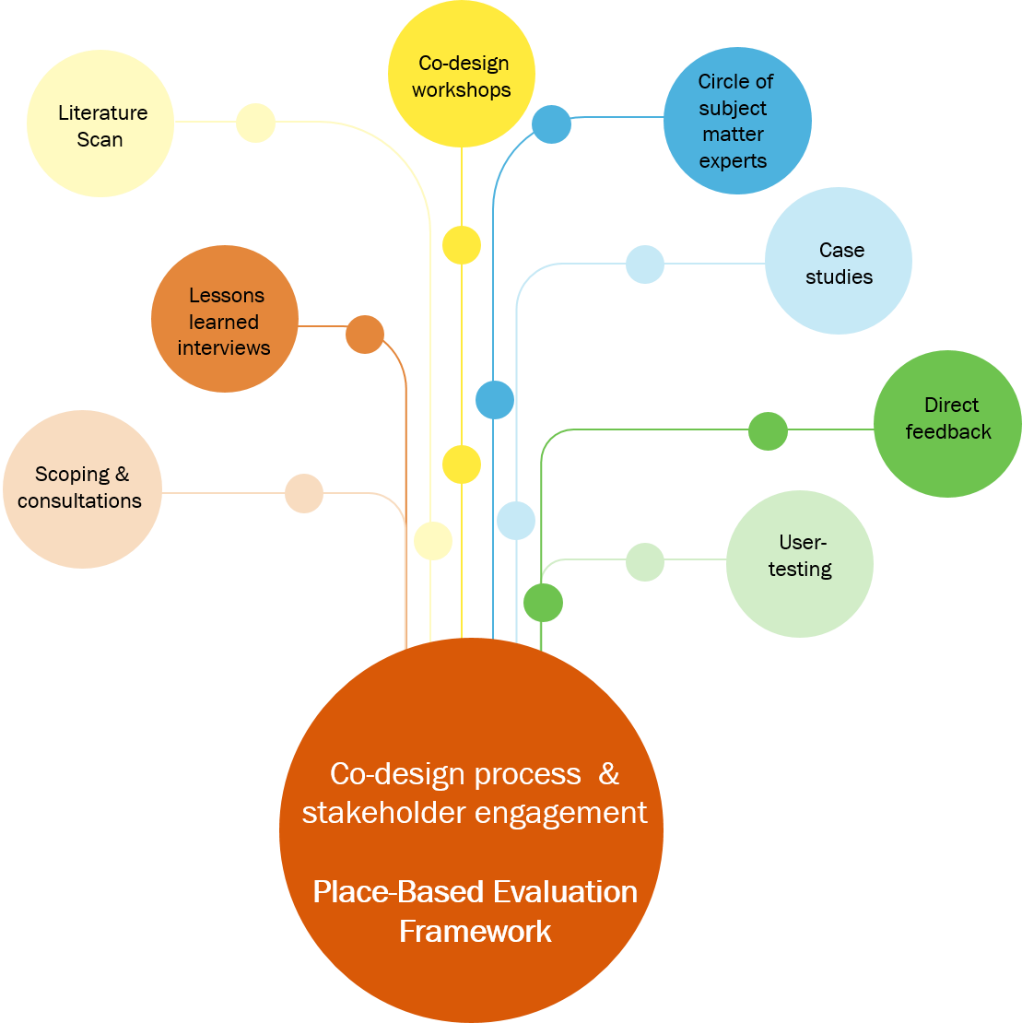

Stakeholder mapping to identify relevant organisations for the co-design was collaboratively undertaken by the core partners, workshop participants and via Clear Horizon’s network of evaluation practitioners/ experts. Participants designed key components of the framework (such as the PBA definition, principles and the rubric) and provided extensive feedback during the drafting of the framework. Some of the participating organisations and agencies included:

The Queensland Government agencies (including the Department of Communities, Disability Services and Seniors, Department of Health; Department of Aboriginal and Torres Strait Islander Partnerships, South East region, Public Service Commission, Department of the Premier and Cabinet, Department of Child Safety, Youth and Women, Department of Education and Queensland Government Chief Information Office); the Australian Government Department of Social Services; Logan Together; Place-Based Evaluation Joint Working Group; Community Service Industry Alliance; Collaboration for Impact; Brisbane South PHN; Opportunity Child; Griffith University; and the Australian Institute of Family Studies.

# Annex 3: Practical guide to cultural capability

While cultural capability, culturally appropriate evaluations and use of cultural lens are important for effective and meaningful evaluation in Aboriginal and/or Torres Strait Islander communities, these can seem like vague terms.

The practical guidance below was developed as part of the framework’s co-design process through cultural consultations with Anangu (Aboriginal) women from Central Australia whose first languages are Pitjantjatjara, Yankunytjatjara, Kukatja and Central Arrernte.[16] While the focus is on cultural considerations for evaluation with Aboriginal communities, the guide is of relevance more broadly for building meaningful and effective engagement with other Aboriginal and/or Torres Strait Islander communities, and some CALD communities. Important cultural considerations when evaluating include:

* Aboriginal people, including local Aboriginal people, should be part of the evaluation team and involved in all aspects of the evaluation.
* Evaluation needs to be relationships-based. There needs to be trusting relationships between Aboriginal and Torres Strait Islander people/evaluators and non-Aboriginal evaluators; these take time to develop and should not be overlooked. These relationships need to support mutual respect and sharing. For example, for Central Australian Aboriginal communities, an important practice in human interactions is that of *ngapartji ngapartji* or reciprocity. Reciprocity is context-dependent and defined and should be present in evaluation processes. Not only are relationship-based evaluations culturally respectful, they also enable better quality and more meaningful data collection. If you are external to a community, it will be important that trusting relationships are formed. This may require that you bring your whole person (beyond your professional role) to the engagement process, to share who you are, where you are from, and where you have worked so community partners can understand where you fit in.
* Every Aboriginal and/or Torres Strait Islander community is unique, and will have different languages, cultures and histories. It will also be important to understand the local socio-political history of the community, and the impact of colonisation and its ongoing legacy, including inter-generational trauma.
* Understand that evaluation has a negative history in many Aboriginal and/or Torres Strait Islander communities as it has been used as a tool of colonisation. These communities may have had a negative personal experience of evaluation and may therefore be sceptical of evaluation. How will this evaluation be different?
* Ensure that Aboriginal and/or Torres Strait Islander people’s values, beliefs about what is important, ways of seeing and understanding (that is their worldview) are explicit in the evaluation design, including evaluation questions, methods of data collection and analysis.
* Use interpreters when working with people for whom English is a second or third language.
* Understand the local governance structure, know who the leaders are, and work through these to engage the community (rather than duplicating structures). Related to this is the importance of knowing and following the local protocols for seeking permission to visit Aboriginal Lands etc.
* If you are planning to seek permission to go to Aboriginal and Torres Strait Islander communities to collect data, find out when there are important events or happenings that might enhance, or conversely constrain or restrict your ability to talk with people and gather information. These may include large sporting events, regular weekly activities, and sorry business.
* Seek advice from local Aboriginal and Torres Strait Islander peoples and organisations on how to create safe places and processes for communities to participate in the evaluation; for example, where data is collected is important.
* Food is important to share at all meetings, gatherings etc. – this reflects the relationships.
* Humour is important to relating and promotes good relationships.
* Supporting Aboriginal people to participate in the evaluation is critical. This may include arranging transport, remuneration for their time and providing other social support to ensure they have equitable access to participate.
* Another consideration is who owns the data; it is important to be clear on cultural knowledge and intellectual property rights.

**Considerations especially relevant during data collection and analysis include:**

* Aboriginal people should be involved in data interpretation and sense-making to reduce incorrect cultural assumptions being made.
* Bringing people together in small groups to get their feedback is considered a good way to work in communities. However, you need to seek guidance from local people to understand who can come together in these groups, and if there are any cultural protocols that need to be followed with regard to avoidance relationships or the need for women and men to be consulted in separate groups. To include young people’s perspective, it might be important to talk with them separately, without senior Aboriginal people present.
* Important to include the perspectives of all family groups; seek the advice of local Aboriginal people about who to consult.
* Find out where people naturally gather in their communities (e.g. women’s centres, art centres, etc.) as this might be a safe and appropriate place to seek permission to talk with people and to gather information for the evaluation.
* Sometimes it might be important that initially Aboriginal and/or Torres Strait Islander peoples talk together about the evaluation questions or the changes that they see in their communities without non-Aboriginal people/evaluators present, and then they invite the non-Aboriginal people/evaluators in to share their perspectives and understandings and/or questions.
* Important to employ/work with local Aboriginal people to identify the tools and processes for data collection that will be safe and work best for local people. This reiterates the importance of Aboriginal people’s involvement in decision making at every stage of evaluations of PBA that include their communities.
* Find out how local Aboriginal people pass on information for teaching and learning and ask if these processes would be appropriate to include in the evaluation to make data collection meaningful and produce data with more integrity and quality for the evaluation.
* Use of visual tools and reports can be useful to promote understanding and facilitate discussion.
* Storytelling and storytelling through art making are important methods for Aboriginal people to share their perspectives on their communities and what has changed. For example, for Anangu[17] in Central Australia, these methods align with their ways of sharing information, teaching and learning. It is important to find out the local Aboriginal and/or Torres Strait Islander ways of knowing and learning, and with permission, try to include or adapt these processes as data collection methods for the evaluation.
* Working with younger Aboriginal people to gather information, it might be good to use photography or video to enable them to share their perspectives and understandings of change in their communities.
* Important to recognise that interviews with direct questions may not be appropriate for some Aboriginal people, especially in remote communities.
* Evaluation needs to go at the Aboriginal people’s pace, and timeframes need to be reflective of the context. It is important to leave enough time for people to think about the questions that are being asked in the evaluation. Aboriginal people often prefer to have time to think about their response, so maybe talk to people to let them know what the evaluation is trying to find out and then give them a couple of days before they come back together to share their perspectives and understandings.
* The concept of reciprocity and how this is defined in a particular community or contextually can be considered during the data collection process by:
* Talking to Aboriginal people to find out what is important for them in their community. For example:
  + - If people are concerned about intergenerational knowledge exchange and transfer, look for ways that the data collection methods can create opportunities for young people to learn from Elders and Elders to learn from young people;
    - If bush picnics are an appropriate and popular activity, take people on bush picnics as part of the data collection process.
* Talking to Aboriginal people about other ways that evaluators can help out while they are in communities.
* Make sure evaluation findings are presented to communities in person and in a format that is accessible to the community, this may include the use of interpreters. Allow time for discussion to make sure people understand the information and can ask questions. It is important the findings are fed back to the actual people who contributed information to the evaluation. When sharing information back to communities and ensuring access to data, you will need to consider issues such as computer/technology and internet access.

1. See https://aifs.gov.au/publications/commonwealth-place-based-service-delivery-initiatives
2. See glossary for further explanation of how we use this term for the framework. ‘Facilitating partner’ is also a term used elsewhere, such as the Communities for Children program. In other contexts, alternative terms are used to describe a similar role/function, such as ‘backbone’ in Collective Impact.
3. May also be referred to as ‘boundary organisations’, an intermediary supports and enables the conditions for systemic change. See glossary definition for further explanation.
4. The definition was the result of the co-design process for the development of this framework and was based on DCDSS, DSS and Logan Together definitions and design principles.
5. This list of common characteristics of place-based approaches was developed in the co-design workshop for the development of this framework (see Annex 2 for description of co-design process).
6. Modified from Patton (1997: 23).
7. For further information on shared measurement see http://www.collaborationforimpact.com/collective-impact/shared-measurement/
8. <https://www.datsip.qld.gov.au/people-communities/cultural-capability>
9. This list of considerations is also relevant to Aboriginal and/or Torres Strait Islander peoples due to the power relations/imbalances that inherently exist in evaluations led by non-Aboriginal/Torres Strait Islander Australians.
10. The Australasian Evaluation Society’s ‘Australasian Evaluation Society Code of Ethics’ can be accessed at: <http://www.aes.asn.au/images/stories/files/About/Documents%20-%20ongoing/code_of_ethics.pdf>
11. Here, systemic changes refers to the many interconnected changes that need to occur in ‘our’ community and across the numerous se affecting our PBA context (e.g. changes in community agency, changes in how resources flow, changes in services, norms etc.). Closely linked with the notion of ‘***systems change***’, the reference to ‘systemic changes’ in the theory of change places an emphasis on the interconnectedness and multiplicity of changes needed across systems and at different scales.
12. Some people think more in terms of the phases of the adaptive cycle (exploration, growth, conservation and release). We have left the time phases in here, as we wish to underline that it may take more than 5 years to get to population-level outcomes.
13. Note when we offer a percentage amount here we are including all aspects of monitoring, evaluation and learning. It includes time to develop the theory of change, developing routine monitoring tools, developmental evaluation, development of the shared measurement framework at the population level as well as funding for any externally commissioned evaluation and research studies.
14. A magic wall is made from a plastic shower curtain (the cheap ones work best) sprayed with re-positional glue (same glue as on sticky notes). For larger groups you can use rolls of brown paper. Magic walls help people lay their hands on the model and build it physically. Remember to use a mask when spraying the glue.
15. The reason we recommend less evaluation questions for a MEL plan than an evaluation study is that an evaluation study is a sub-set of a MEL plan and should be more focused.
16. This list was provided by Samantha Togni with Aboriginal colleagues Margaret Smith, Margaret Heffernan, Eva Nagomara and Ruth Nagomara as part of the framework’s co-design process.
17. Western Desert language-speaking Aboriginal person. Source: <http://www.irititja.com/sharing_knowledge/glossary.html>