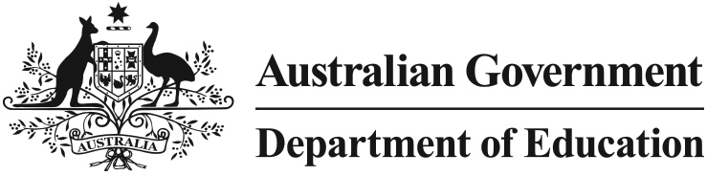

Removal of TAFE fees for diploma and advanced diploma child care courses

What is this initiative?

The Australian Government is supporting over 14 000 people per year to gain a vocational education and training qualification in early childhood through removal of regulated course fees. Funding has been provided to remove the regulated course fees for diplomas and advanced diplomas in child care courses, delivered by a TAFE institute or other government training provider.

How will it work?

The Australian Government will pay the regulated TAFE course fees for students enrolling in TAFE delivered diplomas and advanced diplomas in child care courses. Students enrolling in child care courses at TAFE institutes generally incur upfront fees which can be quite substantial.

This scheme has operated since January 2009 and will finish in December 2014.

Who will benefit?

Anyone who enrols to study at a TAFE institute or other government training provider including existing early childhood educators looking to upgrade or obtain qualifications as well as prospective new entrants to the industry.

Are all child care courses eligible?

This initiative only supports students enrolled at TAFE institutes and other government training providers, such as agricultural colleges and universities offering vocational courses. Courses undertaken with private or community training providers are not part of this initiative.

Current eligible child care courses are:
- CHC50113 Diploma of Early Childhood Education and Care (released 1/7/2013); and
- CHC60208 Advanced Diploma of Children’s Services (released 7/5/2012; to be deleted by 31/12/2014).

What course fees are covered?

Fees covered include compulsory regulated fees levied on students for enrolment in an eligible course of study. Regulated fees are defined as any fees mandated by the State or Territory Government, and exclude any fees that are imposed on students by the TAFE or other government providers. Students will still incur some costs as regulated fees do not cover all costs associated with doing these courses.

How do I find out more about the training opportunities under this initiative?

Contact your local TAFE institute or other government training provider, or look on your state or territory’s TAFE website:

New South Wales

www.tafensw.edu.au

Victoria

www.skills.vic.gov.au/get-training

Queensland

www.tafe.qld.gov.au

Western Australia

www.trainingwa.wa.gov.au

South Australia

http://www.tafesa.edu.au/

Tasmania

www.yourchoice.tas.gov.au

Australian Capital Territory: www.cit.act.edu.au

Northern Territory

www.cdu.edu.au/cduvet

