DSS1600.05.15
Professional Support Coordinators | 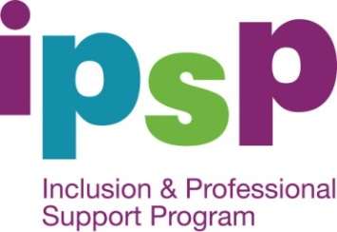
  - Contact Details

ACT PSC

Communities at Work
Phone: 1800 228 772 (toll free)
Website: Communities at Work (www.actpsc.com.au)

NSW PSC

Children's Services Central
Phone: 1800 157 818 (toll free)
Website: Children’s Services Central (www.cscentral.org.au)

NT PSC

Child Inclusive Learning and Development Australia Inc
Phone: 1800 138 662 (toll free)
Website: Child Inclusive Learning and Development Australia Inc (www.childaustralia.org.au)

Queensland PSC

Health and Community Services
Workforce Council Inc
Phone: 1800 112 585 (toll free)
Website: Health and Community Services
Workforce Council Inc (www.pscq.org.au)

SA PSC

Gowrie SA
Phone: 1800 129 606 (toll free)
Website: Gowrie SA (www.pscsa.org.au)

TAS PSC

Lady Gowrie Tasmania
Phone: 1800 647 718 (toll free)
Website: Lady Gowrie Tasmania (www.psctas.org.au)

WA PSC

Child Inclusive Learning and Development Australia Inc
Phone: 1800 783 768 (toll free)
Website: Child Inclusive Learning and Development Australia Inc (www.childaustralia.org.au)

VIC PSC

Gowrie Victoria
1800 103 670 (toll free)
Website: Gowrie Victoria (www.gowrievictoria.org.au)

