DSS1598.05.15
Indigenous Professional Support Units | 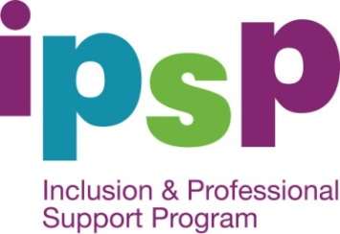
  - Contact Details

NSW IPSU (including ACT)

Gowrie NSW
Phone: 1800 450 472 (toll free)
Website link: Gowrie NSW (http://www.ipsunswact.com.au)

NT IPSU – North

Regional and Remote Aboriginal Children and Services Support Unit (RRACSSU)
Phone: 1800 677 095 (toll free)
Website link: RRACSSU (http://rracssu.batchelor.edu.au/)

NT IPSU- Central

Regional and Remote Aboriginal Children and Services Support Unit (RRACSSU)
Phone: 1800 677 095 (toll free)
Website link: RRACSSU (http://rracssu.batchelor.edu.au/)

QLD IPSU

Queensland Council of Social Services Inc (QCOSS Inc)
Phone: 1800 110 869 (toll free)
Website link: QCOSS (http://www.ipsu.com.au/)

SA IPSU

Network SA Resource, Advisory and Management Services Inc.
Aboriginal Resource & Management Support Unit
Phone: 1800 679 199 (toll free)
Website link: Network SA (http://www.armsu.org.au)

TAS IPSU

Lady Gowrie Tasmania
Phone: 1800 647 718 (toll free)
Website: Lady Gowrie Tasmania (http://www.ipsu.gowrie-tas.com.au/)

VIC IPSU

Victorian Aboriginal Education Association Inc (VAEAI)
Phone: 1800 103 394 (toll free)
Website: VAEAI (http://www.vaeai.org.au/support/dsp-default.cfm?loadref=120)

WA IPSU

Yorganop Association Incorporated
Phone: 1800 788 520 (toll free)
Website: Yorganop Association Incorporated (http://www.ipsuwa.org.au/)

