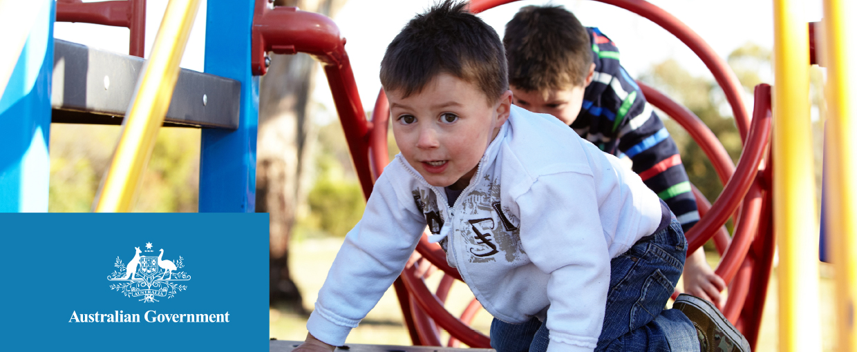

Helping families with the cost of child care

Child Care Assistance
The Australian Government provides families with financial assistance to help cover the cost of approved child care through the Child Care Benefit and Child Care Rebate.
To receive the Child Care Benefit or Child Care Rebate, families must meet eligibility and residency requirements.
The Child Care Benefit is based on family income, the Child Care Rebate is not income tested.

Approved child care
Approved child care services are those services that have been approved by the Australian Government to receive child care payments on behalf of families. Approved child care services can be:
- Long Day Care
- Family Day Care
- Outside School Hours Care (before and after school and vacation)
- Occasional Care, and
- In Home Care (families with special circumstances).
You can ask your child care service if they are approved to receive government child care payments on behalf of families.

Registered child care
Registered child care is provided by grandparents, relatives, friends or nannies who are registered as carers with Centrelink.

Child Care Benefit
The Child Care Benefit is income tested and is usually paid directly to approved child care services to reduce the fees that eligible families pay.

Who is eligible for the Child Care Benefit?

Residency requirements
- You or your partner must be permanently living in Australia and be:
- An Australian citizen; or
- The holder of a permanent visa; or
- A New Zealand citizen who arrived on a New Zealand passport; or
- A holder of certain temporary visa subclasses – Centrelink will confirm eligibility;
- The holder of a Criminal Justice Stay Visa issued specifically for the purpose of assisting in the administration of criminal justice in relation to the offence of people trafficking, sexual servitude or deceptive recruitment;
- A student from outside Australia sponsored by the Australian Government; or
- A non-resident experiencing hardship or special circumstances.

Other eligibility requirements
- Your child must be attending approved child care or registered child care.
- Children under seven years of age must meet the Australian Government’s immunisation requirements or have an exemption.
- You must be the person responsible for paying the child care fees.
- You can apply for the Child Care Benefit in person or online through Centrelink’s Child Care Benefits page. (www.humanservices.gov.au/childcarebenefit)

Child Care Rebate
The Child Care Rebate is an additional payment to the Child Care Benefit which helps families cover the out-of-pocket costs of child care. It is not income tested and covers up to 50 per cent of out-of-pocket child care costs, up to $7,500 per child, per year. Out-of-pocket child care costs are calculated after deducting any Child Care Benefit payments that are received.

Who is eligible for the Child Care Rebate?

Residency requirements
You must meet the same residency requirements for Child Care Benefit.

Other eligibility requirements
- You and your partner (if applicable) must have had work, training, study related commitments (or have an exemption) at some time during a week.
- You must be using approved child care.
- Children under seven years of age must meet the Australian Government’s immunisation requirements or have an exemption.
- You must be the one responsible for your child care costs. If your employer contributes to your child care through salary sacrificing or packaging, you should discuss with them who is responsible for the cost.
Even if your family’s income is too high for you to receive the Child Care Benefit you may be eligible for the Child Care Rebate.

How to claim the Child Care Rebate
You will need to apply for the Child Care Benefit first. There is no claim form for the Child Care Rebate. You do not need to claim the Child Care Rebate separately. You will automatically be assessed and paid if you are eligible when you apply for the Child Care Benefit even if you are assessed at a zero rate for the Child Care Benefit due to your family’s income.
The Child Care Rebate is an additional payment to the Child Care Benefit which helps families to cover the out-of-pocket costs of child care.
You can apply for the Child Care Benefit in person or online through Centrelink’s Child Care Benefits page. (www.humanservices.gov.au/childcarebenefit)
Your eligibility for the Child Care Rebate will be automatically assessed by Centrelink and payments will be made once child care attendance details from your child care service/s are received.

Multilingual Phone Service
If you speak a language other than English, Centrelink’s multilingual phone service lets you speak to someone in your own language. If Centrelink staff are unable to speak your language, a telephone interpreter service will assist you.
Centrelink’s interpreter and translation services can also assist you in making claims, accessing services and payments. You can ask Centrelink to arrange an interpreter either face-to-face or on the phone.
To access the Centrelink Multilingual Phone Service, call 13 12 02 between 8.00 a.m. and 5.00 p.m. (local time) Monday to Friday.

Examples of how Child Care Rebate works

Mitchell and Emma
- Mitchell and Emma both work full time and meet all of the eligibility requirements for Child Care Benefit however their family income is too high to receive any Child Care Benefit.
- Their first child, Amelia, is in Outside School Hours Care, which costs $102.50 per week, $4,920 over the year.
- Their second child, Ruby, is in Long Day Care, which costs, $310 per week, $14,880 over the year.
 | Amelia | Ruby
Total child care fees | $4,920 | $14,880
Child Care Benefit entitlement | $0 | $0
Out-of-pocket expenses | $4,920 | $14,880
Child Care Rebate  (= 50% of out of pocket expenses) | $2,460 | $7,440
This means that child care fees are reduced by $9,900 and Mitchell and Emma pay only $9,900 over the year.
* This example is based on 48 weeks of care.

Jack and Alisha
- Jack works full time and his partner Alisha is studying. Their family income means they receive some Child Care Benefit.
- Their first child, Chloe, goes to Outside School Hours Care, which costs $85 per week, $2,550 for the year.
- Their second child, William, is in Family Day Care, which costs $200 per week, $6,000 for the year.
 | Chloe | William
Total child care fees | $2,550 | $6,000
Less Child Care Benefit entitlement | $450 | $1,500
Out-of-pocket expenses | $2,100 | $4,500
Child Care Rebate  (= 50% of out of pocket expenses) | $1,050 | $2,250
This means that child care fees are reduced by $5,250 and Jack and Alisha pay only $3,300 over the year.
* This example is based on 30 weeks of care.

How much could you get?
To find out how much Child Care Benefit and Child Care Rebate you could receive, use the child care estimator(www.humanservices.gov.au/customer/enablers/online-estimators) or call 13 61 50.

