## e-Newsletter, Issue 4, June 2015

Welcome to the fourth issue of the National Plan e-Newsletter.

This edition has a focus on *community involvement in reducing violence against women and their children*.

Over the past 12 months we have witnessed the extraordinary efforts of Australian governments and the broader Australian community to address the issue of violence against women and their children. The *2014-15 Annual Progress Report for the Second Action Plan*, released on 26 June 2015, details the collective progress made against the 26 practical actions prioritised under the Second Action Plan.

We have also seen significant momentum build within local communities. Across the country, communities of all sizes have been taking a stand against violence through community forums, marches, training programmes, local campaigns, candlelight vigils and a range of other initiatives. Unprecedented media attention on violence against women and their children has also played a significant role in shifting and intensifying the national conversation around the issue.

Recognising the importance of a collaborative, whole of community approach to the issue, this edition seeks to highlight efforts taking place right across the country to reduce violence against women and their children.

We would like to thank you all for your support of the National Plan and your ongoing efforts to ensure Australian women and their children can live free from violence.

## What has been happening?

|  |  |
| --- | --- |
| **17 April** | Council of Australian Governments (COAG) meeting. COAG agreed to contribute $30 million for a national campaign focused on reducing violence against women and their children. |
| **17 April** | The Australian Government announced additional funding of more than $15 million over two years for the delivery of family services to support children and parents experiencing family violence or the impacts of substance abuse. |
| **8 May** | [Our Watch](http://www.ourwatch.org.au/) relaunched [*The Line*](http://www.theline.org.au/)social marketing campaign. |
| **12 May** | The 2015 Federal Budget included $15 million for the national campaign as well as $230 million to expand the National Partnership Agreement on Homelessness for two years, with funding priority going to services that assist women and children affected by domestic violence. |
| **14 May** | Membership of the COAG Advisory Panel to reduce violence against women and their children announced. |
| **17 May** | The Australian Government announced an extra $4 million investment in the 1800RESPECT helpline. |
| **May/June** | The Commonwealth Department of Social Services undertook co-design workshops in every state and territory with government officials from a range of agencies. The aim of this was to collaboratively refine a draft set of national outcome standards for perpetrator interventions. |
| **3 June** | Australian of the Year and Our Watch Ambassador Rosie Batty launched the Our Watch Awards for exemplary reporting to end violence against women. |
| **5 June** | COAG Advisory Panel met for the first time. |
| **16 June** | Daisy app recognised as part of the prestigious Australian iAwards (Victoria). |
| **17 June** | The Foundation for Alcohol Research and Education (FARE) launched its [*National framework for action to prevent alcohol-related family violence*](http://www.fare.org.au/PreventAlcFV/)*.* |
| **26 June** | The [National Plan website](http://plan4womenssafety.dss.gov.au) and [*2014-15 Annual Progress Report of the Second Action Plan*](http://plan4womenssafety.dss.gov.au/the-national-plan/what-is-the-national-plan/) launched by Minister Assisting the Prime Minister for Women, Senator the Hon Michaelia Cash at a meeting of state and territory Ministers. |

# Feature stories

## Annual Progress Report 2014-15 released

The 2014-15 Annual Progress Report of the *Second Action Plan 2013-2016: Moving Ahead* (the Second Action Plan) under the *National Plan to Reduce Violence against Women and their Children 2010-2022* (the National Plan) was endorsed by all Australian government Ministers responsible for the National Plan on 26 June 2015.

The report outlines the progress of the Australian Government, state and territory governments and the community on the 26 practical actions prioritised under the Second Action Plan, and was endorsed at a meeting of Commonwealth, state and territory Ministers responsible for the implementation of the National Plan.

Linking short and long term initiatives, the report charts the collective efforts to address violence against women and their children; from primary prevention and early intervention initiatives, to specialist services for women and their children, to effective perpetrator interventions and controls. The report is available online on the National Plan [website](http://plan4womenssafety.dss.gov.au/the-national-plan/what-is-the-national-plan/).

## $4 million additional funding announced for 1800RESPECT

On 17 May 2015, the Minister for Social Services, the Hon Scott Morrison MP, and the Minister Assisting the Prime Minister for Women, Senator the Hon Michaelia Cash, announced an extra $4 million investment in 1800RESPECT to provide support to women in need.

1800RESPECT is Australia’s first national, professional online and telephone counselling service to assist individuals who have experienced or are at risk of domestic and family violence and/or sexual assault, as well as their family and friends. The service is available 24 hours a day, 7 days a week.

This extra funding builds on previous and ongoing funding to 1800RESPECT and the suite of current policy initiatives to address the issue of violence against women in Australia.

The Commonwealth Government has committed **$33.5 million** over three and half years (to 30 June 2017) to the continued delivery of 1800RESPECT.

### The joint media release can be found on [Minister Morrison’s media page.](http://scottmorrison.dss.gov.au/media-releases/abbott-government-delivers-funding-boost-for-node8entityentityrespect) [Description: Go to 1800 Respect Homepage](https://www.1800respect.org.au/)

## Budget 2015 measures to address violence against women and their children

## The Australian Government announced $15 million over three years in the 2015 Federal Budget for a national campaign to reduce violence against women and their children.

## The Federal Budget also includes $230 million to extend the National Partnership Agreement on Homelessness (NPAH) for two years to 30 June 2017, which for the first time ensures funding priority to services that assist women and children affected by domestic violence.

## Advisory Panel to reduce violence against women

On 14 May 2015, the Prime Minister, the Hon Tony Abbott MP, and the Minister Assisting the Prime Minister for Women, Senator the Hon Michaelia Cash, announced the full membership of the Council of Australian Governments (COAG) Advisory Panel to reduce violence against women and their children.

The Advisory Panel was formed following the Prime Minister’s announcement on 28 January 2015 to elevate the issue of violence against women and their children to a national level at COAG.

The Panel’s role is to advise COAG on the issue of domestic and family violence and make recommendations on how governments can best respond to the issue.

The full membership of the Advisory Panel is as follows:

* Mr Ken Lay APM (Chair)
* Ms Rosie Batty (Deputy Chair)
* Ms Heather Nancarrow (Deputy Chair)
* Ms Julie Oberin
* Ms Tracy Howe
* Mr Ed Mosby
* Dr Vicki Hovane
* Ms Maria Hagias
* Commissioner Darren Hine APM
* Ms Sue Salthouse
* The Hon Bess Price MLA

The joint media release can be found on the [Prime Minister’s media page](http://www.pm.gov.au/media/2015-05-14/advisory-panel-announced-reduce-violence-against-women).

## National Family Violence Bench Book announced

On 9 June 2015, the Attorney-General, Senator the Hon George Brandis QC, and the Minister Assisting the Prime Minister for Women, Senator the Hon Michaelia Cash, announced that work has commenced on a National Family Violence Bench Book, to be made available from June 2017.

The Bench Book will be a comprehensive online tool for judges across Australia to promote best practice and consistency in judicial decision making in cases involving family violence. It will cover civil and criminal laws in federal, state and territory jurisdictions, and will complement efforts under the *National Plan to Reduce Violence against Women and their Children 2010-2022*. The joint media release can be found on the [Attorney-General’s media page](http://www.attorneygeneral.gov.au/Mediareleases/Pages/2015/SecondQuarter/9-June-2015-National-Family-Violence-Bench-Book.aspx).

## DAISY app wins top technology award

The DAISY smartphone App has been announced as a winner of the 2015 iAwards at a state level (Victoria). With over 500 entrants in the 80 odd categories, the App won the top award under the Government category.

For over 20 years the iAwards has been recognising and celebrating the achievements and innovation made in information and communication technologies. The awards are judged by the industry and provide recognition that extends across all sectors of the digital economy.

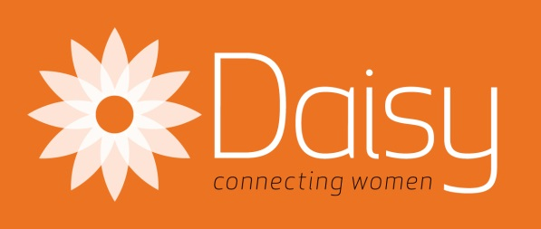The Daisy app empowers Australian women affected by sexual assault, family violence and domestic violence, by giving them a safe place to turn in times of need. In an Australian first, the Daisy app brings together support services from around the country into a simple, safe and intuitive smartphone application.

Daisy was developed with input by all state and territory governments, and funded by the Australian Government under the Second Action Plan of the *National Plan to Reduce Violence against Women and their Children 2010-2022*.

## New tailored resource for women about money

Women face unique financial challenges, such as having less superannuation than men, living longer and taking more time out of paid work to care for others. The Australian Securities and Investments Commission has launched a new Women’s Money Toolkit on ASIC's MoneySmart website.

The Women's Money Toolkit has tips and tools to help women manage their money, gain an edge on their finances and deal with life's ups and downs.  Women can answer some simple questions and receive a tailored list of topics that may include having a baby, relationships and money, being a carer, sorting out superannuation and many more. Women can create a personalised to-do list of actions they can take to make the most of their money.

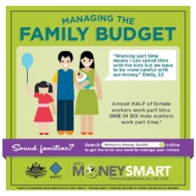For more information, visit the [moneysmart website](https://www.moneysmart.gov.au/life-events-and-you/women/wome%20ns-money-toolkit).

## New research on young people’s attitudes to violence against women, informs *The Line* relaunch

On 8 May, [Our Watch relaunched *The Line*](http://www.ourwatch.org.au/News-media-(1)/News-Media/New-research-shows-need-to-challenge-violence-supp), a campaign for 12 to 20 year olds that encourages healthy, equal and respectful relationships by challenging and changing the attitudes that lead to violence against women. It also released the [research informing the campaign](http://www.ourwatch.org.au/MediaLibraries/OurWatch/our-publications/The-Line-campaign-Research-summary-7-May-2015.pdf), which suggests that young people need more guidance to work out what constitutes a respectful relationship.

At the launch, Our Watch Chair, Natasha Stott Despoja AM, Senator the Hon Michaelia Cash, and [Ambassador for *The Line*, Luke Ablett](https://www.youtube.com/watch?v=5v_ioq8S_g0) discussed the issues young people experience when it comes to negotiating respectful relationships, and how *The Line* can help.

Through the new [website](http://www.theline.org.au/), [Facebook page](http://www.facebook.com/theline), ambassadors, campaign partners and influencers, *The Line* guides young people on how to keep behaviours healthy and respectful, and avoid crossing the line: making someone feel frightened, intimidated or diminished.

*The Line*’s [website](http://www.theline.org.au/) and [Our Watch’s Facebook page](http://www.facebook.com/preventviolenceaustralia) also supports parents, caregivers and teachers to help them understand and talk to young people about the issues.

New activities are being planned for 2015-16, so keep in touch with Our Watch to stay informed.

*The Line is funded by the Australian Government under the National Plan to Reduce Violence against Women and their Children 2010-2022.*

## Our Watch Awards open for nominations

In her address at the National Press Club on 3 June 2015, Our Watch Ambassador and Australian of the Year, Ms Rosie Batty, launched the Our Watch Awards to recognise and encourage exemplary reporting to end violence against women and their children.

Ms Batty talked about the prevention of violence against women and their children and the role of the media in contributing to a deeper understanding of this violence, its causes and prevention. The address was televised live on ABC TV.

The Awards aim to eradicate victim blaming, and encourage the inclusion of information about its causes and links to support services, such as 000 and 1800RESPECT, to assist women in crisis.

These are the very first national awards designed to celebrate and reward the media who play a role in bringing about a change in the culture that minimises, trivialises or even condones violence against women and their children. The awards build on the success of the Eliminating Violence against Women Media Awards (EVAs) in Victoria and are administered by the Walkley Foundation.

Members of the community can encourage journalists (who they know are doing positive work on the issue of domestic violence) to nominate themselves for an Our Watch Award. More information about categories and timeline can be found on the [Walkley Foundation website](http://www.walkleys.com/awards/).

The Our Watch Awards is part of the Our Watch National Media Engagement Project which is funded by the Australian Government under the *National Plan to Reduce Violence against Women and their Children 2010-2022.*

## A ‘whole of community’ response to reducing violence against women

[White Ribbon Australia](http://www.whiteribbon.org.au/) believes that violence against women is unacceptable and that it is every man’s responsibility to prevent it.

With the support of the Australian and NSW Governments, the organisation has [been taking its grassroots campaign to Australia’s many culturally and linguistically diverse and Aboriginal and Torres Strait Islander communities](http://www.whiteribbon.org.au/diversity) through a series of eight training workshops.

The training uses the e-learning module developed for White Ribbon Australia’s Ambassador Program to explore the following through a cultural lens:

* The impact of men’s violence against women
* The causes of men’s violence against women
* What prompts men to become involved in prevention work
* The actions and strategies men can adopt in their communities to stand up to violence

Workshops have been held nationally from 22 May to 23 June 2015. Four workshops have been held for culturally diverse men, in collaboration with the [Migrant Resource Centre of South Australia (SAMRC)](http://www.mrcsa.com.au/), [Myriad Consultants](http://www.myriadconsultants.com.au/) and the [Settlement Council of Australia (SCOA)](http://www.scoa.org.au/).

A further four workshops have been held for Aboriginal and Torres Strait Islander men, in partnership with the [Australian Indigenous Leadership Centre (AILC)](http://ailc.org.au/).

Now in its 12th year, White Ribbon Australia is delighted to have this opportunity to further develop the campaign together with Australia’s diverse communities. It is committed to growing our nation’s shared capacity for action.

As Libby Davies, CEO of White Ribbon Australia says: ‘Men’s violence against women impacts every Australian community. It is an issue for all of us. A guiding principle in preventing men’s violence against women is engaging men. And there is no better way to do this than through the voices of other men.’

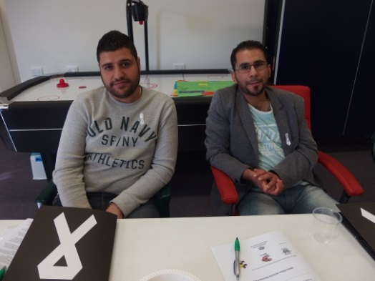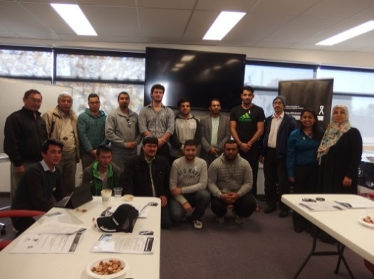Photos: Participants at White Ribbon training workshops

## ANROWS Practitioners Engagement Group (PEG)

Australia’s National Research Organisation for Women’s Safety (ANROWS) is establishing an advisory group, the ANROWS Practitioner Engagement Group (PEG), to assist in the translation of research to practice.

ANROWS's PEG will promote interaction and knowledge sharing between ANROWS, the specialist women’s services sector (that is, domestic and family violence, sexual assault, women’s health, women’s legal services, Aboriginal and Torres Strait Islander communities, culturally and linguistically diverse communities and women with disabilities) and the broader community services sectors (such as, mental health, alcohol and other drugs, housing and homelessness).

Please consult the [**Terms of Reference**](http://www.anrows.org.au/sites/default/files/page-attachments/ANROWS%20PEG-Terms%20of%20Reference.pdf) for background, context and the process for establishing the ANROWS PEG.

Expressions of interest from practitioners closed on 24 June 2015. The PEG will be announced at a joint webinar with 1800RESPECT on 2 July 2015.

## Australia's National Research Organisation for Women's Safety (ANROWS) Logo

# Updates from around the country

## New budget funding measures

On 2 June 2015, the ACT Budget included new funding for anti-domestic violence measures, including funding for crisis services and education strategies in the territory, including:

* $250,000 in additional funding to expand the capacity of three domestic and sexual violence crisis services.  The Domestic Violence Crisis Service, Rape Crisis Centre and Canberra Men's Centre will share in the funding.
* $615,000 in new funding for "social and emotional learning programs" about the importance of respectful relationships, through public schools.

## Appointment of first ACT Co-ordinator General for Domestic and Family Violence

On 30 May 2015, the ACT Government announced the appointment of Justice and Community Safety Directorate Deputy Director-General Vicki Parker as the Territory's first Co-ordinator-General for domestic and family violence.

The new role is designed to ensure the Territory Government meets its responsibilities and actions under an implementation plan for its*ACT Prevention of Violence against Women and Children Strategy 2011-2017*; and support all domestic and family violence prevention and response related work within the ACT government. It will also oversee implementation of the government's response to the Domestic Violence Prevention Council's report into domestic and family violence, and sexual assault.

Further coverage of this announcement is in an [article](http://www.abc.net.au/news/2015-05-30/domestic-violence-coordinator-general-appointed-in-act/6508850) from the ABC.

## Commitment to tackle domestic violence

On 17 March 2015, the ACT Legislative Assembly passed a motion that recognised the abhorrence of family and domestic violence, and called on all governments, political parties and the community to work together to put an end to the harm it causes in our society.

An extra $300,000 in funding was committed from the Confiscated Asset Trust Fund for domestic violence prevention, following the death of ACT woman Tara Costigan. These funds will be used for a number of purposes aimed at addressing domestic and family violence and will go toward women’s safety grants, the Domestic Violence Prevention Council and strengthening data collection on domestic violence crime.

## NSW focusing on prevention

The NSW Government’s commitment to ending domestic and family violence has been strengthened by the appointment of Australia’s first Minister for the Prevention of Domestic Violence and Sexual Assault, the Hon Pru Goward MP.

## Domestic violence disclosure scheme

A domestic violence disclosure scheme will be piloted in NSW, which will allow people to find out if their partner has a history of domestic violence offending. The scheme will also allow police to make applications to disclose a person’s offending history, if they believe a person is at risk of harm from their partner.

The domestic violence disclosure scheme is similar to an initiative that was successfully introduced in the United Kingdom called Clare's Law and will be the first of its kind in Australia.

The scheme is currently being finalised following a public submission process and consultation with domestic violence service providers and justice experts.

## Men’s behaviour change

Four new men’s behaviour change services will receive $1.76 million annually in funding over three years to work with male perpetrators to address their violent behaviour. All of the services are members of the Men’s Behaviour Change Network and are able to respond to the needs of female victims and their children.

Enhancing men’s behaviour change programs in NSW recognises the importance of increasing perpetrator accountability and helping violent men to change the attitudes and behaviours that sustain their violence.

## More support for victims at threat of domestic violence

The NSW Government will expand Safer Pathway, a key element of the Government’s It Stops Here domestic and family violence reforms. Safer Pathway is an integrated, multi-agency approach for assessing safety, making referrals and coordinating support for a victim’s safety, health and wellbeing. As part of the Safer Pathway approach some organisations are able to share information to make access to services easier for victims.

Safer Pathway has been operating in two sites since September 2014 and will expand to another four sites from July 2015.

## A primary prevention program developed at Galiwin’ku on Elcho Island

The Northern Territory Men’s Policy Unit, in partnership with the Aboriginal Resource & Development Services Aboriginal Organisation (ARDS), has developed a family violence primary prevention resource to be delivered at Galiwin’ku on Elcho Island. The resource incorporates Yolngu languages, embeds the strong and active kinship networks and foregrounds Yolngu world view.

Community engagement was conducted in Yolngu languages with the resulting resource incorporating the abstract (Western) concept of the cycle of violence mapped onto Yolngu cyclic knowledges of the seasons. Within this are particular references to deep, cultural mooring points that assist a Yolngu audience to begin to identify primary prevention strategies themselves utilising Yolngu cultural understandings of the world and how people behave and engage.

Residents of Galiwin’ku are from at least fourteen Bäpurru (clan groups) including Dhuwa and Yirritja land-owning groups. The very fabric of Yolngu society consists of a diverse patchwork of strong individual Bäpurru that are stitched together with the threads of gurruṯu (the Yolngu kinship system). In order to see real outcomes manifest within this social fabric, it is crucial to engage with Yolngu on their terms.

In doing this, it has been possible to articulate the complexities of men’s violence against women by respectfully working together the rich knowledge traditions of Yolngu and academic critical theories to negotiate a truly shared understanding.

This program highlights the Northern Territory Government’s commitment to developing a regionalised approach where programs are developed with communities themselves, and tailored accordingly to a particular region’s context.

## Domestic and family violence prevention month in Queensland

May was recognised as Domestic and Family Violence Prevention Month in Queensland. To raise community awareness about the issue, the Queensland Government distributed one-off grants to community groups for 38 events across the state. These events ranged from classroom education programs at three Far North Queensland schools to a poster exhibition on the Gold Coast.

To complement these events, a social marketing campaign was implemented, encouraging people to “Trust your instinct” and contact the state-wide DVConnect helpline if they suspected someone they knew was experiencing abuse. The campaign focused on the dangers of non-physical, controlling behaviour and emphasised the importance of taking action before the abuse became physical.

The campaign urged people to call the helpline for confidential advice about safety strategies and available support. It included out-of-home advertising, a dedicated [website](http://www.qld.gov.au/trustyourinstinct) and [Facebook page](http://www.facebook.com/trustyourinstinctnow), sponsor support, sporting ambassadors, state-wide distribution of printed materials and a suite of online promotional tools for community groups. The involvement of corporate sponsors and sporting ambassadors from all the major football codes and Netball Queensland took the campaign message into local workplaces, clubs and communities.

The campaign extends through June with a focus on elder abuse prevention, to align with World Elder Abuse Awareness Day on 15 June.

## Zahra Foundation in South Australia

The establishment of the Zahra Foundation Australia has been initiated by Zahra Abrahmizadeh’s children in memory of their mother who was stabbed to death by her estranged husband at a community function in 2010.

In partnership with Central Domestic Violence Service, the Zahra Foundation has been established as a trust fund to be used for all women in South Australia to build their economic and financial independence and help women to break the cycle of poverty and violence.

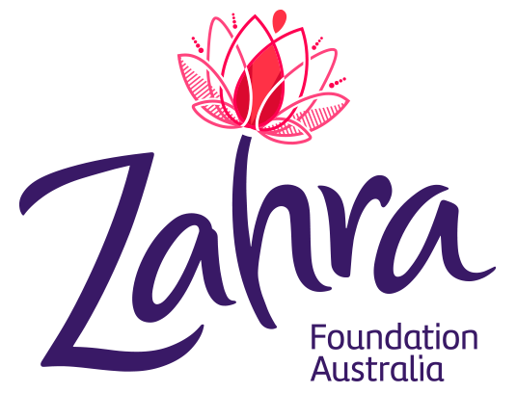The aim of the Foundation will be:

* to support women and children in meeting their crisis and practical needs through initial grants to cover costs for housing, food, medication or school expenses; and
* in the long term, to create partnerships with businesses and community to implement programs such as financial literacy, skill development, training and employment opportunities for women.

An expected secondary effect of establishing the Foundation and creating partnerships and programs will be raising awareness within the community about the impact of domestic violence and changing community attitudes that perpetuate violence against women.

A gala dinner will be held on 5 September 2015 in Adelaide to officially launch the Foundation and raise funds for the Foundation. For more information, please see the [Zahra Foundation website](http://zahrafoundation.org.au/).

## Violence against women collaborations

The South Australian Government is promoting primary prevention through Violence Against Women collaborations which have now been established in most regions of South Australia. The primary purpose of these collaborations is to build community capacity to prevent and reduce the incidence of violence against women in local regions by working to create cultural and attitudinal change within the community, addressing the underlying causes of the violence.

A key benefit of the Violence Against Women Collaborations is the development of regional approaches to respond to and prevent violence against women – not just a state-wide approach which may not suit each region.

Ultimately, the focus of Violence Against Women Collaborations is primary prevention strategies which seek to prevent violence before it occurs.

Activities include White Ribbon community events including a partnership with Adelaide United Football Club and a White Ribbon Oath Night in the front bar of local hotel as a happy hour; promoting 1800RESPECT through the ‘dunny door’ campaign; [TV commercials](https://www.youtube.com/channel/UC4PbsQhQgGKxVxwP6WplMSA) highlighting causal links with sexism and impacts of violence against women on children; community engagement projects working with police to address needs and barriers to service provision; and developing accreditation programs for local sporting clubs which support bodies to adopt anti-violence against women projects.

## Launch of Moving Ahead: Tasmania’s Second Implementation Plan

On 4 May 2015, the Tasmanian Minister for Women, the Hon Jacquie Petrusma MP, launched Tasmania’s response to the *Second Action Plan of the National Plan to Reduce Violence against Women and their Children 2010-2022* (the National Plan)*.*

The launch was attended by approximately 50 people, including women and students from culturally diverse backgrounds and representatives from family violence and sexual assault sectors in Tasmania.

Ms Susan Fahey, from Women’s Legal Service Tasmania, was the guest speaker. Ms Fahey provided an overview of the national app and website [*Girls Gotta Know*](http://www.girlsgottaknow.com.au) which provides legal information for young women including information about relationships, health, housing and renting, employment technology and money.

*Moving Ahead, Tasmania’s Second Implementation Plan* will focus onprimary prevention through continued implementation of *Taking Action: Tasmania’s Primary Prevention Strategy to Reduce Violence against Women and their Children 2012-2022.*

On 25 May 2015, the Premier, the Hon Will Hodgman MP, announced that the Tasmanian Government will be joining Our Watch, the national foundation established to drive change in the culture, behaviours and attitudes that underpin violence against women and children. Tasmania’s focus on primary prevention will complement Our Watch initiatives and other national efforts.

*Moving Ahead* also aims to improve and strengthen family and sexual violence services and systems, improve perpetrator interventions and better understand diverse experiences of violence. *Moving Ahead* is available on the [Department of Premier and Cabinet’s website](http://www.dpac.tas.gov.au).

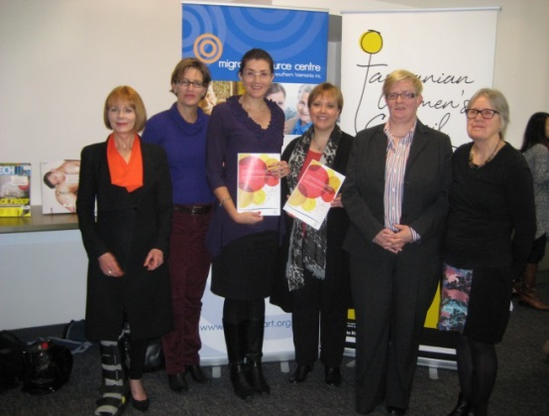Photo: Launch of Tasmania’s Implementation Plan

## Tasmanian Government’s Family Violence Action Plan

On 25 May 2015, the Premier, the Hon Will Hodgman MP, announced he would take a leadership role in addressing family violence Tasmania by taking responsibility for coordinating the Tasmanian Government’s response to family violence, which currently sits across multiple portfolios.

A Family Violence Cabinet Committee has been formed to oversee the development and implementation of a coordinated, whole of Government response to family violence in Tasmania.

The Department of Premier and Cabinet will coordinate an interagency taskforce and a non-government External Consultative Group to develop the Action Plan which will be released in August 2015.

The Action Plan will have 5 key objectives:

* addressing attitudinal behaviours that lead to family violence (primary prevention);
* ensuring Safe At Home remains the nation’s best response model;
* strengthening support for adults and children affected by family violence;
* strengthening legal responses to family violence; and
* strengthening perpetrator management and rehabilitation.

The Action Plan will be developed with service providers, those affected by family violence and government agencies. On the 19 June 2015, the Minister for Women, the Hon Jacquie Petrusma MP,led a community workshop for business and community organisations, services and individuals with an interest and/or expertise and experience in addressing family violence. At the workshop participants were asked to provide ideas and priority actions to inform the Action Plan to address family violence in Tasmania.

The Action Plan will be launched in August 2015.

## Launch of Domestic Violence Victoria’s Media Framework

On 12 May 2015, Domestic Violence Victoria (DV Vic) launched the ground-breaking *Working with News and Social Media to Prevent Violence against Women and their Children: A Strategic Framework for Victoria*.

The Framework, funded by the Victorian Government, sets out a clear plan for working with media in the area of primary prevention of violence against women and their children (PVAW). It reflects Victoria's learnings over the last decade, that:

* the media is a powerful setting for social change
* the family violence sector is enthusiastic about doing media-related PVAW work
* stakeholders need a shared understanding of the evidence base in order to instigate improvements in media’s understanding of PVAW.

The Framework highlights four key action areas around addressing and improving the media’s reporting of violence, which are to:

* align the diverse groups who are working with, or planning to work with, the media on PVAW messages
* develop the skills of organisations seeking to work in this area and provide them with resources to undertake this work
* provide content in the way the media needs to receive it
* strengthen dialogue with the news media on preventing family violence.

Minister Richardson, Australia’s first Minister for the Prevention of Family Violence, spoke at the launch of the Framework. Minister Richardson emphasised the importance of working strategically with the media on PVAW work and the key role of the Framework in achieving this.

The Framework is available on [DV Vic’s website](http://dvvic.org.au/index.php/dv-vic-media-program-to-prevent-violence-against-women.html).

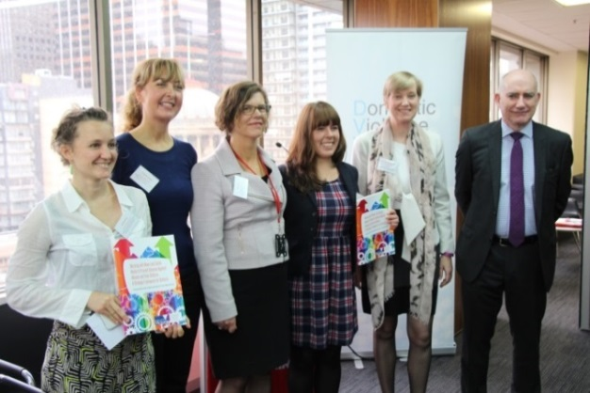

Photo (from left to right): Vanessa Born, DV Vic; Fiona McCormack, DV Vic; Kim Shaw, Maurice Blackburn; Megan Dunstone, Women’s Health East Media Advocate; Minister Fiona Richardson, Minister for the Prevention of Family Violence; and Nick Richardson, Herald and Weekly Times.

## Dates for your diary

|  |  |
| --- | --- |
| 2 July | ANROWS Practitioner Engagement Group to be announced at a joint webinar with 1800RESPECT. |
| 23 July | COAG leaders retreat. |
| 7 August | Meeting of Commonwealth, state and territory Ministers responsible for the implementation of the *National Plan to Reduce Violence against Women and their Children 2010-2022.* |
| 7 August | Culturally and Linguistically Diverse Women (CALD) National Roundtable on Reducing Violence against Women. |
| 5 September | Official launch of the Zahra Foundation (Adelaide). |
| 15 September | The National Domestic and Aboriginal Family Violence Conference 2015 (Adelaide). |
| 16 September | Reporting date for Senate Inquiry into abuse against people with disability in institutions. |
| September  (date TBC) | Awards ceremony for winners of the Our Watch Awards for exemplary reporting to end violence against women. |

Have your say!

We would love to hear from you! If you’d like your event included in this e-Newsletter, or have other questions, comments or ideas, please email us.

If you’ve not done so already, please [subscribe](http://plan4womenssafety.dss.gov.au/latest-news/e-newsletter/) to receive this e-Newsletter.

## Do you need help?

If you or someone you know is experiencing domestic and family violence or sexual assault, get help by calling:

* 000 if you, a child, or another person is in immediate danger
* 1800RESPECT – 1800 737 732
* Relationships Australia – 1300 364 277
* Mensline – 1300 789 978
* You can ask for a free interpreter if needed.

National Relay Service

* TTY users - phone 133 677 then ask for the phone number you wish to contact
* Speak and Listen (speech-to-speech relay) users - phone 1300 555 727 then ask for the phone number you wish to contact
* Internet relay users - visit the [National Relay Service website](http://www.relayservice.com.au/) and ask for the phone number you wish to contact.