What’s in the Candidate Guide and Workplace Guide of the RPL Assessment Toolkit for CHC50113 Diploma of Early Childhood Education and Care?

This document summarises the contents of the Candidate Guide and Workplace Guide in the RPL Assessment Toolkit for Diploma of Early Childhood Education and Care.

The Candidate Guide is a resource to help Recognition of Prior Learning (RPL) candidates to prepare for and participate in each step of the RPL processes promoted in the RPL Toolkit. It summarises roles and responsibilities, and explains RPL from the candidate’s perspective. It should provide candidates with a valuable resource to refer to during their RPL processes.
The Candidate Guide provides information in the following four sections.

Introduction
This introduces the reader to the Guide and the RPL program supported by the RPL Toolkit. It explains how to use the Guide, defines RPL, summarises roles and responsibilities, and gives terms that candidates should know.

Qualification and unit requirements
This section gives the requirements for the qualification, lists the units with a summary of their content, and gives information on electives and unit clusters.

Summary of RPL-related processes
This section of the Guide summarises the steps in the RPL processes in a table, outlining roles and responsibilities of training organisations, candidates and workplaces.

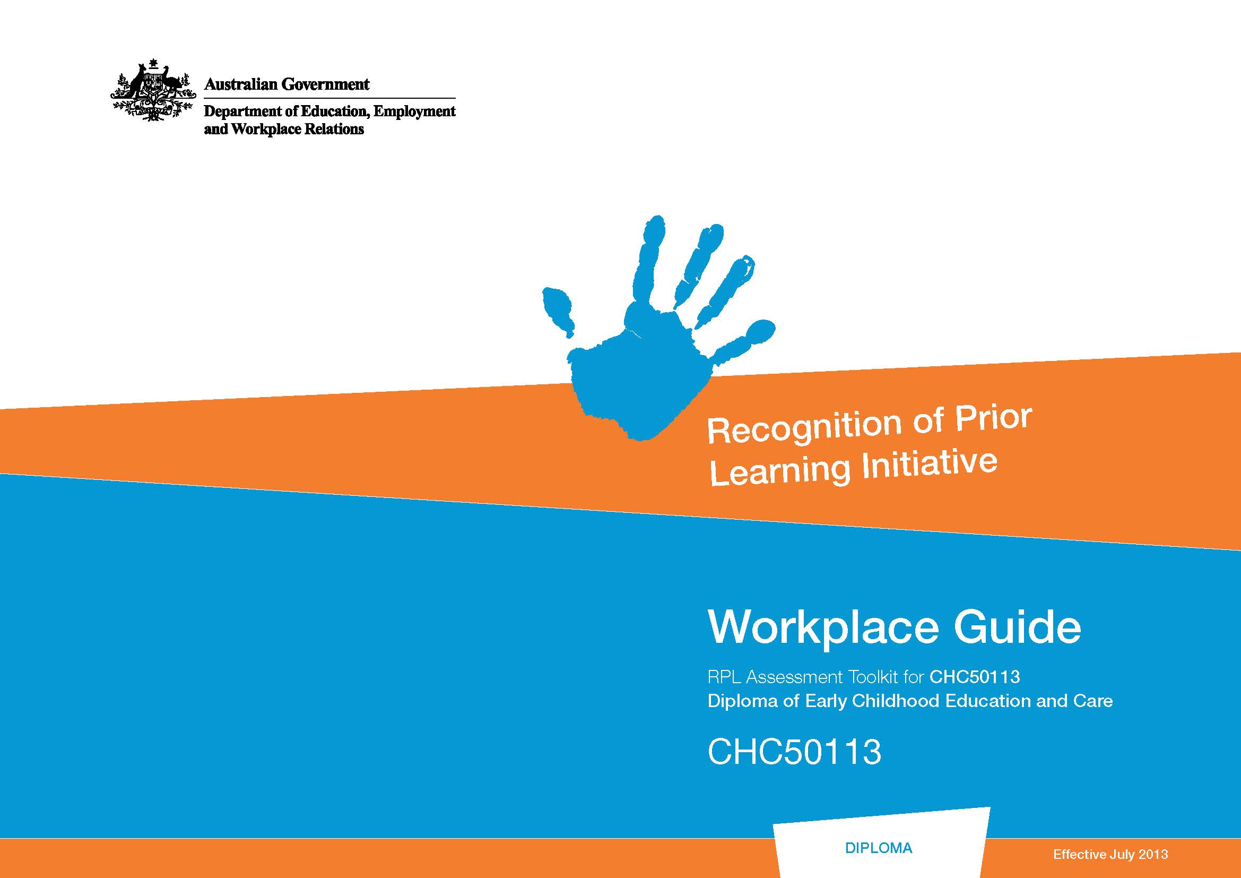
There are five separate steps in the RPL process —as well as ‘pre-RPL’ preparation required before assessment begins. The summary in this section should provide candidates with a useful overview.

Steps in the RPL process
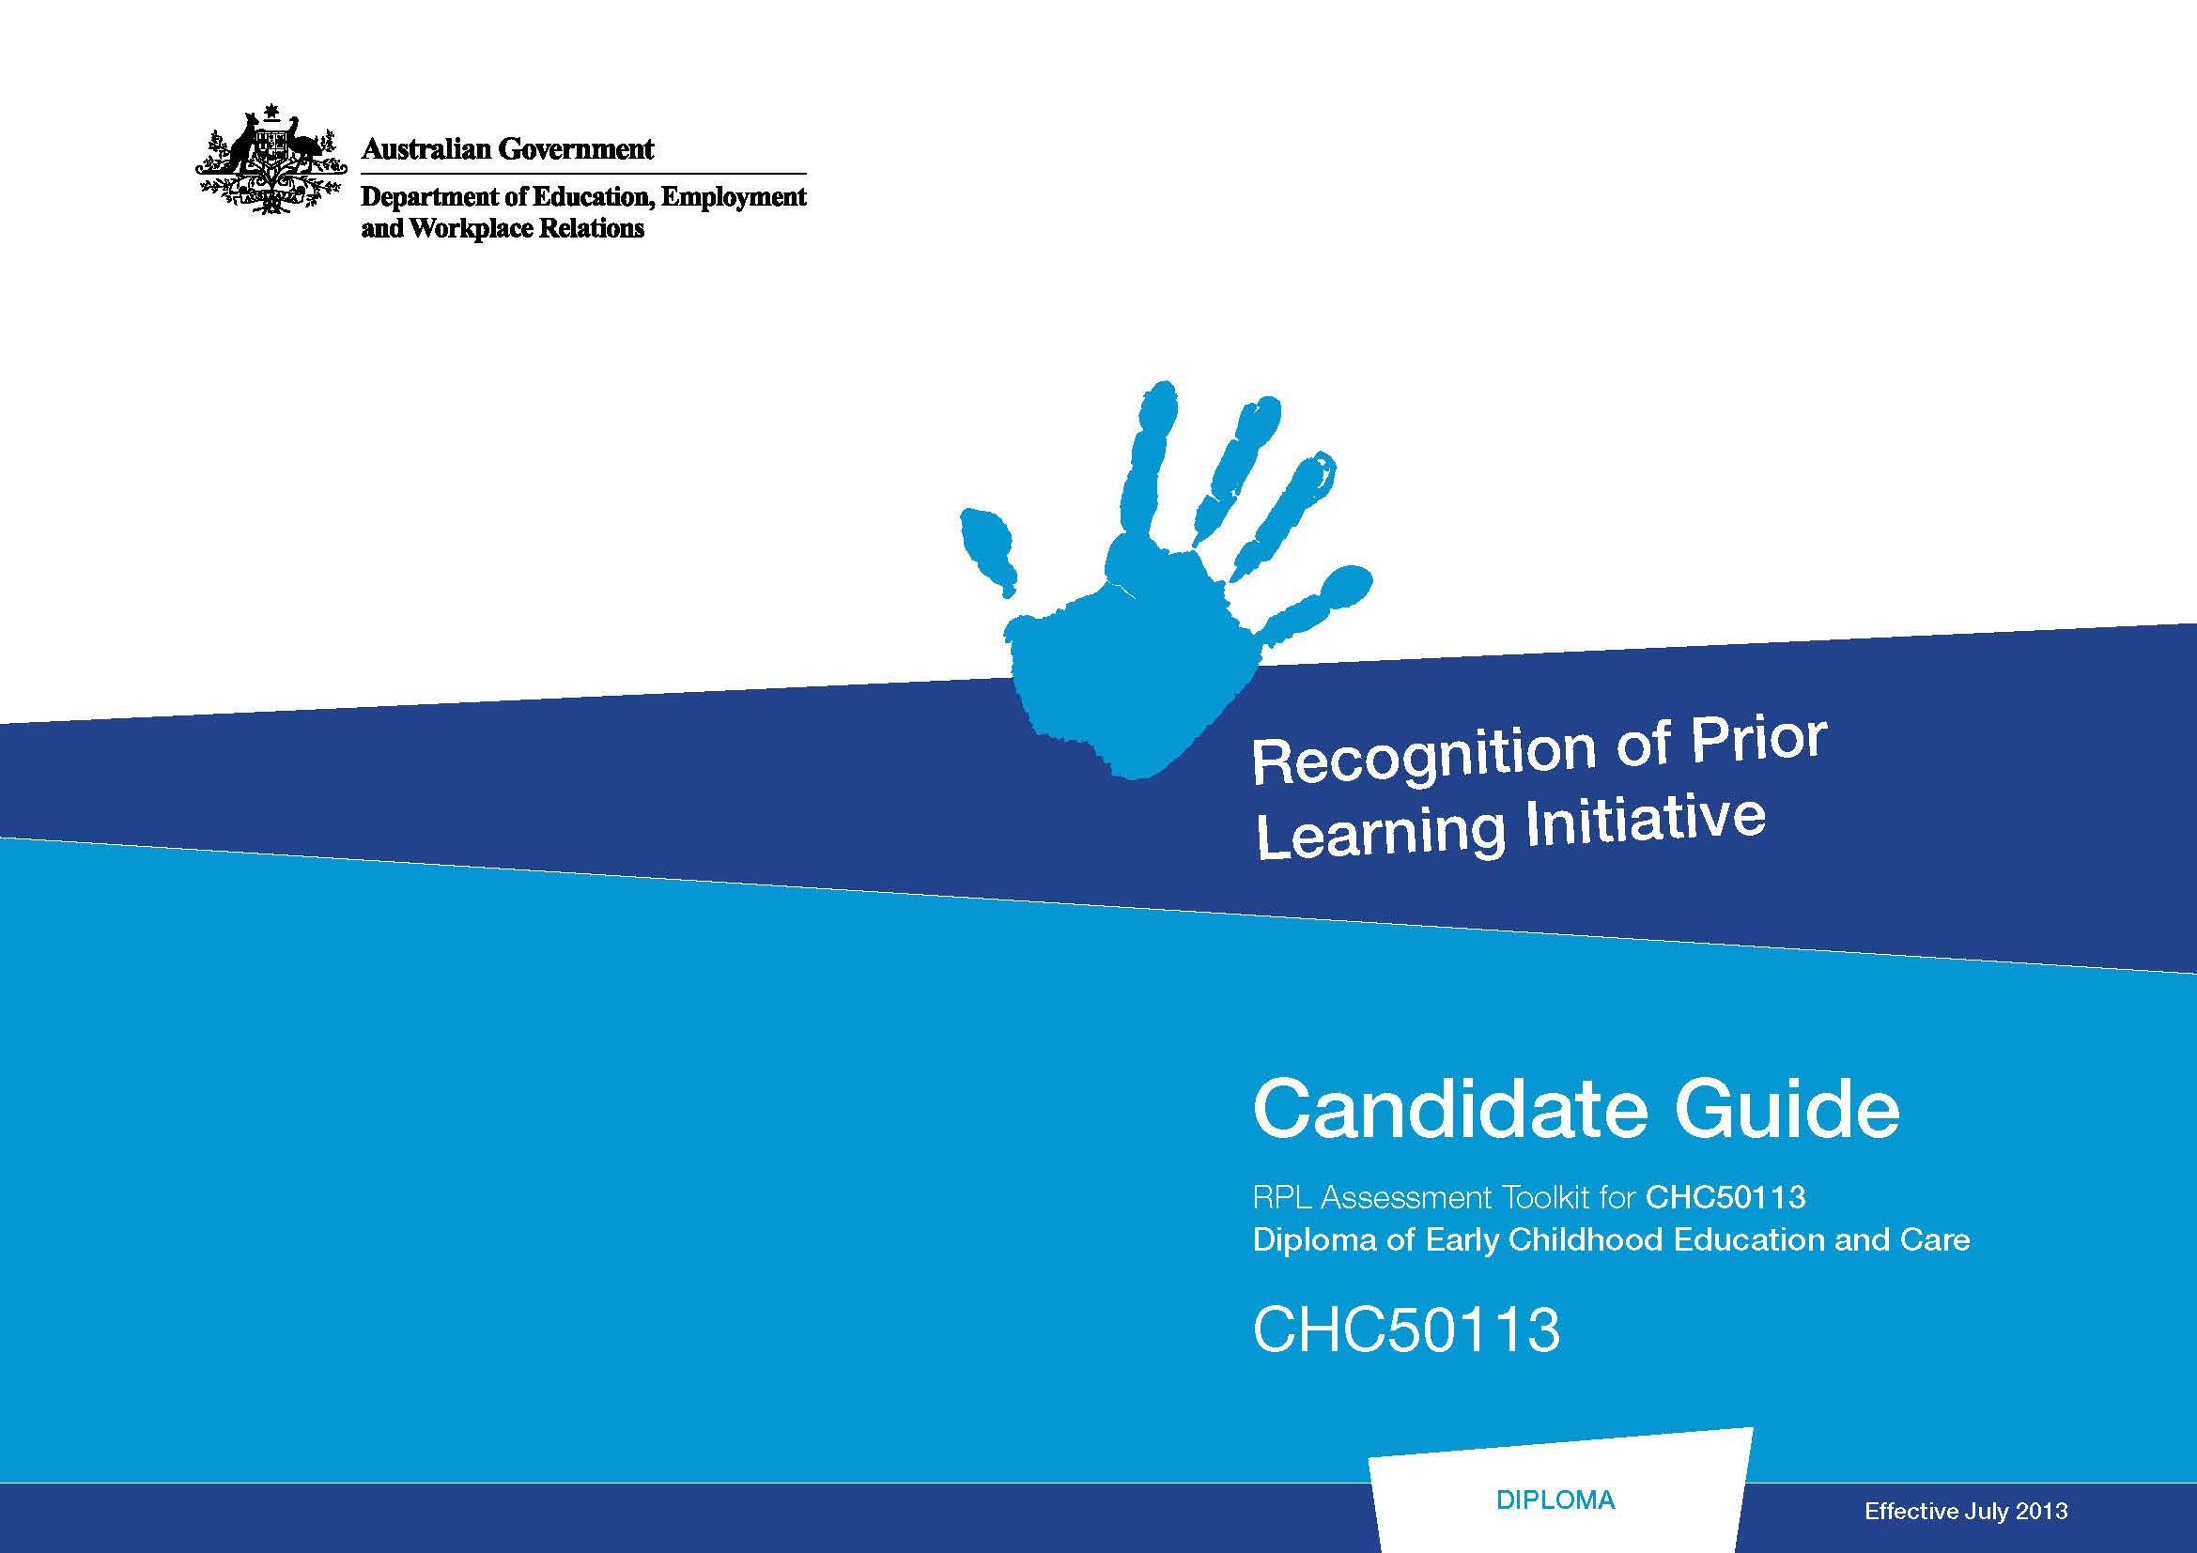
This section of the Guide provides more details on the RPL-related processes.

It should help candidates to prepare for and participate in each step—RPL is an interactive assessment process, any actions candidates can take to prepare for that participation should improve their RPL outcomes.

This section informs candidates about what may happen in each step, and what could be expected of them. Some of the text uses dot points in a ‘check box’ style—candidates could tick off points as they prepare for each step.

It is important that candidates review the relevant text in this section of the Guide before they participate in each step of their RPL process.

As well as the Candidate Guide, the RPL Toolkit also incudes a document designed for workplace representatives—the Workplace Guide. That guide should be useful to people supporting the RPL candidate in their workplace, perhaps the workplace supervisor or manager. It should assist them to understand the RPL process.

The Workplace Guide advises workplace representatives on their likely roles and responsibilities in RPL—for example, in verifying skills and knowledge they’ve seen the candidate apply in workplace tasks, and in allowing RPL assessment-related activities in the workplace.
The Workplace Guide contains similar content to the Candidate Guide, but its information is targeted for the workplace.
The Workplace Guide has three sections.

Introduction
This introduces the Guide and the RPL processes supported by the RPL Toolkit.

- Qualification and unit requirements This section gives information about unit and qualification requirements.

Summary of RPL-related processes
This section summarises the RPL processes outlining the roles of training organisations, candidates and workplaces. If workplaces need more detail they could read the ‘Steps in the RPL Process’ section of the Candidate Guide, or ask the assessor.

