CCMS Fact Sheet – 2011 CCMS Changes (2)
  - Child Care Rebate
In this fact sheet:
- Overview
- Payment options available for families
- Fee reductions paid to the service
- Adjustments during the year
- Adjustments after Reconciliation
- Timeline
- Q&A

Overview
From 4 July 2011 there will be changes to the payment methods for Child Care Rebate (CCR). The changes will support families by providing more frequent payment of CCR. As an operator of an approved service, you already pass on Child Care Benefit (CCB) fee reductions on a weekly or fortnightly basis thereby reducing the family gap fee. After an upgrade to your software in late June 2011 you will also be able to pass CCR to families as a fee reduction, therefore reducing the gap fee even further.
If you submit attendance reports weekly, then the CCR fee reduction will be calculated and paid weekly. If you submit fortnightly, then the CCR fee reduction will be calculated and paid fortnightly.

Payment options available for families
Centrelink has sent a letter to families, asking them to nominate their preferred method of payment. They now have 4 options to choose from:

Option 1 | CCR paid to your service as a fee reduction thereby reducing the gap fee, after attendance records have been submitted by your service.
Option 2 | CCR paid to the family bank account after attendance records have been submitted by your service (i.e. weekly or fortnightly)
Option 3 | CCR paid quarterly to the family bank account
Option 4 | CCR paid annually to the family bank account
Families who do not respond to the letter will remain on their current payment method (most commonly Option 3 - quarterly payment to the family bank account).

Fee reductions paid to the service
Families choosing Option 1 may receive their CCR payment as a fee reduction in the same way that many families now choose to reduce their total child care fees with CCB. This results in the family paying a smaller out-of-pocket or gap fee.
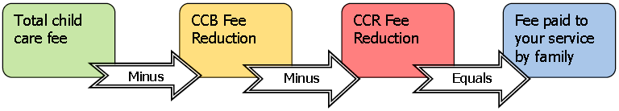

Adjustments during the year
When an attendance record is cancelled, CCR fee reductions will be recovered in exactly the same way that CCB is recovered from your service. Where you now see a negative amount in your software and records for a recovered CCB payment; after July 2011 you will also see a separate negative amount for a recovered CCR payment.
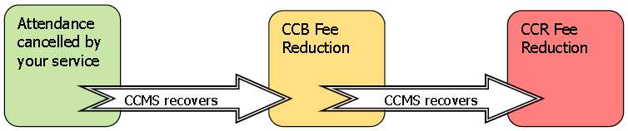

Adjustments after reconciliation
With the introduction of CCR as a fee reduction there are two very important points to consider so unnecessary complications don’t arise after July.
- Ensure attendance data for every child in care with your service is submitted accurately by the third Monday in July. Centrelink commences the annual CCB/CCR Reconciliation process after that and manages CCB and CCR entitlement adjustments directly with customers after reconciliation has occurred.
- If you make a business decision to estimate CCB and/or CCR fee reductions in advance and families are not up to date with their child care fees, once reconciliation occurs fee reduction payments for a previous financial year can no longer be made to a service. Approved services are not required to estimate CCB or CCR or reduce child care fees in advance.

Timeline

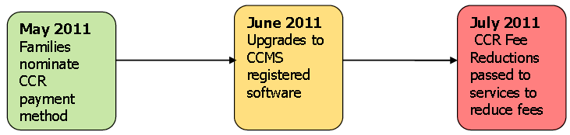Questions & Answers

How will I know what choice the family has made about their CCR payments?
The CCR method appears with other CCB details when you query an enrolment in your software. The two methods are displayed as either:
- ‘Fee Reduction’ if the family has chosen Option 1 or
- ‘Other’ if the family has chosen Options 2, 3 or 4.
Unless the family has chosen Option 1, to have CCR paid as a fee reduction to reduce their gap fee, the other payment methods will not affect your service and you won’t need to know their payment choice. You will report attendance records in the usual manner and the payment for Options 2-4 will be made by Centrelink to the family. If Option 1 is chosen, you will see CCR fee reductions made as a payment to your service through your software. The payments will be reflected on family accounts in the same way as CCB currently appears.

Can I insist that families choose the option for payment to the service as a fee reduction, especially when they are behind with their fees?
No. The family must make the decision about the best payment method to suit their personal circumstances. Services may provide advice about the payment options available but are unable to make important financial decisions affecting the personal budget of families.

When will the changes take place?
Upgrades to software will occur in June 2011. Please contact your software provider if you require more information about your upgrade. CCMS will also be upgraded to incorporate the changes to CCR payment as a fee reduction (Option 1).

Where will I find details of CCR fee reductions?
You will find the details of CCR fee reductions in your software and on your remittance advices. Where you now see details of CCB fee reductions in your software, you will also see separate details of CCR fee reductions. For example, on family accounts and reports generated by your software. Where you now see a payment labelled CCB Fee Reductions on your remittance advice you will see CCR Fee Reductions payment.

Do I need to do anything to show that the family wants the fee reduction to come to the service?
No. It is the family’s responsibility to notify Centrelink if they have chosen Option 1. When the Centrelink calculates the fee reductions for the family the system will check if both CCB and CCR should be paid as a fee reduction. If both are paid you will be able to see a payment for the CCB and the CCR paid separately.

Can the family change their payment choice during the year?
Unless there are exceptional circumstances, the family will not be able to change the payment method for CCR during the financial year. Families wishing to explore this possibility should contact the Centrelink to discuss their situation.
A family can choose to have their CCB payment method changed, for example from lump sum to fee reduction. At this time they may also elect to change their CCR method from lump sum to fee reduction. If they don’t make a decision they will default to their previous choice (usually Option 3 – quarterly to family bank account).

