
Quantitative Report: Baseline Evaluation of the Early Years Learning Framework (EYLF)
Department of Education, Employment and Workplace Relations (DEEWR)
Professor Marilyn Fleer, Dr Chandra Shah,
Dr Chris Peers
Monash University

Table of Contents
1 Executive Summary 5
2 Introduction 8
2.1 Background 8
2.1.1 The Early Years Learning Framework 8
2.1.2 Development of the Early Years Learning Framework 8
2.2 Project Purpose and Summary 10
2.2.1 Evaluation Team 10
3 Overview of Quantitative Evaluation Method 12
3.1 Frame and Sample Selection 12
3.2 Collection Method and Reference Period 15
3.3 Respondents completing the survey 16
3.4 Response Rates 17
3.5 Data Processing and Analysis 20
3.5.1 Study overview and aims 20
3.5.2 Population of Interest 20
3.5.3 Tools Used for Gathering Data in the Field 20
3.6 What does C-BAM measure? 22
3.7 Stages of Concern for the EYLF in Australia 23
3.7.1 Analysing the data using C-BAM 23
3.7.2 Significance of the study 25
3.8 Implications 28
3.8.1 Significant Correlations 28
3.8.2 Professional context as a variable of significance in implementation of the EYLF 28
3.8.3 Geographic context 29
3.8.4 Summary: 29
3.9 Variation in scores across the six stages of concern by remoteness, sector and qualifications 30
3.9.1 Remoteness 30
3.9.2 Service types 31
3.9.3 Educational Qualifications 32
4 Conclusion 34
5 Next Steps/Recommendations 36
References 38
Appendix 1: Diagrams and explanations 39
Stages of concern by state and territory jurisdiction 39
Stages of concern by region 43
Stages of concern by service type 45
Stages of concern by qualification of respondent 47
Variation in awareness score 50
Variation in informational score 53
Variation in personal score 55
Variation in management score 57
Variation in consequence score 59
Variation in collaboration score 61
Variation in refocussing score 63
Appendix 2: Frequency counts for EYLF Baseline Study 2011 data items 65
Appendix 3: Analysis of open-ended comments 75
Appendix 4 84
Descriptive statistics 84
Selected characteristic of ECEC services 84
Size of services 84
Type of management of service and the use of EYLF 86
Age range of children enrolled 88
Selected characteristics of ECEC educators who completed the survey 88
Age profile 89
Qualifications of ECEC educators 91
Appendix 5: Victoria South Australia C-BAM Survey 97

Executive Summary
The Early Years Learning Framework (EYLF) is part of the Council of Australian Government’s (COAG) reform agenda for early childhood education and care and is a key component of the Australian Government’s National Quality Framework for Early Childhood Education and Care (ECEC). The EYLF underpins universal access to early childhood education and has been incorporated in the National Quality Standard in order to ensure delivery of nationally consistent and quality early childhood education across sectors and jurisdictions. COAG endorsed the EYLF on 2 July 2009 and the Australian Government has subsequently provided EYLF related resources to ECEC services across Australia.
The EYLF describes the principles, practice and outcomes essential to support and enhance young children’s learning from birth to five years of age, as well as their transition to school. It has a strong emphasis on play-based learning as play is the best vehicle for young children’s learning providing the most appropriate stimulus for brain development.
To support both the EYLF and the wider National Quality Framework, the baseline evaluation project was commissioned by the Department of Education, Employment and Workplace Relations (DEEWR) in 2010. The purpose of the project is to establish a baseline for assessing the effectiveness of the EYLF in raising quality in early childhood education. This is the initial phase of the evaluation, which will involve a later evaluation, or series of evaluations, against this established baseline.
The quantitative study was conducted across all states and territories of Australia, and included all service types for which the EYLF has been implemented for use i.e., preschools, and long day care and family day care services. It focused on less experienced users of the framework, in order to consider factors that may be delaying or constraining successful fulfilment of Commonwealth outcomes. Of the nearly 3000 centres and preschools with whom initial contact was made, a total of 1495 responses were received.
The sample distribution across regions and remote areas was based on a model provided by the Australian Bureau of Statistics. The response rates for states and territories are indicated in the Table 1 below, showing that the lowest response rate was in Western Australia, and the highest in South Australia.
Table 1: Response rates to on-line survey in relation to states and territories
State | In sample | Responses | Non-responses | Response rate (%)
ACT | 56 | 32 | 24 | 57
NSW | 926 | 459 | 467 | 50
NT | 60 | 29 | 31 | 48
QLD | 491 | 264 | 227 | 54
SA | 214 | 132 | 82 | 62
TAS | 100 | 52 | 48 | 52
VIC | 730 | 410 | 320 | 56
WA | 369 | 117 | 252 | 32
Correspondingly, the responses for different institutions within the sector i.e., service types designated as preschools (P), long day care (LDC) and family day care (FDC), were also subject to specific variation, with preschools showing the lowest response rate. Table 2 below summarises the response rate relation to the sector.
Table 2: Response rate to on-line survey for sector type
Type | In sample | Responses | Non-responses | Response rate (%)
FDC | 112 | 70 | 42 | 63
LDC | 1573 | 816 | 757 | 52
P | 1261 | 609 | 652 | 48
At an overall response rate of 51% within the sample this comparison between geographic location and service type is valuable as a way of indicating how complex the sector is, and that, as we suggest in the conclusions, it will be necessary to undertake other more detailed and focused investigations in order to disclose the specific factors influencing forms of response as opposed to forms of awareness, and their impact on levels of implementation of the Early Years Learning Framework.
Overall the study noted 5 key findings, suggesting a good result with respect to average levels of implementation:
- At this phase of the implementation of the EYLF, Australian early childhood educators are interested, but inexperienced users of the EYLF
- Early childhood educators are generally positively oriented towards the EYLF
- Educators in long day care centres have the highest EYLF information needs
- Levels of awareness of the EYLF heightened in outer and very remote regions for family day care educators
- Educators in remote regions have the greatest need for information about the EYLF
Key Finding 1: Australian early childhood educators are interested, but inexperienced users of the EYLF.
The study was designed to survey less experienced users of the new Commonwealth framework; it consequently found that the EYLF is generally being implemented in a consistent manner across all state and territory jurisdictions. There was a high level of knowledge and familiarity with the EYLF, however the findings related to management, consequence, collaboration, and refocusing of the EYLF indicate that users are, in general, inexperienced with the EYLF. This is what would be expected at this stage of the implementation process.
Key Finding 2: Early childhood educators are generally positively oriented towards the EYLF
The national results indicate that on the whole educators are positively oriented towards finding out more about the EYLF. This is a significant finding and augurs well for the perceptions of the usefulness for the EYLF among early childhood professionals in Australia.
The only index in which scores were relatively low is that referring to “impact”: the response is taken in this report as indicating that as inexperienced users, respondents are not yet in a position to understand and measure the impact on children, and that their higher expressions of concern for how to manage the innovation and how to refocus are confirmation of this analysis. Once again, this result is expected because educators are in a phase in the implementation where they are seeking out information about the EYLF.
Key Finding 3: Educators in long day care centres have the highest EYLF information needs
The study found that although the EYLF is generally being implemented in a consistent manner across all state and territory jurisdictions, relatively moderate variations between service types were noted i.e. long day care, preschools and family day care.
Educators in long day care centres were found to generally have a higher need for information about the EYLF than educators in preschools and family care. The findings also show that family day care educators are less personally concerned than preschool and long day care educators. All service types are still in the initial or early phase of understanding and adopting the EYLF. The results are to be expected at this stage during the introduction of the EYLF.
Key Finding 4: Levels of awareness of the EYLF heightened in outer and very remote regions for family day care educators
The most significant factors effecting implementation of the framework in this early stage were geographic location of a service, with corresponding issues relating to availability of qualified staff, access to professional development, and levels of resources. The results suggest that family day care services in remote locations are possibly suffering the “tyranny of distance” as there is significant variation in levels of awareness when compared with those in metropolitan and inner regional areas.
Key Finding 5: Educators in remote regions have the greatest need for information about the EYLF
The study found that when making a direct comparison in measurements of concern with respect to information, that the remoter the region, the higher the need for information.
The study’s overall findings nevertheless reflect a good result with respect to average levels of implementation. Despite moderate variations, much of the data confirms expectations about the speed of take-up of the new framework. The study confirms that jurisdictional variations are largely irrelevant, and that complex historical issues with respect to the available infrastructure for offering improved qualifications, updating of resources and access to professional development are the most significant challenges to shifts in professional values and concern for the new curriculum.

Introduction

Background

The Early Years Learning Framework
The Early Years Learning Framework (EYLF) is part of the Council of Australian Government’s (COAG) reform agenda for early childhood education and care and is a key component of the Australian Government’s National Quality Framework for Early Childhood Education and Care. The EYLF underpins universal access to early childhood education and has been incorporated in the National Quality Standard in order to ensure delivery of nationally consistent and quality early childhood education across sectors and jurisdictions.
The EYLF describes the principles, practice and outcomes essential to support and enhance young children’s learning from birth to five years of age, as well as their transition to school. It has a strong emphasis on play-based learning as play is the best vehicle for young children’s learning providing the most appropriate stimulus for brain development. The EYLF also recognises the importance of communication and language (including early literacy and numeracy) and social and emotional development. It was developed collaboratively by the Australian and state and territory governments with substantial input from the early childhood sector and early childhood academics.
COAG endorsed the EYLF on 2 July 2009. The Australian Government has subsequently provided copies of the EYLF and Families’ Guide to early childhood services across Australia. An Educators’ Guide to the Early Years Learning Framework, to support implementation of the EYLF, was released on 6 December 2010. Hard copies of the Educators’ Guide, along with a CD of resources, were delivered to early childhood services in February 2011. It is expected that, following a period of familiarisation, each early childhood service will develop their own strategy to implement the Framework, taking their own unique context into consideration.

Development of the Early Years Learning Framework
Early childhood education has received a great deal of international attention due to better understanding worldwide about the impact a quality early education can have on the life chances of children. Research evidence has shown policy imperatives framing quality provision needs to pay attention to:
- An orientation of quality (i.e. policy and regulations concentrate on quality factors)
- Structural quality (e.g. ratio, qualifications of staff)
- Educational focus (i.e. having a curriculum)
- Interaction between staff and children
- Operational quality (i.e. management that is locally responsive)
- Child-outcome quality or performance standards
- Standards pertaining to parent/community outreach and involvement (OECD, 2006).
In line with these international findings, Australia has developed a National Quality Framework for Early Childhood Education and Care (2009). The agreed indicators of quality identified include:
- the qualifications and training of staff
- the quality of interactions and relationships between children and ECEC professionals
- group size and child-to-staff ratios
- the physical environment
- the programs or curricula that support children’s learning and development
- connections with family and community
- leadership and management
- health and safety requirements (p.26).
It is now well understood that the curricula that early childhood educators draw upon to support program development has a huge impact on the quality of provision experienced by young children (Zill et al 2001; Siraj-Blatchford et al 2003; Elliot 2006; National Quality Framework For Early Childhood Education And Care, 2009). In addition, the findings of the study of the trial sites (Charles Sturt University EYLF Consortium, 2009) found that a national Framework, such as the EYLF, provides additional benefits to the profession through the establishment of a common language for supporting educators across states and territories, for providing consistency across the variety of settings that make up the early childhood education, for supporting increased professionalism and professional status, and importantly, that the Framework can also act as a tool for educator self-reflection and readiness for more widespread adoption of contemporary approaches to early childhood learning and teaching.
Whilst it is understood that these interdependent factors contribute to the overall quality provision for young children and their families, there has been an urgent need to progress some areas more quickly due to the absence of a nationally agreed approach for curriculum planning. Up until 2009, Australia has not had a common early childhood curriculum to support children’s learning and development. It is recognised internationally that the curricula that early childhood educators draw upon to support their work has a huge impact on the quality of provision experienced by young children (National Quality Framework for Early Childhood Education and Care, 2009). Consequently, the Commonwealth Government sought to undertake an international curriculum analysis (Wilks, Nyland, Chancellor, & Elliott, 2008), the preparation of a research report to inform curriculum development (Fleer et al, 2008), the trial of a draft Early Years Learning Framework (EYLF) across 28 early childhood settings (Charles Sturt University EYLF Consortium, 2009), and the publication of the final EYLF in 2009.
Fundamental to the Framework is a view of children’s lives as characterised by belonging, being and becoming. From before birth children are connected to family, community, culture and place. Their earliest development and learning takes place through these relationships, particularly within families, who are children’s first and most influential educators. As children participate in everyday life, they develop interests and construct their own identities and understandings of the world.
The Framework conveys the highest expectations for all children’s learning from birth to five years and through the transitions to school. It communicates these expectations through the following five Learning Outcomes:
- Children have a strong sense of identity.
- Children are connected with and contribute to their world.
- Children have a strong sense of wellbeing.
- Children are confident and involved learners.
- Children are effective communicators.
The Framework provides broad direction for educators in early childhood settings to facilitate children’s learning. It guides educators in their curriculum decision making and assists in planning, implementing and evaluating quality in early childhood settings. It also underpins the implementation of more specific curriculum issues relevant to each local community and early childhood setting.
The EYLF is currently being implemented across all states and territories. Under the Joint Commonwealth-State Implementation Plan for the EYLF, the Commonwealth is responsible for the establishment of an evaluation process for the EYLF. Importantly, the EYLF has strong links to the Commonwealth’s universal access commitment, and under the National Partnership Agreement on Early Childhood Education (NP ECE), funding was endorsed by Australian Education, Early Childhood Development and Youth Affairs Senior Officials Committee (AEEYSOC) and the Early Childhood Development Working Group (ECDWG) to conduct a qualitative study to assess the effectiveness of the EYLF in raising quality in early childhood education.
An evaluation was viewed as critical for establishing a baseline of existing practice in early childhood education, so that a distinct ‘before and after’ picture could be established to measure improvement due to the introduction of the EYLF. The qualitative research comprised the initial evaluation of settings, while the quantitative element was commissioned soon afterwards. Subsequent future evaluations will take place against an established baseline, and a fuller evaluation of the EYLF is planned for 2014 to coincide with an evaluation of the National Quality Framework.

Project Purpose and Summary
To support both the EYLF and the wider National Quality Framework, the baseline evaluation project was commissioned by the Department of Education, Employment and Workplace Relations (DEEWR) in 2010.
The purpose of the project is to establish a baseline for assessing the effectiveness of the EYLF in raising quality in early childhood education. The EYLF is in its early stages of implementation, and this is the initial phase of the evaluation, which will involve a later evaluation, or series of evaluations, against this established baseline.
The project has two distinct elements:
- A qualitative study to establish a baseline of existing practice in early childhood education, where the EYLF is yet to be or is in the very early stages of being adopted.
- A quantitative study that gains a picture of the overall adoption of the EYLF across relevant early childhood education and care settings.
- The purpose of the quantitative element was to survey early childhood professionals who were working during the recent (2011-2012) phase of implementation and roll-out of the EYLF and to determine their level of usage and attitudes towards the management of this implementation process for their daily routine. A number of additional questions were asked of respondents including level and field of qualification, years of service, language background, age and access to professional development specifically associated with the new EYLF framework, providing a rich source of important data as the basis for future policy and reform of the sector [See Appendix 3].
This report outlines the findings from the quantitative element.

Evaluation Team
Monash University was selected as the successful tender for this project. Members of that team included:
- Professor Marilyn Fleer (Project Director; Analysis and report writing).
- Associate Professor Chandra Shah (Centre for the Economics of Education and Training).
- Dr Chris Peers (Analysis and report writing)
- Sarah Winter (Survey Administrator).
- Jasmine Evans (Project Manager).
- Document formatting and additional administrative support was also provided by Norma Coull.

Overview of Quantitative Evaluation Method

Frame and Sample Selection
The aim of the survey was to ascertain the type and concerns about the EYLF at the service level. It is assumed that decisions about whether and how to implement the EYLF occur at the service level and primarily involves certain educators within each service. The survey was specifically to be completed by one of the following:
- director/coordinator/teacher-in-charge
- curriculum coordinator
- group leader/kindergarten or preschool teacher or educator
People listed above were believed to have the most intimate knowledge about the implementation of EYLF and be aware of any concerns educators at their service may have had. Therefore, it was expected that the responses they provided on the stages of concerns questionaire (SoCQ) and any open-ended comments they made would reflect not only their own personal views but also those of their colleagues at the service. Some questions were designed to ask educators to comment on staff in the service, for example “I am concerned about my colleagues’ attitude towards the EYLF”. But most questions were related directly to the eduator, such as “I don’t even know what the EYLF is”.
The sampling frame which formed the list of all known ECEC services in Australia was provided by DEEWR who used the following criteria:
- All Child Care Benefit approved early childhood education and care services (minus Occasional Care and Outside School Hours Care Services ); and
- Registered preschools
The sample included long day care (LDC) centres, family day care (FDC) centres and preschools. For each service, the following locational information was also provided:
- jurisdiction (state/territory)
- geographical location (5-level ARIA category)
- type of service
- postal address
- email address.
For a small percentage of services the email and/or postal addresses were missing.
The numbers of services by jurisdiction, type and location are shown in Table 4. Of these, 37 services had taken part in the earlier qualitative evaluation. To lighten respondent load these services were removed from the frame even though they had completed a C-BAM as part of their site visit. However, these services did not complete the additional questions that were added to the C-BAM survey and, therefore could not be used. The frame from which the sample was selected consisted of 10,908 services.
FDC is the least common type of ECEC service in Australia with only 3 per cent of all services of this type. Educators in this service can be spread over a large region. Educators include both those working directly with children in their homes and those who supervise these services.
LDC is the most common with 55 per cent of the share, while preschools’ share is 42 per cent. The proportion of services in a region that are LDCs generally increases with the population density of the region. In major cities, for instance, 62 per cent of all services are LDC but in inner regional, outer regional, remote and very remote locations the percentages are 49, 39, 24 and 14, respectively.
The converse is true with respect to preschools. In some jurisdictions, LDCs are more common (NSW and Queensland) and in others preschools are more common (Tasmania, South Australia, Western Australia and the Northern Territory), reflecting the service provision models which are dominant in each jurisdication
Table 4: Numbers of early childhood education and care (ECEC) services in population by state, type and geographical location
 | Geographical location
State/Type | Major cities | Inner regional | Outer regional | Remote | Very remote | Total
NSW | 2547 | 701 | 233 | 28 | 3 | 3512
Family day care | 48 | 31 | 15 | 1 |  | 95
Long day care | 1935 | 409 | 78 | 8 |  | 2430
Preschool | 564 | 261 | 140 | 19 | 3 | 987
Victoria | 2036 | 560 | 131 | 6 |  | 2733
Family day care | 60 | 29 | 7 |  |  | 96
Long day care | 932 | 187 | 28 |  |  | 1147
Preschool | 1044 | 344 | 96 | 6 |  | 1490
Queensland | 1066 | 359 | 303 | 43 | 50 | 1821
Family day care | 39 | 18 | 26 | 4 | 3 | 90
Long day care | 870 | 246 | 199 | 13 | 13 | 1341
Preschool | 157 | 95 | 78 | 26 | 34 | 390
South Australia | 516 | 85 | 111 | 31 | 27 | 770
Family day care | 12 |  |  |  |  | 12
Long day care | 230 | 35 | 24 | 7 | 3 | 299
Preschool | 274 | 50 | 87 | 24 | 24 | 459
Western Australia | 829 | 161 | 172 | 111 | 89 | 1362
Family day care | 9 | 2 | 5 | 2 |  | 18
Long day care | 351 | 53 | 45 | 22 | 12 | 483
Preschool | 469 | 106 | 122 | 87 | 77 | 861
Tasmania |  | 196 | 126 | 10 | 5 | 337
Family day care |  | 9 | 2 |  |  | 11
Long day care |  | 74 | 30 | 3 | 2 | 109
Preschool |  | 113 | 94 | 7 | 3 | 217
Northern Territory |  |  | 86 | 42 | 76 | 204
Family day care |  |  | 2 | 2 | 1 | 5
Long day care |  |  | 51 | 13 | 5 | 69
Preschool |  |  | 33 | 27 | 70 | 130
ACT | 204 | 2 |  |  |  | 206
Family day care | 5 |  |  |  |  | 5
Long day care | 112 | 1 |  |  |  | 113
Preschool | 87 | 1 |  |  |  | 88
Australia | 7198 | 2064 | 1162 | 271 | 250 | 10945
Family day care | 173 | 89 | 57 | 9 | 4 | 332
Long day care | 4430 | 1005 | 455 | 66 | 35 | 5991
Preschool | 2595 | 970 | 650 | 196 | 211 | 4622

Collection Method and Reference Period
This section describes the process of collecting the data for the pilot and the main survey. It was expected that the main means of conducting the survey would be online but because some services may lack reliable internet connection a postal survey option was also offered. However many ECEC services in the sample in Table 2 were found to lack an email address. Through a combination of online search and phone calls all missing email addresses were obtained. The online part of the survey used Qualtrics software. Qualtrics is web-based survey software that can be used for the creation of survey instruments, distribution of surveys, data storage and analysis.
As the survey was going to involve more than 50 services, approval to conduct the survey was sought from the Australian Bureau of Statistics (ABS) Statistical Clearing House.. The approval (no. 02216–01) was granted on 5 September 2011. Approval to conduct the survey was also obtained from the Monash University Human Research Ethics Committee (MUHRC).
A pre-approach letter was emailed to the list of services in the pilot sample. The letter gave each service an option to complete the survey online or to request a hard copy of the questionnaire. Only one service requested a hard copy.
Of the 49 services in the pilot, two requested to be removed from the study, one no longer existed and the email of one was rejected by Qualtrics. This left 45 services in the sample for the pilot.
The 45 services were sent an individual link to download and complete the questionnaire. Twelve responses were received after a week. Subsequently, those who had not completed the questionnaire were contacted by phone. For eight of them the contact details were either incorrect or there was no response. The rest requested the link to be resent, provided new email addresses or requested to be withdrawn from the study. After further email reminders and phone contact, the final number of responses received was 21, a response rate of less than 50 per cent. The response rate was lowest in the ACT, the Northern Territory and Western Australia. Responses for preschools were also below the expected level.
While most of the questionnaire, particularly that dealing with the stages of concern was well understood, some questions about the service and personal information about the respondent needed tweaking to reduce respondent load. For example, a question on the number of children at the service by age was simplified to require the respondent to simply indicate the ages of the children at the service and not require them to provide the number of children by age.
The experience from the pilot suggested that an introductory letter from DEEWR to each service explaining the purpose of the survey would help improve response rates.
Before conducting the main survey, DEEWR sent a letter to invite each service in the sample to complete the survey. The letter also outlined the importance of the survey and the possible benefits from the research that may accrue to the ECEC sector as a whole. The letter also offered services the option of completing a postal survey if they wished and provided details of how to get a hard copy sent to them.
The online survey was launched about the middle of November, a week after the above letter was posted. Together with the explanatory letter an online link was emailed to 2,988 services. In the following days 35 services requested to be sent a hard copy of the survey and another 64 services had ceased to operate.
About 200 services had duplicate email addresses. These were later found to be services that operated in different locations but under the same central management. A combination of internet search and contact via phone identified 27 services to be listed twice and were thus deleted from the sample. Subsequently, 2,863 services remained for the online sample.
Reminder emails were sent approximately every 2-3 weeks to those services that had not completed the survey. Phone contact was also made to selected services in jurisdictions and geographic areas from which the response rates had been low. These were predominantly in Western Australia and remote and very remote locations. Some preschools in other jurisdictions were also targeted. Between 150 and 200 phone contacts were made to encourage completion of the survey. Although originally the survey was to be closed in the latter half of December 2011, it was decided to keep it open until the end of January 2012 to give services an opportunity to complete the survey during the quiet time in January. While this strategy resulted in some additional completions, the improvement in the response rate was marginal.

Respondents completing the survey
One employee from each service with a direct involvement in the education and care of children in the service was invited to complete the survey. Examples of people who should take part were:
- director/coordinator/teacher-in-charge
- curriculum coordinator
- group leader/educator
- FDC scheme coordinator or FDC educator.

Response Rates
Excluding ECEC services that had ceased to operate and those that were listed twice of those included in the pilot study, 2,946 out of the original 3037 remained in the sample. oOf this sample 1,495 completed the survey. A few partially completed questionnaires were discarded and not included in this total. Thus the overall response rate was 51 per cent. Table 5 shows the response rates by jurisdiction and type of service, and Table 6 shows this by geographic area and type.
While the response rates for most states and territories were close to the average, the rate for South Australia (62 per cent) was well above average and that for Western Australia (32 per cent) well below average. This shows that the follow-up emails and phone calls to services in Western Australia had only a small effect in improving the response rate.
Overall, all three service types were well represented among the respondents. However the response rate for preschools in Western Australia was amongst the lowest at 16 per cent. Finally, the response rates for services in remote and very remote regions are much lower than average. These are mainly the result of very low rates for preschools in these regions.
Table 5: Response rates for EYLF Baseline Study 2011 survey by state and territory and type of ECEC service
State | Number in sample | Responses | Response rate (%)
NSW | 926 | 459 | 50
Family day care | 29 | 19 | 66
Long day care | 629 | 294 | 47
Preschool | 268 | 146 | 54
Victoria | 730 | 410 | 56
Family day care | 27 | 20 | 74
Long day care | 301 | 146 | 49
Preschool | 402 | 244 | 61
Queensland | 491 | 264 | 54
Family day care | 30 | 19 | 63
Long day care | 352 | 197 | 56
Preschool | 109 | 48 | 44
South Australia | 214 | 132 | 62
Family day care | 4 | 2 | 50
Long day care | 85 | 51 | 60
Preschool | 125 | 79 | 63
Western Australia | 369 | 117 | 32
Family day care | 9 | 4 | 44
Long day care | 127 | 76 | 60
Preschool | 233 | 37 | 16
Tasmania | 100 | 52 | 52
Family day care | 5 | 3 | 60
Long day care | 33 | 22 | 67
Preschool | 62 | 27 | 44
Northern Territory | 60 | 29 | 48
Family day care | 5 | 1 | 20
Long day care | 18 | 11 | 61
Preschool | 37 | 17 | 46
ACT | 56 | 32 | 57
Family day care | 3 | 2 | 67
Long day care | 28 | 19 | 68
Preschool | 25 | 11 | 44
Australia | 2946 | 1495 | 51
Family day care | 112 | 70 | 63
Long day care | 1573 | 816 | 52
Preschool | 1261 | 609 | 48

Table 6: Response rates for EYLF Baseline Study 2011 survey by geographical location and type of ECEC service
State | Number in sample | Responses | Response rate (%)
Major cities | 1901 | 943 | 50
Family day care | 51 | 29 | 57
Long day care | 1154 | 570 | 49
Preschool | 696 | 344 | 49
Inner regional | 555 | 321 | 58
Family day care | 26 | 21 | 81
Long day care | 264 | 149 | 56
Preschool | 265 | 151 | 57
Outer regional | 323 | 167 | 52
Family day care | 23 | 16 | 70
Long day care | 121 | 77 | 64
Preschool | 179 | 74 | 41
Remote | 84 | 37 | 44
Family day care | 8 | 2 | 25
Long day care | 18 | 11 | 61
Preschool | 58 | 24 | 41
Very remote | 83 | 27 | 33
Family day care | 4 | 2 | 50
Long day care | 16 | 9 | 56
Preschool | 63 | 16 | 25
All | 2946 | 1495 | 51
Family day care | 112 | 70 | 63
Long day care | 1573 | 816 | 52
Preschool | 1261 | 609 | 48

Data Processing and Analysis

Study overview and aims
The study was designed using a questionnaire to assess the type and strengths of concerns of educators with respect to the EYLF. The questionnaire was designed for use as both an online and a postal survey.
After collecting responses, the data was analysed using the Concerns-Based Adoption Model, (C-BAM) which is a globally recognised instrument developed for the purpose of measuring affective responses of users of an innovation, such as a new curriculum like the Early Years Learning Framework.
One of the strengths of C-BAM is that its a model (both descriptive and predictive) as well as an instrument for measuring how innovations are (or not) being adopted by teachers.

Population of Interest
The study aimed to collect information about early childhood educators responsible for children ranging in age from 0-5 years who came from all the states and territories. Educators were defined as early childhood practitioners who worked directly with children in early childhood settings.

Tools Used for Gathering Data in the Field
The Stages of Concern questionnaire used for this study is an adaptation of the 35-item SoCQ (. According to Hall and Hord, it represents the most rigorous instrument for measuring concerns. It has strong reliability and internal consistency. The SoCQ allows the construction of the graphical representation of relative intensity of different stages of concern for an individual or a group of individuals.
The questionnaire includes questions to capture the characteristics of the service such as:
- age profile of the children attending the service
- number of paid employees who work at the service
- type of care program offered by the service
- type of management
- types of curriculum frameworks currently used at the service
- self-assessment of how staff at the service deal with Indigenous children, children with disabilities and children from non-English speaking backgrounds.

Characteristics of the Australian Early Childhood Education and Care sector (ECEC) services across Australia provide six main types of programs. These are:
- Stand-alone long day care
- Long day care as part of an integrated setting
- Family day care
- Stand-alone kindergarten or preschool, and kindergarten or preschool as part of an integrated setting
- Occasional care programs
- In-home care.
Integrated settings are hubs that provide a number of programs (e.g. child care, playgroups, schools, kindergartens, maternal and child health services or Indigenous services). Long day care services provide child care for children primarily aged 0–5 years. Preschools or kindergartens provide structured educational programs to children in the one or two years before they commence full-time schooling.
The management structure of ECEC services in Australia can be classified as follows:
- private not for profit and community managed
- private for profit
- state/territory or local government managed
- managed by either government schools, Independent schools or Catholic schools.
In addition to the EYLF, it was expected that there would be instances where a service was using another curriculum framework such as one developed by the state or territory (e.g. VEYLDF in Victoria), Montessori, Reggio Emilia etc. Services could have used the EYLF as well as another curriculum framework.
The questionnaire also included questions about the person completing the questionnaire including:
- age
- gender
- Indigenous background
- country of birth
- main language spoken at home
- field and level of the highest qualification relevant to ECEC held
- main role in service
- main type of work performed
- hours of work (full-time/part-time)
- employment arrangements
- length of tenure in current job
- experience in the ECEC sector
- current study for an ECEC-related qualification
- professional development related to ECEC
- professional development related to EYLF.
The data captured through the above questions enabled assessment of how responses to the SoCQ varied, by characteristics of the service where the respondent worked as well as the respondent’s personal background. This type of information is important for developing future targeted professional development programs and interventions to ensure the aims of the EYLF are met.
A copy of the questionnaire is included in Appendix 5.

What does C-BAM measure?
The Concerns-Based data collection model
The Concerns-Based Adoption Model (C-BAM) is not only a survey instrument but also a conceptual framework for interpreting data. C-BAM has been selected to gather data that can be used to both describe and explain how early childhood staff in Australia are currently faring in relation to the use of the EYLF. It is therefore intended to gauge the level of implementation of the EYLF across the sector.
C-BAM was developed at the Research and Development Centre for Teacher Education, University of Texas at Austin. One of the authors of C-BAM, Professor Gene Hall, has contributed summary interpretations of the data yielded within this study, and these remarks are incorporated in the analysis below. C-BAM has regularly been deployed within research conducted in the education sector in Australia and provides a sound basis for studies of this nature where an innovation such as the national EYLF is the focus of the research. The instrument provides directions for professional learning, but when used once or multiple times, the results also determine how educator practices may or may not be changing (in this case, with respect to implementation of the EYLF).
Responses to surveys are plotted onto a chart which gives an overall profile for an individual or for groups of individuals or for sectors, such as long day care, or for specific states and territories. An overall national profile can also be generated.
What is created is a set of relational scores and the reading of these scores gives an indication of the kinds of concerns that a person or sector may have regarding the implementation of the EYLF. The instrument features a set of areas of concern for the implementation of an innovation, such as the EYLF. The relations between concerns and their levels allow for an overall profile to be created. The specific levels of concern were shown in Table 7.
Table 7: C-BAM
Level | Concern for EYLF | Expressions of concern regarding EYLF and different theories of child development
Level 0 | Awareness | I am not concerned about it. I don’t know anything about EYLF or that there are different theories of child development/practices/principles. I have not used it.
Level 1 | Informational | I would like to know more about the EYLF and the theories of child development/practices/principles.
Level 2 | Personal | How will using EYLF affect me? What theory of child development am I using? How does this relate to practices/principles in the EYLF?
Level 3 | Management | I seem to be spending all my time getting materials ready.
Level 4 | Consequence | How is my use of EYLF affecting learners? How can I refine my program in relation to EYLF to have more impact?
Level 5 | Collaboration | How can I relate what I am doing to what others are doing? Does the EYLF give us a common language? What views do others have of child development/practices/principles?
Level 6 | Refocusing | I have some ideas about something that would work even better for meeting the outcomes of the EYLF. Thinking about EYLF in relation to the different theories of child development/practices/principles.

In this baseline study the survey captured the respondents’ reactions to these specific levels of concerns regarding the implementation of the EYLF.
As discussed in Section 1.4, the levels of engagement with the EYLF are likely to move from a simple awareness of the document right through to feeling confident about its use, even making suggestions for better approaches or developments of the EYLF to specific cohorts of children and theories.
Different profiles suggest different levels of take-up of the EYLF. Low scores in Levels 0-2 and high scores in Levels 3-6 suggest respondents who are using the EYLF. Conversely high scores in Levels 0-2 and low scores in the 3-6 suggest inexperienced users of the EYLF. Variations across these scores give indications about how positive or negative respondents are towards the EYLF, with peaks in particular levels giving insights into the kinds of concerns respondents might have, such as ‘seeking out better documents’ or ‘personal concerns’ or ‘management concerns’ or concerns for ‘working with others’.

Stages of Concern for the EYLF in Australia

Analysing the data using C-BAM
The analysis of the data points to a relatively even and balanced acceptance of the EYLF. This is suggested in particular by the responses to “awareness” and “information” that disclose a broad section of professionals who are in the early stages of delivery and familiarisation with the EYLF. A number of recommendations have been suggested, with particular reference to the in-service training of professionals in the sector, and recommendations with respect to further investigation of jurisdictional expenditure and professional values that may be relevant to some of the variables within the sector as a whole.
In this study, we use C-BAM to yield data with respect to the perceptions of early childhood staff about their own use of (or lack of experience with) the Early Years Learning Framework. Figure 5 is an initial visualisation of the kinds of responses that the study provides for each of the six forms of concern expressed across the approximate 1500 responses in the Australian early childhood sector nationally.
Readers unfamiliar with the C-BAM instrument should read the figures as registering the average emotional response of those individuals answering the survey. The linear diagram inclines vertically or upward when concern is high, and dips when concern is low.
Because the EYLF is new, the data indicates generally that staff in the sector nationally were less experienced with the curriculum, and consequently express higher concern about their lack of awareness, but less concerned about how to manage the curriculum, since the impact on their routine is not yet available and coherent to them.
Figure 5: National profile for educators’ stages of concerns about the EYLF
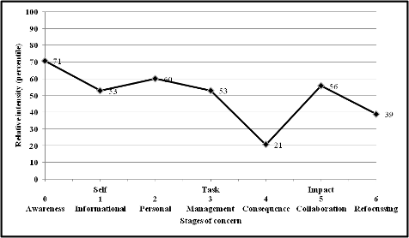
Scores that are high in the 0-2 band [awareness/informational/personal] and lower in the 3-6 band [management/consequence/collaboration/refocusing] are a general indicator of an inexperienced user. This is because the 0-2 band is measuring how well a respondent “knows” or is familiar with the EYLF framework as an “innovation” to their daily practice: the innovation represents new tasks for these respondents. The inexperienced user scores high in response because they are not already using the EYLF framework extensively. If the score was lower in the 0-2 band the result would indicate that respondents were experienced users.
At the same time, the fact that 3-6 band scores are lower for the same respondents shows that respondents consider it very important that they try to come to terms with these new tasks, and are aware of different repercussions of the framework for their day-to-day routine.
This means that these scores relate to each other by giving an explanation of what kind of inexperienced user is evident in the sample. Given the fact that the EYLF has only been introduced relatively recently, it is to be expected that the findings of the study will indicate relatively lower utilisation of the framework at the time the survey was conducted in 2011-12.
The survey indicates that the sample population reported a range of levels of qualification with relatively few indicating they were completely unqualified. The current reporting shows that the Australian early childhood staff surveyed were shown to be interested but inexperienced users of the EYLF. Survey respondents demonstrated a high level of awareness of the EYLF, indicating they were informed about the need for using the EYLF within their service, however, as would be expected, inexperienced users’ depth of understanding about the EYLF was not high. Importantly, they were on the whole positively oriented towards finding out more about the EYLF. This is a significant finding and augurs well for the perceptions of the usefulness for the EYLF among early childhood professionals in Australia.
The only index in the 3-6 band on which scores were relatively low is that referring to “impact”: the response is taken in this report as indicating that as inexperienced users, respondents are not yet in a position to understand and measure the impact on children, and that their higher expressions of concern for how to manage the innovation and how to refocus are confirmation of this analysis.

Significance of the study
The Early Years Learning Framework is a highly significant reform for the early childhood sector in Australia, but it also represents a milestone in international benchmarks for the development of relevant curriculum for reform of the sector. It provides greater depth in the utilisation of up-to-date curriculum and pedagogical research as well as including the most advanced perspectives about human development and measures that can augment learning and social competence.
As a reform that addresses the quality of professional knowledge and the character of service delivery, the EYLF provides a clear and coherent set of professional development criteria for early childhood caregivers and educators, and gives equal access to all (a) service types as institutional components of the early childhood sector i.e., long day care, family day care, and preschool and (b) early childhood teachers, centre leadership and management, caregivers both qualified and unqualified, as well as those currently involved in retraining or who will be seeking the latter over coming years. The raft of factors entailed by the National Quality Framework for Early Childhood Education and Care as an accompaniment to the EYLF is critically important in terms of the future of service quality and professionalisation of the sector in general; providing a structure for improving the status of disciplinary strength for an industry; and a marketplace dominated by women.
The respondents to the study were invited to provide speculative commentary in addition to completing a questionnaire. Table 7 shows that some negative concerns about the use of the EYLF were noted, but that comments were overwhelmingly positive.
Table 7: Summary of negative and positive qualitative comments
Issue | Number of positive comments | Number of negative comments
EYLF in general | 373 | 63
At a deeper level of analysis, the study indicates that personal concerns by individual respondents were not scored highly, suggesting that the degree of doubt about the EYLF or the level of resistance to finding out more about the EYLF was only moderately evident. However, this finding should not be underestimated, as it holds repercussions for both proposed and existing professional development in relation to the EYLF.
For example, some respondents expressed resistance to the use of the EYLF, which we interpret as a wish to satisfy personal knowledge through professional development. For example, qualitative comments such as the following were evident in the comments to the CBAM survey: [We are experiencing] “total confusion with this [the implementation of the EYLF] although our centre has recently undergone an extensive training course… this coupled with the new national standards is causing extreme stress to our centres”.
Availability of Commonwealth sponsored professional development programs was a source of concern in this area; respondents expressing this concern were often not accessing the necessary EYLF documents and found it difficult to obtain good information about the means of modifying daily routines in order to build and improve professional practice in accordance with the framework. Professional development quality may be a necessary measure in order to tackle broader service quality and the concerns of practitioners. These concerns were expressed in the context of already extensive professional development to the field by the Commonwealth, as a general finding of the study was the high percentage of staff who engaged in professional development. The results are shown in Table 8 below.

Table 8: Frequency counts: ECEC related professional development in previous 2 years
PD undertaken | Count | Per cent | Weighted count | Weighted per cent
Yes | 1381 | 92 | 9938 | 91
No | 114 | 8 | 943 | 9
All | 1495 | 100 | 10881 | 100
A very high percentage of staff undertook professional development in relation to the EYLF, as is shown in Table 9 below.
Table 9: Frequency counts: EYLF related professional development
PD undertaken | Count | Per cent | Weighted count | Weighted per cent
Yes | 1308 | 87 | 9371 | 86
No | 73 | 5 | 567 | 5
No applicable | 114 | 8 | 943 | 9
All | 1495 | 100 | 10881 | 100
This could be an indication that the same staff are often trying to improve their professional practice in different ways, or that many existing programs available in this area do not address EYLF topics.
Even though a large number of staff were engaged in professional development related to the EYLF, the availability of sponsored professional development programs was a source of concern in this area. Respondents expressing this concern were often not accessing the necessary EYLF documents and found it difficult to obtain good information about the means of modifying daily routines in order to build and improve their professional practice in accordance with the framework. Professional development quality may be a necessary measure in order to tackle broader service quality and the concerns of practitioners. Table 10 shows the number of comments made by respondents that were negative in relation to the number that were positive about issues relating to professional development. Negative comments tended to focus on lack of access rather than in relation to the quality of the professional development.
Table 10: Frequency count of positive and negative comments regarding professional development
Issue | Number of positive comments | Number of negative comments
Professional development | 19 | 56
EYLF documentation | 16 | 65
Lack of resources (including time) implementing EYLF | 150
Support for CALD students, including urban/rural etc | 5 | 28
Pace/volume of change too fast/high | 99
Knowing more about these personal concerns is important for recommendations about what kind of professional development would be most beneficial at this point of the implementation of the EYLF nationally and locally.
In the national profile (Figure 5 page 22) it is also shown that collaboration was scored highly, and “management” concerns were also noted: “management” here refers to the task of coping appropriately with implementation and use of the framework. Management scores were in fact lower than those for level of “awareness” of the EYLF, suggesting that management is deemed important but collaboration with colleagues was of greater concern to the early childhood staff surveyed.
This also suggests that respondents are focused more on working with colleagues in implementing the EYLF than simply managing what is associated with the EYLF. Early childhood professionals surveyed indicated the importance of collaborative strategies to ensure sound implementation, as opposed to “getting by”. This is partially supported by an equal spread of negative and positive comments from respondents, with particular respect to their colleagues’ knowledge of the EYLF, as shown in Table 11.
Table 11: Frequency count for staff knowledge of the EYLF
Issue | Number of positive comments | Number of negative comments
Other staff’s understanding and knowledge of EYLF | 44 | 40
In the national profile (Figure 5 page 22) it is shown that the scores for the consequence of using the EYLF within a service were very low in comparison to all the other areas. Given the early stage of implementation of the framework, it is understandable that respondents were more concerned about implementing the EYLF than about gauging its impact on the children in their service. Given the staff were predominantly inexperienced users of the EYLF, it would be expected that implementation issues would be the focus of their concerns regarding the EYLF. Consequently, it is only after implementation that concerns regarding impact on children are likely to be the focus of their attention.
A range of qualitative comments were made in relation to implementation, including the following:
At this centre we are very excited about the EYLF however we have much yet to learn in the process of documentation/ critical reflection etc. However we are working on this and have set up team planning meetings with all our staff to reflect on the Frameworks and modify our planning accordingly.
This comment tends to confirm the interpretation of the survey data in which collaborative approaches to planning and implementation are paramount for many professional staff. Another view was that
Our service has been implementing EYLF over the past 2 years. Our team still has a long way to go in turns of understanding its full potential but feel we are well on the way.
The latter remarks confirm the view that professional development is an incremental process and that a “team” (collaborative) approach is valuable.
The frequency count for the concerns about the impact of the EYLF on children was extremely positive. This could be explained through the fact that individuals who responded only 93 made comments in relation to the impact of the EYLF on children. What tended to matter more was the impact the EYLF was having on staff, whereas the concerns for the impact of the EYLF on other staff was slightly more negative. Interestingly, the impact on the family was seen to be almost twice as positive according to the frequency count for comments made by respondents in this area (as shown in Table 12). However, the frequency count is very low in relation to the overall number of respondents:
Table 12: Impact of the EYLF
Issue | Number of positive comments | Number of negative comments
EYLF’s impact on children | 84 | 9
EYLF’s impact on the educators | 55 | 67
EYLF’s impact on family involvement | 34 | 18
Finally it should be noted that whilst early childhood staff in Australia were inexperienced users of the EYLF, they were not generally seeking to look elsewhere for supporting curricula, as noted by the tailing off of the profile (see low score for refocusing) shown in the national profile (Figure 5 page 22). This would tend to suggest that staff diverted their attention only to the EYLF, and that other available documents within their state or territory tended not to be as important. However, it should be noted that in some states the interface between the EYLF and state based curriculum was seen as significant, and for others it was noted as being complementary. This adds to our recommendations (below) that further investigation of jurisdictional variation would be required in order to ascertain stronger data with respect to necessary forms of professional development and ways of shaping this kind of programming. Variations between states as shown in Figures A1-1 to A1-8 in the Appendix for Impact (Level 6), tend to support this finding. The data about experience with the EYLF indicate an understandable disparity and fluidity among respondents with respect to understandings, values and concerns about the use of the Framework. Frequency counts show an almost equal split between positive and negative views on the use of other frameworks or curriculum documents within states or territories.
Table 13: Use of frameworks in relation to other curriculum
Issue | Number of positive comments | Number of negative comments
Integration with other frameworks/curricula | 26 | 25

Implications

Significant Correlations
Our analysis of the quantitative data has two particularly significant outcomes with respect to factors affecting the progress of implementation and the nature of sector responses to the National Quality Framework as expressed in the reaction to the EYLF. Firstly, that remote geography has a significant impact on take-up and implementation of the EYLF, due to a complex intersection of issues. Secondly, improvements in the nature as well as availability of professional development about the EYLF may need to be better designed with respect to variation between professional contexts as well as service type. We will address this latter issue first and then return to the question of geographic context.

Professional context as a variable of significance in implementation of the EYLF
Research literature (Vandenbroek 2006) about the relationship between changing early childhood education policy and improvements in professional practice indicate that family day care is frequently identified as a site for employment among women seeking employment without the need to attain new qualifications. Although historically in Australia both long day care and family day care constitute institutions that are administered either through charity or local government, with either often being located in home settings; staff are originally not qualified (Brennan 2007). However, over the past ten years a concerted effort has been directed towards upgrading qualifications across the whole sector, including family day care. Educators from the family day care sector tended to express less concerns about the EYLF than those from the preschools and long day care services. By comparing Figures A1-26, A1-30, and A1-34 (see Appendix 1), this pattern among family day care respondents becomes more visible.

Geographic context
Figure 6 shows the average levels of awareness for the EYLF corrected by State / Territory.
By comparing the way in which concerns shift in Figure 6 over the page, as well as in others that measure concerns directly with respect to central and remote geographic location, it is possible to suggest that lower scores are consistently recorded for the Northern Territory. However, in both the ACT and Tasmania, the higher scores suggest deepening complexity in two relatively regional (as opposed to main metropolitan population) locations. At the same time, we note this as a significant correlation despite the fact that the variation is still only relatively small.
Further, when compared to Figure A1-40 in Appendix 1 for example, it seems clear that geographic location determines quite different responses between levels of awareness and concern regarding the consequences of the EYLF: in the latter figure little real variation between states and territories is visible, whereas a dramatic shift can be discerned in average awareness of the EYLF between states with lower population densities and those of higher population density.
Figure 6: Geographic differences across Australia for levels of awareness about the EYLF
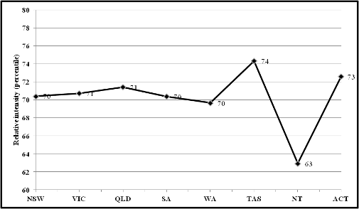

Summary:
Further investigation is necessary with respect to a series of relational constructs disclosed by the present study. These issues are summarised in point form below, but relate generally to the kinds of concerns raised by respondents. This is in respect to understanding of the EYLF and the opportunities to improve quality in accordance with the nature of national reform, as opposed to prevailing standards and knowledge of child development.
- perceived availability of professional development programs and the need for more support with implementation;
- importance of targeting specified areas of understanding about the EYLF and increasing depth of professional knowledge;
- strategies with respect to impact and or comparability with other forms of curriculum in general;
- importance of developing deeper correlative data with respect to comparability of service types and the impact of complex variables on implementation of national reforms; and
- levels and focus of jurisdictional expenditure with respect to professional development and variable needs within different institutions ie. family day care as opposed to long day care or preschool educators.

Variation in scores across the six stages of concern by remoteness, sector and qualifications

Remoteness
The study found relatively moderate variations in the responses as they measured the six stages of concern across the regions (major cities, inner regional, outer regional, remote and very remote). In Figure 7 we show that the strength of the data lies in the similarity between each geographic region as measures of difference in each stage.
Note that the same pattern of higher concerns for awareness of the EYLF and less concern about the consequence of the EYLF for their work are disclosed across all geographic regions. However, as previously noted, the most remote services provide the poles of extremity in each stage.
In general the findings are consistent in affirming the importance of a follow-up study in another two years once higher levels of experience with the EYLF as a workplace/curriculum innovation can be produced.
Figure 7: Levels of concerns across regions
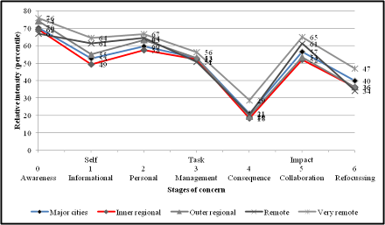

The most significant factors effecting implementation of the framework in this early stage were geographic location of a service, with corresponding issues relating to availability of qualified staff, access to professional development, and levels of resources. Family day care educators scored higher in outer and very remote regions, as shown in Figure X below.
These results suggest that family day care services in remote locations are possibly suffering the “tyranny of distance” as there is significant variation in levels of awareness when compared with those in metropolitan and inner regional areas.
Figure X: Geographical variations in family day care educators levels of awareness
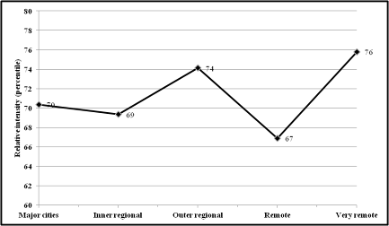
The study found that when making a direct comparison in measurements of concern with respect to information, that the remoter the region, the higher the need for information. Figure X below shows the comparison between educators from major cities, inner and outer regional, remote and very remote regions.
Figure X: National levels of concerns for information about the EYLF according to geographical region
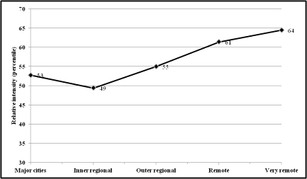
The study’s overall findings nevertheless reflect a good result with respect to average levels of implementation. Despite moderate variations, much of the data confirms expectations about the speed of take-up of the new framework. The study confirms that jurisdictional variations are largely irrelevant, and that complex historical issues with respect to the available infrastructure for offering improved qualifications, updating of resources and access to professional development are the most significant challenges to shifts in professional values and concern for the new curriculum.

Service types
By comparison, the results shown in Figure 8 suggests an ongoing pattern of similarity that varies mainly with respect to family day care respondents.
Figure 8 identifies the variations between service types for the six areas of concern involved in the survey. This figure shows that educators in long day care centres generally have a higher need for information about the EYLF than educators in preschools and family care. It also shows that family day care educators are less personally concerned than preschool and long day care educators. All service types are still in the initial or early phase of understanding and adopting the EYLF.
It should be noted that the lines of divergence between service types are shallow, with a generally moderate comparability between each sector.
Figure 8: Levels of concern for service types
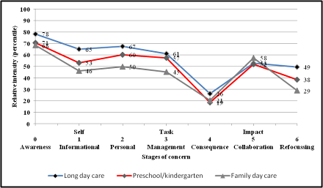

Educational Qualifications
The question of educational qualifications and their perceived significance in affecting levels of concern with respect to the demands of implementation of the Framework is partly addressed by comparing the results of Figure 9 and Figure 10 (below). These figures compare responses of those holding higher educational qualifications and those without such qualifications, using the EYLF in the week prior to the survey.
Given how closely the data compares between these two groups, it is reasonable to conclude that:
- both sets of respondents are equally inexperienced in their use of the Framework and therefore reach similar forms of concern about the demand of implementing the curriculum, and
- only once these respondents had developed suitable levels of experience and familiarity with the EYLF would additional research be able to provide more significant evidence of the kinds of differences produced by more or less qualified respondents.
Figure 9: Respondents with higher qualifications
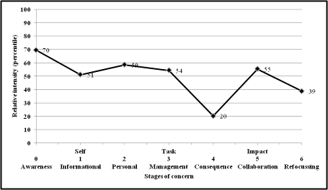
Figure10: Respondents without higher qualifications
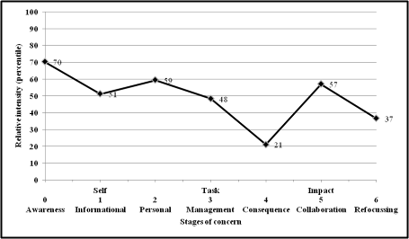

Conclusion
The quantitative survey of early childhood services across Australia provides important data about the efforts of professionals across the sector to introduce and implement mandated reforms. The clearest message that this data indicates is that availability and provision of professional development programs in some areas is correlating directly on the ability of services in those areas to carry out appropriate delivery of the new Early Years Learning Framework.
Most of those states that could be described as sharing a higher concentration of infrastructure around density of population and intensity of services are reflecting better levels of implementation than remote areas, suggesting that Australia continues to be marked by the geographic challenges in distribution of national programs. At the same time, the evidence also suggests that the concern about implementation and to improve service delivery is also highest in these locations, which means that professionals working in such remote places are highly conscious of the problems with respect to their professional development and are seeking to obtain appropriate advice to ensure that children in their communities are not disadvantaged.
The available comparison between the Australian Capital Territory and the Northern Territory provides perhaps one of the most visible expressions of this dichotomy; the Figures for “average awareness” of the EYLF vary dramatically between the ACT and the NT in a way that demonstrates almost an exact correlation between Tasmania and the NT if taken as typical of geographic distance from metropolitan locations. In the same diagram (Figure 6, page 27) the data for the ACT express a contrast between other State capital cities with respect to “awareness” of the EYLF. If the Commonwealth undertakes any follow-up studies of implementation of the EYLF, research about levels of implementation might consider exploring the correlative levels of administrative expenditure from one region to another, with opportunities for professional development. This is significant because the message being projected across the sector nationally is that staff qualifications are a critical factor in the task of meeting the criteria for delivering national reforms. Clearly, distance is not a simple variable in understanding the range and distribution of quality services in the early childhood sector.
Again, a straight comparison between “personal” scores, “informational” scores and “awareness” scores across service types indicates a uniform decrease in concern amongst staff in family day care services, as opposed to long day care and preschools. This should be taken as indicative of a heightened sensitivity amongst preschool educators as opposed to professionals working mainly in the not-for-profit component of the early childhood sector, where home-based services are dominant.
In this baseline study, the generalised picture of concern for the implementation of the Early Years Learning Framework reflects a need for professional development in order to more evenly balance the provision of quality programming in accordance with national reforms. Although the study does acknowledge Commonwealth efforts to provide forms of professional development, it does not address questions of expenditure at the level of jurisdiction. It therefore offers no evidence with respect to variation between regions or jurisdictions, but we believe that such an enquiry may be necessary in the future in order to develop a more cohesive image of the reasons for distinctions between different geographic locations with respect to professional development.
At the same time, we believe that a profile of how different kinds of administration for service type values and approaches the need for professional development may additionally expand the evidence with respect to factors affecting the implementation of the national reform.
In addition, we believe that the baseline evaluation also shows that there is an overall positive response towards the implementation of the EYLF and that this augers well for the take up of the EYLF as an important part of the quality reform agenda.

Next Steps/Recommendations
As alluded to earlier, the EYLF is designed to be flexible enough for each early childhood service to develop their own strategy to implement the Framework, taking their own unique context into consideration. The services that this study aims to represent are of particular interest because they are at a standpoint where they will have to make a decision about how best to make the transition between whatever, if any, framework that currently exists and the EYLF. However, it should be noted that some states and territories, their learning frameworks have been approved under the NQF. (The independence of the individual services making this kind of decision may be an area for attention and ongoing investigation as is further outlined below).
A series of issues arise from this baseline study that suggest that the direction forward for quality reform of the early childhood sector may be guided by further investigation of particular kinds of evidence that the study raised. These factors may partly be explained through the “tyranny of distance” in the Australian national context, which makes for a known “disconnect” between government and services in remote areas.
As noted above, the data presented here provides a positive message that even in remote areas there are relatively few major issues with respect to acceptance and delivery of the EYLF, such that the geographic challenges may be being satisfactorily overcome in this respect. However future measures to track implementation should look more closely at the parity between state and territory based in-service programs and the tendencies to provide such programs in a cohesive manner that affords performance outcomes for the EYLF. As noted in the qualitative phase of the study, the proliferation of Developmentally Appropriate Practices as the main method and knowledge within services is itself an indication of conflict between different sources of knowledge for early childhood education and care professionals. Given the evidence suggested in this phase about the access and availability of in service programming at all regional levels, it would seem of increasing significance that planning with respect to expenditure at a jurisdictional level ought to be in alignment with Australian Government requirements.
The other steps that may be necessary in future planning relate to closer investigation of professional requirements and development of resources, management and leadership roles, opportunities for better collaboration and clearer sources of professional communication among those components of the sector that appear to display lower attention to the mandated requirements for implementation of the EYLF i.e., family day care operations. The overall goals of the National Quality Framework for Education and Care clearly refer to increased professionalisation across the sector, and it may be the case that home-based settings are a challenged in different ways from other service types, such as preschool and long day care, although long day care itself is partly subject to similar issues.
Given the Commonwealth’s reform of the Child Care support system, which endeavours, among other outcomes, to attract more women into paid employment, we believe there is a risk that some parts of the sector may be in need of incentives and structures to improve their professionalisation so as to shape the nature of implementation of the Commonwealth reform. The lower levels of concern and variability between service types appears to indicate that such policy refinement may be helpful, but at the same time we note that more focused investigation and research of these issues would be prudent in order that proper planning of the way forward could be given effect.
Much of the related research that supports these investigations could additionally be focused on the opportunity to better align the geographic distribution of expenditure and to build a more comprehensive database about the way in which metropolitan and regional areas are affected in terms of funding for resources and professional development. Outer regional and inner regional seem often to respond in variations that the present study could not effectively disclose, but which were nevertheless visible. We believe that focus-groups could be composed from professionals according to geographic as well as service-type in order to provide this more refined data.
Table 14: Next steps, actions and projected outcomes
Next Step | Action | Projected Outcome
Increased focus on both geographic variability and service type | Focus group research | Data that can better inform budgetary planning
Investigation of jurisdictional factors affecting professional development focus | Analysis of budget expenditure correlated with state and territory as well as local government | Data that can better inform policy reform
Comprehensive examination of access and availability to in-service programs and factors influencing the content | Development of a database with respect to professional qualifications and sequences of improvement by in-service programming | Data about the professionalisation of the sector that can demonstrate delivery of both EYLF implementation and performance outcomes
Finally, we suggest that it is important for a further survey of the field be undertake in 2013/2014 in order to establish if the trends noted in this baseline study continue, as well as determining if the full implementation of the EYLF has resulted. For full implementation we would expect to see a national profile that showed low levels of concern in the 0-2 band, and higher scores in the 3-6 band. A cross-reference for service ratings against the National Quality Standard could also be a future step – particularly in relation to Quality Area 1 and the levels of concern expressed by educators two years down the track.

References
Brennan, D. (2007) Home and Away: the policy context in Australia. Ch 3 in D. Brennan; E. Hill; B. Pocock; A. Elliot (Eds) Kids count: Better early childhood education and care in Australia. Sydney: Sydney University Press; pp 57-74.
Charles Sturt University EYLF Consortium, (2009). Summary statement on the Report on case study trialling of the Early Years Learning Framework and Supporting Documents. Unpublished document. Australian Government Department of Education, Employment and Workplace Relations.
Early Childhood Development Sub-group of the Productivity Agenda Working Group, 2009, National quality framework for early childhood education and care. A discussion paper. DEEWR, Canberra, Australia.
Elliott, A. (2006) Early childhood Education: Pathways to Quality and Equity for all Children. Australian Education Review. Camberwell: Australian Council for Educational Research.
Fleer, M.; Blaise, M.; Agbenyega, J.; Peers, C. (2008) Assessment within the early years: assumptions, beliefs and practices. Report for South Australian Department of Children’s Services. Adelaide: SADECS.
Mooney A. et al (2003), Early years and childcare international evidence project: Quality, Thomas Coram Research Unit, Institute of Education, University of London. London: Paper for UK Department for Education and Skills.
OECD (2006) Starting Strong II: Early Childhood Education and Care. Paris: Organisation for Economic Cooperation and Development.
Phillipsen L., Burchinal M., Howes C. and Cryer D. (1997) ‘The prediction of quality from structural features of childcare’, Early Childhood Quarterly, 12, 281-303.
Shonkoff, J & Phillips, D. (2000), From Neurons to Neighbourhoods: The Science of Early Childhood Development. National Academy Press, Washington, DC.
Siraj-Blatchford, I., Sylva, K., Taggart, B., Sammons, P., Melhuish, E., & Elliot, K. (2003), Technical Paper 10: The Effective Provision of Pre-School Education (EPPE) Project: Intensive Case Studies of Practice across the Foundation Stage. London: DfEE / Institute of Education, University of London.
Sylva K. et al (2004), The Effective Provision of Pre-School Education (EPPE) Project: Findings from pre-school to end of Key Stage 1, Sure Start, London.
Vandenbroeck, M. (2006) Globalisation and privatisation: the impact on childcare policy and practice. Ghent: Working papers in Early Childhood Development; Bernard Van Leer Foundation.
Wilks, A., Nyland, B., Chancellor, B., & Elliott, S. (2008). Analysis of curriculum/learning frameworks for the early years (Birth to age 8). Unpublished paper, RMIT University: Melbourne
Wood, E. (2004) A new paradigm war? The impact of national curriculum policies on early childhood teachers’ thinking and classroom practice. Teaching and Teacher Education 20 361-374.
Zill, N., Resnick, G., & O’Donnell, K. (2001). Growth in children’s literacy skills in Head Start and early elementary school. Implications for preschool curricula. Washington, DC: US Department of Health and Human Services.

Appendix 1: Diagrams and explanations

Stages of concern by state and territory jurisdiction
Figure A1-1: Stages of concerns: New South Wales
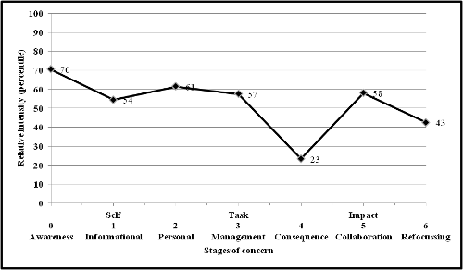
As would be expected at this early stage of implementation, early childhood educations in NSW are mostly non-users of the EYLF. They have some personal concerns for the implementation of the framework, resulting in a slightly negative reaction to its introduction. A low level of concern for the consequences of the EYLF on children is evident and to be expected of non-users. Management issues and collaborating with others as a result of the introduction of the EYLF are also evident.
Figure A1-2: Stages of concerns: Victoria
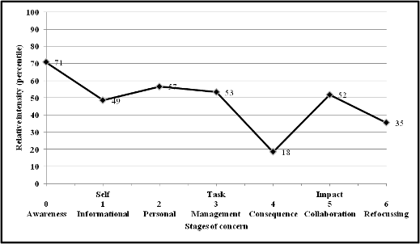
We also see that in the state of Victoria early childhood educators are generally non-users of the EYLF, as would be expected at this early stage of the implementation of the EYLF. They have some personal concerns about its implementation, and consequently are slightly negative towards its introduction. High levels of concern for the management of the implementation of the EYLF and concerns for working with others in using the framework are also evident. As would be expected of non-users, the data does not yet feature regard for the consequences of using the EYLF and its impact upon children.
Figure A1-3: Stages of concerns: Queensland
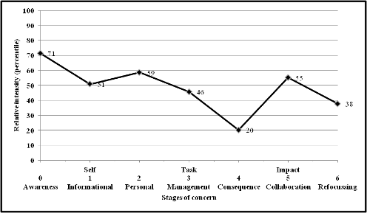
Concerns for the implementation of the EYLF in QLD are consistent with other states, where the early childhood educators are non-users of the EYLF who have some personal concerns for the implementation of the EYLF. A high level of concern for collaborating with others in the use of the EYLF is evident, and some management concerns about its implementation within their services was also noted. A very slight negative reaction to the EYLF is evident as a result of personal concerns. Queensland staff appear to have a reasonable amount of knowledge about the EYLF, suggesting that information disseminated about the EYLF by Commonwealth and state authorities has been received and used for gaining insights into the content of the EYLF.
Figure A1-4: Stages of concerns: South Australia
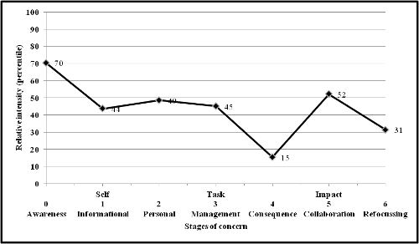
As would also be expected in the early stages of the implementation of the EYLF, early childhood educators in SA are generally non-users, but they are positive about the introduction of the EYLF. SA respondents appear to have reasonable knowledge about the EYLF. They appear not to need more general information about the EYLF. However, they have some concerns for managing the implementation of the EYLF and are worried about using the framework with others.
Figure A1-5: Stages of concerns: Western Australia
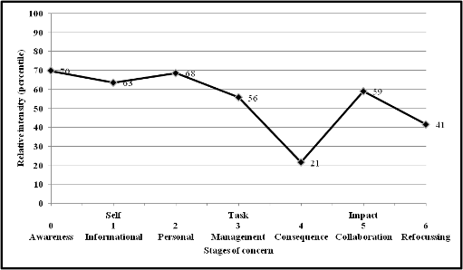
Consistent with other states and territories, early childhood educators in WA are also non-user of the EYLF, with some personal concerns for its introduction. However, this score is relatively low, indicating a generally positive view of the EYLF. Concerns for management and collaboration with others in the implementation of the EYLF are evident. Concern for the consequence of the EYLF on children is not evident because WA is generally not using the EYLF. This finding is to be expected at the early stages of the implementation of the EYLF.
Figure A1-6: Stages of concerns: Tasmania
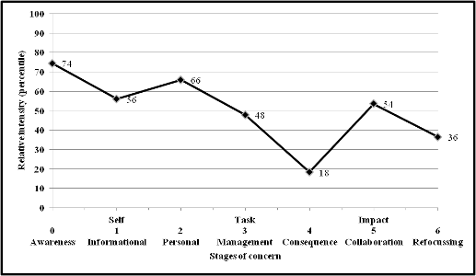
Consistent with other states and territories, Tasmanians are non-users with personal concerns about the EYLF. They are still seeking further information about the EYLF and have concerns about the management of its implementation and its use with others. These findings are expected in the early stages of the implementation of the EYLF.
Figure A1-7: Stages of concerns: Northern Territory
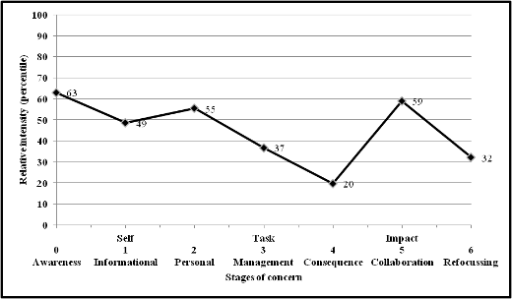
Northern Territory respondents are inexperienced users of the EYLF, but are generally supportive of the introduction of the EYLF. They do not appear to have any major concerns about gaining information about the EYLF, as they appear to be using the framework. They are personally negative towards the EYLF, but this score is quite low. However, respondents do have major concerns for the use of the EYLF with regard to collaboration with colleagues. They are not concerned about implementation. The respondents appear to perceive the quality of implementation to be satisfactory. Interestingly, this profile is more developed in terms of positive identification as users of the EYLF than in other states and territories.

Figure A1-8: Stages of concerns: Australian Capital Territory
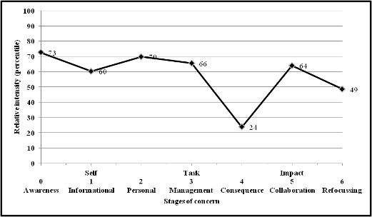
As would be expected in the early stages of the implementation of the EYLF, ACT respondents are non-users of the EYLF. They do show some negativity towards the EYLF, with concerns about management and collaboration for the use of the EYLF.

Stages of concern by region
Figure A1-9: Stages of concerns: Main cities
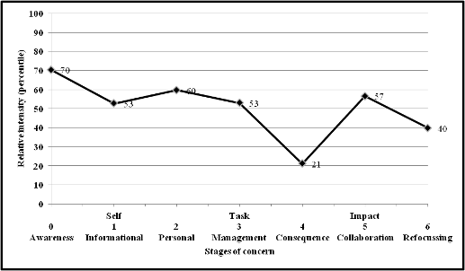
Respondents who are concentrated within the main cities are non-users who are slightly negative about the EYLF and have concerns about management and collaboration with others around the use of the EYLF.
Figure A1-10: Stages of concerns: Inner regional
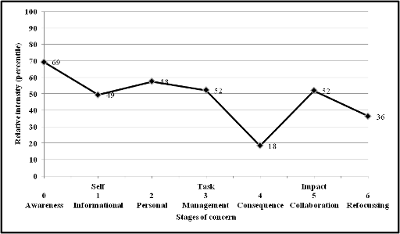
Inner regional are non-users who are negative about the EYLF and they also have concerns about management and collaboration.
Figure A1-11: Stages of concerns: Outer regional
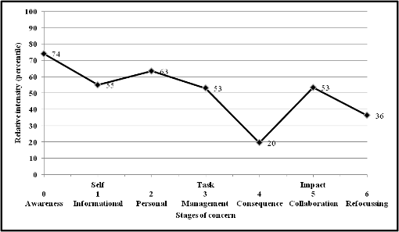
Outer regional respondents are non-users who are slightly negative towards the EYLF. They have a high concern for management of implementation and using the framework with others.
Figure A1-12: Stages of concerns: Remote
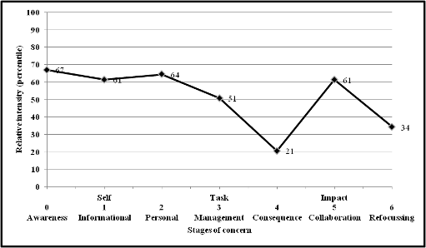
Remote respondents are non-users who are generally very positive towards the EYLF and who have moderate need for more information about it. They are most concerned about collaborative strategies for delivery and implementation of the EYLF.
Figure A1-13: Stages of concerns: Very remote
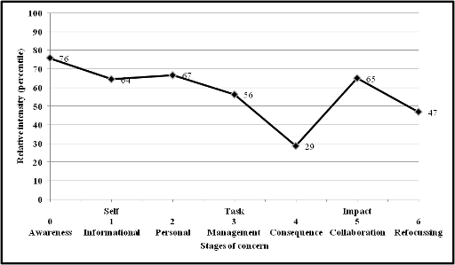
Very Remote respondents were generally non-users who have a high need for information on the EYLF. Respondents have personal concerns and are worried about how they will collaborate, possibly due to the lack of opportunities to network and build professional understanding through shared development activities.

Stages of concern by service type
Figure A1-14: Stages of concerns: Long day care
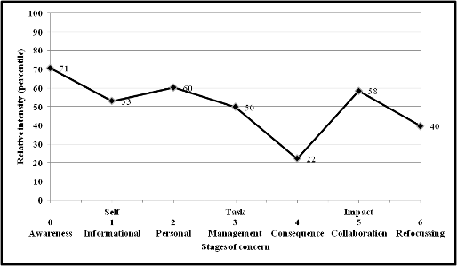
Long day care centres are non-user and have a great deal of concern about working with others and how they will manage the implementation of the EYLF. Very low concerns about impact on children indicate that long day care respondents are not generally at the point where they can consider such impacts. Their slight negativity towards the EYLF is based on personal concerns about being able to sufficiently and effectively get “up to speed”.
Figure A1-15: Stages of concerns: Preschool or Kindergartens
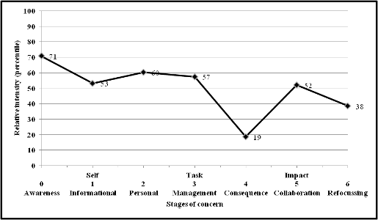
Preschool respondents are non-users and have concerns for management and collaboration with others. Staff are concerned about working with others in relation to the EYLF. They are particularly worried about management and implementation issues associated with the EYLF. At this stage, they are not concerned about the impact of the EYLF on children. In addition, respondents have a slightly negative attitude towards the EYLF based on personal concerns.
Figure A1-16: Stages of concerns: Family day care
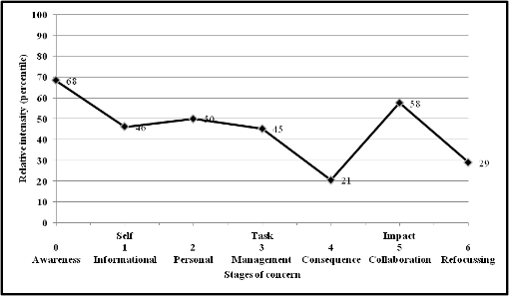
Family day care respondents are non-users. They do not have personal concerns. Family day care respondents have an overall positive view of the EYLF and appear to need marginally less information about it than other service types. However, they are very concerned about how they will use the EYLF with others as noted by their relatively high score of collaboration.

Stages of concern by qualification of respondent
“Level of qualification of staff” is an important quality index in the literature and is embraced within the National Quality Framework. Consequently the study design sought to examine if the stated qualifications of respondents could be used to correlate with implementation i.e. does the professional knowledge of a practitioner (as reflected in their individual level of qualification) have any bearing upon the uptake of the EYLF? We had expected some variability. However, as Figures A1-17 and A1-18 show, no major differences were noted.
Figure A1-17: Stages of concerns: respondents holding higher education qualifications
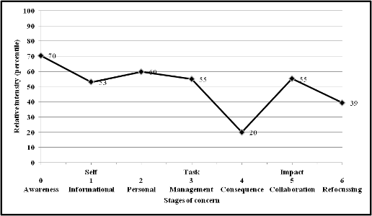
Figure A1.18: Stages of concerns: respondents not holding higher education qualifications
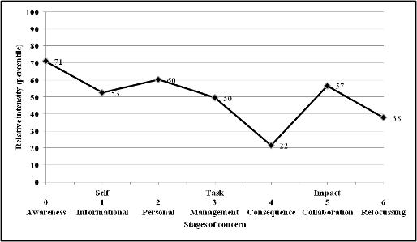
Interestingly the survey results show that there were no significant differences between the concerns expressed by qualified staff and those without qualifications. Both groups were non-users, with a positive view of the EYLF, and with a real need for gaining more information about the EYLF. High concerns for collaborating with others regarding the EYLF were as strong for qualified staff as it was for non-qualified staff. The non-qualified group had slightly less management concerns. However, the five-point difference is not significant because the overall profile across both groups was similar.
Figure A1-19: Stages of concerns: respondents holding higher education qualifications and service using EYLF in the previous week
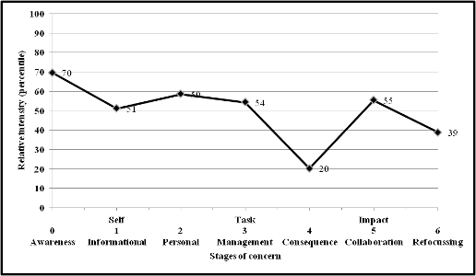
Figure A1-20: Stages of concerns: respondents holding higher education qualifications and service not using EYLF in the previous week
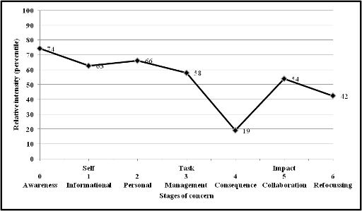
Figures A1-19 and A1-20 appear at first glance to be similar in profile. Whilst both groups consisted of qualified respondents, the difference is that those who were using the EYLF in the week prior to completing the survey, had less need for gaining information about the EYLF, and had less personal concerns about the introduction of the EYLF into the preschool sector.
Those using the EYLF had a score of 51 (informational) and 59 (personal), whilst those who had not used the EYLF had scored 63 (informational) and 66 (personal). Higher needs for information and higher personal concerns suggest that it is through using the EYLF that staff gain more knowledge and confidence in using the framework. This is not surprising, as suggested by Wood (2004) who argues that structured opportunities to redevelop professional practice in new ways enables pre-school teachers to confront “the relationship between theory and practice” and to open their own “situated understanding of their professional knowledge” to “reflective scrutiny and consideration within a community of practice” (Wood 2004, 368).
Figure A1-21: Stages of concerns: respondents not holding higher education qualifications and service using EYLF in the previous week
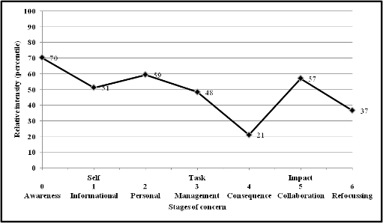
Figure A1-22: Stages of concerns: respondents not holding higher education qualifications and service not using EYLF in the previous week
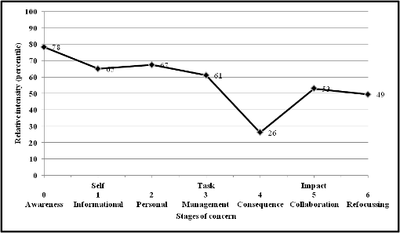
Figures A1-21 and A1-22 show that the profile for non qualified staff, where there are significant differences between those who used the EYLF in the previous week and those who did not. Non-qualified staff that used the EYLF had significantly less concerns about gaining information about the EYLF. This suggests that they had either gained information about its use, and therefore felt more confident to use the EYLF, or through using the EYLF they learned more about the EYLF. Either way, those that used the EYLF had less personal concerns for the implementation of the EYLF than those who had not used it in the previous week. What is interesting to note is that the users of the EYLF had a disproportionate personal concern with respect to the EYLF, suggesting that although they were using the framework in the week prior the survey, they were feeling negative towards the EYLF. Those that had not used the EYLF were personally concerned about the implementation of the EYLF, but they were not negative towards the EYLF compared to those who had been using it.
Table A1-1: Comparison profiles for staff who used the EYLF in week prior to the survey and those who did not use it.
 | 0  Awareness | 1  Informational | 2  Personal | 3  Management | 4  Consequence | 5  Collaboration | 6  Refocusing
Qualified staff Users of EYLF | 70 | 51 | 59 | 54 | 20 | 55 | 39
Qualified staff Non users | 74 | 65 | 66 | 58 | 19 | 54 | 42
Non-Qualified staff Users of EYLF | 70 | 51 | 59 | 48 | 21 | 57 | 37
Non-Qualified staff Non users | 78 | 56 | 67 | 61 | 26 | 53 | 49
The results show that regardless of qualifications, if staff were not using the EYLF in the week prior to the survey, they had higher levels of concern about the EYLF and for gaining information about the EYLF. Non-qualified staff who were non-users were the most negative towards the EYLF, suggesting a need for professional learning to focus on their personal concerns.

Variation in awareness score
Figure A1-23: Distribution of awareness scores
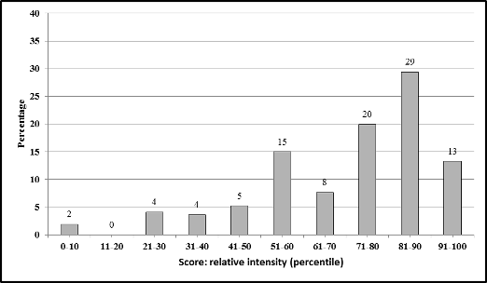

Figure A1-24: Average awareness score by state and territory
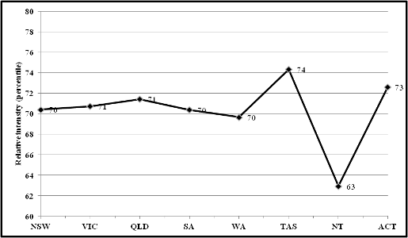
Figure A1-23 suggests that most states and territories have a similar level of intensity to awareness surrounding the introduction of the EYLF, supporting the view that nationally the roll out and implementation of the EYLF is still in its early stages. When the results are considered in relation to Figure A1-24 (Average informational scores by state and territory), the NT appears to have less concerns for the implementation of the EYLF than other states and territories, suggesting they may be engaging with the EYLF more than other states. SA is also demonstrating generally less concerns, and it is possible that they too are engaging with the EYLF more.
When we examine the level of professional development in each of the states and territories, we note that concerns about awareness seem to be higher in those areas where professional development may be perceived to be confusing, difficult to access and/or unavailable, at least among respondents to the survey. The study cannot provide more definitive evidence with respect to the relationships between levels of awareness of the EYLF and the question of professional development, but we strongly believe that the available data produced in this study indicates the need for more comprehensive investigation of a number of relevant factors, including levels of expenditure at the jurisdiction level and the variability between service types with respect to different types of concern.
Figure A1-25: Average awareness score by geographic location of service
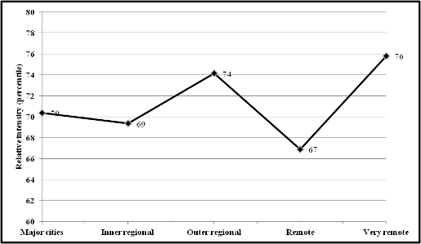
The results shown in Figure A1-25 suggest that the very remote regions are very much aware of the EYLF and the need for engagement. Very remote regions have high information needs and personal concerns about the implementation of the EYLF. Interestingly, outer regions also appear to have higher scores in awareness, but their informational needs are not as pronounced as those of the remote and very remote regions. These results tend to suggest that remote and very remote regions have higher informational needs for learning about the EYLF, than major cities and inner regions, and to some extent outer regions. It is probably due to the fact that remote and very remote regions have not had the same level of access to professional learning and resources (see Figure A1-29 – Average informational score by geographic location).
Figure A1-26: Average awareness score by type of service
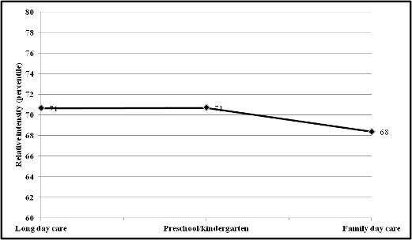
It would appear that all service types have very similar levels of awareness of the EYLF. However, when different service types are compared with respect to scores for different factors, a consistent decrease in concern is shown among family day care service respondents, which is an outcome of the study that may warrant further investigation.

Variation in informational score
Figure A1-27: Distribution of informational scores
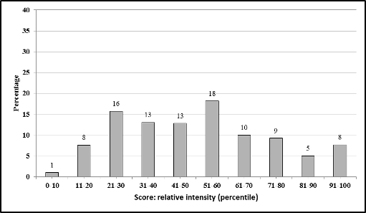
Figure A1-28: Average informational score by state and territory
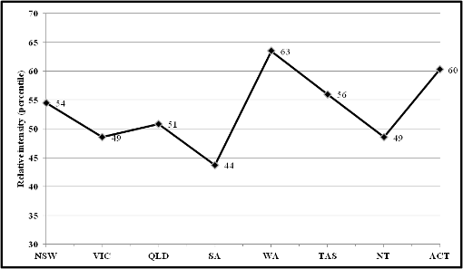

Figure A1-29: Average informational score by geographic location
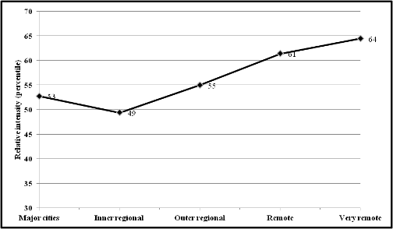
Figure A1-30: Average informational score by type of service
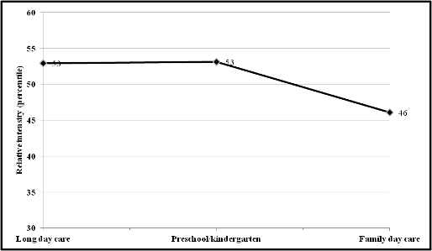
Figure A1-30 suggests that family day care have the least information needs about the EYLF from of all the service types. This may be taken as reflecting differences in values in that part of the sector that is more often staffed by unqualified personnel, often employed in private homes with the administration conducted by local government, and that perceptions of the function of family day care are shaped by different forces than in other institutional components of the early childhood sector, such as preschools. These complex variables could be seen as having a subtle impact on data in the study, but the messages indicate a more layered array of contributing factors with respect to opportunities to incorporate Commonwealth reforms. However without a broader investigative scope the current research on this issue remains difficult to confirm and existing literature about the quality of family day care in Australia more generally is now out-of-date.

Variation in personal score
Figure A1-31: Distribution of personal scores
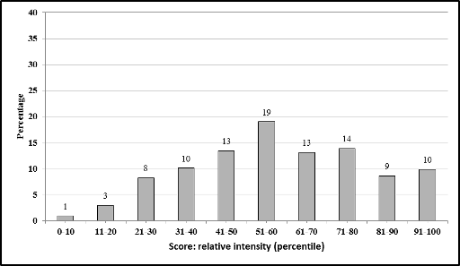

Figure A1-32: Average personal score by state and territory
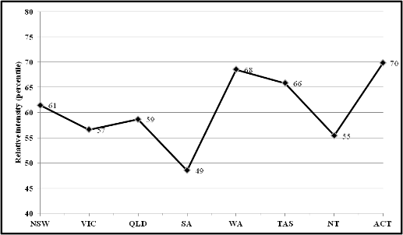
The personal concerns of staff would appear to be highest for the ACT, WA and Tasmania. However, concerns are mostly positively oriented towards finding out more about the EYLF, with the most positive expressions towards the EYLF shown by SA, and the least positive expressed by the ACT. The latter is determined by examining the personal rating in relation to the overall profile for each state and territory (discussed earlier in the report).

Figure A1-33: Average personal score by geographic location
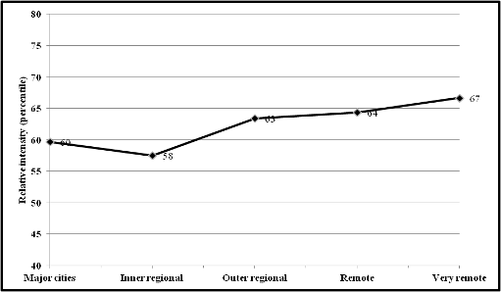

Figure A1-34: Average personal score by type of service
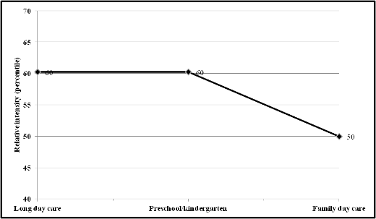

Variation in management score
Figure A1-35: Distribution of management scores
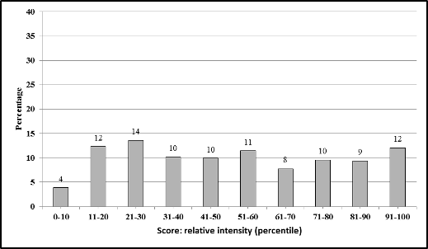
The results of the distributions shown here in Figure A1-35 suggest that approximately 30% of respondents have high management concerns regarding the EYLF, whilst at the same time less than 30% show low levels of concern. The rather even distribution of results suggests that management issues are experienced unevenly throughout Australia. The average national result for management concerns shown in Figure 1 have to be read with this even distribution in mind. That is, roughly a third of staff who responded to the survey do not have any management concerns, a third have some and the final third have major management concerns for the implementation of the EYLF. However, the findings do not change the overall reading of the national results, because non-user or inexperienced user is the dominant profile shown nationally, as well as for all states and territories.
Figure A1-36: Average management score by state and territory
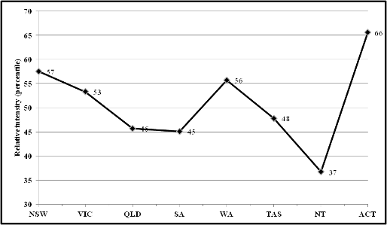

Figure A1-37: Average management score by geographic location
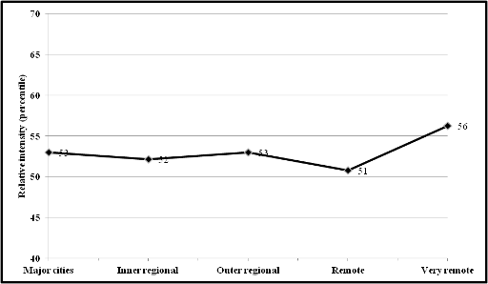

Figure A1-38: Average management score by type of service
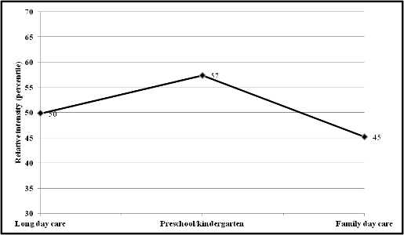
As one might expect for a single staff service such as family day care, management concerns do not rank as highly as it does for multi-staff services such as preschools, kindergartens and long day care centres.

Variation in consequence score
Figure A1-39: Distribution of consequence scores
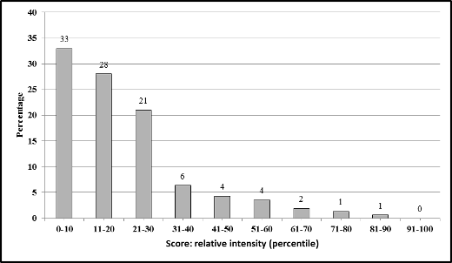
The distribution of results for what impact the EYLF has on children is supportive of national findings and overall state and territory findings that at this stage, staff are not concerned about the impact the EYLF has on outcomes for children. This is not surprising, as staff would need to be users of the EYLF before they would be able to make judgements about its effectiveness for improving the outcomes of the children in their service/centre. This finding is consistent with the view that the staff are inexperienced or non-users of the EYLF.
Figure A1-40: Average consequence score by state and territory
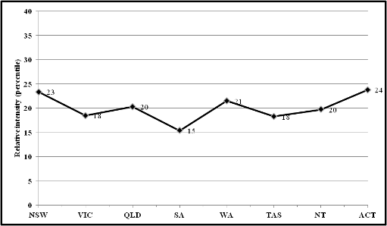
The differences between states and territories need to be read in relation to the overall profiles for respective states and territories. The lower score for SA cannot be easily explained. It is possible that the overall greater awareness of the EYLF (as noted by lower needs for information) and the positive response to the EYLF (personal needs is not very different from information needs), may mean that professional learning sessions in SA have resulted in staff being more familiar with the EYLF than other states and territories and more confident about the usefulness of the EYLF for children.
Figure A1-41: Average consequence score by geographic location
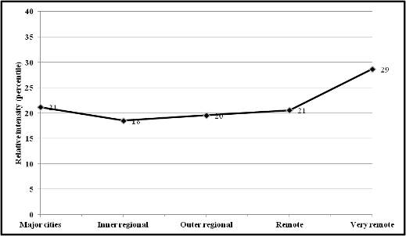
Very remote centres are clearly more concerned about the impact of the EYLF on children. All other regions display remarkably similar profiles.
Figure A1-42: Average consequence score by type of service
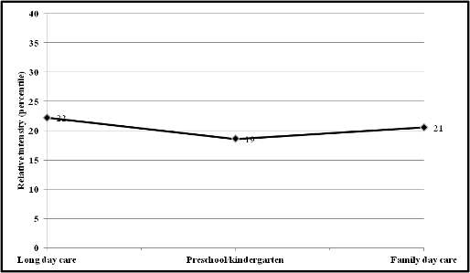
All service types have a similar profile for the impact the EYLF has on children.

Variation in collaboration score
Figure A1-43: Distribution of collaboration scores
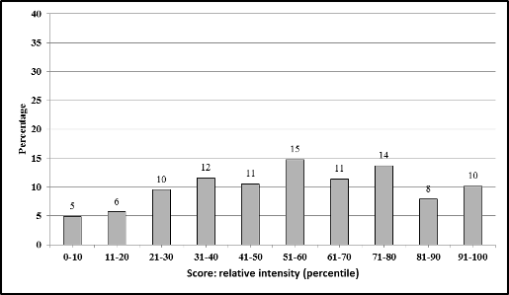
Collaboration, like management concerns has an even distribution of scores. The findings suggest that the people completing the survey responded to concerns for collaboration in similar ways to their management concerns. That is, the respondents were evenly distributed in their concerns across collaboration and leadership, supporting the view that the people completing the surveys were in pedagogical leadership positions and were actively involved in the implementation of the EYLF. This was the target group, and this gives confidence in the overall results obtained for the C-BAM survey.

Figure A1-44: Average collaboration score by state and territory
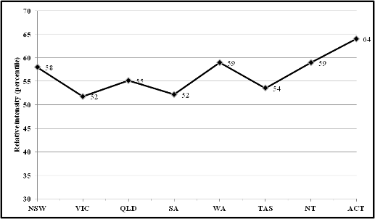

Figure A1-45: Average collaboration score by geographic location
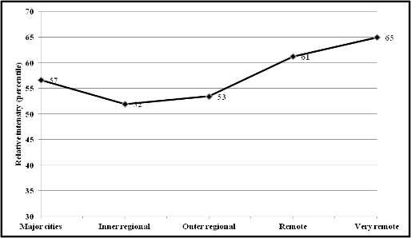
The very remote and remote regions were most concerned about their ability to collaborate. This is not surprising given the geographical location, and potential isolation of staff.
Figure A1-46: Average collaboration score by type of service
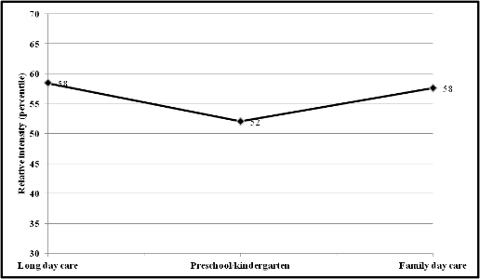
Preschools appear to have the least concerns about collaboration. This may be due to the relationships prevailing between institutional and professional factors in determining the response to this question by preschool staff. We suspect, for example, that where preschools are attached to primary schools the availability for collaboration at a whole-organisation level may be better than for stand-alone long day care facilities administered by local government in a remote location. At the same time, it would be necessary to undertake a more comprehensive set of comparisons between service types and the nature of values with respect to the reforms more generally in order to address such questions appropriately.

Variation in refocussing score
Figure A1-47: Distribution of refocusing scores
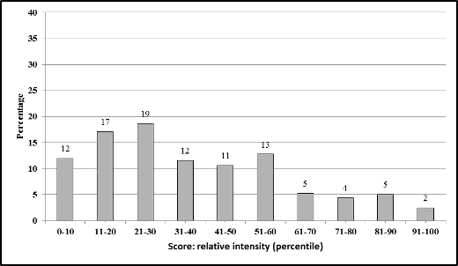
The distribution of results shows that the majority of respondents scored this item low or below 50%. This is not surprising and is what is expected for the early stages for the implementation of an innovation, such as the EYLF.
Figure A1-48: Average refocusing score by state and territory
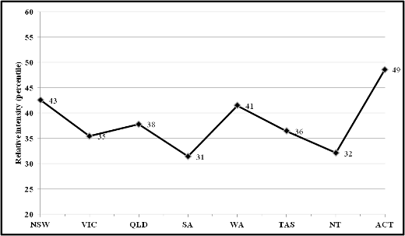
Although Figure A1-48 shows a high score for the ACT, this result needs to be read in relation to overall high scores for the ACT, where there is generally strong evidence of low level of use of the EYLF.

Figure A1-49: Average refocusing score by geographic location
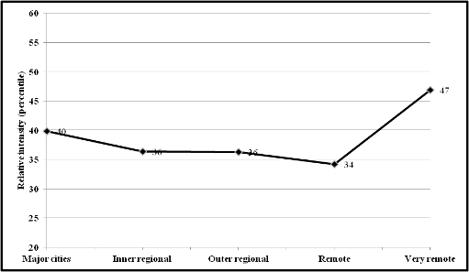
The most interesting finding is for the very remote region. This score tends to suggest that the remote regions may not find the EYLF useful for the children they work with. Relevance of the EYLF may be an important factor here and further work should be undertaken to find out if this is the case, as it will influence the uptake of the EYLF in this geographical sector.
Figure A1-50: Average refocusing score by type of service
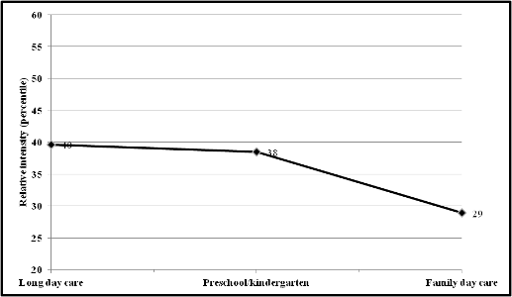

Appendix 2: Frequency counts for EYLF Baseline Study 2011 data items
Table A2-1 Frequency counts: State and territory
State | Count | Per cent | Weighted count | Weighted per cent
NSW | 461 | 31 | 3511 | 32
VIC | 410 | 27 | 2689 | 25
QLD | 263 | 18 | 1813 | 17
SA | 132 | 9 | 763 | 7
WA | 117 | 8 | 1371 | 13
TAS | 52 | 3 | 336 | 3
NT | 29 | 2 | 200 | 2
ACT | 31 | 2 | 197 | 2
Australia | 1495 | 100 | 10881 | 100
Table A2-2 Frequency counts: Type of service
Type of service | Count | Per cent | Weighted count | Weighted per cent
Long day care | 817 | 55 | 5960 | 55
Preschool/kindergarten | 608 | 41 | 4591 | 42
Family day care | 70 | 5 | 330 | 3
All | 1495 | 100 | 10881 | 100
Table A2-3 Frequency counts: Geographical area
Region | Count | Per cent | Weighted count | Weighted per cent
Major cities | 943 | 63 | 7170 | 66
Inner regional | 321 | 21 | 2060 | 19
Outer regional | 167 | 11 | 1156 | 11
Remote | 37 | 2 | 259 | 2
Very remote | 27 | 2 | 235 | 2
All | 1495 | 100 | 10881 | 100
Table A2-4 Frequency counts: Main role of respondent
Main role of respondent | Count | Per cent | Weighted count | Weighted per cent
Principal/Director/coordinator/teacher in charge | 1264 | 85 | 8893 | 82
Group leader/teacher | 162 | 11 | 1419 | 13
Curriculum coordinator | 27 | 2 | 232 | 2
Other | 42 | 3 | 336 | 3
All | 1495 | 100 | 10881 | 100
Table A2-5 Frequency counts: Number of services with children of different ages
Number of employees | Count | Per cent | Weighted count | Weighted per cent
Less than 1 | 765 | 51 | 5257 | 48
1 | 843 | 56 | 5794 | 53
2 | 970 | 65 | 6783 | 62
3 | 1,302 | 87 | 9208 | 85
4 | 1,457 | 97 | 10549 | 97
5 | 1,396 | 93 | 10177 | 94
6 | 402 | 27 | 2977 | 27
7 | 238 | 16 | 1638 | 15
8 | 215 | 14 | 1501 | 14
9 or older | 189 | 13 | 1257 | 12
Table A2-6 Frequency counts: Number of paid employees
Number of employees | Count | Per cent | Weighted count | Weighted per cent
1-4 | 287 | 19 | 2064 | 19
5-19 | 984 | 66 | 7148 | 66
20-49 | 206 | 14 | 1550 | 14
50-99 | 15 | 1 | 97 | 1
100-149 | 3 | 0 | 22 | 0
All | 1495 | 100 | 10881 | 100
Table A2-7 Frequency counts: Type of program offered
Type of program | Count | Per cent | Weighted count | Weighted per cent
Long day care: stand-alone | 755 | 51 | 5465 | 50
Long day care: integrated setting | 128 | 9 | 921 | 8
Family day care | 69 | 5 | 328 | 3
Preschool program: stand-alone | 434 | 29 | 3075 | 28
Preschool program: integrated setting | 109 | 7 | 1091 | 10
All | 1495 | 100 | 10881 | 100
Table A2-8 Frequency counts: Type of management of service
Type of management | Count | Per cent | Weighted count | Weighted per cent
Private not for profit – community | 563 | 38 | 3780 | 35
State/territory/local government | 153 | 10 | 954 | 9
Private for profit | 466 | 31 | 3468 | 32
State/territory government schools | 104 | 7 | 754 | 7
Independent schools | 58 | 4 | 693 | 6
Catholic schools | 25 | 2 | 395 | 4
Other | 126 | 8 | 837 | 8
All | 1495 | 100 | 10881 | 100
Table A2-9 Frequency counts: Curriculum framework used last week
Curriculum framework | Count | Per cent | Weighted count | Weighted per cent
State/territory | 94 | 6 | 809 | 7
EYLF | 1054 | 71 | 7331 | 67
Other | 54 | 4 | 405 | 4
State/territory & EYLF | 183 | 12 | 1507 | 14
State/territory & Other | 3 | 0 | 67 | 1
EYLF/Other | 61 | 4 | 455 | 4
State/territory, EYLF & Other | 14 | 1 | 98 | 1
None | 25 | 2 | 156 | 1
Don’t know | 7 | 0 | 52 | 0
All | 1495 | 100 | 10881 | 100
The Table includes multiple choices.
Table A2-10 Frequency counts: Staff dealings with Indigenous children
Staff deal appropriately | Count | Per cent | Weighted count | Weighted per cent
Strongly agree | 841 | 56 | 6142 | 56
Agree | 421 | 28 | 3051 | 28
Neutral | 211 | 14 | 1527 | 14
Disagree | 8 | 1 | 59 | 1
Strongly disagree | 9 | 1 | 67 | 1
Not applicable | 5 | 0 | 35 | 0
All | 1495 | 100 | 10881 | 100
Table A2-11 Frequency counts: Staff dealings with children with disabilities
Staff deal appropriately | Count | Per cent | Weighted count | Weighted per cent
Strongly agree | 1007 | 67 | 7361 | 68
Agree | 409 | 27 | 2977 | 27
Neutral | 65 | 4 | 445 | 4
Disagree | 8 | 1 | 55 | 1
Strongly disagree | 6 | 0 | 43 | 0
All | 1495 | 100 | 10881 | 100
Table A2-12 Frequency counts: Staff dealings with children from non-English speaking backgrounds
Staff deal appropriately | Count | Per cent | Weighted count | Weighted per cent
Strongly agree | 925 | 62 | 6776 | 62
Agree | 441 | 29 | 3214 | 30
Neutral | 112 | 7 | 760 | 7
Disagree | 8 | 1 | 48 | 0
Strongly disagree | 5 | 0 | 37 | 0
Not applicable | 4 | 0 | 46 | 0
All | 1495 | 100 | 10881 | 100
Table A2-13 Frequency counts: Sex of person completing survey
Sex | Count | Per cent | Weighted count | Weighted per cent
Males | 40 | 3 | 440 | 4
Females | 1455 | 97 | 10441 | 96
All | 1495 | 100 | 10881 | 100
Table A2-14 Frequency counts: Age of person completing survey
Age | Count | Per cent | Weighted count | Weighted per cent
16 | 3 | 0 | 20 | 0
20 | 1 | 0 | 7 | 0
21 | 3 | 0 | 34 | 0
22 | 6 | 0 | 41 | 0
23 | 11 | 1 | 76 | 1
24 | 12 | 1 | 87 | 1
25 | 16 | 1 | 123 | 1
26 | 36 | 2 | 262 | 2
27 | 34 | 2 | 233 | 2
28 | 23 | 2 | 179 | 2
29 | 37 | 2 | 266 | 2
30 | 48 | 3 | 354 | 3
31 | 37 | 2 | 267 | 2
32 | 43 | 3 | 324 | 3
33 | 34 | 2 | 245 | 2
34 | 46 | 3 | 342 | 3
35 | 45 | 3 | 325 | 3
36 | 33 | 2 | 233 | 2
37 | 40 | 3 | 293 | 3
38 | 36 | 2 | 249 | 2
39 | 41 | 3 | 281 | 3
40 | 56 | 4 | 422 | 4
41 | 39 | 3 | 285 | 3
42 | 37 | 2 | 257 | 2
43 | 57 | 4 | 451 | 4
44 | 43 | 3 | 301 | 3
45 | 51 | 3 | 393 | 4
46 | 40 | 3 | 300 | 3
47 | 36 | 2 | 268 | 2
48 | 50 | 3 | 417 | 4
49 | 50 | 3 | 353 | 3
50 | 55 | 4 | 387 | 4
51 | 50 | 3 | 351 | 3
52 | 53 | 4 | 354 | 3
53 | 38 | 3 | 277 | 3
54 | 38 | 3 | 282 | 3
55 | 26 | 2 | 195 | 2
56 | 38 | 3 | 283 | 3
57 | 28 | 2 | 187 | 2
58 | 24 | 2 | 148 | 1
59 | 26 | 2 | 177 | 2
60 | 11 | 1 | 83 | 1
61 | 17 | 1 | 152 | 1
62 | 11 | 1 | 72 | 1
63 | 10 | 1 | 79 | 1
64 | 10 | 1 | 69 | 1
65 | 7 | 0 | 45 | 0
66 | 3 | 0 | 15 | 0
68 | 1 | 0 | 5 | 0
69 | 1 | 0 | 7 | 0
72 | 1 | 0 | 7 | 0
73 | 1 | 0 | 9 | 0
75 | 2 | 0 | 12 | 0
All | 1495 | 100 | 10881 | 100
Table A2-15 Frequency counts: Indigenous status of person completing survey
Indigenous status | Count | Per cent | Weighted count | Weighted per cent
Aboriginal but not Torres Strait Islander | 25 | 2 | 166 | 2
Torres Strait Islander but not Aboriginal | 2 | 0 | 7 | 0
Both Aboriginal and Torres Strait Islander | 1 | 0 | 9 | 0
Neither Aboriginal nor Torres Strait Islander | 1467 | 98 | 10699 | 98
All | 1495 | 100 | 10881 | 100
Table A2-16 Frequency counts: Country of birth of person completing survey
Country of birth | Count | Per cent | Weighted count | Weighted per cent
Australia | 1234 | 83 | 8803 | 81
Other | 261 | 17 | 2078 | 19
All | 1495 | 100 | 10881 | 100
Table A2-17 Frequency counts: Language spoken at home of person completing survey
Language spoken at home | Count | Per cent | Weighted count | Weighted per cent
English | 1447 | 97 | 10463 | 96
Other | 48 | 3 | 418 | 4
All | 1495 | 100 | 10881 | 100
Table A2-18 Frequency counts: Qualification relevant to ECEC of person completing survey
Holds qualification | Count | Per cent | Weighted count | Weighted per cent
Yes | 1401 | 94 | 9979 | 92
No | 94 | 6 | 902 | 8
All | 1495 | 100 | 10881 | 100
Table A2-19 Frequency counts: Field of highest qualification relevant to ECEC of person completing survey
Field of qualification | Count | Per cent | Weighted count | Weighted per cent
Teaching (early childhood related) | 749 | 50 | 5409 | 50
Teaching (primary) | 61 | 4 | 579 | 5
Teaching (other) | 13 | 1 | 100 | 1
Child care | 517 | 35 | 3480 | 32
Nursing (including Mothercraft Nursing) | 9 | 1 | 56 | 1
Other human welfare studies and services | 4 | 0 | 25 | 0
Behavioural science | 6 | 0 | 45 | 0
Other childhood related | 42 | 3 | 285 | 3
None | 94 | 6 | 902 | 8
All | 1495 | 100 | 10881 | 100
Table A2-20 Frequency counts: Level of highest education qualification relevant to ECEC of person completing survey
Level of qualification | Count | Per cent | Weighted count | Weighted per cent
Postgraduate | 355 | 3 | 355 | 3
Graduate Dip/Cert | 619 | 6 | 619 | 6
Bachelor (Hons) | 190 | 2 | 190 | 2
Bachelor (4 years) | 2719 | 25 | 2719 | 25
Bachelor (3 years) | 1898 | 17 | 1898 | 17
Advanced Diploma | 1591 | 15 | 1591 | 15
Diploma | 2475 | 23 | 2475 | 23
Certificate IV | 7 | 0 | 7 | 0
Certificate III | 65 | 1 | 65 | 1
Other certificate | 60 | 1 | 60 | 1
None | 902 | 8 | 902 | 8
All | 10881 | 100 | 10881 | 100
Table A2-21 Frequency counts: Main type of work performed in current job by person completing survey
Main type of work performed | Count | Per cent | Weighted count | Weighted per cent
Primary contact with children | 565 | 38 | 4290 | 39
Other contact with children | 558 | 37 | 3897 | 36
Management/administration only | 283 | 19 | 2015 | 19
Other | 89 | 6 | 678 | 6
All | 1495 | 100 | 10881 | 100
Table A2-22 Frequency counts: Hours of work of person completing survey
Hours of work | Count | Per cent | Weighted count | Weighted per cent
Part-time | 338 | 23 | 2389 | 22
Full-time | 1157 | 77 | 8492 | 78
All | 1495 | 100 | 10881 | 100
Table A2-23 Frequency counts: Employment contract of person completing survey
Employment contract | Count | Per cent | Weighted count | Weighted per cent
Permanent | 1443 | 97 | 10493 | 96
Fixed-term | 37 | 2 | 273 | 3
Casual | 15 | 1 | 115 | 1
All | 1495 | 100 | 10881 | 100
Table A2-24 Frequency counts: Duration in current job of person completing survey
Duration of current job | Count | Per cent | Weighted count | Weighted per cent
Less than one year | 136 | 9 | 932 | 9
1-2 years | 174 | 12 | 1315 | 12
3-5 years | 344 | 23 | 2637 | 24
6-10 years | 347 | 23 | 2460 | 23
11 years or more | 494 | 33 | 3536 | 32
All | 1495 | 100 | 10881 | 100
Table A2-25 Frequency counts: Year of first job in ECEC of person completing survey
Type of comment | Count | Per cent | Weighted count | Weighted per cent
1968 | 1 | 0 | 7 | 0
1972 | 32 | 2 | 217 | 2
1973 | 7 | 0 | 50 | 0
1974 | 11 | 1 | 75 | 1
1975 | 14 | 1 | 108 | 1
1976 | 14 | 1 | 103 | 1
1977 | 15 | 1 | 112 | 1
1978 | 25 | 2 | 160 | 1
1979 | 19 | 1 | 117 | 1
1980 | 24 | 2 | 169 | 2
1981 | 24 | 2 | 184 | 2
1982 | 33 | 2 | 227 | 2
1983 | 28 | 2 | 182 | 2
1984 | 47 | 3 | 328 | 3
1985 | 34 | 2 | 224 | 2
1986 | 34 | 2 | 251 | 2
1987 | 27 | 2 | 190 | 2
1988 | 27 | 2 | 214 | 2
1989 | 43 | 3 | 290 | 3
1990 | 63 | 4 | 466 | 4
1991 | 38 | 3 | 269 | 2
1992 | 41 | 3 | 305 | 3
1993 | 52 | 3 | 364 | 3
1994 | 56 | 4 | 420 | 4
1995 | 56 | 4 | 378 | 3
1996 | 46 | 3 | 332 | 3
1997 | 53 | 4 | 375 | 3
1998 | 53 | 4 | 385 | 4
1999 | 54 | 4 | 396 | 4
2000 | 73 | 5 | 554 | 5
2001 | 57 | 4 | 415 | 4
2002 | 53 | 4 | 391 | 4
2003 | 46 | 3 | 350 | 3
2004 | 48 | 3 | 363 | 3
2005 | 49 | 3 | 340 | 3
2006 | 58 | 4 | 473 | 4
2007 | 39 | 3 | 299 | 3
2008 | 45 | 3 | 337 | 3
2009 | 23 | 2 | 197 | 2
2010 | 14 | 1 | 114 | 1
2011 | 19 | 1 | 152 | 1
All | 1495 | 100 | 10881 | 100
Table A2-26 Frequency counts: Current study for qualification in ECEC field of person completing survey
Studying | Count | Per cent | Weighted count | Weighted per cent
Yes | 264 | 18 | 1896 | 17
No | 1,231 | 82 | 8985 | 83
All | 1495 | 100 | 10881 | 100
Table A2-27 Frequency counts: ECEC related professional development in previous 2 years
PD undertaken | Count | Per cent | Weighted count | Weighted per cent
Yes | 1381 | 92 | 9938 | 91
No | 114 | 8 | 943 | 9
All | 1495 | 100 | 10881 | 100
Table A2-28 Frequency counts: EYLF related professional development
PD related to EYLF | Count | Per cent | Weighted count | Weighted per cent
Yes | 1308 | 87 | 9371 | 86
No | 73 | 5 | 567 | 5
Not applicable | 114 | 8 | 943 | 9
All | 1495 | 100 | 10881 | 100
Table A2-29 Frequency counts: Comments provided
Comments provided | Count | Per cent | Weighted count | Weighted per cent
Yes | 645 | 43 | 4584 | 42
No | 850 | 57 | 6297 | 58
All | 1495 | 100 | 10881 | 100
Table A2-30 Frequency counts: Types of comments provided
Type of comment | Count | Per cent | Weighted count | Weighted per cent
Positive comment about survey | 10 | 1 | 64 | 1
Negative comment about survey | 75 | 5 | 535 | 5
Positive comment about EYLF | 376 | 25 | 2603 | 24
Negative comment about EYLF | 64 | 4 | 432 | 4
Positive comment about professional development | 19 | 1 | 134 | 1
Negative comment about professional development | 56 | 4 | 467 | 4
Positive comment about EYLF documentation | 16 | 1 | 116 | 1
Negative comment about EYLF documentation | 65 | 4 | 471 | 4
Lack of resources implementing EYLF | 152 | 10 | 1036 | 10
Positive comment about integration with other frameworks/curricula | 26 | 2 | 190 | 2
Negative comment about integration with other frameworks/curricula | 25 | 2 | 177 | 2
Anxiety about assessment | 75 | 5 | 573 | 5
Positive support for CALD including urban/rural | 5 | 0 | 33 | 0
Negative support for CALD including urban/rural | 28 | 2 | 172 | 2
Pace/volume of change too fast/high | 99 | 7 | 668 | 6
Positive about other staff’s understanding of EYLF | 44 | 3 | 303 | 3
Negative about other staff’s understanding of EYLF | 41 | 3 | 316 | 3
Positive impact of EYLF on children | 86 | 6 | 605 | 6
Negative impact of EYLF on children | 9 | 1 | 62 | 1
Positive impact of EYLF of educators | 55 | 4 | 400 | 4
Negative impact of EYLF on educators | 67 | 4 | 464 | 4
Positive impact of EYLF on family involvement | 34 | 2 | 267 | 2
Negative impact of EYLF on family involvement | 19 | 1 | 140 | 1

Appendix 3: Analysis of open-ended comments
Below is a summary of responses to an open-ended questionnaire in the Early Years Learning Framework (EYLF) Baseline Study survey. The questionnaire asked respondents to comment on the EYLF or the survey.
The survey was administered to 3037 early childhood education and care services across Australia. Of these 64 services had closed and 27 had an identical contact email address as another service. Altogether 1495 services completed the survey. While the vast majority completed the survey online, a small number completed using a hardcopy. Comments to the last question on the survey were provided by 645 respondents. This section provides an analysis of these comments.
Thirteen common issues were identified from analysing the comments. Each comment is classified as being positive or negative in relation to one or more of these issues. The Table A3-1 summarises these responses.
Table A3-1 Summary of responses to open-ended question at the end of survey
 | Issue | Number of positive comments | Number of negative comments
1 | Survey in general | 10 | 74
2 | EYLF in general | 373 | 63
3 | Professional development | 19 | 56
4 | EYLF documentation | 16 | 65
5 | Lack of resources (including time) implementing EYLF | 150
6 | Integration with other frameworks/curricula | 26 | 25
7 | Anxiety/concern about assessment | 75
8 | Support for CALD students, including urban/rural etc | 5 | 28
9 | Pace/volume of change too fast/high | 99
10 | Other staff’s understanding and knowledge of EYLF | 44 | 40
11 | EYLF’s impact on children | 84 | 9
12 | EYLF’s impact on the educators | 55 | 67
13 | EYLF’s impact on family involvement | 34 | 18

Examples of comments relating to particular issues
1. Survey in general
- I feel the wording of many of the initial section of this survey quite confusing and misleading (9805)
- Found initial Questions negative and a little confusing (5405)
- The Survey questions at the beginning in regard to concerns about staff implementing the EYLF my answer is I am not concerned because staff have embraced the document, however it could read that I do not care (8678)
2. EYLF in general
- I think the EYLF is a much needed national program and am very excited about implementing it in my scheme (5905)
- It is a learning process. I am happy to continue learning by joining in with other services (1612)
- All good (1438)
- At this centre we are very excited about the EYLF however we have much yet to learn in the process of documentation/ critical reflection etc. However we are working on this and have set up team planning meetings with all our staff to reflect on the Frameworks and modify our planning accordingly (1710)
- Total confusion with this although our centre has recently under gone and extensive training course this coupled with the new national standards is causing extreme stress to our centres (8535)
- Our service has been implementing EYLF over the past 2 years. Our team still has a long way to go in turns of understanding its full potential but feel we are well on the way (6644)
- The more I use the frameworks and familiarise myself with the outcomes and the documents the more I understand (1019)
- It has taken me awhile to get my head around it all and I feel I use the EYLF confidently now (2097)
- Excellent document well over due! Although change can be scary it is also such an exciting time and we are ready for the ride! (8508)
- I think the EYLF validates all the hard work that has been done in the early education and care sector for a long time (10713)
- The babies’ room did find it difficult breaking down the framework to suit the babies (7131)
- We use the EYLF but would like to know if we are using it properly (7636)
- I believe condensing the Framework would be more beneficial as the five outcomes we need to address working with children often overlap (2275)
- EYLF is putting into a framework with new names what we as professionals were already doing with the children (2004)
- Learning frameworks seems to be the same - we just change the terminology (3275)
3. Professional development
- Services require a lot more support and guidance to assist with implementing the framework (2360)
- Find websites often difficult to use and locate relevant info. It would be great to have a template or different suggestions on how to implement this in a day to day program (1246)
- I would like training to still be available for new staff and refresher courses that explores new ideas and concepts in relation to the EYLF (7623)
- I think that the roll out of EYLF needed more time and training for free for each centre, expecting on top of everything else we have to do, to go somewhere out of our area after hours for training is too much for our teams and with personal commitments we all have, it need to be more localised (5651)
- what training that was available was rushed, in our own time and often at our own cost. The facilitators were disparaging of the way the change was implemented, and also offered conflicting views on the changes (1347)
- The government should have run a course that had enough room for all centre to attend as when we phoned and booked on the DEEWR run course they did not have enough vacancies and now we do not know which are the best courses for knowledge as so many companies are stating this and that and now we are throwing money away trying to gain as much information as possible (6329)
- We are still working our way through fully implementing the EYLF in our service, gradually feeling like we are understanding more of it. The PD courses I have attended in relation to the EYLF have been very beneficial (5911)
- I don't feel that a 4 yr trained teacher necessary! A three yr degree would be sufficient to implement the EYLF (10189)
4. EYLF documentation
- I feel very confident in using this document. It is easy to read and use on a daily basis—with other educators, children and their families. Supporting documents such as the Educator’s guide gives lots of thought provoking questions to start critically reflective on our current practices and continually focusing on high quality education and care for children (1558)
- The EYLF is a reader friendly document which can be understood by all staff no matter what their qualifications. It guides our everyday practices (542)
- I do like it, but I believe for me to have other staff understand it better, it should have been explained more in common words (7448)
- The language used in the EYLF documentation is not user friendly for the wide ranges of Qualifications and experience within the Early Childhood field. Very open to interpretation, does not clear directions and is multifaceted (6224)
- Our main issues are ones of interpretation (1088)
- even with my academic qualifications I find the language difficult (1272)
5. Resources (including time) implications in implementing EYLF
- I think a lot of things are changing and it just becomes a little too much for everyone to follow. It is our time that we are using and not getting paid for (8517)
- I am concerned for FDC educators that as sole educators, even though they have coordinators support, they will be using their own time, without pay to document information that for most they can discuss and describe (10038)
- The amount of paper work is overwhelming as is the use of the framework when writing transition statements which at this point have taken me 135 hours of unpaid work ....and still going...copying and collating (2105)
- Another addition to an already exhaustive workload. Too many changes in ECE at the one time - not enough time to educate staff and implement it appropriately and review internally (568)
- too much change too quickly. Also need examples of ways to implement EYLF as my time is already stretched to breaking point, I seem to be looking for what’s required and find websites often difficult to use and locate relevant info. It would be great to have a template or different suggestions on how to implement this in a day to day program (1246)
- The EYLF being introduced the same time as the new National Standards and National Regulations is at times overwhelming, demanding and very time consuming in unpacking, understanding and passing on information, inspiration, learning and teaching to Educators and parents as well as to staff (10457) Another addition to an already exhaustive workload (568)
- Another addition to an already exhaustive workload (568)
- I am convinced they are trying to 'kill' all preschool directors off by continually increasing their work load to extremely unsustainable levels. (Sorry about the grizzle but I know all preschool directors in our area are at breaking point. I personally work approx 70 hours per week and still don't keep up. We have an average of 90-100 children per term attending our centre. I had one weekend off for the entire year which was recently due to family commitments (3250)
- It is interesting to see the vast support around the introduction of the new National Curriculum for schools and compare it to the 'just get on and use it' approach been given to preschools (3250)
- I understand from other colleagues that Centre Based providers are receiving financial assistance in the form of a one off payment whereas FDC providers are not. I am not sure if this is just anecdotal evidence or if it is actual fact (5909)
- Because of the EYLF and the lack of support in my school, I have resigned my teaching position (3805)
- I fear FDC will lose very good educators if their workload extends to far beyond their already long days (10038)
6. Integration with other frameworks/curricula
- I really like the way that the EYLF links in with the Victorian Framework. It gives a voice to importance of the work we do with children and their families (2090)
- It is disappointing that EYLF does not link with school curriculum in the seamless way that the South Australian Curriculum, Standards and Accountability Framework did. This made conversations with our school colleagues and reporting much clearer. EYLF focuses on the early years, which is great for child care, but I would like to see links which could work both ways in supporting children transitioning to school (3037)
- Building waterfalls absorbs the framework. We have worked closely with it and now we have BW 2 it is embedded in that curriculum (2548)
- We use the EYLF as the overarching framework with which we align our Montessori Principals and Practices (7480)
- It's been a juggle managing the VEYLDF & EYLF. I'm never really sure which one I should be using (1032)
- I am worried about how to achieve both curriculum outcomes and implement EYLF requirements. I would love to see the EYLF in operation in a classroom - a typical day and an example of a program that incorporates the EYLF while addressing curriculum requirements (3542)
7. Anxiety/concern about compliance and assessment
- I really think it’s a fantastic framework. It has been challenging as far as how best to show how we are doing it as I feel we have done this all the time but we need to display to the information that the accreditors[sic] need to see (8965)
- The accreditation process is daunting (3773)
- From my understanding my centre will be part of the first group of centres that will be assessed under the National Quality Standards and EYLF framework next year. With that mentioned my staff and I are very stressed, apprehensive and anxious due to the reason being we do not feel that we received much support or guidance from DEEWER. Also when I contacted DEEWER via phone I was always referred back to readings that were available online. But that was not what we desired as support. We required for a ‘Support Person’ that would come out to our centre and over look changes that we had made. For example with documentation, policies and answer questions that my staff and I have. To give feedback and tell us if we are on the right track before we continued (10849)
- Once you have started using EYLF it is very interesting and you can take a better look at why you structure you day with children. We found that we are writing more, but it is easy to write an observation. We have made lots of changes along the way (9352)
- the expectations of teachers in this current time to produce mass loads of documentation can be very stressful (1140)
- We also need to look at how are reporting to parents meets our schools requirements but is relevant to the EYLF (4324)
8. Support for CALD students, urban/rural, government-run/community-run
- concerns in our service about its application to children who have a significant Global Development Delays and come from low SES/English as additional language families (4422)
- The main issue we're faced with is the massive communication barrier (98% CALD families). Although we serve a very satisfied CALD community and have strong connections with them (We also have two bilingual staff) it is particularly difficult to convey information to parents/carers about the framework, let alone get involvement/participation or feedback from them. This is the reality we face and I strongly believe the sector needs MUCH MORE support in terms of translators/translations and more 'realistic measures' to include people from CALD backgrounds (1914)
- extremely time consuming, very costly and very much favours children from middle class backgrounds with strong language models in the home (2072)
- Plain English and simple fact sheets would assist bicultural staff to understand the language and concepts easily (8878)
- We need model policies and practices for appropriate Aboriginal Awareness programs, we have been told by one Aboriginal family that we are unable to complete craft activities with the Aboriginal children unless a trained Aboriginal Education Officer is present (7863)
- I think more needs to be done to tie it in with special needs education. I find in my class that some structure and timetabling is required to meet the EAP goals and best interests of my students, especially in the Early Intervention setting (4462)
9. Pace/volume of change
- We are getting more and more things to do and less time to do it. As a result I have seen an unprecedented amount of my colleagues leaving three year old groups and part time positions. Part time positions are turning into full time positions as far as work load and people are moving into the Private Schools as a result. I think I might be the next one to leave a community kindergarten. I might as well get paid for the full time hours I work (1672)
- I think they are wanting to do too much too quickly especially with the new regulations coming in at the same time (1468)
- I think it is something that will take time and lots of feedback to get it up and running smoothly in centres, as there is a lot of concerns from the industry about how they will cope with this change along with other changes currently occurring (6292)
- A lot of change in a very short span of time!!!!!!! (1174)
- It is a pity that the EYLF and the NQF had to be introduced together as I feel that we are not doing justice to either. If we could have a couple of years to really work on the EYLF without the other pressures of major change I am sure the response to the EYLF would have been extremely positive whereas now we just feel pressured and overloaded to the extent that people are leaving the industry (607)
- Sorry to be so negative but the amount of change has devalued the value of the framework as staff are so busy trying to cope with everything! (2105)
10. Other staff’s understanding and knowledge of EYLF
- Staff team are actually enjoying the changes. For me a lot of the EYLF relates to the way I was trained in the early eighties with some semantic changes of course (7129)
- We actually like the national EYLF and are trying hard to implement it at our centre. We are having problems with consistent interpretation. There are 14 staff at our centre and we each come from a different starting point. Some staff are more reluctant to change and this is causing huge problems! (1088)
- Assistants in my service did not receive any information about the EYLF even though they studied for their Cert 3 in 2010. We are trying to encourage them to attend PD and read the EYLF documents to improve their knowledge. The VECTAA does not require assistants to attend PD and I think it should (1019)
11. EYLF’s impact on children
- It seems to be going back to the way I interacted with my own children and giving children more opportunities to experiment with (10646)
- The framework allows for teachers to develop their passions and recognizes the individual needs and interests of the children (1565)
- We are keen to implement the EYLF in our centre and can see the benefits to children in its implementation (327)
- We think that there has been to many changes at once and trying to implement them all at once has caused us to lose focus of what is important and has taken away valuable time with the children (1183)
- I feel that children’s development in some areas is going to be missed as I feel EYLF does not focus on these areas. Things such as colours, fine motor/grip etc. It seems to focus a lot on the child's social wellbeing and there self identity (7144)
12. EYLF’s impact on the educators
- I think it is a valuable step forward to making our field more professional (10207)
- There does not seem to be any training or understanding of what we do in early childhood teaching by primary schools. Frankly, I am tired of having my profession trivialised and marginalised (1347)
13. EYLF’s impact on family involvement
- I think the Framework is useful as a guide to inform curriculum, and a useful tool to use with families to support the thrust and values embedded in preschool education (1457)
- I believe the hardest part about the EYLF is getting the parents to give input to the program and be involved in their children’s early education years. I believe that many parents still perceive early childhood education as just 'care' but they are also very busy and although they want to know their child is happy and learning they are rushing in and out to work, or other extracurricular activities. Engaging parents on a deeper level is difficult (5511)
- a lot of my parents are not happy with some of the changes that have been implemented in the centre there is the focus on they think enough is not being done now to prepare children for school and that they are given to much choice and freedom which is affecting way things are done at home (5206)
- parents don’t understand what emergent and interested based play means as most primary schools don’t use this Terminology and they don’t really support what the EYLF is. thus making it harder for parents to understand that we do in childcare actually helps the child better for school in the long run under the EYLF (7432)
Examples of more substantive comments
- The introduction was very disrespectful of our industry, with a very short lead in time. What training that was available was rushed, in our own time and often at our own cost. The facilitators were disparaging of the way the change was implemented, and also offered conflicting views on the changes. Primary school teachers have also been dismissive of the EYLF and have said to some Early years teachers not to bother doing the transition statements because they won't be reading them (1347)
- I think the EYLF is a positive step for e.c.e. however the way we use it and the expectations that flow on to program planning are huge and somewhat hazy. The amount of paper work is overwhelming as is the use of the framework when writing transition statements which at this point have taken me 135 hours of unpaid work ....and still going ...copying and collating. In a stand-alone kinder the teacher is becoming responsible for not only implementation of the framework but all the other incoming changes such as the NQF, quality improvement plans changes in program expectations etc. Professional development was minimal in its value as we kept on hearing the phrase: just do what is right for your service" then we are told we have to be doing it right next year for the accreditation visits????. When we do press p.d presenters for guidelines they tend to say different things i.e You can work from either the state framework or the national one and then another presenter says you must work with both????.Introducing all the changes at one is so stressful and difficult and i am an experienced teacher who is happy to change and have done so many times over my career in response to reflective practice. Please remember that we have half as much noncontact time these days and much much more paper work to do. Some say the assistants should do more but remember they only get paid at top level $18 per hour, you can’t expect them to do more. I work many many hours in my own time and I still find that the degree of documentation required has resulted in more time on the computer and less time doing hands on preparation for teaching thus the year has not been as good as previous years nor as fulfilling. My parents are not really interested in the framework so it is even more frustrating as the work I produce is skimmed over. Sorry to be so negative but the amount of change has devalued the value of the framework as staff are so busy trying to cope with everything! I have pushed it to one side at the moment as I am flat chat with everything else at the moment, kinder A.G.MS X2, TRANSITION REPORTS (2105)
- I asked at the NQF information session in Benalla about any ideas about how we are meant to do all this extra work and basically i was told to suck it up and if I wasn’t happy to reassess my place in the profession, I am a dedicated professional and I have a young family at home who is missing out because I have to do so much extra work. I am a part time teacher and I do an Average of ten hours extra each week unpaid...support us financially or at least meet us 1/2 way instead of expecting us to do it all in our own time, I have been told by facilitators at PD's (ie Madeline At the NQF in Benalla) that we should absorb these duties into our everyday tasks, how ? this was an arrogant response, our list of duties is so long, I am coming in through my holidays to meet tradesmen to fix a hand dryer and to move furniture to clean floors, bet CSA's and other govt officials wouldn’t do that. The govt needs a reality check (2367)
- We are located in an isolated area, access to EYLF information is difficult, and relief staff is hard to get. I would like to suggest more effort is to trainers or support be sent out to small/isolated areas who do not have easy access to professional development and education (9224)
- I am not paid. I am a volunteer. From a farming family in our district. I receive absolutely no payment for the 10-15 hours per week that I invest into our preschool. I am the preschool executive president. All parents at our preschool are members who work tirelessly to raise money to keep our doors open with limited government funding. EYLF has been very hard on our community. We understand that there needs to be a higher standard of education for our children, but we have been finding it next to impossible to recruit someone for this role. We have been advertising extensively since July 2011 with still no one at this time (December 2011). Our assistant has nominated that she will take over the Directorship for Term 1 2012, she is currently studying a Diploma in Children's Services and has been employed at our facility for 4 years. The Office of Early Childhood says that she does not have the qualifications to take on this position. So we run the risk of closing our doors!! We are a rural/remote township (Mungindi NSW) and our community preschool is the first opportunity for children to have an education experience and for families to have a break from their children and let mothers go back to work. We are a town of 700 people with 110 children under 5. We have no Public Day care facility and next year for the first week of term we have 16 children enrolled, with 20 by September. I understand the EYLF is good for most centres but what if it is disadvantaging those most at need - like us, and for what??? If we can't get a teacher, then we can't have a preschool. Then children who live up to 60km from town (one way) until they are 4 do not have any educational or socialising outlets. What happens to our children. The Federal Govt has been very quick to launch this program without giving much thought to how it effects undesirable locations for teachers, such as ours. It would appear that there are not enough trained educators in this sector to fulfil all the needs, and then again, what happens to our little town? Nothing...because in the scheme of things our children (indigenous, rural, remote, country children) don't count as much as urban children. With little or no support from the state and federal governments with this matter, if nothing happens with us attracting a teacher and our Assistant is not allowed to step up, I will be forced to engage both our state and federal MP's on both sides of the border (Member for Barwon - state, Member for Parkes - federal NSW) and (Member for Warrego - State and Member for Maranoa - Federal QLD). I hope that by completing this survey COAG get some input into the difficulties facing rural communities with this legislation that doesn't seem to have had enough transition time for communities such as ours. Please feel free to pass on my comments to people involved in making educational standards harder, than easier to reach in communities such as ours. I would be happy to be contacted at any time to discuss: Merryn Barlow "Wyadrigah", MUNGINDI NSW 2406 Ph: (02) 67 532 333 or merrynwyadrigah@bigpond.com (2828)
- We all love the idea of a National Framework however the documentation does not interconnect well enough, the rating scales are after something completely different to just 'EYLF'. The EYLF is a lovely document however very hard to implement and monitor all day everyday for managers, it is too in-depth for the mix of staff (ages, cultural backgrounds and qualifications) to implement confidently and as such I now spend hours a week mentoring programs, we were doing a lot of interest based programming already, yet we are aiming for a quality rating of 'above national standard' so now we have all new documentation to learn and implement (not that we have been given hard copies yet), this was clearly designed by intelligent and passionate people for the care and education of the children across Australia BUT have these people worked in a centre 40 hours a week lately, we just want happy children who are settled and learning through play based experiences, now we have to spend the day worrying how we will document EYLF into everything we do, let us just do what we all do best and be 'present' with the children. I do understand that there are some lower quality centres out there not providing anything .... go get them they give our whole profession a bad name (8690)
- As a member of the Independent Schools Sector of Education I feel we were not given enough in-service training and information leading up to the implementation of the EYLF. It was difficult for us to get copies of the suite of documents and were told on several occasions that we had to download them from the internet and yet our colleagues in DECS received all their documents in lovely shiny bright folders ready for them to access. I think if the Government wishes to mandate a national curriculum then they need to make ALL information available to ALL stakeholders at the same time. Discrimination of one lot of teachers against the other simply is bad governing. I also strongly recommend that the assessors who will be involved in coming to our centres be both qualified teachers and in our situation, representative of the Independent Sector. I would be more than happy for you to contact me further should you wish to pursue my thoughts on this.(3027)

Appendix 4

Descriptive statistics
This section provides a brief description of the ECEC services that responded to the survey and the characteristics of the educators who completed the survey. The section also includes the SoC profile of a selected number of groups of ECEC services. The interpretation of these profiles is in another report. The response frequencies for each question, both unweighted and weighted, are discussed in 3.4 in the main body of the report, and detailed records of the relevant data is further included in Appendix 2.

Selected characteristic of ECEC services
The previous section discussed the response rates by jurisdiction, type of service and geographical location of service. They show the following are under-represented in the sample:
services in Western Australia
services in remote and very remote area
preschools.
The bias resulting from the non-response is corrected by applying appropriate sample weights. The calculation of these weights is described in section 5.4.

Size of services
The size of an ECEC service is determined by the number of paid employees it employs. Figure 1 shows a typical long day care or a preschool employs between 5 and 19 paid employees. In particular, more than three out of every four long day care services employ this number of employees. Unlike preschools and family day care services, relatively few long day care services are small. The few large family day care services in the survey are likely to be those run by a local council. Note that in Australia volunteers often supplement the work of paid professional staff in ECEC services. Volunteers are most likely to be found in not for profit community run services. The survey did not collect data on volunteers working in each service.
Two types of care programs are offered in the long day care and preschool settings—stand-alone and integrated. Integrated settings make up 18 per cent of all services (see Table A7). Also, they are relatively more prevalent among preschools than long day care services and, as Figure 2 shows, more likely to be large in size than stand-alone services. About 27 per cent of all services in an integrated setting employ 20 or more people compared to only 13 per cent among the stand-alone services.
Figure A4-1: ECEC services by number of paid employees—long day care, preschool and family day care (%)
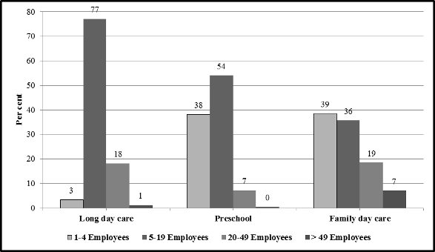
Note: Percentages are weighted. Source: EYLF Baseline Study 2011 survey.
Figure A4-2: ECEC services by number of paid employees—integrated and stand-alone (%)
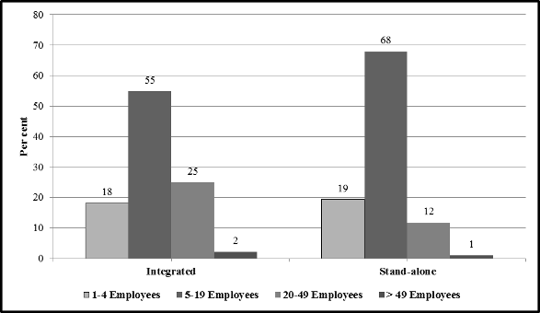
Note: Percentages are weighted. Family day care services are included in the stand-alone group. Source: EYLF Baseline Study 2011 survey.

Type of management of service and the use of EYLF
Figure 3 shows that about a third of all services are community-managed private not for profit and another third are private for profit. The rest have a variety of other management structures.
Figure 4 shows the curriculum framework that ECEC services followed in the week prior to when the survey was completed. It shows most services are following EYLF exclusively (71 per cent) or EYLF in combination with another framework (17 per cent). This means that the EYLF is followed in some form or another by 88 per cent of services.
Table 5 shows the breakdown of the services following the curriculum frameworks by their management structure. The data in this table indicate that the ECEC services associated with Independent and Catholic schools are behind all others in adopting the EYLF. Only half of all services run by Independent schools have adopted the EYLF in some form. Among services run by Catholic schools this percentage is 60. Services for which the management type is unspecified also have a lower than average rate of uptake of the EYLF but it is still significantly higher than for services run by Independent and Catholic schools.
Figure A4-3: ECEC services by type of management structure (%)
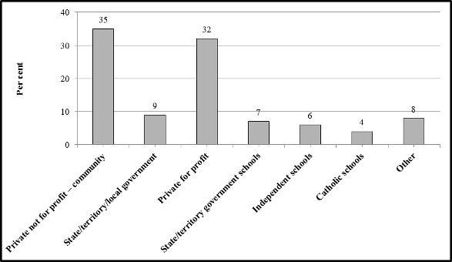
Note: Percentages are weighted. Source: EYLF Baseline Study 2011 survey.
Figure A4-4: ECEC services by framework followed in the previous week (%)
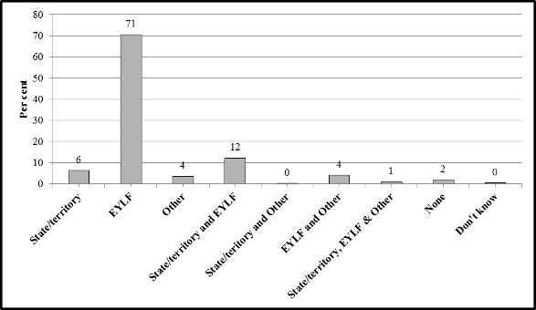
Note: Percentages are weighted. Source: EYLF Baseline Study 2011 survey.
Table A4-1: Curriculum framework followed by ECEC services in week before survey by management structure (%)
 | Management structure
Curriculum framework | Private not for profit – community | State/territory/ local government | Private for profit | State/territory government schools | Independent schools | Catholic schools | Other | All
Single framework | 80 | 80 | 85 | 83 | 67 | 60 | 73 | 80
State/territory | 5 | 8 | 4 | 14 | 14 | 8 | 8 | 6
EYLF | 71 | 71 | 78 | 67 | 36 | 52 | 63 | 71
Other | 4 | 2 | 3 | 1 | 17 | 0 | 2 | 4
Multiple frameworks | 18 | 18 | 12 | 15 | 33 | 40 | 25 | 17
State/territory & Other | 12 | 13 | 8 | 13 | 21 | 32 | 17 | 12
State/territory & EYLF | 0 | 0 | 0 | 0 | 2 | 0 | 0 | 0
EYLF & Other | 4 | 4 | 3 | 1 | 9 | 8 | 7 | 4
State/Territory EYLF & Other | 1 | 1 | 1 | 1 | 2 | 0 | 1 | 1
None / unknown | 2 | 2 | 3 | 2 | 0 | 0 | 2 | 2
None | 2 | 1 | 2 | 0 | 0 | 0 | 1 | 2
Unknown | 0 | 1 | 0 | 2 | 0 | 0 | 1 | 0
All | 100 | 100 | 100 | 100 | 100 | 100 | 100 | 100
Number in sample (n) | 563 | 153 | 466 | 104 | 58 | 25 | 126 | 1495
Note: Percentages are weighted. Source: EYLF Baseline Study 2011 survey.

Age range of children enrolled
Figure 1 shows most ECEC services’ current enrolment included children aged 3 to 5 years. Just over half the services included children aged 2 years or younger.
Figure A4-5: Percent of ECEC services by age of children attending service
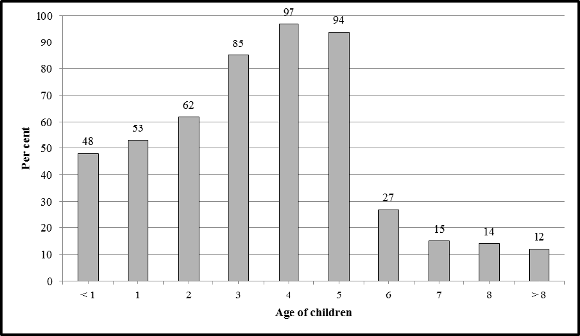
Note: Percentages are weighted. Source: EYLF Baseline Study 2011 survey.

Selected characteristics of ECEC educators who completed the survey
The instructions on the questionnaire stipulated that any person in the ECEC service who has direct involvement with early childhood education and care were to complete the survey. Examples of people who should complete are:
director/coordinator/teacher-in-charge of early childhood education and care
early childhood education and care curriculum coordinator
group leader/kindergarten or preschool teacher.
As the survey was completed online or on paper without an interviewer, one can’t be certain that the survey was completed by one of the above. However we assume all questionnaires were completed by an ECEC educator.

Age profile
The age profile of ECEC educators who completed the survey is shown in Figure 5. The average age of completers is 43 years. Note that this does not represent the average age of all educators in the sector. The respondents to the survey are a selected group with most holding positions of responsibility. About three out of every five are 35–54 years-old.
Table 5 shows that while there is little difference in the average age of educators across states and territories. The average age is highest in South Australia and lowest in NSW. However the age distributions vary across jurisdictions. In NSW, Queensland and the Northern Territory, for example, relatively higher percentage of educators are aged 34 years or younger than in the other jurisdictions. In the Northern Territory 33 per cent are aged 34 years or younger compared to 21 per cent in the ACT. In contrast, 54 per cent in the ACT are aged between 45 and 54 years, compared to 23 per cent in the Northern Territory.
The age profile of educators also varies by the type of service they work in (see Figure 6). In particular, a relatively higher proportion in long day care is aged 34 years or younger than in preschools or family day care.
Figure 7 shows the age profiles of educators in different geographical regions. The age profile of educators in very remote regions is significantly different to the profiles of those in all other regions. Three out every four educators in very remote regions are aged 45 years or older.
Figure A4-6: Percent of ECEC educators who completed survey by age group
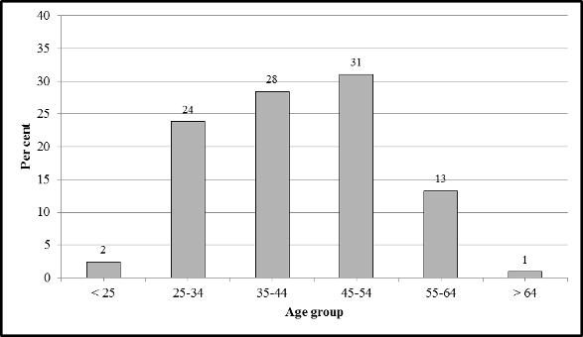
Note: Percentages are weighted. Source: EYLF Baseline Study 2011 survey.
Table A4-2: Age distribution of ECEC educators who completed survey by state and territory (%)
 | Age group
State | < 24 | 25-34 | 35-44 | 45-54 | > 55 | Total | Average age
NSW | 3 | 27 | 33 | 26 | 10 | 100 | 41
VIC | 1 | 21 | 28 | 35 | 13 | 100 | 44
QLD | 3 | 28 | 29 | 26 | 13 | 100 | 42
SA | 0 | 18 | 24 | 33 | 24 | 100 | 46
WA | 4 | 19 | 22 | 40 | 14 | 100 | 44
TAS | 1 | 21 | 29 | 30 | 18 | 100 | 44
NT | 3 | 30 | 23 | 23 | 21 | 100 | 42
ACT | 3 | 18 | 17 | 54 | 7 | 100 | 44
Note: Percentages are weighted. Source: EYLF Baseline Study 2011 survey.
Figure A4-7: Age distribution of ECEC educators who completed survey by type of service they are employed in (%)
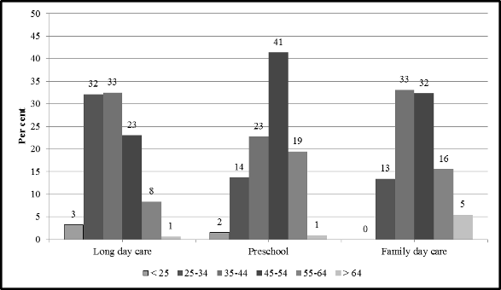
Note: Percentages are weighted. Source: EYLF Baseline Study 2011 survey.
Figure A4-8: Age distribution of ECEC educators who completed survey by geographical location of service they are employed in
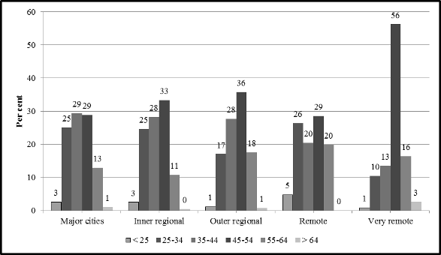
Note: Percentages are weighted. Source: EYLF Baseline Study 2011 survey.

Qualifications of ECEC educators
This section describes the qualification profiles of ECEC educators who completed the survey by various categories. Tables 6–10 relate to the field of the highest qualification. Almost all educators hold a formal qualification, with only 6 per cent not holding one. Educators in long day care are slightly more likely to hold a formal qualification than those working in the other two types of services. Educators who work in services located outside the major cities or inner regional areas are however less likely to hold a qualification. In particular, 19 per cent of educators working in remote areas and 33 per cent in very remote locations do not hold any formal qualifications. Those without formal qualifications are also more likely to be in roles which do not involve contact with children.
Just over half of all educators hold a teaching related qualification, with most qualifications related to early childhood. While most non-teaching qualifications held are related to child care, in family day care the proportion is much smaller.
In preschools, educators are more likely to hold a teaching qualification (80 per cent) compared to those in long day care (38 per cent) and in family day care (29 per cent). The proportion of educators with teaching qualifications is highest in inner regional areas (64 per cent) and lowest in very remote areas (26 per cent). Further, in very remote areas a much smaller proportion (15 per cent) of educators holds an early childhood-related teaching qualification.
A third of all educators have been in the current job for 11 years or more and about two-thirds of them hold a teaching qualification. In contrast, only about half of those have been in the current job for less time than this hold teaching qualifications.
A large majority (68 per cent) of educators commenced their first job in the ECEC sector in 2000 or earlier; 17 per cent between 2001 and 2005; and 13 per cent between 2008 and 2011. Those who commenced their first job before 2000 are also most likely to hold a teaching qualification. Notwithstanding the small number of educators who commenced between 2009 and 2011, about a quarter of them do not hold a qualification.
Educators who have primary contact with children are generally much more likely to hold a teaching qualification than educators whose main work is other than this.
Table A4-3: Distribution of field of highest qualification of ECEC educators by type of service they are employed in (%).
 | Type of ECEC service
Field of qualification | Long Day Care | Preschool | Family Day Care | All
Teaching | 38 | 80 | 29 | 55
Early childhood-related | 35 | 74 | 24 | 50
Other | 4 | 7 | 4 | 5
Non-teaching | 58 | 10 | 63 | 39
Child care | 53 | 9 | 49 | 35
Other | 5 | 1 | 14 | 4
None | 4 | 9 | 9 | 6
All | 100 | 100 | 100 | 100
Number in sample (n) | 807 | 608 | 70 | 1495
Note: Percentages are weighted. Source: EYLF Baseline Study 2011 survey.
Table A4-4: Distribution of field of highest qualification of ECEC educators by geographical location of service they are employed in (%)
 | Geographical location of ECEC service
Field of qualification | Major cities | Inner regional | Outer regional | Remote | Very remote | All
Teaching | 55 | 64 | 44 | 54 | 26 | 55
Early childhood-related | 50 | 60 | 39 | 38 | 15 | 50
Other | 5 | 4 | 5 | 16 | 11 | 5
Non-teaching | 40 | 32 | 45 | 27 | 41 | 39
Child care | 36 | 29 | 41 | 24 | 33 | 35
Other | 4 | 4 | 4 | 3 | 7 | 4
None | 5 | 4 | 11 | 19 | 33 | 6
All | 100 | 100 | 100 | 100 | 100 | 100
Number in sample (n) | 943 | 321 | 167 | 37 | 27 | 1495
Note: Percentages are weighted. Source: EYLF Baseline Study 2011 survey.
Table A4-5: Distribution of field of highest qualification of ECEC educators by length of tenure in current job (%)
 | Length of tenure in current job (years)
Field of qualification | < 1 | 1–2 | 3–5 | 6–10 | 11 or more | All
Teaching | 47 | 45 | 55 | 52 | 63 | 55
Early childhood-related | 46 | 40 | 48 | 48 | 58 | 50
Other | 1 | 5 | 6 | 4 | 5 | 5
Non-teaching | 48 | 47 | 40 | 42 | 30 | 39
Child care | 46 | 44 | 35 | 36 | 27 | 35
Other | 2 | 3 | 5 | 6 | 3 | 4
None | 5 | 8 | 5 | 6 | 7 | 6
All | 100 | 100 | 100 | 100 | 100 | 100
Number in sample (n) | 136 | 174 | 344 | 347 | 494 | 1495
Note: Percentages are weighted. Source: EYLF Baseline Study 2011 survey.
Table A4-6: Distribution of field of highest qualification of ECEC educators by years since first job in ECEC sector (%)
 | Time since first job in ECEC sector (years)
Field of qualification | < 1 | 1–2 | 3–5 | 6–10 | 11 or more | All
Teaching | 53 | 51 | 49 | 40 | 60 | 55
Early childhood-related | 42 | 46 | 43 | 36 | 55 | 50
Other | 11 | 5 | 6 | 4 | 5 | 5
Non-teaching | 11 | 19 | 37 | 55 | 36 | 39
Child care | 11 | 16 | 33 | 47 | 33 | 35
Other | 0 | 3 | 4 | 7 | 3 | 4
None | 37 | 30 | 13 | 6 | 4 | 6
All | 100 | 100 | 100 | 100 | 100 | 100
Number in sample (n) | 19 | 37 | 142 | 253 | 1044 | 1495
Note: Percentages are weighted. Source: EYLF Baseline Study 2011 survey.
Table A4-7: Distribution of field of highest qualification of ECEC educators by main type of work they perform (%)
 | Main type of work educators perform
Field of qualification | Primary contact with children | Other contact with children | Management /admin only | Other | All
Teaching | 81 | 40 | 32 | 59 | 55
Early childhood-related | 75 | 36 | 27 | 53 | 50
Other | 6 | 4 | 5 | 6 | 5
Non-teaching | 14 | 54 | 56 | 33 | 39
Child care | 13 | 49 | 49 | 30 | 35
Other | 1 | 5 | 7 | 3 | 4
None | 5 | 4 | 12 | 8 | 6
All | 100 | 100 | 100 | 100 | 100
Number in sample (n) | 565 | 558 | 283 | 89 | 1495
Note: Percentages are weighted. Source: EYLF Baseline Study 2011 survey.
Table 11–13 relate to the level of highest qualification. Just over half of all educators’ qualifications are at the degree or higher level. Most other qualifications are at the advanced diploma or diploma levels. Those who have been in their current job for 11 years or more are slightly more likely to hold the higher level qualifications. Similarly, those who started in the ECEC sector 11 years or more ago are also more likely to hold the higher level qualifications.
The level of qualification educators hold varies significantly by the main role they perform. For example, 75 per cent of those whose with primary contact with children hold degree or higher level qualifications compared to only 32 per cent of those whose main role is management or administration.
Table A4-8: Distribution of level of highest qualification of ECEC educators by length of tenure in current job (%)
 | Length of tenure in current job (years)
Field of qualification | < 1 | 1–2 | 3–5 | 6–10 | 11 or more | All
Degree or higher | 46 | 44 | 53 | 51 | 57 | 52
Advanced Diploma / Diploma | 48 | 48 | 40 | 41 | 35 | 40
Certificate | 1 | 1 | 2 | 2 | 1 | 1
None | 5 | 8 | 5 | 6 | 7 | 6
All | 100 | 100 | 100 | 100 | 100 | 100
Number in sample (n) | 136 | 174 | 344 | 347 | 494 | 1495
Note: Percentages are weighted. Source: EYLF Baseline Study 2011 survey.
Table A4-9: Distribution of level of highest qualification of ECEC educators by time since first job in ECEC sector (%)
 | Time since first job in ECEC sector (years)
Field of qualification | < 1 | 1–2 | 3–5 | 6–10 | 11 or more | All
Degree or higher | 47 | 49 | 46 | 39 | 57 | 52
Advanced Diploma / Diploma | 11 | 22 | 37 | 54 | 38 | 40
Certificate | 5 | 0 | 4 | 2 | 1 | 1
None | 37 | 30 | 13 | 6 | 4 | 6
All | 100 | 100 | 100 | 100 | 100 | 100
Number in sample (n) | 19 | 37 | 142 | 253 | 1044 | 1495
Note: Percentages are weighted. Source: EYLF Baseline Study 2011 survey.
Table A4-10: Distribution of level of highest qualification of ECEC educators by main type of work they perform (%)
 | Main type of work performed
Field of qualification | Primary contact with children | Other contact with children | Management /admin only | Other | All
Degree or higher | 75 | 40 | 32 | 53 | 52
Advanced Diploma / Diploma | 19 | 54 | 54 | 36 | 40
Certificate | 1 | 1 | 2 | 3 | 1
None | 5 | 4 | 12 | 8 | 6
All | 100 | 100 | 100 | 100 | 100
Number in sample (n) | 565 | 558 | 283 | 89 | 1495
Note: Percentages are weighted. Source: EYLF Baseline Study 2011 survey.

Appendix 5: Victoria South Australia C-BAM Survey
See Attached document

In some states and territories preschools are called kindergartens.
Hobart and Darwin are not defined as major cities.
Approval from the ABS Clearing house was not required to conduct the pilot.
Permission to use the questionnaire has been granted to Marilyn Fleer, Faculty of Education, Monash University by Gene Hall.
The responses to questions on the tenure in the current job and the year of commencement of first job in the ECEC sector for 38 educators were inconsistent in the sense that their tenure in the current job is longer than the time since they commenced their first job in the sector. Consistency check on these two questions was not included in the questionnaire.

