A New System for Better Employment and Social Outcomes
Interim Report of the Reference Group on Welfare Reform to the Minister for Social Services

OVERVIEW
June 2014

© Commonwealth of Australia 2014
With the exception of the Commonwealth Coat of Arms and where otherwise noted all material presented in this document is provided under a Creative Commons Attribution 3.0 Australia licence. The details of the relevant licence conditions are available on the Creative Commons website (accessible using the links provided) as is the full legal code for the CC BY 3.0 AU licence. The document must be attributed as the Department of Social Services A New System for Better Employment and Social Outcomes - Interim Report of the Reference Group on Welfare Reform to the Minister for Social Services.
Phone: 1300 653 227
Email: DSSfeedback@dss.gov.au
Post: Department of Social Services,
Tuggeranong Office Park PO Box 7576,
Canberra Business Centre ACT 2610

A New System for Better Employment and Social Outcomes

INTERIM REPORT RELEASED FOR COMMENT
An Interim Report by the Reference Group on Welfare Reform to the Minister for Social Services has been released to encourage public debate and discussion.
The Reference Group will develop its Final Report based on feedback from consultations and discussion about the proposed future directions.
The Reference Group has reviewed the broad range of payments and services available for people of working age.
The aim is to identify improvements to ensure the social support system is sustainable, effective and coherent, and encourages people to work to their capacity.
The Interim Report proposes four pillars of reform:
- Simpler and sustainable income support system
- Strengthening individual and family capability
- Engaging with employers
- Building community capacity
The Reference Group comprises Mr Patrick McClure AO (Chairperson), Mr Wesley Aird and
Ms Sally Sinclair.
The Interim Report is available here.

Pathway to final report
For its Interim Report the Reference Group has taken stock of the information available from a range of reviews and public debates on welfare reform over the past decade and has tested this through discussions with selected stakeholders.
It is important that the Reference Group now engage more extensively with the public in order to develop its Final Report.
The launch of the Interim Report marks the start of a six week period of public consultation.
This includes a call for public submissions and round tables in capital cities.

The need for reform
The Reference Group considers that further reform is needed to Australia’s income support system. The current Australian income support system is no longer in step with community expectations or Australia’s labour market and economy.
Years of incremental change in some areas and inaction in others have resulted in an unwieldy system that does not reflect the values, expectations and day-to-day experiences of the Australian community. With improvements the system could deliver better value and outcomes for people in need.
The social support system should provide adequate support while encouraging more people to work to their capacity. It should also help people build the capacity they need to participate economically and socially, to the extent they are able.
Reform also needs to take account of recent developments such as the system of lifelong care and support for people with disability being introduced through the National Disability Insurance Scheme, the expansion of paid parental leave and the opportunities offered by new technology. Effective interventions to support people who are vulnerable in the labour market, such as people with mental health conditions and people with disability, are also important.
Cash transfer payments represent a significant investment with a wide reach across the community.
Government cash transfer payments to individuals and families represent the most significant component of Australia’s social support system in expenditure terms. Income support payments and supplements now in the Department of Social Services portfolio were worth around $100 billion in 2012–13, including Age Pension ($36.3 billion), Disability Support Pension ($15.0 billion) and Newstart Allowance ($7.5 billion). Expenditure on supplementary assistance for 2012–13 totalled $24.4 billion.
Reform of the system is required over the medium to long term.

Expenditure by income support payment type (2012–13 actual)

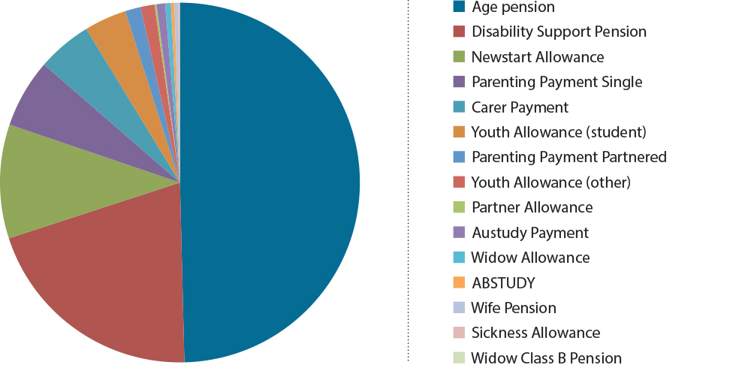
Australia’s income support system needs a stronger employment focus to maximise employment and social outcomes.
Employment generates clear financial, health and social benefits for individuals, families and communities. Many of the benefits are passed on from parents to children. Children who grow up in employed households have better social, emotional, physical development and learning outcomes.
In contrast, long-term reliance on income support increases the risks of poor health, low self-esteem and social isolation.
Major structural changes to the economy over recent decades have had significant implications for the Australian labour market. These include an increase in part-time work and an increasing demand for highly skilled and educated workers over low-skilled and uneducated workers.
For example, between 1986 and 2013 high-skilled white collar jobs increased from 29 per cent to 35 per cent of all jobs, while low-skilled blue collar jobs decreased from 23 per cent to 16 per cent.
A focus on participation and self-reliance should be unambiguous.

Distribution of jobs by skill level over time (per cent)
Category | 1986 | 2013
High-skilled white collar | 29 | 35
Low-skilled white collar | 31 | 34
High-skilled blue collar | 17 | 15
Low-skilled blue collar | 23 | 16
Total | 100 | 100

Source: Australian Bureau of Statistics (Cat. 6204.0.55.001 and 6291.0.55.003) and Department of Social Services calculations.
This shift to higher skilled jobs means educational attainment has become more important than ever, as illustrated below.

Unemployment rate (per cent) by highest level of educational attainment, May 2013
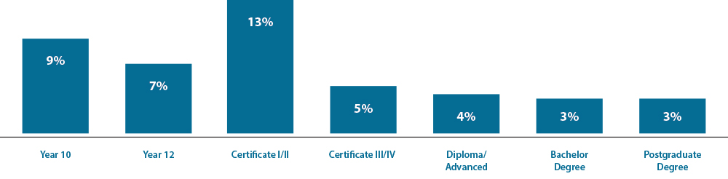
Source: Australian Bureau of Statistics (Cat. 6227.0)
Australia’s social support system needs to be simpler and more coherent.
Changes over time have made the system complex and inefficient. There are now around 20 income support payments and 55 supplements available in a variety of packages of support. This can create confusion and lead to inequities. People can find it hard to understand and access. In addition, people with similar basic living costs can receive different levels of financial support, with different expectations of work.
The current system is too complex, with around 20 payments and 55 supplements.
The figure below demonstrates the variety of packages of support comprising combinations of income support payments and available supplements.
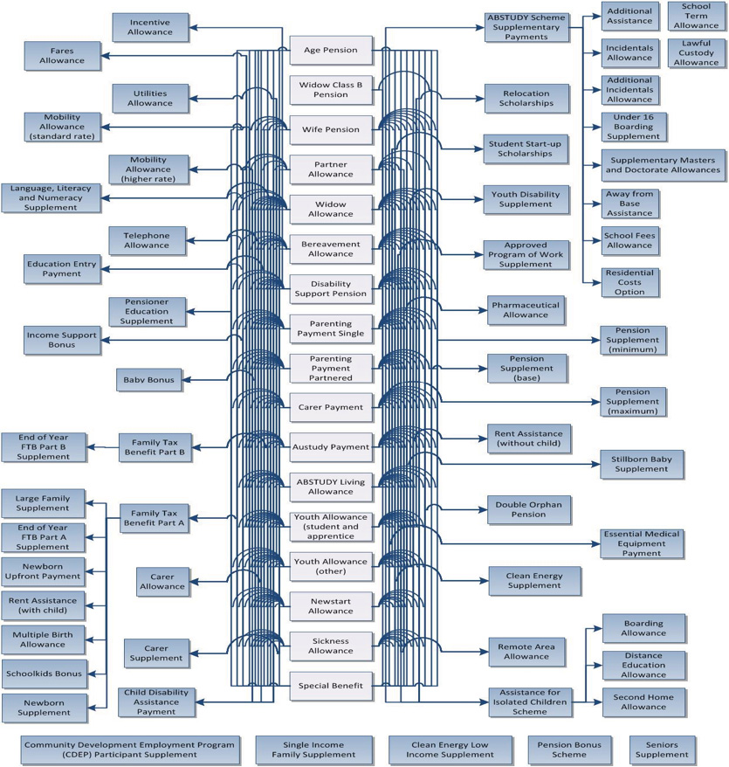
The following graph shows very different levels of financial support across single people of working age. Some of the disparities are as a result of ad hoc changes over time and don’t necessarily reflect community expectations or provide sufficient incentives for people to take up work opportunities.

Annual income support packages for single recipients, March 2014
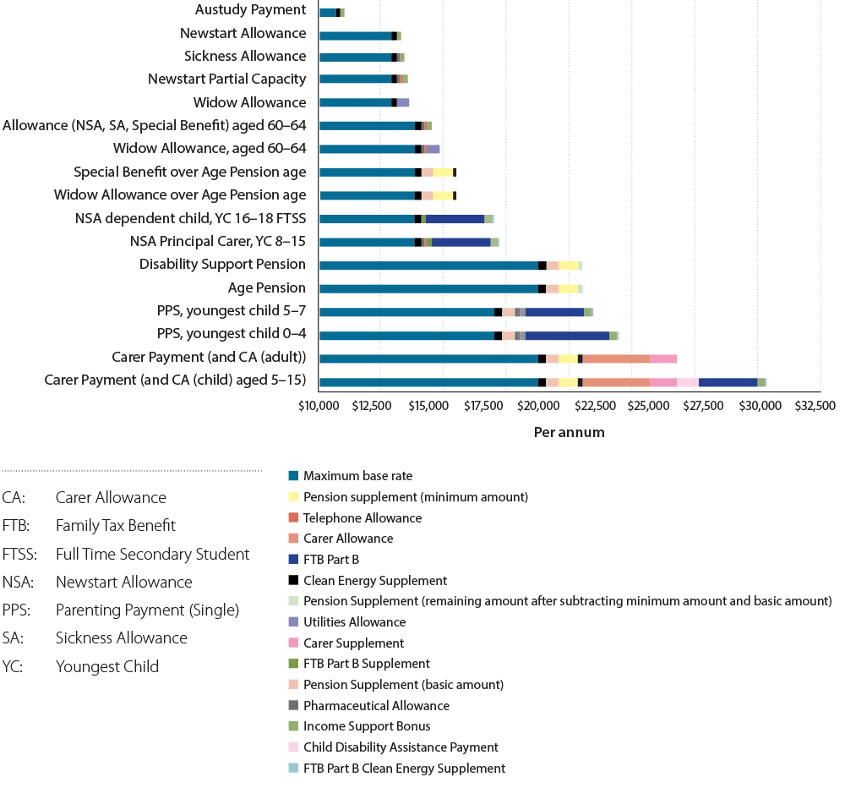

Pillars of reform
The Reference Group proposes four pillars of reform that focus on employment outcomes as the first priority, supported by improved social outcomes.
The pillars of reform are:
- Simpler and sustainable income support system
- Strengthening individual and family capability
- Engaging with employers
- Building community capacity

Pillar One: Simpler and sustainable income support system

- Over time, Australia’s income support system has become too complex.
- The many different payments and supplements create confusion and result in people in similar situations receiving different levels of support, with different requirements for workforce participation.
- There has been a growing gap in payment rates due to different adjustment methods.
- Rent Assistance adjustments have not kept pace with rising rental housing costs.
- There are inconsistencies in means testing across payment types. Parents are often subject to several income tests at once.
- There are also inconsistencies in payments to cover the costs of children at different stages and in different family circumstances. This can undermine the goal of supporting young people to gain education and prepare for the workforce.
- The interaction of personal income tax and means testing on income support payments can reduce the rewards for working, and diminish the incentives to work.

Future directions
A new system should provide adequate support and better reflect a person’s capacity to work now and in the future.

Fewer payments and supplements
There should be fewer primary payments and fewer supplements for a simpler, more consistent income support system.
Payments could comprise:
- a tiered working age payment for people of working age reflecting their capacity to work now or in the future
- a Disability Support Pension only for people with a permanent impairment and no capacity to work
- a child payment structure which could bring together Family Tax Benefit, Youth Allowance, ABSTUDY and other payments for dependent children and young people
- Age Pension as the primary payment for people of Age Pension age, subject to eligibility.
Within the working age payment, different tiers of payment could take account of individual circumstances, such as partial capacity to work, parental responsibilities or limitations on availability for work because of caring. Recipients of higher rates could include single parents, people with disability and a partial capacity to work, and others with a significant barrier to full-time employment.
People with disability who have current or future capacity to work could be assisted through the tiered working age payment to better reflect different work capacities.
Requirements, services and other supports could be individualised to each recipient’s circumstances, including current or future capacity to work.
A new simpler payment should be introduced for the costs of children and dependent young people which recognises the higher costs as children grow up and the additional costs of living away from home to study. Consideration should be given to when young people would access income support in their own right.
There should be fewer supplements with more clearly defined purposes for specific additional costs. Other supplements could be absorbed into the basic payments.

Fair rate structure
In moving towards a new working age payment, consideration should be given to reducing the current gap between pensions and allowances, particularly for people with limited work capacity, or with significant labour market disadvantages.
The single rates in the allowance system should be reviewed taking account of the costs of living alone compared with sharing accommodation as well as the costs of meeting participation obligations.

Common approach to adjusting payments
There should be a common approach to adjusting payments to ensure a more coherent social support system over time. It is important to ensure that any approach to adjusting payments balances sustainability of the income support system, fiscal flexibility for governments and changes to community living standards as the economy grows.

Effective Rent Assistance
Rent Assistance should be reviewed to determine appropriate levels of assistance and the best mechanism for adjusting assistance levels over time. Consideration should be given to moving away from income based rent setting for public housing to Rent Assistance as the preferred rent subsidy scheme across public and private rental.

Rewards for work and targeting assistance to need
The way in which income support and supplements reduce as people earn income needs to be reviewed to provide more consistent and transparent rewards for working. Currently income and asset test free areas and taper rates vary widely between income support payments. Consideration should also be given to how income from work could be more favourably treated than income from other sources.

Different income tests for different payments, March 2014
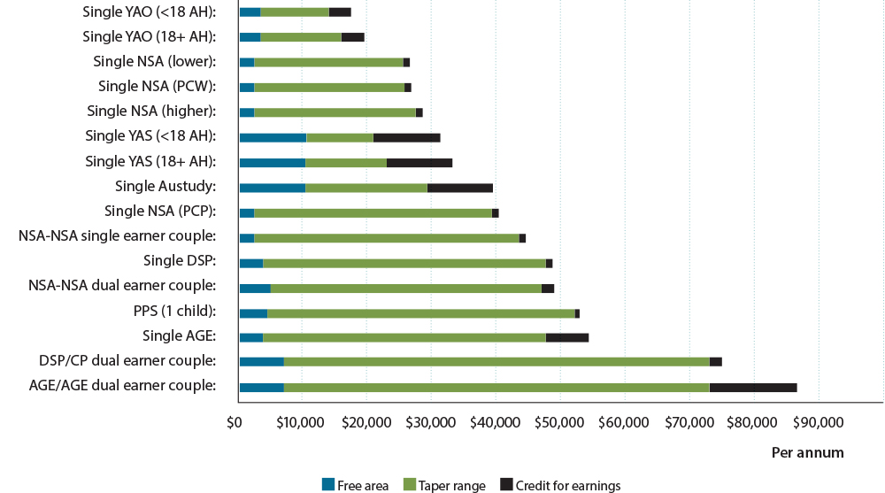
AGE: Age Pension
AH: At home
CP: Carer Payment
DSP: Disability Support Pension
NSA: Newstart Allowance
PCP: Principal Carer Parent
PCW: Partial Capacity to Work
PPS: Parenting Payment (Single)
YAO: Youth Allowance (Other)
YAS: Youth Allowance (Student)
As the figure shows, income test free areas and taper rates vary widely between different income support categories. This results in different rewards for working. For example, someone receiving Disability Support Pension who undertakes part-time work will experience a smaller payment reduction than someone with disability who is on Newstart Allowance.
A new simpler system should take account of interactions between tax and income tests. Over the long-term, consideration should be given to better integrating the administration of tax and transfer systems to improve incentives to work.

Pillar Two: Strengthening individual and family capability
- The development of individual and family capabilities is critical to maximise employment and social participation and for people to lead full and productive lives.
- Mutual obligation requires people on income support to participate in employment. There are also obligations and support for families to encourage parents to provide a good start for their children and help break the intergenerational nature of long-term disadvantage.
- Income management is another approach that helps people meet essential needs and build capability.
- Early intervention is effective in reducing the risk of long-term reliance on income support and improving life outcomes.
- Targeted education and training are increasingly important in a labour market that favours more highly skilled job seekers.
- Tailored support services to meet individual needs will lead to better employment and social outcomes. For people with mental health conditions, a vocational rehabilitation approach and wrap-around services can achieve positive outcomes.

Future directions

Mutual obligation
Participation expectations should be more individually tailored to recognise the diversity and differing capacity of people receiving income support.
Consideration should be given to broadening mutual obligation to include building life skills, promoting parental responsibility and improving outcomes for children, particularly for those living in jobless families who are dependent on income support.
Income management could be considered as part of a package of support services available to job seekers who need to build foundational skills and stabilise their circumstances, as a platform to move into work or study.
An investment model is required to target early intervention and investment for people at the highest risk of long-term income support reliance.
Income management could also be used to build capabilities as part of a case-management approach to assist the large number of disadvantaged young people not fully engaged in either education or work.

Early intervention
Risk-based analysis to target early intervention and investment should be a feature of a new social support system. This would include examining the New Zealand approach to actuarial analysis of the long-run costs in social security outlays and the benefits of addressing these cost drivers for individuals and the system.
Ongoing support should be given to policies and programmes that target children at risk and provide good outcomes and a positive return on investment for government funds.
Young people should be encouraged to finish Year 12 or gain a Certificate III or IV or higher qualification which is linked to available jobs.
Consideration should be given to cost effective approaches that support employment outcomes by improving family functioning.
For people with complex needs, such as people with severe and persistent mental health conditions, there should be wrap-around services that assist them to stabilise their lives and engage in education, work and social activities.

Monitoring and evaluation
Monitoring and evaluation of programmes that aim to increase individual and family capability should focus on whether outcomes are being achieved for the most disadvantaged.

Pillar Three: Engaging with employers
- The Australian Government has committed to improving economic conditions, improving labour force participation and creating more jobs.
- Employers are the key to providing jobs for disadvantaged people. There are proven mutual benefits when businesses embrace social responsibility and diversify their workforce.
- Australian Government contracted employment services, and social enterprises delivered through non-government organisations, are achieving sustainable employment outcomes for disadvantaged job seekers.
- Government has a significant role in improving employment outcomes for people with disability.
- Employment participation rates are lower for groups such as people with disability and mental health conditions, compared to the general population.
- Support services are vital for improving and sustaining employment outcomes for people with disability or mental health conditions.
- Wage subsidies can also play an important role in securing longer-term employment outcomes.

Future directions

Employment focus
Business-led covenants, such as the Australian Employment Covenant, could be used to further improve employment outcomes for disadvantaged groups such as people with disability and mental health conditions.
Consideration should be given to how the success of social enterprises can be replicated more broadly to maximise employment outcomes.

Improved pathways
Pathways to employment can be improved by focusing vocational education and training, and training of disadvantaged job seekers, on the skills required for available jobs.
Employer-driven initiatives such as business-led covenants improve employment outcomes for vulnerable groups.
To assist people with mental health conditions to sustain training and employment, consideration should be given to how support programmes, such as Individual Placement and Support, can be expanded.
In the review of Job Services Australia, the following should be taken into account:
- focusing employment services more on employers and their needs
- maximising employment outcomes for disadvantaged groups by improving job matching and more effective up front assessment of needs
- reducing administrative burdens on employers and job service providers.

Pillar Four: Building community capacity
- Vibrant communities create employment and social participation for individuals, families and groups.
- Investments by government, business and civil society play an important role in strengthening communities.
- Building community capacity is an effective force for positive change, especially for disadvantaged communities.

Future directions

Disadvantaged communities
Innovative solutions are required to address the multiple issues faced by disadvantaged communities. These solutions need to bring together corporates, philanthropic organisations, government and the community.
Connecting disadvantaged people to their community is important in building community capacity.
Volunteering is of significant value to both the individual and the community.
The major initiatives funded by the Australian Government in disadvantaged communities need ongoing evaluation to ensure they are achieving their desired outcomes.
Local micro-businesses are a pathway to employment for disadvantaged job seekers.
Cooperative enterprises are one approach that can address long-term unemployment and exclusion from the labour market in a sustainable manner, and build community capacity.
Innovative solutions are required to address the multiple issues faced by disadvantaged communities. These solutions need to bring together corporates, philanthropic organisations, government and the community.

Role of technology
Being able to access information and communications technology is an important pathway to employment for disadvantaged groups, especially given the importance of this technology in current and emerging employment markets.

Community resilience
Community resilience is the capacity of a community to draw on its own internal resources to cope with and adapt to change. This is important for communities facing the loss of a major industry or significant event like a bushfire or flood. Given that a number of large government initiatives focus on disadvantaged communities, building community resilience could be a pathway to drive change within those communities.
Overall, maintaining social participation and social fabric within communities of lower
socio-economic status is a necessary and critical step to improve the chances that people in
those communities will increase their economic participation.

