A New System for Better Employment and Social Outcomes
Interim Report of the Reference Group on Welfare Reform to the Minister for Social Services

FULL REPORT
June 2014
© Commonwealth of Australia 2014
With the exception of the Commonwealth Coat of Arms and where otherwise noted all material presented in this document is provided under a Creative Commons Attribution 3.0 Australia licence. The details of the relevant licence conditions are available on the Creative Commons website (accessible using the links provided) as is the full legal code for the CC BY 3.0 AU licence. The document must be attributed as the Department of Social Services A New System for Better Employment and Social Outcomes - Interim Report of the Reference Group on Welfare Reform to the Minister for Social Services.
Phone: 1300 653 227
Email: DSSfeedback@dss.gov.au
Post: Department of Social Services,
Tuggeranong Office Park PO Box 7576,
Canberra Business Centre ACT 2610

Contents
Executive Summary 8
About This Review 19
Introduction 19
Reference Group 19
Guiding principles for the review 19
Review process 19
Pathway to final report 20
Scope of the review 20
Interaction with other reviews 20
Report structure 21
Part One: The Case for Reform 22
Summary 23
Australia’s social support system 24
Expenditure 24
Purpose of income support 25
Employment services 25
Need for reform 26
Economic and labour market changes 27
Income support system 27
Broader social support system 30
Groups at risk 32
Young people 32
Parents receiving income support 33
People with disability 33
Indigenous Australians 34
Mature aged 35
Carers 36
People with multiple disadvantages 36
Recent international developments 37
United Kingdom 37
New Zealand 37
The Netherlands 38
Benefits of employment 38
Financial benefits 38
Health benefits 39
Community benefits 39
Intergenerational benefits 39
Part Two: Pillars of Reform 40
Pillar One: Simpler and Sustainable Income Support System 41
Context for reform 41
Simpler architecture 42
Income support for people with disability 46
What previous reviews said 48
Future directions 50
First steps 52
Fair rate structure 53
Large gaps in payment rates 53
The Harmer Review approach 54
Different single and couple rates 54
Adults receiving youth rates 57
Income support packages for parents caring for children 57
Falling support for single parents as children grow up 58
Timely assistance to parents 59
Future directions 60
Common approach to adjusting payments 60
Growing gap between pensions and allowances 61
Current approach to adjusting payments 62
What previous reviews said 63
Future directions 64
Support for families with children and young people 64
Complex family and youth payments 65
Inconsistencies in rates of payment 65
Young people living away from home to study 65
Children living across more than one household 67
Income support payments to children and young people 67
Rent Assistance 67
What previous reviews said 67
Future directions 68
Rent Assistance 68
Pensioners 68
Income support recipients 69
Eligibility for Rent Assistance 69
What previous reviews said 70
Future directions 71
Rewards for work and targeting assistance to need 71
Multiple income tests 72
Interactions with personal income tax 74
Simultaneous income tests 75
Targeting need under the assets test 75
Definitions of income 76
Merged means testing 76
Waiting periods 76
What previous reviews said 76
Future directions 77
Pillar Two: Strengthening individual and family capability 78
Context for reform 78
Mutual obligation 79
Employment obligations 79
Building capability for employment 81
Personal and family responsibility 81
Income management 82
Future directions 83
Early intervention 84
The investment model 84
Investing in children 86
Future directions 87
Education and training 87
Foundation skills 88
Education and training for employment 88
Future directions 89
Improving individual and family functioning 89
Mental health 89
Family functioning 91
Future directions 91
Evaluating outcomes 92
Pillar Three: Engaging with employers 93
Context for reform 93
Employment focus—making jobs available 93
Corporate initiatives 94
Small and medium business initiatives 95
Government initiatives 96
Social enterprises 97
Future directions 97
Improving pathways to employment 98
Employment services 98
Mentoring 100
Vocational education and training 100
Transition from school 101
Mental health and employment 101
Labour mobility 103
Employer attitudes 104
Future directions 104
Supporting employers 105
Employer focus 105
Better job matching 105
Wage subsidies 106
Less red tape 107
Future directions 107
Pillar Four: Building Community Capacity 108
Context for reform 108
Disadvantaged communities 108
Role of civil society 109
Community capacity building 110
Volunteering 112
Future directions 112
Role of government 113
Transport 113
Location based approaches 114
Role of local business 118
Micro business 118
The role of microfinance 119
Mutuals and co-operatives 119
Future directions 120
Access to technology 121
Community resilience 122
Future directions 123
Glossary and Acronyms 124
Glossary 124
Acronyms 127
Appendices 129
Appendix A: Reference Group members 129
Appendix B: Stakeholders consulted by the Reference Group 131
Appendix C: Australian Government expenditure on selected elements of Australia’s social support system 133
Appendix D: Previous reviews and reforms 142
Appendix E: Economic and labour market changes 150
Appendix F: Case studies—International experiences 159
Appendix G: Trends in income support 163
Appendix H: References 167

Executive Summary
Government cash transfer payments to individuals and families represent the most significant component of Australia’s social support system in expenditure terms. The Department of Social Services has policy responsibility for income support payments and supplements worth around $100 billion in 2012–13. This is a significant investment with a wide reach across the community.
Changes to Australia’s income support system over time have resulted in unintended complexities, inconsistencies and disincentives for some people to work. The system is also out of step with today’s labour market realities and community expectations. The income support system is in need of major reform to deliver better outcomes for all Australians now and into the future.
Long-term reliance on income support increases the risks of poor health, low self-esteem and social isolation. It can also have intergenerational effects. Children who grow up in households with long periods on income support are more likely to have poor education, employment and social outcomes. In contrast, employment generates clear financial, health and social benefits for individuals, families and communities.
To maximise employment and social outcomes, and to remain sustainable over the longer term, Australia’s income support system needs to have a stronger employment focus. It should provide adequate support while encouraging more people to work to their capacity. It should also be simpler and more coherent.
While reforms in recent decades have increased participation expectations for income support recipients, a more fundamental reform of the architecture of the system is needed to better capture evolving labour market and social changes such as the growth in part-time work and the increased labour force participation of women.
The broader social support system should work in tandem with the income support system to assist those most in need. This includes well-functioning employment services, housing assistance, child care, and early intervention and integrated services for people and families with complex needs, such as homelessness, mental health conditions and drug or alcohol addiction.
Reform needs to take account of recent developments such as the system of lifelong care and support for people with disability being introduced through the National Disability Insurance Scheme, the expansion of paid parental leave and the opportunities offered by new technology. It should also take account of effective interventions to support people who are vulnerable in the labour market, such as people with mental health conditions and people with disability.
This report proposes four pillars of reform:
- Simpler and sustainable income support system
- Strengthening individual and family capability
- Engaging with employers
- Building community capacity

Simpler and sustainable income support system
A properly functioning income support system should have an employment focus that encourages people to work to their capacity.
Reforms are required to simplify the architecture of the income support system to make it easier for people to identify their pathway to participation. The system should be easy to access and understand and able to be delivered efficiently and effectively.
The system should have adequate payments based on need that encourage people to prepare for and seek work where it is reasonable to do so. It should support people who are unable to work. It should feature fair returns from work, individualised requirements for participating in the workforce, and support services that build individual and family capability. It should be affordable and sustainable now and across future economic cycles.

Future directions
Future directions to achieve a simpler and sustainable income support system should involve a simpler architecture, a fair rate structure, a common approach to adjusting payments, a new approach to support for families with children and young people, effective rent assistance, and rewards for work and targeting assistance to need. These future directions are set out below, together with questions on which the Reference Group is seeking feedback.

Simpler architecture

Fewer primary payments
The Reference Group considers there should be a simpler architecture for the income support system consisting of the following payment types: a tiered working age payment; a Disability Support Pension; an Age Pension and a child payment.

Tiered working age payment
A simpler architecture should include a working age payment.
Within the working age payment, different tiers of payment could take account of individual circumstances, such as partial capacity to work, parental responsibilities or limitations on availability for work because of caring.
People with disability who have current or future capacity to work could be assisted through the tiered working age payment to better reflect different work capacities.
Requirements, services and other supports could be individualised to each recipient’s circumstances, including current or future capacity to work.

Disability Support Pension
A Disability Support Pension would be reserved only for people with a permanent impairment and no capacity to work.

Child payment
To simplify payments to families, a simpler child payment structure could bring together Family Tax Benefit Part A, Youth Allowance, ABSTUDY and other payments for dependent children and young people.

Age Pension
People of Age Pension age should generally receive the Age Pension, subject to eligibility.

Fewer supplements
There should be fewer supplements with more clearly defined purposes for specific additional costs, for example, supplements to contribute to the costs of participation and rents.
Other supplements could be absorbed into the basic payments.
What is the preferred architecture of the payment system?
Should people with a permanent impairment and no capacity to work receive a separate payment from other working age recipients?
How could supplements be simplified? What should they be?
What are the incremental steps to a new architecture?

Fair rate structure

Reconsider gap in rates
In moving towards a new working age payment, consideration should be given to reducing the current gap between pensions and allowances, particularly for people with limited work capacity, or with significant labour market disadvantages.

Targeting higher working age payment rates
Within a tiered working age payment structure, consideration should be given to when a higher rate should be paid. Recipients of higher rates could include single parents, people with disability and a partial capacity to work, and others with a significant barrier to full-time employment. Recipients of the lower payment rates could include students and single unemployed, particularly those of younger age.

Review single rates
The single rates in the allowance system should be reviewed taking account of the costs of living alone compared with sharing accommodation as well as the costs of meeting participation obligations.

Income support for families with children
Work should also be undertaken to establish appropriate payment rates for income support recipients with children. This would consider more consistent rates for single parents compared with the rates for couples with children, and rates paid as children get older but remain dependent on their parents for housing and other support.
Further consideration should also be given as to how to best deliver the additional assistance currently provided through Family Tax Benefit Part B to ensure it is received in a timely way to assist families with children.
How should rates be set, taking into account circumstances such as age, capacity to work, single/couple status, living arrangements and/or parental responsibilities?

Common approach to adjusting payments
There should be a common approach to adjusting payments to ensure a more coherent social support system over time. It is important to ensure that any approach to adjusting payments balances sustainability of the income support system, fiscal flexibility for governments and changes in community living standards as the economy grows.
What might be the basis for a common approach to adjusting payments for changes in costs of living and community living standards?

Support for families with children and young people

Simpler payments
The complex mix of different payments should be replaced by a new child payment for the costs of children and young people to complete education and transition to work.
- Payment rates in a new child payment should increase progressively to recognise the increasing costs as children grow up.
- Supplements could be paid to recognise additional costs in particular circumstances, for example, living away from home to study and the costs of living across more than one household.

Clearer policy
A clearer policy framework should be developed for when children and young people can access income support in their own right. This needs to ensure sufficient incentives for education and transition to work.
How can we better support families with the costs of children and young people to ensure they complete their education and transition to work?
In what circumstances should young people be able to access income support in their own right?

Effective Rent Assistance
Rent Assistance should be reviewed to determine appropriate levels of assistance and the best mechanism for adjusting assistance levels over time. Rent Assistance for parents should recognise their role in supporting young people beyond school to independence.
Consideration could be given to moving away from the current system of income based rents towards the use of Rent Assistance as the preferred rent subsidy scheme across both private and public tenures.
How could Rent Assistance be better targeted to meet the needs of people in public or private rental housing?

Rewards for work and targeting assistance to need

More consistent rules
Income and asset test free areas, taper rates, income banking arrangements and waiting periods should be reviewed with a view to moving towards more consistent rules which provide appropriate rewards for work.
Consideration should also be given to how income from work could be more favourably treated than income from other sources.

Tax and transfer interaction
A new simpler system should take account of interactions between tax and income tests.
Over the long-term, consideration should be given to better integrating the administration of tax and transfer systems to improve incentives to work.

Simpler means testing for families
Simpler income testing for families should provide more certainty of assistance and clearer rewards for working.
How should means testing be designed to allow an appropriate reward for work?
At what income should income support cease?
What would be a simpler, more consistent approach to means testing income and assets?

Strengthening individual and family capability
Reforms are needed to improve lifetime wellbeing by equipping people with skills for employment and increasing their self-reliance. The social support system should help people build the capacity they need to participate economically and socially, to the extent they are able. This will require targeting people at the highest risk of long-term income support reliance, and for whom early intervention has the greatest likelihood of return on investment.
Mutual obligation needs to be aligned with labour market opportunities. It should also reflect broader community expectations that those who can work should do so, in order to become more self-reliant, and that people should care for their children.
The social support system should assist people, especially young people, to attain the education and skills they need to find and retain work. It should also include integrated models of support and employment assistance that are effective for people with complex needs.

Future directions
Future directions to strengthen individual and family capability are proposed in the areas of mutual obligation, early intervention, education and training, improving individual and family functioning and evaluating outcomes. These are set out below, together with questions on which the Reference Group is seeking feedback.

Mutual obligation

More tailored employment obligations
Participation in employment should be a priority across the whole social support system.
Individually tailored requirements rather than the current categories would recognise the diversity of people receiving income support.
Arbitrary exemptions from participation requirements should be avoided. For people who are not currently available to work, such as carers and parents of young children, the participation focus could simply involve a discussion about future plans. For some people who are already working, it may involve preparing a plan to increase work over time.
In a new system, requirements need to be balanced with appropriate and timely sanctions if expectations are not met. The system of sanctions should be progressive, with timely, lighter measures first. The strongest sanctions should be reserved for serious non-compliance. Application of sanctions should take into account the likely impact on children where applicable.

Personal and family responsibility
Consideration should be given to broadening mutual obligation to include building life skills, promoting parental responsibility and improving outcomes for children, particularly for jobless families dependent on income support.

Income management and support services
Consideration should be given to incorporating income management as part of a package of support services available to job seekers who need to stabilise their circumstances and develop a pathway to work or study.
Income management could also be used to build capabilities as part of a case-management approach to assist the large number of disadvantaged young people not fully engaged in either education or work.
How should participation requirements be better matched to individual circumstances?
How can carers be better supported to maintain labour market attachment and access employment?
What is the best way of ensuring that people on income support meet their obligations?
In what circumstances should income management be applied?

Early intervention

Implement an investment model
Risk-based analysis to target early intervention and investment should be a feature of a new social support system. This would include examining the potential for actuarial analysis of the long-run costs in social security outlays and the benefits of addressing these cost drivers for individuals and the system.

Investing in children
Ongoing support should be given to policies and programmes that target children at risk and provide good outcomes and a positive return on investment for government funds.
How can programmes similar to the New Zealand investment model be adapted and implemented in Australia?
How can the social support system better deliver early intervention for children at risk?

Education and training
Young people need to be encouraged to complete Year 12, or alternatively a Certificate III or IV or higher qualification which is linked to available jobs. There should be a stronger focus on foundation skills in both schools and vocational education and training, and on transitions from school to work.
What can be done to improve access to literacy, numeracy and job relevant training for young people at risk of unemployment?
How can early intervention and prevention programmes more effectively improve skills for young people?
How can a focus on ‘earn or learn’ for young Australians be enhanced?

Improving individual and family functioning
Consideration should be given to cost effective approaches that support employment outcomes by improving family functioning.
For people with complex needs, such as people with severe and persistent mental health conditions, there should be wrap around services that assist them to stabilise their lives and engage in education, work and social activities.
How can services enhance family functioning to improve employment outcomes?
How can services be improved to achieve employment and social participation for people with complex needs?

Evaluating outcomes
It is important that support services funded by government are targeted to those most in need and that they are achieving the intended outcomes.
Monitoring and evaluation of programmes that aim to increase individual and family capability should focus on whether outcomes are being achieved for the most disadvantaged. Design of monitoring and evaluation frameworks should take account of the need to minimise the compliance burden on service providers.
How can government funding of programmes developing individual and family capabilities be more effectively evaluated to determine outcomes?

Engaging with employers
Employers play a key role in improving outcomes for people on income support by providing jobs. Reforms are needed to ensure that the social support system effectively engages with employers and has an employment focus.

Future directions
Future directions to effectively engage with employers are proposed in the areas of making jobs available, improving pathways to employment and supporting employers. These are set out below, together with questions on which the Reference Group is seeking feedback.

Making jobs available
It is important that business, government and civil society organisations are encouraged to take social responsibility for improving employment outcomes for disadvantaged groups.
Business-led covenants could be used to further improve employment outcomes for people with disability and mental health conditions.
Social enterprises have been shown to improve employment outcomes for disadvantaged groups as well as provide long-term sustainable employment. Further consideration should be given to how the success of social enterprises can be replicated more broadly.
How can business-led covenants be developed to generate employment for people with disability and mental health conditions?
How can successful demand-led employment initiatives be replicated, such as those of social enterprises?

Improving pathways to employment
The reform of employment services should improve pathways and outcomes for job seekers.
Vocational education and training should focus on the skills that are needed in the job market.
Training of disadvantaged job seekers should focus on the skills that are required for available jobs.
Consideration should be given to how approaches such as Individual Placement and Support can be expanded to assist people with mental health conditions to gain and maintain employment.
How can transition pathways for disadvantaged job seekers, including young people, be enhanced?
How can vocational education and training into real jobs be better targeted?
How can approaches like Individual Placement and Support that combine vocational rehabilitation and personal support for people with mental health conditions be adapted and expanded?

Supporting employers
In the review of Job Services Australia, the following should be taken into account:
- focusing employment services more on employers and their needs
- maximising employment outcomes for disadvantaged groups by improving job matching and more effective upfront assessment of needs
- reducing administrative burdens on employers and job service providers.
How can an employment focus be embedded across all employment and support services?
How can the job services system be improved to enhance job matching and effective assessment of income support recipients?
How can the administrative burden on employers and job service providers be reduced?

Building community capacity
Vibrant communities create employment and social participation for individuals, families and groups. Investments by government, business and civil society play an important role in strengthening communities. Building community capacity is an effective force for positive change, especially for disadvantaged communities.

Future directions
Future directions proposed for building community capacity involve a role for civil society, a role for government, a role for local business, access to technology and building resilience. These are set out below, together with questions on which the Reference Group is seeking feedback.

Role of civil society
Innovative solutions are required to address the multiple issues faced by disadvantaged communities. These solutions need to bring together corporates, philanthropic organisations and individuals, government and the community to address these issues.
Connecting disadvantaged people to their local community is important in building community capacity.
Volunteering is of significant value to both the individual and the community.
How can the expertise and resources of corporates and philanthropic investors drive innovative solutions for disadvantaged communities?
How can the Community Business Partnership be leveraged to increase the rate of philanthropic giving of individuals and corporates?
How can disadvantaged job seekers be encouraged to participate in their community to improve their employment outcomes?

Role of government
The Australian Government funds major initiatives in disadvantaged communities, including Indigenous communities. These initiatives address issues such as unemployment, skills improvement, family dysfunction, community capacity building, school attendance, safety, parenting and transition from school. In addition income management is being rolled out to more communities across Australia.
Ongoing monitoring and evaluation is important to be able to rigorously assess the effectiveness of government intervention in community capacity building to ensure taxpayer funds are well targeted.
How can community capacity building initiatives be evaluated to ensure they achieve desired outcomes?
How can the income management model be developed to build community capacity?

Role of local business
Micro businesses can provide employment for disadvantaged job seekers and contribute to building community capacity.
Mutual and co-operative enterprises can help sustain the economic viability of local communities and build community capacity.
How can communities generate opportunities for micro business to drive employment outcomes?
How can mutuals and co-operatives assist in improving the outcomes for disadvantaged communities?

Access to technology
Access to information and communications technology is an important element in building the capacity of individuals and communities. Increasingly, job seekers require access to information and communication technology to take advantage of employment opportunities.
How can disadvantaged job seekers’ access to information and communication technology be improved?

Community resilience
A stronger focus on building resilience could assist communities under stress, including those affected by structural adjustment or natural disasters.
What strategies help build community resilience, particularly in disadvantaged communities?
How can innovative community models create incentives for self sufficiency and employment?

About This Review

Introduction
In December 2013, the Minister for Social Services, the Hon. Kevin Andrews MP, commissioned a review of the welfare system. The purpose is to identify improvements to ensure it is sustainable, effective and coherent, and encourages people to work. The Minister appointed an independent Reference Group to lead the review.
This is the Reference Group’s Interim Report. The aim of the Interim Report is to encourage public debate and discussion. A Final Report with recommendations for action will be completed in the second half of 2014.

Reference Group
Mr Patrick McClure AO chairs the Reference Group. The other members are Mr Wesley Aird and Ms Sally Sinclair. Brief biographical details are at Appendix A.
The Reference Group was supported by a Taskforce in the Department of Social Services in preparing this report.

Guiding principles for the review
The Reference Group was asked to advise on how Australia’s welfare system can:
- provide incentives to work for those who are able to work
- adequately support those who are genuinely not able to work
- support social and economic participation through measures that build individual and family capability
- be affordable and sustainable both now and in the future and across economic cycles
- be easy to access and understand, and able to be delivered efficiently and effectively.

Review process
The Reference Group has met with an initial selected group of stakeholders to gather firsthand views and feedback about the current system. These stakeholders are listed at Appendix B.
These meetings supplement an analysis of the evidence base including: expenditure; types of payments and who receives them; expectations of and services for people receiving payments; influencing factors and trends; previous reviews and reforms; and recent overseas reforms.

Pathway to final report
For its Interim Report the Reference Group has taken stock of the information available from a range of reviews and public debates on welfare reform over the past decade and has tested this through discussions with selected stakeholders.
It is important that the Reference Group now engage more extensively with the public in order to develop its Final Report.
The launch of the Interim Report marks the start of a six week period of public consultation. This includes a call for public submissions and round tables in capital cities.

Scope of the review
The Reference Group has considered the broad range of payments and services that are available for people of working age and considered whether they support people to participate in work in line with their capacity.
While the focus has been on payments for working age people, the Reference Group has considered issues that affect all payments, such as indexation. The Reference Group has also considered how possible changes to payments that are within scope may impact on other payments.

Interaction with other reviews
Other reviews that may have implications for areas of the social support system that the Reference Group is reviewing are:
- the National Commission of Audit
- the National Mental Health Commission’s Review of Existing Mental Health Services and Programmes
- the review of employment services beyond 2015
- the Review of Indigenous Training and Employment Programmes
- the Productivity Commission’s Inquiry into Child Care and Early Childhood Learning.
The Reference Group is mindful of these other reviews, and its focus is on longer term future directions for the social support system to maximise employment and social outcomes.

Report structure
Part One presents an overview of recent economic and social changes, and the benefits of employment, that provide context for proposed future directions.
Part Two outlines these future directions, grouped into four broad pillars of reform. These are the areas that need to be addressed to achieve the goal of people being supported to work to their capacity.
The four pillars of reform are:
- Simpler and sustainable income support system
- Strengthening individual and family capability
- Engaging with employers
- Building community capacity

Part One: The Case for Reform
Part One presents an overview of:
- Australia’s social support system
- the need for reform
- groups at risk
- international developments
- the benefits of employment.
The argument in Part One, which is supported by detailed analysis in the Appendices, supports the directions in Part Two, the pillars of reform.

Summary
- Income support payments and associated services are intended to help people meet daily living costs, increase participation in work and social activities, and build individual and family functioning.
- In 2012–13, the Australian Government provided more than $110 billion in cash transfer payments and around $2.2 billion for employment services. While government funding of these services and support is important, the involvement of the private and community sectors in providing services to individuals is also critical to maximise their employment and social outcomes.
- The income support system has become complex and inefficient in terms of both process and cost. People can find it hard to understand and access.
- There is a significant and growing gap between pensions and allowances resulting in people in similar circumstances being treated differently. In addition, the higher rate of pension can motivate people with a partial capacity to work to seek a payment that does not encourage a pathway to employment. As a result, it provides a disincentive to work and is against their longer-term best interests.
- Requirements for people to participate in work have not kept pace with changing social values and expectations. For example, there is a growing expectation that people should engage in work up to their capacity to do so.
- Australia’s labour market has changed in recent decades, with jobs increasingly requiring higher levels of education and skills. Part-time work is now a key feature
of our labour market, with most people leaving unemployment by taking up
part-time work.
- Many Australians are well educated and able to take advantage of the emerging job opportunities in the new economy. However, too many people are still missing out on the benefits of work.
- Long-term reliance on income support increases the risks of poor health,
low self-esteem and social isolation. It can reduce the wellbeing of those receiving support, as well as their children. Australia has the fourth highest proportion of children living in jobless families in the Organisation for Economic Co-operation and Development (OECD).
- Employment generates benefits for individuals, their families and the broader community. The benefits of work go beyond the clear financial rewards into other areas such as health, social connectedness and psychological wellbeing. These benefits are not only felt by the person working, they also extend to other family members.
- Australia’s social support system must be fiscally and socially sustainable now and into the future.
- For these reasons the Reference Group is proposing reforms to the social support system that are designed to maximise employment outcomes.

Australia’s social support system

Expenditure
Australia’s social support system includes cash transfer payments to individuals and families, and a range of support services funded or provided by all levels of government and by civil society (commercial and community organisations). The system is intended to help meet the costs of daily living, increase participation in work and social activities, and build individual and family functioning.
In 2012–13, the Australian Government provided more than $110 billion in cash transfer payments. The payments for which the Department of Social Services has policy responsibility account for approximately $100 billion of this expenditure.
Transfer payments include:
- income support payments, which are divided into:
  - pensions (which are generally paid to people with no requirement to work)
  - allowances (which generally have an expectation of work)
- other payments and supplements to help meet specific costs (such as family payments to assist with costs associated with children).
Pensions and allowances to help meet daily living expenses cost more than $75 billion a year (including more than $36 billion on the Age Pension). Another $25 billion assists with direct costs of children and other supplementary payments. Overall, almost five million Australians receive income support and more than three million children benefit from Family Tax Benefit.
In this report the term ‘income support system’ refers to the broad range of pensions, allowances, family payments and other supplements that make up a large part of Australia’s broader social support system.
In addition, the Australian Government’s expenditure on employment services was approximately $2.2 billion in 2012–13.
The estimated cost of administering these payments in 2012–2013 was approximately $3.0 billion. This funding covers programmes and payments which are administered by the Department of Human Services on behalf of the Department of Social Services, the Department of Employment and a range of other policy departments.
The Australian, state and territory governments also provide concessions, for example on health care, prescriptions and some travel.
Other services funded by the Australian Government include family support services, assistance with financial management and financial counselling and services to support people with mental health conditions. For the Department of Social Services, expenditure on these services in 2012–13 was more than $529 million.
This significant government investment has a wide reach across the community. While government funding of these services and support is important, services by commercial and community organisations are also critical to assist and support individuals and families to maximise their employment and social outcomes.

Purpose of income support
The income support system helps different people in different ways. For some it provides
long-term support to meet basic costs of living, where there is no real prospect of recipients improving their circumstances through employment. Examples include older people and people with severe disability who cannot work and have no access to other resources. For others, income support is a transitional payment to support recipients through a period between jobs, the transition from education to work, a period of re-skilling or temporary incapacity.
Between these two groups are many others who need support when circumstances prevent them from working for a period of time, such as when caring full-time for young children or a relative with severe disability. Some may need support for long periods—or even indefinitely—as they are not able to work full-time or fully provide for their own needs. For example, people with disability who have a partial capacity to work and can contribute to providing for themselves and their families.
Beyond these groups, there are low-paid working families who need additional assistance to provide for themselves and/or their children.
Further detail on Australian Government expenditure on transfer payments and selected services is at Appendix C.

Employment services
The main employment services programmes are:
- Job Services Australia—the Australian Government-funded national employment services system available to all job seekers entitled to work in Australia, including job seekers not receiving income support.
- Disability Employment Services—the Australian Government’s employment programme with a specialist role assisting people with disability, an injury or health condition to secure and maintain sustainable employment. Disability Employment Services has the flexibility to ensure services are tailored to each job seeker’s individual needs.
In addition, there are employment programmes for Indigenous people and remote communities.
- Indigenous Employment Program— this complements the employment services provided by Job Services Australia and Disability Employment Services, which together represent the largest provider of employment services for Aboriginal and Torres Strait Islander peoples.
- Remote Jobs and Communities Program—the Australian Government provides a jobs, participation and community-development service in 60 remote regions across Australia. The programme supports people to build their skills and get a job or to participate to their capacity in activities that contribute to the strength and sustainability of communities. It also helps remote-area employers to meet their workforce needs and supports communities in remote Australia to plan and build a better future.

Need for reform
The Reference Group considers that further reform is needed to Australia’s income support system. The current Australian income support system is no longer in step with community expectations or Australia’s labour market and economy. Years of incremental change in some areas and inaction in others have resulted in an unwieldy system that does not reflect the values, expectations and day-to-day experiences of the Australian community. With improvements the system could deliver better value and outcomes for people in need.
Changes to Australia’s social support system over the past decade began with an independent review of the social support system in the late 1990s. The Final Report of the Reference Group on Welfare Reform, Participation Support for a More Equitable Society (July 2000) recommended that:
Australia’s social support system must do more than provide adequate levels of income support for people in need. It must ensure that people are actively engaged socially and economically, including in the labour force, to reduce the risk of long-term social and economic disadvantage for themselves and their families…Whatever their circumstances, the social support system should seek to optimise their capacity for participation.
Reforms since that review have aimed to increase participation, increase activation (encouraging people to prepare for and find employment) and introduce more individualised service delivery.
Over time, this has increased the focus on participation for job seekers, principal carer parents, people with disability and young people.
Employment services now have greater flexibility to individualise service packages to assist more people to prepare for and find work. Funding limits have now been removed and the services are now demand driven for all of those eligible for assistance.
Changes to the allowance income tests reflect the increase in part-time and casual work.
At the same time the payment system has also become more complex and potentially difficult to access.
There is scope for further improvement.
Details of other changes and reviews are at Appendix D.

Economic and labour market changes
Changes in the Australian economy and labour market are associated with over 20 years of economic growth, which has benefited both high and low income households.
The structure of the labour market has changed, with jobs increasingly requiring higher levels of education and skills. Most people have adapted well to these changes, with an increasing proportion of the population holding qualifications higher than Year 12.
However, too many people are still missing out on the benefits of employment. These include people with lower levels of qualifications, young people, people with disability and Indigenous people. These groups tend to have higher unemployment rates and lower participation rates in employment than the general population. Long-term reliance on income support can reduce the wellbeing of those receiving support, as well as their children. Australia has the fourth highest rate of jobless families in the OECD.
Patterns of earnings by people receiving income support vary widely, reflecting both recipients’ characteristics and payment design. At December 2013, 18.9 per cent of Newstart Allowance recipients had earnings, compared with 18.4 per cent of Youth Allowance (Other), 7.8 per cent of Disability Support Pension recipients, and 9.2 per cent of Carer Payment recipients, despite the pension payments like Disability Support Pension providing rewards for working.
An analysis of changes in the labour market that have implications for the social support system is at Appendix E.

Income support system

Complexity
The income support system has evolved to include around 20 income support payments and
55 supplementary payments. While this may enable targeting, it also makes for a complex system that both recipients and administrators can find hard to understand and manage.

Changing expectations
Requirements for people to participate in employment have not kept pace with changing social values and expectations in recent decades. For example more women are working, including those with young children, and it is accepted that many people with disability do have the capacity to participate in the workforce. There is also broad community acceptance that people who have the capacity to work should work where possible.
Some groups receiving payments currently have limited or no requirements to participate in employment and therefore tend not to access employment assistance. These requirements may recognise the limitations to participation due to caring roles (for carers or parents of young children) or due to disability. However, there is scope to improve employment and social outcomes for many people in these groups by reviewing their capacity, to encourage and require greater participation in work, in line with their capacity, and to ensure carers and parents in particular are well positioned to transition into work when their caring roles change or end.

Payment rates, means testing and marginal tax rates
Rates and means testing arrangements are designed to ensure that income support goes to those who need it most. In many cases they are also designed to encourage earnings from employment. However, this approach is not necessarily working as well as it could.
Means tests can become complicated when they interact with other components of the tax transfer system. Not only can additional income result in reduced government payments, but people also generally pay more tax on their additional income. These two things combined are referred to as effective marginal tax rates. High effective marginal tax rates can provide disincentives to work by reducing the returns from work.
In effect a person may earn extra income but be worse off through the combined effect of a lower government payment and paying more tax.

Indexation and benchmarking
Indexation and benchmarking arrangements are different for pensions and allowances. This can mean that people in similar circumstances are treated differently. These differences have created a significant and growing gap between pensions and allowances.
As well as sending mixed messages about payments and participation, this can discourage some people from participating in the workforce, against their longer-term best interests. This gap creates a strong incentive for people to test their eligibility for pensions, which have very limited participation requirements.
In the 2014–15 Budget the Government decided to phase in Consumer Price Indexation as the common form of indexation across all payments.

Singles and couples
The relative difference between payments for singles and couples is not the same for pensions as it is for allowances. Rates of pension payments for singles and couples were reset following the Harmer Review in 2009, but no similar work has been done on the difference between payment rates for singles and couples receiving allowances.

Disability support and mental health conditions
Like other OECD countries, Australia has an increasing proportion of people on Disability Support Pension who have psychological or psychiatric conditions.
People with serious psychiatric conditions (for example, schizophrenia and bi-polar affective disorder) are more likely to qualify for the Disability Support Pension in the absence of other medical conditions. People with other mental health conditions (such as anxiety and/or depression) are more likely to qualify for the Disability Support Pension when they also have a physical impairment.
Where possible, people with psychological or psychiatric conditions have better life outcomes if they maintain some level of participation in the workforce, and more could be done to support them to gain work, and/or remain in work where possible.

Newstart Allowance
The characteristics of the group receiving Newstart Allowance have altered as a result of policy changes during the past decade. With the inclusion of people with disability who have partial capacity to work and principal carer parents who were no longer eligible for Parenting Payment, there are now people receiving Newstart Allowance who have little or no capacity to work full-time.
These policy changes along with economic conditions have increased the average duration of people on the Newstart Allowance. While more than half of entrants leave payment within
12 months, the average duration of recipients has increased from 159 weeks (over three years) in July 2009 to 229 weeks (over four years) in December 2013.

Sustainability
Australia has maintained the cost of the social support system below the costs of some overseas models through flat rate structures and a means-tested, needs-based approach. However, there is a need to ensure the system remains fiscally sustainable in the medium- to long-term.
It is critical to ensure that taxpayer funds are being spent as efficiently as possible and going to those most in genuine need. Demographic changes related to an ageing population will add to fiscal pressures over time.
It is also important for the income support system to maintain community support and reflect community values and expectations. These include the expectation that people receiving income support who are able to work are encouraged to do so, while providing support when people need it.

Early intervention
Many people who need income support find employment quickly and only need support for a relatively short time. Others find the transition to work more difficult and need much more support. For people at risk of longer-term dependence on income support, early intervention is critical to identify needs and build capability. There is potential to improve capacity to identify people most at risk earlier, to more effectively assist them.

Broader social support system
Improved economic and social outcomes for individuals and families depend on their demand for, and access to, a wide range of formal and informal social support services. This is particularly the case for more disadvantaged groups who tend to be on low incomes, have poorer health and wellbeing and often find it difficult to access social support.
It is important that the broader social support system works in tandem with the income support system to support those most in need.

Housing
Stable housing is essential to support employment and wellbeing. Housing fundamentally enables participation through access to shelter and security. Affordable housing with easy access to jobs and services is essential to allow people to participate socially and economically in society. Importantly it provides a stable base for raising children and supports community engagement.
A range of assistance is available to help provide affordable housing for people on income support and family payments. However, the different types of assistance raise issues of equity and affect incentives to work.
Government assistance to people in the private rental market (via Rent Assistance) is less generous than assistance provided to people in public housing. People in the private rental market receive a lower subsidy through Rent Assistance and pay higher rents than people in public housing. They may also have less stable tenancies. This can create an incentive for people to try to change to public housing.
However, public housing is limited and waiting lists are generally very long. Public housing is usually only for those most in need. This can create an unintended incentive for some people not to look for work as it could jeopardise their eligibility for public housing.
Rents in public housing are generally set at around 20 to 25 per cent of income. This can be another disincentive for people to work, because their rents will increase if they earn more.
Another issue is the level and indexation of Rent Assistance. Rent Assistance is indexed to the Consumer Price Index (CPI), but private rents have been rising at a higher rate than the CPI for some time. This means that Rent Assistance has been gradually becoming less effective in reducing rental stress for people in the private market. It has also widened the gap between the relative generosity of Rent Assistance and public housing.
Homelessness is a complex issue that affects many Australians, and is a significant barrier to participating in work and society. A holistic response, incorporating long-term systematic effort across agencies, all levels of government, sectors and the community is required to break the cycle of homelessness.

National Disability Insurance Scheme
The National Disability Insurance Scheme (NDIS) is designed to provide necessary care and support and remove barriers to economic and social participation for people with a significant permanent disability. The scheme takes a lifelong approach to providing care and support. This means that a person’s individual plan looks not only at their immediate need but also at their goals and aspirations across the course of their life. For many this goal will include employment and the NDIS will help with personal care, mobility assistance, aids and equipment to support participation in education, training or employment.
While support provided through the NDIS is not intended to replace informal care provided by families and carers, it is intended that NDIS participant plans should seek to strengthen and build the capacity of families and carers to support the children or adults they care for and that the reasonable and necessary supports that will be funded consider what is reasonable to expect families, carers and communities to provide. For many carers, the NDIS will enable them to work part-time or participate in activities that may enhance their employment prospects when no longer caring.

Prevention and early intervention
Children, young people and families who are vulnerable and at risk of poor lifetime outcomes often benefit from effective prevention and early intervention measures, as well as intensive and ongoing support.
Evidence suggests that disadvantaged families can benefit most from targeted interventions at key life stages: in early childhood, when they start school; during adolescence (with the onset of behavioural problems and major life transitions) and through into early adulthood when they form relationships and begin families.

Education and preparing for work
While most young people successfully transition into the labour market, more than a quarter of young Australians are not fully engaged in either study or employment.
To prepare Australia’s young people for the workforce of the future, the income support system and broader social support system must adequately encourage and support investment in education, training and job-preparedness, particularly for those with low skills who are at risk of unemployment.

Complex needs
Some people find it difficult to access services or are excluded because of issues including homelessness, incarceration, disability, alcohol and/or drug dependencies, and/or long-term illness.
People with complex, multiple needs are less likely to have support networks or access informal care and may present challenges for service providers. People facing significant disadvantage or several complex challenges often require coordinated intensive assistance.
A less fragmented social support system, with more effectively linked-up services, would be more effective in providing the necessary coordinated, intensive response.

Government service delivery
Reforms in government service delivery are improving integration, shared services and infrastructure, to provide more efficient and effective services.
Technological challenges for government service delivery include establishing links across agencies, links with non-government organisations and state/territory governments, authentication of identity and client registration, data-sharing for access across-government and real-time transactions and processing. In addition it is necessary to make it easier for clients to find, understand and access the services that best meet their needs, including through effective self-service (for example, online registration or updating personal details).
Improving data collection nationally, together with evaluation of services, will assist in designing effective services for disadvantaged groups and targeting those services to those most in need.
Simplification of the social support system would also result in improved service delivery. For example, people would find it easier to understand and access their correct entitlements or services, and more people could self-manage their affairs using online services if the system is simpler to navigate. Likewise, simplification of the social support system would facilitate the implementation of more efficient service delivery mechanisms which, in turn, would also improve the administration of payments and services to clients.

Groups at risk
Despite the range of support services to help people to prepare for, find and retain work, some people are still missing out. Groups at risk of becoming dependent on income support are young people, parents receiving income support, people with disability, Indigenous Australians, mature aged people, carers and people with multiple disadvantages.

Young people
Full-time participation in education, training or employment after school is critical to lay a strong foundation for future employment and avoid long-term dependency on income support. However, unemployment among young people is substantially higher than the general unemployment rate. A lack of skills and experience can make young people more vulnerable to becoming unemployed than others who are already established in the labour market.
The proportion of Australians aged 15 to 24 studying full-time increased from approximately
32 per cent (both men and women) in 1987, to 49 per cent (men) and 54 per cent (women) in 2013. This largely reflects changes in the labour market towards more high-skilled jobs.
Despite the increase in young people studying, 27 per cent of people aged 17 to 24 were not fully engaged in either work or study in 2011. These are people at heightened risk of unemployment and coming to rely on income support payments.

Parents receiving income support
Many principal carer parents are motivated to study and work while receiving income support, to become self-sufficient. However, some parents do not move into work as readily as others and this group often has other challenges to participating in work. The growing gap between the rate of Parenting Payment (Single) and Newstart Allowance also makes the transition difficult for single parents.
Currently, principal carer parents do not need to try to find work until their youngest child turns six. This can result in many years of being disconnected from the labour market, particularly if a parent has more than one child while receiving the payment. Recent research from the Longitudinal Study of Australian Children survey indicates that mothers who are in some way disadvantaged (by education, language or location) can have lower workforce participation rates or work that is of lower status or less secure.
The wellbeing of families and children can be affected if parents are not working. This is particularly the case for families working short part-time hours and for single-parent families, who make up a disproportionate number of jobless families. Children who spend a significant amount of time in a jobless family are more likely to have poorer cognitive and social-emotional outcomes than children in families working full-time or long part-time hours.
Joblessness, and the associated low income from reliance on income support, can affect children’s relationships, education and developmental achievements. It may also affect child health, including mental health as an adult. Joblessness and low income influence whether children are likely to do better than their parents in terms of education, earnings and socio-economic status. The OECD has identified that parental or socio-economic background influences children’s educational, earnings and wage outcomes in almost all countries for which evidence is available.

People with disability
Significantly less people with disability participate in the labour force compared with the broader population. In 2012, the Australian Bureau of Statistics reported that 52.8 per cent of working age people with disability were participating in the labour force, compared with 82.5 per cent for people without disability. People of working age with disability also have higher unemployment rates (9.4 per cent) than people without disability (4.9 per cent).
Australia’s employment of people with disability is also lower than the OECD average.
In 2013, there were 790,576 people of working age receiving Disability Support Pension, equal to around 5 per cent of the working age population. In addition, more than 100,000 people with disability were receiving Newstart Allowance in the partial capacity to work category.
There is a low rate of participating in work among people receiving Disability Support Pension. Less than 2 per cent each year stop receiving Disability Support Pension and return to work, and only around 8 per cent report income from employment (many through Australian Disability Enterprises).
More than 75 per cent of people receiving Disability Support Pension continue receiving the payment for five or more years. This highlights that once people begin receiving the payment, they are unlikely to stop receiving it.
People receiving Newstart Allowance with a partial capacity to work are more likely to report income from employment than people receiving Disability Support Pension, but less likely than the broader group of people receiving Newstart Allowance.
If people receiving Newstart Allowance with a partial capacity to work are assisted into work quickly, they are less likely to end up relying on Disability Support Pension in the longer term (for example, if their condition worsens and/or they develop co-morbidities over time). Of the 51,114 new entrants to Disability Support Pension in 2012–13, a total of 35 per cent were receiving Newstart Allowance before being granted the Disability Support Pension.
The groups on Parenting Payment (Single) and Carer Payment with mild to moderate impairment are also at risk of becoming reliant on the Disability Support Pension in the longer-term.
The nature of disabilities is changing, with an increasing proportion of people receiving Disability Support Pension having psychological and/or psychiatric conditions as their primary medical condition. In June 2013, a total of 31.2 per cent of people receiving Disability Support Pension had a psychological or psychiatric condition as their primary medical condition, compared with 24.7 per cent in 2003. A total of 26 per cent had a muscular-skeletal condition as the primary medical condition and 12 per cent had an intellectual/learning condition as their primary medical condition in 2013.

Indigenous Australians
Indigenous Australians as a whole have poorer outcomes across a range of criteria, including employment, than the broader population.
The proportion of Indigenous Australians aged 20 to 64 either studying for or holding a non school qualification (higher than Year 12) increased from 35.2 per cent in 2006 to 40.8 per cent in 2011. While this is a move in the right direction, it is still below the proportion of non Indigenous Australians who are either studying for or hold a non school qualification (64.6 per cent).
Along with a range of other factors, this contributes to relatively low participation rates and high unemployment rates among Indigenous Australians.
In 2011, there were estimated to be more than 200,000 Indigenous people in the labour force.
The working age (15 to 64 years) participation rate for Indigenous people in 2011 was estimated to be 58 per cent, compared with a participation rate of 76 per cent for working age Australians
as a whole.
Indigenous Australians have higher unemployment rates than Australians as a whole. In 2011, the unemployment rate for Indigenous Australians was 16.3 per cent, compared with 4.9 per cent for Australia as a whole.
Around 10 per cent of working age income support recipients (excluding Disability Support Pension and Carer Payment) are Indigenous Australians although they only comprise around 2.3 per cent of the working age population. Indigenous recipients are younger on average, tend to have longer durations (231 weeks) on working age payments than other Australians, report half the rate of earnings of other recipients and are over-represented among job seekers who face compliance action.

Mature aged
In 2013, there were around 1.639 million mature aged people (55 to 64 years) who were employed, around 70,000 who were unemployed and around 964,000 who were not in the labour force. The payment design and the level of participation activity required of mature aged people no longer aligns with the higher Age Pension age and expectations that this age group remain working for longer.
The participation rate for mature aged Australians (64 per cent) was lower than for working age Australians as a whole (76 per cent). This reflects a range of different circumstances for people in this age group, with some unemployed or seeking more work, and a very large group who have voluntarily left the labour force or are not participating in work for other reasons.
The number of mature age people receiving Newstart Allowance has increased in the last three years, although the proportion of the population as a whole has remained fairly stable. In June 2013, mature aged people accounted for around 16 per cent of the total number of people receiving Newstart Allowance. Most mature age people beginning on Newstart Allowance are unlikely to have been receiving income support beforehand (92 per cent).
Mature aged people may be retiring early due to a lack of demand for older unskilled workers (or because they have skills not currently in demand), and the overall design of the income support/superannuation system.
Receipt of Disability Support Pension and Carer Payment tends to increase with age. In June 2013, around 38 per cent of the total number of people receiving the Disability Support Pension and around 30 per cent of the total number of people receiving Carer Payment were mature aged.

Carers
In 2013, there were around 192,000 people of working age receiving Carer Payment (around 8 per cent of the working age population on income support). The number of people receiving Carer Payment has increased dramatically in recent years, growing by 70 per cent between 2008 and 2013. Most people receiving Carer Payment are working age adults (86 per cent), but around 14 per cent are over 65 and some are children. Almost 70 per cent of Carer Payment recipients are female.
About half of the people receiving Carer Payment have received some form of income support for more than 10 years, with many relying on income support for long periods before receiving Carer Payment. For many, reliance on income support also continues when they leave Carer Payment. Around 42 per cent of those who stopped receiving Carer Payment in 2012-13 went on to another working age income support payment. The most common working age payment was Newstart Allowance (61 per cent), followed by Disability Support Pension (13 per cent) and Parenting Payment Single (9 per cent).
Carers can face particular issues transitioning to work when their caring relationship changes or ends. For people who have ended a long period of caring responsibilities, the transition to study or work can be very difficult and it would be desirable to provide support for this transition earlier.
Assisting carers to move into employment would generate benefits for the individuals concerned and their families. Further, as noted by the Productivity Commission in its report on Disability Care and Support, there are potential economic gains from increased labour market participation of people with disability and their carers facilitated by the NDIS.

People with multiple disadvantages
Unemployment and dependence on income support is a particular issue for people with multiple levels of disadvantage and complexity in their lives. Some people need to address substantial challenges to improve their chances of leaving income support.
People who are homeless, who experience poor health or mental health conditions, suffer from drug and/or alcohol problems, or have very low literacy and numeracy levels, may have very deep needs and can face extreme difficulties finding and maintaining employment. Some migrants, especially refugees, may also face serious challenges to participating in work, and generally require a high degree of government support and assistance over a prolonged period.
The Productivity Commission has noted that some families dealing with problems such as poverty, mental health conditions, substance abuse and domestic violence, may be less able to provide an environment conducive to nurturing very young children and promoting learning. Children who experience neglect or abuse and persistent stress early in life are more likely to experience ongoing behavioural and learning problems, engage in violent behaviour and substance abuse, and suffer poor mental and physical health.

Recent international developments
There may be insights for Australia from experiences overseas, including reforms in the United Kingdom and New Zealand as well as changes to sickness and disability schemes in the Netherlands.

United Kingdom
The United Kingdom is introducing a ‘universal credit’ approach: a single working age payment, with a standard base payment and supplements. For people of working age with disability (working or not working) a new Personal Independence Payment is replacing the Disability Living Allowance. The new payment is based on face-to-face interviews and independent medical assessments. There will be participation requirements for anyone receiving universal credit, tailored to some extent to people’s circumstances.
Introducing a single working age payment such as universal credit in Australia would be challenging, mainly due to the gap between pensions and allowances.
However, more tailored participation obligations based on an individual’s capacity are worth further consideration in Australia.

New Zealand
New Zealand has introduced a range of reforms to its social support system in recent years. All the changes have been underpinned by an investment approach to target intensive support where it is likely to give the best outcomes.
As a first step, New Zealand undertook a comprehensive actuarial valuation of the projected income support liability, broken down by categories. This established a sound evidence base that predicts the likely lifetime cost of income support for various groups of people. From the valuation, authorities can now accurately assess the impact of young people entering the system, people who churn in and out of the system, and the critical transition points.
As a result of the valuation, intensive support services are now provided to young people to reduce their likelihood of longer-term income support reliance. An annual revaluation provides an assessment of how effective the early investment in intensive support has been.
New Zealand has also simplified its payments system to five main payments.
A similar investment approach could provide a useful evidence base for Australia, to enable intensive support services to be targeted to people most likely to become long-term reliant on income support. It could also provide a regular assessment of the impact of support services.
New Zealand’s simplified payment system is also a model that may work in Australia.

The Netherlands
The Netherlands has implemented major reforms in the way people with illness or disability are supported. The overall design of the disability support system is very different to Australia’s system and is therefore not directly comparable. However, one aspect that may have some insights for Australia is the approach now taken in distinguishing between people who are wholly and permanently incapacitated and people who are partially or temporarily incapacitated. People with a partial or temporary incapacity are encouraged and supported to work. In 2010, about 25 per cent of people in the Netherlands’ scheme were classified as wholly and permanently incapacitated, 55 per cent were wholly but temporarily incapacitated and 20 per cent were partially incapacitated.
There is merit in considering different payments for people who are wholly and permanently incapacitated and for people who are partially or temporarily incapacitated, with a greater emphasis on workforce participation to the extent of the person’s capacity.

Benefits of employment
Employment generates benefits for individuals, their families and the broader community. The benefits of employment go beyond the clear financial rewards into other areas such as health, social connectedness and psychological wellbeing. These benefits are not only felt by the person working, but they also extend to other family members. For these reasons the Reference Group supports reforms to the social support system that are designed to maximise employment outcomes as the first priority.

Financial benefits
Employment is the best means of achieving financial security now, in the future and into retirement. Households with a working adult have higher disposable income than households with no working adult. Primary carer parents who work not only increase their family’s income, but also have greater financial security in the event of the loss of a partner or relationship breakdown.
Employment is also the best route out of poverty and disadvantage. The majority of periods in poverty end with a member of the household increasing their employment earnings, and sustaining a position in the labour market is important in providing protection against recurrent poverty.
As employment provides financial security for the individual or household, this allows people to invest in long-term assets such as housing and superannuation, leading to greater financial security into the future.

Health benefits
Most people experience health benefits associated with employment. Working adds a time structure to days and ensures at least some physical activity on work days. This also decreases the likelihood that people will engage in behaviours detrimental to their health. Employment, when compared with joblessness, is linked to lower rates of mortality, better general and physical health and lower rates of medical consultation and hospital admission.
Employment and psychological wellbeing have been found to be closely interlinked. People in employment are more likely to report higher levels of overall wellbeing. Conversely, unemployment is associated with lower life satisfaction.
Engaging in work improves mental health while reducing psychological distress for most people. This relates to the way people feel about being engaged in meaningful work, making a contribution to society, providing for their family, creating a time structure to days and weeks, and a sense of social connectedness.

Community benefits
Increasing employment among those not currently working can also benefit the community, through supporting economic growth, and minimising the cost of income support payments.

Intergenerational benefits
Many of the benefits of employment are passed on from parents to children. Children who grow up in employed households have better outcomes in terms of social, emotional and physical development and learning. Extended exposure to income support dependency, by contrast, is associated with poorer outcomes for children. Children living in households where parents are not working are more likely to not work in the future, either for a period of time or their entire life.
The Reference Group supports reforms to the social support system that have an employment focus (to the individual’s capacity), while recognising this approach needs to be supported by complementary reforms across a range of areas.

Part Two: Pillars of Reform
This part of the report presents four pillars of reform that focus on employment outcomes as the first priority, supported by improved social outcomes.
The pillars of reform are:
- Simpler and sustainable income support system
- Strengthening individual and family capability
- Engaging with employers
- Building community capacity
Each pillar includes context, consideration of the issues and discussion starters for future directions that underpin a vision of a simpler social support system that supports employment and wellbeing.

Pillar One: Simpler and Sustainable Income Support System
A properly functioning income support system would have the following features:
- adequate payments based on need encouraging people to use their own resources to support themselves and seek work where it is reasonable to do so
- fair returns from work
- individualised requirements to meet participation expectations, and support services to build individual and family capability
- be affordable and sustainable both now and in the future across economic cycles
- be easy to access and understand, and able to be delivered efficiently and effectively.

Context for reform
Australia’s income support system has become complex and unwieldy. It does not reflect changes to the labour market or contemporary community values and expectations.
The following themes should guide the shape of Australia’s future income support system:
- simpler architecture
- fair rate structure
- common approach to adjusting payments
- support for families with children and young people
- effective rent assistance
- rewards for work and targeting assistance to need.
All these closely interconnected themes must be addressed to reform the income support system. This task will be complex, challenging and take time. However, this is necessary to ensure a modern, responsive income support system that integrates with the wider social support system, meets community expectations for a sustainable system and upholds community values, balancing compassion and expectation.
Due to the complex interconnections, reform will involve incremental steps. Some steps can be taken quickly, while others will require more time to work through the detail. Some steps will be affordable, while others will require an investment. Some transitional arrangements will be necessary to prevent hardship for people moving to a more appropriate model for the long-term.

Simpler architecture
There are currently around 20 income support payment types and 55 supplementary payments available in a variety of packages of support (see Table 1 and associated diagram).
The different payment categories have been developed to define the different pathways that may lead to receiving income support. However, there are too many categories and the different pathways into the system say little about people’s needs once they are receiving income support, or about the support services they may need to find work and increase self reliance.

Similar needs, different support
The many different income support payments and supplements can create confusion and lead to inequities. People with similar basic living costs receive different levels of financial support, with different expectations of work.
Individuals might qualify for more than one payment and have to decide which one to claim. The complexity of the system means a person might find themselves receiving a payment which provides a lower level of assistance than another payment to which they may also be entitled.
Often individuals are required to reapply for a different income support payment as their circumstances change (for example, when they or their children reach certain ages), due to the boundaries between payments.
The total amount someone receives depends on which basic payment rate and which, if any, supplements they are eligible for.

Table 1: Income support payments and supplementary assistance in the income support system, March 2014
Income support payments
Age Pension | Parenting Payment Partnered
Widow Class B Pension (closed 1997) | Carer Payment
Wife Pension (closed 1995) | Austudy Payment
Partner Allowance (closed 2003) | ABSTUDY Living Allowance
Widow Allowance | Youth Allowance (Student and Apprentice)
Bereavement Allowance | Student Assistance (DVA)
Service Pension (DVA) | Newstart Allowance
Income Support Supplement (DVA) | Youth Allowance (Other)
Disability Support Pension | Sickness Allowance
Parenting Payment Single | Special Benefit
Supplementary assistance
Pension Supplement | Rent Assistance, without child
Pension Supplement (minimum) | Family Tax Benefit (FTB) Part A
Pension Supplement (basic) | End of year supplement-FTB Part A
Seniors Supplement | Rent Assistance, with child (FTB Part A max rate only)
Youth Disability Supplement | Family Tax Benefit Part B
Income Support Bonus (to be abolished) | End of year supplement-FTB Part B
Pensioner Education Supplement | Remote Area Allowance
Education Entry Payment | Utilities Allowance
Fares Allowance | Pharmaceutical Allowance
Mobility Allowance, higher rate | Telephone Allowance
Mobility Allowance, standard rate | Clean Energy Supplement
Carer Allowance (child) and (adult) | Clean Energy Low Income Supplement
Carer Supplement | Large Family Supplement
Child Disability Assistance Payment | Multiple Birth Allowance
Double Orphan Pension | Assistance for Isolated Children Scheme  - Boarding Allowance  - Second Home Allowance  - Distance Education Allowance
ABSTUDY Scheme Supplementary Payments
School Term Allowance
School Fees Allowance
Incidentals Allowance
Additional Incidentals Allowance
Lawful Custody Allowance
Aged under 16 years Boarding Supplement
Residential Costs Option
Supplementary Masters and Doctorate Allowances
Away from Base Assistance
Additional Assistance
 | Single Income Family Supplement
 | Approved Program of Work Supplement
 | Language, Literacy and Numeracy Supplement
Community Development Employment Program
Participant Supplement (closed 2009)
 | Student Start-up Scholarship/Loans
 | Relocation Scholarship
 | Schoolkids Bonus (to be abolished)
Baby Bonus (until 28 February 2014) | Essential Medical Equipment Payment
Stillborn Baby Supplement (from 1 March 2014) | Incentive Allowance (closed 1991)
Newborn Supplement and Newborn Upfront Payment (from 1 March 2014) | Pension Bonus Scheme (no new registrations from 1 July 2014)

This diagram demonstrates the variety of packages of support comprising combinations of income support payments and available supplements.
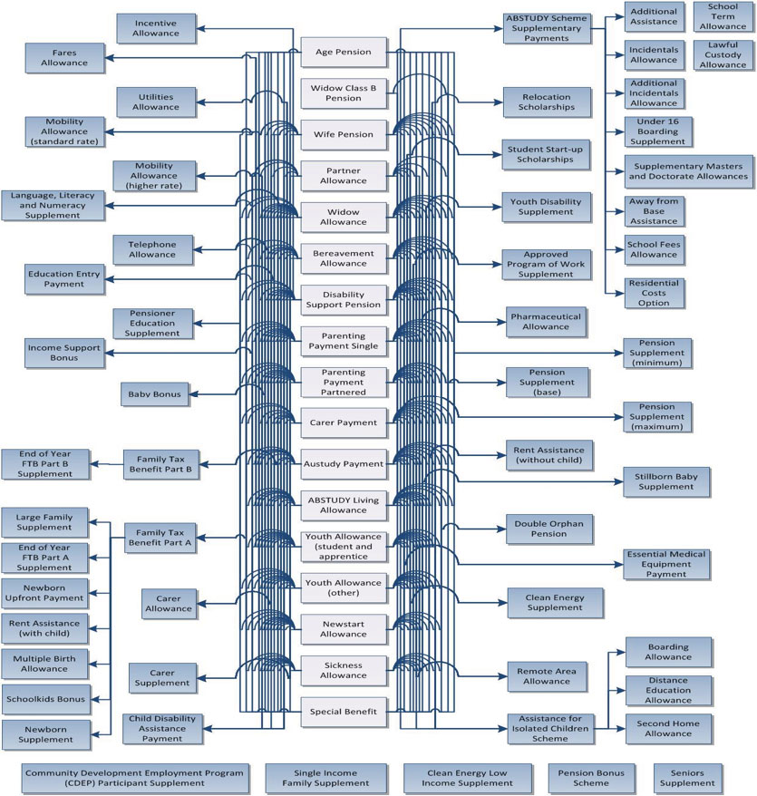
The following figure illustrates the different assistance packages that single people can receive, built up using the various payments and supplements. The amount of assistance can vary from $11,172 a year for an Austudy Payment up to $30,204 a year for Carer Payment plus Carer Allowance (child).

Figure 1: Annual income support packages for single recipients, March 2014
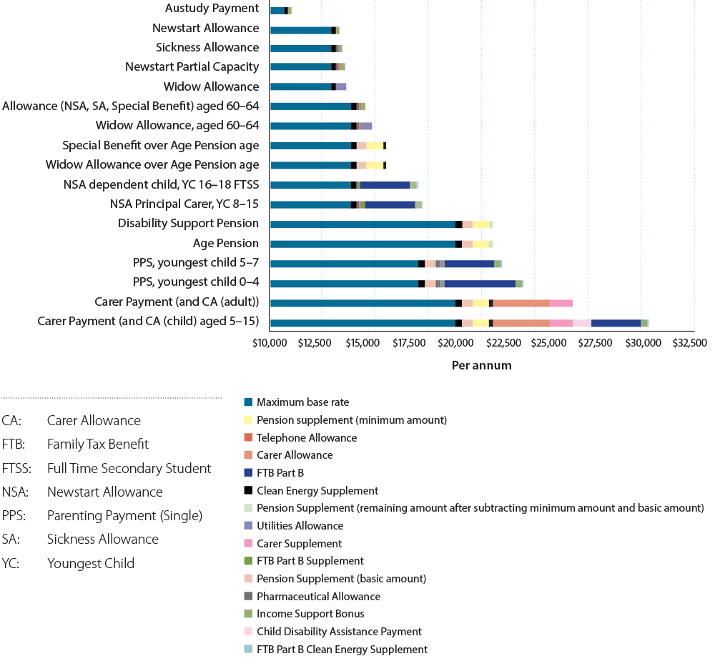
Note: Packages shown are examples only and do not cover all scenarios. This excludes Family Tax Benefit Part A, which is paid to meet the direct costs of children (not the adult recipient’s costs), and Rent Assistance, which is a partial reimbursement of additional costs incurred. Family Tax Benefit Part B is included as this payment ensures a higher standard of living for adults with responsibility for the care of children.
Multiple payment categories can also create problems with the targeting of assistance to people with particular needs. For example, not all unemployed people receive Newstart Allowance, not all students receive student assistance payments, and not all single parents are on Parenting Payment Single. Focusing on services and supports for students on Youth Allowance (Student) or single parents on Parenting Payment Single, overlooks the fact people with similar needs may be on a different payment.

Income support for people with disability
Disability Support Pension currently caters for a population that has a wide divergence of needs. For some individuals, the impact of a permanent and profound disability means that they will never be able to work and will require a pension level payment to achieve a standard of living which the community regards as acceptable.
For others, the impact of a disability may be temporary in terms of work capacity but they require a period of time and employment assistance, such as vocational rehabilitation to increase their work capacity so that they are able to support themselves in the labour market.
Others may have a permanent impairment but a partial capacity to work which means they will only be able to work part-time, but will need a continuing supplement to achieve a basic but adequate standard of living.
In recent years, much effort has gone into improving the assessment of impairment and its impact on work capacity, in order to increase employment of people with disability. The assessment process for Disability Support Pension now focuses on what a person could do rather than what they cannot do.
Most Disability Support Pension claimants are referred for a Job Capacity Assessment.
Job Capacity Assessments, introduced with the July 2006 Welfare to Work reforms, moved assessment for Disability Support Pension from a medical model to an assessment of impairment as it affects an individual’s ability to function in a work-related environment.
From July 2011, Job Capacity Assessments have been undertaken solely by registered health professionals (for example, clinical psychologists) employed by the Department of Human Services. They assess both the individual’s level of functional impairment resulting from the medical condition(s), and the individual’s work capacity.
Revised Impairment Tables were introduced from 1 January 2012 in line with contemporary medical and rehabilitation practice.
The combined effect of these new arrangements has been to reduce the grant rate for the Disability Support Pension from 64 per cent to 43 per cent. In addition, people no longer miss out on disability employment assistance to help them obtain and maintain jobs in open employment, because it is available to everyone who needs it.
The 2014-15 Federal Budget announced that for certain Disability Support Pension recipients aged under 35 years, the Government will introduce compulsory work-focused activities, such as work experience or education and training, to help increase their chances of finding and keeping a job.
A targeted review will also be undertaken of DSP recipients aged under 35 years who originally accessed the payment under different rules between 2008 and 2011. Recipients will have their work capacity reassessed against the current impairment tables, and will be provided with support needed to allow them to develop their work capacity.
However, the gap between the Disability Support Pension and allowance rates still draws criticism about the adequacy of existing allowance rates and the needs of those with a partial capacity to work who will never be able to work full-time. The large disparity in rates is still seen as an incentive for people to seek to minimise their work capacity and maximise perceptions of their incapacity in order to qualify for the higher pension payment.
The Productivity Commission report, Disability Care and Support, stated that ‘the current design of the Disability Support Pension arrangements, and the way people perceive them, discourage the social and economic engagement of people with disabilities, and is inconsistent with one of the central goals of the NDIS’.
The Commission concluded that ‘it may be preferable to construct several layers of disability income support arrangements which, with greater in-work support and more rewards from working, may achieve better job outcomes’.
The Henry review acknowledged that ‘it is inherently difficult to forecast the long-term employment prospects of many people with a disability’. It suggested that it was important to reduce the difference in treatment including payment rates between ‘those assessed as being able to undertake significant part-time work, those deemed marginally able to work and those deemed unable to work’.
To align Disability Support Pension with contemporary disability policy the payment needs to better differentiate between permanent and temporary incapacity. At present the definition of permanent incapacity used to assess eligibility for Disability Support Pension relies on a disability persisting for two years. This definition is outmoded as it disregards modern advances in working with people with disability to improve their employment capacity.
An appropriate treatment or service plan can often extend beyond two years. This might apply for example to young people with intellectual disability who may need support to develop capacity for work over a longer period.
People with psychiatric/psychological impairments are also disadvantaged as many mental health conditions are episodic in nature and with appropriate interventions and flexible participation requirements can be supported in ways that enable them to gain and maintain ongoing employment.
Providing support to people with an incapacity which recognises the possibility of future participation, such as through appropriate medical interventions and disability employment services, could foster greater confidence and skills acquisition and contribute to breaking down stereotypes of what people with disabilities can achieve.

What previous reviews said

Productivity Commission Report, Disability Care and Support

Recommendation 6.1 (extract)
…The Australian Government should reform the Disability Support Pension to ensure that it does not undermine the NDIS goals of better economic, employment and independence outcomes for people with disabilities.
Reforms to Disability Support Pension should aim to:
- encourage the view that the norm should not be lifelong use of the Disability Support Pension among:
  - people with non-permanent conditions
  - people with permanent conditions who could have much higher hopes for employment participation.
- redefine the Disability Support Pension as a transitional disability benefit, not as a pension, for those with some employment prospects, while retaining the pension for those with low employment prospects…

Henry Review, Australia’s Future Tax System Review
Recommendation 86: People with disability who have a partial capacity to work, excluding people receiving Disability Support Pension, should have a part-time work requirement. They should be subject to a means test or payment arrangements that provide an incentive to work part-time and that recognises that they face higher average costs of work. This could also be achieved by an in-work supplement and/or an earnings disregard in the means test.

Too many supplements
Some supplementary payments, like Rent Assistance and Family Tax Benefit Part A, have strong rationales. However, many supplements have remained in the system long after the rationale for introducing them has passed. The 2009 Harmer Review into pensions proposed to rationalise a number of separate supplements into the Pension Supplement. However, these supplements still persist for Parenting Payment Single, youth Disability Support Pension and in the allowance system.
In other cases, parallel supplementary payments perform equivalent roles. For example, there are numerous supplement payments to assist with education costs in various circumstances, such as for children and young people required to live away from home to study. In the ABSTUDY scheme, supplementary assistance is provided to support children from remote areas to study, which parallel equivalent supplementary payments paid under the Assistance for Isolated Children scheme.

Poor support for young people transitioning from school
Multiple payments and inconsistent rules around payments for dependent children and young people create further complexity. Family Tax Benefit is the primary payment for dependent children. However, dependent children over 16 can receive Youth Allowance or Disability Support Pension and Indigenous children and young people can receive ABSTUDY living allowance, which have different rate structures and parental income tests. The result is:
- arbitrary differences in assistance for children in similar circumstances
- reductions in assistance when moving between payments
- optimum payment combinations changing with family circumstances
- families facing multiple means tests to determine their capacity to support children on different payments.

Multiple options for people over the Age Pension age
There is a growing trend for people over the age pension age to receive payments other than Age Pension. A minority of these people are not eligible for Age Pension due to the 10 year residency rule. In most cases, however, it is because people are seeking to qualify for additional entitlements, which were designed to meet the needs of working age people, not retirees. The rules around qualifying for alternative payments over Age Pension age are arbitrary, leading to different people in the same circumstances receiving different levels of support.

The problem with complexity
These complexities are a barrier to achieving a responsive and flexible income support system.
They make the system more difficult to understand and harder to administer. The differences have also become a distraction in the system, leading to perverse incentives for people to try to qualify for higher income support payments, rather than building their capacity and aiming for greater self-reliance, such as through employment.

A common base payment with add-ons?
A popular response to the complexity of the current system is to argue for a common base payment with add-ons. This model was first proposed in July 2000, in the Final Report of the Reference Group on Welfare Reform, chaired by Patrick McClure. That report, Participation Support for a More Equitable Society, proposed medium to long-term recommendations that would provide for an integrated payment system which would include a common base payment and needs based additional payments varying according to different circumstances. For example, add-ons that provide assistance with the costs of disability, or recognise the extra costs of living as the only adult in a household, or provide assistance recognising costs of meeting participation requirements.
The Government subsequently released the report, Building a simpler system to help jobless families and individuals, in 2002, with a model also based on one main payment for working age people with add-on ‘modules’ responding to additional needs, such as the costs of disability.
While attractive at the time, subsequent changes over the intervening years mean that such a model may no longer represent the best pathway for change. For example, the rates of payment for pensions and allowances were quite close at the time, which made a single base payment a realistic option, whereas the gap is now much wider which makes this model less feasible.
A single base rate with an add-on for the costs of living alone also assumes that couples and singles sharing accommodation face similar basic living costs. More recent evidence from the Harmer Review found that paying a higher rate to singles living with others was appropriate to provide a similar standard of living to couples. This suggests that paying the same rate to both single sharers and members of a couple as envisaged in the common base payment model would not deliver equitable outcomes.
The original proposal for an add-on for cost of disability was further considered in the Harmer Review, which found that the preferred approach was improvements to support services such as a National Disability Insurance Scheme.
Apart from these changes in the policy environment, a system of add-ons risks its own complexity, because different add-ons for different purposes may have overlapping rationales with the risk that individuals qualifying for multiple add-ons will be inequitably-assisted. The model discussed below uses different rates to capture the need for different levels of assistance, while retaining supplements for recognised additional costs.

Future directions

Fewer primary payments
The key to a simpler architecture is to have fewer primary payment types. This approach was recommended by the Reference Group on Welfare Reform in 2000, in the Australian Government’s discussion paper, Building a simpler system to help jobless families and individuals in 2002, and in the Final Report of the Henry review into Australia’s tax system in 2009. The United Kingdom and New Zealand are pursuing a similar approach. (See Part One for a summary, and Appendix F for more information on these international reforms.)
A key principle for a simple payment architecture is that pensions should be paid to people who are expected to remain in the income support system for the rest of their life with no expectation of work, and are not suitable for those who are expected or encouraged to leave income support by working.

Tiered working age payment
A simpler architecture should include a single working age payment. This would reduce complexity and confusion for recipients and provide a clearer, more consistent approach to entitlements. People would not need to choose between different payment options, and instead would be able to focus their efforts on building self-reliance.
Payments targeted at working age adults, including Newstart Allowance, Parenting Payment, and Austudy Payment could be combined into a single working age payment. This would be the payment for all adults who are expected to work now or in the future.
People with disability who have current or future capacity to work could be assisted through the tiered working age payment to better reflect different work capacities. This could also include some people with disability and a partial capacity to work, who under existing rules would have qualified for Disability Support Pension.
Within the working age payment, different tiers of payment could take account of individual circumstances, such as partial capacity to work, parental responsibilities or limitations on availability for work because of caring. As discussed in more detail under the theme Fair rate structure, these different rates would recognise that higher payments may be appropriate to support the wellbeing of children or to recognise that recipients may not have the ability or availability for work to earn enough to become fully self-reliant.
Requirements, services and other supports could be individualised to each recipient’s circumstances. For example, requirements for people with disability and a partial capacity to work would reflect their current capacity and the capability building steps and support services to strengthen their capacity to work into the future.
In the context of the national implementation of the National Disability Insurance Scheme, it will be important to consider the right combination of rates of income support, supplements and other supports to help carers continue to do their caring role whilst supporting them to remain attached to the labour market or re-enter it wherever possible.

Disability Support Pension
Disability Support Pension would be reserved only for people with a permanent impairment and no capacity to work. This would recognise that people who can never work need pension-level assistance. People with disability who have capacity to work could be assisted through the tiered working age payment. This would recognise their current or future capacity to work. In setting eligibility rules it would be important to strike the right balance between investing in those with capacity to work and providing a pension for those who cannot work now or in the future.

Child payment
A simpler child payment structure could bring together Family Tax Benefit Part A, Youth Allowance, ABSTUDY and other payments for dependent children and young people. This would simplify payments to families for their children. It would also clarify the expectation that parents who have the means to do so will support their children through school and the transition to independence, including further study and entering the workforce. This is discussed in more detail under the theme Support for families with children and young people.

Age Pension
Payments for those over Age Pension age could be simplified by channelling all individuals into one Age Pension to avoid duplication and inequities. For those without the 10 year residential qualification for Age Pension, a working age payment could continue to be paid and appropriate participation supports could continue to be provided.

In summary
The primary payment types could comprise:
- a disability support pension for people with a permanent impairment and no capacity to work
- a tiered working age payment for people with some capacity to work now or in the future, including independent young people
- a child payment for dependent children and young people
- an age pension for people above the age at which they are generally expected
to work.

Fewer supplements
There should be fewer supplements with more clearly defined purposes for specific additional costs. For example, a Participation Supplement for those receiving the working age payment to cover the costs of job search or training, Rent Assistance for those paying significant private rent and Mobility Allowance for people with disability who are unable to use public transport and who require travel for participation purposes.
In other cases, supplements could be absorbed into the basic payments. For example, Pharmaceutical Allowance, Telephone Allowance, Utilities Allowance, Clean Energy Supplement and even larger supplements such as Pension Supplement and Family Tax Benefit Part B could potentially be absorbed into the primary payment rates.
Overall, this could result in fewer supplements with more clearly defined roles, so that recipients get the help they need, but without unnecessary complexity.

First steps
Many steps are required to transition to a simpler architecture. Early steps could include establishing a new working age payment, by bringing together the different allowances with similar rates and conditions, such as Newstart Allowance, Sickness Allowance, Widow Allowance, Partner Allowance or Parenting Payment Partnered, as well as existing payments that could be transitioned into the new working age payment with minimal changes, such as Austudy Payment. Further consideration of arrangements for managing change for other payments is likely to be required.
What is the preferred architecture of the payment system?
Should people with a permanent impairment and no capacity to work receive a separate payment from other working age recipients?
How could supplements be simplified? What should they be?
What are the incremental steps to a new architecture?

Fair rate structure
Within the different payment categories in the income support system, different recipients are paid different rates depending on their circumstances. There are two main policy reasons why rates should differ:
- Equity—sometimes different payments rates are required to achieve the same standard of living. For example, a member of a couple is generally paid less than a single person, because a single person may live alone and as such is considered to need more money to achieve the same standard of living (due to not having the economies of sharing).
- Incentives to work—different payment rates may be intended to create a stronger incentive to work for particular groups (such as single unemployed adults) by emphasising the higher standard of living that can be achieved through finding work, with full-time work the ultimate goal where appropriate.
In practice, payment rates do not follow these principles in a consistent way. They are instead the result of ad hoc decisions made over time, with unintended consequences for equity and levels of support for particular groups within the payment system.

Large gaps in payment rates
The large differences between pensions and allowances across the income support system and, in particular, the lack of adjustment to allowance rates for growth in community living standards have led to the large gaps now evident in payment rates and to the distortions that have resulted from these gaps.
The growing gap between pension and allowance rates also raises the question of whether current allowance payment rates are adequate and appropriate. This has been the subject of considerable debate in recent years, including a Senate inquiry which attracted a diverse range of stakeholder submissions calling for an increase in allowance rates. Concerns have been raised that allowance rates are too low to effectively support recipients to achieve a basic acceptable standard of living and to fulfil their participation obligations.
There is an argument for differences in payments for different groups. The final report of the Henry Review into Australia’s tax system recommended a three-rate structure with higher payments for pensioners, lower rates for the participation category and lower rates again for student assistance.
Different levels of support may be appropriate for different groups, considering issues such as stage of life, capacity to work, family responsibilities for the care and support of children, and work incentives. However, ultimately income support has to be sufficient to deliver a basic acceptable standard of living for those with no other means of financial support.
There is no simple formula for determining an appropriate level of assistance to achieve basic adequacy. The 2009 Harmer Review into pensions explored a range of measures to develop a picture of whether payment rates were more or less effective in delivering a basic acceptable standard of living to recipients.
There would be value in exploring how current allowance rates perform against some or all of these measures, and how this performance has changed over time.

The Harmer Review approach
The 2009 Harmer Review into pensions approached the question of adequacy by considering a range of indicators, including:
- growth in payments relative to various earnings measures, including minimum wages, median wages, average wages (before and after tax)
- growth in payments compared to equivalised household disposable income,
which is often used to construct poverty measures
- replacement rates (the value of payments compared to various wage measures) over time and compared to other countries
- budget standards research, which estimates the cost of living in a low income household based on a basket of goods
- income poverty measures, which compare the value of payments to a measure of community living standards based on equivalised household disposable income
- indicators of financial stress or hardship
- subjective wellbeing measures.

Different single and couple rates
Pensions, allowances and student payments all have different rate structures. Pensions have single and partnered rates, allowances have two single rates and a partnered rate, and students without children have one rate for both single and partnered recipients.
The following figure compares the level of income support payments for single people and couples, with the singles rate shown as a percentage of the equivalent rate paid to a couple. The ratios shown apply to recipients who are not caring for children. Income support payments to families with children are discussed on under the theme Support for families with children and young people. A ratio of 50 per cent indicates that single recipients and each member of a couple are paid the same amount. A higher ratio indicates that single recipients are paid more than a member of a couple.

Figure 2: Single rates expressed as a percentage of combined couple rates for adult recipients without children, March 2014
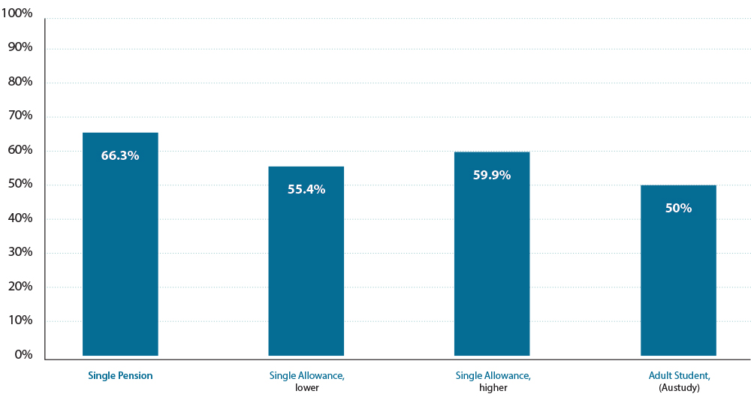
Note: The percentage shown is the single rate compared to the equivalent payment to a couple combined, based on basic income support packages.

Single pension rate
The single pension rate was increased from 60 per cent to 66.33 per cent of the combined couple rate following the 2009 Harmer Review. This was in response to the review’s finding that 60 per cent was too low, based on the costs of a single person living alone (that is, not living with another adult) compared with a couple.
However, the Harmer Review found that the 60 per cent of the combined couple rate was appropriate for a single person sharing with another adult/s (other than a partner), as this group had similar wellbeing outcomes to couples and did ‘not face the same financial pressures as single pensioners living alone’.
Despite this, the pension rate was increased for all single recipients. This means a single pensioner sharing accommodation with another adult is likely to be able to afford a higher standard of living than an equivalent single pensioner living alone or a couple (assuming the same private resources).

Single allowance rates
There are two different rates for single people receiving allowances. The higher rate is around
60 per cent of the combined couple rate and was originally based on the same assumption about higher costs for a single person living alone compared with a couple.
While the additional costs of living alone is one consideration in setting the higher single allowance rate, working age income support recipients also face costs associated with meeting their participation obligations. These are largely individual costs, and couples are unlikely to save any of these costs as a result of being partnered. This suggests that the higher single allowance rate could be set lower than the 66.33 per cent used for single pensioners.
In the case of the lower single allowance rate, this was originally created as a result of an indexation freeze in 1978 and has remained below the other income support rates paid to single adults. This could imply the lower rate was deliberately maintained in order to increase incentives to work. This lower level of adequacy could also be a result of assumptions about living arrangements. While the higher rate is based on the assumption of higher costs for singles living alone, the lower rate may assume lower housing costs for people sharing accommodation.

Who should get a higher working age payment rate?
There are some people for whom full-time work is unlikely to be possible. Two groups in this situation currently receive the higher single rate in the allowance system: single parents and
longer-term unemployed recipients over 60 years old.
The wellbeing of children is a major consideration in paying single parents the higher single rate. A second consideration is the limited participation requirements (30 hours a fortnight). This means that single parents are less likely to stop receiving the payment even if they fully meet their participation requirements, and are therefore more likely to rely on income support over the longer-term.
For the long-term unemployed group aged over 60, the original rationale for paying the higher single rate (which at the time was the same as the pension rate) was that these recipients had limited prospects of finding full-time work, and were likely to rely on working age income support until they reached Age Pension age. With the increasing age pension age and more older people in the workforce, a more individual approach based on capacity to work should be considered.
Arguably a higher working age payment rate could also be considered for other groups currently receiving the lower rate:
- People receiving the Widow Allowance are not required to seek work due to their age
(born before 1955) and lack of recent workforce experience.
- Single allowance recipients with disability and a partial capacity to work (between 15 and
29 hours a week) may face reduced prospects of finding work, are not expected to work
full-time and may not be able to earn enough to leave income support even if they fully meet participation requirements. As a result, they are more likely to rely on income support over the longer-term.
- Some people who have caring responsibilities that place significant limitations on their availability for work.
It may also be appropriate to consider whether different rates should apply to couples.

Adults receiving youth rates
The point at which people receive an adult rate varies according to the payment they receive. Inconsistencies may create perverse incentives for people to access less appropriate payments.
For older recipients, the payment of youth rates may not meet their costs of living. In particular, Austudy, which is paid to students over 25-years-old who are undertaking approved study, is paid at youth rates.

Income support packages for parents caring for children
The wellbeing and longer-term outcomes of children are important considerations when determining rates of payment for parents. Therefore, it is appropriate that income support packages for parents with children are typically higher than those for individuals and couples without children.
Income support packages include both the allowance or Parenting Payment rates plus additional supplements, particularly Family Tax Benefit Part B.
Parents are paid higher packages for four main reasons:
- It recognises the higher costs faced by families with children, such as needing larger homes than people without children.
- It protects the welfare of children by providing a higher standard of living for families with children than equivalent recipients without children.
- It recognises the social and economic benefits of producing the next generation.
- It reflects the desire for healthy and stable families.
While this approach may marginally reduce incentives to work, responsibility for the welfare of children is usually a strong motivation for parents to find work.

Falling support for single parents as children grow up
Assistance to single parents reduces as their children get older. The figure below shows the level of income support payments to single recipients with children, expressed as a percentage of the rate paid to an equivalent couple with children.

Figure 3: Single rates expressed as a percentage of combined couple rates for adult recipients with children, March 2014
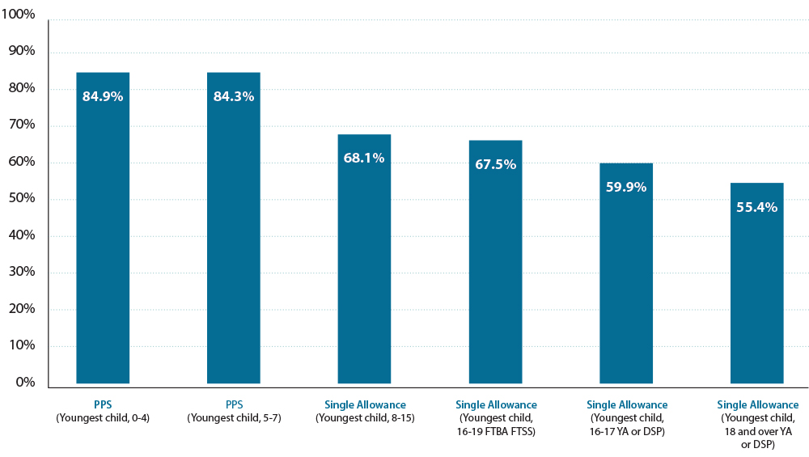
Note: The percentage shown is the single rate compared to the equivalent payment to a couple combined, based on basic income support packages including Family Tax Benefit Part B.
DSP: Disability Support Pension
FTBA: Family Tax Benefit Part A
FTSS: Full Time Secondary Student
PPS: Parenting Payment Single
YA: Youth Allowance
The figure shows that assistance to single parents becomes progressively lower as their children get older:
- The single parents who benefit from the highest income support packages are those receiving Parenting Payment (Single) whose payments are benchmarked to Male Total Average Weekly Earnings (like pensions). In contrast, equivalent couples receive allowance payments not linked to increases in community living standards, and that have not grown in real terms.
- The relatively high payments for single parents on Parenting Payment (Single) may create hardship for single parents attempting to re-partner, or to reconcile with their previous partner who also has a low income. This is because moving from Parenting Payment (Single) to Parenting Payment (Partnered) is likely to result in a significant reduction in the standard of living of the family.
- Rates for single parents fall sharply when they move from Parenting Payment (Single) to an allowance once their child turns eight, reflecting the same lower rates paid to couples.
- There is a drop in payments to single parents when some supplements are withdrawn when their youngest child turns 16.
- There is a drop in payments to single parents whose youngest child moves to Disability Support Pension or Youth Allowance when aged 16 to 17, reflecting the loss of Family Tax Benefit Part B, even though the parent is still responsible for the child living at home.
- There is a drop in payments to single parents when their youngest child turns 18 and the parent moves from the higher to lower rate of allowance, even though the parent is still expected to provide accommodation for a child living at home.
While it is reasonable to increase work expectations for parents as their children grow up, this needs to be balanced against the need for appropriate financial support for children living in low income families, who are at risk of intergenerational disadvantage.
The way the income support system supports young people and their families through the transition to independence is further discussed under the theme Support for families with children and young people.

Timely assistance to parents
Family Tax Benefit Part B is a significant part of the overall income support package for parents with children. However, it is not always received in a timely way, particularly for couples. Parents are required to estimate their income and generally overestimate to avoid a debt. This delays receipt of assistance and undermines the effectiveness of the payment in meeting the day-to-day costs for a family. This assistance may be better delivered through income support rather than family assistance.

Future directions

Reconsider gaps in rates
In moving towards a new working age payment, consideration could be given to reducing the current gap between pensions and allowances, particularly for people with limited work capacity, or with significant labour market disadvantages. Consideration could also be given to eliminating the gap between allowance rates for adult students and allowance rates for unemployed adults, and narrowing the gap between youth and adult rates of allowances.

Target higher working age payment rates
Within a tiered working age payment, the payment of different rates to different recipients is appropriate. However, consideration should be given to when a higher rate should be paid. Recipients of higher rates could include people who are likely to remain on income support payments for a longer period, such as single parents, people with disability and a partial capacity to work, and others with a significant labour force disadvantage (for example those on the Widow Allowance). Recipients of the lower payment rates could include students and single unemployed, particularly those at younger ages who can be expected to share accommodation.

Review single rates
The single rates in the allowance system should be reviewed, taking account of the costs of living alone compared with sharing accommodation, as well as the costs of meeting participation obligations. Results would inform any move to a new working age payment and the rate structure design and the setting of single and couple rates in the future.

Income support for families with children
Work should be undertaken to establish appropriate payment rates for income support recipients with children. This would consider more consistent rates paid to single parents compared with the rates paid to couples with children, and rates paid as children get older but remain dependent on their parents for housing and other support.
Further consideration should also be given as to how to best deliver the additional assistance currently provided through Family Tax Benefit Part B to ensure it is received in a timely way to assist families with children.
How should rates be set, taking into account circumstances such as age, capacity to work, single/couple status, living arrangements and/or parental responsibilities?

Common approach to adjusting payments
Different approaches to adjusting payments over time have led to a wide variation in rates for different payment categories.
In a social support system, there are three main objectives in the adjustment of payments:
- To maintain the real value of payments—to maintain purchasing power, in line with cost of living increases.
- To maintain the relative value of payments—to ensure living standards of people relying on income support payments increase in line with broader changes in community living standards.
- To maintain a coherent system—to maintain relative rates of payment across the system by ensuring all payments are adjusted with the same provisions.
Current approaches to adjusting payments only focus on either the first, or the first and second objectives, rather than all three. As a result, the system has become less coherent. The most notable example is the growing gap between pensions and allowances, which creates challenges in a number of areas:
- Adequacy—the large difference between allowance and pension has raised questions about whether the allowance rate adequately meets recipients’ basic needs. This is heightened by adjustments to pension rates (particularly for singles) following the 2009 Harmer Review. This becomes more marked because of the different groups who now receive allowance.
- Incentives for individuals—large differences in entitlements can focus people on maximising income support payments rather than building their capability and finding a job, where they have the capacity to work.
- Complexity of administration and eroding community confidence in the system—the distorted incentives and lack of coherence in the system, caused by large differences in payments for different groups, mean governments have to increase efforts to preventing people from seeking to claim the wrong payment. This can also undermine community confidence in the fairness of the system.

Growing gap between pensions and allowances
The figure below compares the basic income support packages for various single and couple household types in 1997 and 2014.
It shows the growing gap between basic pension and allowance payment rates over recent years.

Figure 4: Basic income support packages for various households,
January 1997 and March 2014
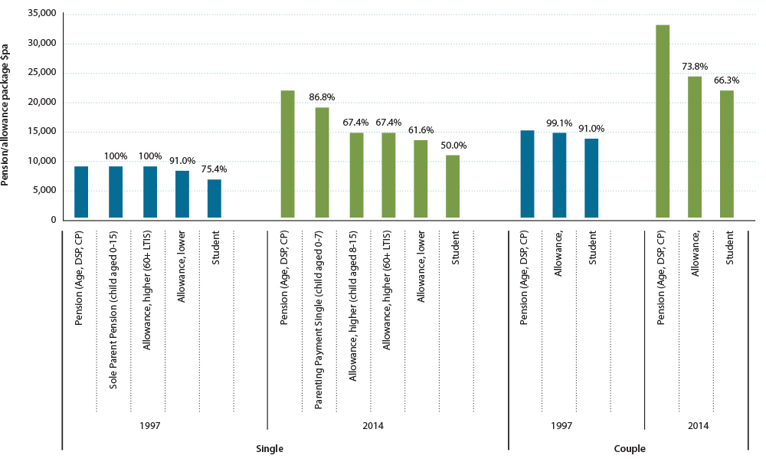
Note: Percentage labels show the proportion of the corresponding pension payment for each other payment group. Income support packages shown are illustrative and do not cover all scenarios. ‘March 2014’ rates are those applying from 20 March 2014.
Age: Age Pension
CP: Carer Payment
DSP: Disability Support Pension
LTIS: Long-tem income support
The figure shows that the basic income support packages payable to different groups on income support were relatively similar in 1997. People receiving allowances on the lower single allowance rate were paid 91 per cent of the pension rate. Those with a partner were paid more than 99 per cent of the equivalent pension rate.
By 2014, however, the relative value of these allowance rates had fallen. People receiving allowances on the lower single rate in 2014 received only 61.6 per cent of the pension rate. Those with a partner received only 73.8 per cent of the pension rate.

Current approach to adjusting payments
There are currently two different approaches to adjusting basic income support payments. This has led to the growing gap in payments. Allowances and family payments have been adjusted to maintain their real value, whereas pensions have been adjusted to maintain their real value and their value relative to community living standards.
In the 2014-15 Budget the Government decided to phase in Consumer Price Indexation as the common form of indexation across all payments in the future.

Allowances and family payments
For allowances and family payments, the maximum basic rate is indexed every six months to the Consumer Price Index which is a general measure of price inflation. Indexation involves increasing the payment by the same percentage as the increase in the Consumer Price Index for the specified period.

Pensions
For pensions, the maximum basic rate is currently indexed each six months to either the Consumer Price Index or the Pensioner and Beneficiary Living Cost Index, whichever is higher.
In addition, the pension maximum basic rate is currently benchmarked every six months to Male Total Average Weekly Earnings. The combined couple rate of the maximum basic pension is benchmarked to 41.76 per cent of Male Total Average Weekly Earnings, with the single rate set at 66.33 per cent of the couple rate. If the pension rate falls below the benchmark it is increased to match that percentage.
This adjustment is intended to increase the pension to maintain its relative value when there has been an improvement in community living standards, as represented by Male Total Average Weekly Earnings.

What previous reviews said

Harmer Review, Pension Review Report
Finding 8: The Review finds that automatic indexation of pensions and a two-part approach of benchmarking and indexation should continue. Benchmarking pensions relative to community standards should be the primary indexation factor, with indexation for changes in prices acting as a safety net over periods where price change would otherwise reduce the real value of the pension.
Finding 9: The Review finds that pension indexation for price change would be better undertaken through an index that more specifically reflected cost of living changes for pensioners and other income support recipient households.
Finding 10: The Review finds that no single measure to benchmark the pension to community living standards is without limitations. However, the Review considers that a measure of the net income of an employee on median full-time earnings may be a more appropriate measure than the existing Male Total Average Weekly Earnings benchmark.

Henry Review, Australia’s Future Tax System Review
Recommendation 84: Payments and income test parameters should be indexed in a consistent way to maintain relativities across the three payment categories and to reflect changes in community standards. Governments should regularly review indexation as community standards are likely to be affected by significant changes in the composition of the workforce and household incomes in coming decades. The current community standard for pensions is set by reference to Male Total Average Weekly Earnings. Indexing all payments to this standard has been projected to involve a significant increase in budgetary outlays over the coming decades so it will be necessary for governments to regularly review the appropriateness of this measure and the level of the benchmark.

Future directions

Common adjustment approach
There should be a common approach to adjusting payments to ensure a more coherent social support system over time. This would also ensure that resources devoted to low income recipients are shared more fairly over time. It is important to ensure that any approach to adjusting payments balances sustainability of the income support system, fiscal flexibility for governments and changes in community living standards as the economy grows.
To design such an approach requires further consideration of several issues including:
- The most appropriate measure of movements in the living costs of households reliant on income support.
- The frequency of adjusting cost of living increases.
- The most appropriate measure for maintaining the value of payments relative to community living standards. This could be done through a periodic review (e.g. every three years) as an alternative to an automatic adjustment.
What might be the basis for a common approach to adjusting payments for changes in costs of living and community living standards?

Support for families with children and young people
The social support system makes payments to low income families to provide a basic acceptable standard of living for their children and support them to build the foundational skills and qualifications they need to participate in the workforce. The cost of providing for children is a large part of total family costs. Therefore, providing adequate support for children in low income households is critical.
Payments for low income families with children and young people should support children to finish their education and transition to the workforce.
As children grow, their needs change and the cost of providing a basic standard of living increases. As children transition from school to further study or into the workforce, they often remain dependent on their parents but their basic costs continue to rise.
In some families, children move away from home to study, but remain dependent on their parents for financial support. The additional costs are higher again for children from remote areas who are required to live away from home to complete secondary study.

Complex family and youth payments
Figure 5 shows the complex range of packages available to meet the direct costs of children and young people. Current arrangements provide inconsistent levels of assistance and inequitable means testing. For some families, anomalies in assistance may undermine the goal of supporting young people to complete school and undertake further education.
There is a need for a simpler system which better reflects the costs of children as they age and strongly supports completion of education and transition to independence and the workforce.

Inconsistencies in rates of payment
The current rates of payment do not reflect the increasing costs as children grow up. This was noted by the Henry Review.
The same rates apply to preschool and primary school age children despite costs being lower in the preschool years. Rates increase at age 13 and stay flat throughout the teenage years, and Family Tax Benefit Part A for secondary school children is higher than Youth Allowance payments to children who finish school. This is despite evidence that costs rise significantly as children are in the final years of secondary school and move into adulthood.

Young people living away from home to study
Families with children and young people who have to leave home to complete their education need appropriate additional assistance.
This is currently covered by a range of different payment arrangements with basic costs met by either Family Tax Benefit Part A, Youth Allowance or ABSTUDY living allowance. Additional costs of living away from home are provided through Assistance for Isolated Children (in combination with Family Tax Benefit), Rent Assistance (in combination with Youth Allowance or ABSTUDY living allowance) or ABSTUDY supplements (in combination with ABSTUDY living allowance). These payments should be rationalised.

Figure 5: Payment packages for children, youth and adult students, March 2014
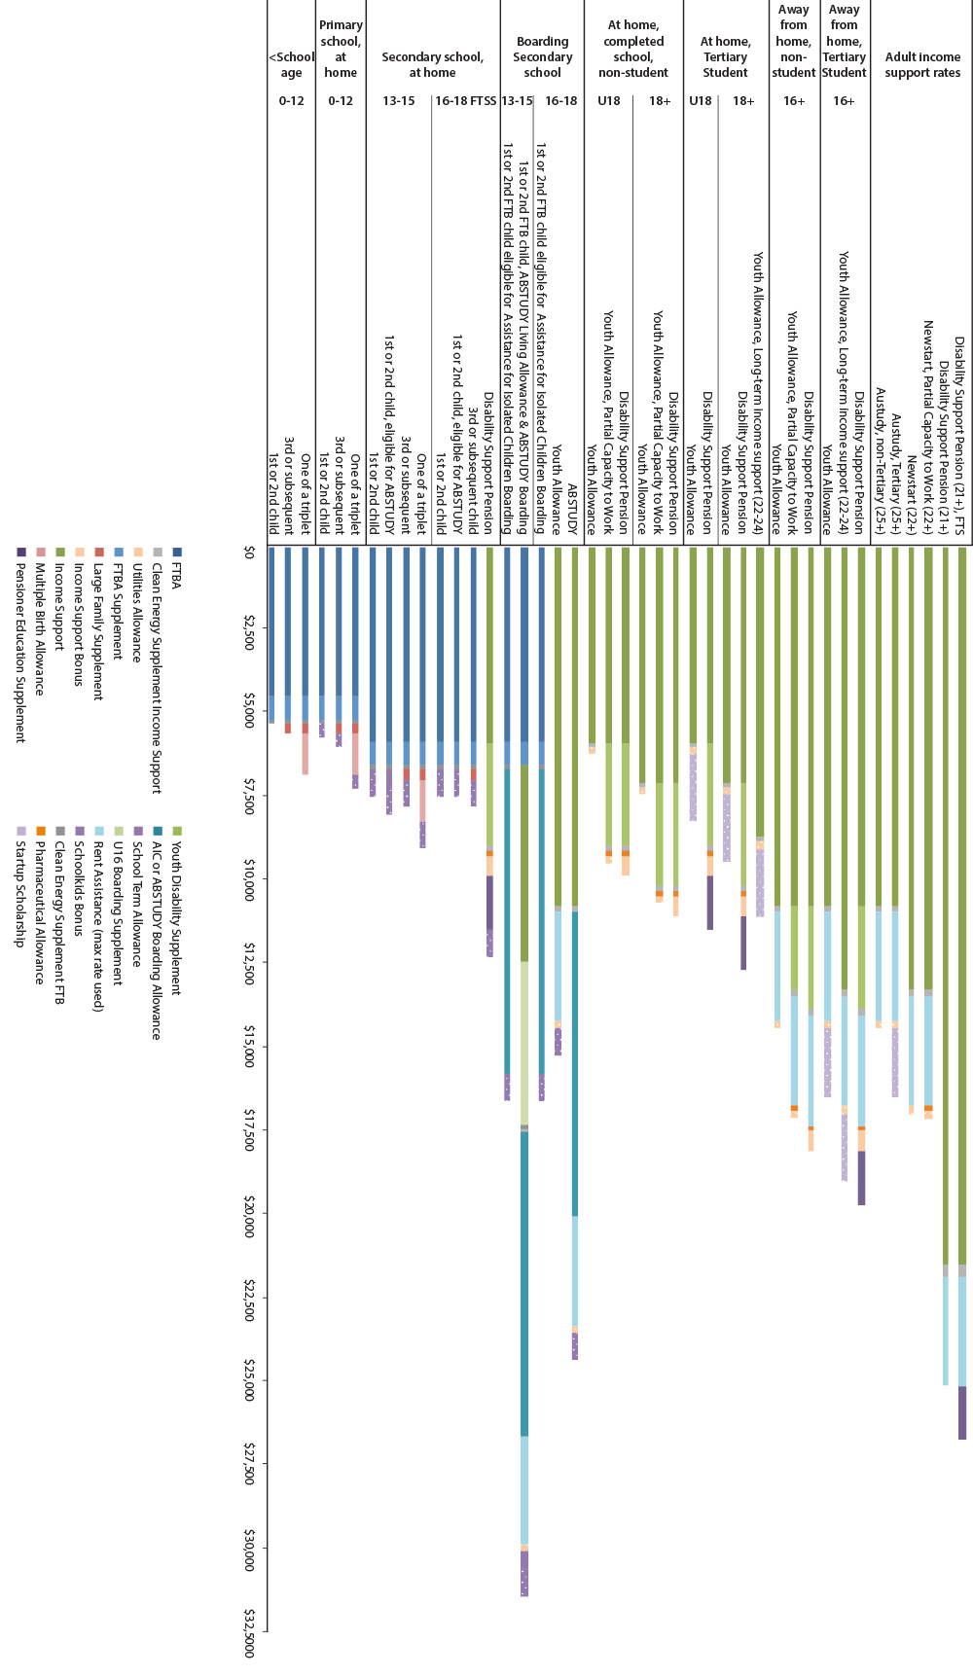
Note: Rent Assistance and Boarding Supplements are reimbursements of expenses and so are not available to support general living expenses. They are shown to allow comparisons of the different packages of assistance available for children and young people living away from home.
AIC: Assistance for Isolated Children
FTB: Family Tax Benefit
FTBA: Family Tax Benefit Part A
FTSS: Full Time Secondary Student

Children living across more than one household
There are over 300,000 children who live across more than one household. The current system does not consistently recognise the circumstances of these children.
There should be a more consistent approach within family assistance and youth payments.

Income support payments to children and young people
Currently, children and young people can qualify for a range of income support payments in their own right before they become adults. For example, Disability Support Pension is paid at youth rates from the age of 16. Carer Payment and Parenting Payment can be paid at adult rates from any age.
There is a need for a clearer policy framework for:
- when income support should be paid to a young person in their own right
- the circumstances under which families should receive assistance for dependent young people.

Rent Assistance
A young person receiving an income support payment (generally, Youth Allowance, Newstart Allowance, Sickness Allowance or Disability Support Pension) aged 16 to 24 (or aged 16 to 20 for Disability Support Pension) who is living at home, is not eligible for Rent Assistance, either for themselves or their parents. This significantly reduces assistance for families at a crucial stage in the young person’s transition to work and independence. A better approach is needed.

What previous reviews said

Henry Review, Australia’s Future Tax System Review
Recommendation 98: Youth payments should be the main form of income support from the age of 18 until the age of independence.
i. Family payments should not be provided for those aged 18 and over unless they are completing secondary school in the year they turn 18.
ii. Youth payment rates should reflect the fact that most young people have lower needs than adults but need adequate assistance to participate in education and training.
iii. Dependent youth payment recipients should be subject to a parental income test consistent with that applying to family payments. Family means tests should be designed so that families with dependent children in both the family payments and youth payments system are not disadvantaged.
iv. The age of independence should be aligned for full-time students and non full-time students.

Future directions

Simpler payments
The complex mix of different payments should be replaced by a new child payment for the costs of children and young people to complete education and transition to work.
Payment rates in a new child payment could increase progressively to recognise the increasing costs as children grow up.
Supplements could be paid to recognise additional costs in particular circumstances, such as living away from home to study, the costs of studying in a remote location and the costs of living across more than one household.

Clearer policy
A clearer policy framework should be developed for when children and young people can access income support in their own right. This needs to ensure sufficient incentives for education and transition to work.
How can we better support families with the costs of children and young people to ensure they complete their education and transition to work?
In what circumstances should young people be able to access income support in their own right?

Rent Assistance
Rent Assistance is a supplementary payment for around 1.3 million individuals and families to help with the additional costs of private rental.

Pensioners
The 2009 Harmer Review found that pensioners who rent privately have poorer outcomes, including higher financial stress than pensioners who are outright homeowners or some living in public housing. This is mainly due to high rental costs and the declining effectiveness of Rent Assistance to help with these costs, as well as other disadvantages such as the security of their housing arrangements.

Income support recipients
A large and increasing proportion of income support recipients rely on housing in the private rental market. Payments therefore are important to facilitate access to adequate housing and maintain living standards after housing costs.

Eligibility for Rent Assistance
Eligibility for Rent Assistance is conditional on eligibility for income support or Family Tax Benefit Part A. Figure 6 shows how median rents have grown by household type for different groups at June of each year from 2001 to 2013, compared to Rent Assistance, and the amounts that households must meet out of their basic income support payments.

Figure 6: Growth in housing costs for income support recipients by household type, 2001 to 2013
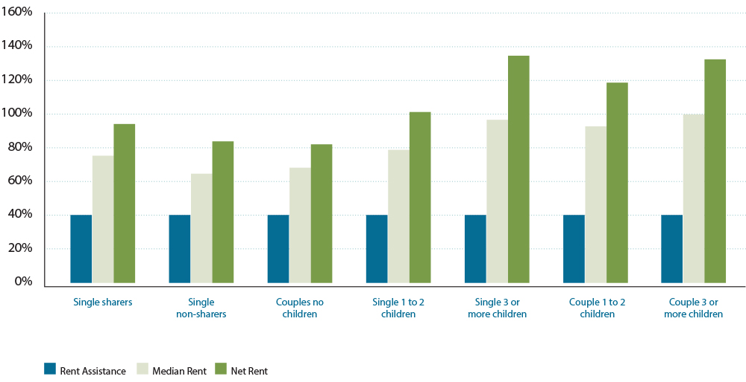
The figure shows that while maximum rates of Rent Assistance have increased by 40 per cent between 2001 and 2013, median rents for each group have increased by between 65 per cent and 100 per cent.
This demonstrates that rates of Rent Assistance have not kept pace with the growth in rents experienced by income support recipients. As a consequence, income support recipients have to cover more of the costs of rent (net rent) from their income support and family assistance payments, which reduces the income available to cover other costs of living.
There is a need to redesign Rent Assistance to assist people in private rental who have the highest needs.

Indexing rent assistance
Rental housing costs have grown faster than the Consumer Price Index which is used to index Rent Assistance.
The 2009 Harmer Review concluded that:
[A] separate index that more appropriately reflects changes in the cost of private rent would have merit [and could] be based on the actual rents paid by income support recipients to obtain a good measure of the actual changes experienced in the particular segment of the market in which this group operates.

Impact of public housing on income support recipients
A key feature of public housing is the policy of charging rents at a proportion of total income. This rent setting policy results in two potential perverse outcomes for income support recipients.
The first perverse incentive is that people consider public housing more attractive than living in private rental accommodation. A key reason is that income based rents are lower than the net rents paid by private tenants in the private rental market. Because demand for public housing is high and waiting lists are long, public housing is only allocated to those who can demonstrate a low income and poor capacity to obtain private rental accommodation. This may result in prospective tenants on the waiting list being reluctant to improve their circumstances, for example gaining employment, because this may jeopardise their claim for a public housing tenancy.
A second potential perverse incentive applies to those already in public housing, who seek to improve their circumstances through paid work. Because public housing rents are set as a proportion of income (typically 25 per cent), any extra earnings result in higher rent charges. This can disrupt financial arrangements and erode the rewards that income support recipients might otherwise gain from working. This effect is not experienced by income support recipients in the private rental market.

What previous reviews said

Harmer Review, Pension Review Report
Finding 17: The Review finds that there would be merit in restructuring rent thresholds to target Rent Assistance to those who pay higher rents and addressing inequities that have arisen with the sharers rate of Rent Assistance.

Henry Review, Australia’s Future Tax System Review
Recommendation 102: The maximum rate of Rent Assistance should be increased to assist renters to afford an adequate standard of dwelling. To ensure that Rent Assistance can be maintained at an adequate level over time, the rent maximum should be indexed by movements in national rents, which could be measured by an index of rents paid by income support recipients.
Recommendation 103: To better target an increase in the maximum rate, Rent Assistance should be part of the income support system, with eligibility based on rent paid and the income support means test, rather than on eligibility for another payment (for example, Family Assistance).

Future directions
Rent Assistance should be reviewed to determine appropriate levels of assistance and the best mechanism for adjusting assistance levels over time. Initial steps in this direction may be possible at little cost to the Budget.
Rent assistance for parents should recognise their role in supporting young people beyond school to independence.

Rent setting in social housing
In the context of deliberations on future directions for state/territory public and community housing, consideration could be given to moving away from the current system of income based rents towards the use of Rent Assistance as the preferred rent subsidy scheme across both private and public tenures.
How could Rent Assistance be better targeted to meet the needs of people in public or private rental housing?

Rewards for work and targeting assistance to need
A central feature of Australia’s social support system is means testing targeted to need. People who have earnings from work, unearned income from investments, or significant assets, receive reduced payments or no payments at all. There are two key benefits of this approach:
- net cost to government is lower
- more funds are available to better support those in genuine need.
However, means testing has consequences for people’s behaviour. Withdrawing income support payments reduces the net gain from work. If too much income support is withdrawn, people may not gain enough income from their earnings to have an incentive to work.
Income tests are usually designed with a ‘free area’. This is the amount of income someone can have before the income test applies. The free area recognises that people need to meet the costs of working out of their wages, before they can spend earnings on other needs. For unearned income, a free area allows a recipient to hold modest savings without affecting their payments (unless they have other income).
Income tests also have a ‘taper rate’. This is the amount by which payments reduce for every dollar of income above the free area. The taper rate is a compromise between the goal of reducing government assistance and encouraging greater self-reliance on one hand, while on the other hand maintaining a reward for working through being able to achieve a higher standard of living as a result of earning income from work. When income falls, the taper rate dictates what proportion of the income will be replaced by income support or family payments.
The ‘cut-out’ is the income at which payments are reduced to zero when people cease to receive income support.
The complexity of current income testing arrangements means that income support recipients are confused about the rewards for working. This may make them reluctant to take up work out of concern that they would be worse off.
As well as income tests there are also assets tests for income support in Australia. These encourage people with low incomes but high assets to make use of savings to generate income or to support themselves.

Multiple income tests
Figure 7 illustrates the complexity of income tests in the Australian income support system.

Figure 7: Different income tests for different payments, March 2014
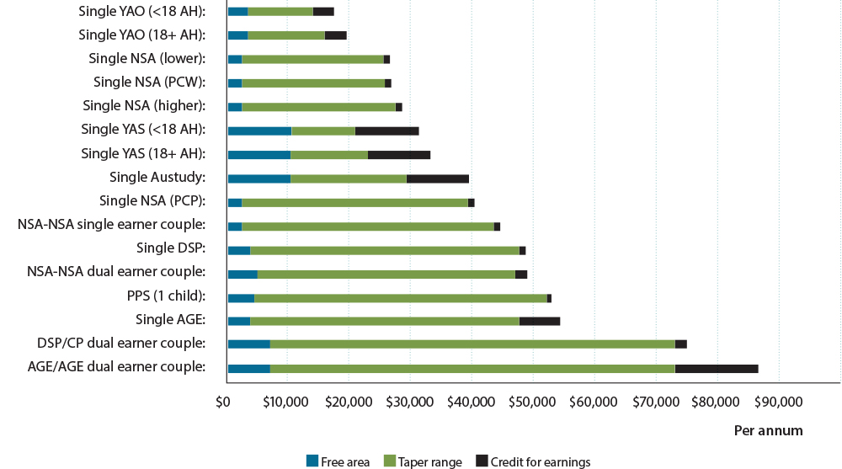
AGE: Age Pension
AH: At home
CP: Carer Payment
DSP: Disability Support Pension
NSA: Newstart Allowance
PCP: Principal Carer Parent
PCW: Partial Capacity to Work
PPS: Parenting Payment Single
YAO: Youth Allowance (Other)
YAS: Youth Allowance (Student)
As the figure shows, income test free areas and taper rates vary widely between different income support categories. This results in different rewards for working. For example, someone receiving Disability Support Pension who undertakes part-time work will experience a smaller payment reduction than someone with disability who is on Newstart Allowance.
For recipients of Special Benefit, the income test has no free area and a dollar-for-dollar taper, which means that these recipients are in some circumstances financially worse off when working.
In addition, some people continue to receive income support when their earnings are above the minimum wage.
The inconsistencies can have unintended impacts and cause significant disruption to people who move between payment categories. For example, a single parent with private earnings experiences a greater reduction in income support when their youngest child turns eight than a parent who is not working.
The problems of inconsistent means testing can be compounded by adjustments to the normal means testing rules that create incentives to start work after a period on income support, or allow recipients to average their income over longer periods than the standard fortnightly entitlement period.
There are various income banking rules to save income in free areas to offset earnings at a later date, or to allow recipients to average their income over a longer period.
The table below shows how different payments enable people to bank or accrue their unused free area earnings before earnings affect their rate of payment.

Table 2: Maximum income bank amounts by income support payment
Payment | Maximum amount of income bank
Youth Allowance (students), Austudy, ABSTUDY | $10,300
Pensioners over age pension age | $6500
Youth Allowance (other) | $3500
Disability Support Pension, Parenting Payment (Single) and adult allowance recipients under age pension age | $1000

It would be preferable if this was more consistent for people in similar circumstances.

Interactions with personal income tax
A major complication in the design of income support tests is that income test reduction can occur over the same ranges of income that individuals are required to pay personal income tax.
Figure 8 illustrates how income testing and personal income taxes interact, and reduce the reward for working.

Figure 8: Effective tax rates for a single Newstart Allowance recipient, March 2014
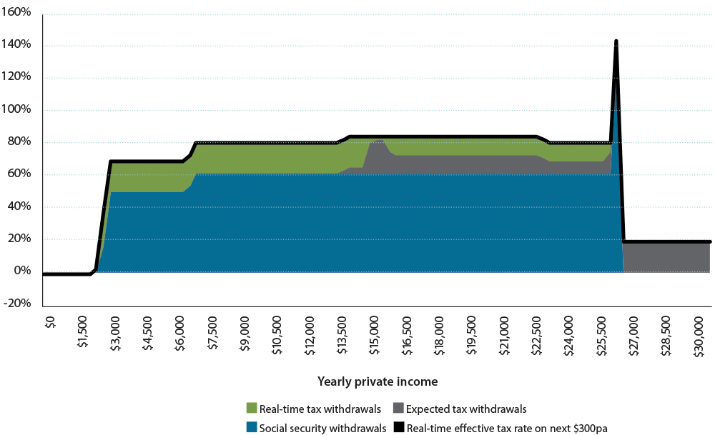
Note: ’Expected’ tax withdrawals reflect what would happen for a period in a tax year if the Pay-As-You-Go system of tax instalment deductions took into account a person’s taxable income from all sources simultaneously. ‘Real-time’ tax withdrawals reflect what actually happens for a period in a tax year under the Pay-As-You Go system of tax instalment deductions. The spike at income of around $25,750 is reaching the income cut out for receiving the allowance and, as a result, loss of the Income Support Bonus (a supplement which is to be abolished).
The combined effect of income test withdrawals and tax obligations on the rewards for working is often referred to as ‘effective tax rate’. Effective tax rates are typically higher than either income test tapers or marginal tax rates. For example, someone receiving a single Newstart Allowance with part-time earnings of $18,000 a year faces an effective tax rate of
83 per cent at the time they earn additional income. At the end
of the tax year they will receive a refund that reduces their effective tax rate to 71.6 per cent. This system does not provide optimal incentives for work.
The design of a new simpler system must take account of payment and tax interactions, to ensure sufficient incentives to work. The United Kingdom has introduced real time reporting of income with a link to income support payments. Such approaches could be considered for Australia.

Simultaneous income tests
A further problem occurs when recipients are simultaneously subject to a number of different income tests at the same time. For example, public housing tenants can be affected by
income-based rent setting policies, which increase rents by 25 cents for each extra dollar earned at the same time as income support payments are being reduced.
For families with children there are many examples where the interactions of different income tests and income definitions may reduce incentives to become self-reliant. For example, couples with children on income support payments face both an income support income test and the Family Tax Benefit Part B second earner income test. To further complicate rewards for work in this case, the two income tests have different definitions of income and different periods of assessment, one fortnightly and one annual.
If a family inadvertently underestimates their annual income for the Family Tax Benefit Part B income test, they face the prospect of having to repay a debt. On the other hand, overestimating their income means they may be underpaid their Family Tax Benefit Part B, and have less disposable income to meet their day-to-day costs.
The problems of estimating income and delays in receiving correct entitlements also apply to Family Tax Benefit Part A for working families.

Targeting need under the assets test
The assets test is intended to limit assistance to people with low incomes and high asset holdings. The rationale is that people with substantial assets can draw down on savings to meet their current needs and are therefore a low priority for taxpayer-funded income support.
While assets tests can apply at any life stage, they are particularly relevant to people who accumulate assets over their working life. With the maturing of the superannuation system, people with assets over the assets test free areas are likely to benefit from generous taxation concessions during their working life to encourage them to save for retirement.
Non-homeowners have a higher assets test threshold than homeowners. The difference between these thresholds (currently $142,500) has not been reset since 1985 and does not reflect the growth in the value of housing as an asset during that time. As home ownership becomes less common in Australia and superannuation and other assets increase it might be appropriate to review this gap.
Newstart Allowance and Parenting Payment (Single) recipients are subject to an assets test limit set at the value of the assets test threshold, rather than a progressive reduction in assistance under an assets test taper. This ‘sudden death’ limit can result in people with similar asset holdings just above or below the threshold receiving different levels of assistance (for example, one person can receive the maximum rate while the other does not attract any income support).

Definitions of income
A new simpler system needs a more consistent definition of income and aligned periods over which income is assessed.
For example, Family Tax Benefit Part B uses an adjusted taxable income definition and an annual period of assessment, while the income support system uses an ordinary income definition from social security law and a fortnightly period of assessment. The Youth Allowance parental income test uses a modified taxable income definition based on an earlier tax year. The child support scheme has a different definition.
This is confusing for people in the income support system and is costly to administer.

Merged means testing
The Henry Review recommended replacing the separate income and assets tests with a ‘merged’ means test. As noted in the Henry Review:
The effectiveness of a comprehensive means test would depend on having the broadest possible asset and income base with minimal exclusions. If there were significant exclusions, there may still be a need for a residual assets test.
Given the complexities of moving to a merged means test as recommended in the Henry Review, this may be a change better considered over the longer-term.

Waiting periods
In a new simpler system, there would be a consistent approach to waiting periods before people could access income support. For example, a one-week waiting period for all income support applicants could apply unless they are facing hardship.

What previous reviews said

Harmer Review, Pension Review Report
The Review has therefore considered whether the balance of means testing is right by reference to three principles:
- targeting pension assistance to those most in need
- ensuring that incentives remain for people to increase self-reliance through savings or work
- ensuring within the pension system that people with similar levels of means and financial circumstances receive similar levels of income support.

Henry Review, Australia’s Future Tax System Review
Means testing as it applies in Australia is a strength of the transfer system because it targets government payments to those with the most need and assists in managing the system’s sustainability.
The current means test for income support payments is not as equitable as it could be because it results in people with different assets of the same value receiving different rates of income support. This reduces the fairness of the system and creates incentives to hold wealth in particular types of assets.
Recommendation 89:
…Consideration should be given to aligning the definitions of income and periods of assessment for family assistance payments more closely to those that apply to income support payments...

Future directions

More targeted means testing
Means testing should target assistance to people most in need. For those able to work, income testing rules should provide appropriate financial returns for working.

More consistent rules
Income and asset test free areas, taper rates, income banking arrangements and waiting periods should be reviewed with a view to moving towards more consistent rules. Consideration could also be given to how income from work could be more favourably treated than income from other sources.

Tax and transfer interaction
A new simpler system should take account of interactions between tax and income tests.
Over the long-term, consideration should be given to better integrating the administration of tax and transfer systems to improve incentives to work.

Simpler means testing for families
Simpler, more integrated and responsive income testing for families should provide more certainty of assistance and clearer rewards for working.
How should means testing be designed to allow an appropriate reward for work?
At what income should income support cease?
What would be a simpler, more consistent approach to means testing income and assets?

Pillar Two: Strengthening individual and family capability
A well-functioning social support system supports people to build their capacity to participate economically and socially to the extent they are able, through:
- mutual obligation that supports people to build capability
- early intervention for people at the highest risk of long-term disadvantage
- encouragement for people to acquire formal education and skills to equip them
for work
- integrated models of support and employment assistance for people with
complex needs.

Context for reform
The development of individual and family capabilities is critical to maximise employment and social participation and for people to lead full and productive lives.
These capabilities can be foundational, such as basic levels of literacy and numeracy, the ability to manage personal finances and appropriate parenting skills. Capabilities can also be more advanced, such as having the level of education, training and/or work experience that assists people in being able to find and keep a job.
Employment is associated with a range of positive outcomes for people and communities. Engaging in work generates financial, health and psychological benefits for the people working and for their families.
Some people need additional help and support to develop the capabilities they need to find and keep a job. Without such assistance, these people (and their families) may be at heightened risks of the negative impacts of unemployment and long-term dependency on income support.
Long-term joblessness and dependence on income support reduces financial resources available to individuals and families. It is also associated with a greater likelihood of health problems, psychological distress and an increased risk of intergenerational dependence on income support. This limits children’s opportunities to develop their own capabilities and participate fully in society and the economy, and undermines social cohesion.
Young people from families with a history of income support dependency are more likely than those from families with no history of income support to receive income support as adults, accept income support dependency, do poorly at primary school and not complete secondary school or enter tertiary education. They are also more likely to be unemployed or underemployed, become parents at an early age, experience physical and mental health problems and become involved in the criminal justice system.
All Australians, wherever possible, should develop core capabilities that enable them to fully participate in employment and society. This pillar of reform focuses on how to develop capabilities for individuals and families that are at risk, based on five themes:
- mutual obligation
- early intervention
- education and training
- improving individual and family functioning
- evaluating outcomes.

Mutual obligation
There has been an international trend towards mutual obligation since the 1980s. It is based on the concept that for societies to function effectively, individuals, communities, businesses and governments all have responsibilities. This includes expecting people to fulfil certain conditions or requirements that reflect social norms and are known to improve outcomes for individuals, children and families. Mutual obligation has traditionally involved a requirement to prepare for and seek work in return for income support or other additional payments. More recent mutual obligation requirements have involved immunisation and health checks for children.
In recent years, governments have acknowledged that, as well as providing a financial safety net for people in need, the income support system is a mechanism to pursue broader policy goals. These include goals such as strengthening individual and family capability and encouraging greater social and economic participation.

Employment obligations
In addition to meeting people’s immediate needs, a key goal of the income support system is to encourage people to support themselves through employment, where this is a reasonable expectation.
The most effective strategies to increase employment and reduce reliance on income support combine assistance and rewards for employment, with clear and fair expectations that people with capacity for work seek to become more self-reliant.
There is evidence that the introduction of mutual obligation has resulted in increasing employment and decreasing reliance on income support.
The Welfare to Work Evaluation Report released on 10 March 2010 showed that changes to Parenting Payment, including mutual obligation for parents with school aged children, increased workforce participation and reduced reliance on income support. The report showed that during 2006–07:
- recipients left income support faster, primarily for jobs—38 per cent of single principal carer parents with a youngest child aged eight to 15 years on Newstart Allowance had left income support after six months compared to only 15 per cent in the years immediately before the changes;
- the proportion of parents with children aged six to 15 who were in paid employment after six months increased from 20 per cent to 29 per cent
- more than 70 per cent of principal carer parents left income support for employment
- 70 per cent of principal carer parents directly affected by Welfare to Work participated in employment services throughout the year.
The current income support system targets participation expectations largely on the basis of payment categories. Over half of working age people on income support are not required or actively encouraged to participate in activities that would assist them to become more self-reliant.
Within a particular payment, such as Disability Support Pension, Parenting Payment or Newstart Allowance, all recipients are assumed to have similar characteristics and therefore similar capacity, availability and readiness for work. The expectations of the system may be unrealistic for some people. For example, people with episodic mental health conditions often find it difficult to fit into the existing category-based approach, as they are neither permanently disabled nor fully able to take up permanent full-time work without significant support.
As a result, the essential participation requirements and exemptions (especially from job search) generally apply equally across the whole group of recipients in a payment category. At the same time, in payment categories where job search is expected, individual exemptions can reflect a person’s circumstances where appropriate.
At any point in time, around 9.4 per cent of people on activity tested payments are exempt from their requirements.
A more individualised approach would mean a person’s capacity is assessed and requirements are tailored to their particular circumstance. This would ensure that all job seekers can continue to access employment services.
As local service providers better understand local circumstances and job seeker characteristics, there may be scope for providers to set requirements and consider exemptions.
Participation requirements should be accompanied by an appropriate and effective compliance framework. The current lag between non-compliance and the imposition of sanctions has been criticised for making the system ineffective. Effectiveness might be improved by giving employment service providers greater management of sanctions, including suspension and penalties. Protections would be required for vulnerable people.

Building capability for employment
Long-term disconnection from work can be detrimental to the wellbeing of individuals such as carers. To address this, carers with full-time caring responsibilities could be assisted to prepare for and be supported through the transition to work after the caring relationship has ended or changed substantially. By providing greater access to support services for people with disability, the National Disability Insurance Scheme may also provide opportunities for Carer Payment recipients to increase their social, education and workforce participation and thereby improve their wellbeing.
Recognising the benefits of work, the current participation framework for younger people on Disability Support Pension and those on Newstart Allowance with partial capacity for work, could be enhanced so that people have a plan of activities, support services and path to education and employment.
People’s skills have a major impact on their employment outcomes, income and prospects for longer-term self-reliance. Some people will need to develop their skills (for example, through education or training) before moving into paid work. Others may need to acquire new skills because their current skills are no longer in demand. Decisions need to be made about the circumstances in which people are able to meet their mutual obligations by undertaking full-time education or training, for how long, and with what level of extra assistance.

Personal and family responsibility
For many years income support has been conditional on people looking for work or undertaking training where they have the capacity to do so. More recently, additional payments to families have required parents to get immunisations and health checks for young children, and to ensure older children attend school.
Families play an important role in supporting positive early childhood development and educational outcomes. The income support system provides Government with a unique opportunity to support hard-to-reach families and promote parental responsibility for ensuring children attend school. Disadvantaged children have lower levels of school readiness, attendance rates and performance at school.
In New Zealand, people receiving income support are obliged to ensure their children are enrolled in early childhood education or school at the appropriate age, are enrolled with a primary health care provider, and are up-to-date in child wellbeing health checks. These mutual obligations promote norms and behaviours that benefit individuals, families and communities. Obligations in return for the payment increases knowledge about the importance of particular behaviours or activities. Services provide the support required and enable people to undertake the activities or change behaviour.
In the Australian context, the Helping Young Parents and Supporting Jobless Families trials are an example of measures that require income support recipients to undertake activities that support the development of family and life skills.

Case study: Helping Young Parents and Supporting Jobless Families
The Helping Young Parents and Supporting Jobless Families measures encourage parents with young children to participate in study, become job-ready, move into paid employment and to focus on the health and development of their children. These measures started in 2012 and will continue until 30 June 2015.
The measures are being trialled in 10 Local Government Areas across Australia (excluding the Northern Territory). Locations were chosen because they had long-term or high rates of people relying on income support, high rates of unemployment, or low rates of people finishing school or gaining other education.
When the Helping Young Parents trial started it was expected to assist around 4000 young parents to boost their education, job readiness and life skills. When the Supporting Jobless Families trial started, it was expected to assist around 34,000 parents to find work, prepare their children for school and establish links with local services.
Eligibility and participation requirements are linked to participants’ Parenting Payment. For example, participants must attend milestone interviews with the Australian Department of Human Services and develop Participation Plans.
Parents in these measures are supposed to undertake activities that build their educational qualifications, improve their work readiness, help them develop their parenting skills and focus on the health and wellbeing of their children.

Income management
Income management is an example of how the income support system is used to promote personal and family responsibility, particularly in relation to care of children. It ensures a percentage of income support and family assistance payments are directed toward necessities including food, housing, utilities, clothing and medical care.
Income management is used as a budgeting tool to build the capability of individuals and families by helping people stabilise their circumstances and better manage their income support payments to ensure essential needs are met.
The progressive roll out of income management has become increasingly targeted to locations of socio-economic disadvantage and particularly vulnerable individuals and families. It is delivered alongside support services designed to stabilise individual and family circumstances by improving financial literacy, budgeting skills, and by addressing debt issues.
Evaluations of international conditional welfare programmes show the best social outcomes are achieved where programmes are used in combination with tailored support services to build capabilities. Providing income managed customers with integrated support services that help to improve family capacity and resilience could maximise longer-term positive outcomes. Examples include support to assist parents or carers address children’s developmental issues, strengthen parenting skills, and improve social connectedness.
To date, various government-funded evaluations of income management in Australia have either been completed or are underway, with mixed findings. Overall, however, the evidence to date suggests income management has assisted individuals and families to stabilise their financial circumstances, helped them meet priority needs, particularly the needs of children, and can protect vulnerable people from financial harassment and exploitation.
Income management also plays a role in community capacity building. This is discussed further in Pillar Four.

Future directions

More tailored employment obligations
Participation in employment should be a priority across the whole social support system. Individually tailored requirements rather than the current categories would recognise the diversity of people receiving income support.
Arbitrary exemptions from participation requirements should be avoided. For people who are not currently available to work, such as carers and parents of young children, the participation focus could simply involve a discussion about future plans. For some people who are already working, it may involve preparing a plan to increase work over time.
In a new system, requirements need to be backed up with appropriate and timely sanctions if expectations are not met. The system of sanctions should be progressive, with timely, lighter touch measures first and reserving the strongest sanctions for serious non-compliance. Application of sanctions should take into account the likely impact on child welfare where applicable.

Personal and family responsibility
Consideration should be given to broadening mutual obligation to include building life skills, promoting parental responsibility and improving outcomes for children, particularly for those living in jobless families who are dependent on income support.

Income management and support services
Consideration should be given to incorporating income management as part of a package of support services available to job seekers who need to build foundational skills and stabilise their circumstances, as a platform to move into work or study.
Income management could also be used to build capabilities as part of a case-management approach to assist the large number of disadvantaged young people not fully engaged in either education or work.
How should participation requirements be better matched to individual circumstances?
How can carers be better supported to maintain labour market attachment and access employment?
What is the best way of ensuring that people on income support meet their obligations?
In what circumstances should income management be applied?

Early intervention
The Reference Group considers targeted early intervention is a very effective approach for people who are disconnected from employment or the community.
Policy and programme interventions targeted to people who need them most can have a very positive impact on life outcomes compared to funds expended. Investing funds early and targeting the greatest need can not only substantially improve the quality of people’s lives, but also maximises the return on investment of taxpayer funds.
While early intervention approaches require up-front investment, this needs to be weighed against the long-term costs of not acting, which include income support dependency, incarceration in justice centres and anti-social behaviour.
The key aspect to effective early intervention is being able to identify target people or groups, before problems become entrenched.

The investment model
New Zealand has introduced a new approach to identify people at risk and determine which groups would benefit most from further investment, as part of reforms to reduce long-term dependence on income support.
The investment approach underpinning these reforms is enabling New Zealand to build a comprehensive evidence base to target intensive support services to those most in need.

Case study: The New Zealand investment model
The New Zealand investment model involves an actuarial valuation of the income support system that calculates the projected lifetime liability for particular groups on income support. This enables funding to be invested in the groups likely to have the highest lifetime cost of income support without additional support services.
A new Multi-category Appropriation provides more flexibility to direct investments where they are proven to be most effective.
The approach has enabled New Zealand to quantify the significance of the age at which people first receive income support. This has led to a substantial investment in young people, as the group identified as having the highest liability.
The range of youth payments has been replaced by Youth Payment and Young Parents Payment. Young people are income managed with about $50 per week being provided as an in-the-hand allowance. This means that for a young single parent, about 85 per cent of the payment is income managed, while for young single people who are not parents about 74 per cent of the payment is income managed.
The Youth Payment includes obligations such as working with a Youth Service Provider, participating in full-time education, training or work-based learning. Recipients must also complete a budgeting course. First and second rule breaches result in suspension of payment and the loss of any extra incentive payments. A third breach results in payments stopping immediately.
The Young Parent payment includes obligations to work with the Youth Service provider, prepare for education, training or work-based learning, and complete budgeting and parenting courses.
As part of the Youth Services initiative, more than $148 million in services are being targeted towards:
- 16 to 17-year-olds and 16 to 18-year-old parents who are receiving a main benefit—in return for receiving financial assistance this group of young people have an obligation to participate in the Youth Service (‘the Youth Service for Youth Payment and Young Parent Payment clients’)
- at risk 16 to 17-year-olds who are not engaged in, or are at risk of not being engaged in, education, employment or training (NEETs)—participation in the
Youth Service is voluntary for this group (‘the Youth Service for NEETs’).
The Ministry of Education and the Ministry of Social Development have established information sharing arrangements to identify and engage with school leavers early.
The actuarial valuation of the income support system has also enabled New Zealand to assess the full impact of the global financial crisis from a liability perspective, and the cost of having people churn in and out of the income support system. This has also identified that if someone is in work for 14 months, they are likely to stay in work and not come back onto income support.
The valuation has also enabled New Zealand to identify the critical transition points at which job seekers move to disability benefits and the windows available to try and stop this happening.
The return on investment is monitored through an annual revaluation of the income support system to determine the effectiveness of the measures (providing an idea of savings to the income support system) and what the next priority groups should be.
The 2013 valuation shows a $4.4 billion decrease in lifetime liability as a result of the reforms and intensive support.
There is potential to re-invest income support savings identified in the revaluation in approaches that are proven to be effective in improving client outcomes and reducing future costs.
Australia’s system of federal and state governments presents some challenges not faced in
New Zealand, related to our capacity to access information for early intervention and assess risk. Much of the data, such as child protection and education engagement, required for risk based analysis is held by the states and territories, requiring negotiations and agreements to gain access. The Australian Government should work with the states and territories to ensure that data is available to make comprehensive assessments of need.

Investing in children
Evidence shows that young people growing up for prolonged periods in jobless families can have poor developmental outcomes. Social and developmental gaps in children’s functioning and achievement emerge early and are significant by the time they reach school.
These marked differences in the cognitive, non-cognitive and social skills are strong predictors of later academic, occupational and life achievement. Poor academic achievement is also associated with a higher prevalence of mental health conditions, teenage parenthood, poor employment, income support receipt and criminal behaviour.
Investing in young children can increase levels of schooling, reduce crime, improve productivity in the workplace, improve adult health and reduce teenage pregnancy.
One example of such investment is the Home Interaction Program for Parents and Youngsters. This is a two year home based parenting and early childhood learning programme that empowers parents and carers to be their child’s first teacher. The programme builds the confidence and skills of parents and carers to create a positive learning environment to prepare their child for school.
Australia has a capacity to assess nationally children’s vulnerabilities as they enter school, through the Australian Early Development Index (AEDI). Research has shown that the AEDI is a good predictor of children’s performance in the National Assessment Program Literacy and Numeracy (NAPLAN) tests in Year 3. Children showing high levels of vulnerability in the AEDI’s five domains are likely to have lower Year 3 NAPLAN results. This information, together with other indicators of disadvantage and low participation in early learning and care, could be used to design and better target more effective programmes and interventions in disadvantaged communities.
Child care plays a role in the development of children, particularly with a renewed focus on early education. The Productivity Commission is conducting an Inquiry into Child Care and Early Childhood Learning. The Commission’s report and recommendations will cover issues including the capacity of the child care system to ensure satisfactory transition to schools, particularly for vulnerable or at risk children. This recognises that for disadvantaged families with limited skills and resources to raise their children, child care can also be an early intervention and prevention tool to maximise children’s developmental outcomes.
Child care can assist families by providing carers who have the skills, time and environment to support children develop. Child care can provide disadvantaged parents with the opportunity to find a job or participate in education or training.
The Reference Group awaits the findings of the Productivity Commission’s Child Care and Early Childhood Learning report with interest.

Future directions

The investment model
Risk-based analysis to target early intervention and investment should be a feature of a new social support system. This would include examining the potential for actuarial analysis of the long-run costs in social security outlays and the benefits of addressing these cost drivers for individuals and the system.

Investing in children
Ongoing support should be given to policies and programmes that target children at risk and provide good outcomes and a positive return on investment for government funds.
How can programmes similar to the New Zealand investment model be adapted and implemented in Australia?
How can the social support system better deliver early intervention for children at risk?

Education and training
The structure of the economy and labour market has changed in recent decades. In the past it was possible for low-skilled workers to find employment relatively easily, even after early school leaving. However, this is no longer the case. These changes over time to the economy and labour market have increasingly favoured more highly skilled and educated workers. Appendix E explains these changes in more detail.
Most Australians have adapted well to the increased demand for skills in the labour market. The percentage of people aged 15 to 64 years with a non-school qualification (higher than Year 12) increased from 47 per cent in 2001 to 57 per cent in 2013. Over the same period, the percentage of people with a Bachelor Degree or higher increased from 17 per cent to 25 per cent.
However, a small group of people have not adapted well to the changes in the labour market.
In 2011, 27 per cent of young people aged 17 to 24 years were still not fully engaged in work or study. These are people who are at higher risk of unemployment and income support dependence. Young people with family responsibilities may require additional support to enter the labour market.
Successful participation in work depends on having skills in three broad areas:
- core language, literacy and numeracy skills
- generic or employability skills (also called core skills for work)
- technical or discipline specific skills.
The first and second areas together are often referred to as foundation skills.

Foundation skills
Industry groups have consistently articulated the need for foundation skills development in Australia’s workforce. This has been supported by the Reference Group’s consultations with stakeholders. In 2009, the COAG Reform Council noted a relatively high proportion of working age Australians have literacy and numeracy skills below the minimum levels required to meet the complex demands of work and life in today’s modern economy.
In 2012, the COAG Reform Council noted overall levels of literacy and numeracy had improved since 2009. However, nationally one in eight working age people had the lowest level of literacy, and one in five had the lowest level of numeracy in 2011–12.
The National Foundation Skills Strategy for Adults in 2012 also highlights that a significant proportion of Australia’s working age population has low literacy levels.
Literacy and numeracy achievement at school is paramount to young people’s future success in work: those with higher literacy and numeracy skills are more likely to be employed and have higher incomes while those with lower skills are more likely to experience unemployment in the early years after leaving school.
It is important to identify and support young people at risk early. Identified obstacles to young people participating in education and employment include family and living circumstances, physical and psychological health, anti-social and behavioural issues, substance use and misuse, and learning/academic challenges. Conservative estimates suggest that up to 15 per cent of Australian high school students will experience some form of mental health condition before they complete year 12 or equivalent.

Education and training for employment
One of the most successful pathways to employment is study that leads to a formal qualification, either at certificate, diploma, degree or higher degree level.
Research shows that more highly educated people have lower unemployment rates than those with lower levels of education. Appendix E covers this in more detail.
The research confirms there are lifetime benefits for young people with higher educational outcomes. Young people from low socio-economic backgrounds are less likely to complete Year 12 (or equivalent) and are less likely to be fully engaged in study or work after leaving school. People who have completed at least Year 12 or a Certificate III or IV are less likely to be unemployed, and their employment is less likely to be casual. People who complete Year 12 are also likely to earn 15 per cent more in hourly wages than early school leavers.
Students undertaking school-based apprenticeships and traineeships have higher completion rates for Certificates I and II compared with other apprentices and trainees. However, their completion rates for Certificates III or IV (usually in traditional trades) are lower. This could point to some difficulties in retaining school-based apprentices once they finish their schooling.
There is a need to improve transitions from education to work. As noted in Part One of this report, there are too many young Australians that are not fully engaged in either education or work. There is a need to examine what more can be done to ensure that as many people as possible are either earning or learning. Vocational education and training should be better linked to available jobs.
Opportunities exist to embed language, literacy and numeracy training into vocational or general qualifications as well as providing specific training for job seekers

Future directions
Young people need to be encouraged to complete Year 12, or alternatively a Certificate III or IV qualification which is linked to available jobs. There should be a stronger focus on foundation skills in both schools and vocational education and training, and on transitions from school to work.
What can be done to improve access to literacy, numeracy and job relevant training for young people at risk of unemployment?
How can early intervention and prevention programmes more effectively improve skills for young people?
How can a focus on ‘earn or learn’ for young Australians be enhanced?

Improving individual and family functioning
The Productivity Commission, in its report on Deep and Persistent Disadvantage in Australia, identified a number of impediments to people participating in work or their community. These include mental health conditions, drug or alcohol dependence and family dysfunction.

Mental health
Continuing participation in employment and social activities can often be a positive experience for people with mental health conditions. Mental health professionals support a vocational rehabilitation approach that enables a person with mental health conditions to overcome barriers to employment. Vocational rehabilitation requires input from a range of health care professionals and other non-medical disciplines, such as disability employment advisers and career counsellors.
The ‘wrap around’ model of service aims to achieve positive outcomes for people with mental health conditions. It works with the individual and family to develop plans for them to reintegrate into the community, building social supports and following education and employment pathways.
An example is headspace, run by the National Youth Mental Health Foundation, which works with young people.

Case study: headspace
headspace is a National Youth Mental Health Foundation initiative that helps young people aged 12 to 25 by providing support for problems like depression, anxiety, bullying and body image.
headspace was initiated in 2006 as a response to concerns that young people were not accessing mental health services despite a high level of need. As such, the model of service has been developed to provide new pathways to care which are engaging, appropriate and accessible to young people and their family and friends. headspace centres are based on strong collaborative networks of community-based agencies, with each centre overseen by a consortium of relevant local services allowing for variation and flexibility to meet the particular needs of the local community.
Agencies are often co-located within headspace centres, spanning the four core service streams of mental health, physical health, alcohol and other drug, and vocational support services. This creates the mechanism to locally weave together a range of Commonwealth and State funded initiatives that aim to support young people in a way that can respond to holistic needs through a single access point and create seamless pathways for young people.
Since 2006, headspace has helped more than 100,000 young people through its three major programme areas. There are currently 65 headspace centres nationally providing GP, allied health and other psychosocial support services, with 90 projected to be operating by 2015.
The headspace programme extends the reach of headspace by providing access to evidence-based mental health services online and via telephone for those young people who don’t feel ready to attend a centre or who prefer to engage via online chat, email or phone. The headspace School Support programme assists school communities and staff across the country to deal with the complex issues following a suicide.
headspace draws on the research and expertise of its health sector partners, which include the Orygen Research Centre, the University of Melbourne; the University of Sydney; the Australian Psychological Society; and the Australian General Practice Network.

Case study: Partners in Recovery
The Partners in Recovery initiative provides coordinated support to people with severe and persistent mental illness with complex needs. It engages government and non government health, housing, income support, disability, education and employment providers in a collaborative approach.
Partners in Recovery focuses on:
- improving the coordination of clinical and other support services to individuals
- strengthening partnerships and links between clinical and community support organisations
- improving pathways to employment and support services.
Forty-eight Partners in Recovery Organisations commenced operation in 2012–13.
An evaluation and monitoring project will evaluate the impact of Partners in Recovery at a system-level and at a client-level, examine its effectiveness in meeting the objectives, and monitor its delivery.

Family functioning
Families that function well generate benefits for individual family members as well as for communities and government.
Australian and international research has identified major social and economic costs to governments, communities, families and individuals from family dysfunction. Family dysfunction can contribute to educational under achievement, unemployment, income support, alcohol and drug abuse, poor health outcomes, teenage pregnancy, failed relationships, criminality, and court and police costs.
Investing in cost-effective approaches that reduce individual and family dysfunction not only benefits individuals and families but also potentially delivers better value to taxpayers.
The Helping Young Parents and Supporting Jobless Families trials recognise the benefits of positive family functioning by including requirements that parents take part in activities that help them develop their parenting skills.

Future directions
Consideration should be given to cost effective approaches that support employment outcomes by improving family functioning.
For people with complex needs, such as people with severe and persistent mental health conditions, there should be wrap around services that assist them to stabilise their lives and engage in education, work and social activities.
How can services enhance family functioning to improve employment outcomes?
How can services be improved to achieve employment and social participation for people with complex needs?

Evaluating outcomes
Governments at all levels have numerous programmes and policies to help individuals and families develop key capabilities.
However, not enough is known about the effectiveness and outcomes of these programmes. There is a need for more rigorous evaluation to determine which programmes are most successful and to redirect funding to those programmes.
Rigorous process and outcome evaluation is consistent with the objectives of the Public Governance, Performance and Accountability Act (Cwth) 2013, which establishes a new performance framework across Commonwealth entities. This framework aims to increase the focus on non-financial reporting by entities, so that Parliament and the public have better information on whether public funds are reaching their stated objectives.

Future directions
It is important that support services funded by government are targeted to those most in need and that they are achieving the intended outcomes.
Monitoring and evaluation of programmes that aim to increase individual and family capability should focus on whether outcomes are being achieved for the most disadvantaged. Design of monitoring and evaluation frameworks should take account of the need to minimise the compliance burden on service providers.
How can government funding of programmes developing individual and family capabilities be more effectively evaluated to determine outcomes?

Pillar Three: Engaging with employers
A well-functioning social support system recognises the benefits of work and has an employment focus:
- Employers should be encouraged to make jobs available for disadvantaged groups including people with disabilities.
- Tailored support services are important to sustain employment outcomes for vulnerable groups, including people with disability and mental health conditions.

Context for reform
The Australian Government has committed to creating one million new jobs within five years and two million new jobs over the next decade. The aim is to increase the number of people participating in the workforce and to improve productivity. To fill these jobs, businesses will have to draw on a wider pool of potential workers.
People currently on income support need to be competitive in the jobs market and will need support to be successful. There is a strong correlation between people’s education and their participation in work. A focus on training and skills development is therefore needed to improve employment outcomes for people on income support.
The cooperation of employers is central to achieving positive employment outcomes for disadvantaged groups. An important aspect in engaging with employers is making the process easy and accessible for employers.
Business, as part of its social responsibility, should work with government and individuals to improve the economic participation of disadvantaged job seekers. More should be done to assist businesses that are not providing employment opportunities to disadvantaged groups.
There are many examples of businesses, governments and civil society organisations employing people with disability, people with mental health conditions, single parents, young people at risk and Indigenous people. However, more needs to be done to make more jobs available.

Employment focus—making jobs available
Progressive businesses recognise the importance of meeting social responsibilities through a diversified workforce. They understand that it is good for a company’s reputation and brand, enhances recruitment of talented staff and makes a difference in the communities where the company operates.
Social responsibility initiatives will improve employment outcomes for disadvantaged job seekers.

Australian Employment Covenant
An example of an initiative based on businesses embracing social responsibility is the Australian Employment Covenant. The Australian Employment Covenant began in 2008 as a national industry-led initiative to secure 50,000 sustainable jobs for Indigenous Australians. It is a three-way commitment between employers, the Australian Government and Indigenous Australians. The aim is to bring Australians together to break the cycle of unemployment and poverty that exists among too many Indigenous Australians by creating demand for an Indigenous workforce.
Through this initiative, more than 335 employers are now committed to roll out more than
60,000 job opportunities to Indigenous Australians right across Australia. At the end of January 2014 over 18,000 jobs committed had been filled by employers.
The success of the Australian Employment Covenant is due to the commitment of business and community leaders to pledge jobs. To translate jobs pledges into employment places for Indigenous Australians, employers receive Australian Government support through programmes like the Indigenous Employment Program and Job Services Australia.
Given the success of the Australian Employment Covenant, businesses and communities more broadly could use this approach to drive employment outcomes for disadvantaged job seekers.

Corporate initiatives
Some employers recognise the business potential of engaging people traditionally outside the mainstream recruitment pool. These employers have an ongoing commitment to diversifying their workforces and have embedded diversity into their recruitment practices.
For many of these employers, reciprocal relationships with civil society organisations provide support for developing individual action plans and building individual business cases for inclusive recruitment. Large organisations such as Westpac Group and IBM are among a growing number of companies resourcing the Australian Network on Disability in return for ongoing support and expertise.
The Reference Group met with Westpac Group, which described its commitment to employing people with a disability. Westpac Group’s Prosper and Grow: Accessibility Action Plan, 2013 promotes the mutual benefit of creating an accessible workplace.

Case study: Westpac Group disability employment
Westpac Group is committed to attracting and supporting employees with disability.
The aim of providing meaningful and satisfying careers for people with disability is embedded in Westpac Group’s recruitment and retention policies, tools and other resources. Placements are by, for example, working with employment services such as Job Support.
An estimated 12.1 per cent of the Westpac Group employees have a disability and
49 per cent of employees are carers, with 15 per cent of those caring for someone who
is elderly or who has a disability.
Westpac Group initiatives to support employees with disability include a managers’ guide to disability in the workplace and a workplace adjustment checklist for use during the hiring process, live captioning technology and in-house Auslan interpreters, an employee network to champion accessibility, revised online learning modules to improve accessibility, internships and work experience for university students with disability, and a Personal Evacuation Emergency Plan to accommodate specific needs of employees with disability.
Westpac Group is also helping develop the capability of organisations that support people with disability through its Organisational Mentoring Program. Employees volunteer their business skills to organisations, such as disability employment services Epic Employment and Ballarat Regional Industries, which provide employment and training opportunities to people with disabilities.
Corporate initiatives often recognise the benefits to the business of inclusive recruitment practices. IBM, for example, proactively seeks to employ graduates and professionals with disability. The company considers that its inclusive recruitment practices and its commitment to creating accessible workplaces provide access to a talent pool not available to other employers.
IBM also participates in an external nation-wide mentoring programme for tertiary students with a disability, facilitated by the Australian Network on Disability.
Inclusive recruitment practices by large corporate organisations are a pathway to employment for disadvantaged groups. However, while large corporate organisations play an important role in employing disadvantaged groups, more needs to be done.
Such corporate initiatives could be more broadly adopted by other companies. Large corporations can act as ‘champions’, promoting and leading by example in employing disadvantaged job seekers such as people with disability.

Small and medium business initiatives
The Australian Chamber of Commerce and Industry is a peak council of business organisations. Its Employ Outside the Box: The rewards of a diverse workforce programme highlights the important role for business in improving employment outcomes for Australia’s most disadvantaged people. Not only does this meet social responsibility to contribute to community development, but there are also identified advantages for business in expanding the scope of recruitment activities.
Employ Outside the Box encourages Australian Chamber of Commerce and Industry members who run small and medium size businesses to employ people with disability, people with mental health conditions, young people at risk, and single parents. It has good uptake by members. This programme is about better understanding the tangible benefits of employing people currently outside the labour force.
The Australian Chamber of Commerce and Industry encourages the Australian Government’s Job Services Australia and Disability Employment Services providers to work with industry more closely to create employment opportunities for disadvantaged people in small and medium businesses.
An example of a small business employing people with a disability is the Australian Dairy Buffalo Company. The company was a finalist for a National Disability Award in 2012, competing against much larger employers. With the assistance of a not-for-profit employment service provider Break Thru People Solutions, the Australian Dairy Buffalo Company has provided long-term employment to four people with a disability. This is a major achievement for a company with only eight employees.
Another example of cooperation between a Disability Employment Service provider and a medium enterprise is Harris Farm Markets. It is a family owned Australian company with more than 20 fresh food stores across Sydney. With the ongoing support of its Disability Employment Support provider Harris Farm Markets has increased the number of employees with intellectual disability and has benefited through strong support from its customers, and a higher retention rate of employees with a disability compared with other employees.
More than 70 per cent of the labour market is employed by small and medium size businesses. To improve employment outcomes for people on income support, small and medium businesses need to play a larger role. In some cases they may need employment service provider support.

Government initiatives
All levels of government employ large numbers of people. The Australian Bureau of Statistics report, Employment and Earnings, Public Sector, Australia, 2012–13, found there were 1,891,300 public sector employees in June 2013. A total of 248,500 were employed by the Australian Government while 1,450,200 were employed by state/territory governments and 192,500 by local government.
The Australian Public Service Commission’s State of the Service Report 2012–13 noted that the Australian Public Service’s longstanding commitment to a workforce that reflects the diversity of the Australian community is an explicit recognition that diverse workforces drive innovation, creativity, problem-solving capabilities and individual and organisational productivity.
However, since 2004 the proportion of employees with disability compared with all ongoing Australian Public Sector employees has been declining.
There is a significant role for all levels of government in improving employment outcomes for people with disability.

Social enterprises
Social enterprises are businesses that trade for a social purpose. While participating in mainstream open employment is the best outcome for many people, for some gaining work through a social enterprise is a more reasonable expectation and can also be a pathway to open employment.
Employment-focused social enterprises only represent one segment of the broader social
enterprise sector. They provide stable ongoing employment for disadvantaged groups or
short- to medium-term placements and training, with the aim of reintroducing disadvantaged
job seekers to the labour market.
Social enterprises work at the local level to provide employment opportunities for disadvantaged groups. This approach also aims to provide job opportunities that lead to more sustainable employment outcomes.
One example is Social Ventures Australia, a not-for-profit organisation established by The Benevolent Society, The Smith Family, WorkVentures and AMP Foundation. Social Ventures Australia aims to provide better education and employment outcomes for disadvantaged Australians. This model brings together corporate expertise and private capital to the third sector.
One of Social Ventures Australia’s venture partners, Fair Business, addresses long-term unemployment with a unique business model that provides jobs and training in a supportive environment for people with backgrounds of entrenched disadvantage. Fair Business is a non profit organisation that acquires businesses and converts them into social enterprises. Fair Repairs, its flagship social enterprise, is a cleaning and maintenance company operating in Campbelltown, Nowra, Redfern and Wollongong. It has secured a minimum of 30 new employment opportunities each year since its inception in 2008, and recruits and trains disadvantaged people in their local area to stimulate local economies.
Social Firms Australia is an intermediary organisation that provides business and operational support to organisations setting up social firms. A social firm is a not-for-profit business which has an integrated workplace where between 25 to 50 percent of employees have a disability or mental illness. Social Firms Australia also provides specific assistance with the supports required for people with a mental illness or psychiatric disability and delivers a range of programmes to help job seekers with a mental illness gain and maintain employment.
The growth of social enterprises highlights that this approach can achieve sustainable employment outcomes for disadvantaged job seekers.

Future directions
Social responsibility is an important approach in improving employment outcomes for disadvantaged groups and business led covenants could be used to further improve employment outcomes for people with a disability and mental health conditions.
Social enterprises have been shown to improve employment outcomes for disadvantaged groups as well as provide long-term sustainable employment. Further consideration should be given to how the success of social enterprises can be replicated more broadly.
How can business-led covenants be developed to generate employment for people with disability and mental health conditions?
How can successful demand-led employment initiatives be replicated, such as those of social enterprises?

Improving pathways to employment
There are many pathways to employment for disadvantaged job seekers. These include using government-funded employment services, improving skills, improving the transition from school to work, using support services, and providing job seekers with opportunity to move to where the jobs are.

Employment services
Job Services Australia is the Australian Government mainstream employment service system, which provides job seekers with individualised support to help overcome vocational and non-vocational barriers to obtaining sustainable employment.
Fully eligible job seekers are placed into one of four streams, based on their relative level of disadvantage as assessed by the Job Seeker Classification Instrument and, where required, also by an Employment Services Assessment. Services within each stream are tailored to the individual needs and circumstances of each job seeker, including their participation requirements and assessed capacity to work.
The Organisation for Economic Co-operation and Development (OECD) in 2012 noted that the Australian system of contracted employment services (Job Services Australia) is highly regarded internationally and is credited with assisting Australia in having one of the highest employment rates in the OECD.
The government is currently reviewing the delivery of contracted employment services within Job Services Australia.
Job Services Australia assists job seekers, including people who face significant challenges into employment. Job Services Australia providers work to overcome complex barriers to employment faced by a significant proportion of job seekers serviced through the programme. These can include disability, homelessness, low educational attainment and skills, criminal history, limited work experience, limited English ability and life histories of trauma or social disadvantage.
Jobs Australia, the National Employment Services Association and other stakeholders have noted that the redesign of employment services should focus on meeting employers’ and job seekers’ needs to achieve truly sustainable employment outcomes, rather than focusing on service process or administrative transactions.
Disability Employment Services is the Australian Government’s other main employment programme assisting people with disability. Providers have a specialist role in assisting people with disability, injury or health conditions to secure and maintain sustainable employment. Providers have the flexibility to ensure services are tailored to the individual needs of job seekers.
The Australian Department of Social Services funds the National Disability Recruitment Coordinator to create job opportunities for people with disability in large organisations. The National Disability Recruitment Coordinator partners with employers and helps them raise disability awareness in their organisation and develop specialised strategies for increasing disability employment. This includes working with employers to develop the tools, knowledge and resources needed to increase the number of people with disability they employ.
The Department of Social Services also funds the Employment Assistance Fund to assist employers with the cost of workplace modifications a person may need to take up a new job or retain their current job. The fund provides assistance for purchasing a wide range of work related modifications, tools, equipment and services. The Employment Assistance Fund can also help with costs such as adaptive equipment, Auslan interpreting, disability awareness training and more.
In addition, there are employment programmes for Indigenous people and remote communities.
- Indigenous Employment Program complements the employment services provided by Job Services Australia and Disability Employment Services, which together represent the largest provider of employment services for Aboriginal and Torres Strait Islander peoples.
- Remote Jobs and Communities Program—the Australian Government provides a jobs, participation and community-development service in 60 remote regions across Australia. The programme supports people to build their skills and get a job or to participate to their capacity in activities that contribute to the strength and sustainability of communities. It also helps remote-area employers to meet their workforce needs and supports communities in remote Australia to plan and build a better future.
Government employment services achieve good outcomes for disadvantaged job seekers. However, the government is currently reviewing the delivery of contracted employment services within Job Services Australia with an expectation of changes to the system to further strengthen performance.

Mentoring
Mentoring provides additional support for job seekers who lack work experience or employment networks. Mentors can share their experiences and provide guidance on job searching, marketing skills or skill development that might improve employment prospects.
Positive Action towards Career Engagement (PACE), developed by the Australian Network on Disability, facilitates opportunities for people with disability to develop their skills and confidence, to assist them in their job search and personal development. The aim is to give students and/or job seekers a range of skills, experience and advice about the workforce, as well as providing mentors with a rewarding and developmental experience. PACE recognises that job seekers with disability can have little or no work experience, and may not be fully aware of the skills and attributes they can offer an organisation. This can make it harder to pursue their chosen career. PACE is equally beneficial to participants and organisations. Participation in PACE can also facilitate opportunities for eligible students to be selected for paid internships through the Stepping IntoTM programme. This employer demand led programme closes the gap in employment outcomes between graduates with disability and those without. The Stepping IntoTM programme is funded by employers.
Mentoring can be an effective tool in helping people with disability to gain entry into the job market.

Vocational education and training
The training and skills sector, also known as vocational education and training or VET, gives Australians the opportunity to gain the skills they need to enter the workforce for the first time, to re-enter the workforce, to retrain for a new job or to upgrade their skills for an existing job. Australian Apprenticeships are available in traditional trades, and in a diverse range of emerging careers, in most sectors of business and industry.
It is important that there is a demand driven and industry led approach to VET to enable businesses to obtain the workers they need and to assist Australians to find and keep a real job in the real economy.
A VET reform taskforce was established by the Australian Government in November 2013 to work with state and territory governments, Registered Training Organisations, industry groups, employers and other stakeholders throughout 2014 to deliver a system that is nationally consistent and coherent, responsive to individual, industry and community needs and recognised as providing quality outcomes.
Where vocational education and training is provided to people on income support, it should be more closely linked to the skills that employers require.

Traineeships and apprenticeships
The Australian Chamber of Commerce and Industry 2012 report Employ outside the box: The rewards of a diverse workforce cited on-the-job learning, such as traineeships, as an ideal way to match training with skills shortages. This was supported in statements from the Business Council of Australia and the Australian Council of Trade Unions.
Business can use traineeships and apprenticeships to provide an effective pathway for people on income support to gain employment. School-based apprenticeships are another way to ensure young Australians learn the necessary skills for a smooth transition into the workforce. This approach enables young people to develop the skills and knowledge that employers require, before they complete their secondary education. This encourages them to find positive pathways to work immediately after graduating either by continuing their apprenticeship or through other post-school arrangements.
More could be done to enable disadvantaged job seekers access to traineeships and apprenticeships, given the shift in the economy to more skilled jobs.

Transition from school
The move from school to full-time education, training or employment is critical for ongoing employment and to avoid becoming dependent on income support. Employers have a key role in young people making the transition from school to work.
For example, Work Inspiration, a programme founded by the Foundation for Young Australians,
The Smith Family and National Australia Bank, is a business-led initiative that introduces young people to the workforce and makes work experience more worthwhile. The programme highlights career pathways by showing Work Inspiration participants the different elements of the business and introducing them to employees who can provide insights about their career journeys. To date, 2328 Work Inspiration placements have been pledged by businesses across Australia.
Work Inspiration is a universal programme which has proven to positively engage students who are at risk of becoming disengaged from school, or face other barriers to education and employment, such as coming from a non-English speaking background. Following a successful pilot in 2013, McDonalds has committed a further 200 Work Inspiration places this year. Other employers have also committed to the programme, including 500 places at National Australia Bank and 100 places with The Smith Family.
Employers have a key role in supporting young people in their transition to work.

Mental health and employment
In Australia, the largest group of people receiving the Disability Support Pension are people with mental health conditions (31.2 per cent in 2013). In addition, more than 12 per cent of people receiving Newstart Allowance have mental health conditions. Gaining work can substantially improve outcomes for people with mental health conditions.
Employees and prospective employees with mental health conditions can benefit from workplace strategies that address their condition, allowing them to become productive workers. The 2013 National Mental Health Commission’s report Review on Mentally Healthy Workplaces concluded that these workplace strategies are worth pursuing for the multiple benefits to individuals and organisations.
Individual Placement and Support is one proven approach to working with people with serious and persistent mental health conditions. The model delivers individually tailored support services with an employment focus.
Extensive international evaluations have demonstrated the effectiveness of this approach. Individual Placement and Support has been evaluated in 19 randomised controlled trials in North America, Europe, Asia and Australia. It significantly outperformed the comparison employment system in every trial, with 60 per cent or more of the clients receiving Individual Placement and Support obtaining competitive jobs, compared with about 25 per cent of those receiving other vocational assistance.

Case study: Individual Placement and Support
Individual Placement and Support (IPS) is an evidence-based, supported employment model that assists people living with mental health conditions to seek and obtain competitive employment.
The IPS model was developed in the United States for people living with severe mental illness. IPS recognises the complex, ongoing support needs of people with mental illness as well as other personal barriers to employment, such as substance misuse, homelessness and contact with the criminal justice system. It addresses these personal barriers in tandem with vocational needs to help clients achieve competitive employment.
The IPS approach views paid employment as a vital part of a client’s broader recovery.
As the name implies, the IPS approach seeks to address the individual needs of people with mental illness by providing tailored employment assistance. It assumes a strong practitioner and organisational commitment to foster hope and work towards goals of recovery, by encouraging clients’ strengths and competencies and actively involving client input in the design and implementation of programmes based on this model.
Evidence suggests Mental Health Services and Disability Employment Services have better outcomes implementing IPS when they form IPS partnerships through an expression of interest process.
Mental Health Services provide direct referrals to Disability Employment Services while the appointed IPS Employment Specialist (co-located in Mental Health Services) provides intensive support to job seekers with mental illness to seek, obtain and retain open competitive employment.
Queensland, New South Wales and Victoria have implemented the IPS model using a partnership approach and the results are reflective of other international research, with at least 60 per cent of people living with severe and persistent mental illness obtaining paid employment through this approach.
Evidence demonstrates the key elements of a strong IPS programme are:
- strong conjoint management through an IPS Steering Committee
- a commitment to adhering to the fidelity scale (measuring tool) of the IPS model
- co-location, where a Disability Employment Services staff member spends no less than three days on site in the Mental Health Service
- evaluation of programme outcomes and success.
Cognitive Behaviour Therapy is another approach that has been shown to greatly assist people with mental health conditions. Research suggests it is successful in getting people with mental health conditions work-ready, and that it results in positive work outcomes. Murdoch University (Western Australia) research indicated that cognitive behavioural therapy has a useful role in the rehabilitation of people on worker’s compensation who are seeking employment.
Employers often need assistance to be able to respond to employers with episodic mental health conditions.
Mindful Employer is a workplace training programme. It equips managers, supervisors and employees with the skills and confidence to effectively respond when someone is experiencing mental health issues at work. The programme offers eLearning and face to face training solutions for all Australian businesses. Beyondblue has also developed e-learning workplace resources to assist workplaces identify and support workers with mental health conditions.
Tailored support for job seekers and employees with a mental health condition is an important enabler to gaining and sustaining employment.

Labour mobility
The Productivity Commission’s April 2014 report, Geographic Labour Mobility, found that geographic labour mobility can contribute to economic efficiency and community wellbeing.
The Productivity Commission heard concerns from some employers that the rate of mobility is inadequate to meet their labour needs.
Low rates of mobility might also be detrimental to people from disadvantaged areas. Research has found that people who remain in disadvantaged areas tend to have lower education levels and lower incomes than those who move away.
However, the main reasons people don’t move relate to factors such as family circumstances and costs of housing.
From 1 July 2014, the Australian Government is introducing new measures to help connect unemployed job seekers with jobs through the Relocation Assistance to Take Up a Job measures.
This assistance is for long-term unemployed people, and provides relocation payments of up to $6000 to move to a regional area or up to $3000 to a metropolitan area. Families with dependent children will be provided with up to an extra $3000.
Assistance can also be accessed through the Employment Pathway Fund, a flexible pool of funds available to Job Services Australia providers.

Employer attitudes
The Australian Chamber of Commerce and Industry has highlighted that some employers have expressed concerns about perceived risks of employing people with a disability.
National Disability Services, the Australian peak body for non-government disability services, has also noted in consultations with the Reference Group that among employers there is a perceived risk regarding work health and safety obligations in employing people with a disability.
However, the Australian Chamber of Commerce and Industry has pointed out there is strong evidence to refute these perceptions. For example, people with disability have fewer work health and safety incidents compared with employees without a disability. Workers’ compensation costs are also lower for people with disability.
National Disability Services also noted in consultations with the Reference Group that corporates often outsource hiring to external Human Resource companies. These companies often provide companies with perceived ‘low risk’ employees and do not put forward candidates with disability. Changing these perceptions can have a positive influence on employment outcomes for people with disability.
Developing inclusive strategies that raise awareness about the benefits of workplace diversity and encouraging outreach activities are positive methods for organisations to implement as part of their corporate culture. These strategies can also include recruitment to encourage and facilitate transitions into the workforce.

Future directions
The reform of employment services should strengthen effective pathways and outcomes for job seekers.
Vocational education and training should focus on the skills that are needed in the job market.
Training of disadvantaged job seekers should focus on the skills that are required for available jobs.
Consideration should be given to how approaches such as Individual Placement and Support can be expanded to assist people with mental health conditions to gain employment.
How can transition pathways for disadvantaged job seekers, including young people, be enhanced?
How can vocational education and training into real jobs be better targeted?
How can models like Individual Placement and Support, that combine vocational rehabilitation and personal support for people with mental health conditions, be adapted and expanded?

Supporting employers
To improve employment outcomes for people on income support, employment service providers need to be much more employer focused. The employment services system needs to more effectively match prospective employees to available jobs, and red tape needs to be reduced.

Employer focus
The National Employment Services Association has noted the need to build awareness among employers of employment services programmes.
Where there is awareness of such programmes, stakeholders have told the Reference Group there could be improvements in the way employment service providers collaborate with each other and with employers. Better cooperation and collaboration could better meet the needs of employers and disadvantaged job seekers, and address labour market supply and demand in particular regions.

Better job matching
Providing employers with job seekers who have the skills for the job is important to ensure a positive outcome. Stakeholder feedback to the Reference Group has highlighted that small and medium size businesses in particular require prospective employees, referred to them by employment service providers to have the right skill sets, interests and attitudes.
Matching job seekers’ skills with employment opportunities would help to ensure that both the employer and the employee receive the best service from the job service provider.
It is also important that employment service providers equip job seekers with the skills that will be required in growing sectors of the Australian economy, to maximise their chances of securing employment.
An effective approach to assessing job seekers needs and abilities, to ensure they get the appropriate services at the right time, is fundamental to preparing job seekers for employment opportunities. The need for improved upfront assessments was raised by stakeholders in consultations with the Reference Group.
Improving assessment of job seekers is important for both the prospective employee and employer. Better assessment would ensure better job matching and a positive employment outcome.

Wage subsidies
Wage subsidies provide incentives to employers to encourage recruitment and ongoing support of people with barriers to employment, for example people with disability or young people at risk.
The subsidies are designed to reduce the costs of transitioning to mainstream employment, including initial training and wage expenses. They can also be used to reduce the cost burden of renovating a workplace to be more accessible, or other additional expenses the employer may identify.
Evaluations of employment outcomes achieved through wage subsidies for disadvantaged groups have shown that, while some groups of participants benefited more than others, wage subsidies reduced the amount of days in a year that participants received income support and increased the proportion of participants who remained off income support after 12 months.
Stakeholder feedback to the Reference Group has suggested that ongoing support for
wage-subsidised employees would ensure their employability, especially in small and medium enterprises, over the longer term.
As an example the Restart Wage Subsidy for mature job seekers announced in the 2014-15 Federal Budget provides payments to employers at six, 12, 18 and 24 months up to a maximum of $10,000.
In addition to wage subsidies, the Australian Government funds the Job Commitment Bonus for young Australians. This provides incentives for the long-term unemployed to find work and remain off income support.
From 1 July 2014, the Job Commitment Bonus will provide a $2500 payment to eligible job seekers aged 18 to 30, who have been unemployed for 12 months or more and receiving Newstart Allowance or Youth Allowance (other), if they get a job and remain off Newstart Allowance or Youth Allowance (other) for a continuous 12 months.
Job seekers will receive a further $4000 if they remain in a job and do not receive Newstart Allowance or Youth Allowance (other) for a continuous 24 months period.
Consideration of wage subsidies or other mechanisms needs to have regard to securing longer-term employment outcomes.

Less red tape
Reduction in red tape is a common theme in feedback received during the Reference Group’s consultations. Red tape refers to both administrative burdens and the complexity of the employment system itself.
Groups such as National Employment Services Association and Jobs Australia have noted that reducing the administrative burden is a priority to assist employers to get disadvantaged job seekers back into work. The time spent on administrative matters is time that could be spent assisting job seekers to find employment. However, a reduction in red tape has to be balanced against accountability and outcomes.
Other groups have also noted that the system itself is too complex. Employers report there are too many programmes with different services, and that navigating through the job services system is time consuming and difficult. Users of the job services system note that the rules are too complex and the pathways to employment are difficult or unclear.
The Australian Government has introduced deregulation measures to reduce the administrative burden on providers, including allowing additional time in which to submit some payment claims, and streamlining guidance material.
In future job services contracts greater priority should be given to assisting job seekers into jobs rather than on complex administration obligations.

Future directions
In the review of Job Services Australia, the following should be taken into account:
- focusing employment services more on employers and their needs
- maximising employment outcomes for disadvantaged groups by improving job matching and more effective upfront assessment of needs
- reducing administrative burdens on employers and job service providers.
How can an employment focus be embedded across all employment and support services?
How can the job services system be improved to enhance job matching and effective assessment of income support recipients?
How can the administrative burden on employers and job service providers be reduced?

Pillar Four: Building Community Capacity
A well-functioning social support system recognises that vibrant communities create employment and social participation for individuals, families and groups:
- Investments by government, business and civil society play an important role in strengthening communities.
- Building community capacity is an effective force for positive change, especially for disadvantaged communities.

Context for reform
Australian and international evidence strongly indicates that the local community environment plays a critical role in lifetime levels of participating socially and economically, individual adult and family wellbeing, and early childhood development outcomes.
Communities can shape people’s capabilities by providing an environment within which they develop their attitudes, aspirations and values (by providing role models, community expectations and social connections).

Disadvantaged communities
There are numerous severely economically and socially disadvantaged communities around Australia, particularly in outer metropolitan suburbs, regional and rural locations and remote communities.
A significant proportion of people in disadvantaged communities experience multiple disadvantage, which affects their ability to participate socially and economically in their community.
The Productivity Commission’s 2013 report, Deep and Persistent Disadvantage in Australia, cites measures of community disadvantage/poor community functioning as:
- poor social connections (little social support and infrequent social activity)
- poor neighbourhood quality (disconnection from the community, low satisfaction with the neighbourhood, low membership of clubs and associations, and low volunteer activity)
- low levels of personal safety (victim of violence and/or victim of property crime and feeling of being unsafe).
In addition, the Australian Housing and Urban Research Institute 2010 report, Addressing Locational Disadvantage, effectively notes that disadvantaged areas or regions are generally characterised by:
- people with lower levels of labour force participation and skills
- lower educational attainment (lower levels of education)
- lower household incomes.
This research also notes that residents of disadvantaged regions are also more likely to have a health condition or disability and be unemployed.
Disadvantaged regions are often characterised by poorer physical infrastructure and quality of housing, along with higher levels of crime and violence than more advantaged regions. Common indicators within these communities are higher unemployment levels and greater reliance on income support.
There is growing recognition that unique and innovative solutions are required to address the complex problems facing disadvantaged communities. Civil society, corporates, government, community sector organisations and local business all have a role to play. In addition there is the challenge of access to technology and the benefits of the Internet.

Role of civil society
Civil society plays a key role in building community capacity.
There is growing recognition that unique and innovative solutions are required to address the complex problems facing disadvantaged communities.
Innovative solutions rely on partnerships that draw on the expertise, experience and resources of the broader community.
Individual philanthropists, corporate and family foundations and private ancillary funds are often better positioned to bring innovative solutions to complex social problems.
Corporates that have partnerships with civil society organisations are increasingly recognising the benefits of social responsibility for their reputation, staff morale, involvement in volunteering activities and the opportunity to make a significant difference to communities and individuals.
The 2014-15 Federal Budget announced the reestablishment of the Community Business Partnership to advise Government on philanthropy in Australia. The Community Business Partnership, to be chaired by the Prime Minister, will bring together prominent business and community leaders to provide leadership and high level advice for encouraging growth in volunteering and philanthropy and promote partnerships between business and community organisations.
Civil society organisations also play a major role in Australia in providing services to disadvantaged groups and individuals. The Productivity Commission’s 2010 research report, Contribution of the Not-for-Profit Sector, noted that civil society is large and diverse, contributes $43 billion to Australia’s gross domestic product, and represents 8.5 per cent of employment in Australia.
The sector has an international reputation for its innovation, advocacy, ability to deliver outcomes, cost-effective programmes and partnerships with government, business and philanthropic foundations and high net worth individuals.
Half the sector’s income comes from fees for goods and services, one third comes from government funding, and one tenth from philanthropic sources.
Venture philanthropy provides a model for innovation by applying the venture capital model to link philanthropic investors with social entrepreneurs and civil society organisations.
Another creative approach to philanthropy has been the development of Private Ancillary Funds. These funds allow individuals, families or associations to create their own charitable foundation and the income earned from the funds invested is distributed to charities or causes in perpetuity for those individuals, families and associations.
Current distributions from Private Ancillary Funds are in the order of $1.5 billion and growing. Philanthropists increasingly look to partner with community service organisations and social enterprises in order to invest in capacity building initiatives.
There is a need to foster an environment which encourages businesses and high-net-worth individuals to engage in capacity building initiatives.

Community capacity building
The Foyer Model is an example of an innovative community capacity building initiative involving young people, housing, education and employment. It involves partnership between business, government and civil society organisations to provide accommodation and support services, to enable young people to develop life skills and undertake vocational training.
Developed first in France and later in the United Kingdom the Australian Foyer movement has seen the development of 16 Foyer Projects across the country, including Foyer Oxford.

Case study: Foyer Oxford
Foyer Oxford is an initiative established by a consortium of Anglicare WA, Foundation Housing and the Central Institute of Technology.
Construction and fit out funding of $23 million was provided by the Australian Government, the Western Australian Government, and Lotterywest. State and Federal Governments provide ongoing support funding through the National Partnership Agreement on Homelessness, matched by significant contribution by BHP Billiton for the first five years of establishment.
Foyer Oxford provides young people who are experiencing homelessness or at risk of homelessness with fully self-contained transitional housing for up to two years, combined with personalised round the clock support and opportunities to access education, training and employment.
Foyer Oxford at the Central Institute of Technology, Leederville was opened in
February 2014. It has the capacity to house and support 98 young people in independent,
student-sized apartments, including apartments for 24 young parents and their children.
Each young person signs a formal commitment through a formal ‘Foyer Deal’. As part of their opportunity with Foyer Oxford, young people must commit to:
- engaging with education, training or employment
- developing plans with support workers
- meeting the obligations that come with a normal lease
- acting as a positive member of the community.
In return for the commitment by young people to the deal, the Foyer Oxford commits to a service guarantee providing:
- one-to-one case management support
- activities and recreation
- parenting support for young parents
- onsite tenancy management
- 24-hour support, including overnight and weekend support workers and concierge services
- high quality housing and onsite facilities
- specific education courses established through the Central Institute of Technology
- partnerships with other organisations to provide health services, mental health support, mentoring and job search assistance.
Foyer Oxford will be independently evaluated over its first five years of operation.
Another capacity-building model involving people with severe mental health conditions is the Day to Day Living in the Community programme. The programme is designed to help people with severe and persistent mental health conditions who are socially isolated re engage with their communities. The programme supports people through activities that help them build their capacity and form social networks.
The Day to Day Living in the Community programme is funded through the Australian Department of Health. The programme is delivered by 39 non-government organisations at 60 sites around Australia.
In 2010, a Department of Health evaluation found the programme improved participants’ quality of life and independence, and at each site there were people who had moved from the programme into training, education or work.
Involvement in structured activities through Day to Day Living in the Community helped build participants’ confidence in dealing with everyday life situations and interactions. This renewed confidence meant that participants were more comfortable engaging with the community in activities outside the programme. In this way, the programme increased community participation for people suffering from a mental health condition.
Innovative capacity building programmes play an important role in connecting disadvantaged people with social, education and employment activities within their community.

Volunteering
National and international research has shown that volunteering can be about engaging with the community as well as providing a possible pathway to employment. For young people, volunteering provides an opportunity to connect with positive role models in the community as well as building skills to become work ready.
Similarly, volunteering equips working age people with new skills and current experience, and provides social networks that can become pathways to paid employment. Volunteering can also build social capital in communities.
Volunteering Australia has noted that employed people (whether full-time or part-time) had a higher volunteering rate than those who were unemployed or not in the labour force.
Civil society organisations use the services of some 4.6 million volunteers. Volunteering adds significant value to the community, improves a person’s wellbeing and can be a pathway to employment.

Future directions
Innovative solutions are required to address the multiple issues faced by disadvantaged communities. These solutions need to bring together corporates, philanthropic organisations, government and the community to address these issues.
Connecting disadvantaged people to their community is important in building community capacity.
Volunteering is of significant value to both the individual and the community.
How can the expertise and resources of corporates and philanthropic investors drive innovative solutions for disadvantaged communities?
How can the Community Business Partnership be leveraged to increase the rate of philanthropic giving of individuals and corporates?
How can disadvantaged job seekers be encouraged to participate in their community to improve their employment outcomes?

Role of government
Governments at all levels—national, state, territory and local—play a very important role in Australian communities.
This includes funding services, infrastructure and community capacity building initiatives that have a significant influence on the way communities function. Funding often requires a partnership between the different levels of government.

Transport
Local transport is the responsibility of state and territory governments.
Poor access to transport is a common characteristic of disadvantaged areas.
Transport costs, time and availability can significantly affect disadvantaged individuals and families.
For example:
- The relatively high work-related or education/training transport expenses for disadvantaged job seekers can affect their ability to work, study and participate socially.
- The availability and cost of public transport can add to the risk of social isolation and disengagement, especially for those living in outer urban ‘fringe’ areas (such as public housing estates) and those in regional and remote areas far away from transport routes.
- People with poor health and a disability also often have higher costs of living due to their need for assistance with access to public transport and private transport (often provided by formal and informal carers). This can restrict their access to health and other services and their ability to participate in work and in their community.
Transport plays an important role in workforce and community participation. Having access to reliable and affordable transport allows people to broaden their access to jobs, education services and social resources. It enhances self-sufficiency and the ability to actively participate in their community.

Location based approaches
There have been a range of place based initiatives trialled across Australia to improve outcomes for specific target groups in disadvantaged areas. These trials have included the use of different service delivery models, greater coordination across government and other sectors and small scale grants for localised projects to address specific needs. Learnings from these types of trials could be used to inform the development of future initiatives for specific groups, to address localised issues, or in particular geographic areas.

Income management
Income management is operating in the whole of the Northern Territory, metropolitan Perth, the Kimberly region, the Ngaanyatjarra Lands, Kiwirrkurra and Laverton Shire in Western Australia, the Anangu Pitjantjatjara Lands in South Australia and in Cape York Queensland. The 2014–15 Federal Budget announced the extension of income management to the Ceduna region in South Australia.
Place-based income management has now also been introduced in five local government areas in New South Wales (Bankstown), Queensland (Logan and Rockhampton), South Australia (Playford), and Victoria (Greater Shepparton). In addition, in the Northern Territory the Alcohol Mandatory Treatment Tribunal must refer people to income management when they make a treatment order. Under Cape York Welfare Reform, the Queensland Family Responsibilities Commission is able to refer people to Centrelink for income management as part of its role in restoring indigenous authority, rebuilding social norms, encouraging positive behaviours and working with Cape York Welfare Reform partners to improve economic and living conditions.
Income management can be an effective tool in building community capacity, by contributing to, and encouraging adherence to, broad social norms as well as reducing community dysfunction. It aims to assist people to better manage their money and limit the amount of funds available for harmful activities involving alcohol, drugs, pornography and gambling.
Evaluations to date, including Evaluating New Income Management in the Northern Territory: First Evaluation Report 2012, and the Cape York Welfare Reform Evaluation Report 2012, have indicated there are positive perceptions of income management in promoting socially responsible behaviour and improving the wellbeing of communities and children.
Survey respondents reported decreases in a range of negative behaviours in their communities, including violence and drinking. A Review of the Child Protection Income Management in Western Australia, 2014 reports that service providers in the Kimberley region considered income management has reduced the level of alcohol in the community, as well as the overall level of substance abuse and its negative effects.
Income management in the Northern Territory, the Place-based sites and the Anangu Pitjantjatjara Lands Yankunytjatjara (APY) lands is currently being evaluated.

Remote Jobs and Communities Program
The Remote Jobs and Communities Program is part of the Government’s current package of employment programmes. It provides a jobs, participation and community development service in 60 remote regions across Australia.
Since 1 July 2013, the programme has supported people to build their skills and get a job or to participate to their capacity in activities that contribute to the strength and sustainability of communities. The programme also helps remote-area employers meet their workforce needs and supports communities in remote Australia to plan and build a better future.
A wide array of civil society organisations and businesses deliver services under the programme. Remote job seekers, including those on Community Development Employment Program wages, are given the personalised support they need to take up job opportunities.
Many of the people supported by this programme are Indigenous Australians living in remote communities where employment opportunities are limited. Those who cannot get a job participate in meaningful activities that contribute to their communities as well as making them more work ready. The Community Development Fund supports projects to help communities build the capability for people to find jobs.
The Reference Group looks forward to the Indigenous Jobs and Training Review, led by
Mr Andrew Forrest. The Review will provide practical recommendations to ensure training and employment services are targeted and administered to connect unemployed Indigenous people with real and sustainable jobs.

Remote Enterprise Centres
Remote Enterprise Centres deliver integrated services that help businesses improve productivity, build internal capacity and capitalise on their growth potential. The Centres take an innovative approach to helping expand markets, boost local economies, create new jobs and develop responses to structural change in regional economies.

Cape York Welfare Reform
The Australian Government, in partnership with the Queensland Government and the Cape York Institute for Policy and Leadership, introduced the Cape York Welfare Reform Trial in the communities of Hope Vale, Mossman Gorge, Aurukun and Coen. The Cape York Welfare Reform Trial originally ran from 1 July 2008 to 31 December 2011. Following two one-year extensions, the 2013–14 Budget provided funding to continue existing Cape York Welfare Reform measures in the four communities to 31 December 2015.
Cape York Welfare Reform aims to restore social norms and local Indigenous authority in response to chronic levels of welfare dependency, social dysfunction and economic exclusion across the Cape York communities by removing barriers to home ownership and supporting parents and families to understand their responsibilities and to get children to school every day.
The Australian Government and Queensland Government have invested more than $100 million since 2008 to support a range of programmes such as a School Attendance Case Management framework, establishment and support for the Family Responsibilities Commission, income management, community engagement, MPower money management workers, Student Education Trusts to help families save for education and ABSTUDY mobility provision which enables children to attend boarding schools outside the participation communities, a parenting programme, a family violence prevention programme, the Cape York Aboriginal Australian Academy and Wellbeing Centres.
An independent evaluation of the Cape York Welfare Reform Trial in 2012 noted ‘the evaluation after only three years of the trial of welfare reform points to a level of progress that has rarely been evident in previous reform programmes in Queensland’s remote Indigenous communities’. In this time the Family Responsibilities Commission has been shown to have played a crucial role in increasing parental responsibility and school attendance. The evaluation also highlighted challenges with assisting harder to reach groups in the communities, including young people who are not engaged in education, training or employment.

Closing the Gap
Closing the Gap is a bipartisan approach to addressing Indigenous disadvantage. It is a long-term commitment to improved outcomes with progress monitored against the Closing the Gap targets established by the Council of Australian Governments (COAG) in 2008.
This approach to Closing the Gap recognises that improving opportunities for Indigenous Australians requires intensive and sustained effort from all levels of government, as well as the private and not-for-profit sectors, communities and individuals. Although Closing the Gap is not a location-based approach overall, action at the community level is critical to progress on Closing the Gap.
The Closing the Gap targets to halve the gap in mortality rates for Indigenous children under five and to halve the gap in Year 12 or equivalent attainment rates are on track. Good progress has also been made on the target to ensure all Indigenous four year olds in remote communities have access to early childhood education.
The record of progress for the other targets on reading, writing, numeracy, employment and life expectancy has been disappointing.
The Government is focusing on three critical priorities in Indigenous affairs: that children attend school, that adults have real jobs and that communities are safe with the law of the land observed. This focus on outcomes reflects the Government’s view that in the past there has been too much focus on whether bureaucratic processes have been completed and not enough focus on delivering better services and outcomes.
School attendance rates for Indigenous children are lower than rates for the broader population and the COAG Reform Council Report Education in Australia 2012: Five years of performance found no improvement in Indigenous school attendance over five years. The Prime Minister proposed a new target on school attendance in his Closing the Gap Statement to Parliament on 12 February 2014, building on the December 2013 commitment by COAG to focus on school attendance.
Although at an early stage, the Remote School Attendance Strategy has had some initial success in improving school attendance in a number of remote communities. The strategy commenced from term 1, 2014 in 40 remote communities with poor attendance rates in New South Wales, Queensland, Western Australia, South Australia and the Northern Territory. As at 7 March 2014, 614 more students across New South Wales, Queensland, Western Australia, and the Northern Territory were attending school in 2014, compared with 2013 (full-time equivalent). This represents a 13.2 per cent increase from the term 1 average for 2013. Attendance rates rose in 31 schools and fell in 12 schools, when compared with the term 1 average for 2013. More than 360 local Aboriginal and Torres Strait Islander people are already engaged as School Attendance Officers and School Attendance Supervisors to help break the cycle of non-attendance and ensure parents take responsibility for getting their children to school to get an education.
In relation to jobs, the government has commissioned a review of employment and training programmes, led by Mr Andrew Forrest. This review will provide recommendations to ensure Indigenous training and employment services are targeted and administered to connect unemployed Indigenous people with real and sustainable jobs.
Many Indigenous people live in communities with higher rates of crime and violence. All Australians have a right to live in a community where the ordinary law of the land is observed and people are safe. Through COAG, governments have agreed to work together to make larger Indigenous communities safer. This includes establishing a permanent police presence in some additional communities.
There are major government initiatives targeting disadvantaged communities. They need cost-benefit analysis and evaluation to ensure they are achieving their desired outcomes.

Future directions
The Australian Government funds major initiatives in disadvantaged communities, including Indigenous communities. These initiatives involve multiple programmes addressing issues such as unemployment, skills improvement, family dysfunction, community capacity building, school attendance, safety, parenting and transition from school.
They need ongoing evaluation to ensure they are achieving their desired outcomes. This is important because many of the government initiatives discussed in this section have limited information about the respective outcomes and costs. This information is needed to be able to rigorously assess the effectiveness of government intervention and ensure taxpayer funds are well targeted.
Income management is being rolled out to more communities across Australia. Its success or otherwise in assisting individuals and communities to function more effectively will need to be monitored and evaluated.
How can community capacity building initiatives be evaluated to ensure they achieve desired outcomes?
How can the income management model be developed to build community capacity?

Role of local business

Micro business
A micro business, also commonly known as a micro enterprise, is a business with less than five employees, and includes self-employed people. Micro businesses make up a large proportion of small and medium enterprises within Australia, and are a very significant force in the Australian economy.
These businesses are important to the economy as they provide employment to a significant portion of the Australian workforce, facilitate innovation and entrepreneurship, and can be used as a tool for community development.
Due to their small size, micro businesses tend to be more embedded in their local communities, and research suggests that many micro businesses are active contributors to community wellbeing. Some micro businesses find that investing in their local communities by making contributions to community initiatives and activities is good for their business.
The 2011 report Australian small business – key statistics, stated that businesses employing one to four employees make up 24.2 per cent of all businesses in Australia. There were almost 500,000 of these businesses in Australia in 2008–09.
Establishing and running a successful small business is challenging. The New Enterprise Incentive Scheme funded by the Australian Government addresses some of these issues. It helps unemployed Australians start new small businesses. The scheme provides accredited small business training, assistance with preparing business plans and, if the business plan is approved, ongoing mentoring and income support for the first 12 months of the business operating.
An example of a successful social enterprise and small business is Enterprise Learning Projects. The business works to improve economic opportunities for people living in remote Aboriginal communities by supporting locally-driven enterprise.
Enterprise Learning Projects supports remote Aboriginal people who want to explore, develop and grow their own business ideas by offering practical learning in the early stages of business development, and ongoing individualised support.
Enterprise Learning Projects has been working steadily to build the capacity of remote residents to create new economic opportunities through the development of small and micro businesses. It uses a team of facilitators to undertake this work and draws on the skills of a wide range of business professionals to ensure aspiring entrepreneurs have access to relevant, appropriate and timely support to establish and grow their ventures.
Enterprise Learning Projects has supported varied businesses and projects including Ngarinyman Bush Soap, Papulankutja Soap, Doomadgee Op Shop, Yarralin Op shop and Healthy Takeaway and Barunga Textiles.
Enterprise Learning Projects helps people to identify their skills and assets and supports them to build on these, leading to the creation of viable businesses and local work opportunities.
Local micro businesses are important in providing employment opportunities for disadvantaged job seekers. In addition, as part of their local community, micro businesses can play a significant role in building community capacity.

The role of microfinance
Microfinance is another example of the role of local businesses in community capacity building. Financial independence and access to loans is an important element in building individual capacity and community participation. Microfinance assists disadvantaged households to buy essential goods and services.
Microfinance programmes funded by government, in partnership with the banking sector and delivered by civil society organisations include No Interest Loans scheme, StepUP low interest loan scheme, and Saver Plus matched savings scheme.
The Australian Government has provided funding for a pilot of a Community Development Financial Institution to test the sustainability of social enterprise delivering microfinance. Community Development Financial Institutions provide access to personal loans and micro business loans for disadvantaged individuals, as well as financial literacy and budgeting initiatives to enable people to manage their finances.
Government funding covers operational costs and has leveraged significant support from banking partners, approximately $63.3 million from 2009–2015.
Evaluations of microfinance schemes demonstrate positive outcomes for clients, in terms of building financial capability and strengthening long-term financial independence.

Mutuals and co-operatives
Mutuals and co-operatives have played a significant role over many years in building communities in rural and regional Australia. Co-operatives and mutuals are autonomous, economic organisations formed to meet the needs of their members. They are premised on self-help and empowerment rather than aid and charity. In developing intergenerational self-reliance co-operatives help to reduce welfare dependency.
They provide jobs for local people, offer goods and services and use procurement practices that support local business. They are grassroots businesses owned and operated at a local level and their profits remain in the community contributing to local economic development. They are a great example of social and economic participation. Their importance is particularly apparent in periods of economic downturn when other businesses may take the decision to close or relocate in response to external shareholders recalling capital.
The Traditional Credit Union in the Northern Territory offers banking services to its member-owners in remote Indigenous communities where there were previously no services. As well as employing Indigenous staff it offers loans and budgeting services.
bankmecu in Victoria is another example of a mutual investing in local communities. bankmecu is a customer owned bank with a commitment to financial wellbeing, responsible investment, and community investment into the areas of environment, housing, community resilience and international development. To grow employment opportunities in regional Australia bankmecu has a commitment not to off shore call centre jobs and instead has invested in the development of its call centre into regional Victoria (Moe, Latrobe Valley) which is a low socio-economic community.
Westfund Health Insurance, which operates throughout Australia, reinvestments its profits into healthcare. As a result its members have access to state of the art dental clinics which has taken the stress off public dental service provision. As well as its role in health care delivery, Westfund is a significant supplier of long-term sustainable employment in regional Australia employing 120 people in Lithgow, NSW.
Macleay Regional Co-operative Limited in Kempsey New South Wales is an example of a cooperative that supports local economic participation and development. It looks after local producers by sourcing fresh local produce, unlike its competitors. Members receive loyalty discounts lowering the cost of consumables. The cooperative also employs disadvantaged young local people and supports numerous local health and education projects.
Retail co-operatives also maintain market diversity in regional Australia against increasing competition from national chains that have head offices domiciled often in capital cities. They act as a social support network providing jobs and training for young people in regional areas. They also buy goods and services from local businesses. They understand the economic and social challenges of the local community.
Mutuals and co-operatives can play an important role in disadvantaged communities. With appropriate support they can be established to provide training and jobs, as well as goods and services for low income people. They are a vehicle for social and economic participation for both individuals and communities.
Mutuals and co-operatives have a long history of building community capacity in Australia. They could play an important role in improving outcomes in disadvantaged communities.

Future directions
Local micro businesses are a pathway to employment for disadvantaged job seekers.
Co-operative enterprises are one approach that can address long-term unemployment and exclusion from the labour market in a sustainable manner, and build community capacity.
How can communities generate opportunities for micro business to drive employment outcomes?
How can mutuals and co-operatives assist in improving the outcomes for disadvantaged communities?

Access to technology
Access to affordable technology is an important element in building the capacity of communities.
Research has shown a strong correlation between disadvantaged communities and limited access to the Internet and computers. This limited access significantly affects the ability of individuals and families to actively participate in their community, both socially and economically. Given the trend in the labour market requiring reasonable computer literacy to get a job, it is more important than ever that these skills are accessible within a community.
For people with disability, access to technology is also an important enabler to find employment.
WorkVentures is a not-for-profit social enterprise working to bridge the digital divide by providing information technology skills training to disadvantaged groups and making low cost information technology equipment available to them.
WorkVentures’ iGetIT course is targeted to Indigenous and disadvantaged young people. The course teaches participants the basics of computer assembly and some basic information technology skills. Participants keep the computer they build in the course. The i.settle.with.IT course is targeted to migrants and refugees and teaches basic information technology skills necessary for employment.
WorkVentures also provides low-income groups and civil society organisations with low cost computers through their ConnectIT project. ConnectIT refurbish computers donated by business, to make them available to people who can’t afford to buy new equipment at retail prices.
The Digital Hubs programme is another example of assisting people to access the Internet. The Australian Government is providing $13.6 million over four years under the Digital Hubs programme to enable local communities to increase their online engagement and better understand the opportunities of the digital economy. The hubs are available in a range of local libraries, local council offices, community organisations and community centres.
Digital Hubs have been established in 40 communities across Australia. People can visit their local Digital Hub to access group and one-on-one training, take advantage of free high-speed Internet access and explore digital technology in a safe and supportive learning environment. All services offered under the Digital Hubs programme are free.
Use of information and communications technology is vital in developing the skills of disadvantaged job seekers. Access to technology-related services needs to be improved.

Future directions
Being able to access information and communications technology is an important pathway to employment for disadvantaged groups, especially given the importance of this technology in current and emerging employment markets.
How can disadvantaged job seekers’ access to information and communication technology be improved?

Community resilience
Community resilience is the capacity of a community to draw on its own internal resources to cope with and adapt to change.
There is a growing body of research investigating how communities cope with and adapt to change, such as the loss of a major industry or a significant event like a major flood or bushfire.
Governments have used structural adjustment funding in a range of industries such as manufacturing, fisheries and marine parks, forestry and agriculture, to lessen the impact of a local industry or major employer closing. There have also been regional-specific structural adjustment programmes, for example, Murray Darling Basin grants.
While governments’ structural adjustment focus is on improving or sustaining economic development, this often neglects trying to build or maintain the resilience of the community affected by the loss of a significant industry.
The Bureau of Rural Studies 2008 paper, Assessing a community’s capacity to manage change:
A resilience approach to social assessment, explored the resilience approach to understand how a community might cope with, and adapt to changes. The paper looked specifically at the impact of changing access to water resources, but the same model could be applied to natural disasters or structural adjustment in the economy.
The resilience approach requires government and communities to work together on a social assessment process to identify the capacity of communities to adapt to change and the resources available to the communities, as well as identifying vulnerabilities.
This differs to the traditional approach which only identifies vulnerabilities. A focus on vulnerabilities tends to result in funding being allocated to strengthen weaknesses in a community rather than resourcing its strengths, which can be costly and ineffective.
A community resilience approach may help communities deal with structural adjustments in their economy and improve outcomes in disadvantaged communities.

Future directions
Given that a number of large government initiatives focus on disadvantaged communities, building resilience could be a pathway to drive change within those communities.
Overall, maintaining social participation and social fabric within communities of lower
socio-economic status is a necessary and critical step to improve the chances that people in those communities will increase their economic participation.
What strategies help build community resilience, particularly in disadvantaged communities?
How can innovative community models create incentives for self-sufficiency and employment?

Glossary and Acronyms

Glossary
Term | Definition
Allowance | An income support payment paid to people who generally have an expectation of work or study. Allowances include: Newstart Allowance, Sickness Allowance, Widow Allowance, Partner Allowance, Parenting Payment Partnered, Austudy Payment, ABSTUDY or Youth Allowance.
Assets test | A method of using an individual’s asset holdings to assess their capacity for self provision that is used to target income support payments to those most in need.
Capability | Encompasses an individual’s functional skills, which are needed to participate in employment or the community. These skills fall broadly in the areas of vocational and non-vocational life skills.
Capacity | An individual’s capacity to engage in work is taken to be a combination of their capability and their availability.
Civil society | The combination of individuals and organizations in Australian society that are independent of the government.
Community housing | Rental housing provided for low to moderate income and/or special needs households, managed by community-based organisations that have received a capital or recurrent subsidy from government.
Cut out | The income or asset level at which payment is reduced to zero so that the person ceases to receive income support.
Early intervention | An approach that focuses support to resolve issues by intervening early in the life of a problem which has not yet become well established or entrenched.
Economic participation | Preparing for, seeking or engaging in paid work in the workforce.
Effective marginal tax rate (EMTR) | The combined effect on a person’s earnings of income tax and the withdrawal through means testing of income support payments and family assistance, and other income related imposts, such as public housing rents, child support and repayment of higher education loans.
Employment services | Australian Government funded employment services that assist people into employment by working with employers, training providers and job seekers to find individuals sustainable employment and where necessary address job seeker’s vocational and non-vocational barriers to employment.
Free area | The amount of income or assets that a person can have before their rate of pension or allowance is reduced under the income or asset test.
Harmer Review | The report of the Pension Review, chaired by Dr Jeff Harmer AO, which investigated measures to strengthen the financial security of seniors, carers and people with disability. The report was released on 12 May 2009.
Henry Review | The report of the Australia’s Future Tax System (AFTS) review, chaired by Dr Ken Henry AO, which considered the tax and transfer system, including state taxes, to deal with the demographic, social, economic and environmental challenges of the 21st century. The report was released on 2 May 2010.
Income support system | The broad range of pensions, allowances, family payments and other supplements paid by the Australian Government to individuals and families.
Income test | A method of using an individual’s income to assess their capacity for self-provision that is used to target income support payments to those most in need.
Male Total Average Weekly Earnings | Male Total Average Weekly Earnings (MTAWE) is a measure of average before tax earnings of all male employees including any overtime payments. It is calculated by dividing an estimate of male gross (before deductions) weekly total earnings by the number of male employees.
Mature age | People aged 55 to 64 years of age.
McClure Review | The report of the Reference Group on Welfare Reform, chaired by Mr Patrick McClure AO, which undertook a review of the welfare system. The report was released in July 2000.
Means test | Arrangements that target income support payments to those who need it most. In many cases they are also designed to encourage participation.
Partial capacity to work | A person with a disability has a partial capacity to work if the impairment prevents them from working at least 30 hours per week at the relevant minimum wage or above, independently of a programme of support.
Participation rate | The proportion of people who are either employed or are actively looking for work.
People with disability | Refers to people with all kinds of impairment from birth or acquired through illness, accident or the ageing process. It includes cognitive impairment as well as physical, sensory and psycho-social disability.
Pension | An income support payment generally paid to people who are not required to look for work and are expected to remain on income support for the rest of their life.
Personal income tax system | The system imposing income tax on individuals that varies with the taxable income of the individual.
Public housing | Housing provided by state and territory governments generally to low income earners, including social security recipients, with rents discounted to a set percentage of a tenant’s income.
Real-time reporting | Refers to the reporting of an event as it happens rather than a later period in time.
Rent Assistance | A supplementary payment that provides additional assistance to reimburse some of the additional costs of private rental housing.
Social enterprise | A business that trades for a social purpose.
Social housing | Rental housing provided by not-for-profit, non government or government organisations to assist people who are unable to access suitable accommodation in the private rental market.
Social participation | Engaging in generally unpaid activities within the community.
Social support services | Services that build individual and family capacity that are often provided by civil society while funded by all levels of government.
Social support system | The combination of the income support system and social support services.
Supplements | Additional amounts paid to people receiving income support payments in recognition of additional costs — for example, rent assistance.
Taper | The rate at which Australian Government payments are reduced as the individual’s overall income or assets rise.
Tax transfer system | The system by which taxation revenue is transferred to individuals in the social security system based on relative need.
Transfer payments | Payments made in the social security system as part of the Tax Transfer System.
Waiting period | Waiting periods apply when claiming certain payments to prevent people from receiving income support for a period of time. People are expected to draw down assets during the waiting period to meet basic costs of living.
Withdrawal rate | The rate at which Australian Government payments are reduced as the individual’s overall income or assets rise. Also known as the taper rate.
Working age income support payments | Income support payment generally paid to people under age pension age, including Newstart Allowance, Sickness Allowance, Widow Allowance, Partner Allowance or Parenting Payment Partnered, Disability Support Pension, Carer Payment, Austudy Payment, Youth Allowance and ABSTUDY.

Acronyms
Acronym | Definition
ABS | Australian Bureau of Statistics
AEDI | Australian Early Development Index
AFTS | Australia’s Future Tax System
AGE | Age Pension
AH | At home
AHURI | Australian Housing and Urban Research Institute
AIC | Assistance for Isolated Children
APY | Anangu Pitjantjatjara Yankunytjatjara Lands (South Australia)
CA | Carer Allowance
CDEP | Community Development Employment Projects
CEO | Chief Executive Officer
COAG | Council of Australian Governments
CP | Carer Payment
CPI | Consumer Price Index
CRA | Commonwealth Rent Assistance
DHS | Australian Government Department of Human Services
DPB | Domestic Purposes Benefit (New Zealand payment)
DSP | Disability Support Pension
DSS | Australian Government Department of Social Services
DVA | Australian Government Department of Veterans’ Affairs
EHDI | Equivalised Household Disposable Income
EMTR | Effective marginal tax rate
EPP | Employment Pathway Plan
ERP | Estimated Resident Population
FTB | Family Tax Benefit
FTBA | Family Tax Benefit Part A
FTBB | Family Tax Benefit Part B
FTS | Full Time Student
FTSS | Full Time Secondary Student
IEP | Indigenous Employment Program
IPS | Individual Placement and Support
JETCCFA | Jobs Education and Training Child Care Fee Assistance
JSA | Job Services Australia
LEED | Local Economic and Employment Development (OECD)
LGA | Local Government Area
LTIS | Long-Term Income Support
MTAWE | Male Total Average Weekly Earnings
NAPLAN | National Assessment Program – Literacy and Numeracy
NDIS | National Disability Insurance Scheme
Ng Lands | Ngaanyatjarra Lands (Western Australia)
NSA | Newstart Allowance
OECD | Organisation for Economic Co-operation and Development
PA | Partner Allowance
PCP | Principal Carer Parent
PCW | Partial Capacity to Work
PES | Pensioner Education Supplement
PPS | Parenting Payment Single
PSMA | Pension Supplement Maximum Amount
PSBA | Pension Supplement Basic Amount
SA | Sickness Allowance
YA | Youth Allowance
YAS | Youth Allowance (Student)
YAO | Youth Allowance (Other)
YC | Youngest Child

Appendices

Appendix A: Reference Group members

Mr Patrick McClure AO
Patrick McClure has been a leader in the third sector for 20 years. He was CEO of Mission Australia from 1997–2006. During that period the organisation was transformed from a state based entity to an international organisation with revenue of $250 million and 3000 staff providing employment, training, housing, youth and family services. He was CEO of the Society of St Vincent de Paul (NSW/ACT) from 1992–1996. He was also CEO of The Retirement Villages Group within Macquarie Capital Funds (2006–2008).
Patrick was Chairperson of the Australian Government’s Reference Group on Welfare Reform (1999–2000), Deputy Chairperson of the Welfare to Work Consultative Forum (2005–2006) and Member of the Board for a New Tax System (1999–2001). He was a Member of the Prime Minister’s Community Business Partnership (1999–2007). He was also Chairperson of the OECD LEED Forum on Social Innovation (2003–2007) based in Paris. He was a Commissioner of the Australian Fair Pay Commission (2006–2009) and a member of the Aged Care Advisory Group (2011). He was appointed an Officer of the Order of Australia (AO) in the Australia Day 2003 honours list and awarded an Australian Centennial Medal (2001).

Ms Sally Sinclair
Sally Sinclair is the CEO of the National Employment Services Association, the peak body for the Australian employment and related services industry. Sally has been instrumental in informing key stakeholders on addressing Australia’s employment and inclusion challenges including strengthening the integration of employment, education and training, and increasing employment of disadvantaged job seekers including Indigenous job seekers, people with disabilities, long-term unemployed, youth and mature aged.
Sally has extensive expertise in the design, development and delivery of employment and related services. Her experience spans the not for profit and for profit sectors, as well as numerous government appointments. Among her expert roles, Sally is a member of the Civil Society 20 (C20) Steering Committee, and co-chairs the C20 Inclusive Growth and Employment Working Group. Sally is also a Board member of the OECD LEED Programme’s Forum on Partnerships and Local Governance and is an expert advisor to the OECD LEED Programme’s Employment and Skills Strategies in Southeast Asia (ESSSA) initiative.
Sally holds a BSc (Hons) from the University of Melbourne, majoring in neuropsychology.

Mr Wesley Aird
Wesley Aird works on solving problems so that Indigenous Australians can become genuine participants in the real economy. His primary work is with resource sector companies in the management of native title and cultural heritage and also in the development of initiatives for Indigenous employment, training and business. Wesley maintains a very strong commitment to his own community through both native title and cultural heritage for the Gold Coast native title group.
Wesley’s previous government appointments include as a member of the National Indigenous Council and the Welfare to Work Consultative Forum.

Appendix B: Stakeholders consulted by the Reference Group
Anglicare, Chief Executive Officers
Australian Chamber of Commerce and Industry
Australian Council of Social Services
Australian Federation of Disability Organisations
Mr Bruce Bonyhady AM, Chair of the National Disability Insurance Agency Board
Financial Services Council
Business Council of Australia
Catholic Social Services Australia
Centre for Independent Studies
Community Housing Federation of Australia
Crawford School of Public Policy, Australian National University
Disability Employment Australia
Professor Alan Fels AO, Chair of the National Mental Health Commission
Mr Andrew Forrest, Chair of the Indigenous Jobs and Training Review
Dr Sam Harvey, Senior Lecturer in Workplace Mental Health in the School of Psychiatry, University of New South Wales
Homelessness Australia
Institute of Public Affairs
Jobs Australia
Professor Pat McGorry, Executive Director, Orygen Youth Health
Melbourne Institute of Applied Economic and Social Research, Melbourne University
Mental Health Council of Australia
Mission Australia
National Council of Single Mothers and their Children
National Disability Services
National Mental Health Commission
National Welfare Rights Network
People with Disability Australia
Property Council of Australia
Salvation Army
Social Policy Research Centre, University of New South Wales
The Benevolent Society
The Brotherhood of St Laurence
UnitingCare Australia
Westpac Banking Group

Appendix C: Australian Government expenditure on selected elements of Australia’s social support system

Expenditure and income support payment recipient numbers
The Australian Government makes a range of cash transfer payments to individuals and families including income support payments to individuals and couples as well as additional assistance with certain costs such as the costs of raising children or the costs of child care.
Recent machinery of government changes have resulted in policy responsibility for all transfer payments, except those for veterans and their families, and child care assistance, being consolidated in the Department of Social Services (DSS).
The DSS share of total Government cash transfer payments for 2012–13 was $99.3 billion.
Expenditures on allowance payments are significantly smaller than expenditures on pension payments.
Government outlays on DSS income support payments for 2012–13 was $73.3 billion and
80.1 per cent of the expenditure can be attributed to three payments: Age Pension ($36.3 billion), Disability Support Pension ($15.0 billion) and Newstart Allowance ($7.5 billion).
Figure 1 below shows the DSS expenditure split across all pensions and allowances.

Figure 1: DSS expenditure by income support payments type
(2012–13 actual)
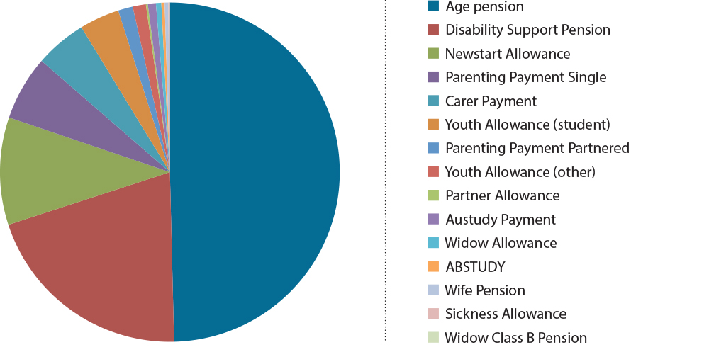
To recognise additional expenses, various supplements are added to the basic rate of income support payments depending on the payment received and recipients’ characteristics, such as age, duration on income support, principal carer status, housing tenure or whether or not a person has a disability or a partial capacity to work. Some people not receiving income support also receive supplements.
The expenditure on supplementary assistance for 2012–13 totalled $24.5 billion (excluding Rent Assistance, for which the expenditure is included in the cost of the income support programme).
The majority of expenditure on supplementary assistance was for Family Tax Benefit Part A which in 2012-13 amounted to $14.5 billion.
Other payments made by DSS include Paid Parental Leave ($1.4 billion) and Dad and Partner Pay ($39.5 million).
Figure 2 below shows DSS expenditure split across all supplement types. As Family Tax Benefit
Part A comprises such a significant component of the outlays on supplementary assistance, it is shown separately to the other assistance available.

Figure 2:Expenditure on supplementary assistance by type (2012-13 actual)
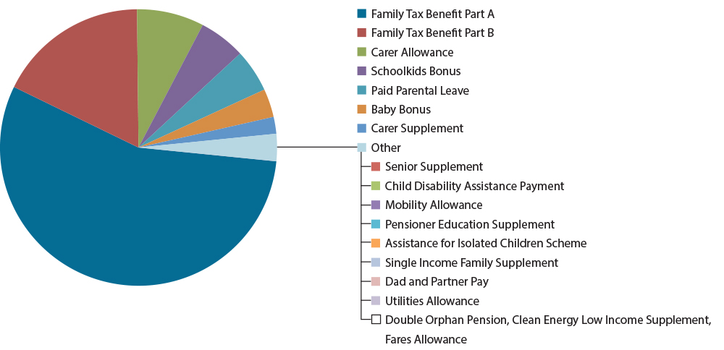
Note: Given the reconciliation process undertaken with the Australian Tax Office, expenditure for Family Tax Benefit relates to the 2010–11 financial year.
Additional to the supplementary assistance outlined above, the Government outlaid $4.9 billion in child care assistance in 2012–13 with expenditure on Child Care Benefit and Child Care Rebate at $2.6 billion and $2.2 billion respectively and Jobs, Education and Training Child Care Fee Assistance expenditure estimated at $0.1 billion.
More detailed data on Australian Government expenditure on individual transfer payments and supplements is provided in Table 1.

Table 1: Participation group by payment type by expenditure and recipient numbers, 2012–13
Participation Group | Payment type | Expense $ million  (actual 2012–13) | Number of recipients  Jun-13
Income Support payments (paid to meet the living costs of adults unable to support themselves)
Not expected/unable to work - aged | Age pension | 36,283.0 | 2,360,000
 | Widow Class B Pension (closed 1997) | 7.4 | 492
 | Wife Pension (closed 1995) | 254.5 | 16,721
 | Partner Allowance (closed 2003) | 133.5 | 9,974
 | Widow Allowance (age limited, born on or before 1 July 1955) | 376.6 | 25,681
 | Bereavement Allowance | 4.2 | 979
 | Service Pension (Department of Veterans’ Affairs) | 2,804.1 | 145,697
 | Income Support Supplement (Department of Veterans’ Affairs) |  | 65,730
Not expected/unable to work - disability | Disability Support Pension | 14,990.0 | 821,738
Not available for full-time work - parents and carers | Parenting Payment Single | 4,504.2 | 255,411
 | Parenting Payment Partnered | 1,027.4 | 103,497
 | Carer Payment | 3,590.4 | 221,954
Not available for full-time work - students | Austudy Payment | 558.3 | 41,078
 | ABSTUDY (living allowance) | 228.2 | 9,363
 | Youth Allowance (student and apprentice) | 2,776.3 | 241,899
 | Department of Veterans’ Affairs Student Assistance | 15.6 | 2,652
Expected to work full-time or partially (including temporarily unable to work) | Newstart Allowance | 7,492.4 | 660,673
 | Youth Allowance (other) | 914.6 | 113,840
 | Sickness Allowance | 98.7 | 7,494
 | Special Benefit | 68.6 | 5,492
Total DSS income support payments |  | 73,323.6 | 4,898,938
Total income support payments |  | 76,127.7 | 5,110,365
Supplementary payment, not separately appropriated
 | Pension Supplement
 | Pension Supplement (minimum)
 | Pension Supplement (basic)
 | Youth Disability Supplement
 | Income Support Bonus (to be abolished)
 | Rent Assistance |  | 1,267,979
 | Remote Area Allowance |  | 71,401 *
 | Newborn Supplement and Newborn Upfront Payment |  | (from 1 March 2014)
 | Education Entry Payment |  | 88,761
 | Approved Program of Work Supplement |  | 54,013
 | Language, Literacy and Numeracy Supplement |  | 29,029
 | CDEP Participant Supplement (closed 2009) |  | 4,749
 | ABSTUDY Supplementary Payments
 | - School Term Allowance |  | 5,914 *
 | - School Fees Allowance |  | 19,576 *
 | - Incidentals Allowance |  | 6,600 *
 | - Additional Incidentals Allowance |  | 9 *
 | - Lawful Custody Allowance |  | 7 *
 | - Aged Under 16 Years Boarding Supplement
 | - Residential Costs Option |  | 165 *
 | - Supplementary Masters and Doctorate Allowances |  | 66 *
 | - Away from Base Assistance (a) |  | 361 *
 | - Additional Assistance |  | 2 *
 | Student Start-up Scholarship / Loan | (Income Contingent Loan from 1 Jan 2014)
 | Relocation Scholarship (Department of Education)
 | Pharmaceutical Allowance |  | 609,062 *
 | Telephone Allowance |  | 404,195 *
 | Large Family Supplement |  | 422,734 *
 | Multiple Birth Allowance |  | 1,026 *
 | Clean Energy Supplement
 | Incentive Allowance (closed 1991)
 | Pension Bonus Scheme (no new registrations from 1 July 2014)
Supplementary payment, separately appropriated
 | Family Tax Benefit Part A (actual 2010-2011) | 14,484.0 | 1,872,000
 | End of Year Supplement - FTB-A
 | Family Tax Benefit Part B (actual 2010-2011) | 4,552.0 | 1,592,000
 | End of Year Supplement - FTB-B
 | Baby Bonus (until 28 February 2014) | 770.0 | 155,743
 | Schoolkids Bonus (to be abolished) | 1,395.9 | 1,250,000
 | Carer Allowance (child and adult) | 2,019.5 | 563,079
 | Carer Supplement | 506.2 | 577,688
 | Child Disability Assistance Payment | 165.2 | 146,741
 | Double Orphan Pension | 3.5 | 1,339
 | Seniors Supplement | 232.4 | 284,239
 | Mobility Allowance (higher rate) | 144.7 | 63,207
 | Mobility Allowance (standard rate)
 | Pensioner Education Supplement | 81.0 | 46,661
 | Assistance for Isolated Children Scheme  - Boarding Allowance  - Second Home Allowance  - Distance Education Allowance | 60.1 | 9,983
 | Fares Allowance | 0.8
 | Utilities Allowance | 32.7 | 69,079
 | Single Income Family Supplement | 56.9
 | Clean Energy Low Income Supplement | 2.3 | 7,615
 | Essential Medical Equipment Payment | 3.7 | 26,229
 | Stillborn Baby Supplement | (from 1 March 2014)
Total DSS supplements |  | 24,510.9
Total income support payments and supplements |  | 100,638.5
Other payments
 | Disability Pension (Department of Veterans’ Affairs) | 1,535.3 | 105,705
 | War Widows (Department of Veterans’ Affairs) | 1,850.5 | 86,865
 | Payments under Special Circumstances (ex-gratia to non-IS recipient) | 2.6 | 28
 | Crisis Payment (one week payment to IS recipient)
 | Transitional Farm Family Payment (Department of Agriculture, Fisheries and Forestry) | 5.5 | 743
 | Exceptional Circumstances Relief Payment (Department of Agriculture, Fisheries and Forestry, till 30 June 2014: to be replaced by Farm Household Allowance) | 1.6
 | Interim Farm Household Allowance (Department of Agriculture, Fisheries and Forestry, commences 3 March 2014)
 | Paid Parental Leave | 1,380.0 | 131,207
 | Dad and Partner Pay | 39.5 | 27,240
Total DSS other payments |  | 1,419.5
Total other payments |  | 4,815.1
Child Care
Child Care Benefit (Department of Employment) |  | 2,589.3 | 1347,000 (b)
Child Care Rebate (Department of Employment) |  | 2,179.9
Jobs, Education and Training Child Care Fee Assistance (Department of Employment) |  | 108.9 | 56,200 (c)
Total child care |  | 4,878.1
Total cash transfer payments |  | 110,331.7
Concessions
Pensioner Concessions Card and Pensioners Health Benefits Card (Department of Health) |  | 6,450.0 | 3,820,081
Low Income Health Care Card (Department of Health) |  | 2,341.4 | 356,600
Commonwealth Seniors Health Card (Department of Health) |  | 580.2 | 283,591
Dental services for concession card holders (Department of Health) |  | 69.2
Great Southern Rail for Concessional Fares |  | 8.4 | 38,663
National Partnership Agreement on Certain Concessions for Pensioner Concession Card and Seniors Card Holders (Department of Health) |  | 292.8
Total DSS expenditure |  | 99,262.4
Total cash transfer payments and concessions |  | 120,073.8

* Figures sources from Supercross (internal DHS administrative data), all other figures sourced from Annual reports.
(a) ‘Away from Base’ ABSTUDY assistance includes Accommodation Allowance, Meals Allowance and Motor Vehicle Allowance.
(b) Approved child care places.
(c) Number of children

Employment services expenditure
Total Government expenditure on employment services for 2012–13 was $2.199 billion, comprising:
- $1.276 billion on Job Services Australia
- $0.75 billion on Disability Employment Services
- $0.17 billion on the Indigenous Employment Program (IEP).
The Indigenous Employment Program (IEP) complements employment services available under Job Services Australia and Disability Employment Services, which are the largest provider of employment services for Aboriginal and Torres Strait Islander peoples.

Selected social support services expenditure
Key expenditure by the Department of Social Services on social support services in 2012–13 comprised:
- $225,055 million on family support services
- $122.585 million on assistance with financial management and financial counselling,
- $181.884 million on implementing community mental health initiatives that provide early intervention and assist people with mental illness, their families and carers to manage the impact of mental illness.

Appendix D: Previous reviews and reforms
The major reviews over the past 15 years and some of the key reforms implemented are summarised below.

Participation Support for a More Equitable Society (McClure Report)
In 1999, Mr Patrick McClure AO was commissioned to chair a reference group to provide advice to the Government on possible approaches to welfare reform. The group’s Final Report, Participation Support for a More Equitable Society—Final Report of the Reference Group on Welfare Reform, made recommendations and concluded that the social security system was out-dated and had been developed to meet economic and social circumstances that were no longer appropriate.
Australia was in its eighth year of strong economic growth, yet joblessness, underemployment and reliance on income support remained high. Similar to many comparable countries, disadvantage was increasingly concentrating in particular segments of the population and in particular localities. In its analysis, the Reference Group focused on the following four trends that underpinned the need for a bold change to the social support system; the growing divide between ‘job rich’ and ‘job poor’ households; labour market trends that brought changes in the balance between permanent full-time jobs and part-time and casual work, between male and female employment, between jobs in manufacturing and primary industry and jobs in service industries; an increase in the number of people receiving income support; job opportunities for less skilled workers had stagnated or declined, while technological change and the globalisation of industry and trade had increased the demand for highly skilled workers.
The major thrust of recommendations was that the Australian social security system needed to ‘do more than provide adequate levels of income support for people in need’. It also needed to ‘ensure that people are actively engaged socially and economically, including in the labour force, to reduce the risk of long-term social and economic disadvantage for themselves and their families’. The Final Report outlined its vision of a Participation Support System and identified the following five core features of ‘participation support’:
- Individualised service delivery focused on meeting the needs of individuals to identify and achieve participation goals and improve their capacity for self-reliance;
- A simpler income support structure that is more responsive to individual needs, circumstances and aspirations. An income support structure that is as simple as possible (taking into account differences in needs), able to respond to changing circumstances, and provides strong encouragement for economic and social participation according to people’s capacities and circumstances. The report recommended a common base rate plus add-on modules to address additional needs such as costs of children, living as the only adult in a household, additional costs of single parenthood and housing costs above a specified level.
- Incentives and financial assistance that encourage and enable participation ensuring a fair return from paid work. An integrated participation support system that ensures strong incentives for both part-time and full-time work; targets assistance to need and provides incentives for participation. The report recommended the development of a participation supplement/account to help people meet their participation costs (above that provided for in the standard rate) and assist with the transition to employment.
- Mutual obligations underpinned by the concept of social obligations. Governments, business, communities and individuals all have roles. Income support recipients have responsibility to take-up the opportunities provided by government, business and community, consistent with community values and their own capacity.
- Social partnerships to increase opportunities for social and economic participation.
The McClure Report noted that the current distinction between the pension and allowance income tests, based on supporting part-time versus full-time work, is difficult to maintain and recommended bringing payment withdrawal rates together to achieve the best balance between targeting assistance to need and providing incentives for self-reliance. The report also noted that in designing a simpler social security system there are various other areas where greater uniformity in treatment is desirable (and would need to be settled) including indexation and the taxation treatment of the basic rate and add-on components.
In the 2001–02 Budget, the Australians Working Together Package was announced in response to the recommendations of the McClure Report. The package included the ‘working credit’ which was introduced in September 2003 to ease the impact of the income test on working-age people in the early stages of returning to employment after an extended period of reliance on income support. The package also provided for additional support services to parents, people with disability, mature age people and others who had been out of work for an extended period. Partner Allowance and Mature Age Allowance were closed to new entrants from September 2003.
The McClure Report recommendations relating to simpler income support structure were the subject of the community consultation paper Building a simpler system to help jobless families and individuals (2002). The paper outlined two key objectives for working age income support—self-reliance and social inclusion—as well as a set of design principles to underpin the objectives. The paper proposed a new assistance package based on the standard rate plus add-on modules, including a participation supplement, as outlined in the McClure Report.
In the 2005–06 Budget, the Welfare to Work package of measures was announced. The package ‘activated’, through the imposition of part-time activity requirements, principal carer parents of older children and new entrants with disability with a partial capacity for work. New entrants were instead required to claim another payment instead of Parenting Payment or Disability Support Pension. Employment services were expanded to ensure that those required to look for work received additional assistance to do so. The package more closely aligned requirements for mature age people on Newstart Allowance with those applying to younger recipients. Consistent with the directions of the Breaching Review Taskforce a suspension based approach to compliance replaced a breaching approach that incorporated rate reductions. From 1 July 2006, to improve rewards from work the maximum income test withdrawal rate was reduced from 70 to 60 cents in the dollar and the income at which this taper commenced was increased from $142 to $250 a fortnight.

Review of Australian Higher Education (Bradley Review)
In March 2008, the then Government initiated a Review of Higher Education to examine the future direction of the higher education sector, its effectiveness in meeting the needs of the Australian community and economy, and the options for ongoing reform. The review was conducted by an independent expert panel, led by Emeritus Professor Denise Bradley AC, and was released in December 2008.
The Review, while focused on higher education, also made a number of recommendations for reforms of student payments that the then Government accepted, the first of which commenced in April 2010. The reforms included:
- the progressive reduction to the age of independence for Youth Allowance from 25 to
22 years of age by 1 January 2012
- the introduction of the Student Start-up Scholarship for higher education students in receipt of Youth Allowance, Austudy or ABSTUDY and the introduction of the Relocation Scholarship to assist with the cost of relocating to study (1 April 2010)
- the introduction of more generous parental means testing arrangements by aligning the parental income threshold for maximum payment with Family Tax Benefits and a 20 per cent family taper rate (1 July 2010)
- increasing the fortnightly personal income threshold from $236 to $400
- increasing the income bank for students to $10,000 in July 2012 (indexed from January 2013).

The Pension Review (Harmer Review)
The Pension Review was led by Dr Jeff Harmer AO. The focus of the review was on the adequacy of Age Pension, Carer Payment and Disability Support Pension. The Pension Review Report was released as part of the 2009–10 Budget.
Five broader structural and demographic environmental challenges were considered in the context of the review: the global financial crisis; sustainability; the management of risk in retirement, in particular investment risk and longevity risk; workforce participation incentives and interactions with the broader tax-transfer system; and complexity.
The Harmer Review considered that the basic structure of Australia’s pension system, with its focus on poverty alleviation, indexation to prices and benchmarking to community living standards, and means testing, was sound. However, it found that to address the challenges faced in the short- and long-term reforms were needed:
- Pension rates did not fully recognise the costs faced by single pensioners living alone and the approach of paying ad hoc bonuses does not provide financial security. Additionally many pensioners who rent privately had high costs and poor outcomes.
- Indexation arrangements for pensions needed to more transparently link to community living standards and better respond to the price changes experienced by pensioners.
- Complexity needed to be reduced as it can undermine the financial security of pensioners, and inhibit the flexible delivery of payments.
- Services were an essential complement to the pension system and can respond to the diversity of needs in ways an income support system cannot. However, they needed considerable review and reform to more effectively and sustainably perform this role.
- Workforce participation by pensioners over Age Pension age should be better supported while a stronger participation focus is needed for those of working age.
- In the face of demographic change long-term sustainability was critical. The situation of pensioners with low to moderate reliance on the pension was different to those who were wholly reliant on the pension, and there was scope for targeting any increases to those who need it.
- An increase in the Age Pension age needed to be considered as a response to the rapid increases in the life expectancy of Australians and the growing duration of retirement.
The Secure and Sustainable Pension Reform Package announced as part of the 2009–10 Budget addressed key findings of the Harmer Review. The reforms included: an increase in the package of assistance for singles to 66.33 per cent of that paid to a couple combined; improved indexation arrangements; supplementary payments streamlined, with several supplements and allowances rolled into a single fortnightly Pension Supplement; an increase in the income test taper rate from
40 to 50 per cent with transitional arrangements to move impacted pensioners to the new system over time; a progressive increase to the Age Pension qualifying age to 67 years, at a rate of six months every two years, commencing in 2017; and introduction of a new Work Bonus to support workforce participation.

Australia’s Future Tax System Review (Henry Review)
The Final Report of Australia’s Future Tax System Review, chaired by Dr Ken Henry AC, was publicly released in 2010 and made recommendations designed to ‘position Australia to deal with demographic, social, economic and environmental challenges of the 21st century’. The key economic and environmental drivers for the review were globalisation, climate change, population ageing and the Internet that was transforming the way Australians lived and did business.
In regard to income support and family assistance, the report focused on the broad architecture of the transfer system and its interactions with the personal income tax system, rather than a detailed review of adequacy or individual payments. The report included chapters covering: income support payments; means testing; family and youth assistance; child care assistance; housing assistance; transfers tied to goods and services; and funding aged care. The report identified the primary purpose of government assistance payments as to ensure a minimum adequate standard of living, taking into account individual circumstances and prevailing community standards. The Henry Review found that the main features of the Australian system should be retained: targeted and category-based income support payments and family assistance, paid to income support recipients as well as working families.
The report found that the current income support settings failed to adequately reflect evolving employment patterns and changes in the composition of the working age population. Large differences in payment rates and conditions create incentives to switch to high payment categories that carry greater risk of long-term dependency. The report stated that re structuring income support could reduce this risk, but only if it is clear that income support recipients are expected to find work and there is adequate investment in employment related services.
The report proposed that a re-structured income support system should include three categories of income support payment:
- A pension category for people who are not expected to support themselves through paid work, whether because of their age, disability or because they are providing full-time care for a person with disability (or frail aged). The review took the payments settings established by the Australian Government following the 2009 Harmer Review as the benchmark for pensions.
- A participation category for people of workforce age who are expected to support themselves through paid work now or in the near future, including those with a partial capacity to work and primary carers of dependent children. The rates would be less than the pension rate but for those expected to work should provide a basic level of adequacy while maintaining incentives to work. Parents on income support would receive a higher total level of payment. Unemployed youth aged less than 21 would be paid no more than full-time students.
- A student assistance category for people engaged in full-time study. Students aged 21 and over would continue to be paid at a lower rate than the unemployed and at the same rate as younger students in similar circumstances.
The report recommended a more consistent approach to payment relativities within each of the three categories of payment given the recent change to the single to couple relativity for pensions. While this meant an increase to rates of payment for singles in the participation and student categories, it was noted that a lower relativity could apply to singles without children given their greater capacity to share accommodation.
The Henry Review also recommended that payments and income test parameters be indexed in a consistent way across the three payment categories and to reflect changes to community standards.
Income support for parents in the participation category included part-time work requirements from age four in the longer-term (age six in the short-term to be reduced in line with significant changes in the availability of early childhood education, adequate and affordable child care and ‘family friendly’ conditions of work) and an additional parenting supplement to maintain adequate assistance for families (paid with family assistance for single parents and couples with young children, and with income support for couples with older children). For families with young children the supplement increased the rate of assistance for parents in the participation category to that provided to the pension category.
People in the participation category with a partial capacity to work should have a part-time work requirement and have means test or payment arrangements that provide an incentive to work part-time and recognise that they face higher average costs of work. This could be developed as an in-work supplement and/or earnings disregard in the means test.
The report argued for a more uniform treatment of assets and proposed the introduction of a comprehensive means test that included deeming an income on most assets. The report recommended establishing a family payment that covered the direct costs of children in a low income family and also assisted parents nurturing young children to balance work and family responsibilities. The direct cost payment included per child assistance that recognised the higher costs of older children, with consideration also given to the introduction of a shared care rate to recognise the higher costs of separated families. Baby Bonus was to be replaced by a small supplementary payment to cover the costs of a new-born baby. A parenting supplement for parents nurturing young children (aged under six) and for single parents would be provided as a per family payment in the family payment system.
Total family assistance would be paid subject to a single means test on family income to avoid cumulative withdrawal rates.
The report recommended that family payments should be the main form of assistance for children up to 18 years, or until completion of secondary school in the year a person turns 18 years. The Supporting Families with Teenagers measure announced as part of the 2011–12 Budget made family payments the main form of support for children until they left school (1 January 2012).
For Child Care Benefit and Child Care Rebate, the report recommended that they be combined into a single payment with a high rate of subsidy (up to 90 per cent) for low income families, a base rate of assistance for all families with access based on the requirement that parents be participating in work, education or training. The child care payment would be means tested to the base rate with interactions with other means tested arrangements taken into consideration to avoid excessive effective marginal tax rates.
Access to adequate housing was seen as an integral part of the social safety net. The report recommended significant increases in maximum rates of Rent Assistance so that it can support access to an adequate level of housing, a change to indexation arrangements to ensure that its value is maintained relative to rents paid, as well as changes to other design features to better target assistance to those paying higher rents. To reduce inequities in assistance between public tenants and private renters it also recommended extending Rent Assistance to private tenants along with replacing income-based rent setting with market based rents

Review of Student Income Support Reforms (Dow Review)
A Review of Student Income Support Reforms was conducted by Professor Kwong Lee Dow. Professor Dow reported to the Australian Government in July 2011.
The Dow Review cautioned against creating any further lines of demarcations between regional and metropolitan students stating that the focus should move to considering the additional cost for all students who need to relocate—both country and city students.
The main recommendation of the Dow Review was for a single new self-supporting criterion for independence for young people who have worked full-time for two out of three years, where a minimum of two years has elapsed since leaving school. This was seen as a tightening of the then current arrangements applying to inner regional and metropolitan students, which require full-time work over 18 months in order to establish independence (though, the report notes that, in effect, the 18 month requirement tends to result in people delaying study for two years anyway).
The Australian Government’s response, which was announced in September 2011, provided additional support to young people from regional areas needing to move away from home to study, while maintaining an emphasis on assisting students from low socio-economic backgrounds.

Senate Committee Inquiry into the adequacy of the allowance payment system for jobseekers and others
In 2012 an inquiry was undertaken by the Senate Education and Employment Committee into ‘the adequacy of the allowance payment system for jobseekers and others, the appropriateness of the allowance payment system as a support into work and the impact of the changing nature of the labour market’.
The review was in response to calls to increase Newstart Allowance by $50 per week.
The Committee agreed that Newstart Allowance was effectively discharging its primary duty: to support people through a short-term transitional period of unemployment. However, the Committee was concerned about those who did not transition quickly back into the workforce and believed that the allowance payment system could better encourage workforce participation.
Based on the evidence presented the Committee questioned whether Newstart Allowance provides recipients a standard of living that is acceptable in the Australian context for anything but the shortest period of time. The committee concluded that one of two possible solutions must be pursued: increase Newstart Allowance to raise the standard of living available or ensure that people spend as little time as possible on payment between jobs. Following this conclusion, the Committee then examined the cost of raising Newstart Allowance and how job services could be improved.
The Committee agreed that Newstart Allowance does not allow people to live at an acceptable standard of living in the long-term, while also noting that the allowance was never intended to be a long-term solution to unemployment. The Committee believed that in the long run the best form of welfare is a job and that the allowance system could be improved through better, stronger investment in employment assistance.
The Committee identified areas where Job Services Australia and other employment programmes could be improved and recommended investing additional resources to enable service providers to provide a greater level of assistance to jobseekers within their first 12 months on payment, including for some specific target groups: the mature aged and former Carer Payment recipients coming into the allowance system after time out of the workforce.
The report also found that transitions to full-time work would be improved by increasing the income threshold for long-term job seekers. The Committee recommended increasing the income free threshold for long-term jobseekers from the equivalent of three hours’ work per week at minimum wage to six hours work per week and increasing the ‘working credit’ from $1000 to the equivalent of three months earnings on minimum wage.
The Committee recommended that processes be reformed to avoid there being any disincentive in relation to leaving payment for casual or short-term work by allowing job seekers to remain active on departmental systems for one year after ceasing payment.
The Committee also formed the view that the allowance payment system was too complex and can and should be simplified and streamlined. Until such time that this can be achieved the Committee recommended that an online calculator be developed to enable recipients to easily calculate the costs and benefits of work, and the impact of work on allowances and other payments.
While the former Government did not respond formally to the Committee’s Final Report in the
2013–14 Budget, the income free area for Newstart Allowance, Widow Allowance,
Partner Allowance, Parenting Payment Partnered and Sickness Allowance increased from
$62 to $100 per fortnight from 20 March 2014. The income free area will then be indexed on
1 July each year by the movements in the Consumer Price Index, from 2015.

Appendix E: Economic and labour market changes

Introduction
The Australian labour market is dynamic in nature, changing in response to numerous factors such as the demand for goods and services, economic conditions and the regulatory framework. At the same time, peoples’ level of labour force participation and the nature of their employment are strongly related to their stage of life and family circumstances. Ensuring the labour force is flexible in adjusting to labour market changes is not straightforward, but understanding the nature of these changes and the implications for Australian workers is a necessary step in developing a meaningful participatory welfare framework.

Structural changes in the economy
There have been major structural changes to the economy over recent decades that have had significant implications for the Australian labour market. The microeconomic reforms begun in the mid-1980s that opened the Australian economy up to international competition, labour market deregulation, technological change and the mining boom have all had a significant impact on the structure of the Australian economy and the structural composition of the labour market.
These economic changes have in aggregate benefited Australians across income deciles (income brackets) by facilitating rapid economic growth. Households in both the highest and lowest income deciles exhibited high levels of income growth between 1988–89 and 2009–10, with the growth in government payments of particular importance to household income growth for the bottom two income deciles. However, these changes have also had an impact on the distribution of income and jobs across the economy.

Changes in industry composition of employment
In recent decades, the majority of employment growth has been in the services sector, which now account for almost 90 per cent of total employment within the economy. The mining sector’s share of employment declined for most of the twentieth century before almost trebling over the last decade in size (albeit from a small base) during the course of the mining boom. However, in 2013, mining employment still only constituted around 2 per cent of total employment in Australia.
By contrast, the shares of employment in the manufacturing and agricultural sectors have declined substantially in recent decades. Manufacturing’s share of total employment fell from around 26 per cent in 1958 to around 8 per cent in 2013. Similarly, agriculture’s share of total employment fell from around 12 per cent in 1958 to around 3 per cent in 2013.
The labour markets of some geographic regions have been adversely affected by structural economic changes, particularly those heavily reliant on manufacturing, agriculture and industries vulnerable to import-competition and technological change. These locational effects have become particularly important in the wake of the mining boom and the high value of the Australian dollar.

Changes in skill levels
The structural economic changes have also favoured highly skilled and educated workers over
low-skilled and uneducated workers in the labour market. Table 1 shows that the proportion of high-skilled jobs in the economy has increased at the expense of low-skilled jobs. This has taken place in both white- and blue-collar occupations over recent decades. White-collar jobs refer to office-type work, with high-skilled white-collar jobs being of a professional or managerial nature.
This compares with blue-collar jobs which involve manual labour, but can be high-skilled as in the case of skilled tradespeople. The remaining low-skilled jobs, both in the white- and blue-collar jobs market, are also more likely to be casual and part-time than was once the case. As a result, unskilled or low-skilled workers are at greater risk of unemployment and dependence on income support.

Table 1: Distribution of jobs by skill level over time (per cent)
Category | 1986 | 2013
High-skilled white collar | 29 | 35
Low-skilled white collar | 31 | 34
High-skilled blue collar | 17 | 15
Low-skilled blue collar | 23 | 16
Total | 100 | 100

Source: Australian Bureau of Statistics (Cat. 6204.0.55.001 and 6291.0.55.003) and Department of Social Services calculations.
Australia as a whole has adapted well to the growing demand for more highly skilled and educated workers in the labour market. The percentage of people aged 15 to 64 years with a non-school qualification increased from 47 per cent in 2001 to 57 per cent in 2013. Over the same period, the percentage of people with at least a Bachelor Degree increased from 17 per cent to 25 per cent.

Likely future employment opportunities
The Department of Employment’s latest Employment Outlook to 2017, which estimates employment growth by industry over the five years to November 2017, notes that Australia’s evolution towards a service-based labour market is expect to continue, with the largest gains projected for major service industries such as Health Care and Social Assistance, Retail Trade and Construction. Together, these three industries are expected to provide nearly half of the total growth in employment over the next five years.
The expected expansion of the aged care sector due to the ageing of the population and the expansion of the National Disability Insurance Scheme will both require a larger carer workforce in the future. As such, there should be a growth in employment opportunities in these and other related areas of the economy. However, while these sectors of the economy will require a range of different skill levels, there is no reason to expect that the trend towards higher skill levels across these and most other sectors will not continue to increase over time.
Employment growth in mining is projected to be slower than in recent years. The share of total employment in manufacturing is projected to shrink, with a projected decline in agriculture, forestry and fishing. (Employment share is the share of total people employed in Australia who are working in a particular industry sector.)
The Employment Outlook to 2017 also estimates projected employment growth by skill level and that the highest projected growth in skill levels will be Skill level 1 (Bachelor Degree or higher qualifications) at 8.3 per cent over the five years to 2017, accounting for around one out of every three jobs created over this period. Skill level 2 (Advanced Diploma or Diploma) and Skill level 4 (Certificate II or III) are also projected to grow strongly over the same period (by 8.3 per cent and 7.8 per cent respectively).
The Department of Employment also carries out research to identify skill shortages in the Australian labour market and identify occupations where skill shortages are evident or emerging at the state, territory and/or national level. In 2013, 26 occupations were assessed as being in national shortage (Seven managerial and professional occupations, 18 technical and trade workers plus care child workers).

Unemployment
The importance of encouraging people to become more highly skilled is underscored by
Figure 1, which shows a strong linkage between level of qualifications and the unemployment rate. Unemployment rates tend to decline with higher levels of qualifications, although they are particularly high for people with only a vocational and education training (VET) Certificate I or II (where Certificate II is broadly equivalent to completion of Year 12 schooling). People with a
VET Certificate III or IV or above tend to have a relatively low risk of unemployment.

Figure 1: Unemployment rate (per cent) by highest level of educational
attainment, May 2013
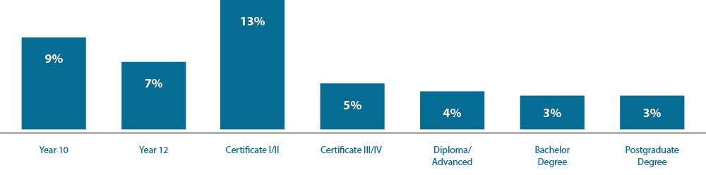
Source: Australian Bureau of Statistics (Cat. 6227.0)
The loss of low-skilled jobs in the economy and the high unemployment rates associated with low educational qualifications make it imperative for people to undertake appropriate education and training to minimise the risk of becoming unemployed and dependent on income support.
Figure 2 shows that unemployment rates have been trending downwards since the economic downturn of the early 1990s, although they have risen slightly since the global financial crisis hit in 2008 and are now around 6 per cent. Unemployed young people are a particular concern, with a rate consistently higher than unemployment in general.

Figure 2: Unemployment rates in total and for young people aged 15-24 years
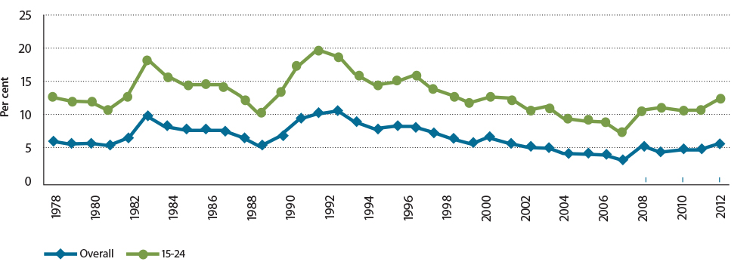
Source: Australian Bureau of Statistics (Cat. 6202.0)

Labour force participation rates
The proportion of working age (15 to 64 years) people participating in the labour force has been increasing over time. Participation rates include those employed, both full- and
part-time, away from work and unemployed. As such, participation rates can show an increase while not necessarily equating to an increase in employment as those previously not in the labour force commence participation, but as unemployed. The labour force participation rate rose from 68 per cent in 1978 to 76 per cent in 2013. Women have been the main driver of higher labour force participation rates, with their participation rate rising from 50 per cent to 70 per cent over this period. This more than compensated for a drop in the male participation rate from 86 to 82 per cent during this time (see figure 4 below).
The increase in women’s labour force participation reflects changing social norms, technological changes and government policies. More women are working now, including those with young children. Figure 3 shows that the trend in mothers’ employment rates according for all the age grouping of their youngest child have been increasing over time.
The employment rate for mothers with a youngest child aged zero to four years has increased from 41.3 per cent in 1994 to 51.5 per cent in 2012. Over the same period of time, mothers whose youngest child is aged five to nine years, rose from 58.7 per cent to 71.6 per cent and for mothers whose youngest child is aged 10 to 14 years, the rate rose from 65.1 per cent to 74.8 per cent.

Figure 3: Mothers’ employment rates by age of youngest child, 1994–2012
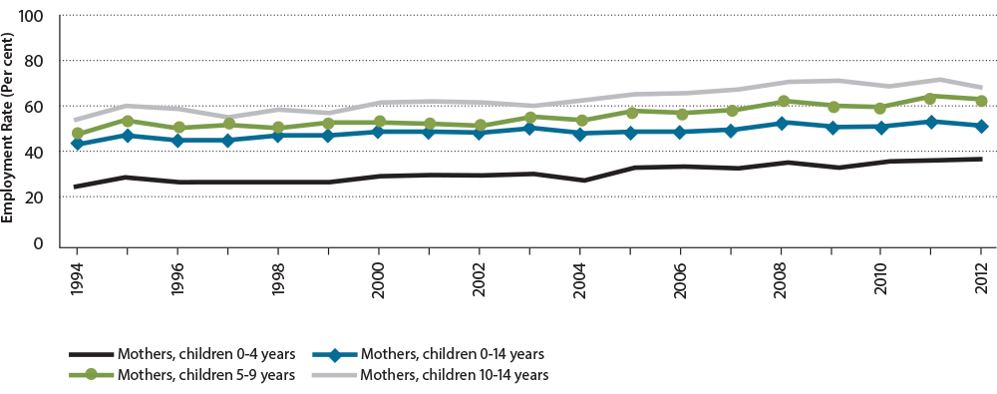
Source: Australian Bureau of Statistics (Cat. 6224.0.55.001).
The growth of jobs in the services sector has particularly suited the growth of female workforce participation, with significant increases in jobs where women are often employed, and with the sector also particularly amenable to part-time hours that are preferred by many women.

Figure 4: Labour force participation rates aged 15-64 years
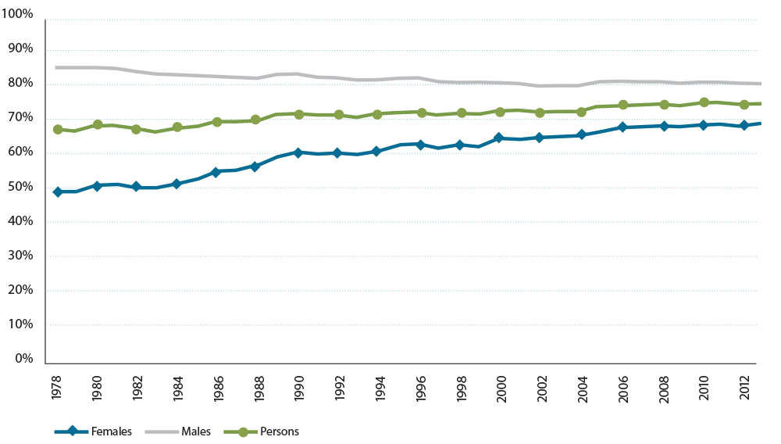
Source: Australian Bureau of Statistics (Cat. 6202.0)
Australia compares well against other OECD countries in terms of labour force participation rates, ranking 11th out of 34 countries (see figure 5). Most of the countries with higher participation rates than Australia do not have substantially higher participation rates; however; only three OECD countries have participation rates 80 per cent or higher.

Figure 5: Labour force participation rates of people aged 15-64 years across OECD countries in 2012 (per cent)
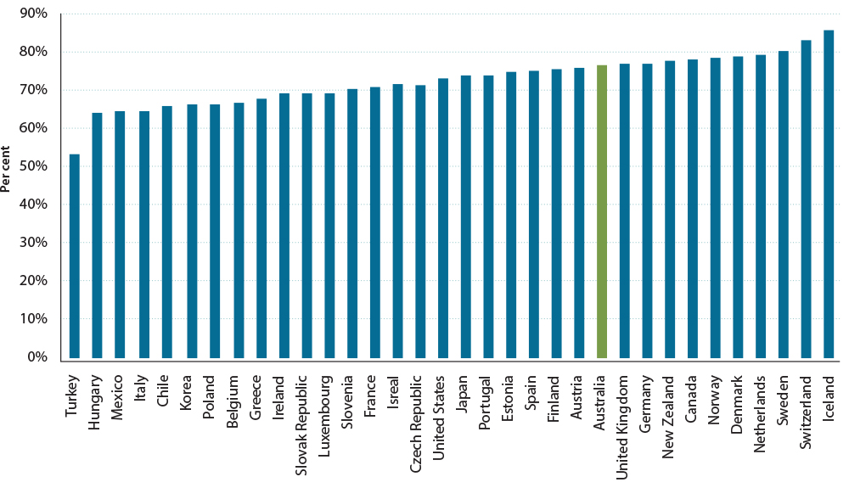
Source: OECD. Statistics
As noted above, women’s labour force participation in Australia has grown significantly over recent decades and was 70.4 per cent for 15 to 64-year-olds in 2012. This is substantially higher than the OECD average of 62.3 per cent.
Australia’s labour force participation rate for women aged 15 to 64 is lower than some other OECD countries, however. The United Kingdom (71.0 per cent), New Zealand (72.5 per cent), Denmark (75.8 per cent), and Sweden (77.9 per cent) are among a group of countries that have higher labour force participation rates for women than Australia.
OECD research has identified several key factors that influence women’s decisions to work and their labour force participation; these are: paid parental leave; available and suitable child care; flexible work; education; and financial incentives (for example, tax-transfer payments).
Typically those OECD countries with the highest female labour force participation rates, such as Denmark and Sweden, have generous paid parental leave arrangements.

Marginal attachment to the labour force
In September 2012, there were 918,100 people with marginal attachment to the labour force, representing people not in the labour force who wanted to work and were actively looking for work but were not available to start work due to a range of factors. The most commonly reported main activity for men with marginal attachment to the labour force was ‘Attending an educational institution’ (38 per cent of men compared to 22 per cent of women), whereas for women it was ‘Home duties’ (31 per cent of women compared to 9 per cent of men) and ‘Caring for children’ (26 per cent of women compared to 5 per cent of men).

Part-time employment
Recent decades have seen a rapid increase in the number of part-time workers. Figure 6 shows that the number of people employed part-time as a proportion of those employed has doubled from 15 per cent in 1978 to 30 per cent in 2013. As noted above, this has been driven by an increase in the labour force participation rate of females (who are more likely to work part-time, especially those caring for young children and where their participation rates increased as their children grew older), as well as an increase in the proportion of females who work part-time, and an increase in part-time employment by males.

Figure 6: Percentage of people in employment who are employed part-time
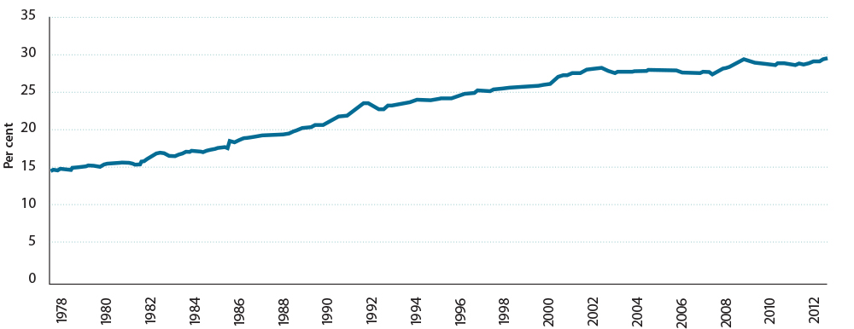
Source: Australia Bureau of Statistics (Cat. 6202.0)

Gender differences in part-time employment
At June 2012, 82.9 per cent of males worked full-time, whereas 54 per cent of females worked full-time and 46 per cent worked part-time. However, the presence of dependent children makes a significant difference to the proportion of women working full-time. At June 2012, around 71 per cent of females with no children were employed full-time, compared with 41 per cent of mothers with children aged under 15 years.
In September 2013, there were 3.5 million part-time workers, of which 70 per cent (2.4 million)
were women.

Part-time workers wanting to work more hours
Just over a quarter (26 per cent) of all part-time workers stated they would prefer to work more hours, compared with 24 per cent of part-time workers who said they would prefer to work more hours in September 2011 and 2012.
Of the 912,200 part-time workers who would prefer more work hours:
- 38 per cent were men and 62 per cent were women
- just over half (55 per cent) would prefer to work full-time
- 90 per cent (817,200) were available for work with more hours, and more than half of these (53 per cent) were looking for more work hours.
Overall, there were around 2.6 million people who were jobless and wanted a job, or were working part-time and wanted to work more hours, but could not for a variety of reasons.

Factors influencing people’s desire to work or to work more hours
Nearly 60 per cent of women caring for children said that the availability of child care places was a very important consideration when looking for work, followed by financial assistance with child care costs. For females with children aged under 13 years, child care incentives were seen as particularly important.
For men, 40 per cent of those seeking work or employed part-time considered that a job matching their skills and experience was very important.
Nearly one third of people aged 18 to 29 years who were not looking for work or more work hours were studying or returning to study; for people aged 30 to 54 years, caring for children was the most common reason for not looking for work or more work hours, and for people aged over 55 years, their main reason for not looking for work or more hours was that they believed that they were considered too old by employers.

Part-time work as a ‘stepping stone’
Generally, the Australian evidence supports the role of casual and part-time work as an important ‘stepping stone’ that provides people, especially young people making the transition from school to work, with skills and experience that enable them to gain full time work.
Getting a casual or part-time job in the first-year after leaving school is associated with a substantially higher probability of being employed in subsequent years.

Appendix F: Case studies—International experiences

New Zealand reforms
New Zealand has recently implemented a wide ranging reform of their social services system. The key focus of the reforms has been increasing participation and targeted early intervention to reduce long-term dependence on income support.

Payment reform
New Zealand has replaced 11 main benefits with five new benefits and has introduced a range of increased mutual obligations.

New payment structure
New benefit | Replaced benefits
Job Seeker Support  People who can usually work full-time.  It also includes people who can only work part-time or temporary cannot look for work, for example because they have a health condition, injury or disability. | - Unemployment Benefit  - Sickness Benefit  - Domestic Purposes Benefit—Women Alone  - Domestic Purposes Benefit—Single Parent if youngest child is aged 14 and over  - Widow’s Benefit—without children, or if youngest child is aged 14 and over
Single Parent Support  Single parents caring for children under the age of 14 who can look or prepare for part-time work. | - Domestic Purposes Benefit—Single Parent if youngest child is aged under 14  - Widow’s Benefit—if youngest child is aged under 14
Supported Living Payment  People who are severely restricted or unable to work on a long-term basis because of a health condition or disability. It is also for people who are caring for someone who needs significant care. | - Invalid’s Benefit  - Domestic Purposes Benefit – Care of Sick or Infirm
Young Parents Payment  For people between 16 and 18 with dependent children. | - Youth Benefits
Youth Payment  For people between 16 and 18: who have left the care of Child, Youth and Family; whose parents or guardian can’t support them; whose relationship with their parents or guardians has broken down and no one can support them financially; there is a good reason why they can no longer live with their parents or guardian, or be supported by them or anyone else. | - Youth Benefits

Mutual obligation
The mutual obligation requirements include some specific measures targeted at young people including young parents. These include income management, budgeting and parenting training, and intensive work with youth support workers. The youth measures are covered in more detail under Pillar Two of this Interim Report.
Other measures include the use of sanctions for those who fail pre-employment drug tests or who refuse to apply for jobs where pre-employment drug tests are mandatory. People with an outstanding arrest warrant will not receive benefits while evading police.
A work availability expectation was added to a number of payments:
- part-time availability for single parents when their youngest child turns five years old;
- full-time availability for single parents when their youngest child turns 14 years old; and
- work availability expectations to women receiving Widow’s Benefit, Domestic Purpose Benefit for Women Alone and partners of other main beneficiaries.
As part of these reforms an activation power was introduced, which requires participants who are not expected to be available for work to take steps to prepare for work. All parents on income support are required to take all responsible steps to ensure their dependent children:
- aged three or over, enrolled in and attending Early Childhood Education until they start school
- enrolled in and attending school from age of five or six (depending on when the child first starts school)
- enrolled with a primary health care provider
- up-to-date with the core WellChild checks.
Parents are required to undertake up-skilling once their youngest child is three years old and look for part-time work by the time their children are five. Upon the birth of another child these requirements will be reinstated when the youngest child turns one. This means that people previously free of work obligations under their former payments are now required to look for work or participate in training. The same participation requirements apply to all parents, partnered or single.
People who are sick or disabled have a new work-focused approach and will be able to choose to opt-in for some work supports. If they have been assessed as having capacity to undertake specific work preparation activities they will be asked to do so. The exception to this is people who are severely disabled, severely mentally ill or terminally ill who continue to be supported.

United Kingdom reforms
The United Kingdom is reforming its welfare system to make it fairer and more affordable. The reforms aim to reduce poverty and welfare dependency though a new simplified payment system and an increased focus on participation.

The payment
When fully implemented by the end of 2017 the United Kingdom welfare reforms will see a single working age payment (Universal Credit) implemented which consists of a base payment with supplements for things such as housing; caring; and costs of children. The entire payment will be subject to participation requirements.
Universal Credit will be available to low income earners, as well as to those who are out of work and it covers all working age people including those with a disability. Under the existing payments system benefits reduced sharply when income was earned and this provided a disincentive to work even part-time. Universal Credit introduces a flat 65 per cent taper rate.
There is a household cap applied to payments so that households cannot get more in income support than the average household wage in the United Kingdom. The total benefit is calculated (including supplements) and a single means test is applied.
Transition arrangements mean that people will stay on their former payment rates until their circumstances change at which time they will apply for Universal Credit.
Personal Independence Payment (PIP) will replace the Disability Living Allowance for working age people with disability. PIP is to cover some of the extra costs associated with disability and is payable to those on Universal Credit and those who are working. Assessment of eligibility has been outsourced to private agencies.

Participation requirements
Under Universal Credit there will be participation requirements on anyone receiving the payment. As an in work payment it not only has a requirement to seek employment, there is also a requirement to gain more hours or a better paying job.
Participation requirements are to some extent tailored to circumstances. Those with caring responsibilities or disabilities will have modified arrangements such as interviews, participation plans and training. For example, people with disability may only be required to attend a work capacity assessment.

Delivery
It is expected that most people will apply for Universal Credit on line and will update their details on line as well. To increase the accuracy of payments, Universal Credit will link to real time reporting of wages from Her Majesties Revenue and Customs. This will also mean that most people will not need to update their earnings within the benefits system.
The payment is made monthly to match how people receive wages in the United Kingdom and is calculated on a household basis with the payment going to a nominated member of the household.

Appendix G: Trends in income support

Introduction
The income support system includes pensions and allowances, and a range of supplements to recognise additional expenses.

Income support receipt
Favourable economic conditions over the past two decades, combined with an enhanced participation focus in the income support system, have led to a reduction in the extent to which the Australian working age population is in receipt of income support.
The percentage of the working age population receiving income support peaked in 1997 at
24.9 per cent, before falling to 16.6 per cent in the 2008, rising to 17.6 in 2010 following the Global Financial Crisis and then easing back to 16.7 per cent in 2013 (see figure 1).
Of those people in receipt of income support, there is an important distinction to be made between those who are largely and wholly reliant upon it as their main source of income and those who receive only partial income support.

Figure 1: Percentage of working age (16–64 years) population receiving
income support
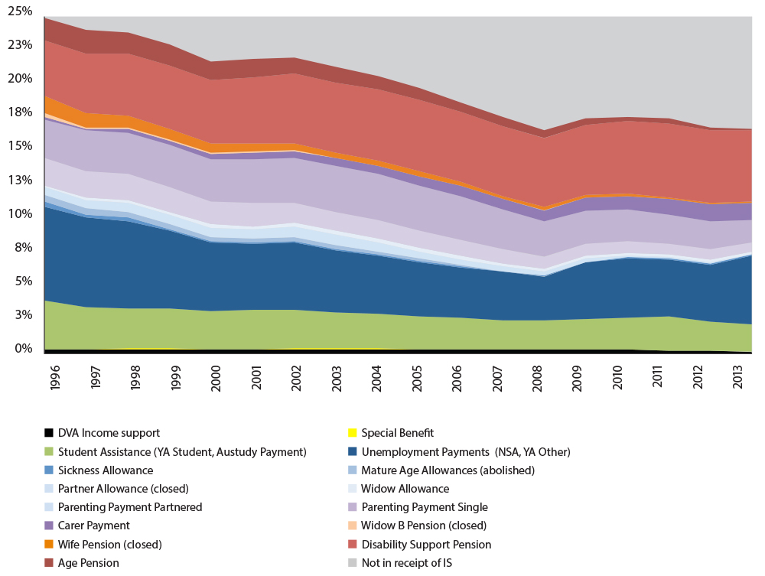
Source: Australian Department of Human Services administrative data and Australian Bureau of Statistics data (Cat. 3101.0)

Trends in major working age income support payments
Figure 1 also provides a breakdown of the proportion of recipients of different working age income support payments.
The proportion of working age people on the Disability Support Pension has remained generally steady over the last decade after increasing by around ten per cent in the late 1990s. Much of this growth is from older women due to the closing of dependency based payments to new entrants (Wife Pension, Widow B Pension and Partner Allowance) and the raising of the Age Pension age for women from 60 to 65 years.
The growth in Disability Support Pension coverage has also been contained by the tightening of eligibility rules as part of the 2006 Welfare to Work changes which limited access to new entrants who had an assessed work capacity of less than 15 hours per week. Further changes under the 2010 Secure and Sustainable Pension Reforms also limited growth in numbers, particularly the conduct of all job capacity assessments by registered health professionals employed in the Department of Human Services, and the introduction of revised Impairment Tables.
There has been a substantial decrease in the proportion of working age people on Parenting Payment (Single) and Parenting Payment (Partnered) over the last decade and a half. This reflects the 2006 Welfare to Work changes, which reduced the age of qualifying children for new entrants to Parenting Payment. Under the changes the age limit for the qualifying child was reduced for new applicants from 16 years to six years for partnered parents; and eight years for single parents. Parenting Payment recipient numbers were further reduce following the removal of grandfathering arrangements for existing recipients from 1 January 2013. The improving labour market conditions over this period of time would likely also have played a role in the decrease of recipients, particularly for those with older children.
The proportion of working age people receiving Newstart Allowance trended strongly down from the beginning of the last decade until the Global Financial Crisis in 2008. The growth in the recipient population since 2008 has been due in part to the poor global economic climate. Growth in Newstart Allowance recipient numbers is also due to the limits on access to other payments following the 2006 Welfare to Work changes, the removal of grandfathering arrangements for Parenting Payment in January 2013 which meant most affected recipients moved to Newstart Allowance, and the relaxation of the single principal carer income test from January 2013 which extended the income test cut out for these Newstart Allowance recipients.
The proportion of working age people on Carer Payment has grown rapidly over the last decade and a half. The number of Carer Payment recipients grew around six-fold over the period 1998-2013.
The increases in Carer Payment numbers reflect:
- demographic changes, such as the ageing of the population, and the associated increase in the incidence of people suffering from disability;
- greater public awareness of the value of two payments (Carer Payment and Carer Allowance);
- an increase in the number of people with disability and medical conditions being cared for at home; and
- changes to qualification criteria that have extended eligibility of these payments to a wider group. The closure of alternative non-activity tested payments and growing gap between Carer Payment rates and allowance rates has also contributed to this growth.
The proportion of working age people on Youth Allowance (Student) declined slowly over the decade to 2008, due to the increase in the age of independence from 22 to 25 in 1997, and the erosion in the value of the parental income test parameters over time relative to Family Tax Benefit Part A. The coverage of Youth Allowance (Student) rose again from 2009 due to higher education participation driven in part by expanding opportunities for tertiary study, including the Bradley reforms which progressively lowered the age of independence back to 22, and relaxed the parental and personal income tests. The decline from 2012 is due to changes which limit access to Youth Allowance for 16 to 18/19 year olds in full-time secondary study living at home and instead keep these young people in the Family Tax Benefit system.
The proportion of working age people on Youth Allowance (Other) has remained relatively constant over the last decade and a half.
There has however been a considerable recent rise in Youth Allowance (Other) numbers over the 12 months from September 2012 to September 2013 due to the rise in youth unemployment and the policy change to increase the maximum eligibility age for Youth Allowance from 21 to 22 years from 1 July 2012.

Appendix H: References
Australian Bureau of Statistics (2011) Disability, Vocation and Education Training, 2009, Cat. No. 4438.0, Commonwealth of Australia.
Australian Bureau of Statistics (2011) Labour Force Characteristics of Aboriginal and Torres Strait Islander Australians, Cat. No. 6287.0, Commonwealth of Australia.
Australian Bureau of Statistics (2012) Household Income and Income Distribution, Cat. No. 6523.0, Commonwealth of Australia.
Australian Bureau of Statistics (2012) Year Book Australia, Cat. No. 1301.0, Commonwealth of Australia.
Australian Bureau of Statistics (2013) Barriers and Incentives to Labour Force July 2012 to June 2013, Cat. No. 6239.0, Commonwealth of Australia.
Australian Bureau of Statistics (2013) Education and Work, Cat. No. 6227.0, Commonwealth of Australia.
Australian Bureau of Statistics (2013) Employment and Earnings, Public Sector, Australia, 2012-13, Cat. No. 6248.0.55.002, Commonwealth of Australia.
Australian Bureau of Statistics (2013) Job Search Experience, Australia, July 2013, Cat. No. 6222.0, Commonwealth of Australia.
Australian Bureau of Statistics (2013) Survey of Disabled, Ageing and Carers 2012 Cat. No.4430.0, Commonwealth of Australia.
Australian Bureau of Statistics (2013) Underemployed Workers, Australia, September 2013, Cat. No. 6265.0, Commonwealth of Australia.
Australian Bureau of Statistics, Labour Force Detailed and Labour Force Historical Time series, Cat. No. 6291.0.55.003 and 6204.0.55.001, Commonwealth of Australia.
Australian Bureau of Statistics, Labour Force, Cat. No. 6202.0, Commonwealth of Australia.
Australian Chamber of Commerce and Industry (2012) Employ Outside the Box: The rewards of a diverse workforce, Australian Chamber of Commerce and Industry.
Australian Common Ground Alliance
Australian Government (2002), Building a simpler system to help jobless families and individuals, Commonwealth of Australia.
Australian Government (2014) Closing the Gap Prime Minister’s Report 2014, Commonwealth of Australia
Australian Government (2014), Mid-Year Economic and Fiscal Outlook 2013–14. Commonwealth of Australia.
Australian Government, Australian Apprenticeships Mentoring Program
Australian Government, Federal Budget 2013–14, Statement Six: Expenses and Net Capital Investment. Commonwealth of Australia.
Australian Government, National Disability Insurance Scheme
Australian Institute of Family Studies. (2008) The nature and impacts of caring for family members with a disability in Australia. Research Report prepared by Ben Edwards, Matthew Gray, Norbert Zmijewski and Marcia Kingston, Commonwealth of Australia.
Australian Institute of Family Studies. (2011), “Access to preschool education in the year before full-time school”. In The Longitudinal Study of Australia Children: Annual Statistical Report 2011, Prepared by Brigit Maguire and Alan Hayes, Commonwealth of Australia.
Australian Men’s Shed Association, Mens Sheds
Australian Network on Disability, Positive Action towards Career Engagement
Australian Public Service Commission (2013) State of the Service Report, State of the Service Series 2012–13, Commonwealth of Australia.
Australian Social Inclusion Board (2012) Social Inclusion in Australia, How Australia is faring,
2nd Edition, Commonwealth of Australia.
Beer, A. (2012), Structural Adjustment Programs in Australia: Community Impacts and Outcomes, Centre for Housing, Urban and Regional Planning, University of Adelaide.
Bureau of Rural Studies (2008) Assessing a community’s capacity to manage change: A resilience approach to social assessment, Commonwealth of Australia.
Business Council of Co-operatives and Mutuals
BUSYAtWork, About BUSY At Work
Cape York Partnerships, Cape York Welfare Reform
Cass, Bettina, Trish Hill and Cathy Thomson. (2012) Care to work? Expanding choice and access to workforce participation for mature aged women carers, Paper for HC Coombs Policy Forum.
Council of Australian Governments (2009) National Agreement for Skills and Workforce Development: Baseline performance report for 2009, Report to the Council of Australian Governments, COAG Reform Council.
Council of Australian Governments (2012) Standing Council on Federal Financial Relations, National Partnerships—Skills and Workforce Development
Council of Australian Governments (2013) Education in Australia 2012: Five years of performance, Report to the Council of Australian Governments, COAG Reform Council.
Council of Australian Governments (2013) Skills in Australia 2012: Five years of performance, Report to the Council of Australian Governments, COAG Reform Council.
Council of Australian Governments, Closing the Gap in Indigenous Disadvantage
Dean, A. (2013), “Tackling Long-term Unemployment Amongst Vulnerable Groups”, OECD Local economic and Employment Development (LEED) Working Papers, No 2013/11, OECD Publishing.
Della-Posta, C. and P. D Drummond. (2006) Cognitive Behavioural Therapy Increases Re-Employment of Job Seeking Worker’s Compensation Clients, Journal of Occupational Rehabilitation, 16(2). pp 217-224.
Department of Communications, Digital Hubs programme
Department of Education, Employment and Workplace Relations (2008), Welfare to Work Evaluation Report, Prepared by Research Branch and Evaluation and Program Performance Branch, Commonwealth of Australia.
Department of Employment (2013) Employment Outlook to 2017, ISSN 2202-6916, Commonwealth of Australia.
Department of Employment (2013) Skill Shortages Australia, Department of Employment Report, Australian Government.
Department of Employment (2014) Job Services Australia administrative data.
Department of Employment, Australian Employment Covenant
Department of Employment, New Enterprise Incentive Scheme
Department of Employment, Remote Jobs and Communities Program
Department of Employment, September 2013 Labour Market Assistance Outcomes report
Department of Employment, Social Enterprise Development and Investment Funds
Department of Families, Housing, Community Services and Indigenous Affairs (2012) Social Change Research Study: Aggregate Report, Prepared by Kylie Brosnan, Robert Corrie and John Young at Colmar Brunton Social Research, Commonwealth of Australia.
Department of Family and Community Services (2000) Indicators of Social and Family Functioning, Prepared by SR Zubrick, AA Williams, SR Silburn and G Vimpani, Commonwealth of Australia.
Department of Family and Community Services, New South Wales Government, Transition to Work
Department of Health, Support for Day to Day Living in the Community
Department of Human Services (2014), Administrative data, Australian Government.
Department of Human Services, Income management
Department of Innovation, Industry, Science and Research (2011) Key Statistics: Australian Small Business, Commonwealth of Australia.
Department of Social Services (2013) DSP and Carers Factsheets, Australian Government.
Department of Social Services (2013) Employment characteristics and transitions of mothers in the Longitudinal Study of Australian Children, Occasional Paper prepared by Jennifer Baxter at the Australian Insititute of Family Studies, Commonwealth of Australia.
Department of Social Services (2013) Income support customers: a statistical overview 2012, Statistical Paper No. 11, Commonwealth of Australia.
Department of Social Services (2014), A review of Child Protection Income Management in Western Australia, Commonwealth of Australia.
Department of Social Services, Microfinance and matched savings initiatives
Department of Employment.(2010), Impacts of the new Job Seeker Compliance Framework: Report of the Independent Review. Prepared by Julian Disney, Anna Buduls and Peter Grant, Commonwealth of Australia
Enterprise Learning Projects, Enterprise Learning Projects
GenerationOne, Employers: Our Role
Generation One, Vocational Training and Employment Centres
Good Shepard Microfinance, Good Shepard Microfinance
Gray, Matthew and Jennifer Baxter. (2011) Family Joblessness and child wellbeing in Australia, Conference Paper. Matthew Gray and Jennifer Baxter.
Harmer Review of Pensions (Australian Government) (2009), Pension Review Report, Commonwealth of Australia.
Hegney, D., H. Ross, P. Baker, C. Rogers-Clark, C. King, E. Buikstra, A. Watson-Luke, K. McLachlan and L. Stallard.(2008), Building Resilience in Rural Communities Toolkit, The University of Queensland and University of Southern Queensland.
Hems, Les and Dhakshy Sooriyakumaran (2013) The roles for co-operatives and mutuals in delivering Australian public services, Tomorrow’s Agenda Research Institute, Business Council of Co-operatives and Mutuals and bankmecu
Henry Tax Review (Australian Government) (2010), Australia’s Future Tax System, Report to the Treasurer (Ken Henry, Chair) Commonwealth of Australia.
IBM, People with a disability
Infoxchange, Infoxchange
Jaumotte, F. (2003), “Female Labour Force Participation: Past Trends and Main Determinants in OECD Countries”, OECD Economics Department Working Papers, No. 376, OECD Publishing.
Jobs Australia (2013) Response to the employment services – building on success issues paper, Jobs Australia.
Marks, Gary. N. (2006) “The Transition to Full-time Work of Young People Who Do Not Go to University” In Longitudinal Studies on Australia’s Youth, Research Paper no. 49. Australian Council for Educational Research.
Mavromaras, Kostas and Cain Polidano. (2010), The Role of Vocational Education and Training in the Labour Market Outcomes of People with Disabilities, Research Report, National Centre for Vocational Education and Research.
McClure Review (Australian Government) (2000), Participation Support for a More Equitable Society, (Patrick McClure, Chair), Commonwealth of Australia.
McLeod, J. (2013) The PAF Report – private ancillary funds after 12 years, JBWere Ltd.
National Disability Services—Queensland Projects, Community Resilience Project
National Employment Services Association (2013) Employment Services in Australia: Roadmap for the future (2015 and beyond), National Employment Services Association.
National Mental Health Commission (2013) Mentally Healthy Workplaces
Oberklaid, F., S. Goldfeld and T. Moore. (2011) Early childhood development and school readiness, Centre for Community Health, Royal Children’s Hospital Melbourne.
Organisation for Economic Co-operation and Development (2012) Activating Jobseekers: How Australia does it, OECD Publishing.
Organisation for Economic Co-operation and Development (2012) Participation Rates 15-64 years
Organisation for Economic Co-operation and Development (2014) Mental Health and Work:United Kingdom, Mental Health and Work, OECD Publishing.
Organisation for Economic Development (2013) Employment Outlook 2013, OECD Publishing.
Organisation for Economic Development (2012) Closing the Gender Gap: Act Now, OECD Publishing.
Oxford Foyer, Foyer Oxford
Productivity Commission (2010) Contribution of the Not-for-Profit Sector, Research Report, Commonwealth of Australia.
Productivity Commission (2011), Disability Care and Support, Report no. 54, Commonwealth of Australia.
Productivity Commission (2011-12) Looking back on Structural Change in Australia 2002-2012, Supplement to Annual Report 2011-12, Commonwealth of Australia.
Productivity Commission (2013) An Ageing Australia: Preparing for the Future Commission research Paper, Commonwealth of Australia.
Productivity Commission (2013) Deep and Persistent Disadvantage in Australia, Productivity Commission Staff Working Paper, Commonwealth of Australia.
Productivity Commission (2014), Geographic Labour Mobility, Research Report, Commonwealth of Australia.
Productivity Commission (2013) Prevalence of Transition Pathways in Australia, Staff working paper, Commonwealth of Australia.
Productivity Commission (2013) Trends in the Distribution of Income in Australia, Productivity Commission Staff Working Paper, Commonwealth of Australia.
Ryan, Chris. (2013), Post-compulsory education and training: do young Australias know what pays?, Presentation, Melbourne Institute.
Social Firms Australia, Social Firms
Social Ventures Australia, Social Ventures Australia
Standing Council on Federal Financial Relations, National Affordable Housing Agreement
Standing Council on Tertiary Education, Skills and Employment (2012) National Foundation Skills Strategy for Adults, Standing Council on Tertiary Education, Skills and Employment.
Sydney Alliance, Sydney Alliance
The Smith Family, Tertiary Mentoring
The Treasury (2014), The implications of economic and financial trends and globalisation for the demand and supply for skills, Paper prepared by David Gruen, Commonwealth of Australia.
Volunteering Australia, Volunteering Facts
Waghorn, G. (2012) Submission to Parliament of Victoria Inquiry into Workforce Participation by People with a Mental Illness, Queensland Centre for Mental Health Research.
Ware, Vicki-Ann, Hellene Gronda and Laura Vitis. (2010) Addressing locational disadvantage effectively, Research Synthesis, Australian Housing and Urban Research Institute, Housing New South Wales
Westpac Group (2013) Prosper and Grow Accessibility Action Plan 2013, Westpac Banking Corporation.
WorkVentures, Work Ventures

A full list of reference material that has informed the development of this report is at Appendix H.
This is likely to under count the numbers working. It does not include blind Disability Support Pension recipients as they are not required to report their income or hours of work.
These statistics exclude recipients aged over 65 years.
ABSTUDY students are paid at an allowance rate rather than student rate. Austudy recipients with children and Austudy recipients who were previously long-term allowance recipients are also paid allowance rates.
Between 1973 and 1997 this rate was aligned to the single pension rate, with the partnered rate also aligned to pension rates.
Other than Austudy Payment, where adults are paid youth rates.
While Family Tax Benefit Part A is linked to the direct costs of children and is paid per child, Family Tax Benefit Part B is extra per family assistance, which is not directly linked to specific costs. Instead it provides a general boost to the standard of living of the household, and does recognise that the housing required for parents on allowance is higher, particularly for a single parent whose housing requirement is more like that of a couple than of a single person living on their own.
A child living at home will receive an ‘at home’ rate of payment, which in the case of people on Youth Allowance is lower than that provided in Family Tax Benefit Part A for a child aged 13 years or older.
Note the distinction between high and low skills is not exact.
Figure 1 is for people aged 15 to 64 years. Note Postgraduate Degree includes Graduate Diploma/Graduate Certificate.
The labour force participation rate in Australia is defined as: for any group, persons who were in the labour force (that is, who were employed or unemployed) expressed as a percentage of the civilian population aged 15 years and over in the same group (Australian Bureau of Statistics Cat 6202.0).
Youth Allowance (Other) is paid to young people aged 16 to 21 years old who are looking for full-time work or undertaking approved activities but who are not a full-time student or undertaking a full-time Australian Apprenticeship.

