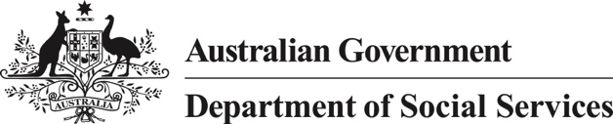

**Aboriginal and Torres Strait Islander Workforce Action Plan**

#### Explanation of the artwork

The painting on the cover is named Punhi Tharli or Many Tongues, and is about communication, information and knowledge sharing.

The wavy white lines with black dots are traditional travelling lines and the black dots represent traditional water holes you would visit on your journey. These lines connect traditional Indigenous groups. Traditional Indigenous groups are represented by the black U shapes with white dots.

The coloured circles represent the department’s offices and providers. Several offices have tradition owners working within the groups, so some traditional groups are connected with a wavy line, those are representative of the tradition kin working for department or the department’s provider.

The traditional groups (the black U shapes with white dots sitting around the campfire) include one group represented with a shield and a spear — this is men’s business, and another representing women with children in their laps. There are also outlying groups, represented by a medium sized black dot surrounded by smaller coloured dots. This represents a collective of groups coming together for discussion.

The white dots between all groups represent new pathways. These are many and varied.

Artist known as Creed

Creative Commons logo.

© Commonwealth of Australia 2021

Copyright notice — 2021

This document, Department of Social Services Workforce Strategy 2021–25 is licensed under the Creative Commons Attribution 4.0 International Licence

Licence URL: https://creativecommons.org/licenses/by/4.0/legalcode

Please attribute: © Commonwealth of Australia (Department of Social Services) 2021

#### Notice:

1. If you create a derivative of this document, the Department of Social Services requests the following notice be placed on your derivative: Based on Commonwealth of Australia (Department of Social Services) data.

2. Inquiries regarding this licence or any other use of this document are welcome.

Please contact: Branch Manager, Communication Services Branch, Department of Social Services.

Phone: 1300 653 227. Email: communications@dss.gov.au

#### **Notice** identifying other material or rights in this publication:

1. Australian Commonwealth Coat of Arms — not Licensed under Creative Commons, see https://pmc.gov.au/resource-centre/government/commonwealth-coat-arms-information-and-guidelines

2. Certain images and photographs (as marked) — not licensed under Creative Commons

#### Acknowledgment of Country

The Department of Social Services acknowledges the traditional custodians and owners of the land on which we meet and work throughout Australia. We extend our acknowledgment to their Elders past, present and emerging and we pay our respects to their continuing connection to culture, land, waters and community.

Table of Contents

Aboriginal and Torres Strait Islander Workforce Action Plan 1

A message from our Indigenous Champion 5

Introduction 6

Strategic alignment 7

Departmental workforce snapshot 8

Our commitment 10

Our priority goals 10

What this looks like in practice 11

Our current actions 12

New actions 13

## A message from our Indigenous Champion

Our Aboriginal and Torres Strait Islander employees make an important contribution to our department and Australian society. The Aboriginal and Torres Strait Islander Workforce Action Plan (action plan) is a practical act that contributes to reconciliation and ensures a culturally supportive and respectful workplace, where Aboriginal and Torres Strait Islander staff can thrive and enrich the policies and programs delivered by the department.

This action plan has been developed to build on the work we do as an organisation to recruit, retain and support Aboriginal and Torres Strait Islander staff to reach their full potential.

This action plan aligns with the Commonwealth Aboriginal and Torres Strait Islander Workforce Strategy 2020–24, the department’s Workforce Strategy 2019–22 and the department’s Reconciliation Action Plan 2021–24, to strengthen our organisation’s understanding of the histories, cultures, knowledge systems and languages of Aboriginal and Torres Strait Islander peoples.

I am pleased that we have 5.7 per cent employee representation of Aboriginal and Torres Strait Islander staff within the department. This is well above representation across the Australian Public Service (3.4 per cent) and broader Australian society (3.3 per cent).

I am proud to serve as Indigenous Champion and I am committed to support Aboriginal and Torres Strait Islander staff, to ensure we offer fair opportunities and a culturally safe workplace. I encourage all staff to take the time to read this action plan and consider your role within it. Through our individual work, and together, we can ensure a culturally responsive and respectful workplace for all staff.

**Adrian Hudson**

Chief Operating Officer and Indigenous Champion

July 2021

## Introduction

The department has established strong relationships with Indigenous communities in metropolitan, regional and remote Australia to better understand the needs, priorities and goals of Aboriginal and Torres Strait Islander peoples and their communities. The department acknowledges and values the significant contribution that Aboriginal and Torres Strait Islander staff make to the public sector and to the delivery of outcomes for citizens and society more broadly.

Increasing employment outcomes for Aboriginal and Torres Strait Islander people is a high priority, and forms the basis of the department’s Aboriginal and Torres Strait Islander Workforce Action Plan (plan).

The success of the plan is dependent on the following key elements.

* Strong commitment and leadership at senior levels
* Aboriginal and Torres Strait Islander employee consultation mechanisms
* Achieving Reconciliation Action Plan commitments
* Commitment and cultural competence of managers
* All staff demonstrating a commitment to a culturally safe workplace
* Embedded workplace inclusion practices
* Alignment with agency priorities.

“I am a strong Yanyuwa woman. For me, the Aboriginal and Torres Strait Islander Staff Action Plan will offer opportunities to expand my existing skills through further training and development. The plan will focus on reconciliation and embracing cultural diversity and value all staff to perform at their best. The delivery of high quality services and improvements in the social and wellbeing of Aboriginal and Torres Strait Islander peoples and staff can be met by working together and sharing experiences and knowledge”.

Leann Bonner   
Community Grants Hub, South Australia

“For me, as an Aboriginal public servant the Aboriginal and Torres Strait Islander Workforce Strategy plays an important part of the department’s commitment to Aboriginal and Torres Strait Islander employees. It clearly commits to improving the recruitment and retention of Aboriginal and Torres Strait Islander staff, which will create a diverse, thriving workforce that will enhance service delivery. Likewise, committing to greater Aboriginal and Torres Strait Islander recruitment through affirmative measures, identified positions, and entry level programs and initiatives is key”.

Nikki Gallagher   
Community Grants Hub, Queensland

## Strategic alignment

The action plan was developed through a comprehensive process of consultation with Senior Executive Service (SES) and Aboriginal and Torres Strait Islander staff, and was endorsed by the department’s Aboriginal and Torres Strait Islander Staff National Committee.

The action plan deliverables are aligned to the department’s Reconciliation Action Plan 2021–2024, the Commonwealth Aboriginal and Torres Strait Islander Workforce Strategy 2020–2024 and the department’s Workforce Strategy 2019–2022.

Figure 1: Alignment of APS and Departmental Plans and Strategies

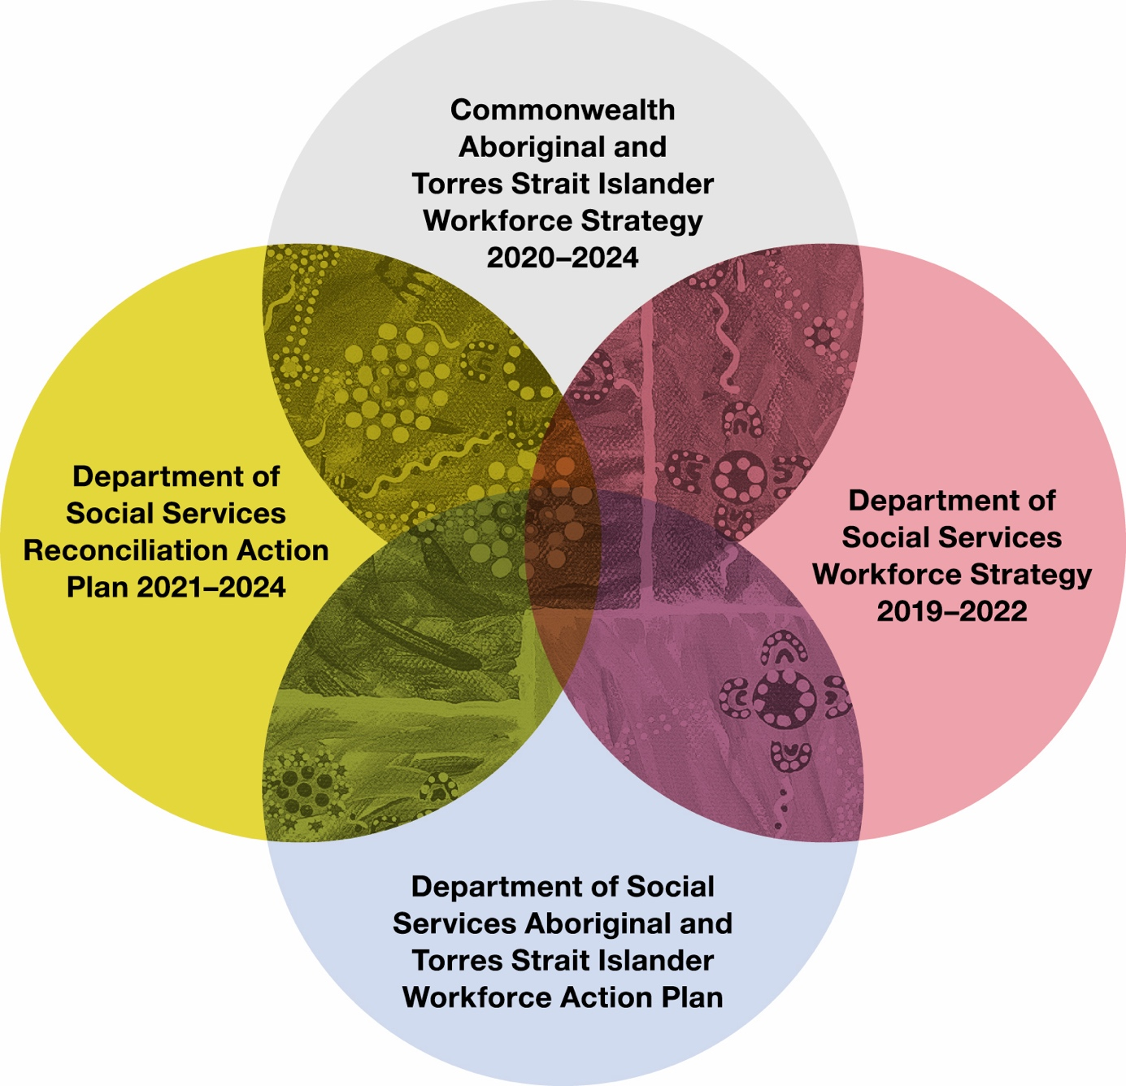

## Departmental workforce snapshot

Sources: 2020 APS Employee Census, 2021 Aboriginal and Torres Strait Islander Staff Survey, 2016 Australian Census, APSED Database 31 Dec 2020, DSS HRM System 31 Dec 2020 & 31 Mar 2021

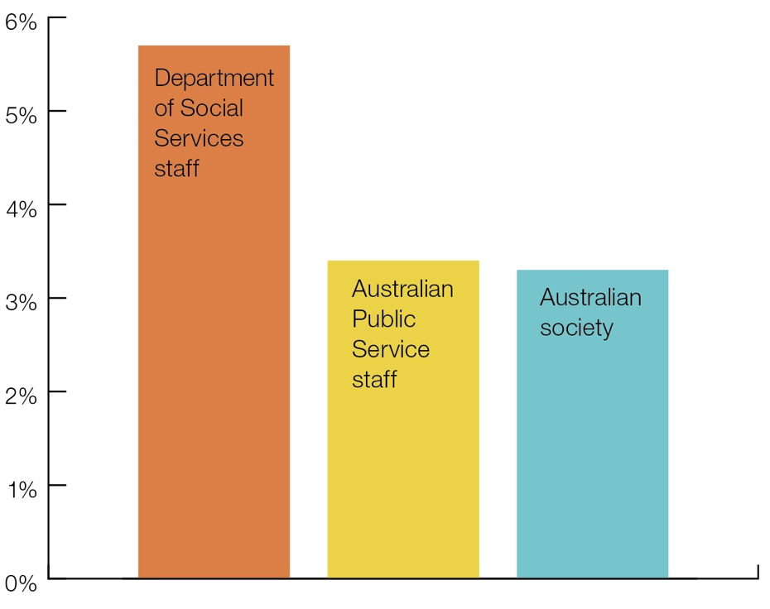

Approximately 5.7 per cent of departmental staff identify as Aboriginal and/or Torres Strait Islander, a significantly higher number than the comparable results across the APS (3.4 per cent), and the number of Australians that identify as Indigenous (3.3 per cent)

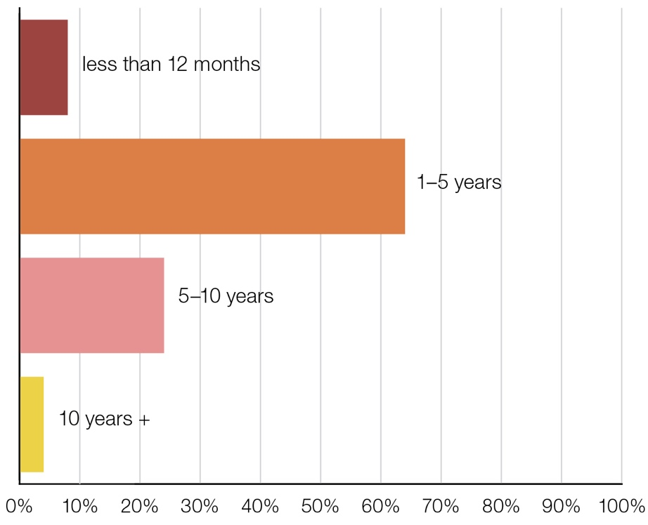

The majority of the Aboriginal and Torres Strait Islander workforce have worked in the department for 1–5 years

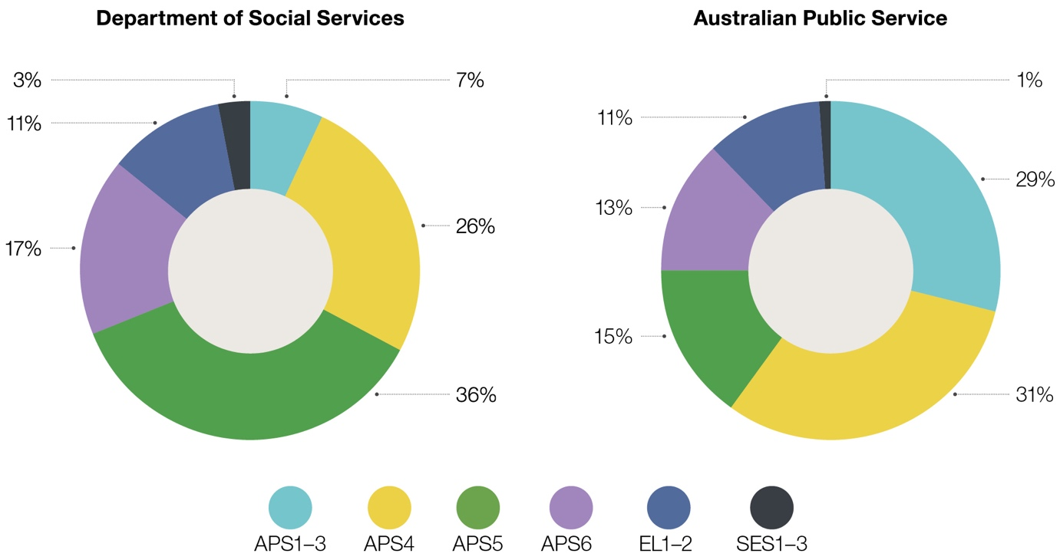

The majority of the Aboriginal and Torres Strait Islander workforce are employed at the APS5 level.

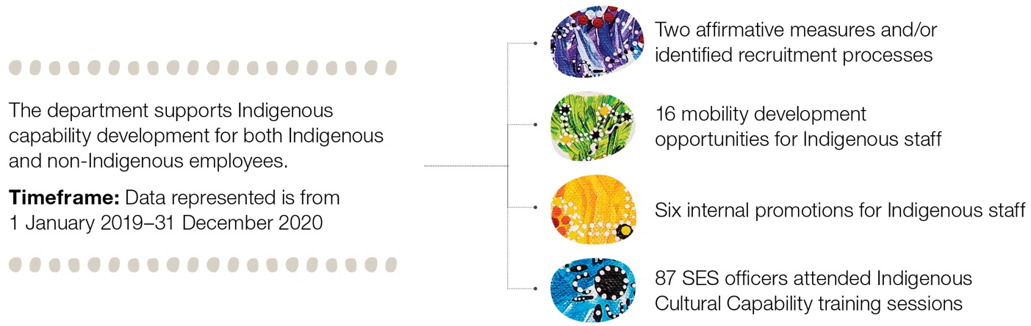

A great example of the way our jobs make a difference to Indigenous communities is through the delivery of services by the South Coast Women’s Health and Welfare Aboriginal Corporation. This organisation provides Indigenous primary health care, children and parents support services, and several other targeted programs to assist the community. The department’s Funding Arrangement Managers (FAMs) are actively involved in monitoring the organisation to improve the outcomes for clients and the community. FAMs who work on these grants find it rewarding as they are able to see the outcomes for individual clients and the overall community, through regular reporting from the organisation, and through site visits to understand first-hand the work that is being undertaken.

**NSW-ACT State Office**

## Our commitment

The department is committed to creating a workplace that serves to attract and retain Aboriginal and Torres Strait Islander peoples by providing a culturally-safe work environment that:

* includes representation of Aboriginal and Torres Strait Islander staff
* provides rewarding career pathways for Aboriginal and Torres Strait Islander staff
* establishes the department as an employer of choice for Aboriginal and Torres Strait Islander peoples
* embraces cultural diversity.

## Our priority goals

### Cultural integrity

Improve and embed the understanding of Aboriginal and Torres Strait Islander culture to support the development of culturally-safe work places and practices.

### Strengthen career pathways

Diversify and strengthen career pathways for Aboriginal and Torres Strait Islander staff. Put in place career development and advancement initiatives and opportunities.

### Inclusive leadership and voice

Be purposeful in cultivating a diverse workforce and encourage and engage with different and unique perspectives and ideas.

“I commenced in the Department of Social Services in July 2015, through the Indigenous Apprenticeship Program (IAP).

I started working in Information Technology (IT) as an APS 3. I was responsible for the set-up and relocation of IT equipment throughout the department. I completed my Diploma of Government during this time and graduated the IAP in 2016. Following a few years in IT, I moved to the Cashless Welfare Branch as an operator on the Cashless Debit Card Hotline. This role helped me connect to community outside of Canberra for the first time, and opened my eyes to issues our people face on a daily basis. I transitioned from working as an operator on the hotline, to being the supervisor — overseeing a call centre of over 10 people at the age of 20. I was in this role for over a year until I was provided with an opportunity to join a taskforce within the Redress Group as an APS 6. Following this, I took an opportunity to come back to the Cashless Welfare Branch and re-commence engagement work.

I am currently working as an APS 6 Engagement Officer in the NT and Cape York Engagement and Transition team. I engage directly with community to create awareness of the option Income Management participants have to transition from the BasicsCard to the Cashless Debit Card. I will be travelling throughout the Northern Territory over the coming months to facilitate community information sessions. Working in the Cashless Welfare Branch has provided me with valuable insights to life outside of Canberra, particularly in rural and remote communities, and has also helped me to explore my own cultural journey.”

**Damon Knight**  
Cashless Welfare Engagement and Support Services, ACT

## What this looks like in practice

A continued shift in mindsets and behaviours will be key to making sustained progress.

Culturally safe workplaces contribute to positive working experiences that underpin the recruitment and retention of Aboriginal and Torres Strait Islander peoples.

At the same time, value is achieved through embracing diverse perspectives to build a workforce that is capable of responding to the department’s priorities and the needs of the Australian community.

Figure 2: Meeting The Challenge (Source, Commonwealth Aboriginal and Torres Strait Islander Workforce Strategy 2020–2024)

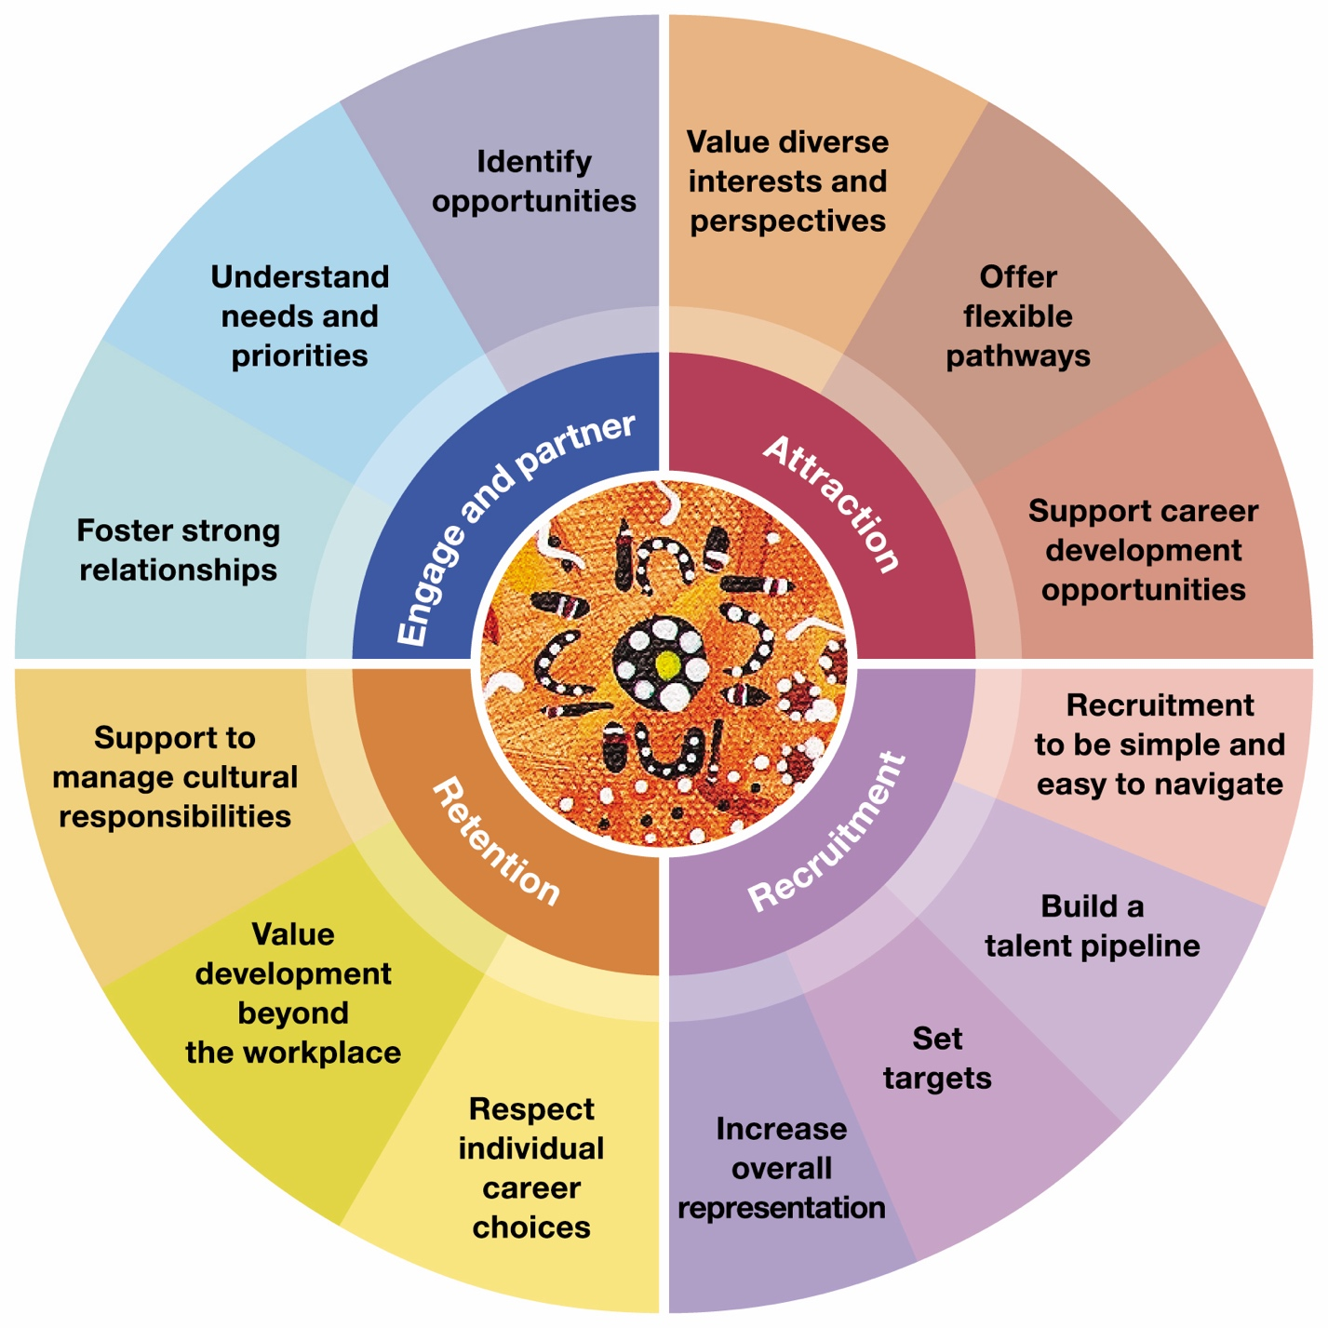

## Our current actions

The department supports its Aboriginal and Torres Strait Islander staff in many ways, including:

* A Senior Executive Service Indigenous Champion
* Senior Executive Service Advisors
* Aboriginal and Torres Strait Islander staff National Committee
* Reconciliation Action Plan 2021–2024
* Indigenous Cultural Awareness Training
* Indigenous Capability Development Team
* Indigenous Liaison Officer
* Indigenous Apprenticeship Program
* Indigenous interns
* Aboriginal and Torres Strait Islander Staff National Conference
* Jawun secondments
* Attendance at Garma
* Annual NAIDOC Awards
* Pat Turner Scholarships
* Indigenous Policy Roundtables

“I’ve had a diverse and rewarding career in the APS, from a Contract Management trainee to a Facilities Manager, Communications Officer, a graduate, and ICT Business Analyst. The range of positions that I have held has given me a transferable skillset, which is useful in a wide selection of jobs, including my current role as the Indigenous Liaison Officer for DSS.

My role is diverse and priorities can change at a moment’s notice. In the course of my day, I could be assisting Aboriginal and/or Torres Strait Islander staff in a variety of matters both professionally and personally, providing feedback to teams by casting an Indigenous lens over a program or talking to staff about Aboriginal and Torres Strait Islander history pre and post colonisation.”

**Jim Abednego**Indigenous Liaison Officer

“I currently work in the Mental Health Policy and Interface Section in the Participant Outcomes Branch. I have varied responsibilities, from coordinating responses to COVID-19 and Royal Commissions, to working with colleagues at the National Disability Insurance Scheme, to managing procurements for the department. My work helps to drive good policy development that enables greater social and economic engagement for people with psychosocial disability.”

**Elysha Zitha**  
Participant Outcomes Branch, ACT

## New actions

To deliver on our commitment to creating a workplace that serves to attract and retain Aboriginal and Torres Strait Islander peoples, the department will further invest in the following areas over the next 12 months:

| Cultural integrity |  |  |
| --- | --- | --- |
| Promote and support Aboriginal and Torres Strait Islander staff to nominate as Harassment Contact Officers. | People Services Branch | July 2021 |
| Publish protocols on STAFFnet for welcome to, and acknowledgment of country. | Communication Services Branch | July 2021 |
| Review recruitment policy and processes to strengthen requirements for Indigenous Affirmative Measures processes. | People Services Branch | June 2022 |
| Explore opportunities to share good news stories that promote Aboriginal and Torres Strait Islander staff achievements. | Communication Services Branch | Ongoing |
| Establish Yarning Circles to support Aboriginal and Torres Strait Islander staff in their own cultural journey. | People Services Branch | Ongoing |
| Strengthen career pathway |  |  |
| Deliver informal career development masterclasses with guest speakers to discuss matters such as career progression ideas, job applications and interview techniques. | People Services Branch | September 2021 |
| Establish mentoring opportunities for Aboriginal and Torres Strait Islander staff. | People Services Branch | March 2022 |
| Support at least 10 Aboriginal and Torres Strait Islander APS staff to undertake formal leadership development (e.g. through the Australian Public Service Commission or the Australian Indigenous Leadership Centre). | People Services Branch | Ongoing |
| Support Aboriginal and Torres Strait Islander staff to connect with their culture through short-term mobility opportunities in state and territory office. | People Services Branch | Ongoing |
| Inclusive leadership and voice |  |  |
| Create a Portfolio Indigenous Liaison Officer Network. | People Services Branch | November 2021 |

Funding Arrangement Managers who work on these grants find it rewarding as they are able to see the outcomes for individual clients and the overall community...

Working... has provided me with valuable insights to life outside of Canberra, particularly in rural and remote communities, and has also helped me to explore my own cultural journey.