Strengthening the social security safety net

Budget 2021-22

The Australian Government is investing more than $9 billion to strengthen the social security safety net to ensure support is there for those who need it most.
What was announced in the Budget 2021-22?
The Australian Government is improving the Pension Loans Scheme to increase its flexibility and make it more attractive to senior Australians. The Government is delivering on a legislated package of measures that permanently increases base rates of working age payments and income free areas. We are also providing additional funding to up to 10 projects through the Try, Test and Learn Fund to support people at risk of long-term welfare dependence into work.

Increasing the Flexibility of the Pension Loans Scheme
The Australian Government is further improving the Pension Loans Scheme to increase its flexibility and make it more attractive to senior Australians.

These reforms build on the measure announced in Budget 2020-21 where
$9.6 million was committed to improve digital service delivery for the Pension Loans Scheme, making it easier for senior Australians to access.

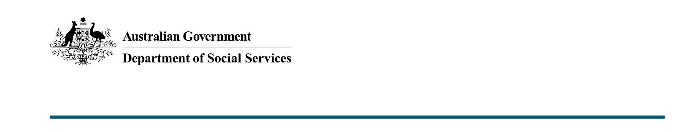
Measure
From 1 July 2022, pending the passage of legislation, Pension Loans Scheme recipients will benefit from:
- a No Negative Equity Guarantee, which means recipients will never owe more than the value of the equity in the secured property, and
- access to capped advance payments.

Recipients will be able to access up to two lump sum advances in any 12-month period, up to a total value of 50 per cent of the maximum annual rate of Age Pension.

Based on current Age Pension rates, a single person would be able to receive lump sum payments of up to around $12,385 per year, while couples combined could receive up to around $18,670.

The total amount of pension plus loan available will still be capped at 150 per cent of the maximum rate of Age Pension, so any advance taken will reduce the maximum fortnightly loan amount a person can take over the rest of the year.

The Australian Government will also be raising awareness of the Pension Loans Scheme and how it can benefit senior Australians in their retirement.

Key facts
- The Pension Loans Scheme supports higher financial independence and quality of life by enabling senior Australians to generate additional retirement income through accessing the equity in their home.

- The Retirement Income Review highlighted that drawing on a small portion of home equity can substantially improve the retirement outcomes of senior Australians.

Increased support for unemployed Australians
The Australian Government has legislated a package of measures that permanently increases base rates of working age payments and income free areas.

These measures guarantee future arrangements for Australians to rely on should they find themselves out of work.

Measure
From 1 April 2021 the base rate of working age payments increased by $50 per fortnight, and the income free area for some working age payments increased to $150 per fortnight.

The rate increase applied to recipients of:
- JobSeeker Payment
- Parenting Payment
- Youth Allowance (including Youth Disability Support Pension)
- Austudy
- ABSTUDY (Living Allowance)
- Special Benefit
- Partner Allowance
- Widow Allowance
- Farm Household Allowance
- Department of Veterans’ Affairs Education Scheme, and
- New Enterprise Incentive Scheme.

The increase in the income free area applied to recipients of:
- JobSeeker Payment
- Parenting Payment
- Youth Allowance (Other)
- Partner Allowance
- Widow Allowance

In addition, individuals who are required to quarantine, self isolate, or care for someone as a result of COVID-19 and do not have access to paid leave can continue to access income support.

Key facts
- These measures started on 1 April 2021.
- Approximately 1.9 million working age payment recipients are already benefitting from these measures.
- This is the biggest year on year increase to the rate of unemployment benefits since 1986.
- These measures were timed with the cessation of the Coronavirus Supplement, which was a temporary, emergency response that came into place when the labour market effectively closed overnight with the onset of the Coronavirus pandemic.

Transition Funding for Successful Try, Test and Learn Projects
More than $12 million will be provided over two years from 2021-22 to support up to 10 projects through the Try, Test and Learn Fund that have demonstrated promise in supporting key groups of people at risk of long-term welfare dependence into work. This new funding will be in the form of one-off, time-limited grants.

Apply a Consistent Four-Year Newly Arrived Resident's Waiting Period across Payments
The Australian Government is increasing the Newly Arrived Resident’s Waiting Period (NARWP) for carer and family payments to four years for migrants granted a permanent or relevant temporary visa on or after 1 January 2022.

The changes will not apply to migrants who are granted a permanent residency or a relevant temporary visa prior to 1 January 2022.

This change ensures consistent expectations for migrants across most welfare payments, and creates a clearer and easier to understand system.

This measure will bring the NARWP for Carer Payment, Carer Allowance, Family Tax Benefit Part A and B, Parental Leave Pay and Dad and Partner Pay in to line with the four year waiting period which is currently applied to JobSeeker Payment, Youth Allowance, Austudy, Parenting Payment and other working age payments and concession cards.

Importantly, this change further encourages self-sufficiency for newly arrived residents, and improves the sustainability of our welfare system.

This measure will improve the future sustainability of our welfare system and provides savings of $671.7 million over five years from 2020-21 to 2024-25.

More information
For more information about this measure and other Department of Social Services’ Budget measures, visit the Department of Social Services website (dss.gov.au).
For information about the Budget 2021-22, visit the Australian Government budget website (budget.gov.au).

