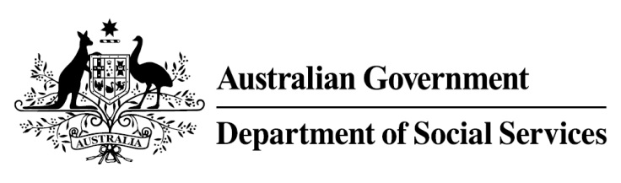

Try, Test and Learn Fund

Initiative: Multicultural Enterprise Development Project

Location: North and South metropolitan Perth

Fast facts
Priority group: Migrants and refugees
Participant numbers: 84
Locations: North and South metropolitan Perth, Western Australia
Trial period: 15 months
Total funding: $1.06 million
Service provider: Metropolitan Migrant Resource Centre
Potential future saving:
If 10 per cent of participants move off income support because of this project, the savings to the welfare system are likely to outweigh the costs of the project.

What are we trying to achieve?

This project aims to improve the employment outcomes of migrants and refugees by supporting them to build skills and confidence and providing them with work experience; and by supporting participants who want to start their own business through access to a culturally customised self-employment program.

What is Multicultural Enterprise Development Project?

The Multicultural Enterprise Development Project will help migrants and refugees through two streams of culturally-customised training and individualised support:
- Stream one participants will receive business training, coaching, and direct support, if needed, for example, counselling or crèche services. Practical English language skills will be embedded in all project activities. Participants will gain business skills and work experience in a social enterprise setting.

Stream two participants will undertake a culturally-customised version of the Australian Government’s New Business Assistance with NEIS to help participants start their own businesses. Participants will have access to training materials in community languages, culturally-appropriate business mentoring and individualised support.
What does the evidence tell us?
While many migrants and refugees successfully gain employment within the first few years of arrival, a small group continue to struggle and this group is at elevated risk of long-term welfare dependence.
On average, migrants and refugees who currently receive income support are likely to be on income support in 30 years over their lifetime. If nothing changes, 56 per cent of this group will be receiving income support payments in 10 years, and 52 per cent will be receiving income support payments in 20 years.
How is this initiative new and innovative?
This project is innovative because it builds on the existing skills and interests of participants, identifying the most appropriate approach to help them become job ready through different business pathways.
It will trial if providing migrants and refugees with culturally-customised business training, individualised support and practical English language skills will reduce barriers to employment.
Using insights from the Priority Investment Approach, the $96.1 million Try, Test and Learn Fund is gathering evidence on new or innovative approaches to addressing barriers to work.

The Try, Test and Learn Fund will help achieve the objectives of welfare reform—that is, to develop a modern welfare system that increases the capacity of individuals, reduces the risk of welfare dependency and maintains a strong welfare safety net.

