Increased Support for Forced Marriage Victims

Forcing anybody to get married is a serious crime in Australia
Victims of forced marriage can now access up to 200 days of holistic support through the Government’s Support for Trafficked People Program (Support Program) without having to participate in a criminal justice process.
The requirement to participate in a criminal justice process against perpetrators in order to access the Support Program has been applied to forced marriage victims since 2013 when the Government criminalised this offence in the Commonwealth Criminal Code.
However, forced marriage victims are often young women and girls with complex needs who may be reluctant to take part in an investigation or prosecution against those who are forcing them to marry – usually parents, relatives or community members.
In order to provide additional support to this highly vulnerable group, in February 2018, the Government announced a new 12 month trial under the Support Program to allow victims of forced marriage to access assistance, for an extended period of time without having to participate in the criminal justice process.
There is no need to contribute to a criminal investigation or prosecution to access this support

Support for Trafficked People Program: Model for Forced Marriage Stream Trial

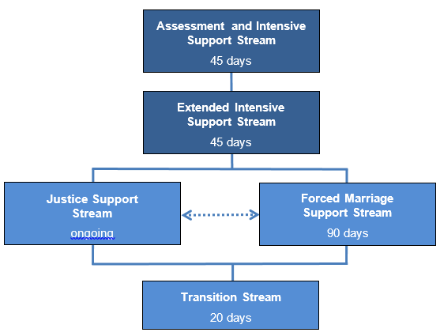

Forced marriage victims will receive up to 200 days of intensive support
The Support Program provides assistance to all eligible victims of human trafficking, slavery and slavery-like practices, including forced marriage victims. It aims to assist victims in meeting their safety, security, health and well-being needs, and develop options for life after they leave the Support Program.
The Government is currently trialling the Forced Marriage Support Stream as part of the Support Program. This will provide intensive and longer-term support of up to 200 days to people who are in, or at risk of, forced marriage.
All forced marriage clients will have access to the Assessment and Intensive Support Stream and the Extended Intensive Support Stream before deciding whether they wish to participate in the Justice Support Stream or the Forced Marriage Support Stream. All clients will continue to have access to the Transition Stream prior to exiting the Support Program.
Participation in the Support Program is voluntary and a client may choose to leave at any stage.
The Australian Red Cross is the national service provider for the Support Program and will deliver support for forced marriage clients who participate in the new Forced Marriage Support Stream.

Eligibility and Referral
To access the Forced Marriage Stream, the potential client must be:
- Assessed by the Australian Federal Police as being reasonably suspected to be in, or at risk, of a forced marriage;
- an Australian citizen, permanent resident, or have a visa status that allows them to stay in Australia;
- not willing to participate in a criminal investigation; and
- agree to receive further support.
To access this support, a person must be referred to the Support Program by the Australian Federal Police
There will be no changes to the Support Program referral process through the Australian Federal Police or the Human Trafficking Visa Framework as part of this trial.

Is someone you know at risk?
If you or someone you know is in or at risk of forced marriage contact the AFP on 131 237 (131AFP).
If someone is at immediate risk and for urgent assistance call 000.
The AFP can provide initial advice and refer victims of forced marriage or human trafficking for support, including accommodation, financial support, counselling and legal and immigration advice.
For more information, follow the link to the AFP website www.afp.gov.au.
My Blue Sky
For support and free confidential legal advice, contact My Blue Sky, Australia’s national forced marriage service by calling (02) 9514 8115, texting +61 481 070 844 or emailing help@mybluesky.org.au.
For more information on forced marriage, visit the My Blue Sky website at www.mybluesky.org.au.

For more information about Government’s response to Forced Marriage
Follow the link to the Department of Social Service’s website at www.dss.gov.au for information on the Support for Trafficked People Program.
Follow the link to the Department of Home Affairs’ website at www.homeaffairs.gov.au for information on human trafficking including forced marriage.

