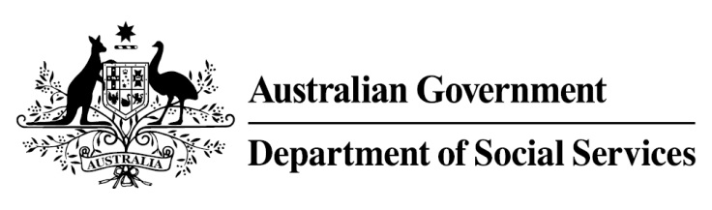

Try, Test and Learn Fund

  - Support for VET students
Using insights from the Priority Investment Approach, the $96.1 million Try, Test and Learn Fund will deliver evidence-based policies that improve peoples’ lives.
The Try, Test and Learn Fund will help achieve the objectives of welfare reform—that is, to develop a modern welfare system that increases the capacity of individuals, reduces the risk of welfare dependency and maintains a strong welfare safety net.

What does the evidence tell us?

Fast facts
Priority group: Young students
Recipient numbers: 400
Locations: Adelaide, Brisbane, and regional Queensland and New South Wales
Trial period: 15 months
Total funding: $1.75 million
Co-designers: Mission Australia, Youth Insearch, MAX Solutions, The Social Deck, and Marist180
Service provider: Mission Australia (subcontracting Youth Insearch Foundation, MAX Solutions and Marist Youth Care)
Potential future saving: The purpose of these initiatives is to test whether an intervention works to reduce long-term reliance on welfare. It is not possible to predict success rates in advance—this is the purpose of testing new approaches. If 15 per cent of participants (60) move off welfare, the savings to the welfare system are likely to outweigh the costs
- 22 per cent of all current 17-19 year olds receiving student payments are expected to be on income support in 10 years.
- From 2003 to 2012, there were 7,160 vocational or university students who started receiving a student payment aged 17 to 19; then experienced more than 12 months on unemployment payments; and were receiving unemployment payments in 2015-16. On average, all of these former young students who transitioned directly to unemployment payments are expected to receive income support in 33 years of their future lifetimes.
- If nothing changes for these former young students, 39 per cent will be receiving income support payments in 10 years, and 30 per cent will be receiving income support payments in 20 years.

What is Support for VET students?
A caseworker will work with students one-on-one and link them to appropriate support services that range from low-intensity to high-intensity, such as support to improve mental health, or to increase motivation to continue studying.
The support will be tailored to the student depending on the level of need.

What are we trying to achieve?
Increase participants’ engagement with, attendance at, and completion of their studies.
This will improve wellbeing, increase the rate of transition to employment, and reduce reliance on unemployment payments.

How is this initiative new and innovative?
This trial will provide important evidence about the effectiveness of providing individualised support to at-risk Vocational Education and Training (VET) students.

How will this initiative be evaluated?
This initiative will be tracked using a range of evaluation methods, such as surveys, participant interviews and actuarial analysis.

