An evaluation of the
Young Carer Bursary Program
Final Report

February 2017

Prepared by Inside Policy for the Australian Government Department of Social Services

Disclaimer
This report has been prepared by Inside Policy Pty Ltd on behalf of the Australian Government Department of Social Services (“the Department”) for the sole use of the Department and for the purposes for which it was commissioned. The contents of this paper do not reflect the views of the Department.
Intellectual property
Inside Policy grants the Department a fee free, non-exclusive, irrevocable, world-wide licence to exercise the intellectual property rights in relation to this report. The licence granted to the Department includes a right to sub-licence those rights, including to the public under an open access licence.
Inside Policy warrants that it is entitled to grant this licence; and that the provision of this report and its use by the Department will not infringe any third party’s intellectual property rights.
Third party reliance
The information, statements, statistics and commentary contained in this report (collectively, the “Information”) have been prepared by Inside Policy based on material publicly available, financial and other information provided by the Department, discussions held with the Department, Carers Australia, members of the independent assessment panel, bursary recipients and their support workers, and otherwise from sources indicated within this report. Inside Policy has not sought to independently verify those sources unless otherwise noted within this report. Inside Policy does not give any guarantee, undertaking or warranty in relation to the accuracy, reliability or completeness of the Information contained in this report, the assumptions made by the parties that provided the Information or any conclusions reached by those parties. Inside Policy does not accept or assume any liability arising from any actions taken in response to this report (including investment or strategic decisions made as a consequence of the Information contained in the report).
Any economic estimates in this report of the impacts of possible events hold all other factors constant and rely on economic parameters that are subject to unavoidable statistical variation. Any economic projections or forecasts in this report rely on economic inputs and parameters that are subject to unavoidable statistical variation. While all care has been taken to ensure that statistical variation is kept to a minimum, care should be taken whenever using this information. Any estimates, projections or forecasts will only take into account Information available to Inside Policy up to the date of the report and so findings may be affected by new information. Events may have occurred since Inside Policy prepared this report, which may impact on it and its findings.
Inside Policy does not accept or assume responsibility for any reliance that may be placed on this report by any third party. Any reliance placed is that party’s sole responsibility.

Table of Contents
Disclaimer 2
EXECUTIVE SUMMARY 4
Evaluation approach 4
Key findings 6
Implications: opportunities for improvement 7
Introduction 8
Purpose of this report 8
Structure of this report 8
Background 9
The Young Carer Bursary Program 9
Young carers and their needs 10
The YCBP program logic 10
Evaluation Methodology 15
Purpose of the evaluation 15
Evaluation questions 15
Evaluation methods 16
Data limitations 20
Findings 22
The program’s achievements 22
Underlying assumptions and opportunities for improvement 23
What is the need for the YCBP? 24
To what extent is the YCBP reaching the desired cohort of young carers? 27
How effective are the advertising, application and assessment processes in selecting the desired cohort of young carers? 30
How appropriate is the $3,000 bursary in assisting recipients? 38
To what extent did the young carer bursary help recipients achieve educational, caring, financial and social connection outcomes? 42
How cost-effective is the YCBP? 50
Implications 54
Appendix A: Interview guides 56
Recipient Interview Guide 56
Support Person Interview Guide 56
Carers Australia Interview Guide 56
Independent Assessment Panel Member Interview Guide 57
Appendix B: Interview participants 58
Appendix C: YCBP administration and bursary cost 59

EXECUTIVE SUMMARY
This report documents the findings of the Young Carer Bursary Program (YCBP) evaluation and their implications. It is intended that this report will aid the identification of positive outcomes achieved by the YCBP as well as any opportunities for improvement.
Arising from a 2013 federal election commitment, and developed in 2014, the YCBP was designed to assist young carers aged 25 years and under to continue to study and to relieve the financial pressure for them to undertake part-time work in addition to their educational and caring responsibilities. The YCBP aims to achieve this by awarding a specified number of financial bursaries to young carers determined to be most in need.
Carers Australia is funded by the Department to administer the approximate total $3.45 million YCBP grant pool (over three calendar years 2015–2017). Bursaries are awarded based on an annual selection process overseen by an Independent Assessment Panel. A summary of the bursaries available for each calendar year of the program is as follows:
 |  | Calendar year | Number of bursaries planned | Value of each bursary | Total value of bursaries
Round 1: |  | 2015 (1)* | 50 | $10,000 | $500,000
 |  |  | 50 | $6,000 | $300,000
 |  |  | 50 | $4,000 | $200,000
 |  | 2015 (2)* | 150 | $3,000 | $450,000
 |  | Total | 300 | n.a. | $1,450,000
Round 2: |  | 2016 | 333 | $3,000 | $999,000
 |  | Total | 333 | $3,000 | $999,000
Round 3: | (still to be administered) | 2017 | 333 | $3,000 | $999,000
 |  | Total | 333 | $3,000 | $999,000
*There were two tranches of bursary awards in calendar year 2015.
Since 2015, 633 bursaries have been awarded at a total value of $2,449,000. A small number of recipients withdrew from the program, resulting in reallocation of the bursaries and a higher number of bursaries being awarded than originally planned. In 2016, a total of 344 bursaries were awarded. In 2017, 343 bursaries are expected to be awarded. Once these are awarded, the total number of bursaries awarded will be 976 at a total value of $3,450,000.

Evaluation approach
This evaluation focused on:
- Processes of the YCBP to help achieve its objectives, including:
- Need for the bursary
- The characteristics of recipients
- Processes and arrangements for establishing the YCBP
- Processes and arrangements for delivering the bursaries
- Specific examination of bursary amount, assessment criteria and verification process
- Cost-effectiveness of the YCBP including establishing the true cost of administering the YCBP.
- Short-term outcomes reflected in the original policy intent and in subsequent evolutions of the program, including:
- Focus on outputs and outcomes achieved in the short-term including number of bursaries awarded, continuation of education, reduced pressure to work part-time, continuation of caring role
- Gaining insight into the likelihood of medium-longer term outcomes and impacts such as educational attainment, feelings of reduced stress and recognition, change in support accessed, and sense of social inclusion.
To address the above, the evaluation sought to answer the following questions:
- What is the need for the YCBP?
- To what extent is the YCBP reaching the desired cohort of young carers?
- How effective are the advertising, application and assessment processes in selecting the desired cohort of young carers?
- How appropriate is the $3,000 bursary (including amount and instalments) in assisting recipients?
- To what extent did the young carer bursary:
- Help recipients continue their education?
- Help recipients continue their caring responsibilities?
- Help recipients to be socially connected?
- Reduce the pressure experienced by recipients to work part-time?
- How cost-effective is the YCBP?
The findings against the above questions inform the evaluation’s conclusions which outline the:
- program’s achievements and opportunities for improvement, and
- most appropriate delivery method for any future YCBP.
The following mix of qualitative and quantitative data collection methods were used to answer the above questions:
- Semi-structured interviews with Departmental Carer Policy Section staff, Carers Australia staff and Independent Assessment Panel members.
- Case study interviews with 12 bursary recipients and four support people.
- Analysis of Carers Australia’s bursary application data.
- Analysis of the mid-year survey data for 2015 (round one) and 2016 (round two).
- Analysis of YCBP program administration and bursary costs.
Together, both streams of research provide an in-depth evaluation of the YCBP by answering the research questions posed.

Key findings
The key findings with respect to the evaluation questions are summarised below:

1. What is the need for the YCBP?
While the specific characteristics of the national young carer population in Australia is an estimate and some characteristics (i.e. caring load, educational attainment and location) are unknown, the available ABS data coupled with the data obtained through the evaluation suggest that the YCBP is an important and much needed initiative that supports young carers by relieving financial pressure and helping them fulfil their caring responsibilities while remaining in education.

2. To what extent is the YCBP reaching the desired cohort of young carers?
Reaching a broad group of young carers has improved with each round. Though there are concerns that the most vulnerable young carers – such as those in remote locations and those that do not have the internet – continue to miss out on opportunities like YCBP.
The characteristics of the recipients (as compared to those applicants who are unsuccessful) share the characteristics of the desired cohort i.e. they have a high caring load, come from low income households and are all engaged in education.
However, when compared to the estimated national young carer population, the female recipient population is slightly under-represented. While a proportional distribution of applications across States/Territories was not a target for the YCBP, it is interesting to note that young carers from the Young Carer Bursary recipient population are more likely to be from Victoria and less likely to be from New South Wales and Queensland.

3. How effective are the advertising, application and assessment processes in selecting the desired cohort of young carers?
The advertising, application and assessment process seem to be effective in targeting the desired cohort. However, young carers suggested the process could be improved by communicating more frequently with applicants during the assessment stage. Further, Carers Australia and the Independent Assessment Panel noted the challenges in distinguishing between applications in need and in “most” need, when the majority of applications received meet the eligibility criteria and the assessment weighting criteria.

4. How appropriate is the $3,000 bursary in assisting recipients?
The bursary amount seems appropriate given recipients were able to achieve their educational and other related outcomes as a result of receiving the bursary. This seems to validate the decision to change the bursary amount from the $4,000 to $10,000 range in round one to a flat-rate of $3,000 in subsequent rounds. There were mixed views about whether a lump sum or instalments were preferred. All young carers suggested that the timing of payments could be improved.

5. To what extent did the young carer bursary help recipients achieve educational, caring, financial and social connection outcomes?
All 12 young carers interviewed reported positive improvements in education, social connection and caring responsibilities as a result of reducing the need for part-time work and by reducing the pressure they felt. Of respondents to the mid-year survey (n = 139 in 2015 and n= 338 in 2016) 97 per cent in 2015 and 99 per cent in 2016, indicated an intention to continue their education throughout the year.

6. How cost effective is the YCBP?
The administration of the program is becoming more efficient over time with an 11 per cent reduction in Administration Costs to Bursary Costs between 2015 and 2016.
The administration costs per recipient reduced from nearly $1,000 in 2015 to approximately $500 in 2016. The average bursary costs per recipient in the same years were $4,833 and $3,000 respectively.

Implications: opportunities for improvement
In order to build on the success and achievements of the program, including its cost effectiveness, and reflecting on the findings to emerge from the evaluation, the following improvements are suggested:
- enhance the advertising process to better reach those most in need
- enhance the assessment process to better identify those ‘most in need’
- make the assessment process more efficient including better communication with applicants
- improve the timing of payments to ensure recipients have funds to pay for educational items prior to study commencing
- manage the growing demand by either increasing the number of bursaries available or targeting the existing number of bursaries to a sub-set of the young carer cohort; and
- seek to better understand the longer-term outcomes and impacts of the YCBP on young carers and government.

Introduction
In 2016, the Department of Social Services (the Department) engaged Inside Policy to conduct an independent evaluation of the Young Carer Bursary Program (YCBP).
This evaluation focused on identifying the outcomes achieved by the YCBP as well as the processes to administer the YCBP, which either enabled or inhibited the achievement of these outcomes.
This evaluation did not explore the longer-term impacts of the YCBP. At the time of the evaluation, the YCBP had only been in operation for three years, or two bursary rounds. This is not a sufficient amount of time or program history to measure impacts. Measuring the impacts of the program would be more fruitful at the five-year point, if the YCBP continues.

Purpose of this report
This report documents the findings of the YCBP evaluation and their implications. It is intended that this report will help identify the outcomes achieved by the YCBP as well as the opportunities for improvement.

Structure of this report
The remainder of this report is structured accordingly:

Background: This section overviews the YCBP including its purpose and how the program is implemented.
Evaluation Method: This section details the purpose of the evaluation, the YCBP program logic, and the methodology employed to conduct the evaluation and the data limitations.
Findings: This section details the findings against the key evaluation questions.
Implications: This section outlines the implications of the evaluation findings on the success of the YCBP including opportunities for improvement and the most appropriate delivery method for the YCBP.
Appendices: Appendix A: Interview guides.
Appendix B: Interview participants (excluding YCBP recipients and their support people).
Appendix C: YCBP administration costs.

Background
This section provides important background information on the YCBP, which provides context for the YCBP and its evaluation. To this end, this section overviews the YCBP, its program logic and how it is implemented.

The Young Carer Bursary Program
Arising from a 2013 federal election commitment, and developed in 2014, the YCBP was designed to assist young carers aged 25 years and under to continue to study and to relieve the financial pressure for them to undertake part-time work in addition to their educational and caring responsibilities. The YCBP aims to achieve this by awarding a specified number of financial bursaries to young carers determined to be most in need.
Carers Australia is funded by the Department to administer the total $3 million YCBP grant pool (over three calendar years) through an annual application round.
In 2015 calendar year, 300 bursaries were funded over two separate rounds in packages of:
- 50 at $10,000,
- 50 at $6,000,
- 50 at $4,000, and
- 150 at $3,000.
The YCBP was refined following its first year in order to:
- simplify the application assessment process
- make the bursary a flat rate of $3,000 (from an original range in 2015 of $3,000 to $10,000); and
- refine eligibility.
Based on the revisions to the YCBP following its first round, 333 bursaries were subsequently made available for calendar years 2016 and 2017, while 344 were actually awarded in 2016 and 343 are expected to be awarded in 2017.
Successful applicants are not required to acquit their funds but they are encouraged to use their bursary to support their participation in education.

How each round is administered
Outlined below is a high-level sequence of events undertaken by Carers Australia to administer an annual bursary round:
- Round planning by Carers Australia: online application form confirmed, Carers Australia website updated, promotional materials developed, independent assessment panel formed.
- Pre-application promotion by Carers Australia: key contacts/networks advised via social media and email of impending applications opening.
- Applications open: key contacts/networks advised by social media and email that applications are open. Carers Australia handles enquiries from applicants.
- Applications received: Carers Australia assesses eligible applications against Weighting Criteria and applicant stories as they are received. Shortlist of eligible most in need applicants developed.
- Independent Assessment Panel assesses shortlist and makes final determination on ranked, successful applications.
- The eligibility criteria of successful applications are verified.
- Successful applicants receive confirmation letter and first payment.
- Recipients receive their second payment in April prior to the mid-year survey.
- Mid-year survey administered and the third payment is made upon completion of survey by the recipient in August.
- Final payment is made in October.
- End-of-year survey administered.
As noted above, Carers Australia is funded by the Department to manage the above processes which result in the required number of bursaries being awarded in the 2015, 2016 and 2017 calendar years.

Young carers and their needs
According to the ABS Survey of Disability, Ageing and Carers, in 2015 it was estimated that there were 272,000 young people under the age of 25 who were carers. The caring responsibilities of this group includes providing care in families where someone has a disability or long-term health conditions or persons who are elderly (i.e. aged 65 years and over).
Based on the 2015 ABS Survey, young carers comprise of all genders and come from a range of backgrounds (including those from Indigenous and culturally and linguistically diverse backgrounds) and locations (including regional and remote Australia).
For a range of reasons young carers often do not disclose their caring responsibilities until a crisis occurs. While not always the case, some young carers do experience educational difficulties related to absences from school/university, keeping up to date with their homework and assessment, and concentrating in class.
Analysis of various data sources – including the Department’s administrative data – suggests that young carers may have compromised life trajectories resulting in an ongoing dependence on income support in later life.

The YCBP program logic
The YCBP was designed to provide young carers most in need (as described above) with a small financial bursary to assist them to stay in education while reducing the need for them to participate in part-time work.
Following an analysis of key YCBP documentation (including the original policy intent stated above), interviews with the Department program management staff and Carers Australia, the following Program Logic was developed.

Fig. 1. YCBP Program Logic.
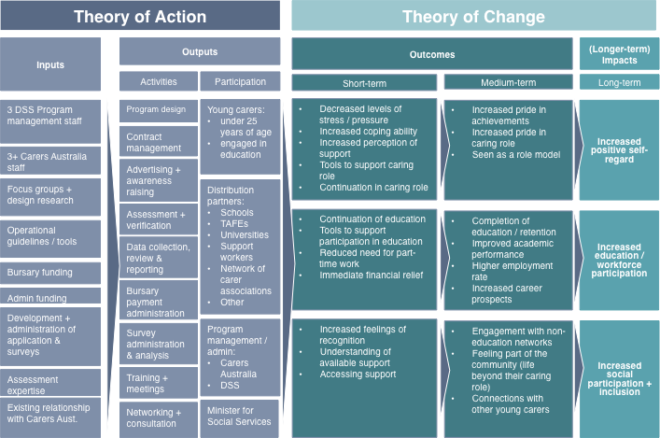

A detailed discussion of the Theory of Action and Theory of Change aspects of the Program Logic is provided below.

Theory of Action
The YCBP Theory of Action outlines the:
- program inputs – funding, time, people, knowledge, tools
- activities – what will be done to administer the program; and
- participants – who will be reached by the program and who is a stakeholder in the program.
Combined, the above form the Theory of Action, which illustrates what needs to be invested and done and who needs to be reached in order to achieve the outcomes and impacts outlined in the Theory of Change.

Theory of Change
The Theory of Change – the short, medium and long-term outcomes and impacts to be achieved by the YCBP – identifies three long-term impacts of the YCBP:
- increased positive self-regard
- increased education and workforce participation; and
- increased social participation and inclusion.
The ultimate aim of creating the above impacts is to assist young carers to have more choice and control over their lives.
In order to achieve these longer-term impacts the YCBP itself focuses on a few short-term outcomes, which will be the focus of this evaluation. These short-term outcomes relate to the stated program objective, which is to assist young carers aged 25 years and under, in the greatest need, to continue to study by relieving the pressure to undertake part-time work in addition to educational and caring responsibilities.
The interviews and document review undertaken to design the evaluation framework revealed other intended outcomes beyond the original policy parameters. These include:
- increased educational attainment
- improved workforce prospects following education
- increased confidence of young carers
- increased social inclusion and support; and
- increased sense of recognition of, and pride in, their caring role.
The outcomes and impacts related to increased confidence, increased social inclusion and increased recognition were also validated by the literature review findings (conducted as part of the design of this evaluation’s framework). For example:
- An evaluation of West Germany’s First Young Carers Project noted the importance of recognising the role that young carers play, especially where that recognition comes from the young carers family or support network.
- Evaluations of the Sheffield Young Carers Project and the Cornwall Young Carers Project found that young carers’ propensity to access support increased following receipt of the bursary.

Underlying assumptions
There are a number of underlying assumptions to the above program logic (i.e. the Theory of Action and Theory of Change combined). These are:
- young carers – due to their caring responsibilities – are more likely to work part-time and as a result are less likely to remain engaged in education
- young carers want and/or need to reduce the pressure to work part-time
- the purchaser-provider model is an effective model for administering the program
- an open application process is the most effective way of reaching young carers most in need
- the assessment weighting criteria is an effective tool for determining those most in need
- factors such as caring hours per week, household type (i.e. single parent or both parents), household income, length of time caring are the most important when assessing those in most need
- a bursary of $3,000 will be effective in achieving the short-term program outcomes.
This program evaluation tested these assumptions and sought to identify opportunities for improvement.

Evaluation Methodology
This section details the purpose of the YCBP evaluation, the questions the evaluation sought to answer, the evaluation method and the data limitations.

Purpose of the evaluation
The purpose of the evaluation of the YCBP is to assess the:
- short-term outcomes achieved by the YCBP within its original policy parameters,
- role that particular processes to operationalise the YCBP played in achieving these outcomes, and
- likelihood of achievement of the medium-term outcomes and longer-term impacts outlined in the Theory of Change.
To understand why certain outcomes have or have not been achieved the evaluation also explores the effectiveness, efficiency and appropriateness of the process of allocating and delivering the YCBP.
An assessment of the appropriateness of the policy that led to the YCBP was not within the scope of this evaluation. Also not within scope of the evaluation was an examination of the longer-term impacts the YCBP may have created or contributed to.
In summary, the evaluation focused on:
- Processes of the YCBP to help achieve its objectives, including:
- Need for the bursary.
- The characteristics of recipients.
- Processes and arrangements for establishing the YCBP.
- Processes and arrangements for delivering the bursaries.
- Specific examination of bursary amount, assessment criteria and verification process.
- Cost-effectiveness of the YCBP including establishing the true cost of administering the YCBP.
- Short-term outcomes reflected in the original policy intent and in subsequent evolutions of the program, including:
- Focus on outputs and outcomes achieved in the short-term including number of bursaries awarded, continuation of education, reduced pressure to work part-time, continuation of caring role.
- Gaining insight into the likelihood of medium and longer term outcomes and impacts such as educational attainment, feelings of reduced stress and recognition, change in support accessed, and sense of social inclusion.

Evaluation questions
To understand if the YCBP achieved its intended outcomes of assisting young carers to continue in education and reduce the pressure for them to participate in part-time work, the evaluation answers the following questions:
- What is the need for the YCBP?
- To what extent is the YCBP reaching the desired cohort of young carers?
- How effective are the advertising, application and assessment processes in selecting the desired cohort of young carers?
- How appropriate is the $3,000 bursary (including amount and instalments) in assisting recipients?
- To what extent did the young carer bursary:
  - Help recipients continue their education?
  - Help recipients continue their caring responsibilities?
  - Help recipients to be socially connected?
  - Reduce the pressure experienced by recipients to work part-time?
    - How cost-effective is the YCBP?
The findings against the above questions informed the evaluation’s conclusions which outline the:
- program’s achievements and opportunities for improvement, and
- options for the most appropriate delivery method for any future YCBP.

Evaluation methods
This evaluation was conducted using a mix of qualitative and quantitative data collection methods. These methods were:
- semi-structured interviews with staff from the Department’s Carer Policy Section
- semi-structured interviews with Carers Australia staff
- semi-structured interviews with members of the Independent Assessment Panel
- semi-structured interviews with a selection of current and past YCBP recipients
- semi-structured interviews with a selection of support people for current and past YCBP recipients
- quantitative analysis of YCBP applicant, mid-year survey and end-of-year survey data
- financial analysis of YCBP administration and bursary costs.
A detailed description of each of these methods is provided below.

Interviews with staff from the Department’s Carer Policy Section
Interviews with the Departmental YCBP staff were held to better understand the program’s administration and financial costs.

Who participated in the interview Managers and officers from the Carer Policy Section responsible for managing the YCBP and the contract with Carers Australia
Number of staff who participated
in the interview 3
Interview length: 1.5 hours
Interview tool: Refer to Appendix A
Interviewees: Refer to Appendix B

Interviews with Carers Australia staff
Interviews with Carers Australia were held to inform:
- the effectiveness of the process used to administer the YCBP,
- whether the YCBP supports those young carers most in need, and
- what outcomes have been achieved by the program.

Who participated in the interview: Managers and officers responsible for overseeing and administering the YCBP
Number of staff who participated
in the interview: 3
Interview length: 2 hours
Interview tool: Refer to Appendix A
Interviewees: Refer to Appendix B

Interviews with Independent Assessment Panel
Interviews with the independent assessment panel were held to inform:
- the effectiveness of the process used to administer the YCBP, and
- whether the YCBP supports those young carers most in need.

Who participated in the interview: The two expert panel members were interviewed separately. The young carer representative on the panel was not interviewed as both young carer representatives for each round did not participate in the full assessment process.
Number of panel members who
participated in the interviews: 2
Interview length: 45 mins
Interview tool: Refer to Appendix A
Interviewees: Refer to Appendix B

Interviews with YCBP recipients
Due to the diversity of the recipient population, it was intended that 20 recipients would be interviewed. This method was intended to provide rich qualitative data on the recipient’s experience of the program, including the impact the bursary may have had on their lives.
Unfortunately, despite significant efforts by the evaluation team in reaching out to 110 past and current recipients and providing an incentive payment for participating in the interviews, only 12 recipients followed through with the consent to be interviewed.
The interviews were semi-structured and all recipients were sent the interview questions along with a participant information and consent form prior to the interview. The parents/guardians of interviewees under 18 years of age provided consent for these recipients to participate.
All interviews were conducted by telephone.
YCBP recipients |  | Details
Profile of recipients who participated in the interviews: |  | Round: | - 1 = 4 recipients  - 2 = 6 recipients  - Both rounds = 2 recipients
 |  | Female: | 7
 |  | Male: | 5
 |  | 18 years +: | 7
 |  | Under 18 years: | 5
 |  | Location: | Qld = 3; Vic = 2; NSW = 2; NT = 1; WA = 1; SA = 2. None from Tasmania or the ACT.
 |  | Indigenous: | 2
 |  | Culturally and Linguistically Diverse (CALD): | 2
Number of recipient interviews conducted: |  | 12
Interview length: |  | 45-60 mins
Interview tool: |  | Refer to Appendix A

Interviews with YCBP recipient support workers
It was intended that each case study would be informed by an interview with the young carer’s nominated support person, where the young carer consents to their support worker being interviewed.
In the event that a young carer consented to being interviewed but did not consent to their support person being interviewed, the case study was developed without the support person’s input. The same applied to the scenario where the young carer did consent but the support person chose to not participate in the interview, or the young carer did not have a support person.
Interviews with support people were semi-structured, with interviewees being provided with an interview guide prior to the interview.

Who participated in the interview: Youth worker, guidance counsellor and 2 x teachers.
Number of recipients interviewed who
had and nominated support people: 5
Number of support people interviewed: 4
Interview length: 45 mins
Interview tool: Refer to Appendix A

Analysis of YCBP applicant and recipient data
Analysis of applicant and recipient data (via survey results) was undertaken to assess:
- the extent to which the short-term outcomes have been achieved (i.e. education participation, number of caring hours, hours of part-time work), and
- any differences in achievements of the short-term outcomes based on certain recipient variables.
Where possible, multiple regression analysis was used to explore the relationship between particular variables. For example, the relationships between the following variables were explored:
- age and continuation of education,
- location and continuation of education, and
- caring hours per week and continuation of education.

Analysis of YCBP program costs
The cost effectiveness of the YCBP was assessed by the following methods:
- comparing the true cost of the program to the total bursary cost,
- comparing the true cost of the program to the bursary cost per recipient.

Data limitations
The data collected to inform the evaluation presented a number of limitations.

Understanding the profile of the national young carer population
The publicly available ABS Survey of Disability, Ageing and Carers data does not disaggregate caring hours, postcode location and educational attainment by age. Therefore, the comparison of the YCBP recipients to the estimated national young carer population is limited to the characteristics of age, gender and state.

Limitations on the applicant and survey data
There are a number of limitations regarding the completeness of the applicant and survey data, which presented a number of challenges in analysing the change in round one recipient outcomes. In particular:
- For the round one bursary (i.e. calendar year 2015), the recipient names were not linked to the mid-year survey responses. While it was never the intention of the evaluation to identify recipients and analyse their specific responses, this meant an analysis of change in circumstances – at an aggregated recipient level – between application and mid-year survey was not possible for the round one cohort. Similarly, this significantly inhibited multiple regression analysis that could be conducted to compare any differences in outcomes achieved between the round one and round two recipient cohorts (see detailed discussion below).
- To date, data has not been collected on the circumstances of recipients following their exit from the bursary and following the completion of their studies. Therefore, examination of this is limited to the experience of the small number of past recipients who were interviewed as part of the evaluation.
- The mid-year and end-of-year surveys rely on recipients’ self-assessment of outcomes therefore these surveys do not capture any objective on educational attainment (i.e. actual grades for subjects achieved by recipients). Therefore, examination of this is limited to the experience of the small number of past recipients who were interviewed as part of the evaluation.
- This evaluation does not examine the round three applicant and mid-survey data as this round had not been activated at the time of preparing this report.

Multiple regression analysis
The evaluation explored an analysis of quantitative variables from the application and mid-year survey data by way of multiple regression analysis. The hypotheses that could be modelled using this methodology were constrained by the completeness and quality of the application and mid-year survey result data.
A particular hypothesis that could not be explored was whether the bursary amount affected caring hours, part-time work hours and educational attainment. This could not be explored as the 2015 bursary recipient names were not provided with the 2015 survey data, negating the ability to link the mid-year survey results to caring load and part-time work questions to the bursary amounts awarded in that year. Further, neither mid-year survey asks respondents to provide their educational achievement by way of score, therefore assessing any relationship between attainment and amount (or other variables) could not be determined.
Another hypothesis that could not be explored was whether recipient’s wellbeing changed following receipt of the bursary. The application asks young carers to rate their level of wellbeing on a scale of one to 10. However, the mid-year survey does not ask the same question. Therefore any change in this and the relationship of any change in wellbeing to the bursary could not be modelled.

Low participation rate by recipients and support people in the interviews
As noted in the section above, the evaluation aimed to interview 20 recipients and their nominated support person. Despite efforts to encourage participation in the interviews, only 12 recipients and four support people were interviewed. While neither group was intended to be representative of the recipient population, it was anticipated that 20 recipient interviews would capture the diversity of the recipient cohort.
Not achieving 20 interviews therefore limits the diversity of the recipient experience reflected in the perceptions and case studies reported in the findings section as a broad age, cultural and locational group of recipients were not interviewed.

Ineligible and unsuccessful applicants
The evaluation did not seek the views of ineligible (i.e. those who do not meet the eligibility criteria, did not complete and submit their application, or withdrew their application) or unsuccessful applicants. Therefore the evaluation findings are framed by those actively engaged in the program, including young carers who have received a bursary.

Findings
This section summarises the program’s main achievements and opportunities for improvement against each evaluation question.

The program’s achievements
The most potent achievements of the YCBP, for such a modest investment, include assisting recipients to:
- stay in education
- continue in their caring role
- increase their social connections; and
- reduce the daily pressure/stress they experience.
The majority of bursary recipients from both rounds (through the case study interviews and mid-year survey results) reported – as a result of the bursary:
- Staying in education, completing their studies and achieving better results in their studies
- Being more connected to their friends and family as a result of having more time and being able to afford social activities
- Reducing the stress and pressure they experienced, especially regarding finances, because they had money to cover unexpected expenses, or to pay daily bills or because they didn’t have to continue working part-time
- Feeling better able to care for their family member(s) as a result of using respite support or being able to pay for their own self-care.
The evaluation found that the above outcomes are starting to reveal potential long-term positive consequences for the program recipients. First, as a result of reducing the financial pressure and stress that the recipients faced, the bursary afforded them the ability to have more social time with friends, participate in hobbies or activities of interest and focus on things to help with their personal development. In essence, it seems the bursary enables these young carers to be young people. This includes doing all the social and personal things to develop as a teenager and into young adulthood.
Second, and related to the above, the bursary has been effective in enabling recipients to aspire to more for their futures. The majority of the 12 recipients interviewed reported the financial breathing space the bursary provided led them to more opportunities, like studying at university (n = 2) and contemplating pursuing a highly skilled or professional career (n = 8). They reported not contemplating these opportunities – or thinking these opportunities were realistic for them – prior to receiving the bursary.
Third, the receipt of the bursary has a powerful effect on increasing the young carers sense of self-worth as a result of being recognised for their caring role. All recipients reported the lack of support for young carers, and the bursary was often the first recognition that the role they have is important and acknowledged.
A longer-term study may also reveal achievement of intended impacts in self-regard, employment and better life circumstances.
Most significantly the bursary seems to be the determinant of recipients remaining in, and completing their education, where in other circumstances they would have chosen to withdraw to work full-time in order to support their family. This has implications for the longer-term welfare costs and savings to government for this group of soon to be 987 young carers who were more likely to receive long-term unemployment benefits.
The program is also effective in targeting young carers from around the country, of different ages, backgrounds and educational circumstances. The assessment process is also effective in determining, of these applicants, which are the most in need of the bursary, based on their caring responsibilities and the impact this has on their education.

Underlying assumptions and opportunities for improvement
Overall, the data from the evaluation suggests that most of the seven assumptions underlying the YCBP’s program logic may be correct, specifically:
- young carers – due to their caring responsibilities – are more likely to work part-time and as a result are less likely to remain engaged in education
The evaluation suggests this assumption may be partially correct in that young carers – due to their caring responsibilities – are less likely to remain engaged in education.
The evaluation did not find as strong a connection between working part-time and that being the reason young carers were likely to discontinue education. Rather, only a minority of recipients worked part-time. Further, the potential disengagement from education seemed to stem from the financial pressures of studying full-time and not having the capacity to work to meet these pressures.
- young carers want and/or need to reduce the pressure to work part-time
As noted above, the minority of recipients work part-time. Those interviewed that worked part time expressed a desire to work less and study more. The driver for releasing the financial pressure seems to be the desire to continue in education and reduce the need to discontinue education completely to take on full-time work.
- the purchaser-provider model is an effective model for administering the program
The evaluation suggests this assumption may be correct.
- an open application process is the most effective way of reaching young carers most in need
The evaluation suggests this assumption may be correct.
The evaluation shows that the applicant pool reflects the national young carer population, and the recipient pool are those in highest need based on the weighting criteria. However it is unknown if those young carers most in need are being reached, in particular, young carers in remote and regional locations, young carers from disconnected or isolated communities, young carers who have already disengaged from education and young carers who do not have internet access.

- the assessment weighting criteria is an effective tool for determining those most in need
While the evaluation does support this notion, it also revealed that the assessment weighting criteria also creates a large group of applications that are deemed to be eligible yet “medium” in level of need. This creates challenges for the assessors in determining who is ‘most in need’ when there are very few distinguishing features. To make this decision, assessors rely on the applicants’ stories to inform who is in most need, with the most harrowing stories being assessed as most in need. This can:
- increase the likelihood that assessments of need are subjective,
- increase the time in deciding the successful applicants,
- disadvantage applicants who are most in need but are unwilling or unable to articulate this in written form, and
- be emotionally taxing on assessors and applicants.
- factors such as caring hours per week, household type (i.e. single parent or both parents), household income, length of time caring are the most important when assessing those in most need
The evaluation revealed first that care recipient need is the most important when assessing need. However, the treatment of need by the assessment weighting criteria in 2016 seemed to be skewed towards mental health conditions. This skew results from applicants being able to choose – in the application form – multiple mental health conditions while there is only one choice for other disabilities (i.e. physical). This increases the scoring for care recipient need in addition to placing young carers who care for family members with mental health conditions in the high category. There is no justification that mental health conditions should be weighted more than other types of need. It is noted that the weighting of this criteria was readjusted in 2017.
- a bursary of $3,000 will be effective in achieving the short-term program outcomes
The evaluation suggests this assumption may be correct.
The above findings suggest an opportunity to revise the assumptions underlying the program logic and where appropriate, the program design.

What is the need for the YCBP?
This question explores whether there is a need for the YCBP and if so, what is the nature of this need. To answer this question the evaluation first examined the size, characteristics and estimates of need of the young carer population. It then examined the demand for the bursary from young carers by way of application numbers, attrition rates and perceptions of value of the bursary.

Key finding: While the specific characteristics of the young carer population is an estimate and some characteristics (i.e. caring load, educational attainment and location) are unknown, the available ABS data coupled with the data obtained through the evaluation suggest that the YCBP is an important and much needed initiative that supports young carers by relieving financial pressure and helping them fulfil their caring responsibilities while remaining in education.

Outlined below are the findings against each of the following measures:
Indicator: The level of
need for bursary support Measures:
- Characteristics and need of the Australian young carer population
- Characteristics and needs of applicants and recipients
- Perception of value by recipients, Carers Australia and support workers

Indicator: The level of need for bursary support

Characteristics and need of the Australian young carer population
To determine the level of need for the YCBP, the size and profile of the Australian young carer population was explored along with the impacts of caring responsibilities on young people and the existence of other programs to reduce the negative impacts on young carers.
The Australian Bureau of Statistics (ABS) Survey of Disability, Ageing and Carers 2015 estimates the 2015 national young carer population aged 24 years and under at 272,000.
Of the total national caring population, 1.3 per cent are less than 15 years of age while 6.8 per cent are between 15 and 24 years of age.
Of the estimated national young carer population, 39 per cent are male while 61 per cent are female.
The international literature suggests that young carers are more likely to work part-time while studying, more likely to discontinue their education and more likely to experience stress and hardship as a result of their caring responsibilities.
While there is no other identical program to the YCBP that exists within Australia, other programs have been formed in Canada, the USA and the United Kingdom. These international programs have been formed in recognition of the financial, social, developmental and educational hardship that young carers face.
The existence of the above programs suggests need for a program like the YCBP that provides financial support.

Characteristics and needs of applicants and recipients
The demand for the YCBP – by way of applications for each round – was then assessed to determine the level of need for bursary support. This assessment gives an indication of whether those in the young carer population see the need for a bursary.
As illustrated by the figure below, 800 applications were received in the first round, 917 applications were received in the second round and 1,200 in the third round. This represents a 50 per cent increase in bursary applications between rounds one and three.
Fig. 2. Bursaries available per round compared to applications received.
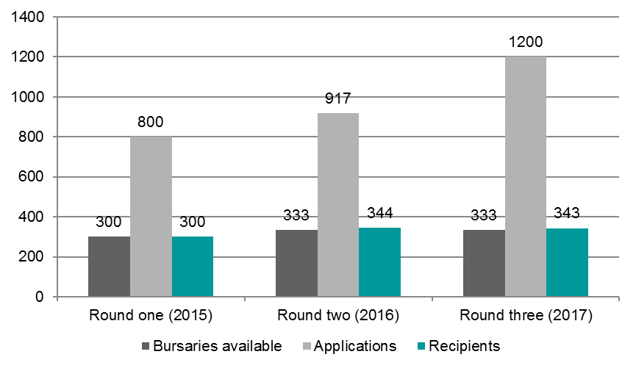
The figure above also shows that all bursary rounds received more applications than available bursaries.
Further, the majority of applications for both rounds (96 per cent for round one and 85 per cent for round two) were assessed to be eligible. “Eligible” refers to the applicant meeting the program eligibility criteria, which is defined as:
- young carer,
- aged 25 years or under,
- studying an approved course either full-time or part-time,
- not in receipt of another bursary or scholarship, and
- a permanent resident or Australian citizen.
The number of applications and eligible applications per round compared to the number of bursaries available evidence the need for the YCBP.

Perceived value of the bursary by recipients
As another measure of the need for the YCBP, bursary recipients provided their perceptions on the value of the bursary.
Recipients who participated in the case study interviews commented on the importance of the bursary in supporting young carers when very little, if any support, is available. Specific comments were:
- “There’s not enough support provided to young carers, especially assistance focussed particularly on education.” – Recipient aged 24 years, both rounds.
- “Prior to the bursary, there was no support for young carers.” – Recipient aged 21 years, round two.
- “The bursary is recognition that young carers exist, we are struggling and our needs are important.” – Recipient aged 17, round two.
The perceptions of bursary recipients indicate a high level of support and need for the YCBP. This need seems to be borne out of a perceived lack of support for and recognition of young carers more broadly.

To what extent is the YCBP reaching the desired cohort of young carers?
This question explores whether the program is reaching the desired cohort of young carers. To answer this question the evaluation examined the reach of the bursary by exploring how young carers become aware of the bursary, the numbers of eligible versus ineligible applications and the characteristics of recipients as compared to the young carer population.

Key finding: Reaching a broader group of young carers has improved with each round. Though there are concerns that the most vulnerable young carers – those in remote locations, those that do not have the internet – are missing out.
The characteristics of the recipients (as compared to those applicants who are unsuccessful) share the characteristics of the desired cohort i.e. they have a high caring load, come from low income households and are all engaged in education.
However, when compared to the national young carer population, females are slightly under-represented in the recipient population. While a proportional distribution of applications across States / Territories was not a target for the YCBP, it is interesting to note that young carers from the recipient population are more likely to be from Victoria and less likely to be from New South Wales and Queensland.

Outlined below are the findings against each of the following measures:
Indicator: Reach of the
YCBP Measures:
- Source, number, nature and characteristics of eligible and ineligible applicants
Indicator: Characteristics
of the selected cohort Measures:
- Number and characteristics of applicants, shortlisted pre-verified and verified recipients as compared to the young carer population

Indicator 1: Reach of YCBP

Source, number, nature and characteristics of eligible and ineligible applicants
To assess the reach of the YCBP the evaluation examined the number and characteristics of both eligible and ineligible applicants.
As noted in the earlier section, eligible applicants are those who are:
- young carers,
- aged 25 years or under,
- studying an approved course either full-time or part-time,
- not in receipt of another bursary or scholarship, and
- a permanent resident or Australian citizen.
Conversely, ineligible applicants are those who do not meet the above criteria and/or they did not complete and submit their application or withdrew their application.
The YCBP guidelines and the application information clearly states that the YCBP is intended to reach young carers 25 years or younger who are engaged in education.

An examination of applications across rounds one, two and three indicates:
- 15 per cent increase in applications received between rounds one and two, and a 31 per cent increase in applications between rounds two and three
- 50 per cent increase in applications received between rounds one and three
- 329 per cent increase in ineligible applications between rounds one and two.
Carers Australia state they are conscious of the importance of the applications reaching those young carers most in need.
The above findings indicate that more young carers are being reached with each round. This seems to be largely due to the extended network that Carers Australia uses to distribute information about the bursary. The effectiveness of the advertising process is examined in more detail in the next evaluation question.

Indicator 2: Characteristics of selected cohort

Number and characteristics of applicants and verified recipients
To assess whether the YCBP is reaching the desired cohort the evaluation examined the characteristics of applicants and recipients and compared these to the known characteristics of the young carer population.
The YCBP guidelines states the bursaries are intended for “young carers who are actively participating in study”.
A comparison of the applicant and recipient characteristics shows that all recipients meet the profile of the intended cohort. As illustrated by the table below a substantial percentage of recipients had a caring load of more than 30 hours per week. In addition, those that were assessed as being eligible but unsuccessful generally had less caring hours per week and came from households with a higher annual income.
Table 1. Comparison of caring hours per week for applicants and recipients by round.
Estimated caring hours per week |  | 2015 |  | 2016
 |  | Applicants | Recipients | Applicants | Recipients
0 to 10 hours |  | 16% | 3% | 15% | 4%
11 to 20 hours |  | 39% | 22% | 27% | 17%
21 to 30 hours |  | 23% | 24% | 26% | 29%
31 to 40 hours |  | 10% | 15% | 6% | 18%
More than 40 hours |  | 12% | 37% | 26% | 32%
When compared to the known characteristics of the young carer population as well as the known needs of this group, the profile of the recipient cohort:
- has a slightly higher representation of:
- males than the estimated young carer population; and
- young carers from Victoria, Northern Territory, South Australia and the Australian Capital Territory than the estimated young carer population.
- has a lower representation of:
- females than the estimated young carer population; and
- young carers from New South Wales and Queensland.
It should be noted that the program was designed to target those young carers most in need. During the design stage, it was revealed that young carers most in need come from all States and Territories. Therefore while a proportional national spread of recipients by location has been not been specifically sought, the program has sought to reach potential applicants from all jurisdictions.
The remainder of the recipient population generally aligns to the profile of the estimated national young carer population.

Table 2. Characteristics of national young carer population and YCBP recipients compared.
 | Estimated national young carer population | YCBP Recipient population | Percentage point difference
Gender
Male | 39% | 44% | +5
Female | 61% | 56% | -5
State/Territory
Victoria | 25% | 31% | +6
New South Wales | 31% | 24% | -7
Queensland | 21% | 15% | -6
Northern Territory | 1% | 2% | +1
South Australia | 7% | 12% | +5
Tasmania | 2% | 3% | +1
Australian Capital Territory | 2% | 4% | +2
Western Australia | 11% | 9% | -2
Carers Australia and the Independent Assessment Panel advised that most eligible applicants have the characteristics that the YCBP is targeting. The stories provided by young carers in their application are used to help determine which applicants are most in need. The applicants with the most difficult and challenging circumstances are granted a bursary.
Recipients interviewed shared the complexity of the care they are providing, often caring for multiple family members while juggling work, study and leading the family household.
These findings indicate that the bursary is reaching the desired cohort. This seems to be driven by Carers Australia’s efforts to expand the network it uses to advertise the bursary. The effectiveness of the advertising process is explored in more detail in the next section.

How effective are the advertising, application and assessment processes in selecting the desired cohort of young carers?
This question explores the effectiveness of the advertising, application and assessment processes in reaching and selecting the desired cohort of young carers. To answer this question the evaluation examined the nature of the advertising, application and assessment processes in addition to exploring recipient and others’ perceptions of the effectiveness of these processes.

Key findings: The advertising, application and assessment process seem to be effective in targeting the desired cohort. However, young carers suggested the process could be improved by communicating more frequently with applicants during the assessment stage. Further, Carers Australia and the Independent Assessment Panel noted the challenges in distinguishing between applications in need and in “most” need, when many applications meet the eligibility criteria and the assessment weighting criteria.

Outlined below are the findings against each of the following measures:
Indicator: Effectiveness
of the advertising process Measures:
        - Nature of the advertising process
        - Type of advertising channels
        - Perception of advertising process
Indicator: Effectiveness
of the application process Measures:
        - Nature of the application process
        - Perception of application process
Indicator: Effectiveness
of the assessment process Measures:
        - Nature of the assessment process
        - Nature and weighting of the assessment criteria
        - Nature of the verification process
        - Perception of assessment process

Indicator 1: Effectiveness of advertising process

Nature of the advertising process
To assess the effectiveness of the advertising process the evaluation explored its nature.
According to YCBP program information and interviews with Carers Australia, the bursary is largely advertised by email and via the Carers Australia website. This occurs in two stages. The first stage occurs a month before applications open to advise Carers Australia’s networks that applications are soon to open. The second stage occurs when applications are open (and the website is ready to receive applications). Here, Carers Australia’s networks are sent an email advising that applications are open along with the link to the application form.
The recipients interviewed did not raise any concerns about the online nature of the advertising process. They advised they received information about the bursary through referrals from their support worker, teachers or others in their network who had received the email.

Type of advertising channels
To assess the effectiveness of the advertising process the evaluation explored the types of advertising channels used and the primary reach of the YCBP information.
Information about YCBP applications has been distributed by Carers Australia to a distribution list that has grown every round and Carers Australia estimates the number of organisations on this list to be over 5,000. The organisations on this distribution list range from educational institutions, to support agencies and other providers. Specific organisations on Carers Australia’s distribution list include, but are not limited to:
- Universities
- Secondary schools
- CIT/TAFE colleges
- Independent schools
- Catholic schools
- Commonwealth Respite and Carelink Centres
- Carers Associations
- Carers Australia’s member organisations
- National Respite for Carers Program Providers
- Australian National Young Carer Action Team (ANYCAT) representatives
- Young Carer Ambassadors
- Young carer workers
- The Smith Family
- Headspace centres
- Schools that target culturally and linguistically diverse (CALD) and Indigenous communities
- Subscribers to YCBP updates; and
- Independent panel members.
At the end of each round, Carers Australia reviews the profile of the applicants to identify opportunities for expanding its reach. For example:
- Following round one, the low number of applications from the Northern Territory led Carers Australia to expand the number of NT schools, universities and young carer networks on its distribution list.
- Following round two, the low number of TAFE students who applied led Carers Australia to add TAFE colleges to their distribution list. Carers Australia has also focused on connecting directly with schools in regional and remote locations.
Carers Australia notes that it does not have a social media strategy to directly engage with young carers and this is an area that can be improved for the purpose of directly reaching young carers in addition to reaching young carers through intermediaries as outlined above.

Perception of the advertising process
To assess the effectiveness of the advertising process the evaluation explored the perceptions of the process from recipients, Carers Australia and the Independent Assessment Panel.
Interviews with recipients validate the multiplicity of referral sources for information about the bursary. Recipients noted that they learned about the bursary from the following sources:
- Carers Australia
- Headspace
- School Nurse
- Teacher; and
- Young Carer Network.
Carers Australia and Independent Assessment Panel members expressed concerns that those most in need may not be reached if only a digital advertising method is used. In particular, young carers in regional and remote locations and those young carers that don’t have access to the internet may not be reached.
On the above point, the risk that young carers who don’t have access to the internet don’t receive information about the bursary may be ameliorated if their referral contact has access to the internet.

Indicator 2: Effectiveness of application process

Nature of application process
To assess the effectiveness of the application process the evaluation explored its nature.
Young carers seeking the bursary are required to apply for the bursary online by completing an application form:
- The 2015 (round one) application form had 33 questions
- The 2016 (round two) application form had 50 questions
- The 2017 (round three) application form had 53 questions.
The increase in the number of questions in rounds two and three related to additional questions for applicants who cared for more than one person.
The questions across application forms for both rounds relate to the following matters:
- Eligibility – young carer status, age, intention to study, Australian citizenship/residency, receipt of other bursaries
- Applicant details – name, gender, address, contact details, cultural background, disability status
- Caring details – care recipient, length of caring role, care recipient needs, caring load, caring responsibilities, impact of caring on education
- Household information – annual household income, family status, employment status
- Educational goals – level educational attainment, intention to study full or part time, intended educational institution.
The application also provides an opportunity for applicants to tell their story by way of open text responses. Applicants are encouraged to share information on their story as a young carer as well as how the bursary would help them.
The primary method of completing the application is online and applicants have the ability to save their application and submit it at a later stage. However, where the applicant does not have access to the internet Carers Australia will send the applicant a hard copy application form to complete.
From the time applications are open, Carers Australia provides assistance to applicants either over-the-phone (via a 1800 number unique to the YCBP) or by way of a special email inbox.
Between rounds, changes have been made to the application form to make it easier to fill in but also to increase information provided by applicants.
Applications are open for approximately two months.
Round two saw a 329 per cent increase in ineligible applications, which includes incomplete applications. This is not necessarily cause for alarm as it may be a result of changes to the form, which allows applicants to save and complete later. For example, if an applicant forgot their password, they may have started a new application, which they later submitted.

Perception of the application process – recipients, Carers Australia and support worker
To assess the effectiveness of the application process the evaluation explored recipient and support worker perceptions of the process.
Recipients and support workers noted no concerns with the online nature of the application form. They also noted that the application form was easy to complete for the most part. One question that recipients noted as being more challenging to complete was estimating the number of caring hours per week. This was a challenge as the load often fluctuates from week-to-week so estimating an average weekly load was difficult.
Younger recipients advised they needed the assistance of their support person and/or family members to complete some of the application questions, particularly those that related to:
- the type of caring requirements; and
- in sharing their story in the free text response box.
Recipients and support people noted that Carers Australia was highly responsive when they had questions about completing the application form.

Indicator 3: Effectiveness of assessment process

Nature of assessment process
To assess the effectiveness of the assessment process the evaluation explored its nature.
The assessment process occurs in three stages:
Stage | Details
Stage 1 – Eligibility assessment by Carers Australia: | This involves Carers Australia assessing applications as they are received based on the eligibility criteria. The outcome of this stage is the preparation of the list of ineligible applicants and eligible applicants. At this point, ineligible applicants are advised that they are ineligible.
Stage 2 – Determination of unsuccessful applicants and ranked shortlisted applicants by Carers Australia: | This involves assessing eligible applicants against the assessment weighting criteria (discussed below). From this assessment, applicants are ranked (by number) and are assigned a “high”, “medium” or “low” category based on the assessment score. High applications are deemed successful, low applications are deemed unsuccessful and medium applications are further assessed by way of their stories provided in the open-ended responses.
Stage 3 – Determination and ranking of final list of applicants by the Independent Assessment Panel: | Carers Australia sends the Independent Assessment Panel the shortlist (high and medium applicants) with all applicant details. The panel then deliberates on the rankings by teleconference culminating in a face-to-face meeting to agree the final list of successful applicants.

Nature and weighting of assessment criteria
To assess the effectiveness of the assessment process the evaluation explored the nature and weighting of the criteria used to assess eligible applications.
As noted above, at Stage 2 of the assessment process, eligible applications are assessed using a set of weighted criteria. This criteria and their weightings are listed below in order of highest to lowest weighting:

Table 3. Assessment weighting criteria for 2016.
Weighting (maximum points) | Criteria (linked to application form questions)
22 | Reason for providing care.
12 | Caring hours per week.
10 | Length of time in caring role and household income.
8 | Main carer.
7 | Own disability.
6 | Single parent household and employment status.
5 | Impact of caring on study, Indigenous status, impact of caring on attendance, location and SEIFA score.
4 | Age, educational level and other carers.
3 | English as a second language.
2 | Studied in previous year.
In 2015, the reason for providing care was not weighted nor was own disability.
Carers Australia and the Independent Assessment Panel noted the usefulness of the assessment weight criteria to sort between the applicants of highest need and those with the lowest need. However, both groups noted that the assessment weighting criteria were less useful for distinguishing all the applicants who are eligible and had a medium level of need, which is the bulk of applicants on the shortlist.
The Independent Assessment Panel also raised another limitation of the assessment weighting criteria in that it does not take in account the cumulative impact of the circumstances of applicants. For example, where a young carer is under 15 years of age, is caring for two parents and has young siblings. The young carer in this scenario may be in more need because of their age compared to an 18 year old with the same caring responsibilities.
Despite the above challenges, both groups perceive the assessment weighting criteria as a useful tool in ensuring the bursary is targeted to the desired cohort. This perception is supported by analysis of the recipient profiles. As summarized below, an analysis of the 2016 recipient data shows that those recipients with circumstances weighted heavily by the assessment tool are receiving the bursary:
- Care recipient disability (22 points) – Nearly three-quarters of recipients are caring for someone with a mental illness and nearly half are caring for someone with a physical disability. Relatively few recipients are caring for someone with a drug or alcohol addiction (4 per cent) or who is frail aged (2 per cent). It should be noted that this criteria was not weighted in 2015 or 2017
- Carer load (12 points) – 50 per cent of recipients do more than 30 hours caring per week, compared to 15 per cent for unsuccessful applicants
- Duration of caring role (10 points) – More than half of recipients and unsuccessful applicants have been in a carer role for more than five years. There is little variation in duration of caring between recipients and unsuccessful applicants
- Household income (10 points) – 86 per cent of recipients live in a household with income of less than $40,000 per annum, compared to just under half of unsuccessful applicants
- Main or sole carer (8 points) – 78 per cent of recipients are the main or sole carer, compared to 23 per cent for unsuccessful applicants
- Carer disability (7 points) – 50 per cent of recipients have a disability, compared to 15 per cent for unsuccessful applicants. It should be noted that this criteria was not weighted in 2015
- Single parent households (6 points) – More than three-quarters of recipients live in a single parent household, compared to one-third for unsuccessful applicants.

Nature of verification process
To assess the effectiveness of the assessment process the evaluation explored the nature of the process to verify successful applicants’ eligibility claims.
Following the determination of the list of successful applicants, all applicants are advised of the outcome. At this point successful applicants are requested to provide supporting documentation to verify their eligibility for the bursary. Successful applicants must provide documents that prove their:
- Age – passport, drivers licence or birth certificate
- Identity – as above
- Enrolment – letter or confirmation of enrolment from their educational institution
- Caring status
- Australian citizenship or residency
- Parental consent if under the age of 18.
The payment of the first bursary instalment is contingent upon successful applicants meeting the verification requirements. This involves:
- successful applicants providing Carers Australia with the supporting documentation in the specified timeframe; and
- the supporting documentation provided by the successful applicants verifying the claims made in their application.
Where successful applicants do not meet the above requirement, they are deemed unsuccessful and the bursary is awarded to the next ranked applicant on the shortlist.

Perception of the assessment process
To assess the effectiveness of the assessment process the evaluation explored how recipients, support people, Carers Australia and the Independent Assessment Panel perceived the process.
The recipients interviewed were broadly satisfied with the assessment process. They understood the need for the verification stage as well as the application process. An area they suggested for improvement was Carers Australia communicating with applicants more frequently at each stage of the process so applicants knew where they were progressing stage-by-stage. This would help prepare recipients for the upcoming school/university year so they can plan their finances for the term ahead.
Both Carers Australia and the Independent Assessment Panel felt that relying on applicant’s stories to determine those most in need was highly subjective and relies on young carers to focus on deficits and requires applicants to be good communicators (or get assistance in completing the application). This may disadvantage young carers who have a higher need but are uncomfortable about sharing their story or are unable to communicate their story in an influential way.
Independent Assessment Panel members suggested encouraging applicants to include stories of strength or aspiration in the application may help to shift the process away from a deficits focus. If such stories of strength were included in future applications, this may also increase the subjective data upon which assessments are made.

How appropriate is the $3,000 bursary in assisting recipients?
This question explores the appropriateness of the bursary amount. To answer this question we’ve examined how the bursary is used, bursary attrition rates and recipient perceptions of the bursary value and instalments.

Key finding: The bursary amount seems appropriate given recipients were able to achieve their educational and other related outcomes as a result of receiving the bursary. This seems to validate the decision to change the bursary amount from the $4,000 to $10,000 range in round one to a flat-rate of $3,000 in subsequent rounds. There were mixed views about whether a lump sum or instalments were preferred. All young carers suggested that the timing of payments could be improved.

Outlined below are the findings against each of the following measures:
Indicator: Level of
appropriateness of the
bursary amount Measures:
        - Attrition rates
        - How the bursary is spent
        - Perceptions of the value of the bursary amount
        - Perceptions of the appropriateness of the instalments

Indicator: Level of appropriateness of the bursary amount

Perceptions of the value of the bursary amount
To assess the appropriateness of the bursary amount, the perceptions of recipients were sought on the bursary amount. By way of background, the table below illustrates the bursary amounts and number of bursaries available in each round.

Table 4. Bursary amounts and number available each round/calendar year of the YCBP.
 | Calendar year | Number of bursaries | Value of each bursary | Total value of bursaries
Round 1: | 2015 (1)* | 50 | $10,000 | $500,000
 |  | 50 | $6,000 | $300,000
 |  | 50 | $4,000 | $200,000
 | 2015 (2)* | 150 | $3,000 | $450,000
 | Total | 300 | n.a. | $1,450,000
Round 2: | 2016 | 333 | $3,000 | $999,000
 | Total | 333 | $3,000 | $999,000
Round 3:  (still to be administered) | 2017 | 333 | $3,000 | $999,000
 | Total | 333 | $3,000 | $999,000
*There were two tranches of bursary awards in calendar year 2015.

As the above table illustrates, there is a difference in the bursary amounts and number of bursaries available between round one and rounds two and three. The original design of the YCBP provided for less bursaries of differing and larger amounts. This coupled with the high demand for the round one bursaries, led to the government providing more funding to a second tranche of round one bursaries of $3,000 each.
A review of round one highlighted challenges experienced by the Independent Assessment Panel in determining which applicants were deserving of the larger amounts versus the smaller amounts. This raised concerns of inequity in the allocation of bursaries. This resulted in a redesign of the bursary amounts and number in rounds two and three, where 333 bursaries per year were made available at the same value of $3,000.
Carers Australia and the Independent Assessment Panel initially questioned the effectiveness of a $3,000 bursary. Specifically they queried whether the bursary would negate the need for recipients to work part-time for example. However, all those that raised initial concerns advised that after receiving positive feedback from recipients and their families, they see the significant difference a relatively small sum of money is making to many young carers lives.
The mid-year survey found that 99 per cent of recipients perceived the bursary as having a positive impact on their lives.
The majority of recipients (n = 10) interviewed advised that while they could do with more money, the amount is sufficient. In particular, these recipients stated the value of the bursary in:
- providing opportunity that never existed before
- relieving financial pressure; and
- recognising their caring role.
The small number of recipients (n = 2) who stated that the bursary amount was not enough, advised that what they received had made a difference to being able to afford everyday expenses however they still needed to work part-time to make ends meet.
These findings indicate that the bursary amount is appropriate and effective in relieving financial pressure and recognising the needs of young carers. However, for some young carers, it was still not enough to negate the need for them to work part-time.

Perceptions of the appropriateness of the instalments
To assess the appropriateness of the bursary instalments, the perceptions of recipients and Carers Australia were sought on the instalment values and number.
By way of background, additional $3,000 bursaries in round one were paid in a lump sum. While the payments, in the first tranche of round one, rounds two and three, bursary payments are paid over four equal instalments. The payment of two instalments – instalments one and three – is contingent upon approved applicants passing the verification process and recipients completing the mid-year survey. Payments of instalments two and four are not contingent upon any requirements and are paid automatically if the eligibility requirements are met for payments one and three.
The payment of the bursary by way of four instalments was implemented to reduce the risk that recipients may use the bursary for purposes other than for their education or to support their participation in education. In the absence of an acquittal process for the payments, the instalments are seen to be a “check and balance” for the responsible management of the funds.
On the above basis, Carers Australia stated that – on balance – the payment of the bursary over instalments is an appropriate measure.
The interviewed recipients had mixed views as to whether the payments should be made as a lump sum or over instalments. Those recipients that preferred the instalments, had this preference as it helped them to budget. Those recipients that preferred a lump sum, had this preference as receiving the lump sum would assist them to buy larger value items, such as a laptop, at the beginning of the school year.
The majority of recipients interviewed suggested the timing of payments as an area for improvement. These recipients noted that they often received payments after the start of the school or university year or semester and this meant they could not buy the textbooks or pay the fees required until weeks later. All recipients suggested instalments to be paid prior to the beginning of the school and university year/term.

YCBP Attrition rates
Attrition rates (or drop-out rates) for the bursary were examined as a proxy measure for the perceived value and appropriateness of the bursary by recipients.
An analysis of the recipient data for 2015 (round one) indicates that, three per cent (n = 9) of recipients withdrew from the YCBP after being awarded the bursary. This matches Carers Australia’s perception that the attrition rate is low. They stated that where recipients do drop-out, this tends to occur if they fail to meet the verification requirements or they don’t complete the mid-year survey. Carers Australia advised that they invest a significant amount of time in following up with recipients to ensure they complete the mid-year survey and continue on with their bursary. This may be the reason for the low attrition rate.
The bursary recipient attrition rate for 2016 is 20 or 5.8 per cent.
All recipients interviewed recognised the importance of fulfilling the bursary requirements in order to receive the next instalment. One young carer reported being successful but had withdrawn from studies a week prior to learning of the outcome.
The low attrition rates coupled with recipients’ recognition of the importance of meeting the bursary requirements during the life of the bursary indicates the bursary is valued by recipients.

How bursary is spent
How recipients use the bursary funds was examined as a proxy measure for appropriateness for what the funds were intended to be used for.
By way of background, while the YCBP guidelines provide that the funds are expected to be used to directly or indirectly support for education, Carers Australia does not mandate to recipients what they can and can’t spend their bursary funds on. Additionally, recipients do not have to prove that they have spent their funds or prove how the funds have been spent through an acquittal process.
During the interviews, recipients advised that they spent their bursary funds on:
- study costs including, text books, school fees, tuition fees
- personal wellbeing and support including, medication, therapy and counseling
- caring costs including respite care
- study enablers including transport costs, internet, technology and computers/laptops
- socialising including school events, school excursions and time with friends
- day-to-day living expenses such as electricity bills, groceries and fuel; and
- savings/safety net including, keeping money in a bank account for unexpected expenses.
These items align with the results of the 2015 mid-year survey as illustrated by the graph below.
Fig. 3. How recipients used the bursary funds (2015 Mid-Year Survey results).
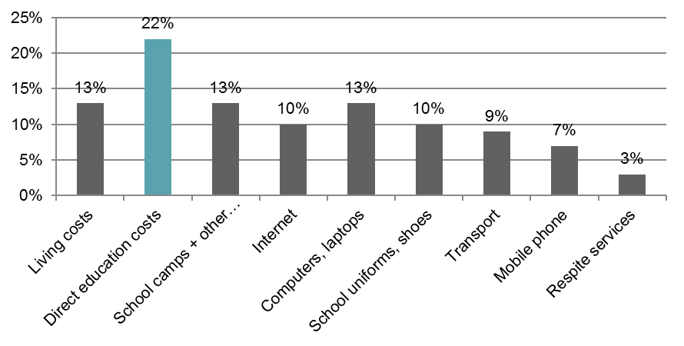
The findings above indicate that recipients are using the bursary for their own, determined purposes which most relate to directly or indirectly assisting them to continue in education.
Case Study 1: A young carer being a young person
Female. 17 years of age. Completing Year 12. Culturally and linguistically diverse background. Cares for mother and sister. Family is newly arrived to Australia, neither parent speaks English.
This recipient described her days before receiving the scholarship as commencing early in the morning to care for her sister and get ready for school, attend school, take her sister to medical appointments, then work til late at night.
She explained that because neither of her parents spoke English, she was responsible for taking her sister to medical appointments in order to interpret for her parents and ensure her sister received the right care. She was also responsible for providing household income as neither of her parents are able to work. These responsibilities left little time for her to study and no time to socialise with friends or take school excursions.
The flexibility in how the bursary can be spent has changed this. This young woman explained that she used the funds to reduce her part-time hours leaving her more time to study and socialise with friends. She has also been able to pay for a school excursion.
While she still has responsibilities at home, she feels she has the ability to do the fun things she wants to do as any teenager would.

To what extent did the young carer bursary help recipients achieve educational, caring, financial and social connection outcomes?
This question explores the extent to which the bursary assisted recipients in:
- continuing their education
- continuing their caring responsibilities
- being socially connected; and
- reducing the pressure to work part-time.
To answer this question the evaluation examined education participation and achievement rates, changes in caring responsibilities, the nature of their social connections and changes in their hours of part-time work.

Key findings: All young carers interviewed reported improvements in education, social connection and caring responsibilities as a result of reducing the need for part-time work and by reducing the pressure they felt.

Outlined below are the findings against each of the following measures:
Indicator: Education
participation and
attainment Measures:
- Levels of educational attainment
      - Use of tools to support participation in education and how the bursary is spent
      - Post-education circumstance
      - Perceived impact on education
Indicator: Level and
extent of caring
responsibilities Measures:
- Caring hours
- Nature of caring role
- How the bursary is spent
- Perceived impact on caring responsibilities
Indicator: Extent of
social connections Measures:
- Nature and frequency of support use
- Participation in non-school activities
- Perceived level of recognition, pride in self and role, and of impact on social connection
Indictor: Level of
pressure experienced
by the young carer to
work part-time Measures:
- Part-time work hours
- Perceived level of financial pressure to work part-time, level of stress, ability to cope and impact on part-time work

Indicator 1: Education participation & attainment

Educational retention rates
Young carers remaining in education is an intended outcome of the YCBP. To this end, the evaluation examined the extent to which recipients remained in education during the life of the bursary.
A condition of being eligible for the bursary is participation in some form of education, including school, university or TAFE. Therefore, 100 per cent of recipients at the time of receiving the bursary were engaged in education.
The 2016 mid-year survey results show that 99 per cent of bursary recipients intend to continue their education throughout the year, compared to 97 per cent in 2015.
All round one recipients that were interviewed (n = 6) were still engaged in education since cessation of the bursary. All round two recipients that were interviewed (n = 6) were engaged in education.

Levels of educational attainment
Young carers improving their educational outcomes is an intended outcome of the YCBP. To this end, the evaluation examined the extent to which recipients perceived their educational achievements as a result of the bursary.
As illustrated by the figure below, the mid-year survey results indicate that more 2015 recipients (76 per cent) than 2016 recipients (64 per cent) reported an improvement in their grades since receiving the bursary.

Fig. 4. Since receiving the bursary my grades have improved, 2015 & 2016 Mid-Year Survey. (N.B. Figures may not add up to 100 per cent due to rounding)
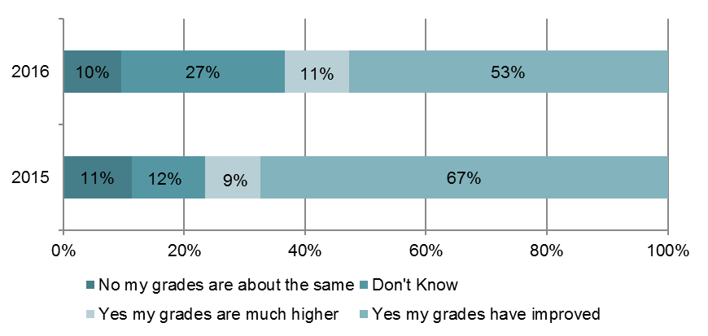
In the interviews, most recipients interviewed stated that their performance in study (either school, university or TAFE) had improved since receiving the bursary. Interviewees attributed the following reasons to the improvement:
- having the ability to pay for educational tools such as text books, laptops and internet to assist them in their studies where in the past they would have foregone these things due to cost
- experiencing less emotional distress, pressure and worry being dedicated to how they will make ends meet
- having the ability to pay for study-related activities such as excursions and work placements that enhance their learning; and
- reducing the need for them to work part-time which made more time available after school, university or TAFE to study.

Case Study 2: Doing better in school and building confidence.
Male. 16 years of age. Completing Year 11. Cares for father who has a terminal illness.
This recipient described immense challenges in keeping up with the demands of school including attendance, homework, assignments and HSC preparations, while caring for his father.
He explained that his worry about managing these responsibilities in addition to the financial pressures his family faced distracted him from his school work. As a result, his grades were slipping.
Receiving the bursary has changed this. This young man explained that – while he will always worry about his father – he no longer worries about financial pressures and is more engaged in school. He has also noticed an improvement in his grades as he is completing his school work and attending school more often.
His support person echoed the difference that the bursary has made on this young man’s life. In particular noting the increased confidence he has as a result of doing better in school.

Use of tools to support participation in education and how the bursary is spent
Young carers improving their educational outcomes is an intended outcome of the YCBP. To this end, the evaluation examined the extent to which recipients used the bursary to purchase tools to support their participation in education.
As noted above the recipients who were interviewed reported using the bursary funds to purchase tools to support their participation in education. The mid-year survey results for rounds one and two show that the majority of recipients (68 per cent and 59 per cent, respectively) spent their bursary funds on direct education costs or tools to assist their education.
Direct education costs include, tuition, textbooks, school uniforms, school fees and stationery. Tools to assist education include, tutoring, computers/laptops and internet. Other supports & activities include, respite, medical services, sporting or other activities, career guidance and transport.
The figure below illustrates the allocation of the bursary spend on educational tools.
Fig. 5. Allocation of the bursary spend on educational tools, 2015 & 2016 Mid-Year Survey.

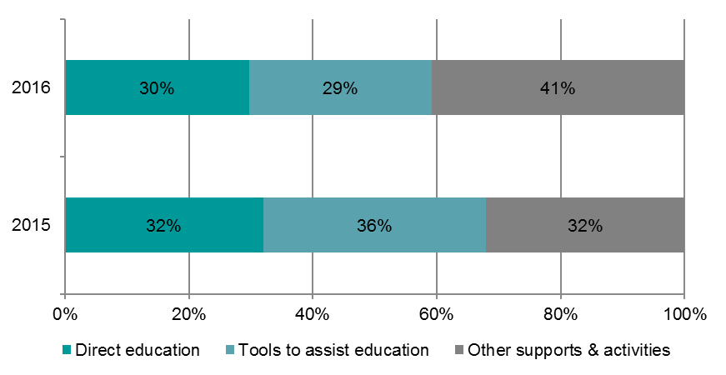

Post-education circumstance
Young carers having better life chances by way of full-time employment is an intended longer-term impact of the YCBP. While it is too soon to determine impacts for the current cohort of bursary recipients, the evaluation did make a cursory exploration with recipients about their expectations following education.
All recipients interviewed were still engaged in education, however their aspirations were to complete their education and gain a job in the professional/occupation related to their field of study. All recipients interviewed reported wanting to find employment upon the completion of their studies.

Perception of impact on education
The evaluation explored recipient and support people’s overall perceptions of how the bursary has impacted on the recipient’s education.
The recipients interviewed all noted the positive impact that the bursary had on their education both in terms of assisting them to stay in education and to improve their educational attainment. Some recipients also noted that receiving the bursary helped them to aspire to greater educational goals for themselves, like going onto university to prepare themselves for a professional career.
Specific comments made by recipients include:
- “If it wasn’t for the bursary I would have dropped out of university and gone onto the carer’s pension.” – Recipient aged 24, both rounds
- “I am doing better at school.” – Recipients aged 16, round two
- “I am now on a level playing field with my classmates who have the time and money to study and do well.” – Recipient aged 15, both rounds.
Support people echoed the above comments. All support people interviewed (n = 4) noted a marked improvement in the recipient’s engagement with school, achievement at school and overall aspiration for their futures.

Case Study 3: Turning dreams of the future into reality
Male. 24 years of age. Completing a law degree. Cared for both parents. From a cultural and linguistically diverse background.
This recipient explained that prior to receiving the bursary he never contemplated going to university and fulfilling his dream of becoming a lawyer as being a viable option.
In fact, prior to being awarded the bursary, this young man was planning to cease work and take up the “Carer Pension” as he was not able to fulfill his caring responsibilities and household costs with the multiple part-time work he had. At the time studying was far from his mind.
Receiving the bursaries in rounds one and two has changed this. This young man explained that receiving the bursary opened up options to him. He was able to give up some of his part-time work to enrol in university to study law.
Studying law has also opened up further possibilities. This young man communicated his plans to complete his law degree, get a job in a law firm and one day become a partner.

Indicator 2: Level and extent of caring responsibilities

Caring hours
Young carers maintaining their caring role is an intended outcome of the YCBP. To this end, the evaluation examined the extent to which these caring hours changed as a result of the bursary.
An analysis of the round two (2016) application data compared to mid-year survey result data shows the proportion of recipients who at the time of their application were doing very high hours of caring per week (40 or more) has decreased significantly (from 32 to 24 per cent).
This change has been accompanied by a slight increase in the proportion of recipients doing relatively low caring hours (0 to 20). The proportion of recipients doing mid (21 to 30) to high (31 to 40) caring hours per week has remained constant.

Table 5. Change in caring hours, before and during bursary, 2016 recipient data.
 | Pre-bursary, September 2015  (Application Form Response) | Mid -bursary, July 2016  (Mid-Year Survey Response)
0 - 10 hours | 4% | 8%
11 - 20 hours | 17% | 21%
21 - 30 hours | 29% | 29%
31 - 40 hours | 18% | 18%
40 + hours | 32% | 24%
Total | 100% | 100%

Nature of caring role
Young carers maintaining their caring role is an intended outcome of the YCBP. To this end, the evaluation examined the extent to which recipients perceived this role to have changed as a result of the bursary and if they spent their bursary on items that supported them in their caring role.
Most recipients interviewed (n = 10) stated that their caring role had been maintained yet became easier since receiving the bursary. They attributed the improvement to being able to pay for:
- support to give them respite from caring
- more therapy and medication for the care recipient; and
- therapy/support for themselves which assisted them to cope in the caring role.

Perception of impact on caring responsibilities
The evaluation explored recipient perceptions of how the bursary has impacted on the recipient’s caring responsibilities.
Overwhelmingly recipients felt they were better carers as a result of the bursary. Specific comments made by recipients include:
- “I am better able to care for my mother” – Recipient aged 17, round two
- “I am able to pay for better quality care for my sister” – Recipient aged 21, round two
- “I have used the bursary to pay for respite care so I can have a break from caring” – Recipient aged 19, round one.

Indicator 3: Extent of social connections

Nature and frequency of support use including participation in non-school activities
Increased access to supports by young carers is an intended outcome of the YCBP. To this end, the evaluation examined the extent to which recipients accessed supports as a result of receiving the bursary.
Supports can include, but are not limited to:
- young carer support networks
- respite
- counselling and other therapeutic support
- sport and recreation activities; and
- pastoral care.
The results from the mid-year survey indicate that 99 per cent of recipients agree that the bursary is having a positive impact on their wellbeing. This included:
- increased participation in sporting, community and social events; or
- increased time spent relaxing with friends.
The interviews with recipients validated the above mid-year survey findings. In addition, some recipients disclosed that as a result of the bursary, they had more money and time available to access respite support, counselling services, participate in young carers support networks, and make new friends with other young carers.
Support people had also observed that the recipients seemed more connected with the school/university community and with their friends.

Perceived recognition, pride, being a role model and impact on social connection
The evaluation explored recipient and support people’s overall perceptions of how the bursary has impacted on their level of recognition, pride, being a role model and social connections.
The recipients interviewed all noted the positive impact that the bursary had on their self-esteem, self-regard and social connections. In particular, all recipients noted receiving the bursary was recognition of the hardships they experience and the important role they play as carers. They also noted that they were more connected to their friends because they had the time to spend with them as well as the money to pay for school activities, which provide forums for these connections to deepen.
Specific comments made by recipients include:
- “I have more time because I don’t have to work as much. This means I am able to make friends and do social things.” – Recipient aged 16, round one
- “I am able to do extra-curricula activities after school with my friends that I couldn’t afford before.” – Recipient aged 15, round two
- “There are still not enough support (beyond money) for young carers. We need help to manage our own mental health needs as well as manage all of our responsibilities.” – Recipient aged 17, round two.
Interestingly, none of the recipients interviewed described themselves as a role model, however four of the support people interviewed all described the recipients they knew as role models.

Indicator 4: Level of pressure experienced by the young carer to work part-time

Part-time work hours
Young carers reducing their part-time work hours is an intended outcome of the YCBP. To this end, the evaluation examined the extent to which recipients changed their part-time work hours as a result of receiving the bursary.
A review of the 2016 applications and mid-year survey results indicates that among the 37 per cent of bursary recipients who do paid work, 55 per cent reported that the bursary has enabled them to stop working or reduce their paid work hours.
This response was more frequent among recipients with a caring load of less than 30 hours per week; those caring for 31 hours or more per week more frequently reported having the same or increased hours of paid work.
It should be noted that as part-time work was not weighted heavily in the assessment weighting criteria, only a small proportion of bursary recipients actually work part-time.

Perceived level of stress, ability to cope, level of financial pressure, and impact on part-time work
The evaluation explored recipient and support people’s overall perceptions of how the bursary has impacted on recipient’s feeling of stress, ability to cope, level of financial pressure and impact on part-time work.
Most (n = 10) recipients interviewed noted the positive impact that the bursary had on their ability to cope, their stress levels, level of financial pressure they experience and their need to work part-time.
In particular, most (n = 10) recipients noted feeling better able to cope and feeling less stressed especially about finances. Others noted this led to them thinking about their future when they hadn’t had the bandwidth or courage to do so prior to the bursary.
Six recipients interviewed noted that they were also able to reduce their part-time work hours, or reverse the decision to drop out of school to take on full time work. However, one recipient did advise that while the bursary was sufficient to help her pay day-to-day bills, it wasn’t enough to help her to stop working part-time.
Specific comments made by recipients include:
- “I am no longer waking up in the morning thinking about money.” – Recipient aged 16, round one.
- “I was able to give up some of my part-time jobs.” – Recipient aged 24, both rounds.
Support people noticed a reduced sense of financial pressure experienced by the recipients they know. They also noted an increased ability to cope with all that was going on in their lives in particular their study commitments.

Case Study 4: Still struggling to make ends meet.
Female. 21 years of age. Completing nursing studies. Cared for partner.
This recipient explained that she is the primary carer for her partner who requires intensive, full-time care and regular medical treatment. Her partner does not have any other support. In addition to being his primary carer, she is studying to become a nurse.
The bursary has assisted this young woman in paying everyday bills and expenses like electricity and telephone that she would have delayed paying without the bursary. However, with her circumstances even with the bursary she was still struggling to make ends meet.

How cost-effective is the YCBP?
This evaluation question explores the cost-effectiveness of the YCBP. The YCBP has two cost components: Total Program Cost and Additional School Education Cost.
The Total Program Cost is the sum of the program Administration Costs and Bursary Costs (see section below). Administration Costs are the costs of establishing and implementing the program and do not include Departmental staff or on-costs. Bursary costs comprise the actual bursaries paid to each recipient. The Administration and Bursary Costs relied upon for this analysis are contained at Appendix C.
Additional School Education Cost is the cost to government of providing up to three years of school education to YCBP recipients who otherwise would have left school early in Years 9, 10 or 11.
The evaluation examined the total administration costs of the YCBP compared to the bursary costs and recipient numbers.

Key Finding: The administration of the program is becoming more efficient over time with an 11 per cent reduction in Administration Costs to Bursary Costs between 2015 and 2016.
The administration costs per recipient reduced from nearly $1,000 in 2015 to approximately $500 in 2016. The average bursary costs per recipient in the same years were $4,833 and $3,000 respectively.

Outlined below are the findings against each of the following measures:
Indicator: Cost of YCBP
compared to bursary costs Measures:
        - Ratio of true program administration costs to total bursary costs
        - True administration costs and bursary costs per recipient

Indicator: Cost of YCBP compared to the outcomes achieved

Ratio of true program administration costs to total bursary costs
True program Administration Costs are the actual costs incurred by Carers Australia to deliver the YCBP (as distinct from funding provided by the Department) and comprise staff costs, some accounting and compliance costs and the costs of one-off information technology enhancements. Program Administration Costs relate to both unsuccessful applicants and actual bursary recipients.
Staff costs comprise the costs of establishing and administering the program, network promotion, the application process, assessment (including use of the independent panel), verification, follow-up and referral, paying bursaries, surveying recipients twice each year and reporting to the Department. Information technology costs are the costs of website and online application form development and the cost of acquiring database software.
Total bursary costs are the total of actual bursaries paid to each recipient in each year.
The assessment of Administration Costs is based upon interviews with Carers Australia staff to determine the tasks performed, staff time allocated to each task and any other cost items. This method relies upon subjective assessment by Carers Australia staff of tasks and associated time requirements. Staff time was converted to cost using a single average full-time equivalent salary. This is a simplified methodology and actual staff costs may vary slightly from the model assessment.
In 2015, the true program Administration Costs slightly exceeded the Department funding and in 2016 were slightly less. Differences between the true Administration Costs and funding were due to some unanticipated tasks, greater than anticipated work volume for some tasks, and the cost of system and process changes. The differences are immaterial.
The reduction in the ratio of true program Administration Costs to Bursary Costs is evidence that the administration of the YCBP is becoming more efficient overtime.
Fig. 6. Ratio of Total Administration Costs to Bursary Costs.
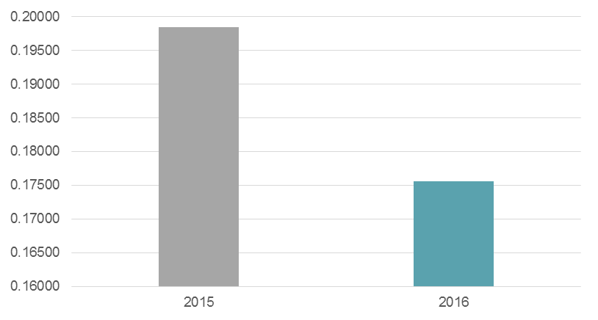
In 2015 the ratio of total Administration Costs to Bursary Costs was just under 0.20:1 (see chart above). In 2016 the ratio was 0.18:1. This was a reduction in the ratio of 11 per cent during the period.
Between 2015 and 2016 Administration Costs fell by 39 per cent (see chart below) and Bursary Costs fell by 31 per cent.

Fig. 7. Total Administration and Bursary Costs.
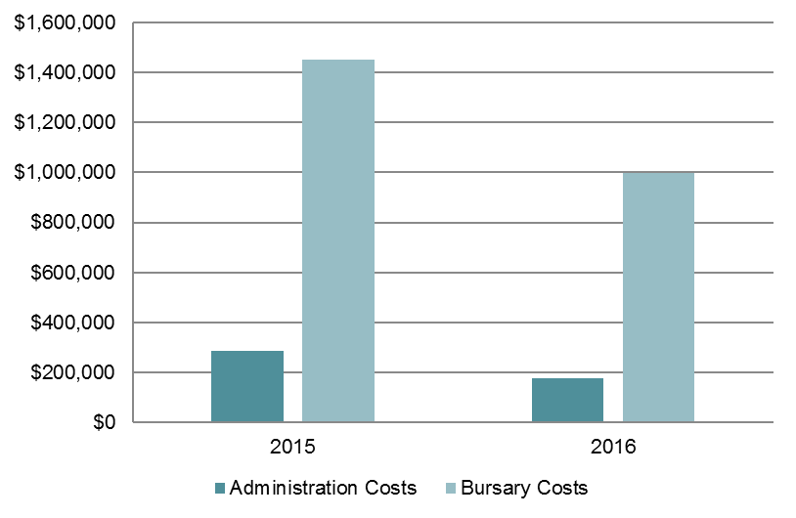
These reductions, in both Administration Costs and their ratio with Bursary Costs, are consistent with expected higher establishment costs in the first year of the program, followed by economies of scale and lower average costs in subsequent years. The size of the reduction in Administration Costs has also been slightly increased by counting the cost of Carers Australia’s 2015 investment in information technology as a single year cost, rather than amortising it over a longer period.
The YCBP Administration Costs are small compared to the amount of funding being disbursed as bursaries. Administration Costs are typical for a social welfare program implemented by a not-for-profit organisation and are reducing over time, which indicates that the program administration is efficient, providing value for money and appropriate for a program of this kind. As the program matures and Carers Australia gains more experience in delivering it, further reductions in the ratio of Administration Costs to Bursary Costs may be expected (although future reductions may be smaller, and there may not be further reductions in absolute Administration Costs).

True administration costs and bursary costs per recipient
Administration Costs and Bursary Costs per recipient have been calculated using the number of full year bursary recipients for 2015 (n = 300) and the number of bursary recipients still compliant and receiving bursary instalments as of July 2016 (n = 333). The 2016 number of recipients may reduce if recipients withdraw, however any additional reduction is expected to be small (reflecting the previous year’s withdrawal rate of around one per cent of applicants and three per cent of initial recipients).
In 2016 there were large reductions in both Administration Costs per recipient and Bursary Costs per recipient. These reductions exceeded those for Total Administration Costs and Bursary Costs (see section above) because of an increase in bursary recipients and the program change to a lower, uniform bursary amount.
Fig. 8. Administration and Bursary Costs per Recipient.
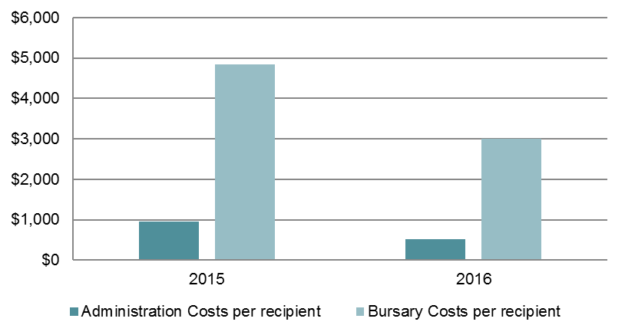
In 2016 Administration Costs per recipient were 45 per cent lower than in 2015. This large reduction was caused by the combined effect of a reduction in total Administration Costs (see section above) and an increase in the number of bursary recipients (11 per cent more recipients in 2016 than 2015).
In 2016 Bursary Costs per recipient were 38 per cent lower than in 2015. This large reduction was caused by the change to a single bursary rate in 2016 of $3,000 per recipient. This compares with varying 2015 bursary rates of $10,000, $6,000, $4,000 and $3,000 (and an average bursary payment in that year of $4,833).
The large reductions in Administration and Bursary Costs per recipient are consistent with the reductions in total Administration and Bursary Costs. The large fall in Administration Costs per recipient is the most significant of these two changes, as it reflects the increasing efficiency and economy of scale being achieved by Carers Australia in its program delivery. Such per-unit cost reductions are typical during the initial years of program delivery and this trend should continue over the medium term, although will most likely do so at a diminishing rate. The large fall in Bursary Costs per recipient are on their own less significant, as they are driven by program changes to a lower bursary amount.

Cost-effectiveness of the YCBP
Undertaking a cost-benefit analysis of the YCBP was explored. There are inherent challenges in developing a sufficiently robust cost-benefit analysis of a program so early in its lifecycle. These challenges increase when attempting to model long-term economic impacts. The relative immaturity of the YCBP, the limitations of the data and some of the assumptions required to underpin the modelling did not support a robust cost-benefit analysis.

Implications
In the context of building on the early successes and strong foundations of the YCBP, this section discusses the implications of the findings outlined in the previous section. Specifically, this section considers what are the opportunities for improvement?

Reaching those most in need
To mitigate the risk that young carers most in need are not being reached, improvements could be made in YCBP processes by:
- advertising directly to young carers through social media channels, in particular Facebook,
- advertising to Indigenous young carers through the Aboriginal Community Controlled Health Service network and to young carers from culturally and linguistically diverse backgrounds through refugee support services
- enhancing the online advertising process by displaying posters and other collateral in regional and remote primary and secondary schools; and
- setting aside a particular proportion of bursaries for younger young carers (i.e. those aged 15 and under) and those from remote and regional locations.

Enhancing the assessment process
To mitigate the challenge in distinguishing between those most in need from within the “medium” need category, improvements could be made by:
- more heavily weighting applicants of a younger age (i.e. 12-17 years) as they are at greater risk of disengaging from secondary schooling
- more heavily weighting applicants that work part-time; and
- including strengths-based questions in the application form that examine the young carer’s aspirations and plan for the future as well as what their achievements are.
To resolve the concerns raised by recipients, it is suggested that additional communication points are built into the shortlisting, pre-verification, during verification and post-verification stages to keep applicants informed as to the status of their application.

Improving the timing of payments
Recipients main piece of feedback was regarding the timing of payments. In particular payments were often received after the commencement of the study term and they were unable to pay for textbooks. To resolve the challenge, improvements could be made by:
- making the first payment then requiring this payment be repaid if the verification process is not successfully completed so that the first payment can be made prior to the commencement of the study year (late January in most cases), or
- splitting the bursary payments into two payments rather than four to allow recipients to pay for full year study costs upfront, or
- speeding up the assessment and verification processes (by implementing assessment weighting criteria changes above or removing the need for the range of supporting documents) to enable payments to be made by late January.

Managing the growing demand
Demand for the bursary is growing year-on-year. Coupled with the benefits the bursary creates to both young carers and government, there seems to be a case to increase the number of bursaries available.
Alternatively, if an increase in bursaries is not possible, tightening criteria by focusing on younger young carers (i.e. 12-17 year old cohort as opposed to 18-24 year old cohort as they are at greater risk of disengaging from secondary schooling), young carers in regional/remote locations, and those young carers about to disengage from study to help manage demand.

Understanding the longer-term outcomes and impacts
The findings of this evaluation – especially the benefits created for young carers and government – as well as the challenges in accessing quality data set on the young carer and recipient populations highlight the importance of rigorous and robust data collection and research methods.
To this end, it is suggested that for future rounds, all applicant and recipient level data (including names on application forms and surveys) is held by Carers Australia so that longitudinal desktop research can be conducted on the changes to recipients over time.
It is also suggested that a qualitative longitudinal study of past recipients is undertaken to examine their circumstances post bursary.

Appendix A: Interview guides

Recipient Interview Guide
- Tell us a little about yourself: your age, year at school, who you care for.
- How did you hear about the young carer bursary?
- How did you apply for the bursary? Did you seek any help to complete the application form?
- How has the bursary impacted on your life? Explore impacts on continuation with education, financial pressure, need to engage in part-time work, continued caring role, access to other support services.
- How do you think your life would be if you didn’t receive the bursary? Explore impacts on continuation with education, financial pressure, need to engage in part-time work, continued caring role, access to other support services.
- Do you feel able cope with day-to-day financial pressures? Before you received the bursary, did you feel the same, less able to cope, more able to cope?
- What does the bursary mean to you? How has the amount of the bursary helped you? What do you think about the four instalments?
- What do you see yourself doing in the next year? Two years? Three years?
- What’s one change to the bursary that would make your life easier?
- Is there anything else you’d like to say about the bursary?

Support Person Interview Guide
- Tell us about your role and your relationship to the young carer.
- What are the greatest challenges that you see the young carer experiences?
- What have you observed about how the bursary has impacted on the young carer’s life? Explore impacts on continuation with education, financial pressure, need to engage in part-time work, continued caring role, access to other support services.
- How do you think his/her life would be if you didn’t receive the bursary? Explore impacts on continuation with education, financial pressure, need to engage in part-time work, continued caring role, access to other support services.
- Reflecting on the young carer themselves, have you noticed any change in them following receipt of the bursary? Explore what this change is.
- How would you describe the young carer?
- What do you see in the young carer’s future?
- Is there anything else you’d like to say about the bursary?

Carers Australia Interview Guide
- Please describe the end-to-end process for each bursary round.
- How much allocated YCBP staff time do you estimate is dedicated to completing:
  - Round preparations?
  - Establishing and ongoing communications with appropriate third-parties?
  - Reaching out to, communicating and liaising with network partners.
  - Opening/advertising applications?
  - Assessing applications?
  - Desk-based assessment of application form data?
  - Phone contact assessment?
  - Verifying successful applicants?
  - Advising successful applicants
  - Advising unsuccessful applicants?
  - Referral and phone counselling for unsuccessful applicants?
  - Managing and making bursary payments?
  - Administering the mid-year survey?
  - Administering the end of year survey?
  - Reporting on the survey?
  - Preparing the acquittal?
- How much additional staff time do you estimate is dedicated to completing the above activities?
- Please describe the distribution channels for advertising the bursary? Who are your distribution partners? How did you choose these partners? What works? What doesn’t work?
- What works and what doesn’t work with the assessment and selection process?
- What works and doesn’t work with the verification process?
- What works and doesn’t work with the survey process?
- What has been unexpected with the administration of the program? Explore any additional time/resources required, psychological impact on staff, other.
- What do you observe as being the benefit that the bursary provides? If the bursary didn’t exist, what would happen?
- What are your suggestions on how the bursary can be improved for the future:
  - Application process?
  - Assessment and verification processes?
  - Surveys?
  - Bursary amount?
  - Bursary instalments?
  - Managing young carer needs?
  - Managing staff needs?
  - Referral to other support services?
  - Other?

Independent Assessment Panel Member Interview Guide
- Please describe your role in the assessment of applications for the bursary.
- How does the independent assessment panel work with Carers Australia to assess applications?
- How effective is the assessment weighting criteria in identifying the applicants in most need?
- How effective are the applicants’ stories in assessing those most in need?
- What works and what doesn’t work with the assessment and selection process? What could be improved?
- What has been unexpected with the assessment of applications? Explore any additional time/resources required, psychological impact, other.
- What do you observe as being the benefit that the bursary provides? If the bursary didn’t exist, what would happen?
- What are your suggestions on how the bursary can be improved for the future?

Appendix B: Interview participants
No. | Role | Organisation
1 | Acting Director, Carer Policy and Programs Section | Department of Social Services
2 | Departmental Officer, Carer Policy and Programs Section | Department of Social Services
3 | Assistant Director, Carer Policy and Programs Section | Department of Social Services
4 | Young Carer Information Services | Carers Australia
5 | Young Carer Information Services | Carers Australia
6 | National Programs Manager | Carers Australia
7 | Independent Assessment Panel Member
8 | Independent Assessment Panel Member

Note that recipients and support people are not identified in order to maintain privacy.

Appendix C: YCBP administration and bursary cost
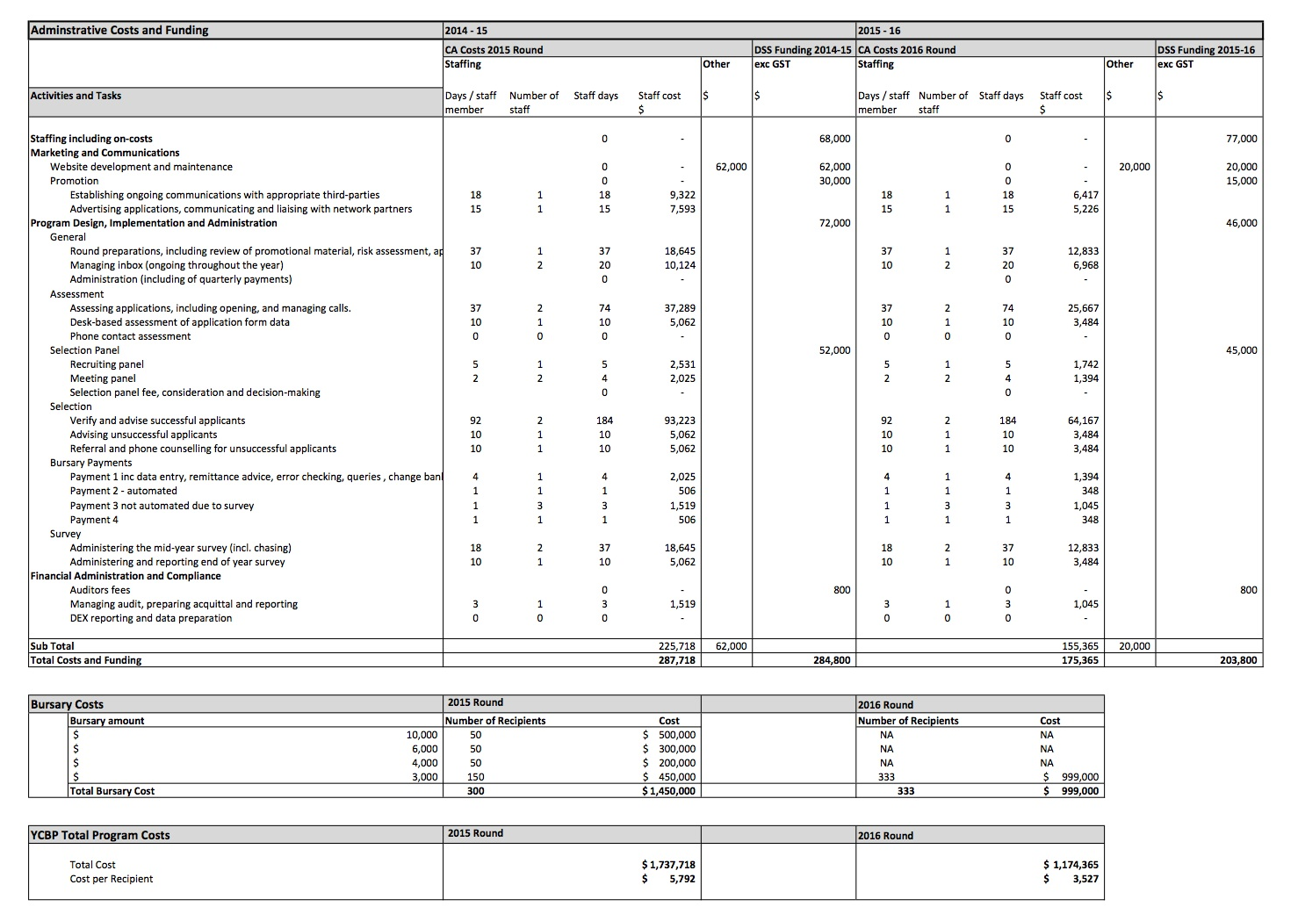

See Table 2 page 30 of the Full Report
Department of Social Services, Disability, Mental Health and Carers Program, Young Carer Bursary Program Operational Guidelines, Australian Government, November 2015.
Ibid.
More than budgeted bursaries were awarded in 2016 and 2017 due to a small number of withdrawals by successful applicants in those years.
Department of Social Services, Disability, Mental Health and Carers Program, Young Carer Bursary Program Operational Guidelines, Australian Government, November 2015.
Data provided by Carers Australia during the design-stage interview held on 16 June 2016.
The Independent Assessment Panel is comprised of three members who collectively represent the young carer support sector, academia and young carers.
Cat. No. 4430.0.
ABS, ibid.
Department of Social Services, Young Carers Research and Data Collection Summary, Australian Government, 7 January 2014, unpublished.
Ibid.
Schlarmann, S., Metzing, S., Schoppmann, S. & Schnepp, W. Germany’s First Young Carers Project’s Impact on the Children. Relieving the Entire Family. A Qualitative Evaluation. Open Nursing Journal, Vol. 5 (2011).
Dearden, C. and Becker, S. Meeting Young Carers’ needs: An evaluation of Sheffield Young Carers Program. Young Carers Research Group, Loughborough University (2000).
Butler, A.H. and Astbury, G. The Caring Child: An Evaluative Case Study of the Cornwall Young Carers Project. Children and Society, Vol. 19 (2005).
This reflects that the YCBP has not been in operation long enough for the anticipated medium and long-term outcomes to be observable.
At the time of conducting the evaluation the number of bursaries to be awarded in 2017 were not determined. Therefore, this figure includes the 2017 estimate.
Recent data suggests if nothing changes for young carers, up to 60 per cent of this cohort could be on income support in a decades time (Source: Australian Priority Investment Approach to Welfare – Carers available on the DSS website)
Cat. No. 4430.0.
Ibid.
Ibid.
Action Canada Taskforce Report. ‘Who Cares about Young Carers?’ (2013); Berthoud, R. The Take Up of Carer’s Allowance: a Feasibility study Department for Work and Pensions Working Paper no. 84. (2010); Butler, A.H. and Astbury, G. The Caring Child: An Evaluative Case Study of the Cornwall Young Carers Project. Children and Society, Vol. 19 (2005); Dearden, C. and Becker, S. Meeting Young Carers’ needs: An evaluation of Sheffield Young Carers Program. Young Carers Research Group, Loughborough University (2000); Newton, B. and Becker, S. The Capital Carers: An evaluation of the Capital Carers Young Carers Project. Young Carers Research Group, Loughborough University (1999); Richardson, K., Jinks, A. and Roberts, B. Qualitative Evaluation of a Young Carers’ Initiative. Journal of Child Health Care. Vol. 13 (2) (2009); Schlarmann, S., Metzing, S., Schoppmann, S. & Schnepp, W. Germany’s First Young Carers Project’s Impact on the Children. Relieving the Entire Family. A Qualitative Evaluation. Open Nursing Journal, Vol. 5 (2011); and Stamatopoulos, V. Supporting Young Carers: A Qualitative Review of Young Carer Services in Canada. International Journal of Adolescence and Youth, Vol. 21. No. 2 (2016).
2014 and 2015 YCBP application data provided by Carers Australia. The recipient numbers exclude successful applicants who withdrew and includes the eligible applicants who replaced those successful applicants who withdrew.
At the time of conducting the evaluation data on eligible versus ineligible applications for round three (2017) was not available.
Department of Social Services, Disability, Mental Health and Carers Program, Young Carer Bursary Program Operational Guidelines, Australian Government, November 2015.
Department of Social Services, Disability, Mental Health and Carers Program, Young Carer Bursary Program Operational Guidelines, Australian Government, November 2015.
This large increase in ineligible applications is largely due to two factors. The first being the significant increase in numbers of applications received between round one and two, i.e. round two coming off a low base of round one. The second being an improvement in Carers Australia’s data collection processes which more formally classified applications as being eligible and ineligible from round two onwards.
Department of Social Services, Disability, Mental Health and Carers Program, Young Carer Bursary Program Operational Guidelines, Australian Government, November 2015.
2015 and 2016 recipient data provided by Carers Australia.
Estimated using 2011 Census data and Australian Bureau of Statistics, Survey of Disability, Ageing and Carers 2015, Cat. No. 4430.0
2015 and 2016 recipient data provided by Carers Australia.
List of organisations compiled from interviews with Carers Australia and Carers Australia’s Report on the Evaluation of the Implementation of the YCBP 2014-15 .
2015, 2016 and 2017 YCBP Application Forms.
Ibid.
Information obtained from interviews with Carers Australia and a review of the YCBP Operational Guidelines 2015.
2015 and 2016 recipient data provided by Carers Australia.
Carers Australia, Young Carer Bursary Program Assessment Process 2016: Year 2, Version 1.0, September 2015.
The Australian Charities and Not-For-Profits Commission does not provide a benchmark for measuring administration costs to income as administration costs vary greatly depending on the size and nature of a charity. Therefore the YCBP’s administration costs are not compared to an industry benchmark.

