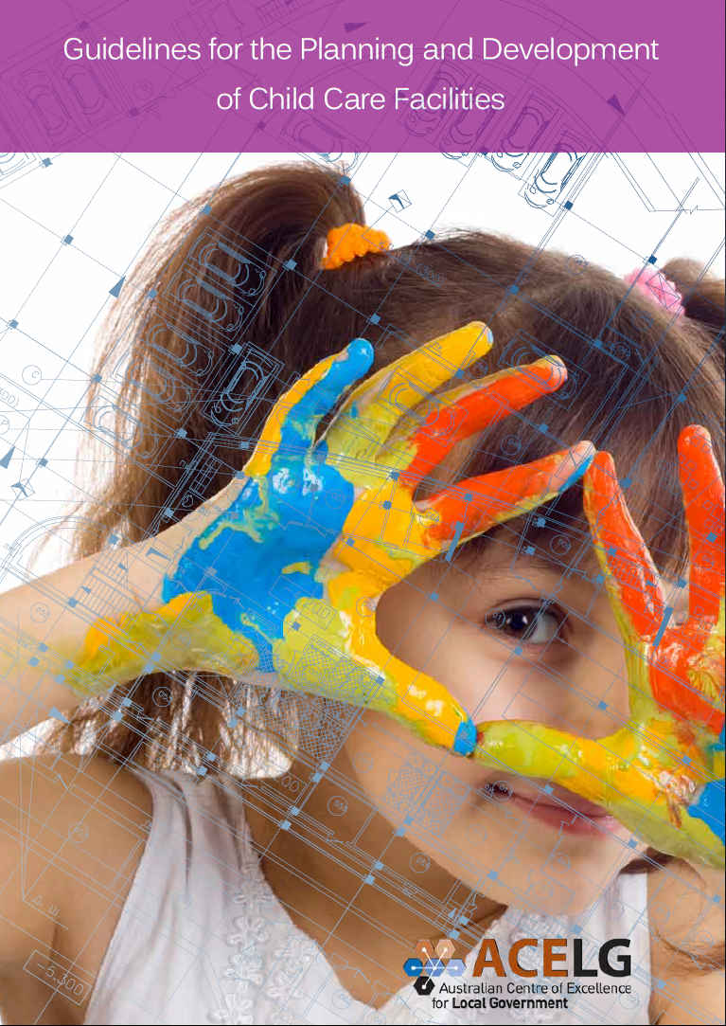

University of Technology, Sydney

b
Australian Centre of Excellence for Local Government
Level 8, 235 Jones Street
Ultimo NSW 2007
Telephone: 02 9514 1061
Fax: 02 9514 2274
Website: www.acelg.org.au
With the exception of the Commonwealth Coat of Arms, the Department’s logo, any material protected by a trade mark and where otherwise noted all material presented in this document is provided under a Creative Commons Attribution 3.0 Australia (http://creativecommons.org/ licenses/by/3.0/au/) licence.
The details of the relevant licence conditions are available on the Creative Commons website (accessible using the links provided) as is the full legal code for the CC BY 3.0 AU licence (http:// creativecommons.org/licenses/by/3.0/au/legalcode).
The document must be attributed as the Guidelines for the Planning and Development of Child Care Facilities.
ISBN 978-1-74361-660-4
Further copies of this document can be downloaded from the Department of Education website www.education.gov.au
June 2014
Acknowledgements
These guidelines are funded by the Australian Government Department of Education.

Table of contents

Preface 1
Glossary 2
Navigating this document 3
About these guidelines 4
Introduction 4
What are these guidelines about? 4
How can these guidelines be used? 4
Who should use these guidelines? 5
How were the guidelines developed? 5
Part 1 1
How to use policy and strategic planning for child care 1
Using policy and strategic planning 2
Introduction 3
1.1. Be child friendly 3
Building Blocks for a Child Friendly City⁷ 3
1.2. Understand policies and legislation 5
1.3. Be proactive in community planning 7
1.4. Take long term view in operational planning 9
Best practice checklist for using policy and strategic planning 10
Part 2 14
Enhancing supply through land use planning 15
Introduction 16
2.1. Align definitions of child care 16
2.2. Partner with relevant authorities 16
2.3 Use flexible land use provisions 17
2.4 Support zoning for child care 17
2.5 Be holistic when master planning 18
2.6 Carefully plan urban infill 20
2.7 Develop child care friendly development controls 21
2.8 Align development codes 23
Best practice checklist to enhance supply through land use planning 24
Part 3 28
Work in collaboration 29
Introduction 30
3.1. Partner with state government 30
3.2. Engage with the community 31
3.3. Inform councillors and collaborate with local government staff 32
3.4. Engage with proponents 33
Best practice checklist to work in collaboration 34
Conclusion 35
Best practice checklist 37
Best practice checklist for using policy and strategic planning 38
Best practice checklist to enhance supply through land use planning 40
Best practice checklist to work in collaboration 43
References and Appendix 44
References 45
Appendix 46

Preface

Local government across Australia makes a vital contribution in securing the well- being of children and families and ultimately strengthening the economy. Ensuring existing and future communities have access to the short and long term community infrastructure they need, including child care centres, is an ongoing challenge.
Communities need a mix of child care service types ranging from family day care, occasional care, home based care, outside school hours care as well as long day care. A child care facility is defined as a building or place used for the supervision and care of children that provides a learning environment in addition to long day care, preschool, occasional care or outside school hours care. These guidelines only pertain to long day care.
Fostering strong communities and economies requires investment in social services. Land use planning is an important tool for ensuring this investment. It is clear that child care has both short and long term societal and economic benefits. It is in this way that planning for child care is different to planning for other uses.
Whilst the availability and quality of child care contributes positively to the development of children, there is also a direct correlation between child care and workforce participation of parents, especially mothers of young children.¹ High rates of workforce participation help build strong, self-sustaining communities and vibrant local economies.
All local governments shape the availability of child care through strategic planning, land use planning and development assessment processes. Through these functions, local government helps determine the priority given to child care by the community, where it is located, and the size and the type of child care provided.
Local government works within a broader context of state and national policy, legislation and regulations which govern the land use planning and service approval processes.
Within this framework, access to child care can be facilitated by local government planning through close collaboration with other government agencies, child care providers and the local community.
Local government and their stakeholders face a broad range of challenges when planning and delivering child care for current and future communities. These include population changes, satisfying the varied preferences of families, the high cost of land and land availability, zoning restrictions and ensuring efficient development assessment processes. Many local governments have met these challenges with great success and these guidelines include short case studies of examples of what can be achieved.
Providing national level guidance on the planning and development of child care facilities is a challenge as state level legislation and regulations vary. These guidelines do not address whether local government should be a child care provider or not. However, these guidelines recognise existing constraints and provide evidence-based, easy to use checklists to help local government build internal capacity to strategically and systematically plan, and work in partnership with a range of stakeholders, to improve the availability of child care.

Glossary
Child care facility | A building or place used for the supervision and care of children that provides long day care, preschool, occasional care or outside school hours care. These guidelines only pertain to centre based long day care.
Centre based long day care | Long day care is a centre-based form of child care for children from birth to six years old.
Community infrastructure | Public and privately provided facilities and services, including local government and other facilities, that are required to accommodate and support community services, programs, activities, and a person’s access to them.
Greenfields site | An area of agricultural or forest land or some other undeveloped site earmarked for development.
Proponent | Any person(s) or entity(ies) with a direct financial interest in a proposed development that lodges an application for approval of the proposed development by a planning authority.
Statutory planning | The collection of legislation, regulations and other statutory orders which set out technical planning standards and establish the legal basis under which planning authorities can enforce these standards
Strategic land use planning | The identification of desired or future types and locations of development and the implementation of these through the preparation of statutory planning rules.²
Urban infill | Development that occurs on vacant or remnant lands passed over by previous development, including the replacement, remodeling or reuse of existing structures to accommodate new development.³
Zones | The classification of land in local planning schemes for use and development, excluding land in reserves. A zoning table (or ‘use-class’ table) may be included in a local planning scheme that sets out the permissibility, uses and classes of land uses in particular zones in the scheme area.

Navigating this document
The navigation wheel can be used as a tool for you to know where you are within this document. At the beginning of each section, it will show you where it fits within the guidelines. On each page, there will also be a small icon to show where you are.
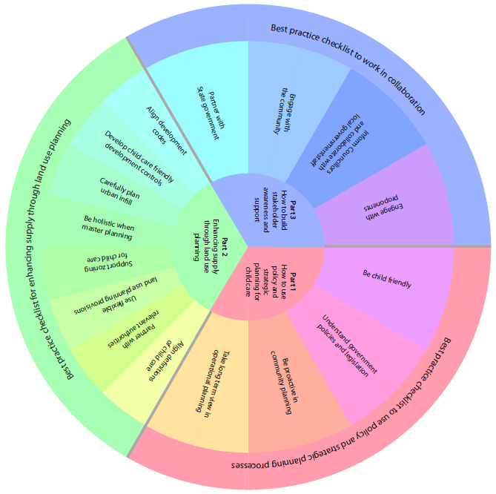

About these guidelines

Introduction
Obtaining building approval, development approval, service approval and registration for Child Care Benefit can be a complex process. Local government can assist proponents to navigate this complexity by helping them to understand the various legislative and regulatory requirements that they will need to meet. Local government can also work to streamline and coordinate the various application and assessment processes in addition to identifying any limiting factors in planning schemes, such as restrictive zoning or parking requirements.
These national guidelines are designed to enable local government to plan better for the future child care needs of their communities through strategic and land use planning. They do not address issues related to quality of service nor whether local government should be a child care provider. The overall objective is to ensure the adequate supply of long day child care places through land use planning. Because this is a national document, these guidelines should be consulted in conjunction with the state level agencies responsible for the planning and development of child care centres. The appendix provides some useful links for each state.
These guidelines provide a good starting point for local governments who do not have a great deal of experience and expertise in strategic and land use planning for child care centres. Not all sections of the guidelines will be relevant to all states. You are encouraged to focus on the sections which are particularly pertinent to your context.

What are these guidelines about?
These guidelines are about how to:
- Use policy and strategic planning processes for child care
- Enhance supply through land use planning
- Build stakeholder awareness and support for child care.
These guidelines will help local governments:
- Work across their organisations in a holistic way
- Form partnerships with other agencies and authorities
- Use zoning and development control processes for child care
- Maximise their own land and buildings portfolio for child care
- Work with proponents to ensure supply meets demand in the right timeframe.

How can these guidelines be used?
Local government can use these guidelines to:
- Understand how to better meet the child care needs of your community
- Engage with colleagues and with agencies and authorities about how to plan and deliver child care
- Improve knowledge of options for delivering child care
- Learn from the experiences of others.
The reader can:
- Read through from start to finish
- Dip in to relevant sections
- Use the checklists at the end of each section to identify areas for best practice.

Who should use these guidelines?
Strategic planners – To understand the importance of forecasting population profiles and community needs.
Community planners – To ensure community needs are incorporated into strategic and master planning.
Land use planners – To ensure land use is efficiently mapped and residential/work land areas are zoned for child care.
Property managers – To identify how a local government’s own land and buildings can be used or adaptively reused for child care.
State government agencies – To understand the relative approval roles and work in partnership with local government.
Other stakeholders – To understand how to work with local government to provide more child care places.

How were the guidelines developed?

- Desktop research
- a literature and policy review
- an analysis of statutory land use planning frameworks and policies
- a review of environment court challenges across all states and territories
- an assessment of planning instruments and development assessment systems in thirteen local governments.

- Stakeholder engagement
- 41 interviews with local and state government staff and proponents
- An online survey with responses from over 200 stakeholders about their experience of child care delivery.

Part 1

11

How to use policy and strategic planning for child care

Using policy and strategic planning

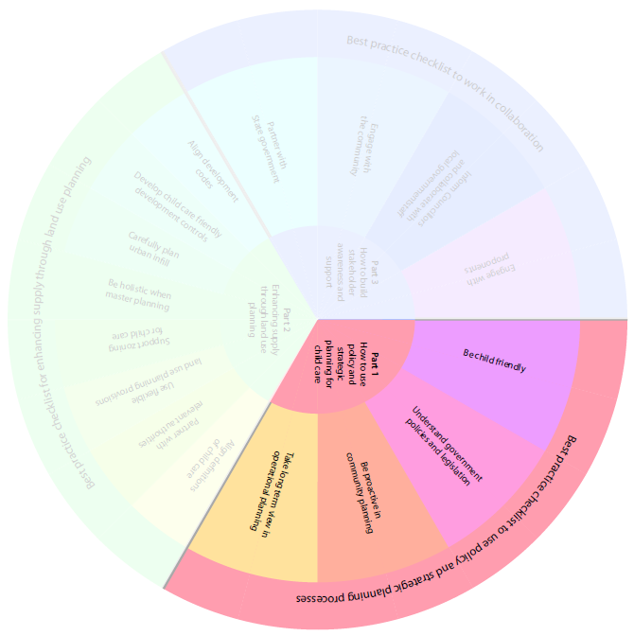

3 1
2
1 4
1
4

Introduction
Communities share a similar vision for a safe, healthy and pleasant place to live, a sustainable environment and economy, opportunities for social interaction and employment and reliable infrastructure.
The challenge for local government is to understand their community now and in the future and ensure that policy and planning processes align to deliver their needs. This is most critical with child care, the provision of which can depend on a variety of interfacing policy and planning regimes.
This section outlines the broader policy context within which local government makes decisions about land use planning for child care facilities.
- Be child friendly
Australian, state and territory governments have developed a range of frameworks, policies and legislation to support local government. A review of these can help local government find out which best address the needs of the local community.

Child Friendly Cities
The Child Friendly City Initiative⁴ guides many state and local government plans. The initiative is a national framework which supports local governments to establish governance structures which include the rights of children. The Framework for Action⁵ outlines nine Building Blocks for a Child Friendly City which allows children to be involved, ensures their rights are considered and ensures equal rights of access to basic services.
This initiative responds to several important trends:
- the rapid transformation and urbanisation of societies
- the growing responsibilities of local government
- and the increasing importance of cities and towns.
It promotes the implementation of the Convention on the Rights of the Child⁶ at the level where it has the greatest direct impact on children’s lives. It is a strategy for promoting the highest quality of life for all citizens.

Building Blocks for a Child Friendly City⁷
- Participation, promoting children’s involvement in issues that affect them
- A child friendly legal framework
- A city-wide Children’s Rights Strategy
- A Children’s Rights Unit or coordinating mechanism
- Child impact assessment and evaluation
- A children’s budget
- A regular State of the City’s Children Report
- Making children’s rights known
- Independent advocacy for children.
Read more about the Child Friendly City Initiative at ACT Children (http://www.children.act.gov.au/)

City of Casey, VIC
Casey’s Children - Plan for the future 2012-2017 includes six key principles and commitments to guide planning, advocacy and the delivery of services and programs for families and children.
The principles are:
- Children’s participation
- Plan for families with children
- A feeling of belonging
- Working together
- The best we can be
- Information and promotion – getting to know the City of Casey.
Casey’s Children a plan for the future (http://www.casey.vic.gov.au/council/policies-strategies/a-c/caseys-children-a-plan-for-the-future)

ACT Children’s Plan 2010-2014
This plan is a whole of government and whole of community commitment to children aged 0 to 12 years. Its vision is that:
Canberra is a child friendly city that supports all children to reach their potential, make a contribution, and share the benefits of our community.
The ACT Children’s Plan covers:
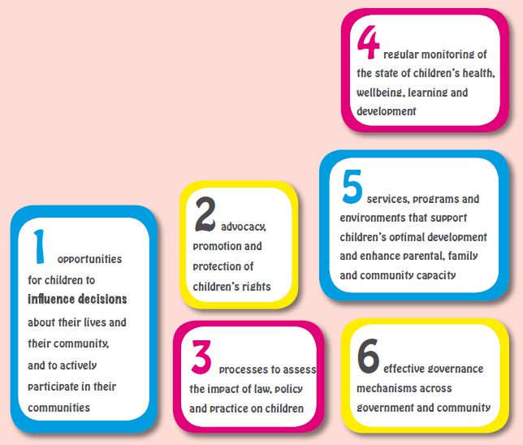
Text description:
- Opportunities for children to influence decisions about their lives and their community, and to actively participate in their communities.
- Advocacy, promotion and protection of children’s rights
- Processes to assess the impact of law, policy and practice on children.
- Regular monitoring of the state of children’s health, wellbeing, learning and development.
- Services, programs and environments that support children’s optimal development and enhance parental, family and community capacity.
- Effective governance mechanisms across government and community.

Municipal Early Years Planning Framework, VIC
The Department of Education and Early Childhood Development and the municipal Association of Victoria partnered to develop the Municipal Early Years Planning Framework.⁸
This framework provides a range of principles and practical guidance to help local governments incorporate the needs of young children in their planning processes.
In addition, it recognises the complementary roles of state and local government in the planning, funding and delivery of a range of services.
Municipal early years planning
(http://www.mav.asn.au/policy-services/social-community/children-families/municipal-early-years-planning/Pages/default.aspx)

National Quality Framework
To ensure all children have access to quality early childhood education and care, the Australian, state and territory governments have established the National Quality Framework, which includes a National Quality Standard, for most long day care, preschool/kindergarten, family day care and outside school hours care services. The framework raises quality and drives continuous improvement and consistency in education and care services and school age care.
Read more about the National Quality Framework (www.acecqa.gov.au)
The Early Years Learning Framework is a key component of the Australian Government’s National Quality Framework for early childhood education and care.
The framework describes the principles, practice and outcomes essential to support and enhance young children’s learning from birth to five years of age, as well as their transition to school. It has a strong emphasis on play- based learning. Play is the best vehicle for young children’s learning providing the most appropriate stimulus for brain development. The framework also recognises the importance of communication and language (including early literacy and numeracy) and social and emotional development. Both of these elements have implications for the planning and establishment of child care facilities.
Read more about the Early Years Learning Framework (http://education.gov.au/early-years-learning-framework)

3 1
2
1 4
4

- Understand policies and legislation
The different levels of government implement overarching policies and legislation which govern child care. However, this often results in several layers of regulations and requirements which can be difficult to understand and navigate.

Align local government policies
It is important that local governments get clarity from the relevant decision maker where there is policy overlap or potential for different interpretations.

A Queensland example
The Education and Care Services National Regulations (Part 4.3⁹) determine the indoor and outdoor space ratios required for children in centre-based child care services.
In parallel, the Queensland Government’s Development Code for child care centres (in Part 5.4) establishes development standards for child care facilities including, amongst others, accessibility, indoor play facilities, toilet and laundry facilities, outdoor play and storage facilities.
Both these need to be identified to local child care proponents to ensure they fully understand the two.
Building laws codes (http://www.hpw.qld.gov.au/construction/BuildingPlumbing/Building/BuildingLawsCodes/Pages/default.aspx)
Referrals to other government agencies to obtain child care service approvals can also be complex processes, involving various government agencies such as state departments of planning, environment and children’s services. For example, in NSW all child care facilities must have received development approval before lodging an application for service approval.

Aligning with the National Quality Framework
In Queensland, the Department of Education, Training and Employment (DETE) is responsible for approving child care services in accordance with the requirements of the National Quality Framework (NQF). Assessing a development application for child care facilities involves DETE working with local government and is a useful mechanism to ensure the NQF is delivered through the land use planning system.
Read more about aligning with the National Quality Framework (http://deta.qld.gov.au/earlychildhood/office/national/approvals-certification.html)

Brief local government staff
Build the capacity of local government staff to better understand how state, national and local government requirements overlap and what they should do if clarification is required. This will help to ensure a more consistent level of service delivery and communication with proponents regarding state and national requirements.

Assist proponents
Child care providers and proponents operate within a national framework set by the Commonwealth. However, they are often working across different state (and local) governments where the policies and legislation may vary.
Local government could consider providing clear pathways and briefings for proponents on how to navigate the required processes.

City of Sydney, NSW
The City of Sydney has developed a child care centre development guideline to assist proponents who are seeking consent for child care centre developments. The guideline provides basic information to proponents and outlines:
- the overall planning framework for child care centres
- approval processes
- information to be included in development applications
- important issues that should be considered by proponents prior to lodging an application, and
- contact details for the City’s Child Care Coordinator.

Sydney development control plans (http://www.cityofsydney.nsw.gov.au/development/planning-controls/development-control-plans)

Align regularly
National, state and territory level policies, practices and legislation change over time. A regular review of local development codes, policies and processes for child care will ensure they are aligned with national and state level requirements e.g. for floor-space ratios.

Brisbane City Council, QLD
Brisbane City Council has developed a Child Care Facility Code that contains most standards for child care facilities across the city.
Having clearly articulated building standards for child care facilities contained in one code allows for regular and efficient updating. The code is a useful mechanism to ensure development standards align with national and state level policies and provides clear communication about what is required.
Operating child care facility Queensland (http://www.brisbane.qld.gov.au/planning-building/do-i-need-approval/business-projects/operating-child-care-facility)

3 1
2
1 4
4

Be proactive in community planning
Local government plans to meet the current and future needs of communities by taking into consideration social, economic and environmental requirements. The process of planning can be equally as important as gathering information and data.

Use a holistic approach
A holistic approach to planning includes a specific focus on the needs of children and families. Consider analysing the availability of child care in the context of how the well-being of the community depends on economic participation and social cohesion, as well as improved outcomes for children.

Strategic Plan 2031, Penrith Council, NSW
Everyone should have opportunities to play an active role in their communities, and participate in making decisions about their future. People feel they have more influence about their local areas if they are engaged. This can contribute to their health and wellbeing, and their individual capacity to feel empowered and take responsibility for other areas of their life.
Some in our communities may first need support, by facilitating access to basic needs such as education or child care to enable them to participate.
Resource strategy 2010-2020 (http://penrith.nsw.gov.au/our-Council/Documents/Resource-Strategy-2010-2020/)

Undertake a needs analysis
The following questions may help build an understanding of the type, location and amount of child care the community requires.
- How many children and of what age live in the local government area? How is this projected to change over the next 5 to 10 years?
- How many and what type of child care facilities currently operate in the area?
- How many and what kind of places do the facilities provide to children of what age?
- What are the parental preferences for child care in the area e.g. do they prefer large or small facilities; does location close to work, home or transport matter?

Leichhardt Municipal Council, NSW
By carrying out a review of early education and care service delivery of children under school age, staff at Leichhardt municipal Council now understand demand and supply in their community.
Engagement with the community for their review highlighted that:
- there is a high demand for all services across all suburbs and demand has increased substantially over the last few years
- parents prefer child care that is local and walking distance from their homes
- parents access care between 2-3 days per week.
Importantly, the review also found that there is a gap of 284 child care places in Leichhardt.
Leichhardt Community Council children (http://www.leichhardt.nsw.gov.au/Community/Children/Children)

Benchmark
Local government can benchmark the availability of child care within their areas with a comparable local government to set targets and assess performance. This will help measure progress toward goals.

City of Greater Bendigo, VIC
The 2011 State of Bendigo’s Children report uses five key indicators to measure change:
- Developing well
- Safe and secure
- Engaged, learning and earning
- Happy and healthy
- Active citizens.
State of Bendigo’s children report (http://www.bendigo.vic.gov.au/Residents_and_Services/Children_and_Family_services/Building_a_child_friendly_city/State_of_Bendigos_children_report)

Plan for change
Demand for child care can fluctuate over time and it may be difficult to meet needs in less well serviced areas, such as rural and regional areas, as well as in cities where land values are high.
As well as understanding population projections and land use mix, local government can refer to the mychild website (www.mychild.gov.au) to identify which child care places are available, allocated and where they are located. Local government can also seek feedback from parents as to their future needs. This will help strengthen the understanding of supply and demand.
In addition to tracking availability, databases can collate information on the location of services relative to where people live and how far parents are willing to travel to access child care.
Local government can form active, ongoing partnerships with child care providers, families and state agencies to build a common understanding of the changes in supply and demand in order to help meet the current and future needs of families.
Local government can also make use of readily accessible data to help plan for future child care needs, including demographic data from the Australian Bureau of Statistics, early childhood vulnerability data from the Australian Early Development Index, and data on vacancies and fees from the mychild website (www.mychild.gov.au). Local government could also consider identifying unmet demand in their areas through for example, the establishment of waiting lists.

Wheatbelt Organisation for Children’s Services, WA
This organisation works to address concerns over the long term sustainability of child care in the rural sector of Western Australia. Membership is made up of a diverse group including:
- Child care professionals
- Local government representatives
- Parents
- Community members.
The organisation designs and implements tools to enable communities to determine current and future child care needs in the local and wider community.
One of these is the Wheatbelt Early Childhood Planning Tool Kit. This comprises several components and templates to support the planning and assessment of a community’s capacity to establish, operate and manage a child care service.
This tool kit was published in 2010 and is currently being reviewed and updated to align with the National Quality Framework.
Wheatbelt Organisation for Children’s Services (www.wocs.com.au)

3 1
2
1 4

1
4

Take long term view in operational planning
Local government manages its own operational or community land and facilities. In some cases it can make these available for child care either through direct provision or by leasing the facility to a provider.

Better utilise local government land and buildings
Ensure involvement of the property portfolio staff to identify under-utilised land or buildings which could be used for child care. Some local governments have been able to re-purpose historic buildings or increase the capacity of existing facilities by highlighting pockets of potential land for child care.
In many cases, management plans govern the allowable uses for operational or community land so local government can review these and work with the appropriate department to ensure child care is included as a permissible use where appropriate.

Using heritage buildings
In Victoria, a major heritage landmark was adapted to create an urban hub for the shared use of residents, workers and the neighbouring community.
As part of this adaptive reuse, commercial and community uses, including child care, were consolidated to a central location on the site to create a vibrant mixed use development: the heart of this major urban renewal project.

Work in partnerships
Local government can play a key role in fostering partnerships between larger landholders such as churches, state agencies, primary schools and private landowners and developers. Initiating or facilitating discussions about the possibilities of establishing child care with these stakeholders can be an effective strategy to increase the supply of land or buildings for child care.

Working with other landholders
Churches, charities and other non-government organisations often have large, under-utilised, land holdings in strategic locations. There are excellent examples of local government and proponents actively seeking partnerships with these groups to re-develop their sites for emerging community uses.
The Catholic Church in Brisbane is working with Greengate Property Group to provide aged care and other community uses on a key site; Uniting Care Ageing, as part of its INSPIRE program, provides services for older and young people in one project to assist with inter-generational contact.

Best practice checklist for using policy and strategic planning
- Be child friendly | Yes | No | N/A
Can you identify which of your policies are aligned with the Child Friendly City Initiative?
Are there other child friendly examples you can adopt/incorporate?
Are your policies aligned with the National Quality Framework and the National Quality Standard?

- Understand state government policy and legislation | Yes | No | N/A
Align your policies | - | - | -
Have you mapped which state government policies/legislation influence your provision of child care?
Do your policies align with these?
Are you able to align with/adopt them?
Are any of these likely to change in the future?
Brief your staff | - | - | -
Do your staff, or staff in other departments who make decisions which affect child care, understand how national, state and local policies and legislation overlap?
Are there opportunities for briefings when things change?
Assist proponents | - | - | -
Do you have appropriate mechanisms to brief proponents (who may be working across jurisdictions) to ensure they understand the requirements at state and local level?
Align regularly | - | - | -
Do you have a process to review and update or amend your own documentation and processes when policy and legislation changes at the national or state level?
Do you have ‘early warning’ systems in place to anticipate change?
When things change can you brief staff effectively and on a timely basis?

- Be proactive in community planning | Yes | No | N/A
Use a holistic approach | - | - | -
Is child care part of your wider strategic planning processes?
Are your community plans, strategic plans, land use plans, asset management plans and financial management plans consistent for child care?
Can you identify which departments influence child care planning and delivery?
Do you know which staff are responsible for property and facilities management?
Can you share ideas with transport planners?
Do your financial managers understand the need for commercial viability and how your own assets can be maximised for child care?
Undertake a needs analysis | - | - | -
Have the community been consulted with regard to future child care provision?
Does data exist on the numbers of children and their ages for your local government and neighbouring areas?
Does this data include predictions on expected changes over the next 5-10 years based on developments in the area and in neighouring communities?
Do you have all the information you need?
Benchmark against a standard or comparative organisations | - | - | -
Do you benchmark the process by which you deliver child care?
Can you identify ways to improve this delivery?
Do you know how child care services in your local government area compare to services in other local governments under the National Quality Standard?
Plan for changes in demand and supply | - | - | -
Is current or forecast research available on the numbers of children and the types of child care required?
Are your planning processes flexible to accommodate any changes needed over time?
Are your planning timeframes consistent?
Can you work with other authorities to better understand supply and demand, especially where there are land use changes or new developments close to boundaries of local governments?
Do you have data on waiting lists for all long day care centres in your community?

- Take a long term view in operational planning | Yes | No | N/A
Utilise your own land and buildings | - | - | -
Do you own existing suitable facilities or land for child care?
Can your property management staff identify your own underutilised land and buildings?
Can child care be made a permissible use of this land or these buildings?
Work in partnerships | - | - | -
Can you identify key land or property owners in your area?
Do you have existing or ongoing relationships with them?
Is it appropriate to approach them about using their land or property for child care?
Are there processes in place to do this?
Would child care be supported as an acceptable use of this land or property?

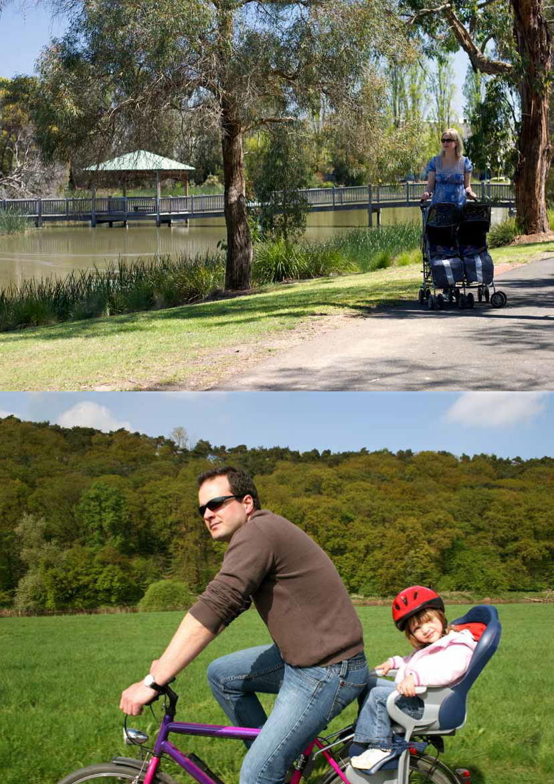

Enhancing supply through land use planning

Using policy and strategic planning

12

Part 2

13

Enhancing supply through land use planning

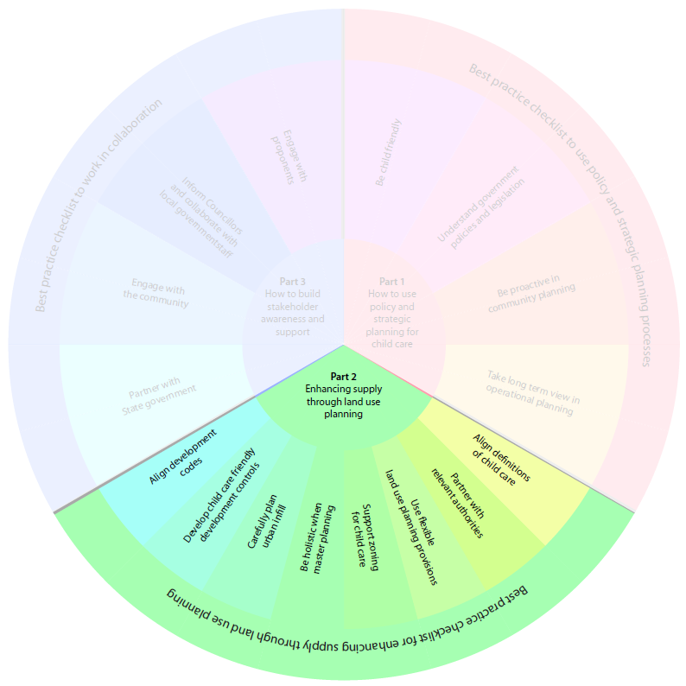

Introduction
Land use planning is the mechanism by which land gets approved for particular uses. Land use planning frameworks generally include:
- Land use zoning
- Development controls
- Development assessment.
Whilst the hierarchical nature of statutory planning instruments establishes a substantial role for state governments in strategic land use planning, significant delegated responsibilities provide an important role for local government to achieve state and local objectives via local land use plans.
Part 2 shows how local government can play a key role in ensuring child care is incorporated into land use planning to ultimately meet community needs.
  - Align definitions of child care
The National Quality Framework defines ‘centre- based care’ and ‘family day care’. Some local governments use different terminology and may also have different definitions of child care facilities.
It is helpful to ensure land use planning and child care service approval definitions are consistent or that the inconsistencies are known. This creates greater certainty for proponents. This will improve processing efficiency and avoid situations where child care development applications need to be re- assessed due to contradictions with service approval requirements.
  - Partner with relevant authorities
Local government is generally responsible for development approvals of child care facilities and state governments for service approvals. As planning approval is typically required before service approval can be granted, closer integration and consistency between these two processes via a referral process can speed up the process.
Referral processes typically involve assessment of a development application by both the local government and the regulatory authority to resolve any conflicts early on and avoid the need to reassess applications where there is a potential issue.

The Queensland Development Code (QDC)
The QDC provides local government with a template of development standards and desired outcomes for child care centres.
Where a proponent proposes an alternative way of achieving the development standards and desired outcomes, the QDC allows the Department of Education, Training and Employment (DETE) to assess the application in conjunction with the local government.
The DETE is also responsible for service approvals in Queensland and the referral process provides an early opportunity to identify and resolve potential issues with the development proposal that may prohibit granting of a service approval.
Queensland development code (http://www.hpw.qld.gov.au/construction/buildingplumbing/building/buildinglawscodes/queenslanddevelopmentcode/Pages/default.aspx)

  - Use flexible land use provisions
There is an increasing trend towards more innovative models of child care delivery. Being aware of new delivery approaches can help local government to think creatively about how to co-locate child care with other community facilities such as schools, sporting clubs and aged care residences, as well as close to where people work, without having to change zoning or development controls.

City of Port Adelaide Enfield, SA
The Parks Community Centre was an early model of integrated social welfare and education services to serve the needs of the local community.
The centre combined a high school, commercial offices, a health centre, swimming pool, library, open space and a child care facility.
At the time, it was a leading example of integrated service design.
In addition, working internally across departments and externally with partners to encourage new models of delivery via strategic, master and land use planning is a useful approach. Local government can use this approach to build organisational awareness and capacity to enable supply of child care through innovative delivery and land use models.

ACT Planning and Development Regulation (PDR) 2008
The PDR sets out development types that are exempt from requiring a development permit.
No permit is required for child care centres where they are to be developed at an existing school, so long as minimum standards are met:
- Boundary setback (6 metres)
- Building height (generally 12 metres)
- Located away from easements and heritage areas
- Plumbing and drainage building standards
- Complies with relevant lease arrangements.
ACT Planning and Development Regulations 2008 (http://www.legislation.act.gov.au/sl/2008-2/default.asp)
  - Support zoning for child care

Be consistent
Local government can enhance the potential supply of child care places by ensuring that this purpose is considered in all zoning types.
Consider assessing the level of consistency between zone objectives and appropriate land uses. Where two land use zones share the same objectives, child care can be considered appropriate uses in both zones.

NSW Standard Instrument
The NSW Standard Instrument provides local government in NSW with a base template of zone objectives and appropriate land uses to help draft local land use plans.
It outlines a common zone objective for medium and High Density Residential Zones as:
Provide facilities or services to meet the day to day needs of residents.
Child care centres are identified as permissible uses within both these zones.
NSW Standard Instruments (http://www.planning.nsw.gov.au/en-us/planningyourlocalarea/standardinstrument.aspx)

Zone for everyone in urban spaces
Trends toward more compact urban forms and integrated land uses means an increasing number of residents and workers share neighbourhoods.
As such, zone objectives can take into account the diversity of population and the full range of daily activities that make up your community.

NSW Standard Instrument
The NSW Standard Instrument zoning objectives acknowledge local communities consist of not only residents but also workers employed in an area on a day-to-day basis.
It identifies the objective of the Neighbourhood Centre Zone to:
…provide a range of…community uses that serve the needs of people who live or work in the surrounding neighbourhood.
NSW Standard Instruments (http://www.planning.nsw.gov.au/en-us/planningyourlocalarea/standardinstrument.aspx)

Zone for workforce participation
The availability of child care encourages economic vibrancy as it supports workforce participation.
This means that local government should aim to facilitate the location of child care in areas of high economic activity as well as close to places of residence.

York Park Master Plan, ACT
The York Park master Plan states there are to be limited commercial and retail uses to support those employed in this largely office and open space area.
However, the plan explicitly permits child care centres as a key land use planning policy which creates supply of child care close to a place of work.
York Park Master Plan (http://www.comlaw.gov.au/Details/F2005L02596)
  - Be holistic when master planning
Master planning takes a broad, systemic approach to a substantial land use and identifies current and future needs. Subsequently, land zoning (and rezoning) can deliver a mix of land uses which will meet the needs of the community.

Conduct a needs analysis
Master planning processes can take into account an analysis of housing, employment, major and community infrastructure, daily activity patterns of both residents and employees and also the characteristics of those living and working in neighbouring areas.
Community needs analysis for growth areas are particularly well established in Victoria and serve as a useful good practice model for enabling the supply of child care in master planning.

Metropolitan Planning Authority, VIC
Metropolitan Planning Authority local governments in Victoria entered into a partnership to develop Guidelines for Planning for Community Infrastructure in Growth Areas.
The aims of the guidelines are to:
- Address the demand of rapid population growth on community infrastructure provision
- Increase cooperation between local government and state agencies with responsibility for providing community infrastructure
- Increase capacity of local government to undertake local planning for community infrastructure
- Encourage consistency in community infrastructure planning.
The guidelines provide a consistent planning framework that local government can use to undertake a community needs analysis.
Planning for infrastructure in growth areas (http://www.mpa.vic.gov.au/planning-for-community-infrastructure-in-growth-areas-april-2008/)

Docklands, City of Melbourne, VIC
In 2002, a master Plan was prepared to guide the major redevelopment of the inner city area of the Docklands.
A 2007 amendment to the master Plan increased the amount of commercial space and outlined a potential resulting increase in the need for child care. In response, the City of Melbourne partnered with the Victorian Government and prepared a detailed Community Infrastructure Plan (CIP).
Based on updated demographic profiling of residents and workers, the CIP identified child care as a key priority and recalculated the number of places needed.
The CIP outlined the preferred land use model as co-location and the preferred mix of providers to include local government, private and community operators.
Docklands community infrastructure plan (https://www.melbourne.vic.gov.au/ABoUTCoUNCIL/PLANSANDPUBLICATIONS/Pages/Docklandscommunityinfrastructureplan.aspx)

Determine the number of child care facilities
Planning for the appropriate number of child care places can be a challenge but supply can be enabled by developing land use planning guidelines that establish a benchmark rate for the provision of child care.
Benchmarks, based on population compared to existing supply, can assist local government calculate child care requirements. However these benchmarks should be considered together with a range of other factors such as the availability of child care in neighbouring local government areas and the type of child care required. Benchmarks are a useful decision making tool but should be used as one factor amongst others when determining need.

Metropolitan Redevelopment Authority, WA
This agency is responsible for the redevelopment of urban areas around Central and East Perth, Subiaco, midland and Armadale.
To ensure these areas are places where people want to live, work and play, the mRA prepared a Planning for Social and Community Infrastructure in a Changing Perth Landscape Report to determine social and community needs as part of strategic planning.
The report provides benchmark guidance for determining an appropriate number of child care facilities to meet the needs of these communities, such as one centre for every 4,000-8,000 people.
Metropolitan Redevelopment Authority WA (http://www.mra.wa.gov.au/)

Partner to deliver
Whilst master planning ensures that the supply of child care facilities is considered a strategic priority for a particular parcel of land, this process can be strengthened by partnering with other authorities to link land use planning frameworks to wider strategic planning.

Metropolitan Planning Authority, VIC
In Victoria, local governments have partnered with the metropolitan Planning Authority to develop strong links between strategic and land use planning frameworks.
Detailed guidelines drive the land use planning process for these areas and encourage delivery of accessible, integrated and adaptable community infrastructure as a way to encourage local employment opportunities.
The guidelines state that master plans should be used as the basis for land use zoning for growth areas and provide a strong mechanism to enable child care from initial planning phases through to delivery.
Metropolitan Planning Authority VIC (www.mpa.vic.gov.au)

Townsville City Council, QLD
Townsville City Council provides an incentive based approach to deliver certain types of development, including child care facilities in the central business district (CBD).
Applications can be made to the local government under the CBD Development Incentives Program which allows proponents to negotiate to achieve fast tracked approvals processes to enable supply of child care.
Townsville economic development (www.townsville.qld.gov.au/business/economic/pages/cbdrevit.aspx)
  - Carefully plan urban infill
It is a challenge to supply child care within urban infill due to the limited availability of suitable land and higher land costs. In addition, urban infill areas may also have existing or former uses that are incompatible with child care. However, there are some innovative options to consider.

Use land smarter
To address the limitations of land supply, local governments can undertake a portfolio review to identify the range of suitable child care sites. Often child care can be incorporated into existing community facilities such as parks, libraries and swimming pools.

Leichhardt Council, NSW
This inner urban local government experienced a significant shortage of child care.
To address this challenge, they reviewed the suitability of their own sites with existing community facilities, including local parks, for child care.
Leichhardt also explored a range of models for child care provision, including being a provider, as well as leasing available community facility land owned by the organisation to community and private operators.
Leichhardt Community Council children (www.leichhardt.nsw.gov.au/Community/Children)
In addition, whilst local government is not always a provider of child care (or may not want to be), there are a number of models which use their land portfolio to enable supply.

City of Playford, SA
The City of Playford recently undertook a review of their existing commitment to operate a child care facility on land within their portfolio. Following the review, the local government decided to no longer be a direct child care operator.
Because of the large number of young families with children, the local government recognised it was important to ensure continued supply.
The local government requested expressions of interest from community based providers to continue operating an affordable child care service at the premises.
City of Playford SA (www.playford.sa.gov.au)

Keep track of land
It is helpful to ensure that the cumulative impact of changes in land uses in urban infill areas and land rezoning are accurately recorded to ensure child care is still a permissible use in these areas.
When coupled with strategic environmental assessments, this is a good practice approach to increasing the availability of sites and enabling supply of child care in inner urban areas.
  - Develop child care friendly development controls

Assess site suitability
Site suitability can be a particular challenge for inner urban areas where land is in short supply and child care is often not the most profitable use of a site. Local government can respond by co-locating child care within existing commercial developments to lower land costs and improve financial viability or other flexible strategies that respond to these issues.

Site suitability in Sydney, NSW
The City of Sydney has approached the challenge of site suitability in a way that responds to the unique local context.
The Child Care Centres Development Control Plan (DCP) 2005, acknowledges the need to cater for the child care needs of resident and workforce populations.
Recognising the higher density and constrained land supply in the area, the DCP provides for child care facilities to be located above ground floor, particularly in the central business district and surrounding high density areas where there are large employers.
The DCP allows approval for above ground child care facilities with indirect access to open space if there are no viable alternative sites.
Development control plans NSW (www.cityofsydney.nsw.gov.au/development/planning-controls/development-control-plans)

Limit the impact of noise
The impact (potential or actual) of noise on surrounding uses can create conflict. There are a number of development control measures which can be implemented to limit the impact of noise and reduce neighbour concerns, such as the use of landscaped buffers.

Noise in Brisbane, QLD
Brisbane City Council has developed a Child Care Facility Code that provides acceptable noise levels for child care developments.
The Code notes that impacts on the amenity of adjoining uses must be eliminated or mitigated. However, instead of prescribing an acceptable level for noise, the Code provides proponents with flexibility to mitigate the impacts, such as landscaping.
Operating child care facilities Brisbane (www.brisbane.qld.gov.au/planning-building/do-i-need-approval/business-projects/operating-child-care-facility)

Create car parking
Local government can ensure that development controls are flexible enough to respond to the specifics of the site context; such as high levels of public transport, plentiful parking for other uses (clubs, shopping centres), accessible on street parking or well used local bike ways. Inflexible or unrealistic demands for the provision of car parking can impact on the viability of a proposal. Where parking requirements have been predetermined, understanding how and why they were established may help to identify potential areas of flexibility.

Orange City Council, NSW
Orange City Council takes a unique approach to determining appropriate parking for child care facilities.
Whilst a base ratio of 1 space for every 4 children is provided, the orange Development Control Plan makes provision for this to be reduced where a proponent can demonstrate ways to mitigate the need for off-street parking, for example, a drive-through pick up bay or convenient access to public transport.
Development control plan Orange City Council (www.orange.nsw.gov.au/site/index.cfm?display=275628)

City of Joondalup, WA
The City of Joondalup has prepared a Child Care Centres Policy to ensure child care facility developments are compatible with adjoining land uses.
The policy provides guidance to proponents and local government staff on the location of child care facilities.
The policy encourages locating child care facilities adjacent to shopping centres and within mixed use developments. This approach promotes co-location of child care facilities where there is existing adequate parking.
Child care centres Joondalup WA (www.joondalup.wa.gov.au/Develop/ApprovalsAndRegulations/ForBusiness/ChildCareCentres.aspx)

Establish clear hours of operation
Child care operating hours need to be flexible in order to support the needs of modern families.
Local government can use development controls to provide flexibility in operating hours for facilities located close to major centres of employment.

Hours of operation Sydney, NSW
The City of Sydney has addressed the challenge of operating hours as part of the development control plan (DCP).
The DCP provides flexibility for proponents to determine operating hours for child care facilities in non-residential areas. Proponents can apply to vary operating hours in a manner compatible with adjoining land uses.
This approach enables supply and enhances opportunity for increased workforce participation (by shift workers and others) through allowing extended operating hours in the CBD.
Development control plans Sydney (www.cityofsydney.nsw.gov.au/development/planning-controls/development-control-plans)

Avoid restrictions that limit the maximum number of places
Many factors, including location and community need, can influence the minimum number of child care places a service must offer to be viable.
Limiting the number of child care places to a level below viability (commercially or to attract staff), through restrictions on the maximum number of places a service can offer, can limit proponent capacity to build child care facilities. Local government should consider ensuring that development controls are not too restrictive in terms of maximum number of places and that they are determined considering issues of viability.

Increase the minimum number of places
As part of City of Sydney’s Development Control Plan (DCP) for child care centres, a minimum number of 30 places is required. The DCP outlines that this is based on a minimum number of places to ensure facilities are viable in commercial and residential areas.
Development control plans Sydney (www.cityofsydney.nsw.gov.au/development/planning-controls/development-control-plans)
  - Align development codes
Local government can ensure development codes are aligned with the National Quality Framework to generate efficiencies in the planning and service approvals processes.
One example is outdoor play areas which, under the National Quality Framework, are required to have minimum dimensions. However, these areas are often considered open space within local governments and the minimum dimensions (often inconsistent with the National Quality Framework) are regulated by local development codes.
Local governments also have quite strict criteria around how much of the outside area should be shaded but this does not easily translate into practice.
Child care provider, NSW
Local government can undertake a thorough comparison between the National Quality Framework and their development codes to identify where there may be differences in the physical environment requirements and make adjustments accordingly.

Best practice checklist to enhance supply through land use planning
- Align definitions for child care | Yes | No | N/A
Is your definition of child care consistent with the National Quality Framework?
Is it clear internally and externally what your local government means by ‘child care’?

- Partner with relevant authorities | Yes | No | N/A
Do you partner with any other authorities to speed up the delivery of child care?
Can you develop such partnerships?
Can you identify opportunities for establishing referral processes with child care service approval authorities?

- Use flexible land use provisions | Yes | No | N/A
Have you considered any other models of child care provision?
Are you able to co-locate child care with other community facilities?
Are you able to exempt child care from all or part of the development process when it is co-located with comparable facilities?
Can you identify other decision makers internally and externally who can help you to make better use of available land?

- Support zoning for child care | Yes | No | N/A
Be consistent | - | - | -
Is the permissibility of child care consistent across your zones?
Are you able to change the zoning or can proponents request a change?
Zone for everyone in urban space | - | - | -
Have you mapped the actual daily land use activities across your local government?
Does your zoning for child care acknowledge that residents and workers both need access to child care, often within the same zone?
Zone for workforce participation | - | - | -
Do you know where child care is located within employment zones?
Can you encourage workforce participation by actively zoning for child care near major employment areas?
Do you understand the daily routines of families and where they might access child care?

- Be holistic when master planning | Yes | No | N/A
Conduct a needs analysis | - | - | -
Has a community needs analysis been undertaken as part of master planning?
Do you have enough capacity within your local government to conduct a needs analysis?
Do you know what the future needs are?
Determine the number of child care facilities | - | - | -
Do you have clear guidelines on how much child care is needed per age of children and size of population?
Have you benchmarked these guidelines against national, state or comparative local governments?
Partner to deliver | - | - | -
Can you identify appropriate authorities to improve the supply of land for child care?
Are there mechanisms to influence decision making?
Have you developed strong relationships with partners?

- Carefully plan urban infill | Yes | No | N/A
Use land smarter | - | - | -
Have you performed a portfolio review of potential infill land?
Can you identify partners you could develop your land with?
Are there opportunities to co-locate with existing community services?
Have you developed a range of models of provision that can be used to provide child care on local government owned land?
Keep track of land | - | - | -
Do you keep a register of the cumulative changes in land use as it relates to child care?
Is this identification built into your existing policies and processes?

- Develop child friendly development controls | Yes | No | N/A
Create car parking | - | - | -
Do your development controls consider the impact of car parking for both child care users and residents?
Do you know how to define ‘adequate parking’ for child care?
Do your controls allow for a reduction in car parking where location and transport access is favourable?
Limit the impact of noise | - | - | -
Do you have any noise restrictions (hours, type and volume) for child care?
Do you allow flexibility for proponents to mitigate rather than remove noise impacts?
Do you allow flexibility for proponents to mitigate rather than remove noise impacts?
Do you require noise monitoring post-delivery?
Assess site suitability | - | - | -
Is there flexibility in urban areas to provide child care above ground floor in high density areas?
Do you have controls about access to outdoor space in inner city child care?
Establish clear hours of operation | - | - | -
Can you allow flexibility to extend operating hours to enhance workforce participation?
Support commercial viability | - | - | -
Are your development controls prescriptive on the maximum size of child care facilities
Are your development controls prescriptive on the proximity of child care facilities to each other?
Can your codes be changed to support commercial viability and encourage supply?

- Align development codes | Yes | No | N/A
Do you have controls over the physical environment requirements of child care?
Do these controls align with physical environment requirements of the National Quality Framework?

Work in collaboration

26

Enhancing supply through land use planning

Part 3

27

Work in collaboration

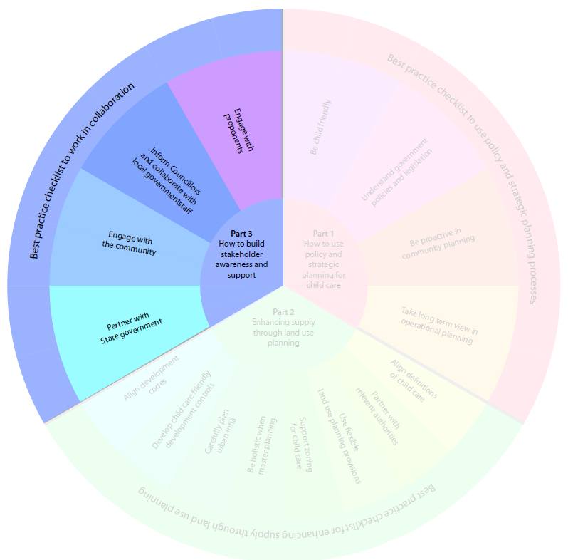

Introduction
Local government play a crucial role in the supply of child care by:
- developing partnerships with other levels of government to align the policy, procedures and practices for child care
- communicating and engaging with a range of stakeholders including communities, councillors, colleagues, child care providers and proponents on the importance of child care together with determining need and ways to meeting this.
Part 3 provides guidance and examples of how to build stakeholder awareness and support.
  - Partner with state government
State and local governments both support the availability of child care. By working in partnership, they can ensure that child care policies, procedures and practices are aligned. They can also share resources and information to develop a common understanding of state- level child care requirements and how actions from both support progress towards these needs.

Partnerships in Victoria
The Department of Education and Early Childhood Development (DEECD) and the municipal Association of Victoria (MAV) signed the Partnership Agreement which commits to building positive, collaborative relationships between the DEECD, MAV and all Victorian local governments and to increase the learning and development opportunities for children, young people and families.
The Partnership Agreement commissioned a survey of all 79 Victorian local governments to map how they supported children and young people, a key step to collating an evidence base for future planning. This led to a report, Victorian Local Government Support for Children, Young People and their Families (2011).
The report provides an analysis of comparative differences in five groupings of local governments:
- metropolitan with rural local governments
- growth areas with other metropolitan local governments
- interfaces with other metropolitan local governments
- metropolitan fringes with other local governments
- Best Start¹⁰ local governments with other local governments.
This analysis helps local governments benchmark child care facilities within Victoria.
Programs and initiatives – Victorian education (www.education.vic.gov.au/about/programs/partnerships/pages/partnermav.aspx)

- Engage with the community

Identify levels of understanding
Local government conducts community engagement to understand service needs, to evaluate performance and to plan for the future. During community engagement local government can also provide information and data about why the provision of child care is important for social cohesion and economic vitality.
Community engagement provides opportunities for local government to understand concerns about the real or perceived impacts of child care facilities. These concerns (often linked to the size of a proposed facility) are usually about noise, traffic and parking impacts. By engaging and educating communities about these issues, local government strengthens community support for child care. This can help to pre- empt objections to development applications which can facilitate a shorter approval timeframe.

A resident’s experience
During the development of these guidelines we spoke with a resident who had a large child care facility approved next door to her house.
You cannot believe how upset I was by the proposal! I was worried that the noise and the coming and going by the staff and the parents would ruin our quiet neighbourhood. We made a lot of objections to our local government, and organised many others to object.
The local government worked with us and showed us how they had made their assessment, and what evidence they used to judge impacts. Now the centre is up and running and our concerns proved not to be founded.

Engage early in the process
Often community objections to development applications cause delays or significant amendments of projects.
Objections are usually made on unfounded grounds – we need to increase the education about how it is desirable to live next door to a child care centre.
(Local government, NSW)
Early engagement with the community, particularly with neighbouring residents, can reduce the number and type of objections. Local governments can also actively encourage proponents to hold meetings with neighbouring businesses and residents very early on in the process.
Having an engagement forum was a real benefit. It opened up channels of communication. Participants were able to discuss concerns about noise, traffic and parking. We were able to discuss concerns and address them. The development application went relatively smoothly. This is partly as a result of the engagement forum.
(Proponent, NSW)

- Inform councillors and collaborate with local government staff

Inform councillors
Councillors play an important role in setting local government policies, priorities and budgets. They also participate in development assessment either directly, via an assessment role, or indirectly, through their role in representing community concerns about an application.
Councillors benefit from understanding the importance of the availability of child care for their communities, the benefits for children and families and for the local economy. This understanding can help them make well- informed decisions about proposals and put them in a stronger position to represent the long term needs of the community.
Local government is very involved in the supply of child care and is aware of the needs of the community in regard to this. The local mayor and councillors are incredibly supportive of child care in our community.
(Local government, NSW)

Collaborate with local government staff
A variety of departments within local government make decisions on child care but they often approach the issue from different perspectives. For example:
- children’s services may have responsibility for direct provision of child care
- land use planning makes decisions about the location of child care facilities and development guidelines
- property services or facilities management understand which of the local government’s own land and buildings could be adapted for child care
- financial management departments drive funding decisions for making land or buildings available.
Local government can try to encourage a more integrated approach to planning for child care which takes a holistic view of the needs of the community and available resources (local government resources and also other government agencies, not for profit organisations and the private sector) through a place based approach.
At a corporate level, this approach ensures that local government works in a cross- departmental, integrated manner to plan and deliver services, programs and infrastructure. This shifts the focus from organisational outputs to whole of community outcomes.

City of Swan, WA
The City of Swan is made up of a diverse range of locations and communities. The municipal area encompasses rural and agricultural areas, industrial and commercial interests, innovative new residential suburbs as well as significant historic areas.
Place planning divides the City of Swan into thirteen smaller ‘places’ based on geography or common interest. This approach provides a place-based focus for planning and encourages a sense of ownership and public participation within individual communities.
Places – City of Swan (www.swan.wa.gov.au/our_City/City_of_Swan_ Places)

- Engage with proponents

Engage early on
Proponents prefer early and continuous engagement, from concept to lodgement of the development application. This early engagement can significantly improve the delivery of child care.
Plan to invest time with key stakeholders from the initial stages of a project. This should make the process smoother and meet demand when and where it is needed.
Good relationships, strong networks and regular discussions with child care sector and community are important for understanding the need for child care.
(Local government, Tasmania)
Pre-lodgement meetings between planning staff and proponents encourage discussion on a range of issues prior to the submission of the development application. These meetings help stakeholders make informed decisions about the project and understand potential reports or studies required.
Many local government land use planners are also available to speak to proponents about applications without requirements for an appointment.

Ipswich City Council, QLD
Ipswich City Council has a dedicated planning website with a wide range of information to help proponents through the development application process.
The website also provides an option to book a pre-lodgement meeting.
Development Ipswich City Council (www.ipswichplanning.com.au/development)

Provide guidelines
Proponents often find it difficult to navigate the various requirements for child care approvals (e.g. local government development applications, the Building Code of Australia, approvals by the regulatory authority and seeking approval under family assistance law for Child Care Benefit).
By creating clear guidelines local government can outline the application process, any code requirements for child care facilities and how local processes fit in with state licensing and approvals procedures. Such clarification improves understanding of the multi-layered regulatory environment and helps proponents plan and deliver more effectively.
Councils could publish a register of how specific planning issues were dealt with because there are so many things that should be taken into consideration and can go wrong in terms of developing child care centres. Confidentiality could be dealt with by de-identifying the developer/provider.
(Proponent, NSW)

Hills Shire Council, NSW
Hills Shire’s Environment and Planning Services provide a fact sheet which covers a range of frequently asked questions to help proponents prepare their development applications and understand the requirements such as:
- What is a child care centre?
- Is approval from council required?
- Is a child care centre permissible in your zone?
- What is the minimum site area requirement?
- How do I design a child care centre?
- Is it necessary to discuss the application with a council officer?
- Do I need to attend a formal pre-lodgement meeting?
Child care development applications – Hills Shire Council (http://www.thehills.nsw.gov.au/IgnitionSuite/uploads/docs/Child%20Care%20Centre%20Development%20Applications%202013.pdf)

Best practice checklist to work in collaboration
- Partner with state government | Yes | No | N/A
Have you considered partnering with your state government to deliver more child care places?
Can your local government association/regional grouping partner for more child care places?
Are you aware of the information your state government generates that could be useful for your analysis of child care?

- Engage with the community | Yes | No | N/A
Identify levels of understanding | - | - | -
Does your community understand why the provision of child care is so important?
Do you engage/communicate with them to increase their understanding?
Have you articulated the benefits of child care to your community?
Are there opportunities to engage/communicate with current/potential neighbours to discuss possible concerns about impacts on amenity eg. noise, traffic, parking?
Engage early in the process | - | - | -
Do proponents engage with the community early on/during in the process?

- Inform councillors and collaborate with local government staff | Yes | No | N/A
Do you understand the position of your councillors regarding child care?
Are your councillors aware of the need for child care and the benefits it provides?
Can you identify opportunities to positively engage councillors?
Can you identify which departments/staff make decisions that affect child care?
Is the need for child care and its benefits widely understood within your organisation?
Do you work across functions and departments to ensure adequate child care?
Do you/can you take a place-based approach?

- Engage with proponents | Yes | No | N/A
Engage early on | - | - | -
Are proponents able to meet to discuss ideas and concepts with planning staff?
Do your processes support pre-lodgement meetings with/without appointments?
Is there a process for keeping communication lines open throughout the delivery cycle?
Provide guidelines | - | - | -
Are guidelines available which clearly explain the relevant development codes and how the requirements must be met?
Do you have a checklist of frequently asked questions to improve understanding of the process and deliverables?
Are the service approval requirements clearly understood?

Conclusion

These guidelines provide a starting point for local government to assess their processes for facilitating the adequate availability of child care within their area. The guidelines provide information on:
- National and state level policy and legislative frameworks and the need to align local government policies within this broader context.
- What can be done in the delivery of land use planning e.g. strategic land use planning, master planning and development controls, to facilitate the establishment of child care facilities.
- The important role that local governments play in engaging with stakeholders and providing information on the benefits of child care to the community, councillors, staff and proponents.
Each section also provides a quick checklist to help local government to quickly see areas where they are already implementing best practice and areas for improvement.
The information contained in the guidelines can also serve to inform discussions with state level organisations responsible for the establishment and delivery of child care services. The ultimate objective is to promote more streamlined mechanisms for development and service approval for proponents.
These guidelines are a start. Each state is different in its land use planning policies, legislation and procedures. In recognition of this difference local governments are encouraged to adapt the tool to their context to make it as relevant and as useful for their situation.

Bestp racti
n ce tio ch
ra ec
bo kli lla st
co to
in us rk e
wo po li
to cy
st an li d
ck st e ra
h
c te
e g
c ic
ti
c p a l r a
p n t n s i e n B g
p
r o
c e s s
e
s

gnin ptseB nalpe citcar sudnal kcehce
hguorht ylppu icnahneroftsil
s gn

Best practice checklist

36

Best practice checklist

Best practice checklist for using policy and strategic planning
- Be child friendly | Yes | No | N/A
Can you identify which of your policies are aligned with the Child Friendly City Initiative?
Are there other child friendly examples you can adopt/incorporate?
Are your policies aligned with the National Quality Framework and the National Quality Standard?

- Understand state government policy and legislation | Yes | No | N/A
Align your policies | - | - | -
Have you mapped which state government policies/legislation influence your provision of child care?
Do your policies align with these?
Are you able to align with/adopt them?
Are any of these likely to change in the future?
Brief your staff | - | - | -
Do your staff, or staff in other departments who make decisions which affect child care, understand how national, state and local policies and legislation overlap?
Are there opportunities for briefings when things change?
Assist proponents | - | - | -
Do you have appropriate mechanisms to brief proponents (who may be working across jurisdictions) to ensure they understand the requirements at state and local level?
Align regularly | - | - | -
Do you have a process to review and update or amend your own documentation and processes when policy and legislation changes at the national or state level?
Do you have ‘early warning’ systems in place to anticipate change?
When things change can you brief staff effectively and on a timely basis?

- Be proactive in community planning | Yes | No | N/A
Use a holistic approach | - | - | -
Is child care part of your wider strategic planning processes?
Are your community plans, strategic plans, land use plans, asset management plans and financial management plans consistent for child care?
Can you identify which departments influence child care planning and delivery?
Do you know which staff are responsible for property and facilities management?
Can you share ideas with transport planners?
Do your financial managers understand the need for commercial viability and how your own assets can be maximised for child care?
Undertake a needs analysis | - | - | -
Have the community been consulted with regard to future child care provision?
Does data exist on the numbers of children and their ages for your local government and neighbouring areas?
Does this data include predictions on expected changes over the next 5-10 years based on developments in the area and in neighbouring communities?
Do you have all the information you need?
Benchmark against a standard or comparative organisations | - | - | -
Do you benchmark the process by which you deliver child care?
Can you identify ways to improve this delivery?
Do you know how child care services in your local government area compare to services in other local governments under the National Quality Standard?
Plan for changes in demand and supply | - | - | -
Is current or forecast research available on the numbers of children and the types of child care required?
Are your planning processes flexible to accommodate any changes needed over time?
Are your planning timeframes consistent?
Can you work with other authorities to better understand supply and demand, especially where there are land use changes or new developments close to boundaries of local governments?
Do you have data on waiting lists for all long day care centres in your community?

- Take a long term view in operational planning | Yes | No | N/A
Utilise your own land and buildings | - | - | -
Do you own existing suitable facilities or land for child care?
Can your property management staff identify your own underutilised land and buildings?
Can child care be made a permissible use of this land or these buildings?
Work in partnerships | - | - | -
Can you identify key land or property owners in your area?
Do you have existing or ongoing relationships with them?
Is it appropriate to approach them about using their land or property for child care?
Are there processes in place to do this?
Would child care be supported as an acceptable use of this land or property?

Best practice checklist to enhance supply through land use planning
- Align definitions for child care | Yes | No | N/A
Is your definition of child care consistent with the National Quality Framework?
Is it clear internally and externally what your local government means by ‘child care’?

- Partner with relevant authorities | Yes | No | N/A
Do you partner with any other authorities to speed up the delivery of child care?
Can you develop such partnerships?
Can you identify opportunities for establishing referral processes with child care service approval authorities?

- Use flexible land use provisions | Yes | No | N/A
Have you considered any other models of child care provision?
Are you able to co-locate child care with other community facilities?
Are you able to exempt child care from all or part of the development process when it is co-located with comparable facilities?
Can you identify other decision makers internally and externally who can help you to make better use of available land?

- Support zoning for child care | Yes | No | N/A
Be consistent | - | - | -
Is the permissibility of child care consistent across your zones?
Are you able to change the zoning or can proponents request a change?
Zone for everyone in urban space | - | - | -
Have you mapped the actual daily land use activities across your local government?
Does your zoning for child care acknowledge that residents and workers both need access to child care, often within the same zone?
Zone for workforce participation | - | - | -
Do you know where child care is located within employment zones?
Can you encourage workforce participation by actively zoning for child care near major employment areas?
Do you understand the daily routines of families and where they might access child care?

- Be holistic when master planning | Yes | No | N/A
Conduct a needs analysis | - | - | -
Has a community needs analysis been undertaken as part of master planning?
Do you have enough capacity within your local government to conduct a needs analysis?
Do you know what the future needs are?
Determine the number of child care facilities | - | - | -
Do you have clear guidelines on how much child care is needed per age of children and size of population?
Have you benchmarked these guidelines against national, state or comparative local governments?
Partner to deliver | - | - | -
Can you identify appropriate authorities to improve the supply of land for child care?
Are there mechanisms to influence decision making?
Have you developed strong relationships with partners?

- Carefully plan urban infill | Yes | No | N/A
Use land smarter | - | - | -
Have you performed a portfolio review of potential infill land?
Can you identify partners you could develop your land with?
Are there opportunities to co-locate with existing community services?
Have you developed a range of models of provision that can be used to provide child care on local government owned land?
Keep track of land | - | - | -
Do you keep a register of the cumulative changes in land use as it relates to child care?
Is this identification built into your existing policies and processes?

- Develop child friendly development controls | Yes | No | N/A
Create car parking | - | - | -
Do your development controls consider the impact of car parking for both child care users and residents?
Do you know how to define ‘adequate parking’ for child care?
Do your controls allow for a reduction in car parking where location and transport access is favourable?
Limit the impact of noise | - | - | -
Do you have any noise restrictions (hours, type and volume) for child care?
Do you allow flexibility for proponents to mitigate rather than remove noise impacts?
Do you require noise monitoring post-delivery?
Assess site suitability | - | - | -
Is there flexibility in urban areas to provide child care above ground floor in high density areas?
Do you have controls about access to outdoor space in inner city child care?
Establish clear hours of operation | - | - | -
Can you allow flexibility to extend operating hours to enhance workforce participation?
Support commercial viability | - | - | -
Are your development controls prescriptive on the maximum size of child care facilities
Are your development controls prescriptive on the proximity of child care facilities to each other?
Can your codes be changed to support commercial viability and encourage supply?

- Align development codes | Yes | No | N/A
Do you have controls over the physical environment requirements of child care?
Do these controls align with physical environment requirements of the National Quality Framework?

Best practice checklist to work in collaboration
- Partner with state government | Yes | No | N/A
Have you considered partnering with your state government to deliver more child care places?
Can your local government association/regional grouping partner for more child care places?
Are you aware of the information your state government generates that could be useful for your analysis of child care?

- Engage with the community | Yes | No | N/A
Identify levels of understanding | - | - | -
Does your community understand why the provision of child care is so important?
Do you engage/communicate with them to increase their understanding?
Have you articulated the benefits of child care to your community?
Are there opportunities to engage/communicate with current/potential neighbours to discuss possible concerns about impacts on amenity eg. noise, traffic, parking?
Engage early in the process | - | - | -
Do proponents engage with the community early on/during in the process?

- Inform councillors and collaborate with local government staff | Yes | No | N/A
Do you understand the position of your councillors regarding child care?
Are your councillors aware of the need for child care and the benefits it provides?
Can you identify opportunities to positively engage councillors?
Can you identify which departments/staff make decisions that affect child care?
Is the need for child care and its benefits widely understood within your organisation?
Do you work across functions and departments to ensure adequate child care?
Do you/can you take a place-based approach?

- Engage with proponents | Yes | No | N/A
Engage early on | - | - | -
Are proponents able to meet to discuss ideas and concepts with planning staff?
Do your processes support pre-lodgement meetings with/without appointments?
Is there a process for keeping communication lines open throughout the delivery cycle?
Provide guidelines | - | - | -
Are guidelines available which clearly explain the relevant development codes and how the requirements must be met?
Do you have a checklist of frequently asked questions to improve understanding of the process and deliverables?
Are the service approval requirements clearly understood?

References and Appendix

Appendix

45

References
- Daley, J., mcGannon, C., and Ginnivan, L. 2012, Game-changers: Economic reform priorities for Australia, Grattan Institute, melbourne.
- Thompson, S., & maginn, P. (Eds.). 2012. Planning Australia: an overview of urban and regional planning. Cambridge University Press.
- LaGro, J. A. 2001. Site analysis: linking program and concept in land planning and design. John Wiley & Sons.
- www.unicef.org.au/Discover/Australia-s-children/Child-Friendly-Cities.aspx
- Unicef 2004 Building Child Friendly Cities: A Framework for Action, Unicef, Florence www.unicef.org.au/Discover/Australia-s-children/Child-Friendly-Cities.aspx
- http://www.unicef.org/crc/
- Unicef 2004 Building Child Friendly Cities: A Framework for Action, Unicef, Florence www.unicef.org.au/Discover/Australia-s-children/Child-Friendly-Cities.aspx
- MAV and DEECD VIC 2011 municipal Early Years Planning Framework and Practical Resource Guide MAV, Victoria http://www.mav.asn.au/policy-services/social-community/children-families/municipal-early- years-planning/Pages/default.aspx
- www.legislation.nsw.gov.au/sessionalview/sessional/subordleg/2011-653.pdf
- Best Start is a Victorian government early years initiative which supports families, caregivers and communities to provide the best possible environment, experiences and care for young children in the important years from pregnancy to school.

Appendix

Australian Capital Territory
ACT Planning and Land Authority, Environment and Sustainable Development Directorate
www.actpla.act.gov.au
Children’s Policy and Regulation Unit, Education and Training Directorate
www.det.act.gov.au

New South Wales
NSW Infrastructure State Environmental Planning Policies
www.planning.nsw.gov.au/ en-us/policyandlegislation/legislationandplanninginstruments/listingofstatepolicies.aspx
NSW Standard Instrument LEP program www.planning.nsw.gov.au/en-us/planningyourlocalarea/standardinstrument.aspx
NSW Early Childhood Education and Care Directorate, Department of Education and Communities
www.dec.nsw.gov.au/what-we-offer/regulation- and-accreditation/early-childhood-education-care
NSW Children’s Services and Care Licensing www.licence.nsw.gov.au/new/categories/children-services-care

Northern Territory
Land and Planning Services, Department of Lands, Planning and the Environment
www.lands.nt.gov.au/planning/planning
Quality Education and Care NT, Department of Education
www.det.nt.gov.au

Queensland
State Planning Instruments, Department of State Development, Infrastructure and Planning
www.dsdip.qld.gov.au/statewide-planning/state- planning-instruments-program.html
Community Infrastructure Designation, Department of State Development, Infrastructure and Planning
www.dsdip.qld.gov.au/strategic-planning/ community-infrastructure-designation.html
Department of Housing and Public works www.hpw.qld.gov.au/Pages/default.aspx
Office for Early Childhood Education and Care, Department of Education, Training and Employment
www.dete.qld.gov.au/earlychildhood

South Australia
Department of Planning, Transport and Infrastructure
http://dpti.sa.gov.au/planning/home
Education and Early Childhood Services Registration and Standards Board of South Australia
www.eecsrsb.sa.gov.au

Tasmania
Tasmanian Planning Commission http://www.planning.tas.gov.au
Education and Care Unit, Department of Education
www.education.tas.gov.au

Victoria
Community Infrastructure, Victorian Department of Transport, Planning and Local Infrastructure
http://www.dpcd.vic.gov.au/localgovernment/ publications-and-research/community- infrastructure
Department of Education and Early Childhood Development
www.education.vic.gov.au/childhood/providers/regulation
Municipal Early Years Planning Framework, Municipal Association of Victoria
www.mav.asn.au/policy-services/social- community/children-families/municipal-early- years-planning/Pages/default.aspx

Western Australia
Western Australian Planning Commission www.planning.wa.gov.au
Education and Care Regulatory Unit, Department of Local Government and Communities
www.dlgc.wa.gov.au

