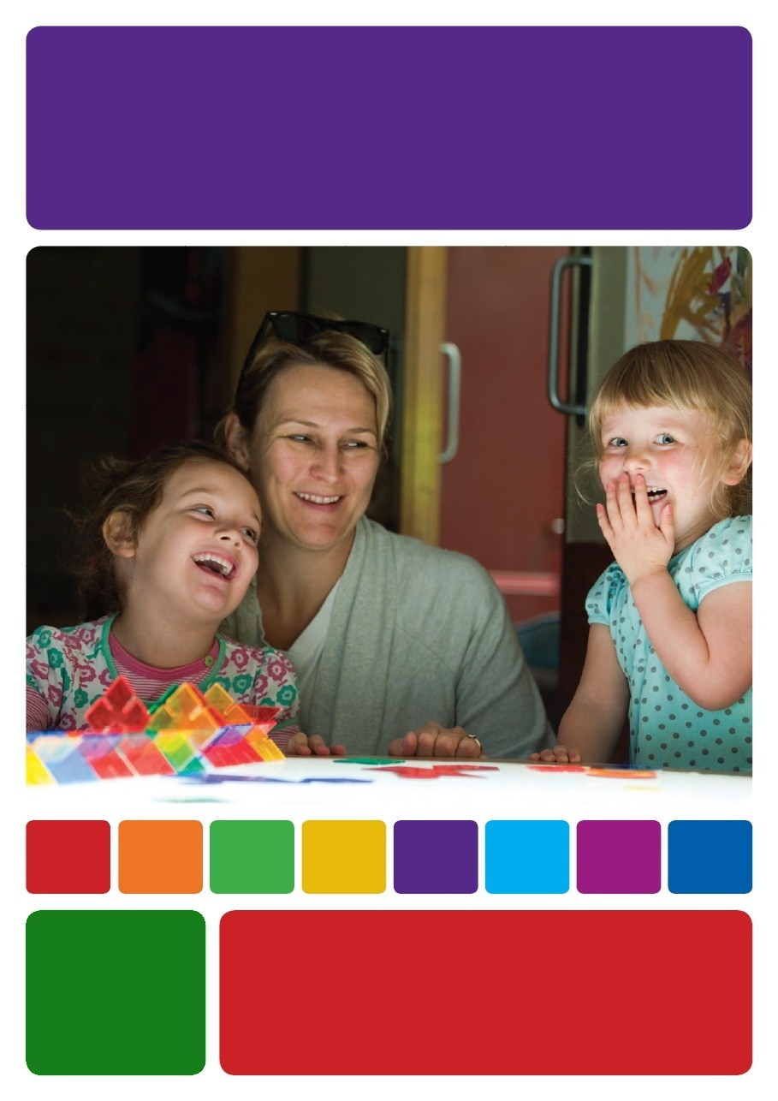
Living the Early Years Learning
Framework everyday

TEAM MEETING PACKAGE
The Early Years Learning Framework Practice Based Resources project has been funded by the Australian Government through the Department of Education, Employment and Workplace Relations. The resources have been developed by Community Child Care Co-operative Ltd (NSW) to provide support for early childhood educators to implement the Early Years Learning Framework.

With the exception of the Commonwealth Coat of Arms, the Department’s logo, any material protected by a trade mark and where otherwise noted all material presented in this document is provided under a Creative Commons Attribution 3.0
Australia (http://creativecommons.org/licenses/by/3.0/au/) licence.
The details of the relevant licence conditions are available on the Creative Commons website (accessible using the links provided) as is the full legal code for the CC BY 3.0 AU licence (http://creativecommons.org/licenses/by/3.0/au/legalcode).
The document must be attributed as the Early Years Learning Framework Practice Based Resources - Team Meeting Package.
ISBN: 978-0-9873543-2-7
CONTENTS

USER GUIDE 4
SESSION 1
A sense of direction Working with the EYLF’s learning outcomes 8
SESSION 2
Belonging, being and becoming 11
SESSION 3
Shared thinking 14
SESSION 4
Learning is everywhere 17
SESSION 5
Relationships matter 20
SESSION 6
Intentional teaching 23
SESSION 7
Continuity of learning 26
SESSION 8
High expectations 29
CONCLUSION 32
GLOSSARY OF TERMS 32
Team Meeting Minutes Template 33

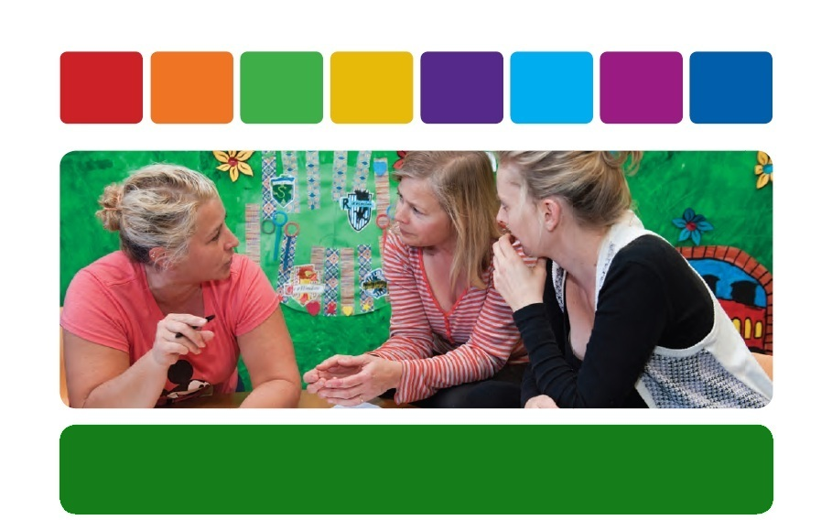

USER GUIDE

What is the Team Meeting Package?
The Living with the Early Years Learning Framework Everyday - Team Meeting Package is a useful approach to helping early childhood educators reflect upon the Early Years Learning Framework (EYLF) within the setting. Key to successful implementation is the engagement of all staff, and the leadership role taken by management and coordination staff. This package provides a plan for reflecting on the EYLF within team or staff meetings. This is not a formula or recipe for ‘doing’ the EYLF - look upon it as some support for professional learning and reflection within the education and care service.

Who is the package for?
The package is appropriate for early childhood educators and staff in all settings within the sector.

How will the package be used?
The Living with the Early Years Learning Framework Everyday - Team Meeting Package can be used in any way that suits your team and setting. You may choose to cover the content over a few sessions or in eight team meeting sessions or use it in any combination. There are Thinking Points and suggestions for activities that may be more easily digested over time and with periods to engage with concepts allocated in between. Each session has a suggested allocation of approximately 60 minutes to fit in with a team meeting. Understanding and professional growth occurs over time and a planned approach to implementing the EYLF is essential. Therefore this package may be used more than once with the same team, or may be revisited as new members join.

Structure of the package
In the Living with the Early Years Learning Framework Everyday - Team Meeting Package you will find clear guidelines as to where one session ends and the next begins. The guidelines are seen as a leadership tool and allow you to adapt the package to suit your needs and the needs of your service. The order of the sessions can be used in any way you feel best suits your team and setting.

Participant handout
Each section of the Living with the Early Years Learning Framework Everyday - Team Meeting Package includes a section for participants to read prior to coming to the team meeting. These sections can be photocopied and provided to educators and staff prior to the meeting. Each section includes information about the key topic, an example of what this might look like in every day practice and some Thinking Points which allow for individual reflection.
We encourage educators and staff to bring their individual reflections to the team meeting and share their thinking with the team.

Team meeting notes
In the Team Meeting Notes you, the facilitator, will have clear information to support you to lead the session. The order of the sessions can be used in any way you feel best suits your team and setting. The notes aim to support you to extend the current knowledge of educators and staff and to adapt it to suit your needs and the needs of your particular setting. Educators have diverse experience, training and backgrounds and this must be considered in any discussion.
Use the discussion questions and Group Exercise sections to initiate and extend discussions between educators. To extend the commitment of the group and to support the team’s professional learning, Decide on an Action that allows the group to follow up within the service. Encourage the group to document their learning and to bring their thoughts, challenges, ideas and successes to the next session.

PowerPoint presentation
The PowerPoint presentation is an additional resource that can be used to support the Team Meeting Notes. Check through the presentation and use individual slides as a support for your experiences and discussions.

The facilitator or leadership role
In order to effectively use this guide all staff will need to have some degree of familiarity with the EYLF. At each session, the facilitator should remind all educators and staff that the success of this session relies on the willing participation of each person. Create a positive learning environment for educators and staff, where sharing is encouraged and everyone is valued equally as a thinker. Remember that:
- All opinions are welcome;
- Everyone has a different perception; and
- There is no right or wrong.
The facilitator of the sessions will need to be familiar with and feel confident with the Framework before embarking on any Team Meeting sessions and related Group Exercises.
These exercises are intended to be led by an educator within the service who has the most extensive knowledge and understanding of curriculum and theoretical knowledge. The facilitator needs to have a close relationship with the educators and staff, the children and families to make learning relative to the individual setting.
Now, if the Framework is still awaiting the team’s attention, distribute it to the team and encourage them to become familiar with it prior to the team meeting session/s.

Suggested checklist for the team meeting

- Team Meeting Notes
- PowerPoint presentation
- Laptop or data projector and/or access to a computer
- Copies of the EYLF for participants for reference
- A copy of the Educators’ Guide
- Team Meeting Minutes template, and
- Resources for activities and experiences
(if required).

Tips for running team meetings
Here are a few tips to assist with running effective team meetings. This extract provides a general guide for meetings. Meetings are an important and an integral part of a successful program. Staff should be informed of the meeting time in advance so they can prepare or plan any activities. Each meeting can be a platform to:
- Discuss and express concerns;
- Share information, for example professional development sessions attended, inservices, seminars, and newsletters;
- Discuss programming and policy issues;
- Discuss relevant information on children/families;
- Discuss any issues or concerns from staff; and
- Debrief on any relevant issues occurring in the previous month or fortnight.
Time is precious so it is important to be very clear about what you want the meetings to achieve. For example, it is not useful for a team to be pulled into a negotiation between two individual staff. It is also important to have a balance of problem solving issues and opportunities for learning and creative discussion (an excellent opportunity for EYLF discussions!)
Discussing with the team how they want to use their meeting time and developing agreements about how this will be achieved can make meetings much more productive. For example, an agreement could be that if a problem is raised, a possible solution also needs to be suggested.
It is up to each individual setting and team meeting leader to decide how and when these Team Meetings will be held and what information will be discussed and reflected upon. It is also important to have a good grasp of the individual personalities within the team and be able to take these into account when facilitating discussions and Group Exercises.
In some instances it is best to have the Team Meetings in the one larger group and in other instances it may be better to break off into smaller individual groups. Some teams may even consider inviting parents and management members to be a part of the experiences - obviously keeping in mind that discussions do not involve individuals and confidential matters.
Remember to enjoy the process and to respect the opinions of everyone involved. In most teams it is rare to reach absolute consensus and individual opinions need to be respected and validated. Sometimes it is a matter of agreeing to disagree!
(Adapted extract Community Child Care Co-operative
(NSW) 2008, pp194-195)

Adult learning
In early childhood settings we spend most of our time working with children before they start formal schooling. However, adults can be somewhat different in the situation of learning. The following information will assist you in your preparation of, and presentation for educators.

What is special about adults as learners?
- Adults have a great deal of experience to draw on. This experience will be valuable and adults will resent learning if it does not take into account their experiences.
- Adults may have preconceived ideas about the situation of learning. These may be based on their positive or negative experiences that have occurred at school, college, university, or other places of learning. This means that some adults are more prepared to learn than other adults.
- Adults may have firmly established attitudes. These may be a barrier to learning, but they may also be a resource for learning.
- Adults may bring a number of preoccupations to the learning situation. They bring worries from home or work with them. This may mean that they are tense or anxious and need to be diverted from these preoccupations.
- Adults may be more internally motivated. They will respond to external motivation on a very limited basis.
- Adults usually approach learning with a specific set of expectations. They will want something out of their meetings and professional development.
- Adults may feel that they know all of the ideas and material being presented and they may have heard it all before. Let them know this may be a positive affirmation of their knowledge and that sharing this knowledge will benefit others.

What do adults worry about when they come to training?
Adults may be concerned that they will be embarrassed during participation in larger group discussions - they may feel quite threatened by the experience.
They may also feel they are unable to keep pace with the rest of the group or that they do not understand the concepts being discussed and reflected upon. Confidence may also be a concern and people may feel insecure and therefore reluctant to contribute.
As the leader you must always remember to respect the participants. It is your job to facilitate learning and sharing of ideas and concepts. This will only happen if everyone feels secure and stimulated.

Keep the following points in mind when preparing for the team meetings:
- Use the strengths of the participants. This will facilitate greater learning for everyone participating. Draw on the knowledge and strengths that you know already exist within the group.
- Acknowledge the experience of the participants. Use the knowledge and experience as a building block in the meetings. This will further everyone’s learning and will make people feel valued and respected.
- Respect the participants as independent learners. Each person comes to the meeting as an individual. As adults they are also independent and will also want to be responsible for their learning. Their reward for coming to the meeting will be an increase in knowledge and understanding of some new ideas. If every person takes this away from the meeting you have had a successful session.
- Keep the focus on fun and participation. Adults will continue to learn at a greater rate if they are enjoying themselves and they are participating in the discussions. Studies show that adults will tune out from speakers 7 minutes after the presentation begins. This is why it is important to get participants involved and thinking early on in the meeting.
- Participation is one of the keys to a successful meeting. With participation you will be able to facilitate learning and reflections with ease. Some people will be reluctant to participate and it is important that the option to be an observer is respected
- When brainstorming and conducting group discussion, clearly state what your intention is. Ask for responses to open questions - such as the Thinking Point questions. Value each contribution. It can be helpful to restate their response to ensure that you have understood.
- At the conclusion of the meeting thank people for their contribution. This will assist in building people’s confidence and encouraging the development of the team.
- Final points. You may be working with people with varying levels of literacy and understanding of the English language. You must acknowledge diversity may exist within the team. People may come from a range of language, educational, sexual or cultural backgrounds. This means that presentation must be clear, concise and may need to be adapted in accordance with the training, experience and background of the participants.
(Edited extract, Lady Gowrie Child Centre, Sydney, 1997, pp10-11)
Remember to enjoy the process and to respect the valuable input, experiences and opinions of everyone involved.

SESSION 1
A sense of direction
Working with the EYLF’s learning outcomes

Participant handout
The EYLF’s learning outcomes help to give a focus to our work with children. They tell us that there are certain things we, as educators, should be working towards. They also remind us that learning is too important to be left to chance. Instead we have a responsibility to do what we can to help each child reach the outcomes.
We will have done our job if every child leaves our care:
- With a strong sense of identity;
- With a sense of connection to their community;
- With a strong feeling of wellbeing;
- As a confident and involved learner; and
- As an effective communicator.
Without the learning outcomes it can be hard to give our program a sense of direction. As educators we are usually very good at thinking about what is going to happen in the short term. We plan for this afternoon, tomorrow or next week. But are we as good at thinking about things over the longer term - next month or next term or next year?
None of the outcomes are about short term learning. None can be achieved through a single experience, no matter how wonderful that experience is. There is, for example, no single thing we can do to give a child a strong sense of identity, or to make them into an effective communicator.
That is not to say that individual experiences don’t matter. Individual experiences make up the steps that can lead toward the outcomes. The learning outcomes are the product of many different experiences that build on each other.
When we think about learning in this way it helps us to start thinking about our work with children in terms of the bigger picture - as more than just a collection of unrelated experiences or activities, but instead as a series of experiences that lead to something bigger.
If we imagine a brick wall, made up of many bricks joined together, then we can see that while the wall is made up of individual bricks, none of those bricks by themselves makes the wall. Even a pallet of a thousand bricks doesn’t make a wall until we put them together in the right way. While the individual bricks are important (because the wall cannot exist without them) the wall is more important because it takes the collection of individual bricks and turns them into something new, something that is more than just the sum of its parts.
The EYLF outcomes are similar to the brick wall - they represent a collection of experiences that fit together to create something important. Like the bricks in the wall, experiences do not just fit themselves together. Our role as educators is to make them meaningful for children. We do this by helping to put the experiences together in such as way that they help each child to reach the learning outcomes.
If we focus too closely on the individual experiences at the expense of the bigger picture, we can fall into the trap of thinking that the individual experiences are the outcome rather than simply being one small part of it. To go back to the brick wall analogy - an individual brick is not a wall until it has been put in place alongside all the other bricks. Rather than focusing on each individual experience as though it alone will lead to the successful achievement of an outcome, we need to take a longer view - one that lets us see how that single experience links to and builds on many other experiences to ultimately lead to the outcome.

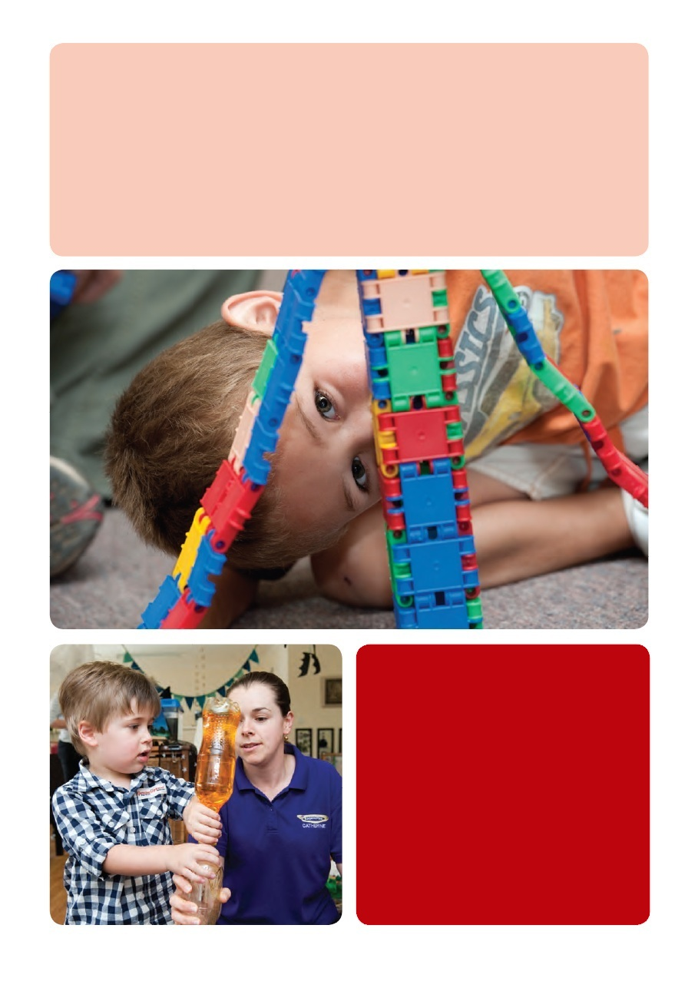

EYLF’s learning outcomes
- Outcome 1 - Children have a strong sense of identity
- Outcome 2 - Children are connected with and contribute to their world
- Outcome 3 - Children have a strong sense of wellbeing
- Outcome 4 - Children are confident and involved learners
- Outcome 5 - Children are effective communicators

Thinking points

- Think about what you already do in terms of the learning outcomes. How does what you do help children to work towards each of them?
- How do the experiences and activities you provide link over time to produce long term learning?
- How do you plan for and support the development of personal characteristics like identity and wellbeing?

Team meeting notes
The EYLF’s learning outcomes can help to provide a sense of direction and focus to what we do, but working out how to integrate them into our programs can be challenging. Working with learning outcomes is a new experience for many early childhood educators. An important step toward using the outcomes effectively is to think about how we plan for and coordinate children’s learning over the long term.
If you are going to use this resource sheet as the basis for a team meeting you should consider:
- Your team’s experience in working with outcomes - are your educators already familiar with an outcome based approach or is this something new to them?
- How you currently plan for children’s learning - do the outcomes fit easily into what you already do?
- How you plan for long term (as well as short term) learning; and
- How you monitor children’s progress over time - the EYLF talks about measuring the “distance travelled” by each child in each outcome area.
Depending on your team’s familiarity with an outcomes based approach you might want to emphasise that the outcomes are not intended as a checklist. The nature of the outcomes means that they will be constantly evolving. What a strong sense of identity looks like in a 2 year old will be different to a 4 year old and probably different again in a five year old. This will be true for each of the outcomes. The idea of “distance travelled” better captures the spirit of the EYLF outcomes than a one-off, checklist approach. As educators our role is not only to help each child reach the outcomes but also to help them maintain that achievement and continue to develop in each of the outcome areas.
Some discussion questions that might be helpful:
- How do the outcomes fit with what we already do? Which do we support well and which need further work.
- What would each of the outcomes look like with the different age groups that we work with? What does identity look like for a baby or a five year old? What is effective communication for a toddler.
- How does our way of working fit with the idea of long term learning? How does what we do from day-to-day and week-to-week link together and how do we ensure that we focus on the long term as well as on what we are doing right now?

Group exercise
Take each of the outcomes one by one and discuss them as a group. If you have a large team you could divide into small groups and take an outcome each. Alternatively you could work through the different outcomes over a number of meetings.
Using the evidence examples in the EYLF as a guide build up your own picture of what the outcome might look like for the children you work with. Discuss how the outcome is reflected in your program as well as in your everyday routines, transitions and interactions.
List the things that you already do that contribute to the achievement of the outcome. Start a list of what else you could do to contribute to meeting the outcome.

Decide on an action
Use the group exercise to highlight key actions for each of the outcome areas. Depending on how much you decide you need to do you might take it one outcome at a time. Don’t try to do too much all at once. You will probably find though that actions in one outcome area will flow into the others because of the way in which the different outcomes overlap and support each other.
Remember to document your actions in your Team Meeting Minutes. This will contribute to your self-assessment and in planning for your Quality Improvement Plan.

End of Session 1.

SESSION 2
Belonging, being and becoming

Participant handout
Belonging, being and becoming are the big ideas that underpin the whole EYLF. Together they describe what we are hoping to achieve for the children in our care. If every child can experience a genuine sense of belonging; if they can have time and space to be themselves; and if they can be supported in who they are becoming then we will have done a good job.
“In early childhood settings children develop a sense of belonging when they feel accepted, develop attachments and trust those that care for them.”
(Early Years Learning Framework, p.20)

Belonging
To belong is to feel included. It is to feel welcome and connected to what is going on around you. Belonging, being and becoming are all critically important. Belonging however is crucial because of the role it plays in enabling being and becoming to occur.
Belonging helps to give children the security and confidence to explore their world. By building a sense of belonging we also build identity, wellbeing and the ability to learn.
Because belonging is about being part of a group, relationships are critical. When we develop meaningful relationships with children and their families we help to create a sense of belonging. Making sure that we treat everyone as an individual, worthy of our time and our respect is a good start. Openly welcoming and accepting the diversity of the different cultures, backgrounds and beliefs that exist in all services also helps all families and children to feel that “this is a place I can belong”.

Example
“First impressions count so we work really hard to make sure that the feeling when you walk through the door is welcoming. We get to know the children and their parents as quickly as we can - we make sure there is time to say hello to everyone every morning and we try to remember something about them. By showing an interest I think you definitely create a sense of welcome.
We also find that some of our daily routines and rituals work really well to create a sense of belonging. We have a sign on sheet for the children as well as for their parents. The children love the feeling of importance when they get to write their own name. It might only be a small thing but it helps each child to feel part of what goes on - it feels like their place rather than just being our place.
I love it when someone new is picking up a child maybe a grandparent or an aunty - and the child proudly takes them on a tour of “my child care”, showing them all their favourite places and things to do - that to me is a sense of belonging. ”

Being
Being is about having the chance to be yourself - to do the things that you want to do, and to do them in your own time. When children have the chance to “be” they are able to lose themselves in what they are doing.
High quality early childhood programs provide children with the time and space to explore and engage with their surroundings; the time and space to develop deep and satisfying relationships; and the time and space to simply enjoy themselves.
The idea of “being” is a reminder that life does not have to be hurried, and that childhood should be a time of joy, wonder and exploration, rather than one of pressure, haste and stress.
Sometimes this sense is lost in the busyness of everyday life. We can feel pressured to always be thinking of “what comes next?”. The EYLF reminds us:
“The early childhood years are not solely about preparation for the future but are also about the present” (p.7)

Example
“When I see a child deeply engaged in play, it makes me want to be a child again myself. That ability to throw yourself so completely into something, without all the interruptions and cares of being an adult - to give all your attention to building the best block tower that you can, as though it’s the most important task in the world - who wouldn’t want to go back to that?
For me that’s the value of “being” - it’s not so much about the learning that might be happening (although that’s important too) it’s about learning to love learning. That’s such an important thing to have.”

Becoming
The third of the EYLF’s big ideas is becoming. Becoming highlights the importance of the early childhood years to children’s later experiences and opportunities in life. It also highlights our role in helping children to reach their potential. It reminds us
that while “being” is important we can’t afford to ignore the future either. Preparation for the future shouldn’t be our only aim. But it is part of our role. By balancing the chance to “be” with a sense of becoming we help children to become confident, successful learners.

Example
“When I think about becoming it’s not about preparing children for anything in particular. We do lots to help the older children prepare for school, and that’s really important, but “becoming” is about so much more than that. It’s about having all the possibilities of life in front of you, all the choices open to you, and how we help children to make the most of those chances.
For us it’s about exposing children to a whole range of experiences and ideas and ways of doing things to help give them a sense of those possibilities, a sense that they can be anything that they want to be.”

Thinking points
- What does belonging feel like to you? How do you help each child at your service to feel a sense of belonging? Where in your service can children and families find their culture reflected in a way that helps them feel good about themselves?
- What opportunities do children have for “being” in your service? Where does “being” fit into your daily routine? How do you provide the flexibility and open-endedness that is so important to children’s chance to “be”?
- How do you provide children with a sense of becoming? What do you do to help each child to develop and realise their potential?

Team meeting notes
Belonging, being and becoming provide the foundation on which the EYLF is based. Elements of each idea can be found throughout the framework. Because of this they provide a good starting point for beginning to explore the framework and how it might be used. In doing so it is important to remember that the three ideas are strongly connected. We can’t separate them out and focus on only one at the expense of the others. All three are essential parts of high quality early childhood programs.
If you are going to use this resource sheet as the basis for a team meeting you might want to think about and review:
- How belonging, being and becoming are currently represented in your service?
- How strongly children and families feel a sense of belonging to your service?
- What opportunities there are for being?
- How you currently support children’s sense of becoming?
From reading the resource sheet your team members should be starting to think about how each of the three ideas apply to their work. Because feelings of belonging, being and becoming are so personal it may be a good idea to start your discussion by asking each team member to talk about what the concepts mean to them, or perhaps use the group exercise outlined below. Alternatively you could start off with the thinking points from the resource sheet.
Some further discussion questions that might be helpful:
- How do we currently incorporate belonging, being and becoming into what we do? What do we already do well? What could we improve?
- Sometimes we are so close to our own practice that it is hard to see it objectively. Imagine that you are walking into your service for the first time (or remember the first time that you did) - what do you notice? what does it feel like? what makes you feel welcome?
- How do we support a sense of belonging in our day to day interactions with children? Do all children feel a sense of belonging? If not, why not?
- How do we include families in our thinking about belonging? How does the way we communicate with families create a feeling of belonging and partnership? How does our orientation process for new families and children help to build a sense of belonging?
- What does time for being look like? Where and when do our children have the chance to “be”? How could we provide more opportunities for “being”?
- How do we nurture a sense of becoming? How does our program help to recognise and develop children’s potential?
- How do we balance being and becoming so that both are part of what we do? How can we help prepare children for transitions, such as starting school, while still maintaining a sense of being in what we do?

Group exercise
Because feelings of belonging, being and becoming are so personal it can be useful to reflect on your own experience in order to think about how you go about creating such feelings for others.
Think back to your own childhood. Discuss with a partner where you felt most comfortable. What made you feel that way? As a child what was most important in helping you to feel that you belonged? Share some of the responses as a group and discuss what you can learn about belonging from your own childhood experiences.
Discuss your experience of being with a partner. Think of a time you could just “be” as a child and as an adult. How did it feel? Again share some of the responses and discuss how you could provide more opportunities for being in your program.
Finally, discuss with a partner your own childhood experience of becoming. Did you have a sense of becoming? Where did it come from? How much was it your own, and how much was it based on others expectations? Share some of the responses and discuss what a sense of becoming might look or feel like in your service. As a group use the ideas you have come up with to develop a statement about belonging, being and becoming that outlines your approach to each concept and what you will do to promote them.

Decide on an action
On the basis of your discussion identify which, if any, of the three ideas need further attention. You might want to consider specific strategies to:
- support feelings of belonging;
- develop environments, routines and relationships that nurture being; and
- recognise and support children’s potential
Think about what you might do to ensure that issues of belonging, being and becoming are considered on a regular basis and become a central focus of your work.
Remember to document your actions in your Team Meeting Minutes. This will contribute to your self assessment and in planning for your Quality Improvement Plan.
End of Session 2.

SESSION 3
Shared thinking

Participant handout

“Educators are actively engaged in children’s learning and share decision making with them. They use everyday interactions with children during play, routines and ongoing projects to stimulate children’s thinking and to enrich their learning.”
(Guide to the National Quality Standard, p.124)

For young children play is an essential part of learning. Through play children are able to:
- make sense of their world;
- develop and explore their own interests and ideas;
- develop curiosity, creativity and problem solving skills; and
- build relationships, social skills and language.

Above all play is enjoyable, satisfying and fun.
Learning through play does not just happen. Educators play a vital role in supporting play and learning. It is not enough to simply allow children to play and then stand back and wait for the results. Children’s play is enriched when educators are directly involved. By engaging in play educators are able to support, guide and extend children’s learning as it happens.
Supportive educators use a range of strategies to involve themselves in play. These can include observing, listening, providing resources and materials, commenting and questioning as well as direct participation. Educators use their own judgement to decide when and how to best involve themselves in play. The aim should be to support and enhance children’s learning without taking over.
When children have the chance to investigate and solve problems with each other and with supportive adults their thinking and learning becomes deeper and more complex. This process of working together is called “sustained shared thinking”.
“Sustained shared thinking” is most effective when:
- it is a shared experience between two or more participants;
- educators become involved in children’s play to “scaffold” their learning; and
- children have uninterrupted periods of time in which to get deeply involved in play and problem solving.

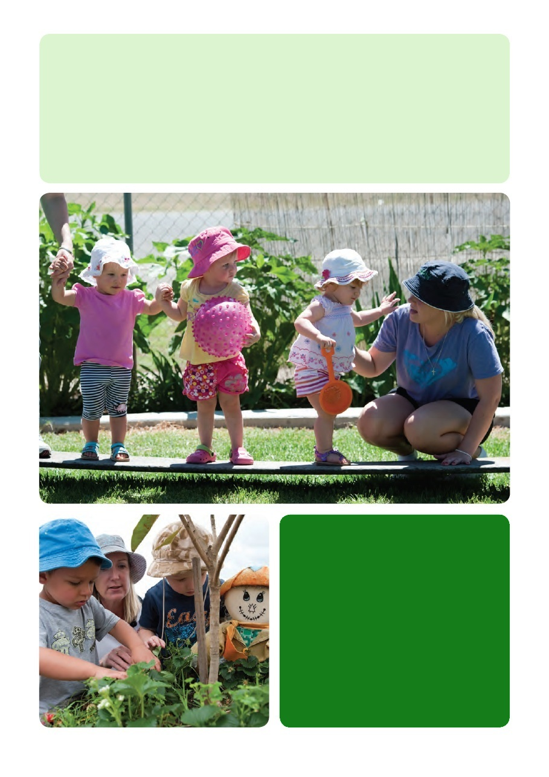

Example
“Everyday I see how important my involvement is to children’s learning. Sometimes it is through asking a question that shifts a child’s understanding to a new level, or setting up an experience that captures the group’s imagination. Even if my presence is just the hook that gets a child interested in an experience, I can see how my involvement makes a difference. And to tell the truth I’m not sure what I would do if I wasn’t involved. The reason I love teaching is seeing children learning and feeling that I am a part of that. Sometimes I’m as excited as they are! If I’m not there as part of the experience then all those moments go by without anyone noticing them, or helping them to happen. Just to sit back and miss all of that - I don’t think I could do it”.

Thinking points
- As an educator how and when do you involve yourself in children’s play?
- What strategies do you use to extend children’s play?
- How do you draw the line between being supportive and involved and taking over?

Team meeting notes
When educators involve themselves in children’s play they help to shape and guide children’s learning. Knowing when and how to be involved is an important skill for all educators to develop. Different strategies will work in different situations. Responsive educators use their knowledge of the children, and of how children learn to judge how best to support and extend children’s thinking. Responsive educators also recognise that while their involvement in play is important, children need time to play without direct adult involvement as well.
If you are going to use this resource sheet as the basis for a team meeting you should consider:
- What level of involvement in children’s play is normal in our service.
- How does this involvement help to support children’s thinking and learning?
- Do all educators recognise the importance of their involvement?
- What strategies do educators currently use to involve themselves in play?
If your team members have read the resource sheet prior to your meeting they will have been introduced to the idea that educators should be involved in children’s play and learning. You might want to start your discussion by talking about this expectation - what does it mean to be involved in children’s play? - or by asking how team members responded to the thinking points at the end of the resource sheet.
Some further discussion questions that might be helpful:
- What strategies do you find most useful for extending children’s play?
- How do you decide when to intervene and when not to?
- When does involvement become “taking over”.
- How can we involve ourselves in play while still allowing children time to play by themselves without direct adult intervention?
- How does our program encourage problem solving and provide opportunities for “sustained shared thinking”?
- How often as educators are we able to get deeply involved in “shared thinking” with a child or group of children?
- How can we balance the need to maintain adequate supervision while still being involved in play?
For educators who may be unsure about how to involve themselves in children’s play the following group exercise may be helpful. The list of questions and comments you develop will make a useful resource to help educators expand the strategies they use to extend children’s thinking and learning.

Group exercise
Ask each educator to think of an experience where their involvement made a difference to children’s learning. Explain to someone else what you did, why you did it and how it helped. As a group make a list of questions and comments that each of you have successfully used to expand and enrich children’s thinking. If it would be helpful you could also make a list of those questions and comments that haven’t worked - that have tended to close down discussion and conversation rather than opening it up.

Decide on an action
To wrap up the meeting think about what you, as a team, can do to make your involvement with children’s learning more effective. You might think about:
- how can we make more time to get deeply involved with children in what they are doing?; or
- what can we do to help build everybody’s confidence in their ability to support children’s learning and play?
Remember to document your actions in your Team Meeting Minutes. This will contribute to your self assessment and in planning for your Quality Improvement Plan.

End of Session 3.

SESSION 4
Learning is everywhere

Participant handout

As a “learning framework” the EYLF is all about children’s learning. When we think about children’s learning we tend to focus on the planned lessons and experiences we provide rather than on all the other things that we do each day. Planned experiences are definitely important. But if we want to achieve the kind of learning that the EYLF is talking about we need to think more broadly.
We need to recognise that children are learning all of the time. Although we might see some parts of our day as being more educational than others it doesn’t mean that children will see it the same way.
For a child everything is a potential learning experience. In an education and care service, learning happens from the moment they come through the door in the morning to the moment they leave. How we greet a child and their family, how we talk to a child, how we respond to their questions and needs are all as important to a child’s learning as the activities or experiences we have planned for the day.
The EYLF recognises that curriculum (and children’s learning) is about more than just the planned things that we do. It is:

“all the interactions, experiences, routines and events, planned and unplanned, that occur in an environment designed to foster children’s learning and development”
(Early Years Learning Framework, p.9)
In other words, everything that happens is important.
Of course, just because children are learning all the time, it doesn’t mean that they are always learning what we want them to. In fact, if we don’t actively think about everything we do as potential “learning” then it is quite possible that some parts of what we do may actually hinder the learning that we hope is going on. We can, for example, try as hard as we like to “teach” a sense of belonging, but if that intention isn’t reflected in our interactions and relationships, children’s learning does not progress. Our words, our teaching and our actions need to support each other. If they don’t, children will learn from our actions, no matter what our teaching tells them.
To maximise children’s learning, and ensure it is the kind of learning we want, we need to get ourselves into the habit of looking for the potential learning in each and every part of the day. Routines, transitions and everyday interactions provide valuable opportunities for learning and relationships. As educators, it is our role to make sure that these opportunities are not overlooked.

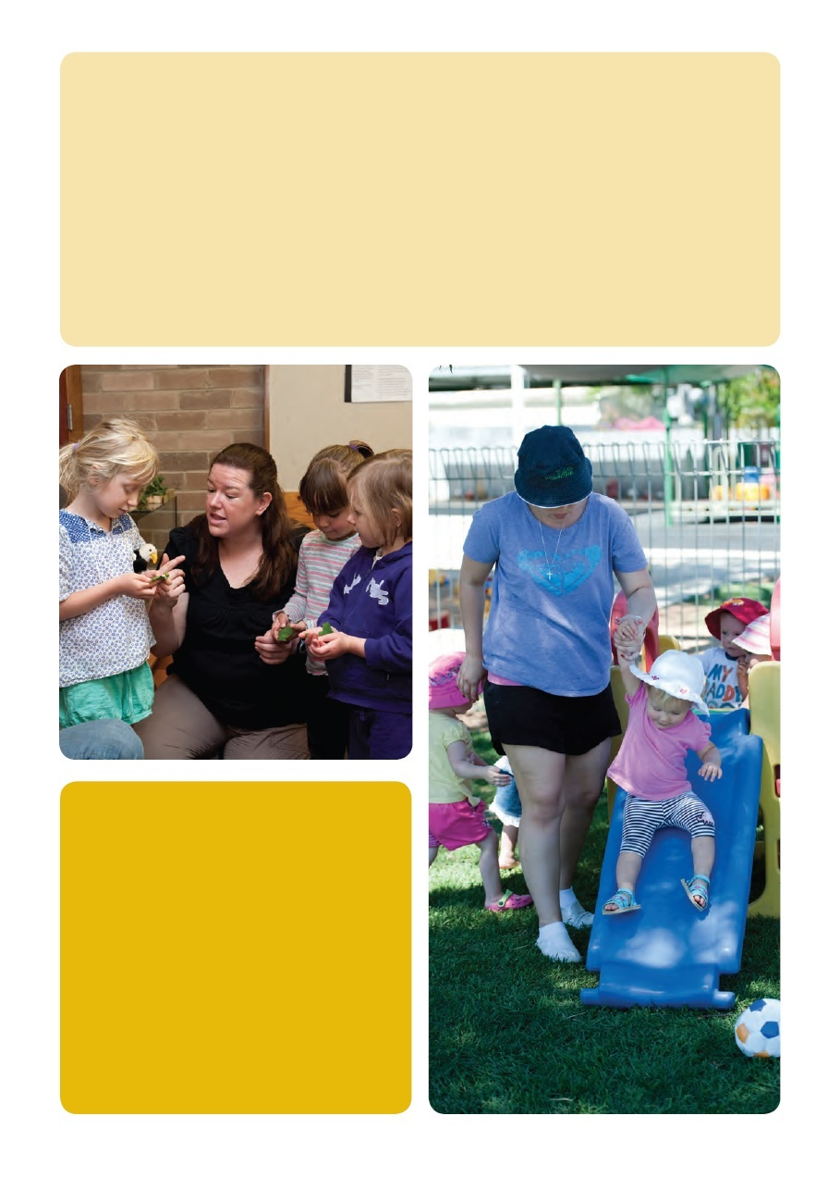

Example
“One of the sub-outcomes in the EYLF is about environmental sustainability. We thought about how we could approach this with the children to make it as meaningful as possible. We didn’t want to be heavy handed or tokenistic. Initially we thought about all the stories and experiences we could plan to introduce the children to environmental messages. But then we realised just hearing about it wasn’t going to be enough. We actually wanted the children to be part of this. So we’ve introduced recycling and compost bins at lunch time so that the children can help to sort their own rubbish. It doesn’t mean we don’t still talk about sustainability as well but this way the children are actually involved in the process. The great thing about being part of the lunchtime routine is that it happens every day. That consistency and repetition is so important for learning. Already the children are far more aware of where their rubbish goes and of what kinds of things the worms like to eat! I’m not sure we could have planned for the same kind of learning to happen so effectively any other way.”

Thinking Points
- What do you think about the EYLF’s definition of curriculum? How does it fit with your own ideas?
- How does your curriculum currently include “everything that happens”?
- What potential for learning is there in the routines, transitions and day to day interactions at your service?

Team meeting notes
The EYLF’s definition of curriculum is a broad one. It makes us think about how everything we do and every part of our day supports children’s learning. If we are used to thinking about our curriculum as the planned experiences we write on our program this involves a big change. It doesn’t mean that we don’t have to plan anymore, but it might mean that we need to think about our planning differently.
If you are going to use this resource sheet as the basis for a team meeting you should consider:
- How you currently think about curriculum - what aspects of the day do you already include and plan for?
- Whether the EYLF’s definition of curriculum will be a big change for your team or not?
- What is it about the way you currently approach curriculum and learning that you want to change?
The resource sheet will have introduced some of the key ideas about curriculum to your team members. You might want to start your discussion by asking for people’s responses - What did they think of it? Did it make sense? Was it new information? What jumped out as being most relevant?
Some specific discussion questions that might be helpful:
- What does learning look like in our service and when does it happen?
- Do we treat some parts of the day as more “educational” than others? If so, which parts?
- Are some kinds of learning easier to plan for than others?
- How can we support learning for outcomes such as identity and wellbeing through our program.
- How do our actions, teaching and words back each other up?
- Do our routines and interactions support the kind of learning that we are aiming for in the rest of the program?
- What messages might children be getting from the way we set up the environment and structure our day? Are they the messages we want them to get?
If you don’t already use routines, transitions and everyday interactions as “learning experiences” you might find the following exercise a useful way to start. As an introduction to this exercise you might reflect on the recycling example from the fact sheet as an example of how a routine can also be a valuable learning experience.

Group exercise
Choose one of your daily routines and talk about how you do it now. What messages is your approach sending to the children?
As a group make a list of the potential learning involved in the routine you have chosen. How much of this learning actually happens? What could you do to increase the opportunities for learning? Is there any other learning that could be brought into the experience? What changes would you need to make for this to happen?
Talk about how you could document the learning you have just been discussing and the planning that you have undertaken around this routine? Would it fit into your normal program or could you record it somewhere else?

Decide on an action
To bring the discussion to a close highlight the issues you have discussed and agree on a course of action. What are we going to do as a result of this discussion?
In making a decision, think about what is going to be practical and achievable in the short term. Tackling big overwhelmed by what needs to happen if you set achievable goals together. What would be the first step in changing the way you currently plan or program to better reflect the EYLF’s definition of curriculum?
Following on from the group exercise develop a plan for any changes you want to make to the routine that you discussed. Set a time to review the changes and evaluate the learning that is occurring.
Remember to document your actions in your Team Meeting Minutes. This will contribute to your self assessment and in planning for your Quality Improvement Plan.

End of Session 4.

SESSION 5
Relationships matter

Participant handout

“When children feel safe, secure and supported they grow in confidence to explore and learn.”
(Early Years Learning Framework, p.20)

As early childhood educators, relationships are at the heart of everything we do. Genuine and positive relationships with children, families and each other are essential to children’s learning. Through relationships we help each child to develop their identity, their connection to others and their sense of wellbeing (EYLF Outcomes 1, 2 and 3). Relationships are also central to how we support children’s attitudes toward learning and to the development of effective communication (EYLF Outcomes 4 and 5).
The importance of relationships is highlighted by the first of the EYLF’s core principles - “secure, respectful and reciprocal relationships”.
Secure relationships are vital to each child’s sense of identity and wellbeing and to their self-confidence. Stable, caring relationships provide children with the security and confidence they need to explore their world. In education and care services secure relationships happen when children are cared for by consistent, responsive and nurturing educators.
Being respectful means treating children as equals. A good rule of thumb is - if you wouldn’t like it done to you, don’t do it to a child. When we treat children and families with respect we treat them as individuals with their own interests, likes and dislikes. It also means that we try to involve them in what we do rather than simply telling them what is going to happen.
Reciprocal relationships go both ways. In reciprocal relationships we get to know children and families and they also get to know us. It doesn’t mean sharing everything about yourself, but it does mean being prepared to share enough - enough that the other person in the relationship gets a sense of who you are as a person. Children, in particular, respond to educators who give something of themselves in their interactions and relationships.
Secure, respectful and reciprocal relationships form the basis for successful learning. Children respond best to educators with whom they have a positive relationship. There are many important things we do as educators. However, it is the relationships we form with children that are the most valuable. Ultimately it is the quality of the relationships that we have that determine the quality of our service.

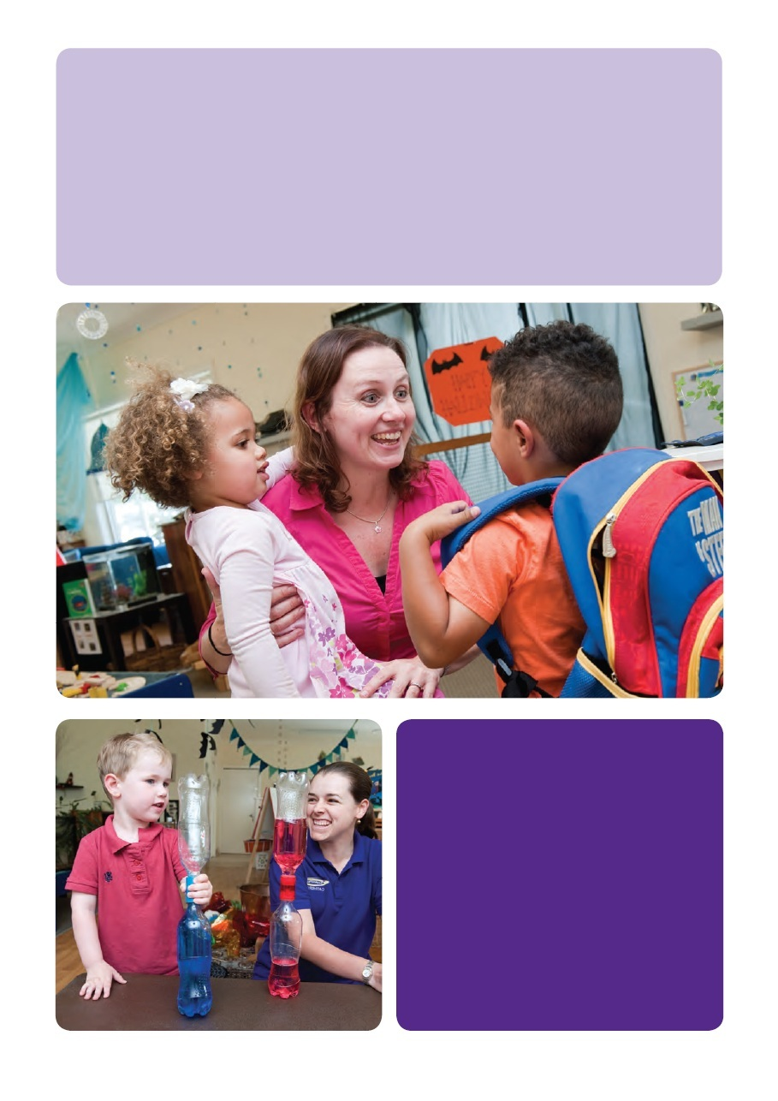

Example
“At our centre we try to think about the power and importance of relationships in everything that we do. It can be so easy to fall into routines and ways of doing things that are all about being efficient and nothing about relationships. We try really hard to make sure that even in our routines we keep a “human face” on what we are doing. That means for example that no one changes a baby’s nappy until they’ve gotten to know that baby. It seems like a little thing but for us it is about respect and about building a relationship with each child. If I’m a baby I don’t want a succession of strangers changing me. I want someone I know and someone I have at least the beginning of a relationship with. Sometimes if we have a new educator or a casual it means that they don’t change any nappies for a while. That can make it harder on our regular educators who have to do the extra work, but we do it because we think those relationships are so important.”

Thinking points
- How would you describe your relationships with children?
- Think about how you go about building a genuine relationship with a child and their family - what do you do? Are there specific strategies that you use or does it “just happen”?
- How do you make sure that every child gets to experience a positive relationship with their educators?

Team meeting notes
Secure, respectful and reciprocal relationships should underpin everything that we do. Because relationships are so much a part of our everyday practice we sometimes take them for granted. It can be a worthwhile exercise to actually discuss, the kind of relationships that you want to have in your service. Everyone’s idea of a “good” relationship will differ. It is only through talking about those differences that we can reach agreement about how we want to work with the children in our care. The value of words like “secure, respectful and reciprocal” is that they help to give some definition to the kind of relationships that are most effective in supporting children’s learning.
Related to our tendency to take relationships for granted is the assumption that relationships will simply happen naturally. In some cases this is true, but in others we need to put in a lot of work to make relationships happen. Without careful thought and planning it is unlikely that every child will experience the kind of relationships that we would want for them. This highlights the importance of thinking about how we actively plan for relationships to occur.
If you are going to use this resource sheet as the basis for a team meeting you should consider:
- The relationships that educators currently have with children;
- How well those relationships support children’s engagement with learning; and
- What kind of relationships you would like to see.
Some specific discussion questions that might be helpful:
- How do we help to create a sense of security for children through the relationships we have with them?
- What do we do to start building a supportive relationship with each child from the time they first start at our service?
- How does the way we organise our staffing help to create predictability and continuity of educators for each group of children? (this links directly to NQS element 7.1.3)
- How do we plan for relationships to happen? How do we support the development of relationships and friendships? What else could we do to support the formation of positive and constructive relationships?
- What opportunities are there for educators to engage in the kind of one-to-one and small group interactions that help to build meaningful relationships? How could you increase these opportunities?
- How do we use the relationships we have with children to engage them in learning?

Group exercise
Take the EYLF’s relationship descriptors - secure, respectful and reciprocal - and discuss what each means in the context of your service and the children you work with. Look at them in turn as a whole group, or for a large team divide into three groups and look at one each.
Through your discussion try to place yourself in a child’s position and think what a secure, respectful and reciprocal relationship might look like from their perspective.
Discuss what you could do to improve the quality of relationships at your service.
NOTE: As well as looking at the place of relationships in the EYLF it is also worthwhile to work through the 6 elements under Quality Area 5: Relationships with Children in the National Quality Standard (NQS). These help to give further definition to the kind of relationships we should be aiming for.

Decide on an action
Use the points identified through your discussion to highlight what you can do to improve the quality of relationships at your service. This might be through coming to an agreement as a team about the kind of relationships you want to see, it might be about improving how relationships fit into your planning and programming, or it might be about ensuring that all of the daily interactions educators have with children are used as opportunities to support the development of relationships.
Think about how you will ensure that relationships are something that you talk and think about regularly rather than just assuming that they are happening.
Remember to document your actions in your Team Meeting Minutes. This will contribute to your self assessment and in planning for your Quality Improvement Plan.

End of Session 5

SESSION 6
Intentional teaching

Participant handout
Intentional teaching is knowing what you do and why you do it.
Being “intentional” means having carefully thought through reasons for what we do. It means making conscious decisions about how we do things rather than doing things in the same way simply because that is the way they have always been done.
When we are intentional have a reason for our actions. If we are setting up materials for play we don’t just choose the first three things we see when we walk into the storeroom. Instead, we carefully choose the materials that will be available based on our knowledge of the children, their interests and our own teaching goals.
Being intentional means being able to answer the question: “why are we doing this?”
Being intentional also means being flexible. While we might have an idea behind a particular experience we also have to be prepared to change and adjust our expectations and intentions depending on how children respond.
Intentional teaching is not always obvious to the outside eye. Intentional teaching is often found in the planning and preparation that goes on “behind the scenes”.
Evidence of intentional teaching can be found in:
- the way we carefully and deliberately set up an environment to promote certain kinds of learning or play;
- the specific experiences that we plan for a purpose or for specific children;
- the way we think about and plan our daily routines; and
- the way we think about and plan for the kind of relationships we have with children.
Intentional teaching reminds us that as early childhood educators there are times when we will choose to actively “teach” children. Sometimes, because of the value we put on play and on being responsive to children, we forget that “teaching” can be a valuable strategy to use.
Learning through play is not just about standing back and letting children play. The EYLF makes it clear that experiences for children should provide a balance of “child-led, child initiated and educator supported learning” (The Early Years Learning Framework, p. 15). In striking this balance, active and deliberate teaching is an important strategy when it is used alongside play and interest-based approaches to children’s learning.
An important part of being a professional educator is being able to choose an appropriate strategy for a given situation. Part of making such decisions is about deciding when is the time to “teach”, when is the time to let something develop on its own, and when is the time to intervene more subtly to guide what is happening.

Example: Being “intentional” - Thinking about lunchtime
Intentional teaching is about more than the pre-planned activities or experiences that we write on a program. Because children are learning all the time, being intentional also involves thinking about learning throughout the entire day. Routines, such as mealtimes, can provide valuable opportunities for learning. If we only see these times as “routines” to be completed as through as quickly and efficiently as possible then we overlook the learning opportunities that they provide. Being intentional could mean thinking about how we “do” lunchtime. It might mean setting things up so that lunch is a relaxed and social occasion where children have the chance to talk with their friends and build relationships, as well as a time to eat.
To do this we might:
- arrange tables and chairs so that children are seated in small groups rather than all together;
- deliberately have an adult sit with each group to model behaviour and facilitate conversations;
- make sure that food, utensils, cleaning materials are all on hand to avoid constantly having to get up and down; and
- think about our daily routine to make sure we provide enough time for lunch so it can be relaxed and enjoyable.
All are good examples of intentional teaching.

Example: A time to “teach” - Cooking with children
Cooking with children can be an incredibly valuable learning experience. In terms of holistic learning there are not many other experiences that so effectively engage children in learning across so many different areas or that integrate such learning into a single experience. Maths and science, measurement, problem solving, prediction, reading and following a recipe, turn taking, talking, describing and asking questions, fine motor coordination and self esteem are all potentially involved in every cooking experience.
As well as being a powerful learning experience, cooking also provides a great example of an experience where, without even thinking about it, we instinctively realise that some form of “teaching” is essential. Few of us would set up a table with all of the ingredients and utensils for a cooking experience and then simply step back to observe what happens. If we did, it is highly unlikely that we would end up with an edible result. Instead we realise that if a cooking experience is to work then we, as the educators, need to be involved - providing the guidance and direction that children will need if they are to learn to cook successfully.
This doesn’t mean that we could or should treat every experience as a “cooking experience”. But it highlights the fact that not everything can be learned by trial and error, and that sometimes our role extends to deliberately teaching skills or concepts that children might not otherwise develop. By doing so, we help children to gain more from an experience than they would if simply left to their own devices.

Thinking points
- How do you engage in intentional teaching?
- What parts of your day are “intentional”?
- What “intentions” do you have in your everyday interactions with children?

Facilitator notes
Intentional teaching - having a reason, purpose or intention for what you do - is one of the key ideas underlying the EYLF. Being “intentional’ is one of the primary responsibilities of educators. What makes up intentional teaching however, is not always easy to define. It can be everything from the way we set up an experience, to the way we interact with children, to the way we organise our day, to the teaching strategies we use to ensure a particular experience is successful.
If you are going to use this resource sheet as the basis for a team meeting you should consider:
- How, as a team, you plan and discuss what you do and how you do it;
- Where you could find examples of “intentional teaching” in what you already do; and
- What are the intentions that currently guide your planning and practice?
If your team members have read the resource sheet they will already be starting to think about how intentional their practice is. Intentional teaching is a complex concept so you might want to start the meeting by asking each team member to talk about what they think of when they think about “intentional teaching” - how do they understand it and what is an example from their own practice?
Some specific discussion questions that might be helpful:
- What “intentional teaching” do we already do? Make a list of all the “intentional teaching” that already happens in your service.
- When we are intentional what are our “intentions”? What do we hope will be the end result of our work with children? How do our “intentions” link with the EYLF’s learning outcomes?
- How can we be “intentional” and still remain flexible and spontaneous?
- How does the way we set up our room or playground reflect intentional teaching? What are we hoping to achieve by the way we set things up?
- How does our planning and recording of our program and decision making show our intentions? How would we be able to demonstrate to someone else that we are being “intentional”?
The following group exercises can help to start discussion about the different aspects of intentional teaching.

Group exercises
- As a group identify a part of the day that you haven’t thought about as being “intentional” before - it could be a routine or transition time or some other part of your day that you haven’t really considered before now. How would you answer the “why are we doing this?” question for this part of the day? How could you make it more “intentional”? What learning would you seek to highlight?
- Using the cooking example from the resource sheet as a starting point, discuss the value of deliberately “teaching” or instructing children. When would it be appropriate to do this? How could you judge this? What strategies could you use to make sure that your “teaching” was appropriate for the children you work with?

Decide on an action
As a conclusion to the meeting decide on what action or actions you are going to take. What are you going to do to improve how, or how often, you engage in intentional teaching?
Think about what is going to be practical and achievable in the short term. If “intentional teaching” is a new idea for your team then it might be best to start small. Choose a particular area or part of your day to work on first - it might be something you have identified in the meeting as an area that needs attention or it might be something that you are already working on that could also include an element of “intentional teaching”.
Remember to document your actions in your Team Meeting Minutes. This will contribute to your self assessment and in planning for your Quality Improvement Plan.

End of Session 6.

SESSION 7
Continuity of learning

Participant handout

“Connections and continuity between learning experiences… make learning more meaningful”
(Early Years Learning Framework, p.33)

Connections and continuity between learning experiences are essential to children’s learning. Learning is most effective when it happens over time and when children have many opportunities to practice new skills and apply new knowledge. As adults we know that doing or hearing something once is rarely enough for it to really have an impact. As we redo and practise things we get better at them. The same applies to children.
Children learn best when they have:
- repeated opportunities to use materials and equipment;
- repeated chances to engage in experiences; and
- links between experiences so that their current learning builds on what has been done previously and leads into what may come in the future.
An important strategy for creating continuity of learning is predictability. In everyday terms we tend to think of ‘predictability’ as being a bad thing. But from an educational point of view it is extremely important. ‘Predictable’ doesn’t have to mean boring and uninteresting. Predictability is crucial to each child’s sense of security and belonging. A predictable classroom environment, where many of the same things are available each day, gives children the opportunity to explore and use materials and equipment in different and more complex ways.
Of course if we are going to offer the same experiences and materials repeatedly we need to make sure that the materials and experiences:
- are open ended and flexible;
- allow children to use them day after day in different ways without getting bored; and
- provide valuable learning opportunities.
With the right kind of materials and experiences, and with the time and support to get good at using them, it is amazing what young children are capable of.
Despite this the importance of predictability can easily be overlooked. Sometimes when we think about the experiences we provide for children we put novelty first, ahead of predictability. We may imagine that regularly changing the experiences, activities and toys we provide will be more interesting and valuable than providing children with the chance to use the same materials over and over again. Maybe it is because we get bored with seeing the same things day after day? Maybe we imagine the children will get bored? Or maybe we worry that parents will think we are simply being lazy by repeating the same experiences time and again?
Whatever the reason, when we constantly change what children are doing, we actually end up limiting children’s opportunities to engage in long term and complex learning. From an educational point of view predictability is far more important than novelty. Predictability, continuity and repetition are all crucial elements in successful early childhood programs.
This doesn’t mean that we should never change anything or introduce something new. What it means is that the programs and environments we provide should have an underlying routine and predictability to them to provide children with a sense of security while still having enough flexibility to make them responsive and interesting.

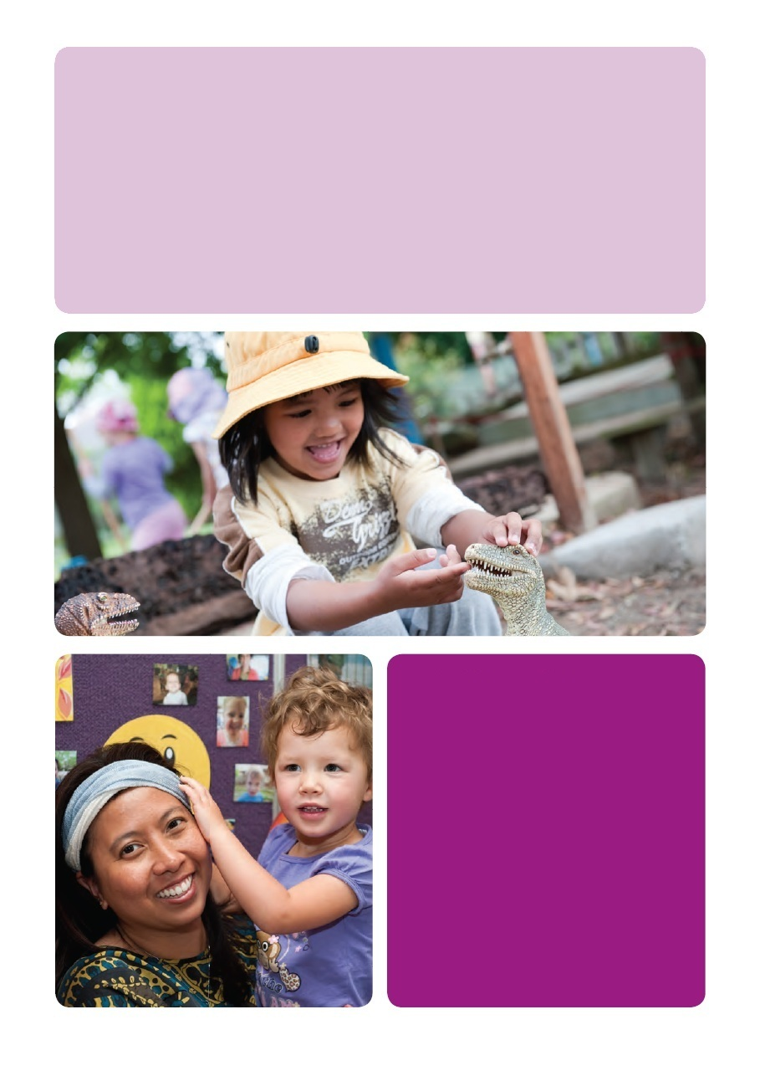

Example
“We used to do a lot of what I would call now “gimmicky” art and craft experiences. Each day we would have something different on offer because we thought we had to. We did marble painting and fly swat painting and bubble painting and every other kind of painting you could think of. And the children usually had fun doing them, but what we started to realise was that as experiences they never really went anywhere. A child’s marble painting from the beginning of the year looked exactly like one they did at the end of the year. As an activity it just didn’t offer any chance for development or improvement or even much creativity. That’s what made us think that maybe there was more to art and craft than just a different activity everyday.
Now we have easel painting and drawing out all the time and the children actually get a chance to build their skills. We have the most amazing paintings and drawings now that we just didn’t get when easel painting or drawing only happened once a week.”

Thinking points
- What opportunities for continuity and predictability are there in your program?
- How do children have the opportunity to develop their skills in using materials and equipment?
- What links are there between children’s learning from day-to-day and week-to-week? How as an educator do you help to create and reinforce those links?
- How much predictability is there in your program and routine? How do you create a sense of predictability and still keep things fresh and interesting?

Team meeting notes
Continuity, connections and predictability are all crucial parts of effective early childhood programs. Implementing them in practice however often requires a light touch and the ability to be flexible while still maintaining a sense of predictability. This can be a challenging balancing act - one that requires careful and thoughtful judgement. It is not always easy to know whether a particular activity or experience has reached its use-by-date and should be replaced or whether a slight tweak or addition to it may reignite children’s interest. Similarly it takes a skilled and observant educator to notice and point out links between children’s current and past learning.

In using this resource sheet as the basis for a team meeting you might want to consider:
- what opportunities for continuity and predictability already exist in your service?
- how you and your team feel about the relative importance of change and predictability in your program?
- the children and families that you work with and their need for predictability and stability.
Having read the resource sheet your team should have some idea about why continuity and predictability are so important for children’s learning. Depending on how new this idea is to them you might want to start by discussing this further - Why is continuity so important? How do we feel about predictability? Do we see it as a positive or negative quality?
Some further discussion questions that might be helpful:
- How much predictability and continuity is there in our program now? What impact does this have on children’s learning?
- What are the core elements of our program that are available for the children everyday?
- What aspects of our program change regularly? What impact do these changes have on children’s learning and sense of belonging?
- How do we encourage children to plan and think about what they are doing over the long term? When there is a necessary break in the day (such as for lunch or pack away time) do children have the chance to continue what they are doing later? How do we encourage this kind of continuity?
- When we introduce changes to our program or environment how do we show respect for children’s need for predictability and consistency and also for the sense that it is their environment as much as ours?
- What materials, equipment or experiences are most suitable to be repeated on a regular basis?
- How can we provide predictability and consistency and still be interesting?

Group exercise
As a group discuss what are the core elements of your program and why they are important. Keep in mind the importance of continuity, predictability and consistency and make a list of the experiences and materials that you want to provide:
- everyday;
- regularly but not necessarily everyday; and
- occasionally.

Decide on an action
To close the discussion, decide on what you are going to do as a result of the ideas you have talked about. What will you do to create a greater sense of continuity in children’s learning? What can you do to build a greater sense of predictability and consistency into your program?
Remember to document your actions in your Team Meeting Minutes. This will contribute to your self assessment and in planning for your Quality Improvement Plan.

End of Session 7

SESSION 8
High expectations

Participant handout
The principle of high expectations asks us to trust, wherever possible, in children’s ability to succeed rather than to assume their inability to do things. When we treat children as though they are capable they often end up proving us right.
Children are endlessly capable of surprising us. It is one of the great rewards of working with children – to be surprised by a child who does the wonderful or unexpected. But sometimes we limit children’s chances to surprise us by assuming they will not be able to achieve something. “They’re only two year olds”, we say, “they wouldn’t be able to do this”, or “this group aren’t ready for that yet”.
Sometimes these judgements are reasonable and well founded. High expectations should not be unrealistic expectations. There will be times where we have a good reason not to do something, but sometimes such decisions are based on our own preconceptions rather than a genuine assessment of what a particular child or group of children are capable of. Too often we ask ourselves “why?” rather than asking “why not?”. When our own expectation is that children will not be able to do something then we are unlikely to provide them with the opportunity to try. If we genuinely expect children to succeed then we need to show our own confidence in their abilities by allowing them to take a chance.
The danger when we talk about high expectations is of expectations so impossible to live up to that they simply set children up to fail. Our expectations should not be set so high that children cannot achieve them.
That just sends the message that if you can’t, you’ve failed. High expectations are more like a trampoline or springboard that allow children to show us how high they can jump.

As educators we need to make sure that children have the chance to push themselves, but also have the chance to succeed when they do. It means we have to get to know the strengths and interests of the children that we are working with. Strong relationships and high expectations go hand in hand. When we have strong, positive relationships with the children that we work with we are better able to draw the best from each of them, and they are more likely to want to do their best themselves.
When our expectations are low children are unlikely to exceed them. It is when they are high that we give the children the freedom to show us what they can really do.

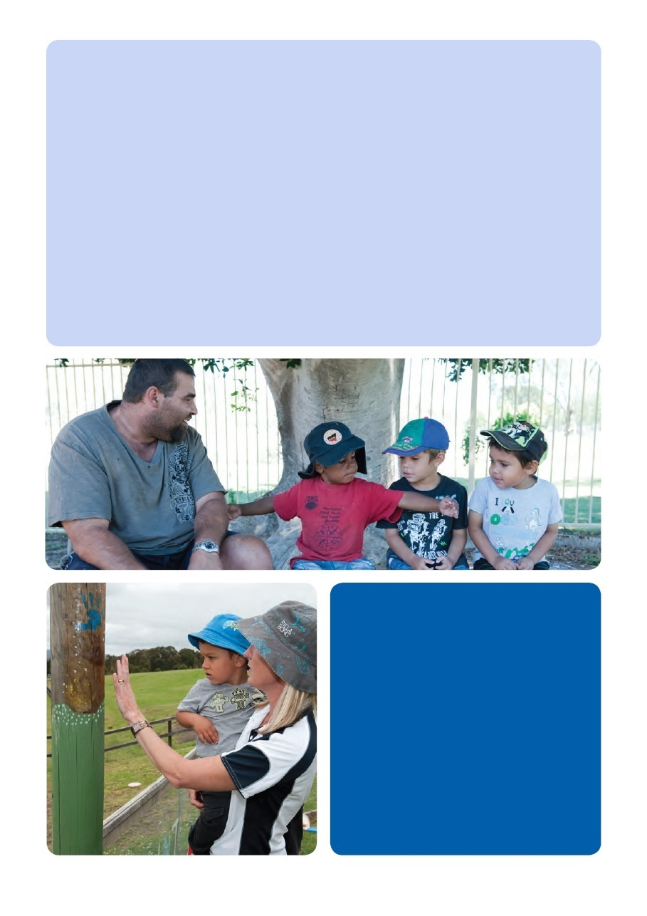
Example
“Without meaning to, we used to place so many barriers in the way of our children. I think we thought we were doing the right thing - protecting them in some way - but really we were holding them back. We had so many unwritten rules about what could and couldn’t be done - all based on our ideas about what the children were capable of. We had equipment that we never used because it was “too good”. It felt like we were always second guessing ourselves - trying to work out what the children might do with something before we put it out rather than allowing them to show us what they could do with it.
We still think about how we do things and what we put out. High expectations doesn’t mean a free for all! But we’re a bit more open to the unexpected these days - happy for the children to use things in different ways rather than always jumping in to stop them. It’s amazing how they’ve responded.
Sometimes it is just the little things. We never used to let our younger children serve themselves lunch. I think we thought they wouldn’t be able to do it without it becoming a huge mess. It took a little while for them to learn how to do it, but when we had the expectation that they would be able to succeed we were more tolerant and patient through the learning process. We didn’t throw up our hands at the first spill and say “this will never work”. Our patience really paid off. Now it is amazing to see the two year olds dishing out and cleaning up. Yes, there are still some spills but watching how capable the children are, when we let them be capable, is just so inspiring!”

Thinking points
- Think about the children you work with and the expectations you have of them. What do you expect in terms of - behaviour? learning? responsibility?
- Think about your own reaction to others expectations - how does it feel when you aren’t allowed to try something because the assumption is you won’t be able to do it?
- Think of a time when a child truly surprised you with what they were able to achieve -how did it make you rethink your expectations of other children?

Team meeting notes
When we hold high expectations of children’s capabilities they are more likely to succeed. It is important though to think about how we approach high expectations. If expectations are unrealistic then they simply lead to frustration for children and for us as educators. We need to support our expectations and help children to achieve them. We also need to make sure we have good relationships with the children we are working with. High expectations work best when children know, like and respond to their educators. Strong personal relationships help children to share our expectations for them, and want to live up to them.
If you are planning to use this resource sheet as the basis for a team meeting you should consider:
- What are the current expectations of children in your setting?
- How do these expectations help to either limit or expand children’s potential?
- What are realistically high expectations for the children in your care?
If your team members have read the resource sheet they should have started to think about their own expectations for children and what effect these may be having on children’s learning. You may want to start with a discussion about your current expectations, identifying, if you haven’t already, what they actually are.
Some further discussions questions that might be helpful:
- What are our current expectations of children and why do we hold them? What information do we base our expectations of children on? How do we decide what is reasonable or unreasonable to expect?
- What are some examples of expectations that could limit children’s abilities?
- How can we balance high expectations with the need to make sure children are safe? If we expect children to take risks and experiment how can we make sure we support them to do so in a safe way?
- How would a “high expectations” approach work for children with additional needs?
- What might we do differently if we had “higher expectations” of our children?
- How can we avoid “high expectations” becoming a recipe for failure? How do we make sure our expectations are high but achievable?
The following group exercise may help to identify examples of children’s learning and abilities that could be fostered through high expectations.

Group exercise
The resource sheet asked you to think of a time that a child surprised you with their abilities. Share that experience with the group. Talk about what the child did and why you were so surprised. What were your expectations prior to this experience? How have they changed since then? Discuss how you did (or could have) followed up on that experience in a way that showed your high expectations to the child.
As each member of the group shares their experience, make a list of the different expectations that were challenged in each case, and of the new expectations that developed as a result.

Decide on an action
At the end of the meeting, decide on what you are going to do as a result of your discussion. This might depend on what your existing expectation levels are.
If you haven’t really considered expectations before, your first action might be to go away and consciously look at what your expectations are and then come back to meet again to discuss further.
Maybe do some research into what are realistic expectations for a particular experience or age group?
If you have been able to identify what your expectations are, how and where might you reinforce them? Is there a particular part of your day or your program where you have identified adult expectations as an issue? What are you going to do to change this?
Remember to document your actions in your Team Meeting Minutes. This will contribute to your self assessment and in planning for your Quality Improvement Plan.

End of Session 8

CONCLUSION
This package is just one tool to understand and reflect on the EYLF within your education and care service. There are many opportunities available for you and your team to gain further knowledge and understanding of the EYLF through your Professional Support Coordinator (PSC).
For more information on the PSC in your state or territory and how you can access professional learning, support and resources, visit www.pscalliance.org.au

GLOSSARY OF TERMS
Extract from EYLF pp45-46.
Curriculum - in the early childhood setting curriculum means ‘all the interactions, experiences, activities, routines and events, planned and unplanned, that occur in an environment designed to foster children’s learning and development’. (Adapted from Te Whariki).
Educators - early childhood practitioners who work directly with children in early childhood settings.
Inclusion - involves taking into account all children’s social, cultural and linguistic diversity (including learning styles, abilities, disabilities, gender, family circumstances and geographic location) in curriculum decision-making processes. The intent is to ensure that all children’s experiences are recognised and valued. The intent is also to ensure that all children have equitable access to resources and participation, and opportunities to demonstrate their learning and to value difference.
Intentional teaching - involves educators being deliberate, purposeful and thoughtful in their decisions and action. Intentional teaching is the opposite of teaching by rote or continuing with traditions simply because things have always been done that way.
Involvement - is a state of intense, whole hearted mental activity, characterised by sustained concentration and intrinsic motivation. Highly involved children (and adults) operate at the limit of their capacities, leading to changed ways of responding and understanding leading to deep level learning (adapted from Laevers 1994).
Learning outcome - a skill, knowledge or disposition that educators can actively promote in early childhood settings, in collaboration with children and families.
Pedagogy - early childhood educators’ professional practice, especially those aspects that involve building and nurturing relationships, curriculum decision-making, teaching and learning.
Play-based learning - a context for learning through which children organise and make sense of their social worlds, as they engage actively with people, objects and representations.
Scaffold - the educators’ decisions and actions that build on children’s existing knowledge and skills to enhance their learning.

Use this template to record important points from team meetings. It will assist in following through on discussions, action points, contribute to your self assessment and assist you to develop your Quality Improvement Plan.

Team Meeting Minutes

Date:
Participants:
Apologies:
DISCUSSION/TOPIC | ACTION PLAN | COMMUNICATION WITH FAMILIES  (if appropriate) | PROFESSIONAL DEVELOPMENT OPPORTUNITIES
NOTES

