Research summary: No.1/2014

Multiple Disadvantage
Deborah Kikkawa
This research examines the extent to which multiple disadvantage affects social and emotional outcomes for 6 and 7 year old Indigenous and non-Indigenous Australian children using data from Growing up in Australia: the Longitudinal Study of Australian Children (LSAC) and Footprints in Time: the Longitudinal Study of Indigenous Children (LSIC).
While there is no agreed set of measures of disadvantage, disadvantage is generally measured in terms of economic situation (e.g. income), social support (e.g. social networks) and personal characteristics (e.g. health and educational attainment). However, research has shown that the absence or presence of these measures of disadvantage is not always predictive of outcomes. For example, aged pensioners often do not experience financial stress despite being on a low income. Similarly, higher education does not always guarantee a job (and therefore economic advantage).
Comparing multiple areas of disadvantage in LSAC and LSIC, it is clear from Table 1 that children in LSIC, all of whom are Indigenous, are living in families with much higher levels of disadvantage than children in LSAC which is representative of the Australian population as a whole (except for remote areas). On average children in LSIC also live in households with more children and with younger primary carers.
Table 1: Percentage of children experiencing different types of disadvantage
Measure of Disadvantage | LSAC | LSIC
Socio-Economic Index for Australia (SEIFA) - advantage & disadvantage index (bottom 5 deciles) | 50 | 80
Jobless household | 10 | 39
Financial stress | 21 | 45
Single parent household | 15 | 39
Low educational attainment of primary carer | 41 | 56
Poor health | 8 | 13
Low household income (<$600 pw) | 13 | 42
The outcome measure used in this analysis is social and emotional problems measured by the social and emotional difficulties score from Goodman’s Strengths and Difficulties Questionnaire. The mean score for children in LSAC is 8.1 (with a possible maximum of 40) and for children in LSIC 12.2.
There is a significant association with social and emotional difficulties scores for all of the measures in LSAC (using bivariate OLS regression models). In contrast, LSIC scores demonstrate a statistical significance only for low socio-economic status, living in a jobless household, experiencing financial stress, poor primary carer health and low income. Having a primary carer who is a lone parent or has a low level of education is not significantly related to LSIC children’s social and emotional difficulties scores.
Table 2 shows the results for a model which includes all the measures of disadvantage but with no other control variables.

Table 2: Multivariate regression model of the effect of disadvantage on children’s social and emotional difficulties scores
Measure of Disadvantage | LSAC | LSIC
SEIFA advantage & disadvantage (bottom 5 deciles) | 0.80*** | 1.17
Jobless household | 1.34*** | 0.26
Financial stress | 1.52*** | 1.74***
Single parent primary carer | 1.26*** | -0.26
Low educational attainment primary carer | 0.94*** | 0.43
Poor health of primary carer | 1.68*** | 2.55***
Low income (<$600 pw) | -0.17 | 0.48
Number | 3799 | 437
Adjusted R2 | 0.0829 | 0.0471
*** p<0.001 ** p<0.01 *p<0.05
Note: the numbers indicate the effect on SDQ difficulties scores if the measure of disadvantage is present. The stars show the level of significance.
While all measures except low income have a significant association with social and emotional difficulties scores for children in LSAC, only financial stress and poor primary carer health have a significant association with these scores for children in LSIC. The effect size for these two measures is also greater for LSIC children than it is for LSAC children, meaning the presence of this indicator is associated with a greater average increase in social and emotional difficulties scores for LSIC children. The effect of low income for children in LSAC is likely to have been moderated by the inclusion of other variables such as joblessness, financial stress and SEIFA.
These results suggest either that these measures of disadvantage do not have the same effect on social and emotional difficulties scores for non-Indigenous and Indigenous children or that the circumstances commonly used to measure disadvantage do not capture the effect. It may rather be due to experiencing one or more of the events the circumstances may trigger. For example, low income may have a negative impact only if it leads to financial stress.

Major Life Events
A major life event is any event in life that can have a substantial impact on a person’s wellbeing (Wilkins and Warren 2012). Such events are not necessarily negative, unwelcome or unexpected but are generally accepted to have an impact. They also may be perceived differently by different individuals—even different individuals within the same household. Some major life events are related to the normal human life cycle—births, deaths and marriages—while others are related to environmental stressors such as the loss of a job, leading to possible financial hardship or social isolation.
Zubrick et al (2005) found that children in the Western Australian Aboriginal Child Health Survey who had experienced up to two major life events in the previous twelve months had a 15 per cent chance of developing clinically significant social and emotional difficulties. This rose to 25 per cent for children who had experienced three to six major life events and to 42 per cent for children who had experienced seven or more.
The prevalence of major life events is markedly different for the children in the two studies with LSIC children experiencing much higher levels. To compare the impact of major life events on children from the two studies, a group of 12 events asked about in each study was used to assess average rates of experience over the first four waves of each study (Figure 1).

Figure 1: Average prevalence of major life events in LSIC and LSAC, per cent
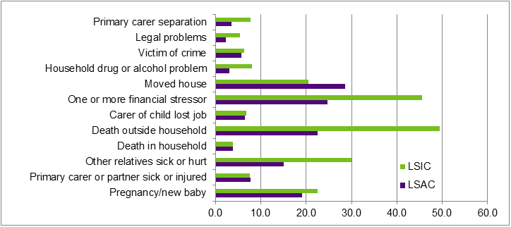

Figure 1: Average prevalence of major life events in LSIC and LSAC, per cent Major life events | LSIC | LSAC
Primary carer separation | 7.7 | 3.5
Legal problems | 5.4 | 2.3
Victim of crime | 6.3 | 5.7
Household drug or alcohol problem | 8 | 3
Moved house | 20.4 | 28.5
One or more financial stressor | 45.6 | 24.6
Carer of child lost job | 6.7 | 6.4
Death outside household | 49.4 | 22.5
Death in household | 3.8 | 3.8
Other relatives sick or hurt | 29.9 | 15
Primary carer or partner sick or hurt | 7.5 | 7.7
Pregnancy/new baby | 22.5 | 19

Table 3 shows that children in LSIC are much more likely to have experienced three or more of the 12 events in each of the four waves.
Table 3: Prevalence of major life events by wave, per cent
 | LSAC | LSAC | LSIC | LSIC
Wave | Low (0/2) | High (3+) | Low (0/2) | High (3+)
1 | 92.8 | 7.2 | 73.8 | 26.2
2 | 90.7 | 9.3 | 74.2 | 25.8
3 | 93.5 | 6.5 | 70.8 | 29.2
4 | 86.8 | 13.2 | 70.4 | 29.6
Longitudinal data can be used to examine the experience of major life events over time. As well as experiencing more major life events in each year, higher proportions of children in LSIC are experiencing high numbers of events on an ongoing basis. Nearly three quarters of the LSAC children experienced no more than two events in any of the four years and only 0.3 per cent experienced three or more events in each year. In contrast, just over a third of the LSIC children experienced no more than two events in each year and 2.3 per cent experienced three or more events in each year.
A bivariate regression model using social and emotional difficulties scores and the number of waves which children experience three or more events show that:
- LSAC children who experienced three or more events in one wave had average social and emotional difficulties scores 1.2 points higher and those who experienced it in two or more waves had average scores 2.6 points higher than those who had experienced fewer than three major life events in all waves.
- LSIC children who experienced three or more major life events in any number of waves (i.e. one or more) had average social and emotional difficulties scores 2.1 points higher than if they had never experienced it.

Figure 2 shows the average number of events experienced across the four waves by the likelihood of developing social and emotional difficulties as reflected by the total difficulties risk categories. In all three risk categories, the average number of events experienced by LSIC children is higher than for LSAC children.

However, regardless of the starting point, an increase in major life events is associated with increases in average social and emotional difficulties scores for children in both studies.

When events experienced were converted into a proportion of events that could have been experienced, the results showed that a 1 per cent increase in experience of major life events over the four waves was associated with a 0.169 point (p<0.01) and 0.167 point (p<0.01) increase in social and emotional difficulties scores for children in LSAC and LSIC respectively, suggesting an increase in major life events is associated with similar magnitude of increase in problems for both groups.
Figure 2: Average number of major life events over four years by SDQ risk categories
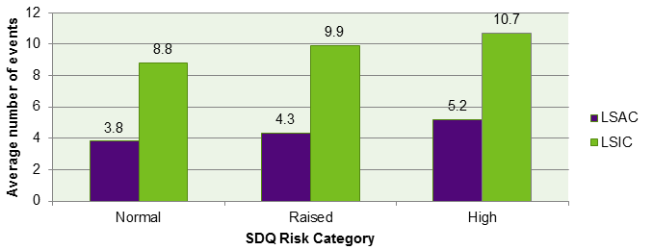
Note: For LSAC, all three risk categories are statistically different. There is no statistical difference in LSIC between the raised and high risk categories but those two combined are statistically different from the normal category (p=0.000).

Figure 2: Average number of major life events over four years by SDQ risk categories
SDQ risk categories | LSAC - Average number of life events | LSIC - Average number of life events
Normal | 3.8 | 8.8
Raised | 4.3 | 9.9
High | 5.2 | 10.7

Conclusion
While circumstances of disadvantage are significantly associated with poorer social and emotional outcomes for non-Indigenous children, the same is not true for Indigenous children from LSIC. However, when those circumstances are translated into major life events, the negative association with social and emotional outcomes is seen for both groups. Children in both groups have higher difficulties scores if they experience high numbers of major life events.

Key Statistics
- 25 per cent chance of children developing clinically significant social and emotional difficulties if they experience three or more major life events.

- 2.3 per cent of LSIC children experiencing three or more events in each of the four waves.

- 2.1 points average increase in difficulties scores for children in LSIC experiencing three or more events in any wave.

A more complete version of this research is available at:
Department of Social Services 2014, Footprints in Time: the Longitudinal Study of Indigenous Children—Report from wave 5, DSS, Canberra.
For any queries regarding this research please email: NCLD@dss.gov.au.

The normal category for SDQ includes scores of 13 or below. The raised category includes scores of 14 to 16 and the high category includes score of 17 or above.
Australian Social Inclusion Board 2012, How Australia is faring, 2nd Edn, Department of the Prime Minister and Cabinet, Canberra.
Wilkins R, Warren D, Hahn M, Houng, B 2006, Families, Incomes and Jobs, Volume 8: A Statistical Report on Waves 1 to 8 of the Household, Income and Labour Dynamics in Australia Survey, University of Melbourne, Melbourne
Lack of significance for Footprints in Time may be partially explained by the relatively small sample size; however, variables for the single parent and low education are not significant even in the bivariate models suggesting that the smaller sample size is not the only explanation.
Wilkins, R, Warren, D, 2012, Families, Incomes and Jobs, Volume 7: A statistical report on waves 1 to 9 of the Household, Income and Labour Dynamics in Australia Survey, Melbourne Institute of Applied Economic and Social Research, Melbourne
Zubrick SR, Silburn SR, Lawrence DM, Mitrou FG, Dalby RB, Blair EM, Griffin J, Milroy H, De Maio JA, Cox A, Li J 2005 The Western Australian Aboriginal Child Health Survey: The Social and Emotional Wellbeing of Aboriginal Children and Young People. Perth: Curtin University of Technology and Telethon Institute for Child Health Research, Volume 2 – p. 101, pp.135–137
For LSIC, the percentages represent the annual average of five waves over the period from 2008 to 2011. For LSAC the five waves of data were collected every two years over the period from 2004 to 2010. Note also that the questions asked in the two studies are not identical but have been used as the closest approximation.

