PRIOR NOTIFICATION TO CHILD CARE SERVICES OF THE
2013 NATIONAL WORKFORCE CENSUS
Dear Service Director / Coordinator
The Australian Government will shortly be conducting the second National Early Childhood Education and Care Workforce Census (National Workforce Census) of all child care services and preschool/kindergarten services. The reference weeks for the 2013 collection are:
- 20 – 26 May 2013 for Preschool providers, and all approved child care services except Vacation Care;
- 1 – 7 July 2013 for Vacation Care Service providers (NT, Qld and Vic); and
- 8 – 14 July 2013 for Vacation Care Service providers (ACT, NSW, SA, Tas, WA).
The National Workforce Census is an important collection to help inform planning for the early childhood education and care sector and ensure that high quality early childhood services are provided to young children and their families.
It is important to complete the National Workforce Census even if you complete similar surveys for your state or territory government, to ensure nationally consistent data on the early childhood education and care workforce. All child care services approved to receive Child Care Benefit are required to participate in the Census under the A New Tax System (Family Assistance Administration) Act 1999.
The National Workforce Census comprises two surveys. The Services survey asks you to provide information on service usage, children with additional needs, access to preschool programs and staff details. The Services survey should take around 45 minutes to complete. The Staff survey requires you to distribute questionnaires to all staff, so that they can provide information on their roles, qualifications, employment status, training activities, pay and conditions and career intentions. The Staff survey should only take around 15 minutes to complete.
Please be assured that the data and personal information that is collected is confidential and will be released in a way that does not enable individual services or people to be identified.
As was the case in the 2010 collection, if your service completes both surveys you will be entered in a draw for educational materials or equipment.
The Department of Education, Employment and Workplace Relations has engaged the Social Research Centre (SRC) to conduct the National Workforce Census on its behalf. You will shortly receive correspondence from the SRC to register for the National Workforce Census, along with further information about the data collection.
If you have any queries on the arrangements for the National Workforce Census, please call the National Workforce Census Helpline on FREECALL 1800-639-098 or email nwc@srcentre.com.au. Further information and regular updates on the National Workforce Census will be available on the Department’s website.
Yours sincerely
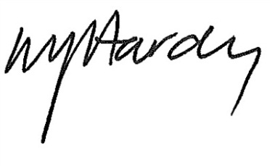

Matthew Hardy

Branch Manager

Early Childhood Data and Analysis Branch

2 April 2013

