Case Study

Pathways to a career in
Child Care and Early Learning
Early Childhood Education and Care Industry Roundtables were held across regional and remote Australia to assist the childcare and early learning sector meet the requirements of the National Quality Framework.

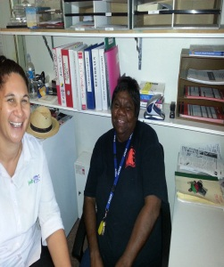
Coralie Williams with JobFind Educator Alice Trinder
Coralie Williams
Coralie Williams grew up in Hermannsburg, 125 km west of Alice Springs. With limited career options available, Coralie relocated her family to Alice Springs and enrolled with JobFind shortly afterwards.
JobFind encouraged Coralie to participate in their child care and early learning pre-employment programme.
JobFind started a training programme in response to the May 2012 Early Childhood Education and Care Industry Roundtable forums which had identified a need for industry training, and they encouraged Coralie to participate in the programme.
“Coralie is a very strong lady who, when she puts her mind to a task, just never gives up,” JobFind Educator, Alice Trinder said.
Coralie completed Certificates I and II in Community Services (Early Childhood) and work experience at the Central Australian Aboriginal Congress as part of the programme.

“Sometimes there were up to 22 babies under three years of age that we were looking after,” a very proud Coralie explains.
“It was a challenge and fun. A lot of the training that we did was really good.”
Soon after starting the programme, Coralie secured a full time position with ‘Bush Mob’, an organisation in central Australia that cares for girls and boys with alcohol and other drug reliance.
“I enjoyed working with the young children, [at the Central Australian Aboriginal Congress] but the next step was providing care and guidance to kids from 14 to 17 years-old with alcohol or drug problems.”
“This provides me with a great deal of satisfaction; I am going to stick with this job.”
“I am proud of what I have achieved.”
Colleagues at Bush Mob hold the highest praise for Coralie. They particularly admire the way Coralie managed the transition from working with young children to challenging work with older kids.

