PRIOR NOTIFICATION TO PRESCHOOLS/KINDERGARTENS OF THE

2013 NATIONAL WORKFORCE CENSUS
Dear Preschool/Kindergarten Director or Principal
The Australian Government will be conducting a National Early Childhood Education and Care Workforce Census (National Workforce Census) of all child care services and preschool/kindergarten service, the reference week for preschools is 20-25 May 2013. Your participation will be highly valued and will inform planning and policy development for the early childhood education and care sector, helping to ensure that high quality early childhood services are provided to young children and their families.
It is important to complete the National Workforce Census even if you complete similar surveys for your state or territory government, as nationally consistent data on the early childhood education and care workforce is needed to inform policy.
The National Workforce Census comprises two surveys. The Preschool Services survey will require you to provide information on the participation of children in preschool/kindergarten programs and staff details. The Preschool Services survey should take around 45 minutes to complete. The Staff survey requires you to distribute questionnaires to all preschool/kindergarten staff, so that they can provide information on their roles, qualifications, employment status, training activities, pay and conditions and career intentions. The Staff survey should take around 15 minutes to complete.
Please be assured that the data and personal information that is collected is confidential and will be released in a way that does not enable individual services or people to be identified.
As was the case in the 2010 collection, if your service completes both surveys you will be entered in a draw for educational materials or equipment.
The Department of Education, Employment and Workplace Relations has engaged the Social Research Centre (SRC) to conduct the National Workforce Census on its behalf. You will shortly receive correspondence from the SRC to register for the National Workforce Census, along with further information about the data collection.
If you have any queries on the arrangements for the National Workforce Census, please call the National Workforce Census hotline on FREECALL 1800-639-098 or email nwc@srcentre.com.au. Further information and regular updates on the National Workforce Census will be available on the Department’s website.
Yours sincerely
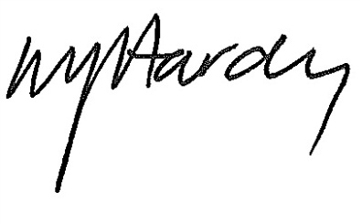

Matthew Hardy
Branch Manager
Early Childhood Data and Analysis Branch
March 2013

