Case Study

Pathways to a career in
Child Care and Early Learning
Early Childhood Education and Care Industry Roundtables were held across regional and remote Australia to assist the childcare and early learning sector meet the requirements of the National Quality Framework.

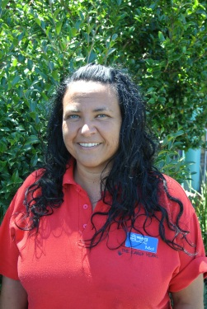
Melissa Harpur
Melissa Harpur
Passion, persistence and a desire to make a difference are factors that drive Melissa Harpur in her child care and early learning career.
Melissa originally wanted to open an art and craft drop in centre. It was only by chance that Melissa saw an advertisement for the former Diploma of Children’s Services.
Melissa completed her diploma at TAFE and began a casual position in the Culburra and Districts Preschool which quickly became a permanent, part-time second in charge role. The support at Culburra and Districts Preschool enabled her to enrol in The Bachelor of Education the Early Years at Wollongong University.
While studying her Bachelor Degree of Education the Early Years at the University of Wollongong, Melissa was partnered with mentor ‘Aunty’ Deb Wray from the Woolyungah Indigenous Students Centre.
“Aunty Deb helped me to get a hold of study in a university environment and with her help and support I started to do really well.”
During Melissa’s third year of university, she undertook practical experience at Noah’s Shoalhaven Early Intervention Centre. With the support of the Centre, Melissa grew in confidence and found she could develop a career in child care and early learning.
Melissa now works as an early childhood teacher for Noah’s Shoalhaven in local centres and collaborates with other services in the Shoalhaven facilitating playgroups for Aboriginal Children and Families.
Melissa finds her career varied and interesting but also very busy. She is currently completing a Certificate IV in training and assessment at TAFE and is planning on completing a Master of Special Education with a focus on Aboriginal and Torres Strait Islander perspectives in the child care and early learning sector and then maybe even a Doctorate.
To people thinking about a career in child care and early learning, Melissa’s advice is:
“Go to TAFE and do the Diploma of Early Childhood Education and Care first and explore your personal strengths, weaknesses and philosophy on working with young children and adults. It is not all painting, play dough and sand pit construction, there is a lot more to it!”

