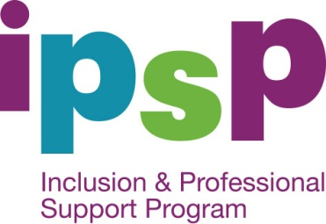u

Inclusion Support Portal – Help

Help with ISS Applications
For general queries and advice relating to you Inclusion Support Subsidy application contact your ISA or:
- The NISSP toll free phone number is 1800 824 955
- If you are located in NSW, ACT, VIC, WA or SA you can send your enquiry by email to issinfo@ku.com.au
- If you are located in QLD, NT or TAS you can send your enquiry by email to iss@includeme.com.au
Further information is also available on the NISSP website: www.ku.com.au

Online Help
- iHelp is a guide within the IS Portal. iHelp has information to assist you, step by step, to complete your ISS application. Each screen has its own iHelp information. Use the iHelp as you move through the screens.
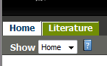
- Access iHelp by clicking on this icon
- Literature Tab – Under this tab you will find a copy of the Task Cards for completing each tab.

