

u

Inclusion Support Portal – Overview for Services

Introduction

This task card gives an overview of the process for lodging an online Inclusion Support Application for home and centre based CCB approved child care and early learning services.

If you are applying for Flexible Support Funding (FSF) you will need to submit a paper application until further notice.

You will receive a letter from your Inclusion Support Agency (ISA) advising you of the web address for the online Inclusion Support Portal and you Case Identification (ID) number. This ID number as well as your CCB Approval ID number will allow you to access the portal from the home page. This field is case sensitive and all letters should be entered in UPPER CASE and dashes included; ie: 1-CAPITALS.

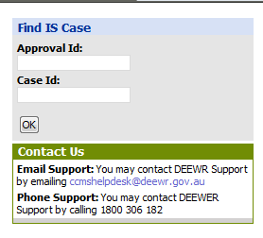

Every child in the application must have an active enrolment of any type in CCMS to proceed with the Inclusion Support Subsidy (ISS) case.

All children in the case must have either a diagnosed disability, be undergoing assessment for disability or be children from a refugee/humanitarian intervention background. If they are not flagged for one of these categories in the portal you will not be able to submit the application. If any child is not eligible, you will need to remove that child from the case.

To complete the application enter information in relevant fields of each tab working from left to right and enter the required information.

There are Primary tabs and linked secondary tabs (underneath the Primary Tabs). Some tabs will not need any information entered and are for information only.

Once the application is complete submit through the portal to your ISA for endorsement. The ISA will forward the application to the NISSP for assessment.

Primary and Secondary tabs

**There are nine Primary Tabs:**



Four of the Primary Tabs have Secondary Tabs that are visible once you have opened the Primary Tab. There are shown below.

**Tab 3 – *Setting and Children* has five Secondary Tabs:**



**Tab 4 – *Support Hours* has three Secondary Tabs:**



**Tab 8 – *Submission* has three Secondary Tabs:**



**Tab 9 – *Claims* has four Secondary Tabs:**



Useful Tips

* **iHelp** is a guide to be used with the task cards (as listed below). iHelp has information to assist you, step by step, to complete your ISS application. Each screen has its own iHelp information. Use the iHelp as you move through the screens.

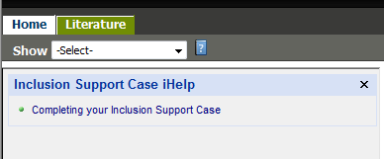

* Access iHelp by clicking on this icon . It is important that you **SAVE** before you use this function.
* **Literature:** Under this tab you will find a copy of the task cards for completing each tab and the exemption form that must be attached if you are requesting additional hours.
* To move from one field to the next you can use the Tab key on your keyboard or use your mouse to click on the next field.
* The system may time out if there is an extended delay while entering data. This means the system will close and you will have to log back in to continue working on the application. Any unsaved data will be lose so it is important that you save your work frequently.
* **You can progress through the application, saving regularly. This will allow you to log out and re-enter at another time to complete the application.**
* **Buttons:** The following buttons are found throughout the application and relate to the page you are on. They can only be used in they are active on the screen. In the example below **New** is active and **Edit** is inactive.



**New:** Click on this button to open a new window or box that requires further information.

**Edit:** Click on this button to make changes to a selected field that already contains information.

**Query:** Click on this button to search for a specific record. Some records may be hidden, depending on which field you have queried.

**Save:** Click on this button to save the information entered into the form. It is very important that the document is saved after each screen is completed.

**Cancel:** Click on this button to go back to the previous page. This button does not delete saved information.

* **Arrows:** (see below) click on the up or down arrows to sort the list of records from top to bottom or bottom to top for the column you select.

Right arrows (>) - click on the right-facing arrow to select the desired record. It will be highlighted in yellow.

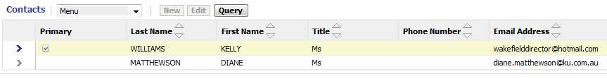

Summary of Task Cards

There are nine Task Cards which relate to each of the nine Primary Tabs. Task Card 10 - Approval Process is an explanation of the procedure once your application is submitted through the IS Portal to your ISA and how you will be notified of the outcome when your application has been assessed.

|  |  |  |
| --- | --- | --- |
|  | **Primary Tabs** | **Secondary Tabs** |
| **Task Card 1** | **Tab 1 – Case Detail** |  |
| **Task Card 2** | **Tab 2 – Service Support Plan** |  |
| **Task Card 3** | **Tab 3 – Setting & Children** | a. Setting  b. Children  c. Enrolments  d. Setting Profile  e. FDC/INC Carers |
| **Task Card 4** | **Tab 4 – Support Hours** | a. Care Week Profile  b. Day Summary  c. All Support Hours |
| **Task Card 5** | **Tab 5 – Attachments** |  |
| **Task Card 6** | **Tab 6 – Contacts** |  |
| **Task Card 7** | **Tab 7 – Notes** |  |
| **Task Card 8** | **Tab 8 – Submission** | a. Exemption Request  b. Application Checklist  c. Application Submission |
| **Task Card 9** | **Tab 9 – Claims** | a. Claims  b. Sessions  c. Payment requests  d. Payee |