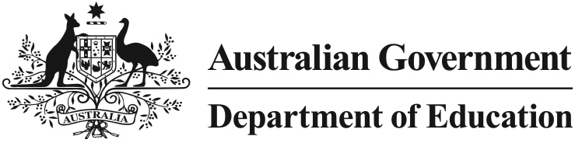

In Home Care Eligibility
Who should read this fact sheet?
The information in this fact sheet is designed to assist approved In Home Care service providers in undertaking their legal obligation to ensure that only eligible children receive In Home Care.
What is In Home Care and who can use it?
In Home Care is a flexible form of early childhood education and care where an approved educator provides care in the child's home. Unlike other care types, IHC is only available to children who meet certain eligibility criteria, as prescribed in legislation.
Approved IHC services cannot exceed the number of places they have been allocated by the Department of Education. Consequently, not all families meeting the eligibility criteria will receive a place and/or the full number of hours of care for which they apply.
What are the eligibility criteria?
IHC is only available to children for whom:
- only an IHC service can provide suitable care; and
- one or more of the following circumstances applies:
- the child has, or lives with another child who has, an illness or disability
- the child's guardian (or guardian's partner) has an illness or disability that affects their ability to care for the child
- the child lives in a rural or remote area
- the work hours of the child's guardian (or guardian's partner) are hours when no other Child Care Benefit (CCB) approved child care service is available
- the child's guardian (or guardian's partner) is caring for three or more children who have not yet started school.
What are my legal responsibilities regarding eligibility?
It is a condition of continued approval that all In Home Care services ensure that care is only provided to eligible children. If you do not meet this legal responsibility, the Department of Education may impose sanctions on your service or cancel your approval to administer Child Care Benefit on behalf of families.
The eligibility criteria for In Home Care referred to above and other legal responsibilities for In Home Care providers are found in the Child Care Benefit (Eligibility of Child Care Services for Approval and Continued Approval) Determination 2000 .
Do you need more information?
Further information is available from the Department’s website at http://www.education.gov.au. Alternatively, you can direct inquiries in relation to the recall of In Home Care places to inhomecare@education.gov.au

