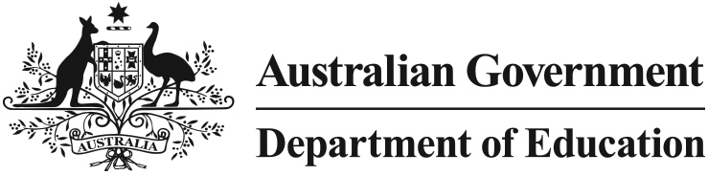

HECS-HELP Benefit for early childhood education teachers

What is this initiative?
The HECS-HELP Benefit for early childhood education teachers reduces the Higher Education Loan Program (HELP) debt of early childhood education teachers who work in areas of high need including regional and remote areas, Indigenous communities and areas of high disadvantage, based on postcode location.
The HECS-HELP Benefit for early childhood education teachers will be discontinued from 1 July 2015. Eligible graduates will have until 30 June 2017 to claim the HECS-HELP Benefit for work undertaken for the 2014-15 income year.

How does it work?
Eligible early childhood education teachers are able to apply to the Australian Taxation Office (ATO) for a HECS-HELP Benefit to reduce their HELP debt for the previous income year. Eligible early childhood education teachers have two years in which to apply for the benefit for a particular financial year.
The best time to lodge your application is generally at the same time as lodging your income tax return.
A list of eligible post codes is available by clicking on HECS-HELP Postcodes. This list can also be found on the Department of Education website at education.gov.au

Am I eligible?
You are eligible for the benefit if you:
- have completed an early childhood education degree
- have a current HECS-HELP debt
- worked as an early childhood teacher or in a teaching related occupation for at least one week in the previous year
- worked in an eligible postcode.

How much benefit will I receive?
The benefit will provide eligible early childhood education teachers with a reduction in their HELP debt of up to a maximum amount each year. In the income year 2013-14, the maximum amount will be $1831.32. This amount will be indexed in 2014-15.
Even if you are not required to make a compulsory HELP repayment, you may still apply to have your HELP debt reduced through the HECS-HELP Benefit.

Am I also eligible to receive HECS-HELP Benefit for education graduates?
Eligible education graduates who have graduated from second semester 2009 onwards and who take up employment in teaching will be able to apply for a HECS-HELP benefit which will reduce their HELP repayments. The maximum benefit for the 2013-14 income year for education graduates is $1716.85. This amount will be indexed in 2014-15.
Note that the HECS-HELP Benefit for education graduates will also be discontinued from 1 July 2015.

How do I find out more about these initiatives?
Detailed information about both benefits and how to apply is available on the ATO website (ato.gov.au) and type HECS HELP for early childhood into the ‘search for' field. This will bring up the ‘HECS-HELP Benefit for early childhood education teachers' link.

