Family Day Care Business Model
This fact sheet explains how Family Day Care operates under national law and family assistance law, particularly in regards to Child Care Benefit and Child Care Rebate.
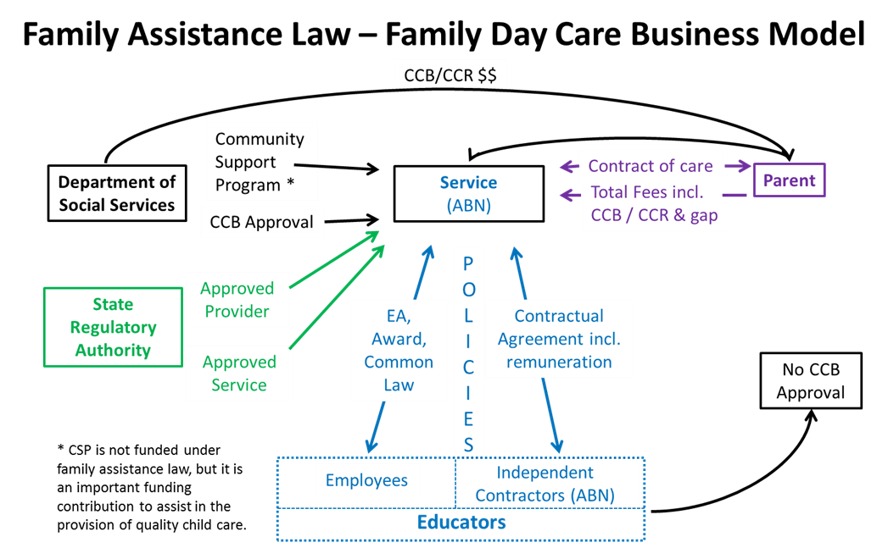

Forming a Family Day Care service
There are three key groups in the Family Day Care business model.
The first of these groups are the regulators:
- State and Territory Regulatory Authorities, the regulators for the Education and Care Services National Law Act (the ‘National Law’) and
- the Department of Social Services, the regulator for the A New Tax System (Family Assistance) Act 1999 and the A New Tax System (Family Assistance) (Administration) Act 1999 (the ‘Family Assistance Law’).
The second group is the Family Day Care service, the entity with a unique Australian Business Number (ABN) and approval to administer Child Care Benefit (CCB) and Child Care Rebate (CCR), which provides care to eligible families.
The third group is the Parents or guardians who pay fees and are eligible to receive CCB and CCR.

State and Territory Regulatory Authorities
The State and Territory Regulatory Authorities assess, grant and monitor ongoing ‘provider approval’ and ‘service approval’ status under the National Law.

Department of Social Services
Once a service operator has been granted both provider and service approval from the relevant State/Territory Regulatory Authority they can apply to the Department of Social Services for approval under the Family Assistance Law for the purposes of CCB.

Family Day Care services
Each Family Day Care service will have a range of policies and procedures in place which relate to the quality of care, support for their educators, fee charging practices, debt collection and other administrative arrangements to ensure the service operates effectively. All educators are required to abide by these policies and this should be part of their employment arrangements.
Family Day Care services generally engage educators in one of two ways. The educators might be engaged as employees and where this is the case they could be employed under an enterprise agreement, an award or common law. Educators can also be independent contractors and they should have a contractual agreement in place that includes their conditions of work including remuneration. Educators who are independent contractors will generally have their own Australian Business Number (ABN).
Note: an independent contractor’s ABN is not licensed or approved to provide family day care services – it is a taxation option or requirement and has no standing under family assistance law.

Operating an approved Family Day Care service
The Department provides fee assistance in the form of CCB and CCR directly to eligible Parents or to the Family Day Care service on behalf of Parents. These benefits are the Parents’ and it is the Parents who choose whether to have their Australian Government assistance paid to the service. The Department of Human Services is responsible for assessing Parents’ eligibility for CCB and CCR.
There is a contract of care between the Family Day Care service and the Parents. This contract of care includes the terms and conditions of the care and, importantly, the total fees to be paid to the service.
The Department provides financial support directly to Family Day Care services through the Community Support Programme, which is a contribution towards the operational expenses of Family Day Care services providing support to a network of educators who provide flexible care and operate in a number of different locations.
Operators should be aware that under family assistance law they are responsible for the operations of the entire service, including ensuring their educators comply with all aspects of their service’s policies and procedures and family assistance law.
Where there are penalties associated with a breach of law, it is the operator that will be subject to those penalties. This means that service operators cannot point to an educator and say that because the educator did it, the service operator should not be held responsible. Under the law, the service operator is responsible. It is therefore important that appropriate arrangements are in place with a service’s educators to ensure they understand and comply with their obligations.
Service operators are also responsible for ensuring obligations that are imposed on the service or a condition that is placed on the service licence by the State or Territory Regulatory Authority is upheld.

More information
The main laws governing your family day care service’s obligations are set out below.

The National Law (administered by your state or territory):
- Education and Care Services National Law Act
- Education and Care Services National Regulations

Commonwealth Family Assistance Law:
- A New Tax System (Family Assistance) Act 1999
- A New Tax System (Family Assistance) (Administration) Act 1999
- Child Care Benefit (Eligibility for Approval and Continued Approval) Determination 2000 and other legislative instruments made under the two acts above.
All these are available on the Comlaw website at:
www.comlaw.gov.au
Further general information on your obligations can be found in the Child Care Service Handbook, located on the Department of Social Services website at:
www.dss.gov.au

Other
For further information on the following items, please go to the ACECQA website at
www.acecqa.gov.au
- National Quality Framework
- Quality Improvement Plans
- Early Years Learning Framework
- State and Territory licensing, including the details for your state or territory

