Being

“Being recognises the significance of the here and now in children’s lives.”

(Early Years Learning Framework, p.7)

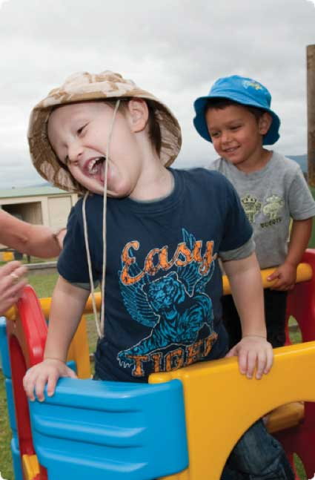
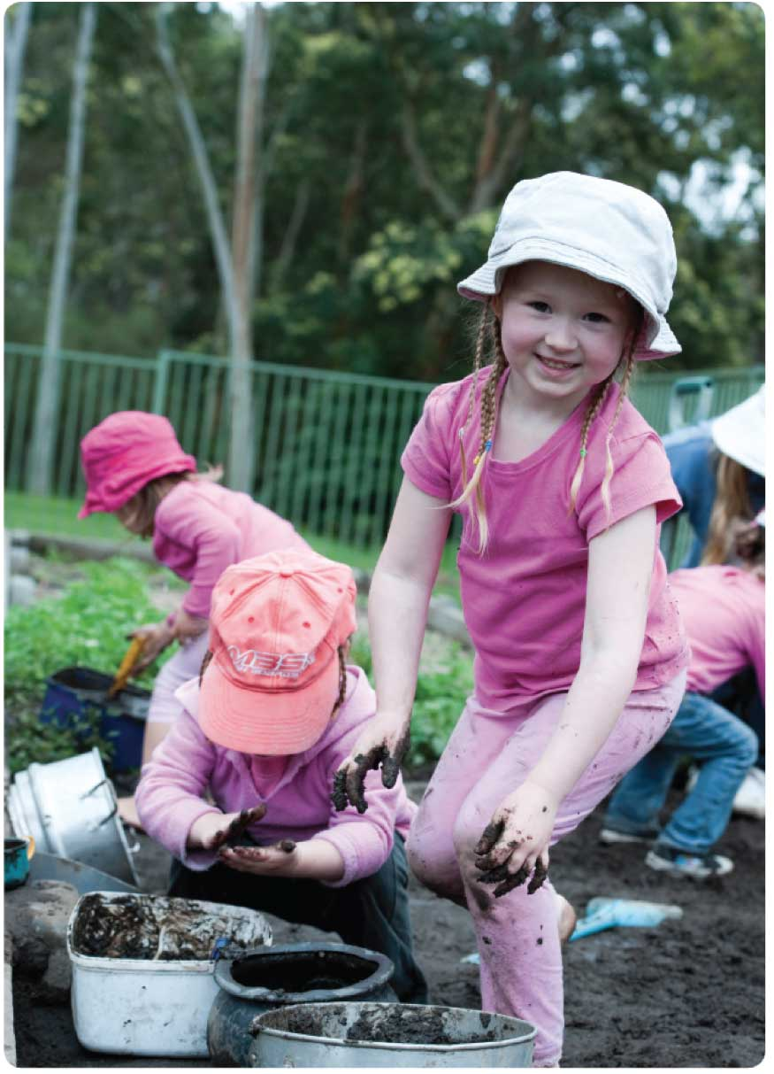

Childhood does not have to be hurried. Sometimes the best preparation for being five (or four, or three, or two…) is to be four (or three, or two, or one) for a whole year.

Becoming
“All young Australians
should become:

- Successful learners

- Confident and creative individuals

- Active and informed
- citizens.”

(Early Years Learning Framework, p.5)

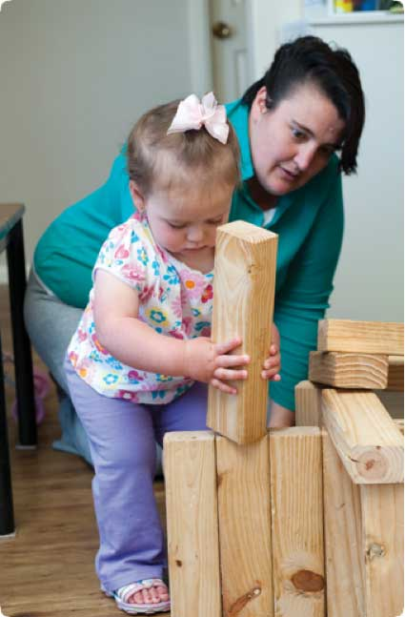
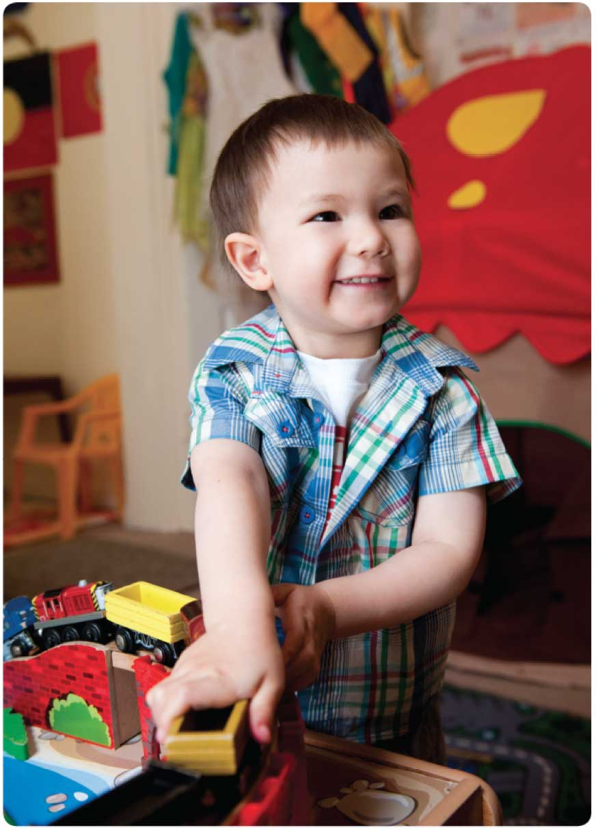

The early childhood years are crucial to each child’s future. As educators one of our most important roles is to help each child reach their potential. What we do now contributes to future success and happiness.

Belonging

“In early childhood, and throughout life, relationships are crucial to a sense of belonging. Belonging shapes who
children are and who they
can become.”

(Early Years Learning Framework, p.7)

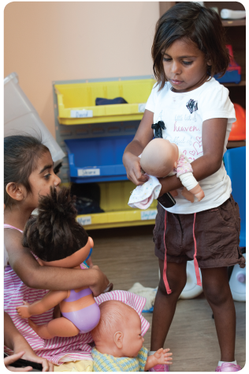
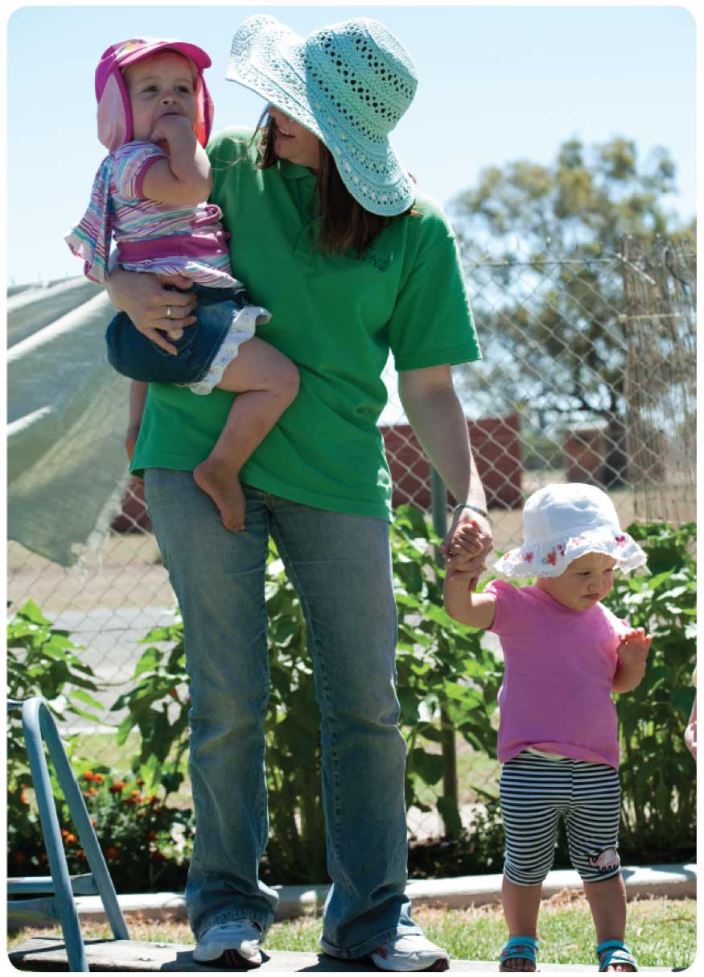

A sense of belonging is essential if children are to be successful learners. By fostering belonging we also foster wellbeing and learning.

is everywhere
Learning

“Curriculum encompasses all the interactions, experiences, activities, routines and events, planned and unplanned, that occur in an environment designed to foster children’s learning and development”

(Early Years Learning Framework, p.9)

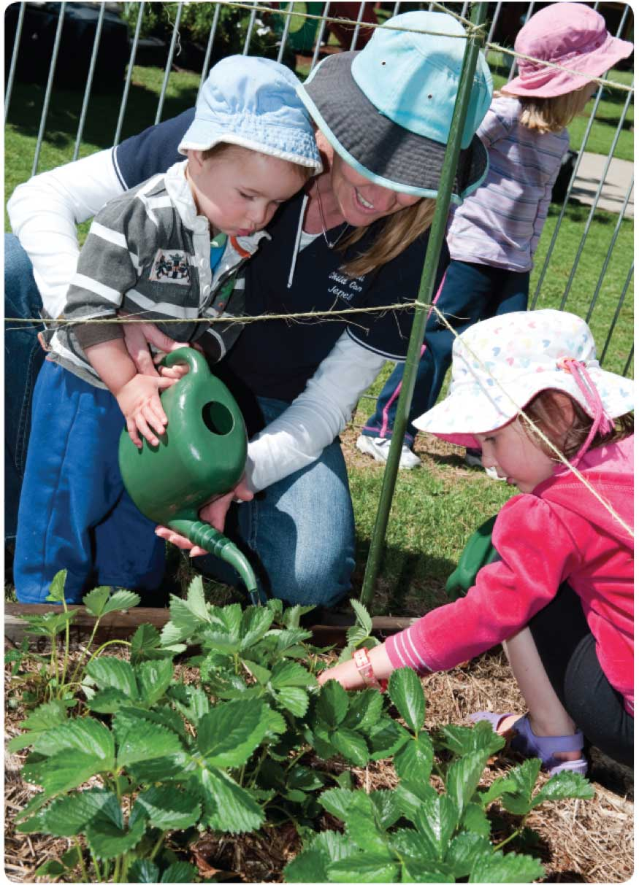

For a child everything is a potential learning experience. As educators we need to think about how learning can be part of every moment of the day.

Relationships
matter

“When children feel safe, secure and supported they grow in confidence to explore and learn.”

(Early Years Learning Framework, p.20)
Secure, respectful and reciprocal relationships form the basis for successful learning. The relationships we form with children are amongst the most important things we do as educators.
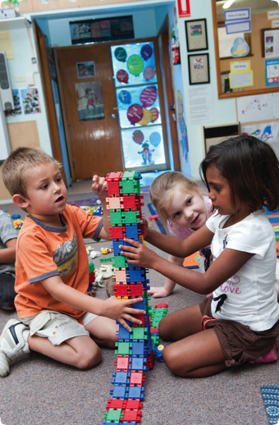
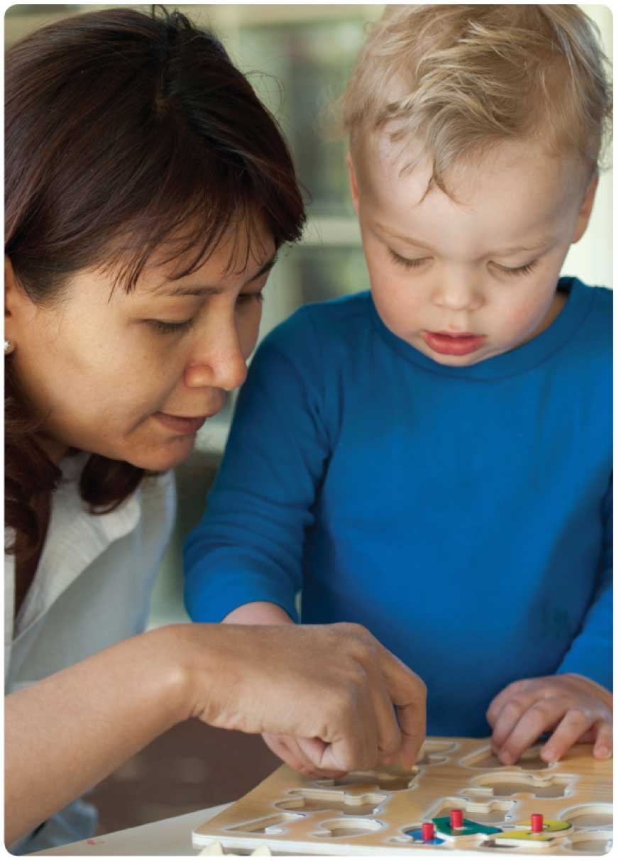

Working together

“Children thrive when families and educators work together in partnership to support young children’s learning.”

(Early Years Learning Framework, p.9)

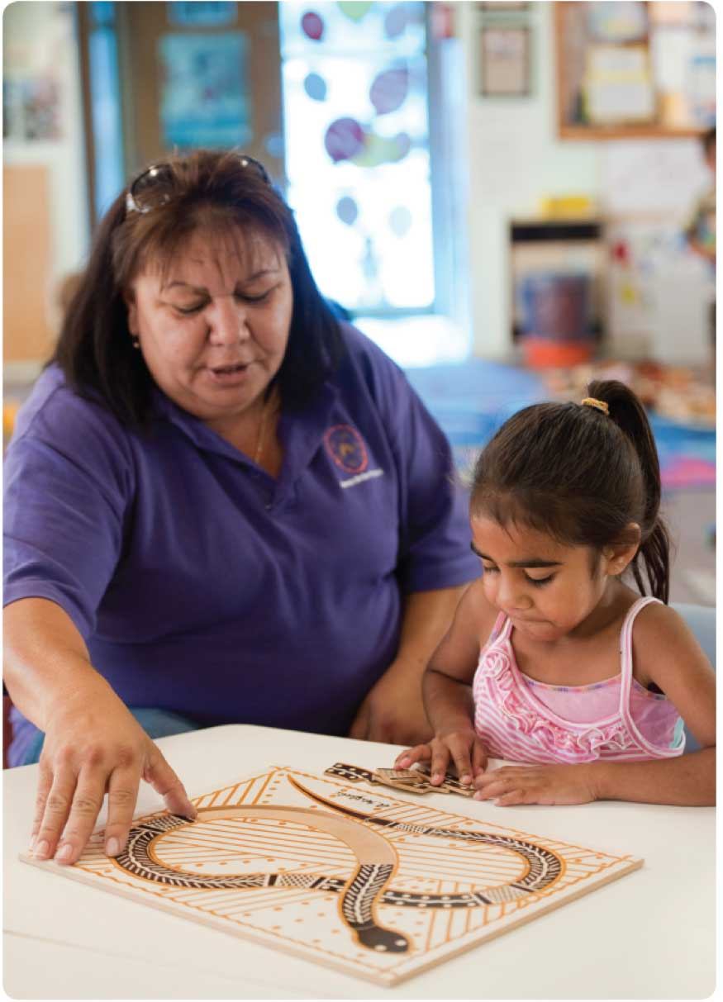

Finding ways to connect with families is essential to support children’s learning. Making time to share meaningful information about each child’s progress helps to create a genuine connection as well as a shared sense of achievement.
Shared thinking

“Responsive learning relationships are strengthened when educators and children learn together and
share decisions, respect
and trust.”

(Early Years Learning Framework, p.15)
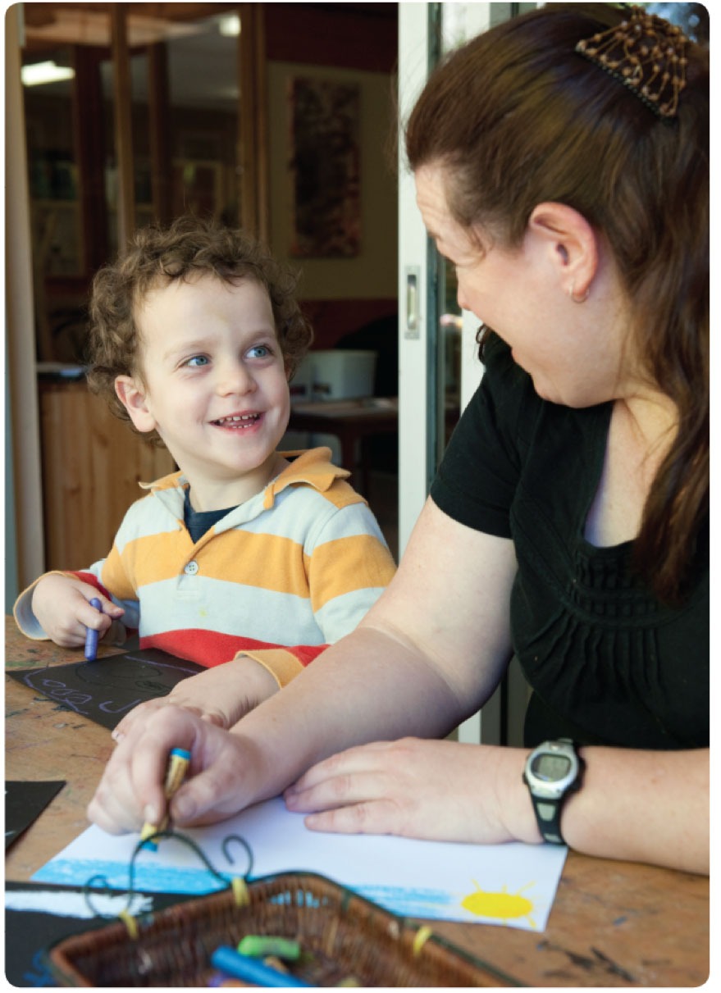
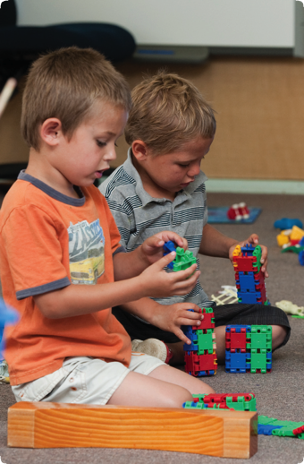
As educators we support and extend children’s learning through our involvement in their play. By engaging in shared thinking and conversations we help children’s thinking and learning to become richer and more complex.

.

