Early Years

Workforce

Strategy

  - The Early Childhood Education and Care Workforce Strategy for Australia

  - 2012–2016

ISBN: 987-0-642-78554-1 [PRINT]
ISBN: 978-0-642-78555-8 [PDF]
ISBN:978-0-642-78556-5 [DOCX]

This publication was commissioned by the Standing Council on School Education and Early Childhood (SCSEEC) and managed by the Early Childhood Development Working Group.

© 2012 Education Services Australia Ltd as the legal entity for the Standing Council on School Education and Early Childhood (SCSEEC). This publication may be copied, distributed, displayed or downloaded for non-commercial educational purposes provided the source is clearly acknowledged. The publication may not be sold or used for any other purpose. Content in this publication indicated as being owned by third parties may only be used as permitted by the Copyright Act 1968 (Cth). Other than as permitted above or by the Copyright Act 1968 (Cth), no part of this publication may be used without the prior written permission of the copyright owner. Address inquiries regarding copyright to: SCSEEC PO Box 202, Carlton South, Victoria Australia 3053 or email enquiries@scseec.edu.au.

Contents

Introduction 1
The need for action 2
Working together to achieve change 3
Key priority areas 4
The strategy in action 4
1. A professional workforce 5
2. A growing workforce 7
3. A qualified workforce 9
4. A responsive workforce 11
5. A collaborative workforce 13
Appendix A—Data and evidence base 15
Abbreviations and definitions 17

Introduction
The Early Years Workforce Strategy sets out a vision agreed by all governments in Australia to build and support the early childhood education and care (ECEC) profession both in the short term and into the future.

The aim of the strategy is to guide governments and the sector to:
- deliver a sustainable, highly qualified and professional workforce
- foster a flexible and responsive workforce capable of identifying and delivering services in response to the needs of children and families
- support ECEC staff to work in a more integrated way with the broader early childhood development (ECD) workforce including the range of professionals that work with children and their families across health and family services.
The strategy builds on Investing in the Early Years—A National Early Childhood Development Strategy, which was endorsed by the Council of Australian Governments (COAG) in July 2009. The vision of the ECD Strategy captures the aspirations of governments that by 2020 all children will have the best start in life to create a better future for themselves and for the nation.
The overarching ECD Strategy provides a specific 2020 vision for the ECD workforce. In the immediate term, major national reforms in the ECEC sector present critical workforce challenges.
This Early Years Workforce Strategy reflects a commitment by governments to address the immediate priorities for the ECEC workforce, and at the same time working towards a long-term broader strategy for the workforce with a focus on supporting more integrated ways of working across the ECD sector. The ECEC workforce comprises educators working in education and care services including long day care services, family day care services and outside school hours care as well as in preschools and kindergartens.

This strategy follows on from significant national policy reform in the ECEC sector, including the introduction of the National Quality Framework for Early Childhood Education and Care, the National Partnership for Early Childhood Education (commonly referred to as Universal Access), the National Partnership for Indigenous Early Childhood Development and the Early Years Learning Framework (EYLF). The reform process is being phased in over several years to ensure a smooth transition and allow the sector time to implement the changes successfully.

The following diagram outlines the significant milestones for the ECEC workforce as the reforms are phased in, including the establishment of the Australian Children’s Education and Care Quality Authority (ACECQA). ACECQA is the national entity overseeing important changes to ECEC and school age care in Australia. Other key milestones include when ECEC workforce ratio and qualification requirements begin.
Early childhood education and care policy context
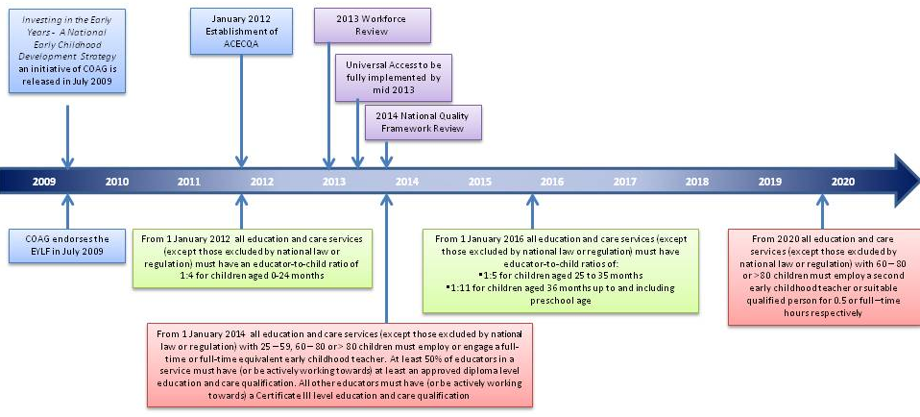

The need for action
A skilled workforce is essential to delivering high-quality ECEC services and to achieving the best outcomes for children and their families. There is increasing recognition that the work of caring for and educating young children is complex and requires enhanced qualifications and ongoing professional development. Programs delivered by qualified educators are particularly effective in improving outcomes for vulnerable children.
In addition, governments throughout the developed world are implementing, or considering moving towards, more integrated models of delivery for early childhood services to provide services that are more accessible and responsive to the needs of children and their families.
In Australia the number of children participating in formal ECEC has been growing consistently over several years, including a 20 per cent increase between June 2009 and June 2011.

While the ECEC workforce has grown considerably in recent years to meet this growing demand and its qualification profile has been raised, there remains a significant task to:
- further expand the workforce
- increase the proportion of staff who have or are working towards a relevant ECEC qualification
- further develop regional and remote workforce capability, and in particular develop and support the abilities of local Aboriginal and Torres Strait Islander people in remote communities to deliver the services their community needs
- increase the representation of Aboriginal and Torres Strait Islander people and those from culturally and linguistically diverse (CALD) backgrounds across the workforce
- facilitate ongoing professional development to embed a cultural focus on pedagogy, educational program design and delivery and leadership
- encourage ECEC staff to work in a more integrated way with the broader ECD workforce, including across health and family support services.
To attract and retain suitably qualified educators, governments are working with the sector to improve the professional status of these roles. The National Quality Framework (NQF) will go some way towards this, through improved and nationally consistent qualification requirements. The strategy identifies other actions to help achieve this goal. Matters such as lower pay and conditions compared to other sectors are recognised as affecting professional status but are outside the scope of the strategy, as they are for employers and employees to negotiate.

Working together to achieve change
Responsibility for developing a sustainable ECEC workforce is shared between service providers; early childhood educators; the peak bodies for the sector, including unions; the Australian, state, territory and local governments; training providers; families; and communities. All of these stakeholders contribute to workforce development for the sector and can drive change by working together.
Shared responsibility for workforce development
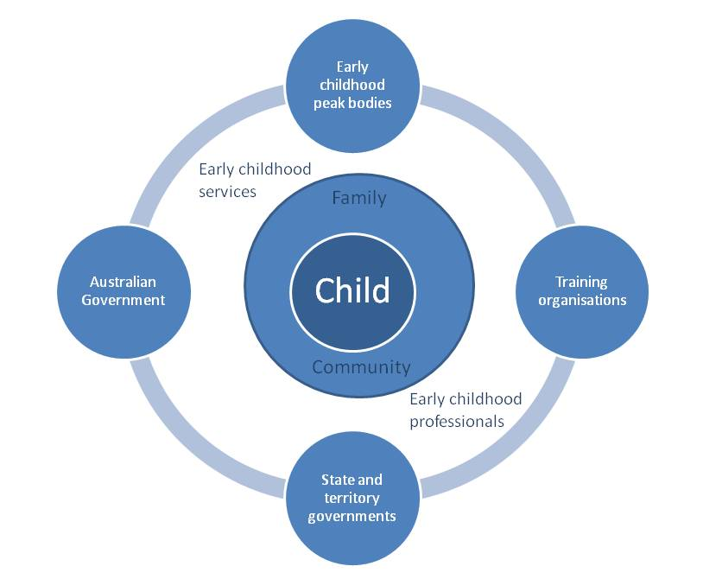
The goals and actions identified in this strategy build on government leadership in policy development, through sector collaboration and shared responsibility.

Key priority areas
The following five priority areas have been identified as essential components of achieving a sustainable and highly qualified ECEC workforce.

The strategy in action
A summary of all Australian Government and state and territory government workforce initiatives for the ECEC sector will be set out in the jurisdictional implementation plans to support this strategy. Jurisdictional implementation plans may include reference to a number of different initiatives outlined in existing plans which tackle jurisdiction-specific workforce issues. These plans will be updated to include new initiatives as they are developed or any changes to current initiatives. They will be made available as links on the Australian Government Department of Education, Employment and Workplace Relations (DEEWR) website.

These actions will be subject to ongoing evaluation, monitoring and review, based on measurable indicators such as Australian Bureau of Statistics labour force data, data from regulatory agencies like ACECQA on compliance with the National Quality Standards (NQS), the Australian Early Development Index (AEDI) and the national ECEC Workforce Census as well as state and territory data collections. The evaluation and monitoring of the implementation of the Early Years Workforce Strategy will take place via updates to the Early Childhood Development Working Group.

1. A Professional Workforce
Goal: Enhance the professionalism and leadership of the ECEC workforce

Success indicators
- Families and communities recognise that ECEC educators have specialist skills and knowledge that supports the development and learning of children.
- Increased participation by the sector in professional development and leadership activities, with a focus on professional educational practice, program design and delivery and leadership.
- High levels of ECEC workforce job satisfaction are maintained and retention is increased.
- The ECEC sector has access to quality professional development.

ECEC is recognised as a profession which requires specialist skills and knowledge to support child development. Quality professional development and job-based training opportunities in ECEC settings are critical to ensuring skills remain up to date and relevant to the workplace environment. The concept of professionalism in the ECEC workforce is incorporated into the NQS through references to capability, leadership, teaching and learning. Enhancing the public perception of the profession will assist in attracting and retaining a skilled ECEC workforce.

Building a career pathway is a key step in raising the professionalism of the ECEC workforce. Clearly articulating the opportunities available for educators through updating and increasing qualifications will offer clear goals and reward professionalism, ultimately improving the quality of education and care of children.

Facilitating better connections and collaboration between the peak professional bodies representing the ECEC workforce is an important step in embedding professional development for educators. Partnerships between governments and industry organisations will assist in the expansion of professional development opportunities available for educators through better utilisation of existing resources.

The establishment of ACECQA will help build wider community understanding of the role of ECEC professionals in delivering quality early childhood services. ACECQA’s work with other bodies, such as the Australian Institute for Teaching and School Leadership (AITSL), will bring a national approach to the development of professional standards in the ECEC sector.

Key approaches:
Support professional development and leadership opportunities
- Engage with the sector to identify and promote quality professional development and encourage participation.
- Develop guidance for management, leadership and governance of organisations that highlights effective practices that attract, retain and develop a professional workforce.
- Engage with AITSL to explore how the National Professional Standards for Teachers could be extended to early childhood teachers.
- Facilitate and encourage better connection and collaboration between existing industry organisations to identify gaps in existing professional development and enhance professional development opportunities.

Promote the professionalism of the ECEC workforce to the wider community
- Promote early childhood education as a rewarding, challenging and important career with clear pathways for progression, via avenues such as school career counsellors, TAFE and university open days and job service providers.
- Build further understanding among parents and the community about the importance of qualified educators who support children’s learning and development.
- Disseminate stories and case studies of professional practice.
- Promote the importance, rewards and career opportunities of being an early childhood educator—in particular to the Aboriginal and Torres Strait Islander community—to encourage more people to become educators.

Recognise professional practice
- Recognise and promote excellent practice within the ECEC profession.
- Recognise the work of Aboriginal and Torres Strait Islander educators.
- Recognise and promote quality education and care on both a service level and an educator level, for example through excellence awards, ACECQA processes, and promotion of excellent services and their educators.

2. A Growing Workforce
Goal: The ECEC sector attracts and retains a diverse workforce, including in regional and remote locations.

Success indicators:
- Increased numbers of jobseekers and school leavers choosing an ECEC career.
- The ECEC sector growing at a rate that meets demand.
- Reduced turnover of existing early childhood educators.
- Reduction of ECEC workforce skill shortages in regional and remote locations.
- Greater diversity in the ECEC workforce, with increased numbers of Aboriginal and Torres Strait Islander and other CALD staff.

Rising birthrates and female workforce participation have led to higher demand for ECEC services and consequently for ECEC educators. This trend is expected to continue. The implementation of the NQF and the national commitment to universal access to early childhood education have also increased the demand for qualified ECEC educators, particularly in preschool and long day care settings.

It is essential that the ECEC sector build a skilled workforce that delivers high-quality ECEC programs that focus on relationships between educators, children and their families. It is also important that educators have relevant cultural competencies in inclusive practices that respond to the diverse needs of children.

Creating a sustainable ECEC workforce in regional and remote communities raises additional challenges, including how best to support a workforce that generally has a lower qualification profile and greater difficulties accessing training and professional development, as well as the broader issues ranging from higher cost of living to housing shortages. Attracting and developing Aboriginal and Torres Strait Islander ECEC educators, particularly in remote communities and in locations with significant Aboriginal and Torres Strait Islander populations, will have significant benefits for the ECEC sector and these communities. These include teaching parenting skills, providing role models and supporting children through the use of home language.

All governments are supporting sector growth through a range of initiatives such as scholarships and improved career and training pathways. Promoting existing programs more widely across the sector, particularly in locations where there is a shortage of early childhood educators and/or where high staff turnover presents an impediment to the delivery of quality early childhood services, will help build the numbers of early childhood educators.

Key approaches:
Promote early childhood careers
- Promote ECEC career opportunities, tailored to specific target groups including:
  - Aboriginal and Torres Strait Islander people
  - people from CALD backgrounds
  - people seeking a career change or return to work after a long absence.
- Promote career opportunities in areas where there are identified skills shortages, particularly in rural and remote Australia.
- Explore opportunities to promote early childhood careers in schools, including through careers counsellors, careers days and school-based vocational training options.

Promote existing training programs and pathways
- Promote existing pathways to training and make access to point-of-entry training and programs easier to navigate through improved consumer information.
- Promote existing employment and training programs available through the Australian Government and state and territory governments.
- Review and improve existing incentives aimed at increasing the recruitment and retention of ECEC professionals in rural and remote areas.
- Promote recognition of related qualifications to facilitate career change.

Support Aboriginal and Torres Strait Islander people to build a career in ECEC
- Promote and ensure relevancy of training and career opportunities within Aboriginal and Torres Strait Islander communities to increase numbers of local ECEC educators working in these communities, including by:
  - consulting with Aboriginal and Torres Strait Islander people regarding training preferences and available opportunities
  - encouraging Aboriginal and Torres Strait Islander school students to consider children’s services qualifications
  - building on existing programs to attract Aboriginal and Torres Strait Islander people to the ECEC sector, including through effective collaboration across government agencies.

3. A Qualified Workforce
Goal: Increase the level of qualifications in the ECEC workforce

Success Indicators
- Increased numbers of educators have qualifications to support the reforms, including the NQF and Universal Access.
- Increased numbers of services meet and exceed qualification requirements under the NQF and Universal Access.
- Increased student, employee and employer satisfaction with training programs.
- Increased numbers of Aboriginal and Torres Strait Islander educators are participating in training programs.
- Increased numbers of employers are aware of training options.

Well-trained and qualified ECEC educators with the right knowledge and skills are essential to quality outcomes for children, particularly vulnerable children. The importance of highly qualified staff to outcomes for children is exemplified in the underlying policy of the NQF, which sets out minimum qualification requirements and promotes a stronger focus on educational leadership.

All qualification courses from Certificate III to Masters need to embed NQF, pedagogy (an educator’s professional practice around teaching and learning) and appropriate practical experience. Professional development in the short term needs to facilitate the attainment of qualifications and focus on supporting the needs of every child, particularly vulnerable children.

High-quality, sector-relevant training and curriculum in both higher education and vocational education and training settings is required to meet the broader qualifications requirements across the ECEC sector. Meeting the changing needs of the sector may involve:
- improving access to existing training in both the vocational education and training (VET) and tertiary sectors
- increasing the ease of obtaining recognition of existing skill sets under the formal qualifications for experienced educators
- designing more effective, flexible training models which are tailored to meet the needs of specific groups, including Aboriginal and Torres Strait Islander educators, CALD educators, family day carers/educators and rural and remote ECEC educators
- removing financial, time, cultural and other barriers.

A number of oversight bodies—including the Australian Skills Quality Authority (ASQA), the Tertiary Education Quality and Standards Authority (TEQSA), the Community Services and Health Industry Skills Council (CS&HISC) and ACECQA—can play key roles in achieving this outcome.

Key approaches:
Facilitate greater uptake of existing training initiatives
- Assist those wanting to access training or qualifications to navigate the ECEC higher education and training system.
- Facilitate more flexible approaches to qualification upskilling—for example, options for bridging courses that support upgrading qualifications, including from diploma to early childhood teaching degree, and cross-skilling initiatives that enable primary school teachers to diversify their skills to become early childhood teachers.
- Promote training options to build foundation skills to assist educators to improve literacy skills for sustainable employment and further training.
- Work with all relevant stakeholders to promote government initiatives to target audiences.

Support the higher education and training sector to continue to deliver high-quality, relevant and flexible training to the ECEC sector
- Support and promote flexible models of high-quality training and delivery.
- Identify potential barriers to accessing early childhood teacher courses and work with the higher education sector to address these.
- Continue to support the role of the CS&HISC in working with the sector to ensure early childhood VET courses are relevant and meet industry needs.
- Support an increased focus on pedagogy and pedagogical leadership in all training provided to the ECEC sector, in recognition that improved educator practice will mean better outcomes for children.
- Support more Aboriginal and Torres Strait Islander people to gain ECEC qualifications and assume leadership roles within the sector.
- Support the roles of ACECQA, ASQA and TEQSA in promoting quality ECEC training and standards.
- Promote training options to employers.

Review training initiatives
- Review current government training initiatives to ensure they are meeting the current and future needs of the ECEC sector, with an emphasis on educator practice and pedagogy.
- Review training initiatives to ensure they meet the needs of Aboriginal and Torres Strait Islander people wanting to become early childhood educators.

4. A Responsive Workforce
Goal: Enhance the capability of the sector to meet the diverse needs of all children, families and communities accessing ECEC services
Success indicators
- Improved ECEC outcomes for disadvantaged children and families in ECEC.
- Increased level of cultural competency for ECEC educators.
- Increased proportion of Aboriginal and Torres Strait Islander educators.
- Increased capabilities of ECEC educators to identify and appropriately assist children with diverse needs.
- Improved AEDI outcomes across Australia.
- Improved service provider knowledge of the staff skill set and where to access training.
A key element of ensuring better outcomes for children, their families and the community is providing high-quality, culturally appropriate ECEC services. Research indicates that high-quality education and care is particularly effective in improving outcomes for vulnerable children. The best learning and care environments have a strong focus on promotion and prevention, engaging and empowering parents and communities and responding to issues that arise for children and families.

Australian society is becoming increasingly diverse, and ECEC services and educators must respond to this. A responsive workforce needs to:
- confidently identify the diverse needs of children
- further develop skills that address the needs of the diverse range of children it is working with, such as those:
  - from Aboriginal and Torres Strait Islander backgrounds
  - with a disability, including children with high support needs
  - from CALD backgrounds
  - from a refugee or humanitarian intervention background
  - who are vulnerable
  - who may be disadvantaged
- work with families to support and assist them in creating strong learning environments.

Responsive ECEC services can play an important role in helping close the gap in outcomes for Aboriginal and Torres Strait Islander children. Services should develop cultural capacities to respond to and support Aboriginal and Torres Strait Islander children and engage effectively with families. Attracting Aboriginal and Torres Strait Islander people to the ECEC sector and supporting these staff can assist in this. Additionally, improving the cultural capability of non-Aboriginal and Torres Strait Islander educators will be an important contributor.

Key approaches:
Enhance the capability of educators to meet the needs of children from a diversity of social and cultural backgrounds
- Determine core competencies at all levels of qualifications for ECEC educators working with children from diverse backgrounds, including vulnerable children.
- In consultation with the sector, develop professional courses on cultural competency and working with vulnerable children.
- Identify and implement initiatives that support outcomes for vulnerable children.

Enhance the capability of ECEC educators to further develop skills in working with children with diverse needs and connecting them with appropriate support services
- Engage with families on the importance of development and early learning in the early childhood years.
- Use evidence-based assessment processes to increase the capacity of the sector to identify early development and behaviour problems in young children.
- Ensure mental health and wellbeing competencies and responsive teaching practices are included in early childhood qualifications and develop options for incorporating these competencies where they do not exist.
- Investigate, develop and implement an Aboriginal and Torres Strait Islander and CALD educator recruitment and retention plan.
- Develop specifically targeted resources that will assist the sector to better identify and meet the needs of vulnerable children.

5. A Collaborative Workforce

Goal: Enhance the capability of ECEC educators to work effectively with other ECD professionals

Success indicators
- Children and families receive timely and appropriate referrals across early childhood services.
- A growing number of ECEC services are rated as ‘exceeding National Quality Standard’ under NQS Quality Area 6: ‘Collaborative partnerships with families and communities’.
- Educators and services are empowered to build or further develop collaborative partnerships and work in an integrated way with other service providers.
- An evidence base to support proactive policy development is established, using nationally consistent data with links to existing data development, research and evaluation activities.
- Staff in services are able to identify when a referral is required and have the skills and support to do a referral.

ECEC is a part of the broader ECD workforce, and enhancing the skills of ECEC educators to work effectively with other ECD professionals represents a significant step towards better integration of early childhood services. Integration of ECD services in the early childhood sector covers a wide range of professionals working with children and families, including child and family health services, social workers, family support workers, child protection officers, speech therapists and physiotherapists. Better integration of service delivery supports the accessibility and responsiveness of services to better meet the needs of families.

Governments throughout the developed world, including in the United Kingdom, Canada, the United States and Scandinavia, are implementing, or considering moving towards, more integrated models of service delivery for early childhood services to provide services that are more accessible and responsive to the needs of children and their families.

Integration encompasses interdisciplinary ways of working, including collaboration and coordination, networking and referral. It can involve co-location of services and there can be different levels of integration between different service types and in different locations.

Integrating early childhood services creates both challenges and opportunities, including developing joint understandings of ECD and key intervention points and strategies; collaborating and communicating effectively across disciplines; developing capability in delivering family-centred practice and identifying cases requiring early intervention; building awareness and understanding of referral pathways; leading multidisciplinary teams; and reducing regulatory barriers to effective management of integrated services and communication across disciplines and services.

Key approaches:
Support qualifications that enhance the skills of ECEC educators to work effectively with other ECD professionals
- Develop a national framework identifying common and core competencies for the ECD workforce.
- Collaborate across the sector to investigate options regarding integrated practice qualifications.
- Promote a shared understanding of ECD, including developing and communicating a consistent definition of ECD.
- Promote dialogue and action across governments and the sector on developing an integrated ECD workforce.
- Develop guidance for management, leadership and governance to assist integration within ECD settings.
- Develop culturally appropriate resources to help Aboriginal and Torres Strait Islander educators to work with other ECD professionals.

Promote evidence-based integrated service practice
- Draw on the findings of the evaluation of integrated practice initiatives to support integration of service models and improve children’s outcomes.
- Collaborate across the sector on options for improving integrated delivery of services.
- Disseminate practice-based evidence on integration in Australia to help the ECD workforce and services successfully integrate.

Improve the Australian evidence base on ECD
- Develop and implement nationally agreed definitions to inform data collection.
- Generate links between existing data development, research and evaluation activities to achieve nationally consistent data.
- Undertake research into the effectiveness of integration in supporting children and families and improving children’s outcomes.

Appendix A—Data and evidence base
This strategy is supported by international and Australian research evidence that ECEC can have a significant impact on children’s development and life outcomes. The first five years of a child’s life is a critical time, as this is when the brain undergoes the most rapid development. Children develop important cognitive, physical, social and emotional skills which enhance their ability to learn. Providing access to high-quality education and care during this time is the most effective way to help all children reach their potential.

National Early Childhood Education and Care Workforce Census
The National ECEC Workforce Census 2010 is part of a range of Australian Government initiatives designed to improve the quality of information used in developing and measuring early childhood policy and programs. The census was conducted in partnership with state and territory governments. For the first time, it included preschool services as well as child care services.

Further information on the census is available at the DEEWR website http://education.gov.au/national-early-childhood-education-and-care-workforce-census-2010-results

Australian Early Childhood Development Index
The AEDI is a population measure of children’s development that collects information on five developmental domains at school entry: physical health and wellbeing, social competence, emotional maturity, language and cognitive skills, and communication skills and general knowledge.

More information about the AEDI can be found at the AEDI website: http://www.rch.org.au/aedi/index.cfm?doc_id=13051

Productivity Commission research report on the ECD workforce
As part of its education and training workforce study, the Productivity Commission examined the workforce of the ECD sector. The Australian Government asked the commission to consider and provide advice on:
- current and future demand for ECD workers, and the mix of knowledge and skills required within the workforce to meet quality objectives
- the current and future supply of the ECD workforce, and the impact of quality objectives on that supply
- the structure of the ECD workforce, and its efficiency and effectiveness
- ECD workforce planning and development in the short, medium and long term
- institutional arrangements affecting the ECD workforce.

The commission’s final report was released on 1 December 2011. The report, along with submissions made by various organisations throughout the consultation, is available at the Productivity Commission’s website:
http://www.pc.gov.au/projects/study/education-workforce/early-childhood

Existing reforms in the ECEC sector
There are a range of national reforms in the ECEC sector. These include the National Partnership for Early Childhood Education, which is commonly referred to as Universal Access; the National Partnership for Indigenous Early Childhood Development; the EYLF; and the National Quality Framework for Early Childhood Education and Care. Details of these reforms and the range of government initiatives in place to support the ECEC sector are available on the websites below.
Australian Government
http://education.gov.au/early-childhood
Australian Capital Territory
http://www.communityservices.act.gov.au/ocyfs
New South Wales
http://www.dec.nsw.gov.au/our-services/children-and-youth
Northern Territory
http://www.det.nt.gov.au/teachers-educators/ec
Queensland
http://deta.qld.gov.au/earlychildhood/workforce/
South Australia
http://www.decd.sa.gov.au/childrensservices/pages/earlychildhoodreform/home/
Tasmania
https://www.education.tas.gov.au/parents_carers/early_years/Pages/Overview.aspx
Victoria
http://www.education.vic.gov.au/about/directions/initiatives.htm#H2N10070
Western Australia
http://www.det.wa.edu.au/curriculumsupport/earlychildhood/detcms/portal/

Abbreviations and definitions

Abbreviations

ACECQA Australian Children’s Education and Care Quality Authority

AEDI Australian Early Development Index

AITSL Australian Institute for Teaching and School Leadership

ASQA Australian Skills Quality Authority

CALD Culturally and linguistically diverse

CS&HISC Community Services and Health Industry Skills Council

COAG Council of Australian Governments

DEEWR Department of Education, Employment and Workplace Relations

ECEC Early childhood education and care

ECD Early childhood development

EYLF Early Years Learning Framework

NQF National Quality Framework

NQS National Quality Standards

TAFE technical and further education

TEQSA Tertiary Education Quality and Standards Authority

UA Universal Access

VET Vocational education and training

Definitions

Early childhood | This generally refers to the period from birth to eight years of age. In this strategy the major policy focus is on the years from birth to age five, to reflect the workforce issues and needs facing the early childhood sector in the years prior to formal schooling.
Early childhood development (ECD) workforce | ECD encompasses all aspects of a child’s growth, learning, development and transitions from birth to eight years. It incorporates a holistic spectrum of policy interventions including in the health, education and care spheres. The ECD workforce comprises the range of staff who work with children and families, including early childhood educators, early childhood intervention professionals, administrative staff, community service workers and health and social welfare professionals. The ECEC workforce, including coordinators, managers, teachers, teaching assistants and early childhood educators, forms a part of this workforce.
Early childhood education and care (ECEC) workforce | The ECEC workforce is part of the wider ECD workforce. It comprises all staff involved in providing education and care in early childhood, regardless of setting, funding, opening hours or program content. It includes long day care, family day care, occasional care, stand-alone preschool/kindergarten services for children and outside school hours care. These services may be delivered through government or non-government (community or private) providers.
Pedagogy | Educator’s professional practice, especially those aspects that involve building and nurturing relationships, program decision-making, teaching and learning.
Educators | Means an individual who provides education and care for children as part of an education and care service.
Staff member | A Staff member in relation to an education and care service, means any individual (other than the nominated supervisor or a volunteer) employed, appointed or engaged to work in or as part of an education and care service, whether as family day care co-ordinator, educator or otherwise.

J Watson and L Tully, Prevention and Early Intervention Update—Trends in Recent Research, NSW Centre for Parenting and Research, 2008.
Australian Bureau of Statistics Labour Force Survey. Department of Education, Employment and Workplace Relations trend data to November 2010 shows a 28% increase in numbers of early childhood teachers and a 29% increase in numbers of early childhood workers between 2005 and 2010.
J Watson and L Tully, Prevention and Early Intervention Update—Trends in Recent Research, NSW Centre for Parenting and Research, 2008.
Centre for Community and Child Health, Policy Brief No. 17, Integrating Services for Young Children and Their Families, 2009.

