Connecting with families

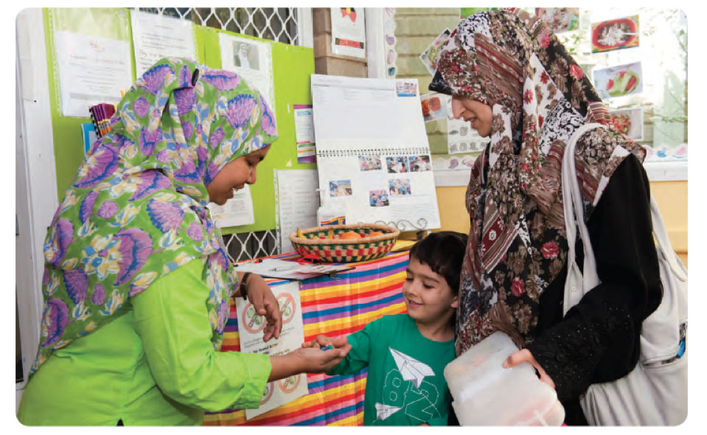

Bringing the Early Years Learning
Framework to life in your community

The Early Years Learning Framework Practice Based Resources project has been funded by the Australian Government through the Department of Education, Employment and Workplace Relations. The resources have been developed by Community Child Care Co-operative Ltd (NSW) to provide support for early childhood educators to implement the Early Years Learning Framework.

With the exception of the Commonwealth Coat of Arms, the Department’s logo, any material protected by a trade mark and where otherwise noted all material presented in this document is provided under a Creative Commons Attribution 3.0
Australia (http://creativecommons.org/licenses/by/3.0/au/) licence.

The details of the relevant licence conditions are available on the Creative Commons website (accessible using the links provided) as is the full legal code for the CC BY 3.0 AU licence (http://creativecommons.org/licenses/by/3.0/au/legalcode).

The document must be attributed as the Early Years Learning Framework Practice Based Resources - Connecting with families: Bringing the Early Years Learning Framework to life in your community.

ISBN: 978-0-9873543-1-0

As early childhood educators relationships are at the heart of everything we do.

Genuine, positive relationships with children, families and each other are essential if we want to achieve positive outcomes.

When we think about relationships it is usually relationships with children that
spring to mind. But the relationships and partnerships that we build with families are just as important.

Working with parents is rewarding, challenging and always full of possibilities.

The best outcomes for children occur when educators and family members work together:

“Children thrive when families and educators work together in partnership to support young children’s learning.”

(Early Years Learning Framework, p.9)

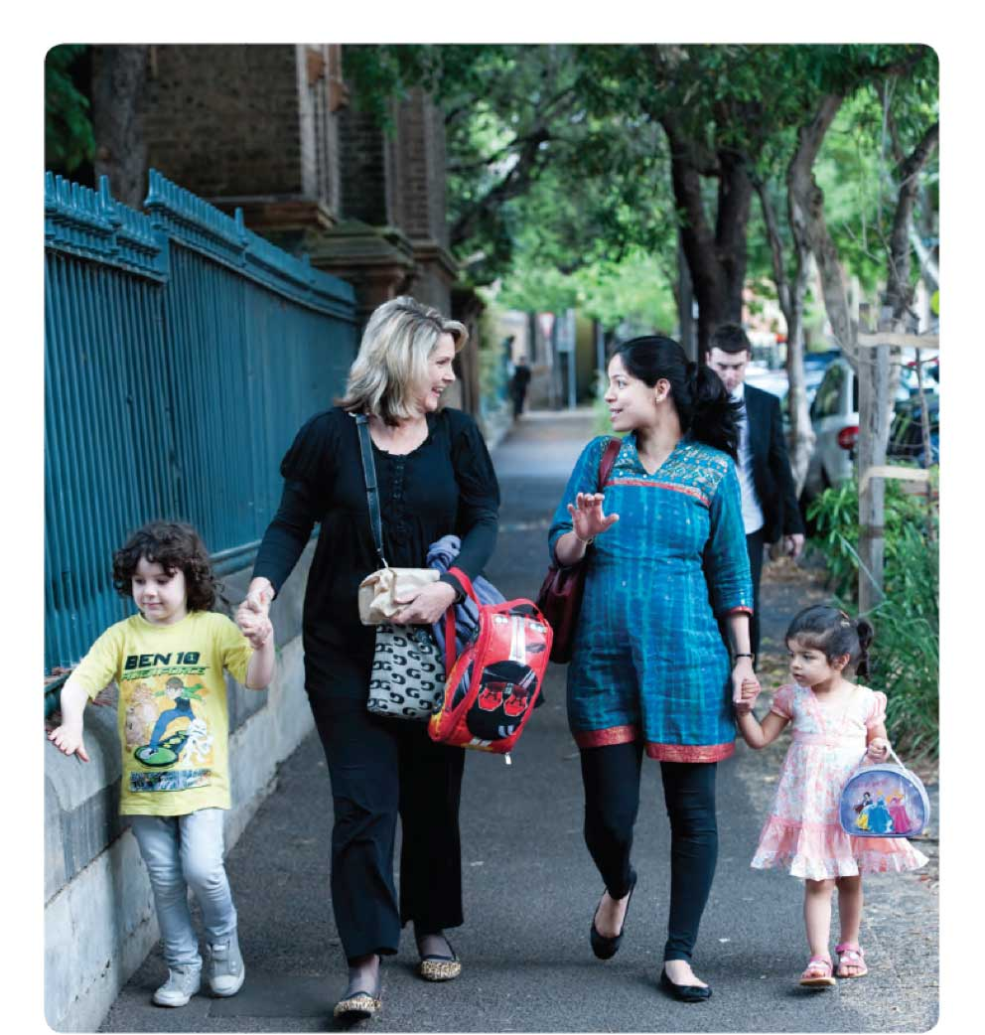

4 Connecting with families

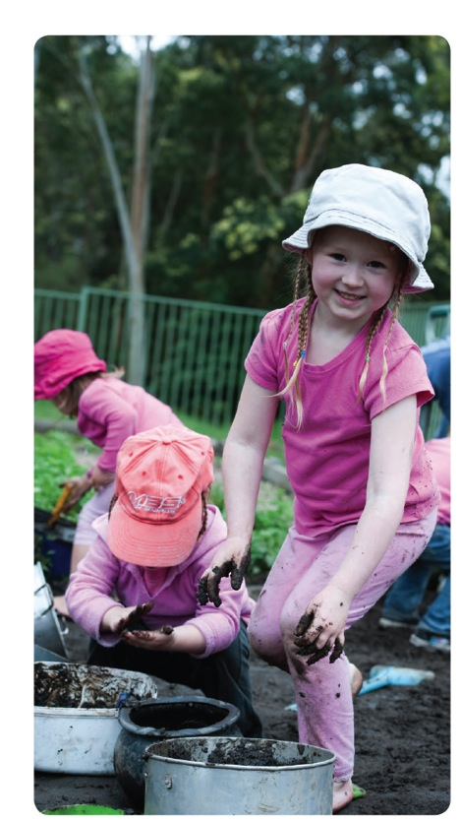

“When you enrol a child you actually enrol a family” 1

Children do not exist in isolation. Each child is, first and foremost,
a member of a family. Parents and other family members are a child’s first and most important teachers.

When we work with a child
we are also working with their family, and often with the wider community, too.

We must think about how we provide authentic opportunities for families to be involved in, and contribute to, their child’s learning.

Before such involvement can happen we need to think about how we help families to feel part of what we do.

1 Intoual, A., Kameniar, B. & Bradley, D. (2009) Bottling the good stuff: stories of hospitality and yarnin’ in a multi-racial kindergar ten. Australasian Journal of Early Childhood Education, 34 (2), 24-30.

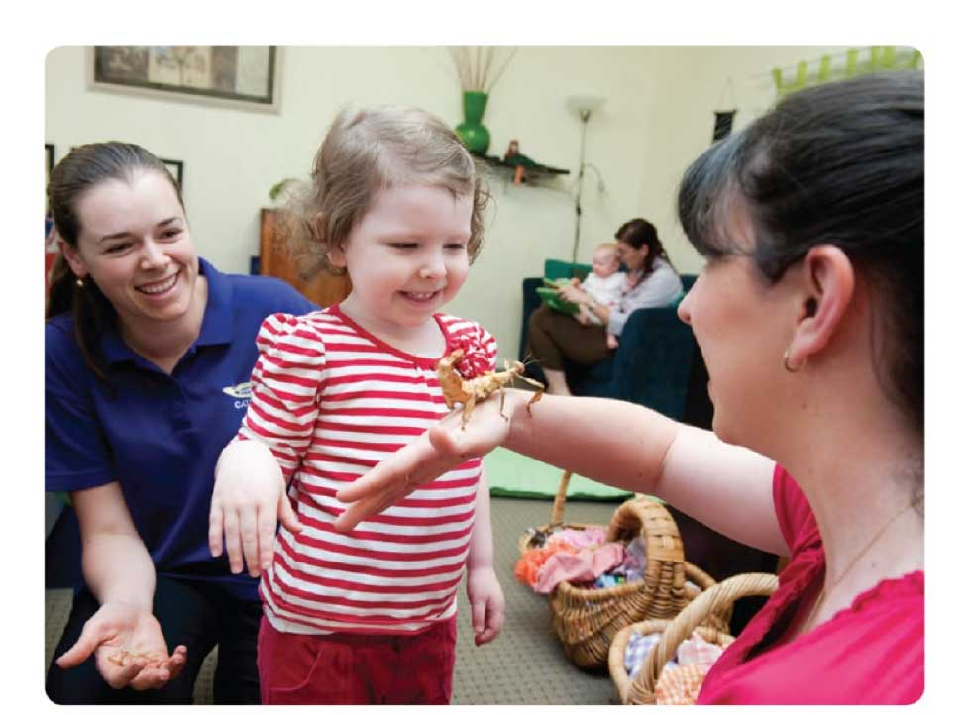

Belonging is as important for family members as it is for the children in our care.

A sense of belonging and welcome is essential if
families are to feel comfortable being in our service, let alone feeling that they can contribute to what we do.

Children learn how to act by watching how family members respond. If families feel happy and welcome then children will too.

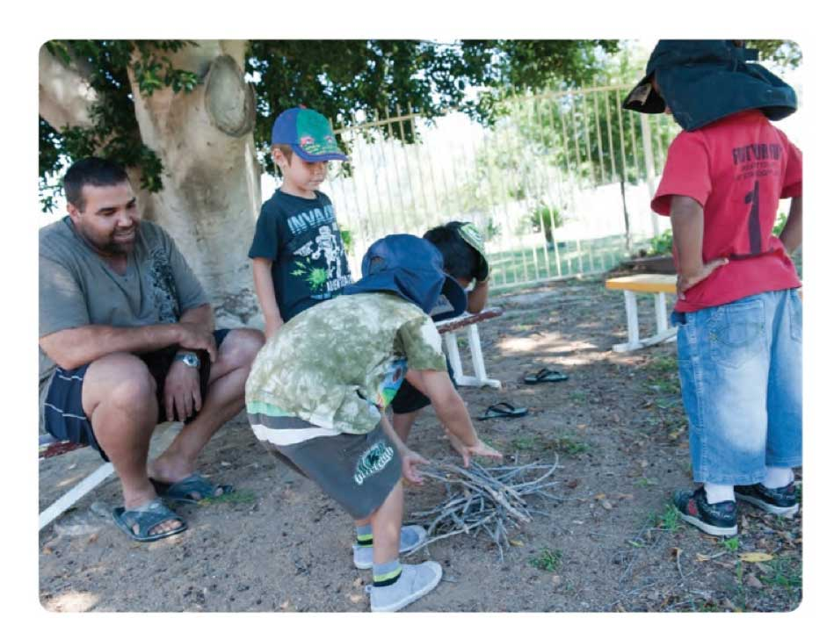

Because we know that family involvement is so important we sometimes expect a lot. We ask families to provide comments on policies and procedures or
to make regular contributions to our program. Such feedback and input is valuable but if we expect all families to be involved in such formal ways we could
be disappointed. Successful relationships are based on respect and understanding. There are different ways
of being involved and we need to listen and then learn about how best to involve families.

It is through day-to-day relationships with family members that we build the foundation for successful
partnerships.

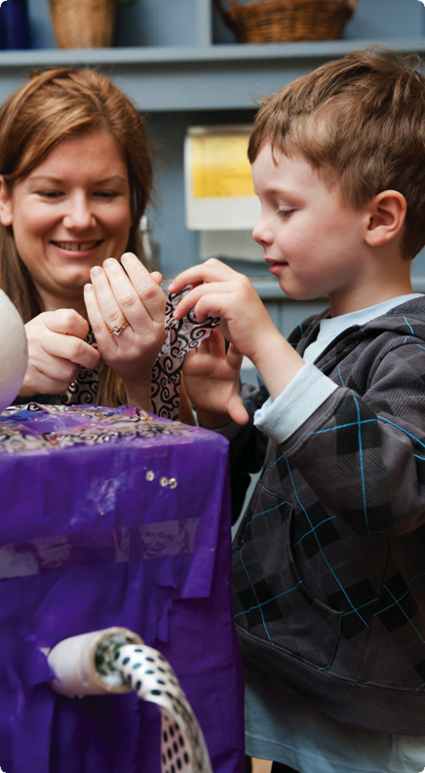

When we show a genuine interest in getting to know each child and their family as individuals we create a sense of belonging and of partnership.

Positive relationships are built on points of connection.

As early childhood educators we already have one very obvious point of connection with each family member - their child.

To build a genuine connection we need to take the time to have meaningful conversations with families about their children.

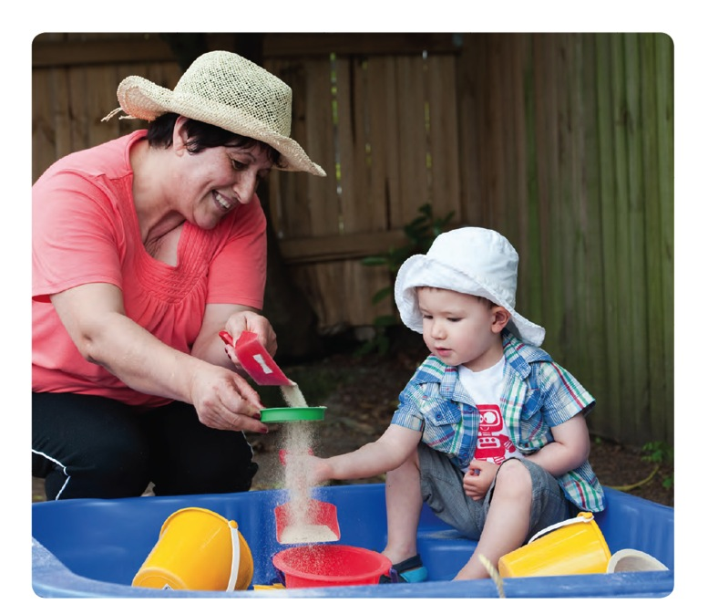

When families entrust their children into our care they want to know, first of all, that we are caring and trustworthy - that their children are going to be okay while they are with us.

Bringing the Early Years Learning Framework to life in your community .. 9

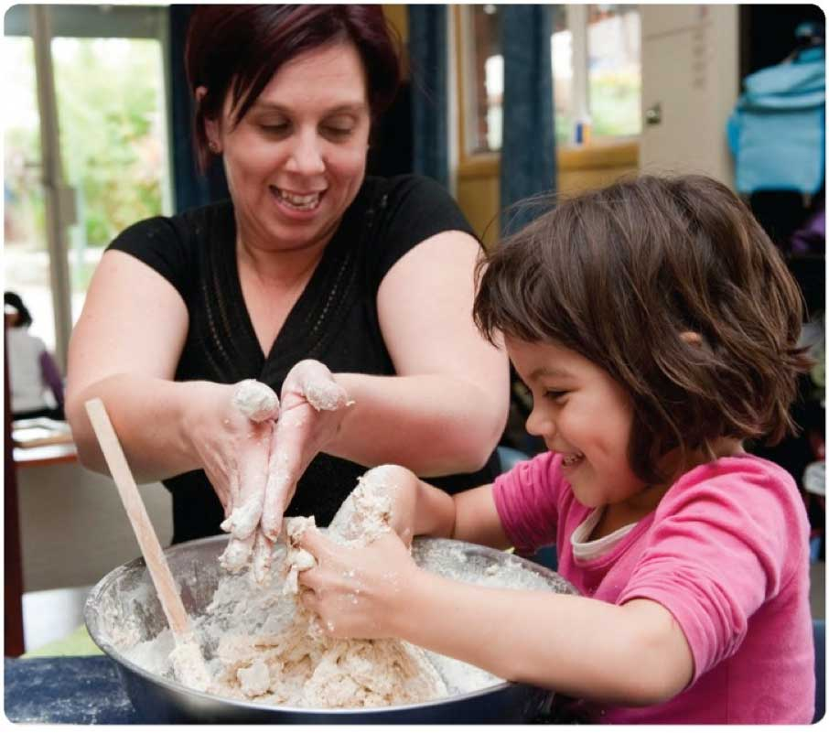

Families are also looking to see that we actually know who their child is; that we know what they like and don’t like; that we’ve taken the time to get to know them as individuals.
I0 :: Connecting with families

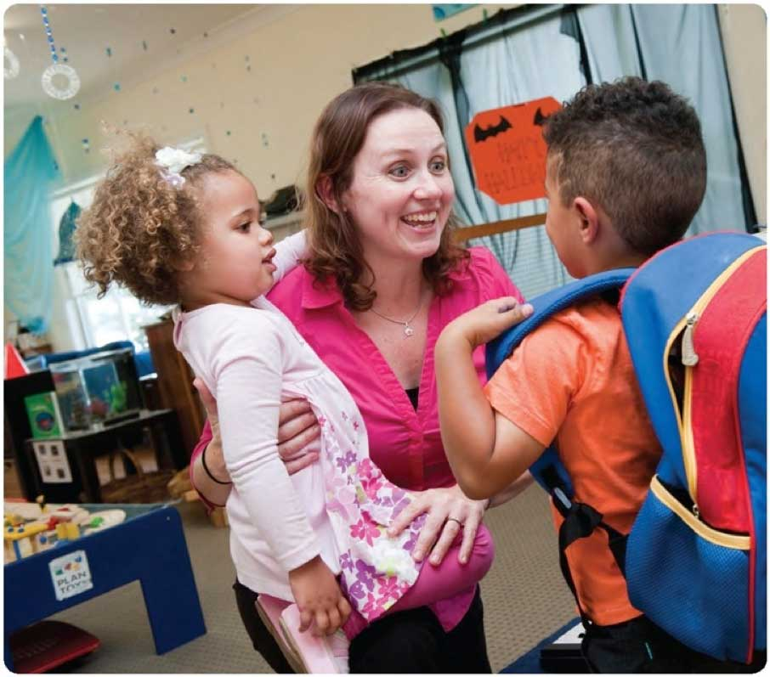

Families are looking to see that we have the skills and knowledge to know how to help bring out the best in their child.

Bringing the Early Years Learning Framework to life in your community II

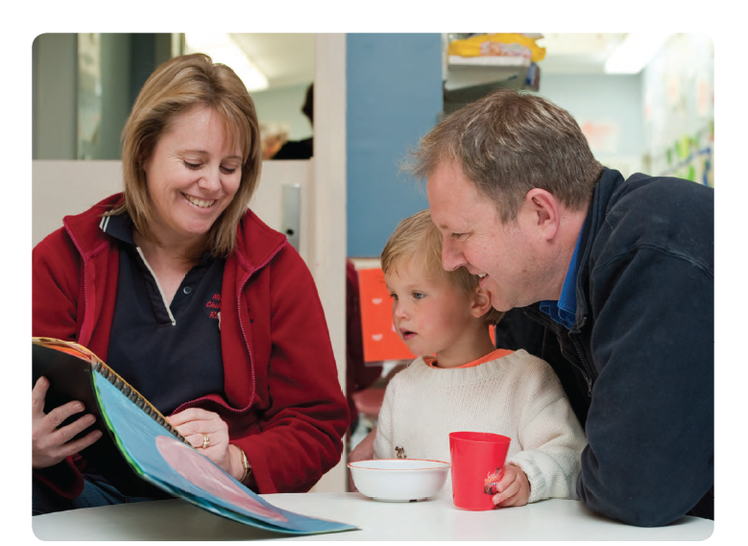

When we talk to families it is important to move beyond the daily greetings and farewells to build deeper connections and understandings. This is our chance to show families that we know their child and that we know what we are doing.

If our conversations are limited to “Sarah had a good day today” or “Toby had fun in the sandpit” then families get little sense of what we actually do. When we take the time to have deeper conversations about children’s interests and their learning it gives families an insight into their own child’s day as well as the importance of our role as educators.

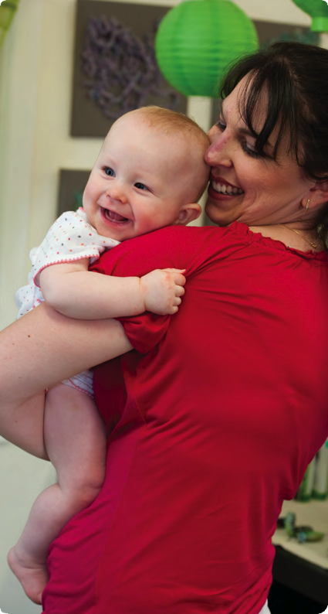

Relationships are complex. If we think of a challenging relationship we have had with a family this only reminds us of the importance of building positive relationships.

Relationships with families are valuable and satisfying when we work in partnership to support children’s learning. By seeking opportunities to talk with families and share information about their child, we are able
to build trusting relationships that give children and families a sense of belonging.

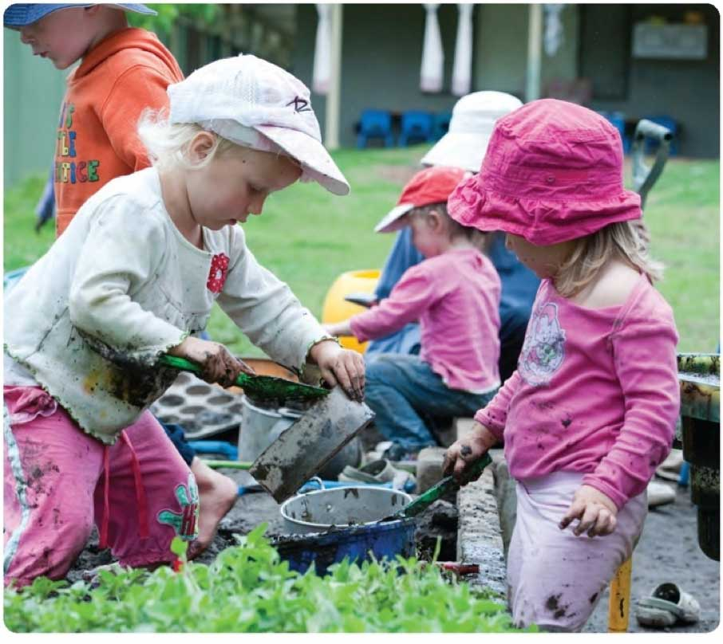
If we truly want to do a good job in our work with children then partnerships with families are not optional. Taking time for building relationships with families is essential.

Building relationships

Sometimes it is the simplest of things that makes the biggest difference.

- Say hello like you mean it - Greetings are important. Even when you’ve already said hello twenty times make it sound like the first time. Whoever you are talking to will appreciate it.
- Learn people’s names - Using someone’s name when you talk to them makes an immediate connection and shows an interest in them as a person.
- Make the first move - Don’t wait for families to come to you. Taking the lead in saying hello and initiating a conversation puts the other person at ease - particularly if they are feeling shy or anxious.
- Share something real about a child’s day - In conversations with family members find something genuine to share about a child’s day. Not just that they’ve had a “good day” but something that shows you are interested in what their child has done. To families the feeling that you genuinely care about and are interested in their child goes a long way.
- Be prepared to listen as well as talk - Families respect and value us as educators more when we show that we value their ideas and opinions. Genuine relationships are about give and take - rather than one side doing all the telling and the other all the listening.
- Put yourself in someone else’s shoes - It can be easy to judge others. But before you dotry and put yourself in the other person’s shoes for a moment. Think about how you would feel in the same situation. Families are just trying to do their best for their children. Think about how you can help them to do it.

Parent perspective

“As an early childhood educator I always thought I had good relationships with the families that I worked with. I still do, but being a parent has given me a different perspective on what parent-educator relationships mean and how important they are.
As a parent I want to know that my child is being cared for - that someone will look after him, someone will comfort him when he’s sad and also share his excitement in finding something new or doing something for the first time.
As a parent I want to feel welcome when I walk through the door - I want someone to smile and say hello to me as well as to my child. I know, because I’ve been there, how busy it can be but I appreciate now what it means for someone to take the time to tell me something meaningful about my child’s day and to show me that you “get him” - that you know what he likes and what he doesn’t, what he’s good at and what he’s not, what he’ll eat and what he won’t - all those little things that make him who he is.
And finally I want to feel that you care about how he’s going - that together we’re thinking about his future and helping him to get there. And I know that’s harder for you because you’re having to think about lots of children and I’m only thinking about one. But when the simple everyday things you do show me that you care, and that in middle of everything that’s going on you know my child and me and our family, then it feels great to think that we’re all on the same page.”

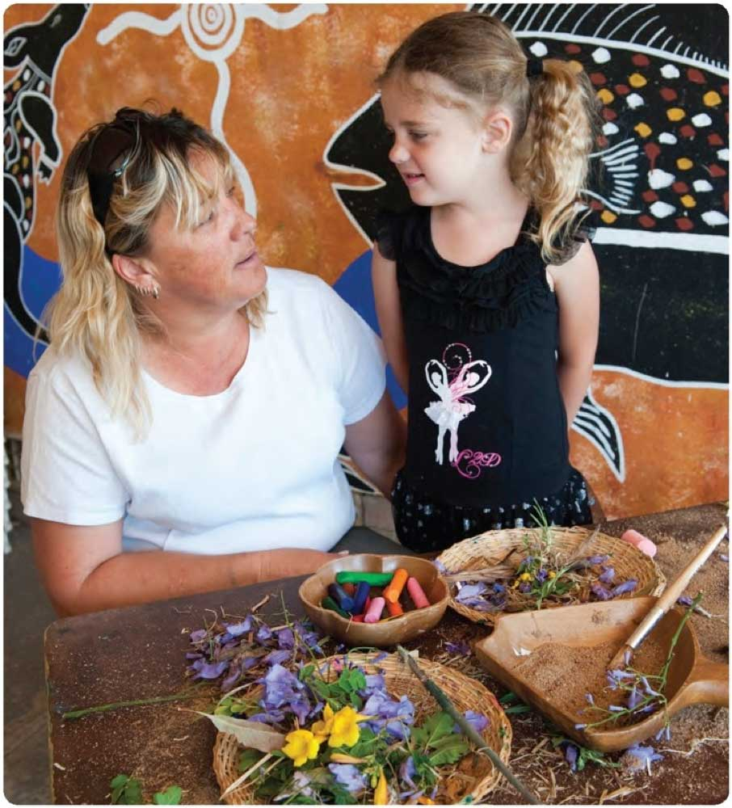

Bringing the Early Years Learning Framework to life in your community 17

