
Appendices: Baseline Evaluation of the Early Years Learning Framework (EYLF)
Department of Education, Employment and Workplace Relations (DEEWR)
October 2012

Table of Contents
Appendix 1: Case Studies (Names have been de-identified) 4
1.1 Domain One 4
1.1.1 Characteristics of the LDC 1.1 4
1.1.2 Characteristics of the CCC 1.2: 12
1.2 Domain Two 22
1.2.1 Characteristics of the Centre 2.1 22
1.2.2 Characteristics of Centre 2.2: 25
1.2.3 Remote Preschool 2.3 30
1.3 Domain Three 39
1.3.1 Characteristics of LDC and Preschool 3.1: 39
1.3.2 LDC and Preschool 3.2 43
1.4 Domain Four 48
1.4.1 Characteristics of the Preschool and Kindergarten 4.1: 48
1.4.2 Characteristics of the Preschool and Kindergarten 4.2: 53
1.5 Domain Five 60
1.5.1 Characteristics of the LDC 5.1: 60
1.5.2 Characteristics of the Integrated Setting 5.2 66
1.6 Domain Six 73
1.6.1 Characteristics of the Family Day Care 6.1 73
1.6.2 Characteristics of the LDC CCC 6.2: 78
1.7 Domain Seven 87
1.7.1 Characteristics of the LDC 7.1 87
1.7.2 Characteristics of the Family Day Care 7.2 95
1.7.3 Characteristics of the Family Day Care 7.3 99
1.8 Domain Eight 104
1.8.1 Centre 8.1 characteristics 104
1.8.2 Centre 8.2 (Kindy regional) characteristics: 118
1.8.3 Family Day Care 8.3 characteristics: 129
Appendix 2: EYLF Baseline Study Sampling Matrix 136
2 Appendix 3: Elements of the Early Years Learning Framework (EYLF) 138
3 Appendix 4: Belonging, Being and Becoming 139
4 Appendix 5: Self Assessment Tool (SAT): Child Development Theories and Their Relations to EYLF 140
5 Appendix 6: Service, Staff and Child Characteristics 141
6 Appendix 7: Interviews Proforma on EYLF Principles, Practice and Outcomes 142
7 Appendix 8: C-BAM 143
8 C-BAM results 146
8.1 Domain One 146
8.2 Domain Two 147
8.3 Domain Three 149
8.4 Domain Four 151
8.5 Domain Five 153
8.6 Domain Six 155
8.7 Domain Seven 156
8.8 Domain Eight 158

Appendix 1: Case Studies (Names have been de-identified)

Domain One
Two sites were visited in Domain One. They were long day care centres; both located in suburbs of Domain One Major City. T54788he principle educator responsible for the services evaluated at each site was rated as non-users of the EYLF. The staff working directly with children and families in both services were also rated as non-users of the EYLF.

Characteristics of the LDC 1.1
Centre | Stage 0 | Stage 1 | Stage 2 | Stage 3 | Stage 4 | Stage 5 | Stage 6
Centre 1.1 | 22 | 37 | 39 | 27 | 3 | 22 | 5
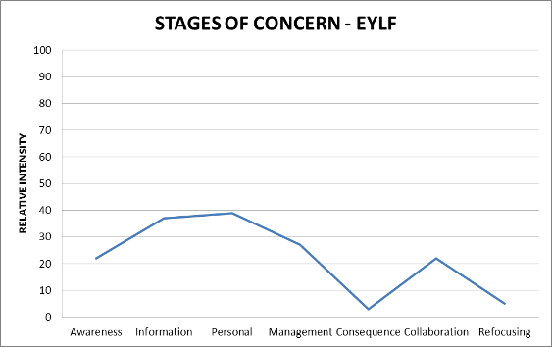
LDC 1.1 is located in a small metropolitan suburb. It is situated in a low to middle income family area. The centre is attached to a health and fitness centre which opened in 2004. The centre is part of a privately owned company which has twenty centres spread across Domains One, Two and Seven. The company’s head office is located in Domain Two and deals with all enrolments, central administrative issues, policies, and has a large input in the program in place in their centres. The Director of the centre is responsible for the day to day running of the centre and for liaising with head office. The Director started at this centre as a room leader and has progressed to the role of Centre Director, which she has held for two years. The centre is registered to cater for ninety children, and the current enrolment figures stand at eighty-three children, split within the six groups listed below:
One Nursery Group (0 - 1 years old) 10 children
Two Tiny Tots Groups (1 - 2 years old) 10 children each group
Two Toddlers Groups (2 - 3 years old) 10 children each group
One Preschool Group (3 - 5 years old) 33 children
The centre opens at 7.30 am and closes at 6.00 pm. There are eighteen educators who work at the centre. All educators have a qualification or are in the process of gaining one. All room leaders hold a Diploma in Child Care. Assistant staff members have their Certificate III qualification or are working towards it. The room leaders have two hours of planning time release per week; however assistant staff members do not have planning release. The families who use the service are from different cultural backgrounds and many have English as their second language.
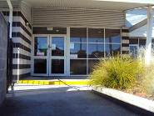

The centre, being part of a much larger health and fitness complex, has a large asphalt car parking area which they share with other tenants and clients using those facilities. The Director mentioned that only two of her students came from families using the complex. The centre’s population is mainly composed of local residents from this small suburb.
Figure 1: Entry to CCC One Figure 2: Shared Parking
The centre has a small arrival area which includes a reception area. The foyer is welcoming and contains safety procedures, menu for the month, greetings in different languages, philosophy, documents and displays which encourage community interaction. Evidence of documentation relating to the EYLF could not be seen in this area. The other rooms have small display areas which are welcoming to families. The children have work displayed on or near the entrance to their room.
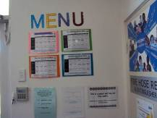
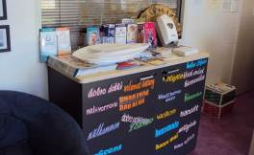
On the day of visiting the site, most of the children were settled at activity tables. Some families trickled in and were warmly welcomed by the Director. Families seemed to be at ease, sharing small anecdotes with the Director before heading for their child’s respective group. The Director knew all the families by their first name and was very warm and welcoming to parents and children alike.
Figure 3: Greetings in many different Figure 4: Menu and other family languages friendly Information
The outdoor area to the centre has two distinct areas. The infants’ room and the toddlers’ room have an outdoor area layered with synthetic grass and removable equipment which educators select and change regularly in order to meet and extend the physical development of children. The main outdoor area has large fixed equipment placed on a rubberised safety layer to minimise the risks of injuries in case of falls. The main outdoor area had also a driving circuit which was well equipped with tricycles, bikes, wheelbarrows and other ‘vehicles’. An obstacle course was set up on the area covered with synthetic grass. Both areas are well used by children attending the centre. No plants, ferns, bushes or trees were present in these outdoor areas; shade sails provided the necessary protection from direct sun.
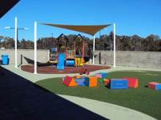
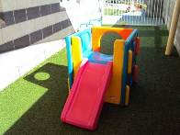
Figure 5: Main Outdoor Area Figure 6: Infants Outdoor Area

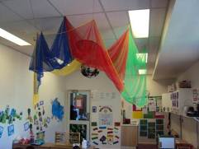
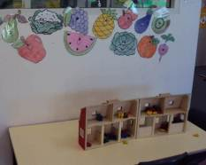
Figure 7 & Figure 8: Indoor Areas
The educators explained that indoor areas within the centres, as well as the outdoor areas, were set up prior to the children’s arrival at 7.30 am. The centre’s philosophy prioritises children’s preparedness for school and this was reflected in the educators’ practices, the environment and activities offered to children. The rooms offered different activities or work stations. The toddlers had shown an interest in dinosaurs and the educators had then provided different pre-cut shapes of dinosaurs to the children. The children coloured them in and their work was then placed on the wall. An educator explained that the children’s interest in this topic had been ongoing for some time now and that they were extending their learning through various activities and materials. A poster representing different dinosaurs could be seen, labels with dinosaurs’ names were also affixed on the wall next to the dinosaurs coloured in by the children, and dinosaur books were available in the reading area.
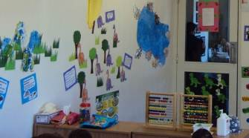
Figure 9: Preparedness for school – Investigating Dinosaurs
Children were encouraged not to move equipment and materials from specific play areas and were gently reminded to keep equipment within their designated spaces. This approach to teaching was observed in all rooms and educators articulated that they were slowly preparing children to the more structured environment which they would encounter at school. This was in keeping with families’ requests and was in line with the centre’s philosophy, as explained by the Director during their interview and by speaking to the educators informally as they worked in the centre. This observation captures well the essence of the pedagogy in place at the centre,
There were six children seated around a table. The children sat silently but seem to be eagerly waiting for the educator to distribute laminated name cards. Once the children received their respective name card, the educator, in this instance, the assistant, handed one coloured crayon to each child. The children then proceeded to trace their names. When completed the children handed back their cards, the educator smiled and thanked each child then moved away from the table and placed the cards back in a tray placed on a nearby shelf. The children seemed to be quite familiar with this activity and did not appear to need any guidance or reinforcement to complete the task. Once the writing task was completed the children moved away to an activity of their choice
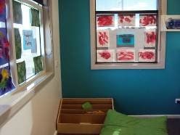
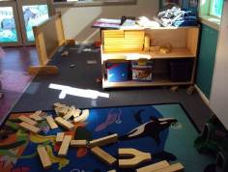
Figure 10: Children favourite play area Figure 11: Book Area Inviting to Children
Educator professional knowledge of EYLF and the elements (principles, practice and outcomes) underlying the document
Principles: It was apparent that there was a high level of awareness of the principles associated with providing a secure context for the children, where interactions are respectful. The evaluator’s observations of the transition period during the morning session confirmed this, and featured during the interview with the Director.
Partnerships with families was an important aspect of the centre’s practices as the Director explained “it is a service that families require and we provide this service to them…they are our customers”. The importance of family relationships was also evident during observations of transition. Great effort had gone into setting up communication channels, and welcoming contexts, to enable interactions where educators could learn about the children from their families creating a sense of community and trust. All rooms were equipped with a laptop computer where the educators uploaded pictures of children engaged in various activities. A short comment was added for the parents’ benefit. The infant and toddler room also incorporated routine aspects of the day, noting the eating and sleeping pattern of the child. The signing in and out book was strategically placed near the laptop, ensuring that families had the opportunity to browse the pictures and information if they wanted to. A weekly newsletter was also uploaded on the computer and a hard copy sent home for those requesting it. Great attention was shown to the children’s wellbeing and safety. There was no evidence of explicit planning for broadening the children’s understanding of the broader cultural communities neighbouring their community or for the multiple communities using the centre.
Opportunities for reflective practice were restricted to the limited two hour planning time given to the room leader. However, the Director mentioned that every month staff had the opportunity to attend professional development sessions offered by the company. These professional development sessions were at times selected by the Director, who identified an area of need in her centre, or by the educators who expressed an area of interest. The Director explained that they had several workshops on the implementation of the EYLF. All staff were encouraged to further their learning and upgrade their qualifications, indicating the importance of on-going professional learning.
Practice: The practices were closely linked to the philosophy of the centre which the Director identified as ‘preparedness for school’. The educators aimed to extend the children’s interest and learning through play activities and resources that allowed them to acquire the skills needed for a smooth transition to school. Intentional teaching was delivered through carefully organised learning environments, and a great strength of the centre was the welcoming way in which the environment was created. The educators explained that they used checklists but were also using learning stories to assess the children’s development and learning. The thinking and practices of the educators strongly reflected a maturational view of child development, though no staff could articulate the philosophy underpinning their pedagogy.
Learning outcomes: It was evident that the educators in the Centre work towards the Learning Outcome 1 ‘Children feel safe secure and supported’ as safety issues, happiness and creating a fun environment was high on the priority list of the centre. The understanding of Outcome 2 ‘Children are connected with and contribute to their world’ was an area which seem not to be well understood at the centre. The student cohort is diverse; cultural artefacts could be seen on walls, but a sameness approach to diversity was in place in all rooms. The Director explained that they treat everyone the same, families come to the centre to learn English and the educator’s role is to achieve this goal. Outcome 4 ‘Children are confident and involved learners’ was translated as gaining skills for a smooth transition to school and practices in place indicated that educators drew from children’s interest to promote these transition to school skills in their teaching and learning environment. Aspects of Outcome 5 were clearly evident, as the children communicated freely with each other both verbally and non-verbally. The interactions between educators and children indicated that the educators focussed on teaching the children how to write, trace, identify numbers and letters through drills and repetition but there were less evidence of a deep engagement with their learning, and of children using a range of media to investigate ideas and represent their thinking.
A summary of evidence to support this evaluation is given below
The educators and Director believed that they provided high quality practices and services as they had great staff with great qualifications, happy staff, a good tight team, happy families and happy children. It was thought the centre had made a smooth transition to, and had embraced the principles of the EYLF.
Interactions
Positioning, ready to engage: The level of educator-child interaction was warm and friendly. Educators worked closely with children while engaging in school like activities, however staff were often observed to be standing at a distance when children were engaged in free play. The Director explained that “free play is when children are engaged in what they want and is much of what EYLF is about anyway and accessing toys themselves. Normally the girls will put out activities which are developmentally appropriate; after a while we will offer the children their free play and they can decide what they would like to do”. This understanding of play explained the practices observed in the rooms.
Shared sustained conversations: The interaction was mainly focused on school-like activities in relation to the task being accomplished by the child. Conversations outside this time seemed to be related to safety issues and personal care practices. No sustained conversations were observed during the visit.
Collective imaginary interactions: The block area in all rooms was well resourced, the variety of books offered was very limited and some books looked tattered. Imaginary play resources were available but the range was limited.
Individual responsiveness
Staff knew a great deal about the children in their care. They talked about their likes and dislikes, their skills and areas of development that they were focussing on at the time. They talked about each individual child with respect. Staff were quick to attend to the specific demands of individuals, needing care or needing a hug, and had a clear understanding of what was needed to when to distract a distressed child.
Transitions
Transitioning into the centre for the first time: New families come and spend an hour with their child in the centre, to become oriented, then come back for settling in visits, perhaps 2 -3 times, where they are involved in the centre for short periods only; later the child begins with a short day only – so that this helps the child to settle into the program. The view is if the parents are feeling settled, then the child will also feel more settled.
Transitions on arrival: On arrival the Director greeted the parent and the child, exchanging a few words. These informal conversations were friendly, warm and welcoming indicating that families had a very good relationship with the Director. The parent would then go their child’s respective room where similar welcoming practices were in place. Each family entering the room was made to feel important and welcome. The child was either placed down onto the floor or transferred to the educator’s arms by the parent. During the transition time, there were two educators seated on the floor with the children, whilst the others were setting up, or were standing to greet arrivals into the centre. One educator was in the kitchen preparing breakfast for some of the early arrivals. The children did not pay much attention to the evaluator when entering the room but once settled they expressed curiosity, inviting the evaluator in their play, thus indicating that they felt secure and safe in their environment.
Planning and documenting
Documentation at the LDC 1.1 is varied. All educators used what was described as learning stories supported by pictures, a short evaluation of the observation and a link to specific areas of the EYLF. All educators also had a parallel system of recording observations and planning ranging from mind maps to a checklist. They explained that they were more at ease with this kind of documentation and were not yet comfortable with the learning stories, but were getting better at it.
When asked about the curriculum and philosophy behind the curriculum the Director mentioned that the “curriculum was to make the learning fun” and that she did not have a specific theory or theories underpinning her curriculum and that “it was mainly what I see and what I feel”. The Director also mentioned that she had a central curriculum provided by head office, but no copies were available at the time and she could not remember any specifics of this document. At no time did the Director refer to the EYLF as informing the centre’s practices. Later when specifically asked about the EYLF the Director mentioned that they had training sessions on how to implement the EYLF and that the transition had been smooth.
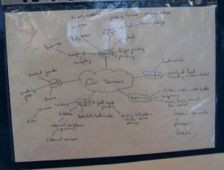
Figure 12: Documentation
Family involvement in planning
Families are involved in the centre through receiving newsletters and planned events, such as “Father’s Day”. The centre has a well-developed website and each family have access to the Parents’ Lounge where they can see their child’s progress report and portfolio, activities offered, newsletters and so on. This site also allows parents to contact the child’s educator directly. During our informal conversations all educators praised the usefulness of this communication tool, mentioning that it brought educators and parents closer and, in their view, this tool help reduced the gap between homes and the centre. This two-way communication led to happy parents, children and educators.

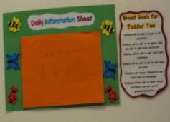
Figure 13: Daily information sheet
The Director indicated that each early childhood educator has a group of focus children that they plan for and observe. During this period, the educators would plan activities specific to the focus child’s interest and need. They would observe the engagement of the child with the activity proposed and record the progress in development achieved through the planned activity. This way of approaching planning and observation was causing some tension between the very systematic way of recording children development and the more holistic approach of the EYLF.
Quality
When asked about the quality mind map, the Director said that she needed help from her staff to fill it in. She left the interview session and after a few minutes came back with the mind map included below. When asked to explain quality the Director provided an articulation of quality which was somewhat different from the mind map provided. She explained that having children, staff and families who are happy and safe essential for quality learning and development The Director thought that having well qualified staff who were happy in their work environment have a positive effect on children learning and development. Happiness, safety and fun were essential elements of quality.

Figure 14: Educators’ mind map of quality
Professional development
The Director mentioned that the company had provided staff with many opportunities to attend professional development programs related to the EYLF. Staff mentioned that they had several versions of the EYLF and how it should be implemented and that was the cause of confusion. They were unsure about the processes to be put in place and found it time consuming but were ready for the challenge.
Every six months all educators in the centre go through a staff performance appraisal and career development process. The Director explained that she would sit with her staff and identify areas of need and work with them on these areas. Staff retention was seen as important for stability of the service. The Director viewed opportunities for professional leadership as central for building expertise, ensuring there was always challenge for staff, and for progressing educators’ careers.
Being
- Being children, having time to play, learn, investigate and to have fun
Belonging
- Having a sense of self.
Becoming
- Becoming is about developing young children’s sense of self to help shape the person they will be. [This] means children are confident, comfortable and welcome in communities and culture. Developing meaningful relationships thus aiding children to lead a fulfilling life
The overall profile of the staff in the centre in relation to their responses to the C-BAM was as follows:
Areas of interest noted
During interviews with the Director it was noted that:
- Educators expressed concerns about the lack of guidance in the EYLF document for supporting planning and assessment. It was their opinion that the lack of direction made the transition from practices already in place to those required by the EYLF harder. The Director explained that she found the transition “different, I am very much a boxes person a day by day boxes person so it was a big change for me. It was an interesting learning experience.”
- Concerns were expressed about what educators described as “the lack of attention given to physical development of children”. This caused some confusion and tension between the educators’ beliefs and the holistic understanding of learning and development proposed in the document.
- Concerns were expressed about the Learning Stories approach to documentation, as it was found to be time-consuming. Educators were unsure as to how to use this approach to assess children’s learning, and resorted to running parallel sets of assessment methods (developmental check list, anecdotal records and so on).

Characteristics of the CCC 1.2:
The other integrated setting that responded to the questionnaire was initially identified as the setting that the evaluator wished to visit, however they advised that they were unable to participate as they were already participating in a project with a local university.
Centre | Stage 0 | Stage 1 | Stage 2 | Stage 3 | Stage 4 | Stage 5 | Stage 6
Centre 1.2 | 94 | 48 | 21 | 39 | 8 | 14 | 65
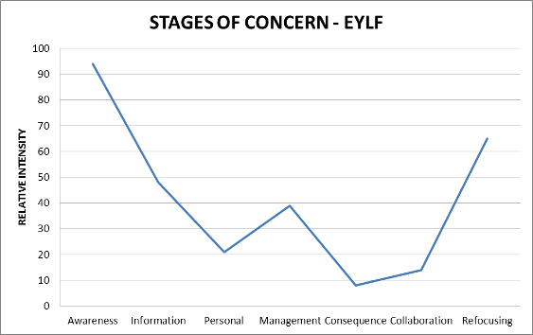
CCC 1.2 visited forms part of an early learning school located in a middle class suburb with a population of 4317 inhabitants (ABS 2006). The centre is located in the residential part of the suburb and is easily accessible by foot, public transport, and private transport. Occupying the premises of what used to be a local primary school, the early childhood school was renovated and opened its doors in 2009. This integrated institution provides services to children from birth to eight years and their families living in the area. This non-profit, community based early childhood school is owned by a kindergarten and crèche consortium which own another 75 centres in different states across Australia. The philosophy of this integrated service emphasises that children’s development, learning and wellbeing are intricately interconnected to their families and communities. As such, this institution caters not only to the needs of children but offers an array of government and community agencies services to families in the form of parent education programs, school aged care, playgroups and access to other services such as housing. The services provided addresses the needs of the specific community in which the early childhood school is situated.
The Director is responsible for the day to day running of this centre whilst working closely with the principal, staff and families using the integrated services. The centre is fully accredited and licensed for 90 students and also caters for the after school care and before school care needs of the community. Presently, 109 families use the centre. The Director explained that she had a long waiting list and that there were 14 families awaiting a place for their child. During the assessor’s visit, a family visited the centre and placed their baby on the waiting list. There are seven main groups namely: before school care; babies; toddlers; juniors; preschool; after school care; half day Wednesday group. The centre opens at 7:00am and closes at 6:00 pm. All educators have a qualification or are in the process of gaining a qualification. There are seven educators who work in the centre, holding a Diploma of Children Services; seven educators who hold a Certificate III and a teacher holding a Bachelor of Education (Early Childhood). The families, as well as the educators using the centre, are from diverse cultural and ethnic backgrounds, with many families having English as a second language. Being part of an integrated service, educators work closely with the local child and family centre, the school counsellor, the school chaplain as well as other services to help them in their work. The team leaders have three hours of planning and programming time, and the assistant educators have two hours on a weekly basis. The centre has a monthly staff meeting after hours and all educators are paid for attending these monthly meetings. All educators attend bi-annual meetings held for the whole of integrated school.
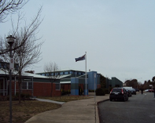
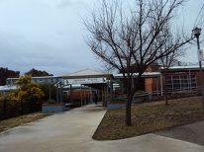
The early childhood school has a large asphalt parking area at the front of the school and the premises are securely fenced. In the front of the school runs the main road leading to this small suburb.
Figure 15 & 16: Main entrance to the centre
The childcare centre has a welcoming foyer area which includes a reception area. The foyer reflects the centre and school philosophy which place an emphasis on families, community and centre interrelationship. The foyer is decorated with various artefacts of different communities. General Information, welcome signs as well as the national curriculum framework were accessible in different languages. The signing books were readily available to families. The educators’ photographs and their position within the centre were in evidence. The atmosphere of the place was warm and welcoming.
Figure 17, 18 and 19: Educator’s photographs and cultural artefacts; sign in book; display of the EYLF in different languages in the foyer

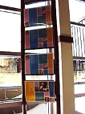
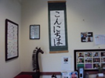
On the day of visiting the site the children were settled at activities and some families were speaking to each other in the foyer area, seeming quite happy to linger and chat. The Director explained that the integrated services has an open door policy that encouraged parents to stay at the school and get involved in their children’s learning and in the various activities and workshops which were dedicated to them.


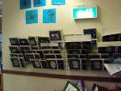
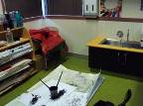
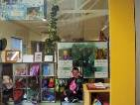

Figure 20, 21, 22 & 23: Painting area, children’s portfolios; children’s lockers and flag display
During informal conversations with the different educators in the rooms it was explained that the indoor areas had been set up prior to the children arrival. Due to privacy, it was difficult to take pictures of the different set-ups as children were occupied at activities. The educators were what they described as “attentive listeners, respectful of children’s knowledge, feelings and interests in order to scaffold their learning and development”. For example in the junior room, the whole planning had evolved from a play that families decided to attend with their children as a group during the weekend. Children spoke about their experiences at the centre. This led to a group discussion, with children and educators working alongside each other deciding where to go next with this interest. The Director explained “we go with the interest and keep it going… the children built a cave, the play the children saw with their families does not have a cave but the children wanted to build a cave for their monsters. Children drew their own monsters”. During the visit children were busy in the cave where they were acting as monsters, and the educators were engaged with different children, one educator being part of the game, one was asking questions and engaging in meaningful conversations, and the other educator was observing and recording the activity.
Educators’ professional knowledge of the EYLF and the elements (principles, practice and outcomes) underlying the document.

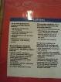
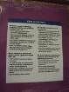

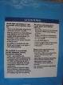

Principles: The Director explained that their birth to five year old programs incorporates the #1 Curriculum and the Early Years Learning Framework Programming. The centre had been proactive at creating a mapping document drawing the links between the outcomes of both documents in order to facilitate programming and planning of children’s learning and development. It was noted that that educators were familiar with the discourse, goals and steps of the #1 Curriculum document but were not as familiar with the EYLF document. All rooms displayed elements of the #1 Documents. These were very much in evidence whilst some evidence of the EYLF could be observed the display was much smaller and one had to know what to look for to find it.

Figure 24: Room Display #1 - Four Currents of Thoughts: Connecting; Enlarging; Listening; Exploring - The EYLF – Learning Outcomes from birth – five years – This poster was more than half the size of the #1 posters.
Nevertheless it was evident that educators were addressing the different practice principles associated with the EYLF. Principle One, Secure, respectful and reciprocal relationships was observed in all rooms and at all levels of interactions. For Principle two, Partnership, the Director explained that family partnerships were at the core of the program, which could be seen in the educators’ practices, in the environment, and in the day-to-day interactions between families, children and educators. Educators working in the rooms mentioned that building a trusting, reciprocal and respectful relationship with families was the essence of their work with children, and that building family and community interrelationship was the primary aim of an integrated school. The evaluator observed families lingering at the centre, speaking to each other or to the educators who displayed genuine interest in the conversations. It was also observed that the educators noted down what families had been sharing for further extension during planning and programming time. The Director explained that many families were engaged in the Genuine Engagement Mutual Support (GEMS), responsible for fund raising activities. The Director stressed that Principles One and Two of the EYLF were closely related to the “connecting and enlarging currents” of the #1 Curriculum framework. Principle Three, High expectations and equity could be observed in the rooms such as the babies’ room where it was observed that educators engaged in meaningful conversation with non-verbal and babbling babies as evidenced in this observation.
The room was setup with soft furnishings. One infant was in a rocker, two toddlers were sitting on a low couch reading books, another was poised in front of one of the educators who was sitting on the floor and having an intense conversation. I observed this interaction for some time. The educator seemed to be in tune with the child and seemed to understand her babbling by responding in full sentences “oh you want this baby” the child nodded and put her arms out. The educator placed the doll in the infant arms. The child’s babbling continued as she seemed to be explaining something to the educator. The educator said “does your baby need something?” the infant nodded “oh what can a baby have?” she pulled out a box with different objects naming them one at a time until she came to a feeding bottle. The infant became all excited and the educator said “oh you want to feed your baby, this is a good idea”. The infant sat nearby and started feeding the baby.
These examples of respectful and engaging conversations between children and educators, as well as children with children, were evident in all rooms.
Principle Four, Respect for diversity, was observed in the physical environment and well as in some of the educators’ practices. As described earlier, the foyer area was aesthetically pleasing and welcoming of diversity, which could also be seen in the way rooms were set up and in its educators’ cultural diversity, which enriched the communication and practices with children and families. As explained by the Director “educators are invited and encourage to bring a bit of themselves in their practices”. During our interview the Director mentioned that she had Indigenous students and whilst they had artefacts and toys representative of their culture, their families specifically requested that their Aboriginality did not foreshadow their learning and development at the centre. These wishes are respected, but the centre has an ongoing commitment to communication and that families were more than willing to come and share their histories and background with the children when asked to.
For Principle Five, Ongoing learning and reﬂective practice, the Director explained that all educators engaged in continual, ongoing learning and reflective practice, and accessed professional development courses on a regular basis. The educators were given time to read and understand what they have learnt during these sessions. Additional time is given to those educators undertaking e-learning sessions ran by the crèche and kindergarten consortium. Modules are made available on-line for educators who need to complete them on a regular basis. The modules mainly consist of health and safety and the understanding of the seven steps of the #1 Curriculum. The Director explained that the centre is also involved with a local university on a project around EYLF and integration schools. Staff are given time to go to these meetings and work on this project
Practice
The educators’ practices appeared to be in line with their curriculum document, #1. Educators articulated the four currents of this document as observed during informal conversations, and systematically used words and phrases such as “working alongside children and families”, “shared understanding”, “we respect and value children’s knowledge”, “we use different communications styles” and so on. These discourses can be linked back to the #1 document. An image of the child being strong, competent and involved in their own learning was evident in the learning featured in both the thinking and practices of the educators in the centre.
Learning Outcomes
It was evident that educators worked towards all the four currents of the Waterfalls Curriculum. When asked specifically about the learning outcomes of the EYLF, the educators found it difficult to articulate their practices and how they linked to the learning outcomes. They referred the evaluator to the mapping done between the documents and said that they achieved the outcomes through the #1 Curriculum.
A summary of evidence to support the evaluation is given below:
The educators were proud of their practices and mentioned that they were performing a high quality level of teaching and learning. Educators were confident users of the #1 document and their practices were closely aligned with the document’s four currents. During the interview the Director mentioned several times that they had contradictory information on how to use and apply the EYLF and that they were still trying to come to grips with the national document.
Interactions
Positioning, ready to engage: Educator-child interactions were respectful, warm and friendly. For example, during the evaluator’s visit, one of the room leaders was engaged in an informal discussion with the assessor when a child came with some dress-ups. The room leader immediately said; “please excuse me I need to attend to this child”. The educator went down to the child’s level and scaffolded the learning of this child by helping her not only frame what she wanted to say, but helping her think through how to approach the task that she wanted to do. They only resumed our conversation when they were satisfied that the child had been successful in the task at hand. These kinds of interactions could be observed in all rooms where educators worked, taught and learnt alongside children in their care.
Shared sustained conversations: The conversations observed allowed children to extend their learning. The children’s interests, as well as the educators’ interests, were often meshed in the discussion. One of the educators explained how a discussion about dinosaurs had evolved from investigating dinosaurs to the human body, as the children were interested in skeletons and bones.
Collective imaginary interactions: Children had access to many resources and the educators were proactive in adding resources which they believed would extend the children’s interest in a topic. Building on the interests and daily lives of the children and families was a strength of this centre. As previously mentioned, the children were occupied in many activities and their privacy needed to be respected so no photographs were taken during the evaluator’s visit.
Individual responsiveness: The evaluator observed a high level of individual responsiveness to children and families using the centre. The educators were able to tell the evaluator a great deal about all the children who were transitioning into the centre during the visit. Educators attended to the children’s needs with respect and care, comforting, redirecting and scaffolding when needed. Educators seemed to know their children well, anticipating their actions and reactions when transitioning from home to centre or from one activity to a routine such as preparation for sleep time.
Transitions
The centre being part of an integrated early childhood school offers support to families in the community. The centre has an open door policy and new families are invited to stay with their children as long as they require and only leave when they feel comfortable. Some families do leave their children but not the premises, rather choosing to use the family room where many parents congregate for a chat in the morning or during the day. The view is to build a strong and secure relationship with families and school in order to make the children’s learning relevant and in touch with community needs.
Transitions on arrival: In the morning the families using the before school care transitioned from home by accessing family grouping. The Director explained that at this time all of the children using the centre but also the school would be in one room. This provided children of all age groups to engage which each other until they had to go to their different classrooms. These family grouping sessions happened in the morning and afternoons before and after school sessions. It was indicated that the children attending these sessions were well integrated in the school system and that it reduced the stress that may come with transition.
Transitioning during the day was achieved through large and small group activities depending on the children’s age. Educators used these group activities to discuss topics such as heath, hygiene, manners and so on. These sessions were educator directed, though children’s voices and ideas were privileged.
Planning and documenting
Documentation at the CCC 1.2 is based upon the #1 Curriculum and the EYLF. The curriculum resources that the Director draws upon are those used by the other seventy-five centres owned by the consortium. The areas emphasised are based around the four currents of thought: Connecting, Enlarging, Listening and Exploring, and links are drawn to the EYLF outcomes. There has been an official mapping of the EYLF and the #1 Document (see below). Educators can refer to this mapping during their planning. During interviews the Director explained the difficulties the educators experienced while trying to come to grips with both documents. “#1 is very, very, very similar to the national curriculum, very similar… I think that our staff are finding it difficult with the different words, different wording but when you break it down it is almost the same”. One educator explained “I do understand the national curriculum, I do understand it. I do understand some things in it. I believe in it but other things I don’t. For example literacy and numeracy, I want to push my children, I do that at home but I do not do it here.”

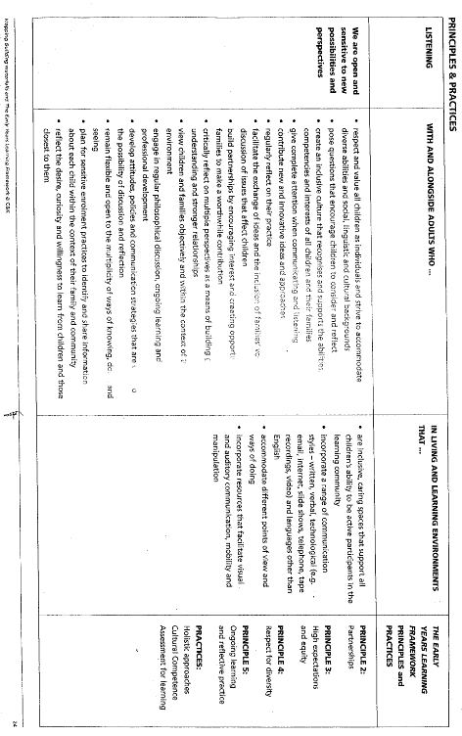

Figure 25: Evidence of mapping between the EYLF and #1 documents
At present the centre uses running records, photographic records, reflection, portfolio documentation, input from parents and children to inform program planning. Being an integrated school, the educators believed that the shared philosophy and understanding allowed for greater flexibility in what they did in their centre.
The centre meets parents regularly during the year in keeping with its open door policy. The portfolio acts as a bridge between home, community and centre which is referred to as a “living and learning document…which belongs to your child…which connects your child’s life at the service with their life outside the service”, as mentioned in the official enrolment booklet each family fills in during admission procedures.
Family Involvement in planning
The centre focuses on building good inter-relationships with families and communities therefore family input in the planning is essential. This is achieved through different methods of communication. Families have a communication book that goes home on a daily basis for each of their children attending the centre. This communication book relays day to day messages between the home and the centre. Parents are invited to take their children’s portfolio home and contribute to the portfolio alongside their children. The centre has many parents who don’t speak English and the Director explained that some families wrote in their home language. She agreed that it was a bit hard to get the communication flowing. The Director explained that the availability of the EYLF in different languages was helping with the communication as it allowed non English speaking parent to have a better understanding of what the centre was trying to achieve in their program. Educators working at the centre are from diverse backgrounds and speak different languages with help with communication and family involvement in the program.
Parents have access to newsletters and the school website. Parents visit and participate in activities with their children, as well as getting involved in the many activities run by the Genuine Engagement Mutual Support (GEMS) committee. This year the committee organised a Neighbourhood Watch Community Fair; Bunnings BBQ; School Birthday Disco: Visual Arts Show, and will run a Movie Night and End of Year Celebrations. The Director mentioned that “the community is there for us, we just need to choose how we engage them”.
Quality
All educators in the service explained that quality was at the nexus of educators’ qualifications, dedication to their work, staff ratio, and strong relationship with families and communities using the service. It was thought that the educators needed to be happy in their working environment and have a supporting leader to be able to create an effective programme.
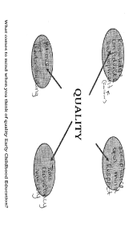
Figure 26: Quality mind map
Professional development
The Director explained that educators are evaluated informally during the year and have access to professional development courses on a regular basis. Educators are given time to read and understand what they have learnt during professional development programs. Additional time is given to those educators undertaking e-learning sessions ran by the crèche and Kindergarten consortium. Modules are available and educators need to complete them on-line on a regular basis. The modules mainly consist of health and safety and the seven modules of the #1 Curriculum. There are also modules linked to the EYLF. Further, all educators had the opportunity to attend six workshops related to the implementation of the EYLF. The centre is also involved with a local university on a project around the EYLF and integration schools. Staff are given time to go to these meetings and work on this project. Further, all educators in the centre have Learning and Development plans and which is reviewed yearly.
Being
- Being available at all time to children throughout the day
- Being in this environment
- Being thought of as a person in this environment
- The here and the now thought of children and adults
Belonging
- Knowledge of children’s learning in this environment and their knowledge that this environment belongs to them.
- The relationship that the child may have or will developed
Becoming
- Changing throughout life
- Becoming part of something
Areas of interest noted
During interviews with the Director it was noted that:
- Concerns were expressed about the lack of clarity in the delivery of the EYLF seminars and workshops which were made accessible to educators. The Director mentioned that they and their staff attended six different seminars over the year and that there was no consistency in the messages that were being given out to educators. The seminars facilitators were contradicting each other which added to the confusion of what should be done at the centre’s level. The Director suggested that all the seminars should be delivered by one specific group of people all agreeing on the messages that should go out to educators. The Director mentioned that this contradiction made the implementation of the EYLF much harder for centres.

Domain Two
Three sites were visited in Domain Two. They were a long day care centre in a regional town of Domain Two; a combined Kindergarten and Long Day Care Centre in suburban Domain Two major city and a Long Day Care Centre in remote, rural Domain Two. The principal educator responsible for the service evaluated at each site were rated on the C-BAM self-study as having some difficulties with the EYLF however this was not clearly evident on the visit to the suburban centre in particular. The principal educator at the regional centre was aware of the EYLF but the staff were not readily identifiable as familiar with the EYLF when interviewed.

Characteristics of the Centre 2.1
Centre | Stage 0 | Stage 1 | Stage 2 | Stage 3 | Stage 4 | Stage 5 | Stage 6
Centre 2.1 | 1 | 16 | 14 | 7 | 5 | 22 | 22
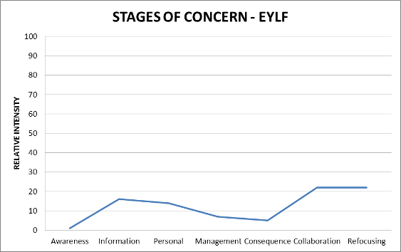
The Centre 2.1 visited is in the middle suburbs about twenty-five kilometres from the CBD. The setting where the site visit was undertaken was located in an upper to middle SES community. The centre Director is an early childhood educator and holds a Masters degree in early childhood education. She indicated that she was very familiar with the EYLF “I think it is important to know what families want and the framework helps to articulate a range of pedagogies.”
The centre is registered for one group of three year old children and one group of four year old children, each with up to twenty-five children who attend from 9:00 am until 3:00 pm.
On the day of the visit, the children had just returned from two weeks school holidays, this was their first day back at the centre. The centre has been purpose built and the entry foyer is tastefully decorated with some art pieces as well as documentation relating to the service such as a policy book, photographs and brief biographic notes including qualifications. Each of the playrooms opens off the main foyer, with reception areas for children to store their bags etc. The program plans are readily available at the entry of each of the play rooms, children’s bathrooms are located on the other side of the playroom near to the doors to the playground, which is a large space shared by both groups of children. The Director’s office and a small kitchen area also adjoin the foyer area and are fitted with child safety catches on the doors.
The centre is affiliated with a large NGO network of children’s services and much of the professional development training and regular meetings are conducted within the affiliated structure. This also provides support staff such as field officers and regional management staff to assist with the general operations of the centre.
The outdoor area is fenced to include a specific space and is serviced by two storage sheds. The site is quite steep and has been stepped at various levels to provide a range of play spaces. The playground has been set up to offer a range of different learning experiences as is illustrated in the photographs. The change table facilities are in the bathroom along with child sized facilities such as toilets and basins. The playrooms were also set up with a range of learning experiences and the children were extremely engaged in their activities, moving freely and purposively around the space. Staff were engaged with small groups of children or individuals as required and there was a calm but industrious atmosphere in both playrooms. The children seemed very familiar with the routines of the centre, which were quite flexible and non intrusive. For example children moved to a specific area to have a snack when they were hungry rather than everyone stopping their activity to eat. Lunch time was more formal and was served by the staff in discussion with the children about their preferences and quantities.
Educator professional knowledge of EYLF and the elements (principles, practice and outcomes) underlying the document:
The principles of early childhood pedagogy as outlined in the EYLF were generally at a highly professional level with staff being able to clearly articulate the rationale for their practices and the theoretical underpinnings of these. The focus was favourable towards a high level of responsiveness to individual children, as well as an overall awareness of the group. Intentional teaching, learning through play, setting up learning environments, planning and observing holistically, being culturally competent, and assessing for learning were all at a high and purposeful level.
The Director and two staff completed the self assessment of EYLF principles, practice and outcomes and indicate predominate concerns about interactions with other staff and how they will approach these and the effects on time management, and the availability of resources to support the implementation of the framework. All responses clearly indicated a desire to be able to work collaboratively with other staff in the adoption of the framework. In particular, the Director’s response could not see how the EYLF would change her practice.
A summary of evidence to support this evaluation is given below:
Interactions
Staff easily talked about theories of child development, understandings about pedagogy, and practices in terms of assessment, reflection and evaluation, they demonstrated a high level of intersubjectivity with all of the children in their care, and a level of sensitivity in the interactions and programme documentation that indicated that staff observed closely and respected the children. The staff interactions demonstrated a high level of listening to the children, paying attention to what they were asking or were talking about body language and verbal responses both demonstrated this. Through this, staff naturally extended their conversations through genuine interest in what the children were sharing.
Transitions
Although the arrival of the evaluators was later than the children’s arrival time at the request of the Director there was no evidence of any distress at separation as the children were very focused and engaged in their activities and interactions
Planning and documenting
Planning is conducted formally at specific planning times and is clearly documented for parents to read. The planning is designed around children’s interests and skill development. The Director identified cultural-historical theory as the main theoretical driver, with elements of post developmental and social learning theories when completing the SAT tool regarding child developmental theories and their relationship to the EYLF. Evidence of individual interests and small group interests being explored through projects were obvious in both the playrooms and were indicated by the high level of concentration and engagement of the children. Staff also spoke of spontaneous responses to children’s requests and this was evident when staff introduced new materials to extend or answer children’s requests and conversations
Family involvement in planning
Staff responses to the SAT questionnaire on EYLF principles and practices indicate strong agreement to the inclusion of parents in planning and decision making for children’s learning, also identifying the community as a valuable support for planning and the education of children. Staff strongly disagreed that they were not providing enough education to the children. Similarly, staff responses showed a clear awareness of relevant theory and the principles used in their teaching and belief in their capacity to plan for individual children’s strengths.
Quality
Quality early childhood education according to the Director focuses on staff relationships and teamwork as well as staff training. She also identified the physical environment as important in both its capacity to support relationships and the physical environment in which children learn. Finally she identified legislation and policy and practice as keys to quality.
Professional development
All staff had attended a number of professional development sessions within the umbrella of the affiliation organisation of their centre, and had also participated in in-house sessions to discuss the EYLF
The Director’s understanding of ‘belonging’, ‘being’ and ‘becoming’ are shown below in her response to the BBB survey:
Being: To acknowledge where a child is ‘at’.
Belonging: building relationships and engaging the children
Becoming: extending knowledge, interests skills and aspirations

Characteristics of Centre 2.2:
Centre | Stage 0 | Stage 1 | Stage 2 | Stage 3 | Stage 4 | Stage 5 | Stage 6
Centre 2.2 | 61 | 51 | 70 | 47 | 11 | 72 | 26
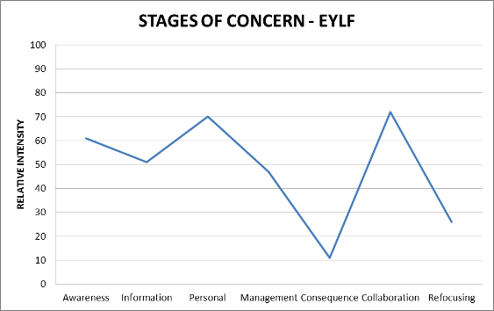
Centre 2.2 is located in southern Domain Two, close to the state border. It is located in a low to middle income family area and has been attached to the local TAFE College, but is moving to a purpose built building in the New Year on the campus of a local university. As a result, the centre is positioned near to a number of empty buildings on a residential street as other departments have moved to the new campus.
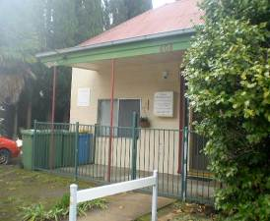
Figure 27: Centre’s entrance
The Director of the centre has been at the centre for several years but next year will be replaced by a new staff member with a Masters degree in early childhood education. The centre is currently registered for thirty families. There are two main groups; the Under 3 group currently has ten children enrolled, and the 3 - 5 year old group has fifteen children attending. The centre opens at 7.30 am and closes at 6.00 pm. All the staff have a qualification or are in the process of gaining one. There are eleven educators who work in the centre, holding Associate Diplomas or a Diploma in Child Care qualifications. One staff member is undertaking her Certificate III qualification.
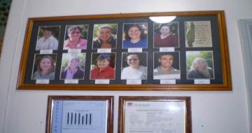
Figure 28: Staff photographs
External support services are drawn upon to assist the families and the educators with developing and implementing programs for those children with additional needs. The educators have four hours of planning time release per month, and all staff attend an after-hours staff meeting every six weeks.
The centre is a small refurbished Victorian cottage in need of further upgrading with a paved car parking area at the front and a small garden at the rear.
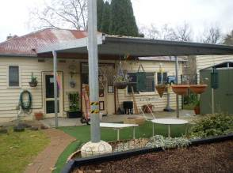
Figure 29: The centre’s garden
The centre has a small entry hall arrival area. The hall is welcoming and contains safety procedures, a display of children’s work, photographs of staff, a child and family friendly book on the centre’s philosophy, and displays which encourage community interaction (e.g. footy tipping competition).
On arrival the children are grouped together in one playroom and as the numbers increase they move into the two separate play rooms which have been set up by staff during the early session
The outdoor area to the centre has three distinct areas, however, only two were actively used during the site visit. The outdoor had area trees, small bushes, vegetable garden (for the older children), small areas set up (e.g. chairs and books; small table with puzzles; painting easels), and moveable equipment (e.g. trestles, boards) and a range of bikes, trikes, wheel barrows etc. Balls were also available.
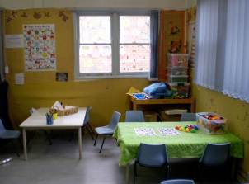
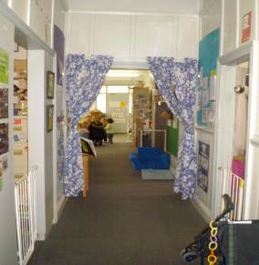
Figures 30 & 31: Indoor playroom and entrance hall
Educator professional knowledge of EYLF and the elements (principles, practice and outcomes) underlying the document:
Principles
It was evident that there was some awareness of the principles associated with providing a secure context for the children, where interactions are respectful and reciprocal. The interview with the centre Director featured this principle, highlighting the importance of meeting the needs of families, and ensuring siblings also connect with the centre as there was a lack of family networks in this regional town. Conversations with parents are valued and they are not rushed out of the centre
Emphasis is placed on seeing the child as an individual and the relationships between the children, with the older children acting as models for the younger children. An area that was not evident was the explicit planning for broadening the children’s understanding of the broader cultural communities as the centre’s community was diverse, drawn together to the college rather than a neighborhood centre
Practice
Expectations for the children’s learning are to encourage the children to question; to follow up; to answer questions and to explore these through books predominantly. A six week cycle was utilised for planning and building on plans for focus children in each cycle
Learning outcomes
Much of the learning at this centre was ad hoc, based on staff beliefs of what was expected to be the right thing. The interactions with the children were gentle and caring but at the instinctive level for the most part. All staff interviewed talked at length about the relationships they had with the children and the importance of these.
“It is the quality of the relationship is better than the quantity, children feel like they’re belonging when we take time to care for them. Routines are not rushed and the children feel cared for and respected”
Interactions
Generally staff were nearby to the children and often had a child in their arms.
Individual responsiveness:
A high level of individual responsiveness was evident in the centre. Staff were able to tell the evaluator a great deal about all the children who were transitioning into the centre during the evaluator’s observations. Staff responded to the specific needs of individuals, noting when to provide additional resources, when to distract or engage a particular child. The educators all appeared to be knowledgeable about each child.
Planning and documenting:
Documentation at Centre 2.2 is based on the Programme Flow model developed in Domain Seven as a commercial application for children’s centres and links to developmental domains and milestones. Areas emphasised are social and emotional development, communications, problem solving and cognitive development. During interviews the centre Director mentioned many times that the EYLF did not provide much guidance, that more direction was needed, and importantly, that there was limited or no access to professional development around the implementation of the EYLF. Geography was identified as the main inhibitor to access professional development.
Presently the centre uses a form of checklists for assessment. The checklists are important for helping determine if children are reaching their milestones. The checklist has been developed so that it is easy for parents to understand. For instance, the checklist for the 3 - 5 year old age group is written to give the child’s voice on assessment: “I can do my ABC’s”. The centre does not use photographic documentation of any kind.
Program planning focuses on children’s interests, and running with what the child wishes to talk about. Important also was preparation for Kindergarten. Here social development was seen as critical and the main focus of the centre programme.

Documentation:
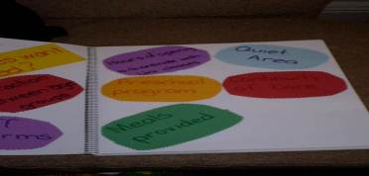
Family involvement in planning
The educators’ responses to the SAT Questionnaire indicate strong agreement to the involvement of parents in the programme planning and the community as a valuable support to the planning and education of the children.
The use of relevant theory is also identified as sound theoretical base for the assessment and the basis of planning by staff.
Quality
According to all the educators in the service, quality centres on relationship and partnerships with families. Having motivated children who are happy and safe is seen as important. Having a warm and welcoming centre, with a flexible and nurturing environment were identified as the cornerstones of quality
A collective response to understanding of ‘belonging’, ‘being’ and ‘becoming’ are shown below in the summary response to the BBB survey administered at Centre 2.2.
Being:
- about the here and now, about the children growing and maintaining relationships
- What I am at this point in time
- Feeling comfortable in your own skin to be yourself
Belonging:
- children need to have a sense of belonging – you belong to this family
- feeling accepted for who I am
- belonging to a community and being respected and treated honestly
Becoming:
- children grow at a rapid rate, becoming is a process
- the journey we are on, it is lifelong learning
- building on who you are
The overall profile of the staff in the centre in relation to their responses to the C-BAM was as follows:
Areas of interest noted
During interviews with the Director it was noted that:
- Concerns were expressed about the open-ended approach in the EYLF for supporting planning and assessment. This in turn gave little guidance of how to frame the assessment approach adopted so that enough evidence of learning outcomes could be generated. Of high importance was the possible misalignment between Centre practices on documentation and an assessors’ conceptualisation of valued practices and documentation.
- Concerns were expressed about capacity to implement the EYLF and time impacts
- Concerns were also articulated about the impact on individual roles and potential changes, however it was difficult to distinguish whether these related to the impending changes of the centre structure with the move to the new building or the EYLF

Remote Preschool 2.3
Centre | Stage 0 | Stage 1 | Stage 2 | Stage 3 | Stage 4 | Stage 5 | Stage 6
Centre 2.3 | 69 | 43 | 48 | 92 | 21 | 72 | 52
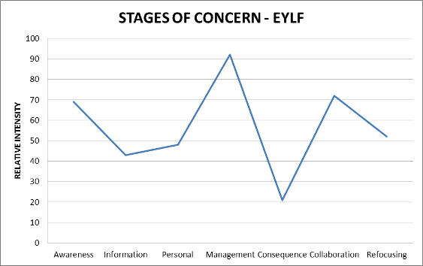
Remote Preschool 2.3 is located in a very small town in the west of Domain Two. Its population is 980, including a number of station properties and an outlying settlement twenty kilometres away. The population’s socioeconomic status is ranked at the highest level of disadvantage (SEIFA index by postcode ABS 2006).


Figure 32 : Journey to Remote Preschool with the local postman
Visiting the site involved travelling with the local postman from the regional centre one hundred and thirty kilometres away as there is no public transport and hire cars were unavailable. This journey emphasised the isolation that influences many aspects of the centre’s operations, as reflected in the interview with the Director. For example, she said:
One little girl lived out there on a station along the XXX road, we call them stations instead of farms…she used to travel an hour and forty minutes just to get to preschool and back again. That was a big decision for the parents, whether they should bring her in, they do School of the Air, and it was definitely the right decision. She was the only child. Initially she found it a little bit hard to settle in, you can imagine her being so isolated for four years of her life, but then she just flourished once she started - a big commitment, though, for them and for her, it’s such a long day. They drove for an hour and then the school bus picked her up for the last little bit … she’d get up and cry on the weekends because there was no preschool; she really enjoyed socialising.
The preschool is located on the sparsely trafficked main street alongside the local central school and opposite the only general store and cafe. The other commercial premises in town that are visible from the preschool are a hotel and the garage/petrol station about one hundred yards away. The large weatherboard building has high ceilings, large windows and generous proportions, and is aligned east-west with a shaded area with a sandpit, small garden and concrete access ramp facing south.
The centre is registered for twenty-three families. There are three main groups. The under 3 group currently has six two year olds enrolled who attend for one day, and the 3 - 5 year old group has seventeen children attending, with the three year olds attending for three days and the four year olds attending for four and a half days. The centre opens at 8.30 am and closes at 3.30 pm. This enables preschool children to catch the school bus, an important timetable adaptation for a remote community where distance is a factor in children’s access to services. All the staff have a qualification or are in the process of gaining a qualification. There are four educators who work in the centre. The Director holds a four year B.Ed in early childhood and her co-leader will have completed a Diploma in Child Care by the end of 2011. Two part time staff members on 18 month traineeship contracts are undertaking Certificate III qualifications. The families who use the service are of predominantly Indigenous background with a few non-Indigenous children. This proportion reflects the difference in age distribution within these demographic groups nationally. The Director has half a day of planning time release per week. Staff meetings occur during operational hours as children’s attendance tends to be irregular.
The centre’s foyer is welcoming and contains children’s lockers, a notice board, large newsprint books with documentation of children’s learning, meeting notices and information pamphlets. The centre displays specially commissioned quality canvas prints of local landmarks and wildlife. From this foyer, through the glass paned door and windows, the large work room is visible.
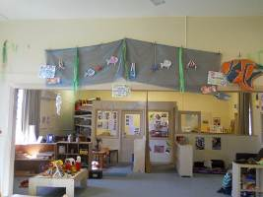
Figure 33: Inside work room, looking east to foyer.
The main outdoor area, past the sandpit and small fragrance garden in the shaded area between the building and the road, is at the western end of the centre. It has a large shade sail, a cubby house, lawn and wheel toy track. During the interview with the Director, the difficulties of gardening in a climate with summer temperatures of 40 degrees Celsius and fully maintaining a natural outdoor environment were identified as a ‘work in progress’. For example, the lawn is watered only when the local Shire council waters the adjoining oval.
The routines that were observed on the day of the visit included transitions between morning tea, outdoor play and lunch, and a short interval of indoor activity before the post van arrived to return back to the regional centre. There were three staff and a school experience trainee on duty for the eight children in attendance.
The indoor areas within the centre were set up as areas of interest with wall displays of posters, documentation of children’s learning and children’s art work next to each area.
The areas included a book corner with cushions and a lounge, a natural science area, a dramatic play area set up as a hairdressing salon, a project block and construction area, art and craft area and literacy and numeracy displays allied with storybooks.
Two kinds of approaches to the set up were observed. There were areas that were deliberately set up to invite play or an experience of one kind, and other areas where it was easy for children to self-select the materials they wished to use. Above each main area of activity within the centre, were learning stories or some kind of documentation of the experiences available to the children. Some of these directly referred to EYLF outcomes and in others, because of their relevance to local landmarks, creatures and cultural traditions, the displays implied themes such as belonging.
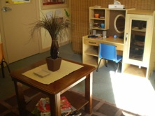

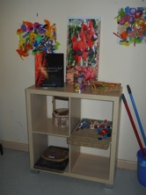

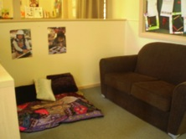
Figure 34, 35 & 36: Self- selection: Inviting dramatic play, inviting drawing, inviting reading
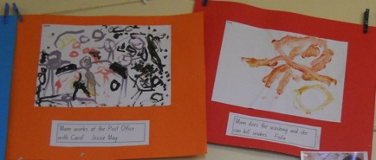
Figure 37: Belonging: ‘mum does the washing and can kill snakes’; Clay models: linked to EYLF outcomes.
The Director has worked at the centre for ten years, having completed her schooling in the township and all of her subsequent early childhood qualifications by correspondence. She began with a TAFE Diploma and has now achieved a four year Bachelor of Education in Early Childhood. Staffing was one of the major issues she identified for her centre. During her upcoming maternity leave the centre will be staffed by her (almost) Diploma qualified co-leader and the two trainees on short- term contracts undertaking the Certificate III (the small enrolment permits this under Domain Two licensing regulations).
Educator professional knowledge of EYLF and the elements (principles, practice and outcomes) underlying the document:
Principles: It was evident that there was a high level of awareness of the principles associated with providing a secure context for the children, where interactions are respectful. On the Director’s desk is a poster describing actions that demonstrate respectful and contrastingly disrespectful attitudes to children. The evaluator observations of the transition confirmed that respectful interactions do take place. A feature of the centre is acknowledgement and reinforcement of place identity. The Director drew my attention to ‘a series of high quality canvas prints of the local area
‘...there’s just been a lot of parents identifying with these; it’s a conversation starter … Another thing, one of the boys tells everyone who comes in that’s his lake. They run the local caravan park at XXX Lake. It’s just that real sense of belonging and trying to bring that more into the centre’.
Family partnerships were valued, and efforts have been made to invite families to community based events with an early literacy focus, such as open days for a ‘books in homes’ program. While there is a local management committee, an area that was not noted was parents’ involvement in shared decision making. The Director said that most of the management committee work all falls on us [the staff]. Most of the families are Indigenous and staff cater for this in their planning and in their daily interactions. The Director said:
As for cultural differences, pretty much all of the staff have grown up here so have grown up in the community; obviously there’s a large Aboriginal population, two of the staff members are, I’m not; I’m not Aboriginal but I’ve sort of grown up here, as my husband has, so obviously the cultural differences are there but there’s a lot more awareness and understanding. I don’t really see that as an issue but I think sometimes I know myself, I tend to just take it for granted, you don’t really recognise it and just encourage that appreciation with the kids, I suppose.
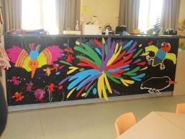
Figure 38: Documentation of Indigenous traditional story picture book: ‘How the birds got their colours’
On our last open day for books in homes we had ‘How the Birds got their Colours’ and we’ve actually made our own books, as you say, for that, and the kids have made a display to make that not an isolated occasion and it’s been brought into everyday teaching. … What else have we got? Big rainbow serpent up there …
Sensitivity was shown to the children’s wellbeing, an acceptance that children attending the centre may experience stressful home lives, and an aesthetic value was expressed of lowering stress by providing predominantly neutral and natural materials in the preschool environment:
a lot of these kids come from very busy, very high stress home environments … and they’d come here and everything was just red and yellow and blue and green, and their levels would just get higher and higher and there was just no real engagement happening, so...as much as we can we’re really trying to take it down.
Opportunities for reflective practice have been enthusiastically implemented despite the isolation. The Director and co-leader have participated over the last eighteen months in an EYLF early years discussion group based in the regional centre; sometimes travelling and sometimes by telephoning in. Ongoing professional learning amongst assisting staff was evident through being encouraged to upgrade their qualifications. The Director said
They start as a casual and they really don’t have anything to compare it to, so we try as much as possible to get them involved in [regional] services to be more aware of what’s out there; I think there’s still that thing of a lot of untrained people that they just play; ‘they just do that here, they don’t do that at other preschools’.
Practice: The practices were tied directly to the setting up of the environment. An effort had gone into organising resources in creative ways in order to stimulate learning through play. Intentional teaching was delivered through carefully organized learning environments on the part of the Director, and through more directly guided activities on the part of the Diploma qualified educator. A strength of the Centre was the welcoming way in which the environment was created. Assessment practices were displayed mainly as learning stories, with content implicitly representing disciplinary areas such as literacy, numeracy, the natural sciences and local place identity. A maturational view of child development was evident. The Director indicated Vygotsky as the main theoretical influence, but the educational values of this centre are influenced by the kinds of knowledge children will be expected to attain in school, represented by ‘developmentally appropriate practice’ but with a bias towards promoting conventional book and print literacy. While accepting and uncritical of Indigenous cultural identity, the Director mentioned that many of the children attending the centre were developmentally ‘below where they should be’.
Learning outcomes: It was evident that the educators in the Centre work towards the Learning Outcome of a strong sense of place identity. In relation to Outcome 2, the centre practices demonstrate that the children have a sense of belonging to their group within the centre, are accepting of Indigenous cultural identity, appear to promote fairness and show social responsibility. A concern for Outcomes 3 and 4 were also evident with an implicit appreciation of the specific well-being issues facing remote and Indigenous communities. The Director was proud of a picture book project the centre had initiated, based on dreamtime stories about the local area and accepted for publication by an educational publisher under the PACE (Parent And Community Engagement) funded ‘Books in Homes’ project. The picture book launch was co-planned and co-attended by regional and Indigenous health and welfare organisations The EYLF outcomes are to be included in the book on the Director’s recommendation. She said ‘people questioned that and I said, “no, you do need to include because our parents are getting it, getting it, getting it and you do need to try; it’s going home; it’s in the journal, it’s in the environment, so while we want to keep it as parent friendly as possible, I think it’s important to be identifying, including that in there as well”. Aspects of Outcome 5 were evident, but few verbal interactions were observed as there were few children attending that day.
A summary of evidence to support this evaluation is given below
While the Director believed she was already engaging in high quality practices, she thought that once she and the staff had learned more about the EYLF that they would come to exhibit more quality practices as determined by the framework. The limitation on this is the lack of depth in trained staff as illustrated by the forthcoming maternity leave arrangements. However, the Director commented that she intended to still be here in three years for the follow-up study.
Interactions:
Positioning, ready to engage: The level of educator-child interaction was warm and friendly. A great deal of eye contact was evident, and some of the educators were sitting at the child’s level but others standing at a distance observing.
Shared sustained conversations: Conversations were not sustained or elaborated by the educators directly involved with children; this may have been different if it had been possible to observe a sustained interaction between children and the Director, but at the time of visiting she was either involved in the evaluation interview or in administrative work.
Collective imaginary interactions: The evidence for these was not so much observed on the day of the visit but evidenced in the documentation and the set-up of the environment. The Director commented on how the boys were initially hesitant to engage with the ‘hairdressing salon’ in the dramatic play corner and how they overcame assigned gender roles, and by the afternoon, were running the salon. Some of the learning stories and other documentation matched the Director’s description of how children’s interests are extended into a variety of modes of representation such as painting, clay modelling, through junk and block constructions and researched on the internet through the interactive Smartboard. The learning story illustrated below shows clay models linking letters of the alphabet with a project that involved keeping a bearded dragon lizard (native to the area) briefly in a terrarium.
‘With the lizard we looked at bearded dragons on the internet and it was really valuable for that, because as soon as technology’s involved they’re just immersed in it…
[The lizard interest] started with one staff member and I took it one way and the other staff member took it another, it was really nice- and obviously having our own lizard was nice-not that we kept it for very long- it was two weeks and the poor thing wanted to escape the whole time …’
Here literacy and natural science are linked through the idea of ‘family’. Children modelled the initial letter of their names and some children went on to make clay lizard ‘families’.
The work is explicitly linked to the EYLF practices of intentional teaching and assessment for learning.
Individual responsiveness:
A high level of individual responsiveness was evident in the centre. Staff knew a great deal about all the children in the centre through being embedded in the community.
Transitions:
The children were confident in their surroundings but, like the staff with the exception of the Director, were a little shy and concerned about a stranger in their centre.
Planning and documenting:
Documentation at the centre is based upon daily learning journals displayed in the foyer. The Director intends to make this ‘more of a working document’ by trying out a planning format jointly developed in her early years discussion group and to deepen the level of reflection evident in the existing staff reflections/ intentions journal by asking provocative questions. She expects all staff to contribute to this journal by explaining why they put activities out, and hopes to provoke these responses by entering reflective questions in to the journal.
Family involvement in planning:
Families are involved in the centre through receiving newsletters, and through planned events, such as the above mentioned ‘books in homes’ event and via the noticeboard in the foyer.
Quality:
According to the Director, quality centres on quality relationships and interactions; staff expectations of both the children and families and the wider community; educational experience/qualifications of staff. Her main concern is with the shortage of available qualified staff. A second concern is with the expectation that staff will spend time fund raising for resources to support a quality program when the range of duties they are expected to perform (eg administration, accountability, gardening, funding submissions) already cuts into the quality of time they have to spend with the children.
Professional development:
The Director and her fellow leader assumed the responsibility for their own professional development by travelling and contacting professional peers in the regional centre through the early years discussion group. This group is sharing knowledge and resources, while the Director assumes responsibility for passing on insights, planning, reflection and assessment formats to the less qualified staff.
Overall, it was thought that the EYLF as applied in this centre is taking on a well justified local interpretation that will depend strongly on the continuity of staff and the continued efforts of the Director, embedded as they are as trusted leaders, to maintain well-resourced quality early childhood practice in conditions of isolation. The service has been developed to suit the learning needs of Indigenous and isolated children in a community subject to climatic extremes that govern the prosperity and wellbeing of all.

Domain Three
Two early childhood sites were visited in Domain Three (Remote). These services included the LDC and Preschool 3.1 and LDC and Preschool 3.2, both located in a town in Domain Three. The sites, their staff and practices were evaluated on the principle of inexperienced users of the EYLF.

Characteristics of LDC and Preschool 3.1:
Centre | Stage 0 | Stage 1 | Stage 2 | Stage 3 | Stage 4 | Stage 5 | Stage 6
Centre 3.1 | 40 | 57 | 63 | 56 | 7 | 44 | 42
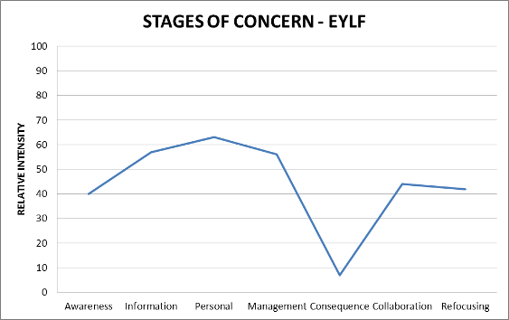
The LDC and Preschool 3.1, which operates both as a Long Day Care and Preschool, is situated in the premises of a college in the town. Although the centre is owned by the college, its operations are financially independent. The total enrolment at the centre is forty-three children. Of these, five children are from Indigenous backgrounds and the rest are of European descent. There are six teachers (five of European heritage and one is a Torres Strait Islander). Of the six teachers, four are permanent staff while the remaining two are casuals. The highest teacher qualification in this centre is a Diploma in Children’s Services. #1, the Deputy Director in charge of the service, has a Diploma in Children’s Services. #2, another member of staff, also has a Diploma in Children’s Services and #3 is currently undergoing a staff development program to upgrade her qualification from a Certificate III in Children’s Services to a Diploma. As she is sponsored by the centre #2 is entitled to two hours study time with pay. #4, another permanent staff, has a Certificate III in Children Services, however, is not currently undertaking any further course to upgrade her qualification. The two casual staff members have no qualifications and are currently studying for the Certificate III in Children’s Services.
The centre caters for 3-5 year olds. There are twenty four children that attend the service on a full-time basis, that is, six hours a day - Monday to Friday while the remaining children attend on part-time basis. #1, the Deputy Director in charge of the service has been working in child care for nine years but has been in her current employment for only nine months. The centre principles are based on the UN conventions on the Rights of the Child 1989 and were boldly displayed in various areas of the service walls.
The educators have internet access at home, planning books and folders for each child. The indoor area has many valuable resources that children use. These resources include toys, paint and brushes, Aboriginal paintings and artefacts, a book corner, child lockers and two desktop computers. One of the two computers has broken down and is yet to be fixed. There is an internet service at the centre but this is not always functional and staff members find it too slow to use in accessing their emails or for research purposes. The centre also has access to the town library where they borrow toys and other resources for use with the children. The outdoor environment is quite small for a country kindergarten and is not so flamboyant. There are few resources for children to take risks and explore their environment in an inquiring way. Basic equipment includes slides, wooden blocks and swings.
Practice: The environment is set up at a basic conceptual level underpinned by maturational perspectives of child development. The observation of children at work indicated that the children were grouped according to their age levels to work on teacher prescribed tasks instead of on EYLF principles, practices and outcomes. The tasks do not seemed to meet children’s ability levels and interests as they were designed with the children’s biological and maturational levels in mind.
The educators arrived early in the morning at 7.30 am to set up all the teaching and learning areas before the children arrived. Play appears to be used minimally and routines and structure appeared to be the foundational to practice. The educators mostly use running records as the process of documentation to assess children’s learning and development, foregrounded mostly in Piagetian psychogenic perspectives on Child Development.
Learning outcomes: The educators at this centre work towards physical development, language learning and communication, early mathematical experiences and an active learning process. There is a strong focus on children’s writing and reading skills. The interactions between the educators and the children were both formal and casual, with emphasis on rules and routines. There is frequent use of patterns, painting, discussions, drawings, which were mostly educator directed rather than grounded in the principles of co-construction of knowledge. Some of the children’s paintings have demonstrated high levels of creativity through their various drawings, which were captured in photos during the site visit. There is a strong emphasis on cultural diversity and inclusion which were evident through a combination of Aboriginal paintings and artefacts that displayed side by side with objects and paintings from other European and non-European cultures at the centre.
Educator professional knowledge of the EYLF and the elements (principles, practice and outcomes)
The educators at this centre have little understanding of the practice, principles and outcomes in the EYLF. The educators noted in a compelling statement, “the EYLF is confusing… there are no specifics just general statements… how do we use this to produce specific outcomes that parents want to see…Parents think that we are just baby-sitting here, they are not interested in paintings or drawings, they want to see real school outcomes but we don’t know how the EYLF leads to this.”
Of particular concern is that the educators have a misunderstanding about child development theories of child development and how these are connected to the EYLF. One of the educators, #4 with a Certificate III in Children’s Services noted: “ I have never heard about these theories, it is not what we have learnt during our professional development…it is not easy for us to identify which theory connect to which outcome and how we can theorise how we plan, teach and evaluate the children…but using children’s maturational levels makes planning and programming straight forward” Another educator noted, “as for the EYLF, we are trying to embrace it, I have not used it in my previous centre and now I am trying to gain a full insight into it…the document is confusing… the way it is explained did not specify criteria for us to determine specific outcomes.”
The Director in charge indicated, “I don’t use the a particular theory but milestones are very important for me… they are just right…I just think all the theories are right and important and I do not think anything is wrong with Piaget’s theory on milestones or stages.” Observation of the educators showed that they actively engage with the children, supporting their well-being and learning but activities are not conceptually rich in relation to the EYLF. One educator indicated, “I do not know the specific learning outcomes the EYLF is about.”
One of the educators reacted strongly by saying: “currently we are just putting children into bubbles… educators are now taking away from children the freedom to be children because of overregulation that prevents children from climbing trees for example…this is a rural community and children must be allowed to get close to nature and take risks and this is good for their future.” This educator added that a tree the children used to climb at the centre was chopped down by the council because of fear that the children will be injured, despite no injury has been sustained in the service with respect to this tree. She questioned how children will be able to develop a strong sense of identity or become confident learners in their own environment if they are limited by regulations in exploring their environment in a natural way.
Interactions: There is evidence of positive interaction between the teachers and the children and among the children themselves. Both the Indigenous and non-Indigenous children interacted well during the visit and according to the educators; this was the usual daily occurrence at the centre.
Individual responsiveness: #1 and her team are minimally attentive to the uniqueness of each child, their family background, home culture, preferences, potentials, likes and dislikes. This was evident through observation of how the educators set tasks based on ages or milestones rather than on interests and abilities. For example, during the site visit the children were put into 3 groups according to their ages to do tasks set for them by the teachers.
Transitions
Children have little time to transit from one activity to the other. Transitions are structured and monitored by the teachers. All children are expected to complete one task and move to the next task at the specific times allocated by the teachers. The evaluator was not present when the parents dropped off their children in the morning. According to the educators parental participation in their service is low. Few parents ask about the work their children have been doing at the centre. The educators said: “we expect parents to stay and spend a little time with the children, play with them and see what we do…when parents come in to drop off their children we welcome them and greet them but some are just not interested to spend some time with their children, only a few do stay and work with us…some of them just put the children down and walk through the door”, A few stay but we need more parents to be involved”. Transition times between activities are also quite rigid as the educators wanted to accomplish routine tasks they have set themselves. Children resisting immediate transitions from one task to the other are moved by the educators. Sleep and meal times are also compulsorily enforced.
Planning and documentation
Planning and Documentation at the centre is not driven by the EYLF. There is emphasis on stage and age level-performance. Videos and cameras are not usually used in capturing children’s learning moments. Running records and checklists are mostly used for documentation. Planning is mostly informed by Piaget’s Theory, the Behaviourist theory of Skinner, and Gesell’s maturational perspectives. In relation to planning, one of the educators said, “I am concerned that I do not have enough time to organise myself each day.” Another educator also indicated: “I am particularly occupied with other things to have enough time to use the EYLF to do my planning and documentation.” Further, another educator said, “planning and documentation using the EYLF is taking too much of a time to coordinate tasks and people.” Overall, they do not see the community in which they work as a valuable supporter of their planning and programs. Interest from parents in programming according to the educators is on the low side.
Family involvement
There is a low level of family involvement in all aspects of the service. The educators have a communication book for parents and encourage parents to come in and read books to the children but only a few are involved. The educators said: “We use celebrations, daily journals and barbecue days to encourage parental participation but the majority seems to be too busy or not just interested.”
Quality
The educators’ expressed different opinions on what constitutes quality early childhood practice. Their perspectives are captured in the following statements “We ensure quality service by making sure both Indigenous and non-Indigenous Families and their children feel valued and respected. The educators’ indicated: “for us quality service entails doing well, encouraging the children to reach their full potential, and creating great rapport with families”
Professional development
The educators indicated that although they had participated in professional development programs, none has specifically addressed their needs in relation to how to use the ELYF document to program plan and teach and assess children’s learning on the five outcome areas. The educators stated: “The ELYF document is too broad; we need professional development in areas of programming and assessment of how to relate these to the framework.” “We are also not familiar with how a cultural-historical theory is better than any of the theories we use…what we need now is which theory relates to which outcomes, we just don’t know… this is quite confusing”.
There is also a mixed understanding of belonging, being and becoming which is summarised below.
Being
The educators understanding of being include, “the point of your life right now”, “existing”
Belonging
They understand belonging to be” feeling at home”, feeling accepted and welcome without judgement or bias”, and “feeling like it is meant to be”.
Becoming
The educators’ understanding of becoming is “developing and achieving”, “striving to reach your full potential”.

LDC and Preschool 3.2
Please note that this setting was not a setting selected as a site to receive a questionnaire. Instead, we sourced an additional setting in the field to visit to compensate for the Integrated Setting that could not be visited due to our inability to make contact with this setting to arrange a visit.
Characteristics of the Long Day Care and Preschool 3.2
The second site the evaluator visited in Long Day Care and Preschool 3.2, also located in the town. This privately owned service, which has been in operation for almost four years and is licensed for eighty five children. Currently it has seventy nine children attending and nearly approaching its full capacity. Twenty five of the seventy nine children identified as Indigenous. There are twenty educators in addition to three disability inclusive support workers who attend occasionally to support children with disabilities and additional needs. Of the twenty teachers, three completed a Diploma in Children Services, six are enrolled in a Diploma of Children Services, another six are currently doing Certificate III in Children Services and four have no qualifications and are yet to enrol.
The children are divided into six separate rooms as follows:
- Two rooms housed children from 6 weeks to 18 months (each room contains ten children and two teachers)
- Two rooms housed children from 18 months to 3 years (each room contains ten children and two teachers)
- One room housed children from 24 months to 3 years (there are twenty children with three teachers)
- One room housed children from 3 to 5 years (there are twenty two children in this room with two teachers)
Children with Additional needs/disabilities
The service also included four children who have been officially diagnosed with different disabilities, attending with other children without disabilities almost on regular basis. The diagnosed disabilities included Spinal Bifida, Cerebral Palsy and stroke, Rett Syndrome and Autism. Each child with a disability receives five hours a day on one to one support, and a child with disability who attends every day receives twenty five hours inclusive support from the inclusion support staff.
The general impression of the service appears to be very welcoming. There is a friendly staff atmosphere with a strong philosophy of inclusive practice. The C-BAM evaluation of educators indicated that they were inexperienced users of the EYLF. According to the Director of the service, there is a strong element of commitment from the staff towards their duty and to the children. As it was difficult to find qualified staff for the service one of the staff members who has an Advanced Diploma in Children’s Services and is from England, was sponsored on a work visa.
The centre is a terrific facility. The structure housing the services is modern and glamorous with rich and abundant resources for babies, toddlers and pre-schoolers to use. It has a very large outdoor area with a natural layout of the playground to encourage the children experience nature in the service. The outdoor area has children’s theatre, a natural tree for children to climb and take risks; rocks, walkways, streams and a shallow pool which the educators use to enhance the children’s development. Included in the outdoor area are also numerous artificial resources like trucks, shovels, spade, axes, boots and other farm implements that represent the main professions in the area. The walls of the centre are filled with children’s work, which included paintings, cuttings, mosaic, number work and patterns. There are also numerous Aboriginal artworks, crafts and paintings in every room and outdoor areas. Centre policy documents and vision statements are all displayed openly at the centre. Despite the flamboyant nature of the centre, observation of teaching and learning through play is superficial. Program planning, development, implementation and assessment of learning is quite rigidly structured and applied.
Transitions
The observer was not present during the drop-off time however, pick up times appeared to be a rush hour. Parents seemed to be inpatient, rushing to take their children home. The first parent arrived at 4.15 pm and asked “where is Jonny?” When little Jonny appeared at the door, her mother said, “it is time to go home Jonny! The child was reluctant to go and wanted to show his mum what he did for the day but Jonny’s mother did not show interest and just pulled him to the car, “get in let’s go home”. Transition between activities also follows a rigid routine and structure and the children do not have their freedom to opt out or in at will. All the children appeared to be compliant at meal times and other learning activity times, demonstrating a biologically determined stage theory and behaviourist perspective of early childhood education.
Learning outcomes
Learning is organised around social and personal learning themes, health and physical learning for the toddlers and language learning, communication and early mathematical experiences for the 3-5 year olds. There is emphasis on knowledge transferability and the educators indicate that they encourage children to explain what they have learnt at the centre at home, particularly the older children. Emphasis is also on oral communication, emotional development, turn taking, and decision making for the children in kindergarten. Learning outcome in the toddler groups is based on educator intuitions and emotions determined by age and stage rather than on the EYLF.
Educator professional knowledge of the EYLF and the elements (principles, practice and outcomes)
The educators’ pedagogical principles as outlined in the EYLF were generally at the spontaneous level. They were theoretically grounded in Piaget’s psychogenic theories in their approach to individual children and in group situations. Teaching through play, setting up the learning environments, planning, observations and assessing for learning are all rigidly structured with routines grounded in universal age and stage theories. A key aspect of concern related to the EYLF is assessment and documentation with respect to the babies and toddlers. There is a lot of cloud around the nature of documentation that could suffice for a particular learning outcome within the EYLF for the babies and toddlers. The educators’ practices and documentation appears to be mostly checklists and running records and learning stories at very basic conceptual levels.
Planning and documentation
Planning, teaching and documentation at the centre are based on the children’s level of maturation rather than on the principles and outcomes specified in the EYLF. The educators found the use of EYLF in planning and documentation too complex to implement, particularly for the babies and toddlers. There is little move towards the use of the EYLF and were concerned that, about the lack of specifics on the number of documentations and assessment they should complete in a teaching session on the various children. The educators mostly use notes from discussions, annotated samples of children’s learning, including drawings and personalised reflections to document and assess learning at the centre outcomes centred on identity, connectedness, wellbeing active learning and communication for the 3-5 year old groups.
Family involvement
According to the Director and other educators at the centre, family involvement is rare. Parents who drop-off or pick-up their children all seemed to have no time to spare and talk with the educators regarding their children except a recent migrant father from Africa who had spent about four minutes with the educators before taking his child home. According to the Director, this parent is involved with the centre activities and recently brought African drums to play and entertained the kids, including teaching some of them to play some of the African rhythms on his drums. The Director noted:
“our main problem here is parental involvement…they think we are babysitters so no one is interested in looking at what we do with their children…when they come to pick their children they are just interested to find out whether their children sustain injury or not…they don’t ask about anything connected with learning because they are not aware we do learning here…if there are no reported injuries then there is no problem they just pick the children up and off they go... Drop off times are also the same.” According to the educators, the majority of the families whose children attend the service are often busy working and thus have little time to commit to centre activities during kindergarten days. Despite the lukewarm attitude of parents the educators indicated that they usually invite families to special occasions like birthdays, picnics, mothers’ and fathers’ days. Families do not make direct input into planning of activities although the educators inform families about the day-to-day activities and practices. The kindergarten also strives hard to connect to families during weekend barbecue programs yet this is also not proving very effective. Generally the educators do not feel that their community and families are valuable supporters in planning and the education of the children.
Quality
The educators have different ideas about quality and try to provide quality services by drawing on mostly on Piaget psychogenic theories. They conceptualised quality service as:
- Care for children
- Holistic education
- Listening to parents
- Listened to children’s needs
- Continuity
- Family feels a sense of belonging
- Developing self-help skills
- Relationship with parents
- Non-bias environment with special needs attended to
- Allowing all aged children to grow and develop own pace
- Children’s choice within a range
- Safe and stimulating environment
- Hygienic environment that meet the needs of children
- Safe and tidy surroundings
- Consistency
- Staff and educators being able to communicate with family members
- Continuity of care for all children
- Confident trained educators
- Children to feel secure in surroundings
- Development of child’s milestones
- Self-help, social, emotional, gross-motor, language skills
Equity
To ensure equity, the educators are welcoming to all parents, both Indigenous and non-Indigenous children co-learn well at the centre. Also there is use of different artefacts and resources from different cultures. There is strong commitment to inclusion of children with disabilities into the mainstream long day care and preschool. Invitation of Indigenous elders to share with the children on an occasional basis is a typical example.
Practice
Practice at the centre is based on Piaget’s psychogenic developmental milestones. They adopt this theoretical perspective in nurturing and developing children’s understanding of their ability. On children’s holistic wellbeing, they talk to parents and encourage them to participate and attend the centre as well as provide ideas for planning of activities. The educators also use observation and learn from each child which they incorporate into their future planning. Some of the educators stated that they do not set challenging task for some children because they do not have high expectation of them.
The educators also attend to children’s individual strengths and abilities by “being respectful to the children, providing caring and loving environment and using non-discriminatory language in practice. There is recognition and support for Indigenous children by incorporating their artefacts and culture into centre programs. Culturally competent practice is evident in the centre through a display of array of different cultural resources as well as using intercultural and cross-cultural communication styles. All children are treated equally at the centre no matter what colour of their skin. Children are also encouraged to bring things from home to the centre to be used in activities. This allows Indigenous children to bring their own culturally related materials which they exchange with other children. Parents are also encouraged to provide to the centre items from their culture. Reflections are carried out through photos, artwork, observations, evaluations, learning stories which are used to inform future planning. This ensures that stimulating activities and progressive environment are provided to the children. The centre educators attempt their best to invite parents to participate in centre events. There are also newsletters and memos for families. They emphasise social skills, entreating all children to treat each other with respect. They encourage children to get to know each other and to make friends with the younger children as well as those with disabilities attending the centre. The Director observed:
“It is a good feeling to see one of the children holding the hands of the child with Cerebral Palsy and walking him to the room…this is good for their future wellbeing to co-exist”.
Identity
The educators ensure that the children get to know their family, their pets, their own space, and that they are part of the whole centre’s family and to develop skills that they can call their own. On relationships the educators said is to: “provide secure, respectful and non-discriminatory environment for the children as well as centre staff.” Regarding planning for individual social and learning outcomes the educators model curiosity, use observation and communication with family members to achieve these outcomes. Identity is developed through family lockers that identify with each child, family photos and children’s photos with holiday pictures or birthdays and self-help skills. Also included in this development is allowing the children to explore their family roots and culture. Responsibility for own learning is developed through role play. Rooms are set up in ways that encourage and challenge children to be active learners. Free choice and group times are used to encourage interpersonal and intrapersonal communication at the centre. There is also emphasis on communication with parents during drop-off and pick-up times although this is proving challenging. In addition, surveys are used to get parents’ opinion on important matters concerning their children, centre activities and programs. Transition is encouraged through engaging children in natural activities and asking parents to assist children to complete some drawing at home. Children undertake excursions to local workplaces to observe activities in its natural form. High expectations of children is ensured at the centre through setting challenging tasks for children and through ongoing learning of children in different modes and allowing choice for children to develop their skills
Professional development
The educators said that although they have participated in professional development programs, their understanding of the EYLF is at the basic level. In particular is the concern regarding how the framework can be effectively applied to the babies and toddlers. There is also the issue of theories in that the main theory they are familiar with is Piaget’s Psychogenetic milestones. Their current preparation is located within structure and routines without a very rich conceptual understanding of how the practice principles and outcomes can be brought together to impact effectively the learning and development of young children.
There is also a mixed understanding of belonging, being and becoming which is summarised below.
Being
- Individual
- Being unique
- Our beliefs and understandings
- Express feelings
- Who you want to be
- Children to be themselves
- Don’t conform, not to be the same
Belonging
- Belonging to a group
- Part of group
- Accepted for who I am
- Our identity
- To be content
- Developing relationships and social skills
- Sense of being part of a group
- Feeling supported
Becoming
- Becoming your own person
- Confident, sincere surroundings
- Having opinion and understanding of self
- Developing new skills, encouraging growth as an individual either child or educator

Domain Four
The evaluator visited two sites in two different towns in Domain Four. Both sites and their staff were evaluated on the principle of inexperienced users of the EYLF.

Characteristics of the Preschool and Kindergarten 4.1:
Centre | Stage 0 | Stage 1 | Stage 2 | Stage 3 | Stage 4 | Stage 5 | Stage 6
Centre 4.1 | 31 | 43 | 25 | 18 | 4 | 9 | 3
Centre 4.1 | 94 | 54 | 67 | 7 | 13 | 14 | 34
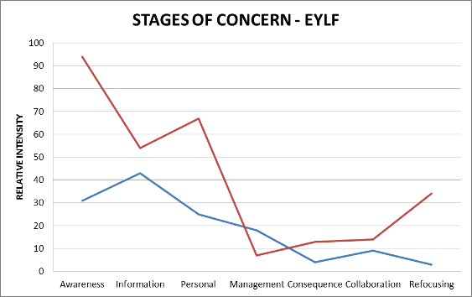
The Preschool and Kindergarten 4.1 is located in a mixed socio-economic (low to high) community. #1 the Director and Educator of the service, is of European heritage and is above 45 years of age. She was formerly a prep teacher and now a kindergarten teacher and Director at the service. #1 has a Master of Learning Innovations degree with a specialisation in Early Childhood Teaching, which she obtained in 2005 from one of the state’s universities. She has been teaching for twenty years but was employed in the Preschool and Kindergarten 4.1 for the past three years. #1 is supported by two other educators, #2 and #3. #2 appears to be above the age of 50 years and has a Certificate III in Community Services/Children Services, in addition to a Certificate IV in Teacher Aide Studies with twenty five years teaching experience. #3 is the youngest of the three educators and appears to be in her late 30s and has a Certificate III in Community and Children Services with ten years teaching experience. #3 and #2 have been working in the centre for more than three years. Interviews confirmed that all the three educators completed their studies before the EYLF was introduced, hence it was not part of their professional training curriculum. However, since the introduction of the EYLF, all three educators had participated in two professional programs focusing on boys’ behaviour management, documentation approaches and play-based practice within the EYLF. This kindergarten has a “no nut policy” because of a child with a serious allergy to nuts.
The centre is a community based denominational service belonging to the Congregational Church. It was established by the church in the 1980s, initially to educate the children of the members of the church but is currently open to the whole community. According to #1, the Director of the service, a strong element of Christian Faith, belief in God and good moral code are incorporated into the kindergarten’s practices. For example, all children say prayers before the day’s activities and before they eat their meals. Both believers and non-believers participate in these activities and routines. It is also noted by the Director that parents who want to bring their children to the service are well-informed about the codes of practice at the service and teachers who seek employment at the service are informed of the need to observe the Christian principles.
According to #1, parents are happy with the centre principles and practices because the physical, emotional and spiritual needs of their children are being met. #1 indicated that the service has been self-financing until 2011 when they received the first funding from the State Government.
The centre is divided into two streams:
Stream one is for 3-5 year olds with twenty children attending on Mondays and Tuesdays with two educators (the Director and one other staff). Stream two is for 4-5 year olds, which also included twenty-four children and run from Wednesday to Friday with two educators attending (Director and assistant teacher). The program usually starts at 9 am and ends at 2 pm but some children stay on up to 3 pm and beyond till their parents pick them up.
All the children currently enrolled are of European heritage. The educators have internet access at home, planning books and folders for each child. There is also a library service at the service for children to borrow books daily for home use with their parents. During the visit the evaluator was asked to loan the books to the children and complete the documentation on library cards. The service has many rich resources provided by the church and parents. These include blocks, books, toys, play-doh, mattresses and a large outdoor area containing sand area, saw-dust area, swinging area, etc for children to use.
Practice: The practices and the setting up of the learning environment are inextricably linked together. The educators arrived early in the morning at 7.30 am to set up all the teaching and learning areas before the children arrive. A great deal of organisational and creative efforts was involved in setting up the environment to stimulate curiosity, exploration and to engage all children in learning through play. The resources are numerous, colourful and naturally appealing to children to clamour around. According to #1, the church and families have put much effort into creating and maintaining the resources. The outdoor and indoor learning environments offer young children great opportunity to experiment; science concepts like environmental sustainability, engineering and construction work. Resources also feature the development of early mathematical concepts, cooking, general office and managerial work. The outdoor area is large, with many natural resources, in addition to humanly created resources that augment exploratory learning activities. According to #1, they do not use checklists in this centre. The educators mostly use running records, anecdotal records, discussion charts and photographic documentation to assess children’s learning and development foregrounded in DAP. They are keen to be learning more about EYLF.
Learning outcomes: The educators at this centre work towards five learning outcomes specified in the Kindergarten Learning Guideline (KLG) and the Kindergarten Learning Guideline Companion (KLGC), which were written by the Studies Authority in 2010. Learning is organised around social and personal learning themes, health and physical learning, language learning and communication, early mathematical experiences and active learning processes. Also, there is evidence of children developing a strong sense of identity and wellbeing, and the educators take children’s special skills into consideration which were documented in children’s learning folders. Also wellbeing is a critical outcome component of practice which is also supported by Biblical principles and that, “God created us all equal so no child or educator should ridicule others” #1 added that, “ridiculing other children could stop them from trying as well as dislocate their wellbeing.” Hence, the discourse is a fair go for each child, use of non-threatening language and respect for children as capable and sensible co-learners. There is a strong focus on children’s needs and interests, identity and voice and emphasis on transferability of their learnings to real life situations. The interactions between the educators and the children were both formal and casual, with an emphasis on character formation, code of conduct/behaviour, and observation of rules. For example, after warm up activities with parents and educators, children would go through the rules that govern the kindergarten practices and code of behaviour before they break out into their various activity groups. The use of technology in exploring ideas is minimal. There is frequent use of patterns, painting, discussions, drawing, photographing by the educators and constructive work to represent children’s conceptual development. The children have demonstrated high level of creativity through their various scientific and mathematical explorations (see photographs) which need to be augment by rich technological resources. There is weakness in cultural diversity which #1 attributed to the fact that all the children are from European heritage hence they take cultural diversity for granted. Planning documents and resources do not show evidence of the practice of cultural diversity.
Educator professional knowledge of the EYLF and the elements (principles, practice and outcomes)
Pedagogical principles as delineated in the EYLF were generally at the intuitive level. The educators demonstrated a high level of responsiveness to individual children and in group situations. Whereas teaching through play, setting up the learning environments, planning, observations and assessing for learning are all done within a high level of understanding in the KLG and KLGC, the use of EYLF to guide the same were at a novice level. #1’s and her two assistants’ self-assessment of the EYLF principles, practice and outcomes indicate that they are still learning about how to use theory to inform their role as educators within the ELYF. A key point worth noting is that #1 and her staff reported that their activities are informed by Developmentally Appropriate Practice (DAP). Yet, observation of the educators showed that they actively engage with the children supporting the children’s well-being, and individual children. #1 reported that because they do not have any multi-cultural children in their service they take this particular area for granted and may be challenged by it should they have a child from a different cultural group attending.
A high level of awareness of outcomes associated with “children develop a strong sense of identity and wellbeing” was noted during the interviews which were confirmed by educator practices and documentation. For example, spirituality was considered critical by #1 and her team as contributing to children’s wellbeing. Children were also given free opportunity to present and discuss ideas in an open and inquiring ways. Importantly, family artefacts were highly valued and documented. Parental influence and family inputs are valued aspects of children’s sense of identity and wellbeing.
The following provided further evidence to support the educators’ interaction and individual responsiveness.
Interactions: During the interviews with #1 and her colleagues they continued to attend to the children, moving to and from the interviewer. Even at the time the interviewer followed #1, she was still busy with the children both outdoors and indoors. The children were split into various activities of their choice with the educators moving between activities to support children’s learning, demonstrating a high level of multi-task. The presence of a parent in most of the activities for the full day assisted the two educators to meet the emotional, physical and cognitive needs of all the children.
Although #1 was able to talk about developmental theories her knowledge is skewed towards Piagetian perspective with only basic knowledge of cultural historical theory. Her two assistants were also operating with a minimal level of theory to inform their understanding of EYLF. Despite a minimal level of theoretical knowledge, particularly a cultural-historical framework, #1 and her assistant educators have high level of respect for children and families, and their interaction with children demonstrated a high level of listening to children. Before the children leave for morning tea #1 and her team engaged them in a word identification quiz competition. On the day of the interview the quiz was about animals and their babies. Two children sat on a chair at a time and after they were shown the animals, the educators supported the children to identify the name of either, the father, the mother or the baby. When they mentioned it correctly they would then be given permission to leave out for a morning tea. No child was a loser as those who had difficulty were prompted and supported to get their answers right. The children waited for others to complete their turn before all of them prayed, thanked God for their meals, and ate.
Individual responsiveness: #1 and her team are mindful of the uniqueness of each child, their family background, home culture, preferences, potentials, likes and dislikes. The recognition of this uniqueness was evident during observation of how the educators set different task tables and asked children to choose which activities they want to do first. At the time of the visit for example, two children chose to listen to music first for 10 minutes before they attended to any other activity. While they were in the music corner listening through the earphone, the other children were engaged in painting their favourite postcards while others were engaged in a ludo game with a parent who volunteered to support the educators on this day. Other children were also involved in reading activities with the third educator while the Director, #1, worked with other individual children on science exploratory activities. The children, after creating their individual objects, share this with peers.
Transitions
#1 and the other educators use “parent session” with the children to settle the children in. When the children arrived with their parents eleven of them stayed behind and participated with the children in warm up activities. #1 indicated that it is a usual practice for parents to stay for at least 10 minutes to warm up the children. The parents, the educators and the children sat in a circle on the floor and sang, flicked fingers, after which the children were given opportunity to say something or show a particular work they did the previous day which they were proud of to the parents. The evaluator also participated in this transition activity with the children and parents. During the warm up activities, one of the children asked the evaluator, “Where do you come from? Your skin is different? Do you have sunburns?”
When the evaluator answered that he comes from Africa, the child said, “Where animals live?” The evaluator was then given opportunity to share with the children about Africa. Through this sharing the children were eager to gain more understanding of how animals co-exist with humans in Africa. Transition to home is also an interesting experience for the children as the parents appeared not to rush in and rush out. It was observed that they took interest in looking at the work their children completed or in the process of completing, chatted with the teachers before they collected their child home. #1 indicated that before they accept new children into the service they invite parents to have time with the staff and other children to acquaint themselves with the centre rules, principles and practices. There is also an open policy where mum or dad can stay and work with the children and staff so long as they wish. There are also after school programs to help children’s transition back home.
Planning and documentation
Documentation at the centre is intensive, utilising generic approaches such as videos, running records, photographs, conceptual descriptions, anecdotes and reflective commentaries. Five thematic areas guide the educators in this service namely; learning about and care for the environment, physical development of children, language and communication, early mathematical experiences, independent and group problem solving skills development and scientific experimentations using active learning processes (see photographs for evidence). The approaches for planning and documentation are mostly informed by the Kindergarten Learning Guideline (KLG) and the Kindergarten Learning Guideline Companion (KLGC), which were written by the Studies Authority in 2010. The educators are now moving towards using the ELYF alongside the KLG and KLGC.
Family involvement
There is a high level of family involvement in all aspects of the service. The service in consultation with families allocated yard duties to families on a rostered basis. Each family contributes once a year to the maintenance of the outdoor learning area. This includes fixing broken materials, care for the sandpit and grass, saw-dust, and other equipment. In addition to these responsibilities, each family volunteers and supports the educators in educating the children. A family member volunteers twice a year at the service working with the educators from morning till the time they close. During my visit it was incredible to see a parent who had stayed and supported the educators throughout the day. It was also reported by the Director that when the children arrive it is usual practice for parents to stay for 10 minutes and participate with the children in warm up activities to settle them in before they depart. Observation conducted indicated that this was liked by the children as they were excited showing their skills to their parents in the warm-up activities. At the time of evaluation, eleven parents stayed with the children and participated together in these warm-up activities. Family involvement is also enhanced through newsletters, discussion forum and celebrations such as birthdays and special occasions. The educators indicated that they usually get together to discuss the direction of their focused activities and planning with parents and they mostly take their suggestions into consideration.
Quality
The educators’ concept of quality is complex. They suggested that quality should not be universally determined in terms of the EYLF. According to the Service Director and her assistant, quality needs to be determined not only in terms of the EYLF practice principles and outcomes but also in terms of what parents want. They also indicated that to ensure quality delivery of services within the EYLF staff motivation should be government priority, followed by theorisation of pedagogy and learning through play underpinned by routines, structure with explicit teaching embedded. Staff also perceived quality in terms of warm, welcoming, natural communication, inclusiveness, recognising children as capable, competent, happy and enthusiastic learners, and children’s ability to express themselves orally. Quality should also be seen in terms of posing challenging activities for children at developmentally appropriate level.
Professional development
The educators have had opportunities for two professional development sessions around the EYLF. These include learning about boys’ behaviour management, and the principles and practice of evidence based documentation of learning. The educators were concerned about the lack of depth in professional development around how the EYLF is different to what they currently have in Domain Four. They were also concerned that the EYLF did not specify the number of assessments to be conducted on particular learning outcomes Kindergarten Learning Guideline (KLG) and the Kindergarten Learning Guideline Companion (KLGC). The educators also have plans to future involvement in professional development programs. According to the educators, they tend to use Developmentally Appropriate Practice and lean more towards social learning theory and Piaget’s psychogenic theory. The educators indicated that they are lacking in applying cultural diversity practices because of the mono-cutural group that they teach. They would like to know more about a cultural-historical theory and cultural diverse practice as it relates to the EYLF.
There is also a mixed understanding of belonging, being and becoming which is summarised below.
Being
The educators understand being to be involvement in class, experiencing here and now to the fullest, children having time to play and engage, making meaning of their world and recognition of the uniqueness of each individual child.
Belonging
They understand belonging to be a feeling of being involved in class, a feeling of comfort with class talks, family and social networks, cultural identity and relationship and connections.
Becoming
The educators’ understanding of becoming is developing social skills with class mates, growing and changing, striving to reach potential, developing the dispositions of a lifelong learner, opportunity to extend learning and awareness of future transitions.

Characteristics of the Preschool and Kindergarten 4.2:
Centre | Stage 0 | Stage 1 | Stage 2 | Stage 3 | Stage 4 | Stage 5 | Stage 6
Centre 4.2 #1 | 96 | 48 | 52 | 23 | 5 | 12 | 30
Centre 4.2 #2 | 48 | 27 | 59 | 15 | 7 | 16 | 6
Centre 4.2 #3 | 55 | 45 | 57 | 30 | 21 | 84 | 47
Centre 4.2 #4 | 40 | 37 | 39 | 39 | 7 | 25 | 20

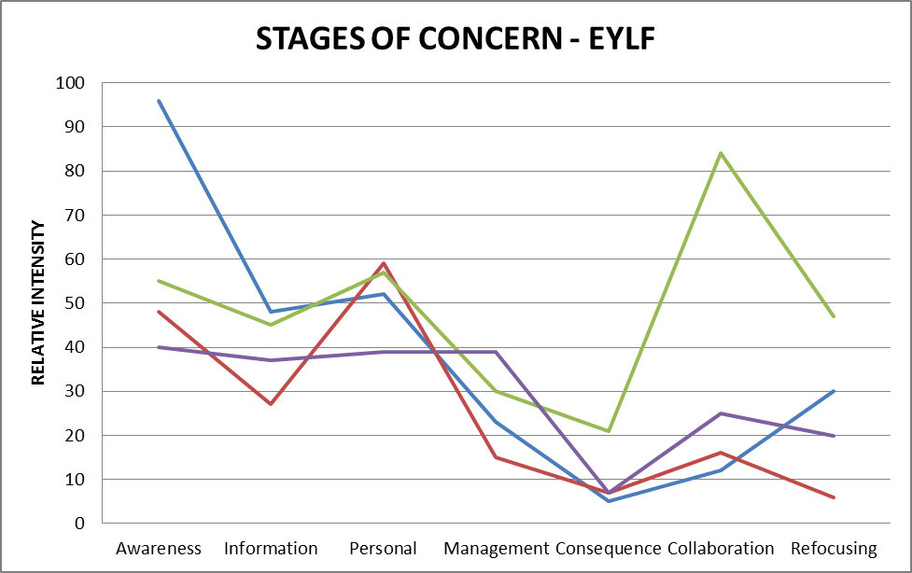
The second site the evaluator visited in Domain Four is Preschool and Kindergarten 4.2. Due to a police lock-down of the service in response to a hostage taking threat, children were not present at the service when the evaluator visited. This kindergarten has been in operation for the past nine years. The kindergarten is located in a high socioeconomic area and is owned and operated by X College, an Independent School. Both the kindergarten and the college share the same compound and facilities including gym, music centre and library resources. Most of the activities of the kindergarten are integrated into the school programs. In total, there are eighty children. The groups comprise of forty children (3-4 year olds) and forty children (4-5 year olds) who attend the kindergarten. The 3-4 year olds are sub-divided into two classes of twenty children in each class who attend kindergarten on Mondays and Tuesdays and each class of twenty children is taught by two teachers. The 4-5 year olds are also in two groups of twenty children. They attend kindergarten from Wednesday to Friday and each class is taught by two teachers. C-BAM evaluations of educators indicated that they were inexperience users of the EYLF.
In general four educators work with children at the service. All the educators were from European heritage and are in their middle 40s. Two of the educators are highly qualified in their field. #1, a pioneering member of the staff that started the kindergarten has a Bachelor Degree in Early Childhood Education with twenty eight years’ experience. She is in charge of the 4-5 year old groups. She has been teaching in her current kindergarten for the past nine years. #2 who works with the 3-4 year old groups is highly qualified with a Masters Degree in Special Education in addition to a Bachelor of Early Childhood Education degree. She has twenty two years teaching experience and has been working in her current kindergarten for the past six years. #1 and #2 are supported by two educators who have a Certificate III in Children and Community services. According to #1 and #2, they are paid according to their qualifications, which is in parity with the primary and secondary school teachers at the college. The college regards the kindergarten as part of the main school. According to #1 and #2, pay parity and the value the college principal accorded them have contributed significantly to their high level of motivation for their career as early childhood educators.
According to the Director of the service, there is a strong element of good moral code and rules. The Service Director indicated that many parents prefer to bring their children to the centre because of the rich resources of the service, qualification of staff and activities children undertake at the centre which they think is meeting their children’s needs. The service run entirely on funds generated from school fees. In 2011 the service received their first funding from the State Government. The program usually starts from 8.45 am and ends at 3 pm. There is opportunity for after school care programs up to 6 pm which is run by different teachers.
Currently, there is only one child who has a Sri Lankan background. There are no Indigenous children enrolled at this kindergarten at the time of this evaluation. All educators have access to broad-band wireless internet at the centre. The service has unique and a variety of rich resources, including computers for children to learn ICT. Children from the kindergarten have access to the new an ultra-modern college library, which was built with a $2 million dollar grant from Education Revolution Fund. A special section is created in the college library and stocked with children’s book where children from the kindergarten borrow books and use at home. There are also electronic smart boards in the junior school that children from the kindergarten are able to access from time to time. Coupled with these, children from the kindergarten use the college gyms, dance theatres and musical studios. Both the teachers at the kindergarten and the college participate in meetings together and staff from the college pay regular visit to the kindergarten to learn more about early childhood pedagogy.
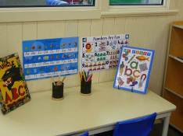
Figure 39
Transitions
Although transition times were not observed due to the police lock-down during the visit, one important transition practice noted by the educators is the relationship between the kindergarten children and their counterparts at prep in the college. The educators informed that being part of a school contributes to the richness of transition for the children as they get to see the big girls in learning activities. This ensures continuity for the children, particularly the girls who normally transit from kindergarten to the college prep. This internal exchange between the college and the kindergarten enhances children’s transition to school programs.
Learning outcomes: The educators at this centre work towards five learning outcomes specified in the Kindergarten Learning Guideline (KLG) and the Kindergarten Learning Guideline Companion (KLGC), which were written by the Studies Authority in 2010. Learning is organised around social and personal learning themes, health and physical learning, language learning and communication, early mathematical experiences and active learning process. There is emphasis on knowledge transferability and the educators indicate that they encourage children to explain what they have learnt to their parents. The educators again explained that anytime handymen come to work on broken equipment which they think is safe for the children to observe they take the children along to observe these real-life activities in order to enrich their developmental and learning experiences. Emphasis is also on oral communication, emotional development, turn taking, and decision making on what activities they would like to engage in.
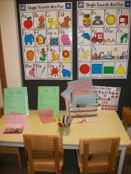
Figure 40
Educator professional knowledge of the EYLF and the elements (principles, practice and outcomes)
The educators’ pedagogical principles as outlined in the EYLF were generally at the spontaneous level. They were theoretically eclectic in their approach to individual children and in group situations. Whereas teaching through play, setting up the learning environments, planning, observations and assessing for learning are all done within a high level of understanding in the KLG and KLGC they are beginning to implement EYLF alongside the KLG and KLGC. A key aspect of concern related to the EYLF is assessment and documentation. There is a lot of cloud around the number of documentations that could suffice for a particular learning outcome within the EYLF. The educators’ practices and documentation appears to be based on age-stages perspective of child development.
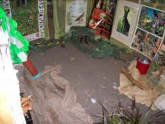
Figure 41
Planning and documentation
Planning, teaching and documentation at the service is mostly informed by the Kindergarten Learning Guideline (KLG) and the Kindergarten Learning Guideline Companion (KLGC), which was written by Studies Authority. The educators found the use of this document more flexible in its approach to documentation of learning outcomes. They are now moving gradually towards the use of the EYLF, however, they were concerned that the lack of specifics on the number of documentations and assessment they should complete in a teaching session is making them risk the quality of their programs. This is because educators are mostly focusing on taking photographs or writing running records when they should be focusing on active teaching. They used anecdotal records, notes from discussions, annotated samples of children’s learning, including images, multimedia records and personalised reflections to document and assess learning at #A Kindergarten. Learning outcomes centred on identity, connectedness, wellbeing active learning and communication. For example on physical wellbeing the educators documented how the children developed their own different healthy menus and priced them.
Note: Because of the police lockdown of the service during the visit as a result of a hostage taking threat, children’s interactions with the educators was not observed. Also, it was not possible to observe transition times during arrival and closing times. However, visual documentations of activities the educators engage in with children demonstrate rich active learning processes.
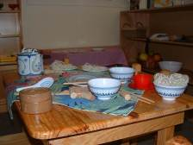
Figure 42
Family involvement
Unlike Preschool and Kindergarten 4.1, family involvement at Centre 4.2 is not intense. According to the educators, the majority of the families whose children attend the service are often busy working and thus have little time to commit to centre activities during kindergarten days. However, the educators usually invite families to special occasions like birthdays, picnics, mothers’ and fathers’ days. Families do not make direct input into planning of activities although the educators inform families about the day-to-day activities and practices. The kindergarten also strives hard to connect to families during weekend bush walk programs as well as encouraging some of the families to support children during bus trips to local places of interest.
Quality
The educators have different ideas about quality and try to provide quality services by drawing on different theories. They were more eclectic in their approach rather than alluding to a specific child development theory. They conceptualised quality service as those that use child play as their focus of learning, well trained and qualified educators, a centre that works together with families in the best interest of children, learning environments that are well resourced and open-ended for families to walk in and walk out, a service that is full of possibilities, and indoors and outdoors that mirror natural settings. The educators of this service also looked at quality in terms of relationships with other educators and community organisations, applying stimulating and interesting approaches to teaching, providing enduring challenges to children, engaging children in play and developmental opportunities based on genuine interest and explicit teaching. They argue strongly that all the above characteristics of quality cannot be realised without a motivated professional workforce. According to the educators to ensure quality, they set high expectation for children during activity times, ensuring that the children know their boundaries on behaviour as well as wear the school uniform.
Equity
To ensure equity, the educators noted that they challenge boys’ and girl’ comments, and use multicultural books and sometimes invite Indigenous elders to share with the children. Although the children currently attending are all from European heritage they ensure that their practices incorporate cultural diversity as a preparation for the children to develop these skills.
Practice
Practice at the service according to the educators is based on the concept that children are confident and capable learners. They adopt an emergent curriculum approach that is flexible which are supported by excursion each term. The educators indicated that during various activities they write down observations and at the end of each day they come together as a group to reflect on children’s activities and discuss these within the EYLF principles, practice and outcomes. This reflection enables them to change things that do not seem to work. They emphasize social skills entreating all children to treat each other with respect. They encourage children to get to know each other and to make friends with the older children in prep. Practice also entails teaching and supporting children to resolve their own conflicts. According to the educators they set up activities in ways that encourage children to work with different children and as individuals.
Identity
The educators ensure that the children get to know their family, their pets, their own space, and that they are part of the whole college and to develop skills that they can call their own.
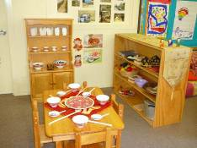
Figure 43
Professional development
All the educators at this kindergarten completed their qualification prior to the introduction of the EYLF hence, post qualification professional development was the only way they have been introduced to the EYLF. Currently they have completed professional development programs equivalent to 7 days on the EYLF. Key components of their professional development include the history and philosophy of the EYLF, evidence based reflective practice, documentation and how to use the Knowledge Learning Guide alongside the EYLF.
There is also a mixed understanding of belonging, being and becoming which is summarised below.
Being
Offer an opportunity and respect for the child’s right to “be a child” (emphasis on the original). This is a valuable and important part of their life that will impact on everything that happens afterwards. This stage should not to be relaxed through or overlooked but valued and recognised as a valued time. It is also about whom the children are now and whom they want to become, who they are in relation with peers, families and adults. Being is also, what children are now and how they see themselves, it is to do with their culture, their family where they lived before and where they are living now and how these multiple environment influence who they are now and their thinking processes. Being is related to where a child comes from, family unit, culture and what makes children the way they are.
Belonging
To the educators at the service, belonging is feeling connected to others, first family and extended family and then wider community, playgroups, friends, neighbours. It is about a sense of belonging to the staff, other children and centre. Children are a part of family, other groups, the kindergarten group, a school community, being themselves as individuals but also working as a member of a group. It is about who they are connected to in their life, neighbours ballet group, etc. It is relationships they see as important in their lives and want to be connected to. Making the child feel that they are part of a group and being respected.
Becoming
This is recognition of the fact that the child is constantly changing, developing, making connections, contributing, learning forming personalities, attitudes, impressions of the world. Growing, learning forming experiences, relationships, events, circumstances and what influences them. It is what they identify with and connect with in some way. What shapes the changes in the child and what influences how they learn and grow.

Domain Five

Characteristics of the LDC 5.1:
Centre | Stage 0 | Stage 1 | Stage 2 | Stage 3 | Stage 4 | Stage 5 | Stage 6
Centre 5.1 | 48 | 60 | 70 | 88 | 30 | 95 | 65
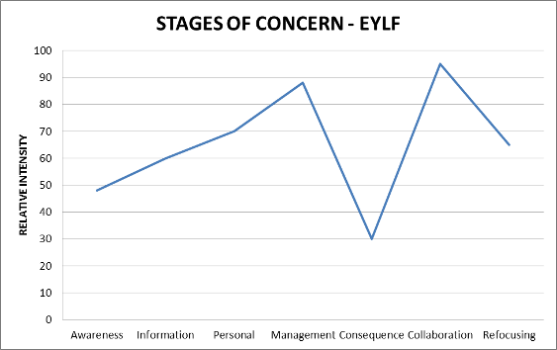
Centre 5.1 is located north-east of Domain Five’s capital city. It is in a planned housing estate whose SEIFA index is in the eighth decile (ie comparatively affluent) and part of an educational precinct that includes three high schools, a primary school and a recreational area. The Centre is located in a converted historic stone farmhouse, is community managed and is approximately 30 years old. The Director is responsible for the educational program while the Assistant Director, who was involved in its establishment in the 1970s, manages the business aspects of the centre under the governance of a community committee. The centre is registered for sixty children. There are three main groups. The Under 18 month old group currently has six children enrolled, the toddler room has thirty-two, and the 4-5 year old group has thirty-six children enrolled. Some of these children attend part-time. On the visit day there were five babies, twenty-four toddlers and twenty four year olds present. The centre opens at 7.30 am and closes at 6.00 pm. All staff have a qualification or are in the process of gaining one. There are fifteen educators (including five permanent part-time relief workers) who work in the centre. Of the families who use the service most are of European heritage background, and there are a few children who have additional needs. In a short initial interview the Director described a number of the families as ‘Defence’ (ie transient) from a nearby large Department of Defence establishment. Other families live in the surrounding ‘aspirational’ suburb. Of this demographic group, an interviewee quoted popular press portrayals of this neighbourhood as ‘two cars in the garage and no food in the fridge’). A staff member is employed to assist children 1:1 with additional needs..
The centre’s unobtrusive car park is edged by trees in park-like surroundings, with high schools, a sporting field and community group hall nearby, high quality private housing over the road and a mall-style shopping precinct nearby. The entrance verandah features free-standing placards denoting the centre’s affiliations with sun protection, nutritional, health and environmental programs. A side door leads to a narrow entrance hall displaying the centre’s daily schedule, a statement of philosophy, sign-on sheets, hand hygiene procedure notice and dental health information. Two suggestion boxes sit on the reception counter where signs refer to the National Accreditation Council.
The hallway has a T-junction, at one end offering access to the kitchen, staff room and storage area and the babies’ room and change area. Each of the main playrooms has its own permanently set up sleeping room, two along the southern (darker) side of the building. Much of the north-facing wall leading on to the rear verandah and main outdoor play area has been converted to glass, which allows light into the high-ceilinged large playrooms and children’s bathroom. Posters illustrating program planning and assessment cycles are displayed on the wall of each room. Many wall surfaces and cupboards display a mixture of children’s work and procedural instructions to staff (such as ‘1: 1 staff child ratio at all times’; ‘The sleep room must be checked every 15 minutes while children are sleeping. The check must be recorded’). There are digital photographs of children’s activities displayed on or near the entrance to their room. The whole reflects recent attention to EYLF concepts and outcomes overlaid on to a previous centre based procedure featuring a standardized daily planning sheet that is still in use.
On the morning of visiting the site, the children had started their day outdoors. This area retains large old trees around the edge
The outdoor area of the centre has two distinct areas. However, only one was actively used during the site visit. The outdoor area in use had a variety of ground surfaces, trees, tyre swings set over pine bark, a large shaded sandpit, a wheel track lined with small bushes, a cloth on the ground with manipulative toys, a range of bikes, trikes and wheel barrows.
The centre’s schedule allows for an hour of family grouping in one room at the beginning of the day. While the whole group was outdoors on this sunny winter day of the visit, except for sleeping babies supervised by the cook (qualified in child care), the indoor areas were being set up for morning tea, after which children moved to their designated rooms. In all areas materials were placed where it was easy for children to self-select those they wished to use. Children freely move materials within their own rooms and ask staff permission to visit other rooms. The building is raised above the level of the outdoor area, accessed by a zig-zag ramp. This fixed feature of the building design precludes free movement between indoors and outdoors, but the centre’s policy to strictly comply with adult: child ratios at all times may place a constraint a free flow of movement indoors. Staff present on the day included the Director, three qualified room leaders, a cook and a number of younger staff, who were celebrating the departure of one of their peers to a nannying job overseas. As the younger people circulated through the staffroom on their breaks there was a sense of transience, difficult to read on a short visit but characterized by a number of staff leaving the centre and refusing to engage with the evaluator or supplementary evaluation materials when asked. This restlessness and lack of focus also seemed to be evident in the behaviour of the children so it may have been that the visit took place on an atypically disrupted day. On the day of the visit the Director declined to be interviewed and delegated this task to the Assistant Director who has been involved in the centre since its inception, first as a community volunteer and then as a manager (she is now studying for a Diploma in Children’s Services). The apparent slight tensions between staff could be read as resistance to external surveillance by the researcher. This may indicate a resistance to ‘compliance culture’ represented on the walls of the centre by reminders of policies, regulations, procedures and quality measures. The dynamic between the older Assistant Director and the younger, fully qualified Director also seemed slightly at odds and possibly may have signified an implicit tension between long established Centre mores informed by life experience and a perspective developed from an academic education.
Educator professional knowledge of EYLF and the elements (principles, practice and outcomes) underlying the document
Warm, responsive and engaged interactions with the children were observed in the case of key staff such as the cook, babies’ room, kindergarten and toddler room leaders. The Director’s face to face involvement with children and other staff appeared to be minimal on the visit day. The EYLF was represented by one. A preponderance of centre practices and culture seemed more to reflect the Domain-specific ‘Assessing for learning and development in the early years using Observation Scales: REFLECT RESPECT RELATE’. The interview supports a view that this framework was preferred over the EYLF and while room leaders and older staff’s practice reflected a focus on the children, some younger staff were inclined to stand and observe from a distance.
Principles: Despite some apparent resistance from younger staff to engage with the evaluation per se, it was evident that there was a high level of awareness among room leaders and ancillary staff of the principles associated with providing a secure context for the children, where interactions are respectful and reciprocal. The evaluator observations of the interactions during mid-morning and through the afternoon confirmed that these staff implemented this in practice while a few less experienced and possibly less engaged staff appeared to be operating on a more laissez-faire approach. The interview with the Centre Assistant Director was not so much framed on educational or EYLF principles but more on the basis of compliance to an externally imposed innovation.
Family partnerships have been embedded into this service from its origins as a community-based centre and Management Committee photographs are featured in the reception area. While the design of the building is not conducive to adult interactions, the hallway and wider lobby at the entrance to the kindergarten room are lined with information for families and documentation of children’s learning as described above. As in many child care centres, a hanging quilt with cloth pockets enables the delivery of notices to parents and suggestion boxes are an avenue for parent communication back to staff. An area that was not noted was parents’ involvement in shared decision making.
Although the families were homogeneous, there was one child with additional needs who was attended by the special needs support worker in her daily interaction, joined by other children who were attracted to the activities and this worker’s seated posture which made her accessible to children. While the staff room featured historic photographs of the farmhouse’s original occupants, an area that was not evident was the explicit planning for broadening the children’s understanding of the history and/or any broader cultural communities of the neighbourhood.
Opportunities for reflective practice were restricted due to the limited planning time of the staff. Educators generally avoided engagement with the evaluator in the playroom, however the planning and documentation of program planning and outcomes displayed on the walls suggested that leading staff were engaging in their own professional enquiry. Ongoing professional learning was evident through the training material on display and notices on the staffroom walls, although interviews suggested that the EYLF was not particularly valued as an innovation or extension of existing principles and practice.
Practice: The practices seemed a little at odds with the planning and documentation displays. These displays demonstrated that effort had gone into organising resources and planned experiences to stimulate learning through play but this was not evident on the day of the visit. Intentional teaching was delivered by a few child-focused staff but the learning materials set out were basic and seemed not to have been arranged purposefully to stimulate any particular intentional teaching. The centre deliberately made use of the natural contours of the outdoor area in order to feature natural exploration. Indoors, three four year old girls were involved with each other in imaginative play, taking themselves into a hidden corner of the entrance lobby to play their game unobserved. In each room, assessment practices featured a wall display of the weekly schedule day by day and one or two learning stories arranged like a flow diagram to illustrate the planning cycle, the specific activity and a link to EYLF outcomes. Due to the Director’s inability to be interviewed it was difficult to ascertain what theoretical influences explicitly underpinned practice. The centre philosophy states: “‘Centre 5.1’ child care centre believes in providing a secure, active, ongoing learning environment which values and encourages children’s learning through play and diversity, providing maximum support to assist parents to balance their work, study and family commitments”. Security, happiness and support for families are conceptually separated from a notion of ‘curriculum’ in this statement. The expressed aims for children are: ‘fostering a positive self-esteem; encouraging curiosity, encouraging respect for others and the environment; promoting an understanding and appreciation of cultural differences and diversity of family backgrounds; and accepting each child as an individual’. This is evidence for an emphasis on social and emotional well-being within a developmental discourse, overlaid with transitional attempts to comply with the new EYLF curriculum.
Learning outcomes: The leading educators in the Centre implicitly work towards the Learning Outcome of a strong sense of belonging. In relation to Outcome 2, the children have a confident sense of belonging to their peer group within the centre and of approaching their familiar carers with requests (e.g. for visits to other rooms). Children were affectionate and confident with staff of diverse backgrounds, but were not confident and outgoing with the evaluator as a visiting adult as was the case in some other centres visiting. Similarly, Outcome 3 was evident but younger learners in the toddler and baby room seemed to lack confidence. Despite ample equipment and learning materials, educators seemed to rely on a ‘default’ room arrangement rather than one deliberately organized to promote children’s engagement. However, aspects of Outcome 5 were clearly evident, as the children communicated freely with each other both verbally and non-verbally. The interactions between educators and children, and an analysis of the documentation revealed less priority placed upon using a range of texts and media, or the use of symbols and pattern systems, or the use of information and communication technologies for investigating ideas and representing thinking – as is now expected within Outcome 5 of the EYLF. Whilst there was evidence for the possibilities of this through the amount of equipment available, the range, complexity and depth of resourcing to support these kinds of outcomes were not evident in posters/models for children, children’s work, or planning documents.
A summary of evidence to support this evaluation is given below:
Senior staff believed they were already engaging in high quality practices, as evidenced by their affiliations with state wide programs such as Centre. It was thought that once the less engaged staff had, they would come to the view that their practice might more closely approximate reflective quality practices as determined by the EYLF.
Interactions
Positioning, ready to engage: The level of educator-child interaction shown by a few leading staff was warm and friendly, especially by the room leader in the babies’ room, the cook and the additional needs educator. A great deal of eye contact was evident, and these educators were always crouched at the child’s level, usually sitting on the floor. When these people were absent and the room was being staffed by less qualified educators and a visiting student, the focus was solely on meeting the children’s physical needs such as nappy changes and food. Directions to the student were expressed negatively, to tell her she was not allowed to hold any child but not giving her any direction about alternative interactions. When the room leader returned she modelled sitting at the window and discussing the scene outside with a number of the walking children. The student then imitated this.
Shared sustained conversations: Conversations between staff and children were not sustained or elaborated in any of the rooms
Collective imaginary interactions: There were many resources provided to the children which had the opportunity for expansive imaginary play and interaction between children but were not taken up by the educators on the day of the visit.
Individual responsiveness
The level of individual responsiveness was evident in the centre in the documentation displayed on the wall but since staff were reluctant to speak to the evaluator it was impossible to gauge this by any other means.
Transitions
Transitions on arrival: On the one arrival that occurred during the evaluation visit, the lead educator in the babies’ room greeted the parent and the child who was placed on the floor, as it is against centre policy to transfer children between adults’ arms above ground level. The child was then held by an educator at child level and a short conversation about routines took place between the adults. The child showed no distress when the parent left.
Planning and documenting
Documentation at the service is based on an amalgam between the Domain-specific ‘Respect Reflect Relate’ evaluation instruments, based on quality improvement values, and the [other state] derived planning format mentioned above that is standardized throughout the centre. Areas emphasized are social and emotional development, communications, problem solving and cognitive development.
In the toddlers’ and kindergarten room, wall posters indicated planning cycles and EYLF learning outcomes of experiences, documented by digital photographs. While these posters were attractive because of the photos, they were written in professional language more suitable for educators than families
Children’s individual profile folders are stored high on an internal wall and permission was not forthcoming to examine them.
Program planning focuses on children’s interests, and running with what the child wishes to talk about. There was little evidence of preparation for school such as number, colour or alphabet charts
Family involvement in planning
Different approaches to documenting or assessing children are used by different educators. While there is a common approach to program planning, there is not a specific formula for documentation. At drop off and pick up time, the educators interact with the families sharing information about the specific child (from educator to family and from family to educator).
Family communications also occur through placing notices on the entrance verandah on an easel with an important message so that families cannot help but notice.
The overall profile of the staff in the centre in relation to their responses to the C-BAM was as follows:
Whatever concerns staff in general may have about the EYLF were not expressed in the general reluctance to engage with the evaluation in personal conversation. Once the evaluator explained that participation was voluntary, after initially refusing to do so, a few were willing to fill in the SAT questionnaire. All staff had completed a C-BAM survey before the visit. The C- BAM responses may have been portrayed as compulsory.
Professional development
The centre educators have been involved in one set of professional learning on the EYLF. A message given was that educators were not going to be told what to do and think but that they had to create their own response to the EYLF. The one staff member who agreed to be interviewed was unsure about the value of the EYLF in comparison with the approaches already used in the centre.

Characteristics of the Integrated Setting 5.2
Centre | Stage 0 | Stage 1 | Stage 2 | Stage 3 | Stage 4 | Stage 5 | Stage 6
Centre 5.2 | 31 | 16 | 5 | 2 | 3 | 55 | 3
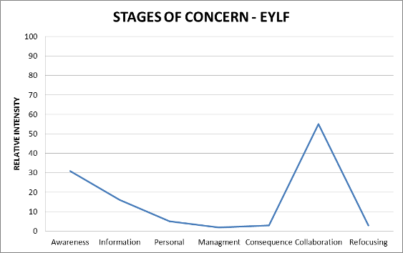
A well-established, Integrated Setting situated in a small rural town outside Domain Five’s capital city, was visited for this project. The region is well known for its wineries and agriculture. There is a strong sense of history in this region and the teachers are obviously proud of their place in the community. The Director tells me that the kindergarten is rated Category Three which reflects the prosperity evident in the area. This does not mean that the staff do not grapple with complex issues and in this Integrated Setting a service is provided to 170 families.
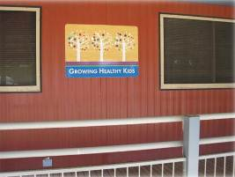
Figure 44: Outside of building
The reviewer drove into a large car park and walked into a very welcoming reception area. The first impression is that space is not an issue here. Everything is well laid-out and there is a mix of information, and personal artefacts contributed by families, as well as notices that comply with ECE regulations. After being greeted at reception the reviewer spent time in the office of the Director and was shown around the setting. Doors lead from reception into a staff room, into the childcare centre, and into the kindergarten. The childcare and kindergarten is situated next to the high school and the site includes a toy library, ‘Growing Healthy Kids’, and a playgroup. There is also an annexe where Certificate III ECE students are trained and where there is a space for staff to use computers and complete administrative work. These are obvious advantages to having a purpose-built complex.
The Director has completed her Diploma in Early Childhood Education. Out of twenty five teachers only one is not trained but she has 30 years of experience working professionally with young children. The remaining staff have Certificate III qualifications, half have the three year Diploma in ECE and above, and two have a four year university qualification. The leadership role is a demanding one. The Director has just completed a course in conflict resolution. She has been there a year and has been building on the work of the previous Director who decided to build a ‘working together’ culture. The Director and teachers work hard to ensure that there is a minimal childcare/kindergarten divide. The Director also appreciates the opportunity for formal and informal interactions with external support services such as ‘Growing Healthy Kids’.
The centre opens at 7 am until 6 pm. Staff take breaks throughout the day and when the reviewer was there the Director reminded teachers to take their break. The childcare centre is divided into two sections; infants/under two-years, and over two-years. There is also an adjoining kindergarten for older children. The childcare has its own cook and some kindergarten parents use this service if they want their children to have a hot lunch. The reviewer noticed that all the children in the childcare rooms were really enjoying their hot lunch which was Shepherd’s pie and custard. All the children ate together and the infants were not discouraged from using food as a source of play and discovery. Infants were encouraged to sit at tables and the use of high chairs is being reduced. Meal times seemed to be a time for pleasant social interactions. The reviewer could see that special attention was paid to well-being.
Outdoor area
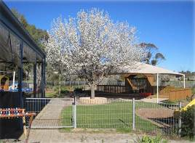
Figure 45: Outdoor area
The outdoor areas are attractive and are divided by medium-height swimming pool fences so that children in the childcare and kindergarten can see and talk to each other and in the kindergarten children can see and talk to students from the adjoining high-school. It was noted by one of the teachers that this transparency supported sibling interactions and meant that children could maintain relationships with their friends. From the kindergarten the reviewer could see vineyards in the distance, the high-school gardens, free-range chickens, and pens for pigs and sheep. This gave a sense that this setting is completely connected to the community and is very much part of the landscape. The outdoor area has mature trees, ample shade, is spacious, and well equipped. There were attractive small spaces as well as a large sandpit. A teacher told me that there was also access to the high-school oval (sports field) because as she said “some children just have to run”.
Indoors – Kindergarten
Tables were set up with various activities. The reviewer was interested in the artwork and clay table. Children were encouraged to use new techniques and were engaged in complex clay work. The teacher here told me that she was passionate about “art and nature”. There were photographs of a fruit and vegetable delivery person who visited the kindergarten. These were displayed at the children’s eye level and the children were discussing the visit at length. There was an attractive white board thanking families for involving themselves in work at the kindergarten.
Indoors – Childcare
The infants’ room was warm and bright with plenty of equipment. There was some interesting documentation of the wall about the visit of a parent with an echidna. There was a wall display about well-being. There were puppets, books, toys and a comfortable sofa. In the over twos setting less work was on display and the room appeared to be less furnished. In this room there was a display about connection and the Indigenous people of the area were featured in a photograph:
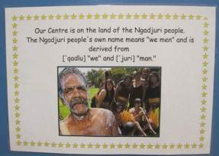
Figure 46: Recognition of the Indigenous people of the area
This reflected that while most of the children were of European heritage, there were also some children with an Aboriginal family background attending the centre.
Educator professional knowledge of EYLF and the elements (principles, practice and outcomes) underlying the document
Family partnerships
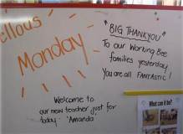
Figure 47: Communication board
Family partnerships are valued and the Director showed me her annual report from 2010. It is documented in this report that when families were asked whether they felt welcome at the centre by staff they were very happy and said ‘yes’. They really appreciated the fact “that everyone knows my name”. The Director acknowledged that the EYLF has outcomes that interest families because families are interested in their children being happy. Teachers have a pre-entry meeting with families where they discuss hopes for each child. The Director feels that the curriculum accommodates these hopes.
Practice
As well as focus on the EYLF, the teachers also use a programme called ‘Traffic Lights’ (children’s needs in terms of wellbeing), another called ‘Strive for Five’(about having five conversational ‘turns’; oral literacy) and another called ‘You Can Do It’ (puppets; dispositions; resilience). The Director also uses the phrase ‘Respect Reflect Relate’ from the Quality Framework for Domain. She feels that this supports an inquiry approach to teaching and learning. These programmes run concurrently with, and support, the curriculum. In this sense there is a lot going on. In my conversation with the Director she explained the benefits of these approaches in terms of behaviour, language and extending conversations, confidence building and inquiry. Some teachers felt that in-depth focus on the curriculum would be something they would find useful. The reviewer wondered if the curriculum is ‘added on’ to what already happens rather than replacing existing programmes. This might mean that the focus is rather diffused. The Director expressed a hope that the inquiry approach would begin to go deeper in the future as she likes the project approach to pedagogy.
Learning Outcomes
Children in the kindergarten have profile books that link curriculum outcomes with individual learning plans. While contributing to these books involves a lot of time from staff, there is a sense of focus on each child. The profile books are specific rather than generic. The Director and Head Teacher of the kindergarten share with me that instead of simply focussing on being ‘ready for school’, assessments must consider ‘the great things we do’. Children are engaged in problem solving and in open-ended activity. They tell the reviewer that there is no need for closed assessment. As supported by the EYLF they appreciate assessment for learning as oppose to assessment of learning and they tell me “it works”.

Interactions
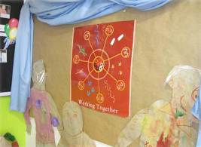
Figure 48: Wall display
Interactions are warm and trusting. Clear communication is valued. One teacher asks a child to say “excuse me” and another requests a toddler to use “gentle hands”. First names are used (there are eighty eight children in the kindergarten alone). Beyond this, teachers share stories with the reviewer about individual children. There is a sense that children can be themselves here and that they are valued. There is a system of primary care-giving and information is provided to families about attachment in a wall display. The infant co-ordinator tells the reviewer that she “fell in love with day-care” and that she reassures families that their children will be loved, cuddled, and talked to. She feels that the EYLF provides a language for everything she wants to achieve professionally. Interactions between staff are equally important and one of the younger and newer teachers said “I love the staff here, it’s nice work”.
Transitions
Infants transition to childcare gradually. They go to the next room when the parents and primary care-givers feel they are ready, rather than when they reach a certain age. The childcare co-ordinator commented that “there is no checklist” but the children indicate when they are ready to move. Their primary care-giver goes with them and the child is reassured that they can go back again. This relates to the EYLF in that in these processes everyone works together to achieve positive outcomes for each child. When children start school they may go to one of seven primary schools in the area. Teachers have relationships with different schools, children and teachers can visit the primary school together and the primary school teacher can come to the kindergarten. The Director points out that if a child is struggling they make an appointment with the primary school and get everyone prepared for the transition.
Planning and Documenting
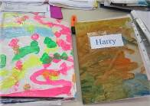
Figure 49: Documentation
As in many other large and complex settings, time is always an issue. What the reviewer noticed is that planning happens from a child-centred perspective. Planning is done by setting up an enriched environment, by having conversations with children and connections are made to the curriculum. These are recorded visually and photographs form a part of the wall displays. The words of children did not seen to be a strong feature of this documentation. The profile books were more detailed and included basic learning stories. The reviewer discerned that learning was happening in the everyday activity of the centre. This learning related to the outcomes of the EYLF but maybe those links to curriculum could have been highlighted in the documentation, particularly wall displays.
Quality
- Parent/carer/child relationships and committed staff.
- Secure relationships.
- Safe educational environment.
- Aiming for 100% good practice.
- High standards.
- High quality conversations.
- Good knowledge of theorists.
- The ‘want’ to improve.

Quality

- Strong values.
- Having a purpose for why and what we do.
- Valuing families.
- Valuing play.
- Confident.
- High levels of well-being.
- Engagement and involvement.
- Following policies and procedures.

Everything in the above model is taken from ‘quality mind maps’ completed by the teachers.

Professional Development
Conversations about professional development highlighted some ambivalence. Staff appreciated the need for professional development but in order to sacrifice their time they wanted it to be worthwhile. The Director knows that she has a very demanding job. One of the long-term teachers admitted that she lacked motivation to extend her training more formally because as she said “it’s so good here”. Because relationships are so valued in this setting staff cite as a reason for not wanting to complete further studies the fact that they will miss the children when further education means attending a placement elsewhere. Apart from further tertiary education, there is space for professional development within the setting. In conversation with the reviewer teachers said that they would appreciate workshops about the EYLF, for example. There was no sense that staff would resist further professional development but it needs to be offered in a way that is attractive to them. The reviewer suggested the possibility of a research partnership with a local university as this could be mutually beneficial.
Highlighting Belonging, Being and Becoming
The Head Teacher (Kindergarten) summarised her beliefs about Belonging, Being and Becoming:
Being: for me is all about individual children having the opportunity to be themselves. To comfortably show their strengths and challenges in an environment that is kind, caring and supportive. Being celebrates children and people for who they are and the knowledge they have.
Belonging: is about relationships and the connections children make with others. Creating environments that children feel comfortable, safe and valued in. belonging helps children develop a strong sense of well-being allowing them to be accepted no matter their race, religion or colour. Belonging is central to all children’s learning!
Becoming: is about encouraging children and supporting them to become the best they can be. Building their confidence, extending their thinking and fostering their prior knowledge to help them achieve their goals. Giving them the tools to make sense of their world and make decisions independently.

Domain Six
Two sites were visited in Domain Six. They were the long day care centre in a northern metropolitan suburb, and a Family Day Care unit in a township. The principle educator responsible for the service evaluated at each site were rated as non-users of the EYLF. The staff working directly with children and families in both services were also rated as non-users of the EYLF.

Characteristics of the Family Day Care 6.1
Centre | Stage 0 | Stage 1 | Stage 2 | Stage 3 | Stage 4 | Stage 5 | Stage 6
FDC 6.1 | 48 | 5 | 5 | 2 | 21 | 98 | 11
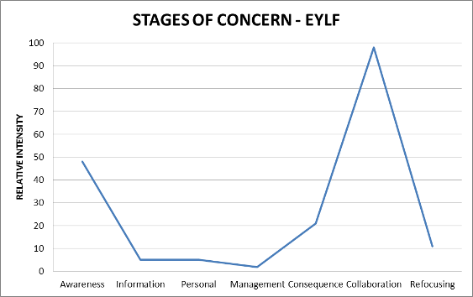
The Family Day Care site visited is in the outskirts of town X. The particular FDC setting where the site visit was undertaken was located in a very low SES community. #1 the FDC educator, who is of European heritage background and appears to be in her mid twenties, has only recently registered as a FDC service, and was still undertaking training. She said “I don’t know anything about the EYLF”. She indicated that she was more focused on setting up her house to meet the requirements for registration, including having her car registered for use for FDC children. She had commenced her Certificate Level III, but had not heard anything about the EYLF at her Certificate III training programs. Interviews with the FDC Coordinator and the Assistant Coordinator confirmed that the TAFE programs for all awards did not include in their curriculum the EYLF. It was understood by all that the early childhood professionals at the TAFE were also learning about the EYLF and that it would take some time before course documentation could be reviewed and changes approved.
#1’s FDC is licensed for four under three five year old children, plus one school age child (5 year old attending Kindergarten). Once she has graduated with her Certificate III in Child Care then she will be licensed for five under five year olds, plus two school aged children. #1 indicated that these ratios would change in 2012, demonstrating a level of awareness of the National Quality Agenda.
Most of the children in #1’s FDC attend two days a week. All of the children arrive at 9 am and most leave at 3 pm, with some leaving at 5 pm. Overall, she has seven children who attend her FDC on a part time basis.
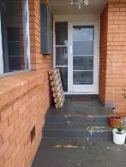
Figure 50: Welcoming children and families to Family Day Care
On the day of the visit, #1 had one infant under 12 months of age, one five year old and two, two year old children in her care. Her own child, who is of school age, was being cared for by the child’s father. All the children who attend the FDC, except one child, are of European heritage background. #1 indicated that the mother was of European heritage background and the father’s child was from Sierra Leone. #1 stated that the mother had recently re-partnered with someone of Jamaican cultural heritage. She said she was actively learning about the child’s cultural background and new Jamaican family context.
#1 has internet access at her home and has a planning book that was provided by the FDC coordinator to support her with planning and assessing. The town’s FDC unit has many resources, including the Educators’ guide, the EYLF, the Early Learning Resources, and a range of ECA publications, leaflets, and teaching materials. These resources are made available to the educators through training sessions, through visiting the unit, and through visits by the coordinator and other staff at the FDC homes. The unit has two staff who are charged with learning as much as they can about the EYLF, particularly the concept of intentional teaching, and learning stories. Once the staff have undertaken more research, they will conduct training sessions for all the FDC educators working directly with children and families.
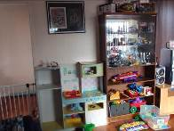
Figure 51: FDC indoor environment – registered areas in the home

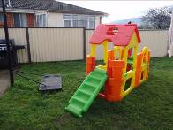
Figure 52: FDC outdoor environment – registered areas
The FDC registered space in #1’s house includes the kitchen, laundry, bathroom, toilet, lounge area, and one bedroom. The outdoor area is fenced to include a specific space which runs from the laundry door through to the side fence, as is illustrated below. The change table facilities are in the bathroom. The lounge area is filled with plastic toys, some children’s books, DVDs and a large screen TV. The kitchen area has a child sized table and chairs, which on the day of visiting contained drawing materials. Previously the children had been gluing green cloth squares on to an outline of a sheep. The eldest child drew a picture and asked where it should go, and #1 responded, “Put it onto the fridge”, which the child skillfully did.

Figure 53: Family Day Care – Levels of understanding as expressed through the children’s work
Educator professional knowledge of EYLF and the elements (principles, practice and outcomes) underlying the document:
The principles of early childhood pedagogy as outlined in the EYLF were generally at the intuitive level, skewed favourably towards a high level of responsiveness to individual children, as well as an overall awareness of the group. Intentional teaching, learning through play, setting up learning environments, planning and observing holistically, being culturally competent, and assessing for learning were all at an intuitive level.
#1’s self-assessment of EYLF principles, practice and outcomes indicates that #1 is still learning about theory, assessment, principles of teaching, equity, diversity, parent involvement in planning, and how the pedagogy of play supports learning. However, she feels confident in her interactions with children and parents, and believes she is supporting the children’s wellbeing, and catering for individual children.
During interviews, a consciousness of outcomes associated with children developing a strong sense of identity and wellbeing were generally articulated at an ‘awareness level’, but were enacted in practice at a higher level than were articulated. That is, outcomes 1 & 3 were undertaken at a more intuitive level. Limited evidence of Outcomes 2, 4 & 5 were evident in practice or noted during the interview.
A summary of evidence to support this evaluation is given below:
Interactions: During interviews #1 continued to attend to the children in her care, showing great capacity to multi-task. Whilst #1 was unable to talk about theories of child development, understandings about pedagogy, and practices in terms of assessment, reflection and evaluation, she did demonstrate a high level of intersubjectivity with all of the children in her care, and a level of sensitivity in her interactions that indicated that she observed closely, and respected her children. #1’s interactions demonstrated a high level of listening to the children, paying attention to what they were asking her or were talking about. Through this, #1 naturally extended their conversations through genuine interest in what they were sharing with her.
Individual responsiveness: #1 did state that each child is unique and her approach to interacting with each child was based on their uniqueness. Her interactions with the children during the site visit showed this sensitivity. For example the 12 month old began to cry after the door to the outdoor area was closed. #1 immediately picked him up and softly said “Oh I know you love going outside. I’m sorry we can’t go out it is just so wet”. She then cuddled him until he settled, and then she put him down. After a few minutes again, he began to cry, and she immediately picked him up, cuddled him and kept him on her hip as she cleared up the lunch dishes. She stopped at one point and gently stroked his hair, saying “We will soon have a nice sleep”. #1 told the evaluator that “His thing is being outside. He just loves it!”.
Transitions: #1 indicated that she uses the activity of blowing bubbles to settle her children, mentions to them that “Mum will come back”, gives lots of cuddles and uses kind and softly spoken words, even to the four month old. She said she also uses photos of the children and their families to help with transition (Due to there being fog at the town’s airport the arrival time of the evaluator was delayed, and she was unable to witness the transition into the home).
Planning and documenting: Planning is through listening to the children and seeing what they like doing and are interested in. #1 tries to “do number work and the ABC’s”, but mostly it is about building secure relationships with the children. #1 consults the “Planning and Evaluating Workbook” that is provided by the town’s FDC unit to support her with thinking about planning. But she said that “I plan my day and it often only takes an hour”, and then she says “What should I do next?”. She indicated that she then just interacts with the children as they are playing with the toys she has made available. She said that they noticed that the kindergarten children didn’t know their colours, and therefore she introduced experiences to help them learn their colours. She had special days where they focused on a particular colour – she termed this experience a ‘colour day’. Planning was based on the individual children, but she also did some group things too. The approach that #1 said she was learning about at the Polytechnic was creating portfolios of children’s work. At this stage she had not learned about how to keep records in ways that were in line with the EYLF. The Assistant Day Care Coordinator indicated that the ‘old ways’ were still being used at the Polytechnic because the staff were still learning documentation in relation to the EYLF. #1 had not seen the Educators Guide.
As part of Charlotte’s planning she has organised to take the children to a special singing group (Thursday) and also on another day she takes them to the local school for play group (Friday) in order to give the children something different to do. She also takes the children for walks when the weather permits.
Family involvement in planning: #1 indicated that she is in the process of setting up a sharing book, where the families put photos of their child at home into the booklet, so she can use this in her FDC program. She said she liked to talk to the families about what the children had been doing at home and what they were doing in her FDC.
Quality: Quality early childhood education according to #1 featured the children’s enjoyment, happiness, and that they are safe and busy.

Figure 54: #1’s quality concept map
Professional development: #1 indicated that she had participated in one training session with the town’s FKC unit where they had looked at the EYLF. She said it was all ‘new language’ for her. But the training was more about the new words, rather than how to put it into practice. At this point in the interview, the FDC assistant coordinator said that the word ‘pedagogy’ was highlighted as something new in the training.
#1’s understanding of ‘belonging’, ‘being’ and ‘becoming’ are shown below in her response to the Belonging, Being and Becoming (BBB) survey:
Being: Being is coming to care and being part of the group.
Belonging: Belonging is also feeling part of the group.
Becoming: Becoming is what you are becoming in growing up and becoming independent, capable little people.
Areas of interest noted
During interviews with the FDC coordinator, the assistant FDC coordinator, and the FCD educator it was noted that:
- Intentional teaching is a new concept for educators and needs further elaboration and research so that educators can better understand this pedagogical principle.
- Learning together: All services and training institutions in the Launceston area were all ‘learning together’ and therefore it was difficult to get local expert support on understanding and implementing the EYLF. People doing ‘training’ were all learning the ‘old ways’ because staff in the training institutions were still learning about the EYLF.
- Learning stories were being picked up as ‘the approach to assessment’ and that how to make learning stories more purposeful required further thinking through for educators than previous approaches. There was some concern about the rigour of the evidence being gathered.
- Diversity of approaches and not enough direction in EYLF: It was being promoted that there is now a diversity of views on how to approach planning, assessment and thinking about child development, and this was causing concern amongst educators. Being given responsibility for creating one’s own proformas to fit with the EYLF didn’t provide enough direction. It was felt there was not enough guidance in the EYLF.
- Milestones In particular, concerns were raised that important milestones would no longer be assessed.

Characteristics of the LDC CCC 6.2:
Centre | Stage 0 | Stage 1 | Stage 2 | Stage 3 | Stage 4 | Stage 5 | Stage 6
LDC CCC 6.2 #1 | 48 | 51 | 55 | 77 | 9 | 59 | 57
LDC CCC 6.2 #2 | 48 | 93 | 94 | 56 | 21 | 84 | 57
LDC CCC 6.2 #3 | 61 | 69 | 63 | 65 | 19 | 80 | 57
LDC CCC 6.2 #4 | 61 | 88 | 97 | 43 | 4 | 72 | 47
LDC CCC 6.2 #5 | 55 | 95 | 99 | 56 | 8 | 93 | 84
LDC CCC 6.2 #6 | 7 | 57 | 63 | 11 | 5 | 19 | 30
LDC CCC 6.2 #7 | 98 | 93 | 95 | 56 | 27 | 59 | 57
LDC CCC 6.2 #8 | 31 | 80 | 55 | 7 | 5 | 31 | 57
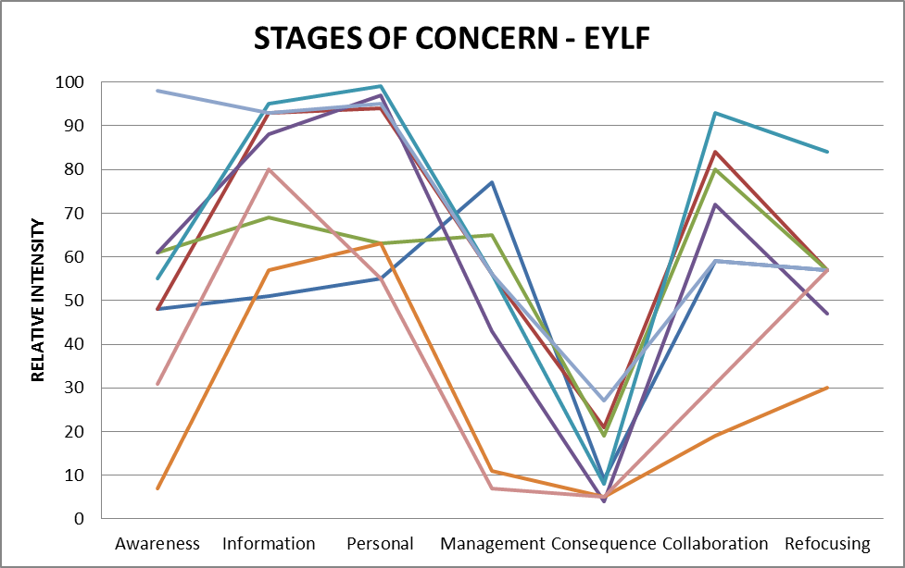
CCC is located in a northern suburb of the capital of Domain Six. It is nestled in a low to middle income family area. The Centre is positioned opposite a tavern and next to a winery. The centre was purpose built by the local council and is approximately 20 years old. The Director of the Centre is responsible for this child care centre and another centre located a short drive away in an industrial estate. The centre is registered for one hundred and ten families. There are two main groups. The Under 3 group currently has twenty five children enrolled, and the 3-5 year old group has twenty children attending. The centre opens at 7.30 am and closes at 6.00 pm. All the staff have a qualification or are in the process of gaining a qualification. There are eleven educators who work in the centre, holding Associate Diplomas or a Diploma in Child Care qualifications. One staff member is undertaking her Certificate III qualification. The families who use the service are all of European heritage background, and there are a few children who have additional needs. External support services are drawn upon to assist the families and the educators with developing and implementing programs for those children with additional needs. The educators have four hours of planning time release per month, and all staff attend an after hours staff meeting every six weeks.
The centre has a large asphalt paved car parking area at the front and at the rear of the centre is a large park which runs down to the River. The centre has a large arrival area which includes a reception area. The foyer is welcoming and contains safety procedures, a display of children’s work, photographs of staff, a child and family friendly book on the Centre’s philosophy, and displays which encourage community interaction (e.g. footy tipping competition). Posters of the EYLF are displayed in the foyer, but also next to each of the two rooms. The two rooms have small display areas which are welcoming to families. The children have work displayed on or near the entrance to their room.
On the day of visiting the site, the children and families were greeted by the Director of the centre, before assembling in the Under 3’s area. Transition into the service occurs from 7.30 am to approximately 8.30 am. At approximately 8.30 am the older children move over to their room, and families who arrive with their children after that time simply go directly to their allocated room. Whilst the children were transitioning into the centre, staff continued to set up the outdoor and indoor areas. However, one staff member was always available for settling the children into the centre.
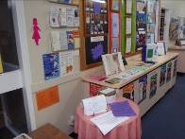
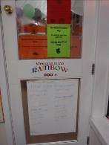
Figures 55 & 56: LDC Centre foyer – welcoming families
The outdoor area to the centre has three distinct areas. However, only two were actively used during the site visit. Both outdoor areas used had large fixed equipment, trees, small bushes, vegetable garden (for the older children), small areas set up (e.g. chairs and books; small table with puzzles; painting easels), and moveable equipment (e.g. trestles, boards) and a range of bikes, trikes, wheel barrows etc. Balls were also available.
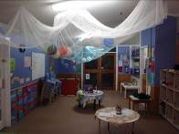
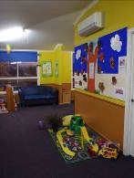
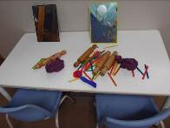
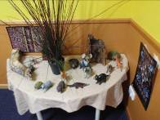
Figures 57 to 60: LDC indoor areas – welcoming children to play
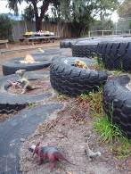
Figure 61: LDC outdoor areas – welcoming children to play
The indoor areas within the centres were the first to be set up, with the under 3’s room having being set up prior the families and children’s arrival at 7.30 am. Two kinds of approaches to the set up were observed. Areas were deliberately set up to invite play or an experience of one kind; and other areas where it was easy for children to self-select the materials they wished to use. Children could move equipment and materials from any area of the centre – including from indoors to outdoors. This approach to thinking behind the setting up of the centre was featured during the Director interview and also when interviewing the educators informally as they worked in the centre. Next to each main area of activity within the centre, were signs indicating the educational value of the experiences available to the children. These posters were attractive and written in accessible language suitable for families.
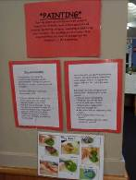
Figure 62: LDC Valuing learning
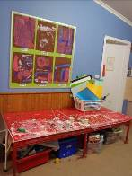
Figure 63: Children having choices – welcoming children to self-select
Centre staff have been working at service for many years, with some longstanding staff having been at the centre for more than ten years. The Centre Director has been an active validator for quality assurance over many years, undertaking four to five assessments per year.
Educator professional knowledge of EYLF and the elements (principles, practice and outcomes) underlying the document
Principles: It was evident that there was a high level of awareness of the principles associated with providing a secure context for the children, where interactions are respectful and reciprocal. The evaluator observations of the transition period in the morning confirmed this, and the interview with the Centre Director featured this principle.
Family partnerships were valued highly, and great effort had gone into setting up communication channels, and welcoming contexts, to enable interactions where educators could learn about the children from their families, where trust was established, where a sense of community was created, and where communications between families could easily occur. Communication books, scheduling of staff and family communication times in order to meet to discuss individual children, and daily interactions during the transition times (and communication book between staff, to take account of shift work) all contributed to the building of effective partnership between educators and families. An area that was not noted was parents’ involvement in shared decision making.
Although the families were homogeneous, there were a number of children with additional needs which the staff catered for in their planning and in their daily interactions, without drawing particular attention to the additional needs. Great sensitivity was shown to the children’s wellbeing, and to the other children’s acceptance of the diverse needs of children. An area that was not evident was the explicit planning for broadening the children’s understanding of the broader cultural communities neighbouring their community.
Opportunities for reflective practice were restricted due to the limited planning time of the staff. However, informal interviews with educators as they set up their environments, suggested that the staff were responsive to engaging in their own professional enquiry. Ongoing professional learning was evident through being encouraged to upgrade their qualifications, and through displaying posters on the value of the centre activities, as well as the innovative practices noted through the setting up of creative play spaces in the environment.
Practice: The practices were tied directly to the setting up of the environment. A great deal of effort had gone into organising resources in creative ways in order to stimulate learning through play. Intentional teaching was delivered through carefully organized learning environments, and a great strength of the Centre was the welcoming way in which the environment was created. They were inviting, suggestive, and very much in tune with what young children would naturally cluster around and be attracted to. The centre deliberately made use of the natural contours of the outdoor area in order to feature natural exploration and imaginative play. Assessment practices featured checklists and running records, with content foregrounding milestones in children’s development. A maturational view of child development was evident, with domains of learning featured in both thinking and practices of the educators in the Centre.
Learning outcomes: It was evident that the educators in the centre work towards the Learning Outcome of a strong sense of identity. In relation to Outcome 2, the centre practices demonstrate that the children have a sense of belonging to their group within the centre, are accepting of additional needs (but no evidence of cultural diversity could be gathered), appear to promote fairness and show social responsibility. Similarly, Outcome 3 and 4 were also evident. However, aspects of Outcome 5 were clearly evident, as the children communicated freely with each other both verbally and non-verbally. The interactions between educators and children, and an analysis of the documentation revealed less priority placed upon using a range of texts and media, or the use of symbols and pattern systems, or the use of information and communication technologies for investigating ideas and representing thinking – as is now expected within Outcome 5 of the EYLF. Whilst there was evidence for the possibilities of this through the carefully organized creative spaces, the range, complexity and depth of resourcing to support these kinds of outcomes were not evident in posters/models for children, children’s work, or planning documents.
A summary of evidence to support this evaluation is given below:
Staff believed they were already engaging in high quality practices, as evidenced by previous assessments of their Centre. It was thought that once the staff had learned more about the EYLF that they would come to the view that they were already exhibiting quality practices as determined by the EYLF.
Interactions
Positioning, ready to engage: The level of educator-child interaction was warm and friendly. A great deal of eye contact was evident, and the educator was always crouched at the child’s level, usually sitting on the floor. In the outdoor area, the educators were always within the activity of the children. They were not standing at a distance observing.
Shared sustained conversations: The interaction was always focused on the present context, in relation to the concrete objects being used by the child. Conversations were usually of one sentence in length, often acknowledging the object, and sometimes naming it if the child offered the language label first. Conversations were not sustained or elaborated.
Collective imaginary interactions: There were many resources provided to the children which had the opportunity for expansive imaginary play and interaction between children and the educators. Indeed the setting up of the environment was rich with possibilities. This was a real strength of the centre. Examples are shown in the photographs in this report.
Individual responsiveness
A high level of individual responsiveness was evident in the centre. Staff were able to tell the evaluator a great deal about all the children who were transitioning into the centre during the evaluator’s observations. Staff responded to specific needs of individuals, noting when to provide additional resources, when to distract or engage a particular child. The educators all appeared to be knowledgeable about each child, and acted according to individual characteristics of the children. Flexibility was shown in their interactions. For example, when one of the toddlers was due to have a nappy changed, and had to be retrieved from the outdoor area, the staff member allowed the child to take his scoop with him to the change table. This was done as a matter of everyday practice, without comment.
Transitions
Transitioning into the Centre for the first time: New families come and spend an hour with their child in the centre, to become oriented, then come back for settling in visits, perhaps 2-3 times, where they are involved in the centre for short periods only; later the child begins, and begins with a short day only – so that this helps the child to settle into the program. The view is if the parents are feeling settled, then the child will also feel more settled.
Transitions on arrival: On arrival the educator greeted the parent and the child, showing enthusiasm for their arrival. The child was either placed down onto the floor or transferred to the educator’s arms by the parent. There was always an exchange between the educator and the parent in relation to the child. For some children the educator and the parent would walk from the area near the door to the room, to the play area that had been set up for the children’s arrival. The educator always sat down or kneeled down to the child’s level until the child had settled. During the transition time, there was usually one educator seated on the floor with the children, whilst the others were setting up, or were standing to greet arrivals into the Centre. One educator was in the kitchen preparing breakfast for some of the early arrivers. All the children were curious about the evaluator, and all interacted with the evaluator after a period of close study. The children were confident in their surroundings and were not concerned about a stranger in their centre.
Planning and documenting
Documentation at the service is based upon the Domain Essential Learnings Curriculum. Areas emphasized are social and emotional development, communications, problem solving and cognitive development. The curriculum resources that the Centre Director draws upon include the Continua because it gives directions for planning and documenting. The resources provided to the Centre as named by the Centre Director include the Educators Guide (with Frameworks in Action) and the Belonging, Being and Becoming framework. During interviews the Centre Director mentioned many times that the EYLF did not provide much guidance, that more direction was needed, and importantly, that there was concern that if the Director created a new system of documentation to support the EYLF, that it might not be viewed as correct by assessors or validators who may have a different perspective on interpretation of the EYLF.
Presently the centre uses a form of checklists for assessment. The checklists are important for helping determine if children are reaching their milestones. The checklist has been developed so that it is easy for parents to understand. For instance, the checklist for the 3-5 age group is written to give the child’s voice on assessment: “I can do my ABC’s”. The centre does not use photographic documentation of any kind. The centre has a computer with internet connection supported by the Council.
Program planning focuses on children’s interests, and running with what the child wishes to talk about. Important also was preparation for Kindergarten. Here social development was seen as critical for setting into the school context. Things such as, sitting in small groups, waiting for your turn, were mentioned as important for transition into school.
Parent –educator meeting are held annual, usually in July. Staff have a one-to-one interview with families. Time is made available for them to ‘come off the floor to speak with families’. Educators do stress that they are available all of the time to talk to families, and if extended conversations are needed, then time will be made available for them to ‘come off the floor’ to meet with a specific family.
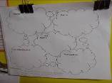
Figure 64: Documentation
Family involvement in planning
Families are involved in the centre through receiving newsletters, through planned events, such as “Biggest Morning Tea” or “World Environment Day”, “Grandparents Day”, and “BBQ for dads”. The view is that the Centre is part of the family’s extended family, hence it is important to create opportunities for two-way communication through planned events.
Educators get together and use a form of mind mapping in order to create programs for four to six weeks. When staff get together they discuss groups of children, they draw upon what they have found out from families, and through this process involve the parents’ perspective in the planning.
The Director indicated that they use a primary carer model for planning and observing: Each early childhood educator has a group of focus children that they plan for and observe. The educator invests time with the family, to make the whole family feel comfortable; to find what things the child likes to do; to encourage the family to spend time in the centre, and to show their centre to families; and the educator is charged with explaining the program to their group of families.
Different approaches to documenting or assessing children are used by different educators. According to the Director, there is not a specific formulae for documentation. It is what works best for the specific educator. Some educators have a notebook strapped to their belt, and others carry with them sticky labels. In each of the rooms is an interactive space with families too, such as “Notes on what children said today about X”. At drop off and pick up time, the educators interact with the families sharing information about the specific child (from educator to family and from family to educator).
Family communications also occur through placing in the foyer an easel with an important message so that families cannot help but notice.
Quality
According to all the educators in the service, quality centres on relationship and partnerships with families. Having motivated children who are happy and safe is seen as important. It is thought that a sense of enthusiasm by staff will in turn motivate the children. Having motivated staff and children was seen as a significant element of quality. Quality means that children are viewed as important. Quality is also shown through evidence that the centre is inclusive.
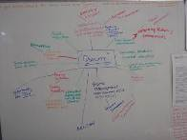
Figure 65: Educators’ mind map of quality
Professional development
The centre educators have been involved in one set of professional learning on the EYLF. A strong message given was that educators were not going to be told what to do and think but that they had to create their own response to the EYLF. The staff were unsure about ‘where to start’, and what might be the ‘sequence of development’ now to be constructed. Concern was expressed about how one could create a profile on a child using learning stories so that there was enough evidence of development. In the past this could be done through the Essential Learnings document. But the EYLF made it difficult to show the links.
All educators in the centre have Learning and Development plans. This is part of the Council’s approach to performance appraisal and career development. Staff are encouraged to list what kinds of things they wish to develop in and also to detail their career aspirations. The Centre Director indicated that this practice allowed her to give her staff opportunities for gaining experiences and developing competence is leadership. She believed it was important for the educators to learn through making mistakes. Giving people experiences was important for development. Retaining staff was important for stability of the service. The Director viewed opportunities for professional leadership as central for building expertise, ensuring there was always challenge for staff, and for progressing educators’ careers.
The overall profile of the staff in the centre in relation to their responses to the C-BAM was as follows.
Areas of interest noted
During interviews with the Director it was noted that:
- Concerns were expressed about the open-ended approach in the EYLF for supporting planning and assessment. This in turn gave little guidance of how to frame the assessment approach adopted so that enough evidence of learning outcomes could be generated. Of high importance was the possible misalignment between Centre practices on documentation and an assessors’ conceptualisation of valued practices and documentation.
- Concerns were expressed about the lack of rigour for the Learning Stories approach to documenting outcomes.

Domain Seven
Three sites were visited in Domain Seven. They were the LDC 7.1 in an industrial suburb of the capital city, the Family Day Centre 7.2 in a south-eastern suburb of the capital, and the Family Day Care 7.3 in a regional country town west of the capital. The service leaders responsible for the city and suburban services were rated as users of the EYLF at level 4 and 5. Since these were the only centres referred to us, selecting services deemed to be minimally engaged with the EYLF presented difficulties. The staff working directly with children and families at the city LDC were rated as aware of the EYLF at levels ranging 1-4 while in both FDC services carers were rated as aware at levels 0-2. In the regional family day care service the service leader was rated as a non-user of the EYLF and consequently there has been no formal exposure of the carers to the Framework. (see Appendix 1, C-BAM results).

Characteristics of the LDC 7.1
Centre | Stage 0 | Stage 1 | Stage 2 | Stage 3 | Stage 4 | Stage 5 | Stage 6
LDC 7.1 #1 | 55 | 51 | 63 | 47 | 9 | 59 | 22
LDC 7.1 #2 | 55 | 99 | 91 | 48 | 96 | 21 | 99
LDC 7.1 #3 | 87 | 96 | 89 | 52 | 30 | 88 | 84
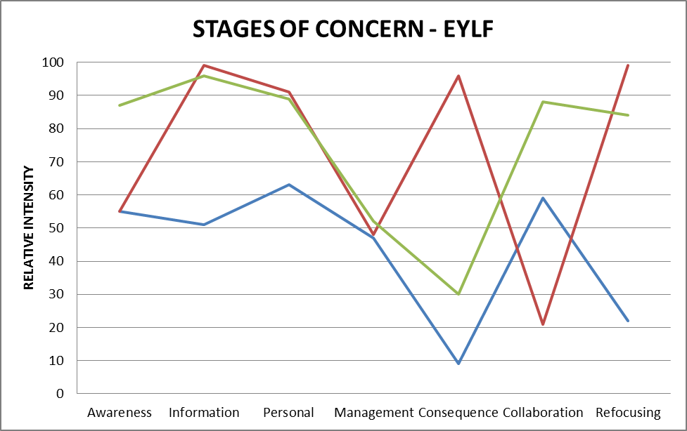
The LDC 7.1 site visited is in a heavily industrialised suburb on the outer west side of the capital city, located between a large factory, railway siding and opposite a shopping strip in a multicultural area. The site is located in a suburb rated by ABS SEIFA data (2006) in the most disadvantaged category. No other major city Long Day care centre was volunteered by the state government.
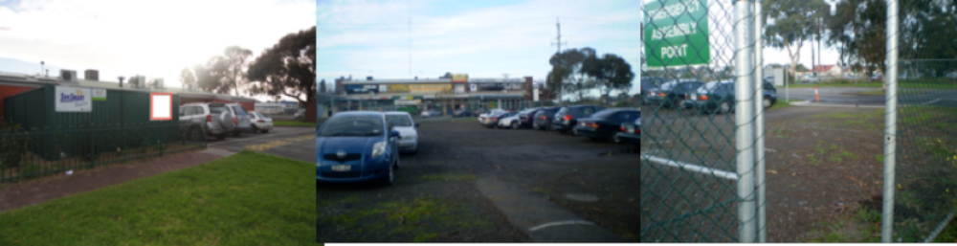
Figures 66 – 68: Outside the centre
On entering the centre the first impression is of a welcoming, bright and life affirming enclave enclosed by shadecloth walls from the rather grimy suburb outside.
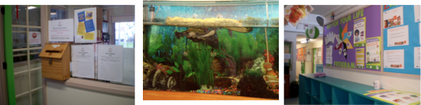
Figures 69-71: Indoor areas of the centre
The 23 year old LDC is run by a parent, community and staff committee. Organisations such as charitable foundations and professionals such as doctors and lawyers provide help. The Director administers the centre, implementing planning, management and finance. She is four year University qualified and a qualified Kindergarten teacher is employed. In each of the four rooms there is a Diploma qualified staff member and eleven staff are qualified to Cert III level. The cook has a food handling certificate. She, the Director and a Certificate III trained staff member circulate to cover staff on breaks.
The centre, licensed for 60 children, is managed by fourteen full time staff and five part timers. It is open from 6:30 am to 6 pm five days a week.

Room | Age group | Number of children | Staff-child ratio | Staff qualifications
Blue | Birth – 1 years | 8 | 1:4 | 1 x Diploma  1 x Cert III
Green | 1 – 2 years | 10 | 1:5 | 1 X Diploma  1 x Cert III
Purple | 2 – 3 years | 10 | 1:5 | 1 x Diploma  1 x Cert III
Yellow | 3 – 5 years | 32 | 1:8 | 1 x 3 year trained Kinder teacher  1 x Diploma  2 x Cert III
There are two intersecting handwashing and toileting areas between the four rooms and separate exit doors to the outside. The outside play areas are fenced off from each other. In some rooms posters display common translated words in English, Arabic, Turkish and Spanish.
A separate staff tea room has lockers and a table for eating and taking breaks. The office is equipped with a photocopier, an administration computer and a program planning room used by staff. A big shelf in this room holds books.

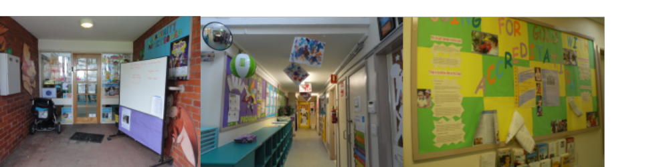
Figures 72-74: Foyer and information displays

The children who attend the LDC are of different backgrounds, for instance: Turkish, Arabic, Vietnamese, European, Chinese, Indian and Anglo-Australian. The staff learn some common greeting sentences in different language based on the children’s home languages. Communication between children and staff is friendly.
They have a team goal “to enrich the lives of the children we care for everyday to make a difference”. After entering the parents needed to sign in the notebook which is kept in the common space.
There are different activities occurring in four rooms according to the children’s ages.
Blue room
At the time we arrived at 8:15 am some babies came to the centre, went to their specific room and carers welcomed them warmly. They knew the babies well and easily interacted with them. There were six babies and three staff at 8.30am. Among the babies, one needed additional help as she could not move, walk or talk. This girl had an able-bodied twin sister.
There were five baby cots, two small tables, four small chairs, plastic toys, dolls, wooden puzzles. This room had store room, kitchen room and toileting and nappy change area. The roof was decorated with colourful nets and balloons. There was also extra bedding for children to sleep in at sleeping time. Children’s photos, information about them, rules and policies and information on Anaphylaxis were hung on the wall.
At 8.45 am staff guided the six children of this room to wash their hands as it was morning tea time. The centre provided bread and milk to all children. Three boys of nearly two years old sat on the chairs and ate together, the babies sat on their toddler chairs. One staff supervised the babies and the other, the boys. At 9.30 am one child came in this room who was crying a lot and the staff said as she came only one day in a week so it took time to settle. I observed that a couple of staff tried to settle her as she was crying too much.
At sleeping time one child was not sleeping so the staff member took him on her lap to sleep.
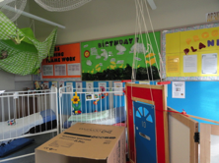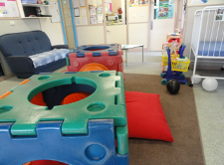
Figures 75 & 76: Indoor play areas in the blue room
Green room
The two older children from blue room came to the green room after their morning snack as it was the play room for them. This room had a sandpit, blocks, lots of toys, four small tables, nine chairs, and messy play area with shredded papers for children. Pictures on letters and numbers, paints and works of children were hung on the wall.
While two boys were playing with one staff, two other boys came in that room with their mother. Both of them were crying and mothers were trying to stop them, the staff also helped them. These boys only came on Monday to the centre.
Purple room (10 x 2-3 year olds and 2.5 staff)
The theme for today seemed to be all about human and non-human bodies.
The purple room home corner has lots of dolls, beds and blankets, shelves with medical play stuff like plastic stethoscopes, an accessible book shelf, cushions and a low couch. Puzzle table with two identical body parts puzzles, light box with animal and human x-rays, tray installation on floor with artificial grass and plastic lizards, snakes, spiders. A Large playdough table and one easel was set up for one at a time painting.
A net suspended from the ceiling with cut out painted fish, walls covered with children’s details, adults’ mission statements and two Indigenous posters.
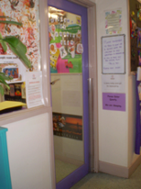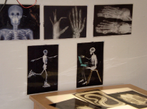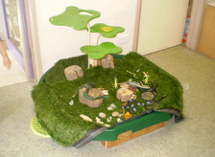
Figures 77-79: Purple room and activities
Using language to develop reasoning skills
All staff are interacting seamlessly with the children, at the playdough table when I arrived, the room leader moved somewhere else to spread the interaction when I started to interact with the children. Transitions are handled smoothly, while I was there (for about an hour) there were two staff changes, the children moved freely from playdough to painting to home corner to toileting to story time. I left just as they were going to eat. One little girl who was new was passed from person to person, always being cuddled and calmly spoken to. When I left another child arrived crying and she received lots of cuddles.
Yellow room
This was the biggest room of the centre, for four year old children. The number of staff was four. This room had a paint area, sand tray, kitchen corner, reading area and block area. The walls were decorated by the children’s paintings, handmade work, pictures on letters, colours and numbers. When I entered in this room I found that one staff was telling stories to the children and children sat in a group on the mat. I observed that one child was not in the group, he was playing alone. I also observed that the staff did not allow children to talk among themselves and she told one child to get out from the group. Other two staff was arranging beds for children to sleep. The kindergarten teacher was busy planning on that day and a Diploma qualified worker was in charge.
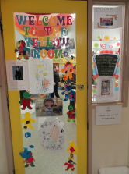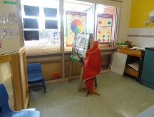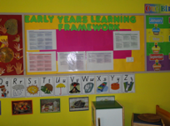
Figures 80 – 82: Yellow room interior and EYLF display
On the day of our visit the outdoor areas were not in use for much of the day because of the cold and rainy weather.
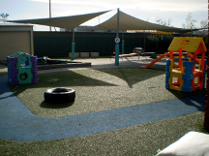
Figure 83: Outdoor play area
Each room has a large format journal on display for parents that documents children’s activities, mainly though learning story formats. Many chose to display children’s work by suspending it from the ceilings and rafters as the photograph from the yellow room (below) demonstrates. Many items on the walls at adult height, especially in public areas, were administrative, decorative or for adult information. Some of the children’s work displayed in the kindergarten room seemed to be products of groups of children making similar planned objects and artworks. The process of learning is systematically documented in individual portfolios.
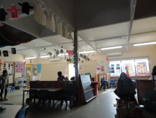
Figure 84: Children’s work suspended from ceiling
Educator professional knowledge of EYLF and the elements (principles, practice and outcomes) underlying the document
On the visit day we interviewed the Director, kindergarten teacher, a room leader and four other workers. All were confident in their grasp of EYLF principles. The most confident in her understanding of the principles was a Diploma qualified worker. The Director, the Kindergarten teacher and the room leader, while less assured, were quite confident. This hierarchy was almost reversed in staff confidence levels about theory. The less qualified workers demonstrated less awareness of theory while the Director and teacher felt confident. About half felt confident to use play to teach complex concepts. There was a spread from levels 1-4 in their confidence with intentional play. Overall there was high level of confidence in their ability to plan for and assist children to achieve the learning outcomes of the EYLF.
In their discussions of theory, the Director named Gardner’s theory of multiple intelligences as an influence, and identified some components of sociocultural theory and the aspect of post-developmental theory that has to do with children’s active construction of social identities. The kindergarten teacher ticked Bandura’s social learning theory, as did the room leader with cultural-historical theory as second. Two other workers attempted this task, both indicating a preference for cultural-historical theory as the main influence but one also marked post-developmental theories.
Interactions
In this centre there seemed to be a high level of morale amongst staff and a focus on positive engagement with children at all times. The main category of engagement was with children individually and in small groups working with the activities that had been prepared for them. Details such as providing two identical puzzles in the toddler room showed appreciation of the ways that small children may react to sharing or taking turns. The routines in a large centre that involve children and staff constantly making transitions in space and activity seemed to run harmoniously and professionally. In the younger age groups several children were upset mainly about separation from parents. Crying children were held calmly and passed from hand to hand when workers needed to take breaks.
Children are exposed to a wide variety of experiences and intentional teaching, are able to be themselves and feel part of a friendly atmosphere. In conversations with staff it became apparent that children’s family and community backgrounds are known. For example, a four year old child with indistinctly articulated language was described as learning three languages, being the youngest child in the family and having two older brothers who often take over. A hearing test has been recommended. In this room and the purple room, one-to one and small group conversations opened up many opportunities for sustained shared thinking.
Staff perceptions of quality
Five staff members completed a quality mind map.
The theme that came though most strongly was the emphasis on warm and supportive relationships between the staff and children. One staff member said ‘children love the staff and it’s like a family’. Specific to this centre is the range of cultural backgrounds and languages evident in the staff as well as in the children, which supports a commonly expressed value placed on celebrating cultural difference.
Common elements were play and enjoyment, trusting and supportive interactions with children, involving and supporting local families and interacting with the community, cultural responsiveness and expectations that engaging with and guiding children will assist them to learn.
Some staff members mentioned the high degree of collaboration and co-operation between staff in the centre. Evidence of this was the smooth running of the centre with no disruption to the continuity of children’s care throughout the day by a complex roster system enabling staff to take breaks. Another is that staff participate voluntarily in fundraising activities for the centre outside work hours.
Professional development
There is a culture of encouraging professional development in this centre and several staff are completing higher qualifications. The impression is of a solid grasp of previous accountability regimes upon which the EYLF is operating at present as an overlay on the centre’s preparation for a higher level of accreditation in 2011.
This centre is at the beginning of implementing the EYLF as is evidenced by the generic displays of departmental materials along the corridors and posters on some playroom walls. However, all staff have participated in one round of professional development specifically about the EYLF. They all spoke highly of the professional development opportunities such as visiting other centres and discussing the EYLF in staff meetings.
Being, Belonging, Becoming
Five staff members completed the Being, Belonging, Becoming response sheet.
Being
Although one staff member included her own role and responsibility as a role model, being was service pro characterised mainly from the perspective of children and families as ‘being yourself’ and confidently expressing your own identity, culture, needs and expectations in an atmosphere of acceptance.
Belonging
was ‘feeling a part of a family based environment’, feeling welcome, ownership, secure, safe, comfortable and relaxed as part of the community of the centre.
Becoming
For three workers the focus here was on their own roles, becoming a good educator and role model, extending their skills to help to guide children in every area of development, giving all children opportunities to explore and develop at their own pace and as part of a group. The other staff focused in on the becoming of the children, inquiring and having input into one’s own learning and experiences, becoming who you are, learning through play.
Concerns about the EYLF
The staff were proud of the high quality of existing service provision in this centre. There was an impression that preparation of both the staff and environment had taken place to ‘showcase’ an involvement with the EYLF, where established high quality planning and documentation of learning may already have been taking place prior to the Framework roll-out due to the forthcoming accreditation effort. It would be interesting to know whether this was a phenomenon in other jurisdictions.
The leadership team expressed no reservations about the framework but some of the responses by less qualified staff showed an emphasis on emotional, cultural and social values and some hesitation about theory-led and intentional teaching.

Characteristics of the Family Day Care 7.2
Centre | Stage 0 | Stage 1 | Stage 2 | Stage 3 | Stage 4 | Stage 5 | Stage 6
Centre 7.2 | 22 | 63 | 67 | 60 | 27 | 76 | 42
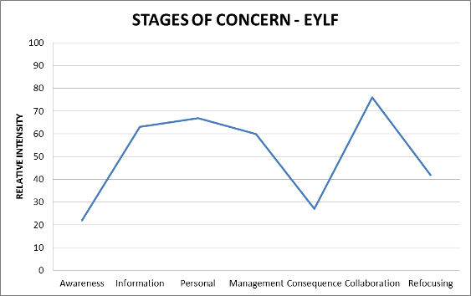
The Family Day Care 7.2 site visited is in the one of the suburbs on the south-eastern side of Domain Seven’s capital city. The particular FDC setting where the site visit was undertaken is located in a suburb of average SES status (ABS SEIFA data 2006). The FDC educator #1, who is of Anglo-Australian background and appears to be in her mid forties, has been a Family Day Carer for eleven years, and is trained to Certificate III level, a minimum level qualification in this service. #1’s FDC is licensed for 9 children part time. #1’s husband and her own two children (9 and 14) are an intrinsic part of the children’s care, as her husband’s shift work ends at lunch time and her children were in the house eating breakfast and getting ready for school when the first child arrives.
Most of the children in #1’s FDC attend 2-5 days a week. Some of the children arrive at 7.30 am and some leave at 5 pm. Overall, she has nine children who attend her FDC on a part time basis.
On the day we visited, four children attended, one baby of eleven months old, a four-year-old boy and two others, a boy and girl, both three. All the children who attend the FDC are of European heritage background. At the time we arrived at 7.30 am the baby was being dropped off while the carer’s two children were eating breakfast ready to be driven to school. They knew the baby well and easily interacted with her.
#1 has internet access at her home. Her main educative aim is to offer the children a wide range of experiences. The FDC service has a list of items that carers should have in their home, books, natural products, dress-ups, blocks. ‘I had 90% from my own children, but I do add when I see they’re interested in something I’ll go out and see if I can buy, or get something from the op shops or the markets’. The educators are supported by four child development officers part-time, a playgroup co-ordinator, a Family Day Care co-ordinator and Council workers who contribute a training calendar, financial and administrative support.
The FDC registered space in #1’s house includes the kitchen, bathroom/toilet, lounge area, and one bedroom. The kitchen is the quite large main play area, with an L-shaped bench separating the food preparation area from a large floor area on which are set out two separate workstations of floor toys for the baby. Half the kitchen table (out of baby’s reach) is prepared with drawing materials and a hammering activity for the older children. There is a child sized table and chairs, which on the day of visiting contained fresh playdough and paddle pop sticks. The change table facilities are on half of the kitchen table. #1 commented about this: ‘we had to get a bin that’s hands free, … it takes up so much room, I have to ask the kids to move, when they’re working at the table … I don’t think it’s an ideal situation’. An archway allows supervision into the lounge room.
The lounge area, together with conventional lounge furniture, contains a few construction kits, DVDs and a large screen TV.
On the day of our visit it was too cold in the morning for outdoor play and after lunch the children went on an outing to the library.
Educator professional knowledge of EYLF and the elements (principles, practice and outcomes) underlying the document
The principles of early childhood pedagogy as outlined in the EYLF were at the intuitive level. The educator’s emphasis was on deep knowledge of the rhythm of routines, physical and emotional care requirements of individual children. She provides for children’s learning by offering wide variety of experiences both in her family home and through outings into the community. Intentional teaching, learning through play, planning and observing holistically, being culturally competent, and assessing for learning were all at an intuitive level. #1 has thought explicitly about setting up learning environments. She said:
“When I first went back and did my Cert III (2008), I learned more about set-ups and we actually went into a child care centre and had a look around, and then we had to do placements…so then I tried to set up different areas where the kids could choose to go that would interest them, but because the ages are so different from (babies) to 5, it’s challenging to think about what to put out.”
#1’s self assessment of EYLF principles, practice and outcomes indicates that she is still operating from prior knowledge from her eleven years’ experience as a parent and family day carer and certificate III training about theory, assessment, principles of teaching, equity, diversity, parent involvement in planning, and how the pedagogy of play supports learning. She expressed a lack of confidence about the EYLF, saying ‘With the new framework and everything … we want it in simple terms … I’m not calling myself a brainy person, but I feel quite stupid when it comes to some of the words they’re using’.
During interviews, a consciousness of outcomes associated with children developing a strong sense of identity and wellbeing were generally articulated at an ‘awareness level’, but were enacted in practice at a higher level than were articulated. That is, outcomes 1 & 3 were undertaken at a more intuitive level. Limited evidence of Outcomes 2, 4 & 5 were evident in practice or noted during the interview.

Interactions
Whilst #1 was unable to talk about theories of child development, understandings about pedagogy, and practices in terms of assessment, reflection and evaluation, she did demonstrate, through her actions with the children in her care, a concern about the children’s routines, physical and health issues. There was evidence of intentional teaching about how to participate in social situations: ‘Tony [pseudonym] was quite little when he came, so he’s quite shy… he’s coming out of his shell … it took a very long time … I said to him ‘It’s OK to tell Jake [pseudonym] you don’t like what he’s doing, tell him no’.
During interviews #1 managed to feed the baby, eat her breakfast and direct her own children to get ready for school. While the researchers took some responsibility for interacting with the children, #1’s interactions demonstrated a high level of awareness of the children, adjusting her speaking to each child’s actions or what they were talking about. Through this, #1 naturally extended their conversations through genuine knowledge of their families and the common experiences they were sharing with her.
Individual responsiveness
#1 said of the children ‘they’re all different’ and her approach to interacting with each child was based on their uniqueness. Her interactions with the children during the site visit showed this sensitivity, which is shared by her own children. For example, after the baby was fed, #1’s daughter, responding to the baby’s body language wanting to get down, placed the baby on the floor and the baby moved immediately from sitting to a crawl position. #1 remarked ‘That’s the first time she’s done that’. Illustrating the baby’s interest in music, she showed the evaluator an electronic musical toy: ‘this is one of the toys she had when she first came into care’.
Transitions
#1 has the paperwork on the kitchen bench, so transitions of children arriving take place in the kitchen. As parents come right into the central play area in the kitchen through the lounge area, they place the children’s belongings on a bay window seat and complete their paperwork and changeover discussion while the children settle into some of the activities prepared for them.
To prepare for their excursion to the library, #1 loads each child into one of the five child safety seats in her car. She warns the older children a few minutes beforehand. With verbal checks, she encourages them to take some responsibility for assembling and carrying their own belongings.
Planning and documenting
#1 photographed some of the children with their work on the day of our visit.
Planning is through listening to the children and seeing what they like doing and are interested in. At this stage #1 has not learned about how to keep records in ways that are in line with the EYLF.
As part of #1’s planning she takes the children to storytime at the library. She said ‘we go to the library, we go to different community things in the holidays, we go to the farms, and then we go to the playgroup, so it’s different interactions with other children they might not necessarily have, or parents mightn’t have time for’.

Family involvement in planning
#1 talks to the families about what the children are doing at home and what they are doing in her FDC.
Quality
Quality early childhood education according to #1 featured the children’s health and safety, that they are exposed to a wide variety of experiences, are able to be themselves and feel part of a family atmosphere.
Professional development
#1 explained that as a part of quality assurance she was required to attend professional development sessions every three months. The house is inspected annually to evaluate its continuing suitability as a place for children, its safety and security.
#1’s understanding of ‘belonging’, ‘being’ and ‘becoming’ are shown below in her response to the BBB survey
Being
Feeling comfortable within themselves and their environment; confident to build relationships with others.
Belonging
Feeling part of a family or groups in the community and the educator’s home environment.
Becoming
There’s a social side of it with outings to the library, into the community, taking holidays and going to the farm so the children feel part of the community. Individual child ‘was quite shy, now coming out of his shell’; noted that as some of the children are cousins, there is ‘maybe a bit of a family dynamic’ in the FDC scheme.
Areas of interest noted
During interviews with the FDC educator it was noted that
While conscientious in photographing children’s work and maintaining portfolios of their activities, the educator was confident in her daily practices and more concerned about complying with health and safety requirements than about her educational practice as it related to a particular curriculum model or theoretical perspective. The FDC co-ordinator was enthusiastic and knowledgeable about the EYLF and was concerned to integrate professional development about this into the training programs available to educators.

Characteristics of the Family Day Care 7.3
Centre | Stage 0 | Stage 1 | Stage 2 | Stage 3 | Stage 4 | Stage 5 | Stage 6
Centre 7.3 | 31 | 51 | 99 | 30 | 30 | 84 | 34
The Family Day Care 7.3 site visited is in a regional country town west of the capital city. The particular FDC setting where the site visit was undertaken is located in a suburb of disadvantaged SES status (197 out of 204 in the SEIFA Index of Disadvantage) (ABS SEIFA data 2006). The FDC educator #1, who is of Anglo-Australian background and appears to be in her mid-forties, has been a Family Day Carer for sixteen years, and holds a Certificate III and a Diploma in Early Childhood Children’s Services. Eloisa’s FDC is licensed for five children. The carer looks after four children during the daytime. She also looks after two boys (9 and 11 years old) before school time and one child after school care. Sometimes two children stay in her care until 10 pm, and on Wednesday four children stay with her until that time. #1’s husband has passed away and her two boys live in another regional town, so she lives alone in her house.
Most of the children in #1’s FDC attend five days a week and she also provides her service on weekends.
On the day we visited, five children attended, two boys before school time, two boys, four-years old and one boy of eighteen-months old. All the children who attend the FDC are of European heritage background. At the time we arrived at 7.30 am, two boys were there and at 8.30 am #1 guided them to walk five minutes from her house to catch the school bus. She collected another boy from his mother at that bus stop.
The FDC service is administered from a local government sponsored long day care centre. The seven carers are supported by one children’s support worker and attend a weekly playgroup in a corrugated iron hall that is permanently set up partially as a children’s play centre and partially as an indoor basketball court.
The FDC registered space in #1’s house includes the kitchen, bathroom/toilet, lounge area and one bedroom. The lounge is the quite large main play area. The entrance of that house is dark but the lounge is bright with the sunshine which comes through the window. There are lots of toys (dolls with trolleys, cars, toy vacuums, empty boxes and blocks), three shelves with children’s books and toys, flip charts/posters on numbers, letters, animals, birds in that room. There are one child size table and three chairs for children which they use for playing and also for eating. In one corner there are some dresses for children to play. A growth chart of children; evacuation plan and learning outcomes of June are hung on the wall. There are no computers, electronic items, music equipment and no work of children are hung on the wall.
The lounge area also has a long sofa, DVDs and a large screen TV. The dining area is adjacent to the lounge where #1 has a shelf of six cupboards and she keeps all of her service documents, children’s portfolios and different information folders there.
Children have to go to the backyard through the kitchen and laundry room. In the laundry room #1 also has kept some toys, natural things, like, leaves, buckles of trees to teach them about environment. The large backyard has swings, plastic slides, a big toy house, screw which was made by children, sandpit and pavers. There were no ramps, bridge, mud patch, digging patch, decks. #1 has one cat and one small dog. The dog was locked in a dog run while we were there.
Every Tuesday #1 and children go to the nearest library and every Friday they go to the Play Group House which is run by Generic PLAYGROUP. They run the play sessions for the children every day of the week and the carers and parents pay fees for each session which runs for three to four hours.
As the visiting day was Friday we got chance to go the playgroup session. #1 went there with one child by driving her car at 9 am and after going there she collected two children whose parents came there to drop them to the carer. It was a big room with lot of toys and activity materials. In attendance were six more carers and one administrative officer of the service who came with children.
The Playgroup is in a large corrugated iron hall. There is a big basketball court area divided by netting for skittles and running. There were 19 children and 7 adults at 9.30am on the visiting day. Children liked that place very much as they found lots of toys, slides, houses, wheel toys, and wooden animals to play and books to read.
The researcher talked with one of the carers who has worked in the area for fourteen years, who had inherited the job from her daughter. All of the other carers have either a Certificate III or enrolled in one but she has not. The FDC employee who set up the morning tea that day had a three year old daughter and after that session she went back to her service at the centre.
After playing the carers guided the children to wash their hands and served snacks and drinks. At the end of this session, two carers brought the children together for storytime. #1 and the children in her care left playgroup at 12 pm.
Educator professional knowledge of EYLF and the elements (principles, practice and outcomes) underlying the document
The principles of early childhood pedagogy as outlined in the EYLF were at the intuitive level. The educator’s emphasis was on her own beliefs about child-rearing as a mother, the physical and emotional care requirements of individual children overlaid with what she learned in her Certificate III course at TAFE. She provides for children’s learning by offering a wide variety of experiences both in her family home and limited outings into the community. Intentional teaching, learning through play, planning and observing holistically, and assessing for learning were all at an intuitive level. There is no conscious awareness of issues of culturally competence.
#1’s self assessment of EYLF principles, practice and outcomes indicates that she is still operating from prior knowledge from her sixteen years’ experience as a parent and family day carer and Certificate III and Diploma training about theory, assessment, principles of teaching, equity, diversity, parent involvement in planning, and how the pedagogy of play supports learning. She expressed confidence about her beliefs and practices in her self assessment.
During interviews, a consciousness of outcomes associated with children developing a strong sense of identity and wellbeing were generally articulated at an ‘awareness level’, but were enacted in practice at a higher level than were articulated. That is, Outcomes 1 & 2 were undertaken at a more intuitive level. #1 was not sure that her education could make children able to transfer their knowledge to other contexts during the interview time and she showed her average conscious level to Outcome 4 and high satisfactory level to outcome 5 however, in practice it was noted in lower level.
Interactions
#1 knew a few words about theories of child development, understandings about pedagogy, and practices in terms of assessment, reflection and evaluation and she was concerned about the children’s routines, physical and health issues. There was evidence of intentional teaching about beings in the nature: ‘Ana [pseudonym], can you see the spider in this tree? Here she is...., good morning spider.....good morning little cat’.
During interviews #1 managed to serve food to two boys and one researcher feed another boy. #2’s interactions demonstrated a high level of awareness of the children, adjusting her speaking to each child’s actions or what they were talking about.
It was observed that two boys played together and made conversation between them, however the toddler was playing alone and did not talk like other two boys. Although #1 gave importance to the questions and conversation of the children and respond to them, she said that she did not involve herself when children were playing or facing conflicts because she first wanted to give them chance to solve them by themselves and also believed that children should invite her into their play or activities.
Staff-parent relationship
As #1 received all children outside of her house no parent signed in on any sheet and she said that they would sign out when they picked up their children after the care. She said that as parents were busy she could not arrange any parents’ meeting; they just came, left children and signed in, some parents also asked her help to do their children’s’ school tasks. Parents did not borrow any book or materials for their children. The office sent the newsletters and information sheets direct to the parent.
Planning and documenting
Planning is through listening to the children and seeing what they like doing and are interested in. As part of #1’s planning she takes the children to story time at the library and to the playhouse. She said ‘we go to the library, we go to different community things in the holidays, we go to the farms, and then we go to the playgroup, so children get opportunity to make interactions with other children’.
Quality: According to #1, Quality Early Childhood Education is to prepare children for kinder, to make them independent, to provide opportunities for play and learning and also to create a warm friendly environment from where children can learn to respect values, show compassion. She thinks that as a teacher she needs to understand children’s individual needs and also parents’ expectations from her. She also gives importance to children’s view of her and open relationships with children and parents for quality.
Supervision and evaluation
Staff from the service office visited the centre once in month and gave feedback on the carer program and skill. #1 also maintained a diary where she wrote comments on her self-evaluation.
BBB survey
To #1 Being, Belonging and Becoming are same which is a journey to become a childcare worker. She said that becoming means to her that she is a child educator now and she has qualifications which helped her to become better.

Centre | Family Day Care 7.2 | Family Day Care 7.3 | Long Day Care 7.1
Context | Suburban home in mid range SES area | Home on main entrance road in lowest range SES quiet country town | Located between large factory, railway siding and opposite shopping strip in multicultural lowest range SES suburban area
Space & furnishings  (Qualitative comments) | A blend of home atmosphere and pedagogically suitable set-up, few but high quality activities for children and retaining a family home atmosphere aided by the presence of the carer’s own children and husband. | A home converted to a pedagogically suitable set-up, many high quality activities and dedicated space for children in a home-like atmosphere. | Purpose-built and well equipped centre with four rooms for children namely blue, green, purple, and yellow. There is a big playground in backyard.  The centre is multicultural, multiracial and multi-dimensional as well and pedagogically suitable set-up, few but high quality playing activities for children and retaining a friendly atmosphere.
Interactions  (Qualitative comments) | Friendly and conversational, mainly about children’s activities or routines, | Friendly, most of the time the staff chat with children about their activities, food and cleanliness, respond to their questions | Staff are very encouraging to children and they appreciate whatever the children make and asked them to explain their creations. Very good positive interactions.
Program structure  (Qualitative comments) | Informal but with outings and influenced by notion of ‘a wide range’. | Informal but with outings and influenced by notion of ‘a wide range’. | Formal settings and staff follow their routine strictly to regulate the centre.
Relations between parents and staff | Parents very busy, most conversations about scheduling or children’s physical or emotional needs. | Parents are very busy so they just talk about their timings, any needs or problems with regard to children’s food, physical or mental adjustments. | Though parents are busy, some parents are involved in the centre and the centre maintains regular parent meetings for improving the quality of the centre. Every parent checks their children’s routine such as feeding, physical health and emotional state.

Domain Eight
Three sites were visited in Domain Eight. In each site the C-BAM results indicated principle educators responsible for the services were non-users or just introducing the EYLF.

Centre 8.1 characteristics
Centre | Stage 0 | Stage 1 | Stage 2 | Stage 3 | Stage 4 | Stage 5 | Stage 6
Centre 8.1 #1 | 14 | 23 | 45 | 15 | 2 | 55 | 22
Centre 8.1 #2 | 2 | 12 | 21 | 18 | 4 | 5 | 5
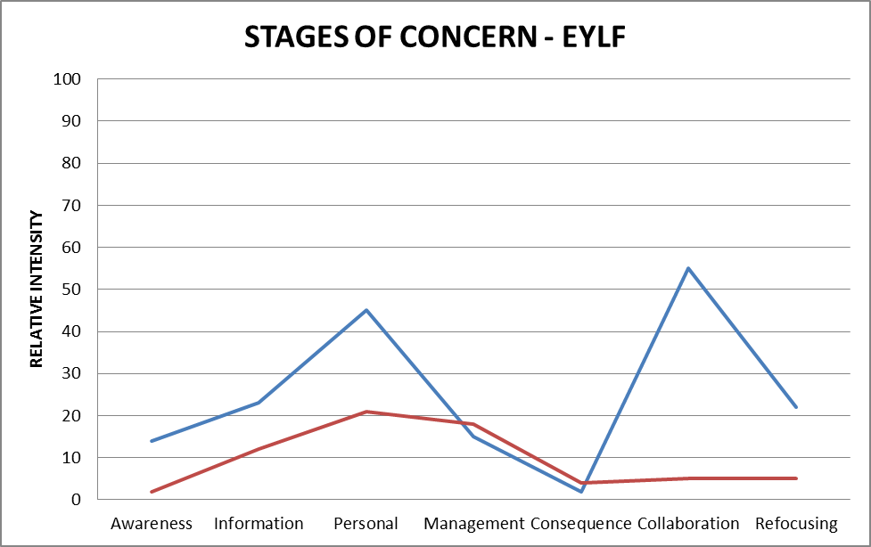
Located very close to the capital city this is a community based Long Day Care, non-profit service, with land granted by State Government for a purpose built child care centre building funded by the Federal Government in 1986. It opens at 7.30 am and closes at 5.45 pm. It is licensed for fifty seven children and has ninety CALD families using the service at different times and days.
There are three rooms –with high staff ratios. Twenty one staff are employed: including six qualified staff and six assistants, two Full Time “floater” staff (one qualified and one assistant) and two Part Time floaters, a food coordinator, administrator, bookkeeper, Deputy Director and Director.
Babies Room: 3 months to 2 years. (Twelve children - Three staff + floaters)
Toddler Room: 2- 3 years (Nineteen children- Four staff)
Preschool room: 4 – 6 years (Twenty five children - Three staff +floaters)
All families using the service are united by joining an incorporated body for a small association fee of $5.50.
Appointed Director XY meets regularly with association committee members and families are directly encouraged to support the service through ongoing social life and building maintenance programs.
Centre 8.1 is a 25 years established service with next generations of families attending. During the observation and discussion period with staff, the local community was variously referred to as “ritzy” “up-market” “friendly” “lovely families here” and “like an English Village, where you walk everywhere and everyone knows you”. The service is conveniently located near a main street, with large hospital, theatre, primary school, a public park and gallery, shops, community garden and community support centre all a walk away. The Director told the evaluator that median house prices are $1 million and weekly rentals average $700. This is a community according to the Director, where families have high incomes, high mortgages and are cashed up “for holidays in Bali”.
The centre has an EYLF coordinator, #1. This appointment has only just occurred. #1’s observations over twenty two years at this service are that “the higher the level of education of the mother the higher the stress levels shown.” Coordinator #1 noted family life now has different pressures that cause impact on children’s wellbeing. “With executive level families, the father, for example, may be away in China for a month and then when he’s home again it’s full on playtime.” The mothers have pressures too. “They are often highflyers who feel parental “guilt about work, daycare, getting the child out of bed early and being exhausted at home.”
The centre is embedded in its community and Director XY noted that 75% of the children from the centre go on to enrol in the local primary school located next door.
Long Day Care quality of physical and communicative environment.
At 8 am on the day of the visit the evaluator was greeted by staff ‘floater’ #2, offered coffee by educator #3, and shown the staff room area by educator #4. #2 said “please enjoy your day” and #4 made herself at home and had her breakfast in the staff room. Families and children who entered early were also warmly greeted by #2 or #3, in a familiar business-like way. “Hi, James [pseudonym], wet day eh?” The families know the routine to sign in the foyer, and move quickly to their child’s particular age group room (there are three rooms). In the foyer mothers stopped to look at a menu board showing food plans for each day of the week. On the day of evaluator’s visit it was “English food” (Roast Beef and vegetables with mashed potato). The menu the day before had been special food to celebrate the Philippines’ National day. A foyer notice for month of June included communicating a welcome to the evaluator and giving the date and purpose of the visit. Director XY reported that the food provision program was part of the centre’s implicit attention to understanding cultural diversity.
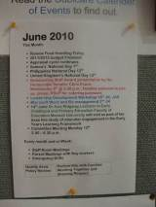
Figure 85: Foyer, welcome in news
The foyer features a full panel of staff photos with names and positions. Staff from a variety of cultural backgrounds have been deliberately selected through the Director’s inclusion policy. Bi-lingualism is the norm. For example, Thai educator #5 was singing the action song “The Wheels of the Bus” in English with the 3 year olds and then switched to Thai to sing about passing out the bus tickets. Staff language and cultural ties included Thai, Japanese, Italian, Indonesian, Greek, Aboriginal-Australian, Welsh, Irish, South African, English and Anglo-Australian. In addition, the centre employs two full time staff with disabilities. The Director XY noted there are 30 different cultural groups represented in families using the centre and inclusive practice really means “reaching out to all families.” Director XY said this was plain common sense in business practice and the centre was a business.
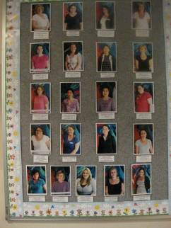
Figure 86: Foyer, display of staff
A key-worker system is used for close communication purposes and links chosen educators to a given group of children and their families. There were key-workers appointed for each of the three rooms. The key-workers gather information on families, cultural practices and special interests in family life. The key-worker was a first point of contact for any daily concerns and kept records on each child and reported details to Director XY as needed.
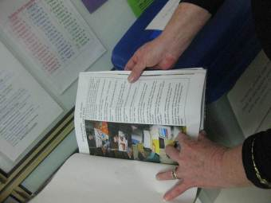
Figure 87: Keyworker records
In each room, there were whiteboard lists that parents filled in as they dropped off their child. The whiteboards recorded for the staff in that room, who was to collect the child later in the day and at what time. The educator in the room noted this information and chatted to each parent as they filled the board in. A systematic emphasis on responsible care, emotional and nutritional care and communication with families was highly evident in these conversations and processes.
Educator #2, who has been with the service for twenty one years, is according to Director XY “the oil that lubricates the cogs” of their system. #2’s work links all staff together; she sorts all resources, knows generations of families and maintains systems for shared resources including storeroom management and library books. In addition she meets and greets children and families in the mornings and evenings and fills in where staff leave is taken or illness causes absence. #2 carefully orders the environment so it is a fully accessible well-maintained resource for all staff.
Director XY invited the evaluator on what she called “the parent tour”. She said she had devoted her day to this baseline data-gathering visit. Taking every opportunity through her leadership and management training, XY had also used the evaluator’s visit to bring awareness to four staff, by inviting them to fill out all the forms and involve them in interviews.
The evaluator’s “parent tour” began in the foyer where a panel photos named staff. (Figure 1) The Director’s notion of quality focused heavily on her very high staff retention rates. She had two “long stayers” twenty one years (#2) and twenty two years (#1), both TAFE trained and with special understanding of disabilities. Director XY explained that “only five staff in six years have moved on: one to nursing, one to further study, another couple moved interstate and one was “performance managed out.” The Director had a sense of humour noting this particular departure through performance management, as a case of not keeping to the high standards she expected of staff. She commented: “it’s my way or the highway”. Retention of staff permits continuity for children and families and this represents good business practice for the Director.
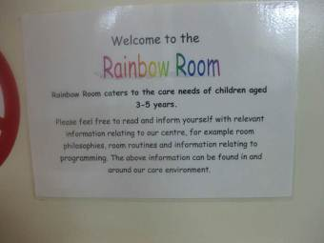
Figure 88: ‘Care needs’ indoor environment
Director XY said retention and quality are also about how you recruit staff, and lamented that many Directors are not trained to recruit, interview or even check references, which for her were important aspects to getting the right mix of staff, which in turn in her opinion had the greatest effect on quality for children, families and staff. All trained staff held certificate and/or diploma qualifications in child services from TAFE. For Director XY, quality began and ended with staff and this was because “the service is first and foremost a business.”
Director XY’s qualifications included mother-craft nurse training and a diploma of management and early years. She had ten years experience in UK with the NHS (National Health Service) during the period of introduction of ‘Sure Start’. With twenty eight years of broad experiences the Director balanced quality and business through taking a lead in performance management of her staff. She includes performance management strategies with a new reflective practice form introduced. The practice principles she said were all important to her and the development of the reflection sheet was a response to the new EYLF. It’s looking at the “why and what” of what we do she commented and is “positioning the staff to ‘see’ further into their practices”. Director XY noted telling “her staff” that the “Reflective Practice Prompt Sheet” is for everything, and they were to be applying reflection everywhere, every day. In this way, the Director’s high expectations were expressed.
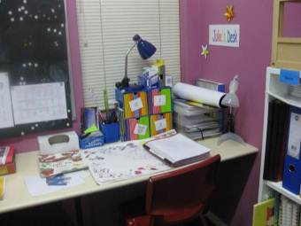
Figure 89: Educator’s space
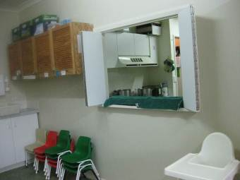
Figure 90: Hutch to kitchen
In terms of overall environment, the centre was clean, maintained, purpose built, well organised, safe and designed with half doors so that visual and verbal communications were easily made. Nearby, an administration section was set up in a stylish benched area, with shelves of files neatly arranged and with no clutter. Storerooms were immaculate, with books, toys and resources centrally arranged and maintained by staff member #2. Space for staff, included a couch and full kitchen, and each room had a laptop for staff members. The Director roamed and was active and friendly with children, staff and families. She seemed ever present. Her office was located right at the entry and her door always open.
This visit included one long audio-taped interview with Director XY and in addition four staff members were interviewed using their filled in documents and notes were taken.
The five interview summaries follow:
Interview 1 LDC
LDC Director XY: Twenty eight years experience qualified as Mother-craft nurse with Diploma of Management and Early Years.
Mind mapped quality as:
Recruitment of staff
Leadership skills
High Expectations
Nurturing
Proactive stance
Sustainability of the sector (business and work/life balance)
Professional development
Partnerships with family community and children
This is all underpinned by the EYLF
SAT: Theoretical: Director XY said she draws on Piaget (mispronounced name)
Director defined BBB:
Being: Affording the child the ability to “be”
Belonging: Affording the child the ability to belong
Becoming: Affording the child to become whatever they want.
Director XY uses management theory, and mixes different personalities in each of the three rooms. She said she thinks about how her staff can combine for quality e.g. “A leader (needs to be unflappable), then you need someone with marshmallow quality and someone in between”. In the babies room she has a leader, a leader in training (role modelling on the leader) and an inexperienced staff person who like all staff is offered on-going professional development.
High standards of professionalism are part of quality for Director XY. She nominates staff for awards (and they have won), applies for business awards (alongside the mining companies) and thinks there is a big problem about regulations regarding 4 year trained teachers being required by 2014. She claims this legislated for quality process is disrespectful and disadvantageous towards experienced child-care educators. It’s “A huge slap in the face” that will “not be met by bridging courses that take two years” and are unaffordable by many in childcare services in terms of time and cost. No educator in the service was degree qualified and teachers were not employed in this childcare business because “some don’t even know how to change a nappy.”
In addition to the Director, of the four staff interviewed, none were familiar with contemporary child development theories, however #1 (22 years experience) had taken a small course training in Indigenous culture and was highly insightful.
Interview 2 LDC
#1: Twenty two years experience, Associate Diploma in Children Studies
Quality- #1 mind-mapped -
Children and families
Nurturing respectful environments
Inclusion and culture
Programs which foster individuals and groups.
SAT – Theoretical (Piaget) but talked of relationships, culture, inclusion and community all through interview
BBB- #1 defined:
Being: relates to ‘the child’ as the individual, it’s about who they are now in the present, their interests, wants and needs now, their relationships with other and facing today’s challenges
Belonging: relates to ‘the child’ as an individual being connected to family, culture and community, it is about the child defining their identity now and in the future.
Becoming: relates to ‘the child’ as they learn and grow now and ongoing into the future. It is about learning and growing through connection to skills and interpersonal relationships.
Experienced staff member #1 has very recently been made the “EYLF coordinator/leader” She said the EYLF “has a comforting focus and will be a learning journey for us” and “it stops you in your tracks because you can make the effort to stop and think, not just about the group.” She considers that without this new framework Child Care would have been forever considered “baby-sitting”. Observing #1 with the 2-3 year old group of children as they had their lunch, she constantly conversed with the whole group and also individuals (19 present) and named all the food they were eating (English national day) and discussions grew about how food grew and how rice might be served, and the colours of food. She took cues from the spontaneous responses of children and extended the children’s ideas. She later reflected on her work: “It’s not about questioning the processes it’s about the team doing the right thing and what works for us”. The EYLF will be “one step at a time” and we’ll “have a go practically with programs”. On reflection she thought, “even though we’re not studying, we’re still studying”, and with this pragmatism, she concluded: “Now it can be overwhelming but we’ll just take a deep breath”. #1 wanted to lead by practical example, listen to children have the “headings” in mind, and “think about how to grasp the actuality of these as ongoing assessment”.
#1 thought the BBB was a way to assess the child. She noted that, “sometimes we think there are only positives but children are coping with the negatives of life and being resilient” which she considered important.
Interview 3 LDC
#3: 5 and a half years experience, Certificate III, currently studying Diploma.
Quality- #3 mind-mapped
High accredited childcare centre
Well planned and thought out programs
Positive interactions with all children
Positive relationships/communication with co-workers, children, families and the community.
SAT #3 selected Social learning (Bandura)
BBB #3 defined BBB as:
Being the best person you are and can become
Belonging -- that you feel a part of the service
Becoming—the best in what you do by achieving your goals
#3 was new to the staff this year and had a country town family history in Child Care with her mother being in child-care too (a model for her). She noted how friendly and welcoming the service’s staff were. She works with the older 4-5 year old children. “Children give us ideas of how we move on from an experience and these are passed on into the program”. “They ask questions and I work with those”. Children in the group rotate so “they are continually telling others what work has been done.” Her view of the Child Care industry was “it comes back to children and family and being in a job that you are happy in.” “If staff are not happy then it’s no good”. “What you see here is what you get”. It’s a happy place and “we are all valued”.
Director XY valued #3 highly for her interest in childcare as a profession and her intuitive understanding of learning and her practical skills with families and children. She wanted to encourage #3’s professional development through giving her time for her further study. #3 interacted positively and at length with the children in her care. She was the only staff member who created an ongoing pedagogy where ideas were noted to be extended intentionally - such as the children’s use of the park next door for a leaf walk, the indoor collective tree construction, where she noted the children’s questions about why leaves dried out and dropped, named colours, grouped those, provided letter A for autumn and apple on the tree and found ways to stick leaves to wall, and explore construction of leaf. #3’s program included learning objectives and a range of expressive arts opportunities.
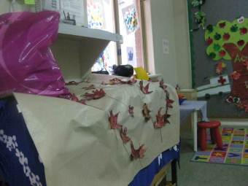
Figure 91: Indoor playroom
Interview 4 LDC
#5: works with the 2-3 year olds, has four years experience, with Certificate III in Children’s Services.
Quality- #5 mind-mapped
Good communication skills
Involving yourself in children’s play
Staff are given the support they need e.g. courses/training
Building positive relationships/interactions with staff, children and parents.
SAT- Social learning (Bandura)
BBB #5’s ideas:
Being is to find out who you are and to find out about the world we live in.
Belonging: to belong to a family, culture, community, it helps to build relationships with a range of people.
Becoming is using our skills and knowledge in the world we live in.
#5 identified social learning as her theoretical framework. She thinks her work with children is about having expectations of them, “not pushing” them but finding out what to build on. Play is about “just joining in, finding out what the child’s doing and for you to extend that.” #5 thought the centre was unique because “it’s very friendly, children and staff get along well, there’s a good range of staff to talk with and listen to”. “It’s also a bit up-market, and swish to work in the city”. The evaluator observed children in this group playing outdoors on bikes around oval tracks, and using blocks. The outdoors for toddlers included synthetic grass and concrete paths with plastic play equipment. This was surrounded by a solid fence and, beyond, a park with large overhanging trees.
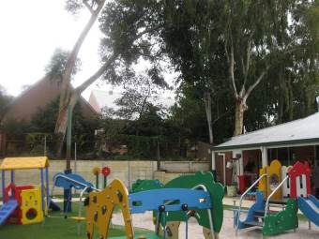
Figure 92: Outdoor toddlers area
Toddlers had low basins for independent hand washing, mirror at their height where they were supported to put on their sunscreen and hats so they could see what they were doing. Play with outdoor blocks was being watched and encouraged and plenty of exchanges with staff and each other were happening. Hat tubs with photos and their names provided them with cues for building confidence in being able to do things for themselves such as finding where their hat is, recognizing their photo and later in their name. #5 was most attentive to the care and safety of the toddling children in her care. They were picked up and attended to if upset and spoken kindly to.
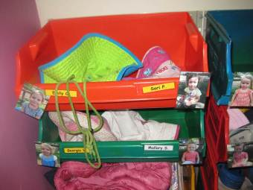
Figure 93: Toddler independence
Interview 5 LDC
#6 works with babies, has 10 years experience, holds room leader position, and has a Diploma of Community Services-Children’s services.
Quality-mind-mapped
Professionalism
Communication and teamwork
Continuous learning and development
Interactions with the children and helping them learn-helping to educate the child to prepare them for the future.
SAT (Piaget-milestones)
BBB-#6
Being the child they are at the moment, exploring their world and learning to prepare themselves for the future.
Belonging to the centre, community and groups the children are involved in.
Becoming the person the child will be in the future. Taking what they have learnt in the past and using it to become the person they will be.
For #6, as a team leader she noted the importance of “staying in touch”: “I need to make sure we’re all on the same page and that this transfers to the children”. “Centre 8.1 is where you get a feeling of belonging. There’s the park next door where all the local events happen and we’re next to the primary school and library.” #6 was concerned for a baby in her care during the interview, as the baby had not settled to sleep and no other staff member substitute related the same way #6 did with the baby, so the interview ended.
Summary
Educator professional knowledge of EYLF and the elements (principles, practice and outcomes) underlying the document
Practice principles: Generally, collaborative, effective and reflective framed by business and management focus with children’s care and welfare at heart.
Learning and development outcomes 1-5 were less visible as discussed below, in this Long Day Care centre.
Interactions: Three of the five interviewees specifically mentioned interactions as a feature of a quality service. All staff interacted caringly with children. Director XY and EYLF leader #1 in particular used their long experience to encourage, relate and acknowledge children and families.
The playfulness of Director XY was a feature. Fun loving, she set an example to all her staff of how to build and maintain a reputation for friendly communicative business-like care. What was generally missing in this centre was an awareness of a pedagogical approach to interactions with children, however educator #3 was an exception in the way she intentionally extended children’s thinking in the 4-5yr old room.
The physical environment of this centre relates well to the community in a central well-established location next to the local primary school. This has big advantages for interactions between the families, children and staff with school staff next door. Transitions to school are word of mouth discussions with visits with folders of children’s drawings, paintings and so on, and milestone notes passed on to families and shared with school if needed. Archived centre records were noted and are referred to over time.
Individual responsiveness
The over-arching view is that this centre responds quickly and thoughtfully to children and takes their well-oiled routines seriously and professionally. The children received care and attention, were happy, well fed, clean, encouraged in their independence, respected and cared for each other, and much of this was governed and encouraged by efficient systems put in place by the Director for both staff and families. The fact that there were sufficient staff to cover the variety of daily routines, changes and play times, meant children were responded to promptly and kindly.
Transitions
Set daily routines, kitchen time rosters for the three rooms and very regulated staffing meant the transitions observed by the evaluator were all smooth. Moving to the dining space was efficient and playful and getting prepared for outdoor play showed how children helped each other and staff did the same. Sleep time had a special name “jelly time’ and this was based on meditative recorded music signalling times to relax. Children quietly settled with the support of staff and all staff (and visitors) ate kitchen cooked warm lunch with the children, using the institution plates and spoons.
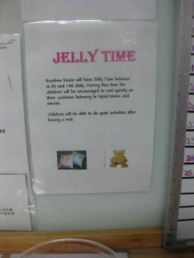
Figure 94: Jellytime
Planning and documenting
Programs and routines were displayed on walls and photo journals were evident. The evaluator saw no documenting during the visit but noted there were staff times devoted to meetings and record keeping.
The 4-5 years room educator had recorded EYLF outcome plans for “talking and thinking about sessions” around Autumn/Winter teaching and linked these to Strong sense of well-being (Outcome 3) and Confident and involved learners (Outcome 4).
Family involvement in planning
The LDC Association family members come together with the Director for the planning of fundraising and maintenance and equipment decisions, and bring recycled materials and so on for program support. Social activities include local events where families participate, and local contact with the Chamber of Commerce supports things such as award nominations for staff and local business of the year competitions. Parents were not involved in planning the learning program.
Professional development: All interviewed staff mentioned that ongoing PD opportunities were offered and funded. This was an exceptional LDC in terms of developing staff expertise. In the staff room there was a large box of learning and development opportunities booklets and this centre’s Director placed a strong emphasis on professional development and through it, performance management. The Director had made a bid for the next World Forum in Child Care to come to Domain capital city She had developed a prospectus, thought of sponsors, had 45 resources to visit ideas laid out and had the backing of community associations and the LDC management committee to undertake this project. The Director thought that this ambitious plan would involve the wider community and her staff, in ways that would be good (business) for everyone.
Areas of interest noted
Respect for children’s well-being - Jelly time - a tradition for rest time (it worked) established through use of meditation relaxation music and soft floor mats.
Communication channels: Key worker scenario - a system that meant there was an educator for each of the three rooms who maintained a point of reference for parents and their children, as well as the centre’s online newsletter.
Independence and self-regulation: Purpose built bathroom environment- for babies/toddlers to build independence- seen by Director and staff as “Giving each child the ability to get it right.”
Workplace Values: The TV logbook was the Director’s response to possible laziness of staff turning on the TV to keep children quiet. Any use of the TV is logged in the book and monitored. What is watched, and for how long.
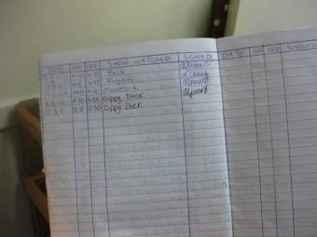
Figure 95: TV Log
Health and Safety: In the toddler yard a red wheelie bin completely organized for Pandemic or evacuation. Included nametags for children, all enrolments with details and water etc.
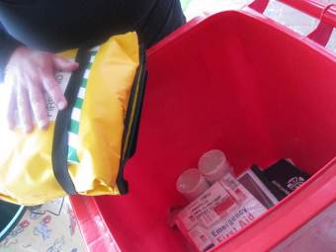
Figure 96: Evacuation wheelie bin
Links to community and cultural diversity. Local organization Indigenous Professional Support Group available for reference by Director and staff
Link between quality control systems and business efficiency
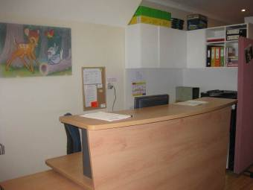
Figure 97: Administration desk
Attitude of staff on how to handle children’s sad, disappointed emotions - it’s “unrealistic to expect happiness all the time.”
‘Intentional teaching’ interpreted by the Director as responsibility and focus of intention.
During interviews with the centre’s Director and staff it was noted:
Intentional teaching was a new concept for her and the educators and needs further elaboration and research so that all educators can better understand this pedagogical principle.
Learning together in LDC applied as much to families and children as to the educator team
Learning stories were not used but photo journals were.
Guidance for the EYLF. A coordinator for the introduction of the EYLF had been newly appointed to provide a lead and practical guidance using the EYLF. The Director saw value in the EYLF as a professionalisation of the child-care industry.
Social learning was named as a theoretical underpinning. There was possible misunderstanding of social learning theorists e.g. Bandura and Vygotsky. Child Care training courses may not yet teach the underpinning contemporary theories of the EYLF.
Safety and business management: High priorities noted in all documents, signs and systems in the LDC site.
The Jurisdiction representative nominated the contact for the Domain child-care sector, came to meet the evaluator and the Director at Centre 8.1 and was also taken on ‘the parent tour’ by Director XY. Their interest in the project in Domain Eight was most supportive. The representative was particularly interested in having a copy of the elaborated SAT tool, and this was passed on to them. The representative was wondering about the notion of intentional teaching and its relationship with responsible teaching.

Centre 8.2 (Kindy regional) characteristics:
Centre | Stage 0 | Stage 1 | Stage 2 | Stage 3 | Stage 4 | Stage 5 | Stage 6
Centre 8.2 | 31 | 66 | 70 | 30 | 8 | 36 | 26
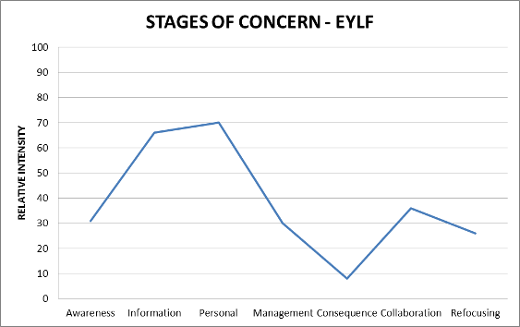
The ‘kindy’ (pre-school) was attached to a local primary school of 580 students, known in the local area as “one of the best schools” (new headmaster’s words) with a high SES index. Located 450 kms north of the capital city in an eastern part of xx, a mining boom town settlement, the school population comprised culturally and linguistically diverse families, living in quality homes within a walk or bike ride of the school. With attractive garden surrounds, and an interactive outdoor activity emphasis the distinctly portable/makeshift classrooms for the kindy section contrasted with brick pre-primary and primary school buildings. A low wire fence defined the Kindy- Pre-primary area from the Primary school area.
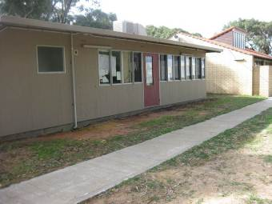
Figure 98: Kindy back view
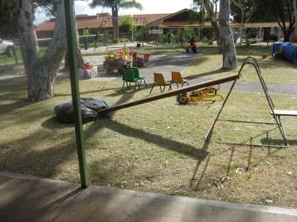
Figure 99: Kindy playground adjoins primary school
There were two ‘kindy’ classrooms for three kindy groups. Two groups of 4-5 year olds attend two and a half days each and in addition the second kindy classroom had younger children (3-4yr’s) attending half days on a rotational basis.
The Kindy group that the evaluator visited, attended Tuesday, Thursday and a half day Friday and the second group using the same classroom with same teacher, attending Monday, Wednesday and a half day Friday. Twenty children were enrolled in each of these groups. Teacher #1 worked with a total of forty children over the week and had two assistants, one for each of the two groups.
Three Pre-primary classrooms were also part of the physical grouping –there were three classes of 5-6-7 year olds undertaking full school days. Their rooms adjoined the kindy rooms, shared part of the yard, divided only by low fence or pathway and all staff shared resources. All were currently undertaking introduction of the new EYLF.
Five staff from Pre-primary (Educators #2, #3, #4, #5 & #6) and the other Kindy teacher (Educator #7) filled out C-BAMs- in addition to Kindy teacher #1.
Teacher #1 was observed all day (8.15 am-3.30 pm) and interviewed. Assistant #2 filled out the C-BAM but had no time release for an interview. #3 (helper on the day) signed permission to participate and filled out the form to indicate what she thought Being Belonging and Becoming meant to her.
Welcoming
On the day of the visit, (8.15 am - 3.30 pm) the evaluator was warmly welcomed by teacher #1 “please take us as we come” and was introduced to assistant #2 and a visiting grandmother, #8, who arrived to help with the program. The outdoor area was set up early.
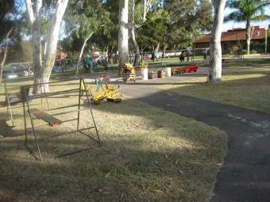
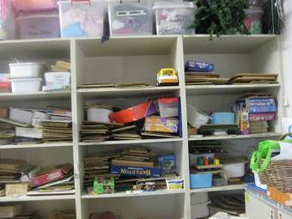
Figures 100 & 101: Classroom
The classroom environment was cluttered, but children knew where to find things and settled to play with materials on the floor mat and at a table where freshly made play-dough was placed. The evaluator and visitor #3 were offered a tiny free space on top of the fridge to place bags out of the way. There were no spaces designated for adults to sit or store things.

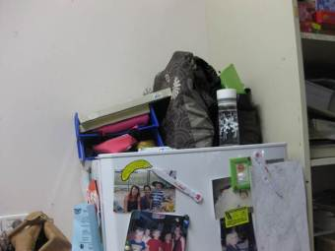
Figure 102: Adult bag space
The teacher’s desk was in the playroom corner with computer and was not once used during the evaluator’s time there.
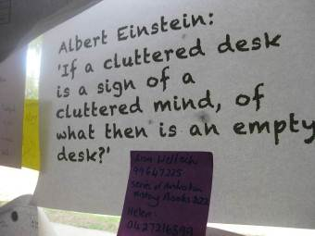
Figure 103: Teacher’s desk message
Enthusiastic greetings and welcomes were witnessed from 8.30 am when parents started bringing children in to centre. All received a conversational exchange and a dose of #1’s good humour. Parents stood about and talked together whilst their children moved into activities. By 9 am most of the children had arrived and were settled playing together with a great deal of interactive conversation mirroring their parents and the teacher #1 and her assistant #2, who were constantly exchanging thoughts throughout the whole day.
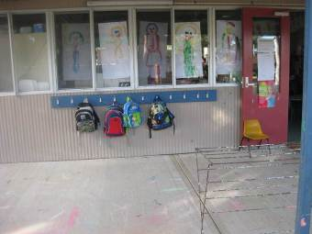
Figure 104: Entry to kindy
Classroom interactions
At 9.15 am group circle time began and all nineteen children were introduced to evaluator one by one, and asked to say “hullo Avis”- to which replies were made. There was a great deal of sustained conversation, fun and laughter during this activity which became an hilarious game and included implicit counting work as each child was counted by turns. Teacher #1 used organised and measured methods of inclusion and choice for all daily transitions. She involved visitors who came, including a gardener, other teachers, parents bringing in recyclables and mothers with birthday cakes for a child’s special day. The room was like a family home and with 19 children all part of it. They all knew what was going on and why. Explicit language by the teacher and the assistant, elaborated and linked the children into ideas, to one another, to discoveries, each other’s feeling and all this interaction built a shared experience as the day proceeded. #1 said of her active style of teaching “it’s actually my exercise for the day”. Indoors, teacher #1 worked with the whole group most often but also with small groups, where she and assistant #2 would undertake an activity such as the vegemite sandwich making that had been demonstrated by #1 in whole group mat time.
Lunch was a shared break where staff seated on small chairs chatted together in another classroom, whilst children lunched outside with supervising staff doing rotational duty. The evaluator briefly met all staff working with the EYLF in the Pre-primary/Kindy section over this brief 15 minute lunch break.
Children were engaged fully throughout the whole day (8.30 am-3.30 pm with no rest period) and intentional teaching was highly evident in every interactive moment that Teacher #1 undertook. Story telling narrations were left open for children to enact and add to. Not every child spoke English, so every time that a word was used that could be misunderstood, #1 would give an extended meaning: e.g. “choose can also mean ‘pick out’ or ‘point to’ you know”. The Teacher’s strong confidence in playing roles with children made the whole day playful and the particular focus on story Possum Magic character journeying to find visibility was a very engaging experience played out purposefully throughout the day. For example foods were prepared early for a later picnic, to be an anticipated imaginary journey. The journey was mapped in abstract form on a large floor map of Australia with the whole group participating.
Quality and learning
Teacher #1 noted, “we do try to make the relationships with all parents and families. Me and #2 like each other, actually we love each other and the relationships between all staff are committed to support one another. You need to like what you are doing and it’s nice to have a basis of understanding.” There was a strong team feeling during the visit. What’s unique about the place for Teacher #1 is that she’s been teaching children that she’s “known before they were born.” She has a sense of belonging herself and relationships have built up. On a display in the classroom there were photos of her own family and years of the annual class group photos, which she says the older children now come back to Kindy to look at.
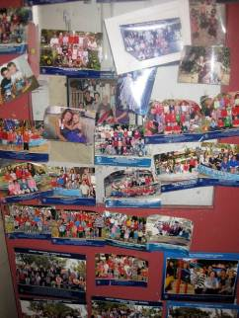
Figure 105: Images over years
The day’s routine included an outdoor time of 1 hour of play at 11am with materials and equipment that had been set up prior, followed by a lunch eaten outdoors sitting down. Teacher #1 began the outdoor play with all children starting the obstacle course she had arranged. This was to include everyone in the physical activity of climbing, which she said many children didn’t do unless directed within the group.
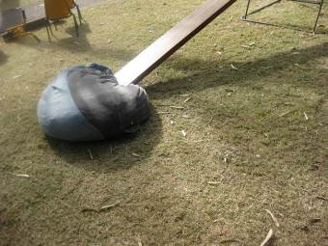
Figure 106: Obstacle course
Afterward children freely selected materials and ran about, played spontaneous shadow games, rode bikes and had special rules for waiting turns for riding bikes and scooters. Both #1 and #2 were involved in the play and encouraging and watching and conversing with each other and with the children. They each noted the children’s idiosyncratic features (spiky hair, arm crossing, long eyelashes), supporting children in noticing and accepting differences in daily living in this kindy room. Teacher #1 says it’s vital to be “Taking on a team mentality” because the educator’s work is about supporting children in self-regulation and embodying their activity into a collective whole. Some children played out the map journey (continued on from the inside activity) by using the sand pit and marking sticks to make their own map.
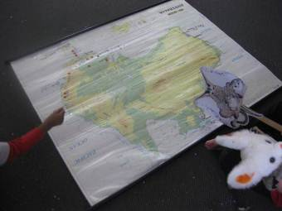
Figure 107: Map indoors
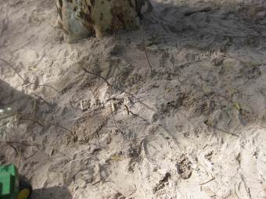
Figure 108: Map in sandpit
Intentional teaching
#1’s work throughout the day was notable for its intentional direction and choices for children. At morning tea for example a shared platter was placed in the middle of the circle of children. All children were asked to “think what two pieces you will choose” and one by one the children named by teacher were able to help themselves to what they had thought about and chosen to eat.
By afternoon picnic time, lamingtons, vegemite sandwiches and pavlova had all been made together with the children, who were by then, taken on the much anticipated journey outside and beyond the kindy yard. #1 led them to walk ‘a secret path’ to a bushy area behind the school, where they sat together on a picnic rug to eat their prepared foods. They all had bare feet and sunhats and were full of questions and conversations with each other. Their previously made paper plate possums had been secretly hung by their tails in the trees by #2 prior to the walk.
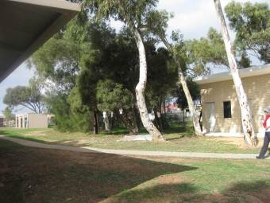
Figure 109: Heading for picnic
Teacher #1 describes these playful surprise filled and adventurous activities as having a fully intentional basis- “you’re clever if you know how to do this-like with phonological awareness-we’ll take it on -we use rhyming daily but we’re not going to sit down and say these are the rules for rhyming.” “The Possum Magic hunt for visibility around Australia and our instructions and modelled preparations with cooking actually brings many possibilities for phonemic awareness.” Teacher #1 articulated the action to the children clearly and participated wholeheartedly in every occasion the evaluator saw, and this made the children’s day exciting and playful. “It’s just in the doing isn’t it?” she said of the children’s daily activity.
“Philosophy on play according to Teacher #1”
To summarise, Teacher #1 commented at interview: “play-based underlies everything here. It’s hard to plan for and you have to give lots of examples, and model. Play allows them to practice.”
Teacher #1 says she always has a purpose for what it is they are doing and then “let it be flexible” and “try to go with the child’s way too”. She suggests (to the audio tape) that there are three layers of play: “Sometimes play is directed by me, like at the mat session, then we will set up things and provide stuff, and then there’s just do what you want to do. You need all three types happening all day. Is that enough? It’s philosophy on play according to #1.”
Centre 8.2 - Kindy
Educator professional knowledge of EYLF and the elements (principles, practice and outcomes) underlying the document:
Principles: Family-centred and school community practice was evident in observations at meeting and greeting times before and after the long day Kindy session. Family partnerships were valued highly, and personality of long serving teacher went a long way to create friendships and trust. Welcoming contexts, warm and extensive interactions were regular habit for this teacher and in this school. A strong sense of community was created, and daily space for communications between families occurred. Families were culturally and linguistically diverse and the teacher’s experience with Indigenous community education and her open-minded attitude to shared humanity resulted in happy children and happy families. Children’s well-being, and children’s acceptance of each other’s differences was implicit. A newly arrived Italian boy was immediately included in all group times. Teacher comments in a humorous fashion: “he’s Italian but I’m turning him into an Australian with this accent poor child” and she introduced him to families as well. Muslim mothers brought in cake for a birthday party to share with all children and acceptance of everyone on equal terms was also reflected local community attitudes in this multicultural mining boomtown.
Reflective practice was ongoing between the staff. Teachers met regularly to discuss curriculum matters and staff were very engaged in collective professional enquiry as witnessed over lunch when all Kindy and Pre-primary staff filled out the CBAMs for this project and discussed how interesting it was to do so.
Practice: The Kindy practices were relational and pedagogically driven by teacher and assistant and included Primary school pushdown curriculum demands. (e.g. Phonological awareness and word list). Setting up outdoors environment was deliberate but inside the materials were freely available and play based curriculum underpinned planning. Intentional teaching was delivered through carefully organized learning experiences that promoted engagement and enthusiasm and full group participation. The Kindy used an expansive outdoor area for both organized physical training and natural exploration with imaginative play. Assessment practices featured outcome charts from the Domain’s Department of Education related to EYLF and children’s development. A social view of child development was evident with great care taken of individual interests being coordinated in tandem with the collective group intentions that developed as the day went on. Each day was building on from the last in this sense and the continuity of learning was clear through, as exemplified by the ongoing narrative of the journeying Possum Magic character. The brief meeting with new headmaster led evaluator to believe the expected use of information and communication technologies for investigating ideas and representing thinking in the Kindy were, in his opinion, limited and needed further funding and reform. The Kindy teacher who had worked in Indigenous communities considered that for some Indigenous families the high expectations for technical literacy and numeracy were not considered a “measure of success for their mob”. Outcome 2 in her opinion was therefore non-inclusive for some children and depended very much on ‘the world’ that the child and family inhabited.
Learning outcomes: The teacher and assistant worked together implicitly towards the Learning Outcome of every child having a strong sense of identity. In relation to Outcome 2, the Kindy practices showed that the children felt a sense of belonging in their group within the Kindy, and were connected to and contributing to the undertaken indoor and outdoor experiences. Everyone had a turn (as in the obstacle course), and fairness and social responsibility were promoted (e.g. turn taking and naming and greeting in mat sessions) in the relationships staff demonstrated. Outcome 5 was clearly evident, as the children communicated freely with each other, the staff, other parents and the evaluator, both verbally and non-verbally. Staff modelled friendly outgoing relations with everyone they met and this friendliness between teachers, other staff, families and children was a noted feature of the Kindy.
The Kindy curriculum placed priority on language development through dramatic fun-filled interpretation of narratives and numerous measurement/counting opportunities, where the integrated activities provided daily teachable moments that were constantly realized. Planning documents showed growing awareness of child development and the teacher and other staff in the Pre-primary section noted the need for all families to belong to a shared community and for all children to succeed.
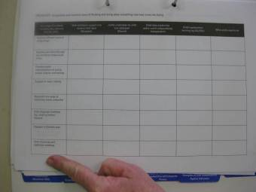
Figure 110: Domain’s Department of Education profile page
The cake raffle was a family–school weekly event tradition and it happened on the day of evaluator’s visit. At collection time (3.30pm) families entered the room to observe the performance of teacher Andrea as she eliminated children carefully through given clues to help produce a winner of the cake for that week. The parent who had brought the cake in and made it was highly praised and very involved in the whole process. A strong classroom community supported this weekly fun filled event. “It’s amazing what a cake reward can do”, commented Teacher #1.
Kindy Teacher #1: Primary Teacher with Grad Dip Early Childhood
26 years of experience: 12 years Primary grades 1-3, and 14 years Kindy and Pre-primary (Prep).
Quality:
Positive relationships, teacher, child, family
Play based
Committed well trained staff
Environment- safe welcoming, motivating, interesting.
SAT- Cultural-historical but in addition Psycho-genetic.
Cultural-historical because “we’re social beings and pitch the learning above what children can do…we model for them, looking for ideas and they practice these ideas by playing. We explain a bit more than they can understand. We plan to do and will choose a particular thing because children learn on a developmental basis. There are physical development examples and language, like expressing orally, retelling stories and mucking about with sounds.”
BBB
Being: Strong sense of self-identity.
Emotional well-being
Healthy-mind/body
Enjoying making the most of the here and now.
Belonging: Being part of the group (family-class-school)
Accepting expectations of group
Participating
Seeing themselves as valued in the group
Becoming: Future-being prepared for it-skills needed-growing-developing
Kindy Teacher 2: BEd. (ECE) 7 years experience.
Quality:
Culturally appropriate
Based on ‘Best Practice’
Inclusive
Flexible
SAT Psycho-genetic and Cultural-historical
BBB
Being: Having an awareness of self and how the individual interacts with others.
Belonging: Having a sense of community, feeling safe and secure in the learning/work environment.
Becoming: Exploring and discovering self through observation, role play and modeling.
#8 Visiting grandparent interested in the new EYLF.
Qualification: Postgraduate Diploma Palliative Care (Nursing)
45 years as a mother, 14 years as a grandmother, 10 years nursing children in hospital.
Volunteered to fill out the BBB
Being: Acceptance and sense of self, being me here and now, part of the universe, freedom, freedom to express without judgment.
Belonging: Roots, love, family, sharing integrating sense of self, acceptance, tolerance, giving, understanding.
Becoming: Owning self-belonging to me, acceptance, sharing, changing, growing, moving forward, happy to be me in my own skin, knowing self, non-judgmental, forgiveness.
Concerns of teacher:
Being part of a Primary school, having a very formal prescriptive curriculum for Kindy children would mean losing expressive spontaneity and mucking about playfully.
The newly appointed school Headmaster a secondary school teacher, was familiar with the National Curriculum and was not yet familiar with the EYLF.
Asked to reflect on their work, teacher said “joyful and welcoming” and assistant Ro suggested, “exhausting with excitement.”

Family Day Care 8.3 characteristics:
Centre | Stage 0 | Stage 1 | Stage 2 | Stage 3 | Stage 4 | Stage 5 | Stage 6
Centre 8.3 #1 | 14 | 34 | 57 | 47 | 2 | 9 | 11
Centre 8.3 #2 | 69 | 54 | 63 | 43 | 11 | 28 | 34
Centre 8.3 #3 | 75 | 60 | 57 | 52 | 9 | 22 | 34
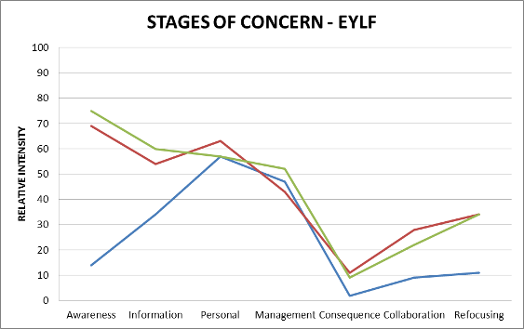
Family Day Care Educator #5’s home is located in an area north east of the capital city.
Qualifications: Certificate III, Diploma Children’s Services plus numerous related certificates and short courses all kept in a folder and some framed on wall.
Practice principles
#5 met the evaluator and CSO #4 outdoors in a concreted yard with wheel toys. She had three young children under 3 years of age present on this day. Her routine for visitors included taking our shoes off at the door, washing our hands with gel and signing in and out of the visitor’s book.
These protocols are part of her professionalism and welcoming. Although English was not her first language she communicated with the young children in playful exchanges and encouraged their play with each other.
Planning and documenting with Family involvement in planning
#4 (CSO) took over playing with the three children so #5 could share her programming and planning and the ways she works with the EYLF with the evaluator. Her programming (Figure 12) and written reflections for each child that parents had signed, (Figure 13) were detailed, in excellent written English and sustained since starting with the EYLF this year. Her planner related carefully to her stated outcomes and her reflections matched this. She explained, “we were like just seen as babysitters but now we are called educators. It’s a good idea that children are learning before they go to school and you can look at what this kid needs….you know like that.”
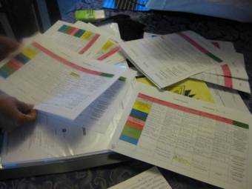
Figure 110: Home educator programs
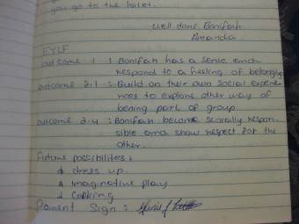
Figure 111: EYLF diaries
Reflective practice
#5 recorded her observations of the children to show their families “how they can do things and know things, like riding the bike not just pedalling.” #5 is Burmese and used language differences in a fun loving way….”they learn your language and I learn from them too.” She is “talk, talk, talk” with the children, and it was noted how she was explaining to them her actions as they are doing things together. She noted, “every time they play you listen to that too.” She kept a developmental summary for each child that read like a small story.
Professional development.
Her qualifications including many certificates for short courses and conference attendances along with her Children’s Services Diploma, and license for FDC registration and membership which were all displayed on the wall. Whilst there, a support package from Domain Eight’s government arrived. #5 opened it and there were health check materials and tools such as the epi-pen. She said she was being sent resources to support her work all the time. #5 was well resourced, showing cupboards of materials for expressive and creative activities and she was well organised with detailed folders and records including her latest validation report that she proudly stated “was 100%.” In this site #5’s professional development was motivated by her own high expectations for self-improvement and through the support systems from FDC scheme and the State Government’s “Every Day Matters” material.
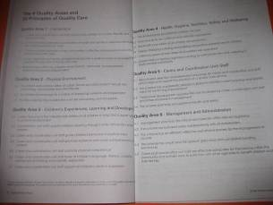
Figure 112: Quality principles
Work-life balance
#5’s FDC service was open “24/7” however on “Monday evening I play soccer, Tuesday squash and I go walking.”
#5 said she was flexible in her work as her three older children and partner come home and could share in the play with the children too. She explained that some families needed weekend care for their child if they wanted to go to the capital city or attend a conference or workshop, or if a grandmother needed respite. Her business had grown. Whilst registered for up to 7 children each day, including her own she had various numbers of children on different days and evenings.
With growth of her FDC business a playroom extension was a recent addition. This had been set up with her own five children’s help and the murals and colourful wall paintings by her children showed how they were involved and this was a family business, a shared community of family life.
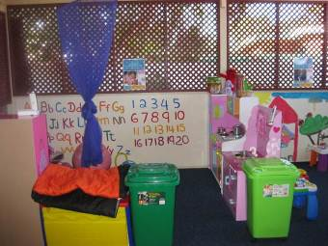
Figure 113: Playroom extension
All the EYLF principles were evident in this site. Most evident was #5’s ongoing learning and reflective practice for herself, her family and the children in her educative care. In addition, respect for diversity (she had been a refugee), and having high personal expectations and equity with others was an intuitive part of her everyday life experience.
Quality- For #5 this was about constantly developing professionally. This particularly included self-education and linking into families by showing them her observations of their child and the stories for parents to read and sign. Keeping immaculate records, meeting high standards of the FDC association, reading and responding to the new changes using the EYLF were undertaken seriously. Being playful and loving with the children in her FDC setting was a way of life according to #4 (CSO) who has known #5 for a long while.
For example, #5 toileted one little child during the visit by flying him in her arms making plane noises and talking him though the routine of hand-washing afterwards and then flying him back to the play area with shrieks of delight so the others would anticipate his return to the bike play. Laughter and energy were characteristic of #5’s approach and close relationship with the young children.
BBB #5 found it difficult to use English words to define. She said in Burmese, “Being is simply here and now.” “Becoming is good, like putting in and my language has many words for it.”
Educator professional knowledge of EYLF and the elements (principles, practice and outcomes) underlying the document:
The intention of #5 to work with the learning and development Outcomes 1-5 was noted in this FDC setting with evidence of her work and observations and record keeping related to the three young children present that day and to others who come to her regularly.

Figure 114: EYLF outcomes reflection example
Her principles matched her practices. All three children present were from diverse cultural backgrounds and #5 enjoyed the diversity learning from it, sharing languages and making the environment a secure and happy place. Interactions observed between children and #5 were full and whole hearted in the family home setting and interactions with CSO #4 were trusting to the extent that when #4 took over where #5 left off to speak with evaluator the children comfortably switched their play and relations and vice versa when she returned. Connected to their world in the FDC home setting in a secure and confident way, these children showed a sense of wellbeing and communicated effectively.
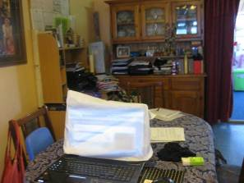
Figure 115: Inside home environment
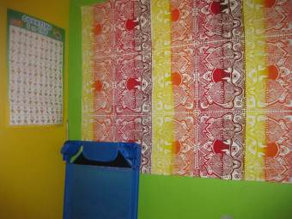
Figure 116: Registered bedroom
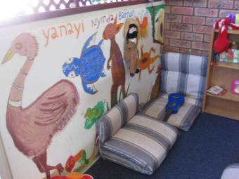
Figure 117 Play space
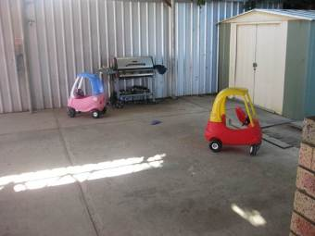
Figure 118: Outside play space.

Areas of interest noted
Advanced understandings and usage of EYLF by Family Day care home educator working with guidance and support from FDC Scheme Coordination unit related to personal motivation and the regular, reliable support and professional development from FDC central unit.
Prior knowledge and experience in remote FDC experience was perceived by CSO as intervention for Indigenous children.
Growth in FDC in regional and remote communities, mining town “in venue” support.
Change from being called home carer to educator, welcomed
Importance of a stable and consistent support structure for organizing FDC and recruiting educators and supporting those operating in the field.
Efforts to come to grips with EYLF were various in reflecting understanding.
E.g. Whiteboard in centre mind mapping….EYLF “Being belonging and bringing”.

Appendix 2: EYLF Baseline Study Sampling Matrix
 | Major Cities | Regional | Remote | Australia
Domain Two
LDC |  | Centre 2.2
FDC
Preschool | Centre 2.1 |  | Remote Preschool 2.3
Total |  |  |  | 3
Domain Seven
LDC | Long Day Care 7.1
FDC | Family Day Care 7.2 | Family Day Care 7.3
Total |  |  |  | 3
Domain Four
LDC |  |  | Long Day Care 4.3**
FDC
Preschool | Preschool and Kinder 4.1 | Preschool and Kinder 4.2
Total |  |  |  | 3 (2 visited)
Domain Five
Preschool | Long Day Care 5.1
Integrated  Setting |  | Integrated Setting 5.2
Total |  |  |  | 2
Domain Eight
LDC | Centre 8.1
FDC |  | Centre 8.2
Preschool |  | Family Day Care 8.3
Total |  |  |  | 3
Domain Six
LDC |  | Long Day Care 6.2
FDC | Family Day Care 6.1
Total |  |  |  | 2
Domain Three
LDC |  |  | Long Day Care and Preschook 3.1 & Long Day Care and Preschool 3.2
Integrated Setting |  | Integrated Kindergarten and Preschool 3.3**
Total |  |  |  | 3 (2 visited)
Domain One
LDC | Long Day Care 1.1
Integrated  Setting | Long Day Care 1.2
Total |  |  |  | 2
Total LDCs | 3 | 2 | 3 (2 visited) | 7
Total FDCs | 2 | 2 | - | 4
Total Preschools | 3 | 2 | 1 | 6
Total Integrated Settings | 1 | 2 (1 visited) | - | 3
Grand Total | 9 | 8 | 3 | 20
** Was unable to be visited

Appendix 3: Elements of the Early Years Learning Framework (EYLF)
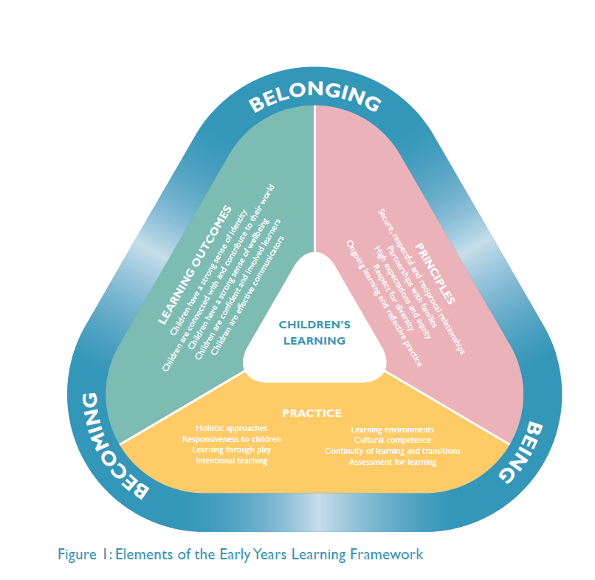

Appendix 4: Belonging, Being and Becoming
Being, Belonging and Becoming
TASK: The national Early Years Learning Framework mentions the words “Being, Belonging and Becoming:. We invite you to write about your understandings about the terms Being, Belonging and Becoming.

What I believe is meant by Being

What I believe is meant by Belonging

What I believe is meant by Becoming

Highest qualification you have ________________________________________

Years of experience in early childhood education ________________________________________

Appendix 5: Self Assessment Tool (SAT): Child Development Theories and Their Relations to EYLF
In order to develop base-line information of staff knowledge of child development, pedagogy, and curriculum, we would like you to identify which theory(ies) inform your thinking. Just circle the one that you draw upon the MOST. If you are undecided about one or two, then circle and number according to which you draw upon the most to the least.
Child Development Theories | Main Theorist | EYLF – The Lens  “How the view of child development being used by the educator shapes how they read the EYLF” | Principles and practices associated with the particular view of child development
Biological | Gesell (1925) | Growth and development according to milestones. Teaching programs and pedagogical practices would match content to stages of development, mostly defined according to middle class European heritage children only. | Educators to: Engage with research and practice evidence which shows cultural diversity and differing family practices which DO NOT FIT with the existing milestones.
Behaviourism | Skinner (1957) | Observable and measurable behaviours. Educator programs would focus only observable behavioural outcomes. | Educators to:– children have strong sense of wellbeing – and workshop how these values can be assessed and planned for in a program.
Social learning | Bandura (1986) | Learning by observing role models. Importance of the significant other. Feelings and emotions are foregrounded. Teaching programs would focus mostly on free play, and learning through observing others, and through the materials made available. The educator would model, but not actively intervene in children’s learning. Child autonomy and sense of self. | Educators to: Note that not all learning of children occurs through observing role models, and that the EYLF deliberately brings together “Guided play and learning; Adult-led learning; and Child-directed play and learning”. Research evidence from EPPE positions concept of ‘sustained shared thinking’ for increasing cognitive outcomes of children.
Psycho-genetic | Piaget (1950, 1952) | Milestones are important, and educator judgments are made in relation to matching the child’s development with the curriculum. Learning is viewed as an individual and independent process. | Educators to: See they have an active role in children’s learning, and not just a provider of resources. Evidence of research which shows how learning is constructed across groups of children, and does not reside solely within a child’s head. Practice with EYLF assessment models
Cultural-historical | Vygotsky (1998)  Rogoff (2003)  Fleer (1995; 2010) | Learning is viewed as a cultural and social process. Programming of learning is always ‘above’ what the child can do independently. Scaffolding of EYLF positions the educator as a pedagogical leader. Cultural ways of learning are foregrounded. | Educators to: Examine how the content and processes of the EYLF are realized across different cultural communities. Migrant and culturally diverse families need to be involved in the implementation of EYLF
Post developmental theories | Blaise (2007) | Learning content and learning processes are viewed as contested, and subject to power relations. Child development is viewed as representing not a single truth, but as diverse. | Educators to: Examine Learning Outcome focused on Children as effective communicators, and Learning Outcome associated with building children’s identity.

Appendix 6: Service, Staff and Child Characteristics
Please provide the following information:
- Service level characteristics, including (as relevant):
  - location (state/territory and level of regional area/remoteness)
  - size of site (ie average number of children per day/session)
  - whether public, community-based, private-for-profit or independent school-based
  - nature of setting (Child Care, Preschool, Integrated Setting)
  - nature of integration if an Integrated Setting
  - nature of internal and external environment.
- Educator level characteristics, including:
  - demographic information – age group, sex, Indigenous status, CALD background
  - number of educators by qualification and years of experience.
- Child level characteristics, including:
  - demographic and socioeconomic information – age groups, sex, Indigenous status, low SES, CALD background, of newly arrived migrants, with disabilities.
- Existing frameworks and curricula, including:
  - level of awareness and knowledge of the EYLF, and the elements underlying it
  - knowledge of the relationship between the EYLF and the frameworks, curricula or other documents outlined above
  - level of awareness and use of other frameworks, curricula and other documents which guide planning and practice at each site.
- Other factors or resources which may influence teaching and learning at each site, and the context or conduct of the Study at each site

Appendix 7: Interviews Proforma on EYLF Principles, Practice and Outcomes
Principles | Practice | Outcomes
What is the nature of educator-child relationships and interactions at each site? | What pedagogical principles influence practice at each site, and how do educators draw on such principles in their practice? | What planning do educators do at each site to understand and contribute to children’s individual, social and learning outcomes?
How well and in what ways are children, their families and communities encouraged to be involved in the planning for and decision making for children’s learning and other experiences at each site? | How effectively do educators at each site take a holistic approach to children’s well-being, including physical, personal, social, emotional, spiritual and cognitive aspects? | How do educators promote children’s learning in order to develop a sense of identity and well-being, and to connect with and contribute to their world?
How are high expectations of children’s learning promoted? | How attentive and responsive are educators at each site to children’s individual strengths, abilities and interests? | How are children guided to develop responsibility for their own learning, and to become confident life-long learners? Do educators ensure that children’s learning is transferable to other contexts?
How does each site address and promote principles of social diversity, inclusion and equity? | Is learning at each site play-based, intentional and supported by a rich learning environment? | How are the range of elements of communication, problem-solving and decision-making fostered in children’s learning?
Is professional enquiry through reflective practice embedded in the operation of the site? | Do educators demonstrate culturally competent practice? In what ways? | How do educators seek to prepare children to make successful transitions between the site and other settings?
 | What, if any, cycle of reflection and review is used by educators at each site (i.e. how well is information about children’s learning used to promote their ongoing learning)?
 | How well and in what ways are children, their families and communities encouraged to be involved in the planning for and decision making about children’s learning and other experiences at each site?

Appendix 8: C-BAM
NAME:
PHONE NUMBER:
EMAIL:
CENTRE OR FAMILY DAY CARE ADDRESS:

Concerns Questionnaire
The purpose of this questionnaire is to determine the nature of the concerns of educators who are thinking about how to implement the Early Years Learning Framework (EYLF) in their setting. Some items on this questionnaire may appear to be of little relevance or irrelevant to you at this time. For the completely irrelevant items, circle the 0 on the scale. Other items will represent those concerns that you have in varying degrees of intensity, and they will be marked on a scale of 1 to 7.

For example
This statement is very true of me at this time | 0 | 1 | 2 | 3 | 4 | 5 | 6 | 7
This statement is somewhat true of me now | 0 | 1 | 2 | 3 | 4 | 5 | 6 | 7
This statement is not at all true of me at this time | 0 | 1 | 2 | 3 | 4 | 5 | 6 | 7
This statement seems irrelevant to me | 0 | 1 | 2 | 3 | 4 | 5 | 6 | 7

Please respond to the items in terms of your present concerns, and how you feel about your involvement or potential involvement with the EYLF in your setting. Please make a response to every item on the questionnaire by circling one digit only.
Upon completion, please place the survey in the addressed envelope provided.
Thank you for taking the time to complete this task

0 | 1 | 2 | 3 |  | 4 |  |  | 5 |  |  | 6 |  |  | 7
Irrelevant | Not true of me now |  | Somewhat true of me now |  |  |  |  |  |  |  | Very true of me now
I am concerned about my colleagues’ attitude toward the EYLF |  |  |  | 0 |  | 1 | 2 |  | 3 | 4 |  | 5 | 6 |  | 7
I now know some of the things that might work better that what is in the EYLF |  |  |  | 0 |  | 1 | 2 |  | 3 | 4 |  | 5 | 6 |  | 7
I do not even know what the EYLF is about |  |  |  | 0 |  | 1 | 2 |  | 3 | 4 |  | 5 | 6 |  | 7
I am concerned that I do not have enough time to organise myself each day |  |  |  | 0 |  | 1 | 2 |  | 3 | 4 |  | 5 | 6 |  | 7
I would like to help other staff in their use of the EYLF |  |  |  | 0 |  | 1 | 2 |  | 3 | 4 |  | 5 | 6 |  | 7
I have a very limited knowledge about the EYLF |  |  |  | 0 |  | 1 | 2 |  | 3 | 4 |  | 5 | 6 |  | 7
I would like to know the effect of EYLF on my professional status |  |  |  | 0 |  | 1 | 2 |  | 3 | 4 |  | 5 | 6 |  | 7
I am concerned about conflicts between my interests and my responsibilities in relation to EYLF |  |  |  | 0 |  | 1 | 2 |  | 3 | 4 |  | 5 | 6 |  | 7
I am concerned about revisiting my use of the EYLF |  |  |  | 0 |  | 1 | 2 |  | 3 | 4 |  | 5 | 6 |  | 7
I would like to develop working relationships with both our staff using the EYLF in and out of the centre |  |  |  | 0 |  | 1 | 2 |  | 3 | 4 |  | 5 | 6 |  | 7
I am concerned about how the EYLF will affect my students |  |  |  | 0 |  | 1 | 2 |  | 3 | 4 |  | 5 | 6 |  | 7
I am not concerned about using the EYLF in my centre |  |  |  | 0 |  | 1 | 2 |  | 3 | 4 |  | 5 | 6 |  | 7
I would like to know who will make the decisions about the use of the EYLF |  |  |  | 0 |  | 1 | 2 |  | 3 | 4 |  | 5 | 6 |  | 7
I would like to discuss the possibility of using the EYLF in my centre |  |  |  | 0 |  | 1 | 2 |  | 3 | 4 |  | 5 | 6 |  | 7
I would like to know what resources are available when we adopt the EYLF |  |  |  | 0 |  | 1 | 2 |  | 3 | 4 |  | 5 | 6 |  | 7
I am concerned about my ability to manage the implementation of EYLF in my centre |  |  |  | 0 |  | 1 | 2 |  | 3 | 4 |  | 5 | 6 |  | 7
I would like to know how my teaching or administration is supposed to change |  |  |  | 0 |  | 1 | 2 |  | 3 | 4 |  | 5 | 6 |  | 7
I would like to familiarise other persons with the progress of implementing the EYLF in my centre |  |  |  | 0 |  | 1 | 2 |  | 3 | 4 |  | 5 | 6 |  | 7
I am concerned about the impact of EYLF on my students |  |  |  | 0 |  | 1 | 2 |  | 3 | 4 |  | 5 | 6 |  | 7
I would like to revise the EYLF documentation |  |  |  | 0 |  | 1 | 2 |  | 3 | 4 |  | 5 | 6 |  | 7
I am completely occupied with other things |  |  |  | 0 |  | 1 | 2 |  | 3 | 4 |  | 5 | 6 |  | 7
I would like to modify our use of the EYLF in the centre based on the experiences of our children |  |  |  | 0 |  | 1 | 2 |  | 3 | 4 |  | 5 | 6 |  | 7
Although I do not know about the EYLF, I am concerned about things in this area |  |  |  | 0 |  | 1 | 2 |  | 3 | 4 |  | 5 | 6 |  | 7
I would like to excite families about the EYLF |  |  |  | 0 |  | 1 | 2 |  | 3 | 4 |  | 5 | 6 |  | 7
I am concerned about time spent working with non teaching problems related to the EYLF |  |  |  | 0 |  | 1 | 2 |  | 3 | 4 |  | 5 | 6 |  | 7
I would like to know what the use of the EYLF in the centre will require in the immediate future |  |  |  | 0 |  | 1 | 2 |  | 3 | 4 |  | 5 | 6 |  | 7
I would like to coordinate my efforts with others to maximise the effect of the EYLF in the centre |  |  |  | 0 |  | 1 | 2 |  | 3 | 4 |  | 5 | 6 |  | 7
I would like to have more information on time and energy commitments required to use the EYLF |  |  |  | 0 |  | 1 | 2 |  | 3 | 4 |  | 5 | 6 |  | 7
I would like to know what other staff are doing in this area |  |  |  | 0 |  | 1 | 2 |  | 3 | 4 |  | 5 | 6 |  | 7
At this time, I am not interested in learning about the EYLF |  |  |  | 0 |  | 1 | 2 |  | 3 | 4 |  | 5 | 6 |  | 7
I would like to determine how to supplement, enhance or replace the EYLF |  |  |  | 0 |  | 1 | 2 |  | 3 | 4 |  | 5 | 6 |  | 7
I would like to use feedback from children and families to change the use of the EYLF in my centre |  |  |  | 0 |  | 1 | 2 |  | 3 | 4 |  | 5 | 6 |  | 7
I would like to know how my role will change when I am using the EYLF |  |  |  | 0 |  | 1 | 2 |  | 3 | 4 |  | 5 | 6 |  | 7
Coordination of tasks and people is taking too much of my time |  |  |  | 0 |  | 1 | 2 |  | 3 | 4 |  | 5 | 6 |  | 7
I would like to know how the EYLF is better than what we have now |  |  |  | 0 |  | 1 | 2 |  | 3 | 4 |  | 5 | 6 |  | 7

C-BAM results

Domain One
Domain One Major City LDC sample
Centre | Stage 0 | Stage 1 | Stage 2 | Stage 3 | Stage 4 | Stage 5 | Stage 6
Centre 1 | 48 | 60 | 67 | 47 | 13 | 52 | 38
Centre 2 | 40 | 27 | 25 | 23 | 27 | 19 | 22
Centre 3 | 22 | 37 | 39 | 27 | 3 | 22 | 5
Centre 4 | 22 | 60 | 72 | 15 | 13 | 22 | 3
Domain One Major City LDC sample average
Awareness | Information | Personal | Management | Consequence | Collaboration | Refocusing
33 | 46 | 50.75 | 28 | 14 | 28.75 | 17
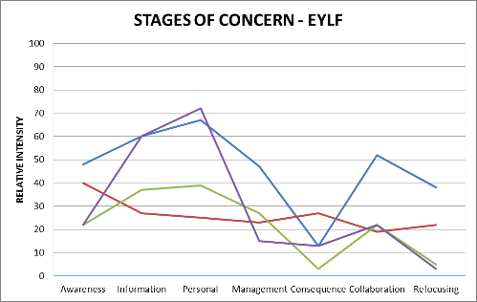
Domain One Major City Integrated Service sample
Centre | Stage 0 | Stage 1 | Stage 2 | Stage 3 | Stage 4 | Stage 5 | Stage 6
Centre 5 | 55 | 63 | 48 | 27 | 24 | 68 | 11
Centre 6 | 94 | 48 | 21 | 39 | 8 | 14 | 65

Domain One Major City Integrated Service sample average
Awareness | Information | Personal | Management | Consequence | Collaboration | Refocusing
74.5 | 55.5 | 34.5 | 33 | 16 | 41 | 38
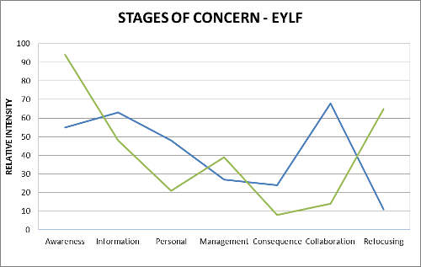

Domain Two
Domain Two Major City Preschool sample
Centre | Stage 0 | Stage 1 | Stage 2 | Stage 3 | Stage 4 | Stage 5 | Stage 6
Centre 1 | 1 | 16 | 14 | 7 | 5 | 22 | 22
Centre 2 | 31 | 19 | 25 | 27 | 3 | 72 | 2
Centre 3 | 22 | 30 | 28 | 34 | 19 | 10 | 9
Domain Two Major City Preschool sample average
Awareness | Information | Personal | Management | Consequence | Collaboration | Refocusing
18 | 21.67 | 22.33 | 22.67 | 9 | 34.67 | 11
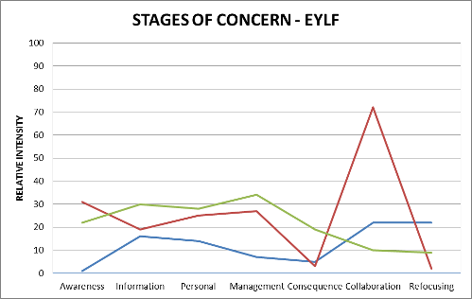
Domain Two Regional LDC sample
Centre | Stage 0 | Stage 1 | Stage 2 | Stage 3 | Stage 4 | Stage 5 | Stage 6
Centre 4 | 61 | 51 | 70 | 47 | 11 | 72 | 26
Centre 5 | 4 | 40 | 67 | 11 | 7 | 40 | 14
Domain Two Regional LDC sample average
Awareness | Information | Personal | Management | Consequence | Collaboration | Refocusing
32.5 | 42.5 | 68.5 | 29 | 9 | 56 | 20
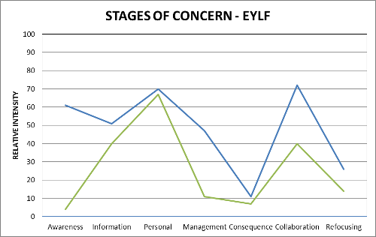

Domain Two Remote Preschool sample
Centre | Stage 0 | Stage 1 | Stage 2 | Stage 3 | Stage 4 | Stage 5 | Stage 6
Centre 6 | 55 | 80 | 70 | 90 | 16 | 64 | 42
Centre 7 | 99 | 91 | 87 | 85 | 54 | 76 | 90
Centre 8 | 69 | 43 | 48 | 92 | 21 | 72 | 52
Domain Two Remote Preschool sample average
Awareness | Information | Personal | Management | Consequence | Collaboration | Refocusing
74.33 | 71.33 | 68.33 | 89 | 30.33 | 70.67 | 61.33
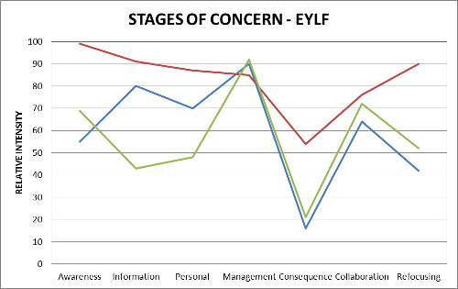

Domain Three
Domain Three Remote LDC sample
Centre | Stage 0 | Stage 1 | Stage 2 | Stage 3 | Stage 4 | Stage 5 | Stage 6
Centre 1 | 40 | 57 | 63 | 56 | 7 | 44 | 42
Centre 2 | 31 | 88 | 83 | 65 | 86 | 98 | 60
Centre 3 | 91 | 91 | 94 | 88 | 30 | 84 | 65
Centre 4 | 55 | 88 | 94 | 90 | 43 | 91 | 57
Domain Three Remote LDC sample average
Awareness | Information | Personal | Management | Consequence | Collaboration | Refocusing
54.25 | 81 | 83.5 | 74.75 | 41.5 | 79.25 | 56
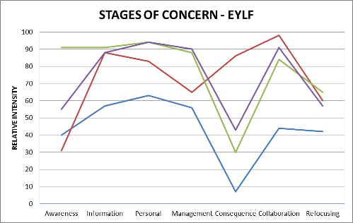
Domain Three Outer Regional LDC sample
Centre | Stage 0 | Stage 1 | Stage 2 | Stage 3 | Stage 4 | Stage 5 | Stage 6
Centre 5 | 61 | 23 | 25 | 15 | 39 | 71 | 6
Centre 6 | 31 | 23 | 25 | 15 | 16 | 72 | 14
Domain Three Outer Regional LDC sample average
Awareness | Information | Personal | Management | Consequence | Collaboration | Refocusing
46 | 23 | 25 | 15 | 27.5 | 71.5 | 10
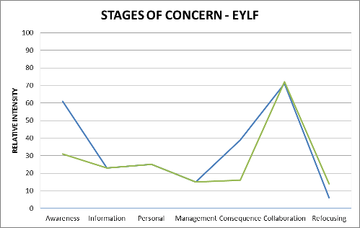

Domain Four
Domain Four remote LDC sample
Centre | Stage 0 | Stage 1 | Stage 2 | Stage 3 | Stage 4 | Stage 5 | Stage 6
Centre 1 | 55 | 57 | 55 | 34 | 13 | 31 | 60
Centre 2 | 81 | 84 | 76 | 60 | 33 | 44 | 65
Centre 3 | 91 | 99 | 99 | 80 | 30 | 88 | 34
Domain Four remote LDC sample average
Awareness | Information | Personal | Management | Consequence | Collaboration | Refocusing
75.67 | 80 | 76.67 | 58 | 25.33 | 54.33 | 53
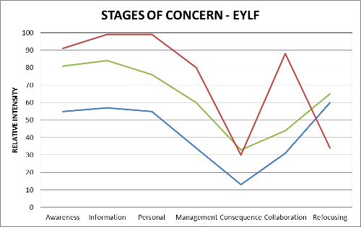
Domain Four Major City Preschool sample
Centre | Stage 0 | Stage 1 | Stage 2 | Stage 3 | Stage 4 | Stage 5 | Stage 6
Centre 1 | 31 | 43 | 25 | 18 | 4 | 9 | 3
Centre 1 | 94 | 54 | 67 | 7 | 13 | 14 | 34
Domain Four Major City Preschool sample average
Awareness | Information | Personal | Management | Consequence | Collaboration | Refocusing
62.5 | 48.5 | 46 | 12.5 | 8.5 | 11.5 | 18.5
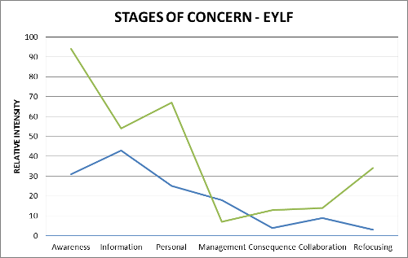
Domain Four Regional Preschool sample
Centre | Stage 0 | Stage 1 | Stage 2 | Stage 3 | Stage 4 | Stage 5 | Stage 6
Centre 1 | 96 | 48 | 52 | 23 | 5 | 12 | 30
Centre 1 | 48 | 27 | 59 | 15 | 7 | 16 | 6
Centre 1 | 55 | 45 | 57 | 30 | 21 | 84 | 47
Centre 1 | 40 | 37 | 39 | 39 | 7 | 25 | 20
Domain Four Regional Preschool sample average
Awareness | Information | Personal | Management | Consequence | Collaboration | Refocusing
59.75 | 39.25 | 51.75 | 26.75 | 10 | 34.25 | 25.75
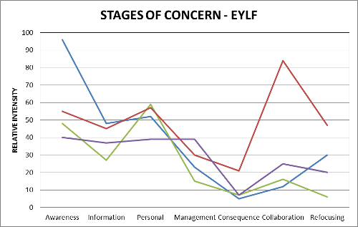

Domain Five
Domain Five Regional Integrated Service sample
Centre | Stage 0 | Stage 1 | Stage 2 | Stage 3 | Stage 4 | Stage 5 | Stage 6
Centre 1 | 31 | 27 | 48 | 27 | 9 | 93 | 20
Centre 2 | 31 | 16 | 5 | 2 | 3 | 55 | 3
Domain Five Regional Integrated Service sample average
Awareness | Information | Personal | Management | Consequence | Collaboration | Refocusing
31 | 21.5 | 26.5 | 14.5 | 6 | 74 | 11.5
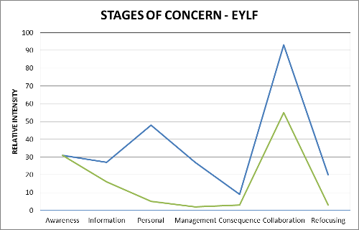
Domain Five Major City Preschool
Centre | Stage 0 | Stage 1 | Stage 2 | Stage 3 | Stage 4 | Stage 5 | Stage 6
Centre 3 | 48 | 60 | 70 | 88 | 30 | 95 | 65
Domain Five Major City Preschool sample average
Awareness | Information | Personal | Management | Consequence | Collaboration | Refocusing
48 | 60 | 70 | 88 | 30 | 95 | 65
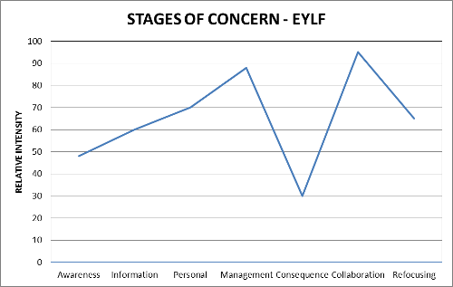

Domain Six
Domain Six Regional LDC sample
Centre | Stage 0 | Stage 1 | Stage 2 | Stage 3 | Stage 4 | Stage 5 | Stage 6
Centre 1 | 55 | 23 | 12 | 27 | 9 | 20 | 3
Centre 2 | 7 | 75 | 83 | 95 | 48 | 72 | 73
Centre 3 #1 | 48 | 51 | 55 | 77 | 9 | 59 | 57
Centre 3 #2 | 48 | 93 | 94 | 56 | 21 | 84 | 57
Centre 3 #3 | 61 | 69 | 63 | 65 | 19 | 80 | 57
Centre 3 #4 | 61 | 88 | 97 | 43 | 4 | 72 | 47
Centre 3 #5 | 55 | 95 | 99 | 56 | 8 | 93 | 84
Centre 3 #6 | 7 | 57 | 63 | 11 | 5 | 19 | 30
Centre 3 #7 | 98 | 93 | 95 | 56 | 27 | 59 | 57
Centre 3 #8 | 31 | 80 | 55 | 7 | 5 | 31 | 57
Domain Six Regional LDC sample average
Awareness | Information | Personal | Management | Consequence | Collaboration | Refocusing
47.1 | 72.4 | 71.6 | 49.3 | 15.5 | 58.9 | 52.2
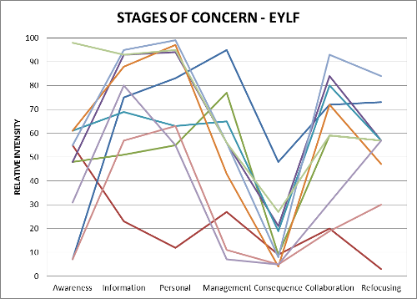

Domain Six Regional FDC sample
Centre | Stage 0 | Stage 1 | Stage 2 | Stage 3 | Stage 4 | Stage 5 | Stage 6
Centre 4 | 48 | 5 | 5 | 2 | 21 | 98 | 11
Domain Six Regional FDC sample average
Awareness | Information | Personal | Management | Consequence | Collaboration | Refocusing
48 | 5 | 5 | 2 | 21 | 98 | 11
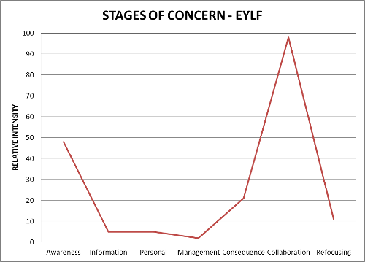

Domain Seven
Domain Seven Major City FDC sample
Centre | Stage 0 | Stage 1 | Stage 2 | Stage 3 | Stage 4 | Stage 5 | Stage 6
Centre 1 | 22 | 63 | 67 | 60 | 27 | 76 | 42
Centre 2 | 40 | 88 | 92 | 98 | 19 | 88 | 22
Domain Seven Major City FDC sample average
Awareness | Information | Personal | Management | Consequence | Collaboration | Refocusing
31 | 75.5 | 79.5 | 79 | 23 | 82 | 32
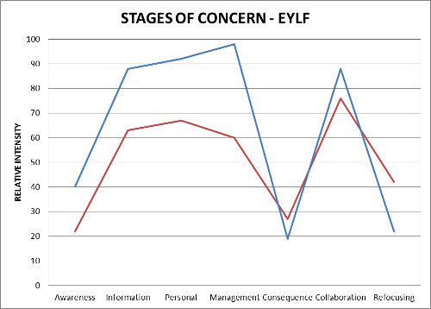
Domain Seven Regional FDC sample
Centre | Stage 0 | Stage 1 | Stage 2 | Stage 3 | Stage 4 | Stage 5 | Stage 6
Centre 3 | 31 | 51 | 99 | 30 | 30 | 84 | 34
Domain Seven Regional FDC sample average
Awareness | Information | Personal | Management | Consequence | Collaboration | Refocusing
31 | 51 | 99 | 30 | 30 | 84 | 34
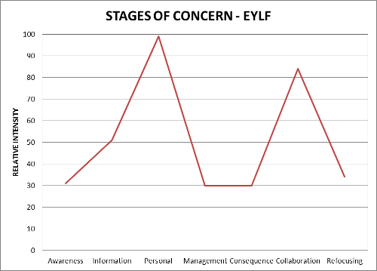

Domain Eight
Domain Eight Regional FDC sample
Centre | Stage 0 | Stage 1 | Stage 2 | Stage 3 | Stage 4 | Stage 5 | Stage 6
Centre 1 | 91 | 80 | 92 | 85 | 38 | 52 | 57
Centre 2 #1 | 14 | 34 | 57 | 47 | 2 | 9 | 11
Centre 2 #2 | 69 | 54 | 63 | 43 | 11 | 28 | 34
Centre 2 #3 | 75 | 60 | 57 | 52 | 9 | 22 | 34
Domain Eight Regional FDC sample average
Awareness | Information | Personal | Management | Consequence | Collaboration | Refocusing
62.25 | 57 | 67.25 | 56.75 | 15 | 27.75 | 34
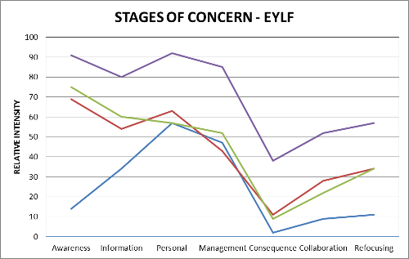
Domain Eight Preschool sample
Centre | Stage 0 | Stage 1 | Stage 2 | Stage 3 | Stage 4 | Stage 5 | Stage 6
Centre 3 | 81 | 23 | 72 | 80 | 63 | 93 | 47
Centre 4 | 31 | 66 | 70 | 30 | 8 | 36 | 26
Centre 5 | 87 | 95 | 99 | 52 | 3 | 31 | 22
Domain Eight Preschool sample average
Awareness | Information | Personal | Management | Consequence | Collaboration | Refocusing
66.33 | 61.33 | 80.33 | 54 | 24.67 | 53.33 | 31.67
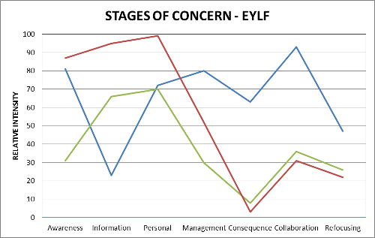

‘ "Assessing for Learning and Development in the Early Years using Observation Scales: REFLECT, RESPECT, RELATE" is a resource designed as a self-paced package to support educators of children from birth to age 8. The package includes a set of scales for critically examining the interactions that take place between adults and children, educators' pedagogy, children's wellbeing and children's involvement. The Observation Scales have proved valuable for critiquing and informing practice through self reflection and inquiry, ideally in collaboration with others.’ http://www.earlyyears.sa.edu.au/a8_publish/modules/publish/content.asp?id=32835&navgrp=3247 accessed 21/08/2011.
SEIFA: Socio-Economic Indexes for Areas http://www.abs.gov.au/websitedbs/D3310114.nsf/home/Seifa_entry_page
SEIFA: Socio-Economic Indexes for Areas http://www.vcgr.vic.gov.au/CA2570C30016EEF3/pages/map_central_goldfields

