CASE STUDY

Anthea Kane

Early childhood educator at Birraleegal Goodni Preschool, Walgett NSW

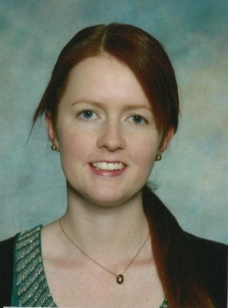
“I love the sense of community in Walgett, it’s great to be able to interact every day with children and families as part of my job!”

Early childhood educator, Anthea Kane is interested in supporting the high quality education of children living in regional Australia. Sharing her experiences teaching and living in a remote community with similarly placed educators during the 2013 Australian Children’s Education and Care Quality Authority (ACECQA )National Quality Framework Conference in Sydney was a fantastic experience. ‘The conference definitely exceeded my expectations!’
One of 14 educators who received sponsorship from the Department of Education to attend the ACECQA Conference; it was the first time Anthea was able to network with early childhood educators interstate, early childhood industry professionals and ACECQA staff.
“I found that each person I met had unique experiences, communities and knowledge to share.”
Anthea found participating in the conference’s seminars a positive experience, which shed light on the structure of the National Quality Framework (NQF) and the role of assessments and ratings.
“Some people feel anxious about assessment but it’s about being prepared, confident and knowing what you do and why.”
“The NQF sets the bar high and so it should, because every child has the right to participate in a high quality early childhood programme.”
Anthea lives and works in Walgett and teaches at Birraleegal Goondi Preschool. During Anthea’s third year of university studies she visited remote NSW through her studies which influenced her decision to take up the position in Walgett when it became available.
‘I moved there not knowing anyone and it was definitely challenging at first but I have never looked back!’
“It can feel isolating at times but as you make more connections with people in the community you really can make the most of being in a remote area.”
“There are some fantastic events in our community which always bring everyone together.”
In 2014 Anthea will begin her fourth year teaching at the preschool and is looking forward to continuing to encourage her local families to engage with and support the Walgett preschool.

