Labour market region of Sydney
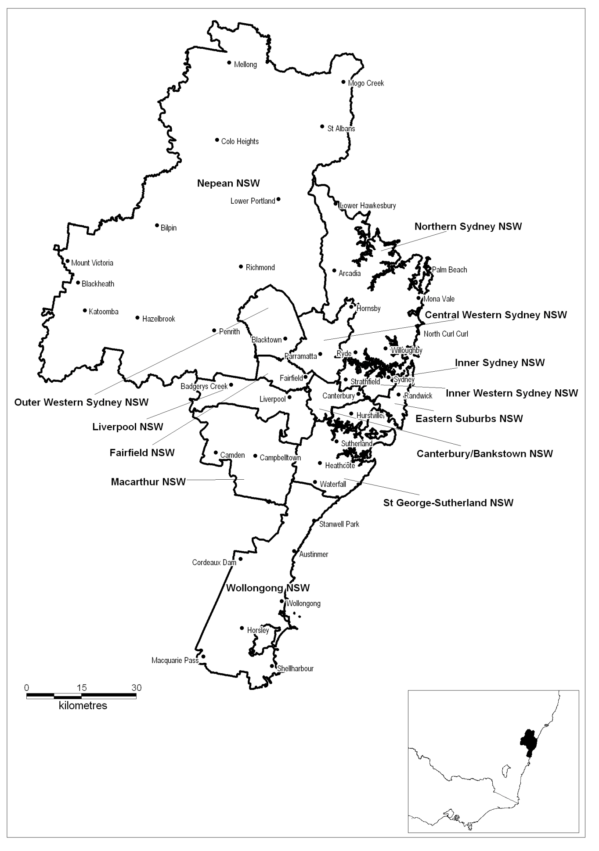

Labour market region of Sydney
Employment Service Area | DES–DMS business available for tender in each ESA (%)
Canterbury/Bankstown NSW | 50
Central Western/Sydney NSW | 47
Eastern Suburbs NSW | 61
Fairfield NSW | 46
Inner Sydney NSW | 43
Inner Western Sydney NSW | 66
Liverpool NSW | 46
Macarthur NSW | 50
Nepean NSW | 62
Northern Sydney NSW | 54
Outer Western Sydney NSW | 48
St George-Sutherland NSW | 49
Wollongong NSW | 59
Note: If you are tendering to deliver a Specialist Service you must demonstrate the need (i.e. satisfactory demand) for these Services in the ESA. You should take into account the labour market data and other information that is provided on the Labour Market Information Portal, www.employment.gov.au/lmip.

Labour market region of Hunter
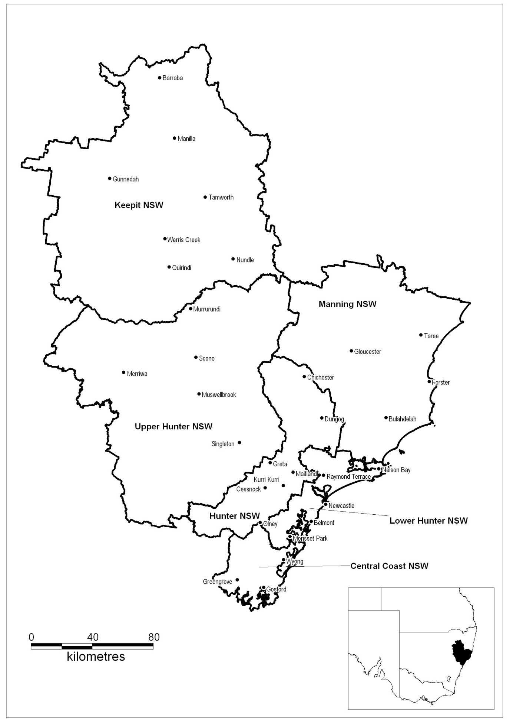

Labour market region of Hunter
Employment Service Area | DES–DMS business available for tender in each ESA (%)
Central Coast NSW | 46
Hunter NSW | 56
Keepit NSW | 75
Lower Hunter NSW | 56
Manning NSW | 60
Upper Hunter NSW | 45
Note: If you are tendering to deliver a Specialist Service you must demonstrate the need (i.e. satisfactory demand) for these Services in the ESA. You should take into account the labour market data and other information that is provided on the Labour Market Information Portal, www.employment.gov.au/lmip.

Labour market region of Northern New South Wales
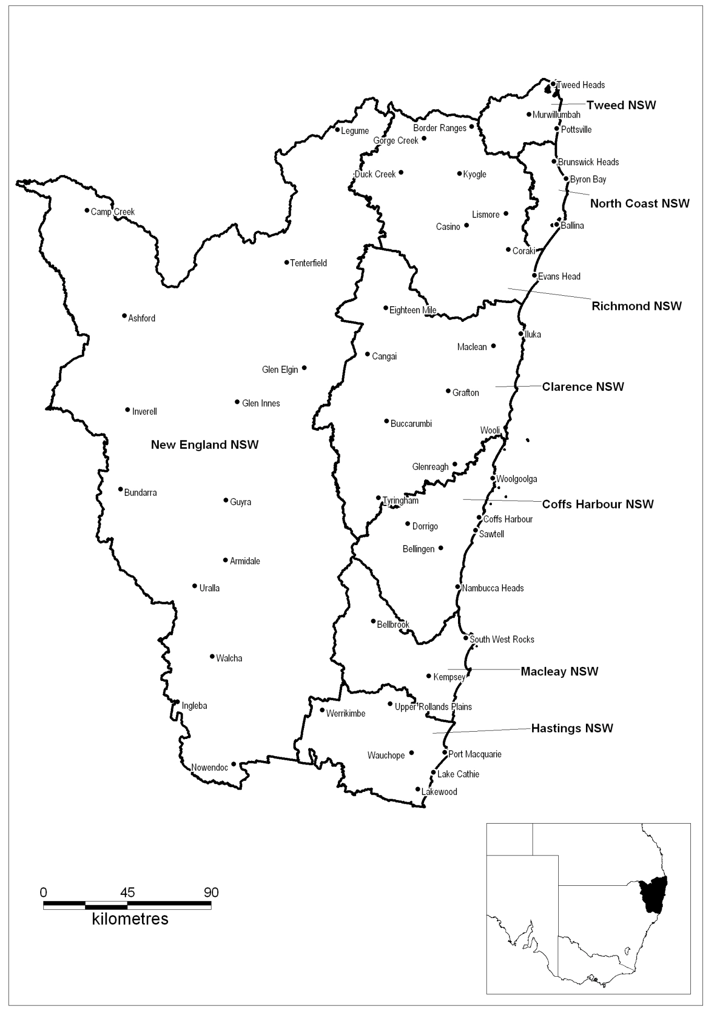

Labour market region of Northern New South Wales
Employment Service Area | DES–DMS business available for tender in each ESA (%)
Clarence NSW | 58
Coffs Harbour NSW | n/a
Hastings NSW | 57
Macleay NSW | 40
New England NSW | 60
North Coast NSW | 75
Richmond NSW | 52
Tweed NSW | 36
Note: If you are tendering to deliver a Specialist Service you must demonstrate the need (i.e. satisfactory demand) for these Services in the ESA. You should take into account the labour market data and other information that is provided on the Labour Market Information Portal, www.employment.gov.au/lmip.

Labour market region of Western New South Wales
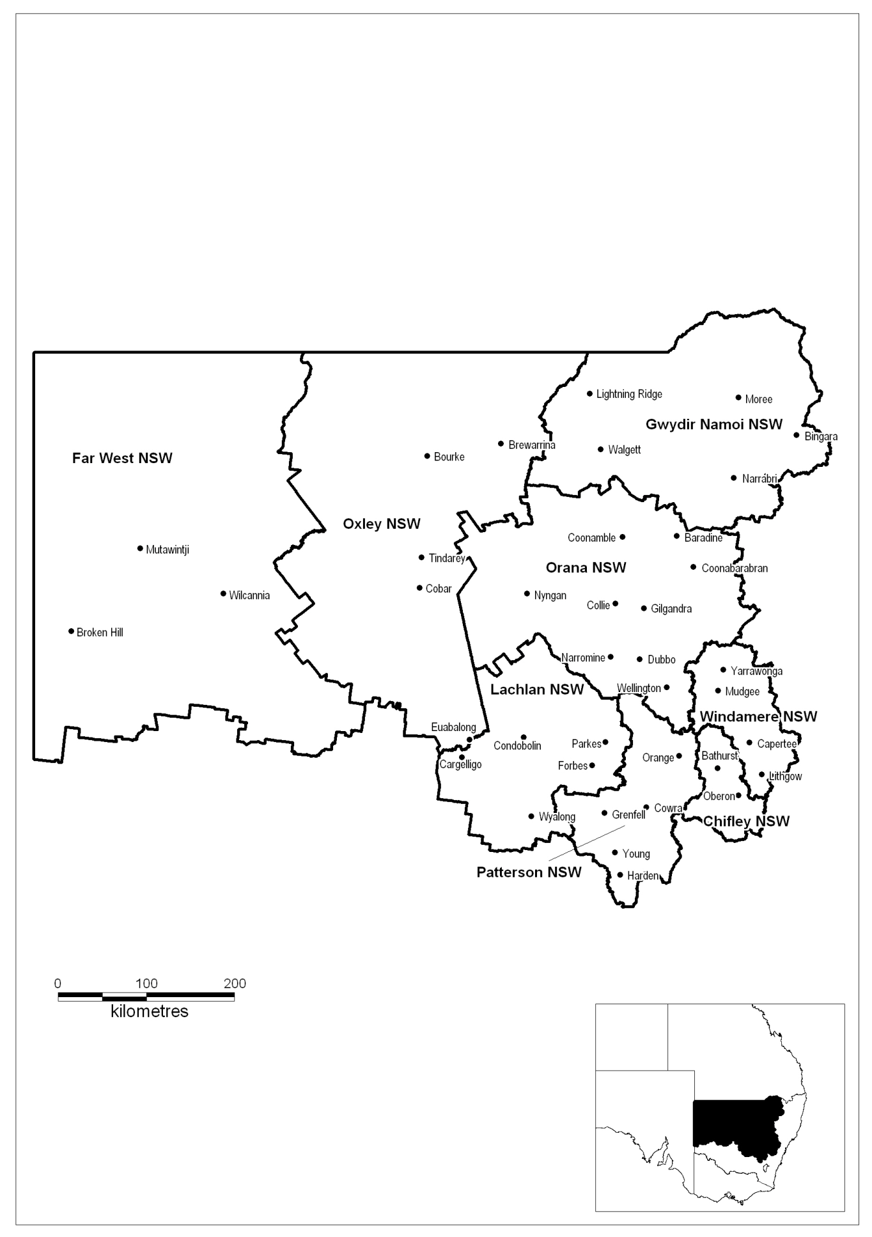

Labour market region of Western New South Wales
Employment Service Area | DES–DMS business available for tender in each ESA (%)
Chifley NSW | 69
Far West NSW (Excised Non-remote area only) | 77
Gwydir Namoi NSW | 50
Lachlan NSW | 45
Orana NSW | 53
Oxley NSW | n/a
Patterson NSW | 61
Windamere NSW | 49
Note: If you are tendering to deliver a Specialist Service you must demonstrate the need (i.e. satisfactory demand) for these Services in the ESA. You should take into account the labour market data and other information that is provided on the Labour Market Information Portal, www.employment.gov.au/lmip.

Labour market region of Southern New South Wales
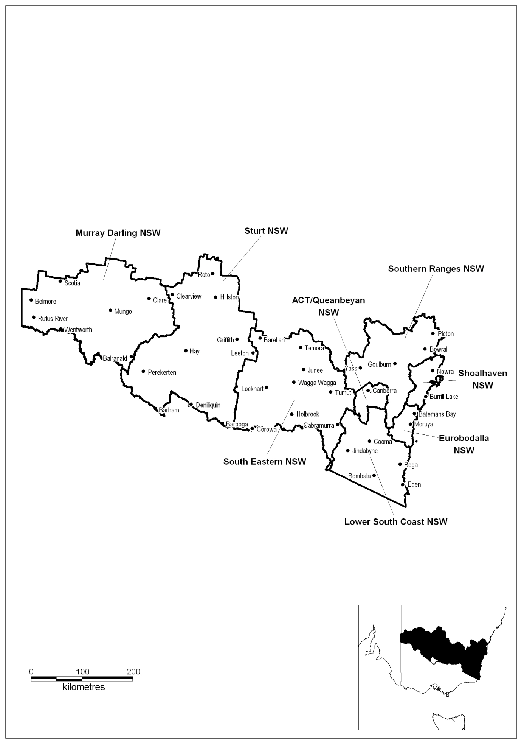

Labour market region of Southern New South Wales
Employment Service Area | DES–DMS business available for tender in each ESA (%)
ACT/Queanbeyan NSW | 68
Eurobodalla NSW | 76
Lower South Coast NSW | 77
Murray Darling NSW | n/a
Shoalhaven NSW | 54
South Eastern NSW | n/a
Southern Ranges NSW | 68
Sturt NSW | 52
Note: If you are tendering to deliver a Specialist Service you must demonstrate the need (i.e. satisfactory demand) for these Services in the ESA. You should take into account the labour market data and other information that is provided on the Labour Market Information Portal, www.employment.gov.au/lmip.

Labour market region of Melbourne
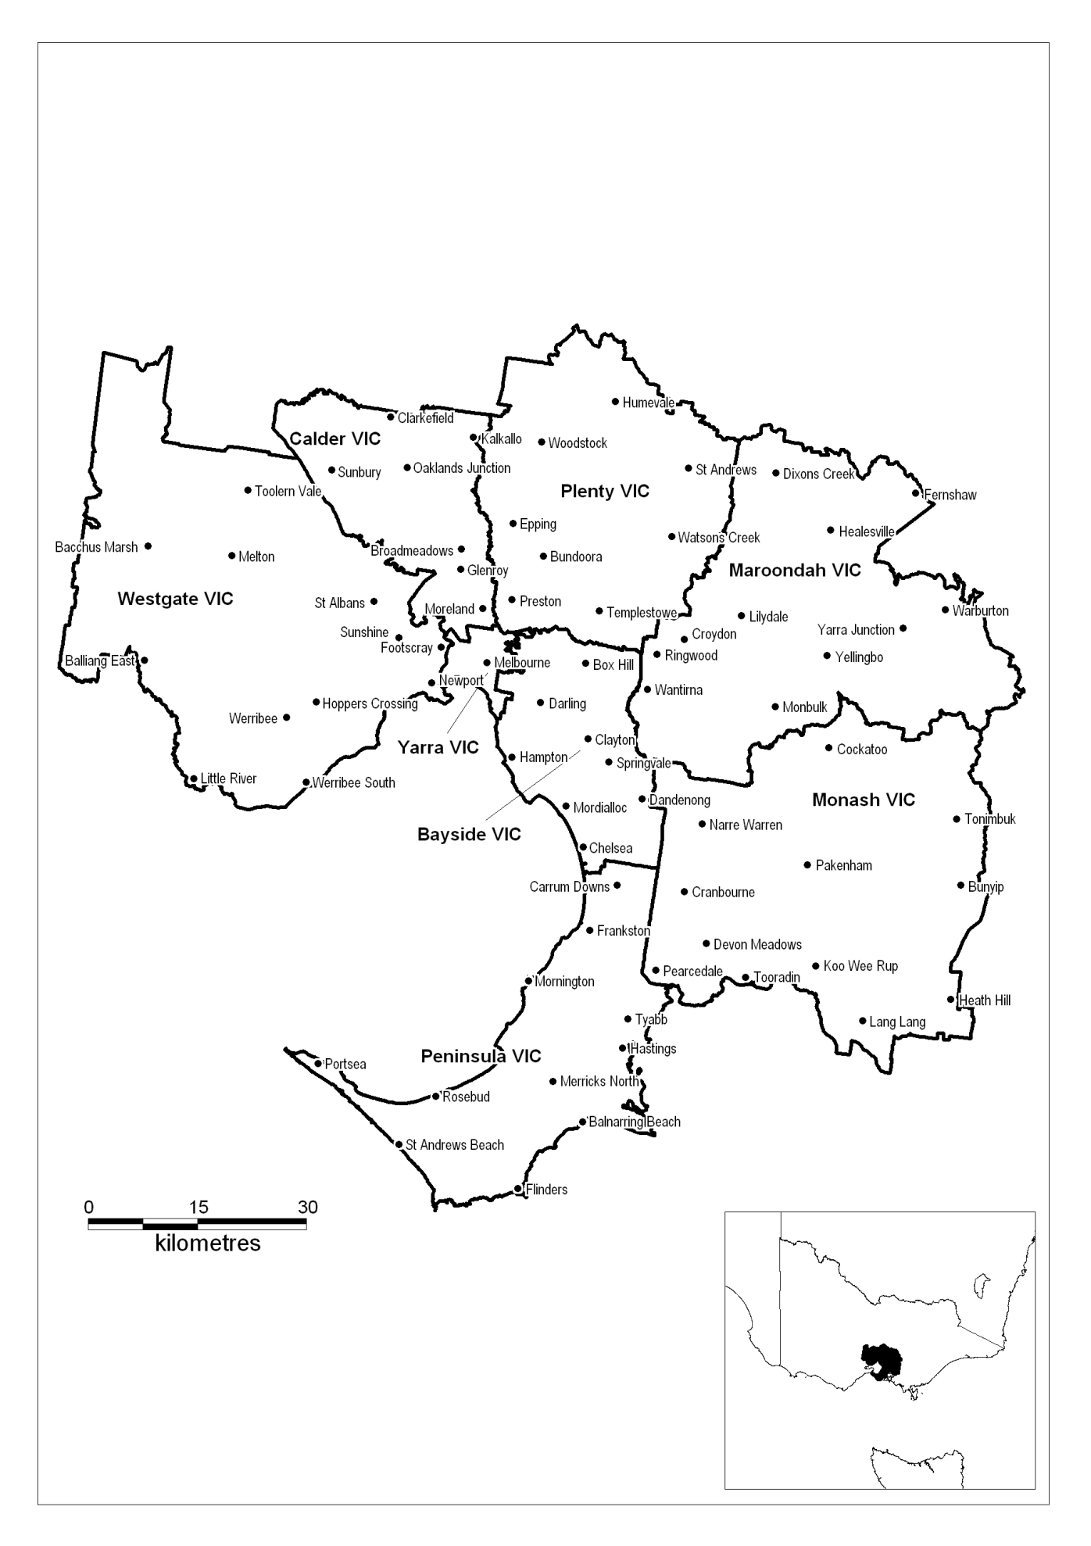
Labour market region of Melbourne
Employment Service Area | DES–DMS business available for tender in each ESA (%)
Bayside Vic | 57
Calder Vic | n/a
Maroondah Vic | 43
Monash Vic | 48
Peninsula Vic | 34
Plenty Vic | 49
Westgate Vic | n/a
Yarra Vic | n/a
Note: If you are tendering to deliver a Specialist Service you must demonstrate the need (i.e. satisfactory demand) for these Services in the ESA. You should take into account the labour market data and other information that is provided on the Labour Market Information Portal, www.employment.gov.au/lmip.

Labour market region of Western Victoria
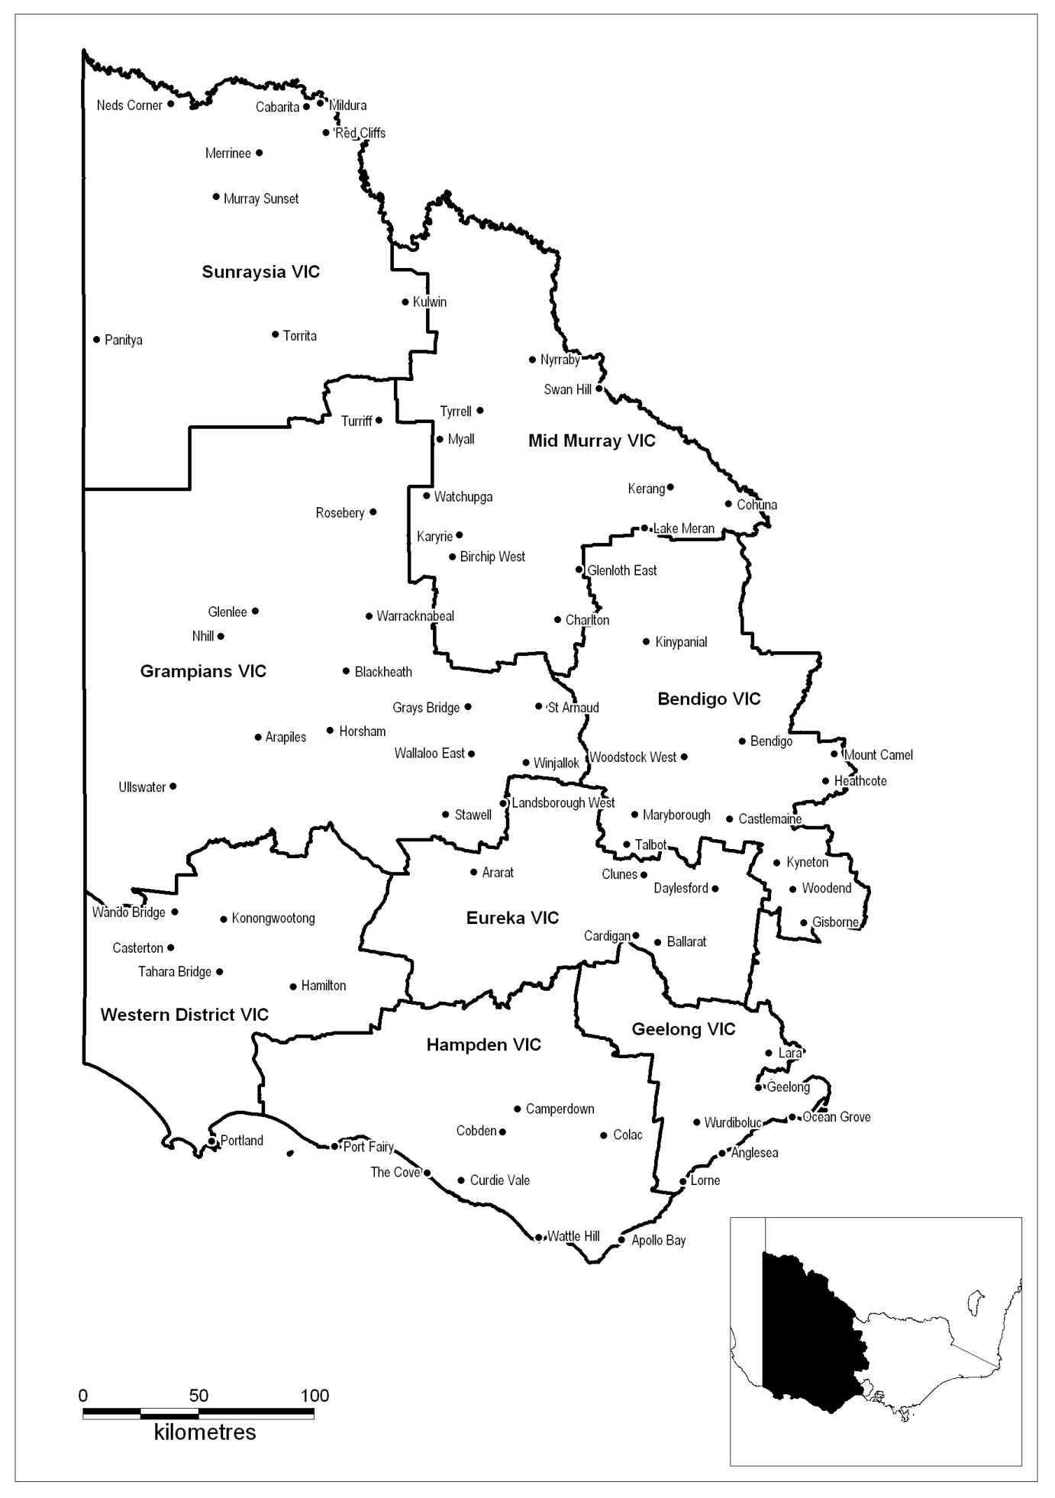

Labour market region of Western Victoria
Employment Service Area | DES–DMS business available for tender in each ESA (%)
Bendigo Vic | 30
Eureka Vic | 54
Geelong Vic | 38
Grampians Vic | n/a
Hampden Vic | 75
Mid Murray Vic | 76
Sunraysia Vic | 75
Western District Vic | n/a
Note: If you are tendering to deliver a Specialist Service you must demonstrate the need (i.e. satisfactory demand) for these Services in the ESA. You should take into account the labour market data and other information that is provided on the Labour Market Information Portal, www.employment.gov.au/lmip.

Labour market region of Eastern Victoria
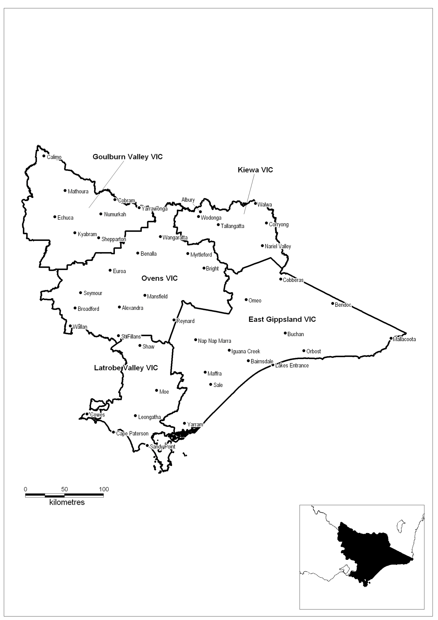

Labour market region of Eastern Victoria
Employment Service Area | DES–DMS business available for tender in each ESA (%)
East Gippsland Vic | 54
Goulburn Valley Vic | 50
Kiewa Vic | 75
Latrobe Valley Vic | 40
Ovens Vic | 51
Note: If you are tendering to deliver a Specialist Service you must demonstrate the need (i.e. satisfactory demand) for these Services in the ESA. You should take into account the labour market data and other information that is provided on the Labour Market Information Portal, www.employment.gov.au/lmip.

Labour market region of Brisbane
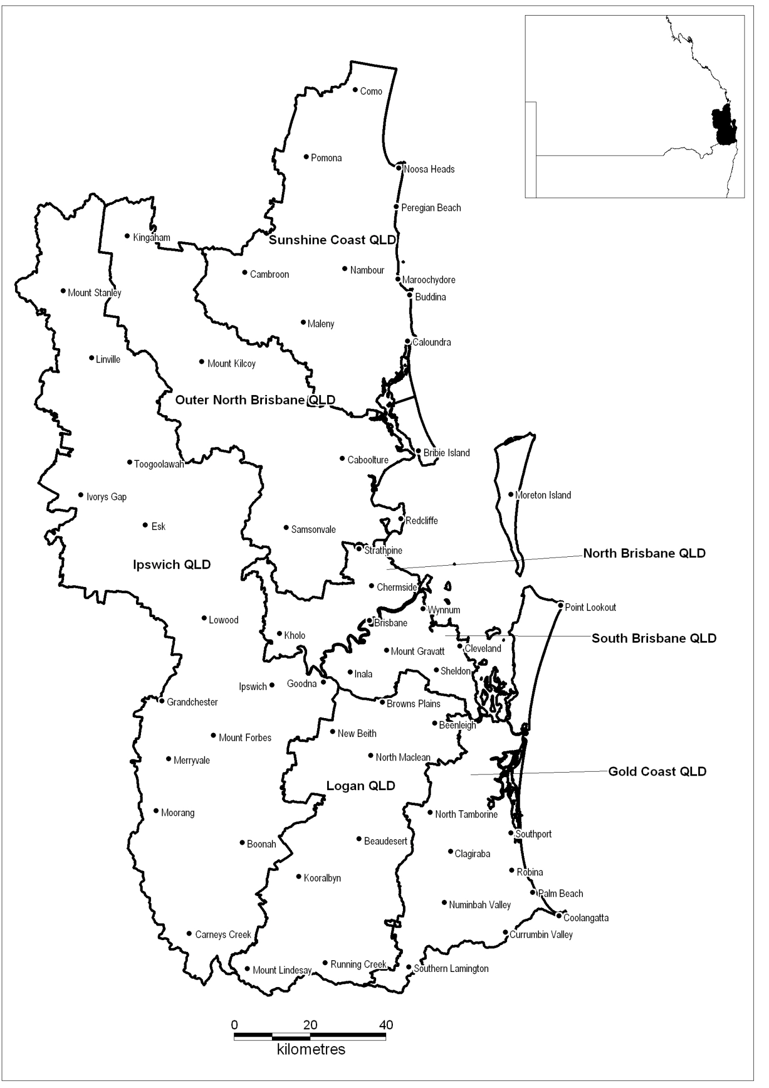

Labour market region of Brisbane
Employment Service Area | DES–DMS business available for tender in each ESA (%)
Gold Coast Qld | 44
Ipswich Qld | 55
Logan Qld | 43
North Brisbane Qld | 65
Outer North Brisbane Qld | 56
South Brisbane Qld | 27
Sunshine Coast Qld | 60
Note: If you are tendering to deliver a Specialist Service you must demonstrate the need (i.e. satisfactory demand) for these Services in the ESA. You should take into account the labour market data and other information that is provided on the Labour Market Information Portal, www.employment.gov.au/lmip.

Labour market region of Central and North Queensland
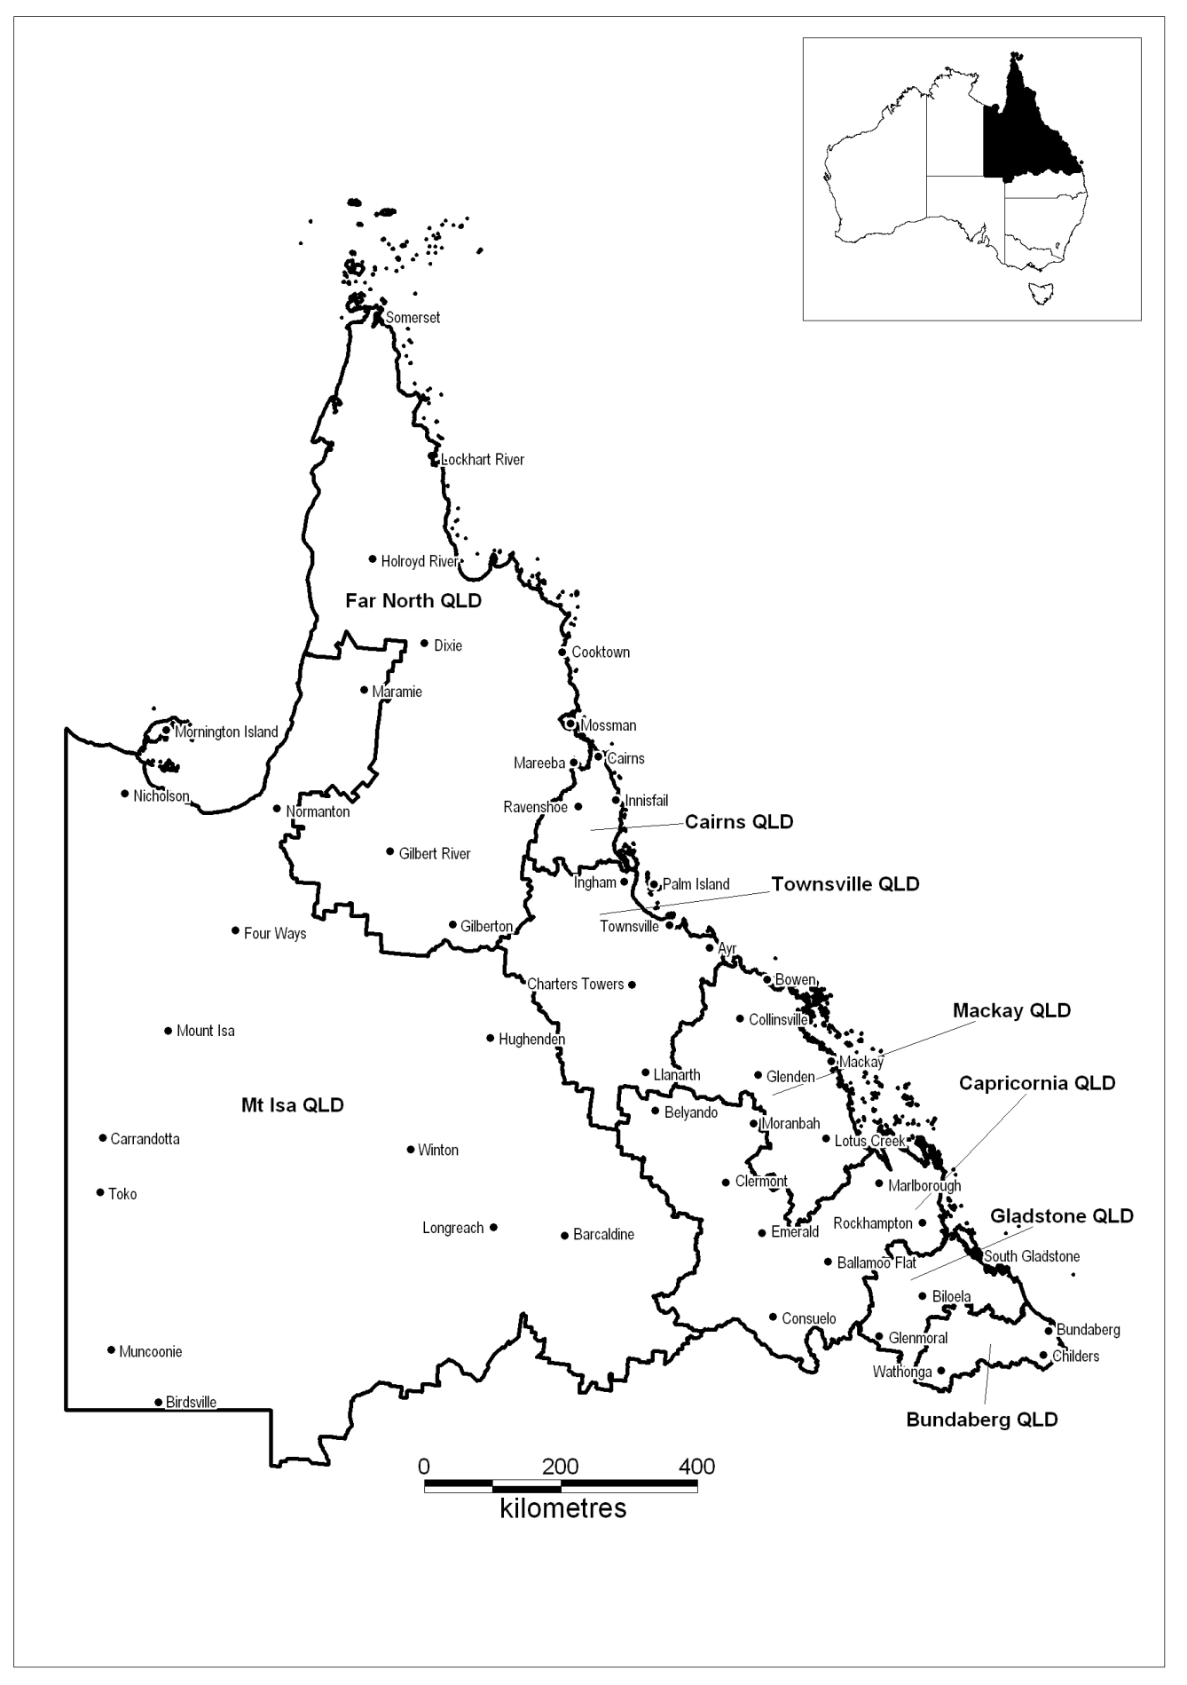

Labour market region of Central and North Queensland
Employment Service Area | DES–DMS business available for tender in each ESA (%)
Bundaberg Qld | 43
Cairns Qld | 49
Capricornia Qld | 58
Far North Qld | n/a
Gladstone Qld | 50
Mackay Qld | 72
Mt Isa Qld (Excised Non-remote area only) | n/a
Townsville Qld (Excluding the Excised Remote Area of Palm Island) | 57
Note: If you are tendering to deliver a Specialist Service you must demonstrate the need (i.e. satisfactory demand) for these Services in the ESA. You should take into account the labour market data and other information that is provided on the Labour Market Information Portal, www.employment.gov.au/lmip.

Labour market region of Southern Queensland
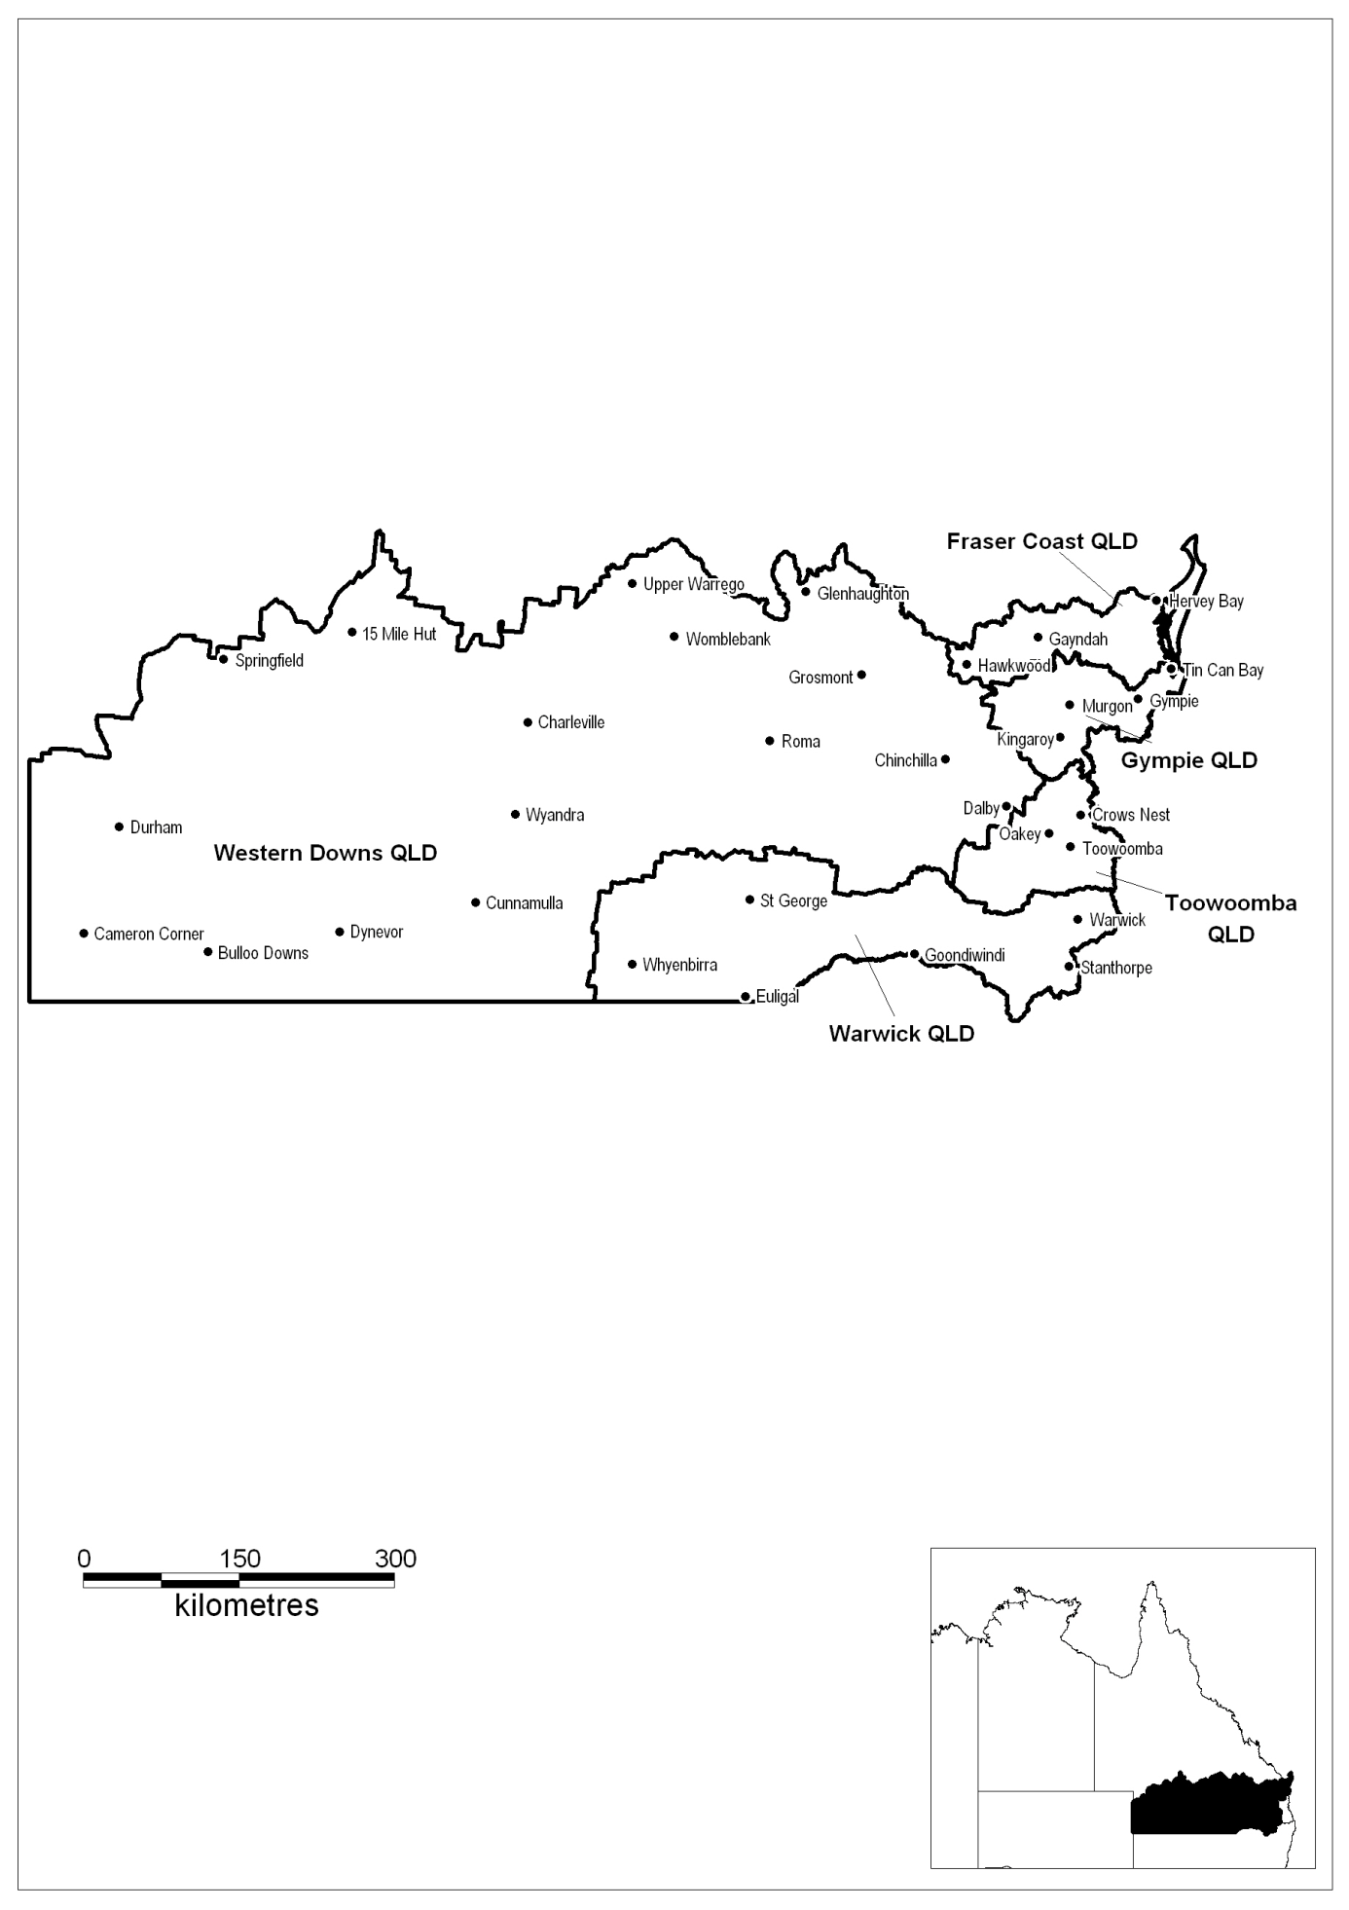

Labour market region of Southern Queensland
Employment Service Area | DES–DMS business available for tender in each ESA (%)
Fraser Coast Qld | 55
Gympie Qld | 43
Toowoomba Qld | 62
Warwick Qld | 74
Western Downs Qld  (Excised Non-remote area only) | 50
Note: If you are tendering to deliver a Specialist Service you must demonstrate the need (i.e. satisfactory demand) for these Services in the ESA. You should take into account the labour market data and other information that is provided on the Labour Market Information Portal, www.employment.gov.au/lmip.

Labour market region of Adelaide
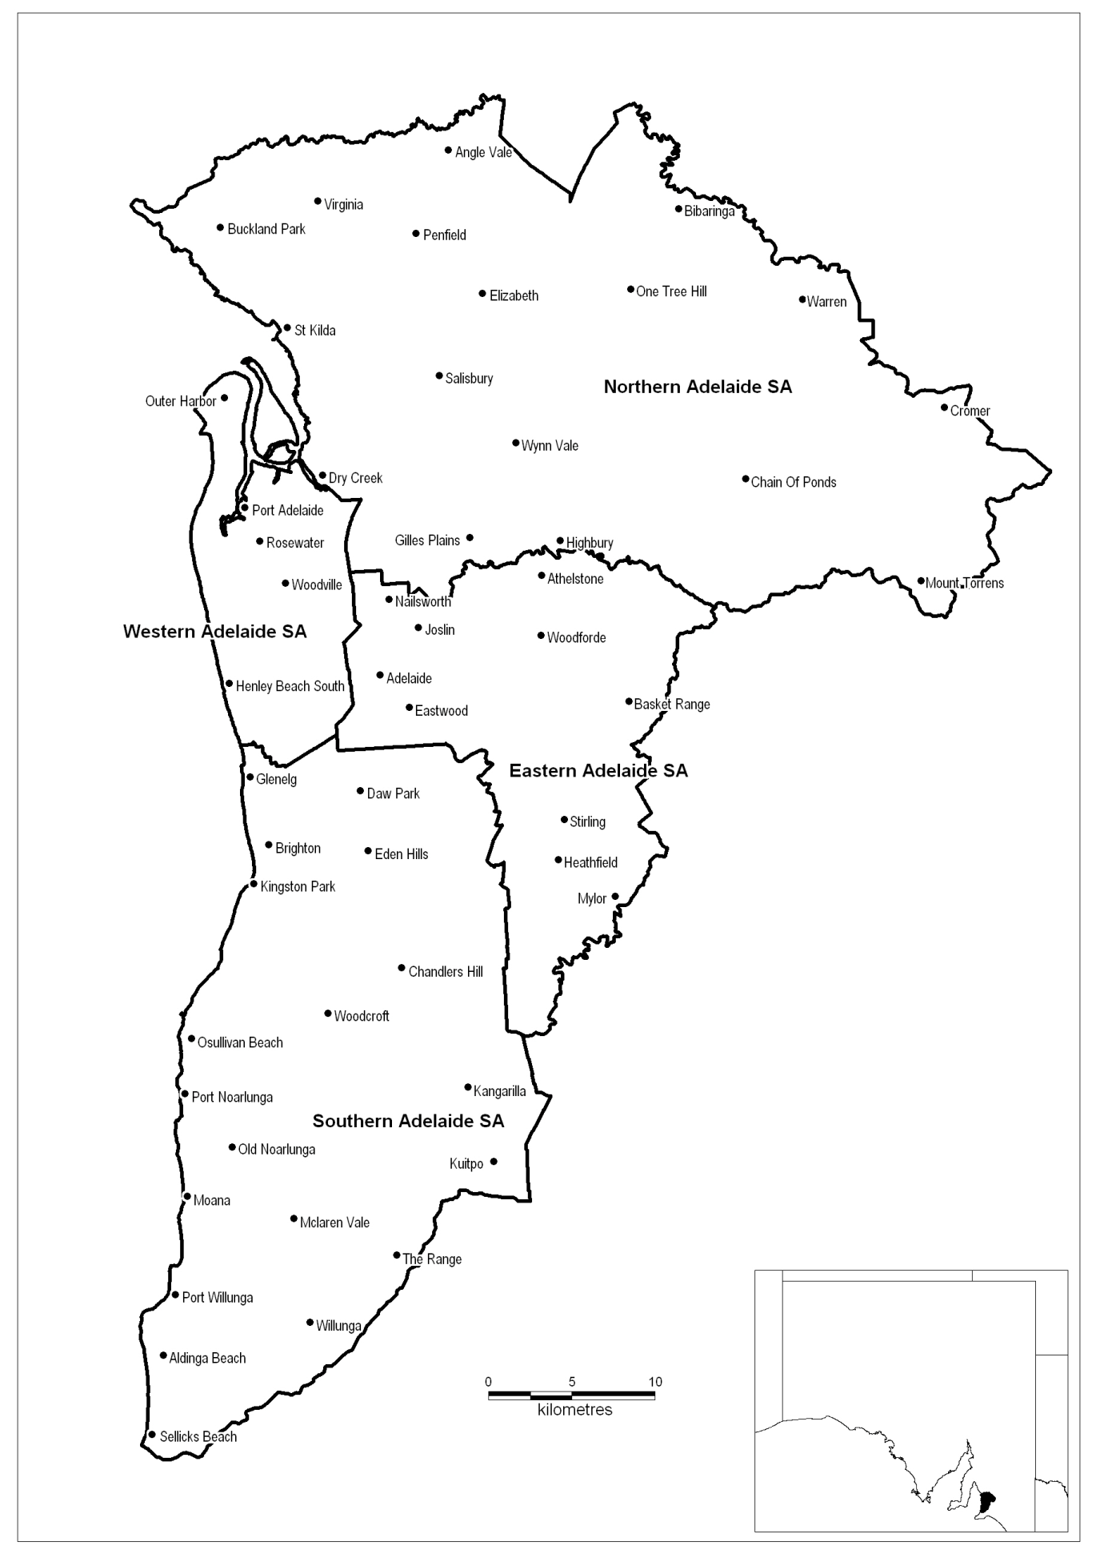

Labour market region of Adelaide
Employment Service Area | DES–DMS business available for tender in each ESA (%)
Eastern Adelaide SA | 61
Northern Adelaide SA | 49
Southern Adelaide SA | 57
Western Adelaide SA | 53
Note: If you are tendering to deliver a Specialist Service you must demonstrate the need (i.e. satisfactory demand) for these Services in the ESA. You should take into account the labour market data and other information that is provided on the Labour Market Information Portal, www.employment.gov.au/lmip.

Labour market region of South Australia Country
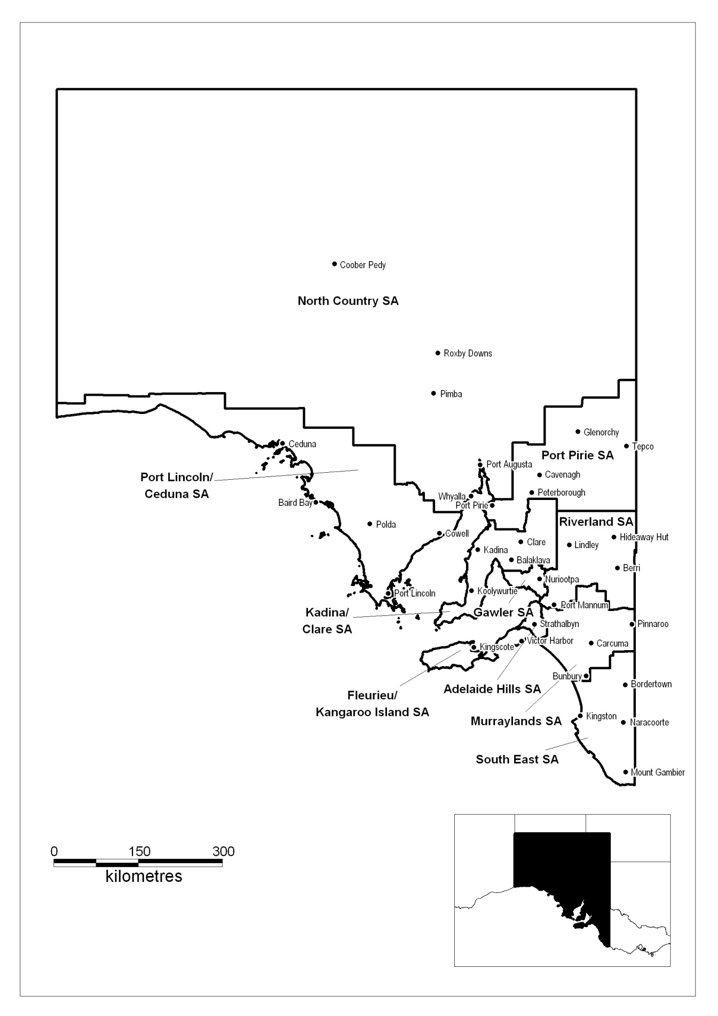

Labour market region of South Australia Country
Employment Service Area | DES–DMS business available for tender in each ESA (%)
Adelaide Hills SA | 41
Fleurieu/Kangaroo Island SA | n/a
Gawler SA | n/a
Kadina/Clare SA | 68
Murraylands SA | 67
North Country SA (Excised Non-remote area only) | 76
Port Lincoln/Ceduna SA  (Excised Non-remote area only) | 67
Port Pirie SA | 50
Riverland SA | 40
South East SA | 74
Note: If you are tendering to deliver a Specialist Service you must demonstrate the need (i.e. satisfactory demand) for these Services in the ESA. You should take into account the labour market data and other information that is provided on the Labour Market Information Portal, www.employment.gov.au/lmip.

Labour market region of Perth
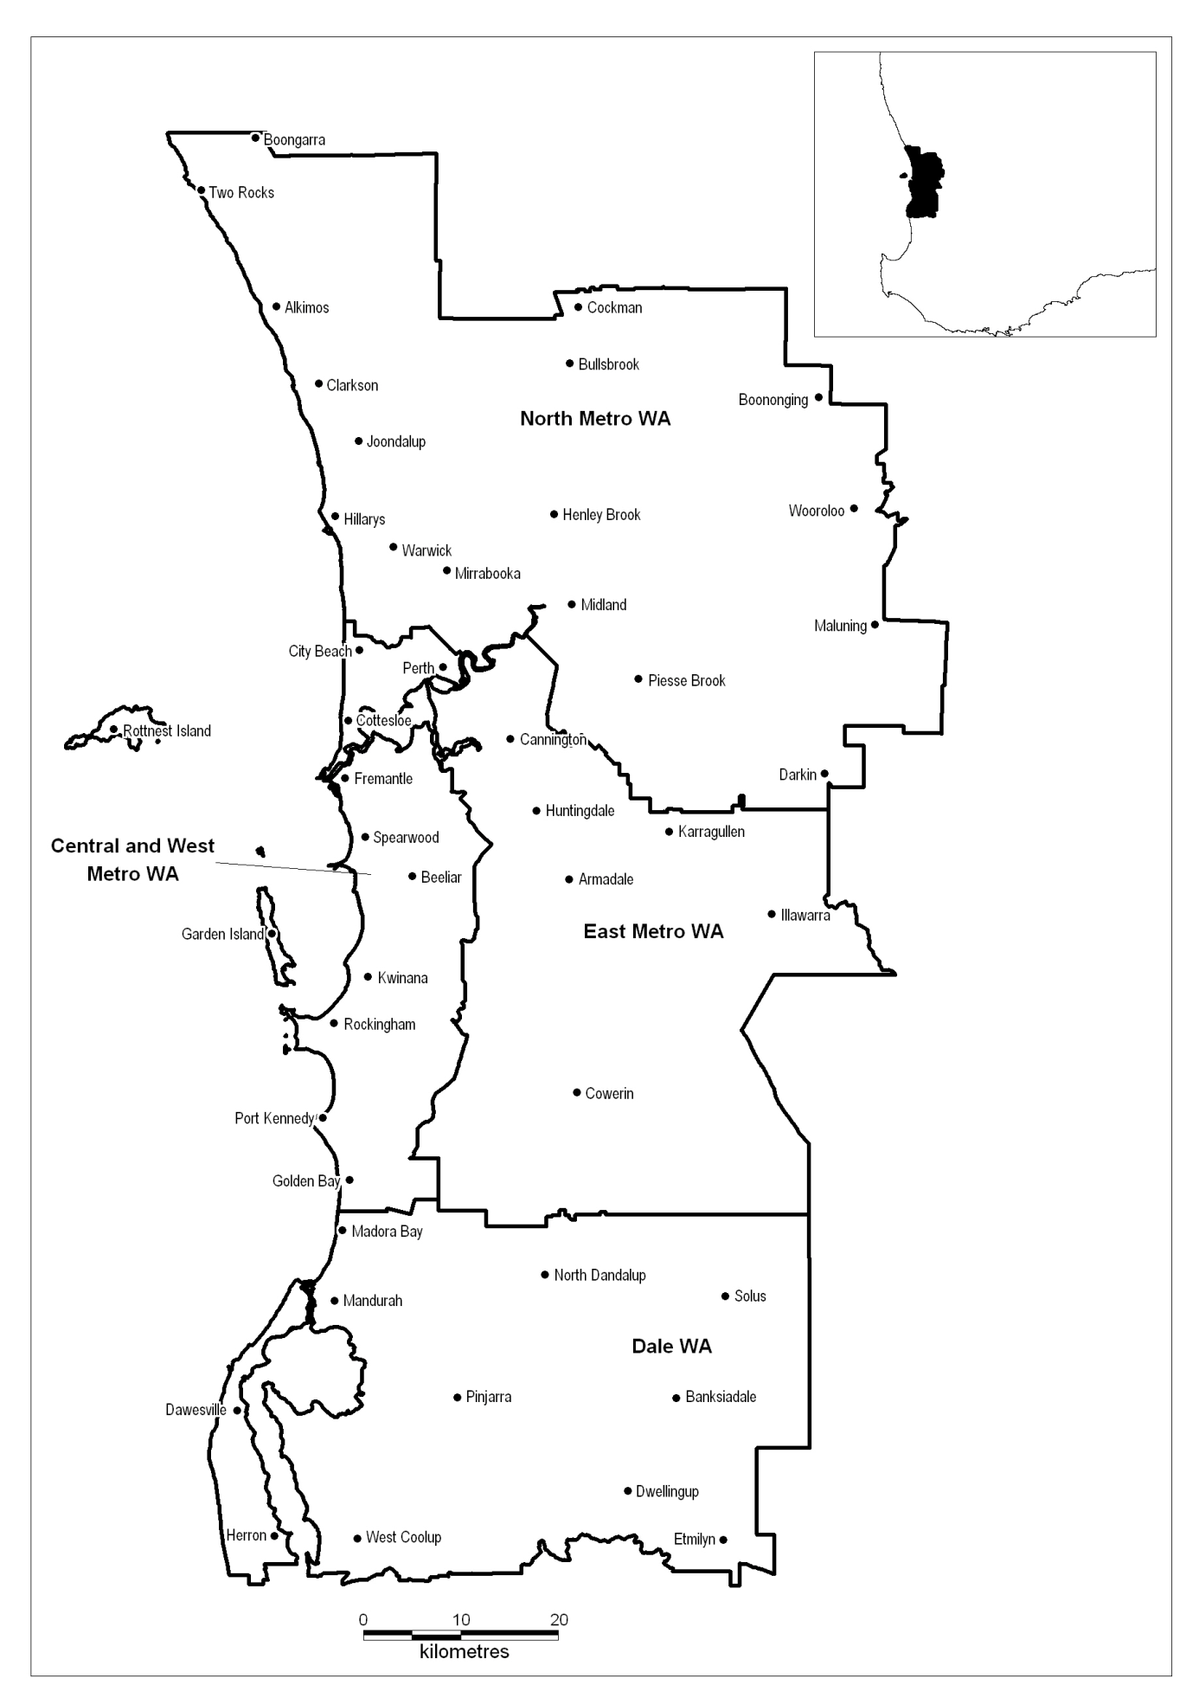

Labour market region of Perth
Employment Service Area | DES–DMS business available for tender in each ESA (%)
Central and West Metro WA | 64
Dale WA | 77
East Metro WA | 59
North Metro WA | 53
Note: If you are tendering to deliver a Specialist Service you must demonstrate the need (i.e. satisfactory demand) for these Services in the ESA. You should take into account the labour market data and other information that is provided on the Labour Market Information Portal, www.employment.gov.au/lmip.

Labour market region of Greater Western Australia
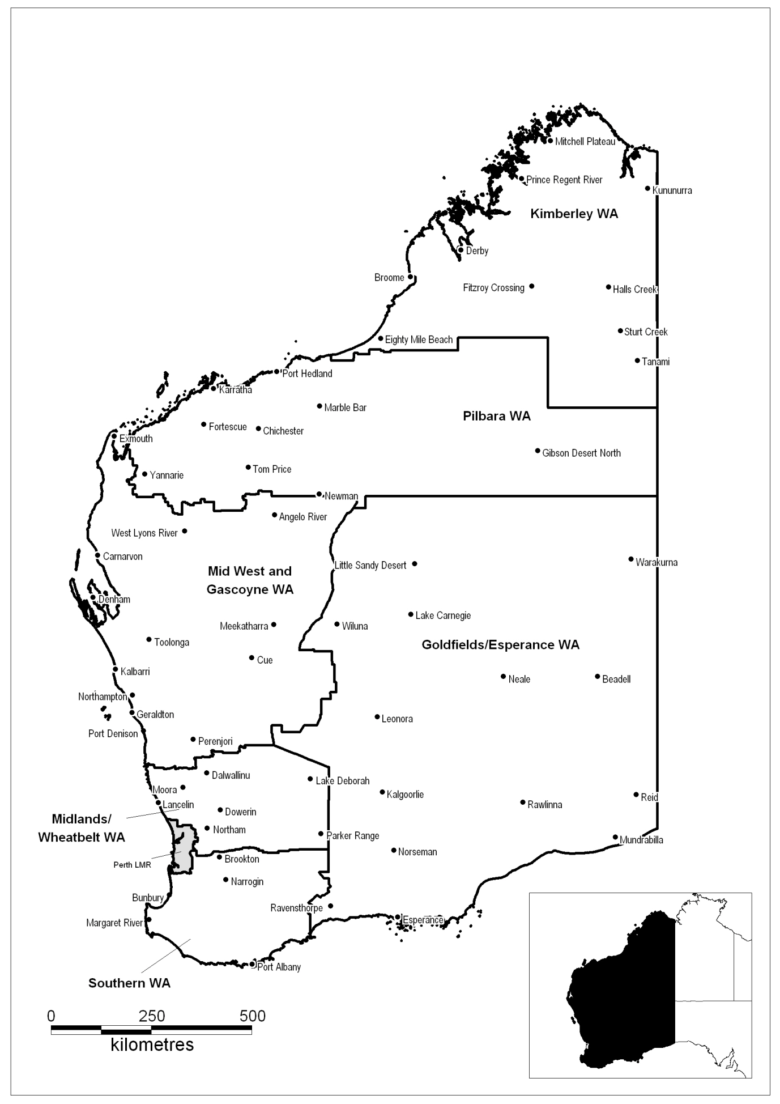

Labour market region of Greater Western Australia
Employment Service Area | DES–DMS business available for tender in each ESA (%)
Goldfields/Esperance WA  (Excised Non-remote area only) | 77
Kimberley WA (Excised Non-remote area only) | 100
Mid West and Gascoyne WA  (Excised Non-remote area only) | 65
Midlands/Wheatbelt WA | n/a
Pilbara WA | n/a
Southern WA | 41
Note: If you are tendering to deliver a Specialist Service you must demonstrate the need (i.e. satisfactory demand) for these Services in the ESA. You should take into account the labour market data and other information that is provided on the Labour Market Information Portal, www.employment.gov.au/lmip.

Labour market region of Tasmania
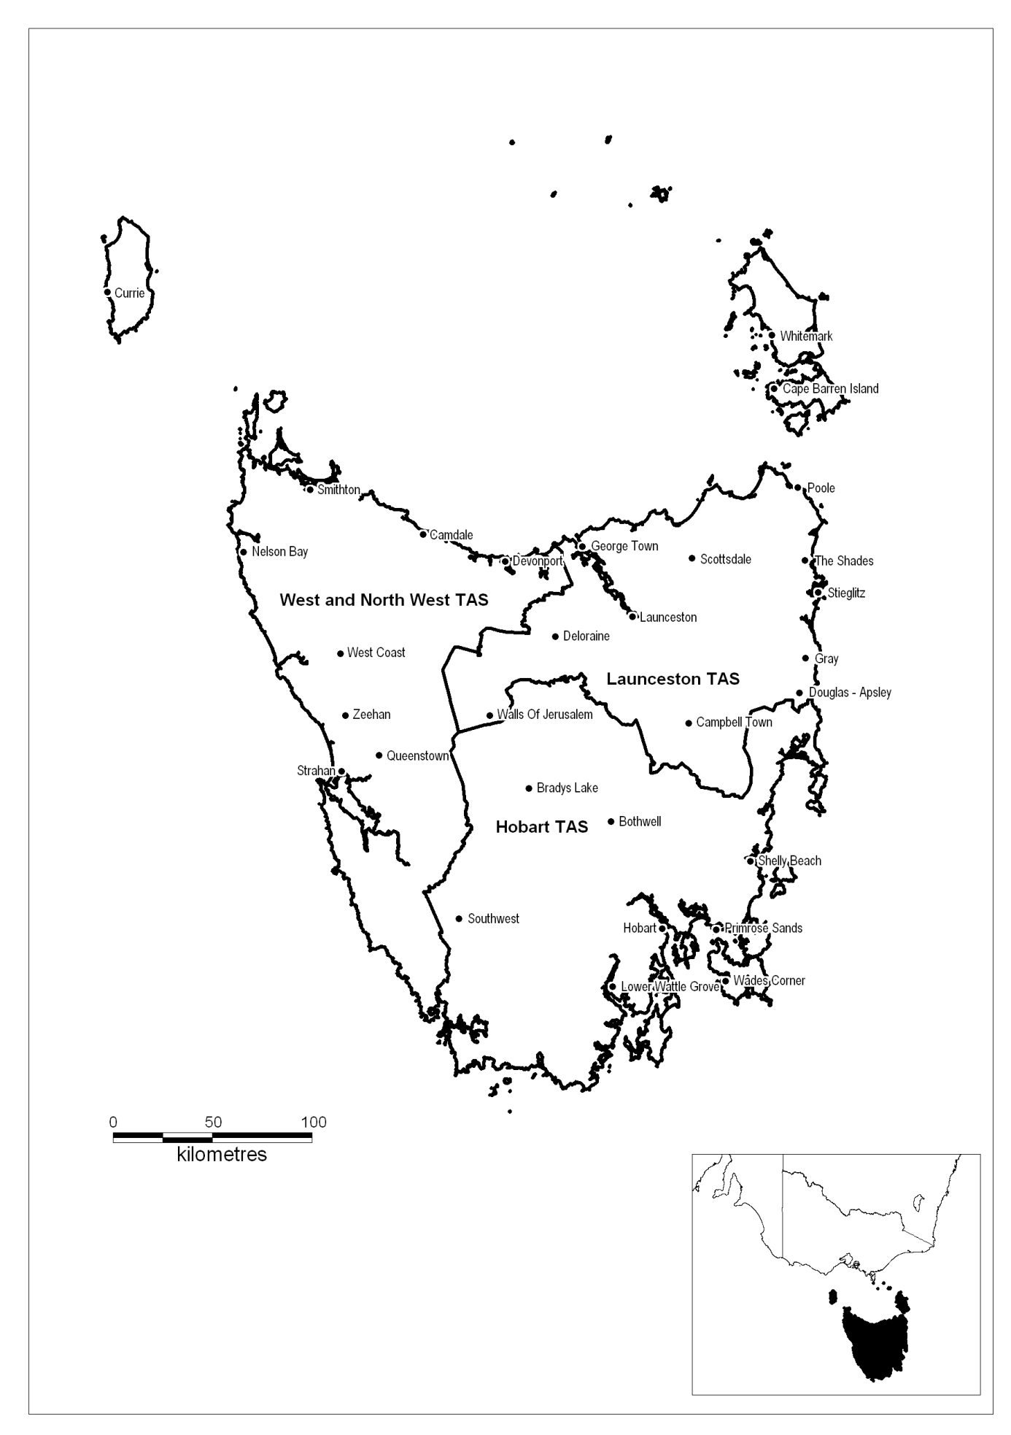

Labour market region of Tasmania
Employment Service Area | DES–DMS business available for tender in each ESA (%)
Hobart Tas | 64
Launceston Tas | 63
West and North West Tas | 54
Note: If you are tendering to deliver a Specialist Service you must demonstrate the need (i.e. satisfactory demand) for these Services in the ESA. You should take into account the labour market data and other information that is provided on the Labour Market Information Portal, www.employment.gov.au/lmip.

Labour market region of Northern Territory
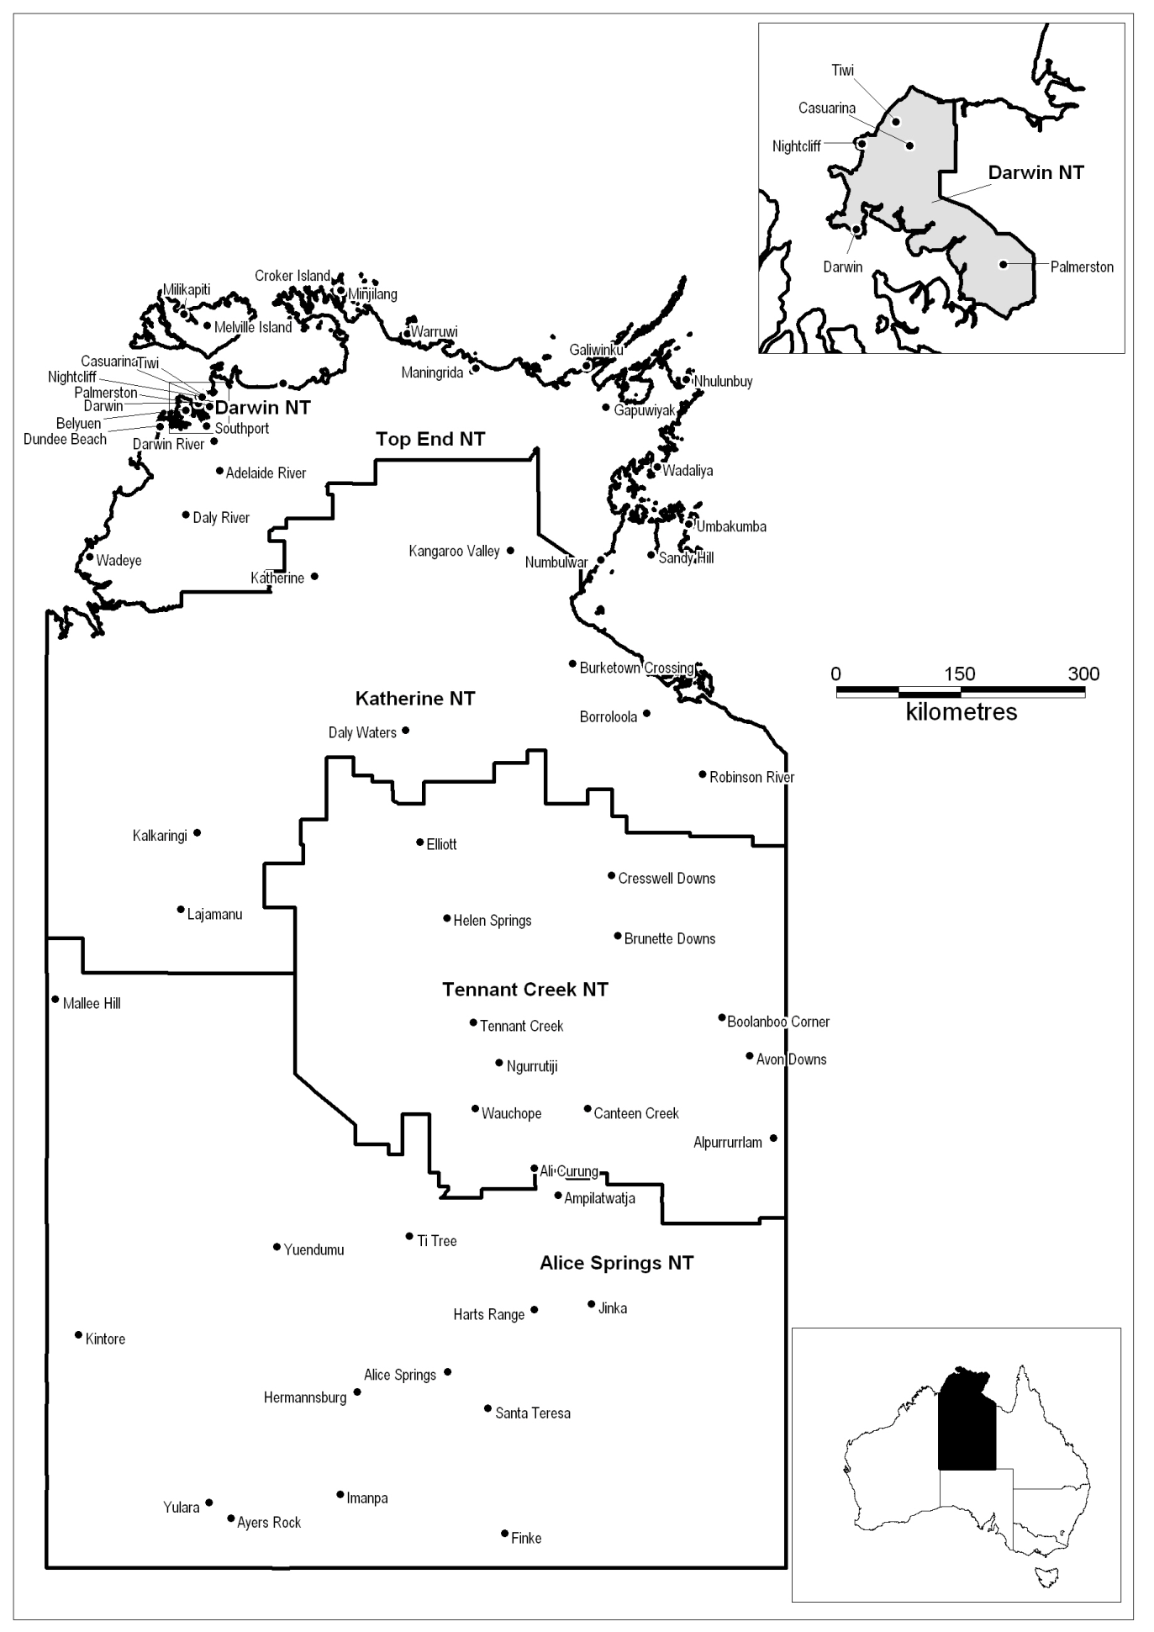

Labour market region of Northern Territory
Employment Service Area | DES–DMS business available for tender in each ESA (%)
Alice Springs NT (Excised Non-remote area only) | N/A
Darwin NT | 64
Katherine NT | N/A
Tennant Creek NT | N/A
Top End NT | N/A
Note: If you are tendering to deliver a Specialist Service you must demonstrate the need (i.e. satisfactory demand) for these Services in the ESA. You should take into account the labour market data and other information that is provided on the Labour Market Information Portal, www.employment.gov.au/lmip.

Excised non-remote area of Western Downs
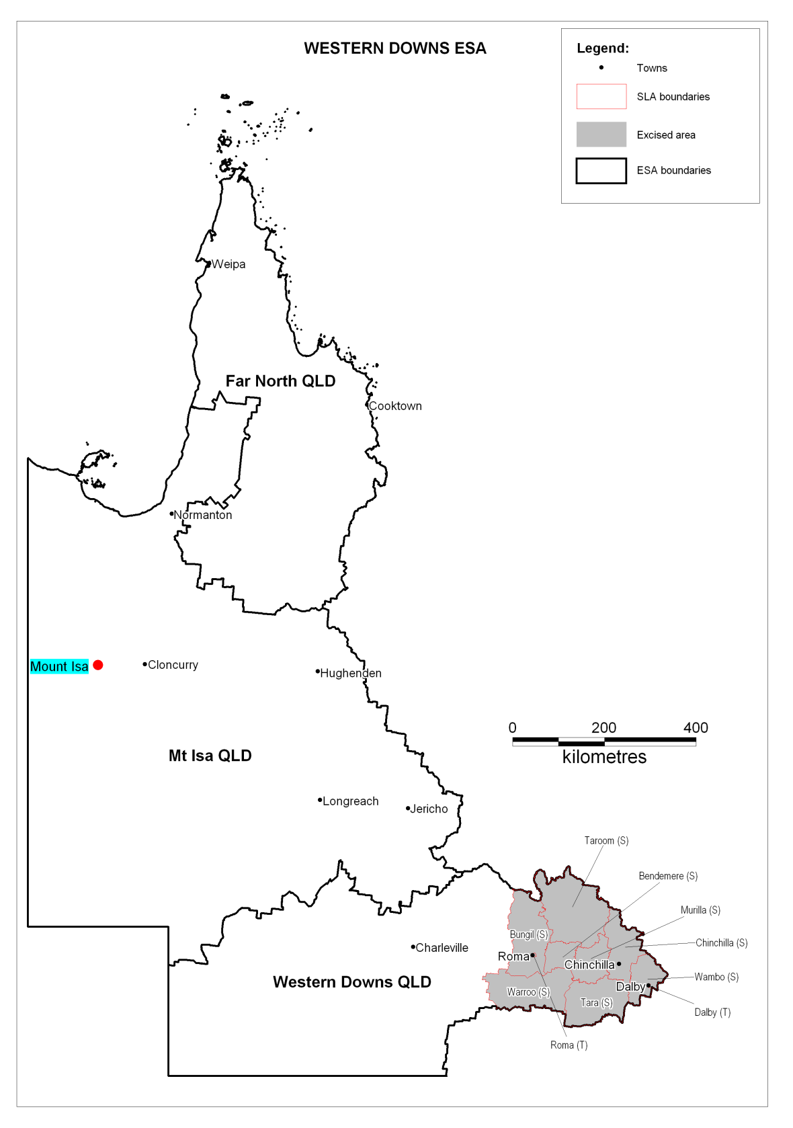
Excised non-remote area of Mount Isa
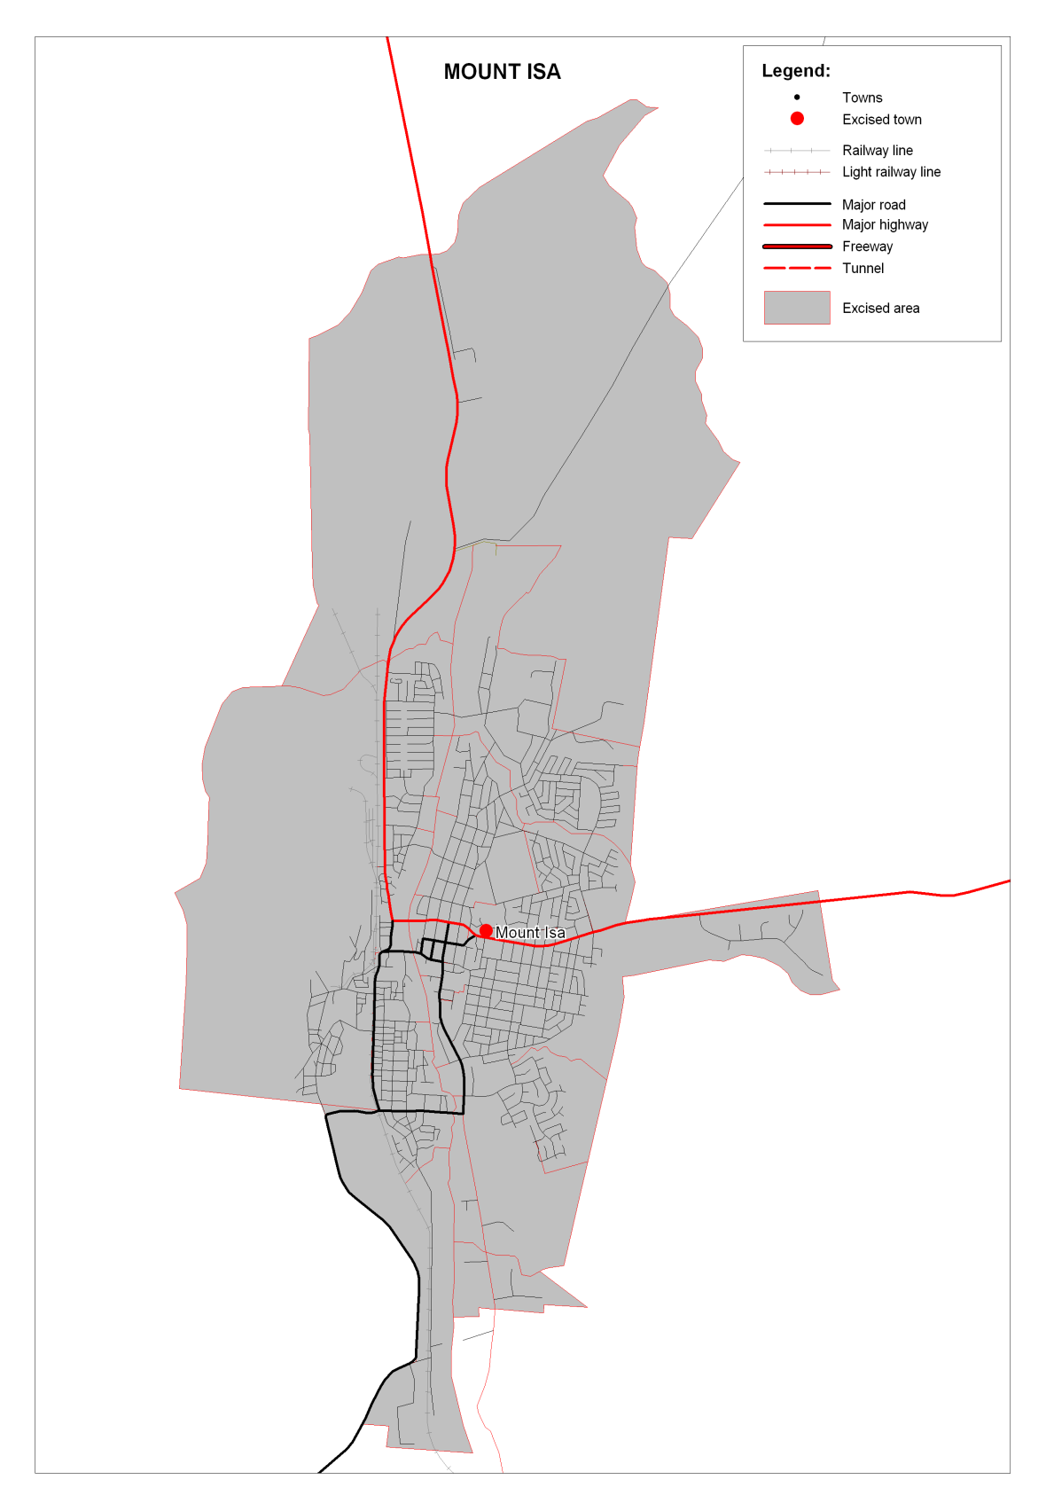

Excised non-remote area of Broken Hill
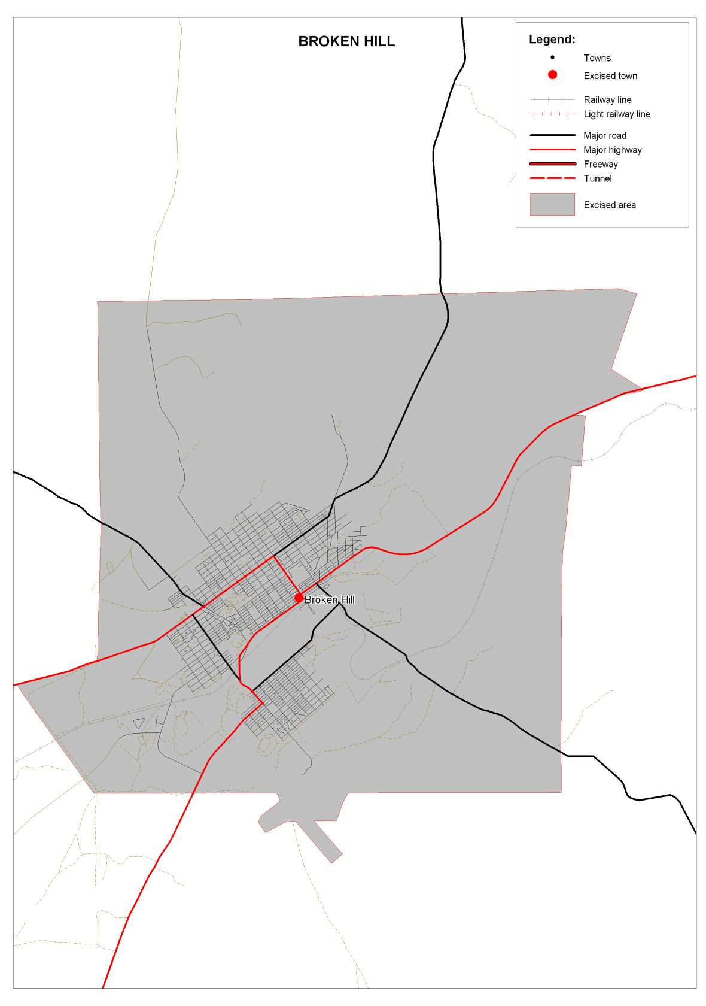
Excised non-remote area of Alice Springs
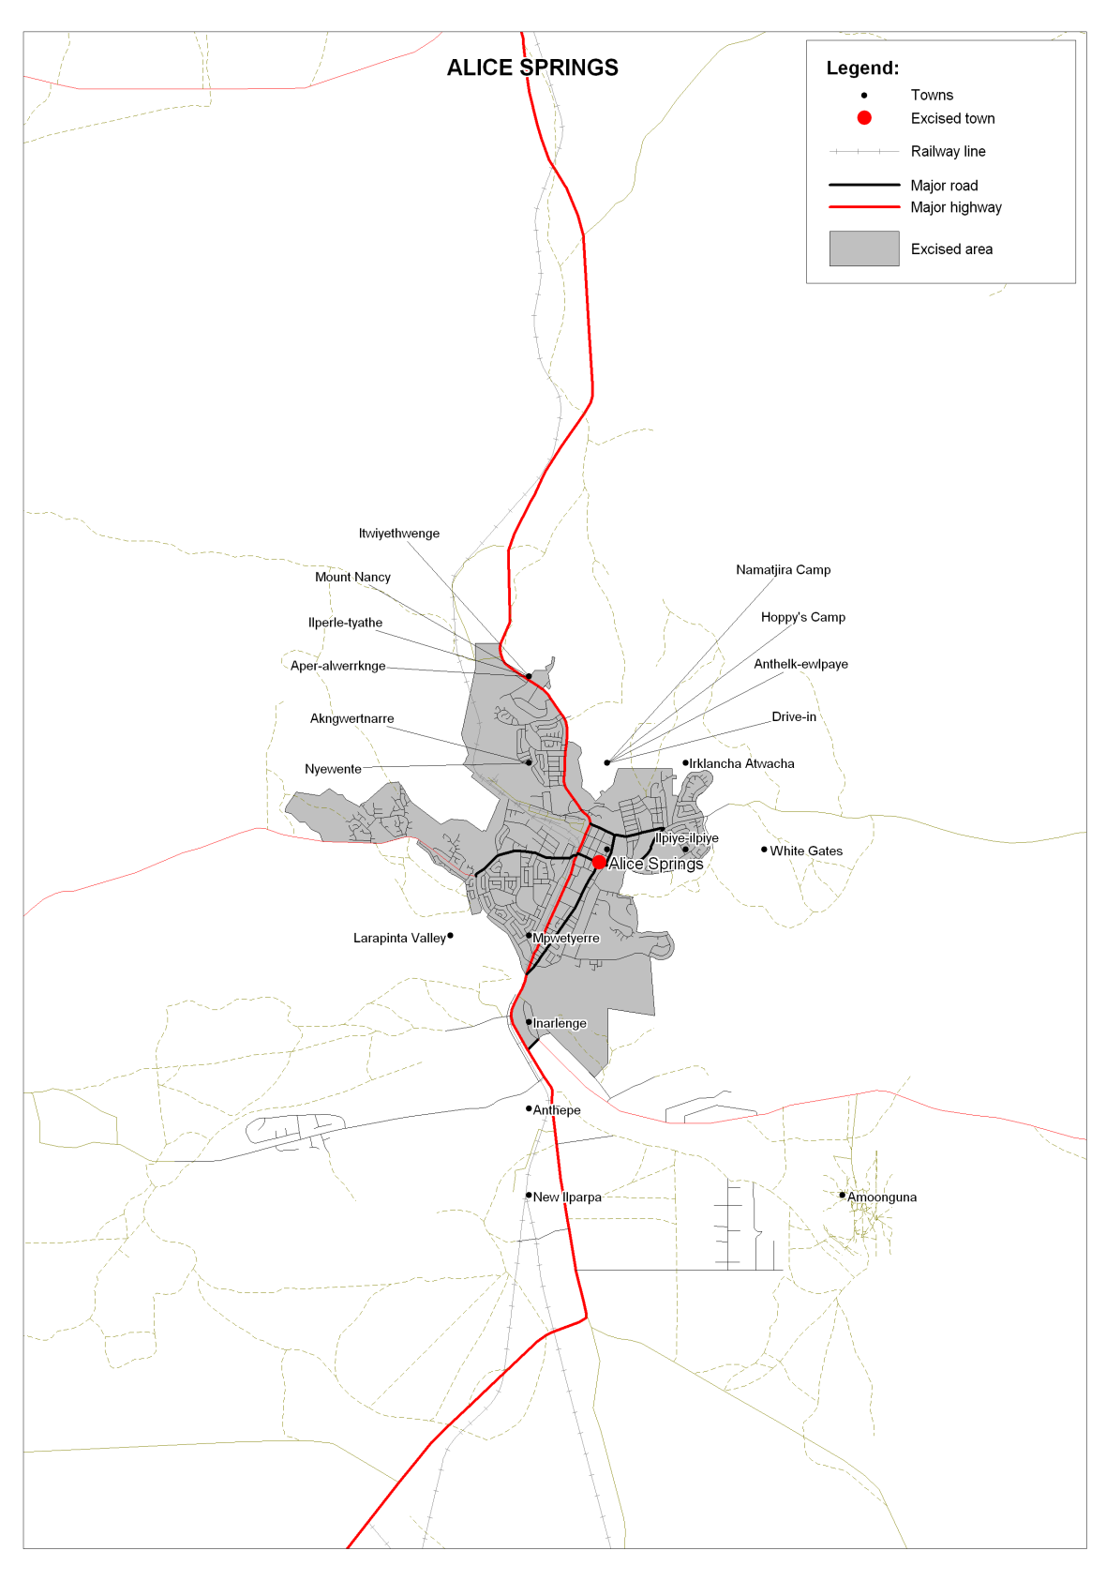

Excised non-remote area of Port Augusta
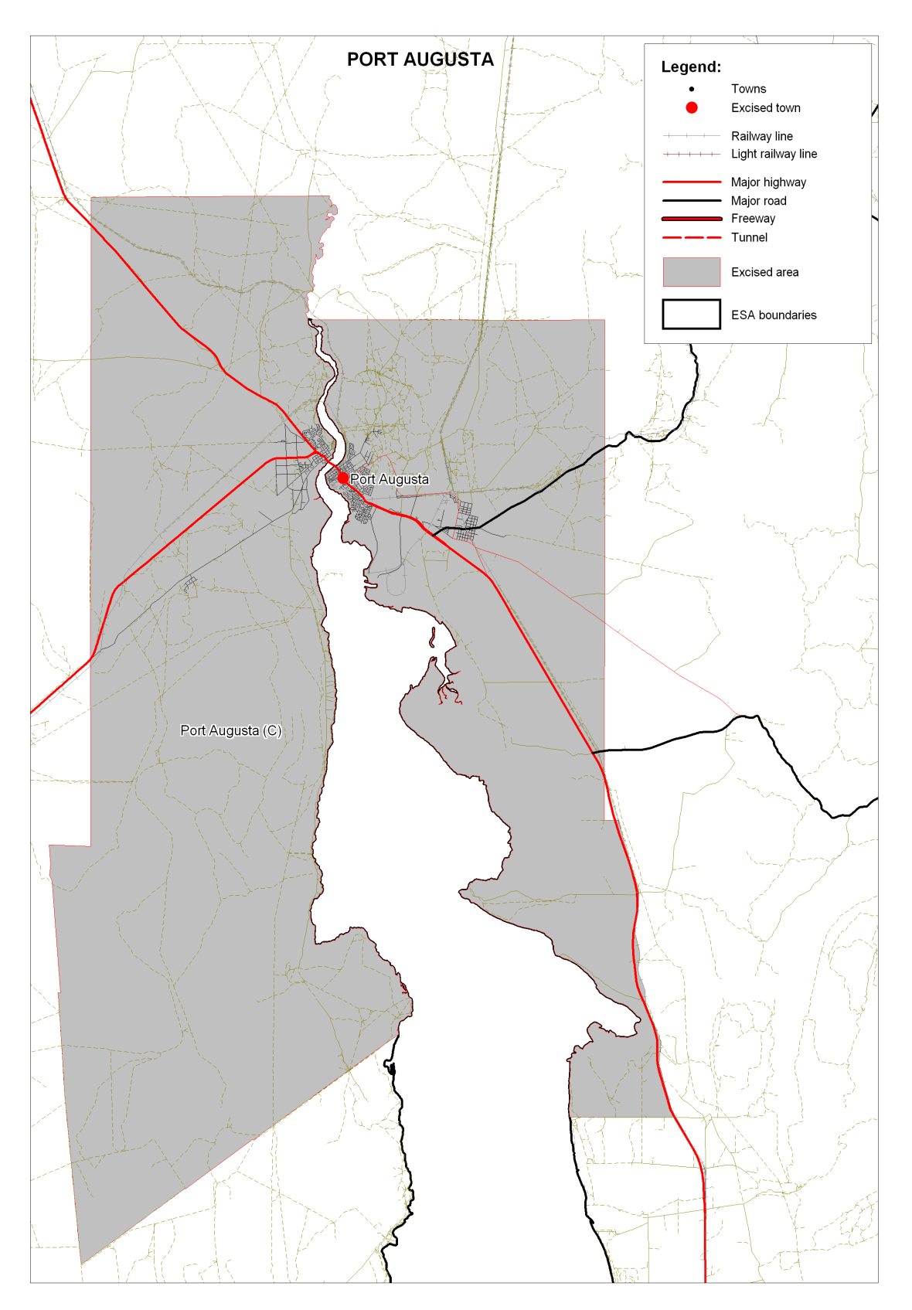

Excised non-remote area of Whyalla
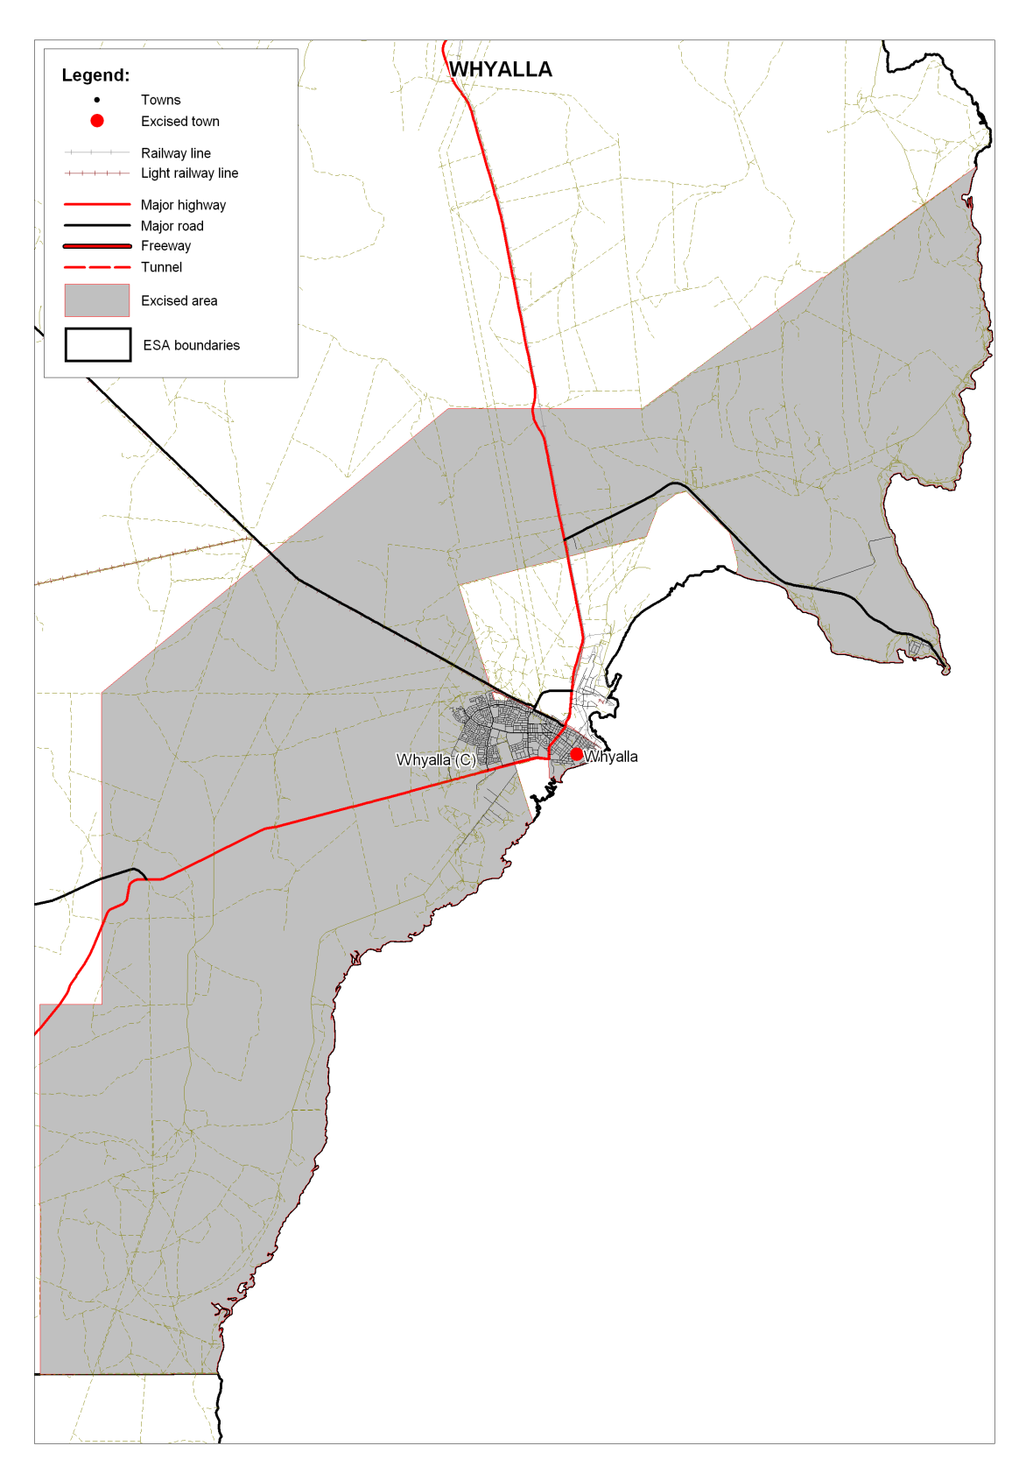

Excised non-remote area of Port Lincoln
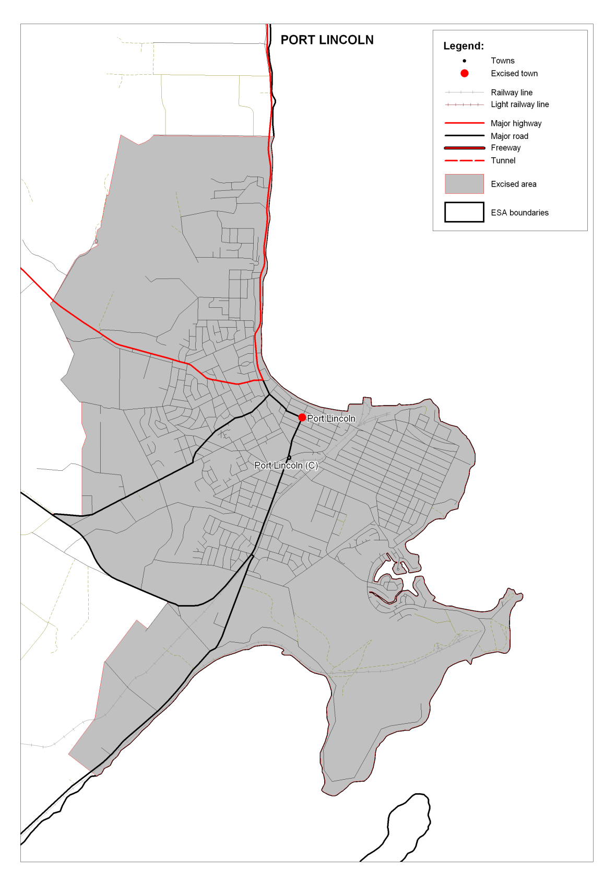

Excised non-remote area of Kalgoorlie
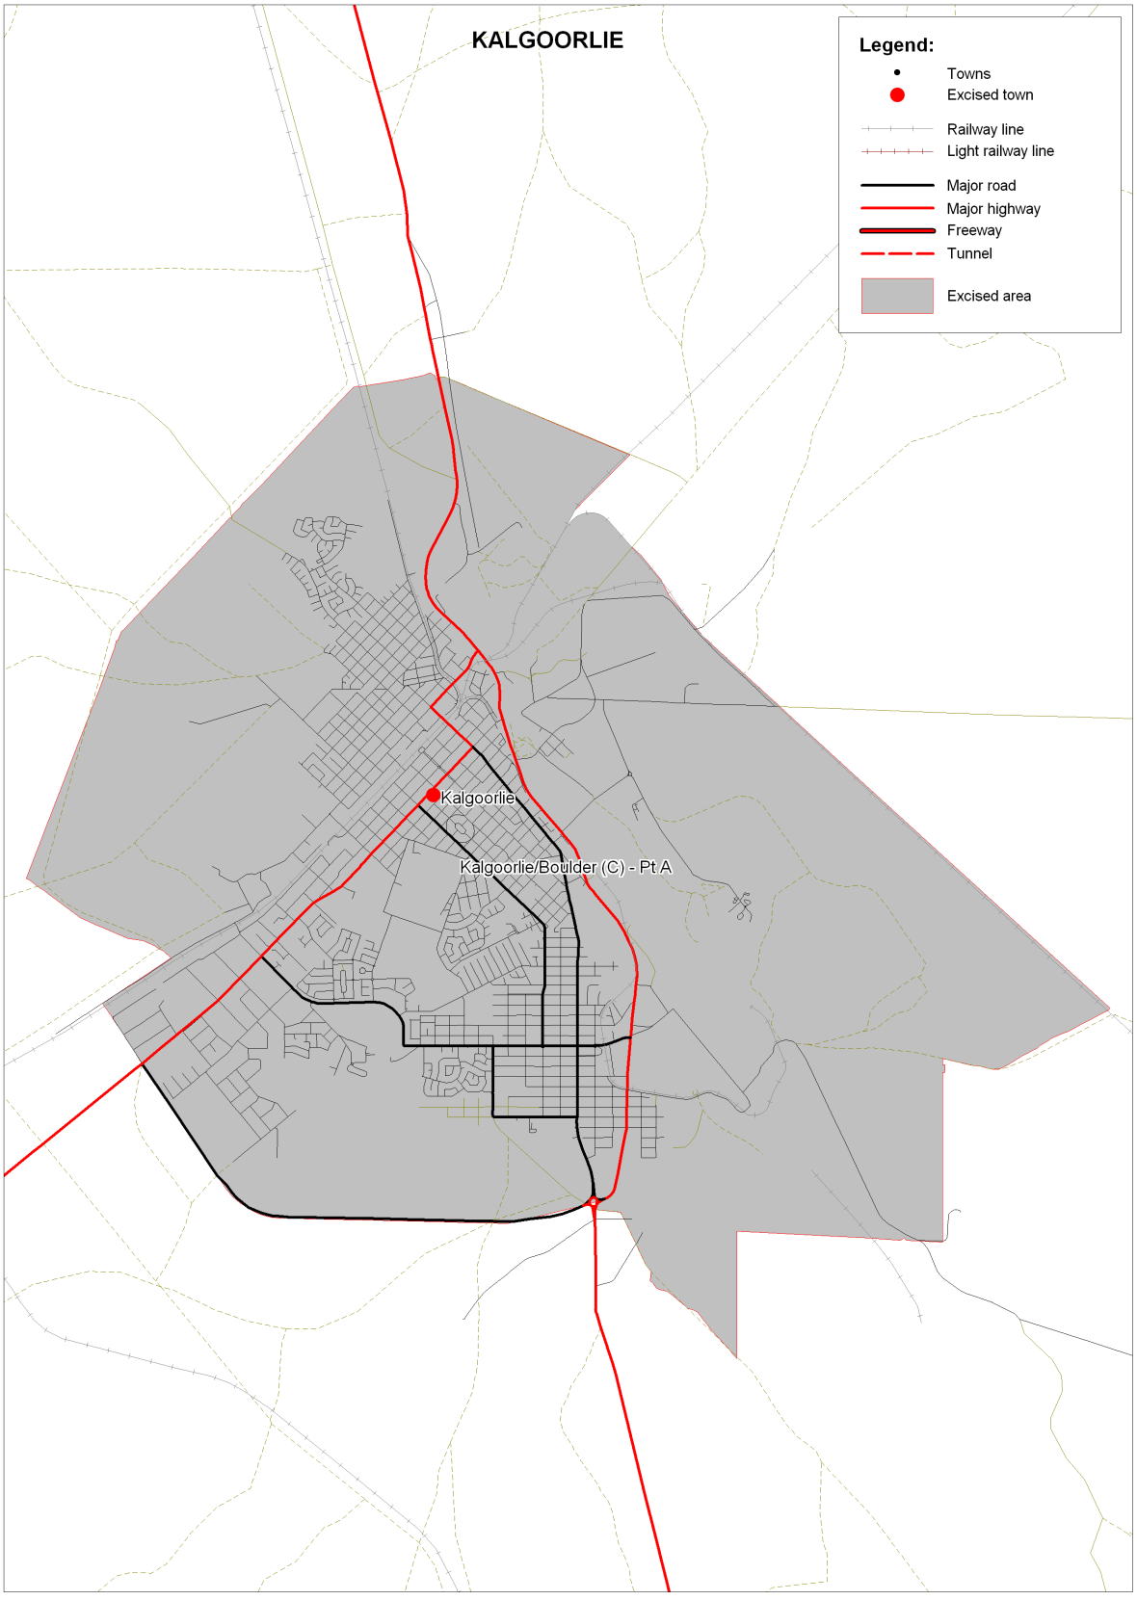

Excised non-remote area of Esperance
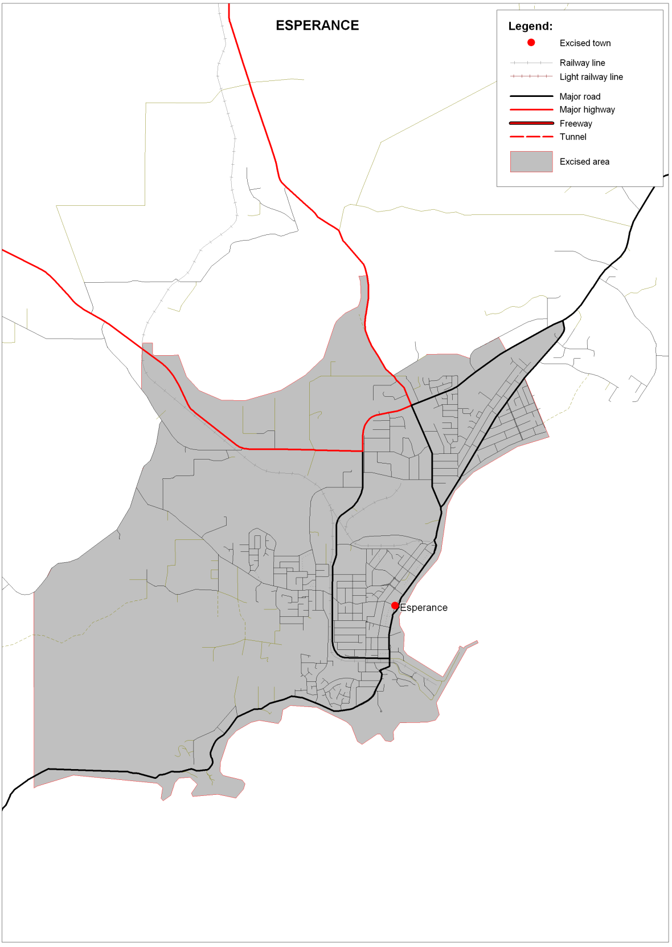

Excised non-remote area of Broome
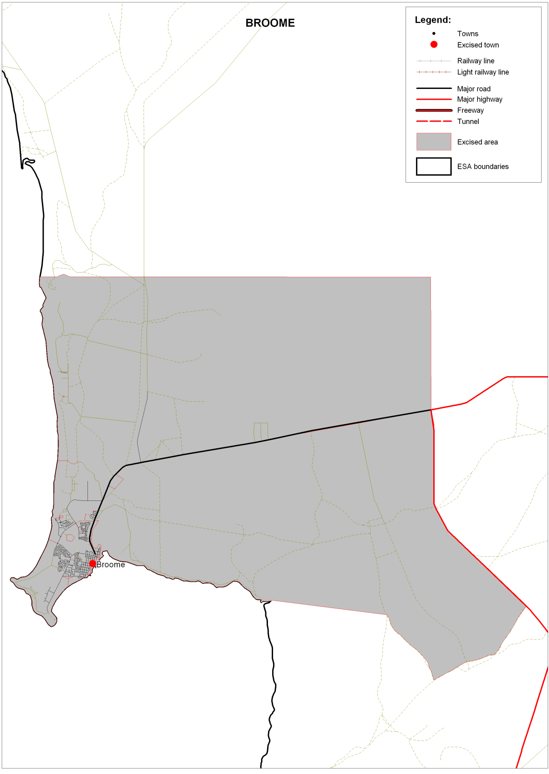

Excised non-remote area of Geraldton
