Economic Inclusion Advisory Committee
2024 Report to Government

Table of Contents
Abbreviations 5
Introduction 7
The Economic Inclusion Advisory Committee 8
An Economic Inclusion Framework for Government 8
Policy priorities for 2024 8
Findings and recommendations 11
Gemma: JobSeeker and would be student 17
Chapter 1: An Economic Inclusion Framework for Government 19
1.1 Rationale 20
1.2 A definition of Economic Inclusion 20
1.3 A four point Economic Inclusion Framework 21
Paul: JobSeeker with physical and mental health issues 27
Chapter 2A: Adequacy of working age payments – an update 29
2A.1 Introduction 30
2A.2 Key findings 30
2A.3 Financial stress and people receiving social security in Australia 33
2A.4 Why has the gap between unemployment payments and Age Pensions widened? 39
2A.5 Fiscal and inflationary impacts 48
2A.6 Conclusion 49
Chapter 2B: Would a rise in JobSeeker affect incentives for paid work? 50
2B.1 Introduction 51
2B.2 How economists think about choosing the optimal level of unemployment income support payment 51
2B.3 Existing evidence on the impact of unemployment payments on incentives to move into employment 51
Tahnee: Single parent living in a remote community 58
Chapter 3: Commonwealth Rent Assistance 60
3.1 Introduction 61
3.2 Adequacy of Commonwealth Rent Assistance 61
3.3 Housing Costs for Low Income Renter Households 64
3.4 Policy Options 65
3.5 Discussion 66
Cliff: Regional mature aged JobSeeker 67
Chapter 4: Removing barriers to employment and supporting participation 69
4.1 Introduction 70
4.2 The problem to overcome 70
4.3 Rebuilding employment services 72
4.4 Addressing barriers to employment and supporting participation 76
Immediate changes 76
4.5 Conclusion 83
Tara: Single parent receiving JobSeeker Payment 84
Chapter 5: Improving support for children and families 86
5.1 Introduction 87
5.2 Developing a universal early childhood development system 88
5.3 Access to ECEC and early years services 89
5.4 Reforms to the Family Tax Benefit and Child Support Systems 95
5.5 Conclusion 101
Farnaz: Mature-aged JobSeeker 102
Chapter 6: The culture, purpose and intent of the social security system 104
6.1 Introduction 105
6.2 Setting a new purpose for the social security system – to support economic inclusion and wellbeing 107
6.3 Acknowledging that the social security system is for all of us 108
6.4 New guiding principles to renew the social security system 112
6.5 Conclusion 123
Chapter 7: Assessing Government responses to the 2023 report 124
Appendix A - List of members 140
Appendix B - Economic Inclusion Advisory Committee Act 2023 140
Appendix C - Additional data for Economic Inclusion Framework 140
Appendix D - Aboriginal and Torres Strait Islander Housing Review 141

The Economic Inclusion Advisory Committee acknowledges the traditional owners of country throughout Australia, and their continuing connection to land, water and community. We pay our respects to them and their cultures, and to Elders both past and present.

Abbreviations

ABS
Australian Bureau of Statistics
ACCC
Australian Competition and Consumer Commission
CHINS
Community Housing Infrastructure Needs
CPI
Consumer Price Index
CRA
Commonwealth Rent Assistance
DSS
Department of Social Services
ECEC
Early Childhood Education and Care
EDHI
Equivalised Disposable Household Income
FTB
Family Tax Benefit
FTB Part A
Family Tax Benefit Part A
FTB Part B
Family Tax Benefit Part B
HILDA
Household, Income and Labour Dynamics in Australia
IGR
Intergenerational Report
LAWP
Liquid Assets Waiting Period
MIT
Maintenance Income Test
MTAWE
Male Total Average Weekly Earnings
NACCHO
National Aboriginal Community Controlled Health Organisation
NATISHA
National Aboriginal and Torres Strait Islander Housing Association
NDIS
National Disability Insurance Scheme
NHHA
National Housing and Homelessness Agreement
NIAA
National Indigenous Australians Agency
NT
Northern Territory
NPRHNT
National Partnership for Remote Housing Northern Territory
PBLCI
Pensioner and Beneficiary Living Cost Index
RAA
Remote Area Allowance
SIH
Survey of Income and Housing (ABS)

Throughout the report, reference to ‘the Government’ should be taken to mean the Commonwealth Government unless otherwise stated.

Introduction

The Economic Inclusion Advisory Committee
On 8 December 2023, the Economic Inclusion Advisory Committee Act 2023 (the Act) received Royal Assent, establishing the Economic Inclusion Advisory Committee (the Committee). The Committee takes the place of the Interim Economic Inclusion Advisory Committee established in November 2022.
The Committee provides non-binding advice on boosting economic inclusion and tackling disadvantage, including policy settings, systems and structures, and the adequacy, effectiveness and sustainability of income support payments. Its advice is to be delivered ahead of every Federal Budget.
The Committee is comprised of social security and economics experts and leaders from the community sector, advocacy organisations, unions, business, and philanthropy. A list of current members of the Committee can be found in Appendix A. Legislation which provides the Terms of Reference for the Committee can be found in Appendix B.
The Committee’s 2024 Report aims to assist the Government in its ongoing efforts to improve support for vulnerable people in Australia and enable wider economic and social participation. We recognise it is for the Government to determine whether to accept our advice and note the Government’s consideration and potential approval of the Committee’s recommendations must ensure the long-term sustainability of the social security system and minimise the impact on long-term debt.
In compiling this Report, the Committee held consultations with people who interact with Australia’s social security system. The Committee is grateful to those who participated in these consultations, who greatly helped to guide our advice and to improve our recommendations. We have reflected some of the experiences generously shared with us through composite and individual stories from participants, as well as the service experience of Committee members at the start of each chapter and in quotes throughout the Report. Now the Committee is permanently established, it will be possible to improve the way we consult in an ongoing way. The Committee also recommends that people with current or recent direct experience of the income support system be members of the Committee to help ensure that priorities for reform are informed by people receiving income support.

An Economic Inclusion Framework for Government
To inform its approach, the Committee has drafted an Economic Inclusion Framework. The Framework provides a clear definition of economic inclusion and an outline of the broad problems that need to be addressed to reduce the economic exclusion that is very real for so many Australians (see Chapter 1).
The Framework defines economic inclusion as ensuring that all people can participate fully in society, improve their economic wellbeing, and contribute to a stronger nation.
The Framework outlines four domains to guide policy to advance economic inclusion:
- economic security
- equal opportunities
- growth and equal sharing of growth
- efficient and responsive governments.
The Committee plans to strengthen the framework and its key measures ahead of our 2025 report.

Policy priorities for 2024
Guided by its Terms of Reference and the Act, the Committee has provided 22 recommendations to inform the Commonwealth Government of how best to improve economic inclusion and create a more equal and prosperous nation. We have had regard to the fiscal implications of our recommendations, and their effect on workforce participation, relevant Government policies, and the long-term sustainability of the social security system.
The Committee draws the Government’s attention to five priority recommendations to address the needs of the most economically excluded Australians. The priority recommendations are to:
1. Substantially increase JobSeeker and related working age payments and improve the indexation arrangements for those payments.
The current rates for the JobSeeker and related working age payments (including Youth Allowance, Austudy, ABSTUDY and Special Benefit) are too low. Despite the $40 base rate increase delivered in last year’s Federal Budget, people receiving these payments told the Committee that they regularly go without life’s essentials because they simply cannot afford them. This is in part the result of unsatisfactory indexation arrangements over many years. Without change to indexation arrangements, the living standards of recipients of these payments will continue to fall – whether measured relative to average or National Minimum Wages, pensions, or income poverty measures (see Chapter 2A).
Importantly, the Committee’s assessment is that any negative effect on incentives to work due to an increase in the Jobseeker Payment is likely to be small. For people facing economic exclusion, some literature suggests that higher income support payments may improve the capacity to search for and accept employment (see Chapter 2B).
2. Increase the rate of Commonwealth Rent Assistance.
Rental costs in recent decades have exceeded household incomes for lower income families and individuals. The composition of the rental market has also shifted from lower cost public housing to the higher cost private rental market. Over the past two years many renters have experienced particularly high increases in private rental costs. Continued strong rental growth in asking rents and actual rents is expected through 2024. Australians on income support payments often suffer from high rates of rental stress, with many finding their incomes heavily absorbed by rent, pushing them further into poverty or unsuitable and unsafe forms of accommodation.
While Commonwealth Rent Assistance (CRA) helps alleviate this problem and rose by 15% in 2023-24, indexation of this payment has not kept pace with the spiralling cost of rents, especially in a housing market with a declining proportion of social housing. In addition to its priority call for a substantial increase to JobSeeker and related payments, the Committee calls for a further increase in the rate of CRA (see Chapter 3).
3. Create a new employment services system to underpin the goal of full employment and ensure a more positive focus on supporting Australians seeking work.
Two important recent reports – the 2023 Employment White Paper and the 2023 House of Representatives Select Committee on Workforce Australia Employment Services Final Report – agree that Australia’s current employment services system is not fit for purpose and is causing harm. The system’s failings have been laid bare: there is an urgent need to remove automated payments suspensions; its culture is negative, unsympathetic and punitive; participants are regularly left dispirited and broken by its excessive, often pointless and frequently counterproductive compliance measures; it provides poor service that other Australians would not be asked to accept; and it is highly inefficient, producing an unacceptably low employment success rate. This is the right time to replace it with an employment service that promotes economic inclusion instead of one that worsens economic exclusion. While this is a multi-year reform effort, it must start now. Some elements of the new model will need to be tested, but trials should not delay decisive action. The Committee believes strongly that undertaking comprehensive employment services reform is one of the decisive measures the Government can take this year to increase economic inclusion. It is a necessary condition to achieve the goal of sustained and inclusive full employment (see Chapter 4).
4. Implement a national early childhood development system that is available to every child, beginning with abolishing the Activity Test for the Child Care Subsidy to guarantee all children access to a minimum three days of high-quality early childhood educationand care (ECEC).
The Committee continues with its call for the creation of a national early child development system in partnership with the states and territories, including making ECEC services available to every child.
Currently, the Activity Test limits access to Child Care Subsidy based on parental work related activity and is designed to incentivise workforce participation by parents. One of its unfortunate consequences has been to limit access to ECEC for some of the children who could stand to benefit from it the most. It is arguable that the children most likely to gain from interaction with an early childhood education environment are those whose parents who are not in the paid workforce. Abolishing the Activity Test and providing a guarantee of three days of care to every Australian child would address this issue and has the potential to make a considerable difference to their life chances (see Chapter 5).
5. Renewing the culture and practice of the social security system to support economic inclusion and wellbeing.
Australians who receive income support payments can face strong antipathy, commonly finding themselves misrepresented as ‘dole bludgers’, ‘welfare cheats’, ‘rorters’, ‘leaners’ and so on, when the actual evidence for welfare fraud and intentional evasion of mutual obligation requirements is miniscule. This has fostered a punitive attitude that extends from parts of the media to the Parliament, the government, and the administration of the social security system. The result is a social security system insufficiently informed by the real-life circumstances of people it is supposed to support. Such demonstrably false premises lead inevitably to poor public policy, with services that are often harmful, unfair, complex, costly to administer, counterproductive, and bound to fail.
Starting with government and social security agencies, leadership is needed to replace ill-informed, negative and discriminatory language and attitudes towards people receiving income support with ones that are accurate, positive and conducive to good policy making. A new and positively framed objective for the social security system should inform a new statement of purpose or charter (see Chapter 6).

Findings and recommendations

Chapter 2A: Adequacy of working age payments – an update
Recommendation 1
The Government commit to a substantial increase in the base rates of JobSeeker Payment and related working age payments as a first priority.
Finding: Indexing JobSeeker Payment and related income supports only in line with the Consumer Price Index (CPI) has resulted in their relative base rates falling significantly below existing benchmarks such as the Age Pension. Increasing their rate to 90% of the Age Pension would improve adequacy and return them to payment relativities of 1999.
Recommendation 2
The Government commit to a timeframe for the full increases of JobSeeker and related payments to be implemented, if increases are to be staged.
Recommendation 3
The gap between the current level of JobSeeker Payment and the Age Pension is primarily the consequence of the benchmarking of pensions but not allowances to Male Total Average Weekly Earnings (MTAWE) since 1997. Maintaining the current approach to benchmarking in the long run will recreate the same or an even wider gap. The Committee recommends the Government improve the adequacy of indexation of working-age payments immediately, and regularly reviews and monitors the relationship between working age payments levels and widely accepted measures of community living standards, including wages.
Recommendation 4
The Australian Bureau of Statistics (ABS) or an appropriate researcher or research centre in partnership with remote communities should be funded to undertake analysis of the additional costs of living in remote areas, but the case for an immediate increase in the Remote Area Allowance (RAA) seems particularly strong.

Chapter 3: Commonwealth Rent Assistance
Recommendation 5
In addition to substantially increasing base rates of JobSeeker Payment and related payments, further increase the rate of CRA to address the long-term reduction in adequacy and better reflect rents paid.

Chapter 4: Removing barriers to employment and participation
Recommendation 6
The Government commit to a full-scale redesign of Australia’s employment services system by adopting the recommendations in the report from the Select Committee on Workforce Australia Employment Services.
As a priority the Government should:
- Finalise an implementation plan and enact necessary legislative changes in 2024.
- Commit to a full redesign of the mutual obligations and compliance settings in the Workforce Australia system that focus on building capability and confidence to support people into work, consistent with the directions outlined in the Select Committee’s report.
- Build and refine a new practice model that genuinely meets the needs of people furthest from the labour market, including through:
- A network of demonstration sites and regional hubs that enable stronger connections to local human services systems and place-based direction of effort.
- Strengthened approaches to employer engagement.
- Greater investment in national paid work experience and training programs assessed as significantly improving employment prospects of people who are unemployed long term.
- Commissioning that incentivises collaboration and rebuilds the public core of the system.
- An independent Employment Services Quality Commission to set minimum quality standards, drive improvements in qualifications and skills of frontline staff, share best practice, and handle licensing and complaints.
- A client council (or councils) so the voices of people experiencing the system influence its redesign.
Recommendation 7
The Government take immediate actions to end automatic payment suspensions and the damaging effects of current settings while broader reforms are progressed, including by:
- Tripling the Liquid Assets Waiting Period (LAWP) amount threshold, consistent with increases in inflation and its relativity to payments, and have a single waiting period of four weeks, and reconsidering the need for the LAWP given the complexity it adds to the system when there are already income and asset tests in place.
- Reviewing the role of sickness allowances, the length for which medical exemptions are granted and the process to obtain them, and eligibility for the Disability Support Pension (DSP), as suggested by Recommendations 32-34 of the Select Committee’s report.
Recommendation 8
The Government changes Working Credit settings that have not been updated since 2003, to bring the Working Credit system closer in line with other employment credit schemes such as the Pension Work Bonus and help smooth the transition to work. Specifically, to:
- Grow the Working Credit accrual rate for all eligible payments from $48 to $150 per fortnight, consistent with the income free area, and shift from a daily to fortnightly calculation.
- Increase the maximum balance of the Working Credit up to $7,800 (equivalent
to two years of accruals of $150 per fortnight), and index to CPI.
- Introduce an initial ‘boost’ so each eligible recipient has a starting balance of $500 in the Working Credit.
- Develop a communications approach to accompany the reforms, so that people receiving payments better understand the Working Credit and how it can help them, and design implementation to enable evaluation of the impacts of these changes.
Recommendation 9
The Government relax work limit rules on payments to encourage and enable workforce participation, particularly for people who have fluctuating or episodic conditions or caring responsibilities, including by:
- Removing the 30 hour per week work limit for DSP recipients.
- Adjusting the 25-hour participation rule for the Carer Payment to give carers greater flexibility to undertake paid work, by:
- Changing the 25 hours per week work participation limit to an allowance of 100 hours over four weeks, and applying the participation limit only to employment (not study, volunteering or transport time).
- Suspending, rather than cancelling, the Carer Payment where a carer exceeds a participation hours or earnings limit.
- Allowing the single Temporary Cessation of Care days provision to be applied to one-off or occasional instances of exceeding the participation hours limit.
Recommendation 10
The Government urgently commit substantial investment to address need in public housing and homelessness for Aboriginal and Torres Strait Islander peoples, including maintenance and upgrades, community infrastructure and the Aboriginal and Torres Strait Islander housing sector.
To improve the economic efficiency of investments, the Government should fund a National Aboriginal and Torres Strait Islander Housing Data Register to improve data availability, quality and sharing. The register should be developed in partnership with the Coalition of Aboriginal and Torres Strait Islander Community-Controlled Peak Organisations and the Housing Policy Partnership and agreed as part of the new Housing and Homelessness Agreement (NHHA).
To better target existing investment, including from the Housing Australia Future Fund and Social Housing Accelerator Fund, the Government should:
- Negotiate improved performance reporting and data sharing within intergovernmental agreements and arrangements.
- Undertake rapid needs assessments of homelessness and overcrowding, maintenance, repair and community infrastructure requirements in remote hotspot areas.
- Commission a redesigned Community Housing Infrastructure Needs (CHINS)-like survey, which considers limitations of earlier iterations and subsequent advancements in data collection.
Information collected through these mechanisms, along with existing collections, can underpin the new register. The register should be accessible to communities to support local decision making.

Chapter 5: Improving support for families and children
Recommendation 11
The Government commit to developing a national early childhood development system in partnership with the states and territories.
- This system should connect child and maternal health services, early learning, family supports, and other services into a well joined-up pipeline of supports for children and families through the early years.
- The system should be built upon proportionate universalism principles and particularly focus on improving supports for families with the lowest incomes or with extra needs.
- The commitment to Australia’s new childhood development system should be enshrined in legislation and a new or expanded national partnership agreement.
- The Government, in collaboration with state and territory governments, should establish an Early Childhood Development Commission to oversee the coordination and implementation of the early years reform agenda that will deliver the new system over time.
Recommendation 12
The Government build upon the recommendations from the Productivity Commission and the Australian Competition and Consumer Commission (ACCC) to support access to Early Childhood Education and Care services for all children in Australia.
- As an immediate first step the Government should abolish the Activity Test on the Child Care Subsidy and guarantee all children access to a minimum three days of ECEC.
- The Government should further progress funding model reform to make appropriate use of supply as well as demand side supports and consider block funding if necessary to ensure access.
- The Government should support through the reformed funding mechanism the delivery of new, more holistic models of ECEC that include opportunities for health and family support services.
Recommendation 13
Support applications in the Fair Work Commission that seek to raise the wages and improve the job quality of early childhood educators. As a step to remedying historical undervaluation of educators’ work, ensure that the outcomes of these cases are fully funded.

Recommendation 14
As an early action of the new Early Years Strategy, the Government commits to wider scale delivery of integrated child and family centres and holistic “full service” school models targeted to communities of highest need.
- To deliver on this commitment the Government should create a national framework, funding scheme and evaluation and learning framework.
- The Commonwealth should accept an ongoing stewardship role of the network of integrated centres and full-service school models in partnership with states and territories, using opportunities such as the National Schools Reform Agreement to embed long term commitments from all parties.
- As a supporting measure the Government should take further steps to advance place-based approaches in target communities and consider a fuller response to recommendations provided in the Committee’s 2023 Report.
Recommendation 15
The Government implement Recommendation 33 from the Committee’s 2023 Report, namely, to remove the Maintenance Income Test (MIT) from the calculation of Family Tax Benefit Part A (FTB Part A) for child support customers. Payment criteria should be adjusted so that affected families receive a similar amount of family benefits as would have resulted under the MIT. The desired outcome is that FTB Part A payments are made more predictable for recipients, rather than significantly altering payment values. The removal of the MIT would result in more certain FTB Part A payments for financially vulnerable families, remove the prospect of retrospectively applied FTB Part A debts, and concurrently close a loophole that allows child support and FTB Part A to be used as vehicles for enacting financial abuse.

Chapter 6: The culture, purpose and intent of the social security system
Recommendation 16
The Government adopt a refreshed mandate for Australia’s social security system and that this mandate should be to promote economic inclusion and wellbeing.
Recommendation 17
The Government adopt a set of guiding principles to support an ongoing process of renewal in culture and practice across the social security system. These guiding principles should align with the system’s primary purpose to support economic inclusion and wellbeing. The Committee proposes that these principles be:
- Adequacy
- Dignity and autonomy
- Equity and fairness
- Accountability and acting on evidence
- Person-centredness
- A safety net for all.
Recommendation 18
The Government regularly update language guidance with respect to people receiving income support and that terms like “dole” and “welfare” are replaced in legislation. This language guidance should be extended as a requirement for contracted service providers who engage with people receiving income support and incorporated into their performance and contract review framework.
Recommendation 19
The Government reform aspects of the compulsory activation and compliance framework within the social security system that are at odds with its proposed mandate to support economic inclusion and wellbeing. This will require the systematic improvement of many practices over time. A priority focus should be on rethinking processes and rules that risk harmful effects on people who are more at risk – such as people with long-term barriers to employment who rely on the JobSeeker Payment. The Government should establish co-design, feedback and consultation structures with people directly affected and other stakeholders to inform the program of reform.
Recommendation 20
People with current, direct experience of receiving income support and/or economic exclusion be members of the Economic Inclusion Advisory Committee. Attention must be given to ensuring there is sufficient representation of different experiences in the Membership.
Recommendation 21
The Government revise strategies that delay access to payments for those who need them by addressing the underlying policy, legislative and resourcing drivers of these delays. This should include:
- Taking urgent action to reduce wait times for claims.
- Reconsidering the need and rationale for waiting periods for payments that currently attract them.
Recommendation 22
The Government should consider a collaborative process to develop a new charter for the Australian social security system. This charter should be centred upon the proposed new mandate for the social security system to promote economic inclusion and wellbeing.
- This co-design process should involve people receiving social security payments and a broad range of other stakeholders.
- The Government should consider legislating the resulting statement, so it guides reform, policy development and practice long term.
- The charter legislation should contain mechanisms that hold public servants, political representatives and others engaged with the social security system to standards of behaviour that prevent use of stigmatising language or other forms of vilification of people receiving income support.

Gemma: JobSeeker and would be student
Gemma is 24. She had been receiving Austudy when she was doing a communication design course and she’s now receiving the JobSeeker Payment.
Gemma had to drop out of her course after two years because she couldn’t afford to live near the university and when she moved further away, it took her so long to get to and from classes on public transport that she didn’t have the time to work enough hours to live on.
After two years of struggling to get by Gemma quit university with a large HECS debt and moved back to her hometown where she now lives with her mother, a casual disability support worker. Gemma now works also casually at a petrol station, but finds the hours are unreliable and the job extremely low paid. This was the only job that was within walking distance of her house – she doesn’t have her licence and public transport in her small town is irregular, unreliable and unsafe, especially in winter when it gets dark early.
When she first quit her course and moved back to her hometown, she only planned to receive JobSeeker for a semester or two, to get herself back on her feet and find a way to continue with her studies at the regional university an hour away.
It has now been five years and she is frustrated and feeling stuck in a system she can’t exit. She is now even more reliant on Centrelink, as her income each month is inadequate, causing her to get further and further behind.
She’s had to ask her mother and her siblings for money to pay for food and bills. She’s discovered that even though her family members love her, there’s only so much you can ask. The shame she feels for always having to ask for help is enormous, and there’s no way she can ever pay people back. Her mother is barely making ends meet herself, and her siblings are trying to save for their own houses. Clearly, they’re not in a position to keep giving her money, and she wonders what she will do when her family members tell her they can’t help any longer. The guilt she feels is enormous.
Gemma is now finding that her physical health is suffering because she can’t afford to look after herself. She’s had to give up going to the gym and going out with her friends, which is affecting her mental health.
Gemma lives in a tourist town where housing is hard to come by and where permanent, well-paid jobs are scarce. She would love to move out with friends or get a place of her own but there are no affordable houses available. She would love to have a communication design job, but she can’t afford to travel or move to the regional centre where she could resume her course. Instead, she has a large debt and worsening mental and physical health.
What Gemma really needs is her driver’s licence and a bit more money to buy a car, but her first employment service provider only offered her resume writing courses and job search training. The jobs they recommended required a car or were labouring work which is hard for her as she has rheumatoid arthritis.
There aren’t any jobs in her area that match her interests, so she felt it was all a bit pointless. She changed providers, and the new service is helping her to get her licence. Gemma is now hopeful that she can get things back on track.
Gemma thinks that if the Government took a longer-term view and actually helped people to achieve what they know will help them over the long term, then the whole country and taxpayers would be better off. Instead, she believes Centrelink regards her as a ‘dole bludger’ trying to dodge work, and that employment service provider staff look down on her.
It’s all imposing a huge toll on her mental health. She’s trying to improve her life and trying to get ahead. But the system often puts barriers in her way. She found that all of the pressure put on her to take any job exacerbated her mental health issues and made finding a secure long-term income even further out of reach.
When she left high school and went to university in the city, Gemma had hopes for a bright future. She could see an enjoyable career ahead. But she has found that that once you’re down, the Centrelink system can sometimes keep you down. She doesn’t know why Australia insists she wastes her life in dead end jobs rather than supporting her to succeed.

Chapter 1:
An Economic Inclusion Framework for Government

1.1 Rationale
Under the Economic Inclusion Advisory Committee Act 2023 the Committee’s annual report must consist of advice on the following matters as they relate to the policies, programs and responsibilities of the Commonwealth Government:
- economic inclusion, including approaches to boost economic participation through policy settings, systems and structures in the social security system and other relevant programs and policies
- the adequacy, effectiveness and sustainability of income support payments, including options to boost economic inclusion and tackle disadvantage
- options to reduce barriers and disincentives to work, including in relation to social security and employment services
- options for tailored responses to address barriers to economic inclusion for long term unemployed and disadvantaged groups, including place-based approaches at the local level, having regard to the split between commonwealth, state, territory and local government responsibilities
- the impact of economic inclusion policies on people with barriers to work, including (without limitation) people with caring responsibilities, Indigenous Australians, and people with disability
- the impact of economic inclusion policies on gender equality
- the trends of inequality markers in Australia and international comparisons.
To aid the preparation of this advice to Government and aid the Government’s policymaking in this area, the Committee has developed the following working definition and framework of economic inclusion. The definition and framework aim to provide the Committee and Government with clarity about the nature and extent of economic exclusion and how policies might promote economic inclusion generally. The definition and framework are intended as a living document that evolves over time.
The Committee has started the process of developing indicators to complement the framework and help identify areas of focus for the work of the Committee. Examples of these are provided in this year’s report and will be expanded in future years as the work of the Committee proceeds.

1.2 A definition of Economic Inclusion
Economic inclusion is the process of ensuring that all people have the opportunity to participate fully in society and to improve their economic well-being. Economic inclusion is based on the premise that every member of our society has the right to fully participate and that our economy and society would be stronger if this was the case.
The Committee has identified four domains to guide its work and advice:
- economic security
- equal opportunities
- growth and ensuring equal sharing of growth
- efficient and responsive Government.
These domains are not mutually exclusive, and there is overlap but they provide a framework helpful for guiding the Committee’s advice to Government.
Across all areas of the Committee’s work an intersectional lens will be applied that accounts for the different experiences, needs and approaches for all priority groups, including Aboriginal and Torres Strait Islander Australians, people with a disability that are able or not able to participate in paid work, women, people from a non-English speaking background, people living in regional and remote Australia, and households with children. The Committee has endeavoured throughout to include distributional analysis on the effects of its recommendations, including across different household types and priority groups.
This chapter presents the framework and a snapshot of selected measures within the framework. Appendix C contains more data, including methodological notes and caveats. For some measures, additional data is available on the Measuring What Matters dashboard on the Treasury website.

1.3 A four point Economic Inclusion Framework
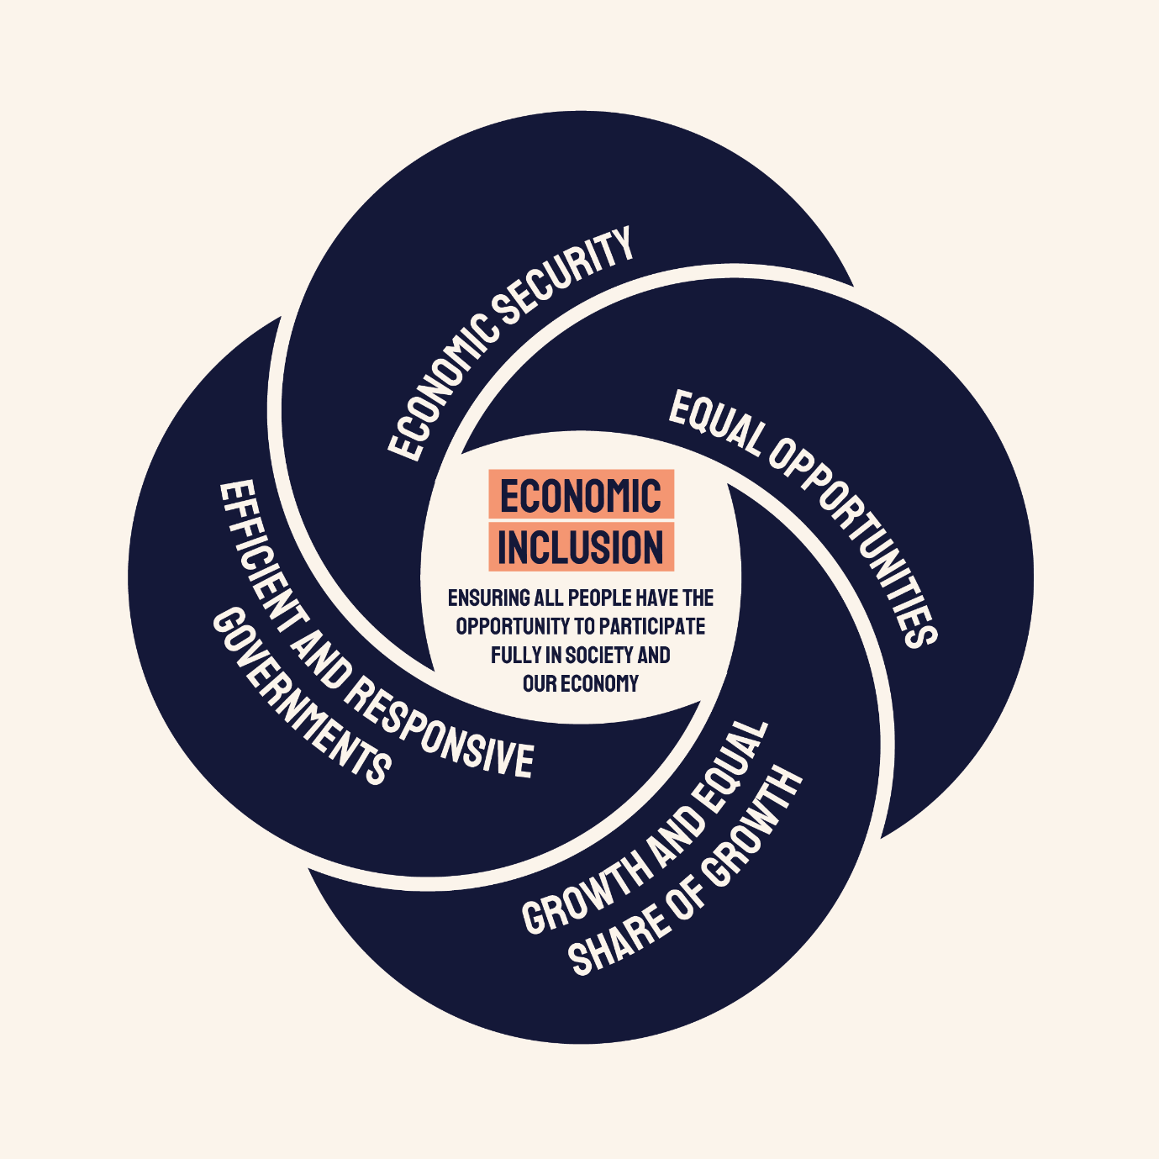
Economic Security
Without economic security it is not possible for individuals or families to fully participate in society or the economy.
Measures:
- Adequacy of income support payments
- Material deprivation
- Financial stress
- Poverty rates
- Poverty gap
- Persistence of poverty
Equal Opportunities
Economic inclusion requires the opportunity to participate in economic activity and having agency to choose one’s own future path.
Measures:
- Australian Early Development Census outcomes
- Home ownership
- Housing stress
- School completion
Growth and equal share of growth
There is a symbiotic relationship between strong economic growth and economic inclusion.
Measures:
- Full employment
- Secure employment
- Adequacy of minimum wage
- Levels of business dynamism
- Effective marginal tax rates
- Income and wealth inequality
Efficient and responsive Governments
Government processes and maintaining administrative justice underpin economic inclusion through public accountability, transparency, and participation.
Measures:
- Administration of government payments and services
- Involvement of underrepresented or excluded populations in decision making
- Crisis response

1.3.1 Economic Security
The Committee recognises that without economic security it is not possible for individuals or families to fully participate in society or the economy.
Economic security can be advanced through a strong social safety net for those who cannot fully participate in paid work either during episodes of vulnerability or for longer periods of time and through access to secure employment. Economic security is crucial for the healthy development and educational success of children.

Table 1: measures of Economic Security
Measure | Relevance
Adequacy of Income Support Payments | The adequacy of income support payments can influence levels of poverty and financial stress.
Material Deprivation | Individuals can have high levels of wealth but low levels of income, and thereby not experience the same level of material deprivation as groups with low levels of wealth and low levels of income.
Financial Stress | Financial stress is linked to poorer mental health, poorer general health, lower educational outcomes for children, and lower workforce productivity.
Poverty Rates | Experiencing poverty and material deprivation is linked to poorer mental and physical health, lower productivity, and can undermine child development outcomes. Reporting on rates of poverty and the impact of proposed policies on its incidence will provide important an important tool for Australian public policy.
Poverty Gap | Households can fall just below a poverty line or be well below the level consistent with a decent standard of living. Understanding the severity of poverty across the community allows the prioritisation of policy responses.
Persistence of Poverty | Individuals can cycle in and out of poverty, but persistent poverty has greater long-term effects on health and productivity.

Snapshot into poverty rates
3 million people currently experience poverty in Australia.
Between 9.8% - 13.4% of people, depending on which poverty line is used.
There are a range of measures relevant to assessing poverty in Australia.
There has been a steady decline in the level of income support payments over two decades.
Except for a brief spike during the COVID-19 pandemic. This is relative to all poverty line measures.
The current rate of JobSeeker Payment is well below all poverty lines used in Australia.
Depending on which poverty line is chosen, it is between 57% - 72% of the poverty line.

Graph 1: JobSeeker payment as a percentage of poverty measures
Excluding Commonwealth Rent Assistance, Before Housing Costs
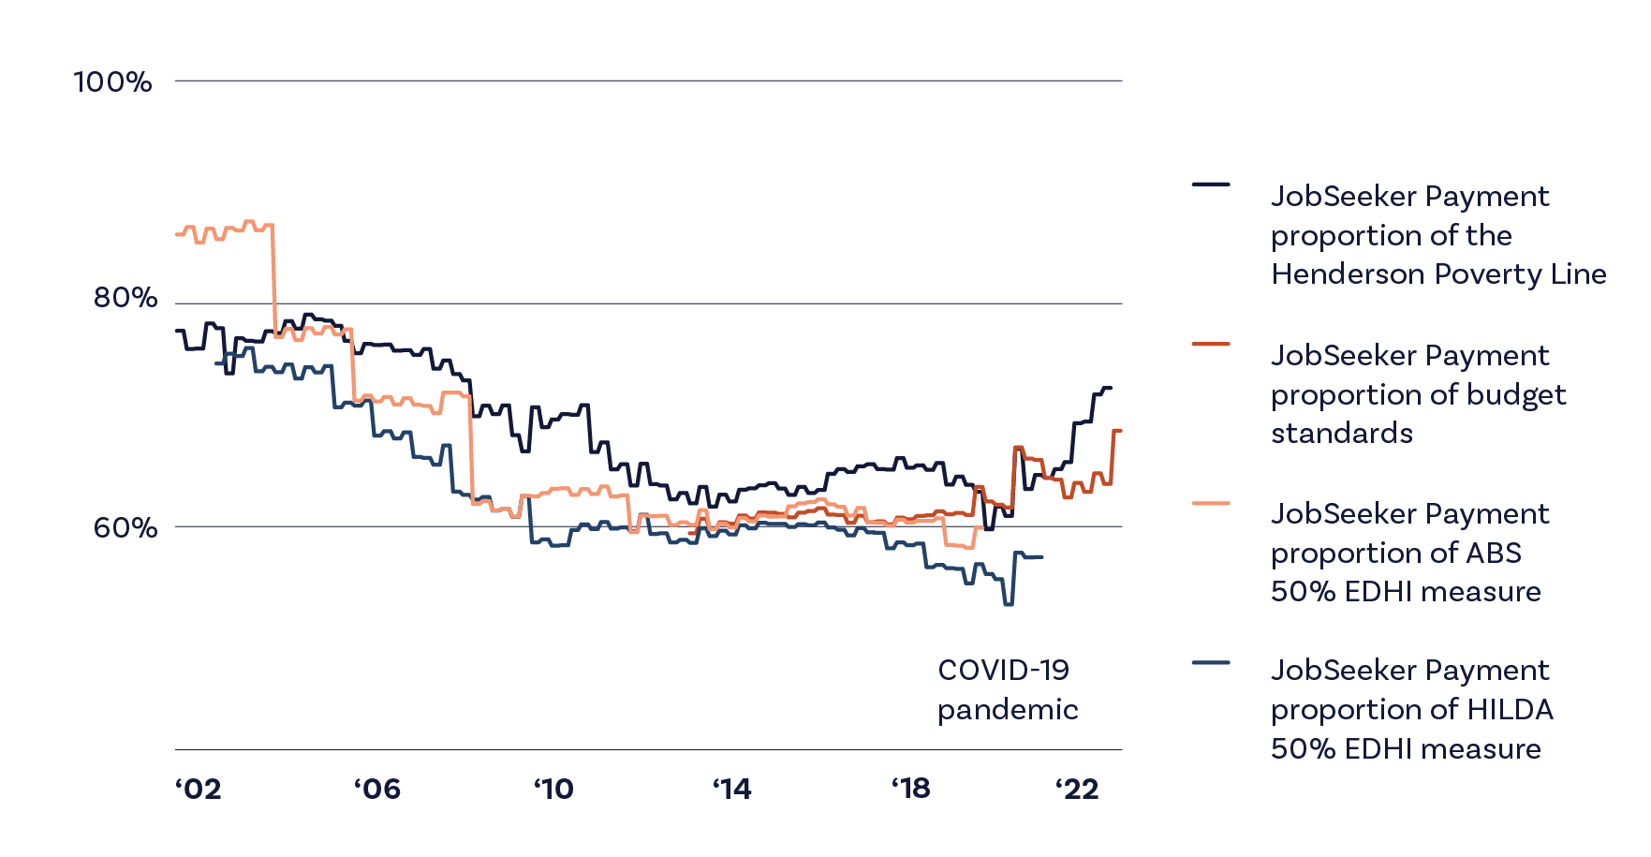

1.3.2 Equal Opportunities
Economic inclusion requires the opportunity to participate in economic activity and having agency to choose one’s own future path.
The Committee’s policy advice is informed by an understanding that disadvantages due to place of origin, early childhood education, access to housing, health, and labour market need to be addressed so that they do not compound throughout the life cycle and undermine inclusion.
This compounding of life opportunities is seen in many areas. For example, children with a disability who attend a special school are more likely to end up working in an Australian Disability Enterprise (where the earning capacity is well below the minimum wage) and living in group homes where there may be barriers to accessing work outside Disability Enterprises.

Table 2: Measures of equal opportunity
Measure | Relevance
Australian Early Development Census Outcomes | Developmental outcomes at school entry are associated with school performance and completion, and life-long health and wellbeing measures. They are influenced by access to ECEC.
Home Ownership | Home ownership is linked to greater economic inclusion, and lower rates of poverty, especially in older age.
Housing Stress | Access to affordable housing underpins broader economic participation.
School completion | School completion is associated with significantly higher life-long earnings and improved health outcomes.

Snapshot into housing stress
Levels of homelessness and housing stress across Australia are unacceptably high.
48 people per 10,000 experience homelessness. (ABS census, 2021).
The rate of homelessness has risen over the past 15 years
Young people & First nations people experience homelessness at a higher rate than the national average.
More than half (58%) of lower income households who rent from a private landlord experience housing stress.
This means they spend more than 30% of their income on housing costs. (ABS Housing and Occupancy Costs, 2019-20).
In regional areas, the rate of housing stress experienced by low income renter households has been substantially increasing over the past decade.
20.8% of single parents
5.0% of couples with dependent children
4.4% of non-elderly couples
10.7% of single non-elderly people
experience housing stress (HILDA, 2021)

1.3.3 Growth and equal share of growth
The Committee considers that there is a symbiotic relationship between strong economic growth and economic inclusion.
Strong economic growth enhances economic inclusion, and economic inclusion underpins stronger economic growth. Full employment, a fair minimum wage, and removing disincentives to work are key levers for achieving economic inclusion – and these understandings are reflected in this report.
In the Australian context, the interaction of marginal tax rates and the removal of government benefits can result in individuals facing very high effective marginal tax rates. For people with a disability or high health care costs these barriers can be even higher, as individuals can lose access to health benefits and disability supports as they increase their participation in paid work.

Table 3: Measures of sharing growth
Measure | Relevance
Full Employment | Full employment ensures that everyone who wishes to work can find work in a reasonable time frame.
Secure Employment | Access to secure employment underpins economic security and access to credit markets.
Adequacy of Minimum Wage | The minimum wage underpins the living standards of working Australians.
Levels of business dynamism | Productivity growth requires the movement of resources across firms, and the free entry and exit from industries.
Effective Marginal Tax Rates (EMTRs) | High EMTRs can act to discourage labour force participation.
Income and wealth inequality | The distribution of income and wealth is an important aspect of community wellbeing and cohesion.

Snapshot into full employment
Full employment ensures that everyone who wishes to work can find work in a reasonable time frame
In 2023:
The unemployment rate reached a near 50-year low at 3.5%
This is the percentage of the labour force who are actively looking for work but haven’t found a job yet.
The long-term unemployment rate reached its lowest levels since 2008 at 87,000
This is the number of people who have been unemployed for a year or more.
The underemployment rate reached a low of 5.9%
This is the percentage of the labour force who aren’t getting the hours they want.
In recent months, there has been an uptick in long-term and short-term unemployment
The Committee considers an appropriate target for the rate of unemployment to be close to 3.5%

1.3.4 efficient and responsive Governments
The Committee considers that the processes of government and the maintenance of administrative justice underpin economic inclusion by maintaining public accountability, transparency, and participation.
Processes that involve underrepresented or excluded populations in decision-making are better able to reflect the needs of those populations, as evidenced by governments’ commitment to greater community led solutions under the Closing the Gap Agreement.

Table 4: Measures of building efficient and responsive Governments
Measure | Relevance
Administration of government payments and services | Fair and timely administration of government processes is an important component to economic security, and encompasses information on wait times, complaints data and ease of access.
Involvement of underrepresented or excluded populations in decision making | Processes that involve underrepresented or excluded populations in decision-making are better able to reflect the needs of those populations.
Crisis response | How government protects its citizens, not just in times of stability, but in times of crisis, is important to building a cohesive society.

Snapshot into social security wait times
Fair and timely administration of government processes is an important component to economic security
In Dec 2023:
Social security claims took an average of 40.1 days to process.
The JobSeeker Payment, which is meant to be processed in 16 days, took an average of 24 days to process.
The disability support pension took an average of 86 days to process.
With some local government areas experiencing average wait times of more than 200 days.
1.1 Million Claims were on backlog across all payments.
From 1 Sept to 31 Dec 2023:
5.1 million Centrelink calls failed with congestion messages received.
Less than half (46%) of calls to Centrelink were answered and handled.
20 minutes was the average wait time of calls answered.

Paul: JobSeeker with physical and mental health issues
Paul is a 28-year-old who suffers from fibromyalgia and mental health issues. He was first diagnosed with these conditions when he was 23 after suffering an acute mental health issue that saw him admitted to a psychiatric inpatient facility.
He has been receiving JobSeeker payment for the last five years, having been turned down from the DSP three times.
With the amount of money Paul receives from JobSeeker, he’s falling behind every fortnight. His income is less than his rent and he fears that he will be evicted any day. He can’t afford anything but the most basic of food and he can’t afford all of the medications that he needs each month. Paul must choose which of his three prescriptions he is going to fill and which two he’s going to do without.
Paul has mutual obligations where he’s required to undertake 15 hours of employment or job search each fortnight. Paul’s employment provider often sends him to training courses or to volunteer activities that don’t match his interests, skills or needs.
Paul has a degree, was previously employed as an office worker, and has retail experience. He knows how to get a job. What he needs is support in finding employment that he can do with his health conditions.
For a short time, Paul found employment on his own as an accessibility worker, providing phone support to students undertaking vocational education. His employment was casual, with hours varying by term and decreasing markedly over the summer. Paul found this caused problems with his Centrelink payments.
Sometimes he would be over the income threshold and other times he wasn’t meeting his mutual obligation work hours requirement. He also found that having to work 15 hours per fortnight was more than he could physically and mentally cope with. His job service provider told him that he had to come in for appointments and attend training courses when his hours dipped down, even though he knew that he was getting more shifts in the coming weeks. His job service provider breached him at one point for failing to attend an appointment when they knew that he was working 20 hours that week. Paul tried to tell him that he couldn’t come because he was working, but they wouldn’t accept that as a reasonable excuse.
At busy times of year, Paul often found that his employer gave him more work than he was able to do. When he worked more than about 10 hours per week, his physical health condition flared up and his mental health declined. He then needed to refuse shifts, which his employer and his job service provider frowned upon. He was only allowed to lodge three medical certificates as reasons for refusing shifts with Centrelink before they refused them outright.
He was recently breached and lost his payments when he failed to attend an appointment with his job service provider. He did not attend because a mental health episode had left him unable to leave the house. Unable to provide medical documentation, his provider suspended his payments, leaving Paul without any income and unable to eat anything other than toast for the next few days until an emergency payment was arranged.
To get the crisis payment, Paul needed to arrange documentation of his circumstances, his health condition, his finances and his immediate financial needs. Paul didn’t have the money to get a medical certificate as his doctor doesn’t bulk bill. He is also unable to see his specialist within the public system as it’s a three to four month wait. Paul doesn’t have a printer or any device where he can print out bank statements and he isn’t able to upload these to Centrelink because he doesn’t have enough data on his prepaid Internet plan. As Paul didn’t have the bus fare to be able to travel to the local Centrelink office, he phoned the help line and was on hold for three hours. While he was on the phone, Paul missed another call from his job service provider and he’s hoping that he’s got not going to be breached again.
His worker suggested that he should just get moved to the DSP, which he was unable to do. Instead, he was breached for refusing work and his employer soon stopped offering him shifts. Now the prospect of taking on work causes his mental health to deteriorate because of the uncertainty and the likelihood of being breached.
What Paul wants is actual support. He wants someone to help him find a job that works for him. He wants employers that recognise that physical and mental health is real and needs to be managed. He wants Centrelink to support people when they need support instead of punishing them for not being able to work as if they had no mental and physical health difficulties.
Paul wants enough money to be able to get well, but now he can’t afford the prescriptions, medical and mental health services he needs to improve. Centrelink is not providing him enough money to eat good food and he can’t have the social life or security essential for his full recovery.
Paul is therefore stuck – blamed for not being able to work and not supported to contribute to society.
He has tried to do everything that the Government has asked him to do, like working and studying but his mental and physical health problems have prevented him from continuing.
He has tried getting help, but every time he reaches out to Centrelink, they say ‘no’ and more things are taken away. He thinks that with a bit more money and a bit more autonomy he could choose to do the things that will help him achieve success.

Chapter 2A:
Adequacy of working age payments – an update

2A.1 Introduction
The concept of ‘adequacy’ is one of the core values of the Australian social security system. The McClure Review (2015) defined ‘adequacy’ as providing ‘income support recipients with sufficient support to ensure a basic standard of living in line with community standards’.
As emphasised in the First Report of the Interim Committee (EIAC, 2023), all indicators reviewed by the Committee showed that rates of social security payments for JobSeeker Payments and related non-pension payments for working-age Australians are seriously inadequate, whether measured relative to average or National Minimum Wages, in comparison with pensions, or measured against a range of income poverty measures. People receiving these payments face the highest levels of financial stress in the Australian community.
The Government has responded to the recommendations of the First Report with a range of measures in the 2023-24 Budget (Department of the Treasury, 2023a), the White Paper on Jobs and Opportunities (Department of the Treasury, 2023b), and through the Tackling Entrenched Disadvantage Package.
This section of our report quantifies the progress that has been made over the past year. In summary, there has been some progress, but it has been limited. The Committee continues to find that rates of working age income support and supplements should be increased to 90% of the pension rate and supplements as a priority to improve the adequacy of the Australian social security system, and if increases are to be staged, that a clear timetable to achieve this objective should be established.
The section also presents new analysis of trends in financial stress affecting households receiving different income support payments, that has been undertaken since the Committee’s First Report. This complements and deepens the analysis of the first report, emphasising the significant disadvantages experienced by many people receiving inadequate income support.
This section then discusses how indexation of payments and benchmarking to wages for pensions has contributed to the wide gap between JobSeeker and related payments and pensions and discusses the policy approaches to ensuring that the gap does not continue to widen in the future.

2A.2 Key findings
Table 5 summarises the main changes that have been made to payment rates since the Committee’s First Report. It does this by simply comparing the level of payments that applied in March 2023 before the 2023-24 Budget and those applying after September 2023, as a result of the Budget changes and the indexation increases that also come into effect in September. There was a small additional improvement because the $40 a fortnight increase was also added to the base for indexation purposes.
Table 5 shows that the single base adult rate of JobSeeker increased by 8.1% in this period, or slightly less by 8.0% when including the Energy Supplement (which is not indexed). For couples – whose lower payments were also increased by $40 per fortnight, plus indexation – the increase was higher at 8.7%, while for unemployed young people receiving Youth Allowance at the independent rate, the increase was 7.1%. The rate for this group increased by $40 per fortnight, but their indexation increases are annual and are applied in January each year.
The two largest increases applied to people receiving JobSeeker aged 55 to 59, who were made eligible for the higher rate previously applying to those aged 60 and over receiving payments for nine months or more, and to single parents with a youngest child aged 8 to 14 years, who were moved onto Parenting Payment Single. The increases for these groups were 15.8% and 26.5%, respectively.
Table 5 also shows that the single rate of Age Pension plus the Pension and Energy Supplements increased by 3.1% in this period. As a result, the gap between JobSeeker and Age Pension (plus supplements) was reduced from around $362 per fortnight to $339 per fortnight, a reduction of 6.4%.
Table 5 shows that MTAWE has increased by less than inflation (1.9%). As discussed later in the chapter this is likely to reflect changes in the composition of the workforce. The ABS Wage Price Index increased by 2.5% between March and September 2023, and by a further 1.0% since then.
It is notable that the Henderson Poverty Line fell by 0.7% between March and September 2023, as it is adjusted by changes in seasonally adjusted household disposable income per head.
While the most recent ABS Income Survey is for 2019-20, the ANU POLIS Centre for Social Policy Research has used microsimulation analysis to model recent developments in household incomes. Their results are discussed below.
Table 5 shows that it is estimated that a relative poverty line (50% of median equivalised disposable income) has increased by 5.8% over the past year, suggesting that the Budget changes will have reduced the poverty gap slightly.

Table 5: Changes in payment rates and benchmarks, March to September 2023, $ per fortnight
 | March 2023 | September 2023 | % Change
Single Adult JobSeeker | 693.10 | 749.20 | 8.1
Single Adult JobSeeker with Supplements | 701.90 | 758.00 | 8.0
JobSeeker Couple (each) | 631.20 | 686.00 | 8.7
JobSeeker Couple (each) with Supplements | 639.10 | 693.90 | 8.6
Youth Allowance (away from home) | 562.80 | 602.80 | 7.1
Youth Allowance (away from home) with Supplements | 569.80 | 609.80 | 7.0
Single parent, JobSeeker, child 14+ | 745.20 | 802.50 | 7.7
Single parent, JobSeeker, child 14+ with Supplements | 754.70 | 812.00 | 7.6
Single parent, child 8-13 | 745.20 | 942.40 | 26.5
Single parent, child 8-13 with Supplements | 754.70 | 982.20 | 30.1
JobSeeker 55-60 | 693.10 | 802.50 | 15.8
JobSeeker 60+ | 745.20 | 802.50 | 7.7
Age Pension Single | 971.50 | 1002.50 | 3.2
Single Age Pension with Supplements | 1064.00 | 1096.70 | 3.1
Parenting Payment Single | 922.10 | 942.40 | 2.2
Gap 1 | 362.00 (66.0) | 339.00 (69.1) | -6.4
Gap 2 | 923.30 | 1007.60 | 9.1
Additional measures
MTAWE | 3281.80 | 3345.40 | 1.9
Wage Price Index | 144.3 | 147.9 | 2.5
Relative poverty line 50% of median equivalised disposable income | 973 | 1029 | 5.8
Henderson poverty line  Before and After Housing Costs  Single  Head working  Head not working | BHC (AHC)  1203.00 (809.60)  975.46 (582.06) | BHC (AHC)  1194.62 (803.96)  968.66 (578) | BHC (AHC)  -0.7 (-0.7)  -0.7 (-0.7)
CPI | 132.6 | 135.3 | 2.0
Note:Gap 1 is the difference between the Single Adult rate of JobSeeker and the Age Pension (both including supplements); Gap 2 is the difference between the Single Adult rate of JobSeeker (including supplements) and the gross minimum wage.
Source: DSS data
As shown in the First Report of the Committee (2023), the level of benefits for people short-term unemployed in Australia in 2019 was the lowest in the OECD. When the maximum rate of Coronavirus Supplement was briefly in force in 2020, Australia moved to around the OECD average (Whiteford and Bradbury, 2021).
The OECD Benefits and Wages data show that in 2022 (the most recent data to include Australia), if the new higher rate had applied, it would still have been the lowest in the OECD.
An increase to 90% of the pension rate, would move Australia to being the 4th lowest in the OECD, marginally higher than in New Zealand and exceeding the United States and the United Kingdom.
In summary, for most people receiving JobSeeker and related working-age payments there has been a slight improvement in the adequacy of income support – with a larger increase for single parents with a youngest child aged 8 to 14 years – but the need for further action remains urgent.
Recommendation 3 of the First Report of the Committee was that “The Government commit to a timeframe for the full increases to be implemented, if increases are to be staged.” While welcoming the improvements that have been made, the Committee emphasises the importance of substantially increasing JobSeeker and related payments, and if this increase is to be staged, committing to a clear process to improve adequacy.

2A.3 Financial stress and people receiving social security in Australia
Financial stress is broadly defined as the difficulty that an individual or household may have in meeting basic financial commitments due to a shortage of money. The Household Income and Labour Dynamics in Australia (HILDA) survey and the ABS Survey of Income and Housing (SIH) both measure financial stress (due to a lack of money).
These measures include the following in HILDA and similar are available in the SIH:
- Could not pay electricity, gas, or telephone bills on time
- Could not pay rent or mortgage on time
- Asked for financial help from friends or family
- Unable to heat home
- Went without meals
- Pawned or sold something
- Asked for help from welfare/community organisations
- Could not raise $2000 for emergency reasons.
Financial stress is not uncommon with around 25% of persons recording at least one form of stress and 11% recording two or more forms of stress (HILDA 2021-22). Stress has declined moderately over the HILDA sample period with about 34% of persons experiencing some financial stress in 2000-01.
This likely reflects improved household incomes and economic growth in Australia.
An advantage of financial stress indicators is that unlike poverty measures (typically based on income alone) this measure can take account of many other factors that may affect financial wellbeing, such as wealth, disability, financial literacy, age, and family type.
There is no agreed metric to summarise the 8 forms of financial stress listed above but typical measures include an ‘any’ form of stress, the average number of stress responses or a deeper form of stress such as ‘3 or more’ forms of stress. Experience with these different measures is they tend to provide similar results in terms of ranking different individual or household types.
Social security payments such as the Age Pension and JobSeeker are intended to provide people receiving them with a basic living standard or ‘safety net’. Across the population there is a base level of financial stress, however financial stress measures can provide some guidance to how different the financial living standards of social security recipients are and potentially provide some guidance as to the relative position of different recipient types.
Financial stress measures have their own limitations. For example, for some they may be an indicator of financial mismanagement or a lack of financial literacy. They don’t necessarily imply that an individual or household’s sole reason for financial stress is an income that does not meet what many may consider a basic, or sufficient income. The measures may also not be a good indicator of lower-level forms of financial stress.
For example, a family or individual may be making considerable sacrifices to ensure that they are able to meet basic financial commitments such as those listed above. It also may be that certain demographics are more likely to reach out for support such as asking friends or community organisations for financial help. With those caveats in mind the financial stress measures are generally considered to provide a reasonable guide to relative financial wellbeing between different groups in society.

2A.3.1 Results
The Department of Social Services (DSS) has provided the Committee with time series data for different social security recipients by their primary income support payment along with some general demographic averages from HILDA using (a) average number of financial stress responses, and (b) share (or probability) of having 2 or more forms of financial stress. The results in the figure below show DSS figures based on HILDA up to 2020-21, keeping in mind that 2019-20 and 2020-21 are influenced by supplementary payments from the COVID period that have since been phased out.

Figure 5: Measures of Financial Stress among Australian households, 2001 to 2021

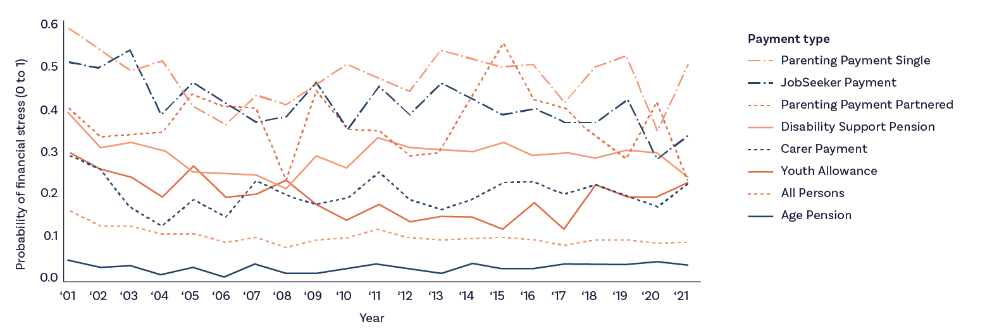
Source: HILDA, 2023.
The main points from this chart are as follows:
- There is significant variation in financial stress between different payment types.
- Age Pensioners have lower financial stress than other social security recipients and lower than the rest of the population with or without income support payments.
- Working age payments, in particular, Parenting Payments (single and couple), and JobSeeker have very high rates of financial stress – typically around a 30% to 50% probability of stress.
- DSP recipients, despite similar payments to the Age Pension, are in a much worse position of stress compared to Age Pension recipients.
- Youth Allowance recipients, despite very low payments, are in better financial position than other working age income support recipients.
- Financial stress declined through the 2000s but was more stable for the overall population and for Age Pensioners, with some possible improvements to working age recipients through COVID.
Additional estimates using HILDA up to 2022 in Figure 6 (DSS estimates are only to 2021) show a similar picture, albeit for more aggregate payments such as ‘parenting payment’ covering both single and couple recipients. This analysis also included a category for people receiving family payments who don’t receive other income support payments but who are generally in the lower half of the family income distribution.
Stress rates for people receiving JobSeeker and Parenting Payment are similar, and both have increased since COVID (significantly) – tentatively this suggests that COVID payments did lower financial stress. With that in mind there are likely to be significant differences between some of these payment types. For example, people receiving Youth Allowance, particularly students, may have more ability to earn private income or have access to support from parents than people receiving JobSeeker. As discussed below, Age Pensioners are likely to have higher wealth with both a home ownership rate and financial wealth significantly greater than people receiving working age payments.

Figure 6: Measures of Financial Stress among Australian households, 2001 to 2022
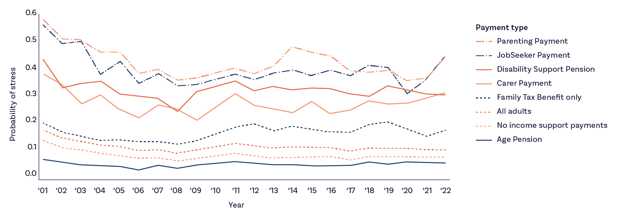
Source: HILDA, 2023.
Those persons receiving family payments only (and no main income support payments) have much lower rates of stress than those recipients who do receive working age payments. Their rates of stress have increased over the last 14 years which may be due to some tightening in the eligibility and therefore the group is increasingly made up of lower income families. Stewart et al. (2023) estimate that coverage of FTB has declined, with an estimated 46% of children aged 0 to 18 years receiving FTB in 2021, down from a peak of 68% in 2005. This has resulted in low-income families making up a much higher proportion of families receiving FTB.

2A.3.2 Factors underlying differences in financial stress
What explanations are there for the variation in the extent of financial stress among households discussed earlier? This section describes some of the characteristics of households in 2023 associated with different rates of stress.
Figure 7 shows modelled estimates for rates of financial stress where the household experienced three or more forms of stress in the ABS Survey of Income and Housing. The highest rates of stress were experienced by people receiving Parenting Payment Single. More than half of these households were experiencing three or more forms of stress.

Figure 7: Modelled Rates of Financial Stress among Australian households, December 2023
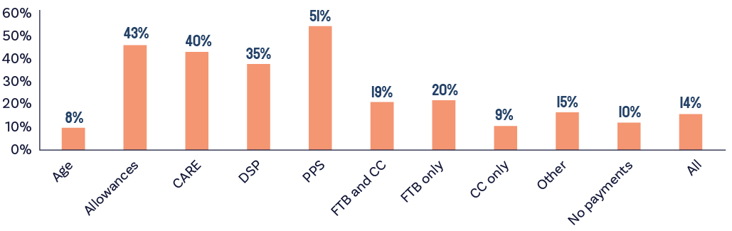
Source: ANU PolicyMod, ABS Survey of Income and Housing 2019-20.
As discussed, the next highest level was experienced by those receiving Allowances (such as JobSeeker or Youth Allowance), but rates of stress were nearly as high for those on Carer Payment and DSP, which have much higher levels of payment. As can be seen, the lowest household stress rates were among people receiving Age Pensions (8%), lower than families receiving only the Child Care Subsidy or among those not on any payment at all.
Figure 8a shows the level of median equivalised wealth in 2023 for the same household types. The median wealth for Age Pensioner households – both those receiving the full rate and a part rate – was nearly the same as for those completely outside the income support system at around $531-$533 thousand dollars (including the family home). Levels of median wealth for those receiving allowances were less than $40,000 all-inclusive and for those receiving Parenting Payment Single was around $20,000.

Figure 8a: Median equivalised household wealth among Australian households, by type of social security support, 2023
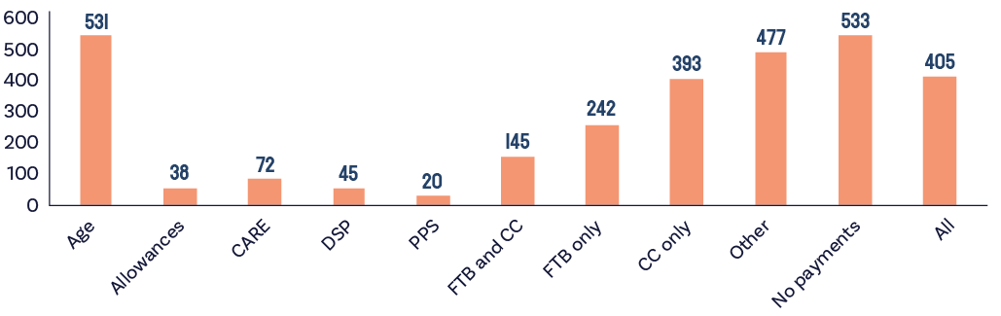
Source: ANU PolicyMod.
Figure 8b uses DSS administrative data from December 2023 to show the average and median level of assessable assets for a range of income support payments.

Figure 8b Average and Median Assessable assets balances, December 2023
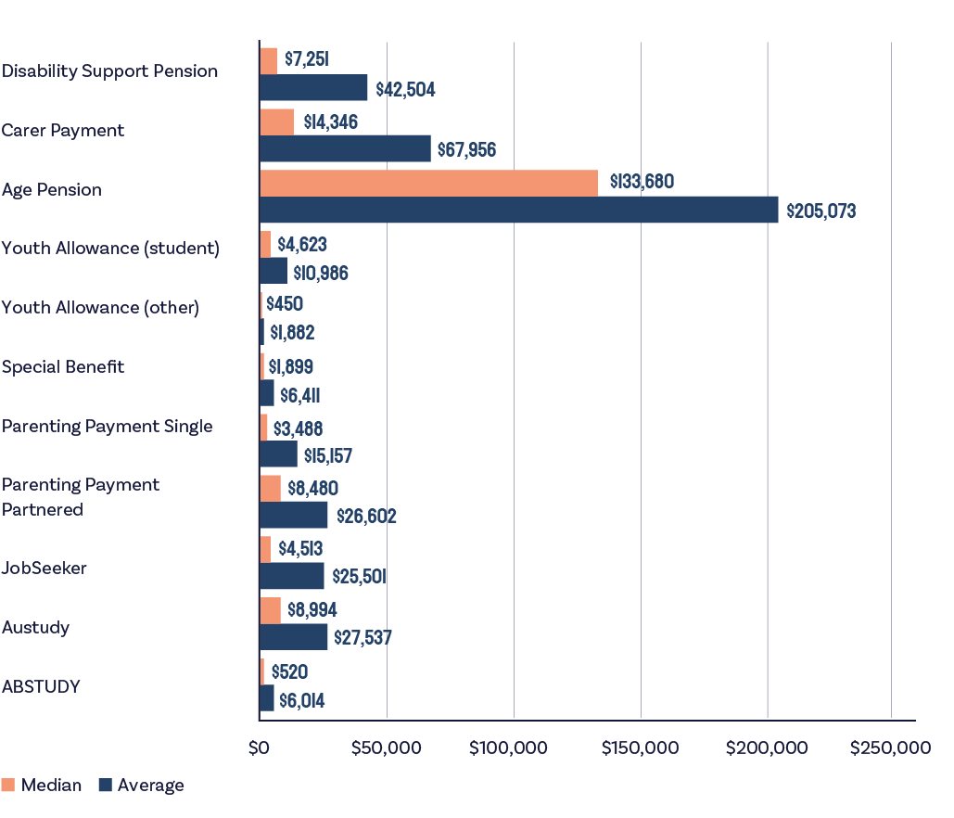
Source: DSS administrative data
Figure 8b clearly shows that assets for working age income support recipients are typically very small. JobSeeker recipients have median assets of around $4,500 and an average of $25,500. Those on DSP have only marginally more while youth allowance (other) recipients typically have less than $500 in assessable assets. Those on Parenting Payment Single (mostly women) have typical assets of around $3,500 and an average of just over $15,000. These amounts are in stark contrast to age pensioners who have a typical balance of around $134,000 and average asset value of $205,000. These asset values relate to the value of an ‘income unit’ such as a single person or a couple and include a range of assets some of which are ‘liquid’ (e.g., shares or bank accounts) and some which are not liquid, such as home contents. Assessable assets do not include the value of the family home. Figure 8a figures relate to household totals which is conceptually similar but not the same as an income unit. Some households may consist of more than one income unit.
Figure 8a and Figure 8b indicate that many people receiving social security payments, particularly working age payments, have very low levels of wealth/assets. Combined with typically low incomes such low levels of wealth (particularly liquid wealth) likely explain the high rates of financial stress amongst many working age payment recipients such as those in receipt of the JobSeeker Payment, DSP and Parenting Payment. A lack of liquid wealth will mean, where other assistance is not readily available from friends and family or charities that emergency funds are particularly difficult to find.
Figure 9 shows that rates of home ownership are highest among Age Pensioner households at 80%, which is not surprising given their age. For all the other groups of people receiving income support payments, home ownership is well below 50% - that is the median households in these groups are not home-owners.
People receiving Parenting Payment Single have by far the lowest rates of home ownership at 16%. This is likely to reflect their younger age and the breakup of a relationship that led to their receipt of this payment.

Figure 9: Rates of home ownership among Australian households, by type of social security support, 2023
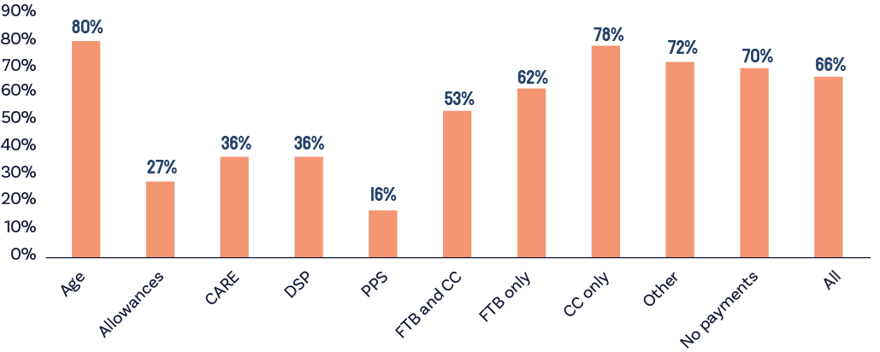
Source: ANU PolicyMod.

2A3.3 discussion
What can this analysis tell us about current rates of social security payments? The high rates of stress amongst Parenting Payment should raise concerns about the levels of Parenting Payment, particularly the Single rate, and raise concerns about the level of family payments – at least for those on the maximum rates of those payments. The rates of stress for all working age payments are well above the rest of the population and are an indication that many people receiving these payments face significant financial barriers.
This is perhaps a good example of where comparisons of income alone do not necessarily provide an accurate guide to financial well-being and financial stress. Parenting Payment Single has a rate of payment well above JobSeeker ($989 per fortnight compared to $758 per fortnight) and about $108 per fortnight lower than the Age Pension (and DSP) at $1096.70 including supplements.
Despite these income differences, Parenting Payment Single recipients have the highest rates of stress, just above JobSeeker. People receiving the DSP report much higher rates of financial stress than the Age Pension yet have the same social security income.
The key here is that income is only one driver of financial wellbeing, and it would be expected that there is considerable difference between people receiving these payments regarding their fundamental financial requirements.
The most recent estimates from HILDA are from 2021-22 and therefore do not include the changes in the 2023-24 Budget.
These figures in themselves do not provide a clear indication of what the ‘right’ level of payment should be, but they reinforce the picture of disadvantage among people receiving working-age income support payments and suggest further financial assistance is required to improve their financial position to a level more closely aligned with the rest of the community.

2A.4 Why has the gap between unemployment payments and Age Pensions widened?
It is important to understand the past processes by which payments for the people who are unemployed have fallen so far from acceptable standards of adequacy.
The First Report of the Interim Committee noted that “levels of social security payments in Australia have been set by Parliament through a complex historical process, usually involving long periods of inaction or “set and forget”, interspersed with bursts of activity that have been necessary as a result of the previous inaction” (The Committee, 2023, p.14).
In terms of how adequacy changes over time, the methods of indexing payments – if at all – are the most important influence on long-term trends in benefit levels. In addition, the total level of support is influenced by additional supplements paid to people receiving income support or concessions available to them. Governments have also made explicit policy decisions to improve adequacy for some payments.
In summary, indexing JobSeeker Payment and related income support payments only in line with the CPI has resulted in their relative base rates failing to keep up with other payments such as the Age Pension. This gap has been reinforced by related policy decisions about pension payment levels in other periods.
When unemployment payments became payable in 1945, the single rate of payment for a person aged 21 years and over was around 77% of the single rate of pension and the partnered rate was 69% of the pension rate. Payments for people who are unemployed were next increased in 1952, which prior to the increase, had fallen to 42% of the pension rate.
Over the next twenty years, they were increased eight times – usually during periods of higher unemployment or announced before elections – and in December 1972 the basic payment rates were equalised and significantly increased. The single and partnered rates of unemployment payment and pension rates then remained the same until November 1978, when the benefit rate for singles without dependents was not increased. However, pensioners had access to fringe benefits that reduced specific costs for them, and that were not available to the same extent for beneficiaries.
Indexation of pensions and benefits was legislated in 1976 (Bancroft, 1983), but was made less regular for pensions and abolished for beneficiaries without children between 1978 and 1980, when the cumulative inflation rate was over 20%. By mid-1982 the lower single benefit rate was less than 80% of the single pension rate, whereas the higher single rate and the partnered rate of benefit continued to be aligned to pension rates.
The Fraser Government increased unemployment payments towards the end of its period in Government, and from 1983 onwards the Hawke Government further increased the lower single rate of unemployment payments relative to pensions, so that by 1989 the lower single rate had reached 93% of the pension. In March 1996, the lower single adult rate of payment was around 92% of the basic rate of pension. Including the supplements available to pensioners but not available to people unemployed, the total payments were about 90% of the support available to pensioners.
In 1997, the Howard Government legislatively “benchmarked” pensions to 25% of MTAWE; this meant that if the price indexation increases in March and September each year left the single rate of pension below this, then it was raised to this level. As the change did not apply to the higher single rate or the partnered rate of allowances for people unemployed, over time a gap developed between pension rate and the partnered and higher single rates of benefit/allowance.
Figure 10 shows trends in the real gap between income support for a single adult on JobSeeker attracting the lower single rate and the single rate of pension (the maximum basic payment rate plus additional supplements) since the 1990s.
At the end of the period of the Keating Government, the gap in basic payment rates for a single recipient without dependents was around $53 per fortnight in current terms and including supplementary payments it was around $69 per fortnight.
Legislative benchmarking the pension to MTAWE started to have a discernible effect after 1998, so that by early 2000 the lower single unemployment payment was worth around 87% of the support for a pensioner, including supplements. The gap in basic payment rates grew to $78 per fortnight in 2000 and $94 including supplements.
The gap in basic payment rates appears to slightly narrow in 2000. This was a result of the different approaches taken to compensate social security recipients for the July 2000 introduction of the Goods and Services Tax (GST). Basic rates for people unemployed were increased by 4% on 1 July 2000, but basic payments for pensioners were not indexed. Instead, the Government introduced a new GST supplement, which increased the support package by 4%. The reason for doing this appears to be that the new supplement was indexed in line with changes in the CPI, but was excluded from the wage benchmark, potentially reducing expenditure over the longer term.
Real wage growth was stronger in the 2000s (up until the Global Financial Crisis) so that by 2009 the real gap had increased to $142 per fortnight and $179 per fortnight, including supplements.
As can be seen in Figure 10, the largest single increase in the gap between payments was in 2009 when the basic gap increased by nearly $90 per fortnight and the total gap by $130 per fortnight. Support for the single adults unemployed on the lower rate fell from 79% to 68% of the support for single Age Pensioners, with the relativity for couples falling from 83 to 81%.
This was the result of the increases in pensions as a result of the implementation of recommendations of the Harmer Review, which had been established in May 2008 by the Minister for Families, Housing, Community Services and Indigenous Affairs, the Hon. Jenny Macklin MP. The terms of reference directed the Review to consider:
- the appropriate levels of income support and allowances, including the base rate of the pension, with reference to the stated purpose of the payment
- the frequency of payments, including the efficacy of lump-sum versus ongoing support
- the structure and payment of concessions or other entitlements that would improve the financial circumstances and security of carers and older Australians.

Figure 10: Real Gap (Sep 2023$ per fortnight) between JobSeeker Income Support and Pension Income Support, 1995 to September 2023
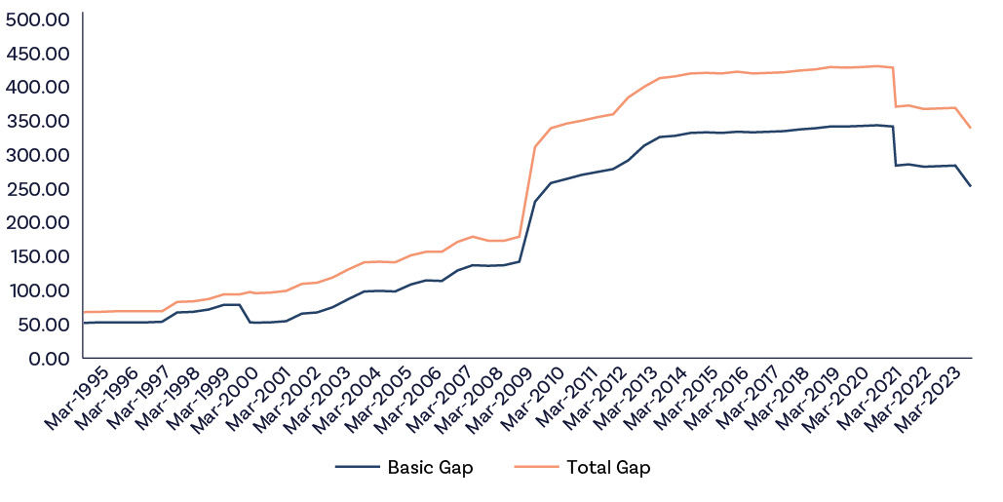
Note: The Basic Gap is the difference between the maximum basic payment rates for a Single Adult receiving Newstart/JobSeeker and Single Age Pension; the Total Gap includes the additional supplements paid to pensioners and beneficiaries in different periods.
Source: Daniels, D. (2011) Social security payments for the aged, people with disabilities and carers 1901 to 2010, Parliamentary Library Background note, 21 February 2011, Canberra.
Ey, C. (2012), Social security payments for the unemployed, the sick and those in special circumstances, 1942 to 2012: a chronology, Parliament of Australia Department of Parliamentary Services, BACKGROUND NOTE 4 December 2012
DSS reference Guide to Historical Rates, https://guides.dss.gov.au/social-security-guide/5/2
As noted in the First Report of the Committee, the Harmer Review contains the most comprehensive Australian review of payment adequacy, but it was limited to Age Pensions, DSP, and Carer Payment.
It is worth emphasising that the Harmer Review looked at a range of different measures of adequacy and outcomes, to consider both the adequacy of payments per se and the relativities between households, in particular those living alone and those who are members of couples. The Review also recommended changes in the indexation of payments for pensioners.
The package of reforms included a large increase in payments for single pensioners, simplification of the supplementary payments, with the Pension Supplement replacing the previous GST Supplement and the Pharmaceutical, Telephone and Utilities Allowances, and a change to indexation.
Pensions (including the Age Pension, Service Pension, DSP and Carer Payment) are now indexed twice each year by the greater of the increase in the CPI or the Pensioner and Beneficiary Living Cost Index (PBLCI). They are then ‘benchmarked’ against a percentage of MTAWE.
The combined couple rate is benchmarked to 41.76% of MTAWE; the single rate of pension is set at 66.33% of the combined couple rate (which is equal to around 27.7% of MTAWE). ‘Benchmarked’ means that after it has been indexed, the combined couple rate is checked to see whether it is equal to or higher than 41.76% of MTAWE. If the rate is lower than this percentage, the rates are increased to the appropriate benchmark level. The combined couple rate of Pension Supplement is indexed to increases in CPI only, with the single rate set at 66.33% of the combined couple rate.
As a result of these changes, the gap continued to increase until recently so that by early 2020, the basic payment gap was more than $340 per fortnight and the total gap was nearly $430 per fortnight.
The introduction of the temporary Coronavirus Supplement raised the rate of JobSeeker Payment to above the Age Pension for a short period, but in March 2021 the gap had returned to its previous levels.
In April 2021, the Morrison Government increased payment rates so that the gaps fell by nearly $60 per fortnight in current terms, with the increase in September 2023 reducing the gap to $253.30 per fortnight for basic payment rates and $339 per fortnight including supplements.
In summary, the gap between total payment rates for those receiving JobSeeker Payments and pensions has widened over the past 30 years, mainly as a result of deliberate policy choices to improve support for pensioners – and more recently, has narrowed with policy decisions to improve support for people who are unemployed.
Table 6 shows an estimate of how the real level of the differences in support packages has evolved since 1997, when the legislated benchmarking to MTAWE commenced, and the current situation.
The largest single change related to the implementation of the Harmer Review recommendations to improve the adequacy of pensions, when the difference in support packages for single adults increased by more than $130 a fortnight, comprising an increase of $89 in the difference in basic payments rates and nearly $44 in fortnightly supplements.
However, indexation and benchmarking – which are policy choices – also play an important role. Benchmarking to wages saw the differences in real basic support increase by $90 per fortnight between July 2000 and May 2009. The real increase in the difference in support packages was nearly $113 a fortnight between September 2009 and September 2020. It can be roughly calculated that around 60% of the gap in support packages at its peak was a consequence of the benchmarking of pensions to MTAWE.

Table 6: Changes in differences in real values of components of income support packages for people receiving JobSeeker and pensioners, September 1997 to September 2023 (September 2023$ per fortnight)
 | Differences in support at chosen dates |  |  | Change in differences in support from previous date
 | Total | Basic Payments | Supplements | Total | Basic payments | Supplements
Sep-97 | 69.28 | 53.43 | 15.85
Jul-00 | 96.66 | 52.53 | 44.75 | 28.08 | -0.82 | 28.90
May-09 | 213.54 | 141.88 | 71.66 | 81.82 | 89.27 | -7.45
Sep-09 | 311.42 | 230.50 | 80.92 | 132.24 | 88.62 | 43.62
Sep-20 | 430.58 | 343.37 | 86.75 | 116.74 | 110.91 | 5.83
Sep-23 | 338.70 | 253.30 | 85.40 | -89.46 | -88.11 | -1.35
Notes: September 1997 was the date when benchmarking of pensions to MTAWE was introduced although the first increase above inflation was in March 1998; July 2000 was the introduction of the GST and compensation packages; March 2009 was the indexation date immediately before the Government implemented recommendations of the Harmer Pension Review; September 2009 was the introduction of the Review recommendations; September 2020 was the point of greatest real difference between support for people receiving JobSeeker and pensioners (excluding the Coronavirus supplement); September 2023 reflects the impact of changes in 2021 and the 2023-24 Budget.
Source: Daniels, D. (2011) Social security payments for the aged, people with disabilities and carers 1901 to 2010, Parliamentary Library Background note, 21 February 2011, Canberra.
Ey, C. (2012), Social security payments for the unemployed, the sick and those in special circumstances, 1942 to 2012: a chronology, Parliament of Australia Department of Parliamentary Services, BACKGROUND NOTE 4 December 2012
DSS, Guide to Historical Rates, https://guides.dss.gov.au/social-security-guide/5/2
The gap was narrowed by the increases by the Morrison Government in 2021 and in last year’s Budget.
Figure 11 shows trends in the real value of the MTAWE benchmark over time. While Male Total Average Weekly Earnings rose in real terms from $1,405 a week in 2001 to $1,765 per week in May 2013, it subsequently fell, and then did not increase for the next six years. There was a spike in early 2020, and it subsequently fell and by May 2023 it was about the same level as in November 2009.
It should be noted that MTAWE is affected by changes in the composition of the male workforce as well as by changes in male wage rates. It is likely that the spike in the real level of MTAWE in 2020 was affected by the increase in unemployment at the time, when lower paid workers either became unemployed, left the workforce or were supported by the Coronavirus Supplement. Correspondingly, the fall in MTAWE up to November 2022 is likely to be affected by the dramatic fall in unemployment rates, bringing low paid workers into jobs.

Figure 11: Trends in real (May 2023$ per fortnight) MTAWE, 1995 to November 2023
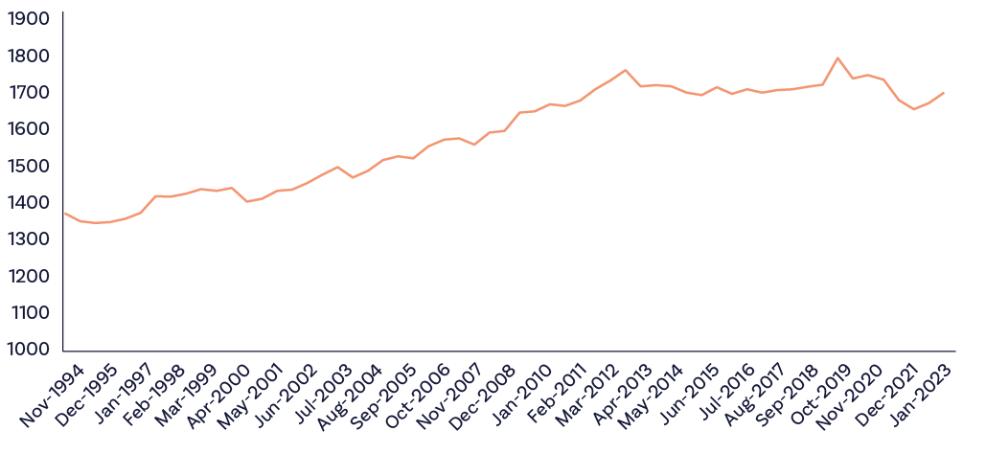
Source: Calculated from ABS (2023), Average Weekly Earnings, November 2023, https://www.abs.gov.au/statistics/labour/earnings-and-working-conditions/average-weekly-earnings-australia/latest-release and ABS (2023)
While benchmarking to MTAWE is not responsible for the increasing value of pensions after 2013, there is an anomaly in the indexation measures that should be noted.
Figure 12 shows the cumulative changes in the CPI and different living cost indexes between September 2009 and September 2023 (May 2023 for MTAWE). The calculations start from September 2009, as this was the date when indexation was based on the greater of the increase in the CPI or the PBLCI.

Figure 12: Change in CPI and Living Cost Indexes, September 2009 to September 2023
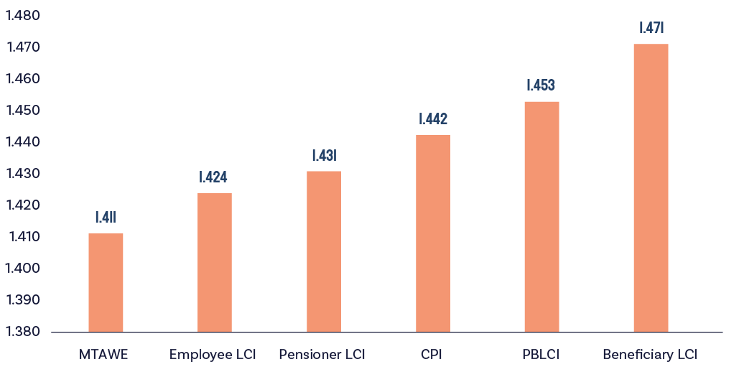
Source: https://www.abs.gov.au/statistics/economy/price-indexes-and-inflation/consumer-price-index-australia/sep-quarter-2023
Figure 12 shows that the Pensioner and Beneficiary Living Cost Index increased by 45.3% over this period, compared to an increase of 44.2% in the CPI. However, the Beneficiary Living Cost Index increased by 47.1% over this period, while the Living Cost Index for Pensioners increased by somewhat less than the CPI (43.1%).
What this means is that part of the increase in the difference between basic payments was due to the fact that living costs increased most for people receiving working age income support payments, raising the PBLCI at a faster rate than the CPI.
So, pensioners benefited from the rising cost of living of working age income support recipients, while actual working age income support recipients did not.
In addition, the single basic rate of pension in May 2023 was around 29.6% of MTAWE, well above the benchmark of 27.7%, meaning that price indexation will continue to dominate benchmarking for some period after wage increases return to above inflation.
The next section describes in more detail the range of current indexation provisions applying to payments and how these have developed over time to influence the disparities between payments. This is followed by a discussion of approaches to indexation that improve the adequacy of payments, as well as improving the coherence of the social security system and simplifying the system both for people receiving payments and for administration.

2A.4.1 Current Indexation of Pensions and Benefits
Table 7 summarises the current indexation provisions.

Table 7: Indexation provisions in the social security system
Payment | Indexation
Age Pension, Service Pension, DSP, Carer Payment | Indexed twice each year by the greater of the movement in the CPI or the PBLCI. They are then ‘benchmarked’ against a percentage of MTAWE. (See text for details.)
Parenting Payment Single | Indexed twice each year by movements in the CPI and benchmarked to 25% of MTAWE.
JobSeeker Payment, Rent Assistance and rent thresholds | Indexed twice each year by movements in the CPI.
Youth Allowance (Student) | Indexed once a year on 1 January by movements in the CPI.
Telephone Allowance | Indexed on 20 September each year by movements in the CPI.
Pharmaceutical Allowance | Indexation is on 1 January each year using CPI for the year to the previous September quarter.
Essential medical equipment payment | Indexation is on 1 July each year using CPI.
Pensioner Education Supplement; Remote Area Allowance; Energy Supplement | Not indexed.
Family Tax Benefits | Indexation was paused between July 2016 and July 2019.  The following rates and thresholds, where indexation has not been paused, are indexed on 1 July each year based on CPI increases:  - FTB Part A rates  - newborn supplement  - newborn upfront payment  - FTB Part A supplement  - FTB Part B supplement  - multiple birth allowance  - the FTB Part B rates  - the FTB ACO (1.1.A.80) rate  - the FTB Part A income free area  - the FTB Part A higher income free area  - standard basic MIFA, double basic MIFA and additional MIFA  - the FTB Part B secondary earner (1.1.S.25) income free area (1.1.I.40), and  - the FTB Part B primary earner (1.1.P.122) income limit.  Single Income Family Supplement rates are not subject to indexation.
It is apparent that there are a wide range of specific indexation approaches. The rationale for some of these different approaches is not evident. For example, indexation of youth payments on a 12 monthly basis continues to reflect that Austudy was formerly an annual ‘calendar year’ entitlement aligned to the study year, but it also means that calculation of financial incentives to study rather than look for work change during the calendar year.
In addition, the different indexation and benchmarking provisions means that the relativities between payments change over time. For families with children, the delinking of FTB Part A from wage benchmarking in 2009, and the suspension of price indexation between 2016 and 2019, means that the level of payments per child has fallen below the benchmarks introduced by the Hawke Government as a result of its pledge to eliminate child poverty in 1987 (Cass and Whiteford, 2009; Stewart et al., 2023).
Under current indexation and benchmarking arrangements it is inevitable that these gaps will recur and continue to widen.
This can be seen in all of the projections of the Intergenerational Reports to the Government since 2002. Using the assumptions specified in the 2023 Intergenerational Report (IGR), for example, average earnings rise by 3.7% per year and prices by 2.5% per year over the next 40 years.
On average, employed Australians and those on pensions benchmarked to wages will be better off in real terms by nearly 60 per cent. However, the same assumptions imply that the people living on price-indexed payments in the future Australian community will not share in any increase in real living standards. The single rate of unemployment payments would fall from 74% of the pension to 47% by 2063. The improvements in payments achieved in 2022 and 2023 would be undone by 2035.
The result would be much higher relative poverty among people of working-age receiving benefits in the future. Child poverty would also increase very substantially.
If deep poverty among future disadvantaged working-age adults and their children is to be avoided, then spending on social security payments needs to keep pace with general improvements in population living standards, with implications for future spending.
The discussion of the gap between pensions and working age income support payments has widened primarily because of the benchmarking of pensions to MTAWE. If benchmarking and indexation are not reformed, then the problems that have developed since 1997 will become even wider over the next 40 years.
In terms of the simplicity of the overall system and providing a sustainable level of adequacy, a more consistent approach to indexation must be developed.
The Committee recommends the Government improve the adequacy of indexation of working-age payments immediately, and regularly reviews and monitors the relationship between working-age payments levels and widely accepted measures of community living standards, including wages.

2A.4.2 Differences in supplements
Three other specific issues may warrant attention – the coverage of Pharmaceutical Allowance and the Telephone Allowance, and the level and indexation of Remote Area Allowance (RAA).
Pharmaceutical Allowance is designed to help those with additional needs for medical prescriptions, but mainly assumes that these are Age Pensioners or people qualifying for DSP or Carer Payment, for whom this support is now part of the Pension Supplement. This assumes that anyone over the age of 67 or people with disabilities or are carers have increased needs for this assistance.
Evidence to the Committee and the changing composition of the population receiving JobSeeker Payment – in part a consequence of the declining number of younger people receiving DSP due to restrictions on access to payments – suggest that the coverage of this assistance should be considered.
While the Government’s Budget changes to the Pharmaceutical Benefit Scheme are very welcome, health costs for those on working age payments may be a major barrier to increasing participation and employment.
The Telephone Allowance (TAL) was introduced from 1 July 1992 to replace telephone rental concession vouchers, following the privatisation of the public telephone carrier. Since 2008, there are 2 rates of TAL – standard TAL being paid to subscribers of a telephone service and a higher rate of TAL being paid to eligible recipients who also subscribe to a home internet connection.
TAL is part of the Pension Supplement, but is also paid to people receiving DSP (under 21 years of age without children), Parenting Payment (Single), or receiving JobSeeker Payment or Special Benefit, provided they are at least 55 years of age and have been receiving a social security pension or benefit continuously for the previous 9 months, or receiving JobSeeker or Youth Allowance (job seeker) and who have a partial capacity to work, or who is a single principal carer.
The Committee will undertake further analysis of these supplements as part of its future agenda.
The RAA was introduced by the Hawke Government in 1984 in recognition of the higher cost of living in remote areas but was increased only twice since then. It is not indexed and was last increased in July 2000.
Recent research from the ANU Centre for Aboriginal Economic Policy Research has highlighted that conventional (cash) income poverty rates are extremely high in the 2021 Census in remote and very remote areas, at 41.0% and 51.7%, respectively. However, cash poverty rates do not capture the impact of the much higher living costs in these areas.
Evidence from the lived experience of members of the Committee is that the cost of living in remote areas – particularly the cost of a healthy diet for children and adults – is much higher than the RAA.
Markham (2024) calculates that if the RAA had been indexed to inflation since 1984, then the single rate would be $52.50 per fortnight (rather than $18.20 per fortnight), or if it had kept pace with the single rate of Age Pension it would be $78.50 per fortnight.
Markham (2024) uses a variety of data sources to estimate that the estimated cost of living (for food and drink, transport, electricity, tobacco products and other goods and services) is 38.8% higher for Indigenous households in very remote areas and their counterparts in metropolitan areas. If this estimate was applied, then the RAA for a single adult on JobSeeker would need to be around $290 per fortnight, with higher levels for larger households.
It may also be the case that RAA could be better targeted to areas with higher essential costs. Markham (2024) argues that some of the people receiving RAA do not live in areas where costs are so elevated, suggesting that the appropriate geographical boundaries for higher payments need to be assessed, as well as the structure of the payment.
Improving the evidence base for assessing the role of this allowance in helping households with very high costs of living is essential. In this context, particular attention could be paid to recent developments in Canada. In 2018, the government of Canada released Opportunity for All, Canada’s First Poverty Reduction Strategy, which contained long-term commitments to guide current and future Government actions and investments to reduce poverty.
Since the release of Opportunity for All, Statistics Canada has investigated Market Basket Measure thresholds for Canada’s remote territories, (Yukon, the Northwest Territories and Nunavut). These poverty thresholds are also adequacy benchmarks, which are likely to be of relevance to related work in Australia.
Statistics Canada has also consulted extensively with First Nations people in the development of these measures. The ABS or an appropriate researcher or research centre in partnership with remote communities should be supported to undertake similar analysis, but the case for an immediate increase in the RAA seems particularly strong.

2A.5 Fiscal and inflationary impacts
The implementation of recommendations will have an impact on the Government’s short- and long-term fiscal strategy. The Committee recognises these reforms will add to the pre-existing fiscal pressures facing the Government due to an ageing population as outlined in its 2023 Intergenerational Report.
While overall the proposed increase in income support payments will add to the fiscal task facing the Government, how it meets this broader challenge will have important impacts on economic inclusion. Ensuring that the fiscal challenge is met in a way that both maximises economic growth and maintains equity can underpin greater economic inclusion.
The Committee has also considered analysis on whether an increase to JobSeeker by the Government consistent with our recommendations would be inflationary. We have done so because of the heightened concern around inflation in Australia and the associated need to assess proposed increases in Government spending for their potential impact on inflation.
In its deliberations on this issue, the Committee acknowledged the difficulty of calculating the likelihood of any increase in inflation due to the proposed rise in JobSeeker and related payments. Ultimately the Committee was advised that any impact would likely be small to negligible. This is primarily because the increases represent a small share of overall expenditure in the economy. An increase in the rate of JobSeeker and related payments to 90% of the Age Pension would cost approximately $4.6 billion per annum and represent around 0.43% of total household consumption and 0.16% of GDP.
There may be a one-off marginal increase to inflation if the additional payments fully flowed through to household spending, but any change is likely to be small to negligible and depend on how such a change is implemented. The Committee would welcome further analysis by Treasury on these matters, and any subsequent decision should be based on the Treasury analysis.

2A.6 Conclusion
As emphasised in the First Report of the Committee (EIAC 2023), all indicators reviewed by the Committee continue to show that rates for JobSeeker Payment and related non-pension payments for working-age Australians are seriously inadequate, whether measured relative to average or National Minimum Wages, in comparison with pensions, or measured against a range of income poverty measures. People receiving these payments face the highest levels of financial stress in the Australian community.
The Government has responded to the recommendations of the First Report with a range of measures in the 2023-24 Budget, the White Paper on Jobs and Opportunities, and through the Tackling Entrenched Disadvantage Package.
In summary, there has been some progress, but it has been limited. The Committee continues to argue that rates of working age income support and supplements should be increased to 90% of the pension rate and supplements as a priority to improve the adequacy of the Australian social security system. If these increases are to be staged, a clear timetable to achieve this objective should be established.
Since the 1990s, the gap between pensions and most working-age payments widened primarily as a result of the benchmarking of pensions to MTAWE, which was applied to the Age Pension and DSP and Carer Payment, but not to other working age social security payments.
The Committee recommends the Government improve the adequacy of indexation of working-age payments immediately, and regularly reviews and monitors the relationship between working age payments levels and widely accepted measures of community living standards, including wages.
The social security system is complex. The Committee considers it essential that further analysis be undertaken of the overall system of support for working-age households.
However, the immediate priority remains substantial increases to the base rates of JobSeeker Payment and related payments.
Recommendation 1
The Government commit to a substantial increase in the base rates of JobSeeker Payment and related working age payments as a first priority.
Recommendation 2
The Government commit to a timeframe for the full increases of JobSeeker and related payments to be implemented, if increases are to be staged.
Recommendation 3
The gap between the current level of JobSeeker Payment and the Age Pension is primarily the consequence of the benchmarking of pensions but not allowances to MTAWE since 1997. Maintaining the current approach to benchmarking in the long run will recreate the same or an even wider gap.
The Government improve the adequacy of indexation of working-age payments immediately, and regularly reviews and monitors the relationship between working age payments levels and widely accepted measures of community living standards, including wages.
Recommendation 4
The ABS or an appropriate researcher or research centre in partnership with remote communities should be funded to undertake analysis of the additional costs of living in remote areas, but the case for an immediate increase in the RAA seems particularly strong.

Chapter 2B:
Would a rise in JobSeeker affect incentives for paid work?

2B.1 Introduction
This section examines how an increase in the JobSeeker Payment might affect incentives for people receiving JobSeeker to take up employment. More precisely, it examines the potential effect on the take up of employment of increasing the JobSeeker Payment to 90% of the Age Pension, as is proposed in this report.
The Committee’s assessment is that the negative effect of increased JobSeeker Payments on incentives to take up employment is likely to be small. This is true even for a relatively large increase to 90% of the Age Pension. The major cause of this is that the current level of JobSeeker Payments is so low that even a substantial increase would still leave unemployed Australians on extremely low incomes compared to having a job. Indeed, they would still earn less than 97.5% of employed Australians. The financial benefits of employment would remain large, and the substantial non-financial benefits of employment only add to the motivation for employment.
For job seekers facing economic exclusion, for whom financial stress is a major issue, some literature suggests that higher income support payments may improve the capacity to search for and accept employment. The Committee would welcome further work by Commonwealth Treasury to build evidence on these matters.

2B.2 How economists think about choosing the optimal level of unemployment income support payment
The standard economic model identifies a key trade-off over the effect of a higher unemployment income support payment on society’s wellbeing. Social wellbeing is raised when the income of an unemployed person is increased (towards the level they would earn when employed). However, to the extent that the unemployed person’s incentive to move into employment is lowered, implying a longer time out of employment and lost output, society’s well-being is lowered. Choosing the level of income support that maximises society’s wellbeing therefore requires balancing the benefit and cost of a higher payment level.
A range of other macroeconomic effects of raising the level of unemployment income support can arise:
- Extra tax revenue must be raised to pay for the higher payment, which causes a cost to society via costs of tax collection and distortions to resource allocation from taxation.
- By improving well-being for job seekers, compared to being out of the labour force, a higher payment can increase labour force participation.
- By increasing a worker’s bargaining power (via their options outside employment being improved), a higher unemployment income support payment can result in increased wages in an economy, with consequent benefits for equity.

2B.3 Existing evidence on the impact of unemployment payments on incentives to move into employment
Australian evidence on the impact of the level of unemployment income support payment on time taken to move into employment is limited. International evidence suggests an average negative effect from higher unemployment benefit levels on incentives for job seekers to move into employment. A recent major review found that the median estimate of the cost to society from a $1 increase in payment – via the negative incentive effect – is $1.35. That is, in addition to paying the $1, the Government must make up an additional 35 cents of tax revenue due to the reduced labour supply/time in employment of the person who receives that higher payment.
An earlier review had similarly concluded that:
‘The main conclusion that can be drawn on the basis of the overview of studies…is that there are substantial effects on unemployment duration if the replacement rate (the ratio of unemployment income support payment to average earnings) changes…Consistent with the theory, most of the effect of the increase in benefit levels takes place early in the spell…’
The major difficulty with applying existing evidence to judge what would be the impact of an increase in JobSeeker is that the relevance of that evidence is questionable. The financial disincentive effect from receipt of an income support payment for unemployment depends on the size of gap between the income support payment and labour market earnings that could be achieved from moving into employment.
The level of JobSeeker Payment is so low in Australia compared to other countries, and the fact that Australia has a relatively high minimum wage, mean that international studies are based on changes in income support that have occurred with much smaller starting gaps between the payment and potential labour market earnings than in Australia. This difference is likely to cause significantly different implications for financial disincentives from increasing income support for job seekers in Australia compared to other countries.
What would be the impact of increasing JobSeeker on incentives to move into employment in Australia?
With existing evidence being of limited relevance, the best way to proceed to analyse the impact of an increase in JobSeeker on financial disincentives for work is to present descriptive information on the size of gap between JobSeeker and potential labour market earnings that would exist following an increase in JobSeeker.

2B.3.1 Financial disincentives
Decisions about whether to take up extra work occur on different margins. The extensive margin is whether to move into work from unemployment – for example, a JobSeeker recipient who is not in paid work may have the opportunity to move into full-time employment. The intensive margin is the amount of time worked – for example, a JobSeeker Payment recipient who is currently working may need to decide whether to agree to extend their current amount of work by an extra day.

2B.3.2 Shift from no work to full-time employment
The size of the JobSeeker Payment could increase by a substantial amount without significantly reducing the relative monetary returns from working compared to receiving only the payment.
One comparison is with the National Minimum Wage (NMW). Currently, the NMW is $882.80. At its current level of $379.00 per week (including energy supplement), the JobSeeker Payment is 42.9% of the NMW. If JobSeeker was to be raised to equal 90% of the single Age Pension, $493.52 per week, it would still be only 55.9%. Table 8 shows this information for a variety of sizes of increase to the JobSeeker Payment.

Table 8: Increased JobSeeker Payments as a percentage of the National Minimum Wage
Increase in JobSeeker ($ per week) | Per cent of National Minimum Wage
0 (Current rate = $379) | 42.9
25 | 45.8
50 | 48.6
114.52 (90% of Single Age Pension) | 55.9
Source: Calculated from income support rates effective from 20 September 2023 from https://www.servicesaustralia.gov.au/sites/default/files/2023-09/co029-2309.pdf; https://www.fwc.gov.au/agreements-awards/minimum-wages-and-conditions/national-minimum-wage#:~:text=The%20national%20minimum%20wage%20sets,hours%20(%2423.23%20per%20hour)
Comparison with weekly earnings of the current workforce provides an even stronger message about the minimal disincentive effect from an increase in JobSeeker. Figure 13 shows the distribution of weekly earnings of full-time employees in Australia in 2023. At the current rate of payment, a JobSeeker recipient is receiving just above the weekly earnings of an employee at the 1st percentile of the distribution. If the JobSeeker Payment was to be increased to be 90% of the Age Pension, it would still be at a level just above the weekly earnings of a worker at the 2nd percentile of the distribution. That is, more than 97.5% of full-time employees would be earning more than the JobSeeker Payment recipient.
Even if it was thought that JobSeeker recipients were mainly likely to move into jobs at the bottom of the distribution of earnings, there would still be a substantial gain in their incomes from doing that. For example, a worker at the 10th percentile had weekly earnings of $847 per week in 2023. So only moving to a job at the 10th percentile would still raise the income of a JobSeeker recipient by 70%, even after an increase in JobSeeker to 90% of the Age Pension.

Figure 13: JobSeeker Payment (increased to 90% of the Age Pension) compared against the distribution of weekly earnings of full-time employees, Australia, 2023
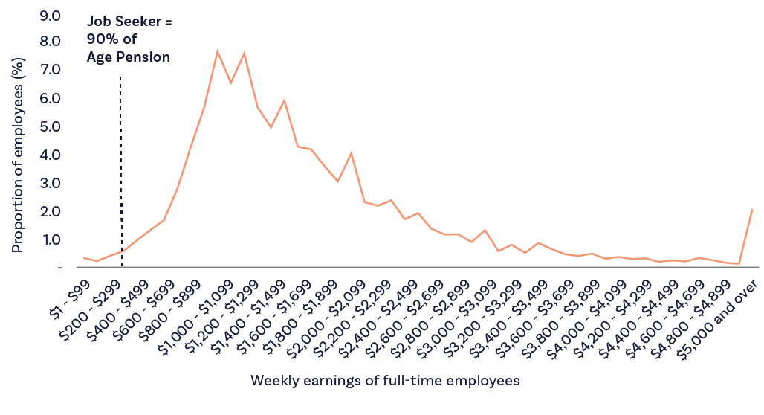
Source: ABS, Employee Earnings, August 2023, Table 8.

2B.3.3 Increasing current time worked by a day
Should the JobSeeker Payment be increased to 90% of the Age Pension, recipients would retain a significant financial incentive to work extra days. Table 9 shows financial gains from extra days of employment: the total gain compared to no work and the marginal gain from an extra day of work. These are shown for the current JobSeeker Payment (1) and under the scenario where the JobSeeker Payment is increased to 90% of the Age Pension (2). Calculations reported assume that the minimum wage is paid for work done, income testing arrangements for JobSeeker remain the same as at present and make adjustments for income tax (but not the Medicare levy).
Under both scenarios, the gain from an extra day of employment is always positive.
Was JobSeeker to be increased by $114.52 per week, to be equivalent to 90% of the Age Pension, the marginal gain from working an extra day is similar to at present for the 1st to 4th days of work, and smaller for the 5th day. The smaller gain from working on the 5th day is due to the JobSeeker Payment cutting out after four days at present, but only cutting out on the 5th day if the payment was to be increased to 90% of the Age Pension. It is important to note that calculations reported in Table 9 assume income test arrangements remain as at present. Hence, by also adjusting income test arrangements at the same time as increasing the JobSeeker Payment, it would be possible to (for example) create an increasing marginal financial gain from an extra day of work across days.

Table 9: Gains from an extra day of employment for a single adult on JobSeeker Payment
Days worked per week at minimum wage | 0 | 1 | 2 | 3 | 4 | 5
Gross earnings ($ per week) | 0 | 176.56 | 353.12 | 529.68 | 706.24 | 882.80
(1) Current JobSeeker Payment & income test
JobSeeker Payment | 379.00 | 323.36 | 217.43 | 111.49 | 5.56 | 0
Total net gain from employment | 0 | 92.44 | 149.65 | 206.85 | 264.05 | 400.22
Marginal gain from working an extra day |  | 92.44 | 57.21 | 57.20 | 57.20 | 136.17
(2) Increase in base JobSeeker rate to 90% of Age Pension & current income test
JobSeeker Payment | 493.51 | 437.88 | 331.95 | 226.01 | 120.08 | 14.14
Total net gain from employment | 0 | 70.68 | 127.89 | 185.09 | 242.30 | 295.24
Marginal gain from working an extra day |  | 70.68 | 57.21 | 57.20 | 57.21 | 52.94
Note: Includes income tax. Employer superannuation contributions are not included and would increase the financial rewards from work.

2B.3.4 Non-financial incentives for work
Comparing the monetary earnings from work to the JobSeeker Payment substantially understates the incentive to move from unemployment to work. A major body of empirical research has established a significant positive effect of employment on people’s health and psychological well-being. These effects are generally estimated to be large.
Conclusion 1
In the Committee’s assessment, and noting the utility of building an evidence base, any negative effect on incentives to move into employment from an increase in JobSeeker is likely to be small.
The low current level of the payment relative to labour market earnings likely to be obtained by jobseekers means that no significant financial disincentive to shift into employment should result from a large increase in JobSeeker Payment. This holds if the payment is increased to 90% of the Age Pension. The prediction that any negative incentive effect would be limited is only made stronger when it is recognised that the employment brings substantial non-monetary as well as monetary benefits.
For example, some studies of the determinants of happiness find that the non-financial returns to work outweigh the financial returns.

2B.3.5 What if there is a negative impact on incentives to move into employment from raising JobSeeker?
Suppose that raising JobSeeker did – similar to as found in international studies and contrary to what has just been argued is likely to be the case – slow the rate at which recipients move into employment. This is still not a sufficient reason against increasing the JobSeeker Payment. Only if the cost to society from a slower rate of movement into employment by job seekers outweighs the benefit to society from payment recipients receiving a higher income, would it not be optimal not to increase JobSeeker.
But this seems unlikely. The same recent review of international evidence as cited earlier concludes that:
‘Overall, it is clear that the welfare gain of a marginal increase in UI benefits is positive and likely to be substantial, especially in recessions.’
Given that the level of JobSeeker compared to average labour market earnings in Australia is much lower than in most other developed countries, the welfare gain from an increase in JobSeeker will be even higher than in the countries from which that evidence was generated.
This is reinforced by evidence that JobSeeker recipients on average are forced to decrease their spending after moving on to the payment; for example, by 10.5% in the first year after job loss. A recent study has concluded:
‘The payment rate appears insufficient to prevent a large and sustained drop in spending by many of those who receive it.’
Conclusion 2
Choosing the optimal level of unemployment payment requires considering both the welfare gain and cost from increases to the payment.
Hence, even if an increased level of JobSeeker did slow movement into employment, the negative effect must be more than the welfare benefit, for it not to be optimal to increase the payment level.

2B.3.6 A positive impact on the capacity to move into employment from a higher JobSeeker Payment?
There are reasons to believe that, for those job seekers facing economic exclusion (such as very long-term unemployed), an increased JobSeeker Payment will not adversely affect job search activity, and in fact may even increase that activity and hence also increase the speed of movement to employment.
The responsiveness of job search to the level of JobSeeker Payment for groups facing economic exclusion (such as the very long-term unemployed) is likely to be relatively low, regardless of the level of payment. This is because many of these payment recipients will perceive they are not likely to obtain employment due to barriers they are facing and will already have a low level of job search activity. As another way of putting this – only with substantial extra support to increase their probability of employment does job search (and hence incentive effects from unemployment payments) become a relevant consideration for this group.
Job search activity for groups facing economic exclusion may also be constrained by time and money.
A higher level of JobSeeker Payment would reduce the financial stress of many recipients, allowing them more time and ‘bandwidth’ to commit to job search.
It would also provide greater capacity to pay for job search-related costs, like transport, clothing and grooming for interviews.
Conclusion 3
Focusing on JobSeeker recipients facing potential economic exclusion, there is less reason to expect negative effects on job search incentives.
For jobseekers experiencing financial stress, a higher level of JobSeeker may increase job search and the likelihood of moving to employment.

Tahnee: Single parent living in a remote community
Tahnee is a 34-year old woman living in remote Australia. She has three children aged five, seven and ten and lives in an old three-bedroom house on community.
Tahnee’s family shares their house with her sister and her four nieces and nephews, aged between 13 and 18 who left a violent relationship two years earlier. There wasn’t a public house available in town for her sister, and her sister’s ex-partner also lives in their small town. Tahnee is scared for her sister – when her ex gets drunk, he sometimes comes over and tries to talk to her. She’s scared that one day he’ll get violent and hurt her, her sister or the children.
Child protection has been to see them a few times and they tell her sister that she needs to do a better job at protecting her children or they’ll take them away. Tahnee doesn’t know what her sister can do.
Often, Tahnee’s nieces and nephews don’t stay with them, as there aren’t enough beds for everyone, and the younger ones are also scared of their father showing up. Her 18-year-old niece has been living with her boyfriend’s family and the other three kids often stay with Tahnee and her sister’s cousin or at their aunty’s house. Tahnee wishes that there were enough houses so that her kids and her sister’s families were safe, but there just aren’t enough houses in town and even the ones that are there are in a bad way.
In Tahnee’s house, the water doesn’t work in the bathroom, so they all have to bring water from the kitchen to have a bath, brush their teeth or flush the toilet. There’s wiring that’s exposed on the front veranda and a hole in the laundry wall, and Tahnee worries that her youngest child might hurt himself one day. She’s asked the housing authority to fix the problems, but she’s on the waiting list for a long time as there just aren’t enough tradespeople to come to their small town. She’s given up trying to get things fixed anymore.
English is Tahnee’s fifth language. While she can get by speaking English, Tahnee finds Centrelink’s site impossible. Yet she’s always told to use the self-service terminals whenever she has a problem and goes into the local office. Tahnee is frustrated that she can’t get the forms or documents she needs in her language.
She’s made a lot of mistakes entering the wrong information into the system because she hasn’t understood the question. There’s always a long wait for an interpreter at the Centrelink office as there are lots of people in her community who can’t read or write well in English.
Tahnee has had her payments cut off because of mistakes she’s made entering her income. This makes it difficult to feed her children, especially because the cost of food is so high. Even when she receives payments, food is too expensive. Tahnee tries to make do with what food she can afford. The prices for fresh fruit and vegetables are often too high for her at the local store, so she mainly relies on tinned and dried food. Meat is almost always out of the question. She also tries to avoid driving to the bigger town, some two hours away, as petrol is too expensive and it means she’ll have to cut back on other things for the next few weeks.
While Tahnee has to pay a portion of her Parenting Payment Single to the state housing authority, she doesn’t receive any Rent Assistance, which makes things that much harder. To make things even worse, she only receives a small amount of Family Tax Benefit Part A, and doesn’t understand the system well enough to potentially get higher payments. No-one at Centrelink told her that she can get an exemption and receive more Family Tax Benefits, and she doesn’t know enough to even ask.
Sometimes, Tahnee has tried to call the Centrelink phone line, but her telephone reception is poor and she often gets cut off while waiting on hold. She can make calls easier from her aunty’s house, but she can’t stay there for hours waiting to get answered and for an interpreter to become available as she has to get home. Tahlee couldn’t get a mobile phone plan on her Parenting Payment Single income, so she got the cheapest pre-paid phone that she could afford. She’s frustrated that she uses up a lot of her credit on Centrelink calls and often doesn’t even get to speak to anyone. When she does speak to someone, they tell her to upload things online – but she doesn’t have a computer or the internet at home and doesn’t know how to use the one at the Centrelink office. She can’t upload documents using her phone, so she has to spend hours waiting at the Centrelink office to see someone who then makes her feel bad for not doing it herself. Still, Tahnee finds it better to go into town if she needs anything from Centrelink, the bank or Medicare, as at least she knows she’ll get seen, because the phone or internet won’t drop out. But that takes most of the day as she can’t afford the petrol and as there’s no public transport near her house. She has to go and come back when someone else is driving there.
Tahnee loves her community and wants to see her children, and her nieces and nephews grow up to be strong, healthy and proud. She just wishes that life wasn’t so hard and that there was more investment in her community to make sure everyone had a house and enough money to do what they need. She wants the Government to help rather than blame people like her for how things are.

Chapter 3:
Commonwealth Rent Assistance

3.1 Introduction
As in the first Report of the Interim EIAC, while the first priority is addressing the inadequacy in the base rate of JobSeeker Payment and associated payments, the inadequacy of CRA risks leaving households that rent in housing and financial stress.
In addition to the increase in income support payments announced following the first Report, rates of CRA were increased by 15%, which combined with the indexation increase in September 2023 produced a total increase for people receiving income support and CRA of 17.6%.
However, the rental market continues to experience very low vacancy rates and the upward pressure on rents has continued. CPI rents for all rental properties have increased by 5.8% since March 2023 and advertised rents for apartments have risen by 10.2% nationally.
Recent Australian Housing and Urban Research Institute (AHURI) analysis of the 2021 Census found that 82% of very low-income renting households were in housing affordability stress (where they pay more than 30% of their income in rent). Concerningly this analysis refers to a period of relatively favourable rental markets conditions during the COVID-19 pandemic, with rents having risen substantially since that time.
Analysis undertaken by the Committee for last year’s report highlighted the need for an increase in CRA to address the long-term decline in affordability for eligible households. The ongoing upward pressure on rents, that are growing faster than CPI, means this remains a priority area for the Committee.

3.2 Adequacy of Commonwealth Rent Assistance
At December 2023, 1.28 million Australian households received CRA, a payment that reflects the fact that renters are at a greater risk of financial stress and poverty, and therefore need additional assistance.
A household is typically described as being in ‘housing stress’ if it is paying more than 30% of its income in housing costs.
CRA is not payable until rent paid exceeds a threshold, which is indexed to the CPI. For a Single JobSeeker Payment recipient living alone, the current rent threshold is $143.40 per fortnight, meaning that they would be paying just under 20% of their benefit payment on rent before they start to receive CRA. CRA is then paid at a rate of 75 cents for every $1 of rent paid above the threshold, so that currently the maximum rate of CRA for a single JobSeeker of $184.80 per fortnight would be payable when rent reaches just under $390 per fortnight.
At that level of rent, a single JobSeeker would be currently paying 34.5% of their total income support plus CRA in rent. Moreover, there is no additional CRA payable for rents above this level, so the intensity of housing stress increases even further.
The Productivity Commission Report on Government Services (2024) estimates that between 2011-12 and 2019-20 the share of private renter households in the bottom 40% of the income distribution who spent more than 30% of their income on housing fluctuated between 51% and 54% of this group of low-income households, increasing from around 465,000 households to 565,000 households over this period.
Two-thirds of those experiencing this stress lived in major cities, with 1.1% living in remote or very remote areas – although in the Northern Territory (NT), more than 25% lived in remote or very remote areas.
Using DSS administrative data, the Productivity Commission Report on Government Services (2024) Table GA.13 also estimates that without CRA, 71% of 2023-24 recipients would be paying more than 30% of their income in rent. With CRA, this share is reduced to 43%. They also calculate that without CRA, nearly one-third of recipients (31.8%) would be paying more than 50% of their income in rent, but with CRA this is reduced to 16% (Productivity Commission, 2024, Table GA.14).
It is also notable that the Productivity Commission Report estimates that across all states and territories the equity group with the highest rates of housing stress, both before and after CRA, are income units including a family member under 25 years of age.
Figure 14 shows the share of people receiving the maximum rate of CRA by payment category. This ranges from 50% of those receiving Youth Allowance (Other) to more than 80% of those receiving Parenting Payment Single or Parenting Payment Partnered.
DSS data by income unit type show that at December 2023 nearly 150,000 income units with 273 thousand children were paying more than 30% of their income in rent, and thus experiencing high levels of housing stress. Around 40% of these children are in households receiving Parenting Payment Single and 13% in families receiving the JobSeeker Payment.

Figure 14: Percentage of CRA Recipients Receiving Maximum Payment by Income Support category, (December 2023)
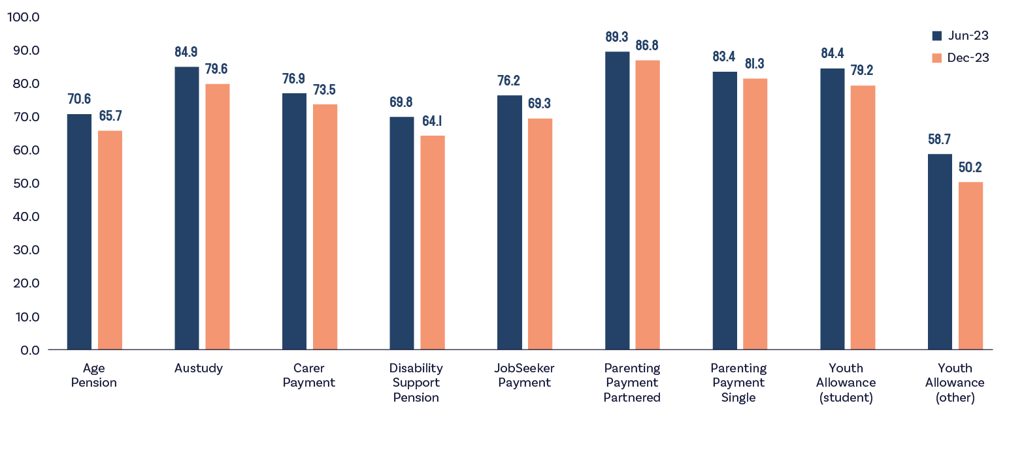
Source: DSS (2023), DSS Demographic Data June 2023 and December 2023.
The share of CRA recipients receiving the maximum rate of payment fell slightly between June 2023 and December 2023. This is likely the result of the increase in payment rates, which resulted in an increase in the rent qualifying a single JobSeeker to receive the maximum rate from $350 a fortnight to nearly $390 a fortnight.
While CRA is invaluable and the increase in the 2023-24 Budget provides improved assistance, the vast majority of people receiving the payment continue to pay rents above the maximum amount of CRA. This means that CRA is not adequately addressing the additional costs faced by renters on Government payments.
Further details are provided in Table 10 which also shows the mean and median fortnightly rent paid and the mean and median CRA received. This includes information on the number of Family Tax Benefit Recipients receiving CRA, as well as income support recipients.

Table 10: CRA by Primary Payment Type, December 2023
Primary payment type | Recipient household* |  | Fortnightly rent paid |  | Fortnightly CRA |  | % eligible for maximum rate^
 | Number | Per cent of recipient households | Average | Median | Average | Median
Disability Support Pension | 273,130 | 21.3 | $497.45 | $440.00 | $160.98 | $184.80 | 64.1
Carer Payment | 80,550 | 6.3 | $656.47 | $600.00 | $174.23 | $184.80 | 73.5
Age Pension | 309,560 | 24.2 | $512.53 | $448.36 | $151.66 | $174.00 | 65.7
Parenting Payment Single | 148,400 | 11.6 | $715.13 | $700.00 | $179.50 | $191.94 | 81.3
JobSeeker Payment | 259,300 | 20.3 | $528.31 | $460.00 | $147.95 | $162.40 | 69.3
Youth Allowance (student) | 27,445 | 2.1 | $482.36 | $440.76 | $137.36 | $123.20 | 79.2
Youth Allowance (other) | 9,230 | 0.7 | $387.51 | $350.00 | $114.85 | $123.20 | 50.2
Youth Allowance (apprentice) | 450 | 0.0 | $481.82 | $440.00 | $132.22 | $123.20 | 75.6
Austudy | 8,990 | 0.7 | $559.06 | $500.00 | $144.11 | $123.20 | 79.6
Parenting Payment Partnered | 17,115 | 1.3 | $869.39 | $840.00 | $208.37 | $217.28 | 86.8
Other** | 3,040 | 0.2 | $569.10 | $500.00 | $153.06 | $174.00 | 69.2
FTB (only) | 142,560 | 11.1 | $881.11 | $860.00 | $150.73 | $160.86 | 90.3
Total individuals and families | 1,279,775 | 100.0 | $589.80 | $520.00 | $157.57 | $177.52 | 71.7
Source: DSS (2023), DSS Demographic Data December 2023.
Rates of housing stress are set to increase as observed rental rises in new bonds data and record low vacancy rates flows through to existing leases in annual rent adjustments.
Since 2000 the impact of rents growing faster than the rate of CRA has led to the maximum rate of CRA for singles falling as a share of average low-income renter housing costs from 28.4% to a projected 22.3%. There has been some recent improvement, this is due to rent assistance increases in the 2023-24 Budget. A concern going forward is that rent growth is expected to remain strong through 2024 with asking rent and actual rent growth remaining strong through the early part of 2024.

Figure 15: CRA Maximum Share of Rent (2023 Projection Only)
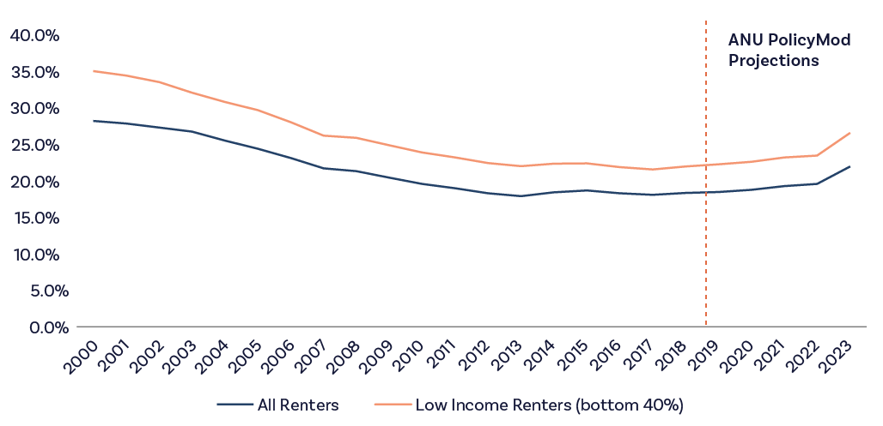
Source: Survey of Income and Housing, Rent Assistance Maximum historical amounts

3.3 Housing Costs for Low Income Renter Households
The chart to the right shows that housing costs for low-income renter households have increased dramatically over recent decades. In 1984, the average ratio of housing costs to disposable income was around 26%. By 2019 this ratio increased to around 33%. The result has been driven by both strong increases in rent costs for low-income households and a structural shift in the housing market away from social housing towards the private rental market. That CRA has not kept up with low income rent growth is expected to have contributed to the upward shift in housing costs relative to income.

Figure 16: Housing Costs to income %, Low Income private renters
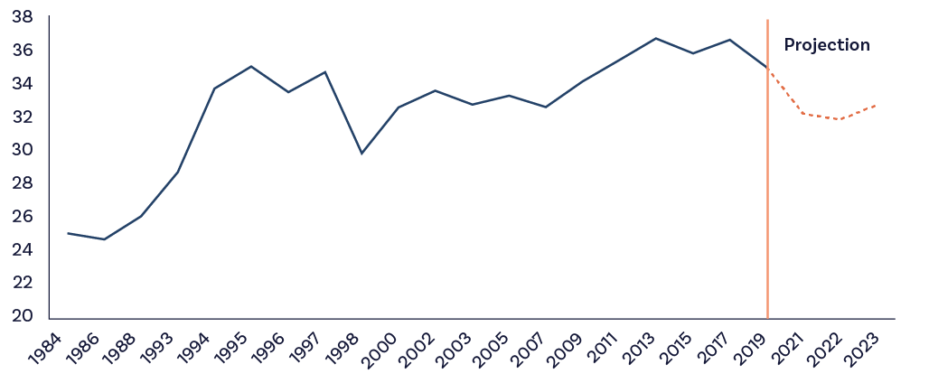
Source: ANU PolicyMod, ABS Survey of Income and Housing 2019-20

3.4 Policy Options
As noted in our report last year, the adequacy of CRA has been the subject of several reviews and reports, with various recommendations for reform.
The 2009 Henry Taxation Review recommended linking the maximum rate of CRA to the 25th percentile of paid rents in capital cities, which based on 2021 Census figures indexed for rental price growth to December 2023 would represent over a 190% increase in the maximum threshold and a 206% increase in the maximum CRA payment.
The Grattan Institute has previously proposed increases that would equate to roughly a further 20% increase in CRA, that would provide singles with a further $20 per fortnight increase and provide some relief from higher rental costs. However, in the absence of a substantial increase in the rate of JobSeeker Payment, such an increase will leave many in this cohort experiencing significant levels of housing stress because of the inadequacy of their base rates of payment.

Figure 17: Impact of Increasing CRA on Maximum Affordable Rents
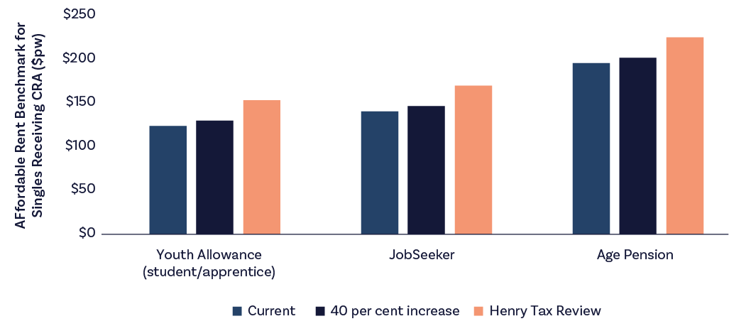
Source: Services Australia administrative data, Department of Treasury, “Australia’s Future Tax System – Report to the Treasurer,” (Commonwealth of Australia, 2010)

3.5 Discussion
More generous CRA payments need to be carefully considered alongside workforce incentives and any potential impacts on the rental market. While increased CRA payments will improve housing affordability for low-income renters, they may also distort the market in such a way that is not tenure-neutral and contribute to an increase in rents for low-income earners who are not eligible for the payment.
Current CRA rates have fallen well below rent and income levels of the broader community and so should be increased.
The Committee understands the need to balance adequacy with workforce participation and potential housing market distortions and so recommends modest increases in CRA is appropriate alongside other recommendations of the Committee such as the increase JobSeeker Payment.
The Committee recognises that the setting of CRA is complicated with recipients having a great diversity of financial, housing and family situations. Further work is required to better understand the current and evolving needs of recipients.
Finding: The current maximum rate of CRA is inadequate.
Recommendation 5
In addition to substantially increasing base rates of JobSeeker Payment and related payments, further increase the rate of CRA to address the long-term reduction in adequacy and better reflect rents paid.

Cliff: Regional mature aged JobSeeker
Cliff is a regional mature-aged JobSeeker. In 2011, Cliff was earning around $120,000 a year as an interstate truck driver.
He had a heart attack coming out of Sydney, and the ambulance drivers said that the authorities would’ve pulled his heavy vehicle license before he even made it to the hospital. By the time Cliff came out of the hospital a week or two later, he had no heavy vehicle license, which meant that he was out of work. As a result, Cliff went from earning $120,000 a year to about $17,000 a year on Centrelink.
Cliff has worked a few times since 2011. He’s still currently in receipt of JobSeeker Payments and is working part-time in a shop. It is not to Cliff’s benefit to do more than 10 hours in a fortnight, or he loses money. When Cliff earns more income, they take away 60 cents in a dollar. He thinks that to some extent this is understandable, as he is working. But Cliff’s wife is a little bit older and receives an Age Pension. Centrelink also takes 60 cents in a dollar off her when Cliff earns over the earning threshold.
As a result, Cliff and his wife are actually losing $1.20 from their family’s income for every dollar Cliff earns. His thoughts are: ‘what is the incentive for me to actually work?’
Cliff went to a Centrelink office to explain the situation. The Centrelink worker suggested he and his wife should declare that they had separated. Cliff and his wife had been married for 44 years and they didn’t want to do that. Cliff is an honest man who doesn’t want to be dishonest for the sake of extra money.
Leading up to Christmas, Cliff was doing long hours and earned $2,000 for the fortnight more than he normally made. The following fortnight he had to report to Centrelink on Christmas Eve and made an income estimate. He estimated his fortnightly income as being the same as it was the previous fortnight. But when his paycheque came he was paid $400 less. It was weeks later before his Centrelink payments were sorted out and his wife’s pension took an additional month before it was the correct amount.
Cliff has also had difficulty dealing with Centrelink. He spent an hour and a half on the telephone before hanging up. His daughter was going into town and Cliff got a ride to the Centrelink office with her. They told Cliff that he could have fixed his problem over the phone. He told them that that was what he was trying to do in person.
Cliff thinks that the entire job agency industry is solid proof that privatisation hasn’t worked. He gets on pretty well with his job agency, but he thinks they are ‘basically useless’. Almost three years ago, the employment service found Cliff a job cleaning out chook houses on a commercial chook farm. Cliff told them that he wasn’t sure he could do it because of his heart problems, and because he had broken his neck five years ago. Cliff has three bits of steel in his neck, but he can walk and do most things, so he considers himself lucky. But, as he relates, ‘my employment service provider still sent me to a job where it turned out I was supposed to be shovelling manure, which I can’t safely do’.
The other part of the job they recommended for Cliff was to pick up sick chickens and break their necks. As an animal lover, Cliff would never do such a thing. Cliff’s job lasted for two hours before he could do it no longer. That was the only job the provider had ever found him.
Cliff thinks too many organisations are trying to punish people for being unemployed or on a low income.
When they doubled the unemployment payment rate during COVID, Cliff thinks that showed the benefit of having people on a reasonable level of income. ‘Nobody got rich when they doubled the rate, but they could at least live reasonably.’ Cliff and his wife even went to the pictures one night before payments dropped back down again.
Now Cliff and his wife do without. They buy only what is needed as they can’t afford any luxuries. They struggle to buy groceries. As they get older, Cliff has more health problems and it is getting harder for him to find doctors who bulk bill. Cliff and his wife have had to change doctors last year, as the ones they were using stopped bulk billing; yet Cliff and his wife can’t afford to buy petrol to drive somewhere unnecessarily.

Chapter 4:
Removing barriers to employment and supporting participation

4.1 Introduction
After many years of neglect and harsh treatment, attention is finally being paid to one of Australia’s most important moral issues – removing the barriers that are currently preventing so many of our fellow citizens from getting back into paid work.
The September 2022 Jobs and Skills Summit was followed in September 2023 by the Working Future White Paper, and then in November 2023 by the Final Report of the House of Representatives Select Committee on Workforce Australia Employment Services. The Committee welcomes the White Paper’s commitment to ‘sustained and inclusive full employment’ and notes that around half of the White Paper’s ten areas of priority relate directly or indirectly to getting those currently locked out of the workforce back into paid and meaningful employment. It strongly endorses the White Paper’s commitment to a full employment target, and for that target to be one of the dual objectives of Australia’s monetary policy framework. The Committee also strongly supports the analysis, findings and recommendations of the Select Committee regarding employment services, which it regards as no longer fit for purpose.
Much good analysis has been done by the White Paper and Select Committee and in this chapter the Committee urges action on what it believes are the most pressing and consequential reforms.
The Committee believes that with the right approach Australia’s income support provisions and employment services system can be transformed from endless sources of bad news into positive contributors to Australia’s changing economic needs.
This is a highly achievable goal with considerable economic and social payoffs.
The Committee urges the Government not to be daunted by the notorious complexity of employment services reform but to be confident that important change can be obtained through a clear timeline of practical measures, legislative changes and affordable funding adjustments. Reconceptualising income support and employment services as positive economic policy levers will benefit the nation enormously.
At the same time, the Committee believes these potential benefits will only be fully realised when the full employment objective is also achieved. Getting to full employment is what allows the greatest opportunity for workforce participation by those facing barriers to work, and the greatest chance to grow Australia’s collective prosperity. The Committee remains of the belief that an appropriate target for the rate of unemployment is close to 3.5% and does not share the view that labour utilisation as of February was still below the level for full employment.

4.2 The problem to overcome
Despite Australia’s comparatively strong labour market, low unemployment rate, and high participation levels, considerable workforce potential remains untapped. The moral imperative for action is strong. According to the White Paper: some 3 million people in Australia want work or want to work more hours but are prevented from doing so by intersectional factors like geographically concentrated disadvantage, cultural background, gender, age, and disability. As the White Paper reports, the effects of the poorly working system are easy to observe:
- Intergenerational disadvantage: “Disadvantage is often intergenerational. Roughly one in three children born into families in the bottom 20% of the income distribution will remain there.”
- Geographic concentration: “Opportunities in Australia’s economy have not always been shared equally. The five regions with the highest long-term unemployment rates make up 12% of all long-term unemployed people nationally, despite only having 5% of the working age population.”
- First Nations: “The employment rate of Aboriginal and Torres Strait Islander people continues to significantly lag that of non-Indigenous people, and the gap has not closed notably over the past 30 years.”
- Disability: “The employment rate for people with disability has been consistently lower than for those with no reported disability and has shown no improvement over 20 years.”
- Age: “Young people aged 15 to 24 years face an unemployment rate twice the unemployment rate for all Australians.” “Mature age workers generally have good labour market outcomes, however, when they lose their job or want to return to the workforce, they can find it hard to get back into work.”
- Gender: “Women are participating in the labour market at higher rates than ever before. However more work can be done to achieve gender equality. Barriers include the affordability and accessibility of ECEC, disincentives for secondary earners to engage in paid work, the unequal distribution of unpaid care between men and women, societal norms that limit choice and perpetuate discrimination, occupational segregation, and the impact of gender-based violence.”
- Single parents: “Australia’s employment rate for single mothers is one of the lowest in the OECD. About 52% of single mothers with a child under five years participate in the labour market, compared with 70% of partnered mothers and 90% of all fathers.”
These problems are further compounded by poor policy settings, inadequate social and physical infrastructure, underdeveloped local labour markets, failing employment services, ongoing discrimination, and out-of-date employer attitudes.
Given the reality that not everyone of working age is capable of working or in a position to work at a given point in time, achieving progress will require us to broaden our understanding of what productivity really means and to recognise economic participation in wider forms, including appropriately valuing caring responsibilities.
The benefits of success are potentially immense. Inclusive full employment will increase economic activity, ease pressure on Government spending, and increase revenue.
According to the Treasury, improving the workforce participation rate by 2% by 2062–63 could on its own raise GDP by 3.25%.
This chapter addresses these problems under the two broad headings of (1) rebuilding employment services, and (2) removing barriers to employment and supporting greater workforce participation. While making several important recommendations, the Committee emphasises the need to replace the current failing employment services system with a new one based on economically sounder principles, and the need to increase JobSeeker and related payments to improve people’s capacity to re-enter the paid workforce. Crucially, the Committee finds that any reduction in incentives for people to re-join the workforce is likely to be extremely small.

4.3 Rebuilding employment services

4.3.1 Full redesign of Australia’s employment services system
The Committee finds that increasing economic inclusion will require nothing less than a comprehensive reform of Australia’s employment services system. This view is widely shared among the public policy community. As the Select Committee stated: Australia “no longer has an effective coherent national employment services system”. The White Paper concluded similarly that in recent years: “employment services had failed to keep those people at the highest risk of disadvantage connected with labour markets, let alone in paid employment”.
Simply put, the privatisation of employment services that began around a quarter of a century ago has failed to improve the prospects of Australians looking for work. That era has outlived whatever usefulness it may have had and has become an economic, social and human burden we just can’t afford. In the interests of people and the economy, it must be replaced. Another round of incremental changes – of the sort represented by the most recent change from Jobactive to Workforce Australia – will not suffice. A full scale rebuild of the system is needed.
The need for this overhaul is urgent and financially necessary. With the Government planning to spend more than $9.5 billion in employment services over the next four years, time wasted will mean money wasted.
The Committee therefore believes change must begin immediately, starting with the creation of a timeframe of legislative changes to enable comprehensive reform and transition to a new employment services system in line with the recommendations from the Select Committee and the Working Future White Paper.
The goal should be the creation of a new employment services system fit for the future – one focussed on building personal capabilities, supporting economic inclusion, and responding to the needs of a modern Australian economy in transition.

4.3.2 Immediate reforms to mutual obligations
If they are to succeed, reforms must be built around a new and positive culture and set of objectives that suit our contemporary economic needs. This will require a fundamental shift away from the “deficit and punishment paradigm” that animates so much of the current system and is responsible for so many of its failures. That paradigm and the compliance system it underpins are unduly harsh and economically counterproductive, preventing Australians from moving from income support into the paid workforce to improve their lives and provide employers with the motivated and skilled people they need. The sheer cruelty of the system is totally unworthy of our egalitarian national ethos. This issue is discussed at more length in Chapter 6.
This positivity starts with wholesale change to mutual obligations, which Services Australia defines as the ‘tasks and activities that you agree to do while you get some payment from us.’ Reforms must ensure the mutual obligations system understands the practical realities of job seekers’ lives, can respond to their individual circumstances, address the employment barriers they confront, and build up their capability to work or participate more actively in the community. The Select Committee summed up the problem as follows:
“Consistent with the findings of previous reviews, it is clear that the majority of unemployed people want to work. But the current rigid approach to mutual obligations is killing unemployed people’s intrinsic motivations and efforts to seek work, by drowning them and those paid to help them in a mountain of red tape, compliance requirements and pointless mandatory activities. People are made to do silly things that don’t help them get a job—such as pointless training courses or applying for jobs they won’t get—and are then harshly and repeatedly sanctioned for trivial or inadvertent breaches of prescriptive rules. It is ridiculous that over 70% of people with providers have been subject to payment suspensions despite zero evidence that 70% of people are cheating the system. The Robodebt Royal Commission’s finding that fraud in the welfare system is miniscule is apt. The nature and extent of mutual obligations is like using a nuclear bomb to kill a mosquito.”
Work commissioned by the Committee found that while mutual obligation requirements can lead to improved employment outcomes in some settings, effectiveness is dependent on the type of activity requirement, jobseeker characteristics, and labour market conditions. Although mutual obligations in the form of job search requirements can reduce time spent receiving income support payments, there is less evidence that it benefits participants’ employment and income levels. Different categories of job seekers respond to different forms of assistance: job search programs work best for those who are relatively job-ready; wage subsidy programs help job seekers who benefit from demonstrating their capabilities to employers; and public sector job creation programs only benefit job seekers if they allow them to acquire job-relevant skills and provide a pathway to longer-term employment. There is also strong evidence that mutual obligation programs can cause harm, such as stress, mental health issues and economic insecurity that can reduce job seekers’ confidence and employability.
Given this evidence, the Committee finds that the overall orientation of a mutual obligations program – in terms of activities for job seekers – should be matched to the characteristics of the population of job seekers. For example, at present that would mean orienting program design towards a population of JobSeeker Payment recipients that includes relatively high proportions with partial capacity to work and with long spells of payment receipt. There is little evidence that job search requirements, for example, are an effective approach for these cohorts, yet job search and ‘work-first’ requirements are often the ‘go to’ activity requirement in Australia’s current mutual obligations system.
Design of any mutual obligation system must also weigh up the costs and benefits. That a benefit can derive from income support recipients undertaking mutual obligation requirements – job search and other related activities – is not a sufficient justification for the existence of mutual obligations, nor for their current form. The costs of the system must also be considered – primarily, the negative impacts on income support recipients and others (such as their children), and the substantial administrative cost of operating the system, which has been estimated at more than 10 percent of the value of income support payments to job seekers.
The best starting point for design of a compliance system is the principle that the vast majority of income support recipients do want to work. Substantial evidence presented to the Select Committee and echoed through the Committee’s consultations, is that most people do want to work, and hence will not need external motivation to do activities to assist them in doing that. It is a relatively small proportion of people for whom this is not the case, and who will need external motivation via a penalty regime. Current data on payment suspensions – including that over 70% of participants in Workforce Australia services with mutual obligation requirements faced suspensions over a 15-month period – suggests that the system is a long way from being founded on this basis. A scan of the evidence prepared for the Committee shows that while the imposition of penalties increases compliance with activity requirements and the rate of exit from income support payments, here in Australia the size of the penalty has only muted effect, and those who exit payments can sometimes become completely inactive rather than get a job, leading to hardship.
All up, this research indicates that a better place to begin in designing a compliance system is on the principle that the vast majority of people on income support want to work, and that any mutual obligation requirement must be tailored to what will build capability for a given job seeker in given labour market conditions.

4.3.3 Meeting the needs of those facing the highest barriers to employment
As was made clear in the Robodebt Royal Commission findings and in other chapters of this EIAC Report, people are not long-term unemployed by choice. They typically find themselves out of work for more than five years because they confront participation barriers that tower over them, blocking out all sunlight and hope. And these barriers include the ones thrown up by the very employment services system meant to help them.
People who experience the most disadvantage and long-term unemployment often do not need help writing resumes or sending in job applications. As the Select Committee heard in their consultations, typically these people do not have the money, housing, transport, good health, or access to early learning they need to seek work. These points were reinforced by those who took part in consultations for the Committee. This is where help should be provided. For people who face significant barriers to employment, the employment services system must become the front door to a broader human services system that is better equipped to provide a range of necessary supports. This is a shift from the ‘work first’ models that have formed the basis of employment services over the past 25 years, towards a system based on genuinely meeting the needs of a person where they are.
Employment services should be a gateway to economic participation and the broader human services system.
A new system should work to support everyone who needs help, particularly those facing the highest barriers. It should also be designed to meet the economy’s voracious appetite for workers in important sectors. With the right approach, a new employment services system can have a major modernising effect on our economy, now undergoing major transitions in industries like energy and health and human services.
The new employment services model should therefore:
- Tailor mutual obligation requirements more closely to the specific goals, needs and realities of each job seeker. This means providing a broader spectrum of support and a broader definition of ‘success’ in participant outcomes – recognising that for some people a job may not be a realistic result.
- Include a network of Regional Hubs which enable stronger connections to the local human services system and place-based direction of effort to support local priorities and conditions. This is consistent with the Committee’s recommendation in its 2023 Report for “innovation zones” to demonstrate new social and economic development strategies. The proposed Regional Hubs network would be a natural place to start.
- Build greater discretion into the compliance system and ensure decisions are made by public servants, not automated processes.
- Place much greater emphasis on employer engagement and activation, including social procurement and social enterprises, wage and transport subsidies, and a focus on meeting skills needs through periods of industry transition.
- Strengthen investment in national paid work experience and training programs assessed as significantly improving employment prospects of people who are unemployed long term.
- Use approaches that incentivise collaboration and learning, rather than competition, and which rebuild the public core and evidence base of the system.
- Be overseen by an independent Employment Services Quality Commission responsible for a quality framework, licensing, workforce standards, and sector development, advising on pricing for services, complaints management, data analysis, continuous learning, research and evaluation.
- Include a new client council (or councils) as a mechanism for ensuring those with lived experience have a say in the redesign of the system.
While elements of the new model will need to be tested, trials should not be used as a substitute for widespread change – major decisions need to be made with Government leadership, and a new employment services system put in place. This is a critical lever the Government can act on this year to strengthen economic inclusion.
To this end, the Committee notes and welcomes the Government’s recent commitment of $707 million to a new Remote Jobs and Economic Development Program to replace the Community Development Program and create 3,000 jobs in remote Australia. There is no time to waste in implementing these reforms given the appallingly high levels of unemployment, economic disadvantage and poverty in remote Australia, particularly for Aboriginal and Torres Strait Islander people.
Recommendation 6
The Government commit to a full-scale redesign of Australia’s employment services system by adopting the recommendations in the report from the Select Committee on Workforce Australia Employment Services.
As a priority the Government should:
- Finalise an implementation plan and enact necessary legislative changes in 2024.
- Commit to a full redesign of the mutual obligations and compliance settings in the Workforce Australia system that focus on building capability and confidence to support people into work, consistent with the directions outlined in the Select Committee’s report.
- Build and refine a new practice model that genuinely meets the needs of people furthest from the labour market, including through:
- A network of demonstration sites and regional hubs that enable stronger connections to local human services systems and place-based direction of effort
- Strengthened approaches to employer engagement
- Greater investment in national paid work experience and training programs assessed as significantly improving employment prospects of people who are unemployed long term
- Commissioning that incentivises collaboration and rebuilds the public core of the system
- An independent Employment Services Quality Commission to set minimum quality standards, drive improvements in qualifications and skills of frontline staff, share best practice, and handle licensing and complaints
- A client council (or councils) so the voices of people experiencing the system influence its redesign.

4.4 Addressing barriers to employment and supporting participation
The harshness, complexity and disorienting bureaucratic maze of the social security system are substantial barriers to participation. Intentionally or not, many conditions are unduly harsh, entrench disadvantage, and make it harder to work. As the Select Committee stated: “People want to work . . . But they are being punished, rather than supported, by the system that is supposed to be there to help them.”
In some cases, neither Government nor participants understand the system
– proof if ever it was needed, that the system has gone wrong, and a fresh approach is required. Often it feels like multiple PhDs are needed to understand the complexities of the system, whether it be the rules for “Working Credit” or the application of the Liquid Asset Waiting Period (LAWP).
The evidence of failure of the system abounds. As the Select Committee reported, around 70% of the 754,555 JobSeeker Payment (JSP) recipients in September 2023 are long-term on income support, meaning they have been receiving income support for over one year, and around 45% have an assessed as having partial capacity to work (PCW). Some 150,000 people have been in the system for over five years. The system is not successfully helping them. Change is essential.

Immediate changes
Important changes are needed while broader reforms to employment services are progressed.
Firstly, immediate action should be taken to end automatic payment suspensions and the damaging effects of current compliance settings.
Existing data provides limited evidence on the benefits of penalty regimes, especially when the negative impacts on health and wellbeing of payment recipients and the significant administrative cost of operating the system are considered. There is clear evidence, including in the Select Committee’s report, that the vast majority of people do want to work and need little or no external motivation to undertake activities that will get them into a job. Only a relatively small proportion of income support recipients need external motivation. That 70 percent of participants in Workforce Australia Services with mutual obligation requirements had at least one suspension during a 15-month period, and that 16% of participants in Workforce Australia Services and Workforce Australian Online had five or more suspensions during a single period of assistance, suggests that the system is a long way from being founded on this basis.
Secondly, mandatory waiting periods to access JobSeeker Payments, including the LAWP, often result in participants exhausting their life savings before receiving income support. This has a corrosive impact on applicants’ mental health and their confidence to pursue employment. Data presented to the Committee revealed that between 1 July 2023 and 30 September 2023, the average waiting period for those subject to LAWP before receiving JobSeeker was 61.9 days, and 46.4% of JobSeeker recipients subject to LAWP during this period had liquid assets of under $25,000. Expecting JobSeeker recipients to drain their savings before receiving assistance is counterproductive to smoothing the path back to employment, and particularly unfair given LAWP reserve amounts have not been increased in nominal terms since LAWP was introduced in 1991.
Thirdly, those who are part of the Workforce Australia system and who are unwell should be better supported, consistent with Recommendations 32-34 of the Select Committee’s report. This means ensuring people who face sickness or injury and an incapacity to work are not unfairly subject to mutual obligations to receive income support, and the process for securing or extending medical exemptions does not cause further harm – at present the process is unduly onerous and de-humanising. It also means reviewing whether some people within Workforce Australia are more appropriately supported by the DSP.
Recommendation 7
The Government take immediate actions to end automatic payment suspensions and the damaging effects of current settings while broader reforms are progressed, including by:
- Tripling the LAWP amount threshold, consistent with increases in inflation and its relativity to payments, introducing a single waiting period of four weeks, and reconsidering the need for the LAWP given the complexity it adds to the system when there are already income and asset tests in place.
- Reviewing the role of sickness allowances, the length for which medical exemptions are granted and the process to obtain them, and eligibility for the DSP, as suggested by Recommendations 32-34 of the Select Committee’s report.

4.4.1 Smoothing the transition to work for people who receive income support payments
Given that one of the prime objectives of the Australian income support system is to get people who can work back into employment as soon as possible, it makes logical sense that work limit rules should be changed when they actively discourage people from accepting part-time and casual work opportunities. This is particularly so when the cause of people not taking up work is confusion and fear caused by unnecessary complexity and poorly explained rules. Encouragement, fairness and simplicity should the guiding principles governing transition to work payments.

4.4.2 Modernising our Working Credit scheme
Changes to employment credit schemes must be part of the answer. Such schemes allow Government to smooth the transition to work for people who receive income support payments. But unlike the similar Age Pension Work Bonus (updated in 2022), working credit arrangements for the unemployed have not been updated or indexed or even officially evaluated since their introduction in 2003, resulting in a decline in their real value and the fairness of the system.
The Committee therefore recommends improving and properly evaluating the Working Credit settings. Expanding and properly evaluating the Working Credit program will determine how effective it is at encouraging people on income support payments to work, or work more hours, and retain access to income support payments for longer. It will also reduce complexity in the system and be a step towards harmonising arrangements between payments. This can be done by:
- Growing the Working Credit accrual rate for all eligible payments from $48 so it is the same as the income free area ($150 per fortnight).
- Increasing the maximum balance of the Working Credit from $1,000 to up to $7,800 (equivalent to two years of accruals of $150 per fortnight).
- Indexing the maximum balance to CPI, consistent with the Student Income Bank.
- Shifting from a daily to fortnightly rate calculation, consistent with other employment credit schemes.
- Introducing an initial ‘boost’ so that each eligible recipient has a starting balance of $500 in the Working Credit.
- Designing these changes to enable evaluation to assess the impacts of the changes and the role working credits play in removing barriers to the transition from income support payments into work.
- Implementing a simple and clear communications strategy that ensures people receiving payments understand the Working Credit system and how it can support their transition from payments into work.
It is estimated that these changes would cost up to approximately $400 million per year. The benefits resulting from increased workforce participation have not yet been quantified.
Recommendation 8
The Government changes Working Credit settings that have not been updated since 2003, to bring the Working Credits system closer in line with other employment credit schemes such as the Pension Work Bonus and help smooth the transition to work.
Specifically, to:
- Grow the Working Credit accrual rate for all eligible payments from $48 to $150 per fortnight, consistent with the income free area, and shift from a daily to fortnightly calculation
- Increase the maximum balance of the Working Credit up to $7,800 (equivalent to two years of accruals of $150 per fortnight), and index to CPI
- Introduce an initial ‘boost’ so each eligible recipient has a starting balance of $500 in the Working Credit
- Develop a communications approach to accompany the reforms, so that people receiving payments better understand the Working Credit and how it can help them, and design implementation to enable evaluation of the impacts of these changes.

4.4.3 Supporting people with disability to increase paid work participation
Workforce participation rates for people with disability have barely increased in the past two decades and remain approximately 30% lower than for the general population. The DSP is subject to income testing which gradually reduces an individual’s payment as they earn more, meaning they are generally better off financially through working. However, the Committee believes the current 30-hour work limit must shoulder some of the blame by deterring DSP recipients from working or taking on extra hours for fear of having their payments suspended, on top of the substantial discrimination still faced by people with disability in the workforce. In fact, the current work limit rules for carers and people on DSP are at odds with economic inclusion.
Currently, 275,475 people are assessed as having a capacity to work of between 8-14 hours but only 56,865 (7.3% of all DSP recipients) report any earnings from an employer. Advocates consistently report a common misconception among DSP recipients that any paid work will lead to their DSP being suspended, resulting in many choosing not to do any work at all for fear of losing access and having to reclaim. Removing the work limit removes this deterrent and will likely increase the number of DSP recipients who engage with work or increase the hours they work.
The Committee believes that relaxing work limits would encourage greater workforce participation among DSP recipients, and particularly benefit people who have fluctuating or episodic conditions, providing greater flexibility to work hours that are suitable to them at that point in time. This change would not leave the system open to abuse because the 30-hour work rule operates in addition to the income test – and without the work limit, the income test would continue to operate to ensure DSP is targeted to those most in need.
It is estimated that removing the work limit would also result in just over 2000 people each year no longer facing suspensions of their DSP for working more than 30 hours per week, and a further 850 would not have their DSP cancelled.
With an indicative start date of 1 July 2024, removing the 30-hour rule for the DSP is estimated to cost approximately $65 million over the 3 years from 2024-2025 to 2026-2027. The benefits resulting from increased workforce participation have not yet been quantified.

4.4.4 Giving carers greater flexibility to undertake paid work
The Committee also recommends modifications to work restrictions on the Carer Payment as a practical and inexpensive change that would offer significant benefits to the people affected and reframe the culture of the social security system as more supportive of broader participation.
Employment offers significant wellbeing benefits to carers, but currently less than 10% of Carer Payment recipients report any earnings. Not every person in receipt of the Carer Payment may be able or want to work, but for carers who do want to work, the current working hours limits pose a real barrier to participation. Amending the rules to offer greater flexibility will offer carers opportunities to work more, harness opportunities and remain connected to the workforce, where care arrangements allow.
There is strong support for such a change. The 2020 Productivity Commission Inquiry Report into Mental Health recommended that the Commonwealth Government amend eligibility criteria for Carer Payment and Carer Allowance to improve access, including replacing the 25 hour per week restriction on work, study and volunteering with a 100 hour per month restriction on work only.
The Committee endorses the Productivity Commission’s recommendation and calls for its implementation, including to suspend, rather than cancel, the Carer Payment where a carer exceeds a participation hours or earnings limit.
Recommendation 9
The Government relax work limit rules on payments to encourage and enable workforce participation, particularly for people who have fluctuating or episodic conditions or caring responsibilities, including by:
- Removing the 30 hour per week work limit for DSP recipients.
- Adjusting the 25-hour participation rule for the Carer Payment to give carers greater flexibility to undertake paid work, by:
- Changing the 25 hours per week work participation limit to an allowance of 100 hours over four weeks, and apply the participation limit only to employment (not study, volunteering or transport time)
- Suspending, rather than cancelling, the Carer Payment where a carer exceeds a participation hours or earnings limit
- Allowing the single Temporary Cessation of Care days provision to be applied to one-off or occasional instances of exceeding the participation hours limit.

4.4.5 Adequacy and availability of housing and essential services as a precondition for participation
Without a house, it is hard to look for a job or hold down work, meaningfully participate, and live a life of dignity.
Levels of homelessness and overcrowding are a problem across Australia but are concerningly high for Aboriginal and Torres Strait Islander people, particularly in remote communities, posing a significant barrier to economic inclusion and the attainment of Closing the Gap targets.
In its 2023-2024 report, the Committee focused on measures that would target the largest number of Australians experiencing poverty and disadvantage. This included recommending an increase to the CRA to support people living in the private rental market. The Commonwealth Government’s increase to the CRA is welcome. However, Aboriginal and Torres Strait Islander people are likely to have benefited least. In 2022, only 6.6% of CRA recipients reported having an Aboriginal and/or Torres Strait Islander person as a household member. This is particularly pronounced in remote areas where Aboriginal and Torres Strait Islander people are more likely to be living in social housing than Aboriginal and Torres Strait Islander people living in non-remote areas (54% of households compared to 15%), and while still required to pay rent are not eligible for CRA.
The National Agreement on Closing the Gap (Closing the Gap Agreement) acknowledges this and sets out housing and related infrastructure as a key socio-economic outcome. But there is no dedicated investment strategy to meet the housing and related infrastructure targets and no capacity for detailed monitoring of improvements in outcomes.
Existing data collection demonstrates there is a clear need for significant additional investment to address Aboriginal and Torres Strait Islander people’s housing needs across Australia. Aboriginal and Torres Strait Islander people are nearly nine times more likely than non-Indigenous people to experience homelessness and overcrowding. The need in remote communities is even greater. Aboriginal and Torres Strait Islander people experience homelessness at a rate of 14% in very remote areas and 7% in remote areas (compared with 1.5% in major cities). In remote areas, nearly half of overcrowded dwellings (47.5%) are of an unacceptable standard.
Analysis conducted for the Committee estimates (see Appendix D) there is an Aboriginal and Torres Strait Islander housing need of an additional 18,342 houses nationally. Of these, 5,261 are needed in remote and very remote areas. The largest number of houses is needed in remote and very remote NT (2989), followed by Queensland (1012), and Western Australia (917). A further 69,500 existing houses are likely to need substantial repair or replacement due to significant structural problems or a lack of basic facilities. These are likely estimates of the minimum additional housing need, as they are based on 2021 Census data and do not account for population growth or flooding events which have increased housing need. Data is not available to reliably estimate the related housing and community infrastructure requirements; however, this is also likely to be significant.
The available data to understand fully the extent of Aboriginal and Torres Strait Islander people housing needs and undertake need-based planning is hampered by a decline in the level and quality of collection and reporting over the 15 years since the cessation of the CHINS.
No one has a clear, comprehensive understanding of the full extent of data currently available, and no designated entity, governance structure or accountability mechanism currently has the responsibility or resources to comprehend and enhance current remote Indigenous housing data collection. There is more housing data collected by state and territory governments and on the ground at a community level by services providers, than is currently shared with the Commonwealth Government and reported on to the public and to Aboriginal and Torres Strait Islander communities. The biggest gaps in the data collection are more granular data on existing housing conditions and housing-related infrastructure.
There have been numerous calls to improve data collection and quality on Aboriginal and Torres Strait Islander housing, but these have, so far, been met with little or no progress, are not incentivised nor appropriately resourced.
Whilst there is sufficient evidence to warrant investment now, there are economic efficiencies in ensuring housing investments for Aboriginal and Torres Strait Islander people are better targeted and monitored.
The Committee supports calls from the National Aboriginal and Torres Strait Islander Housing Association (NATSIHA) to substantially increase investment in Aboriginal and Torres Strait Islander housing and homelessness solutions, including maintenance and upgrade programs, led by Aboriginal and Torres Strait Islander organisations. The Committee also supports their call to fund the Aboriginal and Torres Strait Islander Housing Sector Strengthening Plan (HSSP) which was a commitment under the Closing the Gap Agreement that remains largely unfunded.
The recent announcement on 12 March 2024 from the Australian and NT governments to jointly fund a $4 billion ten-year project that aims to build up to 270 houses annually in remote Aboriginal communities and halve overcrowding in the NT is welcome. This announcement is around double that of the previous five years. However, even in light of this announcement, the Committee notes that the need is significant, not just in the NT, current effort is not sufficient, and allocation is not always based on need.
To target housing investment, support community decision-making, and improve economic efficiency of its interventions overtime, it is imperative for the Government to take immediate action to improve data availability, quality and sharing.
This can be done by establishing a national Aboriginal and Torres Strait Islander housing data register. The register would hold data and information on Aboriginal and Torres Strait Islander housing and related housing and community infrastructure and households. It would inform community planning and investment decisions on a needs basis as well as research priorities. The register could be negotiated and agreed as part of the new NHHA and state and territory governments should contribute to its establishment and ongoing data provision.
The register and associated data and information contributions should be developed in partnership with the Coalition of Aboriginal and Torres Strait Islander Community-Controlled Peak Organisations (Coalition of the Peaks) and give effect to Government commitments under the Closing the Gap Agreement. The register should be accessible to communities and support place-based planning and partnerships and held by the ABS to enable coordination with existing collections. This asset could build upon and incorporate the housing data stocktake that has already been commissioned under the Housing Policy Partnership.
The register would provide an opportunity to bring together and obtain a comprehensive understanding of the existing data picture and whether existing data collection could be refined or streamlined, as well as identifying genuine gaps and targeted indicators to better inform investment decisions (i.e., not just more but better targeted data). Reporting from the register could be considered at regular intervals by the Housing Policy Partnership and the Joint Council on Closing the Gap and recommendations made to governments on current and future investment and community planning.
The register would support needs-based allocation of funding, making it a cost-effective option over the long term. It would follow in the precedent of other policy areas in which the Commonwealth Government has recognised the need for upfront investment in data to support policy development and improved service delivery, such as through the $68.3 million commitment to establish the National Disability Data Asset (NDDA) and its underlying infrastructure.
To target investment now, including informing the negotiations of the allocation of the $200 million for the repair, maintenance and improvement of housing in remote Indigenous communities under the Housing Australia Future Fund and the recently announced $4 billion remote housing agreement in the NT, the Government should also consider immediate data improvement actions, which would include:
- Negotiate improved performance reporting and data sharing within intergovernmental agreements and arrangements. The renegotiation of the NHHA and the National Partnership for Remote Housing Northern Territory (NPRHNT) provide an opportunity to agree new data arrangements on how funding is reaching Aboriginal and Torres Strait Islander people and households and incentivise sharing of existing state and territory held data on housing stock quality.
- Undertake rapid needs assessments of homelessness and overcrowding, maintenance, repair and community infrastructure requirements in remote hotspot areas. Existing Census data could be used to identify regional hotspots of Aboriginal and Torres Strait Islander homelessness and overcrowding for rapid assessments to support new and targeted regional investment shared by the Commonwealth and relevant state or territory.
For the identified areas, dedicated teams – consisting of ABS officers from the Centre of Aboriginal and Torres Strait Islander Statistics, NACCHO and NATSIHA staff and NIAA and relevant state or territory governments officers – could undertake rapid surveys to inform a comprehensive picture of need. The previous data points and outputs from CHINS could be used as a starting basis.
This approach could help inform how the $200 million from the Housing Australia Future Fund for repairs and maintenance to Indigenous housing should be spent and facilitate an equitable share, based on need, of other Commonwealth and state and territory housing investments.
- Commission a redesigned CHINS-style survey. In addition, work should be undertaken to redesign and roll out a new CHINS, with the methodology built around the Priority Reforms of the Closing the Gap Agreement including additional data points on climate resilience and other community planning metrics and taking into account advances in data collection since the last CHINS survey.
Recommendation 10
The Government urgently commit substantial investment to address need in public housing and homelessness for Aboriginal and Torres Strait Islander peoples, including maintenance and upgrades, community infrastructure and the Aboriginal and Torres Strait Islander housing sector.
To improve economic efficiency of investments, the Government should fund a National Aboriginal and Torres Strait Islander Housing Data Register to improve data availability, quality and sharing. The register should be developed in partnership with the Coalition of Aboriginal and Torres Strait Islander Community-Controlled Peak Organisations and the Housing Policy Partnership and agreed as part of the new NHHA.
To better target existing investment, including from the Housing Australia Future Fund and Social Housing Accelerator Fund, the Government should:
- Negotiate improved performance reporting and data sharing within intergovernmental agreements and arrangements.
- Undertake rapid needs assessments of homelessness and overcrowding, maintenance, repair and community infrastructure requirements in remote hotspot areas.
- Commission a redesigned CHINS-like survey, which considers limitations of earlier iterations and subsequent advancements in data collection. Information collected through these mechanisms, along with existing collections, can underpin the new register. The register should be accessible to communities to support local decision making.

4.5 Conclusion
It has been clear to observers for a long time that our current employment services system is not working.
Australia has a strong labour market, with jobs available for those with the qualifications, skills and capacity to work. Given the right support, those who are able to work can generally find it. In this context, it has become obvious that a good proportion of the relatively small number who are not in work are prevented from working because they have significant barriers to overcome. Our employment services system should be doing more – much more – to help them.
Instead, animated by a punitive culture that has not changed for a quarter of a century, it is harassing and discouraging them, often at great bureaucratic cost which acts as a millstone around the neck of the Australian economy. Instead of helping meet Australia’s employment shortages, it is harassing those whose contribution is sorely needed.
This sort of approach is out of touch with the needs of a dynamic, modern economy that needs all the workers – skilled and unskilled – it can get. Through more generous payments and smarter payment rules that encourage increased workforce participation, we can build up people’s psychological and physical health and preparedness to participate and in doing so add to the prosperity of the entire nation. New support rules will also need to be teamed with a totally new employment services system with a positive and empowering, not negative and punitive culture.
Small scale changes and limited trials just won’t be enough – in fact the cumulative small changes to the employment services system of the previous 25 years have demonstrated conclusively that tinkering without a change of direction will have little or no effect. Opportunities for transformative reforms of the size needed are rare.
They demand conviction, vision and leadership.
The Committee urges Government to embrace positive change and give Australia the wholly new employment services system it needs.

Tara: Single parent receiving JobSeeker Payment
Tara is a single parent receiving a JobSeeker Payment as well as Family Tax Benefits. Her children, Mitchell and Eva are fourteen and sixteen. Eva has an acquired brain injury and needs a lot of supervision, despite not qualifying for the National Disability Insurance Scheme (NDIS).
Tara usually works about 12 hours per week as a casual dental nurse. It’s a good job, as she can limit her hours so that she can pick her children up from school and be home to look after Eva and make everyone dinner. She sometimes gets extra shifts when other assistants are on leave, but there are times when there aren’t many shifts available. Because she can only work within school hours, she sometimes doesn’t get asked to take on additional shifts. She has to attend monthly appointments with her employment provider, but she doesn’t want another job. She just wants to keep her current job, and hopefully pick up a few more hours each week that fit within what she can do around Eva’s needs.
Tara has a spreadsheet for how many shifts she can work; if she were to lose her benefits – and more importantly her Health Care Card – she doesn’t know how her family would survive. Tara was moved off Parenting Payment and onto the much lower JobSeeker payment when Mitchell turned 8. Then she had a brief window of moving back onto Parenting Payment when the age cut off changed to 14. During this window, Tara could afford new uniforms for the children and saved up for new devices for them to use at school. She didn’t have to worry about paying the rent, and while they lived a very modest lifestyle, they were able to survive. But, when Mitchell turned 14 a few months later, she moved back onto JobSeeker Payments and life became much harder again. Her work and benefits just don’t cover their costs each month and her children have had to go without many of the things other Australian children can take for granted, like sports, excursions, and even snacks and treats. It broke her heart when he told her son that it was his turn to start supporting the family. She is really guilty that he feels responsible for fixing their family’s poverty, when he’s not even old enough to work.
Tara, Mitchell and Eva live on the Gold Coast, although Tara is originally from Melbourne. She would love to move back to Melbourne where she has friends and family who can help and support her, but her family court order prevents her from moving away. Instead, Tara is renting a two-bedroom apartment, which is unaffordable and not appropriate for her teenage children. Tara has started sleeping on the couch so that Mitchell can have his own room.
Tara received a notice two months ago that her landlord is putting their rent up by $200 per week when her lease ends in four months’ time. She can’t afford the new rent and has spent the last two months looking for a new place. She’s even cut back on casual shifts to try being at the front of the queue for inspections, but she hasn’t been able to find anywhere affordable to live on the Gold Coast and can’t move to a cheaper town. Rent assistance used to help cover the cost of rent, but it is no longer even close to what landlords ask.
Tara has stopped eating dinner to try and save a little bit of extra money and has stopped taking her asthma and sinus medication. She wonders how she’ll be able to afford the extra $200 per week, and how long she’ll be able to keep her job – and her children – if they become homeless. She used the money that she saved to buy a tent so that they have somewhere to stay if they are evicted.
Tara doesn’t sleep much anymore, as she’s worried about how to make ends meet, and what effect losing their apartment might have on her children’s futures. How can you do homework and use a computer from a tent or car? She feels panicked every time she receives a myGov notification, as any reduction in income will push them further into debt and less able to afford to rent anything.
She recently received a myGov notification telling her that she hadn’t uploaded her income statement. She had uploaded it and has tried to phone them four times. She’s either received an automated message that has then hung up, or she’s been on hold for hours. She hasn’t been able to get through to correct the error and is terrified that she’ll lose her payments for no reason. She doesn’t have any savings to cover her while she has no income – and if she doesn’t pay her rent, the landlord might use that to kick her out early.
At the same time that Tara is just one missed JobSeeker Payment away from homelessness, she is owed $20,000 in child support for her children. Her former partner used to pay $2,000 a month, but then started paying less often, and usually doesn’t pay at all. He didn’t lodge tax returns for a few years and then reduced his taxable income so much that he’s only supposed to pay $10 per week.
Sometimes her ex-partner gets a tax return or makes a lump sum payment towards the child support debt, which means her Family Tax Benefits get cut. When he doesn’t pay, they can’t make ends meet. Child support causes enormous stress in their lives without providing a reliable source of income. Real estate agents don’t consider child support when assessing how much rent you can pay, and even Centrelink workers tell her not to budget on child support. But she’s compelled to stay in the system and compelled not to be able to move away. Her family is trapped in poverty with no foreseeable way out.
Tara is angry that she can’t move to Melbourne where she could get help from her parents so that she could work more and live better, but her ex-partner is free to not pay child support while having nothing to do with his children. Why does he get a choice as to whether to be a parent or not, and all she gets is punished by Centrelink for trying to be one? That’s what she wants to know.

Chapter 5:
Improving support for children and families

5.1 Introduction
In its first report, the Committee made recommendations relating to the wellbeing of children and support for families raising children, with an emphasis on supporting children and families through early childhood.
The Committee continues this theme, which it considers important for three reasons:
Brain development, along with the love, care, services and support children receive in the first three to five years of life hugely influence their later development and life chances.
The most profound influence on our earliest years is our family environment and the pressures that shape our family households.
Raising children – particularly during early childhood and when children have extra needs – significantly affects household finances, parental career progression, and the emotional stability of families.
This is a crucial social equity issue.
Recent inquiries by the Productivity Commission, the South Australian Royal Commission on Early Childhood Education and Care, the Review of the NDIS, and the ACCC Inquiry into Early Childhood Education and Care, demonstrate that a strong early child development system benefits poor and disadvantaged children the most.
It is a crucial human capital issue.
Numerous studies across different locations have found that affordable childcare increases both the probability of women with young children working, and the number of hours they work. Investments in ECEC therefore have the potential to lift female labour force participation, raising tax revenues, and offsetting the cost to government of providing those services.
It is also an issue of very obvious human importance.
Providing happy and healthy childhoods needs no further justification.
This year the Committee has examined five issues affecting children and families that have relevance to economic inclusion and inter-generational disadvantage:
- Developing a universal child development system for Australia and the appropriate mechanisms to coordinate it.
- Access to ECEC and other early years services.
- Encouraging the wide adoption of integrated child and family hubs and holistic “full service” school models that leverage the universal platform of schools to boost outcomes for children and families.
- Reforms to interactions between the FTB and Child Support Systems.
- The effects of poverty on children.
The Committee’s discussion and recommendations have relied not only on data and the findings of other recent reports, but also on the (sometimes heart-rending) testimonies of low income families who find themselves trapped in poverty as a result of a lack of a universal childhood development system, insufficient availability of family services, lack of innovation in our education system, the complex and sometimes cruel interactions between eligibility requirements and income tests, and the decisions of co-parents who game a poorly designed child support system. The Committee offers five recommendations to address these problems and build a better future for Australia’s children and adolescents.

5.2 Developing a universal early childhood development system
Economic inclusion begins with children and a better universal early childhood development system.
Australia currently has a universal platform of services with layers of targeted support for healthcare and for schooling, but no guaranteed entitlement for children and families in the early years. Access to care, its affordability, and the number of child health checks provided, vary widely according to geography. Sadly, the children most likely to benefit from early childhood services are less likely to receive them.
The literature review commissioned by the South Australian Royal Commission found “various studies demonstrate that ECEC programs can have a significant and persisting impact on children from disadvantaged contexts above the gains observed for other children” and that participation plays a “pivotal role in altering trajectories for children to break cycles of poverty”. The Women’s Economic Equality Taskforce (WEET) has championed the improvement of our early childhood system as a means of driving women’s economic inclusion. The WEET called for legislation to establish and invest in universal, high-quality and affordable ECEC, noting that under the current system, “women experience a lifetime of economic inequality and insecurity, despite performing essential activities in paid and unpaid capacities.”
The Productivity Commission’s draft report about a path to universal ECEC recommends the creation of an independent Early Childhood Education and Care Commission “to support, advise and monitor Governments’ progress towards universal access to ECEC”. We note the Terms of Reference for the Productivity Commission’s report are limited to ECEC. A wider focus that encompasses the broader concept of early childhood development will be important for future work, including future considerations for the Committee. Early childhood development would include all services and supports provided specifically to young children and families, including ECEC, maternal and child health, child and family hubs, paid parental leave, and other services that may exist within communities, such as playgroups and First Nations services. This is consistent with the findings of the South Australian Royal Commission, the NDIS Review, and the Expert Report into the National Schools Reform Agreement about the imperative to connect services in the early years.
Moving towards a coherent and consistent early childhood development system should be a priority for Australia.
Achieving this requires a complex and carefully coordinated national reform agenda, which can only be advanced in partnership with states and territories. While the majority of families access ECEC with support from the Commonwealth Government, state and territory governments play a critical role through the provision of three- and four-year-old pre-school programs, the provision of maternal and child health services, and the recent commitment to growing foundational supports for children with disability and developmental delay. While there are differences in the scope and provision of services across Australia, some states are expanding access to pre-school services to ensure universal access.
Federal-state collaboration on early years reform is therefore essential for achieving a universal early childhood development system and should be prioritised by National Cabinet. A strategic and phased approach to implementing reforms is vital. If not, substantial investments and reforms to boost affordability, quality, access, inclusion and integration will slip past each other. The intergovernmental approach should be well-coordinated to uphold quality standards and prevent bottlenecks that could worsen unmet demand. Collaboration to offer integrated service offerings in community centres, schools, local ECEC services and other neighbourhood settings is vital. The upcoming expansion of preschool programs in various states and territories will heighten the need for qualified staff. So too will the development of foundational supports as part of the response to the NDIS Review.
To accelerate the early childhood reform agenda, the Committee recommends national legislation enshrining the aspiration and timeframe to achieve a universal early childhood development system, together with a new National Partnership Agreement for Early Childhood Development with the states and territories. Alternatives, such as broadening the existing National Schools Reform Agreement or Preschool Funding Agreement, should be considered, particularly given the need to examine the relationship between existing and prospective funding models that underpin early childhood services.
The proposed Early Childhood Development Commission would steward the reform agenda set out by the National Partnership Agreement and ensure consistent quality and access across states and territories, with a focus on improving access in disadvantaged areas currently underserviced. The Commission could also assume the responsibility of monitoring and evaluating the costs and benefits associated with the implemented reforms. Through systematic evaluations and a well-defined research agenda, valuable insights can be gained to shape future policies that aim to deliver affordable early childhood services.

5.3 Access to ECEC and early years services
ECEC and other early years services are important to households raising children. These services allow adults to work, further their education, and meet community responsibilities. They are also an important source of advice and support for parents about their child’s development.
For children, particularly those with extra support needs or vulnerabilities, ECEC and early years services are part of the vital web of experiences and supports that are essential to growing healthy and strong. They also create special opportunities to explore the world, make friends and nurture talents and gifts.
While ECEC services in Australia are delivered widely, with more than one million early learning places available across the nation in 2023, there is as yet no universal system. Service availability is patchy and of variable quality. ECEC services are accessed by comparatively fewer children from First Nations backgrounds, from lower income households, and by children with a disability.
Recommendation 11
The Government should commit to developing a national early childhood development system in partnership with the states and territories.
- This system should connect child and maternal health services, early learning, family supports and other services into a well joined-up pipeline of supports for children and families through the early years.
- The system should be built upon proportionate universalism principles and particularly focus on improving supports for families with the lowest incomes or with extra needs.
- The commitment to Australia’s new childhood development system should be enshrined in legislation and a new or expanded National Partnership Agreement.
- The Government, in collaboration with state and territory governments, should establish an Early Childhood Development Commission to oversee the coordination and implementation of the early years reform agenda that will deliver the new System over time.
Other early years services – such as child and maternal health services, child and family hubs, playgroups, developmental support services, infant and parental mental health, nature play groups, inclusion support services, and the like – are far more inconsistently provided with very significant differences in availability and quality across state and territory jurisdictions and between different regions. The Committee heard many examples of adjacent communities having considerably different levels of service and rates of access.
For families with young children the early years are often a time of extreme financial pressure. service access, and pricing can be major stressors.
It is the Committee’s view that Australia should aspire to a universal child development system built around a reinvigorated early learning system paired with a greatly expanded child and maternal health system and that this system should be responsive to the geographic, demographic and cultural diversity of Australian communities. It should be built around proportionate universalism principles with extra support for children, families and communities with more complex needs. It should support First Nations-led and designed service models and models designed with children with a disability and their families. It must get the balance right between a guarantee of universal provision and the ability to work with local communities and particular cohorts to customise the system to local needs and conditions.

5.3.1 Abolishing the Activity Test
The Committee recommended abolishing the Activity Test for the Child Care Subsidy in its 2023 Report. The Activity Test limits access to Child Care Subsidy based on parental work-related activity and is designed to incentivise workforce participation by parents. One of its unfortunate and unintended consequences has been to limit access to ECEC for some of the children who could benefit from it the most.
Ensuring access to high-quality ECEC during early childhood is crucial, given that 90% of brain development occurs before the age of five. It yields long-term benefits across all areas of life.
The current Activity Test impedes universal access to childcare, and its elimination would bring substantial benefits, including greater access for children from low-income families, increased workforce participation among low-income parents, and improved system efficiency for the Government and providers.
While changes in the 2022–23 Budget eased the Activity Test for Aboriginal and Torres Strait Islander families, guaranteeing only 1.5 days of childcare per week, it still falls short of the three days recommended by experts. Furthermore, it fails to address the needs of single parent, non-English speaking, and low-income families.
In addition, the Activity Test for the Child Care Subsidy, while aiming to encourage workforce participation, paradoxically imposes higher search costs on those seeking employment and creates uncertainty for parents in casual jobs. This system places parents at risk of failing the test and accumulating debts.
Enhancing access to ECEC will enable parents to more actively participate in the workforce – increasing workforce participation and allowing more parents to extend their working hours. An estimated 450,000 Australians with children under five express a desire to work more hours and improving access could facilitate this.
Calls for reform or removal of the Activity Test are growing. Recommendations from the ACCC, Productivity Commission, and the WEET have all recommended either removing, relaxing, or substantially reconfiguring the Activity Test. Such changes, coupled with increased subsidy rates for low-income families, are projected by the Productivity Commission to result in a 12% increase in childcare hours attended by children and a 3.4% increase in total hours worked by single parents and secondary earners, equivalent to 20,700 full-time employees. Such projections rely on assumptions that formal childcare prices don’t increase in response to such changes and that the childcare industry is able to supply additional early learning educators and other staff.

5.3.2 Addressing market failures that reduce access
The current market settings for ECEC are failing many children and failing to support greater workforce participation, especially among women and essential workers.
The ACCC Child Care Review Interim Report found that given the nature of childcare markets, the role of pricing, and the impact of the Child Care Subsidy, it is unlikely that market forces alone will effectively constrain prices to guarantee affordability for households, including those with low incomes and vulnerable populations, and minimise the fiscal burden on taxpayers.
In less advantaged and remote areas, there is a shortage of centre-based day care services, leading to a scarcity of available spots for children, lower service quality, and, when services are accessible, a higher proportion of household income being spent on out-of-pocket expenses.
The Committee notes with concern the lack of funding mechanisms incentivising service provision in regional and remote areas, resulting in markedly lower rates of childcare availability. Research from the Mitchell Institute has found that in these areas, 85.3% of the population resides in childcare deserts, a stark contrast to the 28.8% in major cities.
The importance of addressing childcare access in regions outside of cities is underscored by evidence revealing an increase in the developmental vulnerability of children in remote areas.
This vulnerability is likely a consequence of diverse and compounding factors – from residing in childcare deserts, coupled with pre-existing disadvantages, lack of access to child and maternal health services through to the escalating frequency and severity of natural disasters primarily affecting regional and remote locations.
Even in major cities, where access to childcare is better, more than half of parents still have difficulty finding a place in a suitable childcare centre in the right location.
Beyond these considerations, hopes for more holistic early years services that might include onsite access to health care and family supports have currently no funding mechanism to support them in the current market paradigm.
Reforms that have been flagged in the ACCC Child Care Review include moving to supply side rather than sole reliance on demand side subsidies and providing block grants to ensure access for particular communities and groups and to support more holistic models. The Committee supports this proposal.
Recommendation 12
The Government build upon the recommendations from the Productivity Commission and the ACCC to support access to Early Childhood Education and Care services for all children in Australia.
- As an immediate first step the Government should abolish the Activity Test on the Child Care Subsidy and guarantee all children access to a minimum three days of ECEC.
- The Government should further progress funding model reform to make appropriate use of supply as well as demand side supports and consider block funding if necessary to ensure access.
- The Government should support through the reformed funding mechanism the delivery of new, more holistic models of ECEC that include opportunities for health and family support services.

5.3.3 Supporting quality childcare through higher wages
The ECEC sector is grappling with a severe shortage of workers, marked by all-time high vacancy rates—approximately double the levels observed before the onset of the pandemic.

Figure 18: Internet Vacancies – Child Care Workers
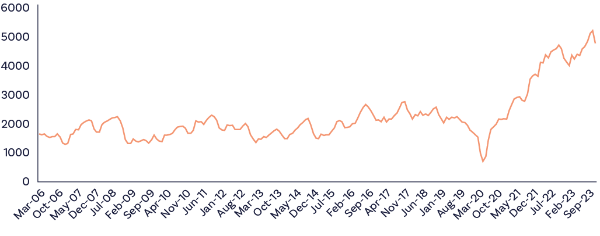
Figure 18: Job vacancies for child care workers are at an all time high, approximately double the levels observed before the onset of the pandemic.
Source: Jobs and Skills Australia, Internet
Job vacancies data shows that since the Fair Work Commission announced a 15% wage increase for aged care workers, vacancies for aged and disability care workers have fallen 13.2%, while vacancies for childcare workers have risen 13.6%.

Figure 19: New vacancies – Aged carers vs child carers
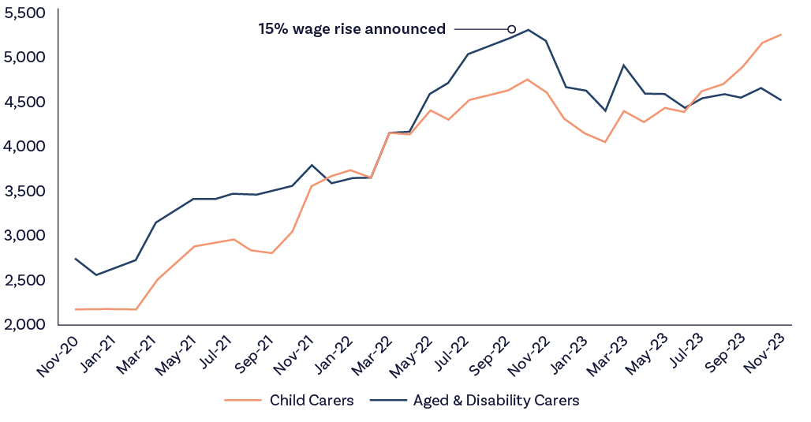
Figure 19: Job vacancies data shows that since the Fair Work Commission announced a 15% wage increase for aged care workers, vacancies for aged and disability care workers have fallen 13.2%, while vacancies for childcare workers have risen 13.6%.
Source: Jobs and Skills Australia monthly internet vacancy index, analysis by John Cherry
Numerous participants in the Productivity Commission’s Inquiry into Early Childhood Education and Care have highlighted the difficulties centres have in attracting and retaining staff. This scarcity of personnel jeopardises the availability and quality of these services.
The situation is particularly acute in remote areas of Australia, where the vacancy rates stood at 15 to 20% of staff in 2022, compared to just over 10% in major cities.
While positive steps have been taken to alleviate workforce shortages, such as the approval of multi-employer bargaining with unions seeking a 25% wage increase for early childhood educators, shortfalls persist. Despite the passage of the Fair Work Legislation Amendment (Secure Jobs, Better Pay) Act 2022 and the endorsement of a ten-year workforce strategy by Australian education ministers, advancements to translate to actual wage increases are slow.
In response, calls have been made for the Commonwealth Government to fund an interim 10% wage supplement for early childhood workers from January 2023. This proposal, endorsed by several organisations, aims to bridge the gap until the implementation of ECEC Workforce Strategy measures.
The Committee believes that without a substantial increase in wages in the sector, workforce shortages will persist undermining access to quality ECEC.
Recommendation 13
Support applications in the Fair Work Commission that seek to raise the wages and improve the job quality of early childhood educators. As a step to remedying historical undervaluation of educators’ work, ensure that the outcomes of these cases are fully funded.

5.3.4 Supporting scaled delivery of holistic, integrated early years models and holistic “full service” school models
Supporting children and families through the early years requires support from family and friends, an ever-changing sequence of child-related services, and health, employment, training and personal supports for parents and carers.
For some families, raising children through their early years can be an isolating experience as old connections are lost, and financial pressures restrict options for getting out of the house.
Landmark inquiries into the early years over the past 12 months have highlighted the fragmentation and inconsistency of services and supports available to families and young children and made recommendations towards creating a far more integrated, seamless and navigable service system.
Connecting services through physical co-location at schools, ECEC sites or in community settings and through connector, navigator or “glue” roles are seen as good practice solutions with many current on-the-ground examples of successful service delivery. The location of services in welcoming community environments in which nourishing relationships can also be formed is a closely related concept. The SA Royal Commission into ECEC went as far as recommending:
“...making integrated services the default for all newly established state Government early years services, including preschools and schools, community health, parent and infant mental health and parenting supports, with variance from the default only occurring because of the needs of the local community”
And
“... integrating into the normal process of maintenance and upgrade the creation of appropriate physical space for integrated or multidisciplinary work in state Government early years services which lack such facilities.”
Social Ventures Australia, the Centre for Community Child Health at the Murdoch Children’s Research Institute, and others have explored the extent of current delivery of Integrated Child and Family Centres (ICFCs) of the kind promoted through recent inquiries, finding 209 examples of Integrated Child and Family Centres around Australia – albeit of substantial variability in scale, quality and sustainability.
A further 700 communities were assessed as likely to benefit from Centres if they were available. Four common delivery types were noted:
- Community centres, such as the Child and Family Learning Centre network in Tasmania.
- Schools, such as the Our Place or FamilyLinQ models in Victoria and Queensland.
- ECEC services – such as several of the Aboriginal and Torres Strait Islander integrated early years centres.
- Community Health settings – various state-based examples.
Social Ventures Australia’s 2023 Report Happy, Health and Thriving Children – Enhancing the Impact of Integrated Child and Family Centres in Australia makes 10 recommendations to advance towards a consistent, sustainable and national-scale provision of ICFCs, including:
- Create a national approach to ICFCs that includes a broad definition, national quality framework, and professional learning system
- Design and operationalise an ICFC specific funding model
- Design a unique funding stream for Aboriginal and Torres Strait Islander integrated early years centres
- Enable ICFCs to provide ECEC
- Reform the allied health system to ensure ICFCs are able to provide access to allied health for children and families.
The Committee supports the creation of a robust national system of ICFCs and views the recommendations in the Social Ventures Australia’s 2023 Report as a good starting point.
The Committee also welcomes the recommendations from the NDIS Review about creating a continuum of support for children with disability and developmental concerns, including the importance of foundational supports for young children outside the NDIS, and the opportunity for such supports to be provided in ECEC settings.
The new National School Reform Agreement (NSRA) is currently being negotiated between the Commonwealth and the states and territories. That process is being informed by the Review to Inform a Better and Fairer Education System, published in December 2023, which recommends the wider adoption of holistic “full-service” schooling models.
The Committee supports the idea that schools are logically well placed to promote engagement, social connection and service access, able to integrate their learning and pastoral care supports with a potentially wider range of assistance and specialist care.
Several full-service school models exist in Australia in a variety of formats and scales. The most well developed – the Our Place model in Victoria – operates in 10 school communities and offers a pipeline of supports on the school campus from pregnancy through the early years and school years for both parents, carers and children. These supports are provided through a partnership with a philanthropic foundation that coordinates a wide variety of service partners in close coordination with school leadership.
Other models and examples include:
- Queensland’s FamilyLinQ model
- The Challis Community Primary School in Perth
- The Community Hubs Australia organisation
- Several individual schools where school leaders have taken an active role in this field.
Despite the evidence of their success, a full system-level embrace of full-service school models has yet to be adopted in Australia. Community leaders have told the Committee that clear and supportive policy and implementation remains inconsistent. As is common in many multi-disciplinary initiatives, accountability mechanisms are unclear and decision makers are cautious about assuming unknown, expanded and unfunded obligations.
The Committee concurs with the findings of the 2023 Review to Inform a Better and Fairer Education System that full-service school models should be more widely delivered and that the policy, funding and cross-portfolio and cross-Government partnership arrangements required should be developed to enable scaled delivery over time.
Recommendation 14
As an early action of the new Early Years Strategy, the Government commits to wider scale delivery of integrated child and family centres and holistic “full service” school models targeted to communities of highest need.
- To deliver on this commitment the Government should create a national framework, funding scheme and evaluation and learning framework.
- The Commonwealth should accept an ongoing stewardship role of the network of integrated centres and full-service school models in partnership with states and territories, using opportunities such as the National Schools Reform Agreement to embed long term commitments from all parties.
- As a supporting measure the Government should take further steps to advance place-based approaches in target communities and consider a fuller response to recommendations provided in the Committee’s 2023 Report.

5.4 Reforms to the Family Tax Benefit and Child Support Systems
In this section the Committee outlines the broad changes that have occurred over time to coverage and levels of benefit within the FTB scheme – an area the Committee will explore further over the coming year. We also examine the interactions of the FTB and Child Support systems and make recommendations towards improving the safety, wellbeing and economic security of women and children after separation.

5.4.1 Family Tax Benefits
FTB is a payment for eligible families with children. FTB consists of two parts: FTB Part A and FTB Part B. FTB Part A is the primary form of family assistance for the direct costs of children aged under 16 and dependent full-time secondary students aged under 18 living at home.
FTB Part A assists low and middle-income families with the direct costs of raising dependent children. The payment is paid per child and includes fortnightly and end of year assistance. Supplementary payments such as Rent Assistance, Newborn Supplement and Multiple Birth Allowance may also be paid as part of FTB Part A where families meet relevant eligibility requirements.
Figure 20 (on the following page) shows trend in FTB Part A recipients between 2001 and 2023 by type of family (couples and single parents). In 2000, when FTB was first introduced, there were 1.801 million FTB Part A families.
The FTB Part A population peaked in 2005 at 1.828 million, and has trended downwards since, falling to 1.2 million families by June 2023, a reduction of 33.4%. Over the same period, nationally, according to ABS Labour Force Status of Families, the number of families with a dependent child aged under 15 years increased by 26% and the total number of families with a dependent child aged under 25 increased by 30.3%.

Figure 20: FTB Part A families over time, 2001 to 2023 (instalment population)
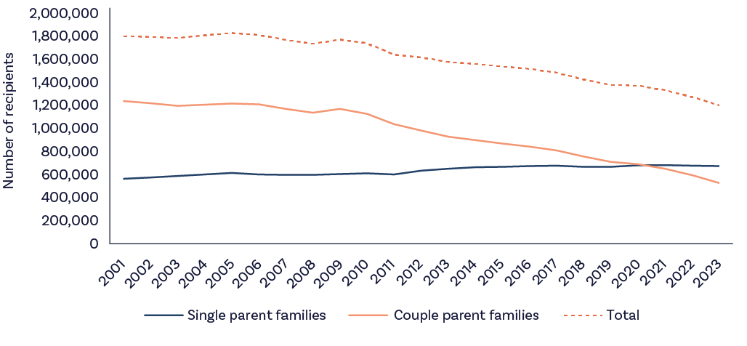
Source: Services Australia administrative data
FTB Part A coverage
Since 2003-04, the percentage of Australian children attracting FTB Part A at some time in the entitlement year has reduced from a high of 80.5% in 2003-04 to 47.6% in 2020-21.
Children aged under 5 years have experienced the largest reduction with coverage reducing from 84.1% to 47.6% for children aged one to 4 years (see Figure 21, below). The reduction in coverage is the result of a combination of factors including policy changes, growth in family incomes, fertility rates and other demographic changes, with each effect hard to disentangle from the others.

Figure 21: Unique number of FTB Part A children as a proportion of population by age group, 2003/04 to 2021/22 (at Q8 after each entitlement year, Q6 for 2021-22)
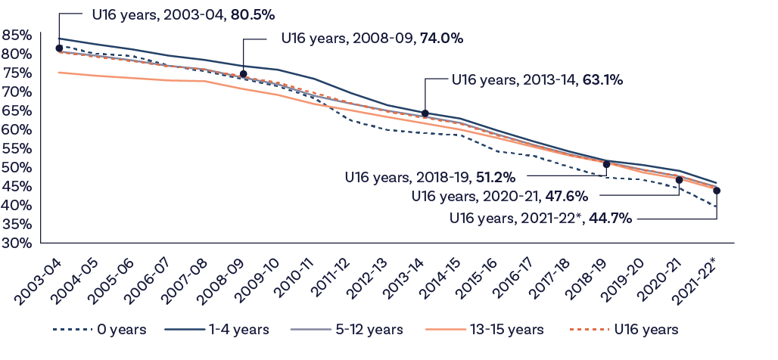
Source: DSS calculations using EDW Family Tax Benefit Reconciliation Package. Unique count of children attracting FTB Part A in the entitlement year, age at 30 June. Data as at quarter 8 (2 years) after entitlement year to allow for reconciliation. 2021-22 is as at quarter 6 and is not yet mature. ABS 3101 National, state and territory population, Table 59. Estimated resident population at 30 June each year. 2022 is preliminary.
FTB Part A coverage and value
From July 2009, various measures to target FTB Part A to lower income families have operated to reduce payment coverage.
The most significant of these has been the pausing of indexation of the FTB Part A family income test higher income free area (HIFA). The HIFA is currently $111,398. If CPI indexation had been consistently applied since July 2009 the HIFA would be $138,554. The HIFA indexation pause was also applied to the additional HIFA amount for each child after the first. The HIFA additional child amount was removed from July 2015. If this amount had been retained and indexed, it would currently be $5,475.
Other significant impacts include:
- the removal of the end of year supplement where family income exceeds $80,000 (July 2016)
- the removal of the large family supplement (July 2016) and Energy Supplement for new entrants (March 2017)
- for larger families, the increase in the FTB Part A maximum rate taper from 20% to 30% once income reaches the HIFA (July 2019).
Changes to FTB Part A indexation and indexation pauses, as well as the removal of various supplementary payments available to families have also operated to reduce the maximum rates of assistance provided by FTB Part A in real terms (compared to CPI) and compared to pension rates. At 1 July 2023, the FTB Part A 0-12 fortnightly rate was $36.54 per fortnight ($953 pa) lower than if the indexation of family payments had continued to apply since 1 July 2009 (without the indexation freezes applied).
For a more detailed discussion of these falling rates of FTB coverage and adequacy, the Committee directs readers to a recent study undertaken for the Brotherhood of
St. Laurence, Growing pains: Family Tax Benefit issues and options for reform.
Given that those families receiving FTB Part A are already struggling to make ends meet, the Committee is strongly concerned about the declining adequacy and coverage of FTB and intends to make this the subject of further analysis and recommendations in its next report. In the meantime, the Committee believes that a small but important sub-cohort of FTB recipients – those in receipt of FTB Part A – can be assisted by simple and affordable changes to action and income tests.

5.4.2 Child support and the interaction with Family Tax Benefits
Child support is a private payment, typically made by a non-resident parent to a resident parent to support the cost of children following parental separation. At present, 88% of child support recipients are mothers, reflecting the deeply gendered division of work and care in Australia that contributes to single parent poverty. Child support forms an important part of single parents’ income package, reducing the likelihood of single mother family poverty by 21%, when payments are received.
As of September 2023, there were 649,355 active child support cases pertaining to almost one million children. Of these cases, approximately half (50.5%) transfer payments via Services Australia, known as Agency Collect, with the other half transfer payments privately between parents. While the number of single parent families is increasing slowly over time, from 14.5% in 1996 to 15.9% in 2021, the number of child support cases is declining. There was 5% fewer active cases in September 2023 compared to the same time in 2019, and 2% fewer than the same time a year ago.
The decline in the child support caseload is concerning given the significant and persistent financial stress experienced by single parent families, particularly single mother families, and the requirement that single parents seek child support in order to qualify for above-base-rate FTB Part A (currently $68.46 for each child, per fortnight).
Departmental data show that the proportion of the child support caseload who pass the Maintenance Action Test (MAT) by seeking child support from their ex-partner (Figure 22).

Figure 22: Separated parents’ access to child support over time, March 2018 – Sept 2023
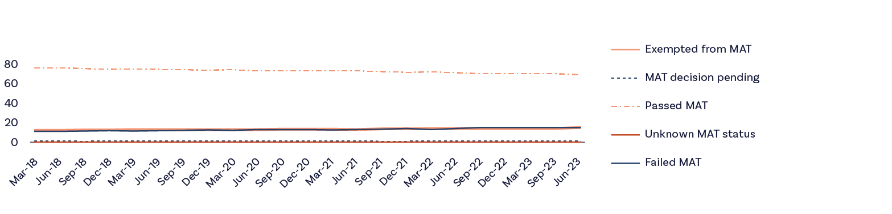
Source: DSS administrative data
Figure 22 shows a decrease in the proportion of single parents who passed the MAT between March 2018 and September 2023, decreasing from 76% to 69% over this period. Over the same period, single parents exempt from the MAT increased from 12% in March 2018 to 15% in September 2023.
Parents may be exempt from taking action to receive child support on a number of grounds, including a fear of violence as a result of seeking child support, unknown other parent identity, surrogacy, cultural considerations, deceased other parent, and other exceptional circumstances.
The proportion of parents exempted from taking child support action for each of the above reasons is not known. However, the growing societal awareness of family violence may account for the increase over time. In any case, the small proportion of single parents who are exempt from seeking child support due to fears of violence is dwarfed by the finding from ABS data that 60% of women who were now single mothers had experienced violence from a previous partner. Not all such women may still be at risk of violence. In addition, not all may not be able to document incidents of violence or be able to demonstrate that violence may occur as a result of seeking child support, and as such will not meet the eligibility criteria for an exemption. However, the implied definition of violence used in the MAT exemption seems particularly limited.
A survey of single mothers found that 80% of respondents reported that their ex-partner had replaced physical violence with financial abuse via child support following separation. The MAT exemption does not appear to recognise the risk of financial violence that separated mothers face, or the role the child support plays in its perpetration.
In addition to the increase in parents exempt from the MAT over time, there has been an increase in the proportion of single parents who have failed the MAT, increasing from 11% in March 2018 to 15% in September 2023. This trend is of particular concern as it leaves single parents with extremely low incomes, well below the poverty line. It is not acceptable for children growing up in such households to be denied the level of Family Tax Benefits that their parents’ incomes warrant.
Parents who fail to take reasonable action to seek child support, and who are not eligible for an exemption, have their FTB Part A payments reduced to the base rate. Given that family tax benefits comprise a significant proportion of single parents’ total income package, the growing proportion of parents who receive only the base of payments is of considerable concern and likely contributes to the high levels of single mother poverty.
In addition to the increasing rate of MAT failures and the low level of exemptions on the grounds of family violence, the previous Interim EIAC report raised concerns about the opaque nature of Private Collection payments, and the potential for these arrangements to lead to debts owed to the Government when ex-partners intentionally manipulated tax returns and child support payments. The Committee’s previous report outlined how the MIT reduced FTB Part A payments by 50 cents for every dollar of child support received – or due to be received in Private Collect cases – above a meagre threshold. The report detailed how the MIT afforded malicious ex-partners scope to manipulate the timing of tax returns, the value of child support liabilities and the timing and value of payments in order to raise FTB debts against single mothers. In the previous report, the Committee recommended that the Government remove the MIT from the calculation of FTB Part A for child support customers. This recommendation was also made by the WEET and has yet to be actioned or responded to.
Several Government inquires and reports have echoed the concerns of the Committee over the potential for child support to be used to inflict financial harms post separation.
The Women’s Budget Statement set out several reforms intended to improve the child support system, including committing $5.1 million over 5 years to implement key recommendations made by the Joint Select Committee on Australia’s Family Law System. Commitments include:
- establishing a Child Support Stakeholder Consultation Group
- commissioning expert research on the costs of raising children in Australia and consider whether changes are needed to the child support formula
- reviewing compliance in the child support scheme, with a focus on collection and enforcement
- reviewing the interaction between the child support scheme and FTB to ensure vulnerable single parent families are financially supported after separation
- undertaking an evaluation of separated families to understand what can be done to support parents with caring responsibilities where private collect arrangements have broken down.
To action these commitments, the Government has established the Child Support Stakeholder Consultation Group as well as a Child Support Expert Panel. However, the scope of the Consultation Group and Expert Panel is limited to advising on the commissioning of costs of children and related research, considering the technical details of the operation of the child support scheme, and developing a methodology to review the child support formula. These functions are limited to assessing the scheme’s technical calculations and fail to address the Government’s commitments to review the potential for child support scheme and FTB system interactions to cause harm through MAT failures and the use of the child support system to induce FTB Part A debts owed to Government and perpetrate financial abuse, particularly in Private Collect cases. These issues will be the subject of more detailed enquiry by the Committee in next year’s report. However, the Government could take up its commitment to ensuring women’s safety by eliminating key interactions between child support and the FTB system. Accordingly, the Committee recommends:
Recommendation 15
The Government implement Recommendation 33 from the Committee’s 2023 Report, namely, to remove the MIT from the calculation of FTB Part A for child support customers.
Payment criteria should be adjusted so that affected families receive a similar amount of family benefits as would have resulted under the MIT. The desired outcome is that FTB Part A payments are made more predictable for recipients, rather than significantly altering payment values. The removal of the MIT would result in more certain FTB Part A payments for financially vulnerable families, remove the prospect of retrospectively applied FTB Part A debts, and concurrently close a loophole that allows child support and FTB Part A to be used as vehicles for enacting financial abuse.

5.5 Conclusion
The early years of a child’s life are the most crucial in so many respects. It’s when their brains reach important development milestones, their potential can start to be realised, and their life chances opened up. Spending on them and the stability of their families at this stage should be regarded as a vital investment.
While Australia’s early child development efforts are generally considered strong, there is little doubt that they could yield an even greater benefit.
This starts with the creation of a fully developed and coordinated national early child development system as a partnership between the Commonwealth, state and territory governments, with the aim of bringing all service elements together to achieve the goal of universal access to higher quality joined up services.
Because too many of the children who need it most miss out on ECEC services, those services need significant policy change. Activity tests that take care away from non-working families, market shortages that lead to ECEC service deserts, and staff shortages due to insufficient wages offered to care workers, all need to be addressed.
Innovation is also needed. The success of full-service school models provide a potential way of creating strong pathways through the early years and through schooling for children in the most disadvantaged communities. Holistic ECEC services and integrated child and family centres are other promising modalities that should be more widely supported. Leadership and cooperation will be needed to make cross-service programs like this work.
In addition to this, the financial support of families with young children – most numerously single mothers – must and can be improved. The unforeseen consequences of interactions between the FTB Part A and child support, especially involving parents who game the system, reduce the certainty of income of many care givers, exposing them to unforeseen debts and financial violence by ex-partners.
Getting rid of the cause of this injustice by removing the MIT from the calculation of FTB Part A would be a good step forward.

Farnaz: Mature-aged JobSeeker
Farnaz is a 48-year-old IT specialist who moved to Australia nine years ago as a skilled professional.
She has two daughters, aged seventeen and twenty, who are in their final year of high school and second year of a law degree. Farnaz had been working for a major IT firm in Adelaide but moved to Sydney to be closer to her family after her husband died suddenly two years ago. Since then, Farnaz has struggled to find work or even get an interview for jobs in her field and has been receiving a JobSeeker Payment.
Farnaz is grateful to live in a country that has a social security system. She feels very lucky to be supported by her new country and wants to be able to pay back the help that she has received by paying taxes and contributing her skills.
But she has found it incredibly difficult to find a job in a job market in which knowing people can be more important than responding to a job ad.
Farnaz had never received a Government payment before moving to Sydney. She had no idea what her options were, or what she was supposed to do. She went to the local Centrelink branch and followed what they told her. But she found that she had to go back almost every day to give them a new document or fill out a new form. She was frustrated that they often had no record of things that she’d given them previously. When she rang the call centre, she once waited hours to be told that she had to complete the information online and to phone back if she had problems. But it took her hours to get through the first time, so she didn’t want to do that again.
At the Centrelink branch and on the phone, Farnaz has been told that she was only allowed to ask one question. But often she has multiple questions, or the answer to her question leads to more questions that she needs answers to follow the rules. Farnaz has found that meeting with staff in-person allows her to insist her questions are properly answered. This means that rather than spending her time looking for work, she spends a lot of time travelling to and from the Centrelink office on public transport and waiting for her turn. She has been surprised at the poor quality of advice she has received from Centrelink and her employment service providers.
Her employment service provider treats her not as a skilled, qualified and willing worker but as someone who needs motivation to look for work. The jobs they suggest will not help her get back into the profession that she loves and will provide a secure financial future for her. She has a good resume, but the gap between now and when she last worked in her profession is getting wider. She is worried that her future is slipping away. All she needs, she thinks, is helping to connect with the right people in her industry. She simply can’t understand why the Government is spending so much money making her go to interviews for jobs that aren’t appropriate and undertake courses that waste her time. She knows how to dress for an interview and write a covering letter for her CV. How many times must she tell them?
Farnaz is always worried that if she doesn’t follow the rules and do all of the things that the Employment Service and Centrelink say, they will have her payments cut off. She can’t afford to have that happen, as she wouldn’t be able to pay the rent or provide food for her family.
It took her three months to find the house that they are now renting, because no-one would rent to her when she didn’t have a job. Before she found her rental, Farnaz and her two daughters lived with her cousin’s family. But her cousin has her own family, and it was hard for seven people to live in a three-bedroom house. Farnaz tries to help her cousin by looking after her children after school and taking her cousin’s mother to medical appointments. Farnaz is happy to help her cousin’s family, as they help her when she needs it, but sometimes her Employment Service provider doesn’t understand why she can’t make an appointment.
Farnaz is worried that while her income seldom increases, her rent has gone up by $200 a month in 18-months. She doesn’t know what her family will do if she can’t pay the rent or if her landlord decides not to renew her lease. There is nowhere else that her family can go – she can’t ask her cousin to take her back again. Asking her daughters to start working instead of studying to bring in extra income will harm their future potential as well.
Farnaz wants the Government and employers to know that migrants are tough people with valuable skills and experience they can contribute to Australia. They just need support to be given a chance. She wants Centrelink and Employment Service providers to see her as a skilled professional who needs help to find a job in her field, rather than encouraging her into low skilled, dead-end jobs that will keep her at the bottom of society. More money from Centrelink would make her feel more secure, ensure her family had somewhere to live, and allow her daughters to fulfil their potential. She is looking forward to earning enough to pay taxes again soon.

Chapter 6:
The culture, purpose and intent of the social security system

6.1 Introduction
Ideas about social security typically fall between two poles.
To paraphrase Commissioner Catherine Holmes and her report from the Royal Commission into the Robodebt Scheme, one pole sees …
“…those in receipt of social security benefits as a drag on the national economy, an entry on the debit side of the Budget to be reduced by any means available.”
While at the other pole sits an approach that recognises ….
“…that many citizens will at different times in their lives need income support – on a temporary basis for some as they study or look for work; longer-term for others, for reasons of age, disadvantage or disability – and to provide that support willingly, adequately and with respect.”
The evidence presented to the Committee suggests that attitudes to Australia’s social security system often gravitate strongly towards the first pole, allowing pernicious myths about ‘dole bludgers’ and ‘rorters’ to infect the system’s culture, design and operations. The system is burdened with many unfounded beliefs about people who receive income support, including that:
- There is ever-present or widespread fraud within the system which demands a rigorous policing.
- Long-term recipients of working-age payments do not value work and compulsory activation is effective in moving them away from a reliance on income support.
These attitudes and myths have created a complex set of practices and rules related to some of the system’s income support payments, making them unfair, illogical, complex, costly to administer and insufficiently informed by the real-life circumstances of people they are supposed to support. They are not fit for purpose.
This is most acutely observed in relation to working-age payments, most notably the JobSeeker Payment, which was designed as a short-term support for people between jobs, but whose caseload is now overwhelming dominated by people over 55 years of age, people with a partial capacity to work, and other people with long-term barriers to employment. For many of these Australians no amount of compulsory job search activity, Certificate 1 or 2 training courses, or low-value make-busy work will move them closer to employment or satisfy the labour needs of employers. And yet it is required of them, constantly.
The Committee recognises the Government’s positive responses to the Robodebt Royal Commission findings. But more change is needed.
As part of its investigation into the culture of the social security system, the Committee heard directly from people receiving a range of income support payments about the effect of its strict rules on their lives.
The picture it paints is one of Australians living in grinding poverty, sometimes unable to afford sufficient food or medicines, whose interactions with the social security system are moving them even further away from employment. People are forced into mutual obligations activities that are often degrading, humiliating, pointless, and time-wasting. They are required, repeatedly, to provide unnecessary evidence of their circumstances. And they are frequently given low-quality and misleading advice from those employed to help them but who are often insufficiently trained to do so, despite what are often their best intentions. Addressing the resulting mistakes takes many hours more. These experiences can dominate people’s lives year after year. It consumes them, and leaves those who have transitioned onto other payments such at the DSP, Carer Payment, or Parenting Payment terrified at the prospect of reverting to reliance on JobSeeker – with the result that many will never actively seek paid work again. The harshness of the regime, designed to discourage passivity, is having the exact opposite effect – entrenching long-term unemployment, constraining labour supply and further impacting wellbeing.
“I’m deeply angry about how I’ve gone through so many distressing experiences on mutual obligations that have served nothing, just seems like I was on surveillance the whole time, it was like I was on a knife edge with my income could be taken away at any time. One wrong move, even an inadvertent one could cause me to fall through the cracks.”
Robert, who received JobSeeker Payment until recently, when his partner’s income excluded him from support.
The Committee also heard from social security experts and sector stakeholders who administer the system and care deeply about their work. They also reported practices that remain onerous, illogical, unfair, stigmatising, costly and time wasting for everyone. They told the Committee about the great complexity of the current system and the difficulty both Centrelink customers and staff have in understanding and fairly applying entitlements and rules. There are significant inconsistencies between payment regimes and the entitlements for different cohorts which perpetuate stigmatising distinctions between “deserving” and “underserving” recipients of support. These feelings of stigma are reinforced by language and rhetoric used about people in the income support system.
“I’m not sitting back on my sofa drinking champagne and booking my trip to Bahamas. I’m sitting back thinking of all the uncertainty and having to think, “Oh, can I afford to pay my bills?” So, the Government, I think the narrative has to change, that people on JobSeeker are not dole bludgers. We’re not losers. We’re not unemployable.”
Diana, who receives JobSeeker Payment
These testimonies are backed up strongly by the findings of the Robodebt Royal Commission, which reported that the prevailing culture of the system contributed to that now discredited debt recovery program. The Royal Commission’s report details how the relentless characterisation of people receiving income support payments as suspect criminals and fraudsters led, somewhat ironically, to illegality of historic proportions. As Commissioner Catherine Holmes stated, the long-term response to the Robodebt disaster must include a change in the culture of the social security system, starting at the top, without which progress will not be possible.
“…politicians need to lead a change in social attitudes to people receiving welfare payments. The evidence before the Commission was that fraud in the welfare system was miniscule, but that is not the impression one would get from what ministers responsible for social security payments have said over the years. Anti-welfare rhetoric is easy populism, useful for campaign purposes. It is not recent, nor is it confined to one side of politics, as some of the quoted material in this report demonstrates. It may be that the evidence in this Royal Commission has gone some way to changing public perceptions. But largely, those attitudes are set by politicians, who need to abandon for good (in every sense) the narrative of taxpayer versus welfare recipient.”
Catherine Holmes AC SC, Royal Commissioner in the Robodebt Royal Commission
The Committee found little evidence that the unduly harsh policies that can be enabled by this culture serve any legitimate public purpose with respect to people receiving income support. The Committee found in general that:
- JobSeeker and related working-age payments including Youth Allowance, Austudy and ABSTUDY are not enough to live on.
- The experience of many people interacting with the social security system is gruelling.
- As a result, people’s mental, physical and financial wellbeing often worsens and limits their future employment capacity and quality of life.
To begin the journey towards a more balanced approach for Australia’s social security system the Committee makes recommendations both on updating the underlying ideas and beliefs that animate the system, and on reforms to practices that have taken root within the existing culture that are most out of step with the contemporary needs of the Australian community.
The Committee believes that Australia’s social security system should deliver economic inclusion and wellbeing for those who use it, which we all do at different stages of our lives. As a first principle, social security should prevent poverty, ensure people can cover the cost of the essentials of life, and enable them to live with dignity. Our system should provide a safety net of support for people when they are unable to support themselves, and protect them against poverty, financial deprivation, and exclusion from society.

6.2 Setting a new purpose for the social security system – to support economic inclusion and wellbeing
The Committee is of the view that the culture, purpose and intent of Australia’s social security system should be to promote economic inclusion and wellbeing.
Social security should support people when they need it, prevent poverty and ensure people can cover the cost of the essentials of life. Doing so will create a strong platform to support other Government objectives because, as we know, providing people with adequate income improves health, education, employment and childhood outcomes.
Over the past 18 months the Government has initiated much policy development relevant to considerations of economic inclusion and wellbeing. The Employment White Paper, the Measuring What Matters wellbeing framework, reviews into Workforce Australia, the Early Childhood Education system, the National School Reform Agreement and the NDIS, along with the development of the Early Years Strategy, are just some of the significant policy undertakings delivered to date.
In Chapter 1 of this year’s report, the Committee has proposed a definition of economic inclusion to guide its own work and provide a framework for how a more economically inclusive society might be understood. It is built around four domains:
- Economic security
- Equal opportunities
- Growth and ensuring equal sharing of growth
- Building efficient and responsive governments.
The Committee’s definition and the wider body of recent policy development work provides vital context for what the social security system should do and how it should operate. To proceed without the system responding to this raft of refreshed policy thinking will leave it marooned – pursuing its own priorities adrift from the direction of reform and at odds with the refreshed programs and policies that are the fruit of that reform. Positioning the system in this way offers an exciting opportunity for strategic and operational renewal.
Aligning the system to the purpose of supporting economic inclusion and wellbeing requires rethinking and updating the conditionality that applies across many payments, including mutual obligation requirements, and reducing the complexity that has developed as part of the ever tighter targeting of support.
It also requires leadership from Government to create a new narrative about social security to shift the culture that has created a negative view of receipt of income support in Australia. The new narrative must position the social security system as a valued piece of civic infrastructure that supports all of us in times of need. Social security must be centred as a key enabler in building Australia’s human capital, providing a springboard for community and economic participation and helping deliver on essential public policy priorities. The system has a central contribution to make in creating a flexible and responsive labour market, ensuring the safety of women and their children, supporting people with disability, creating a universal child development system, and ending homelessness, to name but a few related policy priorities. Social security must be reframed so that it is free of stigma, and instead represents a shared commitment to look after each other at times of need, including during pandemics, disasters, industry transformations and global economic disruptions.
These ideas should be captured and asserted as a first step in the process of ongoing renewal. Accordingly, the Committee recommends:
Recommendation 16
The Government adopt a refreshed mandate for Australia’s social security system and that this mandate should be to promote economic inclusion and wellbeing.

6.3 Acknowledging that the social security system is for all of us
Social security is one of the most important achievements of the last century. Its role in managing income volatility in an increasingly dynamic and globalised economy gives every Australian good reason to value and celebrate it. The high unemployment caused by the COVID 19 pandemic led to increased empathy for people who are unemployed and rising levels of trust and regard for the social security system. It reminded us that reliance upon social security is something that affects most of us at various times of our life, and that use of social security system is far more widespread than we tend to think.
Receipt of income support is not an isolated nor extraordinary experience. Between 2001 and 2015 some 70% of Australians of working age at some point received an income support payment or lived in a household with someone receiving income support. Between 2000 and 2016, 25% of eligible working-age Australians received unemployment benefits (Newstart). Add to this those receiving the Age Pension, FTB, and other payments and it becomes clear that practically everyone receives, or has someone close to them who receives, income support from the social security system.
Despite this strong system use and support, the Committee found that pejorative views persist. Despite little evidence to support them, myths about “deserving”, and “undeserving” people retain a grip on the public’s consciousness, undermining social cohesion and inspiring poor policymaking.
These myths must be challenged, the facts must be made more widely known, and the culture of Australia’s social security system must be reset to reflect the reality of our near universal reliance upon it. It is the Committee’s view that Government should strive to reframe Australia’s social security system as a core support for our society and economy. Notions like “deserving” and “underserving” should be challenged and rejected.
“I don’t think anyone on earth or anyone in Australia would choose to be where we are. Not by choice, not by choice. There’s no way. I just want the barriers gone. I want my kids to be able to not turn around and go, I know we’re poor mum. That just breaks me. That breaks me...”
Moeata, who receives Parenting Payment

6.3.1 So who receives the system’s support?
Having established near universal engagement with Australia’s social security, we need to understand in what ways people engage with it.
As at September 2023 there were 6.2 million people in Australia receiving a Commonwealth Government payment. This total was comprised of 5 million people receiving an income support payment (some of whom also received an FTB) and a further 1.2 million people receiving an FTB on its own (either directly or as part of a couple). Of the 5 million receiving an income support payment, 51% received the Age Pension (2.6 million people), while 45% were in receipt of an unemployment payment, Parenting Payment, DSP or Carer Payment. Table 11 provides a breakdown.

Table 11: Income Support Recipients at September 2023
Payment | Recipients | As a % of total income support population
Age Pension | 2,585,820 | 51.3%
Carer Payment | 304,480 | 6.0%
Disability Support Pension | 776,760 | 15.4%
JobSeeker Payment | 754,555 | 15.0%
Parenting Payment Partnered | 58,210 | 1.2%
Parenting Payment Single | 290,630 | 5.8%
Youth Allowance (other) | 71,805 | 1.4%
Other payments | 197,760 | 3.9%
Total | 5,040,015 | 100.0%
Source: DSS administrative data.
With the exception of the COVID-19 period in 2020 and 2021, the total number of people receiving these non-Age-Pension payments has remained relatively stable, with 2.04 million recipients at September 2013 compared to 2.14 million recipients at September 2023. Indeed, growth in the number of people receiving income support is well below growth in the general population which increased about 15% over the same period.
Comparing September 2013 to September 2023:
- JobSeeker Payment (formerly known as Newstart Allowance) increased by 3.2% or 23,525 people
- Parenting Payment Single increased by 31,770 people or 12.3%
- Carer payment has the largest proportional increase, increasing by 33.8% or 76,995 people
- DSP has decreased by 48,480 people or 5.9%

Figure 23: People receiving Newstart Allowance/JobSeeker Payment, Parenting Payment Single, Carer Payment and DSP - Monthly Time Series – September 2013 to September 2023
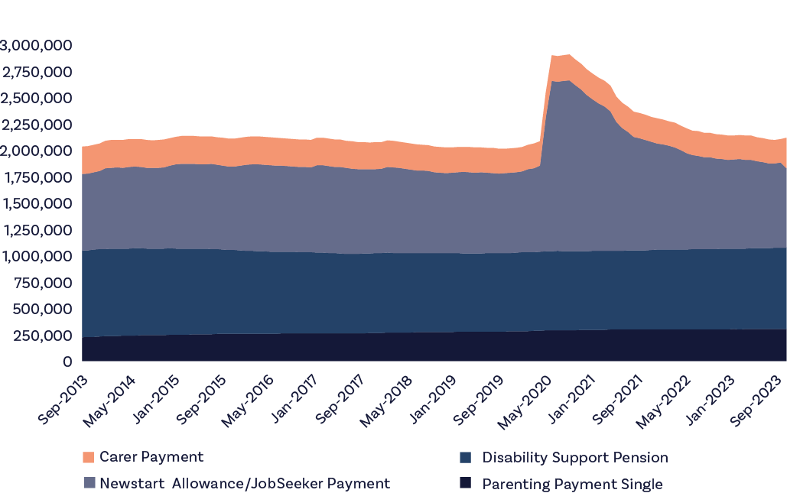
Source: DSS Administrative Data

6.3.2 Who receives JobSeeker payment in particular?
As of September 2023, a snapshot of the current JobSeeker caseload reveals the average period of receipt of income support is 5.4 years. Some 45% of the approximately 750,000 people receiving the JobSeeker Payment were assessed as having a partial capacity to work – that is, unable to work full time because of illness or disability, while 31% of people were over aged 55, many with fewer practical opportunities to retrain and join new industries. Overall, 70% of people receiving JobSeeker were long-term unemployed (unemployed for 12 months or more). Table 12 provides more detail.

Table 12: People receiving JobSeeker Payment as at September 2023
JobSeeker payment cohort | Population (at Sept 2023) | Average Income Support Payment duration (yrs) | Proportion on long-term Income Support Payment (%)
Principal Carer Parents | 42,475 | 8.6 | 80.6
Partial Capacity to Work | 339,475 | 7.3 | 83.3
Mature Age (MA) (55+) | 233,850 | 6.7 | 79.3
Culturally and Linguistically Diverse background | 150,375 | 5.4 | 70.0
Regional & remote Australia | 278,070 | 5.9 | 73.0
First Nations Australians | 101,730 | 5.9 | 69.9
All people receiving JobSeeker Payment | 754,555 | 5.4 | 70.4
Source: DSS administrative data
Over the last 10 to 20 years, older people, people with a partial capacity to work and people who are long-term receivers of income support have grown very substantially as a proportion of all people receiving JobSeeker. People receiving JobSeeker aged 55 years and over as a total proportion of all people receiving payments has tripled from 9.9% to 31% in the two decades to 2023. The proportion of people receiving JobSeeker with a partial capacity to work has roughly doubled from 22.7% to 45% since 2013. Table 13 below provides detail:

Table 13: Newstart Allowance/JobSeeker Payment, Yearly, September 2003 to September 2023
Date | Total Recipients | Long Term Income Support |  | Aged 55+ years |  | Partial Capacity to Work*
Sep-03 | 531,545 | 327,985 | 61.7% | 52,415 | 9.9% | n/a | n/a
Sep-04 | 513,665 | 313,995 | 61.1% | 65,595 | 12.8% | n/a | n/a
Sep-05 | 492,170 | 296,240 | 60.2% | 74,020 | 15.0% | n/a | n/a
Sep-06 | 480,460 | 291,950 | 60.8% | 80,140 | 16.7% | 12,570 | 2.6%
Sep-07 | 442,420 | 271,910 | 61.5% | 77,420 | 17.5% | 38,235 | 8.6%
Sep-08 | 439,565 | 257,325 | 58.5% | 76,850 | 17.5% | 61,950 | 14.1%
Sep-09 | 584,090 | 288,215 | 49.3% | 92,530 | 15.8% | 83,580 | 14.3%
Sep-10 | 589,655 | 346,160 | 58.7% | 95,395 | 16.2% | 98,870 | 16.8%
Sep-11 | 576,835 | 341,675 | 59.2% | 96,580 | 16.7% | 107,135 | 18.6%
Sep-12 | 613,915 | 360,740 | 58.8% | 109,015 | 17.8% | 130,150 | 21.2%
Sep-13 | 731,030 | 461,425 | 63.1% | 128,225 | 17.5% | 166,140 | 22.7%
Sep-14 | 768,245 | 511,735 | 66.6% | 144,235 | 18.8% | 196,365 | 25.6%
Sep-15 | 799,670 | 538,325 | 67.3% | 159,370 | 19.9% | 221,180 | 27.7%
Sep-16 | 813,640 | 554,315 | 68.1% | 174,315 | 21.4% | 250,390 | 30.8%
Sep-17 | 805,155 | 568,815 | 70.6% | 188,185 | 23.4% | 266,795 | 33.1%
Sep-18 | 772,150 | 540,515 | 70.0% | 194,455 | 25.2% | 291,115 | 37.7%
Sep-19 | 761,610 | 540,610 | 71.0% | 199,665 | 26.2% | 318,280 | 41.8%
Sep-20 | 1,586,465 | 666,545 | 42.0% | 340,050 | 21.4% | 396,185 | 25.0%
Sep-21 | 1,051,650 | 852,690 | 81.1% | 275,250 | 26.2% | 392,290 | 37.3%
Sep-22 | 862,540 | 649,310 | 75.3% | 244,960 | 28.4% | 369,480 | 42.8%
Sep-23 | 754,555 | 531,550 | 70.4% | 233,850 | 31.0% | 339,475 | 45.0%
*Partial Capacity to Work refers to activity tested recipients with an assessed work capacity of under 30 hours per week. Partial Capacity to Work was introduced from July 2006, under Welfare to Work provisions.
Source: DSS Administrative data
The relationship and relativities with respect to people receiving JobSeeker Payment who are long-term unemployed, have a partial work capacity and who are 55 and over as at September 2023 is visualised in Figure 24 below.

Figure 24: Relationship and relativities of key cohorts from the JobSeeker caseload as at September 2023
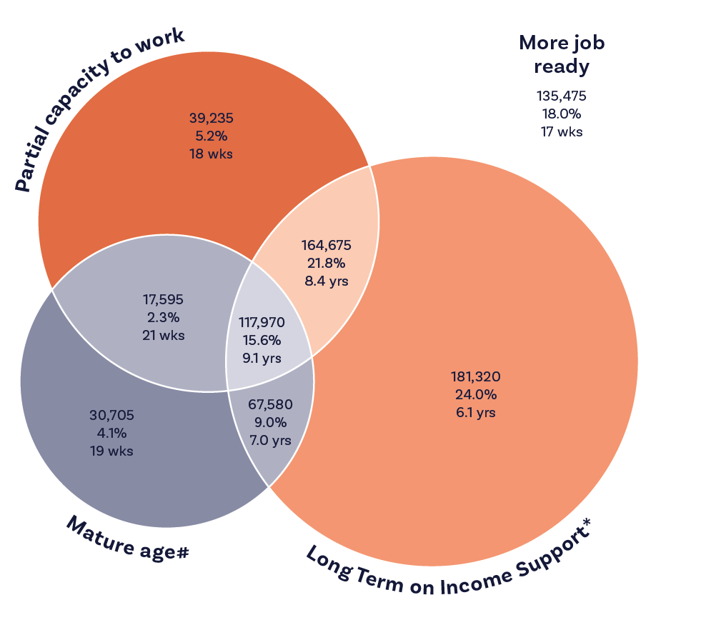
Key:
1. Sub-cohort population
2. % of JSP
3. Average duration on income support
# Mature age refers to recipients aged 55 and over
* Long Term refers to being on Income Support for more than 12 months
As at the end of September 2023:
The JobSeeker Payment total population was 754,555
The average duration of income support was 5.4 yrs
Cohorts total recipients
Long Term on Income Support: 531,550 (70.4%)
Partial capacity to work: 339,475 (45.0%)
Mature age: 233,850 (31.0%)

6.4 New guiding principles to renew the social security system
Renewing the social security system and focussing it on its proposed new mandate of supporting economic inclusion and wellbeing requires a new set of guiding principles. The Committee believes a good starting point is the set of principles recently proposed by the Brotherhood of St. Laurence. With adaptations, these are:
- Adequacy: Economic security is a human right and a precondition for wellbeing (International Labour Organization 2012). To prevent poverty and enable economic and social participation, social security payments must be adequate for people to live with dignity.
- Dignity and autonomy: Individual dignity and autonomy are fundamental to human rights. As the UN collaborative platform Social Protection & Human Rights (2015) points out, these are ‘inextricably linked to the principles of equality and non-discrimination’. The principle of dignity and autonomy also respects the right
to privacy.
- Equity and fairness: An equitable system is fair and impartial. An equitable assessment of the adequacy of social security recognises that people have different needs depending on their age, gender, health and circumstances. Its practices should be based on evidence.
- Accountability and acting on evidence: Accountability is reciprocal. For too long, the concept of reciprocity has focused overly on the obligations of people receiving income support payments, rather than also recognising the obligations of government. Accountability entails transparency: clear statements of eligibility, assessment and decision-making processes, so that individuals can understand their entitlements and if necessary, challenge decisions. Policy based on evidence and a commitment to evaluating outcomes and the performance of policy decisions is a closely related principle.
- Person-centredness: the social security system should be effective in helping to address the needs of each person who relies on it. It should be easy enough to access and to understand for people receiving income support and easy enough to administer for staff. Focussing on people and their needs rather than schemes and their rules will help reduce complexity and improve the experience of everybody involved with the system.
- A safety net for all: Social security provides a safety net for all of us. As part of a progressive tax and transfer system it socialises risk across the whole population. A social security system that recognises the value of investing in people enhances social cohesion.
The Committee is of the view that adopting and mobilising a set of guiding principles such as these will be necessary to support the required improvement in culture and practice across Australia’s social security system. Accordingly, the Committee recommends:
Recommendation 17
The Government adopt a set of guiding principles to support an ongoing process of renewal in culture and practice across the social security system. These guiding principles should align with the system’s primary purpose to support economic inclusion and wellbeing.
The Committee proposes that these principles be:
- Adequacy
- Dignity and autonomy
- Equity and fairness
- Accountability and acting on evidence
- Person-centredness
- A safety net for all.
How can we put these new principles into practice?

6.4.1 Ensuring adequacy and suitability of payments – by raising payment levels and matching people to the right payments
The Committee has heard from people receiving income support that inadequate payment rates are causing severe financial distress, social exclusion, and poverty. People receiving income support commonly report an inability to cover basic costs, maintain good health, undertake education and training, and obtain paid work. This erodes their dignity and exacerbates existing imbalances of class and power. The starting point, therefore, is to raise income support payments to adequate levels.
In its 2023 Report, the Committee considered the adequacy of the JobSeeker Payment and Rent Assistance. Chapters 2 and 3 above reiterates the Committee’s position on the need to improve the adequacy of payments.
Another important consideration involves the suitability of payments and the rules and conditions that apply to them. JobSeeker is poorly suited to the needs people without paid work, particularly people who receive the payment long term, people with a partial capacity to work, and people aged over 55.
For many people receiving the payment, no amount of weekly job search efforts, Certificate 1 or 2 level training courses, or referrals to support services with long waiting lists will improve their chances of getting a job. The Committee has heard that to many such people mutual obligations requirements have become soul-crushing. They are also disdained by employers and expensive and wasteful to administer and police.
“The Government doesn’t seem to separate or think that it’s important, that our psychological health is of value as well. Not just the fact that we can’t afford to pay bills, but the way we feel is ... I feel like a ghost. I walk around feeling invisible. Why should I feel that way? I shouldn’t feel that way.”
Wendy, who receives JobSeeker Payment
A better set of income supports for these groups must be a priority. Sadly, one long-term effect of the system’s unnecessary harshness is repelling people from seeking employment if they move onto a different, more adequate payment in the future. So harmful and demanding are the mutual obligations requirements for people receiving JobSeeker Payment that many people receiving the DSP (for example) shy away from re-entering the job market to avoid losing their eligibility for that payment.
Ensuring dignity and autonomy – by removing stigma
The Committee heard that enormous stigma still attaches to receiving some income support payments.
The myths of the “deserving” and “undeserving” poor persists. This is socially divisive – labelling people receiving income support as a form of “other” – and affronts the dignity of those so labelled. Maintaining people’s dignity must be an important goal of our social security system.
Stigma is overtly and inadvertently in the system. For example, some payment recipients told the Committee they felt bullied and treated like frauds by Employment Services and Centrelink staff. They felt that the public and employers also shared these views and, as a result payment recipients told us that their self-esteem, confidence and mental health suffered.
“Sometimes you reach that point where you feel so helpless that you say, ‘okay, just give me something. Any job. It doesn’t have to be a professional job.’ Yesterday I was applying for a job which was – I keep lowering my standards. I was applying to a job that I knew I could do much better, but still, I just – I apply.”
Zenath, who receives JobSeeker Payment
A good and important place to start is to lead change in the language people use when they discuss social security. ACOSS has worked with people receiving income support to consider particular language and associated connotations that work to enforce feelings of stigma. For example, phrases such as “welfare” and “benefits” could easily be replaced by terms “social security” or “income support”. “The unemployed” can be replaced by “people without paid work” or “people not currently in paid work”. Changing the language used in official documentation and by service provider staff provides a useful way to address the system’s stigmatising culture.
This point was also strongly made by Commissioner Holmes in the Report of the Robodebt Royal Commission.
Language guides have been developed by many organisations to educate the community, public servants and those in the care sector about language that is inclusive, respectful and promotes dignity for everybody. The Committee calls for such work to be made a priority. The Committee therefore recommends:
Recommendation 18
The Government regularly update language guidance with respect to people receiving income support and that terms like “dole” and “welfare” are replaced in legislation.
This language guidance should be extended as a requirement for contracted service providers who engage with people receiving income support and incorporated into their performance and contract review framework.

6.4.2 Giving people dignity and autonomy – by lifting customer service standards
The Committee heard many examples of the administrative burden placed upon people who receive income support along with the unacceptably poor standards of customer service so often provided to them, despite the efforts of many committed and hardworking staff. The burden of poorly designed and overly complex compliance administration offends people’s dignity, robs them of their autonomy, and causes immense frustration and stress. It can also prevent people from receiving their correct or full entitlements.
The three most significant and detrimental burdens mentioned at Committee consultations were: (1) the need to provide evidence of health conditions or disabilities, (2) the time required to engage with Centrelink or Job Service Providers, and (3) the psychological trauma inflicted by the system.
People with significant and chronic health conditions or disabilities told us they were often unable to provide sufficient evidence of their impediments because as they could not afford to see the specialists needed to provide this documentation. Such people can find themselves on JobSeeker Payment when they clearly are incapable of returning fully to the workforce.
“Three times, I was cut my Centrelink benefits through the job providers, and on all the same occasions was because they forced me, offered me work that I physically could not do.”
Jim, who receives JobSeeker Payment
The Committee heard that wait times of one, two or even three hours for Centrelink service-related calls are commonplace, with periods of many months where the majority of calls to Centrelink go unanswered. Such time waiting on the phone fails to recognise the realities of parenting, providing care to elderly relatives, or the health and personal care needs of people with disabilities and chronic health conditions. The Committee’s consultations heard numerous examples of people not being able to get through on the phone at all, or being on hold for hours, and either having to hang up or miss their turn when they were finally connected as they were attending to another matter.
“There’s been like so many days like I’ve been calling them [Centrelink], and I was waiting for about 1 hour on the line […] just listening to the music that they play in the background. So, after an hour you hang up and you don’t get any response, just wasting your time.”
Adnan, who receives Austudy
“Never call Centrelink – you don’t get what you want. You always have to go in person.”
Bahini, who receives Parenting Payment Single
Call data for Centrelink services from 1 July – 31 August 2023 revealed 2.8 million calls were met with a congestion message, versus 1.8 million calls answered.
The Committee is of the view that such poor levels of customer service would not be tolerated in almost any other field of business or public administration. Brisbane woman Anna rang Centrelink on her day off on 13 October 2023 to ask for information about a system-generated letter sent to her sister who receives the DSP. After over two hours on hold in the queue it took a further hour to find someone who could answer the question as to why the letter had been sent and clarify what Anna’s sister needed to do in response.
Many said that rather than call they would instead go to a Centrelink branch, involving additional transport costs some struggled to afford. Once there, people reported being told they could only ask one question per visit or needed to phone Centrelink because their question required specialist advice.
“As soon as it involves me going into Centrelink [..] you have to wait hours on end, and then you get in, and they don’t listen to you fully, and then they do something wrong, and then they try and put the blame on you.”
Georgia, who receives JobSeeker Payment
These examples demonstrate that the social security system is failing important aspects of its obligations to its users. Indeed, an academic literature has arisen over the administrative burdens that face people using the NDIS, claiming the DSP, trying to get Child Support and people subject to income quarantining.
Some suspect these burdens are partly to create a disincentive to make a claim – but deliberate or not, they are onerous and discouraging in the extreme. Crucially, for people looking for paid work, they take time away from searching for a job or making oneself job ready.
The Committee’s consultations were replete with examples of people avoiding engaging with Centrelink or Job Service Providers due to the psychological harm it causes.
While many consultation participants report that some service providers went to great lengths to help, others said they felt the system staff were under skilled or overly suspicious and pre-disposed to suspect wrongdoing. This was most frequently observed about JobSeeker provider relationships but also related to reported experiences with Centrelink staff.
“I’ve had to repeat myself a lot. Even with the new providers, like the people, are very, very nice, but the training and just systems that they’re dealing with seems completely either outdated or very poorly made.”
Tobias, who receives JobSeeker Payment
The psychological damage done to people who rely on our social security system results in a great cost to our economy. Taking the dignity and autonomy of users into account as we design a better system will improve it immensely.
“And so, after about 6 months of just applying for jobs, not getting anything, it really took a toll on my mental health, and just really demotivated me, causing me to isolate myself.”
Sam, who receives JobSeeker Payment
“They [Centrelink staff] do not care how they speak. They will talk very negatively. They’ll make comments. Essentially, they will bully the people they help, because there’s nobody around to be like, ‘That’s not appropriate. That’s not okay.’”
Kiara, who receives Austudy
The Robodebt Royal Commission made several findings regarding the need to lift customer service standards which the Committee strongly supports. These include:
Recommendation 10.1: Design policies and processes with emphasis on the people they are meant to serve
Services Australia design its policies and processes with a primary emphasis on the recipients it is meant to serve. That should entail:
- avoiding language and conduct which reinforces feelings of stigma and shame associated with the receipt of Government support when it is needed
- facilitating easy and efficient engagement with options of online, in person and telephone communication which is sensitive to the particular circumstances of the customer cohort, including itinerant lifestyles, lack of access to technology, lack of digital literacy and the particular difficulties rural and remote living
- explaining processes in clear terms and plain language in communication to customers…
Recommendation 23.3: Fresh focus on “customer service”
Services Australia and DSS should introduce mechanisms to ensure that all new programs and schemes are developed with a customer centric focus, and that specific testing is done to ensure that recipients are at the forefront of each new initiative.
Recommendation 23.5: “Knowledge College”
The Commonwealth should explore the feasibility of establishing an internal college within Services Australia to provide training and development to staff linked to the skills and knowledge required to undertake their duties.
Recommendation 23.6: Front-line Service
SES staff at Services Australia should spend some time in a front-line service delivery role and with other community partnerships.
The Committee notes and welcomes the Government’s recent investment in increased staffing and better training for Services Australia staff as part of its response to the Royal Commission’s recommendations. The Committee is of the view that fully implementing the Royal Commissioner’s recommendations to an agreed timetable would be a valuable first step in lifting customer service standards across the system.

6.4.3 Ensuring equity and fairness – by abolishing excessively punitive approaches and reducing payment delays
Excessively punitive approaches
Our social security system needs rules, and these rules need to be enforced. However, over time some aspects of the social security system have become excessively punitive in their approach to participation and activation regimes and their accompanying reporting, surveillance and compliance processes. The Committee heard how the excesses of these regimes drive many hours of often low-value activity and divert energies from doing things that might actually help people get a job, attend to their health needs, or look after their loved ones.
The Committee heard that failure to comply leads to payment suspensions at a scale totally out of proportion with any analysis of malfeasance within the system. The recent Parliamentary Inquiry into Workforce Australia reported that 70% of people in the Workforce Australia system had been subject to a payment suspension despite no evidence that such a large number of people sought to cheat the system.
The Committee heard that the experience of compliance activity itself is often harmful, especially where people subjected to the compliance activity have heightened vulnerabilities. This harm was extensively examined by the Robodebt Royal Commission, which recommended that:
“Services Australia should incorporate a process in the design of compliance programs to consider and document the categories of vulnerable recipients who may be affected by the program, and how those recipients will be dealt with. Services Australia should consult stakeholders (including peak advocacy bodies) as part of this process to ensure that adequate provision is made to accommodate vulnerable recipients who may encounter particular difficulties engaging with the program.”
Unsurprisingly perhaps, the burden of this punitive culture tends to fall disproportionately on certain groups of people, including:
- First Nations people
- Single parents
- People with chronic health conditions
- Young people
- People with caring responsibilities.
The Committee is of the view that the Government should embark upon a sustained campaign to rethink compliance regimes across the social security system and move away from excessively harsh approaches. Priorities for reform should be informed by people receiving income support who live with the consequences of these approaches. Accordingly, the Committee makes two recommendations:
Recommendation 19
The Government reform aspects of the compulsory activation and compliance framework within the social security system that are at odds with its proposed mandate to support economic inclusion and wellbeing.
This will require the systematic improvement of many practices over time. A priority focus should be on rethinking processes and rules that risk harmful impacts on people who are more at risk- such as people with long-term barriers to employment who rely on the JobSeeker Payment. The Government should establish co-design, feedback and consultation structures with people directly affected and other stakeholders to inform the program of reform.
Recommendation 20
That people with current, direct experience of receiving income support and/or economic exclusion be members of the Economic Inclusion Advisory Committee. Attention must be given to ensuring there is sufficient representation of different experiences in the Membership.

Waiting periods
A related group of concerns raised with the Committee is the widespread but inconsistent application of waiting periods across different payment types, as well as delays in payment claims. The Committee is generally of the view that where eligibility and means tests have been satisfied, access to income support should be provided in a timely manner. Where waiting periods persist across different payment schemes, a consistent rationale should be provided for their use.
The LAWP, which makes people with liquid assets over a certain threshold wait up to 13 weeks for payment when claiming selected working-age payments should be reformed. The Committee agrees that Australians should look to their own means first before seeking support through the social security system. The current thresholds below which claimants are exempt from the LAWP – $5,500 for single persons and $11,500 for partnered persons or persons with dependents – are extremely low. While people with substantial savings buffers may not be significantly affected by these settings, their effect on people with fewer resources can be severe, requiring a liquidation of a substantial proportion of their life savings. Higher thresholds and shorter wait periods should be introduced.
“I have not been getting by, none of us have been getting by. I doubt that anybody here or who’s on these payments who has to solely rely on them is getting by at all. It’s not a matter of surviving. We’re drowning. We are really, really drowning. We’re selling off personal assets. We’re borrowing money from relatives and friends. We’re running up debt. I have $16,000 credit card debt and that’s how I’ve been funding things as far as eating recently.”
Fiona, who receives JobSeeker Payment
In the case of the Ordinary Waiting Period applying to the JobSeeker Payment, Youth Allowance (Other) and Parenting Payment, the Committee does not see a strong rationale for its continuation or its selective application to these payments. Similarly the application of the Newly Arrived Residents Waiting Period seems somewhat arbitrary.
The Committee also heard how the problems caused by delays in the processing of claims for income support can have significant effects on household cashflow.
Continuing efforts to reduce claim wait times should be a priority as should reforming waiting periods that delay access to income support for those who need it most. The Committee therefore recommends:
Recommendation 21
The Government revise strategies that delay access to payments for those who need them by addressing the underlying policy, legislative and resourcing drivers of these delays.
This should include:
- Taking urgent action to reduce wait times for claims
- Reconsider the need and rationale for waiting periods for payments that currently attract them.

6.4.4 Ensuring accountability – by rethinking the mutual obligation regimes
Mutual obligations frameworks are considered an important compact between citizens and society and are common to many countries. The Committee agrees they should continue to form part of Australia’s social security system.
Unfortunately, though, Australia’s mutual obligations regime has become unbalanced. The priority being given to satisfying activation requirements is too great and as discussed in the section above, enforcement is often uncompromising, frequently imposing payment suspensions and other sanctions that cause considerable hardship, harm and stress. Appealing enforcement decisions is time consuming, difficult and traumatic.
The Committee has heard from people receiving activity-tested income support of their experiences with current mutual obligations arrangements. People have reported being suspended for not attending appointments they were not made aware of, as well as having to attend appointments scheduled for times when they are working. People reported to the Committee the frustration of having to engage with employment services that have not actually helped them find paid work.
“And what about if you’re working? They don’t care. They make an appointment. You go, ‘Oh look, I’ve got an appointment at 11:00. But I’ve just been called in to do a four-hour shift.’ They’re like, ‘Don’t miss your appointment.’ ‘You are going to make me miss four hours of work just to spend- to come in, to drive in, to park is probably a paid car park because you so-and-so’s don’t even have the decency to give us free parking’.
Jessica, who receives JobSeeker Payment
“Job providers that don’t provide. They’re hopeless. They haven’t helped me at all. Every interview I’ve been to has been off my own back. They haven’t helped me in seven years. They shouldn’t punish you because you haven’t met the quota. It’s awful. I have to apply for any job so I meet the quota. They just don’t do anything to help you at all.”
Wendy, who receives JobSeeker Payment
“I still have to do these job searches. I’m working casually, but I’m not doing enough hours in a fortnight. I still have to go to these stupid provider appointments and still have to these stupid job searches to get my payment.”
Sophie, who receives Parenting Payment
The Committee heard over and again of the cycles of often meaningless, wasteful, and at times soul-destroying activities people are forced to undertake to satisfy activation requirements, often at the expense of actual job searching.
Such deficiencies were identified in the recent design process for the scheme to replace the Parents Next program and in the 2023 Select Committee on Workforce Australia Employment Services Final Report which recommended reform of mutual obligations. The Select Committee recommended individually customised jobs plans that identify and deliver tailored supports and create realistic participation obligations that take account of the talents and life circumstances of each person. This new approach would be framed by a Shared Accountability Framework which would replace the existing Targeted Compliance Framework. The extent to which the employment services system has lost its way, with the resultant damage to the social security system, is reflected in this summary comment from the Select Committee’s report:
“Many staff are compassionate, caring people who deliver great outcomes in difficult circumstances, despite the numerous barriers. Yet overall, the employment services system is not delivering adequate or optimal outcomes for clients and appears to now largely neglect employers. There is little service tailoring, and many frontline staff do not possess the skills or qualifications to support an increasingly vulnerable and heterogenous client caseload. Moreover, the system is so choked with red tape that staff have little time to focus on supporting people.”
The Committee has reached similar conclusions about the social security system’s administration of working-age income support and the interaction between the system and the employment services sector. The Committee makes recommendations in Chapter 4 for improving the mutual obligations regime as it applies to working-age payments.

6.4.5 Making the system person centred – by focussing on people not red tape
A way to overcome the big problems caused by the complexity of Australia’s social security system is to attempt to reorient it around people. Currently people are unsure of their entitlements, administrators find it difficult to provide the right support and advice, contracted service providers are unsure of their obligations, no one is certain of how best to support and train their staff and conflict results – as has been pointed repeatedly out throughout this report.
The Committee has observed several drivers of the complexity in the system including:
- A progressive tightening of eligibility and requirements for payments, including the DSP, JobSeeker Payment, and payments for people providing care, with an associated increase in the burden of proof, reporting and activity required to satisfy participation requirements or to receive an exemption.
- An unstated assumption that complexity and onerous qualification processes act as an effective rationing mechanism dissuading people from engaging with the social security system.
- A partly self-defeating drive for cost savings by adding more and more rules and qualifications governing eligibility and entitlements. The Committee observes that any cost savings so derived must be diluted by the increased costs of administering the impossible complexity of the system that has now arisen.
- The differences between payments – their rates, conditions and obligations – creates a substantial requirement to police the eligibility boundaries of the more adequate payments. A more uniform suite of payments would reduce both the incentive and friction arising when people seek income support or are forced to move from one payment to another.
Addressing complexity across the social security system by re-orienting it towards the needs of people is an urgent requirement and neither a simple nor small undertaking. The Committee observes that a place to start would be to increase harmonisation between the rates of payment and indexation regimes. There should also be a reduction in eligibility requirements that apply to some payments and not others, which act as barriers to support, including waiting periods.

6.4.6 A safety net for all – a new compact to underwrite our social security system
The Committee proposes that an open and collaborative process be undertaken to codify a new guiding statement or Charter to serve as a “north star” for the rejuvenation of the social security system. This co-design process should include people who receive income support, the public servants who operate the system, civil society stakeholders, employers, and others who care about our social security system. Consideration could also be given to legislating the resulting statement to give it force.
The Government of Scotland conducted such a process and produced a Charter to improve culture and practice. Excerpts from the Charter and the Act which enshrined it are provided here to illustrate what might be possible for Australia’s social security system.
Social Security (Scotland) Act 2018 – Section 1.
- social security is an investment in the people of Scotland
- social security is itself a human right and essential to the realisation of other human rights
- the delivery of social security is a public service
- respect for the dignity of individuals is to be at the heart of the Scottish social security system
- the Scottish social security system is to contribute to reducing poverty in Scotland
- the Scottish social security system is to be designed with the people of Scotland on the basis of evidence
- opportunities are to be sought to continuously improve the Scottish social security system in ways which —
(i) put the needs of those who require assistance first, and
(ii) advance equality and non-discrimination,
the Scottish social security system is to be efficient and deliver value for money.
Social Security Scotland – Our Charter
- A People’s Service – we are here to help you get everything you are entitled to
- Social Security Scotland and the Scottish Government will:
- be patient, kind and consider how you might feel
- listen to you, trust you and treat you as an individual
- treat everyone equally, fairly and without discrimination
- support you through your application, keeping you updated and explaining what will happen and why
- ensure staff are knowledgeable about social security to help you get what you’re entitled to
- refer you to independent advice and support if you want extra help with your application or appeal. You are also entitled to ask someone that you know to support you
- make decisions in a way that is consistent and accurate – and aim to get them right first time
- be honest, provide clear reasons for decisions and explain what to do if you disagree
- pay you on time in the right amount
- refer you to other organisations, services or forms of help where they could help improve your wellbeing or financial circumstances
- tell you if we think you might be entitled to benefits not delivered by Social Security Scotland
- recruit people who care about delivering a service based on equality, respect, dignity and human rights
- involve people with diverse lived experiences of social security and the organisations that represent them in training staff.
Please help us by:
- treating staff with dignity, fairness and respect
- telling us if you have particular access or cultural needs – we’ll do our best to meet them
- giving us the information we need to help you and telling us if something changes that might affect your entitlement
- telling us about any problems with getting this information that we might be able to help with
- telling us how you feel about the service. We always want to get better and your ideas can help us do that.
The ethic explicit in Scotland’s Charter contrasts strongly with that revealed in evidence given to the Committee. The Committee believes that the collaborative development of a such a Charter for the Australian social security system would help draw a line under the traumas of the Robodebt policy and encourage people to work to create a more constructive future.
The Committee therefore recommends:
Recommendation 22
The Government should consider a collaborative process to develop a new charter for the Australian social security system.
This charter should be centred upon the proposed new mandate for the social security system to promote economic inclusion and wellbeing.
- This co-design process should involve people receiving social security payments and a broad range of other stakeholders.
- The Government should consider legislating the resulting statement, so it guides reform, policy development and practice long term.
- The charter legislation should contain mechanisms that hold public servants, political representatives and others engaged with the social security system to standards of behaviour that prevent use of stigmatising language or other forms of vilification of people receiving income support.

6.5 Conclusion
As part of its consultations, the Committee heard many worrying testimonies from people receiving social security, which point to the need for significant changes to be made. Their critique mirrors closely that provided in the report of the recent Royal Commission into Robodebt.
Many of the problems people outlined result from inadequacy of payments. Many others, relate to things that can be improved through reform of the operation of the system, delivering benefits to people receiving income support, who are important and equal citizens of our country.
The Government must recognise that changing eligibility criteria for higher-paid payments like the pension and parenting payments has markedly changed the make-up of those receiving the JobSeeker Payment over the last two decades. People receiving JobSeeker Payment are now older and less capable of engaging in full-time, paid work. This underscores the need to lift the adequacy of this and related working-age payments as a priority.
Other major problems stem from the culture of the system, much of which is based on claims for which there is little or no evidence: that the system is characterised by widespread fraud, and that people receiving income support do not value paid work and therefore must be shamed and coerced to seek employment by highly onerous activity and compliance requirements. A further and related cultural problem is the poor standard of service currently provided in some parts of the system, which, intentionally or not, deters people from claiming income support.
As a result, the system is becoming counter-productive. Instead of assisting Australians back into paid work and active community life, it causes unnecessary humiliation, stress and even trauma for some, due to the stigma and shame attached, as well as the delays, mistakes and imposed costs associated with claiming payments.
This chapter argues for leadership to provide the system with a new sense of purpose, with a more positive attitude towards people, and with improved and less compliance-based customer service.

Chapter 7:
Assessing Government responses to the 2023 report

The table below summarises The Committee’s assessment of Government responses to date to the recommendations of the Interim Economic Inclusion Advisory Committee’s 2023 Report.
The table identifies the Government response to each of the 37 recommendations of the 2023 report and comments on how far the recommendations have been implemented, as well as further monitoring to be undertaken by The Committee in future. The substantive chapters of this year’s report also provide a more detailed evaluation of action to date.
Recommendation in the Committee’s 2023 report | The Committee response | The Committee comment
Adequacy of working age payments
Recommendation 1  The Government commit to a substantial increase in the base rates of JobSeeker Payment and related working age payments as a first priority. | Sustained priority in 2024 report | The increase in the 2023-24 Budget is welcome, but the Committee considers that the level of JobSeeker and related payments continue to remain well below all measures of adequacy of payments and should be increased substantially. This remains the first priority in the Committee’s 2024 report.
Recommendation 2  The Government commit to increase Commonwealth Rent Assistance and reform its indexation to better reflect rent paid. | Sustained priority in 2024 report | The increase in Commonwealth Rent Assistance is welcome but as the 2024 report points out more work needs to be done to further increase the rate of Commonwealth Rent Assistance to address the long-term reduction in adequacy and better reflect rents currently paid.
Recommendation 3  The Government commit to a timeframe for the full increases to be implemented, if increases are to be staged. | Sustained priority in 2024 report | The Government has yet to commit to a timeframe for the full increases to be implemented, if increases are to be staged.
Recommendation 4  The Government consider any increase in income support be accompanied by, but not contingent upon, major reform of employment services to support people who have been on payments for an extended period, including exploring demand-led and place-based approaches. | Sustained priority in 2024 report | Creating a new employment services system to underpin the goal of full employment is a priority recommendation in the 2024 report.  The Committee can continue to actively follow up in coming years as reforms are announced.

Relevant Government actions
In the 2023-24 Budget, the Government announced $4.9 billion to increase working age and student payments by at least $40 per fortnight from 20 September 2023, including JobSeeker Payment, Youth Allowance, Parenting Payment (Partnered), Austudy, ABSTUDY, Disability Support Pension (Youth), and Special Benefit. This measure commenced from 20 September 2023, on the same day as indexation, and is benefitting around 1.1 million income support recipients by around $56 per fortnight.
This measure also included extending eligibility for the existing higher rate of JobSeeker Payment to single recipients aged 55 to 59, who are on payment for nine or more continuous months. Previously the qualifying age for this higher rate was 60. The higher level of support for older recipients on JobSeeker Payment, the majority of whom are women (55 per cent), acknowledges the additional barriers they face when they are looking for work, such as age discrimination or poor health. More than 50,000 recipients aged 55-59 (on payment for 9 continuous months or more) have received an increase of $109 per fortnight.
The Government is also investing $1.9 billion to extend eligibility for Parenting Payment (Single) to single principal carers with a youngest dependent child under 14 years (up from 8 years). This measure has provided an increase to the maximum basic payment of $197.20 per fortnight and around 75,000 single parents with a youngest child aged 8 to 13 years are now benefiting from this measure.
The Government also invested $2.7 billion to provide additional support to around 1.1 million households, with the biggest increase to Commonwealth Rent Assistance in over three decades—a 15 per cent increase to the maximum rates of Commonwealth Rent Assistance.
With respect to employment services reform, the Government set out principles for future reform of employment services in its White Paper on Jobs and Opportunities (Employment White Paper). The House of Representatives Select Committee Review of Workforce Australia Employment Services recommended a new employment services system be developed and implemented.
The Government has announced it will have a new Disability Employment Service from 1 July 2025.
The Government has announced a new Remote Jobs and Economic Development Program to replace the Community Development Program and create 3,000 jobs in remote Australia.
Recommendation in the Committee’s 2023 report | The Committee response | The Committee comment
Full employment objective
Recommendation 5  The Government commit to a full employment objective as a critical means of maximising economic inclusion | Achieved – monitor implementation | The commitment in Employment White Paper achieves this recommendation made by the Committee.  Next steps for the Committee through future work can be to:  1] Support the establishment in policy-making processes of this objective and the method for determining the sustainable rate of labour underutilisation detailed in the Employment White Paper; and  2] Have an annual process of evaluating whether the full employment objective is being achieved; and engaging with the Government as to how the objective can be best achieved.
Recommendation 6  The Government commit to a full employment objective receiving increased weight in the design of macroeconomic policy – both monetary and fiscal. | Achieved – monitor implementation | That the Employment White Paper increases the weight placed on the full employment objective can be seen from use of the term ‘sustained’ and clarification of the RBA as having the ‘dual mandate of price stability and full employment’ (p.39), juxtaposed against statements such as ‘the Australian economy has rarely achieved full employment for extended periods’ (p.26); and discussion of policy making in the second half of 2010s.  The Government also committed in its response to the review into the RBA to strengthen and clarify the RBA’s mandate and clarify that “Australia’s monetary policy framework will have the dual objectives of price stability and full employment” (20 April 2023). The Statement on the Conduct of Monetary Policy has been agreed between the Treasurer and Reserve Bank Board and was announced on 8 December 2023. The Statement clarifies that the RBA’s mandate for monetary policy is to contribute to both price stability and full employment. A role for the Committee is to support the establishment of this mandate in policy-making processes.
Recommendation 7  The Government commit to a full employment objective including a target for labour utilisation that encompasses both unemployment and underemployment; ideally expressed as a (hours-based) rate of labour underutilisation. | Achieved – monitor implementation | Rather than committing specifically that a numerical target should encompass both unemployment and underemployment, the Employment White Paper recommends a ‘broad suite of measures to gauge the extent of current underutilisation and track progress towards the longer-term full employment objective’. This suite includes measures of labour underutilisation. To implement the full employment objective, the end point in the policy making process will need to be set a numerical target. By proposing that a broad suite of indicators should be used in that process, the Employment White Paper does shift policy making substantially towards the Committee recommendation, and away from basing policy on a target based on unemployment.
Recommendation 8  The Government commit to an appropriate full employment target for labour utilisation, based on recent labour market outcomes, at a rate of unemployment close to 3.5 per cent. Moreover, there still being uncertainty about what the rate of unemployment can be reduced to without causing excessive wage inflation, the possibility that the target rate should be lower needs to motivate macroeconomic policy. [Expressed in terms of labour underutilisation incorporating both unemployment and underemployment, this corresponds to a target for the Australian Bureau of Statistics (ABS) (hours-based) rate of labour underutilisation of 5 to 5.5 per cent.] | Achieved in part – monitor implementation | The Employment White Paper may not have been the appropriate place for the Government to commit to a specific numerical target. White Papers set out long-term policy strategy, whereas a numerical target for labour underutilisation is likely to vary over time. The Employment White Paper has appropriately provided a definition of full employment and a process for getting from that definition to a numerical target at any point in time, based on information from a broad set of indicators.  What is required as the next step is for both the Government and RBA is to follow the process specified in the White Paper to say what rate of labour underutilisation they believe is consistent with the objective of ‘sustained full employment’.  The Committee remains of the view that an appropriate target for full employment is a rate of unemployment close to 3.5 per cent. Wage growth should be the primary indicator of a potential trade-off between price inflation and full employment objectives. Present evidence is that wage growth would not be excessive at that rate of unemployment.  More generally, the Committee believes that the process for establishing the numerical target for full employment from the broad set of indicators needs to be transparent and to place appropriate weight on each of those indicators.
Recommendation 9  The Government commit to a full employment objective incorporating the objective of achieving high rates of labour utilisation for specific groups who face high barriers to employment and economic inclusion. For example, First Nations people, people with a disability, young disengaged people, refugees and recent immigrants from Culturally and Linguistically diverse (CALD) backgrounds, people living in regions with low levels of employment opportunity, and homeless people or people with insecure housing. | Achieved – monitor implementation | The commitment in Employment White Paper achieves this recommendation.  The Committee can monitor outcomes for groups facing high barriers to employment. Funding has been provided for the ABS to develop and implement improved measures of barriers to work.
Recommendation 10  The Government explore broadening the full employment objective to encompass issues of job quality, for example, for inclusion in the set of Wellbeing Indicators for the 2023-24 Budget and through the Employment White Paper process. That similarly, the House Select Committee inquiry into Workforce Australia Employment Services takes a broad perspective on the objectives of the employment services system. | Achieved – monitor implementation | Commitments in Employment White Paper achieve this recommendation.  The Employment White Paper has noted (p.186): ‘Limitations in the level of labour market information available have constrained policymakers’ ability to account for underemployment and variation in employment outcomes across cohorts. To address this, the Government will invest in significantly improving the data available to policymakers through expanding the ABS’s data on barriers to job mobility and career progression, job security and the quality of employment.’  The Committee can assist in this process by developing a new framework for measurement of job security and job quality, intended to provide a new and broadly agreed basis for policy analysis.

Relevant Government actions
The Employment White Paper has as Objective 1 ‘delivering…full employment’. Full employment is defined as ‘an economy where everyone who wants a job is able to find one without searching for too long’. The objective has two key dimensions: sustained full employment and inclusive full employment. The dimension of ‘inclusive full employment’ explicitly addresses the motivation for the Committee’s recommendation, that full employment is a necessary condition for inclusion. Inclusive full employment is defined to be ‘about broadening opportunities, lowering barriers to work including discrimination, and reducing structural underutilisation over time to increase the level of employment in our economy’.
The Government’s objective of “sustained and inclusive full employment” is also now recognised as a core objective in the Government’s Economic and Fiscal Strategy (Employment White Paper Roadmap, page 186). This means it will be a key consideration in the development of each Federal Budget.
The dimension of ‘sustained full employment’ commits the Government to ‘using macroeconomic policy to reduce volatility in economic cycles and keep employment as close as possible to the current maximum sustainable level of employment that is consistent with low and stable inflation’ (p.24).
Monetary policy will continue to be focused on, and the primary tool for, managing business cycles. Fiscal policy is cast as playing a supporting role via not acting against monetary policy, automatic stabilisers and addressing significant adverse episodes (pp.37-38).
The Employment White Paper recognises ‘the importance of all types of underutilisation, and what causes them, in addition to unemployment’ (p.24). The Employment White Paper includes an extended discussion of why underemployment ‘has become a more important indicator of capacity’ (p.17). Measures of underutilisation and potential workers are identified as alternative measures for understanding the degree of spare capacity in the labour market for the purposes of business cycle management (p.33).
The Employment White Paper does not commit to a specific numerical target that represents full employment. The definition it uses of full employment includes as one of two key dimensions, ‘inclusive full employment’. It points to ‘stark differences in employment outcomes across different groups of people in our society’ (p.20) as a motivation for ‘giving attention to employment outcomes for specific groups and regions, as well as the aggregate national outcome’ (p.24).
With respect to job quality, the Employment White Paper has as Objective 2 that ‘The Government will seek to promote a labour market with jobs that are safe, secure, fairly paid and provide mutually beneficial flexibility to workers and employers’. With more specific reference to the full employment objective, the statement of the definition of full employment is immediately followed by the statement that ‘These should be decent jobs that are secure and fairly paid’.
With respect to employment services, the Employment White Paper lists ‘Building capabilities through employment services’ as one of 10 areas of policy focus. Employment services are identified as a core element of overcoming barriers to employment and broadening opportunity (6.3). The Employment White Paper presents eight principles for reform of employment services (Box R.4). A path forward to delivering on these principles is proposed in the House Select Committee inquiry into Workforce Australia Employment Services.
Recommendation in the Committee’s 2023 report | The Committee response | The Committee comment
Addressing disadvantage in places where it is concentrated
Recommendation 11  The Government provide long-term certainty around funding provision for place based strategies, with a priority on ensuring operational continuity for successful existing initiatives | Achieved – monitor implementation | Commitments in the Targeting Entrenched Community Disadvantage substantially achieves this recommendation.  Funding certainty has been achieved for communities engaged in the Stronger Places Stronger People initiative and the development of a whole-of-government strategy to advance place-based work has been embarked upon.  There are opportunities to bring greater coherence to existing place-based Commonwealth initiatives and to advance funding to promising community initiatives that currently sit outside any Commonwealth program. These opportunities will be priorities for resolution through the whole-of-government framework development process.  Over time, the Committee can monitor progress of these strategies to ensure they fully achieve the intent of the recommendation.
Recommendation 12  The Government agree to a whole-of-government policy and investment framework for place-based initiatives, informed by an audit of current place-based initiatives and their funding, administrative and support arrangements across different levels of government and philanthropy. This work should also embrace the priorities set out by the Closing the Gap Implementation Plan. | Achieved – monitor implementation | Commitments in the Targeting Entrenched Disadvantage package substantially achieve this recommendation.  The scope of the development of the whole-of-government framework to Address Disadvantage is not yet known, however it will be important that it maintains the intended ambition. Engagement with state and territory governments and stakeholders connected to the Closing the Gap agenda will be required.  The Committee can maintain visibility of the development of the whole-of-government framework to ensure it works to its intended scope.
Recommendation 13  The Commonwealth and state and territory governments should proceed with the creation of key enabling infrastructure such as a Community Data Asset to inform decision making and measure progress. This Community Data Asset might best be developed leveraging the National Disability Data Asset which should be fully funded and progressed without delay. The voices and agency of people in communities should be reflected in the design and implementation of data strategies. The data initiatives underway via the Closing the Gap Implementation Plan should be supported and linked where appropriate. | Achieved in part – active follow up | Commitments in the Targeting Entrenched Disadvantage package partly achieve this recommendation, but some critical elements remain to be addressed.  The ABS-led Life Course Data Asset will make a valuable contribution to building cross-Government data sharing capability, however, the extent of engagement with state and territory and community data sets is unknown. It is also unclear the extent to which delivery of data tools and assets from this project will support shared local decision making – a principal requirement intended from the recommendation.  There are several projects afoot around Australia – such as the Australian Child and Youth Wellbeing Asset – that are seeking to achieve similar objectives and opportunities remain for much better alignment of – and resourcing for – these initiatives.  There also remain some important data governance reforms to be undertaken to allow for the well managed and ongoing sharing and building of the kinds of intersectional data sets intended by this recommendation. It is unclear whether current initiatives will achieve these reforms.  The Committee can advise on further work to be considered to respond to the recommendation more fully.
Recommendation 14  The Government progress two key administrative instruments to support place based strategies:  a) mechanisms to coordinate and control services investment into target communities from across multiple agencies and multiple levels of Government;  b) mechanisms to support shared local decision making at scale. These should be designed in concert with similar work underway via the Closing the Gap agenda. | Active follow up | It is unclear whether these recommendations will be advanced sufficiently through current processes connected to:  • The Closing the Gap Implementation Plan  • The Targeting Entrenched Disadvantage Package (and related Whole-of-Government Framework to Address Disadvantage)  • Program level work through Empowered Communities and Stronger Places Stronger People.  • Development of the Place-based Centre for Collaboration (Nexus Centre).  The Committee can advise on further work to be considered to respond to the recommendation more fully.
Recommendation 15  The Government create “Innovation zones” in partnership with a select number of communities to allow trial and learning of new social and economic development strategies, including as part of the Employment White Paper and Early Years Strategy. This opportunity should also be open to First Nations communities if it is of value to them. | Achieved in part – monitor implementation | Actions to date progress this recommendation with more to do in the coming year. Several actions afoot offer progress on this recommendation, without yet providing a certainty as to its achievement at the scale and ambition intended.  Creating innovation zones is part of rebuilding a new employment services system.  The Committee can maintain visibility of the development of the “innovation zones” concept to ensure it progresses as intended.
Recommendation 16  The Government commit to systematic developmental and summative evaluation of all existing and new place-based strategies. This should include evaluation that is properly funded and conducted independently, including randomised control trials and effective use of administrative data. The funding and continuation of individual programs should depend upon the outcomes of evaluation. Funding should be re-allocated from things that do not work to things that do so that approaches that are found to deliver the best outcomes can be scaled up. | Achieved in part – monitor implementation | Actions to date progress this recommendation with more to do in the coming year.  The Government has initiated the Targeting Entrenched Disadvantage package, including the Whole-of-Government Framework to Address Disadvantage, which may in time deliver against this recommendation.  The Committee can maintain visibility of progress against this recommendation.

Relevant Government actions
The Employment White Paper embraces place-based approaches as a central strategy within its chapter on ‘Overcoming Barriers to Employment and Broadening Opportunities’.
The 2023-24 Budget delivered a $199.8 million Targeting Entrenched Disadvantage package.
This package has a strong focus on intergenerational disadvantage and child and family wellbeing. Action in the early years of a child’s life – including through health, education and protection from harm – is key to breaking these cycles of disadvantage.
This includes:
- A new strategy to partner with philanthropy through the Investment Dialogue on Australia’s Children – enabling the Government to coordinate efforts and rapidly divert funding where it’s needed most. The inaugural Roundtable took place on 4 December 2023.
- A new approach to gain insights and put data in the hands of communities to help guide local decision making and better direct funding.
- A new strategy to embed and expanding local decision-making in existing place-based initiatives.
- A new $100 million Outcomes Fund which will see the Commonwealth partner with states, territories and social enterprises to tackle disadvantage by funding projects that deliver outcomes in communities.
The Department of Social Services and Treasury are developing a Whole-of-Government Framework to Address Community Disadvantage (the Framework) to identify strategic objectives and key principles to guide how Government works in partnership with communities and to support more impactful investment in initiatives.
In June 2023, the Government committed $68.3 million for the analysis, research and delivery of the National Disability Data Asset, with expectations the Asset will be fully operational in 2026.
The Government has committed to establish the Life Course Data Asset led by the ABS as part of the Targeting Entrenched Disadvantage Package, detailed above. This is expected to allow more comprehensive evaluation of place-based strategies pursued by governments.
The Innovation Zones idea is a central focus of the Investment Dialogue for Australia’s Children process with philanthropy which the Government has committed to, and the Targeting Entrenched Disadvantage Package has funded initial small steps towards enacting the Innovation Zones idea.
Recommendation in the Committee’s 2023 report | The Committee response | The Committee comment
Recommendation 17  The Government should set out a Local Jobs Deals framework to guide future decision making and resourcing by governments, industry, the community sector and philanthropy. This framework should build on work underway through the Net Zero Economy Taskforce, Employment White Paper, Local Jobs Program, the House Select Committee inquiry into Workforce Australia Employment Services, and employment initiatives priorities under the Closing the Gap Implementation Plan. | Sustained priority in 2024 report | The Employment White Paper and Select Committee report on Workforce Australia Employment Services create the authorising environment within which this recommendation can be progressed. Work in the year(s) ahead will allow an assessment of how fully the recommendation is responded to.  In the 2024 report, the Committee recommends the Government commits to a full scale redesign of Australia’s employment services system, including a network of demonstration sites and regional hubs that enable stronger connections to local human services systems and place-based direction of effort.
Recommendation 18  The Government commit to an innovation, evaluation and strategic learning framework to be designed as an intrinsic part of any Local Jobs Deals framework to support agile development of localised schemes and the wider framework to support them. The evaluation strategy should be fully funded and should be developed simultaneously with program design. | Sustained priority in 2024 report | As per recommendation 17

Relevant Government actions
The Employment White Paper embraces place-based approaches as a central strategy within its chapter on ‘Overcoming Barriers to Employment and Broadening Opportunities’. The Employment White Paper committed to reforming the Local Jobs Program to align with best practices in place-based policy design, and expanding eligibility for projects to more people seeking work (outcome 63, pp. 180, 222 & 225). The proposed enhancement of the Local Jobs Program is consistent with the intent of this recommendation.
More extensive reform has been recommended in the Select Committee report on Workforce Australia Employment Services, including a network of regional hubs and service gateways to facilitate locally-coordinated prioritisation and service delivery. The Select Committee report also recommends a new evaluation framework for employment services and a research, evaluation and continuous learning function embedded in a new Employment Services Quality Commission.
Recommendation in the Committee’s 2023 report | The Committee response | The Committee comment
Recommendation 19  The Government establish a national framework to manage an equitable and inclusive energy transition for people experiencing poverty and disadvantage, including coordination, monitoring and recommending reforms to reduce energy inequity and stress, promote access to household electrification, efficiency and renewables, and other measures to ensure people experiencing disadvantage benefit from the transition. | Active follow up | While commitments announced through the Household Energy Upgrades Fund are welcome, more could be done to systematically ensure an equitable and inclusion energy transition for people experiencing poverty and disadvantage.  Over time, the Committee can monitor progress of work in this area and offer advice to ensure it achieves the intent of the recommendation.
Recommendation 20  The Government establish an independent and properly resourced National Energy Transition Authority to manage an orderly and fair transition process for workers in emissions intensive industries and impacted communities to support economic and social inclusion – that has governance of governments, industry, community and unions. | Achieved in part – monitor implementation | Work to establish the Net Zero Economy Authority in legislation is welcome, and has the potential to support an orderly and fair transition process as outlined in this recommendation.  The Committee can monitor the establishment of this Authority to ensure it fully achieve the intent of the recommendation.

Relevant Government actions
The $1.3 billion Household Energy Upgrades Fund will improve the energy performance of households. The Fund will deliver concessional loans and mortgages for energy efficient upgrades for at least 110,000 homes; and partnering with states and territories, the Fund will support over 60,000 social housing properties to improve energy efficiency. The $100 million Community Energy Upgrades Fund will also support local Governments’ lower emissions and costs through energy upgrades.
The Net Zero Economy Authority will promote orderly and positive net zero economic transformation for Australia, its regions, industries, workers and communities. The Government is targeting commencement of the legislated Authority in 2024, subject passage through Parliament.
To lead on the design of the Authority and begin some of its core functions, the Net Zero Economy Agency has been established in the Department of the Prime Minister and Cabinet.
Recommendation in the Committee’s 2023 report | The Committee response | The Committee comment
Recommendation 21  The Government use the Early Years Strategy to explore how it can partner with States and Territories, philanthropy and other stakeholders to expand holistic child and family models across community, school, primary health, early learning and other relevant settings, including by creating common infrastructure, workforce and standards to support these at network scale. | Sustained priority in 2024 report | The final Early Years Strategy is due for release in 2024. It is unclear from the draft Early Years Strategy whether there is likely to be a relevant response to this recommendation in the final Strategy.  In the 2024 report, the Committee includes a recommendation that as an early action of the new Early Years Strategy, the Commonwealth Government commits to wider scale delivery of integrated child and family centres and holistic “full service” school models targeted to communities of highest need.
Recommendation 22  The Government commit to an audit of existing integrated models is undertaken and secure resourcing provided for those which are (or have the potential to be) high performing. | Active follow up | It is unclear that there has been a relevant response to this recommendation.  Integrated school models, child and family centres and other hub models are achieving significant outcomes and are central to the reform of the child and family support system.  The Committee can advise on further work to be considered to respond to the recommendation.
Recommendation 23  Pending the outcome of recommendations 21 and 22, the Government commit to establish a forward program of projects creating a pipeline of shovel-ready capital and services projects that can be accelerated in the event that economic stimulus is required in a future downturn. | Active follow up | It is unclear that there has been a relevant response to this recommendation.  The Committee can advise on further work to be considered to respond to the recommendation.

Relevant Government actions
The development of the Early Years Strategy is progressing. The draft Early Years Strategy has been developed following broad consultation throughout 2023 and into early 2024.
The Early Years Strategy will be an overarching 10-year document. It will be implemented through Action Plans and will be supported by an Outcomes Framework to measure its progress and effectiveness. Action Plans will be developed after the Early Years Strategy is finalised.
Recommendation in the Committee’s 2023 report | The Committee response | The Committee comment
Recommendation 24  The Government work with the Secretariat of National Aboriginal and Islander Child Care (SNAICC) and other First Nations stakeholders to re-invigorate, re-fund and expand the Aboriginal Child and Family Centre model, learning the lessons of past successes and challenges. This should include a robust evaluation strategy and funding which is linked to outcomes. | Active follow up | A response to this recommendation does not seem to have been progressed.  The Committee can advise on further work to be considered to respond to the recommendation.
Recommendation 25  The Government continue to build support for Aboriginal Community Controlled Organisations (ACCOs) so these multidisciplinary service models are led by Aboriginal and Torres Strait Islander organisations, and create a dedicated fund to support ACCO-led innovation, monitoring and evaluation. | Active follow up | Support for ACCOs remains a priority under Closing The Gap, with ‘Building the Community-Controlled Sector’ as the fourth Priority Reform. However, there has been no additional investment, prioritisation, or dedicated fund established to support ACCOs since the Committee’s recommendation in the 2023 report.  The Committee can advise on further work to be considered to respond to the recommendation more fully.
Recommendation 26  The Government progress all actions from the Closing The Gap Implementation Plan relating to early childhood. | Active follow up | The Government continues to progress the Closing The Gap Implementation Plan with more to do in the coming years. The Productivity Commission’s latest data on Closing the Gap, released in March 2024, shows that 5 out of 19 targets are currently on track.  The Committee can maintain visibility of progress against this recommendation.

Relevant Government actions
The Government is committed to working in partnership with First Nations representatives to improve outcomes for First Nations children and families and implement actions from the 2024 Closing The Gap Implementation Plan. Progress towards each action will be reported in the 2025 Closing The Gap Annual Report.
The Early Childhood Care and Development Policy Partnership, co-developed with SNAICC, is the mechanism for all governments and First Nations representatives to work together to develop advice on future reform options, including for integrated service delivery.
In February 2024, Government announced its commitment to establish a National Commissioner for Aboriginal and Torres Strait Islander Children and Young People, to address the number of children in out of home care and in youth detention.
Recommendation in the Committee’s 2023 report |  | The Committee response | The Committee comment
Recommendation 27  The Government commit that Measuring What Matters reporting includes legislated measures on economic inclusion and poverty, and an expansion of the Intergenerational Report to include forecasting, benchmarking, tracking and modelling of savings from the alleviation of disadvantage, with a specific focus on outcomes in places of persistent disadvantage. | Relevant Government actions  Themes within the Measuring What Matters framework and Intergenerational Report are consistent with the proposed increase in focus on the alleviation of disadvantage, including financial stress, homelessness, housing serviceability, income and wealth inequality and household income and wealth indicators.  The indicators for financial stress is the proportion of households:  • who experienced a cash flow problem in last 12 months;  • unable to raise $2,000 when needed.  The indicator for homelessness is the rate of people who are experiencing homelessness.  However, measures on poverty are not included in the Measuring What Matters framework or Intergenerational Report. | Consider relative priority | The Government has not taken up this recommendation in the first iterations of the Measuring What Matters Framework and latest Intergenerational Report, however could do so in future years.  The Committee can consider whether this recommendation remains a priority for the future.
Recommendation 28  The Government commit to use actuarial and whole-of-society modelling such as the Priority Investment Approach to underpin long range investment in alleviation strategies, with returns tracked and savings through cost avoidance reported. This may best be first applied to communities where place-based strategies are active and to delivery of the kinds of holistic integrated models set out above. New models and tools capable of capturing social and non-monetary benefits that are difficult to quantify will also be needed. | Relevant Government actions  No response | Consider relative priority | The Government has not taken up this recommendation in the first iterations of the Measuring What Matters Framework and latest Intergenerational Report, however could do so in future years.  The Committee can consider whether this recommendation remains a priority for the future.  A response to this recommendation does not seem to have been progressed.  The Committee can consider whether this recommendation remains a priority for the future.
Recommendation 29  The Government commit to a whole-of-Government strategic learning framework to coordinate evidence, evaluation, learning, innovation and adaptive decision-making. This includes leading cross-jurisdictional efforts to ensure data held by all levels of Government is made readily available to inform and evaluate place-based approaches. | Relevant Government actions  The Department of Social Services and Treasury are developing a Whole-of-Government Framework to Address Community Disadvantage (the Framework) to identify strategic objectives and key principles to guide how Government works in partnership with communities and to support more impactful investment in initiatives.  ‘Evaluation and strategic learning’ is an element contained within the Targeting Entrenched Disadvantage package and may be expected to feature within the Whole-of-Government Framework to Address Disadvantage.  The Australian Centre for Evaluation (ACE) was established to help put evaluation evidence at the heart of policy design and decision-making, and the ABS is leading the Life Course Data Initiative as a component of the Targeting Entrenched Disadvantage package.  The National Centre for Place-Based Collaboration (Nexus Centre) is envisaged to be an independent entity supporting more inclusive and effective partnerships between communities and governments. | Achieved in part – monitor implementation | The Government has initiated the Targeting Entrenched Disadvantage package and related Whole-of-Government Framework to Address Disadvantage, which may in time deliver against this recommendation.  The Committee can maintain visibility of progress against this recommendation.
Recommendation 30  The Government review public service capability to deliver a place-based agenda and an appropriate skilling and workforce development program be introduced. This review should consider what arrangements, tools, capacity and resources are required for effective policy-to-practice implementation, including in cross departmental governance and coordination. | Relevant Government actions  Australian Public Service capability may be expected to feature within the Whole-of-Government Framework to Address Disadvantage. | Active follow up | It is unclear what priority has been given to this recommendation.  The Committee can maintain visibility of progress against this recommendation and advise on measures to implement it.
Removing barriers to economic inclusion – families with children
Recommendation 31  The Government abolish the Activity Test on the Child Care Subsidy and commit to guaranteeing all Australian children access to three days of early childhood education and care. All children benefit from access to early childhood education and care, and Government policies that ensure affordable access can lift female participation. | Relevant Government actions  The Productivity Commission has been asked to consider activity requirements in their Inquiry into Early Childhood Education and Care. A draft report was provided to Government in November 2023. A final report is due to Government by 30 June 2024. In the draft report, the Productivity Commission recommended that the activity test should be relaxed so that it is not a barrier for any family wishing to access up to 30 hours or three days a week of ECEC services. | Sustained priority in 2024 | The Government has not yet taken up this recommendation.  In the 2024 report, the Committee continues to recommend the abolition of the Activity Test on the Child Care Subsidy.
Recommendation 32  The Government abolish the ParentsNext program. Its resources should be redirected to a co-designed set of voluntary support programs for vulnerable families, particularly low-income parents with young children who want to enter or re-enter the workforce, or access more financially secure employment. These voluntary support programs should be designed with a fully-funded evaluation strategy, to inform ongoing service improvements. | Relevant Government actions  The Government will provide $20.9 million over four years from 2023–24 (and $29.4 million per year ongoing) to implement a new voluntary pre-employment service for disadvantaged parents of children under six years of age from 1 November 2024, following the abolition of ParentsNext. | Achieved priority – monitor implementation | Actions to date achieve this recommendation.  The Committee can maintain visibility of progress against this recommendation to ensure successful implementation and evaluation of the new program.
Recommendation 33  The Government remove the Maintenance Income Test (MIT) from the calculation of Family Tax Benefit Part A (FTBA) for child support customers. Affected families should be provided with a similar amount of family benefits as would have resulted under the MIT. The removal of the MIT would result in more certain FTBA payments for financially vulnerable families, remove the prospect of retrospectively applied FTBA debts, and concurrently close a loophole that allows child support and FTBA to be used as vehicles for enacting financial abuse. | Relevant Government actions  As part of the Government’s response to the Family Law Inquiry, the Department of Social Services has established the Child Support Expert Panel and the Child Support Stakeholder Consultation Group. The expert panel and consultation group will have a role in the department’s work to examine interactions between Family Tax Benefit and the Child Support Program.  The Government will also commission an evaluation of separated parents in 2024 to understand the barriers that vulnerable child support and Family Tax Benefit parents may face to apply for child support, an exemption from the maintenance action test, or seeking help. | Sustained priority in 2024 | The Government has not yet taken up this recommendation.  In the 2024 report, the Committee continues to recommend implementation of this recommendation.
Advice on legislated measures on economic inclusion and poverty reduction
Recommendation 34  The Government specify and include measures on economic inclusion and poverty reduction in the legislation to establish an Economic Inclusion Advisory Committee. The legislation should follow the release of the Measuring What Matters statement and specify the process to agree targets and track progress against economic inclusion and poverty measures over time. | Relevant Government actions  The Economic Inclusion Advisory Committee Act 2023 received Royal Assent on 8 December 2023.  The Measuring What Matters framework was released on 21 July 2023. The framework provides a range of measures of financial stress and distribution of income and wealth, but does not specify poverty measures.  The Government will respond to the final report from the Senate Inquiry into the Extent and Nature of Poverty in Australia. The final report, released in February 2024, provided information on current poverty rates, impacts of poverty, structural drivers of poverty and the relationship between income support payments and poverty in Australia. | Consider relative priority | This recommendation was not taken up in the legislation to establish the Economic Inclusion Advisory Committee.  The Committee has included a set of poverty measures within its framework for Economic Inclusion and maintains that legislated poverty measures that are routinely reported would give Australia clarity on our progress as a nation, and help identify where additional support or investment is required.  The Committee will also monitor the extent to which the Measuring What Matters framework is updated to incorporate poverty measures.
Recommendation 35  The Government develop a data, evidence and consultation strategy to support the legislated measures and agreed targets. |  | Consider relative priority | As per Recommendation 34.
Recommendation 36  The Government establish a multidimensional poverty index, to supplement legislated measures, to provide a more comprehensive picture of the nature and extent of poverty and to enable monitoring of trends and targeting of effort by population and dimensions such as health, education and living standards. |  | Consider relative priority | The inclusion of additional poverty measures to the Measuring What Matters Framework, and construction of a multidimensional poverty index, would advance this recommendation.
Recommendation 37  The Government include Economic Inclusion and Poverty Reduction in the Treasury Portfolio, with the Treasurer to be the responsible Minister for setting targets and driving whole-of-government implementation. | Relevant Government actions  There are several clear developments consistent with this recommendation:  • the Employment White Paper has encompassed themes of reducing economic disadvantage  • the Treasurer is the co-sponsor of the Committee  • Treasury’s social policy group has expanded to co-sponsor the Tackling Entrenched Disadvantage package  • The Treasurer is a member of the Executive Group of the Investment Dialogue for Australia’s Children, which aims to reduce intergenerational disadvantage, with a focus on children and families  The Measuring What Matters framework has some dimensions encompassing economic disadvantage, but does not specify poverty measures. | Consider relative priority | Actions to date significantly progress, but do not fully achieve this recommendation.  The Treasury and the Treasurer have been very active in promoting these themes as central considerations within Treasury’s mandate, in partnership with the Social Services portfolio. There are many practical manifestations.  In future, the Committee may wish to further consider whether to recommend a more formalised adoption of this recommendation through, say, an explicit expression within portfolio responsibilities and within charter documents.

Appendix A - List of members

Members of the Committee
Hon Jenny Macklin AC
Chair
Mr Bran Black
Business Council of Australia
Professor Jeff Borland
Melbourne University
Ms Emily Carter AM
Marninwarntikura Women’s Resource Centre
Professor Kay Cook
Swinburne University of Technology
Mr Matthew Cox
The Bryan Foundation
Dr Cassandra Goldie AO
Australian Council of Social Service
Dr Angela Jackson
Impact Economics and Policy
Mr Travers McLeod
Brotherhood of St Laurence
Ms Sally McManus
Australian Council of Trade Unions
Associate Professor Ben Phillips
Australian National University
Ms Leah van Poppel
Independent Advisory Council to the NDIS
Professor Peter Whiteford
Australian National University

Ex-Officio Members
Dr Steven Kennedy PSM
Secretary to the Treasury
Mr Ray Griggs AO CSC
Secretary Department of Social Services

Appendix B - Economic Inclusion Advisory Committee Act 2023
See Attached PDF.

Appendix C - Additional data for Economic Inclusion Framework
This attachment provides greater detail on selected measures in the Economic Inclusion Framework:
- Poverty measures and social security rates
- Financial stress and deprivation
- Income growth and income inequality
- Housing stress.

Poverty measures and social security rates
Charts 1 to 4 provide an overview of selected poverty measures since 2000, along with comparisons to primary working age and pension payments.
The following poverty measures were compared against selected social security payments over time, from January 2000 to December 2023. All figures used are as at December 2023 prices.

Poverty measures
- ABS 50% of median Equivalised Disposable Household Income (EDHI)
- Household and Income Labour Dynamics in Australia (HILDA) Survey – 50% of median EDHI
- Budget Standards for single unemployed, before housing costs
- Henderson Poverty Line, single, head not in the workforce, before housing costs

Social security payments
- JobSeeker Payment – single
- Austudy – single
- Age Pension – single
Where possible, the closest ‘like-for-like’ comparisons between poverty measures and social security payment rates have been made with the latest available data.
Changes in relative income and other poverty measurement indices over time reflect individual calculation methods, indexation methods of payments and measures, and may not reflect actual changes in circumstances for any individual or household.
Care should be taken in assessing the comparisons with Budget Standards, as noted in the most recent report of the Social Policy Research Centre for the Research for the Annual Wage Review 2022–23 | Fair Work Commission (fwc.gov.au), as ‘beyond the seven-year time horizon, it is preferable to review and revise the entire budgets to ensure that items, quantities and lifetimes as well as prices are reviewed and adjusted to reflect changes in community norms and average living standards’).
See Attached Word Document for charts and tables.

Appendix D - Aboriginal and Torres Strait Islander Housing Review
See Attached PDF.

(McClure, 2015, p 9)
This is higher than the 2.0% change in the CPI over the six months between March and September, because the increase applied is based on the change in the CPI between December 2022 and June 2023, when the inflation rate had been higher. This “indexation lag effect” means that the real rate of payment is measured as rising when inflation is falling but falling when inflation is increasing.
(ABS, 2024)
Since the first quarter of 2022, the Henderson Poverty Line has fallen by more than 10% in real terms.
Poverty line values in PolicyMod incorporate the latest tax and income support changes and economic parameters up to and including 2023 MYEFO. The estimate is based on equivalised income using the OECD modified equivalence scale.
The poverty gap is the ratio by which the mean income of the poor falls below the poverty line used. The poverty gap measures the depth of poverty, while the poverty rate only measures the share of the population below the poverty line. A policy change that helps the most disadvantaged may not change the poverty rate but can still reduce the depth of poverty and disadvantage.
https://www.oecd.org/social/benefits-and-wages/
HILDA increases this amount through time roughly in line with prices and is now $4000.
Further analysis could be undertaken for the Committee on the timing of COVID payments and when the stress questions were asked.
Phillips (2024) estimates include an additional financial stress question relating to the ability to raise funds in an emergency, so are not directly comparable to the DSS estimates. The relativities in financial stress between payments are not significant, however.
Ownership includes those both with and without a mortgage.
It should be noted that these financial stress measures apply for 2021 and 2022, before the most recent increases in payments and so cannot capture any effects of the increases in payment rates or the shifting of single parents from JobSeeker Payment to Parenting Payment Single.
Daniels, D. (2011) Social security payments for the aged, people with disabilities and carers 1901 to 2010, Parliamentary Library Background note, 21 February 2011, Canberra.
That is, in 1951.
Indexation of pensions had started in the 1930s but was suspended, and again reintroduced for some of the 1940s (Daniels, 2020).
The two supplements available to pensioners at this time were Pharmaceutical Allowance and Telephone Allowance, which were worth $7.35 combined per fortnight.
The Age Pension rate has been used to calculate the value of supplements as eligibility for Utilities Allowance excluded DSP for a period.
The Review had found that single pensioners living by themselves were finding it much more difficult to meet their living costs compared to couple pensioners.
The indexation increases to payments in March 2024 slightly widened the gap in payments to $257.90 for basic payments and $344.80 for payments plus supplements.
Officially known as the Other Government Transfer Recipient Living Cost Index, which comprises Government pension or benefit recipients (apart from Age Pension or DVA pension).
The Hawke Government set benchmarks of adequacy establishing the rate per child for families receiving income support and in low-paid work as 15% of the married rate of pension for children up to 12 years of age and 20% for those aged 13-15 years. Assistance per child was increased under the Howard Government, but the change in benchmarking and suspension of indexation means that the current maximum payment rate for a younger child is around 14% of the married rate of pension and for older children the rate is 18.4%.
Markham, F. (2024), The Poor Pay More: Why the Remote Area Allowance Needs Urgent Reform • 12 February 2024, AusTaxPolicy, https://www.austaxpolicy.com/the-poor-pay-more-why-the-remote-area-allowance-needs-urgent-reform/
“Expenditure weights are primarily derived from a household expenditure survey in two remote Indigenous communities, with an updated weight for weighting for tobacco products using 2018 sales data extracted from Thomas et al. (2021). Food prices refer to a national 2020 analysis by the Commonwealth Government. Differentials in transport costs are approximated by comparing the retail price of diesel in Northern territory remote Indigenous communities with that in Darwin, as reported through MyFuelNT on 1 February 2024. Tobacco prices are based on a comparison of remote store data extracted from Thomas et al. (2021) with national data recorded by Scollo and Bayly (2023). The price differentials for ‘other goods and services’ are based on a conservative assumption that the price premium is half that reported for groceries.” (Markham, 2024. p.6.)
Johannes Schmeider and Till von Wachter (2016), ‘The effects of unemployment insurance benefits: New evidence and interpretation’, Annual Review of Economics, 8, p.553.
Tito Boeri and Jan van Ours (2016), The Economics of Imperfect Labour Markets (Princeton University Press; 2nd edition), p.317.
The major difficulty with estimating the impact of changes to payment level on job search is finding a way to identify the causal impact. Early Australian studies studied the impact on unemployment duration of changes over time in the payment or replacement rate (for a review, see Jeff Borland and Ian McDonald, 2000, ‘Disaggregated models of unemployment’, Melbourne Institute Working Paper 16/00). However, those changes are likely to have reflected macroeconomic conditions. A more recent study estimates a large short-term impact on unemployment duration from increased income via early superannuation withdrawal in Australia (as part of Government policy following the onset of COVID-19) (see Tristram Sainsbury, Robert Breunig and Timothy Watson, 2022, ‘COVID 19 private pension withdrawals and unemployment tenures’, IZA Working Paper no.15399). However, this policy, which allowed withdrawals from superannuation of up to $10,000, at a time when COVID 19 was affecting the labour market, seems a very different policy exercise to increasing the base rate of the JobSeeker Payment.
Johannes Schmeider and Till von Wachter (2016), op.cit., p.563.
Tito Boeri and Jan van Ours (2016), op.cit., pp.332-33.
Based on a single Age Pension payment of $548.35 (including supplements).
In fact, the majority of JobSeeker recipients are likely to obtain employment with higher earnings. For example, a large proportion of unemployed persons have high levels of education attainment – in May 2023, 25.2% with a Bachelor degree or above and 24.0% with Certificate III/IV or Advanced Diploma (compared respectively to 37.1% and 28.8% for employed persons) (ABS, Education and Work 2023, Table 22).
For reviews of this research, see Rainer Winkelmann (2014), ‘Unemployment and happiness’, IZA World of Labor, October; https://wol.iza.org/uploads/articles/94/pdfs/unemployment-and-happiness.pdf; David Johnston and Olena Stavrunova (2021), ‘Subjective well-being dynamics’, Australian Economic Review, 54(4): 518-29; and Colin Mathers and Deborah Schofield (1998), ‘The health consequences of unemployment: The evidence’, Medical Journal of Australia, 168(4): 178-82.
Schmeider and von Wachter, op.cit., p.566.
For an international comparison of the ratio of unemployment income payments to average labour market earnings, see Interim Economic Inclusion Advisory Committee (2023), 2023-34 Report to the Australian Government, Figure 7. As shown in the First Report of the Interim Economic Inclusion Advisory Committee (2023), the level of benefits for the short-term unemployed in Australia is the lowest in the OECD. As discussed above, if the current higher rate had applied in 2022, it would still have been the lowest in the OECD. An increase to 90% of pension rate, would move Australia to being the 4th lowest in the OECD, marginally higher than in New Zealand and exceeding the United States and the United Kingdom.
Erin Clarke, Nicole Adams, Gianni La Cava and Matt Nolan (2023), ‘Does JobSeeker target those who need it?’, e61 Research note no.7; accessed at: https://e61.in/wp-content/uploads/2023/04/Does-JobSeeker-target-those-who-need-it-1.pdf
Studies of the impact of the United States Federal Pandemic Unemployment Compensation find that the increase in unemployment payments had only a small negative impact on employment. A major explanation was that the high number of jobseekers relative to available vacancies reduced the benefit of job search and made the choice of job search intensity less responsive to the level of unemployment payments. For a review, see Jeff Borland (2021), ‘Increasing unemployment payments as counter-cyclical macroeconomic policy: Lessons from the US Federal Pandemic Unemployment Compensation’, Labour Market Snapshot #81: access at: https://drive.google.com/file/d/1iU3VJl0-iPqMfM7hDXx1HHoyYJj2PFpG/view.
On time and bandwidth effects, see Sendil Mullainathan and Eldar Shafir (2013), Scarcity (Picador), p.4. On cost effects, see John Daley et al. (2020), ‘The recovery book: What Australian Governments should do now’, Grattan Institute Report; accessed at: https://grattan.edu.au/report/recovery-book/
SQM Research (2024), Weekly Rents – National, 12 March 2024
Reynolds, M., Parkinson, S., De Vries, J and Hulse, K. (2024) Affordable private rental supply and demand: short-term disruption (2016–2021) and longer-term structural change (1996–2021), AHURI Final Report No. 416, Australian Housing and Urban Research Institute Limited, Melbourne, https://www.ahuri.edu.au/research/finalreports/416, doi: 10.18408/ahuri5128501.
(Matthew Thomas, and Alicia Hall (2016) https://www.aph.gov.au/about_parliament/parliamentary_departments/parliamentary_library/pubs/briefingbook45p/housingaffordability 2016).
This is based on analysis of the ABS Surveys of Income and Housing for these years.
Of these families, around 28,000 income units, with 50.6 thousand children were receiving Family Tax Benefit (FTB) only.
Note: Low income relates to those renters in the bottom 40% of the income distribution using equivalised disposable income.
Reserve Bank of Australia, “Statement on Monetary Policy,” (Reserve Bank of Australia, 2023), February 9, 2023: https://www.rba.gov.au/publications/smp/2023/feb/pdf/statement-on-monetary-policy-2023-02.pdf.
Note: Low-income households are defined as any renter household with a disposable income in the bottom 40% of the equivalised income distribution for all households in a given year. Adjustments were made account for changes in income definitions in the 2007 income survey and for all subsequent years.
Department of Treasury, “Australia’s Future Tax System – Report to the Treasurer,” (Commonwealth of Australia, 2010): 610.
Note: Author’s calculations using 2021 Census Tablebuilder and ABS (2023), Consumer Price Index – December Quarter, Chart 6
Joey Moloney and Brendan Coates, “Renters spend 10 times as much on housing as petrol. Where’s their relief?” The Conversation, April 12, 2022, https://theconversation.com/renters-spend-10-times-as-much-on-housing-as-petrol-wheres-their-relief-180702.
Rachel Ong et al.,” Demand side assistance in Australia’s rental housing market: exploring reform options,” AHURI Final Report 342 (Melbourne: Australian Housing and Urban Research Institute Limited, 2020), doi:10.18408/ahuri8120801.
Working Future, The Australian Government’s White Paper on Jobs and Opportunities, September 2023 https://treasury.gov.au/employment-whitepaper/final-report
Rebuilding Employment Services, Final report on Workforce Australia Employment Services, House of Representatives Select Committee on Workforce Australia Employment Services https://www.aph.gov.au/Parliamentary_Business/Committees/House/Workforce_Australia_Employment_Services/WorkforceAustralia/Report
Working Future, p.vii
Working Future, p.141
Working Future, p.x
Working Future, p.x
Working Future, p.x. See also Independent Review into the National Disability Insurance Scheme, Final Report, October 2023, pp. 58, 62, 64.
Working Future, p.x
Working Future, p.x. See also Women’s Economic Equality Taskforce (WEET), Final Report, October 2023.
Working Future, p. 23. See also the WEET Final Report, p. 67
Working Future, p.139
Working Future, p.150
Rebuilding Employment Services, p.xii
‘What does a review of quantitative research on Mutual Obligation tell us about how the system should be designed?’, Paper prepared for the Economic Inclusion Advisory Committee by Jeff Borland, Department of Economics, University of Melbourne, February 2024
Interim Economic Inclusion Advisory Committee, 2023–24 Report to the Australian Government, p.5
Rebuilding Employment Services, p.xii
DSS data, supplied
Rebuilding Employment Services, p.xiii
Productivity Commission 2020, Mental Health, Report no. 95, Canberra, p.55 https://www.pc.gov.au/inquiries/completed/mental-health/report
Australian Institute of Health and Welfare (AIHW) 2023, Aboriginal and Torres Strait Islander Health Performance Framework; summary report 2023. Canberra: AIHW. Viewed 19 February 2024. Available at: indigenoushpf.gov.au/getattachment/4a44660b-5db7-48d0-bcec-1e0a49b587fc/2023-july-ihpf-summary-report.pdf
AIHW 2021, Housing circumstances for First Nations people, Analysis of ABS Census Population and Housing 2021. Canberra: AIHW. Viewed 19 February 2024. Available at: https://www.aihw.gov.au/reports/australias-welfare/indigenous-housing
Remote residents living in housing owned by community housing associations have access to CRA, however this is a very small proportion.
ABS Census Data 2021. Estimates from the 2021 Census indicate that around 24,900 Indigenous Australians were homeless on Census night (3.1% of the Indigenous population). The homelessness rate for Indigenous Australians was 8.8 times the rate for non-Indigenous Australians in 2021 (307 compared with 35 per 10,000 population).
ABS (2022), Housing Statistics for Aboriginal and Torres Strait Islander Peoples.
The Housing Policy Partnership (HPP) was established under the Closing the Gap Agreement to bring all governments and Aboriginal and Torres Strait Islander community-controlled representatives and experts together to support coordinated action on the design and delivery of Aboriginal and Torres Strait Islander housing services. The new NATSIHA co-chairs the HPP with the DSS.
See South Australian Royal Commission report, p. 88; Productivity Commission draft report, p. 4.
https://www.pmc.gov.au/sites/default/files/resource/download/womens-economic-equality-taskforce-final-report.pdf
As defined in Starting Better, Centre for Policy Development, p.5. https://cpd.org.au/wp-content/uploads/2021/11/CPD-Starting-Better-Report.pdf
Productivity Commission (2023), A path to universal early childhood education and care Draft Report p.4
Work related activities include paid work, and studying. Some hours of volunteering and job search can also be counted towards meeting the Activity Test
Royal Commission into Early Childhood Education and Care (2023) Final Report. Recommendation 8 b) and c) p. 10.
Social Ventures Australia (2023), Happy, healthy and thriving: enhancing the impact of our Integrated Child and Family Centres in Australia.
Note that the FTB Part A population examined is the FTB Part A active population. This definition excludes FTB Part A recipients who receive a zero-rate due to their income estimate being too high. The following analysis examines FTB Part A receipt for FTB instalment recipients. Families claiming FTB as a lump sum at the end of the year are excluded from the analysis (around 6% of FTB families). FTB A families are the focus as FTB Part A is the primary form of support available to income support and other low and middle-income families to assist with the direct costs of dependent children. FTB Part B is not separately examined as nearly all (over 99%) FTB Part B families receive both Part A and Part B, and analysis would largely duplicate this analysis. NOTE: FTB Part A and ABS data are not directly comparable. ABS data is an undercount of families potentially eligible for FTB Part A, particularly for single parent families. This occurs as an FTB child can appear in more than one FTB Part A family where FTB Part A is shared between parents/carers, whereas in ABS data a child is allocated to one family (generally the parent with greater care). At June 2001 there were: 2.179 million families with a child aged under 15 compared to 2.746 million at June 2023. This compares to 1.049 million FTB Part A families with a child aged under 15 at June 2023. The figure for FTB Part A families is 38% of the ABS family count. 1.706 million couple families with a child aged under 15 compared to 2.205 million at June 2023. This compares to 483,000 FTB Part A couple families with a child aged under 15 at June 2023. The figure for FTB Part A couple families is 22% of the ABS couple family count. 472,000 single parent families with a child aged under 15 compared to 541,000 at June 2023. This compares to 566,000 FTB Part A single parent families with a child aged under 15 at June 2023. The figure for FTB Part A single parent families is 105% of the ABS single parent family count.
Labour Force Status of Families, June 2023, Australian Bureau of Statistics.
Stewart, M, Porter, E, Bowman, D & Millane, E 2023, Growing pains: Family Tax Benefit issues and options for reform, Brotherhood of St. Laurence, Fitzroy, Vic. https://library.bsl.org.au/bsljspui/bitstream/1/13398/1/StewartPorterBowmanMillane_Growing-Pains_FTB_Issues.pdf
Women’s Economic Equality Taskforce, “A 10-year plan to unleash the full capacity and contribution of women to the Australian economy” Commonwealth of Australia, 2023.
Christine Skinner et al., “The potential of child support to reduce lone mother poverty: comparing population survey data in Australia and the UK,” Journal of Poverty and Social Justice 25, no. 1 (2017): 79-94.
DSS, “Child Support Program Information,” September 2023 (data.gov.au, 2023), https://data.gov.au/dataset/ds-dga-6379b974-e547-4303-a361-6edebbb52550/details?q=child%20support.
Australian Bureau of Statistics, “Snapshot of Australia, 2021” Summary of Census data, last modified 28 June 2022, https://www.abs.gov.au/statistics/people/people-and-communities/snapshot-australia/latest-release#our-families-and-households
DSS, 2023
Australian Bureau of Statistics,” Household Income and Wealth, Australia,” Summary of Results 2019-20, last modified April 4, 2023, https://www.abs.gov.au/statistics/economy/finance/household-income-and-wealth-australia/latest-release; Melbourne Institute, ‘The Household, Income and Labour Dynamics in Australia Survey: Selected Findings from Waves 1 to 20’, University of Melbourne, 2022.
A Summers, ‘The Choice: Violence or Poverty’, University of Technology Sydney, 2022
DSS, “Child Support Program Information (data.gov.au, 2018-2023), https://data.gov.au/dataset/ds-dga-6379b974-e547-4303-a361-6edebbb52550/details?q=child%20support.
Australian Government, “Family Assistance Guide”, January 2024 (3.1.5.70 Exemptions from the maintenance action test) https://guides.dss.gov.au/family-assistance-guide/3/1/5/70
Commonwealth of Australia, “National Plan to End Violence against Women and Children 2022-2032”.
Summer, 2022
K Cook, A Byrt, R Burgin, T Edwards, A Coen and G Dimopolous, ‘Financial Abuse: The Weaponisation of Child Support in Australia’, Swinburne
Skinner C, Meyer D, Cook K & Fletcher M (2017). Child maintenance and social security interactions: the poverty reduction effects in model lone parent families across four countries. Journal of Social Policy. 46(3): 495-516.
Interim Economic Inclusion Advisory Committee, “2023–24 Report to the Australian Government”.
Ibid, Recommendation 33.
https://www.pmc.gov.au/sites/default/files/resource/download/womens-economic-equality-taskforce-final-report.pdf
Joint Select Committee on Australia’s Family Law System, Australia’s Child Support Scheme; Third interim Report, Joint Committees (Commonwealth of Australia, 2021); Women’s Economic Equality Taskforce 2023; Women’s Budget Statement (Commonwealth of Australia, 2023).
DSS, “Child Support Expert Panel” (DSS, December 2023), https://www.dss.gov.au/families-and-children-programs-services-the-child-support-scheme/child-support-expert-panel
Royal Commission into the Robodebt Scheme (2023) Report, Volume 1, p.xxiii
It was also a time that Government temporarily doubled unemployment payments and relaxed a large number of conditions tied to payment receipt – a tacit recognition of the limitations of the existing system in meeting the everyday needs and expectations of Australians who rely on it.
Wilkins, R 2017, The Household, Income and Labour Dynamics in Australia survey: selected findings from waves 1 to 15, Melbourne Institute of Applied Economic and Social Research, The University of Melbourne.
Bowman, D, Banks, M, Whiteford, P, de Silva, A, Anantharama, N, Csereklyei, Z & Mallett, S (2020), Everyone counts: uncovering patterns of Newstart Allowance, Brotherhood of St. Laurence, Fitzroy, Vic. P.4
Australian Bureau of Statistics (June 2023), National, State and Territory Population data release.
This point-in-time snapshot is illuminating but an analysis of the caseload over, say, the period of a year would capture a larger proportion of people who are more job-ready and who received income support for a comparatively short period.
Bowman, D, Thornton, D, & Mallett, S 2019, Reclaiming social security for a just future: A principled approach to reform, Brotherhood of St. Laurence, Fitzroy, Vic. https://library.bsl.org.au/jspui/bitstream/1/11443/1/Bowman_etal_Reclaiming_social_security_for_a_just_future_2019.pdf
Royal Commission into the Robodebt Scheme (2023). Report Volume 1. Page i
Services Australia Telephony Report FYTD 31 August 23, available at: https://www.aph.gov.au/-/media/Estimates/ca/supp2324/Social_Services/01_TabledDoc_ServicesAustralia_Telephony_Report_31Aug2023.pdf?la=en&hash= 1F0DF658A51BAE8D5D6439997353B1BCB0985A74
House of Representatives Select Committee on Workforce Australia Employment Services (2023). Rebuilding Employment Services, 70
Royal Commission into the Robodebt Scheme (2023). Report Volume 1. Page i
ACOSS https://www.acoss.org.au/wp-content/uploads/2023/03/Select-Cttee-Workforce-Australia-ACOSSsub.pdf
House of Representatives Select Committee on Workforce Australia Employment Service (2023). Rebuilding Employment Services xvi.
House of Representatives Select Committee on Workforce Australia Employment Service (2023). Rebuilding Employment Services, 29.
Social Security Scotland (2019). Our Charter.
Bradbury, B., M. Bedford and Y. Naidoo (2023), Budget standards for low-paid families, Social Policy Research Centre, University of New South Wales.

