NDIS National Workforce Plan: 2021-2025 – quarterly update – March 2022
Planned implementation timeline
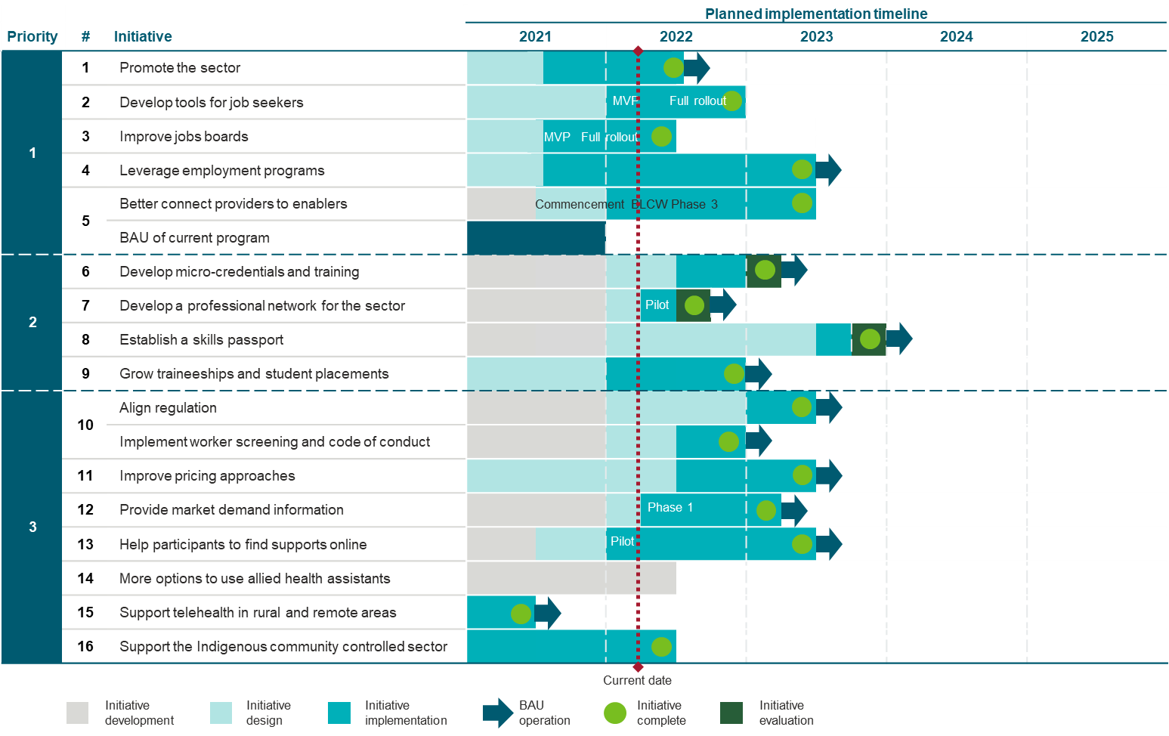
Achievements and next steps
Initiative | Achievements | Next steps
- Promote opportunities in the care and support sector – the A Life Changing Life campaign, launched  15 August 2021  Funding:  2020-21  $13.3 million  2021-22 (extension)  $9.45 million  Total  $22.7 million | Communication activities have continued throughout the second half of 2021 and first half of 2022 to promote the care and support workforce.  The A Life Changing Life campaign advertising second and third bursts ran from 17 September 2021 – 6 November 2021 and 30 January 2022 – 19 February 2022, respectively. The fourth burst of advertising commenced 20 March 2022 and is planned to finish 9 April 2022.  SEEK webinars were hosted on 30 November 2021 and 8 March 2022. The webinars are available at https://www.careandsupportjobs.gov.au/.  The content partnership with Year13 (online platform for post-school career and life advice) went live on 24 November 2022 with the launch of an e-learning program, which is designed to move students through the decision making process of their post-school pathway.  The content partnership with popular youth culture and news website, Junkee began on 18 October 2022.  The culturally and linguistically diverse (CALD) campaign supporters kit was distributed in ten languages (Tagalog, Punjabi, Hindi, Farsi, Dari, Indonesian, Thai, Arabic, Vietnamese and Korean) to stakeholders.  Conducted cultural awareness and engagement training webinar for employers on 31 March 2022.  Held a series of webinars with employment service and training providers, and service providers in late March 2022. | Continue fourth advertising burst. Conduct fifth advertising burst in mid-2022.  Ongoing public relations activities, including development of more case studies, media outreach, stakeholder communications and follow-ups.  Ongoing Aboriginal and Torres Strait Islander targeted public relations and engagement.  Ongoing Culturally and Linguistically Diverse targeted public relations and engagement.  Conduct final SEEK webinar in June 2022.  Continue content partnerships with Year 13 and Junkee.  Work with the Department of Education, Skills and Employment and Boosting the Local Care Workforce (BLCW) Program to provide exhibition packs to jobs fairs and events.
- Develop a simple and accessible online tool for job seekers to self-assess their suitability for new roles based on values, attributes, skills and experience. | Completed new worker user journey mapping.  Department of Education, Skills and Employment and NDIS Quality and Safeguards Commission are continuing development of self-reflection and self-assessment online tools for jobseekers in the care and support sector. | Promote the online self-reflection tools for use by job seekers, employers and employment service providers once they are launched.
- Improve effectiveness of jobs boards to match job seekers to vacancies in the sector.  Targeted, pre-filled JobActive and SEEK jobs boards available at https://www.careandsupportjobs.gov.au/. | Ongoing review of JobActive and SEEK jobs boards performance data. To date there has been strong correlation with advertising bursts, SEEK webinars and jobs boards usage. | Analyse data on usage of https://www.careandsupportjobs.gov.au/, JobActive website and SEEK jobs boards to identify if further enhancements to the jobs boards are required.
- Leverage employment programs to ensure suitable job seekers can find work in the sector. | Ongoing consultation with program owners to determine the scope of trials into:  - Disability Employment Services  - Community Development Program  - Workforce Australia | Continued consultation with program owners of:  - Disability Employment Services  - Community Development Program  - Workforce Australia  Participation in BLCW steering group for pilot of remote community initiatives across WA, SA and NT to increase Aboriginal and Torres Strait Islander workforce participation in the care and support sector.
- Better connect NDIS and care and support providers to employment and training providers and workers.  Funding:  $16.9 million (2021-22 to 2022-23) | Via the Boosting Local Care Workforce (BLCW) Program delivered:  - Three National Remote Roundtables on the workforce challenges and opportunities in Remote Australia with Registered Training Organisations, service providers and the Community Development Program.  - Employment Consultant Objection clinics for employment provider consultants.  - Case studies and business strategy models for Allied Health student placements. | Continue to host workshops and events to support workers and providers across the care and support sector, with a focus on workforce attraction, retention and organisational strategy.  Pilot small-scale initiatives within 9 communities across WA, SA and NT.  Update the BLCW Program website to improve usability and add resources developed through NDIS Jobs and Market Fund grant projects.
- Develop micro-credentials and update nationally recognised training to improve the quality of supports and enhance career pathways. | A vendor has been procured to work with the department and the Human Services Skills Organisation to map job families and career pathways in the NDIS workforce as well as develop guidance on topics, content, assessment criteria, delivery modality and options for industry recognition for short-courses or micro-credentials to offer more flexible and efficient means of skilling the workforce to improve the quality of supports and enhance career pathways.  A program of stakeholder consultation is underway with training and disability service industry bodies and across Government. | Drawing on disability services, workforce and training data holdings and stakeholder inputs, a job architecture and career pathway map will be developed for the disability care sector during the first half of 2022.  Following a training needs analysis, it is anticipated that guidance for the delivery of priority short-courses for the workforce will be made available to Registered Training Organisations in the second half of 2022, along with a plan to enable their industry recognition.
- Support the sector to develop a Care and Support Worker Professional Network. | A vendor has been procured to establish and pilot professional networks led by sub-contracted organisations, and produce a report on the learning from the pilot to produce model activity guides and next steps to consider as part of the workforce plan implementation.  Consultation on options for networks has been undertaken. | Expressions of interest will be sought from industry organisations to co-design and lead the pilot networks with the vendor.  The network pilots will commence in April 2022, with a complementary program of action learning and evaluation to monitor and measure outcomes as the pilots’ progress.
- Work with the sector to establish a skills passport. | A vendor has been procured to develop and trial a digital platform that integrates existing ICT infrastructure to provide a verified record of worker information to facilitate industry recognition and portability of qualifications, skills, screening checks etc.  A program of stakeholder consultation and co-design is underway to scope the framework for credentials and the technology to facilitate their verification. | The project will continue and expand the stakeholder consultation and co-design program with government and non-government stakeholders, including NDIS participants and providers; disability support workers and their representatives and training bodies.
- Support the sector to grow the number of traineeships and student placements, working closely with education institutions and professional bodies. | The department established the Allied Health Policy Roundtable (the Roundtable) to bring together industry and government to promote the growth of the Allied Health workforce in the care and support sector. The Roundtable includes representatives from Allied Health Professions Australia (AHPA), Australian Council of Deans of Health Sciences, Indigenous Allied Health Australia, Services for Australian Rural and Remote Allied Health (SARRAH), Universities Australia, Boosting the Local Care Workforce, the Department of Health and the Department of Social Services.  The first Roundtable was held on 10 February 2022 and discussed policy ideas to increase successful Allied Health student placements in the sector.  The BLCW subject matter specialists developed case studies and business strategy models for Allied Health student placements. | Conduct quarterly roundtables to facilitate development of policy ideas to increase the success of Allied Health student placements.  Continue to work with BLCW subject matter specialist on business strategy models for Allied Health student placements.  Once outcomes of the Human Services Skills Organisation’s project on mapping existing student traineeships and placements are received, an action plan for next steps will be co-designed with stakeholders
- Improve alignment of provider regulation and worker screening across the care and support sector.  Funding:  $12.3 million (2021-22 to 2022-23)  $10.8 million (2022-23) | The joint-agency taskforce led by Health undertook consultation with stakeholders over October 2021 to January 2022.  NDIS Amendments (Improving support for at risk participants) Act – passed November 2021 and enables sharing of appropriate and relevant information across regulators and other bodies.  Residential aged care providers who support NDIS participants can now recognise the NDIS worker screening check.  Aged Care and Other Legislation Amendment (Royal Commission Response No. 2) Bill 2021 – to establish worker screening arrangements for aged care consistent with NDIS worker screening, allow for a care and support code of conduct and enable information sharing between regulators is currently before Parliament. | Joint-agency taskforce to release summary of findings from the consultation.  The joint-agency taskforce will continuing to progress initiatives to align regulatory arrangements for the care and support sector including further analysis and development of options for a comprehensive roadmap for regulatory alignment and consideration of options for standards alignment and models to pilot integrated audits/assessments.  Joint-agency taskforce will undertake further consultation and engagement strategy with the sector.  A consultant to be engaged by DSS to undertaken the NDIS Quality and Safeguards Framework Review.
- Continue to improve NDIS pricing approaches to ensure effective operation of the market, including in thin markets. | The department is planning for a proposed project on pricing for the effective operation of the NDIS market by identifying potential options for price and payment arrangements to improve outcomes for participants while supporting longer-term sustainability. | Finalise proposed consultation and survey for use with disability support sector and NDIS participants.
- Provide market demand information across the care and support sector to help identify new business opportunities.  Funding:  $2.4 million | The department hosted initial workshops with members of key provider peaks including National Disability Services, Ability First Australia, and National Aboriginal Community Controlled Health Organisations in regard to developing a whole of care and support online demand map tool.  An ICT Business Analyst was procured to conceptualise business requirements through consultations for the design and build of the Care and Support Sector Demand Map.  Ongoing consultation with the Department of Health and the Department of Veterans’ Affairs on business requirements for the expanded Demand Map. | Consult with care and support service providers to inform the design and implementation of the Care and Support Sector Demand Map.
- Support participants to find more of the services and supports they need online. | The department has mapped the current services and supports available online in the care and support sector. | Investigate integration into current and future digital projects with NDIA. Potential projects include:  - Digital Partnership Program  - provider finder through MyPlace  Investigate integration in MyPlace App Pilot with NDIA.
- Explore options to support allied health professionals to work alongside allied health assistants and support workers to increase capacity to respond to participants’ needs. | Consideration of training opportunities are being explored through the micro-credentials project (see initiative 6). | Engage with stakeholders including allied health assistants’ representative groups to explore challenges and options.
- Enable allied health professionals in rural and remote areas to access professional support for case conferencing via telehealth. This enables a local allied health professional in regional and remote areas access specialist support from other allied health professionals where it helps support the NDIS participant. | NDIA has agreed to allow providers to charge for case conferencing for professional support via telehealth to support NDIS participants. | The department and NDIA are working with key stakeholders, particularly those in rural and remote areas, to highlight the availability of this service option.  This service will continue to be promoted through the BLCW, the Chief Allied Health Officer and Allied Health Peaks.
- Help build the Aboriginal and Torres Strait Islander community controlled sector to enhance culturally safe NDIS services.  Funding:  $5.9 million (NDIS Ready) | 57 Aboriginal Community Controlled Health Organisations and Aboriginal Community Controlled Organisations across Australia will receive Indigenous Business Support Funding grants, worth $22,000 each. The grants will enable organisations to address challenges in registering and delivering NDIS services, including engaging business and technical advice to develop better systems to deliver NDIS services. The funding will also provide an opportunity for organisations to scope future Aboriginal-led disability solutions within Aboriginal and Torres Strait Islander communities. | Deliver the Remote and very Remote Yarning Circles.  Explore opportunities for future projects to build the community controlled sector through the Sector Strengthening Plan on Disability and through the Closing the Gap National Agreement.

Disability Workforce Industry Working Group
The department established a Disability Workforce Industry Working Group to support the implementation of the NDIS National Workforce Plan. The industry-led Working Group will provide a forum to collaborate, co-design and jointly implement initiatives.
- The working group is co-chaired by National Disability Services who will hold the position for 12 months before another service provider is elected.
- The Working Group also includes representatives from Ability First, Alliance20, Community Services Industry Alliance, Boosting the Local Care Workforce and the Human Services Skills Organisation.
- The Working Group meets every 6 weeks. The first meeting was conducted on 15 December 2022.

Joint Standing Committee on the NDIS – Inquiry into NDIS Workforce
The Joint Standing Committee on the NDIS tabled its final report on the inquiry into the NDIS Workforce, including the NDIS National Workforce Plan, on 15 February 2022. The Government is currently considering the Joint Standing Committee’s final report.

